United Nations in Namibia

Common Country Analysis

10 November 2017

Lund, Orlandini, Reeh

COPYRIGHT 2017 UNITED NATIONS COUNTRY TEAM IN NAMIBIA

This document is prepared by the United Nations Country Team (UNCT) and the Office of the UN Resident Coordinator in Namibia with the assistance of the independent consultant team Lund, Orlandini and Reeh, following standard guidelines s for Common Country Analysis as set down by the United Nations Development Group (UNDG) through the United Nations Development Operations Coordination Office (UNDOCO).

Unless otherwise stated the contents of this document are the responsibility of, owned and copyrighted by the UNCT in Namibia. All rights reserved.

The term UNCT refers collectively to all United Nations organisations, funds, programmes and agencies in Namibia, both resident and non-resident.

The content of this document may not be copied, reproduced, republished, posted or transmitted without the express and prior permission of the UN Resident Coordinator.

For information contact:

Office of the UN Resident Coordinator - Namibia
UN House, 38 Stein St.
Klein Windhoek, Windhoek, Namibia

Cover photograph: <insert photo credit if needed>

ACKNOWLEDGEMENTS

We would like to thank the contributors of primary and secondary data to the CCA including both resident and non-resident agencies, all partners and stakeholders. Some special thanks goes to the Office of the UN Resident Coordinator in Namibia for its support and guidance throughout the whole assignment.

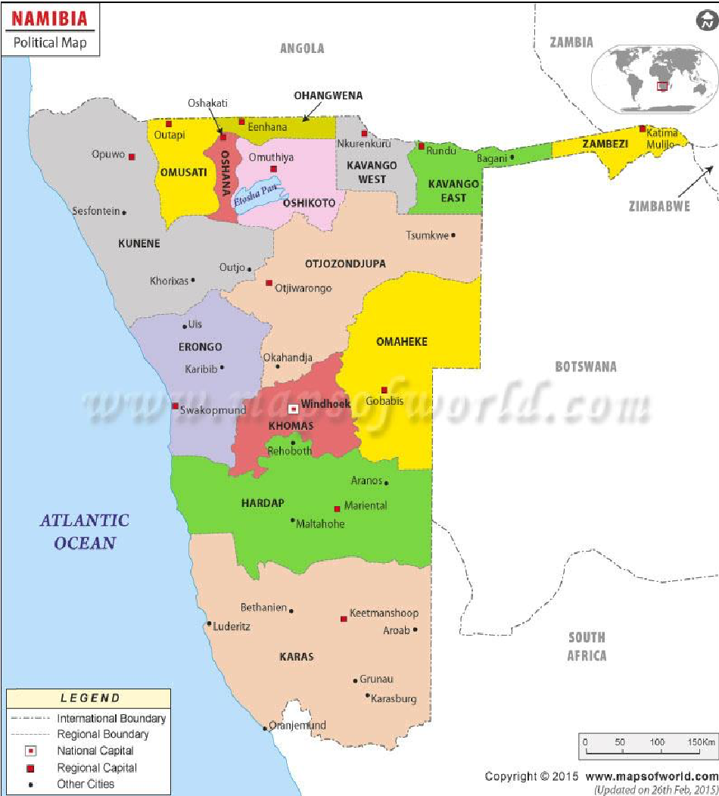
Table of Contents
1. EXECUTIVE SUMMARY 8
2. INTRODUCTION 10
a. Methodology 10
b. Principles of the 2030 Agenda and the SDGs 12
3. OVERVIEW OF COUNTRY 14
a. Economic dimension 14
i. Macro-economic situation 14
ii. Poverty and inequality 15
iii. Employment 19
b. Social Dimension 20
i. Population 20
ii. Health 22
iii. Food Security and Nutrition 26
iv. Education 28
v. Sanitation 29
vi. Social Protection 30
vii. Land and urban planning 30
viii. Gender equality and empowerment 31
c. Environmental Dimension 33
i. Environment and Climate Change 33
ii. Disaster Risk Management 36
d. Policy and Institutional Environment 37
i. Policy environment 37
ii. Protection, Justice and Rule of Law 41
e. Risks and Threats 42
4. RIGHTS-BASED ANALYSIS 42
a. Patterns of exclusions and discrimination 42
b. Root Causes Analysis 43
5. UN COMPARATIVE ADVANTAGE 47
a. UNCT SWOT Analysis 48
b. Stakeholder Interviews 49
c. Partner Perception Survey 51
d. UN Capacity Assessment 53
e. Proposed UN Comparative Advantages 53
6. CONCLUSIONS AND RECOMMENDATIONS 55
7. REFERENCES 58
Annex 1 – Terms of Reference 60
Annex 2 – Final List of People Interviewed 65
Annex 3 – Interview Guide 66
Annex 4 – UN Capacity Assessment Surveys 68
Annex 5 – Partner Perception Survey 73
Annex 6 - Selected Relevant Data 79

List of Tables
Table 1 - Namibia's National Development Plan 5 Economic Sector Targets 15
Table 2 Poverty oriented spending in Namibia FY10/11-2013/14 (World Bank, 2013) 38
Table 3 Partner Perception survey responses - UN Programming priorities now and in the next 5 years 51
Table 4 Regional Values of individual domains of deprivation and changes (2001-2011) 82

List of Figures
Figure 1 Overview of proposed CCA methodology 11
Figure 2 Poverty rate and GDP per capita 16
Figure 3 Spending on education, health and other social programmes 17
Figure 4 Gini Index - Namibia's position in the world 17
Figure 5 Population income by Language spoken at home 18
Figure 6 Percentage of consumption by population group 19
Figure 7 Namibia’s share of employment 1991-2013 20
Figure 8 Namibia projected population 2011-2041 21
Figure 9 Population Pyramid Namibia 2030 21
Figure 10 Population Pyramid Namibia 2015 21
Figure 11 Projected population for Namibia, urban and rural, 2015-2040 22
Figure 12 Projected Populations by Regions, 2011 and 2041 23
Figure 13 Overall HIV prevalence among pregnant women receiving antenatal care 24
Figure 14 HIV prevalence amongst females aged 15-24 25
Figure 15 Survival rates by incentive category, 2012 29
Figure 16 Share of Land Area under different status 35
Figure 17 Sendai Framework for Disaster Risk Reduction (2015-2030) Priorities for Action 37
Figure 18 - Problem Tree - Root Causes Analysis 47
Figure 19 ODA in Namibia 48
Figure 20 Top ten donors of gross ODA for Namibia 48
Figure 21 Results of UNCT SWOT Analysis 50
Figure 22 Distribution of UN Agency Capacity 54
Figure 23 Trends in Gini Coefficient – Source NHIES 80
Figure 24 Education Attainment of Male HH population by region 80
Figure 25 Education Attainment of Female HH population by region 81
Figure 26 Percentage of women age 15-49 who reported that they have serious problems in accessing health care for themselves when they are sick by wealth quintile and type of problem 81
Figure 27 Percentage of women age 15-49 who reported that they have serious problems in accessing health care for themselves when they are sick, by type of problem and region 82
Figure 28 Percentage of 15-19 years old women who have begun childbearing by region 82

ACRONYMS

ART Anti-Retroviral Therapy
CBNRM Community Based Natural Resource Management
CCA Common Country Assessment
CCHF Crimean Congo Hemorrhagic Fever
CEMONC Comprehensive Emergency Obstetric and Newborn Care
CVD Cardio Vascular Disease
CSO Civil Society Organisations
DAO Delivering as One
DRM Disaster Risk Management
ECD Early Childhood Development
EMONC Emergency Obstetric and Newborn Care
EPI Expanded Programme of Immunisation
FGD Focus Group Discussions
GBV Gender Based Violence
GBVPU Gender Based Violence Protection Union
GDP Gross Domestic Product
GRN Government of the Republic of Namibia
HH Household
HIV Human Immunodeficiency Virus
HoA Head of Agency
HPP Harambee Prosperity Plan
IMF International Monetary Fund
JPRSM Joint Partnership Resource Mobilisation Strategy
LFS Labour Force Survey
MAWF Ministry of Agriculture Water and Forestry
MDG Millennium Development Goals
M&E Monitoring and Evaluation
MEAC Ministry of Education, Arts and Culture
MHSS Ministry of Health and Social Services
MNCH Maternal and Newborn Child Health
MPESW Ministry of Poverty Eradication and Social Welfare
MSME Micro, Small Medium Enterprise
MTR Mid-term Review
NAFIN Namibia Alliance for Improved Nutrition
NASA Namibia National AIDS Spending Assessment
NCD None Communicable Disease
NDHS National Demographic and Health Survey
NDP5 Fifth National Development Plan
NDRMC National Disaster Risk Management Committee
NDRMS National Disaster Risk Management System
NEET Not in Education, Employment or Training
NHIES National Household Income and Expenditure Survey
NLP National Land Policy
NRA Non-resident Agency
NSA Namibia Statistics Agency
ODA Official Development Assistance
PFM Public Financial Management
RBM Results Based Management
RCO Office of the Resident Coordinator
RISDP Regional Indicative Strategic Development Plan
SADC Southern African Development Community
SDGs Sustainable Development Goals
SWAPO South West Africa People’s Organisation
SWOT Strengths Weaknesses Opportunities and Threats
TB Tuberculosis
TiP Trafficking in Persons
TVET Technical Vocational Education and Training
UMIC Upper Middle Income Country
UN United Nations
UNCT United Nations Country Team
UNDAF United Nations Development Assistance Framework
UNDG United Nations Development Group
UNFCCC United Nations Framework Convention on Climate Change
UNPAF United Nations Partnership Framework
UPR Universal Periodic Review
VAC Violence Against Children

EXECUTIVE SUMMARY

As the current United Nations Partnership Framework (UNPAF) with the Government of the Republic of Namibia (GRN) is coming to an end in 2018, the UN in Namibia, as mandated by the UN Development Group (UNDG), has prepared a Common Country Assessment (CCA). As stated in the 2017 UNDAF Guidance, “The CCA is a required and essential element of every UNDAF process. It is the UN system’s independent and mandate-based articulation of the country context, opportunities and challenges, encompassing sustainable development, human rights, gender equality, peace and security, and humanitarian perspectives.” From this, and learning lessons from the current UNPAF, a new outcome focused joint programmatic framework will be developed, aligned with the Fifth National Development Plan (NDP5) and other related government’s policies and strategies.

Since the inception of the current UNPAF (2014-2018), several significant developments have taken place in Namibia, regionally and globally, that will influence the development trajectories of the country. At the country level Namibia’s Fifth National Development Plan (2017-2022) has been launched, together with the Harambee Prosperity Plan (HPP) for the period 2016/17 - 2019/20 and the Blue Print on Wealth Redistribution and Poverty Eradication by the Ministry for Poverty Eradication and Social Welfare (MPESW). At the global level a new development agenda has been adopted defining a new holistic vision of development and a set of interrelated Sustainable Development Goals (SDGs) to be reached by 2030. The latter calls for a more integrated and coherent response by the UN in its support to countries’ efforts towards sustainable development.

Only reaching its independence in 1990, Namibia is a young nation with a population of 2.3 million, which is widely distributed across the vast country (825 615km²). The country has been classified, by World Bank definition, as an Upper Middle-Income Country (UMIC) since 2009 when it reached the Gross-Domestic Product (GDP) per capita of USD 5,210. The lift to this higher income status has implications regarding access to development grants and the overall flow of Official Development Assistance (ODA). The UMIC status, however, does not reflect reality on the ground and masks significant redistribution issues. While GDP grows thanks to the country’s significant natural resources (linked mainly to mining), this has not led to the development of a manufacturing sector nor significant job creation. Persistent pockets of poverty, unemployment and staggering inequalities are lingering development challenges in Namibia in spite of its UMIC status. These are exacerbated by the negative impact of climate change phenomena with recurring droughts and floods.

The country features one of the most unequal distributions of wealth with a national Gini coefficient index of 0.572 (NDP5), with a rural/urban and inter-regional divide. Poverty rates have declined significantly since independence, but it is still 27 percent in rural areas (9.6 percent in urban); 66 percent of the population is under the age of 30, and youth unemployment is as high as 43.4 percent.

Access to quality social services, especially in rural and remote areas, remains a significant challenge. 46 percent of the population does not have access to toilet facilities (NDHS 2013); only 47 percent of households have electricity (ibid); 22 percent of new-born children are not being registered (UNICEF 2016); in spite of great achievements made in expanding education services in the poorest, most remote communities the survival rate from Grade 1 to Grade 12 is at 1 percent (UNICEF 2016); maternal mortality rate is at a high 385 per 100,000 live births (2013, source MDG Report 2015); HIV epidemic is estimated by UNAIDS to be 14 percent among the general population in 2016.

The HPP and the NDP5 aim to bring ‘prosperity to all’ in Namibia and at the core of the SDGs agenda is the goal of “leaving no one behind”. With these aspirations, significant efforts need to be made to tackle the root causes of the current disparities.

The UN has been a trusted partner to Namibia dating back to the time of independence and has continued to significantly support the country significantly in its fight against poverty and path towards sustainable development. As the country moved to its UMIC status, the UNCT (United Nations Country Team including both resident and non-resident agencies) has undertaken a thorough analysis of its role in the country further reflecting on its key comparative advantage. What emerges is the need for the UN to slightly reposition itself in order not to lose relevance and to continue to have impact. This implies combining ‘upstream’ services to develop the policy framework, and ’mid-stream’ to strengthen institutions and systems for service delivery, whilst keeping ‘a foot on the ground’ to continue some downstream contributions, including service delivery in the most deprived areas, as pilot projects for upscaling.

Namibia is an official Delivering as One (DaO) country and the UN has shown commitment to designing implementation processes that further enhance coordination and coherence in the way the UN deliver results. The UN Country Team is also cognizant of the revived UN Reform Agenda of the new Secretary General, which calls for more integrated approaches to development. Namibia’s overall experience of being a DaO country can certainly be further enhanced, especially in view of delivering on the SDGs and the renewed global focus of Delivering Together. In this regard, the Partners’ Perception Survey has delivered useful insights, which, together with the rest of the analysis, will allow the consultants to structure recommendations on the way forward.

The CCA is presented as a complementary and independent UN analysis of achievements, challenges, and policies, drawing on existing literature and data, and presenting findings through economic, social and environmental dimensions, with an indication of potential areas for future UN support. The economic dimension captures the macro economic status and challenges as well as issues around poverty and inequality as well as un-employment industrialisation, and access to energy. The social dimension provides a narrative that focuses on population trends, health priorities and challenges, food security and nutrition as well as education, sanitation, social protection, land and urban planning and gender equality and empowerment. The environmental dimension ensures focus on environment and climate change and disaster risk management. Two additional sections within the country overview capture key data regarding the policy environment, and protection, justice and rule of law. The country overview concludes with consideration of risks and threats which highlights primarily Namibia’s vulnerability to external economic shocks, being prone to natural disasters and the persistent, staggering inequalities along ethnic, regional and residential area lines, as well as growing unemployment and lingering land reform.

The rights based analysis within the CCA covers the priority considerations of exclusion and discrimination, and presents a root cause analysis which is undertaken recognizing Namibia’s aims to achieve their Vision 2030 and the SDGs.

The UN’s comparative advantages are identified with specific consideration for Namibia’s country development context and the roles, position and resources of the UN. A partner perception survey provided key messages regarding the areas where the UN’s inputs are required and needed. In addition, priorities for the next five years were highlighted as; a focus in all areas particularly natural resource management, resilience and climate action, support for minority and disadvantages groups, strengthen state institutions and provide support to the current government structures.

The CCA concludes with the presentation of eleven recommendations prioritised against what is seen to be the UN’s comparative advantage. In order to advance the implementation of Agenda 2030 and support the Government of the Republic of Namibia (GRN) in its achievement of the SDGs the conclusions emphasise the UN’s unique position in Namibia’s development context; the priority for facilitating partnerships; strengthening M&E capacities; maintaining a focus on multi sectoral support; building and strengthening the UN’s DAO agenda; ensuring the technical strength of the UN; prioritising the work ‘on the ground’ focusing on those areas most deprived and with the highest development need; tackling patterns of exclusion and discrimination; and supporting the GRN to maintain a rights based approach in all dimensions.

INTRODUCTION

The CCA aims to articulate Namibia’s context, opportunities and challenges, encompassing sustainable development, human rights, gender equality, peace and security, and humanitarian perspectives. This exercise has:
- Provided the essential evidence base from which the United Nations Development Assistance Framework (UNDAF) theory of change is drawn, and offers grounding and direction for a strategic UNPAF;
- Defined medium and long term trends, based on a wide range of data sources, which provide the foundation of the UN Vision 2030 document;
- Identified areas for enhanced policy coherence, reflecting the interdependence of the SDGs and issues the country must have addressed.

Methodology

The methodology of the overall CCA is a rights-based causal analysis aimed at identifying the leverage points and potential high impact interventions across the three dimensions of sustainability. A ‘systems approach’ is used to reach these conclusions, having collected both quantitative and qualitative data, utilizing a number of tools and processes.

Analysis

Desk Review of key documents

Thematic areas

Key informants

Semi structured stakeholder interviews

SWOT analysis

Focus Group Discussions

Surveys

UN Capacity assessment survey

Qualitative data collection

Qualitative survey

Partners perception survey
Figure 1 Overview of proposed CCA methodology

The desk review of key documents representing recommended secondary data sources, reports and evaluations, was undertaken to synthesize relevant data that encompasses the thematic areas listed in key policy documents. Documentation analysis has been augmented by a limited number of semi structured interviews. Consultations were undertaken to discuss the UN’s comparative advantage and dedicated consultation with the UNCT included a SWOT exercise. Surveys were conducted to inform a UN capacity assessment and a partner perception survey. Inputs were received from both resident and non-resident UN agencies.

There are four key elements of the CCA

- A Country Analysis: describes the current development status, challenges and opportunities in Namibia. The country analysis seeks to provide an overview incorporating: the situation of people living in Namibia; the political, policy and legislative environment for achieving the SDGs and other national commitments and obligations under international conventions ratified by the country; vulnerabilities for different groups and geographic areas; and considers these in the context of the UN system’s comparative advantage; the immediate, underlying and root causes of multidimensional poverty, inequalities and discrimination, and the reasons why particular groups are left behind; and gaps in capacities of duty bearers to fulfil their obligations and of rights holders to make their claims.

- A UN capacity assessment: presents a mapping of the UN’s current capacity to leverage the UN policy advisory, programme implementation, coordination and resource mobilization roles. The capacity assessment has been a means to assess internally the UN’s capacity to undertake its work, particularly in relation to its implementation of UNPAF. The assessment methodology involved both quantitative and qualitative data collection, with quantitative data from agencies focused on presenting a human resource capacity analysis in each sector/ sub-sector.

- A Partners’ Perception Survey: undertakes to assess the UN System’s perceived value in Namibia through consultation with external stakeholders. The survey results form part of determining the UN’s comparative advantage and informs conclusions regarding partnership development. See Annex 5 – Partner Perception Survey

UN Comparative Advantage Assessment: analyses the UNCT’s comparative advantage in the context of both UN Reform and Namibia’s development agenda, in relation to all development actors in the country; focused on the UN’s ‘mandate to act, the capacity to act and being best positioned to act’. The SWOT exercise with the UNCT, identified the specific strengths that the UN system brings individually and collectively in relation to other partners, and the potential threats and opportunities in the external environment that need to inform the focus and implementation priorities of future programming.
Primary Data
The consultants have taken the assignment’s time constraints into account and have organized data collection in an efficient manner to allow sufficient time for data analysis, verification and presentation. The consultants generated a provisional schedule for the in-country consultations based on the list of stakeholders provided by the RCO. Subsequently, the consultants relied on the RCO to arrange for the face-to-face interviews and consultations to collect primary data (final list of meetings can be found in Annex 2 – Final List of People Interviewed). These interactions followed an agreed guide (see Annex 3 – Interview Guide) which was designed to cover the main aspects of the country analysis. Primary data was collected in order to inform the UN capacity assessment, contribute to the definition of the UN Comparative Advantage in Namibia and carry out an analysis of Partners’ Perception. Two main surveys have been conducted online:
- The first to UN staff for a self-assessment of current capacities (see Annex 4 – UN Capacity Assessment Surveys). This was administered to all programme staff across the UN agencies operating in Namibia (including NRAs).
- The second to UN partners in Namibia across its main categories, i.e. Government, Civil Society Organisations and Development Partners (See Annex 5 – Partner Perception Survey)
Time was provided to collect responses to ensure a critical amount of data entries to support statistical analysis. Quantitative data on current UN capacities (priorities within TOR and percentage of time allocated) has been collected (see Annex 6).
Secondary Data
The UNCT provided material for relevant secondary data, which has informed the analysis, and additional material emerged in the course of the assignment as further research was carried out by the consultant team. The consultants have elicited qualitative data from existing analyses, reports, programme documents, policy papers and others. Some of the major sources have been the NDP5, NPC- Poverty Mapping Report and Index of Multiple Deprivation, UNPAF 2014-18, Namibia poverty macro outlook (World Bank), the UN Joint Partnerships Resource Mobilisation Strategy (JPRMS) for Namibia, Blue Print on Wealth Redistribution and Poverty Eradication, Namibia Vision 2030, and HPP 2016/17 - 2019/2020. Quantitative data has been obtained from survey reports, administrative data, census materials and others, including NHIES 2016 (preliminary findings), NHIES 2009/10, NDHS 2013, Labour Force surveys.

Data Analysis
The data analysis has involved the triangulation of information retrieved through the desk review of relevant documents, statistical data provided therein and collected from primary data producers, together with the assessments and perceptions gathered through the interviews and Focus Group Discussions (FGDs).

In line with the TOR and UNDG’s CCA UNDAF Companion Guidance 2017, this allows for elaboration of an evidence-based analysis of:
- Overall socio-economic and political working environment and related root causes of outstanding development challenges (based on the existing literature, analysis of the trends on key indicators, mapping and comparison of views of stakeholders). This includes analysis of root causes of inequalities, unemployment and environmental/health threats.
- Institutional capacities and overall political environment to address development challenges and realise the SDGs, related to the design and implementation of evidence-based policies.
- Outstanding human rights and gender-related challenges and corresponding capacity gaps (based on the mapping and analysis of human rights mechanisms recommendations and observations; existing data and analysis, mapping and triangulation of information and perceptions of interviewees).
- UN Comparative Advantage determined based on the stakeholders’ and UN’s comparative advantage arising from the interviews and Focus Group Discussions (FGDs) and the SWOT exercise conducted with the UNCT.
- UN Capacity Assessment – based on the outcomes of the online survey administered to UNCT members’ staff, interview with Heads of Agencies (HoA) and the FGDs. This information has been substantiated and triangulated with the outcome of the analysis of UN agencies’ programmatic documents and related review/evaluations.

Principles of the 2030 Agenda and the SDGs

The 2017 CCA for Namibia is designed to ensure that the findings and conclusions of the assessment will assist the UN System in promoting and fulfilling the principles of the global 2030 Agenda and its SDGs. The 2030 Agenda is universal, integrated, transformative and people-centred. The SDGs are interdependent goals which require coherent efforts at all levels by governments, the UN and all other stakeholders.

For the UN system, this means overcoming the development, humanitarian and peace-building divide and working as one integrated system. At the core of the UN programming principles to achieve the Agenda 2030 is the principle of “leaving no one behind” which reinforces the human rights-based approach to development programming. This means identifying the groups of people who are more at risk of being left behind. As elsewhere, in Namibia this principle calls for the UN system to prioritise its programmatic interventions and resources to address the situation of those most marginalised, discriminated against and excluded.

The “leaving no one behind” principle is supported by three other programming principles for the UN system: human rights, gender equality and women’s empowerment; sustainability and resilience; and accountability. These principles are grounded in the norms and standards that the UN is tasked to uphold and promote and that inform all phases of UN programming at the country level.

The 2017 CCA for Namibia is intended to assist in identifying links among national goals and targets in order to effectively determine mutually reinforcing priorities and catalytic opportunities for implementation of the 2030 Agenda as a whole. It aims at moving beyond the aggregation of sectoral analysis and facilitating a comprehensive and common understanding of the interdependence of the SDGs. In doing so, the 2017 CCA for Namibia will analyse all three aspects of sustainable development (economic, social and environmental) and their interrelations, by identifying the key factors hampering progress towards sustainable development and the interlinkages that deserve particular attention to define the UN development system’s scope of work.

OVERVIEW OF COUNTRY

Economic dimension

Macro-economic situation

The Republic of Namibia gained independence from South Africa in 1990, and covers an area of approximately 825,615 square kilometres, bound by the Atlantic Ocean on the west and shares borders with Angola, Zambia and Zimbabwe in the north, Botswana in the east and South Africa in the southeast and south, and aspires to be a prosperous and industrialised country. The country has been classified, by World Bank definition, as an Upper Middle-Income Country (UMIC) since 2009 when it reached the Gross-Domestic Product (GDP) per capita of USD 5,210. The lift to this higher-income status has implications regarding access to development grants and the overall flow of Official Development Assistance (ODA). The UMIC status, however, does not reflect reality on the ground (see section below on Poverty and Inequality). It should also be considered that the indicator used to classify the country as a UMIC (BDP is a simple measure to track a very complex process (development). Furthermore, the shift from an income level group to the next is defined as an abrupt change of status, rather than a gradual transition. While it should reflect reduced dependency on donors and does reduce access to concessional ODA, it should, at least in theory, attract more direct investment. Lastly, such status could also be reversible and indeed based on World Bank estimates (using Atlas method) the GNI per capita in the country has dropped considerably since reaching the UMIC status in 2009 with a projected figure of USD 4,620 per capita GNI in 2018 (World Bank Classification FY 2014-2018).

Namibia has a small open economy that has grown on average by 5.6 percent a year from 2012-2015 (Republic of Namibia, 2017). Extraction and processing of minerals for the export market is the largest contributor to the country’s GDP with mining accounting for 11.5 percent of GDP and providing more than 50 percent of foreign exchange earnings. The mining and quarry sectors employ two percent of the population. However, Namibia’s economy is increasingly diversified primarily by growing exports in fish and beef and a boom in the housing industry. Exports are susceptible to external shocks, including in recent years where there has been reduced import from South Africa and the Eurozone. As a result, the country’s GDP growth slowed down in 2016 to 1.2 percent (WB 2017). IMF Article IV 2016 indicated a growth prospect (strong growth and economic stability) of over 5 percent in 2017 and 2018 fueled by the commissioning and production of new mines. However, Namibia’s unfavorable trade balance is indicated by a current trade deficit of N$25.3billion (ILO, 2016) and public debit is rising with reserve coverage below safe levels. Rising housing prices and personal debt pose macro-financial concerns.

Inflation in Namibia reflects a downward trend slowing down by 5.4 percent from July 2016 to July 2017 (Namibia Statistics Agency, 2017). Prices for food has increased very slowly representing a slow down with meat prices increasing due to the impacts of the drought. The current drivers of inflation are housing, water and electricity, and health services prices rising very slowly and housing representing the largest share of consumption.

Namibia is the world’s fifth largest producer of uranium. The Husab uranium mine is expected to start producing uranium ore in 2017, and upon reaching full production Namibia, is expected to become the world’s second largest producer of uranium.

Key risks to medium-term growth include weak global demand for minerals, fluctuating commodity prices and adverse weather-related shocks, and lower revenues due to the economic slowdown in South Africa. It should also be noted that Namibia’s retail and service sectors, especially in the northern border regions, are heavily dependent on the provision of goods and services to Angolans. Decline of the latter’s purchasing power (as a reflection of regional and global economic downturn) negatively impacted the country’s economic performance.

Whilst the economy at a macro level is considered to be balanced, significant imbalances are noted at the micro and regional level with the challenges of youth unemployment and income inequality very present (UN Namibia, 2016). The lack of industrialisation in farming techniques and infrastructure in business development makes the agriculture sector inefficient, only contributing three percent to Namibia’s GDP while employing 31 % of the workforce. The goals of the NDP5 2017-2022 however are to focus on enhancing infrastructure, and upgrading existing industries to produce a broader and more valuable range of products. The government’s long-term goal of food security and poverty reduction depends on the productivity of the agriculture sector. However, in 2015 Namibia imported about 76 percent maize, 98 percent millet and 91 percent wheat indicating an ongoing scenario of import dependency considered to represent a trade imbalance and a food security risk (Republic of Namibia, 2017).

Table 1 - Namibia's Fifth National Development Plan (NDP5) Economic Sector Targets
Namibia’s Fifth National Development Plan (NDP5) 2017-2022 – Targets
Sector | Current GDP growth | Current % of workforce | Target GDP growth 2022 | Target % of workforce 2022
Agriculture | 3.2 | 30.9 | 2.9 | 28.1
Fisheries | 1.9 | 0.1 | 1.9 | 0.1
Mining | 12.5 | 2.0 | 15.2 | 6.9
Tourism | 2.1 | 5.4 | 2.2 | 8.1
Manufacturing | 8.3 | 4.8 | 7.8 | 3.0

Overall, infrastructure development is considered crucial for a possible macro-economic transformation of the country as is the importance of ensuring positive trends in budgetary allocations for the social sectors. The potential for Namibia to become a regional logistical hub has been suggested (i.e. functioning as a gateway to European market via its ports for the neighbouring landlocked countries) but this would entail a significant enhancement of transport infrastructure and logistical facilities at the points of entry/exit. Likewise, more efficient energy and water production, and management are key to further industrialisation.

Poverty and inequality

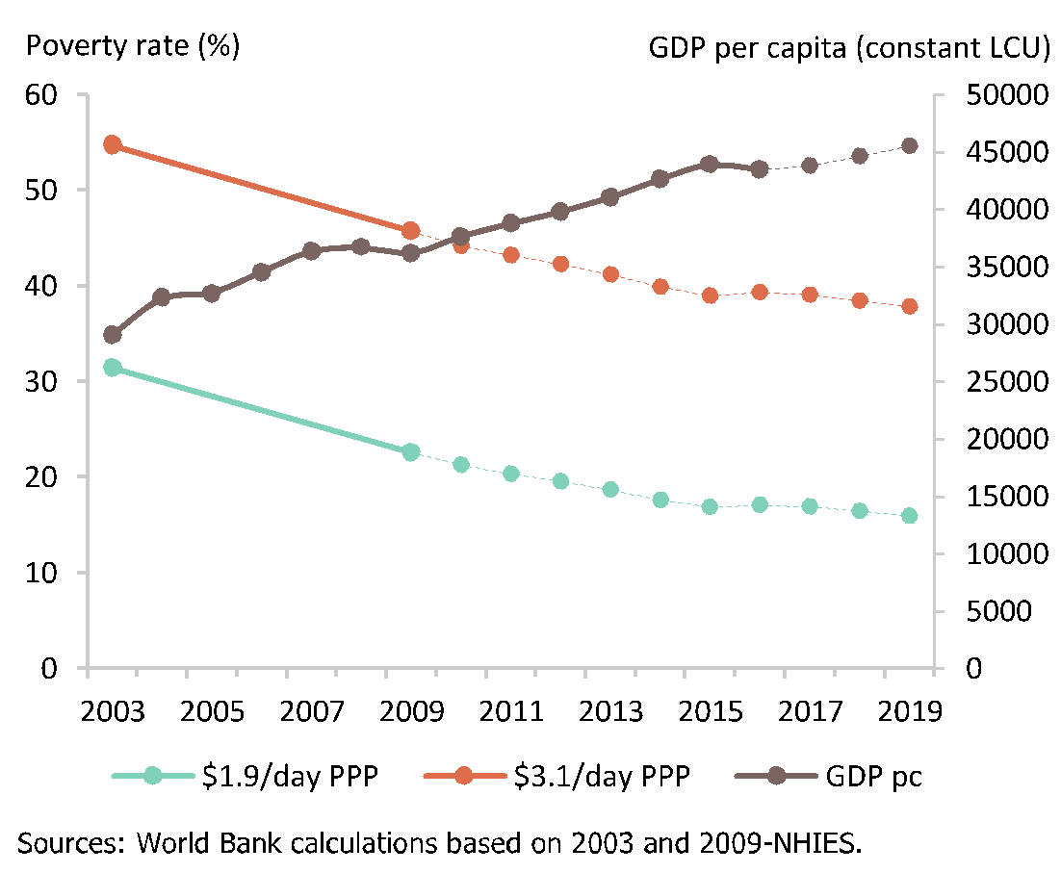
Namibia has achieved the level of ‘medium human development’ moving from 0.556 in 2000 to 0.637 in 2014, ranking 126th on the Human Development Index out of 188 countries (Republic of Namibia, 2017). Life expectancy is 68 years and the adult literacy rate is 89 percent. Namibia has a high score of 0.981 (out of a possible 1.0) in the 2014 Gender Development Index, considered by the GRN, as outlined in the NDP5, to be largely attributable to the share of parliamentary seats held by women; female attainment in secondary and higher education; and labour market participation rates of women. Poverty in Namibia is reported to be falling, but remains high. The incidence of poverty has declined from 21.9 percent of individuals in 2003/04 to 11 percent in 2015/16 (NHIES, 2016). Compared to other countries, Namibia’s poverty remains high relative to its level of national income per person (see Figure 2).
Figure 2 Poverty rate and GDP per capita (Source: World Bank, 2017a)

Since independence in 1990 Namibia has given high priority to the use of public resources to address poverty, inequality and social policy objectives. “Education, health, social security, housing, and other social programmes routinely receive more than half of government spending” and has a progressive impact on both poverty and equity (World Bank, 2017b). Despite the shocks of the global economic down turn, Namibia has, since the 1990s, increased social spending as a share of GDP (see Figure 3).
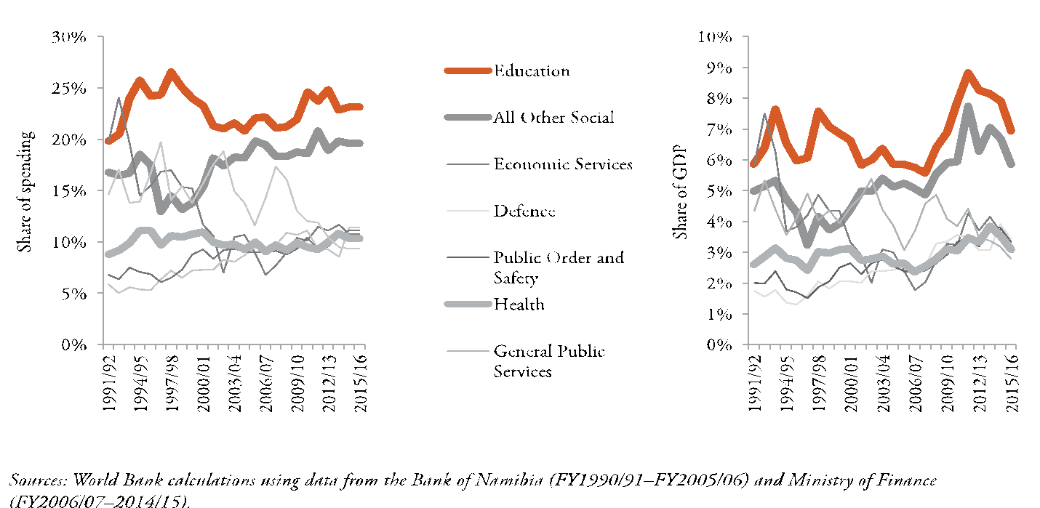
Figure 3 Spending on education, health and other social programmes (Source: World Bank calculations using Bank of Namibia data)

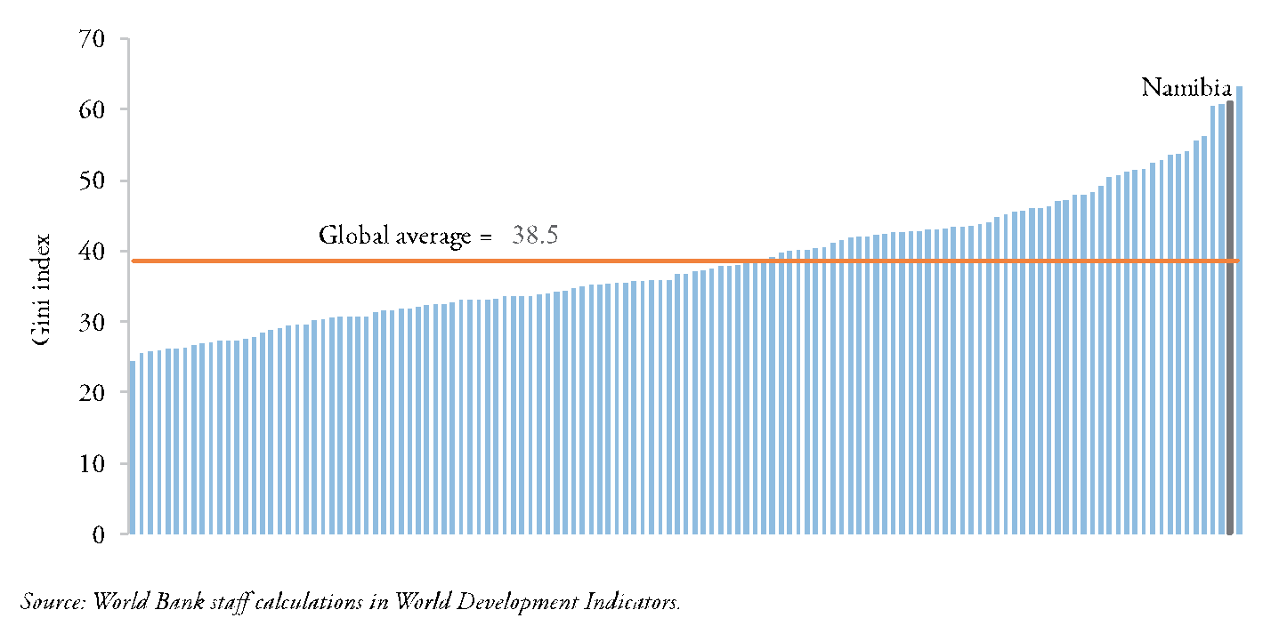
Low income workers, who are mostly women, are exempt from personal income tax. Cash transfers provided to vulnerable segments of the population are considered generous compared to other countries (World Bank, 2017). The proportion of pensioners, for instance, grew in the growth period 2003 – 2010 and poverty reduction amongst pensioners therefore declined by 2.56 percentage points as a result.
Figure 4 Gini Index - Namibia's position in the world (source World Bank – World Development Indicators)
Inequality in Namibia is amongst the highest in the world. Namibia has the second most unequal distribution of income in the world after South Africa (see Figure 4). The root causes are cited as a century of colonial rule and apartheid, which concentrated Namibia’s wealth including ownership of land, companies and financial assets (World Bank, 2017a).

Namibia’s Gini coefficient had not significantly declined in two decades. In 1993/94 the Gini was at 0.646 and declined to 0.572 in 2015/16 (NHIS 2016). The GRN’s Vision 2030 sets a numerical target of reducing the Gini coefficient by three percent per year to achieve a Gini coefficient of 0.30 by 2030. To reach this goal, appropriate investments in productive sectors and building Namibia’s human resource base will be necessary.

Income and consumption inequality also has a racial and residential dimension. Using as a proxy to the ethnic background, the language spoken at home, the NHIES provides clear indication of the structural inequalities within Namibia. Those speaking Afrikaans, German or English represent nine percent of the total population of Namibia, but their income is equal to 36 percent (see Figure 5).

Figure 5 Population income by Language spoken at home (Source: NHIS 2009/10)
Consumption patterns show similar results. Income distribution is also clearly skewed towards urban areas, with 62 percent of the population, as of 2009/10, living in rural areas but only receiving 35.3 percent of the country’s income (see Figure 6).

Figure 6 Percentage of consumption by population group (source NHIS 2009/10)

Urban poverty is however on the rise due to a significant influx of the rural population into urban areas where housing and social services are challenged by the increasing population pressure. The rural/urban divide also emerges in analyzing poverty and inequality by regions. The largely rural northern regions of Kavango, Oshikoto, Zambezi, Kunene and Ohangwena remain the poorest in the country with more than one third of the population in these regions being poor. Ohangwena and Oshikoto account for 15 percent and 14 percent of the poor, respectively. In Kavango, more than half of the population is classified as poor. Subsistence farming employs 58.3 percent in Kavango and 53.3 percent and 44.3 percent in Ohangwena and Oshikoto, respectively (National Planning Commission, 2015). Only in the mainly urbanized Khomas and Erongo regions is poverty recorded in single digits (National Planning Commission, 2015b). Data trends for the period 2001-2011 indicate a continued urban rural divide. The seven poorest regions – Kavango (most poor), Oshikoto, Zambezi, Kunene, Ohangwena, Omusati and Otjozondjupa – have poverty indices above the national average of 26.9 percent. These are the regions where the majority of the population lives in rural areas, where in the less poor regions of Khomas and Erongo, the economic hubs of the country, with relatively more employment opportunities, have largely urban populations.

These disparities across the different regions within Namibia are mirrored in the Namibia Index of Multiple Deprivation (2015), which focusses on the domains of material, employment, health, education and living environment and concludes that wide regional disparities across multiple deprivations exist in Namibia. Three of the five most deprived constituencies in Namibia are located in the Kavango region where the population is classified as the poorest, and three of the five least deprived constituencies are located in the Khomas region, where poverty is low but the incidence of poverty is increasing, and the urban population is anticipated to more than double in the next five years (National Planning Commission, 2015b).

Poverty is recognised to have an age dimension; NHIES data shows that child poverty rates fell from 43 percent in 2003/2004 to 34 percent in 2009/2010. However, children still remain at higher risk of income poverty than the general population, whose risk is 28 percent. This represents a social vulnerability that has only partially been addressed by cash grants for orphaned and vulnerable children, which currently reach only one in five children. While income poverty has fallen, children often are deprived in multiple ways. An analysis of 2011 census data found that 73 percent of rural children and 24 percent of urban children under-five were deprived in three or more of the following areas: source of energy, access to sanitation, type of housing or living in a female headed household.

Employment

Employment creation remains a priority for Namibia and targeted structural reforms and policies are considered necessary for significant increases in job creation and inclusive growth in Namibia. Reforms to the education and training systems to reduce skills mismatch and strengthen school-to-work transition as well as to simplify business regulations are considered to be the strategies that will have the highest impact on employment and on Namibia’s economy.

Namibia’s GDP has grown at an accelerated rate since 1980 but has not created employment with the structure of production and external trade remaining essentially unchanged, tied closely to metals, minerals and other national resources which are not employment intensive. According to the 2016 Labour Force Survey (LFS) in results published by the National Statistical Agency, unemployment is high, particularly in urban areas and among women and youth. It was also found that labour force participation is 69.4 percent of working aged individuals contributing to a broad unemployment rate of 34 percent. Unemployment in the economy is long term in nature, with 43.3 percent of the unemployed having been unemployed for more than one year, posing challenges for future employability because of the depreciation of human capital.

More worrying is the level of youth unemployment which is at 43.4 percent, and the number of youths Not in Education, Employment, or Training (NEET) is at 34.5 percent. These rates, indicating a large percentage of the population is unproductive, limit the ability of Namibia to reap the full extent of its demographic dividend in the future. The 2016 LFS also shows growth in the informal economy and a decline in the formal economy. This has negative implications on tax revenue, decent work, income, and working conditions. Declining coverage of social security is a further consequence of an increasing informal economy. This coupled with high levels of unemployment means that the majority of Namibia’s population of working age is excluded from social security coverage putting added pressure on the social welfare grants budget as more people enroll in social assistance programmes to supplement low and informal incomes.

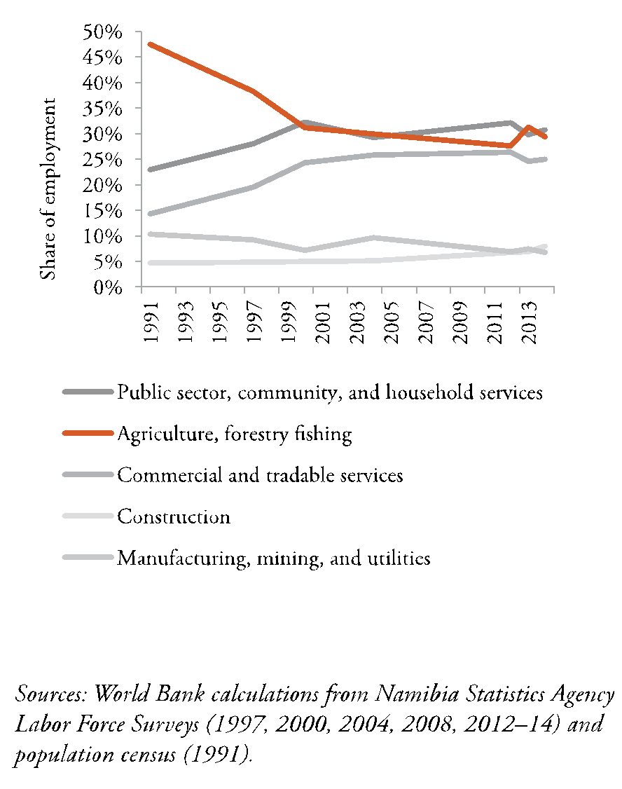
Only 30 percent of Namibia households rely on employment income as a primary source of income and employment has not been moving into areas with growing productivity, rather it has grown in industries with low wages and low productive growth. The construction sector is an exception with respect to its positive growth in jobs and productivity. Household income is therefore dependent on subsistence farming or receipt of the social grants mentioned, drought relief or private transfers (World Bank, 2017). Pressures on wages remain in key challenge for labor relations in many sectors of the economy; and GRN is exploring the possibility of a national minimum wage.
Figure 7 Namibia’s share of employment 1991-2013 (Source: World Bank calculations from NSA Labor Force Surveys

Social Dimension

Population
Namibia is one of the world’s least densely populated countries in the world averaging three persons per square kilometre. Namibia’s population grew from 1.4 million in 1990 to 2.3 million in 2016 and is projected to increase to 3.44 million by 2041 (see Figure 8). The current growth rate is 1.2 percent per annum slowing down from 2.6 percent in 2001, the result of the fertility rate slowing from 6.1 children per woman in 1991 to 3.6 in 2011, a trend projected to decline further to 2.4 children by 2041 (Republic of Namibia, 2016; Namibia Statistics Agency, 2014).
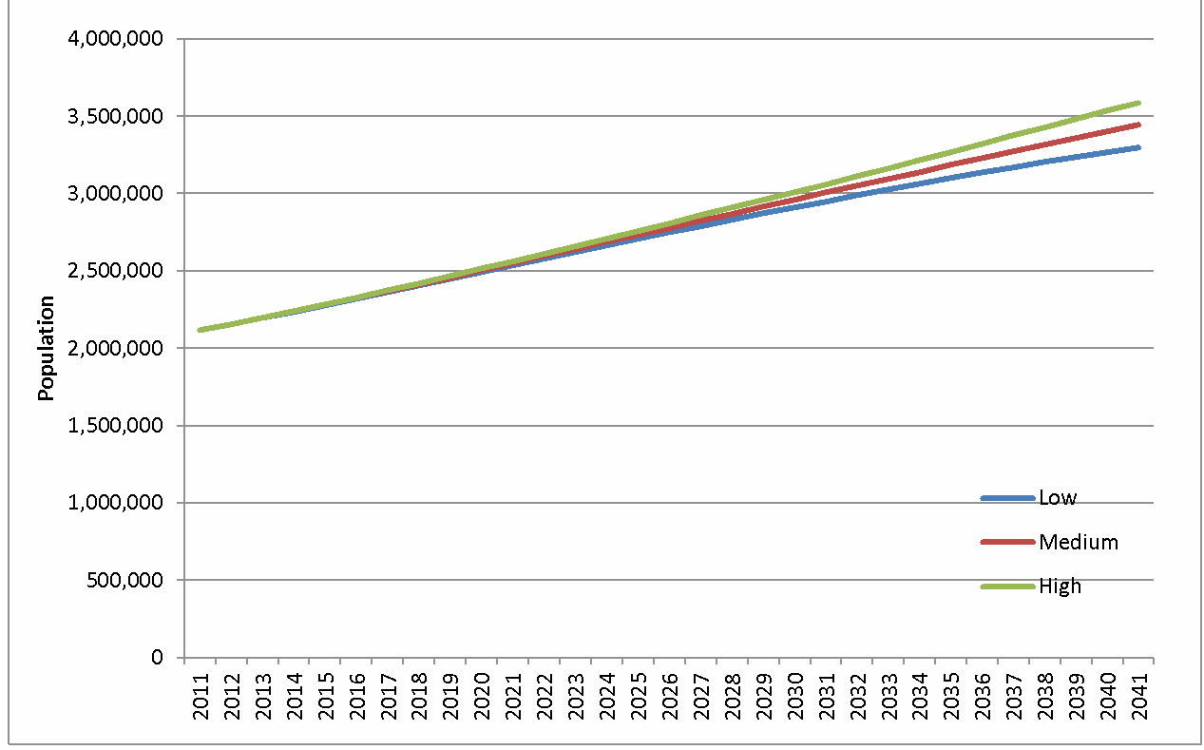
Figure 8 Namibia projected population 2011-2041 (Source: Namibia Statistics Agency, 2014)

As a result, the share of the population under 15 years old is expected to decline slightly from 36.4 to 33.7 percent. In contrast the proportion of the population at older ages (65+) is expected to remain fixed at about 4.5 percent (Namibia Statistics Agency, 2014) (see Figures 9 and 10).

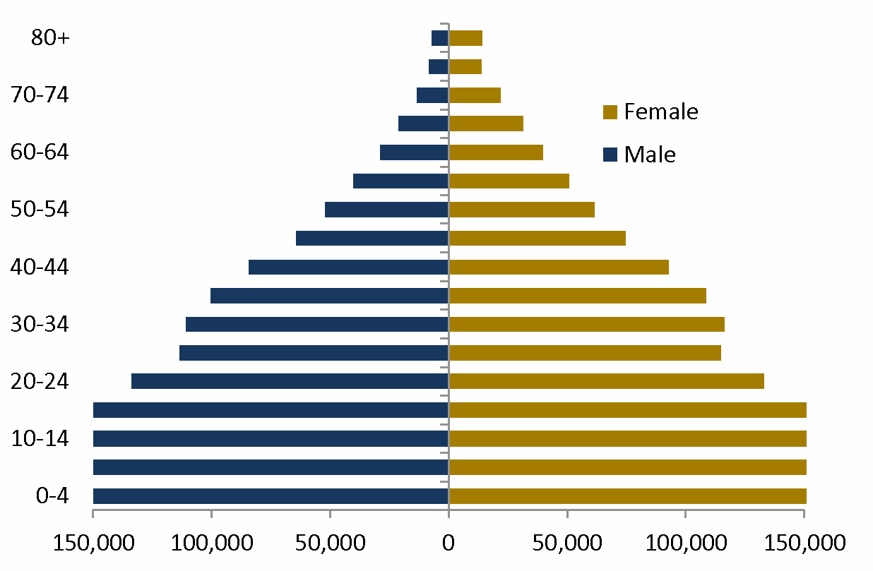
Figure 9 Population Pyramid Namibia 2030
Figure 10 Population Pyramid Namibia 2015
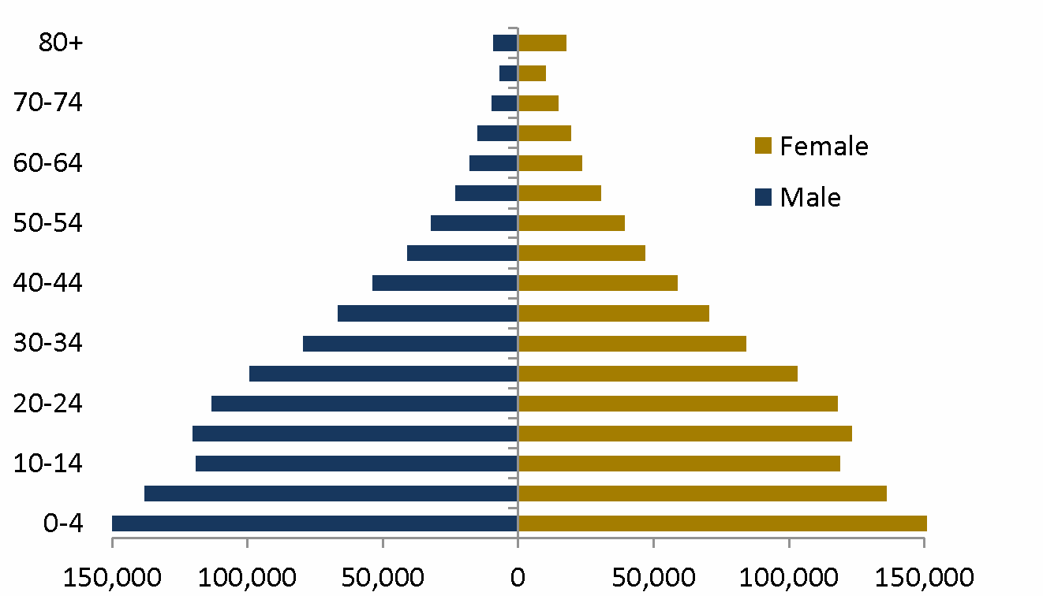

Marginalised communities are two percent of the population (42,261 individuals) and disabled persons are five percent of the population. Females make the higher proportion of the population with 100 females to 94 males (Namibia Population and Housing Census 2011) and youth aged 16-35 is 33 percent of the population. A trend considered attributable to the historical trend of male labour migration. There are a significant number of Indigenous people in Namibia who make up about 8 percent of the total population, reside in different regions and suffer many deprivations including lack of access to education, health, land and opportunities to develop their livelihoods.

Youth
The Namibia Population and Housing Census 2011 indicates that Namibia has a relatively young population with 66 percent of the population is below the age of 30 years. Young people below the age of 25 makes up 58 percent and adolescents (10-24 years) constitute 33 percent of the total population. Hence adolescents and youth in Namibia will continue to be the largest proportion of the total population. This growing number of young people represents a golden opportunity for economic growth and social progress which could reduce poverty, but this demographic dividend will only be realised if the right investments are made at the right time for Namibia.

Human Capital
The demographic profile of Namibia is changing, from one dominated by children to one dominated by working age adults. Establishing quality human capital is therefore both a challenge and a priority. The NDP5 acknowledges this as a priority but stresses that a demographic dividend is not automatic, and these opportunities within the changing demographic of Namibia require “investment in the development of young people by ensuring that the resulting surplus labour force is well educated, skilled, healthy, and economically engaged” (Republic of Namibia, 2016). Having quality human capital is seen as crucial to being able to optimize productivity and associated socio economic benefits that can be drawn from demographic transition. The Namibia National Human Resource Plan 2010-2025 provides an outlook of demand (economy) and supply (population) confirming that the current demand surpasses supply and will continue to do so against current population trends. The NDP5 therefore focuses on the development of skills required for a competitive economy.

Rural and urban
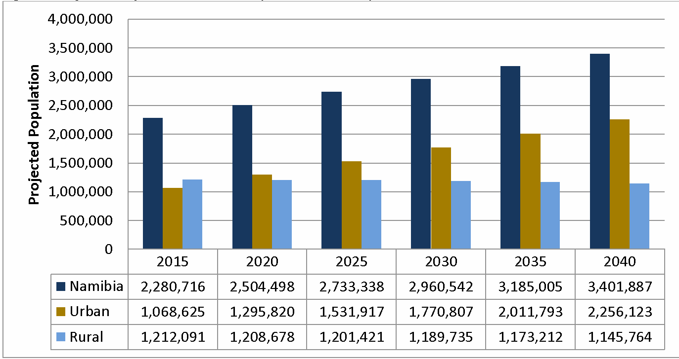
Namibia’s territory is predominantly rural with 57.9 percent of the population living in rural areas, which constitute 82 percent of the country’s total surface area, however as a result of anticipated continued rural urban migration the share of the population living in urban areas is set to increase to 67 percent by 2040 (see Figure 11 ). This indicates a trend where over the interval from 2011 to 2041 the urban population is expected to more than double while the rural population will gradually shrink (Namibia Statistics Agency, 2014). Namibia will therefore transit from being a mostly rural society to a mostly urban one, and will require development responses to address issues of inequality, unemployment, urban poverty, and housing already prevalent.
Figure 11 Projected population for Namibia, urban and rural, 2015-2040 (Namibia Statistics Agency, 2014)

Sub-regions
Of the total population in Namibia 21 percent are in the Kavango region. There are projected shifts in populations, for example the populations of Khomas and Erongo are projected to increase the most, whereby over a third of Namibia’s population is projected to live in these two regions by 2041 (see Figure 12), up from under a quarter in 2011, requiring development of infrastructure, markets and services to meet the demands of this shifting population (Namibia Statistics Agency, 2014). Khomas alone is projected to experience a population change from just over 300,000 in 2011 to just over 800,000 people by 2041.
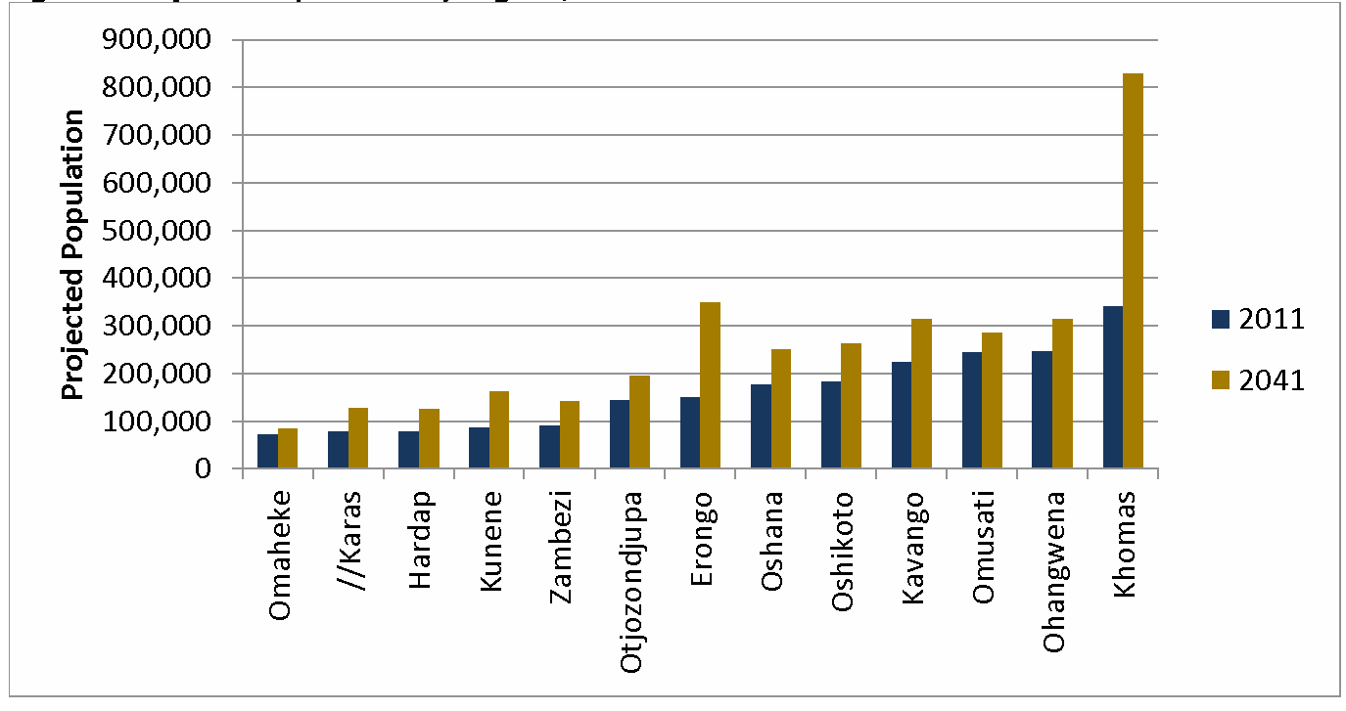
Figure 12 Projected Populations by Regions, 2011 and 2041 (Namibia Statistics Agency, 2014)
Migration
The country faces significant cross-border and internal migration (see IOM, 2016). It is important that migration into, within and out of Namibia is adequately managed. Data in this regard is either not available or insufficient, as noted in the Migration Profile of Namibia (IOM, 2006), nevertheless there are indications of cross-border movement for family reasons, economic opportunities and potential employment, better living conditions and access to services. Cross-border health implications need to be better explored. Likewise, information on emigration is inadequate and the contribution of remittances flow to the national economy should be further analysed. Internal, rural-urban, migration is a growing phenomenon as already noted, and cuts across age groups. Thirty-six percent of children under 15 are not living with their biological parents, whereas for 29% of this group both parents are alive (DHS 2013).

Health

Namibia has improved health in a number of areas but serious challenges remain. Public spending on health is relatively large and the state is the main provider of health care services through the Ministry of Health and Social Services (MHSS) with a private health sector running in parallel. The government health system is funded through general taxation and reaches 85 percent of Namibians whereas the private system is funded largely through employee and employer contributions. The total government health expenditure in 2012/2013 was close to NAD 5 billion (NAD 4,970,002,000), which was 13 percent of the total general government expenditure. During the 2014/15 financial year, the government of Namibia made the largest contribution to health spending by contributing 64 percent of the total budget, which represents an increase from 54 percent in 2012/13. The substantial GRN contribution to health spending comprises 13 percent of the government’s total spending, which is close to the Abuja target of 15 percent. Health spending as a percentage of GDP increased steadily from 2001/02 to 2005/06 from 7 percent to 9 percent, dropped back to 7 percent in 2007/08 and 2008/09, and then increased again to its peak of 9 percent, which remained consistent in both 2012/13 and 2014/15. User fees apply in public health facilities but primary health care is subsidized to ensure access, however this still serves as a barrier to the poor gaining access to health services (World Bank, 2017b) and the development of pro poor policies to ensure access to health services by the poorest and most vulnerable in the community are therefore still needed.

Communicable disease such as HIV/AIDS, tuberculosis (TB) and malaria continue to pose significant public health risks in the country. The country experiences repeated disease outbreaks such as malaria, measles, Crimean Congo Hemorrhagic Fever (CCHF), cholera, meningitis contributing to increased communicable diseases morbidity and mortality. For instance, two outbreaks of CCHF and massive outbreak of malaria have been registered since January 2017.

The TB notifications and estimated prevalence, incidence and mortality have been declining steadily and significantly over the past ten years. However, the rates remain some of the highest in the region. TB remains a serious health challenge and the second leading cause of death, after HIV related deaths. In Namibia, TB is one of the three most frequent reasons for attendance at an out-patient clinic and causes of hospitalisation. The current trend in TB indicators shows that TB control has improved considerably and that steps towards national and international targets are being made.
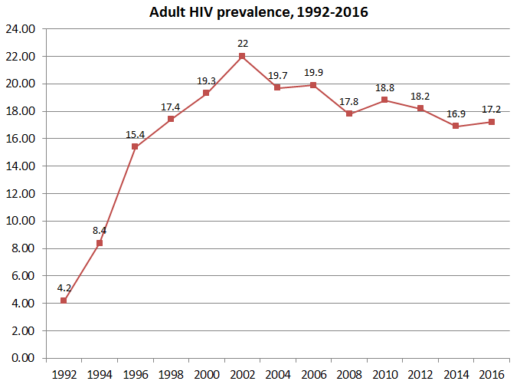
Namibia has one of the highest HIV/AIDS prevalence rates in the world. The prevalence among pregnant
Figure 13 Overall HIV prevalence among pregnant women receiving antenatal care (Source: NHSS 1992-2016)
women dropped from 22 percent in 2002 to 17.2 percent in 2016, based on the Namibian sentinel survey conducted (Figure 13). The National Prevalence is estimated by UNAIDS to be high at 14 percent among general population in 2016 (Female and Male aged 15-49) however, progress has been made with the epidemic reaching a plateau and downward trend. Namibia reached the Global Target as new infections have reduced by 50 percent since 2005, but in 2016, 9000 Namibian were newly infected meaning every day, approximately 26 Namibians are infected by HIV, primarily through heterosexual transmission (UNAIDS 2016).

In Namibia HIV prevalence is twice as high among women as opposed to men. Figure 14 illustrates that as females age HIV prevalence increases with the highest prevalence observed in 20-24-year-old at 9.3 percent. Women and girls, and poor women specifically are particularly vulnerable to HIV infection due to gender inequality and gender based violence. Women’s economic marginalization forces them to depend on men, increasing the likelihood of involvement in “transactional and inter-generational sex, both key drivers of the epidemic” (UN, 2013). Eighteen percent of pregnant women have tested HIV positive, and indirect causes of maternal mortality are related to high HIV/AIDS prevalence. Programmes have been implemented to alleviate the epidemic, namely the Prevention of Mother to Child Transmission and Anti-Retroviral Therapy programmes, which achieve high levels of coverage and impact (UN, 2013).

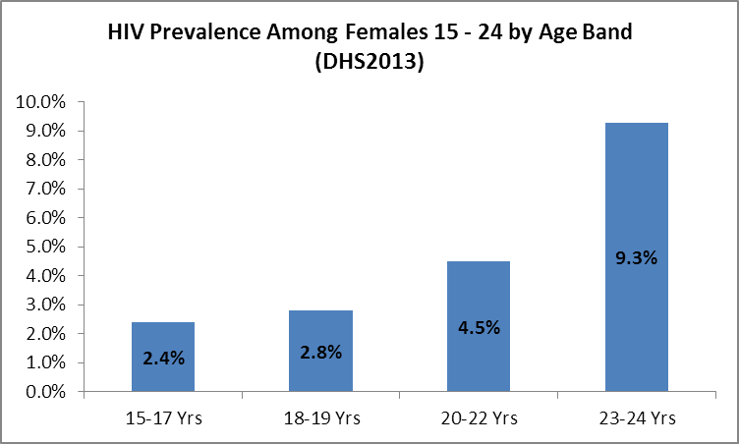
Figure 14 HIV prevalence amongst females aged 15-24 (Source: DHS 2013)
With 43 percent of new infections are occurring among young people aged 15-29, the vulnerability of this group is very concerning in the context of Namibia. Additionally, geographical variations indicate that prevalence rates in Katima Mulilo are extremely high at 19.2 percent. The remaining regional prevalence ranges from 5.9 percent to 2.2 percent in Kunene region. By region, Zambezi has the highest HIV prevalence amongst young people standing at 16.3 percent, followed by Erongo and Otjozondjupa at 4.1 percent and 3.8 percent, respectively. The HIV prevalence among young women is about twice as high as that among young men in Kavango and Oshikoto and nearly six times as high in Oshana.

Regarding treatment, access to Anti Retro Virals (ARV) for all people living with HIV has increased from 52 percent in 2013 up to 64 percent in 2016 with 95 percent of pregnant women living with HIV accessing ARV. As a consequence, mother to child transmission reduced to under 5 percent in 2016. AIDS related deaths have reduced by 56 percent since 2005 (Namibia End Review of the 2010/11-2016/17 HIV/AIDS Strategic Framework). To address sustainability domestic Funding for HIV/AIDS has increased to 64 percent in 2013/2014 (Namibia National AIDS Spending Assessment [NASA] 2012/13-2013/14).

The new National Strategic Framework for HIV and AIDS 2017/18-2022/23 sets ambitious targets linked with the 2016 United Nations General Assembly Political Declaration for Ending AIDS by 2030 and prioritises the roll out of prevention, testing and treatment for all people living with HIV which started in January 2017.

Sustaining the HIV national response is hindered, however, by weak institutions and the weak functioning of multi sectoral coordination mechanisms within the MHSS, and among civil society organisations, private sector and development partners. In addition, the implementation of strong legislative frameworks and policies that address stigma and discrimination against people living with HIV/AIDS is still needed (Legal Environment Assessment on HIV/AIDS 2016).

Namibia has been on track to eliminate malaria and has exceeded targets set within the 2000 Abuja Declaration cutting malaria deaths in half by 2010, with malaria cases falling from 80,000 in 2005 to 16,000 in 2011, and malaria deaths falling from 1,700 in 2001 to 36 in 2011 (World Bank, 2013). However, these statistics have more recently reversed with an increase in cases every year since 2013. Infant mortality and child mortality have declined over time with infant mortality declining from 57 per 1 000 live births registered in 1992 to 39 per 1 000 live births in 2013 (while registering an increase between 2000 and 2006 – primarily due to mother-to-child transmission of HIV). Under-five mortality decreased from 83 per 1000 live births in 1992, to 62 in 2000 and increased to 69 per 1 000 live births in 2006/7, but then decreased again to 54 per 1000 live births in 13 (NPC & UN, MDG Report 2015, DHS 2013).

Less progress has been realised in improving the maternal mortality rate, which increased since 2000 and as of 2013, 385 deaths per 100,000 live births have been registered. This significant change may in part be attributable to trends of greater access to health facilities coupled with the increased reporting in health facilities and health systems that may otherwise not have been reported in the past. Neonatal mortality is also high, with 20 deaths per 1,000 live births and accounting for 35 percent of under 5 mortality. The underlying causes of maternal and neonatal deaths vary and include the lack of skilled health personnel, long distances, and delays in seeking care, and low quality of maternity services. Hospitals expected to provide Comprehensive Emergency Obstetric and Newborn Care (CEmONC) services are present in every district in Namibia. Based on the current population of 2.3 million, Namibia requires a minimum of 25 functional EmONC facilities, five CEmONC and 20 BEmONC facilities are evenly distributed at sub-national level and provide quality services. In 2016 the Emergency Obstetric and Neonatal Care (EmONC) assessment showed that only 17 percent (six) of the 35 hospitals were fully functioning comprehensive EmONC facilities, while none of the 88 health centres and clinics designated to be BEmONC facilities, provided all the required BEmONC functions.

The main policies governing maternal and newborn health in Namibia are the National Policy on Sexual, Reproductive and Child Health 2013 and the National Policy on Infant and Young Child Feeding 2007. These policies are contingent on skilled health workers ablility to provide quality essential services, which remains a challenge, so much so the MHSS has stated there is a general crisis in human resources for health in the public sector, with human and other resources insufficient and unevenly distributed (MHSS, 2008). A national assessment of maternal and new born care services in 2006 informed the development of the National Plan and Roadmap for Accelerating the Reduction of Maternal and Newborn Mortality (2009-2014), with the purpose of guiding government and partners in achieving universal access to comprehensive quality maternal and neonatal health care. Review of Maternal, Newborn, Child and Adolescent Health and Nutrition Programmes, carried out in 2015 revealed that key gaps and challenges exist in service delivery particularly in terms of quality of care, human resources and shortage of some life-saving commodities. The Roadmap Review Report (2015) and the EmONC Assessment Report (2016) will inform the development of the upcoming strategy for women, children and adolescent health. Similarly, the Expanded Programme on Immunization (EPI) with the support of several partners, conducted a review focusing on all aspects of immunization such as logistics and surveillance. The outcome of this review was used to develop the strategic plan for EPI 2018-2022.

Namibian society in general desires large families and the median period between births is 42.3 months. High fertility rates are prevalent in some regions but are reducing overall. Focus therefore remains on the spacing of births, and reduction of teen childbearing. The national rate of adolescent pregnancy is 19 percent (DHS2013) however, regional data shows disparities. The highest teenage pregnancy rates are observed in Kunene (38.9 percent), Omaheke (36.3 percent) and Zambezi (28.1 percent) regions. Teenage pregnancy is more than three times higher among young women in the lowest wealth quintile than among those in the highest wealth quintile. Teenage pregnancy has a negative cascade effect on a woman’s health, her chances to complete education, and access to employment as well as her children’s well-being. Evidence shows that girls who marry early often abandon formal education and become pregnant. In Namibia, despite policies to allow them to continue with school, teenage mothers find it difficult to complete school. Girls from poor households are far more likely to have less education, less access to reproductive health information and services, and to marry young (UNFPA, 2016).

Non-communicable diseases (NCD) are estimated to account for about two thirds of all years lived with disability in low and middle-income countries and Namibia is witnessing an increasing burden of NCDs. Cardio-Vascular Diseases (CVD are the most common NCD in Namibia accounting for 21 percent of mortality in 2012. High Blood Pressure rates range from 57 percent in the Khomas Region to 30 percent in the Kavango Region (NDHS, 2013). Diabetes accounted for 4 percent of all mortality in Namibia in 2012. Injuries contribute significantly to mortality and morbidity in Namibia contributing to 10 percent of mortality in 2012. Deaths from self-harm, road injuries, and interpersonal violence peak in males aged 20-24 and collectively account for almost 50 percent of all deaths in this age group. Increasingly, mental, neurological and substance abuse disorders are of concern as are increasing overweight and obesity rates. Obesity is also emerging as a health challenge in urban and peri-urban areas and associated with NCDs that are some of the leading causes of death in Namibia. The risk factors contributing to NCDs are preventable and require systematic, well-coordinated and evidence based communication and health promotion programs.

Obtaining positive health outcomes requires ongoing improvements in health service delivery, cross sectoral collaboration around priorities such as nutrition, and strengthened capacity to ensure a well performing primary health care system (World Bank, 2013). In addition to a lack of funding for the implementation of the health strategic plan, other causes that are primary causes of poor performance of the health sector are a lack of organisational structures, overlapping of mandates between Directorates of the MHSS, lack of a strong Health Information System, and the lack of a performing procurement system leading to many vaccines and drugs being out of stock, and weak coordination of vertical programmes for service delivery. In addition, there are issues in recruiting, training and retaining professional staff in the health sector.

Food Security and Nutrition

The GRN is fully committed to ending hunger and supports the Zero Hunger initiative. Zero hunger stands as one of the priorities in all key development documents thus recognising the importance of food and nutrition security.

A number of interrelated factors contribute to the limited access to food for some parts of the population. Poverty, income inequality, high unemployment rates, high food prices and high HIV prevalence are major factors limiting access to food (MHSS, 2015). Food insecurity affects 28 percent of the population with lowest earners spending 57 percent of their income on food (Zero Hunger Strategic Review 2016). As a result of structural food deficits, Namibia relies on food imports which are susceptible to price and currency fluctuations for up to 60 percent of needs (Emongor and Kirsten, 2008).

Despite the national commitment to gender equality women experience higher levels of food insecurity and remain more disempowered and excluded than men with regard to accessing resources and technologies that may reduce food insecurity. Food insecurity affects smallholder farmers who depend on rain fed agriculture because their resilience to weather-related shocks is limited; food shortages affected 76 percent of rural agricultural households in 2013 (Census of Agriculture Report 2013/14).

It is anticipated that the agriculture sector in Namibia needs to grow by four percent a year to meet the food requirements for the growing population, including the poor. Farmers practice rain-fed (dry land crop production) crops with pearl millet, sorghum and maize as the most dominant crops grown in Namibia. The average yield for these crops is very low. The livestock industry accounts for about 90 percent of all agricultural production. Due to the arid climate, low rainfall, persistent droughts and increasing heats and temperatures, crop production is limited and likely to be facing risks. Further reduction in yields will have devastating impacts on food security at both national and household levels under the current conditions and could be higher with the risks posed by climate change.

Most smallholder and subsistence farmers live in communal areas where access to land and water is challenging. Of all smallholder producers, 54 percent are women with 45 percent of communal areas registered under women. In addition, three-quarters of agricultural labourers are women. According to the Census of Agriculture Report 2013/14, production of food and livestock in communal areas has remained significantly low, mainly as a result of limited access to modern farming technologies and practices, poor soil fertility, over-grazing and prolonged dry spells.

Food assistance, remittances and social grants are an important part of people’s coping strategies and sometimes account for a significant proportion of their income. The annual need for emergency food relief has increased as a result of droughts, and in 2015/16 the GRN supported 595,000 people, 13 – 28 percent of the population with emergency food relief (OPM, 2015/16).

Child Malnutrition
The nutritional condition of children in Namibia is poor with almost 24 percent of children stunted, 48 percent of children with iron deficiency anaemia and 13 percent of low birth weight, indicating the significant poor nutrition of pregnant women. Both stunting and low birth weight impact the overall long term human development capacity of the population and other elements of the lifecycle. Inequality is extremely apparent when it comes to child nutrition whereby children living in rural areas are twice more likely to be stunted than their urban counterparts. Children from the poorest households are three time more likely to be stunted than children from the wealthiest households. The ongoing drought and weak currency has resulted in rising food prices, which has further exacerbated malnutrition in areas that are already vulnerable (UNICEF, 2016).

The 2013 Demographic and Health Survey (DHS) report reveals that 24 percent of children below the age of five are stunted with eight percent severely stunted. Stunting has permanent consequences for cognitive development of children. Failure to address the issue of malnutrition has direct adverse effects on Namibia’s human capital. For example, chronic malnutrition (caused by factors such as maternal malnutrition, access to MNCH services, insufficient practice of breastfeeding, food insufficiency, unsafe water supplies, lack of required micro-nutrients, etc.) leads to health problems and disability.

Gaps and Challenges
There are several gaps and challenges linked to food security in the country. The Zero Hunger Strategic Review, conducted in 2015, identified five key challenges.

- Lack of coherent policy: The legal and policy frameworks are sufficient enough to aid Namibia’s development agenda, but coherence among sectors managed by different government agencies is a major issue. There is a need for cross-sector and inter-sector synergies and coherence to be created, together with a national system to monitor and evaluate the implementation of policies.

- Capacity constraints: Institutional and human resource capacity for policy and programme design and implementation are limited. The implementation of food security programmes is affected by challenges impacting prioritization and gaps in technical and managerial capacities in government bodies at the national and regional levels.

- Weak evidence: Weakness in monitoring, research and evidence collation create challenges for good programming, and it is difficult to quantify the interactions among food and nutrition insecurity, poverty and HIV/AIDS. There is no food and nutrition security baseline by which to measure progress in addressing hunger. The limited information on food consumption patterns, overall and by population group, and fragmented data collection mechanisms among sectors and ministries, make it difficult to obtain a comprehensive outlook of the food and nutrition security situation to inform programme design, policy and timely government response.

- Fragmented social programmes (See section on Social Protection).

- Weak coordination: Poor coordination among ministries, sectors, agencies and public and private organizations limits progress towards zero hunger in Namibia. Communication among sectors and institutions is inadequate, and there is no momentum to reinforce such linkages. Enhancement of coordination of programme and policy implementation at the national and sub-national levels to address food and nutrition insecurity is needed.

Education

The Namibian Constitution guarantees the right to a free and compulsory education for 10 years (until the age of 16). Increased access to education is a government priority and the education sector has been the highest recipient of national budget since the country’s independence in 1990. Education expenditure increased from 22.1 percent of total government expenditure in 2007/08 to 24.7 percent in 2012/13. As a percentage of GDP, it increased from 6.0 percent in 2007/08 to 9.2 percent in 2014/15 (Bank of Namibia, 2016). Amongst the goals of the Ministry of Education, Arts and Culture (MEAC) is the goal to improve access to quality inclusive education and to promote lifelong learning. To address the inequities in education and to ensure that all learners benefit equally, universal primary education and universal secondary education were introduced in 2013 and 2016, respectively.

However, despite receiving the highest budgetary allocations, education outcomes do not reflect this investment, and continue to remain below expectations (see Figure 15). Many children drop out of school early. One factor which contributes to this is the high level of repetition found in much of the school system, despite a policy which limits repetition to one grade per phase, i.e. twice in primary school and once in junior secondary school. School dropout affects remote communities in particular (also known as Category 1 schools). This also contributes to poor completion rates (see Figure 15) which shows that learners living in relatively urban areas are more than three times as likely to have completed secondary education compared to their counterparts living in the remote areas. Only about 1 percent of learners in Category 1 schools make it to Grade 12 (MEAC and UNICEF, 2015).

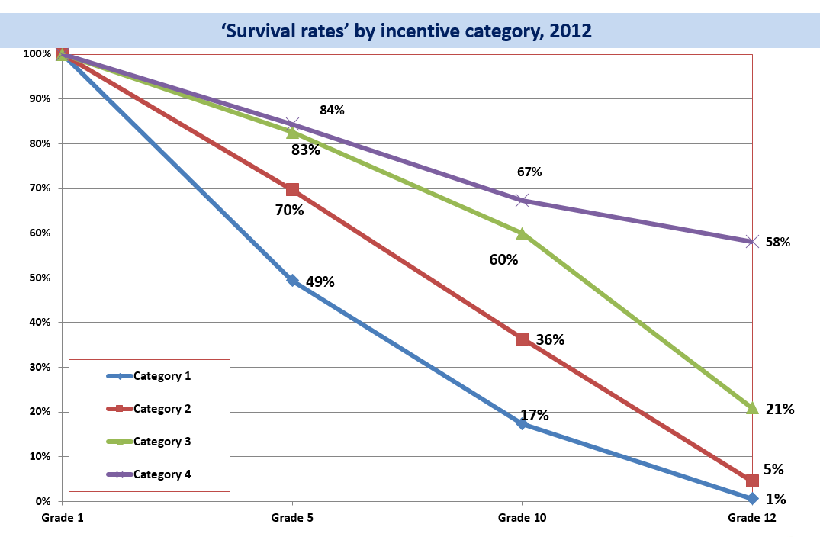
Figure 15 Survival rates by incentive category, 2012 (Source MEAC 2015)
According to the Education Management Information System (EMIS) 2012 report, a total of 1431 learners dropped out of school due to pregnancy. Of these, 1406 were girls and 25 were boys. Kavango region reported a total of 326 learners who dropped out of school due to pregnancy. Ohangwena region recorded 257, Omusati region with 178, Oshikoto region with 168 and Oshana region with 121. Kunene region recorded a total of 60 drop outs due to pregnancy. The 2013 Situation Analysis of Children and Adolescents in Namibia reported that adolescent girls remain at very high risk of violence, exploitation and persistent harmful traditional and cultural practices with numerous unreported cases. One in three adolescent girls aged 15-19 have experienced physical or sexual violence putting them at risk of unintended pregnancies and HIV infections. To counteract this, the Ministry of Education, Arts and Culture instituted the Sector Policy for the Prevention and Management of Learner Pregnancy, which is progressive and rights-based, however the understanding and adherence to this policy remains limited in the regions. In addition, MoEAC has formed a National Out-of-School Children (OOSC) Youth Task Force the purpose of which is to operationalise the MoEAC’s action plan to tackle the OOSC problem in the country.

Government investment in education has resulted in progress in improving primary enrolment rates and adult literacy rates, which is currently at 90 percent. However, there are overall, skewed results by region and areas as well as poor quality education outcomes which have not yet led to a skilled workforce that could support a diversified economy. Youth are not leaving school prepared for the labour force and employers are citing low availability of adequately trained workers and skills mismatch as constraints (World Bank, 2013). Technical, Vocational Education and Training (TVET) is fragmented between different types of providers and does not constitute a comprehensive and consistent network. The system has poor linkages with basic education, with higher education, and between its own components. Key issues arise regarding quantity, quality and relevance of the TVET system producing small numbers of adequately skilled workers.

The TVET system is not able to adequately respond to the demand from a large and growing youth population, and largely excludes people who did not complete basic education. Lifelong learning opportunities exist but need to be scaled up. Many trainees lack foundation skills and face precarious living conditions, which hampers their ability to learn. Initial qualifications and training of trainers appear inadequate. The equipment of training centres is sometimes deficient and outdated.

While Namibia has made great strides in terms of ensuring access to primary education, access to early childhood development (ECD) services and pre-primary education remains low despite the strong evidence on the impact of ECD on reducing poverty and enhancing lifelong learning and an increased quality of life. It is during the early years of life that the most critical neurological development takes place, with the most significant brain growth occurring in the first three years of life. According to the 2011 Population and Housing Census, less than 20% of children aged 0-4 years attend an ECD or pre-primary class with only 37,789 children between the ages of 0 and 4 years were enrolled in ECD programmes. Out of a total number of 707,878 learners in Namibian schools in 2016, only 37,298 were pre-primary learners, representing only 5% of that population (15th School day Report 2016). Therefore, ECD becomes crucial in terms of health and nutrition, child care and protection and early learning.

While Namibia is signatory to the Convention on the Rights of the Child and the Convention on the Rights of Persons with Disabilities, access to ECD and education remains a challenge to children and learners with disabilities. According to the Namibia 2011 Census Disability Report (2016), 87 percent of children with disabilities between the ages of 0-4 years have never attended ECD programmes. The proportion of persons with disabilities aged 5 years and above that never attended school is higher in rural (82.1 percent) than in urban areas (17.9 percent).

Namibia’s higher education system is still relatively new. The country has only two public universities and one private university, besides other private higher education institutions. Enrolment has grown exponentially since the late 2000s, to almost 44,000 in 2013. As a consequence, Namibia’s gross enrolment ratio in tertiary education (19.0 percent in 2013) is high by sub-Saharan African standards (8.2 per cent for the region in 2013). Yet admission criteria exclude a large share of applicants, although public universities have established bridging programmes to facilitate access by young people from disadvantaged background or with previous work experience.

Sanitation

Standing at 34 percent, Namibia has the lowest levels of sanitation coverage in Southern Africa and almost half of all Namibians practice open defecation. Access to proper sanitation facilities varies greatly between rural and urban areas. 49 percent of the households in urban areas have improved toilet facilities, while in the rural areas only 17 percent have access to such facilities.

There is another challenge to sanitation in urban areas, which is the existence of informal settlements. In 2014, the report from the City of Windhoek indicated that 350,000 people that represent 30 percent of the population of Windhoek are living in informal settlements and only 19 percent of them have access to proper toilets. 87 percent of households use an improved source of drinking water. This proportion varies greatly between rural area (76 percent) and urban area (97 percent), and across regions

Being prone to both droughts and floods, risks associated with water borne diseases and sanitation are increased, especially in the areas with no sanitation facilities.

Based on the Annual Education Census (EMIS, 2012), 20 percent of schools did not have sanitation facilities and 16 percent of schools did not have water for hand washing, over 28 percent of schools had to use toilet facilities that were not separated from those of the boys and 53 percent of schools made no provision for girls in relation to menstruation. This is particularly disadvantageous for girls who then may not attend school during their menstrual period. These issues are compounded by a lack of coordination at the government level. “Unlike water supply, sanitation falls under several ministries which has resulted in fragmented service delivery and poor coordination” (UNICEF, 2016).

Social Protection

Namibia has one of the most comprehensive social protection systems in sub-Saharan Africa. However, the registration and targeting procedures are not efficient, monitoring needs strengthening as well as beneficiary selection, which leads to exclusion and inclusion errors. This inefficiency continues to contribute to high administrative and delivery costs and limits scalability and overall, the social protection as a sector could be better coordinated and with stronger and more uniform policy guidance.

Social assistance schemes include grants for the elderly, for people with disabilities, child grants and other forms of indirect support such as school fees exceptions (MPESW, 2016). However as long as all vulnerable people are not properly registered and accounted for (almost 17 percent of children in the lowest wealth quintile are not registered) the most at risk population will fall off these safety nets. Furthermore, issues of efficiency and duplication of grants have been raised and acknowledge in the MPESW’s Blueprint, indicating the need to establish an integrated and coherent database based on a proper mapping of vulnerabilities. This database needs to be grounded in the e-National Population Registry System, the country’s civil registration system, to ensure social protection targeting is based on accurate ID and civil registration data. There are also human resource constraints, particularly when there is an onerous means test on eligibility for support. Large discrepancies in the value between Old Age Pension, Veterans Grants and child grants, limit their impact on poverty reduction in particular for the child grants, which are too low to meet the basic needs of children. There is scope for improvement towards reaching a Social Protection Floor with regards to expanding the coverage of social protection systems which are particularly important for economies with growing informal sector. There is also a need for innovations in social protection service delivery, ensuring access to social assistance is connected to access to other social services in order to maximize poverty reduction impact for the most vulnerable.

Land and urban planning

Years of colonial dominance and apartheid has resulted in dispossession of land and unequal distribution of this fundamental asset. At independence nearly all commercial land in Namibia was owned by a white minority constituting less than 0.5 percent of the population, whilst 70 percent of the population lived on what is now classified as communal land. 47 percent of Namibia’s total land mass is used for agricultural purposes, 43 percent is protected areas and 8 percent in forested. The National Land Policy (NLP) of 1998 laid the foundation for land ownership and reform, based on a unity land system on both communal and commercial agricultural land. The NLP established basic principles for governance of all land in Namibia, with a strong emphasis on protecting the rights of the poor and women and promoting transparency and accountability in land administration. Namibia is one of the only countries in the world to include habitat conservation in its Constitution (Art. 95) allowing for the creation of nature conservancies on commercial or communal land and grants the owner, the right to profit from wildlife and tourism activities in the area (World Resources Institute).

The HPP acknowledges the fundamental challenge land reform represents for the economic future and stability of Namibia and the GRN, through the HPP, pledges the passing of a New Land Reform Act as well as conduct of a second Land Reform Conference which is due to take place in September 2017. Amidst persistent youth unemployment and climate change related disasters an inclusive, transparent and efficient land distribution policy is the priority, and one the second conference will target. The conference follows the post-liberation 1991 First Land Reform Conference which deliberated not to touch residential land and to embrace the ‘willing buyer willing seller’ principle to land distribution. This allegedly led to high selling prices that constrained the GRN’s capacity to acquire land and distribute it to landless Namibians. Access to serviced land also presenting as a challenge, currently curbing commercial use and affecting housing and sanitation, especially in rapidly growing city outskirts. Opportunities exist for employment intensive investments in public housing and infrastructure development for job creation.

Gender equality and empowerment

Gender equality and the empowerment of women have been the cornerstones of Namibia’s development agenda since independence in 1990. The GRN’s Vision 2030 recognises gender equality as a key “driving force” to achieve sustainable development in the country. Namibia’s gender related milestones include a gender-neutral Constitution that prohibits sex discrimination, a number of gender sensitive legislation and policies, and ratification of key international conventions and regional protocols mentioned above aimed at eliminating discrimination against women and promoting gender equality. As a direct result of government commitments to gender the literacy rate of females is 88 percent, with more girls enrolled in all levels of education than boys.

In the 2014, Gender Development Index, Namibia ranked among the top tier of countries with a high score of 0.981 (out of a possible 1.0). This strong performance is largely attributed to the share of parliamentary seats held by women; female attainment in secondary and higher education and labour market participation rates of women (Republic of Namibia, 2017)

Gender based violence
Despite these advances, disparities between women and men remain common. According to the Namibia Demographic Health Survey 2013, domestic violence is an endemic problem in Namibia and may be the most underreported form of violence all people residing in the country. The Namibia Demographic Health Survey indicates that 32 percent of ever-married women aged 15-49 have experienced physical violence within the 12 months prior to the survey; overall, 33 percent of ever-married women aged 15-49 reported ever having experienced physical, sexual, and/or emotional violence from their spouse, and 28 percent report having experienced such violence. 6 percent of women reported experiencing violence during pregnancy. 15 percent of Namibian women who have experienced violence never sought help and never told anyone about the violence.

Gender based Violence (GBV) is deeply entrenched in harmful socio-cultural norms. According to UNFPA National Gender Base Violence Baseline Study 2017, harmful traditional norms are those that undermine women’s decision-making power, contribute to women’s poor health outcomes, maternal mortality and HIV infection.

The Mid Term Review (MTR) on Gender Base Violence Plan of Action (MGECW, 2014), indicated an increase in cases of intimate partner violence. Women were the majority of victims of physical violence compared to men. In the age group of 25-39 years, more women than men were victims and survivors of physical violence. While more girls than boys are sexually abused, MGECW administrative data over the period Jan-June 2017 indicate that 8% of reported child sexual abuse cases concerned boys. For reported cases of child physical violence, child neglect and abandonment, boys and girls are equally affected as per the data. The data demonstrate that not all violence has a gender dimension, especially violence against children. Girls and women in the age group of 15- 19 and 25-39 years were victims of sexual violence more than any age group. Women in the age group of 25-39 years suffered economic violence more than men. The DHS survey (2013) shows the widespread prevalence of domestic violence, but also limited claim on GBV services. Poor quality, accessibility. Long-drawn out processes and weak coordination of services for survivors of GBV/VAC and the absence of shelter care, all have a negative impact on demand-seeking behavior. The MTR on GBV Plan of action highlighted the following strategies as recommendations: 1) Strengthen integrated services; 2) Strengthen monitoring, data and coordination 3) Mobilize and engage communities (specifically gatekeepers and men and boys) on changing harmful social norms and cultural practices that reinforces gender inequality and gender based violence.

Forced marriage
Although there is little or no research on the magnitude of harmful cultural practices, observations of communities during this study indicates that forced marriages and child/early marriages remain widespread. National Census data on child marriage shows that 2,759 children, mostly females, are in traditional marriages. Almost the same number of our children, (2,768) are in consensual unions.

The greatest number of cases involves young women in forced marriages to older men. There are also early marriages and marriage of female foetus, that is payment of lobola before the baby girl is born. The Married Person’s Equality Act 1 of 1996 only sets a minimum age of 18 years for civil marriages. Customary law lower ages for lawful marriage. Furthermore, the payment of lobola gives some men the impression that they own their wives, and such perceptions makes them abusive to their wives.

Traditional practices such as “widow inheritance” are also prevalent in some communities. A widow may be compelled to marry a relative of the deceased husband. This practice is not a crime if the widow consents. However, in some cases, coercion and physical threats are reported. The practice of widow inheritance could have implications in the context of HIV if there is discordance in the HIV status of the widow and the new spouse. In cases where the widow is HIV positive, this may predispose the new spouse to infection. Therefore, efforts to promote women’s empowerment should ensure cultural considerations are respected while women’s rights are upheld (UNFPA National Gender Based Violence Based Violence 2017).

Lack of empowered voice
There are higher rates of women living below the poverty line at 32 percent, with 44 percent of women headed households living in poverty. Poverty among women linked to unequal access to, control over and benefit from uneven distribution of productive resources such as land, capital, skills and labour as well as limited participation in political and economic institutions (Republic of Namibia, 2017). As such, the GRN seeks to ensure that, “Namibia is safe, secure and peaceful with a high respect for the rule of law, women have been empowered and gender based violence has reduced from 33 percent in 2015 to 20 percent in 2022” (Republic of Namibia, 2017).

The challenges in achieving these outcomes have been identified in the NDP5 as:
- Absence of gender responsive measures for equitable redistribution of productive resources and absence of well-coordinated National Women Economic Empowerment Framework/Programme (NWEEF/P)
- Inadequate sex disaggregated data
- Lack of effective coordination and referral between service providers

Strategies to address gender inequality
The strategies to address these challenges have been specified by GRN as: Increased financial and human capacity of service providers; strengthened implementation of the Gender Responsive Budgeting and Planning; Mainstreaming Informal businesses into the formal economy and ensuring financial inclusion for women in MSME (agri-business, blue economy and extractive industries). In the NDP5 empowering women in business is a key strategy to addressing growth in the manufacturing sector. The plan speaks specifically about ensuring equal access for women both as workers and as entrepreneurs in the manufacturing areas supported through a National Women Economic Empowerment Framework Programme.

To further enhance gender equality, the GRN launched the revised National Gender Policy 2010-2020 in March 2012 and updated the National Gender Plan of Action, however the institutions responsible for gender mainstreaming need to be strengthened and adequately funded for the GRN to effectively implement the gender policy and action plan (Africa Development Bank, 2014). Furthermore, the government is in the initial stages of reviewing and updating the National Gender Based Violence Plan of Action 2012-2016. The main objective of this revision is to strengthen prevention and responses against gender based violence and violence against women and girls.

Environmental Dimension

Environment and Climate Change

Namibia is known to be one of the most arid countries in sub-Saharan Africa and the world. The country’s climate is influenced by two desert zones, the semi-arid Namib along the Namibia coast line, and the subtropical Kalahari stretching eastward to Botswana. Most rainfall occurs during storms in the summer months from September to February, with total annual rainfall varying from one year to the next, and within the country from 50mm along the coast to 700mm in the northern regions (UN Namibia, 2016). 81 percent of Namibia’s population is dependent on a semi-arid environment, which makes up 50 percent of the total land area (UN Namibia, 2016).

Water scarcity
Namibia suffers from extreme water scarcity and the country’s 2.3 million people are exposed to water shortages. Namibia is also exposed to high water insecurities, as the core sources are mainly from the permanently running rivers, near to or forming part of the country international boundaries, and shared with neighboring countries. The lack of readily available freshwater in the interior remains one of the greatest barriers to sustainable development efforts. Water scarcity has been compounded by increased changes in weather patterns. Historical trends of climate in Namibia reveal that there has been a consistent increase in daily maximum temperatures. Prediction from the GCM projects that some regions of the country may receive extreme rainfall events - and associated extreme flooding - while in other regions climate change may contribute to increased aridity due to the combined effect of variable rainfall and increased evaporation.

Natural Resources
There is a heavy reliance on the extraction and use of vast natural resources in Namibia, and as a result the GRN gives high priority to environmental protection. The 2018-2021 NDP5 highlights that Namibia has distinguished itself as a leader in environmental protection and natural resource conservation, as the first nation in the world to incorporate environmental protection into its constitution (see Figure 16). Forty-three percent of the area of Namibia is under protection by either the state, communal conservancies or private conservancies, including a total of 18 percent under state environmental protection including 976 miles of coastline as a national park. Almost all of the world’s oldest desert, the Namib, is protected from environmental damage.
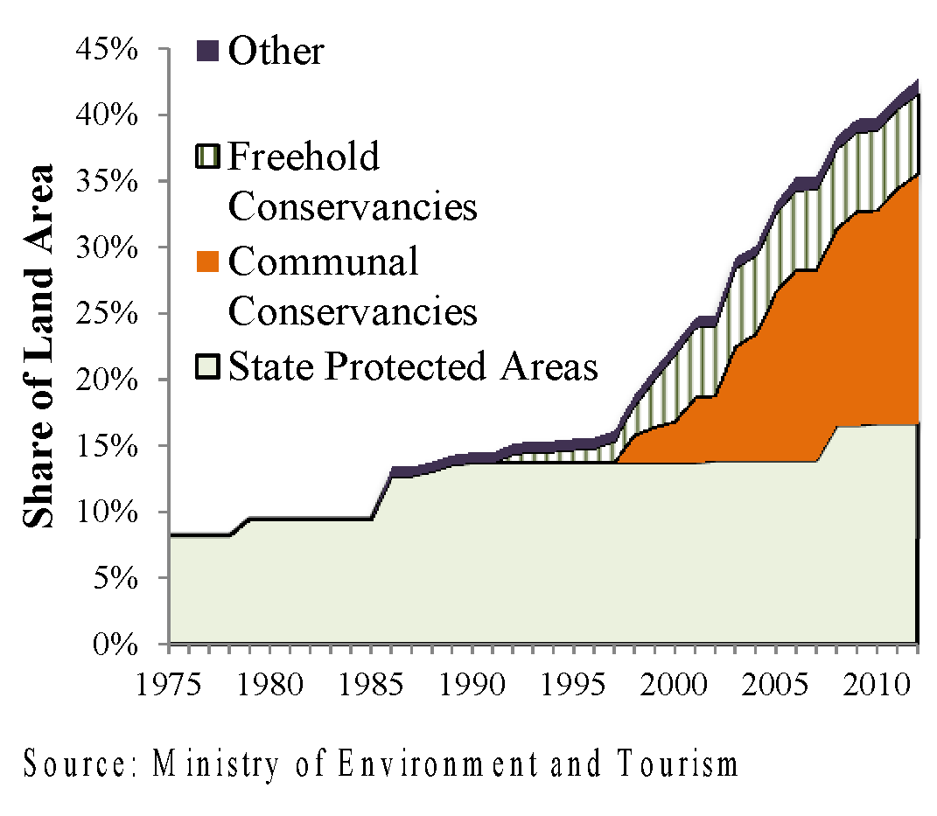
Figure 16 Share of Land Area under different status (Source: Ministry of Environment and Tourism [MET])
The country’s community based natural resource management (CBNRM) plan provides incentives to communities to manage wildlife and natural resources in sustainable ways and has led to Namibia earning “a good reputation internationally for prudent environmental management” (Africa Development Bank, 2014). The Nature Conservation Amendment Act of 1996 provided for the devolution of the rights over wildlife to the people living in communal areas is the cornerstone of community based conservancy and provides the legal and organizational foundation for conservancies to operate tourism, trophy hunting and other commercial activities or to enter into joint ventures with companies to conduct these activities. By 2013 79 conservancies existed covering 160,000 square kilometers. Total income was NAD 46.7 million. 24 tourism joint ventures contributed NAD 18.9 million and 33 trophy hunting concessions produced NAD 14.1million in fees and salaries and NAD 5.0 million in meat distribution (World Bank, 2013).

Nature based tourism
Thus, the interior parts of the country require complementary commercial growth activities. While nature-based tourism in conservancies and community forests supplements agricultural production, there are a few interconnected factors impacting socially, economically and environmentally equitable development in Namibia. As Namibia occupies a strategic location in terms of transboundary conservation, bordering biodiversity-rich areas of countries such as Botswana, Zimbabwe, Zambia and Angola, it is offering refuge for endangered species such as black rhino and cheetah. This could supplement the tourism industry, which is one of the fastest growing industries in-country, with much needed win-win sustainable solutions.

Despite that, there are still deficiencies, notably the absence of corridors and buffers to ensure spatially contiguous or clustered protection. Clusters of conservancies and community forests would enable contiguity of natural landscapes and ecosystems, reconnecting historic migration and forage routes of animal wildlife while providing for supporting economic services. The latter would also contribute to the eradication of poverty particularly in the geographically marginalised areas where human-wildlife conflict may be a constraint to economic growth.

New Integrated Management Solutions
Many of the economic and social benefits of climate and nature-based successes, as well as the threats and challenges, are outside the mainstream of strictly ‘state control and management’, as they are more in wider production landscapes. Henceforth, Namibia’s social, economic and environmental protection efforts and conservation successes are pertinent to cultivating the core principles of the SDGs in totality. The latest NBSAP confirms that biodiversity is under threat from several factors, including (1) unsustainable water uses, (2) climate change, (3) uncontrolled mining and prospecting, (4) continued population growth and increased consumption patterns, (5) unsustainable land management practices, (6) alien invasive species, (7) some poorly directed tourism and recreation activities, and (8) human-wildlife conflict. Such threats expose the country’s prosperity to major development challenges with potential to increase food, water, and energy insecurities and economic shocks because of multiple and complex interactions in nature with climate.

Considering these threats, Namibia needs to adapt the fishery, agricultural, nature, tourism, and mining practices and adopt integrated management solutions. By adjusting the behaviour and management practices in these sectors, Namibia would be securing its developmental gains from ENR. To address access to the services, such integration would need to enable reduction of vulnerabilities at all levels, which can further empower citizens to take actions and hold local, community and national systems accountable to delivery of vital services to increase their resilience.

Climate change
Namibia is considered highly vulnerable to climate change, which manifests itself in floods and droughts. Floods, drought, veldt fires and disease outbreaks, all have negative effects on communities, the economy, infrastructure and the environment. Veldt fires, in addition to uncontrolled forest fires, destroy between three to seven million hectares of land in Namibia annually, caused by lightning and people (Shigwedha, 2006). Drought has reduced agricultural production and led to rising food prices (World Bank, 2017a). All of these impacts, “undermine both commercial livestock production and traditional subsistence agriculture, with serious implications for employment, food security, and export revenue. Furthermore, Namibia’s tourism and agriculture exports are vulnerable to other countries’ climate change mitigation policies, if these take the form of taxing international transportations (World Bank, 2013:12). Although Namibia contributes a minimum amount to global greenhouse gas emissions, climate change presents Namibia with excellent opportunities to move towards low carbon and climate resilient development (Republic of Namibia, 2016).

To strengthen its climate change adaptation and mitigation measures, Namibia adopted the National Climate Change Policy in 2011 and the designated National Authority for Climate Change, under the Ministry of Environment and Tourism (MET), is operational (Africa Development Bank, 2014). To address climate change and environmental management, in the future the GRN is setting its focus on strengthening mechanisms and capacity for improved environmental protection and promoting environmentally sound investments and production systems. This would include, “Aggressively mobilizing sufficient transformational funding through multilateral financing mechanisms such as the Green Climate Fund and Global Environment Facility as well as through bilateral relationships and partnerships with the private sector” (Republic of Namibia, 2016).

To achieve sustainable development and build long-term resilience for people’s basic needs (such as water, health, food, energy) and auxiliary amenities (such as unpolluted air, better infrastructure, and clean nature), the economy would need to withstand the global universal challenges posed by climate change. Moreover, the ENR services and resources need to sufficiently sustain the economic growth that can simultaneously enable complete poverty eradication, while safeguarding long-term provisions in a socially just manner. Such complex issues will need, not only proactive preparations to adapt and mitigate the effects of climate change, but also transformational collaborative mechanisms.

Similarly, Namibia’s wide and huge landscapes require extensive backing by and partnership with international, regional and local partners, financially and otherwise. Additionally, the public, private and civil society need to collaborate and strengthen systems, institutions and individual efforts to effectively prepare the country to fight climate change.

Despite these challenges, Namibia has achieved major milestones: a) Namibia’s ratification of the United Nations Framework Convention on Climate Change (UNFCCC) in 1995; b) Namibia’s development and adoption of its National Climate Change Policy in 2010; c) Namibia’s National Climate Change Policy, Strategy and Action Plan; d) Namibia’s Comprehensive Conservation Agriculture; e) Namibia’s Integrated Resource Plan and Renewable Energy Policy of 2017; and f) Namibia’s creation of conducive environments to incorporate private sector partners in mining, fishery, tourism and renewable energy as partners for sustainable development initiatives aimed at mitigation and adaptation. These, in addition to Namibia’s Constitutional provisions, would be vital foundational pillars to build upon for the future Namibian nation, that is transformed, empowered and resilient.

Disaster Risk Management

Namibia is prone to natural disasters as well as health and humanitarian emergencies resulting from the HIV/AIDS epidemic, deepening food insecurity and the ongoing need for adequate socials services by the state. Natural disasters such as floods, drought and desertification are negatively affecting human development, with resources for human development priorities being consistently diverted to disaster response, delaying developmental programmes (UN Namibia, 2016). Poverty is a major contributor to increased vulnerability to disaster and there are disparities in levels of poverty, economic hardship, institutions and infrastructure development throughout the country especially between the urban and rural areas, which impact the resilience of communities and the sustainability of development outcomes in the face of humanitarian emergency.

Poverty is a major contributor to increased vulnerability to disaster and there are disparities in levels of poverty, economic hardship, institutions and infrastructure development throughout the country especially between the urban and rural areas, which impact the resilience of communities and the sustainability of development outcomes in the face of humanitarian emergency.

In order to address the challenges emanating from disaster and climate risk the Government of Namibia has established the National Disaster Risk Management System (NDRMS), founded on the Disaster Risk Management Act (2012), the National Disaster Risk Management Plan (2011) and the National Disaster Risk Management Policy (2009), and coordinated by the National Disaster Risk Management Committee (NDRMC), which is placed under the authority of the Prime Minister. The system is a means to move from disaster response to comprehensive DRM that takes account of a wide range of hazards and stakeholders (GRN/UN, 2016). The NDRMS is aligned to relevant international agreements such as Hyogo Framework for Action (2005-2015), the Sendai Framework (2015-2030), the Kyoto Protocol, and the Africa Regional Strategy for Disaster Risk Reduction.
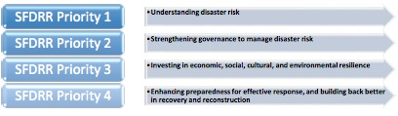
Drought in the country has been protracted whereby a state of emergency in all regions of the Republic of Namibia was declared by the President. The GRN contributed NAD 910 million in 2016 towards alleviation of drought. The committee was not convened before or after the drought emergency was declared in May 2016. Despite the legal provisions in support of the NDRMC the Capacity Assessment of the National Disaster Risk Management System in Namibia (2016), found that it is not an active decision making and oversight body and does not meet regularly. There are however relatively well functioning regional and constituency structures dedicated to DRM in Namibia’s regions. At a sector level, line ministries and technical departments have ‘DRM Focal Persons’ who take part in DRM related meetings. Not all ministries have focal persons and staff turnover is a challenge to institutionalizing roles and responsibilities and maintaining capacity (GRN/UN, 2016).
Figure 17 Sendai Framework for Disaster Risk Reduction (2015-2030) Priorities for Action

The 2016 Assessment of the NDRMS 2016 acknowledged that there was a fair understanding of the current and potential impacts of disasters (including climate change) on various sectors, particularly agriculture, environment and health. However, during the assessment, many institutions highlighted the fact that limited human, financial and technical capacities seriously hamper the effectiveness of their work as far as DRM is concerned (GRN/UN, 2016). More specifically issues of lack of data; lack of institutional capacity; lack of information exchange to support any interministerial or cross sectoral exchange; policies and strategies that don’t adequately address DRR and current institutional arrangements that lead to conflicting priorities and delays in implementation of new innovations in DRR, as well as minimal training, were all highlighted as challenges. To strengthen the humanitarian development nexus recommendations for future strengthening of national systems included: the mainstreaming of DRM; benchmarking and mapping DRM activities across sectors; training communities in alternative agricultural practices and resilience strategies for health and education facilities, for instance, as well as establishing and mobilizing coordination mechanism that share knowledge across sectors and across development actors. Recommendations to leverage UN system support for DRM included: mobilization of the DRM Task Force; training and learning in DRM concepts and good practice; enhanced regional coordination in early warning and response; post disaster inter-agency assessment; and improved advocacy for better fundraising.

Policy and Institutional Environment

Policy environment

Namibia is a constitutional multiparty democracy where elections have been declared free and fair. The South West Africa People’s Organisation (SWAPO) has dominated parliament since independence from South Africa in 1990.

Namibia ranks as ‘high’ in peacefulness as per the 2016 Global Peace Index sitting at 55 out of 163 countries, and is ranked eight out of 44 nations in sub-Saharan Africa with a high level of peace and security, equivalent in the index to Australia and Great Britain, in terms of rule of law and degree of internal and external conflict (UN Namibia, 2016, and Republic of Namibia, 2016). Namibia’s Vision 2030 specifically refers to peace calling for the nation to be a just, moral, tolerant and safe society with legislative, economic and social structures in place to eliminate marginalization and ensure peace and equity between women and men, the diverse ethnic groups and people of different ages, interests and abilities (ILO, 2010).

Namibia ranks among the top sub-Saharan African countries in good governance. President Hifikepunye Pohamba was peacefully succeeded by Hage Geingob in 2015 elections. The 2016 Ibrahim Index of African governance shows Namibia ranked five out of 54 African nations (after Mauritius, Botswana, Cape Verde, and Seychelles). Namibia is ranked as the seventh least corrupt country in sub-Saharan Africa. Namibia is considered to have a free press with a score of 77 out of 100 on the 2016 Freedom on the World Index (Republic of Namibia, 2016). Namibia is recognised as the third most transparent country in Africa and ranks 53 out of 176 countries on Transparency International’s 2016 Corruption Perception Index. In 2015, 65 percent of Namibians surveyed expressed the opinion that the government was doing badly fighting corruption, while 34 percent felt that the government was doing well (Republic of Namibia, 2016).

In efforts to improve governance Namibia has sought to reform Public Financial Management (PFM) which has resulted in transparent and inclusive fiscal budgetary processes and well controlled budget execution mechanisms, resulting in declining public sector over and under expenditure (Africa Development Bank, 2014:1). The government dedicates over 44 percent of its central government budget to anti-poverty programmes including programmes to increase human capital, basic health and food security, as well as social safety net programmes such as the disability pension, universal old age grant, grants to support 155,000 orphans and 95,000 vulnerable children, and school feeding policies (see Table 2).

Decentralisation of government functions, much needed to improve service delivery and bring decision making processes closer to the people, is still in progress in Namibia. No detailed information nor compiled analysis could be found in this regard, but indication arising from interviews with key informants highlighted the need for a consistent and coherent effort across the ministries and in support of local government bodies to further this agenda.

Table 2 Poverty oriented spending in Namibia FY10/11-2013/14 (World Bank, 2013)
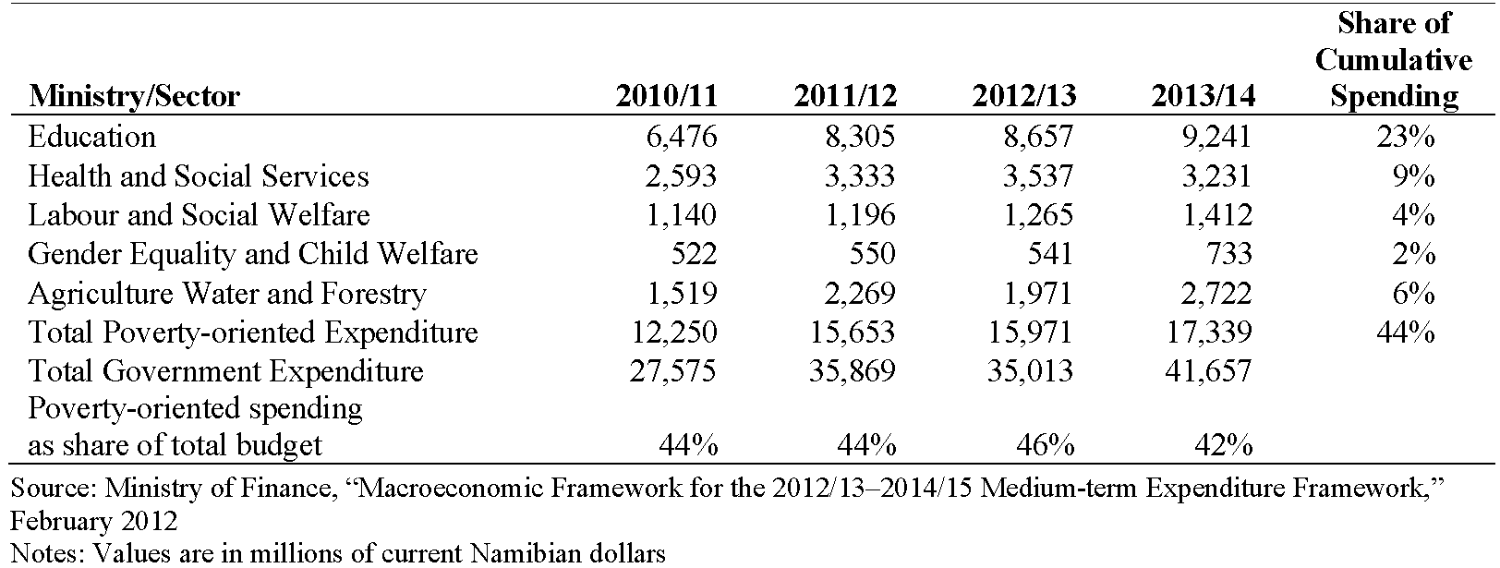

African Union Agenda 2063
The African Union Agenda 2063 has the vision of “An integrated, prosperous and peaceful Africa, driven by its own citizens, representing a dynamic force in the international arena”. It is a strategic framework for socio economic transformation of the African continent and looks to accelerate the implementation of past and existing continental initiatives for growth and sustainable development.

African Union Agenda 2063 – seven aspirations
- A prosperous Africa, based on inclusive growth and sustainable development
- An integrated continent, politically united based on the ideals of Pan Africanism and the vision of Africa Renaissance
- An Africa of good governance, democracy, respect for human rights, justice and the rule of law
- A peaceful and secure Africa
- Africa with a strong cultural identity, common heritage, values and ethics
- An Africa whose development is people driven, relying on the potential offered by people, especially its women and youth and caring for children
- Africa as a strong, united and influential global player and partner

Southern African Development Community (SADC)
The SADC’s Regional Indicative Strategic Development Plan (RISDP) is a comprehensive development and implementation framework guiding the Regional Integration agenda of the Southern African Development Community (SADC). It is designed to provide clear strategic direction in deepening integration in the region with a view to accelerate poverty eradication and the attainment of other economic and non-economic development goals. The RISDP is also complemented by the SADC Industrialisation Strategy 2015-2063; an inclusive long-term modernization and economic transformation scheme that enables substantive and sustained raising of living standards, intensifying structural change and engendering a rapid catch up of the SADC countries with industrializing and developed countries.

Vision 2030
Through its NDP5 the GRN embraces the principle of partnerships for success, a cornerstone of Namibia’s Vision 2030. GRN actively encourages the involvement of partners in from the private sector, civil society, community-based organisations and the international community in Vision 2030 (Republic of Namibia, 2017). Partnership is recognised as a major prerequisite for the achievement of dynamic, efficient and sustainable development and extends to partnership between urban and rural societies and, ultimately, between all members of the Namibian society (ILO, 2010).

Namibia’s Vision 2030 is expected to be implemented through the five-year National Development Plans (NDPs), with NDP 5 commencing in April 2017 until March 2022. Vision 2030 is expected to reduce inequalities and has an overriding objective of, “A prosperous and industralised Namibia, developed by her human resources, enjoying peace, harmony and political stability” with a supporting vision in which, “Poverty is reduced to minimum, the existing pattern of income distribution is equitable and disparity is at the minimum” (Government of the Republic of Namibia, 2004).

Namibia Vision 2030
Pillar 1 | Pillar 2 | Pillar 3 | Pillar 4 | Pillar 5 | Pillar 6
Education | Science and Technology | Health and Development | Sustainable Agriculture | Peace and Social Justice | Gender Equality

Following the 2014 elections a new ministry – the MPESW – was formed and the National Planning Commission (NPC) was elevated to the Ministry of Economic and National Policy. A ‘War on Poverty’ was declared with the introduction of the Harambee Prosperity Plan focusing on improving the quality of life of the average Namibian and transforming the economy of the nation. The current President, Dr. Hage Geingob seeks to eradicate poverty in Namibia prior to the global target of 2025.

Harambee Prosperity Plan (HPP) 2016-2020
The GRN’s Harambee Prosperity Plan (HPP) 2016-2020 was launched in April 2016 as a targeted action plan to accelerate development in areas of priority. It is aligned with the national development plan framework and focuses on ensuring the attainment of Vision 2030. The Government has prepared the HPP to ensure quick wins that support economic transformation to bridge the income inequality divide and to accelerate development via targeted measures to remove bottlenecks and implementation challenges. The plan calls for improving the administration of targeted social safety nets (GRN, 2016).

Harambee Prosperity Plan(HPP) 2016 - 2020
Pillar 1 | Pillar 2 | Pillar 3 | Pillar 4
Effective Governance | Economic Advancement | Social Progression | Infrastructure Development

Fifth National Development Plan (NDP5)
The GRN’s Fifth National Development Plan (NDP5) is established on the principles of sustainable development and partnership. The NDP5 is comprised of four pillars, which in turn have six aspirations, targeting 19 focus areas. The development of the NDP5 was more inclusive than with past NDPs, engaging different levels of government including line ministries, agencies and local government with the aim to increase ownership. Development of the NDP5 entailed a high level of participation from all sectors, including the UN system in Namibia, and included substantial focus on aligning the NDP5 with the SDGs.

Namibia National Development Plan 5 (NDP5) 2018-2022
Pillar 1 | Pillar 2 | Pillar 3 | Pillar 4
Economic Progression | Social Transformation | Environmental Sustainability | Good Governance
Sub pillar areas
Economic Development  Economic Infrastructure | Human Capital Development  Social Development | Natural Resource Use  Environmental Management | Peace  Accountability and Transparency  Service Delivery
Goals
Inclusive, Equitable and Sustainable Economic Growth | Capable and Health Human Resources | Sustainable Environment | Good Governance

International Human Rights Conventions
Namibia, as a member of the United Nations and the African Union (AU), has ratified a number of UN Human Rights Conventions and has thus made binding international commitments to adhere to the standards laid down in these universal human rights documents, as well as other international covenants including labour standards.

Namibia is a State Party to seven International Conventions and six optional protocols:
- International Convention on the Elimination of All Forms of Racial Discrimination: 1969
- International Covenant on Civil and Political Rights: 1976
- International Covenant on Economic, Social and Cultural Rights: 1976
- Convention on the Elimination of All Forms of Discrimination against Women: 1981
- Convention against Torture and Other Cruel, Inhuman or Degrading Treatment or Punishment: 1987
- Convention on the Rights of the Child: 1990
- Convention on the Rights of Persons with Disabilities: 2008

The constitution of the Republic of Namibia (1990) enshrines in chapter 3 a list of “Fundamental Human Rights and Freedoms”. However, the Bill of Rights includes mainly civil and political rights. Economic, social and cultural rights are referred to in Chapter 11 of “Principles of State Policy” (Art. 95) and are not justiciable (UN, 2012). “Nonetheless, as a State to the core United Nations Human Rights treaties, Namibia is under the obligation to ensure the realization of several economic social and cultural rights for all Namibians, without discrimination of any kind” (UN, 2013). In addition, Namibia has adopted a legal framework for the protection of rights, but there are gaps in between laws and practices affecting implementation and monitoring which affects the realization of several economic social and cultural rights by all Namibians. International treaties automatically become law upon signature and require capacity to ensure their implementation, monitoring and review. Where policies exist in response to the responsibilities of duty bearers, weak implementation is often linked to underdeveloped civil society, limited technical expertise in the normative responsibilities of the state, including gaps in monitoring and evaluation systems, issues that also impact on national capacity to report against SDG attainment and national development targets.

Vision 2030 and NDP5 acknowledge the State’s commitment to uphold the constitution, good governance and strengthening of human rights. The challenges to implementation of these strategies are considered to be at least partly due to the absence of time bound milestones, effective accountability and monitoring mechanisms, and a substantial skills gap in service provision that affects the enjoyment of rights such as education, health, housing and land reform and social protection strategies. In addition, the structures to facilitate the participation of people living in poverty in decision-making processes to monitor the implementation of public policies and programmes is lacking (UN, 2013).

The Universal Periodic Review (UPR) Report for Namibia 2016, by way of insight, presents both challenges and new opportunities for addressing Human Rights obligations in Namibia. Addressing the issues of ‘The Right to Health; ‘Non-discrimination’; ‘Gender based violence’; ‘Prohibition of Slavery/Trafficking’ (UPR Progress Report, 2016). In all cases the common issues raised relate to: the need for scale up of civil society engagement; increased coordination; allocation of financial and human resources; the need for improved community engagement; increased efforts to reduce the stigma associated with HIV/AIDS; and ongoing demands for technical assistance.

Protection, Justice and Rule of Law

Protection, justice and the upholding of the rule of law for the most vulnerable members of the Namibian society, including women, children and men exposed to neglect, abuse and exploitation including human trafficking, remains a significant challenge and risk in the country. The protection of adolescents is a serious concern in Namibia, with evidence demonstrating that one in three adolescent girls aged 15-19 have experienced physical or sexual violence, exposing them to the risk of unintended pregnancies, HIV infections and risk behavior affecting their overall development and human capital (DHS 2013). The School Health Survey 2013 points to high rates of suicide attempts among learners aged 13-15 (26.6 percent), early sexual debut (58.2 percent of 13-15 year old female learners, 78.8 percent for 13-15 year old male learners), and high exposure to physical violence (35.8 percent). New risks include online abuse and exploitation. A study conducted in 2016 demonstrates that 29% of children surveyed had seen child pornography content, 30% of girls had been stalked online and 19% of girls (11% of boys) had been asked for sexual images (MoICT/UNICEF, 2016).

Trafficking in Persons (TiP) is an emerging concern in Namibia. Whereas the legal framework responding to Gender Based Violence (GBV) and Violence Against Children (VAC) is fairly strong, with progressive legislation in the form of the Combating of Rape Act, Domestic Violence Act and the Child Care and Protection Act, Government is current closing the legal gaps with regards to TiP through the Combating of Trafficking in Persons, especially Women and Children, which is in the drafting process. The GRN is further finalising the Child Justice Bill, which provides for a detailed response to children in conflict with the law in Namibia.

Implementation of the laws in the forms of accessible, quality protection and justice services however remains a major concern. Although the Government established seventeen Gender Based Violence Protection Units (GBVPU) aimed at providing counselling, court preparation, victim assistance, medical treatment and emergency drugs to prevent HIV infection, most of these Units are not yet multi-functional and fully integrated. Additionally, many first responders in the charge offices are not specifically trained on adequate response to sensitive and complex cases such as GBV, VAC and TiP. As a result, many cases are already dropped at this stage and hence, the survivors never enter the justice system and are left without protection and access to social welfare services. Hundreds of women, men and children are in urgent need of shelters where they can receive a myriad of support. However, the state shelters are not fully operational yet in particular lack sufficient security standards. The lack of safe accommodation curbs the rate of withdrawal of cases, as the survivors feel that there is no escape of the situation.

The prosecution of these cases, especially when children are involved, still pose significant challenges for the criminal justice sector, with judicial delays, challenges in the forensic evidence generation and a low conviction rate for GBV, VAC and TiP. An underlying factor is the limited collaboration between police and prosecution and inadequate coordination amongst stakeholders. This has resulted into lack of guidance by prosecutors, insufficient evidence collection, and duplication of activities amongst many consequences. There is also limited capacity and few facilities to facilitate giving of evidence by vulnerable witnesses in line with rights guaranteed in the section 319 of the Criminal Procedure and Evidence Act. Only two high courts in Namibia have the appropriate facilities and trained support persons/intermediaries for vulnerable witnesses. This extensively curtails rights of access to justice for many people.

The provision of social welfare services, such as counselling, court preparation and forensic interviewing, during the course of the court process is detrimental for survivors, in particular for children. Shortage of social workers and minimal budget allocation cause serious shortcoming in the social welfare service delivery. Child welfare and protection services only amounted to a 0.09 percent share of the total state budget in 2016/17, and in average, one state social worker is on charge of 11,235 children in Namibia. A significant boost in both human and financial resources is required in order to implement Namibia’s legislation in the protection and welfare sectors.

Risks and Threats

The connections between peace, humanitarian and development are evident in Namibia where there remains a need to promote a fully integrated approach to support for the country as a means to promote sustainable peace (UNDP, 2016).

There are a number of potential threats to Namibia’s continuous progress to sustainable development that need to be kept in considerations as the UN moves into its joint programming with the government and other stakeholders. These country’s vulnerabilities clearly emerge from the situation analysis outlined above and can be summarized under three main clusters:
- Vulnerability to external economic shocks. The high dependency of Namibia’s economy to South Africa for import of goods and in general to the external markets for export of her natural resources (which is the bulk of its economy), means that fluctuation in prices of key Namibia’s export goods and/or contraction of the economy in the connected countries will have very negative effect on the country’s balance of payments (as already witnessed recently).
- Risk of natural disasters Namibia is prone to natural disasters as well as health and humanitarian emergencies resulting from the HIV/AIDS epidemic and deepening food insecurity. Natural disasters such as floods, drought and desertification are already negatively affecting human development, with resources for human development priorities being consistently diverted to disaster response, delaying developmental programmes (UN Namibia, 2016).
- Persistent inequalities: Despite the high level of peace and overall stability the country has enjoyed since independence, the persistent staggering inequalities along ethnic, regional and residential areas lines, as well as the growing unemployed youth population and lingering land reform pose a threat to this status quo. The high level of domestic and GBV in this respect.

RIGHTS-BASED ANALYSIS

Patterns of exclusions and discrimination

From the situation analysis above clear patterns of exclusion emerge. These can be presented as the following main inequality traits:

- Gender – Despite the progress made, women are clearly lagging behind in Namibia’s society and subject to discrimination. The widespread phenomenon of GBV is exemplary in this regard, as well as women’s disproportional exposure to HIV and unequal economic attainments.

- Area of residence – whether you are born and live in a rural or urban setting in Namibia, your chances of leading a healthy and satisfying life is extremely different. Access to social services and economic opportunities vary greatly from rural to urban areas, pushing a significant trend of internal rural-urban migration and in turn posing challenges to effective urban planning.

- Regional disparities – There is a clear divide in the country when it comes to poverty as well as exposure to HIV and overall health and education outcomes, with the northern regions consistently being left behind and also featuring internal disparities.

- Age – Children and youth are more at risk of being excluded in Namibia. Children are particularly vulnerable to poverty, malnutrition, violence and exploitation. The growing youth population struggles to act as the driving force of the country, which they potentially represent. Access to quality education, enabling environments and economic opportunities are limited and skewed for young Namibians. These deprivations together with the persisting significant inequalities across the country can lead to social instability.

- Ethnicity – although data along ethnic background lines is not readily available, the NHIES offers some insights into the well-acknowledged inequalities inherited from the colonial regime first and the apartheid system that followed. These are staggering in terms of wealth and income with those having an English, German or Afrikaans mother-tongue scoring far better than the rest of the population.

Root Causes Analysis

In analyzing Namibia’s main inequality traits and the challenges in seeking to achieving their Vision 2030 and the SDGs, persistent poverty and inequalities in human development achievements emerged as the core issues to be addressed, so as to meet the country’s aspiration to ensure ‘prosperity for all’ and to ‘eradicate poverty’. This focus reflects a people-centred approach which provides the opportunity to remain focused on the priority of ‘leaving no-one behind, which sits at the centre of the UN’s programming principles. These overall development challenges have been analysed through the lens of social, economic and environmental dimensions, considering a healthy environment and sustainable management of the country’s natural resources as a means to improve the lives of the people living in Namibia now and in the future. Consideration should also be given to the specific aspects related to trade-offs between productivity aspirations and the SDGs designed to preserve the environment for future generations.

On the basis of the country context analysis undertaken, a number of fundamental root, underlying and immediate causes have been identified. Within the economic dimension, immediate hurdles to overcome to ensure prosperity for all in Namibia appear to encompass:

- Skewed distribution of assets (and in particular land): This is linked to the limited land reform and unequal distribution of wealth along ethnic lines stemming from the colonial and apartheid heritage. While the government is set to address this issue, public participation and people’s capacity to effectively engage in the reform process will be key to a sustainable solution.

- Youth unemployment: This is mainly the consequence of a skills mismatch between the outcomes of vocational and technical training and the needs of the labour market, as well as economic growth based on sectors that are not labour intensive (such as the extractives industry), will also need to be considered alongside the potential impact on the environment and sustainable use of natural resources. Young people in the country, as they often migrate from rural to urban areas in a quest to improve their standard of living, place pressure as a growing population on an increasingly unproductive agricultural/pastoral land. However, they do not have the capacities and required skills to enter the labour market and the TVET institutions fail to adequately respond to the growing demand.

An analysis of the social dimension highlights a number of immediate hurdles, which are well known and outstanding social challenges that Namibia has been struggling with, including:
- Unexpressed female potential: This relates to the clear inequalities along gender lines (including in access to wealth and income levels) that are rooted in social and cultural norms and practices that undermine women’s role in society. A glaring manifestation of this is the high rate of GBV (in particular affecting women) which, to be effectively addressed, requires tackling the male-dominant culture which underpins not only the social acceptance of GBV but also undermines the effective enforcement of existing laws to combat such forms of violence. Data indicates that women, especially in rural and remote areas, are not empowered to speak up and claim their rights or to live free from fear. However, law enforcement and social service providers are also poorly equipped to effectively respond in terms of sensitivity as well as implementation and coordination capacities. Teenage pregnancy shows a worrisome upward trend which further impairs women’s capacity to live to their full potential, putting them at risk of poverty, health issues, violence and dropping out of school. It also has repercussions for the quality of life of the future generation.
- Child malnutrition and overall limited availability and access to ECD opportunities: This curtails the human capital potential of future adults and hence the future of the country. This is also linked, to a certain extent, to the phenomenon of early marriage and teenage pregnancy, but most broadly to the efficiency of the system (in terms of social services and welfare schemes) to reach out to the most vulnerable. Outstanding gaps in the protection system leave a number of marginalised children unregistered and hence falling off the social safety nets that the government has in place. Such children come from underprivileged families and/or disrupted households, which are less likely to be able to claim such rights.
- Skewed access to quality social services especially by region and between urban and rural areas: This is a key factor in determining significant differences in health and education outcomes. Reaching out to disperse, far communities is costly and alternative cost-effective ways are being explored such as mobile clinics where feasible.
- HIV epidemic: This continues to pose significant threats to the socio-economic fabric of Namibia, especially acutely so in some regions of the country. Women are significantly more affected than men due to the overall gender inequality and related GBV phenomenon. Of concern is the fact that a significant proportion of new infections are occurring among youth, and girls in particular. The issue of women’s and girl’s empowerment is key, together with the public sector’s capacity to more effectively protect women and girls to exposure to harmful practices and conditions.
From the perspective of environmental sustainability and how this intersects with the opportunities and threats to enhance the standards of living of the people living in Namibia, the following two main issues have been identified:

- Scarce resilience to natural hazards: This is due to poverty itself but also to the efficiency of the DRR systems in the country and in particular lack of data, institutional capacity and adequate inter-ministerial coordination. The increasing gravity of droughts and floods is caused by global climate change and the country should continue to consider the environmental sustainability aspects of its aspirations to expand its industrialization and increase its agricultural productivity.
- Limited agriculture productivity: This hinders the capacity of the majority of Namibians, who live off farming, to move out of poverty. This is partly due to the semi-arid nature of the country and the increasing effects of climate change, but also due to infrastructural limitation (e.g. irrigation systems) and poor farming techniques.
The underpinning structural root causes are explained as being linked to the ‘male-dominant’ culture that prevails in Namibian society, the country’s colonial and apartheid era legacy as well as the global phenomenon of climate change. While these structural causes can, by definition, be addressed only in the longer term, there are underlying causes that appear to be linked to all dimensions of development. If addressed, this could contribute to reducing poverty and inequalities, speaking to the capacities of the duty-bearers (government institutions) to fulfill the rights of the people and rights-holders to claim their rights to development. The capacity of duty bearers to fulfill their responsibilities is, on one side, hampered by limited public participation in decision-making processes and overall weak civil society and, on the other, impacted by the inadequate capacity of the public sector to implement policies and plans including lack of effective inter-sectoral coordination. Lack of data and integrated M&E systems further undermine the ability of the state to effectively address outstanding challenges across all sectors. Public participation and efficiency of social services delivery are further hindered by an underdeveloped decentralization process.

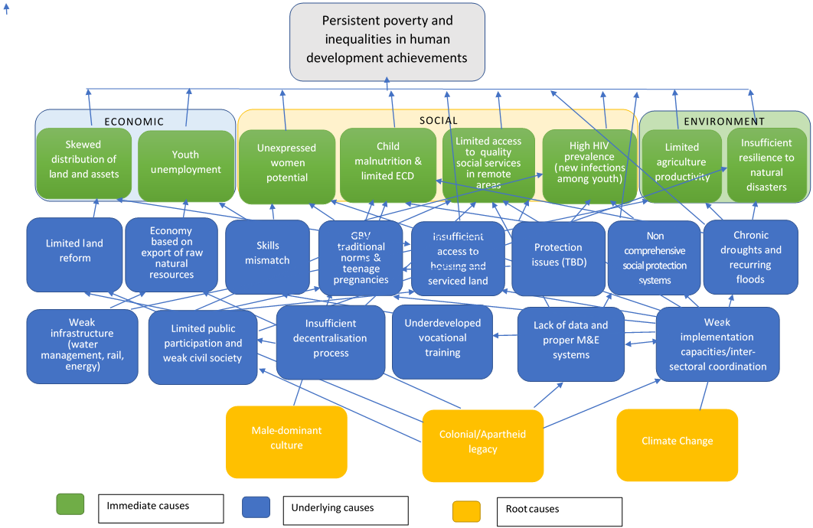
Figure 18 - Problem Tree - Root Causes Analysis

UN COMPARATIVE ADVANTAGE

The UN’s definition of comparative advantage is, “the mandate to act, the capacity to act and being better positioned to act than others”. Comparative advantage is identified with consideration for the specific country development context and the role, position and resources of the UN as well as other stakeholders.

To identify the comparative advantage and capacity of the UN in Namibia, three complementary analyses were undertaken to draw on current data, insights and understanding from both the UN in Namibia and its partners: 1) SWOT (Strength, Weaknesses, Opportunities and Threats) analysis exercise conducted with the UN Country Team; 2) Structured in-depth key informant interviews; and 3) Comprehensive Partner Perception Survey targeting key UN Stakeholders. In parallel, a snapshot of the UN System’s capacity was established through 4) a quantitative internal UN capacity assessment exercise.

Namibia Aid Environment
The UN’s comparative advantage and future role must be considered in the context of the aid environment in Namibia. Data indicates that the availability of ODA has continued to decline since Namibia achieved the UMIC status in 2009. As can be seen from the Figure 18 below, at its peak in 2009 Namibia was receiving approximately USD 330 million per year in ODA, this level of funding fell to USD 142 million in 2015. This represents 1.2 percent of Namibia’s GNI. Financial development assistance is therefore relatively low and declining in view of the country’s overall income status. Since independence in 1990 the most relevant bilateral partners have been Germany and the United States (see Figure 20).

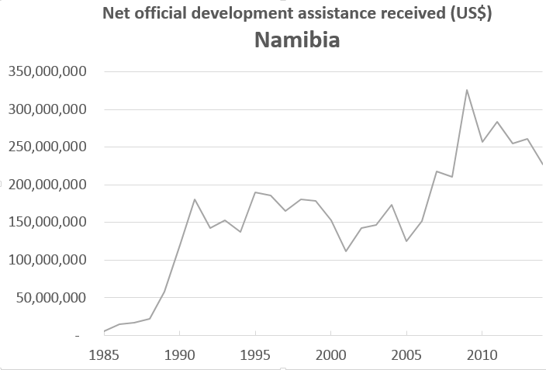
Figure 19 ODA in Namibia. (Source: OECD)
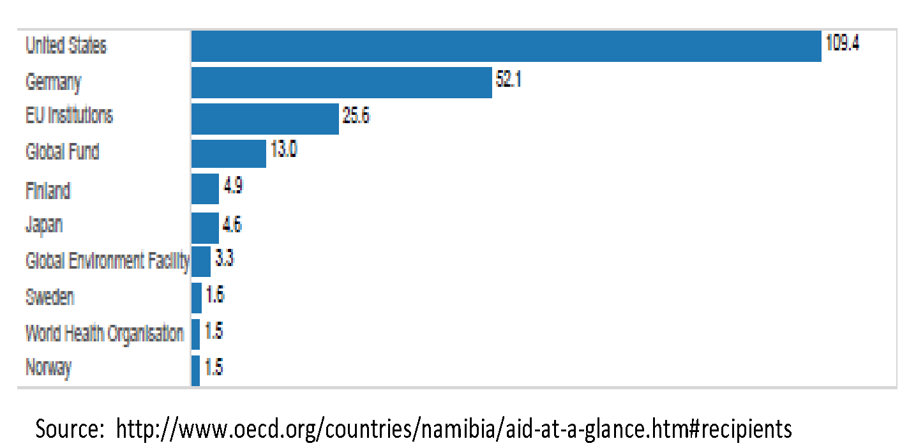

Figure 20 Top ten donors of gross ODA for Namibia(Source: OECD)

UNCT SWOT Analysis

The Strengths Weaknesses Opportunities Threats (SWOT) analysis undertaken by the UNCT in July 2017 reflected upon the perceived internal strengths and weaknesses of the UN system and the opportunities and threats within the external environment over the next five years. The participants identified a high number of opportunities and threats that the external environment offers including socio-economic factors, political environment, role of other development partners and available resources. The internal UN strengths and weaknesses were also identified based e.g. skills and abilities of the UN, networks and financial resources allocated to the UN system.

The UNCT in Namibia considers its greatest strengths to be the capacity to inject technical capacity in areas of national priority and the ability to convene partners and networks. In addition, the coordination mechanisms and leadership of the UN, as well as its provision of technical expertise and best practices are seen as important strengths. The UN also considered its overall reputation, influence and voice a strength in terms of access to GRN and assuming the role of honest broker between all development actors in Namibia.

The UN’s overall ability to mobilize resources was considered a strength and opportunities for further resource mobilization were identified for example around climate change. However, it was also highlighted with equal weighting as a weakness with reference to Namibia’s UMIC status and the subsequent reduction of availability of ODA. It was concluded that the UN needed to include in its resource mobilization efforts the leveraging of domestic resources, engaging with development partners and continue to explore opportunities for partnerships with the private sector

By contrast, the UN sees its weaknesses first and foremost around its ability to Deliver as One (DAO), where by good work has started but needs to be strengthened, particularly in the areas of coordination, programming and communication. This is validated by the perception survey whereby a large percentage of respondents were not aware of DAO, deeming communication in particular a priority.

Whilst knowledge management and results based management (RBM) tools were generally considered a strength of the UN, weaknesses in internal M&E, data and information and use of different management tools was observed and reflects some internal capacity concerns. With the domination of the SDGs and the national planning tools of NDP5, HPP, Vision 2030, National Human Development Report on Inequality, AU Agenda 2063, SADC Agenda 2020, Africa Peer Review Mechanism (accountability and governance) perceived as opportunities in the external environment, the UN will need to strengthen its management and monitoring capacity to fully align with these planning tools and therefore to have the ability to monitor the UN’s contribution and levels of harmonization with these frameworks.

The highest-ranking opportunities identified by the UNCT were women’s empowerment and the SDGs, considered to present opportunities both for the country and in the UN’s engagement in the development agenda in Namibia. Inequality is ranked as a high-level threat along with climate change/water and land reform being the root cause of increasing instability, rural/urban migration and informal settlements. UMIC status, the absorptive capacity of government and the low capacity or mismatch of skills amongst government employees presents threats to the ability of government to respond to development priorities, and as such are presenting challenges to the way the UN engages with government. Whilst the demographic youth bulge is identified as an opportunity for the country’s growth, the reality of youth unemployment, high rates of youth school dropout, low capacity of government employees and a skills mismatch present challenges for the future of the country and hence was also highlighted as a threat.

Human Rights advocacy was also mentioned as a lower level weakness particularly concerning the inability of the UN to work together on shared priorities and to convey these joint human rights messages to an external audience. The summary of the SWOT analysis is compiled in Figure below ranked in order of number of ‘votes’ received by the UNCT members at the end of the exercise. It is observed that what is identified as a strength in one context, can be perceived as a weakness in a different context. For example, the UNCT identified resource mobilization as both a strength in terms of providing access to regional and global funds and as a weakness, as options for mobilizing funds in Namibia were diminished. Likewise, it was observed that these tools were not being adequately adhered to in the internal planning and monitoring processes, another weakness.

STRENGTHS  - Technical Capacity / Focus to National Priority  - Ability to Convene the Partners and Networking  - Coordination Mechanism / Leadership  - Expertise - Best Practices  - Ability to Mobilize Resources  - Working Relationship / Access to Government  - Reputation / Influence - Voice  - Knowledge Management - RBM Tools  - Flexibility / Relevance | WEAKNESSES  - Delivering as One (good work has started but needs to be strengthened):  - Coordination  - Programming  - Communication  - Resource Mobilitisation  - Influencing External Perception of the UN  - Internal M&E  - Data / Info  - Different Management Tools  - Human Rights (joint advocacy)
OPPORTUNITIES  - Women Empowerment  - SDGs  - NDP 5 - HPP - Vision 2030  - UMIC Status (UN leveraging domestic resources and private sector engagement)  - Climate Change: Leverage Resources and engagement with Development Partners  - Innovation  - National Human Development Report on Inequality  - Youth Bulge  - Africa Agenda 2063  - Peace and Stability  - SADC Agenda 2020  - Africa Peer Review Mechanism (accountability and governance)  - Budget Constraints (engage private sector) | THREATS  - Inequalities  - Climate Change/water  - Land Reform: Instability, Rural / Urban migration, Informal Settlement  - Absorptive capacity of government (e.g. GFATM)  - UMIC Status (reduced development assistance)  - Youth Unemployment  - Budget Constraints/Poor financial management and accountability  - Potential Extremism / Terrorism  - Low Capacity of Govt/Skills Mismatch  - Global Reduction of Funding  - High School Drop-out Rate/low completion rates
Figure 21 Results of UNCT SWOT Analysis

Stakeholder Interviews
Structured interviews with government officials, NGOs, development partners and key UN entities were conducted to further elaborate how the UN could best position itself to deliver services in the areas where it has a comparative advantage and where greatest impact could be obtained (See Key Informant Interview Guide).

It was generally understood by most key informants, that the strength of the UN in Namibia was not the dollar value of its resources or how much funding in brought to the table. Instead, the strength of the UN lies in its technical expertise, and the measure of success for the UN will be how it supports Namibia’s development priorities and the degree to which successful initiatives are effectively scaled up.

As a precursor to the interviews, the key messages of stakeholders within the Namibia UN Partnership Framework 2014-18 Mid-Term Review (October 2016) and the Joint Partnership and Resource Mobilization Strategy (April 2017) were reviewed. Both documents confirmed that the work done by the UN is fully aligned to Namibia’s National Development Plans and therefore is building a strong case for UN relevance and sustainability. The UN was acknowledged for its efforts in capacity building for Government institutions, both on upgrading human capacity and for the development of adequate systems and processes. One key area where it was felt that there is insufficient knowledge transfer or capacity development was in the area of reporting, monitoring and evaluation. Government has demonstrated good capacity to plan, with some adequate capacity to implement, but the UN is considered to be well positioned to provide capacity building in the areas of performance tracking and management; and M&E of development plans.

In response to the 2017 CCA key informants interviews, the UN agencies were generally recognised for their added value as a partner in Namibia’s development plans through their role in support of knowledge generation, management and transfer, sharing of best practices, application of rights-based normative standards, policy advocacy as well as capacity enhancement through the design of improved implementation processes.

Development partners identified the UN as the one institution that could play a bigger convening role for all development partners in Namibia, benefitting from the UN’s relationship with the GRN as a trusted partner. Development partners encouraged the UN to exercise more leadership in donor coordination through the establishment of various development fora to discuss pertinent development issues in order to provide for more effective and efficiently delivered support to Government. As a collaborative, neutral, responsive and valued partner, the UN was encouraged to make further use of its unique access to key government counterparts and effectively exercise its convening power and building consensus with national and international partners, particularly on sensitive issues.

It was also observed that there was a need for the UN to communicate better on how it was delivering services under the joint programmatic framework (UNPAF) and that coordination amongst the UN agencies could be improved e.g. by further advancing the DAO initiative.

Many interviewees pointed towards the UN’s strength in terms of providing high-level policy advisory services and in supporting Government in its efforts to improve the consistency and quality of policy-making processes (planning, implementing and monitoring). The UN is seen as a key actor in terms of providing multi-sectoral technical expertise and ensuring access to global and regional best practices. The UN’s technical policy advice was considered instrumental for the development of sound policy strategies. Strongly linked to this, the UN was also called to ensure that citizen participation existed in policy and decision-making processes, in order to assure that people are at the centre of development efforts. Empowering the nation’s citizenry, in all its diversity, to meaningfully participate in the decisions that affect them through deliberately creating opportunities for such participation was assessed to be an important accelerator for Namibia’s overall development progress.

While there was general consensus that the UN should continue to focus on providing support to GRN in terms of high-level policy advisory services and development of national policies, it was observed that these efforts should be mixed with downstream support. Some key informants observed that the UN could scale up efforts to focus on mid-stream support through capacity building of decentralised systems at local and regional level. This focus on mid- to downstream implementation support was considered particularly important as a means to compensate for the relatively poorly organised and capable NGO sector in Namibia. Link to this, and the role of civil society organisations (CSOs) in Namibia, the UN was encouraged to provide support to the official Namibian NGO policy, which has current slow implementation and would benefit from enforcement and follow up.

Many observed that the UN was considered the go-to institution for ensuring that focus was put on the need for significantly enhanced data and knowledge systems at all levels. Currently these systems were not in place. Building evidence-based policy processes, with comprehensive, robust, and readily implementable monitoring and evaluation and strategic information systems, supported by disaggregated data, that reach the lowest levels of governance was considered to be a key responsibility of the UN. This would facilitate the better monitoring of the delivery of quality public services and public expenditures, and would enhance transparency and accountability of the government.

In addition to providing technical support, the UN was also seen as a key partner in terms of ensuring access to global and regional funding opportunities which was particularly important considering the decline in ODA.

Partner Perception Survey
The Partner Perception Survey was designed to monitor understanding and measure key stakeholder perception of the UN’s work in Namibia. A total of 98 stakeholders from three subgroups (GRN [national, regional, local], NGOs [national and international] and development partners) responded to the survey. Stakeholders were asked to provide information on the overall perception of the UN in Namibia, what programmatic interventions the UN was engaged with currently and which ones the UN should be engaged for the next five years. The stakeholders also assessed the progress made by the UNCT in terms of implementing DAO at the country level.

The Partners Perception Survey (see Annex 5 – Partner Perception Survey) confirmed that the UN’s comparative advantage is perceived to be one of being impartial, committed to helping Namibia and of a high reputation in the country. The UN is perceived to have comparative advantage working across actors providing specialist advice, access to specialised technical knowledge, leveraging global comparative advantage and promoting human rights approaches.

Partners were asked if they were familiar with the UN and 60 percent of respondents said yes. Ninety percent of partners confirmed that their organization worked directly with the UN system on a continued basis. Partnerships with the UN are at 84 percent, engaging primarily with FAO, UNESCO, UNICEF, UNDP, UNAIDS, WHO and UNFPA. When asked to indicate current and future (next five years) priority in the six priority areas of the UN in Namibia, responses indicated maintenance of the priorities already established. In the area of Human Rights and gender, inclusion of priority for compliance with International Norms and Standards and engagement with Human Rights Mechanisms was requested. Current priorities for regional and global climate change and Disaster Risk Reduction were given a lower priority for the next 5 years where responses indicated the need for a greater focus on natural resource management.

Table 3 Partner Perception survey responses - UN Programming priorities now and in the next 5 years. Number of responses in parenthesis. Respondents could identify more than one answer for each priority area.
Priority | Now | In next 5 years
Socio economic development | Health (82)  Education (77) | Health (83), Education (79), Enhancing economic situation (75)
Inequality, discrimination and vulnerability | Support women and girls (90), children (82), People living with HIV/AIDS (73) | Support children (90), women and girls (82)
Strengthening state institutions | Public Participation (64) | Public Participation (83)
Human rights and gender | Addressing gender equality (67) | Addressing gender equality (68), Compliance with Int. norms and standards (68), Engagement with human rights mechanisms (65)
Climate Change and protecting the environment | Natural resource management (53), Regional and global climate change (50), Disaster risk reduction (51) | Natural resource management (80)
Peace and humanitarian efforts | Sustainable development (62) | Sustainable development (75)

All subgroups surveyed ranked the UN four or above (on a scale from 1 to 5) in different parameters around the UN’s impartial status, commitment to support the development in Namibia, ability to provide technical support in a cross-sectoral manner, providing access to international knowledge and best practices, and promoting a human right based approach to development.

A number of highlights can be drawn from the Partner Perception Survey:

- Education and health are seen as the area where the UN contributes the most, with equal priority given to poverty alleviation and sustainable livelihoods.

- To address inequality, discrimination and vulnerability, the UN was seen as supporting women, children and people living with HIV. At a lower rank, persons with disabilities, migrants and displaced persons, indigenous people and minorities were also perceived as benefitting from UN support.

- The UN is perceived to be actively supporting initiatives promoting gender equality and at the same time being somewhat active in the area of ensuring compliance with international norms and standards and engagement with human rights mechanisms.

- The UN is seen to be currently contributing to addressing climate change and protecting the environment equally on a number of fronts including; natural resource degradation/ management; resilience and climate action including mitigation and adaptation; sub-regional, regional and global climate and environmental cooperation; and disaster risk reduction.

- The UN was not seen as providing support to national financing structures, and development partners felt that it should pay more attention to supporting the development of the financing structures.

- NGOs would prefer a model where much more attention was given by the UN to securing widespread public participation in decision-making processes and less on supporting financing structures.

- Development partners ranked efforts around sustainable development and humanitarian response significantly higher than the other two sub-groups and indicated that humanitarian response is still of the utmost importance.

- In the area of supporting peace and humanitarian efforts, stakeholders found that the UN’s focus on short, medium and long-term activities for sustainable development and humanitarian response, based on a human rights approach was appropriate for both the current and the five-year perspective.

- With regards to DaO, two-thirds of the respondents in all three sub-groups responded that they were not familiar with the initiative and subsequently skipped the questions. Of those who responded, most were positively assessing the DaO results achieved in terms of promoting UN coherence and coordination and speaking with one voice. More reserved responses were given in the assessment when asked if the DaO initiative had led to increased effectiveness or efficiency in the delivery of services. Overall, knowledge on the separate components of the DaO initiative was assessed to be relatively low.

For the next five years, in addition to those priorities highlighted above the UN in Namibia was requested to:

- Upscale its focus on all fronts, particularly natural resource degradation/management and resilience and climate action, including mitigation and adaptation;

- Upscale its efforts in supporting minority and disadvantaged groups, particularly with regards to support to indigenous people;

- Strengthen state institutions with particular regard for public participation, legal frameworks, international integration and governance structures; and

- Continue to provide support to the current GRN structures it works with.

UN Capacity Assessment
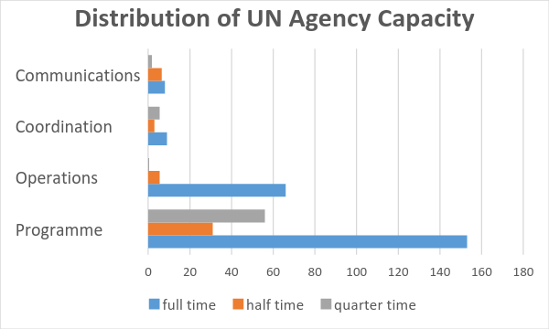
Fourteen UN agencies responded to the quantitative survey on UN agency capacity. Areas of programme were presented in the survey in disaggregated form covering the priorities of: data generation/analysis; research; project management; resource mobilization; humanitarian crisis and emergency response; governance; gender; human rights; and development.
Figure 22 Distribution of UN Agency Capacity

The summaries in Figure 21 indicate a higher proportion of human resources dedicated to programme than to operations, however it is anticipated a slightly different profile of operations would be achieved if operations was disaggregated further and an equal surveying of both programme and operations staff could be ensured. Fewer resources are dedicated to coordination and communication, which is something to be given further consideration, particularly in a DaO environment.

Within programme, the areas of priority are resource mobilisation, policy advice, development and project management all of which have some fulltime resources assigned. Human Rights, gender and governance are areas where responsible staff have these duties as a ‘one amongst others’, i.e. not fulltime responsibility.

Proposed UN Comparative Advantages
The analysis of comparative advantage confirms that the UN is considered to offer numerous broad comparative advantages that contribute to further national development and the potentially elevation of Namibia to a high-income country in the foreseeable future. Overall, partners to the UN acknowledged and appreciated the UN legacy in the country, as the organisation that supported the achievement of its independence from South Africa. Such a legacy clearly positions the UN as a ‘partner of choice’ and, most importantly, as a trusted and credible organisation.
Building on these results, the UN thus must deploy its comparative advantages to harness its leadership and global authority, advocacy and access to effectively champion implementation of international norms and standards, human rights instruments, and ultimately the SDGs, all in the interest of supporting national policies, processes and systems.
In summary, the proposed comparative advantage of the UN in Namibia is identified as:

- The ability to enable the GRN to better strategise and scale up national and local initiatives that directly relate to the priority development challenges identified within this CCA. The UN is particularly well-positioned to help address and mitigate disparities in development areas among vulnerable groups;

  - In doing so, the UN should benefit from its unique ability to promote inclusiveness and the principles of human rights, equity, accountability, empowerment and participation are considered in development plans, policies and processes through effective social and geographical targeting to reduce inequities in numerous development areas among vulnerable groups;

- The ability to strengthen national capacities at all levels, underpinned by and leading to national ownership. The UN offers comparative advantages in the technical, institutional and managerial areas, all of which can contribute to effective systems reforms. A particular area where the UN has a comparative advantage is in knowledge management and implementation of comprehensive RBM measures, which should be used to support GRN efforts in upscaling the emphasis on results orientation, as well as objective reporting and monitoring of the national development frameworks and plans;

- The ability to provide multi-sectoral and multi-dimensional technical policy advice on interrelated development issues, particularly relevant for advancing on the SDG agenda. In so doing, the UN can focus on providing upstream policy advisory and advocacy services to the GRN in support of building ‘human infrastructure’, mid-stream support to systems development to roll-out policies and plans, whilst at the same time ensure support to downstream implementation at local level;

- The ability to provide support to domestication (integration into national laws and policies, of reporting on and monitoring Namibia’s international commitments under human rights treaties, conventions and other instruments;

- The ability to broker dialogue among all national partners - GRN, development partners and civil society alike. As a trusted and credible partner, the UN can facilitate dialogue on critical development issues, particularly on topics considered to be sensitive. Linked to this, the UN can upscale its efforts on further promoting donor coordination and convey the consolidated inputs from all relevant development partners in discussions with GRN;

- The ability to showcase best practices, including those of Namibia itself as it again becomes a dynamic participant in the regional and global arenas. The country has accumulated a wealth of experience, technical knowledge, expertise and best practices that can be an important contribution to global partnership platforms, including through South-South cooperation; and

- The holistic and interconnected nature of the SDG platform particularly complements the DaO approach already initiated in Namibia, requiring UN agencies to coordinate their efforts to deliver seamless, more effective services.

Moving forward, the UNCT should remain very mindful of ensuring that the strategic areas of UN development priorities in UNPAF 2019-2023 reflect the current and expected future capacity of the UN. A more detailed analysis on the capacity within each resident and non-resident agency, and of the UN as a whole against perceived comparative advantage, would facilitate the UNCT in this process.

CONCLUSIONS AND RECOMMENDATIONS

Namibia has made tremendous gain since independence in reducing stark inequalities and poverty levels across the country. The country features a sound governance system, a forward-looking legislative and policy framework, rich and overall well-managed natural resources. However, current levels of poverty and inequality, in addition to restricted economic diversification and uneven access to social services negatively affects Namibia’s human development indicators, which are underscoring compared to the GDP levels of the country.

The present analysis of the country’s outstanding development challenges to advance the implementation of Agenda 2030 highlights the following key elements that deserve attention in order to push the agenda forward under each dimension of sustainable development:

Economic Dimension
      - Limited economic diversification with a reliance on sectors that are not labour intensive and with low value-addition. To address this a significant investment in infrastructure is needed, aiming at establishing Namibia as a regional logistical hub, as well as a focus on skills development to create the human capital required to move into production sectors with higher value-addition. Agriculture and pastoralism are the main occupation but are affected by chronic drought and climate change induced hazards as well as limited mechanisation, hindering their potential contribution to the country’s GDP and poverty reduction.
      - Poverty and income inequality remain significant in spite of the growing GDP per capita. These are mainly along ethnic lines, place of residence (urban/rural) and regions. This is the core challenge of the country which is influenced by all the dimensions of sustainable development.
      - Unemployment, especially among youth, is high and it is linked to the macro-economic structure of the country, the population dynamics, deteriorating performance of traditional economic sectors, and skills mismatch as indicated below.
Social Dimension
      - Demographic trends and migration – Namibia’s is one of the world’s least densely populate countries and this poses significant challenges to reach out and provide services. Her population is young (66% under 30) with a great potential to support the country’s economic development, but currently hindered by a skills mismatch and shrinking opportunities in rural areas. Rural-urban migration is hence high and challenging.
      - Health – both communicable (HIV/AIDS, TB and Malaria) continue to represent a risk in the country as well as rising non-communicable diseases and injuries linked to road traffic and violence. HIV epidemic affects disproportionally women and girls and border regions. Maternal and neonatal mortality is high. These are sustained by harmful cultural and social norms as well as the difficulty for social services to reach out to all remote areas and vulnerable groups.
      - Food security and nutrition – reliance on food imports and rain-fed agriculture challenges food security in the country. Access to land and water is an issue, as well as chronic and worsening droughts. Child malnutrition is high and linked to poverty.
      - Education – survival rates are very low especially in remote communities; education outcomes are poor and, moreover, not in line with the requirements of the labour market. Access to higher education is difficult for young people from disadvantaged background or with previous work experience.
      - Sanitation – open defecation practices are widespread and proper sanitation services are lacking in the growing urban informal settings. In the latter in particular this poses significant health risks. Sanitation facilities in schools is not universal.
      - Social Protection – comprehensive systems are in place but are not efficient, making it costly and not reaching all in need. Better coordination is needed as well as a merging of databases and rationalisation of schemes.
      - Land and urban planning – cutting across social and economic dimensions of development, skewed distribution of land not only hinders economic opportunities for all but can fuel social instability. Urban planning and access to serviced land is crucial to support economic transformation and ensure proper housing and services to the growing urban population.
      - Gender equality – with specific challenges linked to pervasive GBV, entrenched in harmful socio-cultural norms which affects women’s potential including their contribution to the country’s development. Significant rates of teenage pregnancies further negatively influence women’s wellbeing and future opportunities.
Environmental Dimension
      - Water scarcity and management determines water insecurities and set barriers to sustainable development efforts. This need more (and more efficient) investments in water management.
      - Natural resources management is key to Namibia’s sustainable development given the country’s reliance on the extractive industry and nature-based tourism. Integrated management solutions are needed in order to maximise natural resources contribution to sustainable development.
      - Disaster Risk Management is crucial given the country’s exposure to natural disasters. Poverty is a major contributor to vulnerability to disaster as well as disparities in infrastructure and institutions development.

In line with the Agenda 2030 the analysis also explored the enabling environment that would allow to make progress in these three dimensions and sustain achievement made, namely “peace” (including the governance set up to maintain stability and fulfill human rights) and “partnerships” in terms of effective engagement of all stakeholders and institutions. The root cause analysis, using a people-centred approach, allowed to identify cross- cutting issues that need to be addressed across the board. These include:
- Weak implementation capacities and intersectoral coordination
- Lack of data and proper M&E systems
- Insufficient decentralisation process
- Limited public participation/weak civil society

The analysis further identified key UN ‘s comparative advantages in Namibia, which include its role and capacity to promote inclusive development policies; ability to strengthen national capacities at all levels; promote multi-sectoral approaches; act as a convener and broker among all national partners (including private sector, donors, civil society); showcase best practices and “Delivering as One”.

In light of the above, the following recommendations are made in order for the UN to most effectively support Namibia in achieving the SDGs in the next few years:
- Develop interventions to address each dimension of sustainable development with the following focus: economic dimension - skewed distribution of assets, youth unemployment; for the social dimension - unexpressed women’s potential, child malnutrition and overall limited availability and access to ECD opportunities, skewed access to quality social services especially by region and between urban and rural areas and the HIV epidemic. For the environmental dimension - scarce resilience to natural hazards, water management and limited agriculture productivity (the latter cuts across the economic dimension).
- Adopt a strategic approach to address patterns of exclusions and discrimination in terms of gender, area of residence, regional disparities, age and ethnicity.
- Develop national capacity for data collection and management, as well as setting up effective M&E systems.
- Provide multi-sectoral support on issues of cross cutting priority, with a view to enhancing inter-ministerial coordination and communication; this should be reflected in the structure of UN modus operandi, including strengthening the Delivering as One agenda.
- Prioritise work ‘on the ground’ in the most deprived areas forging targeted pro poor and pro ‘farthest first’ strategies; and at the policy level focusing on building implementation capacities of the public sector.
- Act as convener and neutral broker to:
  - promote increased donor coordination that increases levels of harmonization around national development priorities; in addition to providing a forum for dialogue around sensitive issues.
  - promote public participation in policy processes, creating a space for Civil Society Organizations’ engagement and supporting the development of CSOs
  - Support the establishment of partnerships with the private sector for the achievement of the SDGs.

In order to implement the above, the UN should carefully review its own current and projected future capacity to ensure that it has the adequate technical strength to provide support in the identified strategic priority areas. The capacity assessment conducted for this CCA should be strengthened to further elaborated the distribution of staff capacity across both programmatic and operational areas of priority, with consideration for the demands of coordination and communication in a DaO environment. Collecting data linked to the grade, contract type and projected availability of funding for posts should also be considered.

- REFERENCES

African Development Bank (2014), Namibia Country Strategy Paper 2014-18
Government of the Republic of Namibia (2016), Harambee Prosperity Plan, 2016/17-2019/20: Namibiian Government’s Action Plan towards Prosperity for All, Office of the President, Windhoek
GRN-UNICEF Programme of Cooperation 2014-2018: Mid-Term Review UNCT Retreat Summary Report 2015
ILO (2010), Namibia Decent Work Country Programme 2010-2014
ILO (2016), Mobilising Resources, A Strategy for Southern Africa, September 2016
IOM (2016), Migration in Namibia - A Country Profile 2015
MGECW (2010), National Gender Policy 2010-2020
MHSS & NSA (2014), Namibia Demographic and Health Survey 2013
MPRSW (2016), Blue Print on Wealth Redistribution and Poverty Eradication
NHIES (2016), Namibia Household Income and Expenditure Survey (NHIES) 2015/2016 Key Poverty Indicators
NPC (2008), Third National Development Plan 2007/2008-2011/12
NPC (2012a), National Human Resources Plan 2010-2025
NPC (2012), Namibia fourth National Development Plan 2012/13 to 2016/17
NPC & UN (nd), Namibia MDG report draft 2015
NPC (2015a), Poverty and Deprivation in Namibia 2015
NPC (2015b), Namibia Index of Multiple Deprivation Report
NPC (2015c), Namibia Poverty Mapping Report
NPC (2017), Namibia Fifth National Development Plan 2017-2022
NSA & UNFPA, Namibia 2011 Population and Housing Census Indicators
NSA (2014), Namibia Population Projections 2011 - 2041
NSA (2015), Namibia Social Statistics 2010 – 2014
Office of the President (2004), Namibia Vision 2030
Office of the President (nd), Harambee Prosperity Plan 2016/17 - 2019/20
Republic of Namibia (2017), Working Together Towards Prosperity, National Development Plan 5, 2017/18-2021/22
Republic of Namibia, UN (2016), Capacity Assessment Report of the National Disaster Risk Management System in Namibia.
Shigwedha, A. (2006), Veld fires destroy valuable resources, Economic News, The Namibian, 2006-03-23. Accessed www.namibian.com.na
UN (2013), Report of the Special Rapporteur on extreme poverty and human rights, Ms Magdelena
Sepulveda Carmona, Mission to Namibia (1 to 8 October 2012), UN General Assembly A/HRC/23/36/Add.1
UN Namibia (2016), Emergency Preparedness and Response Strategy
UNCT and GRN (2013), United Nations Partnership Framework 2014-2018
UNCT Retreat Summary Report 2016
UNDP (2016), UN70: Rethinking the humanitarian-development nexus: How can the UN achieve a better integration of long term aid and humanitarian assistance?, 15 March, 2016 accessed http://www.undp.org/content/undp/en/home/presscenter/speeches/2016/03/15/magdy-mart-nez-solim-n-un70-rethinking-the-humanitarian-development-nexus-how-can-the-un-achieve-a-better-integration-of-long-term-aid-and-humanitarian-assistance-.html
UNICEF (2016), GRN-UNICEF Programme of Cooperation 2014-2018: Mid-Term Review
UNPAF Mid-Term Review Report 2014-18
UNPAF 2014 to 2015 Consolidated Report
UNPAF Action Plans
WHO, Africa, Analytical summary – Maternal and new born health, www.aho.afro.who.int
World Bank (2017a), Macro-Economic Poverty Outlook
World Bank (2017b), Does Fiscal Policy Benefit the Poor and Reduce Inequality in Namibia?
World Bank (2013), International Bank for Reconstruction and development International Finance
Cooperation and Multilateral Investment Guarantee Agency Country Partnership Strategy for The Republic of Namibia for the Period FY 2014 – FY 2017, 26 June 2013. Report Number 77748-NA
World Resources Institute, Land Rights and Development in Namibia, www.focusonland.com/countries/namibia, accessed 2 August 2017
www.oecd.org/dac/financing-sustainable-development/development-finance-data
http://www.oecd.org/countries/namibia/aid-at-a-glance.htm#recipients

Poverty = not having enough financial resources to meet a need; Deprivation = an unmet need which is caused by a lack of resources of all kinds, not just financial ones.
See also specific sections covering sectoral analysis
Whilst the term ‘marginalised groups ‘or ‘communities’ is used often to refer to groups in the population unable or least able to access services there was no definition of of ‘marginalised groups found, however reference to educational marginalization, orphans and vulnerable children, those marginalized by distance and location there is no definition of ‘marginalised groups’.
See Namibia MDG Report 2015
Ministry of Health and Social Services, December 2016. Report on Emergency Obstetric and Newborn Care Needs Assessment
Ministry of Health and Social Services, April 2016, Joint Review of Maternal, Newborn, Child and Adolescent Health and Nutrition Programmes in Namibia.
The NDRMC membership is comprised of Ministries in charge of finance; health and social services; agriculture; water and forestry; defence; education; information and communication technology; urban and rural development; safety and security; works and transport; and gender equality and child welfare. The Committee also comprises a representative of the Association of Regional Councils in Namibia/the Association for Local Authorities in Namibia.
Six members are appointed by the president, bringing SWAPO’s share to 60 out of 78 total seats.
This table is provided as such in the Ministry of Finance “Macroeconomic Framework 2012-2013”. Data collated in the same way is not available in the more recent MTEF issued by the ministry making it difficult to compare and hence update the table.
Article 144 of the Namibia Constitution provides that unless otherwise provided by the Constitution or Act of Parliament, the general rules of public international law and international agreements, binding upon Namibia under this Constitution shall form part of the Law of Namibia. This is still subject to other national legislative processes.
For further information: Namibia UN Partnership Framework 2014-18 Mid-Term Review, October 2016, pg. 29-30 and 41-43 and Joint Partnership and Resource Mobilization Strategy (April 2017) pg 22-24.

