


THAILAND
country analysis

Contents

EXECUTIVE SUMMARY 3
CHAPTER 1: INTRODUCTION 4
CHAPTER 2: DEVELOPMENT LANDSCAPE 5
2.1 Human Capital Transformation 5
2.1.1 Education for All: A National Commitment 5
2.1.2 Gender Equality Progress and Challenges 6
2.1.3 Health Landscape: Demographics and Disease Trends 6
2.1.4 Agrifood System 8
2.2 Economic, Digital and Energy Progress 9
2.2.1 Digital Transformation 9
2.2.2 Energy Access and Affordability 10
2.3 Environment, Climate Change and Natural Hazards 11
2.3.1 Climate Change: A Critical Challenge 11
2.3.2 Biodiversity Conservation 12
2.3.3 Pollution and Environmental Health 12
2.3.4 Urban Planning for Eco-Smart and Resilient Cities 12
2.4 Poverty, Inequality and Access to Rights and Opportunities 13
2.4.1 Poverty 13
2.4.2 Inequality 13
2.4.3 Human Rights 15
2.5 Transboundary Issues 15
2.5.1 Transboundary Pollution 15
2.5.2 Transnational Organized Crime Trends 15
CHAPTER 3: MULTIDIMENSIONAL RISK ASSESSMENT 16
3.1 Risk Ranking and Impact Assessment 16
3.2 Interlinkages Among Risks and Coordinated Responses 17
3.3 Emerging Risks 17
CHAPTER 4: PROGRESS TOWARDS THE 2030 AGENDA 17
4.1 Thailand’s SDG Integration 17
4.2 SDG Data Gaps 20
CHAPTER 5: SDG FINANCING LANDSCAPE 21
5.1 SDG Financing Needs 21
5.2 Analysis of Climate Finance Flows 21
5.3 Development Finance Availability 21
5.4 Sustainable Finance 22
5.5 MSMEs and Inclusive Sustainable Development 23
CHAPTER 6: CONCLUSIONS 23

EXECUTIVE SUMMARY
Thailand has made remarkable socioeconomic progress over most of the past four decades. The overall national development path demonstrates balanced, inclusive and sustainable progress, guided by the Sufficiency Economy Philosophy and aligned with the Sustainable Development Goals (SDGs). As an upper-middle-income country, Thailand has seen a steady post-pandemic recovery with economic growth of 2.4 per cent in 2025, while the ongoing digital transformation reflects a commitment to innovation and sustainability for a people-centred digital economy in the future. Gender equality has seen progress in both education and the workplace, advancing women’s leadership and participation in decision-making as a critical driver of an inclusive and resilient society. Education access remains strong, with near-universal enrolment and youth literacy, and continued investment strengthening learning quality, digital literacy and equitable access. In human capital development, Thailand’s progress positions the country to advance the SDGs and achieve high-income status by 2037.
Monetary poverty declined from 34.1 per cent in 1988 to 4.9 per cent in 2024, reflecting sustained growth, expanded social protection and consistent policy efforts to enhance equity and resilience. Universal Health Coverage remains a central pillar of the social contract, ensuring nationwide access to essential services and strengthening social cohesion.
Digital transformation under Thailand 4.0 continues to advance connectivity and efficiency. Initiatives such as PromptPay, Digital ID and automated welfare enrolment have improved access to finance and public services. Thailand’s rise from 60th to 31st in the Government AI Readiness Index and its second place ranking in ASEAN in the 2024 UN E-Government Development Index underscore its commitment to digital governance and innovation.
Environmental sustainability is progressing under the Bio-Circular-Green Economy model, which integrates growth with ecological stewardship. Thailand’s pledge to achieve net-zero emissions by 2050 promotes cleaner production and supports green innovation. Education policy guarantees 15 years of free schooling for all children, regardless of nationality or status, reinforcing inclusivity and human capital development.
Alongside this progress, structural challenges continue to affect inclusive growth. Economic growth remains moderate and geographically uneven, constrained by low productivity and informality. Household debt, at 86.8 per cent of GDP, highlights both the country’s financial dynamism and the need for stronger resilience.
Persistent inequalities remain a priority for policy attention. Vulnerable groups, including migrants, stateless persons, persons with disabilities and LGBTQIA+ communities, continue to face barriers to equal participation in social and economic life. The transition to a super-aged society by 2029 underscores the urgency of expanding opportunities for all generations, while advancing gender equality and women’s empowerment as cross-cutting solutions.
Environmental and climate risks remain significant but are met with growing determination. Thailand ranks 30th globally in the 2025 Climate Risk Index, with continued investment in disaster preparedness, renewable energy and adaptation measures demonstrating clear progress toward resilience.
Agriculture contributes 6.4 per cent of GDP and remains central to rural livelihoods and food security. Productivity gaps, resource pressures and environmental impacts persist, requiring sustainable, climate-smart and inclusive agricultural transformation supported by targeted assistance to smallholders.
Thailand ranks 43rd globally in SDG performance and continues to lead ASEAN for the seventh consecutive year – an achievement that reflects the country’s sustained commitment to sustainable development. Realizing the full ambition of the 2030 Agenda will require an estimated 1.4 trillion baht in additional annual financing. In response, Thailand is advancing innovative approaches to mobilize sustainable finance through its Sustainable Financing Framework and national Taxonomy, aligning public and private investments with sustainability objectives.
Looking ahead, the forthcoming Climate Change Act, expected in 2027, will introduce a Climate Change Fund, an Emissions Trading System and a carbon tax, further strengthening transparency and accountability, supporting vulnerable communities, and guiding the nation toward a just, low-carbon and resilient future.

CHAPTER 1: INTRODUCTION
The 2025 Country Analysis (CA) reflects the collective perspective of the United Nations Country Team (UNCT), offering a data-driven framework to guide UN support to the Royal Thai Government in advancing its national development priorities and achieving the SDGs. Conducted as a foundational component of the forthcoming United Nations Sustainable Development Cooperation Framework (2027–2031), the CA was initiated at the outset of its preparatory process. It provides a strategic platform for inclusive engagement with diverse stakeholders, including government institutions, the private sector, academia, international financial institutions and civil society, fostering a shared understanding of Thailand’s development context. Based on extensive data, the CA identifies key trends and successes, explores root causes of persistent challenges, and highlights structural factors shaping the country’s development trajectory.
Anchored in a human rights-based approach, the analysis emphasizes universality, equality, participation and accountability. Complementing this, the principle of Leaving No One Behind (LNOB) guides the assessment of inclusion, focusing on populations at heightened risk of exclusion. Gender Equality and Women’s Empowerment (GEWE) is integrated throughout, reflecting its critical role in promoting inclusive, just and resilient outcomes.
The CA opens with a focus on human capital, including Thailand’s achievements in education, gender equality and health, while taking into account rapid demographic change. The economic overview examines the post-COVID-19 recovery and digital transformation as well as efforts to improve energy access and affordability. Environmental sustainability is a central focus, encompassing climate change, biodiversity loss and pollution. A multidimensional review of poverty and inequality highlights intersections with broader social outcomes and their influence on social equity, followed by a survey of the human rights landscape covering social inclusion and equitable access for vulnerable groups. The analysis also examines transboundary and regional dynamics shaping Thailand’s development.
Based on the insights from 507 experts across sectors, the risk assessment identifies key vulnerabilities and systemic risks that may impede SDG progress and informs the UNCT’s collective priorities.
The CA further evaluates Thailand’s performance across all 17 SDGs and presents an overview of the SDG financing landscape, outlining opportunities and challenges in mobilizing the financial and technical resources required to sustain development momentum. Key reference documents, including the 20-Year National Strategy (2017–2036), the 13th National Economic and Social Development Plan (2023–2027), and analytical inputs from UN agencies and international financial institutions, ensure the analysis is both rigorous and closely aligned with Thailand’s strategic vision.
Charting the Course: Thailand’s Vision and Development Priorities
Thailand remains firmly committed to the 2030 Agenda, aspiring to attain high-income status by 2037 while advancing inclusive, resilient and sustainable growth. The country continues to address structural challenges such as modest labour productivity, limited innovation, persistent inequality and population ageing, with Thailand now classified as an aged society, all of which require rights-based and coordinated policy responses. Notable progress has been made in reducing poverty and expanding access to education and healthcare, while disparities remain for vulnerable groups, including women, youth, persons with disabilities, stateless individuals, migrants, people living with HIV and LGBTQIA+ communities.
Thailand’s pledge to achieve net-zero greenhouse gas emissions by 2050 reflects a strong commitment to environmental sustainability. Challenges persist in curbing emissions, forest degradation and waste, as well as in managing climate-related risks. National strategies emphasize resilience, climate-smart agriculture, biodiversity conservation and nature-based solutions that protect ecosystems while supporting local livelihoods.
The private sector plays an increasingly pivotal role in sustainable development, evolving toward strategic partnerships that promote green finance, ESG integration and innovation. International cooperation remains central to Thailand’s approach. Guided by the Sufficiency Economy Philosophy, Thailand promotes South-South and Triangular Cooperation to enhance peer learning and capacity-building. The country also strengthens multilateralism within ASEAN and advances international standards through its ongoing OECD accession, particularly in green growth and responsible business practices. Engagement with platforms such as BRICS further expands collaboration on trade, innovation and development finance.
Overall, Thailand’s development path reflects a clear vision of balanced, inclusive and sustainable progress. By leveraging its institutional strengths, investing in education and human capital development, and fostering innovation and deepening partnerships, the country is well positioned to accelerate SDG achievement with continued UN support in advancing integrated, forward-looking solutions that leave no one behind.

CHAPTER 2: DEVELOPMENT LANDSCAPE

2.1 Human Capital Transformation
Thailand continues to advance human capital development, reflected in a 2023 Human Development Index (HDI) of 0.798, ranking 76th globally and fourth in ASEAN. The result underscores strong national efforts to expand access to health, education and economic opportunity through a rights-based approach that ensures inclusiveness for all.
Life expectancy reached 76.4 years in 2023, with 80.9 for women and 72.2 for men, alongside low child mortality and declining stunting rates. Thailand’s achievements in universal health coverage and health security demonstrate sustained commitment to well-being, while ongoing efforts focus on improving access for migrants, older persons, persons with disabilities and other groups at risk of exclusion. Gross national income per capita reached USD 20,570. Women’s labour participation rose to 62 per cent, supported by policies promoting equality and inclusive workplaces.
Thailand’s Inequality-adjusted HDI of 0.677 and Planetary Pressures-adjusted HDI of 0.726, which are the highest in ASEAN, reflect progress toward inclusive, sustainable and resilient development, positioning the country to advance the SDGs and its 2037 high-income aspiration.

2.1.1 Education for All: A National Commitment
Thailand demonstrates a longstanding and comprehensive commitment to education as a cornerstone of human development, social cohesion and national progress. Guided by its constitutional principles and aligned with global and regional frameworks, including the 2030 Agenda, the World Declaration on Education for All and the 2016 ASEAN Declaration on Strengthening Education for Out-of-School Children and Youth, Thailand upholds education as a universal right. The 1999 National Education Act guarantees equitable access to quality learning, complemented by the 2005 Cabinet Resolution ensuring 15 years of free education for all children, regardless of nationality. The Equitable Education Fund, established in 2018, enhances opportunities for disadvantaged learners through targeted financial support and partnerships.
Education outcomes remain strong, with near-universal enrolment, including growing inclusion of non-Thai learners, and youth literacy above 99 per cent. While primary completion rates are high for both genders, retention drops at higher levels. Only 76 per cent transition to upper secondary at the expected age, net attendance falls to 74 per cent, and completion declines to 71.7 per cent, with disparities by wealth, region, disability and language. Gender gaps widen at these levels: girls complete upper secondary at 77.5 per cent compared to 65.5 per cent for boys and face fewer dropout risks across the system. Regional variation is also notable, with upper secondary completion ranging from 79.7 per cent in Bangkok to 63.4 per cent in the North. Foundational learning challenges persist, with 27 per cent of children not meeting reading benchmarks and 31 per cent not meeting basic numeracy expectations as early as grade 3.
The education system encompasses formal, non-formal and vocational pathways. As of 2024, approximately 9.8 million students were enrolled in primary and secondary education. Among them, over 215,000 non-Thai children were attending schools under the Office of the Basic Education Commission. Thailand offers three years of free early childhood care and education, with national attendance among children aged 3–4 years at about 75 per cent.
To address enrolment, the Government launched the Thailand Zero Dropout Policy in May 2024, aiming to reintegrate 1 million out-of-school children and youth into the education system by 2027. Thailand has taken important steps, including the establishment of the Happiness and Safety Centre, focusing on school-based violence, student well-being, and child participation.
Climate and environmental education are being mainstreamed through the Education for Sustainable Development initiative, preparing learners for a sustainable future. Thailand’s education sector also fosters global citizenship, peace education and respect for diversity by integrating multicultural learning, human rights and environmental awareness.
Digital transformation has further advanced equity in access to education. Expanding internet connectivity, digital learning platforms and AI competency training for teachers enhance the quality and inclusiveness of education delivery. From 2019 to 2022, internet access among students in the lowest income quintile rose from 48 to 85 per cent, and among those from non-Thai-speaking households from 57 to 83 per cent.

2.1.2 Gender Equality Progress and Challenges
The country has made notable strides on gender equality, with the HDI for women at 0.802 slightly surpassing that of men at 0.795, and Thailand ranking in the highest category globally on the Gender Development Index (GDI). Gender disparities persist across multiple dimensions, including labour force participation, occupational segregation and wage returns to education. Gaps in sex-disaggregated data and limited SDG 5 indicators hinder efforts to address gendered dimensions of poverty, particularly for vulnerable women including migrants, stateless persons, and persons with disabilities.
Women’s labour force participation remains lower than men’s across all ages, with a consistent gap of 16 percentage points from 2001 to 2022. While the gender wage gap has narrowed significantly, with weekly wage differences falling from 15 per cent in 2001 to 2 per cent in 2022, returns for education and work experience have increased more rapidly for men. Women are also overrepresented in informal employment and unpaid family work, especially among married women and those with caregiving responsibilities.
Women entrepreneurs face structural barriers, with limited access to markets, finance and professional networks. Gender gaps in asset ownership often leave women with less collateral to secure loans or credit, constraining their ability to start or expand businesses, with only 24 per cent accessing credit compared to 37 per cent of men. Thailand continues to face challenges in women’s political empowerment, with representation in ministerial positions, Parliament and public decision-making roles remaining relatively limited.
The lack of affordable childcare and eldercare services continues to constrain labour market entry and retention, reinforcing gender gaps in income and career progression. Women continue to shoulder most domestic, care and household responsibilities, which limits their mobility and ability to take on full-time or more demanding jobs. The unpaid care responsibilities amplify gender inequalities, especially in periods of emergency (e.g. during COVID-19), limiting women’s opportunities and increasing their workload.
Gender-based violence continues to be a major concern, with survivor services, including health, psychosocial, legal and shelter, unevenly distributed across provinces. Violence in employment, including abuses faced by women workers, workers from marginalized groups and migrant workers, has adverse impacts on the individual, workplace, and productivity.
Progress on legal recognition of same-sex partnerships through the passing of the Marriage Equality law in 2025 and the pending anti-discrimination law mark a positive shift toward broader inclusion. Although advocacy for LGBTQIA+ and marginalized groups has increased, their representation in policymaking remains limited. The absence of legal gender recognition for transgender, intersex and non-binary persons may limit access to certain services, employment, and identification documents.
Gender disparities in education also affect boys. While 74 per cent of all children attend upper-secondary school, only 67 per cent of boys remain enrolled compared with 81 per cent of girls, resulting in over half a million more boys than girls dropping out early.
Older women tend to live longer but are more likely to face financial insecurity, live alone and experience chronic health issues or mental health concerns. In 2017, 12.7 per cent of older women lived alone compared to 8.5 per cent of men. Women also constitute the majority of those affected by depression and dementia. Additionally, older women often encounter distinct sexual and reproductive health challenges, such as postmenopausal complications, a higher prevalence of gynaecological conditions and limited access to age-appropriate services and information.

2.1.3 Health Landscape: Demographics and Disease Trends
Thailand has made strong progress in public health. In 2023, life expectancy reached 80.9 years for women and 72.2 years for men. Declining fertility, influenced by evolving social norms and lifestyle choices, coincides with a steadily ageing population and Thailand’s growing aspiration to serve as a regional medical and wellness hub.
Key challenges include premature deaths from road traffic accidents, particularly among people aged 5 to 44, as the leading cause of death in this age group with overall road traffic injuries costing an estimated 3.06 per cent of GDP in 2022. Despite some progress in prevention and enforcement, Thailand’s road traffic death rate reaches 25.4 per 100,000 population in 2021. Noncommunicable diseases remain a major public health and economic challenge for Thailand, accounting for 81 per cent of all deaths and an estimated 9.7 per cent of the country’s GDP in 2019. Noncommunicable diseases such as hypertension and diabetes are on the rise, with many cases undiagnosed. Child malnutrition, including stunting, wasting and overweight, remains a critical concern. Statistics show 12.5 per cent of young children are stunted, 7.2 per cent wasted and 10.9 per cent overweight or obese. Stunting is highest in the North, while wasting and overweight are highest in Bangkok. Anaemia affects up to 57 per cent of infants and toddlers, while 53 to 94 per cent risk inadequate intake of key nutrients like calcium and iron.
Mental health has become a critical and growing issue in Thailand, with nearly 2.9 million people seeking services in 2023. Depression cases have risen 1.7 times since 2015, and dementia cases increased nearly tenfold. Substance use disorders significantly affect youth and working-age adults.
Thailand has made notable progress in addressing HIV. In 2025, an estimated 568,565 people were living with HIV, with 13,357 new infections and 10,217 AIDS-related deaths. Since 2010, HIV incidence has fallen by 52 per cent. Gaps in prevention, rising youth vulnerabilities and delayed diagnoses continue to limit progress, underscoring the need for strengthened prevention, broader use of innovations such as pre-exposure prophylaxis and HIV self-testing, and youth-sensitive strategies.
Thailand’s Universal Health Coverage has expanded to include fertility services, telemedicine and community-based models of care. Thailand’s healthcare workforce reached 4.66 per 1,000 population in 2024, doubling over the past decade. Over 1 million village health volunteers form the backbone of local service delivery, while ongoing decentralization enhances responsiveness to community needs.
Demographic Transition and Rise of an Aged Society
Thailand is experiencing one of the fastest demographic transitions in Asia, with ageing driven by lower fertility and longer life expectancy. In 2023, nearly one-fifth of the population (about 13.2 million people) were aged 60 or above, officially classifying Thailand as an “aged society”. The share of those aged 65 and over is projected to exceed 20 per cent by 2029, positioning the country among the world’s super-aged societies. In 2023, workforce participation among older persons stood at 37.5 per cent, with the majority engaged in low-income sectors such as agriculture.
Figure 1: Proportion of Elderly Population in Thailand by Age Group, 2015–2050
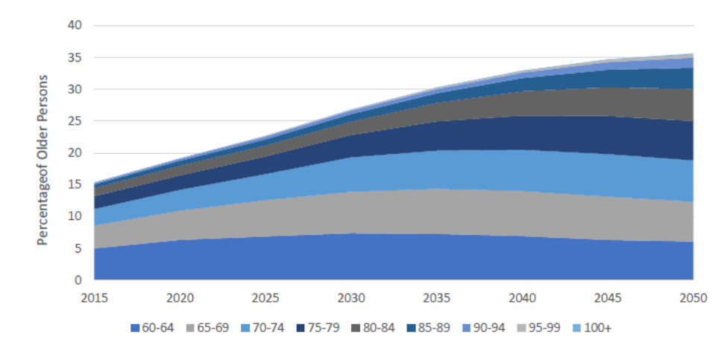
Source: World Bank
Longer life expectancy reflects Thailand’s public health and social development achievements. With a median age of 41 and rising old-age dependency ratio, older persons often face vulnerabilities such as financial insecurity, declining health and social isolation. The average monthly income for seniors remains below the national minimum wage, and less than 5 per cent of older persons have sufficient income to both meet their needs and save. Debt and limited savings are common, and more than 40 per cent of those with savings hold less than 50,000 baht. Gender disparities are particularly pronounced.
As demographic change reshapes labour supply, migrant workers play a vital role in sustaining key sectors including agriculture, manufacturing, services and care work. Ageing also presents new economic opportunities with the emerging “silver economy” projected to reach 2.6 trillion baht by 2030, driving innovation in healthcare, wellness, housing and assistive technologies. Thailand continues to focus on its ageing policy framework through the National Agenda on Aged Society and the 5x5 Policy, promoting family resilience, lifelong learning and age-friendly environments to ensure dignity, participation and well-being for all generations.
Social Protection
Thailand continues to strengthen its social protection and employment frameworks through the National Strategy Master Plan on Equality and Social Protection and the 13th National Economic and Social Development Plan (2023–2027). These frameworks promote life-cycle protection, equitable growth and poverty reduction across generations. Efforts focus on expanding inclusion for informal workers and marginalized groups, including women, migrants, ethnic minorities and persons with disabilities.
Figure 2: Share of Population Covered by Social Protection in Thailand, by Contingency
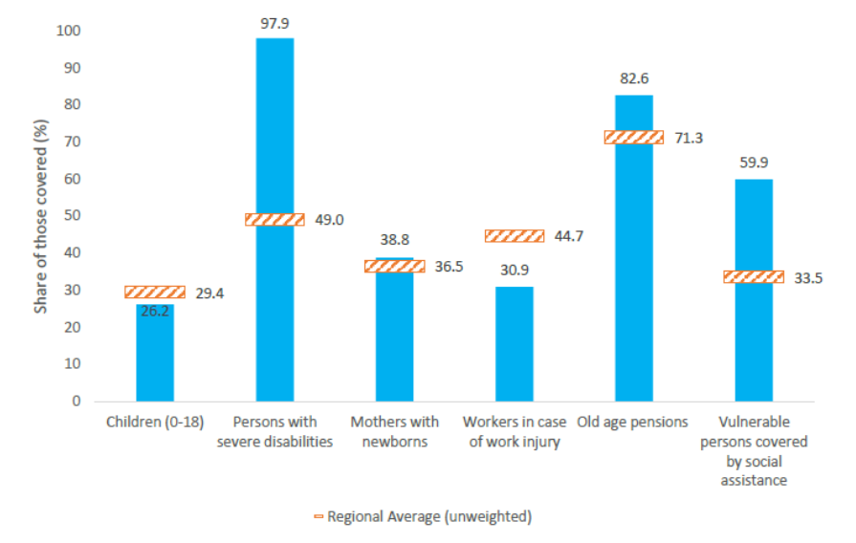
Source: ESCAP
Social protection expenditure accounts for 4.9 per cent of GDP, with over half allocated to the Old Age Allowance. About 65 per cent of the workforce is employed in the informal sector, and nearly half of all workers are not contributing to any social protection scheme. Low voluntary enrolment among informal workers leaves many vulnerable to economic shocks and without adequate safety nets, with women facing greater social protection gaps, as they represent the majority of older persons and persons with disabilities.

2.1.4 Agrifood System
Thailand has sustained its upper-middle-income status since 2011, supported by a diversified economy in which the agrifood system remains vital for food security, livelihoods and trade, contributing 6.4 per cent of GDP in 2025. The sector employs over 12 million people and underpins rural development, with smallholders managing most farms. Thailand continues to rank among the world’s leading agricultural exporters.
Thailand’s Twenty-Year Agriculture and Cooperatives Strategy (2017–2036), led by the Ministry of Agriculture and Cooperatives, sets out a comprehensive vision to modernize the sector. It includes ambitious targets to raise farmer incomes, expand smart farming, accelerate agricultural GDP growth, and certify all agricultural establishments by 2036, while promoting environmentally sustainable growth. The strategy is closely aligned with key national frameworks, including the National Biodiversity Strategy and Action Plan, Nationally Determined Contributions, and the National Adaptation Plan. To deliver on this vision, Thailand is implementing action plans such as the Five-Year Digital Agriculture Action Plan (2023–2027), which promotes smart farming technologies, data-driven management, and digital extension services, and the Agriculture Action Plan for Climate Change Adaptation (2023–2027), which strengthens the sector’s capacity to adapt to and mitigate climate impacts in a concrete and systematic way.
Significant progress has been made in food security, with undernourishment declining to 4.6 per cent in 2023. Food prices have become less stable over time, as indicated by the gradual rise in the Indicator of Food Price Anomalies from -0.34 in 2010 to -0.02 in 2023.
The country has also achieved notable success in conserving plant genetic resources, with over 31,800 samples preserved ex situ by 2022. Livestock biodiversity remains vulnerable, with more than half of local animal breeds still categorized as “at risk” or “unknown”. Resource management aligns with the National Biodiversity Strategy, Nationally Determined Contributions and the National Adaptation Plan, ensuring coherence between agricultural and environmental objectives.

2.2 Economic, Digital and Energy Progress
Thailand, an upper-middle-income economy, is pursuing a steady recovery amid structural challenges and geopolitical tensions. GDP grew by 2.4 per cent in 2025, driven mainly by private consumption, investment and exports, although growth remains below regional peers.
Figure 3: Thailand’s Growth Path Compared to Regional Peers
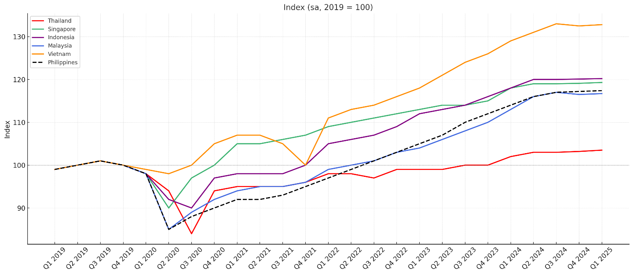
Source: NESDC and World Bank
Employment rose slightly to 39.8 million, while unemployment improved to 0.7 per cent. Nonetheless, elevated private debt and trade tensions pose downside risks. Rising global protectionism may affect exports and supply chains. Household debt, at 86.8 per cent of GDP, and fiscal pressures, although stable at a 3.6 per cent deficit and 66 per cent public debt, underscore the need for prudent, inclusive and forward-looking economic management.

2.2.1 Digital Transformation
Thailand’s digital transformation continues to advance under the Thailand 4.0 strategy, supported by initiatives such as PromptPay, the Thai QR Code and the national Digital ID system. Fuelled by global AI and blockchain advances and pandemic-driven digital adoption, Thailand rose from 60th to 31st on the Government AI Readiness Index (2020–2022) and ranked second in ASEAN on the 2024 UN E-Government Development Index, highlighting strong progress in digital government services.
The National AI Strategy and Action Plan (2022–2027) focuses on harnessing AI in ethical, secure, and socially beneficial ways, aiming to develop 90,000 skilled AI professionals and 50,000 advanced developers by 2027. National guidelines are being developed to regulate AI use, including strict oversight of high-risk applications such as facial recognition. According to the 2022 Disability Survey, digital access for persons with disabilities has improved but remains limited due to accessibility barriers and inadequate assistive technologies.
The Bank of Thailand’s Payment Strategy (2022–2024) promotes innovation through fully digital banks, improved regulation for non-bank financial institutions and faster, more secure payment systems. Initiatives such as PromptBiz and the pilot Retail Central Bank Digital Currency enhance efficiency and transparency, while the rollout of national Digital ID and e-signature platforms strengthens secure online transactions. Virtual banks, set to launch in 2025, will further extend services to underserved populations.
While mobile and internet penetration exceed 89 and 91 per cent respectively, disparities persist in connectivity, affordability and advanced skills, especially among rural residents, low-income households, women, older persons and persons with disabilities. Beyond access, many households possess only basic digital skills. Over 70 per cent are unable to use advanced software or install applications, and digital engagement tends to focus on entertainment rather than productive use such as e-commerce or employment-related activities.
Thailand’s health sector has made notable progress through digital innovations. Currently, 76 per cent of the population accesses health-related information online, and 35 per cent use digital tools for fitness and health monitoring.

2.2.2 Energy Access and Affordability
Thailand’s power sector operates under an enhanced single-buyer model, ensuring centralized coordination of generation, transmission and distribution. The institutional framework includes the Ministry of Energy for policy direction, the Energy Regulatory Commission for oversight and renewable promotion, and the Electricity Generating Authority of Thailand, which manages generation and transmission alongside distribution companies and independent producers. The National Energy Plan provides integrated guidance through five sub-plans: the Power Development Plan, Alternative Energy Development Plan, Energy Efficiency Plan, Natural Gas Plan and Oil Plan. The current Power Development Plan (2018–2037) prioritizes energy security, affordability and environmental sustainability through diversification, efficiency and renewable expansion.
Fossil fuels remain dominant, accounting for about 78 per cent of total energy consumption in 2022, with natural gas and coal providing 70 per cent of electricity. This reliance underscores the need to accelerate renewable deployment and reduce import dependence. Thailand targets 51 per cent renewable electricity by 2037 and 74 per cent by 2050, with milestones including the phase-out of oil-fired plants by 2025 and coal by 2050.

Figure 4: Electricity Generation by Fuel Type
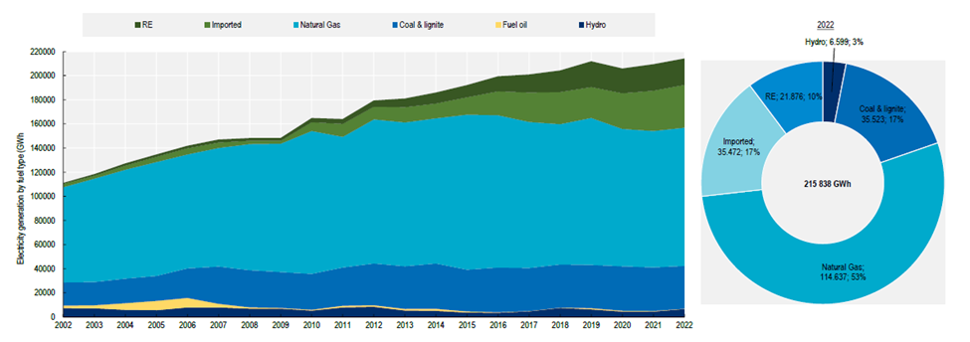
Source: OECD
Achieving this transition requires an estimated 779 billion baht (USD 22 billion) in investment, or 2–5 per cent of GDP annually. Financing will combine public funding and private capital through project finance, green bonds and green loans. While financial institutions increasingly support green initiatives, policy uncertainty, system overcapacity and limited incentives for small-scale projects remain challenges. Expanding the energy service company market and developing innovative mechanisms such as Energy Savings Insurance could further catalyse investment. The uniform electricity tariff plays a fundamental role in maintaining affordability and equitable access to energy, particularly for vulnerable and low-income populations.

2.3 Environment, Climate Change and Natural Hazards
Thailand has articulated a clear vision for sustainable development that aligns with both its national aspirations and international commitments. Central to this vision is the achievement of high-income status by 2037 under the overarching framework of "security, prosperity and sustainability". This ambition is embedded within long-term policy instruments such as the Twenty-Year National Strategy and successive Five-Year National Economic and Social Development Plans, National Adaptation Plan and Climate Change Master Plan B.E. 2558-2593 (2015-2050).
A key policy innovation in this area is Thailand’s Bio-Circular-Green (BCG) Economy model, launched in 2021. The BCG model harnesses the country’s rich biological and cultural diversity alongside advances in science and technology to create value-added goods and services that are environmentally sustainable and economically competitive.

2.3.1 Climate Change: A Critical Challenge
Thailand remains exposed to climate-related risks, ranking 30th out of 174 countries in the Climate Risk Index 2025, an improvement from ninth in the previous period. Advances in disaster management, early warning systems and emissions reduction have reduced vulnerability. However, Thailand’s extensive coastlines, rapid land-use changes largely driven by heavy reliance on agriculture, and urbanization, especially in low-lying vulnerable areas, continue to increase its climate sensitivity. Ocean ecosystems, which are crucial to Thailand’s fisheries, face significant pressure from overfishing, marine pollution and rising sea temperatures linked to climate change, threatening fisheries production worth up to USD 26.2 billion.
The Northeastern and Southern regions are the most vulnerable to climate threats, including droughts, heatwaves, and floods. Between 2016 and 2035, the 10 provinces of Ubon Ratchathani, Nakhon Ratchasima, Si Sa Ket, Nakhon Si Thammarat, Narathiwat, Surin, Songkhla, Buriram, Khon Kaen and Surat Thani are projected to face particularly high climate risks. The Climate Change - Gender and Social Inclusion (CC-GSI) analysis reveals that women bear a disproportionate share of climate-related burdens such as unpaid care duties during disasters, reduced access to health services and economic vulnerability.
Thailand has integrated its green transformation into national planning through a wide array of strategies and initiatives. It prioritizes four key sectors: food and agriculture, human health, bio-based materials and energy, and tourism and the creative economy. Mobilizing sustainable finance is widely recognized as essential to driving the transition. Through the Working Group on Sustainable Finance (WG-SF), Thailand's financial regulators are promoting a viable green finance ecosystem. While government spending on environmentally friendly growth has averaged 108 billion–121 billion baht annually in recent years, it accounts for only 3–4 per cent of the national budget and is declining. To bridge this gap, green bonds and other sustainable financial instruments are gaining momentum.
Carbon markets, although still voluntary in Thailand, are an emerging mechanism to support emissions reductions. The Thailand Voluntary Emission Reduction Project, Thailand Voluntary Emission Trading Scheme and participation in the Clean Development Mechanism exemplify the country’s growing carbon finance portfolio. Thailand currently does not benefit from exemptions from the European Union’s Carbon Border Adjustment Mechanism introduced in 2023, as it lacks a carbon pricing scheme comparable to the EU Emissions Trading System. Although the immediate impact on Thai exports is limited since covered goods account for less than 1 per cent of total exports, the mechanism signals a broader shift towards climate-aligned trade.

2.3.2 Biodiversity Conservation
Thailand hosts exceptional biodiversity, representing 8–10 per cent of global species. Its forests, watersheds and coastal ecosystems provide essential services such as water regulation, flood control and climate moderation, while supporting livelihoods, cultural heritage and the right to a healthy environment. Currently, about 13 per cent of species are classified as endangered, and forest cover stands at just over 31 per cent. The BCG Economy Model aligns biodiversity conservation with sustainable development, advancing the 30 by 30 target to protect 30 per cent of terrestrial and marine areas by 2030. The National Biodiversity Action Plan (2023–2027) and the National Ecosystem Assessment promote habitat protection, sustainable use and inclusive governance through community participation, empowering ethnic minorities and women in managing Thailand’s natural and cultural heritage.

2.3.3 Pollution and Environmental Health
Thailand faces interlinked challenges from climate change, pollution and rapid urbanization, which intensify pressures on ecosystems and public health. Air pollution, particularly PM2.5 and PM10, remains a major concern in urban and agricultural areas, while droughts and forest fires heighten risks. Major sources include vehicular emissions, industrial activities, agricultural burning, and transboundary pollution. Seasonal fires in northern Thailand further worsen air quality, contributing to 32,211 premature deaths annually and causing an economic loss of USD 33 billion in 2019, equivalent to 6 per cent of GDP.
Thailand is transitioning from EURO 3 and 4 to cleaner EURO 5 fuel standards, complemented by fiscal measures such as adjusting gasoline taxes based on fossil fuel content. Recognizing the urgency of forest fires, smoke haze and PM 2.5 pollution, a national committee has been established to enhance cross-sectoral coordination in forest fire management. Emerging environmental policies, such as the draft Climate Change Act and draft Clean Air Act, are expected to strengthen private sector engagement in advancing green finance, sustainable business practices, and responsible value chains.
Thailand faces plastic pollution challenges driven by high consumption, a linear waste system and structural inefficiencies. The plastics industry contributes 8 per cent of GDP and produces 5.5 million tonnes annually. Of the 2.76 million tonnes of plastic waste generated each year, half is inadequately managed, with leakage into rivers and oceans harming biodiversity and tourism. Thailand is advancing a circular economy through the Roadmap on Plastic Waste (2018–2030), BCG Model and legislation promoting recycling, sustainable packaging and green innovation.

2.3.4 Urban Planning for Eco-Smart and Resilient Cities
Thailand’s rapid urbanization is reshaping development, with nearly 60 per cent of the population projected to live in cities by 2030. Secondary centres like Chiang Mai, Khon Kaen, Hat Yai and the Eastern Economic Corridor are emerging alongside Bangkok. Urban systems are central to both climate mitigation and adaptation. Nationally Determined Contributions and long-term net-zero commitments depend heavily on low-carbon transitions in buildings, transport and waste management. At the same time, adaptation will require climate-proofing urban infrastructure, housing, and services to withstand floods, droughts, and heat extremes.

2.4 Poverty, Inequality and Access to Rights and Opportunities

2.4.1 Poverty
Thailand has achieved remarkable socioeconomic progress, attaining upper-middle-income status in 2011 and sharply reducing poverty through sustained growth and long-term development strategies. The national poverty rate dropped from 34.1 to 4.9 per cent, underscoring the country’s enduring commitment to inclusive development.
Figure 5: Number of Monetary Poor People and Households in Thailand

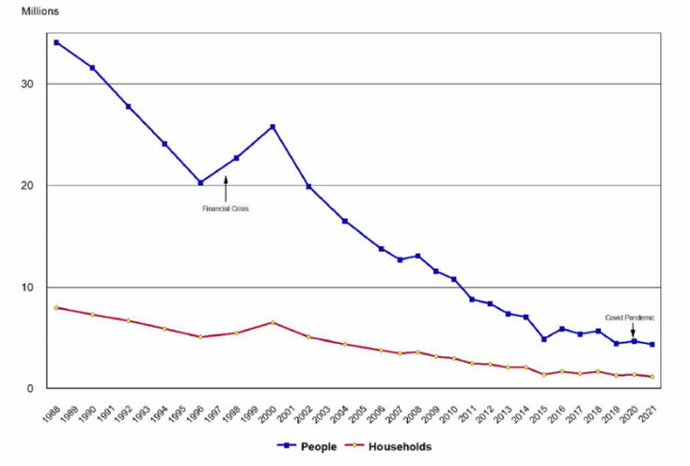
Source: UNICEF
Poverty remains closely associated with age and employment sector. Children and older persons are disproportionately affected, with child poverty (5.8 per cent) exceeding that of adults (2.6 per cent). Persons with disabilities also face higher deprivation with 16.1 per cent living in extreme poverty, reflecting barriers in employment, accessibility and welfare registration. Women remain concentrated in informal, lower-paid and less secure work, particularly in rural and ethnic minority communities.
To capture a more comprehensive picture of poverty, Thailand has developed a national Multidimensional Poverty Index (MPI), led by the National Economic and Social Development Council. In 2023, the national MPI stood at 0.032. Approximately 8.8 per cent of the population (6.1 million people) were multidimensionally poor. Among this group, the average deprivation intensity was 37.1 per cent. The living conditions dimension contributed the most (35.8 per cent), followed by financial security (30.5 per cent) and healthy living (18.5 per cent). The most common deprivations included lack of pensions or allowances (18.1 per cent of the poor), insufficient asset ownership (15.3 per cent) and inadequate garbage disposal (13.9 per cent).

2.4.2 Inequality
In 2023, the income Gini coefficient stood at 41.7 per cent. Wealth inequality is more pronounced, with a Gini coefficient of 63.1 per cent. The richest 10 per cent of the population held 48.8 per cent of net personal income and 74.2 per cent of net personal wealth. Although women in Thailand have achieved higher average educational attainment than men, particularly at the tertiary level, they continue to face persistent labour market barriers.
Significant regional disparities persist at the provincial level. Rural areas, particularly in the South and Northeast, face higher rates of poverty and more limited access to basic services. In 2021, the rural South reported a poverty rate of 13.1 per cent, the highest among all regions. Infrastructure gaps are particularly stark, with only 10 per cent of farm households in the rural South and 13 per cent in the rural Northeast having access to irrigation.
Ethnic minority populations, approximately 6.1 million or nearly 10 per cent of the total population, face persistent barriers stemming from complex identity classification systems and limited recognition of citizenship rights. As of December 2023, over 89,000 individuals remained registered under the category of "other populations without citizenship". The enactment of the Promotion and Protection of the Way of Life of Ethnic Groups Act in August 2025 represents an important step forward, affirming certain rights related to culture, national resources, and protection of ethnic groups. Other legislation, notably the National Park Act 2019 and the Wildlife Conservation and Protection Act 2019, continues to undermine the rights of ethnic groups.
On 29 October 2024, the Royal Thai Government approved a historic resolution to create an accelerated pathway to permanent residency and citizenship for 483,000 stateless persons who are long-term residents and children born in Thailand to stateless parents, many from ethnic minority or hill-tribe backgrounds.
Disability and Inclusion
Persons with disabilities in Thailand face significant disparities in employment, education, and access to services, particularly in rural areas. Of the 4.2 million persons with disabilities (approximately 6 per cent of the population), about half do not complete primary education, and only 1–2 per cent obtain a bachelor’s degree, due in part to inaccessible facilities, lack of trained teachers and occasional denial of admission. Just 21.2 per cent are employed, with only 6.3 per cent in public or private sector jobs, often in low-wage or segregated positions. Stigma, inaccessible workplaces, and limited infrastructure, especially in the North and Northeast, further restrict opportunities.
While the 1 per cent employment quota for persons with disabilities provides a strong legal foundation, significant implementation gaps remain. Many employers opt to pay fines rather than hire, resulting in an estimated 24,000 unfilled employment opportunities each year. Women and girls with disabilities, who face compounded marginalization, experience even more limited access to training and workplace accommodations.
Migrants, Refugees and Asylum-Seekers
Thailand’s labour migration framework supports over 5 million migrant workers, who play an essential role in the economy. Measures to improve social protection coverage, healthcare access and skills recognition continue to progress. The Thailand Migration Report 2024 notes that many migrants, particularly those in irregular status, remain uninsured or face administrative and practical barriers to enrolment and use of health and social protection schemes. Immigration detention remains a central administrative measure in Thailand’s management of irregular entry and related removal procedures.
Although formal mechanisms exist for enrolling regular migrants in the Social Security Fund, only about half are currently covered, and nearly half remain without health insurance. Portability of benefits remains limited, and barriers such as language, legal awareness, discriminatory attitudes, and documentation continue to impede access to public services and redress mechanisms. Domestic workers, many of whom are women, face particular vulnerabilities, including high rates of abuse, lack of leave and limited redress.
Progress has been made with the establishment of the Memorandum of Understanding on the Determination of Measures and Approaches Alternative to Detention for Children in Immigration Detention Centres (MOU-ATD). In addition, Thailand has developed Standard Operating Procedures (SOPs) to implement the MOU-ATD, which came into effect in 2020, ensuring that all relevant stakeholders—including frontline officers, international organizations, and civil society organizations—can effectively operationalize the framework.
Thailand hosts a large refugee population of more than 77,000 individuals primarily from Myanmar, most of whom reside in temporary shelters with restricted mobility and lack formal legal status. On 26 August 2025, the Government approved a landmark resolution granting long-staying refugees in these temporary shelters the legal right to work, signalling a gradual shift toward greater inclusion and self-reliance. While pathways to citizenship or permanent residency remains unavailable, the Government is working to ensure their access to basic rights following the policy that allows them to work outside temporary shelters. Uptake of the National Screening Mechanism has so far been limited, despite its significance. In addition, Thailand withdrew its final reservation to the Convention on the Rights of the Child (CRC), specifically Article 22 on the protection of refugee and asylum-seeking children, effective 30 August 2024.

2.4.3 Human Rights
Thailand continues to demonstrate a commitment to promoting and protecting human rights through legislative, policy and institutional reforms. The Fifth National Human Rights Plan (2023–2027) and the Second National Action Plan on Business and Human Rights aim to strengthen equality and promote inclusive development. As of August 2025, Thailand is party to eight of the nine core international human rights treaties and had been elected as a Member State of the UN Human Rights Council for the 2025–2027 term, committing to a series of pledges to advance human rights domestically, regionally and internationally.
Recent milestones on civil and political rights include the ratification of the International Convention for the Protection of All Persons from Enforced Disappearance in 2024 and the implementation of the Prevention and Suppression of Torture and Enforced Disappearance Act (2023), introducing safeguards aligned with international standards. The National Committee on Torture and Enforced Disappearance also adopted a regulation in 2025 enabling compensation for victims’ families. The National Human Rights Commission of Thailand, reaccredited with “A” status in 2022, continues to expand outreach and regional presence.
In terms of economic, social and cultural rights, Thailand has broadened access to education, healthcare and social protection, while enhancing legal inclusion through initiatives such as the Justice Fund Act and reforms supporting marriage equality. Efforts to align national frameworks with international standards continue, particularly in addressing gender-based violence and improving access to essential services for vulnerable groups, including migrants, stateless persons and persons with disabilities. Universal Health Coverage now extends to some migrant groups, reinforcing Thailand’s commitment to health equity.

2.5 Transboundary Issues
Located at the geographic nexus of mainland Southeast Asia, Thailand occupies a pivotal position in shaping regional cooperation. The country’s response to transboundary threats is informed by its commitment to multilateralism, human security and sustainable development, and anchored in regional and global agreements such as the ASEAN Charter, 2030 Agenda, ASEAN Agreement on Transboundary Haze Pollution, UN Convention against Transnational Organized Crime, Global Compact for Safe, Orderly and Regular Migration, and International Bill of Human Rights.

2.5.1 Transboundary Pollution
Air pollution, especially PM2.5, poses a major threat to health, the environment and livelihoods in Thailand, with domestic sources like agriculture, transport and industry compounded by transboundary pollution during the dry season. Marginalized groups, including children, women, the elderly, persons with disabilities and rural communities, are disproportionately affected. Northern Thailand experiences particularly high health impacts, with PM2.5 causing 41,372 years of life lost to disability annually. Thailand has demonstrated policy leadership through the revision of the National Ambient Air Quality Standards, localized mitigation plans and public consultations on a proposed Clean Air Act.
Transboundary water pollution in Southeast Asia poses growing challenges to public health, biodiversity and food security, affecting the rights and well-being of river-dependent communities. Rivers such as the Mekong, Salween, Kok and Moei face increasing pressures from industrial, mining, agricultural and wastewater discharges.
Plastic debris damages marine ecosystems, fisheries and coastal livelihoods. Pressures arise from domestic mismanagement and transboundary inflows, including illegal waste imports. Thailand has tightened regulations through new contamination criteria and the forthcoming Industrial Waste Management Act, while collaborating with ASEAN and global partners to strengthen enforcement and reduce marine debris by 50 per cent by 2027.

2.5.2 Transnational Organized Crime Trends
Transnational organized crime in Southeast Asia remains a complex challenge, with Thailand serving as both a target and transit hub for drug trafficking, cyber fraud, waste smuggling, money laundering and environmental crimes. Criminal networks increasingly operate through legitimate businesses, such as casinos, Special Economic Zones and logistics firms, and exploit digital tools and cryptocurrencies to move illicit funds undetected. A concerning trend is the rapid rise of cyber-enabled fraud, often through scam centres staffed by trafficked or coerced individuals and operating from jurisdictions with weak oversight.
The Mekong subregion’s illicit drug economy, especially in synthetic drugs such as methamphetamine and ketamine, presents enduring challenges. Thailand remains a significant transit and destination point for illegal wildlife and timber products, including ivory, pangolin scales and Siamese rosewood, as well as for exotic pets and marine species.
Positioned at a regional crossroads, Thailand is simultaneously a source, transit, and destination country for various forms of human trafficking and exploitation, including forced labour, sexual exploitation and forced criminality. Thailand has strengthened its anti-trafficking measures, adopting a victim-centred, gender-sensitive approach. It is the first country in Southeast Asia to establish a National Referral Mechanism to coordinate legal, medical, psychosocial and shelter support with government, civil society, and international partners. The Specialized Cyber Scam and Trafficking in Persons for Forced Criminality Taskforce led by the Royal Thai Police focuses on victim rescue, investigation, and prevention.

CHAPTER 3: MULTIDIMENSIONAL RISK ASSESSMENT
A comprehensive risk assessment was conducted to identify the key challenges that may influence Thailand’s progress toward the SDGs. Input was collected from 507 experts across government, the private sector, academia, research institutions, civil society and international organizations. Respondents evaluated both the likelihood and potential impact of each risk, allowing for aggregated scoring and comparative analysis.

3.1 Risk Ranking and Impact Assessment
The analysis identifies key risk areas shaping Thailand’s sustainable development. Risk scores, ranging from 12.21 to 13.95 on a 1–25 scale, fall within the medium-risk range, highlighting the need for proactive management. Political and democratic risks (13.95) involve instability, corruption, restricted civic freedoms and declining public trust. Economic risks (13.76) relate to stagnation, inequality, high debt and slow reform. Climate, environmental and disaster risks (13.28) emphasize extreme weather, degradation and marginalized impacts. Gender risks (12.32) include unequal participation, gender-based violence and wage disparities. Social cohesion risks (12.21) involve discrimination, harmful narratives and gaps in the consistent application of human rights standards.
Figure 6: Likelihood and Severity Evaluation of Five SDG Risk Categories
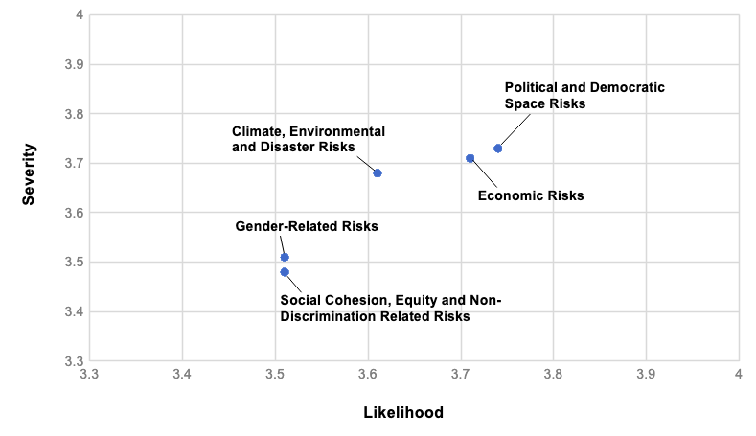
Source: NIDA Poll
Political and Democratic Space Risks
Political and governance-related risks continue to shape Thailand’s sustainable development context. Expert perspectives indicate that these factors have significant influence on the country’s ability to make progress towards the SDGs, particularly in relation to policy coherence, institutional performance, and public trust. Efforts are ongoing to strengthen transparency, accountability and institutional resilience, including in the Southern Border Provinces, where development and security considerations remain closely linked.
Economic Risks
Thailand’s economy has experienced remarkable growth over the past decades, averaging 7.7 per cent annually between 1961 and 1994, and moderating to 2.3 per cent from 2012 to 2025 as structural transformation continues. Achieving high-income status by 2037 will require sustaining annual growth of about 5 per cent. This goal faces headwinds from heightened economic uncertainty. Domestically, political volatility and rising public debt are weighing on investor confidence.
Climate, Environmental and Disaster Risks
Survey findings indicate that the public views climate, environmental and disaster-related risks as both significant and interconnected. Future biological hazards, such as pandemics, received the highest levels of concern, reflecting the lasting imprint of the COVID-19 experience. Closely related is concern over inadequate disaster data systems, underscored by the earthquake in March 2025, which highlighted growing expectations for timely, transparent, and integrated information.
Gender-Related Risks
The assessment of gender-related risks indicates ongoing structural challenges that may influence Thailand’s progress towards achieving the SDGs. While the aggregate risk score suggests a moderate level of concern, expert feedback across diverse sectors reflects a consensus that these issues warrant attention due to their potential impact. Among the identified risks, gender-based violence is regarded as the most pressing, with strong agreement on its likelihood and significant consequences. Challenges related to women’s economic participation and access to decent work, such as wage disparities and limited access to political and social spheres, also represent important barriers to inclusive development.
Social Cohesion, Equity and Non-Discrimination Risks
Insights from experts on risks related to social cohesion, equality and non-discrimination highlight persistent vulnerabilities, particularly regarding unequal opportunities, systemic discrimination and stigmatization that remain evident within institutions, cultural norms, and business practices. Among the most significant risks is the continued exclusion and discrimination faced by marginalized groups, including the rural poor, children, women, persons with disabilities, ethnic minorities, migrants, LGBTQIA+ individuals, people living with HIV, sex workers and people who inject or use drugs.

3.2 Interlinkages Among Risks and Coordinated Responses
Thailand is navigating a transitional period characterized by interconnected political, economic, social, environmental and gender equality dynamics. Survey findings suggest that political uncertainty, marked by changes in government, a sensitive environment for public expression, limited transparency mechanisms and long-standing governance complexities, can undermine democratic principles and human rights, weaken investor confidence, disrupt policy continuity, and affect fiscal management, constraining sustainable economic growth. Conversely, economic pressures such as slowing growth and rising debt may heighten public dissatisfaction. Environmental and climate-related risks disproportionately affect vulnerable groups, including women, small-scale farmers, informal workers, and low-income populations. Although sometimes less prominently highlighted, gender equality plays a structural role in addressing vulnerability.

3.3 Emerging Risks
The survey identifies three key emerging risks with high likelihood and impact: changes in population structure, technology and AI, and health-related risks including pandemics. Experts agree that Thailand is becoming a “fully aged society,” with low birth rates and a shrinking workforce, putting pressure on the labour market, economic productivity, pension systems, healthcare services, and government budgets. While technology helps development in many areas, it also brings new risks such as job loss, skill gaps, data privacy issues, and biased algorithms. Health risks, including pandemics, affect not only public health but also the economy, supply chains, and people’s movement. Strong early warning systems and health infrastructure are needed to handle these threats.

CHAPTER 4: PROGRESS TOWARDS THE 2030 AGENDA

4.1 Thailand’s SDG Integration
Thailand’s 20-Year National Strategy (2017–2036) aligns closely with the SDGs, aiming to foster security, prosperity, and sustainability across key sectors. Building on this foundation, the emerging direction of the draft 14th National Economic and Social Development Plan prioritizes human capital development, structural transformation, and innovation, with focus on health, education, economic growth, and industry (SDGs 3, 4, 8 and 9). It acknowledges the ongoing challenges of inequality (SDGs 5 and 10) and underscores the need for greater emphasis on environmental sustainability (SDGs 7, 11, 12, 13 and 14). Additionally, the draft Plan highlights the importance of enhancing governance and institutional effectiveness (SDG 16).
The 2025 Sustainable Development Report by the Sustainable Development Solutions Network ranks 167 countries on SDG progress using international SDG and non-SDG indicators. Thailand is 43rd globally, up from 45th in 2024, with a score of 75.3, exceeding the East and South Asia regional average of 69.5. Within ASEAN, Thailand retains its leading position for the seventh consecutive year, ahead of Viet Nam, Singapore and Indonesia. In the broader East and South Asia region, Thailand ranks third after Japan and South Korea, underscoring its regional leadership.
Goal 1: No Poverty
Thailand has achieved significant progress in reducing income poverty and enhancing access to essential services, with child multidimensional poverty persisting as a significant challenge.
Goal 2: Zero Hunger
Thailand has made steady progress in reducing undernourishment and stunting among children, although stunting, overweight and obesity rates underscore the importance of fostering food environments that promote healthy nutrition.
Goal 3: Good Health and Well-being
Thailand’s Universal Health Coverage has contributed to low maternal, infant and under-5 mortality rates, alongside a decline in new HIV infections. Looking ahead, Thailand’s demographic transition poses long-term challenges.
Goal 4: Quality Education
Thailand has made notable progress in improving primary and secondary school completion rates and enhancing youth and adult ICT skills. Gaps persist for children in rural, low-income, migrant, disabled and ethnic minority communities.
Goal 5: Gender Equality
Thailand has made notable progress in advancing women’s leadership and participation in decision-making, with a priority to strengthen gender-disaggregated data collection on gender-based violence, unpaid care work and early marriage.
Goal 6: Clean Water and Sanitation
Thailand has improved access to safely managed sanitation, water quality and integrated water resources management. Water stress and equitable access for persons with disabilities and vulnerable groups remain areas of focus.
Goal 7: Affordable and Clean Energy
Access to electricity is nearly universal in urban areas, and energy efficiency has improved. However, the share of renewable energy in total final consumption fell from 2015 to 2022.
Goal 8: Decent Work and Economic Growth
Average hourly earnings and financial inclusion have increased. Youth who are not in education, employment or training, with women and girls accounting for 62.2 per cent, highlight ongoing challenges.
Goal 9: Industry, Innovation and Infrastructure
Digital infrastructure is strong, covering almost the entire population. Manufacturing contributed 25 per cent of GDP in 2024. Nonetheless, a majority of youth and adults lack digital skills and fall below literacy proficiency.
Goal 10: Reduced Inequalities
Thailand has made steady progress in reducing income inequality. The proportion of the population below 50 per cent of median income remains at 10 per cent.
Goal 11: Sustainable Cities and Communities
Urban slum populations have declined. Most local governments implement disaster risk reduction strategies. However, disaster exposure remains high and only 33 per cent of SDG 11 indicators have sufficient data for monitoring.
Goal 12: Responsible Consumption and Production
Electronic waste increases indicate a need for stronger waste management. Recycling rates remain stable, while fossil fuel subsidies have increased. Corporate sustainability reporting has grown.
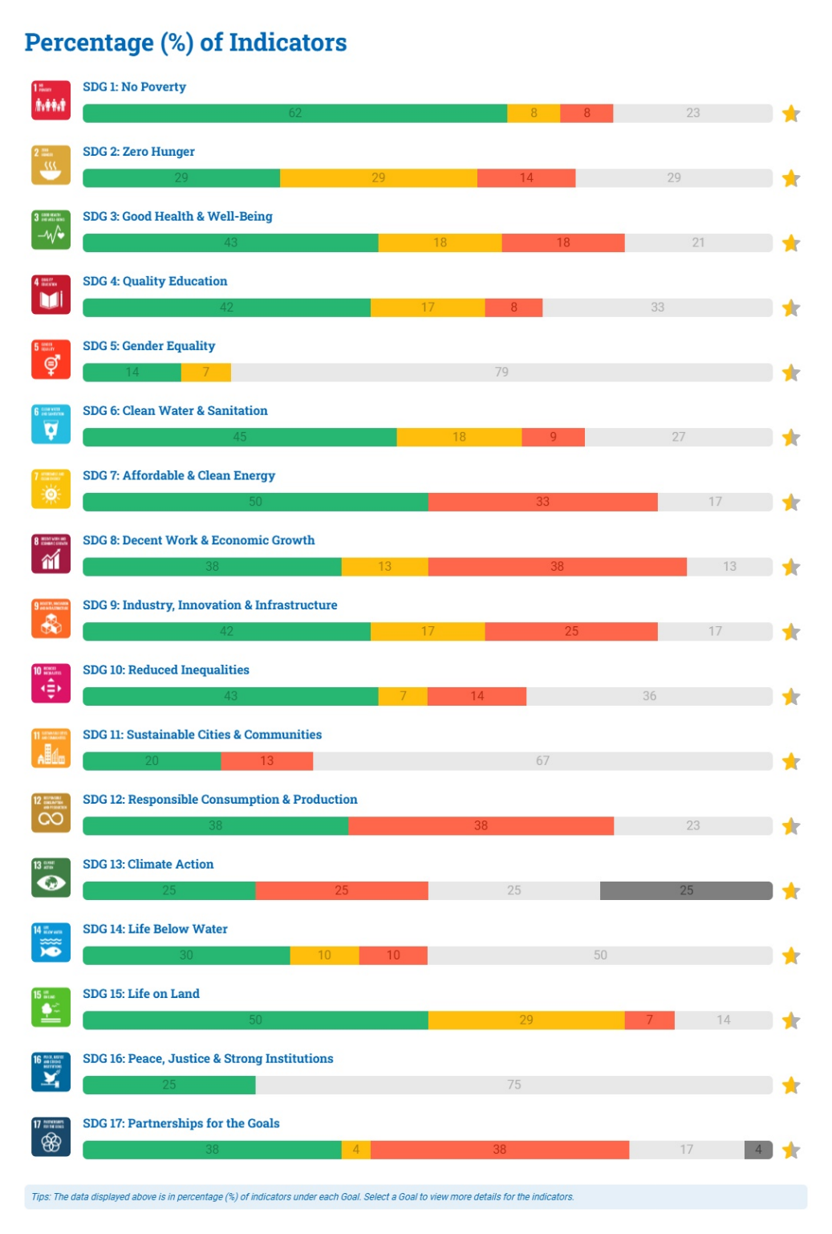
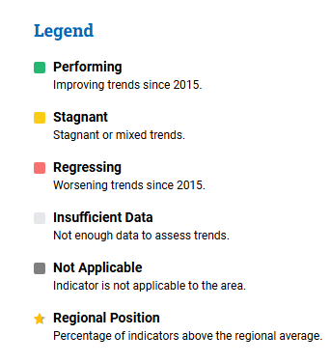
Figure 7: Overview of Thailand’s SDG Trends by Goal

Source: ESCAP Asia-Pacific SDG Gateway (https://data.unescap.org)

Goal 13: Climate Action
Climate-related risks, including droughts and floods, are increasing. Vulnerable communities are disproportionately affected, emphasizing the need for sustained investments in disaster preparedness, adaptation and inclusive climate action.

Goal 14: Life Below Water
Marine conservation has progressed, with protected marine key biodiversity areas increasing from 41.6 per cent in 2015 to 44 per cent in 2022. International cooperation and legal protections for small-scale fisheries support sustainability.
Goal 15: Life on Land
Sustainable forest management has improved, and degraded land declined from 27.8 per cent in 2015 to 26.2 per cent. Forest area has decreased and degraded mountain land increased, indicating ongoing challenges.
Goal 16: Peace, Justice and Strong Institutions
Thailand has made progress in key areas of peace, justice and strong institutions. Draft anti-discrimination legislation and measures supporting human rights defenders are under review.
Goal 17: Partnerships for the Goals
Internet usage is increasing, enhancing digital inclusion. Public-private partnerships for infrastructure has declined, but opportunities remain to strengthen collaboration to advance sustainable development.

4.2 SDG Data Gaps
Thailand demonstrates regional leadership in data availability, with 70 per cent of SDG indicators containing at least two data points, the highest in the Asia-Pacific region. Some challenges persist in ensuring the consistency, quality and disaggregation of data across all indicators. For certain goals, such as 5, 11 and 16, only about one-third or fewer of the indicators have sufficient data. SDG 5 on gender equality represents the most significant data gap in Thailand, with the lowest data availability and performance, underscoring the urgent need for targeted investments in gender-disaggregated data to support inclusive progress. SDG 11 on sustainable cities highlights data challenges that resonate across the agenda, with key urban indicators such as public transport access, environmental risk exposure and housing quality often underreported or insufficiently disaggregated.

CHAPTER 5: SDG FINANCING LANDSCAPE

5.1 SDG Financing Needs
Thailand requires at least an additional 1.27 trillion baht annually to achieve its SDGs by 2030, equivalent to about 50 baht per person per day. Figure 8 below illustrates the additional investments needed, including resources for post-pandemic recovery and climate change challenges.
Figure 8: Thailand’s SDG Financing Gap Analysis Towards 2030
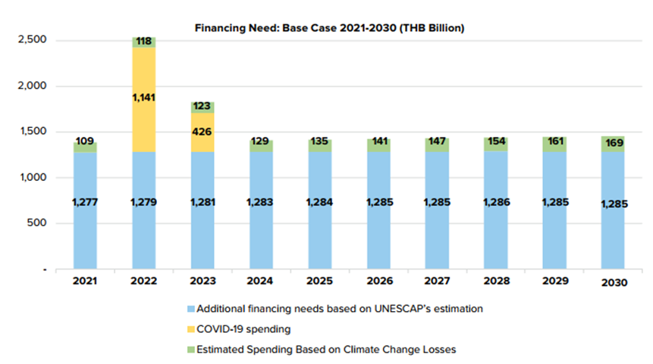
Source: UNDP
Financing needs are projected to increase gradually, from 1.41 trillion baht in 2024 to 1.44 trillion baht by 2030, with the rise largely driven by expenditures related to climate change losses.
To complement broader SDG financing efforts, the Climate Change Finance Strategy (2024) outlines funding needed to meet Nationally Determined Contributions mitigation targets, estimating 5 trillion baht for unconditional and 2 trillion baht for conditional targets, equivalent to 500 billion–700 billion baht annually. Comprehensive estimates for adaptation are still lacking, with UNDP estimating that about 13 billion–14 billion baht would be required to climate-proof transport infrastructure alone.

5.2 Analysis of Climate Finance Flows
The Climate Finance Network Thailand conducted the first comprehensive assessment of financial flows for climate mitigation and adaptation from 2018 to May 2025. At least 1.7 trillion baht was invested in mitigation, with corporations, commercial banks and state-owned enterprises contributing 82 per cent. Energy and transport received 64 per cent of investments, with rooftop solar, electric vehicles and mass transit projects being the most prominent sub-sectors. For adaptation, an estimated 148 billion baht was invested between 2020 and 2024, mostly by the central government. Key adaptation priorities focus on sustainable water management, urban resilience and sustainable agriculture.

5.3 Development Finance Availability
Public Domestic Finance
Public finance as a share of GDP has declined since 2021 following the tapering of COVID-19-related spending. Public resources peaked at 26.7 per cent of GDP in 2020, driven by both higher absolute spending and a contraction in GDP. Between 2000 and 2019, the average budget stood at about 20 per cent of GDP, with a gradual rise from approximately 18 to 21 per cent. In the post-COVID-19 period (2021–2024), revenues initially declined but recovered to 15.1 per cent of GDP in 2024. In 2025, 28.4 per cent of the national budget is allocated to national security and administration, creating trade-offs that leave comparatively less fiscal space for areas like education, health and infrastructure.
Private Development Finance
Private finance has declined overall, mainly due to lower foreign direct investment and portfolio inflows, despite a temporary debt-driven surge in 2022. Domestic private investment remains dominant, accounting for 81 per cent of total private investment and about 16 per cent of GDP in 2024. Foreign direct investment and remittances contributed about 2 per cent of GDP each.

5.4 Sustainable Finance
The Bank of Thailand established the Working Group on Sustainable Finance in 2021, leading to the Thailand Taxonomy Phases I and II providing voluntary guidelines for financial institutions. The Risk-Informed Integrated National Financing Framework launched in 2023 aligns a wide range of instruments, including tax and budget measures, public debt, incentives, insurance and risk finance. Building on this effort, the Ministry of Finance developed the Sustainable Financing Framework to guide the issuance of green, social and sustainability financing instruments aligned with the Paris Agreement and the SDGs. The Public Debt Management Office issued two sustainability bonds in 2020 and 2022, with a combined value of 492 billion baht, and a 30-million-baht bond in 2024 to finance mitigation measures and support the scale-up of zero-emission vehicles. This initiative is expected to expand significantly, with an additional 100 billion baht in financing planned for 2025.
Figure 9: Annual Issuance of ESG Bonds (Million Baht)
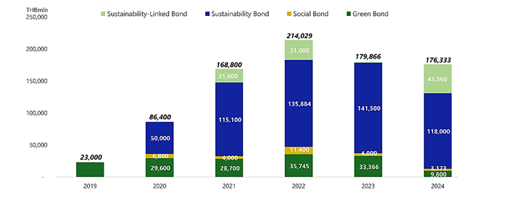
Source: TBMA
The number of ESG-focused funds grew significantly from just 40 funds in 2020 to 155 funds by the end of 2024. Total assets under management in these funds expanded from approximately 3 billion baht in 2020 to over 85 billion baht by the end of 2024. In addition, 228 listed companies (representing 82 per cent of total market capitalization) were included in the SET ESG Rating. Seventy-eight per cent of listed companies disclosed sustainability-related information through the SET ESG Data Platform.
Biodiversity Finance
The Biodiversity Expenditure Review shows that the primary funding source for biodiversity conservation is the government budget, with expenditures totalling 2.08 billion baht for fiscal years 2022–2024. The National Biodiversity Finance Plan promotes subnational public-private solutions and innovative financial mechanisms, including biodiversity credits and tiger bonds. Efforts to realign budgets, reduce costs, generate new revenue and enhance conservation efficiency are creating regional benchmarks supporting integrated, results-oriented biodiversity management.
Climate Change Financing
The Voluntary Emissions Trading Scheme was established in 2015, alongside the Thailand Carbon Offsetting Programme and the Thailand Verified Emissions Reductions Programme, overseen by the Thailand Greenhouse Gas Management Organization. The forthcoming Climate Change Act includes a proposed Climate Change Fund, mandatory Emissions Trading System and provisions for introducing a carbon tax, likely starting with liquid fossil fuels such as diesel and gasoline.
HIV Response Financing
Thailand allocated about USD 260 million annually to its HIV response in 2022–2023, equivalent to 0.05 per cent of GDP, with 91 per cent financed domestically, primarily through Universal Health Coverage schemes. Most funding went to treatment at 74 per cent and prevention at 15.5 per cent. Only 4 per cent of HIV spending in 2022 targeted prevention for key populations, well below the estimated 35 per cent required by 2025.

5.5 MSMEs and Inclusive Sustainable Development
Micro, small and medium-sized enterprises (MSMEs) play a vital role in the economy, contributing 35.2 per cent of GDP, employing 70.4 per cent of the workforce and comprising 99.5 per cent of all registered enterprises in 2023. MSMEs face challenges including limited access to finance, low productivity, low technology adoption, lack of early-stage infrastructure and regulatory barriers. The National Strategy (2018–2037) promotes digital and financial infrastructure, low-interest loans, credit guarantees and capacity-building. Instruments such as the SME Development Fund and Thai Credit Guarantee Corporation support enterprise growth. Thailand also seeks to institutionalize a Women-Owned Business registry linked to business and e-procurement systems, expanding access to finance, capacity-building and market diversification.

CHAPTER 6: CONCLUSIONS
Thailand stands at a pivotal moment in its development journey, having made substantial progress in advancing the 2030 Agenda. Guided by the principles of the Sufficiency Economy Philosophy and integrated national strategies, the country has achieved notable socioeconomic gains, culminating in its transition to an upper-middle-income economy. In the context of the evolving landscape of interconnected risks, Thailand is pursuing accelerated, inclusive and rights-based approaches to realize its long-term goal of attaining high-income status by 2037. These efforts underscore the importance of integrated strategies that address economic, social, environmental and governance dimensions.
Advancing inclusive economic transformation will benefit from policies that enhance equitable income distribution, strengthen labour productivity, and foster innovation and skills development for knowledge-based industries. Supporting micro, small and medium-sized enterprises through access to finance, technology adoption, incubation support and workforce development will further bolster resilient growth. Addressing household debt can enhance economic stability through targeted restructuring, financial literacy programmes and expanded access to affordable financial services. Emerging technologies, when harnessed effectively, present opportunities to reskill the workforce, bridge skill gaps, promote critical thinking and ensure digital inclusion for marginalized groups, particularly women, children and youth, preparing them to thrive in the evolving economy.
Human capital and social protection remain central to Thailand’s sustainable development agenda. Strengthening an inclusive education system from early childhood through lifelong learning is essential, incorporating climate-smart curricula, science and technology programmes for girls, and digital literacy for all. Investments in early childhood education and care yield high returns for both individuals and society, forming the foundation for long-term resilience. Social protection schemes can be broadened to cover informal workers, children, older persons, persons with disabilities, women and migrants, while becoming more responsive to climate-related and other shocks. Expanding coverage, improving benefit design and decoupling entitlements from formal employment will contribute to equitable outcomes.
Demographic shifts, including population ageing, underscore the need for comprehensive approaches to care. Expanding long-term care services, promoting active ageing, supporting employment in the care economy and implementing policies that facilitate women’s participation in the workforce are integral to sustainable social development. Recognizing unpaid care work, extending retirement where appropriate and investing in early childhood development are critical to enhancing societal productivity and resilience. Mental health services, particularly for youth, can be strengthened to address challenges such as depression, suicide risk and substance use. Volunteerism, including among older persons, offers opportunities to foster social cohesion and leverage untapped human capital. Equitable access to healthcare, including for migrants and remote populations, alongside attention to noncommunicable diseases and adolescent reproductive health, further supports inclusive well-being.
Accelerating the green transition and strengthening climate resilience are vital for sustainable growth. Expanding renewable energy adoption, increasing investment in clean technologies and advancing power sector reforms support a low-carbon economy. Policies such as emissions trading and carbon pricing facilitate a just transition, while adaptation efforts prioritize early warning systems, climate-smart agriculture, flood and coastal protection, and community-based disaster risk reduction. Pollution management through improved waste systems, regulatory measures and community-led initiatives, alongside biodiversity conservation through reforestation, sustainable land use and ecosystem protection, reinforces environmental sustainability while respecting customary land rights and local livelihoods.
Strengthening governance, justice and human rights enhances policy coherence and societal resilience. Transparency, accountability and institutional capacity can be reinforced through legal reforms and robust administrative mechanisms. Safeguarding civic space for youth, journalists, human rights defenders and other civil society actors supports inclusive development. Protecting vulnerable groups, including ethnic minorities, stateless persons, refugees, migrants, persons with disabilities, children, youth, women and LGBTQIA+ individuals, ensures equitable access to services, opportunities and justice. Effective responses to organized crime and human trafficking benefit from international cooperation, victim-centred approaches and gender-sensitive interventions. In parallel, comprehensive and disaggregated data collection, especially on gender equality, child well-being and education outcomes, will be indispensable to inform evidence-based policymaking and ensure that no one is left behind.
Mobilizing innovative financing and fostering multi-stakeholder partnerships will be instrumental in bridging resource gaps. Domestic resource mobilization can be strengthened through progressive tax reforms and expanded contributory schemes, while international financing complements national efforts. Sustainable finance instruments that are aligned with development priorities, including green and sustainability-linked bonds, support integrated investment strategies. Capacity-building for regulators, officials and financial professionals enhances the effectiveness of these instruments. Close collaboration among government, the private sector, academia, civil society and international partners will harness diverse expertise and resources to support integrated risk management and sustainable development, ensuring that Thailand continues its trajectory toward inclusive, resilient and sustainable growth.

NESDC, Poverty and Inequality Report 2024, 2025.
https://thailand.prd.go.th/en/content/category/detail/id/48/iid/352895
https://www.nationthailand.com/news/policy/40056322
National Statistical Office and UNICEF, Thailand: Multiple Indicator Cluster Survey 2022, 2022.
NESDC, 4Q2025 Social Development Report, 2026.
Krungsri Research, Aged Society: Embracing Challenges and Unlocking Opportunities, 2024.
Germanwatch, Climate Risk Index 2025, 2025.
SDSN, Sustainable Development Report, 2025.
UNDP, Development Finance Assessment for Thailand, 2023.
UNDP, The 6th Thailand Human Development Report, 2025.
UNDP, Human Development Report 2023, 2025.
Ibid.
UNDP, The 6th Thailand Human Development Report, 2025.
UNICEF, The Costs and Benefits of Mental Health and Psychosocial Support (MHPSS) for Children and Adolescents in Education Settings in Thailand, 2024.
UNICEF, Human Capital Development in Thailand: An Examination of Gaps, Bottlenecks, and Policy Options, 2025.
UNICEF, Thailand Education Fact Sheets, 2022.
UNDP, Human Development Report 2025, 2025.
World Bank, Bridging the Gap: Inequality and Jobs in Thailand, 2023.
Ibid.
Promoting gender equality is not only a matter of rights but also offers significant economic benefits. For example, the McKinsey Global Institute estimates that improving gender equality in Thailand could generate economic gains equivalent to 12 per cent of GDP by 2025.
UN Women, Caring Societies, Inclusive, and Green Economies in Asia and the Pacific, 2024.
Ibid.
Civil and Commercial Code Amendment Act (No 24), 2567 B.E. passed on 23 Jan 2025
World Bank, Caring for Thailand’s Aging Population, 2021.
UNDP, Human Development Report 2023, 2025.
TDRI, Valuation of Losses from Road Accidents in Thailand, 2024.
National Statistical Office and UNICEF, Thailand: Multiple Indicator Cluster Survey 2022, 2022.
Pongcharoen, T. et al., South East Asian Nutrition Surveys II (SEANUTS II) Thailand: Triple burden of malnutrition among Thai children aged 6 months to 12 years, 2024.
Mahidol University and Thai Health Promotion Foundation, Thai Health Report 2025, 2025.
https://hivhub.ddc.moph.go.th/executive/aids.php
Ibid.
WHO, Thailand Health System Review, 2024.
Krungsri Research, Aged Society: Embracing Challenges and Unlocking Opportunities, 2024.
Ministry of Social Development and Human Security, Situation of the Thai Older Persons 2023, 2024.
Krungsri Research, Aged Society: Embracing Challenges and Unlocking Opportunities, 2024.
Ministry of Social Development and Human Security, Situation of the Thai Older Persons 2023, 2024.
Krungsri Research, Aged Society: Embracing Challenges and Unlocking Opportunities, 2024.
World Bank, Towards Social Protection 4.0: An Assessment of Thailand’s Social Protection and Labor Market Systems, 2021.
ESCAP, Readiness to Implement the Action Plan to Strengthen Regional Cooperation on Social Protection: Thailand, 2025.
NESDC, 4Q2025 Gross Domestic Product Report, 2026.
FAO, Brief on the State of the Agrifood System in Thailand, 2025.
Ibid.
NESDC, 4Q2025 Gross Domestic Product Report, 2026.
NESDC, 4Q2025 Social Development Report, 2026.
Ibid.
IMF, The 2024 Article IV Consultation Report, 2025.
Public Relations Department of Thailand. Significant improvement of Thailand’s global digital government ranking, 2025.
Bank of Thailand, Directions for Development of Payment Systems Under the New Financial Sector Landscape of Thailand, 2022.
PIER, Understanding the Dynamic of Digital Economy in the Context of Digital Literacy of Thai Households, 2020.
Ibid.
Mahidol University and Thai Health Promotion Foundation, Thai Health Report 2024, 2024.
Friedrich-Ebert-Stiftung, Energy Transition in Thailand – Challenges and Opportunities, 2017.
OECD, Clean Energy Finance and Investment Roadmap of Thailand, 2024.
Ibid.
Germanwatch, Climate Risk Index 2025, 2025.
ASEAN et al., ASEAN Gender Outlook 2024, 2024.
World Bank, Towards A Green and Resilient Thailand, 2024.
Ibid.
UNDP, Integrating Climate Change with Gender and Social Inclusion in Thailand (CC-GSI), 2024.
TDRI, Stocktaking Study on Green Economy Thailand Report, 2021.
As part of the forthcoming Climate Change Act, Thailand plans to establish an Emissions Trading System (ETS) and introduce a carbon tax, creating market-based mechanisms to incentivize emissions reductions and accelerate the transition to a low-carbon economy.
TDRI, Stocktaking Study on Green Economy Thailand Report, 2021
World Bank, Towards A Green and Resilient Thailand, 2024.
World Bank, Towards A Green and Resilient Thailand, 2024.
UNEP, Plastic Pollution and Circularity: Informing the Common Country Analysis of Thailand, internal document, 2025.
NESDC, Poverty and Inequality Report 2024, 2025.
UNICEF, Measuring Poverty in Thailand, 2024.
UNICEF, The 2022 Disability Survey, 2022.
NESDC, Multidimensional Poverty Index 2021, 2022.
NESDC, Poverty and Inequality Report 2023, 2024.
World Bank, Bridging the Gap: Inequality and Jobs in Thailand, 2023.
Ibid.
World Bank, Bridging the Gap: Inequality and Jobs in Thailand, 2023.
United Nations Network on Migration in Thailand, Thailand Migration Report 2024, 2024.
UNICEF, The 2022 Disability Survey, 2022.
Ibid.
Ibid.
Ibid.
United Nations Network on Migration in Thailand, Thailand Migration Report 2024, 2024.
Ibid.
OHCHR, Pathways to Migrant Protection: A Mapping of National Practice for Admission and Stay on Human Rights and Humanitarian Grounds in Asia and the Pacific, 2022.
United Nations Network on Migration in Thailand, Thailand Migration Report 2024, 2024.
Supasri et al., Association between ambient air particulate matter and human health impacts in northern Thailand, 2023.
Mutlidimensional Risk Assessment Study conducted in partnership with NIDA, May 2025
Using stratified, proportional and purposive sampling, data were collected in person and online, analyzed with descriptive statistics, and used to generate composite risk scores following UNDRR methodology, enabling prioritized, evidence-based insights to inform policy and strategic planning.
https://dashboards.sdgindex.org/
UNRCO, Thailand: Financial Landscape and Opportunities in 2021, 2021.
UNDP, Development Finance Assessment for Thailand, 2023.
UNDP, Identified investment needed for climate-proof transport infrastructure in Thailand, 2022.
https://climatefinancethai.com/tracker/mitigation/
https://climatefinancethai.com/tracker/adaptation/
UNRCO, Thailand: Financial Landscape and Opportunities in 2021, 2021.
Ibid.
Budget Bureau, Thailand’s Budget in Brief Fiscal Year 2025, 2024.
Public Debt Management Office, 2024 Sustainability Bond Annual Report, 2025.
UNAIDS, HIV Financial Dashboard, 2025
Ibid.
ADB, Asia Small and Medium-Sized Enterprise Monitor, 2024.
World Bank, Thailand Economic Monitor: February 2025, 2025.

