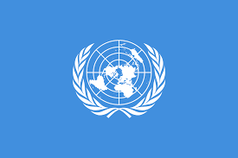

PACIFIC Common Multi Country Assessment

December 1, 2021 – V9.0

Table of Contents

Acronyms 5
Executive Summary 10
1. Introduction: Pacific UN Context 13
2. Purpose, Scope and Methodology of the PCMCA Process 16
2.1 Scope of the PCMCA 17
2.2 Methodology 19
3. Regional Context 20
3.1 Overview of the Region. Geopolitical Analysis 20
3.1.1 Population 20
Dispersion of Population 20
Population Growth and Flows 21
Labour Mobility 22
3.1.2 Land and Ocean in the Blue Pacific Continent 23
3.1.3 Distance 25
3.1.4 Climate and Disaster Risk 28
3.2 Macroeconomic Context and Economic Transformation Analysis 29
Human Development 29
Poverty 30
Labour Market Analysis 31
3.2.1 Emerging Frontiers and Transformational Opportunities 33
3.2.2 Digital Transformation 35
3.2.3 Blue Economy 39
3.2.4 Green Economy 44
Agriculture 44
Forestry 47
3.2.5 Renewable Energy, Mineral, Oil and Gas Extraction 49
3.2.6 Innovative Financing and FDI 52
3.2.7 The Care Economy 55
3.3 COVID Impact Analysis 57
3.4 Pacific Countries’ Position on the Multi-dimensional Vulnerability Index 65
3.5 Regional Integration and Political Context 68
3.6 Regional Development Challenges and Pacific Vision 73
The 2050 Strategy for the Blue Pacific Continent 74
4. Progress towards the 2030 Agenda in the Pacific 76
4.1 Environmental Analysis 76
Asset Loss Value Calculation 76
Cyclones, Tsunamis, Earthquakes and Droughts 77
Water, Sanitation & Hygiene 79
Fragility of Land and Marine Natural Environments 84
International Agreements on Biodiversity and the Pacific 86
The Paris Agreement and the Pacific 87
4.2 Governance and Institutional Analysis 88
4.3 Human Rights Commitments under International Norms and Standards 95
Status of Human Rights Treaties Ratification in the Pacific 98
4.1.1 Fundamental Freedoms 101
4.1.2 Public Services 102
4.1.3 Right to Health 102
4.1.4 Right to Education 109
4.1.5 Right to Food 114
4.1.6 Right to Work 115
4.2 Social Exclusion Analysis 116
4.2.1 Poverty Drivers and Outcomes 116
Inequality in the Outer Islands 118
Inequality of Opportunity and Intersecting Disadvantages 119
4.2.2 Gender Analysis 120
4.2.3 Children and Youth Integration Analysis 125
4.2.4 Rights of Persons with Disability 131
4.2.5 Other Populations at Risk or Furthest Behind 133
Children 133
Indigenous People 134
LGBTIQ+ 135
Older Persons 135
Refugees and Asylum Seekers 136
Incarcerated Persons 136
Other Groups 136
4.3 Multidimensional SDG Risk Analysis 137
4.3.1 Regional SDG Dashboard. SDG Assessment of Key Targets. 139
4.3.2 Risks to Peace and Security 140
4.3.3 Risks to the Environment and Climate Resilience 141
4.3.4 Risks to Sustainable Economic Growth 143
4.3.5 Risks to Social Progress and Social Cohesion 144
4.3.6 Risks to Gender Equality 144
4.4 Transboundary, Regional, and Subregional Perspectives 147
4.4.1 Humanitarian-Development Nexus 147
4.4.2 Population Migration and Displacement 149
Displacement 151
Trafficking in Persons in the Pacific 152
Migrant Smuggling in the Pacific 153
4.5 Financial and Partnership Landscape Analysis 154
Concessional Debt Financing and ODA 154
Regional Institutions 158
Private Sector, FDI, Public Revenue and Debt 158
5 Conclusions: Key Opportunities towards Achieving the SDGs in the Pacific 162
References 168

Acronyms

AAL Average Annual Loss
ABS Australian Bureau of Statistics
ADB Asian Development Bank
ADRA Adventist Development and Relief Agency
AECID Agencia Española de Cooperación International para el Desarrollo
BAU Business As Usual
B Biennial
Bn Billion
CAT Convention against Torture and Other Cruel Inhuman or Degrading Treatment or Punishment
CBD Convention on Biological Diversity
CCA Common Country Assessment
CED Convention against Enforced Disappearances
CEDAW Convention on the Elimination of All Forms of Discrimination against Women
CFC Cobalt-rich Ferromanganese Crusts
CMCA Common Multi Country Analysis
CMW Convention on the Protection of the Rights of All Migrant Workers and Members of their Families
COP Conference of the Parties
COVID Coronavirus Disease
CRC Convention on the Rights of the Child
CROP Council of Regional Organizations in the Pacific
CRPD Convention on the Rights of Persons with Disabilities
DESA Department of Economic and Social Affairs
DIOC Database of Immigrants to OECD Countries
DPPA Department of Political and Peacebuilding Affairs
DSM Deep Sea Mining
DSSI Debt Service Suspension Initiative
EEZ Exclusive Economic Zone
EHRD Environmental Human Rights Defenders
ESCAP Economic and Social Commission for Asia and the Pacific
EU European Union
FAO Food and Agriculture Organization of the United Nations
FDI Foreign Direct Investment
FEMM Forum of Economic Ministers Meeting
FFA Pacific Islands Forum Fisheries Agency
FfD Finance for Development
FFGS Flash Flood Guiding System
FOI Freedom of Information
FPIC Free, Prior and Informed Consent
FPR Framework for Pacific Regionalism
FRDP Framework for Resilient Development in the Pacific
FSM Federated States of Micronesia
GANHRI Global Alliance of National Human Rights Institutions
GBV Gender-based Violence
GDP Gross Domestic Product
GHG Greenhouse Gas
GNI Gross National Income
HDI Human Development Index
HDN Humanitarian-Development Nexus
HIV Human Immunodeficiency Virus
HPV Human Papilloma Virus
HRD Human Rights Defenders
ICAC Independent Commission Against Corruption
ICCPR International Covenant on Civil and Political Rights
ICERD International Covenant on the Elimination of All Forms of Racial Discrimination
ICESCR International Covenant on Economic Social and Cultural Rights
ICT Information and Communication Technologies
IDMC Internal Displacement Monitoring Centre
IFAD International Fund for Agricultural Development
IFHV Institute for International Law of Peace and Armed Conflict
ILO International Labour Organisation
IMF International Monetary Fund
INFF Integrated National Financing Frameworks
INTOSAI International Organization of Supreme Audit Institutions
IOM International Organization for Migration
ISO International Organisation for Standardisation
ITC International Trade Centre
ITU International Telecommunications Union
IUU Illegal, unreported, and unregulated (fishing)
LGBTIQ+ Lesbian, Gay, Bisexual, Transsexual, Intersex, Queer (or Questioning) and other sexual identities (+)
LNOB Leave No One Behind
M Million
MDG Millennium Development Goals
MDTF Multi Donor Trust Fund
MHMS Ministry of Health and Medical Services
MICS Multiple Indicator Cluster Surveys
MP Member of Parliament
MPA Marine Protected Area
MSME Micro, Small and Medium Entreprise
MSW Municipal Solid Waste
MVI Multidimensional Vulnerability Index
NCD Non-Communicable Disease
NDC Nationally Determined Contribution
NDP National Development Plan
NEET Not in Employment, Education or Training
NGO Non-Governmental Organisation
NHRI National Human Rights Institution
NMHS National Meteorological and Hydrological Services
NMRF National Mechanism for Reporting and Follow-up (on HR)
NZL New Zealand
OCHA Office for the Coordination of Humanitarian Affairs
ODA Official Development Assistance
OECD Organisation for Economic Cooperation and Development
OHCHR Office of the UN High Commissioner for Human Rights
PACER Pacific Agreement on Closer Economic Relations
PASO Pacific Aviation Safety Office
PCMCA Pacific Common Multi Country Analysis
PFRPD Pacific Framework for the Rights of Persons with Disabilities
PHES Pacific Heads of Education Systems
PIC Pacific Island Countries
PICTA Pacific Island Countries Trade Agreement
PICTs Pacific Island Countries and Territories
PIDF Pacific Island Development Forum
PIDP Pacific Islands Development Programme
PIF Pacific Islands Forum
PIFS Pacific Islands Forum Secretariat
PILNA Pacific Islands Literacy and Numeracy Assessment
PIPSO Pacific Islands Private Sector Organisation
PLGED Pacific Leaders Gender Equality Declaration
PLS Pacific Labour Scheme
PMN Polymetallic Manganese Nodules
PNG Papua New Guinea
PPA Pacific Power Association
PPP Public-Private Partnership
PRP Pacific Resilience Partnership
PRSD Pacific Roadmap for Sustainable Development
PTFAC Pacific Financial Technical Assistance Centre
PT&I Pacific & Trade Invest
Q Quadrennial
RCC Regional Climate Centre
RCO Resident Coordinator´s Office
RMI Republic of the Marshall Islands
RMNCAH Reproductive, Maternal, New-born, Child and Adolescent Health
RSE (New Zealand’s) Recognised Seasonal Employer
SAI Supreme Audit Institution
SAMOA SIDS Accelerated Modalities for Action
SDG Sustainable Development Goals
SDR Sustainable Development Report
SDSN Sustainable Development Solutions Network
SIDS Small Islands Developing States
SMS Seafloor Massive Sulphides
SOE State of Emergency
SOPAC South Pacific Applied Geo-Science Commission
SPC Pacific Community
SPREP Secretariat of the Pacific Regional Environment Programme
SPTO South Pacific Tourism Organisation
SSC South-South Cooperation
STI Sexually Transmitted Infection
SWFP Severe Weather Forecasting Programme
SWP (Australia’s) Seasonal Worker Programme
TAD Transboundary Animal Disease
TB Tuberculosis
TC Tropical Cyclone
TCOP Tropical Cyclone Operational Plan
TVET Technical and Vocational Education and Training
UIS UNESCO Institute of Statistics
UN United Nations
UNAIDS Joint United Nations Programme on HIV/AIDS
UNCAC United Nations Convention Against Corruption
UNCDF United Nations Capital Development Fund
UNCLOS United Nations Convention on the Law of the Sea
UNCTAD United Nations Conference on Trade and Development
UNDESA United Nations Department of Economic and Social Affairs
UNDP United Nations Development Programme
UNDRR United Nations Office for Disaster Risk Reduction
UNEP United Nations Environment Programme
UNESCO United Nations Educational, Scientific and Cultural Organisation
UNFCCC United Nations Framework Convention on Climate Change
UNFPA United Nations Population Fund
UNGASS Special Session of the UN General Assembly
UNICEF United Nations Children's Fund
UNODC United Nations Office on Drugs and Crime
UNOHRLLS United Nations Office of the High Representative for the Least Developed Countries, Landlocked Developing Countries and Small Island Developing States
UNPRPD United Nations Partnership on the Rights of Persons with Disabilities
UN WOMEN United Nations Entity for Gender Equality and the Empowerment of Women
UNWTO United Nations World Tourism Organisation
UPR Universal Periodic Review
USA United States of America
USD United States Dollar
USP University of the South Pacific
VAW Violence Against Women
VNR Voluntary National Review
WASH Water, Sanitation and Hygiene
WB World Bank
WCPFC Western and Central Pacific Fisheries Commission
WDI World Development Indicators
WFP World Food Programme
WHO World Health Organisation
WMO World Meteorological Organization
WWF World Wildlife Fund

Executive Summary

The world is changing dramatically, and so is the Pacific. New opportunities are emerging for Pacific Islanders, particularly in tourism and technology, offering employment and making education and skills development ever more relevant. Amidst the many opportunities, represented mainly by the Blue Economy, the Digital Transformation and the Demographic Dividend, immense challenges persist. Many are common, some remain specific amidst the wide diversity of Pacific Island contexts, from the increasing risk of communicable and non-communicable diseases to the worsening climate change impacts and growing disaster risk exposure. The latter combined with the effects of COVID-19 will affect development gains, exacerbate poverty and undermine resilience, highlighting the importance of increased investment in social protection measures to shield the most vulnerable.

COVID-19 has shown the resilience and governance capacities of the PICTs, but also highlighted the fragility of its economies, the limitations of its public services and its interdependence with overseas territories. People, their prosperity, the ecosystems, and the economies in the Pacific are particularly vulnerable to multidimensional impacts from different shocks because of geographical remoteness and isolation, dependence on imports from abroad, dispersion across a large area of the ocean, economic and social challenges and the degradation of natural resources. Shortcomings of the health systems before the outbreak led to closing the borders to avoid a catastrophe. Past underinvestment in health has deepened economic vulnerabilities, a lesson for the future, where robust essential social services will help build resilience. As a health and development exigency, COVID-19 will require universal vaccination in the Pacific over the shortest possible period. COVID-19 also demonstrated the need for a well-supported care economy, comprising the formal, albeit generally under-resourced and low-paid health and education sectors, and the unpaid but profoundly important work of child-care, elder-care and domestic activities in general.

Many of those providing or requiring care in the Pacific, especially Pacific women, and other groups of population, have been left behind or are at risk of being left behind. Most Pacific women live under actual violence or the threat of it. Despite the complexity of obtaining accurate data in relation to violence against women and children, it is widely accepted that the Pacific has some of the highest rates in the world, and as a region, it is around twice the global average. In the early months of the pandemic, an increased demand for domestic violence support services indicated that this situation was deteriorating further still. In 2020, helpline calls in Samoa jumped 150% from the same time the previous year while in Fiji the national domestic violence helpline recorded 500% more calls in April than it did in February.
Women predominate in vulnerable employment and the gender pay gap is high. Deprivation of bodily autonomy undermines Pacific women’s agency in every area of life, to the detriment of inclusive growth. Accelerated progress to reduce gender inequality is necessary if equal and shared progress is to be achieved under the 2030 Agenda.

Children in the Pacific, who account for 40% of the population, experience multiple forms of vulnerabilities and deprivations that may prevent them from reaching their full potential. They are more likely to be in poverty than their adult counterparts. Children may face exclusion in access to key essential services such as health, education, protection and social welfare, a situation worsened by their little voice in key decision-making processes that affect their wellbeing. The triple burden of malnutrition is a clear and present threat to early childhood development. The most prevalent forms of malnutrition among children under five are stunting, anaemia, overweight and obesity. Access to early childhood education is increasing. Quality in the delivery and equity in access need more attention to ensure all children gain the foundational learning they need to succeed. Many children in the Pacific are also subject to violence, abuse, negligence and exploitation at home, at school and in the community. The negative impact of child deprivations can have profound and irreversible effects into their adulthood with a lasting impact on the long-term national development trajectory. The survival, protection and development of children should be prioritized in any inclusive development agenda that aspires to leaving no one behind.

On their current path, NCDs could cause enormous losses to Pacific societies, families, and individuals, in terms of quality of life and poor health outcomes. Changing climate, especially rising temperatures, create an environment much more conducive to life-threatening microorganisms and bacteria that cause disease, viruses in the water and plant pathogens. The NCDs also impact the economy and are forecast to represent losses between three and ten percent of GDP by 2040 across the region. According to the IPCC, the impacts of climate change and natural hazard-induced disasters are expected to continue to increase, reversing hard-fought development gains. NCDs place additional burden of care on women and girls which further limits their capacity to participate in development actions.

The impact of COVID-19 on the realisation of human rights in the Pacific and progress towards the Sustainable Development Goals has resulted in a devastating blow. In building a post COVID-19 Pacific there are, however, opportunities to address the harsh lessons the pandemic has taught about previous shortcomings.

Some of the future opportunities for the Pacific, if not sustainably managed, bring new problems along: resource exploitation that trades long-term environmental degradation for only short-term economic gain and mass tourism that deteriorates pristine habitats present dilemmas to societies that do not have an unlimited list of economic options for development. The return of tourism is one of the avenues, likely a gradual one, to provide an enhanced economic backbone for many countries in our region, in the context of economic strategies that seek greater diversification. Tourism will be surrounded by uncertainties in the coming years, from health safety to flight routes, origin and typology of demand. The future of tourism in the Pacific, if it is to be sustainable, is linked to the concept of Building Back Better and to the need for reimagining an economic activity without sacrificing the environment where it takes place, which is its main asset.

Effective engagement in Deep Sea Mining (DSM) will require robust social and environmental safeguards, appropriately trained human resources and further analysis of its cumulative impacts. The potentially harmful impact of DSM on ocean sustainability has not been assessed.

The UN in the Pacific does not promote a mineral resources-intensive economic diversification strategy. Extreme caution needs to be exercised in mining industry development especially by PICTs who are already sponsoring and licensing states, with exploration activities underway. The United Nations is however cognizant of the existence of these resources and participates in the debate on the advisability of their exploitation, well-aware of the limited growth options PICTs have at their disposal and expressing a strong preference for new approaches to economic development that would steer COVID-19 recovery investments toward a greener, more inclusive and sustainable future.
An integrated whole-of-government strategy for digital transformation is one of the keys to accelerate Pacific Island countries and territories´ progress towards the Sustainable Development Goals. It requires policies, legislation, plans and frameworks, infrastructure, cybersecurity, capacity building, and the development of digital services, including emergency telecommunications with a lens of digital inclusion to avoid the recreation of a divide. Improved internet access and connectivity would not only significantly increase productivity in the Pacific, but also create new opportunities for Pacific workers to join global value chains. Labour market mobility and DSM are realities that present significant risks, requiring a precautionary approach, and potential opportunities, if appropriately managed with sustainable human development criteria. Investments in education and skills training need to be geared towards labour market opportunities, and a balance must be found between new forms of employment and the sustainability of livelihoods for those who remain in remote and coastal communities.

Social cohesion and inclusive growth are two sides of the same equation to trigger a successful and sustainable development in the Pacific. This will include addressing poverty; geographic disparities; high rates of youth unemployment and adolescent pregnancy amongst a numerous youth population; discrimination against women including barriers to paid work, low rates of women in leadership and high rates of gender-based violence; and the need to include a range of at risk or excluded groups including persons with disabilities, LGBTIQ+ communities, human rights defenders, and older people in development initiatives with a view to empowering them. Focused programming needs to continue in the region to align laws and create policies consistent with human rights treaty commitments.

Strong governance and a Human Rights-based approach to development are the antidotes to exclusion that will support peaceful, more resilient, and more inclusive societies. PICTs have been actively promoting good governance over many years, but despite the explicit region-wide political commitment and many initiatives across PICTs, examples of poor governance persist with regards to parliaments, executive governments and key institutions such as auditors general and ombudsman offices. Some of these shortcomings have likely contributed to weak economic growth across Pacific Island countries. It is important to strengthen implementation of international human rights treaty commitments and independent institutions such as national human rights commissions and to ensure enhanced participation of civil society and non-governmental organisations.

Regional stability is facing emerging and growing threats which, in turn, can have negative long-term effects on economic growth, sustainable development and enjoyment of human rights. Whereas the Pacific region is generally known for relatively high levels of social resilience and low levels of armed violent conflicts, interpersonal violence, particularly against women, is widespread. Although the Solomon Islands stand out as the only PICT that has experienced violent conflict, there have been accounts of political unrest in Tonga, Vanuatu and Fiji and ensuring the prevention of the emergence of conflict or relapse is critical for sustaining peace in the region. Potential threats to peace and security of PICTs include corruption, population growth, urbanization, migration, displacement and migration, climate fragility risks, water resource issues, agricultural production decline, youth unemployment, political instability, unstable governance, rising socio-economic inequalities and exclusion, poor resource management and land disputes, exacerbated by the growing negative effects of climate change on the environment and customary livelihoods, as well as shifts in the international order, increasing transnational organized crime and cyberattacks.

A central issue which affects the accountability and responsiveness of Pacific regional and national institutions is the paucity of data which constrains evidence-based planning, monitoring, reporting and evaluation. Apart from weak statistical capacities and limited financing, this challenge is also rooted in the Pacific region’s unique geographic and demographic context and limited appreciation of planning, monitoring and utilization data/evidence from evaluations for decision making, target setting and planning for the SDGs.
A well-governed Pacific, which promotes and protects human rights, pursues climate and disaster resilience development, that will avert, minimize and address loss and damage and leave no one behind, with a pathway towards sustainable development and equitable growth, will require political will, committed partnerships and access to necessary climate and development finance. This analysis addresses some of the requisites and conditions under which such a horizon is attainable.

Introduction: Pacific UN Context

Since the approval of the last Common Country Analysis by the United Nations in the Pacific (2020), and even more strikingly, since the United Nations Pacific Strategy 2018-2022 was adopted (2017), the megatrends affecting the Pacific have remained the same, with the significant gamechanger introduced by the COVID-19 pandemic outbreak and the response of the Pacific Island Countries and Territories (PICTs) on the health, social and economic fronts. Regional differences of perspective have appeared on the Pacific coordination scene. Conversely, the Pacific leaders have consolidated the notion and the practice of speaking with one voice, especially on global affairs such as development finance, climate action, disaster risk reduction and ocean policy.

The Pacific nations have seen how growing inequalities have exacerbated the hardship of the new poor. Economic opportunities linked to growth sectors, labour mobility and social protection mechanisms enabled by the States have decreased in intensity and coverage and been in many cases redirected towards COVID-19 health and economic resilience responses. Voluntary and safe migration leading to meaningful employment can contribute to positive development outcomes as migrants and their families may benefit from increased income, skills and capacities, allowing them and their families, the recipients of remittances, to spend more on basic needs, access education and health services, and make social and economic investments. One ongoing trend linked to the digitalisation of the economy and societies has accelerated its pace with the impact of the pandemic. E-learning has become the norm for a while, although it has not been universally available. Remote communications have become necessary for all transactions. Services have been provided and received online. Those who had developed the infrastructure and the skills necessary to evolve confidently in this “all-virtual” atmosphere have been able to cope with the difficulties of social distancing. Those who missed this boat are frequently those who already suffer from one or more form of social disadvantage, have fallen further behind and become even more excluded.

The UN architecture in the Pacific has further evolved towards integration, collaboration, coordination and specialisation in support of the region´s needs. The Pacific Humanitarian Team (PHT) which is a network of humanitarian organizations (comprising of UN agencies and representatives of INGOs and the Red Cross Movement) assists the fourteen Pacific Island countries covered by this regional strategy in preparing for and responding to disasters. It oversights nine regional clusters which focus on operational issues and provides support to national disaster preparedness and response systems. The Pacific region is one of the most disaster-affected zones in the world in terms of the recurrence, severity and scope of natural hazards, accelerated by climate change. Nearly all countries within the PHT’s Area of Responsibility – such as Fiji, Solomon Islands, Vanuatu, Samoa and Tonga – have established their own national clusters or working groups that are responsible for coordinating disaster preparedness and response, and Solomon Islands has recently established its own National Emergency Response Team. The PHT fully recognizes and supports these national structures. In addition, and parallel to the work of regional clusters with their national counterparts, UN OCHA – which coordinates the PHT – works closely with National Disaster Management Offices (NDMOs) which are mandated by the respective governments to coordinate emergency preparedness and responses. The PHT members and national partners (NDMOs, ministries) are currently working intensively to ensure appropriate preparedness and logistics capacity on a regional and national level for the cyclone season 2021/22. PHT members are available together with OCHA’s global response resources such as INSARAG and UNDAC and the World Health Organization supported Emergency Medical Teams to assist Pacific Island countries in emergency reponses.
The adoption of the humanitarian-development nexus and the Triple Planetary Crisis Framework represent a conceptual umbrella for a more integrated approach when attempting to tackle complex problems. The interlinked effects of climate change, disaster risk, biodiversity loss, and pollution require responses for development, well-being and growth with different incentives and development planning priorities. The marine, agricultural, terrestrial, and freshwater ecosystems in the Pacific are all choked by plastic pollution and under pressure from overexploitation. Livelihoods in agriculture, fisheries and forestry, as well as tourism and pharmaceuticals sectors, rely on natural environmental processes.

The COVID-19 pandemic, combined with high climate and disaster risk exposure, has shown that risks are increasingly interconnected and systemic. This requires comprehensive and joined-up efforts to build resilience that can transcend a range of sectors, risks, and stakeholders. The UN System has a key role as a convener of multiple actors working together to reduce the systemic risks that have become deeply ingrained in the functionality of Pacific societies. Partnerships include very significantly the CROP Agencies, Pacific Civil Society and Human Rights Defenders, Labour Unions and private sector actors, among others. Resilience is a common thread across the three United Nations pillars of development, human rights, and peace and security– and is reflected in many important global policy agendas and frameworks that acknowledge that risks and their manifestation can hinder the implementation of the 2030 Agenda for Sustainable Development and the Sustaining Peace Agenda.

At the heart of the commitment to Leave No-One Behind (LNOB) in the 2030 Agenda is the need to ensure that efforts include a focus on people and the equitable distribution of development benefits. While many Pacific countries have signed on to key international human rights instruments, there are gaps in signatures, ratifications and implementation of these commitments. For many groups in the Pacific, including women and girls, people with disability, youth, older persons, indigenous peoples, LGBTQI+ and hard to reach populations, a concerted effort is needed to address and prevent the discrimination and exclusion that they face.

Development options for the PICTs are few and far apart. Several UN initiatives – such as UNDP´s Climate Promise Initiative, the Partnership for Action on Green Economy´s Green recovery Support Programme, UNEP´s funds that support nature-based solutions and green recovery, or FAO´s work with international financial institutions to redirect existing loans to focus on more resilient food systems are examples of coordinated action to combat the Triple Planetary Crisis.

This is especially relevant in regions like the Pacific where domestic appetite for transformative nature-sensitive climate action coexists with the need for rapid economic growth and employment generation as immediate priorities. Green technology and green jobs cannot be seen as a burden rather than an opportunity. The sentiment that increasing carbon emissions in the short term is necessary and acceptable if promising longer-term reductions is understandable in the post-pandemic period, as governments look to jump-start their economies by any means possible and recover the losses of the COVID-19 restrictions year – but would have damaging medium to long-term implications for the Pacific.

The consequences of a Business-As-Usual (BAU) strategy are the undeterred increase in global warming. The UN can explain the central place of nature in a business value chain and provide solutions that will not penalize economic or welfare ambitions. Sticking to science means delivering some uncompromising and uncomfortable messages. “A green recovery that marks the beginning of low carbon, resource and energy efficient, nature positive, job-rich and socially inclusive growth is a road [that] will not be even and will challenge most economies, especially those with limited fiscal space and heavy debt burdens. The Triple Planetary Crisis will necessitate a range of solutions that combine fixing the upstream macroeconomic enabling environment and downstream projects that restore and build degraded environments and ecosystems (…) Many developing countries are wrestling with hard choices as they work to mitigate and adapt to the harmful impacts of climate change and pursue low carbon transitions. Several innovative solutions exist that can help with industry and broader socioeconomic transitions, from nature-based solutions to new financial instruments, such as green debt swaps. Making the case for these solutions is the first challenge…”

Purpose, Scope and Methodology of the PCMCA Process

The Fiji Multi-country Office and the Samoa Multi-country Office in the Pacific launched in 2021 the process of the new Pacific Common Multi Country Analysis (PCMCA) to cover 14 PICTs (Cook Islands, Fiji, Federated States of Micronesia, Kiribati, Nauru, Niue, Palau, Republic of Marshall Islands, Solomon Islands, Samoa, Tokelau, Tonga, Tuvalu, and Vanuatu).

20 entities (DESA, DPPA, ESCAP, FAO, IFAD, ILO, IOM, ITC, ITU, OHCHR, RCO, UNAIDS, UNCDF, UNDP, UNDRR, UNEP, UNESCO, UNFPA, UNICEF, UN WOMEN, WFP, and WMO) nominated leaders and experts for agency inputs and quality assurance.

The PCMCA provides the foundation for the design of the new UN Cooperation Framework for the Pacific Countries and at the same time, informs annual planning and decision-making processes of Government and other stakeholders as well as the development of the Joint UN Country Action Plans.

The PCMCA is the UN system’s independent, impartial and collective assessment of the region, its nations and its peoples. It examines progress, gaps, bottlenecks and opportunities vis-à-vis the countries’ endeavours to achieve the 2030 Agenda, national commitments to UN norms and standards, and the principles of the UN Charter.

2.1 Scope of the PCMCA

The PCMCA is an up-to-date source of information and decision-making tool on the countries and the Pacific regional context for the whole UN system, feeding into the discussions on emerging issues. The PCMCA draws from and adds to existing data, statistics, analyses, reviews, research, capacities and resources from within and outside the UN. These include national and sector specific development visions and strategies, national budget allocations, and development financing from domestic and international, private and public sources.

The PCMCA process offers an opportunity to engage with a wide range of stakeholders including the Pacific issue-based coalitions, through continuous and inclusive dialogue to address complex matters. The PCMCA is a living flagship product of the UN in the Pacific that will be reviewed and updated periodically, for the UN to be responsive to emerging needs and changing conditions in the region and provide a basis for making course corrections in programme implementation.

The PCMCA integrates findings of the impact assessments of COVID-19 in the Pacific and is linked to other country analyses undertaken by national institutions and development stakeholders, including but not limited to: IFI analyses on SDG financing and macroeconomic strategies; reviews and recommendations of human rights mechanisms; regional/cross-boundary assessments; VNR Reports of the Governments of the region; Council of Regional Organizations in the Pacific (CROP) Agency assessments; and disaster risk profiles.

The PCMCA consists of 14 country-specific and a regional overarching chapter. The PCMCA captures, for each of the 14 countries, the development context, SDG progress analysis, emerging trends, gaps and transformational opportunities for attainment of SDGs by 2030.

The main elements of PCMCA assessment and analytical process include

- An overview of the region, including a geopolitical analysis
- Climate and disaster risk exposure
- The setting of the macroeconomic context
- An analysis of the COVID-19 impacts on the region
- The position of the countries on the Multi-dimensional Vulnerability Index (MVI)
- Regional integration and political context perspectives
- A study of emerging frontiers and transformational opportunities
- An environmental, biodiversity and climate analysis
- A governance and institutional analysis
- An analysis of the implementation of country commitments under international norms and standards
- An analysis of the rights situation, with particular emphasis on fundamental freedoms, the public services, and the rights to education, equality, health, food and work
- a social exclusion analysis focused on poverty drivers and outcomes
- a gender analysis
- a children and youth integration analysis
- an analysis on the rights of persons with disability.
- a further analysis on other groups of persons furthest left behind or at risk
- a multi-dimensional SDG risk analysis, a regional SDG dashboard and an SDG assessment of key targets for the region
- a risk analysis including to peace and security, to the environment and climate resilience, to sustainable economic growth, to social progress and social cohesion, and risks to gender equality
- transboundary, regional and subregional perspectives, in particular referring to climate risks and adaptation and to population migration and displacement
- an analysis on the development-humanitarian-peace linkages
- a description of the financial and partnership landscape, and
- conclusions on key development opportunities towards achieving the SDGs in the Pacific.

Methodology

The CCA Interagency technical taskforce which includes technical members from UN agencies, under the leadership of the UN Resident Coordinators, provided the overall strategic oversight and guidance for the entire process. A technically sound methodology was buttressed by a strong data foundation in spite of the limitations imposed by the available statistics on the region (see footnote 1).

The methodology amongst others drew on and synthesized country specific secondary and primary data and added to existing data, statistics, analyses, reviews, research, studies and resources. It captured data on regional and cross-border issues which impact on the country’s development trajectory.

The process involved data collection from a wide range of national stakeholders –government, regional bodies, development partners, international financial institutions, private sector, civil society, international NGOs, trade unions, youth, women, children, persons with disabilities, and other vulnerable groups of persons at risk or already left behind; the assessment employed innovative approaches to inclusive and participatory data collection and analytical processes that also took advantage of the internet and mobile coverage and usage in the region.

The PCMCA design and tools facilitated identification of those left behind or at risk of being left behind across all the themes examined. The evidence and data, where it was possible, was disaggregated not only by income, sex, geography and age, but also other grounds of discrimination prohibited under international law. Social, cultural, economic, political, legislative and other systemic drivers of exclusion were examined and described. Overall, the process of developing the PCMCA took 6 months, covering the period of July 2020 to December 2020.

Regional Context

Overview of the Region. Geopolitical Analysis

3.1.1 Population

The Pacific Islands are unique. As such they face unique development challenges due to their economic demography and geography: remoteness from major markets, archipelagic nature, small size and population dispersion. The Pacific comprises thousands of islands spread over an area of tens of millions of square kilometres and grouped into 21 countries and territories. The fourteen PICTs assessed under this CCA comprise a total population of slightly over 2.5 million inhabitants, with Fiji [896,444] and Solomon Islands [686,878] accounting for over 63% of people. The remaining 12 PICTs have populations ranging between Tokelau at 1,500 and Vanuatu slightly above 300,000. On average 57% of the population in the PICTs is below the age of 25, and 40% below the age of 18.

The number of inhabited islands ranges from four for Samoa to more than 300 for Solomon Islands. In contrast however to the small population and total land area, the combined Exclusive Economic Zone (EEZ) of the Pacific region is only slightly smaller than China and the USA´s landmasses combined. As stated by the UN in the region, “Any long-term vision and sustainable development strategy for the Pacific needs to closely consider the population dynamics of PICTs as a prerequisite for meeting the future demand for resources from a growing and more prosperous population.”

Dispersion of Population

Most PICTs have small and often dispersed populations – more dispersed than those of any other country - resulting at best in a small domestic market for goods and services. This limits local production and results in a heavy reliance on imports – one of the many intractable issues that cannot be resolved with economically inviable import substitutions. In the context of globalized markets, the Pacific´s productive base has grave difficulties to compete, as very few goods can be produced locally at a price that beats imports. Costs for public infrastructure (roads, electricity grid, water supply, telecommunication and transport) and governance costs are high, and most countries have a very limited pool of specialized and competitive human resources. Dispersion reduces population and economic density and magnifies small size and remoteness, generating additional challenges in terms of spatial equity, connectivity, migration, and public service delivery. PICTs’ public sectors tend to be large in relation to the size of their economies, even though the range and quality of services delivered is often limited. In outer islands, challenges have been described as “limited statehood in areas where the presence of government rarely goes beyond the provision of basic education and health services” (Utz).

Population Growth and Flows

Population growth rates vary widely: Samoa, Fiji and Tonga have very low population growth. “The developing countries of the Pacific can be divided into two groups: high migration and low population growth, and low migration and high population growth. The Pacific countries with higher migration (whose diaspora has grown by at least 10% relative to the baseline population of 1990) all have low population growth (1% per annum or less); those with lower migration (growth of 5% or less in the diaspora relative to the 1990 population) have higher population growth (at least 1.5% per annum and normally 2% or more).” Population growth in the Pacific is therefore not only a result of mortality and fertility rates but the result of migration patterns. Migration can play a significant role in population change, but it may vary significantly by country and over time and may not be the predominant component of population change, while still playing a role. Some of the countries with higher population growth also have higher fertility levels (e.g., Solomon Islands, Vanuatu) which could be the main drivers of relatively high population growth in those countries. However, high emigration levels in Samoa and Tonga do contribute to lower population growth.

The Melanesian countries (in figures that include Papua New Guinea´s population) are projected to witness continued rapid population growth, which would increase the population by 48 percent from around 9.6 million in 2015 to 14.3 million in 2040. The Micronesian and Polynesian countries are projected to grow at a slower pace by 25% and 16%, respectively. All Pacific countries are projected to see increases in the average age of their populations, implying that child dependency ratios will decrease, and old age dependency ratios will increase. Only the Melanesian countries, however, are projected to harvest a demographic dividend from a decline in the total dependency ratio from 66 in 2015 to 55 in 2040. That said, over half of the population in PICTs are currently below the age of 25, providing a growing working age population for many years to come.

Labour Mobility

In the Pacific, migration and population growth are inversely related
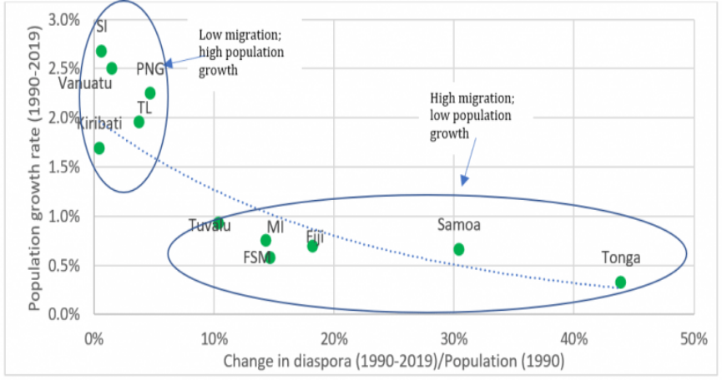
Migration is a fundamental fact of life in the Pacific. The number of international migrants from PICTs has almost doubled over the last 25 years. Today, almost 460,000 Pacific Islanders live overseas. Countries with open labour market access to the USA (Marshall Islands, Micronesia, and Palau) and countries with preferential access to the New Zealand labour market (Fiji, Samoa and Tonga) coexist with countries that experience moderate to low mobility (Solomon Islands, Vanuatu, Kiribati, Tuvalu). COVID-19 legislation and border closure has brought migration flows to a virtual halt since the outbreak of the pandemic. (Graph above is from Howes et al., 2020, Op. Cit.)

In the recent past, UNFPA estimates placed the out-migration at 16,000 Pacific islanders leaving their countries each year (UNFPA, 2014). In addition, until the COVID-19 outbreak, approximately 25,000 seasonal workers from the Pacific were employed in Australia and New Zealand each year. The majority came from Tonga, Vanuatu and Samoa, and participated in either Australia’s Seasonal Worker Programme (SWP) or New Zealand’s Recognised Seasonal Employer (RSE) scheme. This labour mobility plays a significant role in poverty reduction of many PICTs through remittances.

Land and Ocean in the Blue Pacific Continent

The Pacific is the largest expanse of ocean in the world. The PICTs are situated far from countries of any substantial size. While the combined land area of the 14 countries is only about 520,000 km2 – slightly more than the size of Thailand – their combined Exclusive Economic Zones (EEZ) cover 16.8 million km² - more than the land area of Russia. Cost disadvantages arise for governments and companies in the production of goods and the provision of services, including public services.

Most PICTs are archipelagos consisting of a large number of inhabited islands, with Nauru and Niue the only PICTs consisting of a single island. Like most rural/urban and metropolis/periphery divides, capitals nearly always offer more opportunities than regions, but the majority of people reside in rural areas. PICTs’ main and outer islands mark an inequality and access frontier.

“The main island is home to the capital city and, except for Solomon Islands, the island with the largest population. In addition, the main island holds a privileged position as the seat of government and most public sector institutions as well as the locus of vital sea- and air transport that connects the PIC to the rest of the world. A main island typically offers more economic opportunities, better access to a wider range of public services, and many social and cultural benefits. Land area and population vary, with many smaller outer islands having fewer than 1,000 people and a few large outer islands spreading more than 100,000 people over sizeable land areas. Outer islands also differ with respect to distance to the main island and other islands, with some forming clusters of islands in close proximity and others separated from the next island by hundreds of kilometres of Open Ocean. The characteristics of outer islands shape economic opportunities and challenges.”

The Melanesian countries (Solomon Islands, Vanuatu and Fiji) have quite large landmasses, while land is particularly limited in the Micronesian and Polynesian countries. The smaller island states are even more limited in their natural land resources, just like outer islands usually are. Land property regime is often characterized by native titling and administration by men in their traditional authority, even in Pacific communities where women hold traditional titles and where matrilineal ownership of resources such as land exists. Access to land and the amount of available land in some PICTs is a development issue. Increasing soil salinity, limited and reducing arable land, rising sea levels and lack of fresh water are some of the issues placing great pressure on land for Pacific countries. Sea-level rise is at a level of 3-6mm per year in the Pacific with variations amongst the Pacific islands. Solomon Islands and Papua New Guinea, have experienced sea level rise of up to 6mm per year, in contrast to islands further to the east, such as Samoa and Kiribati, which are impacted less by slow-onset events but are no less vulnerable to extreme weather events. Coastal sea-level rise rates are in general slightly higher that the global mean rate, approaching 4mm/year in several areas except in Southern Australia where the rate is similar to global mean rate. Saltwater intrusion from coastal flooding disrupts farming and can result in relocation.

Projected impacts of climate change, particularly regarding extended drought periods, sea level will very likely continue to rise and loss of soil fertility and degradation due to increased precipitation, overfishing and degradation of coastal ecosystem are expected to affect both subsistence agriculture as well as cash crops further constraining livelihoods and compromising competitiveness of commercial agriculture. This highlights the importance of investment in anticipatory action and climate adaptation and resilience measures.

A mixed record arises from this reality: it confers stability and limits land loss and community eviction from collateral execution, reckless or forced sales, as land cannot be used as collateral in numerous territories, areas and islands; it also reduces pressure on land and environmental degradation; on the negative side, it represents a systemic hurdle to gender equality; it makes FDI, tourism and other productive capital investments development more difficult; in terms of national mobility, rules around traditional landownership pose important constraints for internal migrants to acquire property, leaving them the only choice of informal squatter settlements, with no security of tenure and contributing to conflict between migrant communities and the established population. Customary law and customary ownership of natural capitals constitute objective obstacles to business growth and FDI attraction. The limitation of private and State-owned land property, and special jurisdictions to settle land disputes, produce the mixed impact of protecting and preserving resources at the cost of impeding dynamism.

Distance
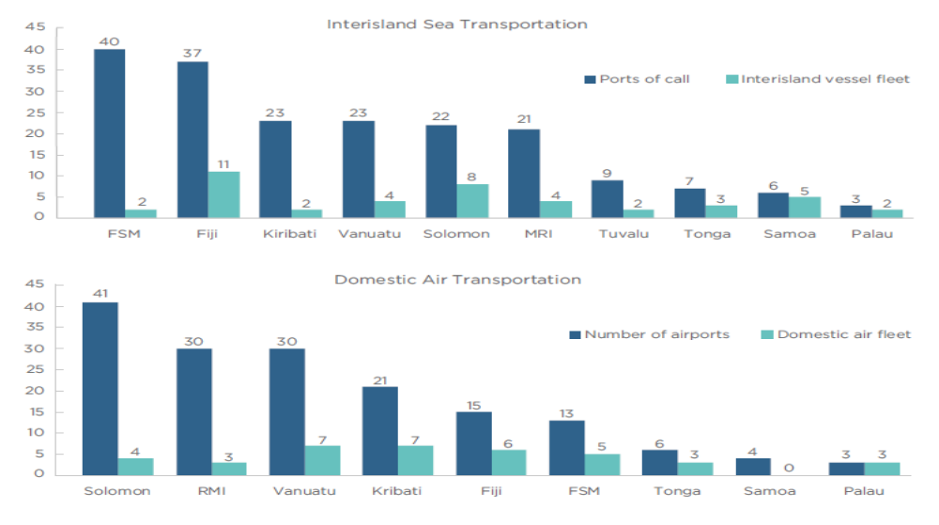

The Pacific islands were settled through migrations broadly thought to have moved from Southeast Asia through Melanesia, and then on to Polynesia, with some movements west at other points. The constraints to imports arising from the PICTs’ remoteness mean that imported inputs to domestic production processes are more expensive, as are the costs associated with exporting to the rest of the world. As a result, PICT exports tend to be uncompetitive on global markets, and exports as a proportion of GDP are relatively low in the PICTs, even compared with other small countries. As a consequence, the PICT manufacturing sectors have generally remained insignificant in size, in contrast to the experience of other developing countries in the region, which have developed through progressive increases in the sophistication of their export baskets.

“In a region where voyages between islands sometimes take days, most PICs support domestic interisland shipping and airline services, particularly along routes that are not otherwise commercially viable. In addition to the capacity constraints of too few vessels, two other shortcomings define the maritime infrastructure on outer islands – inefficient ports and inadequate maintenance. Most outer islands do not have any infrastructure for vessels to berth. Maritime services often rely on old second-hand vessels that are poorly maintained and not designed for the purposes they are being used.”

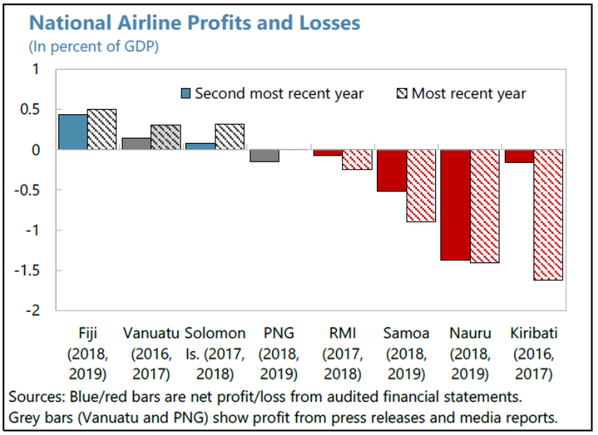
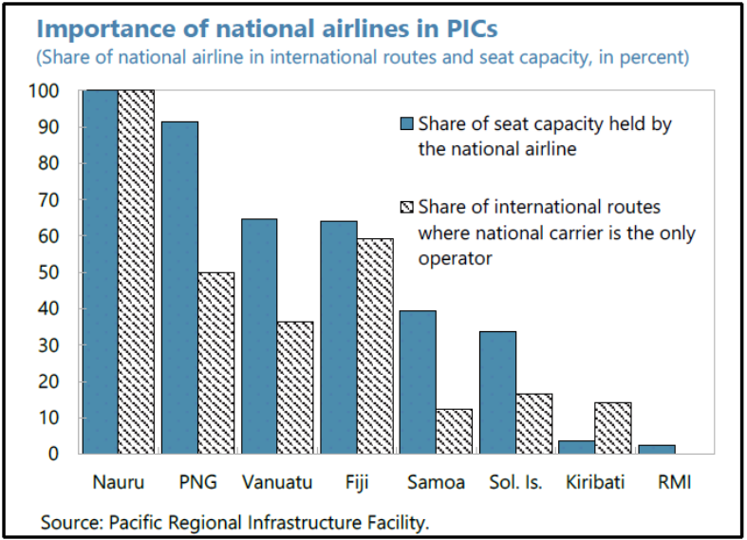
Further research from the IMF has shown how, in one of the most geographically isolated regions in the world, countries rely on airline connectivity for tourism, education, employment opportunities, access to healthcare, and delivery of goods and services. This dependence has driven many PICTs to have state-owned national airlines that cater to both domestic and international markets. “Many of these national airlines generally had weak financial conditions prior to the pandemic, largely due to their high fixed costs, particularly the capital requirements that result in excessive debt burden, vulnerability to external shocks, limited commercial viability and weak governance. With virtually no international travel since March 2020, these airlines are being struck hard by COVID-19 and have been receiving substantial financial support from governments to stay afloat. With a backdrop of tight fiscal space and increasing government debt, losses in airlines are adding to fiscal risks in some PICs.”

The net effect of these demographic and geographic characteristics–smallness, remoteness, and internal dispersion–is to lower the productivity of capital, labour, and skills (Total Factor Productivity or TFP) and to limit the range of activities in which PICs can be internationally competitive. These factors, combined with gender-based violence and gender inequality, NCDs and climate are some of the main development constraints of the Pacific Nations.

Transport infrastructure challenges are further aggravated by climate and disaster risk, with maintenance and rehabilitation cost increasing due to extreme events and disruptions resulting in ripple effects across the whole economy, adding transportation time and cost, hindering access to basic services and hampering relief and recovery efforts.

“In Fiji, transport asset losses represent 46% of the country’s total non-agricultural annual asset losses from hurricanes, earthquakes, tsunamis, and floods. For all SIDS, given the share of road maintenance and reconstruction in government budgets, reconstruction costs aggravate fiscal pressure. In addition, the remoteness of the islands raises transportation costs for reconstruction material. This increases reconstruction costs, narrows fiscal space even more, and results in deferred maintenance and high vulnerability to future hazard events… Since most SIDS are served by transport networks that offer limited redundancy, transport disruptions or closures associated with disasters have significant effects on local economies and population well-being. Even a small loss in transport assets can lead to high service disruptions.”



The Pacific Islands region is becoming more complex as competition for influence grows. On the one hand, the growing interest over recent years from a range of new governments, development partners and civil society organisations has brought greater opportunities for partnerships and access to financing. On the other, this increased attention has called for some caution on the side of the Pacific Leadership regarding their alliance strategies in a geopolitical environment that has returned to a more visible scene, with growing tensions in the broader region and localisation of global risks and threats, from which the Pacific is not immune. In the words of the Pacific Island Forum summit in Nauru in 2018, “leaders acknowledged the dynamic geopolitical environment that has led to an increasingly crowded and contested region and reaffirmed the need to strengthen collective and cohesive action…”

Climate and Disaster Risk

Despite contributing to less than 1% of the world’s total greenhouse gases (GHG), the Pacific Islands are on the frontline of and amongst the most vulnerable nations to the impacts of climate change. The region is also one of the most disaster-affected zones in the world in terms of the recurrence, severity, and scope of natural hazards. Vanuatu, Tonga, Solomon Islands, Kiribati and Fiji are consistently ranked among the 20 countries most at risk in the World Risk Index. Due to technological progress and advanced early warning information and forecasting skill, it is increasingly possible to predict climate disasters and their impacts. These improvements highlight the importance of greater investment in anticipatory action and access to forecast-based financing, including climate risk finance.

Disasters caused by natural hazards affected productivity, infrastructure, and people’s quality of life. In March 2015, tropical cyclone Pam caused widespread damage in Vanuatu affecting 64% of the country’s GDP. Disasters have triggered almost 175,000 displacements in Vanuatu since 2008. In February 2016, tropical cyclone Winston, caused damages and loses to an equivalent of 30% of Fiji GDP and it is estimated that Winston affected 540,400 people, including 263,000 women. The total represents 62% of Fiji’s population of 865,000. 5 years later, in April 2020, tropical cyclone Harold caused significant damages and losses at about 61% of GDP and in December 2020, Tropical Cyclone Yasa brought damages and loses in Fiji at about 4.5% of the country's GDP.

Disaster risks are converging with critical socio-economic vulnerabilities, environmental degradation and climate change making the Pacific a disaster hotspot. Building resilience to climate and disaster risk is essential to ensure economic transformation is sustainable and growth is sustained. UNESCAP estimated that annual economic losses due to disasters in the Pacific SIDS are more than double the previous estimates, at US$1.075Bn or nearly 5% of the combined GDP for the PICTs. Some Pacific SIDS are at risk of losing more than 10% of their GDP, annually, due to disasters. Recurring losses, expected to rise due to climate change, erode development assets and reduce the potential to invest the dividends of economic growth into human development. Exposure of economic stock and of the infrastructure network enabling economic growth (e.g., 84% of power plants are exposed to tropical cyclones) highlights the need for investments, public and private, to be risk-informed to enable more resilient systems and economies. Investments in social sectors and resilient infrastructure can prevent disasters from undermining development gains.

Macroeconomic Context and Economic Transformation Analysis

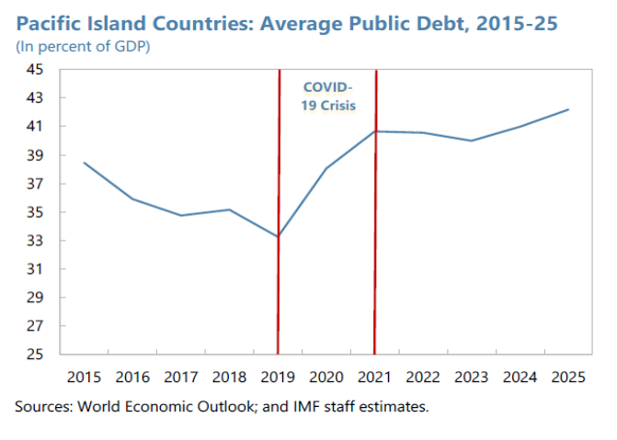
While countries have no control over their geographic remoteness, land dispersion, resources, and size, they do have tools to mitigate what these geographic challenges pose to economic development. Like everywhere else, COVID-19 has worsened fiscal balances in the region. Lower tax revenues and higher healthcare spending have led to a deterioration in the fiscal position for most PICs, notwithstanding an increase in grant support from multilateral and bilateral development partners. According to the IMF, “the average fiscal balance is estimated to have deteriorated from a surplus of 3.5 percent of GDP in 2019 to a smaller surplus of 0.3 percent of GDP in 2020 while the average level of public debt is estimated to have increased from about 33 percent of GDP to 38 percent of GDP over the same period.” Largely due to substantial donor support, current account balances for the group as a whole are estimated to have improved. The level of foreign exchange reserves cover remains adequate for most of the PICs. The PICs as a group are now projected to contract by an average of 0.6 percent in 2021. Even when recovery takes hold, it will take time for output to recover to pre-pandemic levels. The prolonged reduction in economic activity and border closures will likely have more lasting effects in such sectors such as tourism, and those reliant on trade, supply/demand chains, and expertise from abroad.”

Human Development

According to the UNDP’s Human Development Index, Palau, Fiji, Tonga, the Marshall Islands and Samoa show the best human development outcomes and are in the high human development group. The Federated States of Micronesia, Vanuatu, and Kiribati are in the medium human development group, and Solomon Islands recently graduated into this group, registering as number 151 HDI out of 189 nations and territories for which there are data available.

Poverty

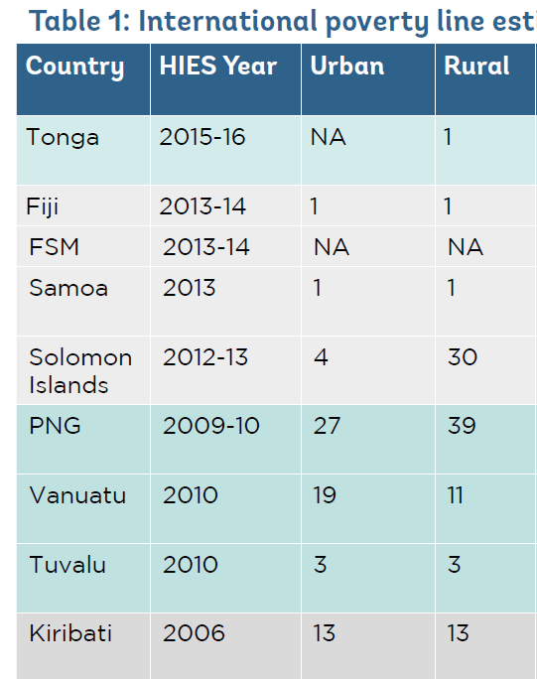
Extreme poverty is relatively uncommon in the Pacific region. Extreme poverty is estimated to surpass 10% in only three countries: Kiribati, Vanuatu, and FSM (proxies indicate that RMI poverty levels are similar to those in FSM). The prevalence of extreme poverty is negligible in Samoa, Tonga, and very likely Palau, and it is just above 3% in Tuvalu. Poverty and hardship are widespread in FSM, Vanuatu, Kiribati, and possibly RMI. “Many of the poor inhabit the outer islands, where poverty is structural and persistent, linked to coral atolls where very little subsistence agriculture is possible. Across the Pacific more generally, a broad sense of hardship prevails, experienced as a lack of access to even basic services (including quality education), economic opportunities, cash for meeting basic needs. Hardship is also increasing owing to the impacts of NCDs. COVID-19 has increased the NCD-associated health risks. Across the region, a significant share of the population remains on the edge of poverty. Many paths lead households into poverty—the loss of a job, a crop failure, illness, an economic crisis that reduces tourism, a natural disaster that deprives them of housing and land. Often the poor come from groups that have specific social disadvantages and economic vulnerabilities, such as the elderly, individuals living with disabilities, children, or members of female-headed households.” COVID-19 has increased the number of people living in poverty in the Pacific, with the impact being greater in tourism-dependent economies.
Urban and Rural Poverty in the Pacific Percentage of population to international poverty line
(Utz´s assessment of Household Income and Expenditure Surveys)

In 7 out of 14 PICTs, more urban populations fall below the basic-needs poverty line than rural. Limited access to land for subsistence or cash-based farming, rising youth unemployment, and continued migration between rural and urban areas, is creating a growing urban poor population unable to meet basic needs without sufficient access to cash income, with a significant proportion of income spent on food. This growing urbanization of poverty is concentrated in informal and squatter settlements. The right to adequate housing has seen limited progress in most PICTs, including due to a lack of affordable public housing and policies recognizing the specific needs of informal settlements and slums. Fiji is one of the few to have developed a National Housing Policy that includes provisions for affordable and decent housing for all, including the right to tenure for informal dwellers. National Urban or Urbanization Policies in Samoa, Kiribati, Fiji and Solomon Islands are helping to improve land administration and strengthen planning capacity.

Labour Market Analysis

The low economic growth combined with frequent natural disasters exacerbates the Pacific island countries and territories’ labour market challenges and hinders prospects for increased opportunities for decent work across the Pacific. A crucial vulnerability in the Pacific labour market resides in the low labour force participation rates, which are below 50% in many of the countries and territories. Moreover, vulnerable employment, although relatively low at the regional level, is pervasive in many countries. Research suggests that there are vulnerabilities associated with the high incidence of subsistence activities and informality, and often a combination of both. Unemployment is relatively prominent, where it ranges between 8.5 and 14.5 per cent, compared with an estimated 5.4% globally in 2020, and with 4.7% in the Pacific. It is, conversely, lower than the global rate in the rest of the region. Low unemployment rates in Pacific countries are likely related to a relatively small formal economy and widespread informality.

In a majority of PICTs, unemployment is more prevalent among women than men. Young workers are also at a disadvantage in finding employment and their unemployment rates are between two and seven times the prevalent rate among adults (defined as those aged 25 and older). As the youth population expands, ensuring decent work opportunities for young workers becomes a growing and major challenge. A broad measure of untapped youth potential is the rate of young people not in employment, education or training (NEET). NEET data reveal that large shares of youth are not in employment for reasons other than education. In most of the PICTs young women are more than 50% more often NEET than young men. There are many reasons youth become NEET: many do not believe there are jobs available or do not know how where to search for employment. Others, especially young women, are unable to work or study due to family and household responsibilities. Young NEETs are not gaining skills and experience valued in the labour market, compromising their future prospects.

Often, the quality of jobs is a concern for people with employment. One of the characteristics traditionally associated with employment quality is status in employment and informality. Globally, an estimated 44.6% of workers engaged in vulnerable work in 2020, defined as own-account and contributing family work, and associated with limited legal and social protection and income security. Said characteristics suggest that these workers are particularly vulnerable to disruptions in economic activity, including those brought about by disasters.

Poverty and hardship are drivers of vulnerability to disasters. At the same time, climate change impacts and disasters, such as the pandemic act as poverty multipliers, forcing families into extreme poverty as livelihoods are disrupted, assets destroyed and cost of access to services such as health care might increase. Slow onset impacts bring changes to livelihood and nutrition patterns, which in turn creates health challenges such as non-communicable diseases and an increased need for access to affordable essential medicines.

“COVID-19 has triggered a vicious feedback loop that is putting healthy food out of reach for countless Pacific households. Widespread loss of livelihoods and reduced incomes mean there is less money to buy food, at the exact time that food (especially nutrient-rich food) is becoming more expensive and less available due to supply chain disruptions from lockdowns. This has added to the time and work burdens of women who are principally responsible for provision of food to their families, and in many cases has increased psychological stress. Between February 2020 (before the pandemic) and June 2021, food prices rose in all countries in the Pacific region. Australian food prices rose by an average of 3.4%. This was dwarfed by food price increases in Vanuatu (30.6%)”

The declining options for migrant laborers to access Australian and New Zealand´s markets due to COVID-19 increase the pressure on PICTs Governments, as do growing unemployment and NEET numbers, expanding poverty and pressures on the labour market.

Emerging Frontiers and Transformational Opportunities

Economic growth in most of the PICTs has been low during the last two decades and has been lagging significantly behind what other developing countries have been able to achieve. The PICTs tend to be competitive only in areas where natural resource rents outweigh the high costs of production. Small size, remoteness from major markets and internal dispersion push up the costs of private production and public administration, lower the return to market activities and narrow the feasible set of economic opportunities.

To transform the Pacific Economy, five strategies have been identified by the main development partners of the Pacific and their national counterparts: sustainable expansion of the tourism sector by taking advantage of increasing demand from key markets; labour mobility; improved connectivity to harness ICT-related opportunities; sustainable Pacific tuna fisheries; and deep-sea mining. The digital, blue, and green economies are discussed below. Labour mobility will be studied in connection with the right to work. Under the terms of the 2030 Agenda the framing of these priorities around inclusive, diversified and job-intensive economic interventions that leave no-one behind, protect the planet and strengthen the ecological foundations of Pacific economies will be the basis of their sustainability, and their transformational impact.

Fisheries, ICT, and tourism have the potential to significantly boost government revenue. The WB forecasts that, by 2040, access fees from fisheries could increase by between US$160 to US$320 million, without an increase in catch levels or threats to the sustainability of the fisheries stock. “Accelerated growth of the tourism and ICT-based sectors would help to broaden the tax base and thus increase resources available to governments.” In all the Pacific economies, the lack of diversification for foreign currency earnings (tourism, fishery licensing and remittances) represents yet another symptom of structural limitations and challenge to growth. It also requires making the best use of these scarce resources of foreign income.

The United Nations stands for inclusive growth: the creation of wealth that is fairly shared across society and that generates economic opportunity for all, especially for those who face greater difficulties and disadvantage. Inclusive growth means growth, economic performance and increase of material outputs. It also requires that in the end, the bottom deciles of society take home a fair share of the earnings, when compared to the top quintiles.

Growth may be shared and redistributed through educational and training opportunities, allowing children whose parents did not complete school to have chances of pursuing a good education. Fairer tax systems, decent work, removal of barriers to women’s participation in governance and employment, social protection systems, a business-friendly environment, investments in long-neglected areas and a better globalisation all contribute to making growth, when it happens, inclusive enough to generate public confidence in the system and the economy.

The UN has a role in fostering inclusive growth in the Pacific. It is an advocate for the principles of inclusion and fairness in the distribution of economic wealth. It provides technical policy assistance to institutions mandated to making decisions that will ultimately result in fairer outcomes in society. The UN has developed de-risking strategies so that public expenditure is accrued by development finance – generating more growth for developing countries. In the Pacific, the UN is a tireless advocate of global climate finance and climate justice for the region. Through the support on development of integrated national financing frameworks (INFFs) the UN in the Pacific has been supporting an enhanced understanding of the development financing landscape and has an opportunity to support a risk-sensitive approach to financing for development with financing strategies which are able to finance the reduction of existing risk, ensure future investments do not create new risks and provide instruments to cover the remaining residual risk and build resilience.

The UN is finally a catalytic agent focusing on the human aspects of growth and offering toolkits that allow for redistribution to happen with proven impacts: from gender-budgeting to local participation in public expenditure reviews, and from social and environmental safeguards, prior and informed consent and other impact analyses that make growth not only inclusive but also responsible.

Digital Transformation

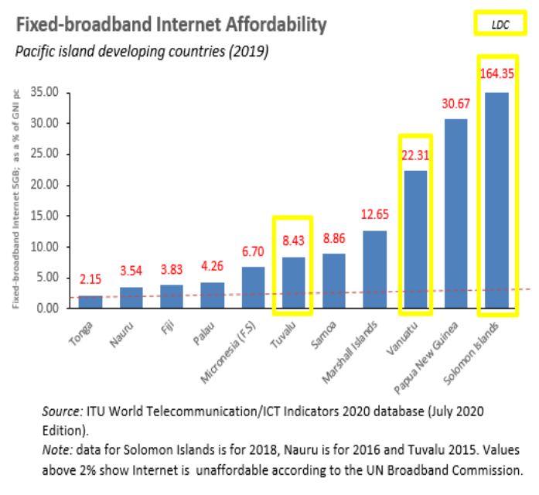
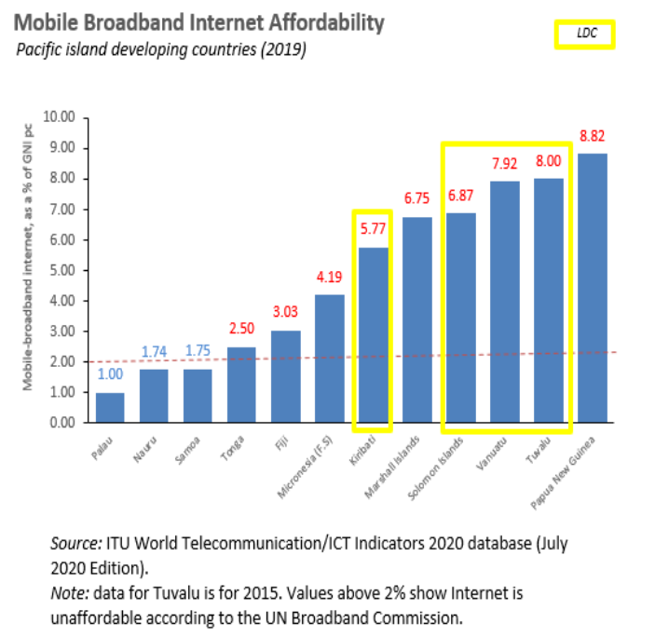
The digital transformation presents a vital opportunity for economic and social transformation in the Pacific, with the information and communications technologies boom and the surge of an e-labour market, off-shoring of trade and remote service industry location. A 2017 World Bank study suggested that digital transformation could inject up to 5 Bn US$ into Pacific economies and help create 300,000 jobs. As the pandemic demonstrated, access to ICT tools was a key enabler for continuing core government services, and economic and social activities such as education. The PICTs have already improved connectivity by investing in their ICT infrastructure (underwater fibre optic cables such as Hawaiki and the Coral Sea Cable) and taking advantage of better satellite connectivity offers (such as Kacific 1); they opened their telecommunication sectors to reforms, allowing greater competition to improve services and reduce pricing. This has resulted in a significant increase in the number of Internet and mobile phone subscribers, and the development of an e-commerce market of goods and services, including banking and finance, especially in Fiji, Samoa, and Tonga.

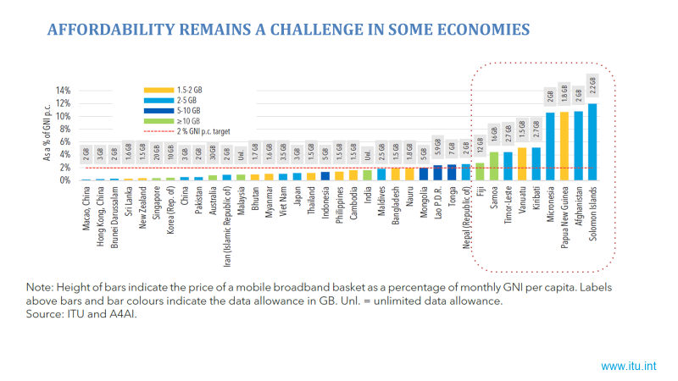

While connectivity is on the rise in the Pacific, affordability of broadband services remains a concern. Broadband services linger above the target of 2% of GNI (for 2025) in a number of countries. Broadband technology has still ample space for growth, therefore investing in digital connectivity infrastructure, increasing affordability, promoting better services of connectivity, and reducing their cost is critical. Investments in international bandwidth will be required for more sophisticated services, greater penetration and access, increased affordability, and the possibility of promoting offshore online industries.

The ICT sector presents a significant opportunity to boost growth, employment and government revenue across the Pacific. In addition, the ICT development will promote public services (for instance, online education, e-government and telemedicine) in a more cost-effective way, reaching out to the most remote and vulnerable groups and outer islands where the services have not yet been easy to deliver. ICT and its applications spill over to traditional development sectors such as agriculture, energy and water management, disaster risk management and fisheries by promoting sharing of real-time information and knowledge. This is represented in SIDS context by the Smart Islands approach.

One way forward to strengthen institutional capacities and government effectiveness in the Pacific region is through increased use of ICT and investment in digital or e-governance. This is an area where most PICTs lack far behind when compared to the progress achieved globally. E-Governance strategies have often fewer resources associated than would be necessary for ambitious progress in sectors like e-medicine, online education, national digital IDs and strengthened security in the region. UN E-Governance Index 2021 highlights that most PICTs fall well below the average global e-governance score of 0.59. Except for Fiji, Tonga and Palau, most of them also lag behind the regional average e-governance score.
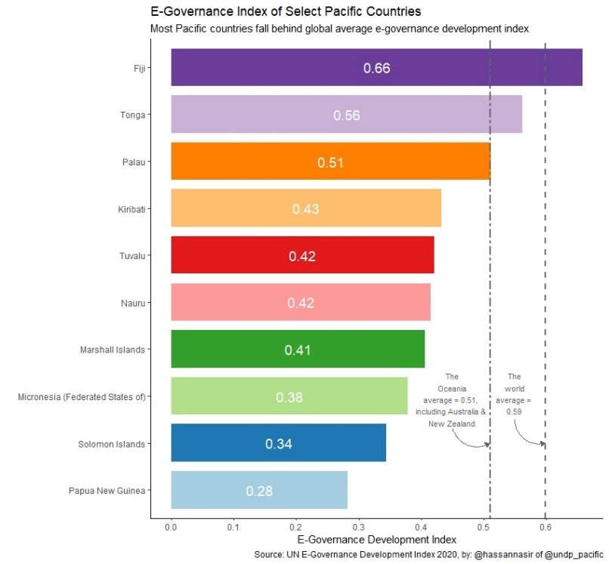

There is much room to develop the foundation of the nascent innovation ecosystem across PICTs by supporting the growth and synergies of the innovation community; building up its skills; and expanding the availability of national and international mentors and experts to support entrepreneurs. Investment finance needs to be available to support entrepreneurs at all stages of their journey. Most Pacific economies are still in their digital beginnings. Pacific leaders have emphasized their commitment to increase connectivity and the use of information and communication technologies through improved infrastructure, training and national legislation, as well as public and private sector involvement and to support the implementation of innovation and digitalization as a catalyst for accelerating the achievement of the SDGs.

Access to ICT across different population groups needs to be evened. Digital skills and capacities are required and need to be shared across the social spectrum for the development of the digital economies to be inclusive – of disadvantaged individuals and smaller economic operators. Returns on the very costly, highly performing connectivity across the Pacific remain modest and probably demand an affordability policy through public subsidies. COVID has also led to the acceleration of the digital transformation agenda across countries and sectors, intensifying the need to increase digital literacy and capacity to navigate the digital era. Digital transformation is about much more than just ICT infrastructure, mobile penetration or technical conditions. It is about people and processes, leadership, political will, institutional coordination across Government institutions, collaboration with business, upgraded digital skills and capacities of students, civil servants and the whole society, in sum, a new mindset.

Despite this progress in harnessing the potential of digital or e-governance, many PICTs continue to be more interested in ICT hardware and connectivity than in defining integrated whole-of-government strategies which can serve to make a step change in the quality and access to public services across the Pacific region, especially for populations living in remote rural areas and on outer islands.

Together with the great potential of investments in ICT and digital transformation in the Pacific region, it is important to note that cybercrime offences are on the rise, including ATM skimming (cashing out), cyber bullying, cryptocurrency related crimes, online child sexual abuse and exploitation, sextortion, etc.. as well as in some instances, surveillance of civil society. With very few exceptions, many PICTs lack specific cybercrime legislation and have no overall national cybersecurity strategies. Their law enforcement also lacks specialized cybercrime investigation units and digital forensics capabilities. There is a strong need for PICTs to develop national cybersecurity strategy and cybercrime legislations. Governments in the region need to better understand the current and emerging cyber threats and trends as well as a strategic roadmap to address cyber threats. Moreover, both the public and private sectors need support on raising awareness, helping them to understand cyber threats and highlighting the measures that everyone can take to be safe online.
In assessments undertaken as part of ITU Global Cybersecurity Index 202, the Pacific Islands Countries have ranked very low, evidencing serious challenges. All Pacific Island countries have nevertheless introduced telecommunication, broadband or ICT strategy and policy documents, and a number of countries have reviewed, or are currently reviewing, frameworks related to digital transformation, digital government, data-sharing, cybersecurity and universal access. Consumer protection including misinformation online, data protection, quality of service and experience and data privacy concerns also remains issues to be addressed, especially in very young digital ecosystems. Enactment of necessary legislation and policies remains inadequate in a number of areas. Professionalising the Government information services that are increasingly provided online such as tourism information, fisheries and geological data and meteorological forecasts, will be part of this enterprise.

Blue Economy

The idea of using the sea for economic gain is not a new concept. Island nations, in particular, have benefitted from their ocean resources for centuries, with marine uses and activities contributing significantly to their development and overall economies. These include a wide range of maritime activities essential to both current and future economic development, including capture fisheries; maritime transport and ports; coastal tourism; mineral exploitation; as well as the marine ecosystems and resources that support them. What is new, however, is the growing appreciation of the critical role that the ocean plays in sustainable economic growth and, as a result, a growing appreciation of the need to better manage and protect coastal and marine ecosystems and resources that are the fundamental basis for that growth. “The emerging concept of the 'blue economy' has been embraced by many SIDS as a mechanism for realising sustainable growth centred on an ocean-based economy. In that time the blue economy has emerged as a key component of a new global dialogue about the role of coastal and ocean waters in sustainable development. For SIDS in particular, the concept of the blue economy presents itself as a promising avenue for economic diversification and growth embedded in fundamental principles of environmental sustainability.” To this must be added the critical dimensions of socio-economic inclusion and sustainable livelihoods.

The Blue Economy is a developing world initiative pioneered by SIDS but relevant to all coastal states. The Blue Economy conceptualises oceans as “Development Spaces” where spatial planning integrates conservation, sustainable use, oil and mineral wealth extraction, bio-prospecting, sustainable energy production and marine transport. The Blue Economy breaks the mould of the business as usual “brown” development model where the oceans have been perceived as a means of free resource extraction and waste dumping; with costs externalised from economic calculations. The Blue Economy incorporates ocean values and services into economic modelling and decision-making processes and proposes a sustainable development framework for developing countries addressing equity in access to, development of and the sharing of benefits from marine resources, offering scope for re-investment in human development and the alleviation of crippling national debt burdens. Other definitions of the Blue Economy emphasise the range of economic sectors and related policies that together determine whether the use of oceanic resources is sustainable. An important challenge of the Blue Economy is thus to understand and better manage the many aspects of oceanic sustainability, ranging from sustainable fisheries to ecosystem health to pollution. Furthermore, it is crucial to understand land-to-sea interactions, as terrestrial and marine ecosystems are interconnected. The Blue Economy concept seeks to promote economic growth, social inclusion, and the preservation or improvement of livelihoods while at the same time ensuring environmental sustainability of the oceans and coastal areas. At its core it refers to the decoupling of socioeconomic development through oceans-related sectors and activities from environmental and ecosystems degradation. It draws from scientific findings that ocean resources are limited and that the health of the oceans has drastically declined due to anthropogenic activities.
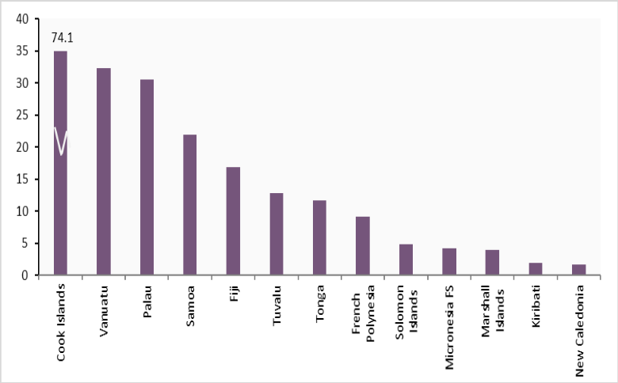
Tourism Share of GDP (UNWTO 2019-2017 data) The Blue Economy is well at home in the Pacific and with the PICTs. The ocean is the critical source of export earnings for many PICTs. Blue Economy opportunities cover a spectrum of sectors, including fishing and coastal tourism, notably through the connection to Underwater Cultural Heritage and World Heritage Sites. New avenues are opening in aquaculture, ocean-based renewable energy, sustainable maritime transport, desalination, research and education, and marine genetic resources. Living marine resources have great potential for the development of new food, biochemical, biomaterials, pharmaceuticals and cosmetics, fertilizers and pest control products. Non-market economic benefits can come from blue carbon storage, coastal protection, and the preservation of cultural values and biodiversity. As the Blue Economy concept continues to be developed in the region it will be critical to ensure that the men and women who gain their livelihoods and also cultural value from it (whether through employment in deep water extraction, fisheries and commercial processing, or in subsistence use of inshore and freshwater fisheries) are fully consulted, and their interests are drawn into the frame. This is an effective means to maximise the potential for sustainable rather than exploitative development of the Blue Economy.

Tourism generates the majority of the foreign currency flows. It is the largest single source of income for Tonga, about five times the size of export earnings from agriculture and fisheries combined. For Fiji, it has replaced sugar as the primary export earner. Tourism is a significant employer. The South Pacific Tourism Organisation (SPTO) estimates that the share of the workforce employed by the tourism sector is 15% for Tonga, 18% for Samoa, and 50% for Palau.

International tourism has vanished with COVID-19 lockdowns, leading some countries to innovate with safe arrivals schemes in the luxury segment and others to promote national tourism. In 2017, the Pacific region (16 PICTs) received a record number of 2,983,781 million tourists (half of them from Australia and New Zealand) of which 2,000,983 million arrived by plane and the rest by cruise ships and yachts. Fiji took 42% of the market share followed by French Polynesia (10%), Cook Islands (8.1%), and Samoa (7.8%). The South Pacific Tourism Organisation (SPTO) estimated in 2017 that tourism contributed then more than 60% to the GDP of Cook Islands, and over 40 percent to Fiji, Vanuatu and Niue. Tourism also provided between 25% and 35% percent of total employment in the Cook Islands, Niue, Vanuatu and the Federated States of Micronesia (FSM) that year.

Research from development partners has suggested a way forward buttressed by a number of strategic investments and policy developments to boost the tourism industry in the Pacific. These include elevating tourism planning, creating and applying tourism strategies, linking infrastructure to tourism, fostering secondary attractions, improving waterfront areas, training local workers, engaging SMEs, selling the “Pacific Brand”, and working together as a regional touristic destination. The regional dimension of such strategies, implemented by several clusters of countries in the world, would allow overcoming, to some extent, current competition for international tourists, share arrivals, articulating common benefits between primary and secondary destinations. As travel restrictions begin to ease, tourism will be essential for economic recovery in the region. Nonetheless, an important challenge to address is the sustainability of tourism, including the adequate compliance of conservation measures in marine protected areas and the reduction of the human footprint on coastal and marine ecosystems.

The other strong pillar of the Blue Economy is offered by fisheries. According to the Pacific Islands Forum Fisheries Agency, the region supplies over a third of the world’s premium tuna each year, with a multi-billion delivered value to processors. Foreign fleets now coexist with locally anchored vessels. The small local processing industry, access fees and the Pacific-based fleet are the three main sources of income from the fisheries industry. Regional cooperation has been critical, in the recent past, to increasing the earnings from fees, establishing common rules for access (with a notable success of the Parties to the Nauru Agreement Vessel Day Scheme), and avoiding overexploitation of stocks. With respect to fisheries, a key focus should be on moving up the value chain (e.g., fish processing and canning) to capture a larger share of the value-added.

In terms of value, the share taken by FFA fleets has increased significantly with the value share rising from 31% in 2013 to 49% in 2018 which exceeds the 2020 target. Oceanic fisheries are therefore a relevant source of jobs (in 2017, the total direct employment in the fishing industry was recorded at around 22,500 jobs, an increase of around 7,000 since 2013), government revenue and growth for the PICTs, a source that needs to be sustainably managed in the favourable context of a foreseeable stability of the stock size in Pacific waters and of the global demand.
Harvesting the potential benefits of this sector will require enhancing regional cooperation, investing in technology and skills, managing the stock for the future and including coastal communities in fisheries to guarantee food security. The objective is arguably to increase the current share Pacific nations enjoy (less than half) over the value of the fishery production in Pacific Island waters, by increasing economic intelligence and knowledge of the value chain, legal advice, more government coherence in negotiation, at par with private sector licensees’ coordination. The existence of alternative fisheries and the need to balance less expensive licenses with more controls over catches and avoidance of overfishing needs to be countered by emphasizing the productivity and quality of the Pacific fish stocks.

After all, despite a considerable number of Fish and Fish products already being exported from the region, the International Trade Centre’s Export Potential Map suggests that Fish and Fish products are still the products with the most untapped export potential in the upcoming years for at least 9 of the 14 countries. Nevertheless, this potential must be balanced with the 2030 Agenda for inclusive growth, and care to ensure that the benefits of investment in Blue Economy trade are shared with local communities, and do not increase income gaps, causing more to be left behind. Attention also needs to be paid to the employment conditions in the fisheries industry; and the possibility of foreign fishing crews sexually exploiting women, including through trafficking onto fishing vessels.

Particular concerns about modern slavery and labour standards have been addressed by the Western and Central Pacific Fisheries Commission (WCPFC) in the fisheries sector. Specific attention needs to be given to the link between illegal, unreported, and unregulated (IUU) fishing and human rights abuses, especially human trafficking. IUU fishing is a threat to ocean ecosystems and is inextricably linked to human rights abuses at sea. Some unscrupulous vessels are involved in other illegal activities to further cut costs and drive up profits, including the use of forced labor and other human rights abuses. Human trafficking and forced labor in the fishing industry are a humanitarian crisis coupled with the environmental degradation driven by IUU fishing. Reports point at Fiji and Vanuatu-flagged and owned vessels, and fishermen, or foreign foreign-flagged fishing vessels transiting Fijian and Ni-Vanuatu ports and waters. as especially vulnerable in this regard.

Strategic investments in the Blue Economy will require its adoption as main pillar of national development strategies, plans and budgets and the protection of blue resources against damaging human activities, in particular through effective waste management systems and the control of agricultural discharges such as pesticides and toxic fertilizers that have a negative impact on coral reefs, fish and produce. It will also be necessary to transition from well-oriented policies and legislation to their effective enforcement. This includes, for instance, regulations to prevent, deter and eliminate illegal, unreported and unregulated (IUU) fishing. Effective international instruments are already available, such as the Agreement on Port State Measures (PSMA). Investments will also need to be made in building knowledge and technical capacities in respect of the marine environment, to facilitate effective participation in research, knowledge creation and development and in order to optimize regional capabilities to sustainable use and manage the ocean’s resources. As such the sub region must align education and training with future requirements by addressing gaps in marine sciences and research, innovation and technology development. Further, strengthening technical and vocational skills training related to the blue economy, to create a large enough pool of skilled professionals to support the sub region’s efforts, will be key.

Climate change and disasters, including technological, chemical and maritime accidents, poses stark risks to the health of the ocean and to the realisation of a prosperous and sustainable blue economy. Acidification and rising ocean temperatures are negatively impacting important industries such as fishing and tourism, as well as the well-being of coastal populations. Climate change will affect the breeding cycles of fish stocks, their geographical spread (ocean temperature warming may drive certain species to cooler parts of the oceans and away from their normal breeding and feeding grounds), and whether they move up or down ocean temperature gradients, into warmer or cooler waters. These changes will impact the sustainability of the Blue Economy, as will the continued preservation of the large Marine Reserves and Protected Areas in the region as they are the bank for biodiversity replenishment of the Fisheries sector. Keeping them intact is vital to underpin the Blue Economy and also one of the attractions of a Blue Tourism.

Ocean-based climate action offers multiple opportunities for emissions reduction. Restoring, protecting, and managing in resilient manner coastal and marine ecosystems, including mangroves, seagrasses, salt marshes, macroalgae and reefs enhance their ability to sequester and store carbon, adapt to the effects of climate change, and improve coastal resilience, providing multiple opportunities for advancing climate change mitigation, adaptation, and risk reduction integrated solutions that incorporate socio-economic equity for the men and women already using these resources sustainably, as part of the region and country specific blue economy objectives.

In sum, the Blue Economy presents significant opportunity for stronger, and more rapid growth through the use and trade in the various resources that it has to offer, but also significant risk of highly uneven growth, destruction of environmental and social capital and greater socio-economic distortion. At the same time, a sustainable Blue Economy transformation offers efficient Climate Change mitigation and adaptation opportunities to Pacific SIDS. The 2030 Agenda and the SAMOA Pathway provide resources to address the risks and develop a Blue Economy framed by the commitment to equal growth. At the regional level, the 2050 Strategy for the Blue Pacific Continent, currently under development by the Pacific Island Forum, will provide high-level direction for the region over the next 30 years. The Blue Pacific Economic Strategy, also under development by PIF, will provide a policy instrument to guide regional economic issues, including the Blue Economy.

Green Economy

Agriculture

The agriculture sector in the Pacific is limited by the small landmasses, hence the scarce availability of fertile and arable land. Soils in the Pacific Islands vary in their fertility and are influenced by topography and climate. “The coral sands that are common in low-lying countries produce soils that are inherently infertile, with low water-holding capacity, low nutrient content, high leaching potential and exposure to salt spray. In larger island countries where soils originate from volcanic parent materials soils are generally more fertile. However, soil erosion, soil acidity and nutrient leaching have contributed to declining soil fertility in the islands.” Declining soil fertility is exacerbated by human interventions such as land clearing, subsistence farming, illegal cropping adjacent to drainage lines and uncontrolled fire.

Transboundary animal diseases (TAD) such as African swine fever can devastate the livestock sector. African snail and rhinoceros beetle in Solomon Islands affects palm oil production and vegetable crops. Biosecurity at the borders and on the farm is therefore crucial to prevent entry and spread of TADs in countries. There is a need to boost capacity and improve infrastructure to prepare and respond to TADs. The “One Health” concept allows for a multidisciplinary approach to address issues such as biosecurity which covers not only animal biosecurity but also aquaculture. Antimicrobial resistance and antimicrobial use that affects humans and animals requires connecting veterinary and human health departments. The Pacific is at high risk of emerging resistant microbes due to the high consumption and misuse of antimicrobials. Other areas where the livestock sector needs improvement are application of animal welfare practices, feed formulation using local materials, genetic improvement of livestock, and exploring climate smart livestock adaptation and mitigation opportunities.

Climate change impacts and extreme events, such as tropical cyclones, storms and floods have damaged and can continue to damage and seriously disrupt agriculture and forestry activities and the livelihoods and domestic consumption associated with these. Disasters influence production conditions, damage trees and crops, accelerate land erosion, damage farming assets, stock and facilities, cause livestock to drown, alter water supply, or still influence transport infrastructure essential for connecting with markets such as roads and ports.

In the Cook Islands, agriculture provides the economic base with major exports made up of citrus fruit and copra. Fruit processing is an important manufacturing activity. Fiji still has a large subsistence sector. Sugar and subterranean water exports are a major source of foreign exchange. Sugar processing makes up one-third of industrial activity. Agriculture and forestry (sugar cane, beef, chicken, cow milk, coconuts, pine chip and mahogany timber) account for over 10% of GDP. Kiribati has little soil, giving only limited opportunities for agricultural development. Subsistence activities range from fishing to the growing of food crops like coconuts, bananas, pandanus, roots and tubers, pork and vegetables.

In the RMI the main agriculture product is coconuts; taro and breadfruit are subsistence crops. Subsistence farming is the main economic activity. Soil quality is generally poor. Similarly, in the FSM the principal crops are coconuts, pork, cassava, bananas, beef, and vegetables. Nauru´s only suitable parts of the island for agriculture are the narrow coastal strip and the area surrounding the inland Buada Lagoon. Coconut and pandanus palms grow around the lagoon.

In Niue, the agricultural sector consists mainly of subsistence gardening (taro, coconuts, and fresh fruits), although some cash crops are grown for export. Palau´s agriculture is mainly on a subsistence level. Samoa´s mountainous terrain and narrow coastal plain only affords subsistence farming, agriculture remaining below 10% of GDP. The main food crops are coconuts, bananas, pork, taro, yams, fruits, beef, and mangoes.

In Solomon Islands, the main agriculture products are coconuts, palm oil, fruits, taro, yams, and sweet potatoes. About two thirds of the islands’ labour force is engaged in subsistence farming and fishing. Forests and woodland cover 75 percent of the total land area, turning the logging industry into the dominant sector within the economy (see below). Coconut products are traditionally the main agricultural output. Other important cash crops and exports include copra and palm oil.

Tonga has a small, open economy with a narrow export base in agricultural goods. Coconuts, pumpkins, vanilla, pork, and vegetables are the main crops, and agricultural exports make up the bulk of total exports. In Tuvalu, agriculture is limited to subsistence farming (coconuts, pork, and fruits). 30% of Vanuatu´s population (52% of the labour force) is engaged in agricultural activities and most depends on subsistence agriculture, with the agricultural sector as a whole accounting for 27% of GDP. Coconut is the most important cash crop (making up more than 50% of the country’s exports), followed by root and tubers, beef, bananas, pork, and vegetables.

Agricultural markets are a key source of locally grown fruit and vegetables for communities across the Pacific. Supporting and empowering women market vendors (who make up the majority of vendors), and the operation of agricultural markets supports the food security and nutrition of the communities that these markets serve.

Untapped economic potentials include pharmaceuticals and cosmetics drawing on a wealth of medicinal plants (coca beans, morinda juice, moringa leaves, virgin coconut oil, tamanu oil, lemongrass, papaya extracts, coconut water, algae and other ocean products). Organic agriculture has developed as of late in the Pacific, benefiting the ecosystems with a more climate-friendly agricultural paradigm, with an increase in soil carbon through green manuring, mulching and the use of natural inputs and management techniques that boost resilience to local conditions, leading to an increased conservation of soil, water and forest resources, preventing soil erosion and enhancing soil moisture and water percolation.

Reduced use of agrochemicals has limited the risk of non-communicable diseases related to the cumulative effect of chemical residues in food while protecting the rural population from pesticide spray hazards. The Governments of Niue, Samoa and Tonga provide financial support to organic family farmers for obtaining organic certification.

The Government of Niue was the first in the world to target 100 percent organic production by 2020. POETCom – the unified voice for the organic and ethical trade movement in the Pacific Islands – is a not-for-profit membership organization housed at SPC. Its work has resulted in, among others, the Pacific Organic Standard, a regional participatory guarantee system (PGS), a marketing tool, and the Pacific Organic Tourism and Hospitality Standard. The partnership “Organic Islands: Growing our Future”, formed as part of the Small Island Developing States (SIDS) Accelerated Modalities of Action (S.A.M.O.A.) Pathway, was created to raise awareness of the potential for organic agriculture to contribute to addressing development issues for SIDS.

Just as the soils, topography, rainfall and other physical characteristics of the various islands across the region are diverse, leading to marked variations in the form that agriculture can take on each island, and in the various ecological zones of each island, so are the social relationships in agriculture highly varied. It is through these relationships that raw materials are transformed into products that are either consumed or enter the market place. The relationships shape all agricultural processes, so that agricultural interventions cannot be undertaken independently of an understanding of the relevant social structure governing each agricultural economy, in which gender relations are always highly prominent, if not determinant. This is at least as important as the physical properties of the land and climate.

The local demographics and division of labour in agriculture are the context in which the above-described physical characteristics of agriculture are operationalized. The division of labour between men and women varies from island to island, and also according to the various crops and farming activities, and, very importantly, whether the crop is destined for domestic consumption or sale.

While recognizing the great variety in these relationships, it is possible to generalise that in many instances men are responsible for certain crops, particularly commercial crops, often root crops, and for the heavier work on the farm, such as land clearing, care of large livestock and use of heavy tools, while women are largely responsible for subsistence production in household “gardens”, small livestock especially poultry, and may also sell surplus products by the roadside or in local markets (just like women also make up the majority of vendors in agricultural markets). Like men, women may seek employment in commercial agriculture, although their choice to do this is more restricted. While much land is held communally, use of it is generally controlled by men, including in matrilineal societies.
Work that is unpaid, such as subsistence (non-market) agriculture and household chores is often assumed to have no value and to be infinitely elastic. It lies outside the formal economy and is typically unrecorded in national statistics. However, it imposes significant constraints on those undertaking it, mainly women, who are usually working within tough time-constraints and possibly also under the control of relatives. People engaged in these activities are restricted in their options when new practices are introduced, which may fail if they do not reflect either women’s practical needs for improvements within the existing division of labour, or their strategic interests in changing that division of labour. Therefore, differentiated assessment of both men’s and women’s (and boy’s and girl’s) roles in agriculture, and the relationships among them, must be considered carefully by agricultural planners.

Forestry

Like all extractive industry activities in developing countries, recent record of logging in the Pacific has presented a mixed balance of positive impacts in terms of development, employment, investment and foreign currency earnings, and of concerns about the impact to the rainforest cover, the water sources and the communities, the gender impact (in terms of job access, alcohol consumption increase by men, and sexual exploitation of women and children), sustainability of the activity in the midterm, illegal logging, accountability, transparency, fiscal compliance by the foreign companies and the types of employment generated, including for foreign migrant workers, and their relationship with local communities.

Logging in Solomon Islands has generated income and impact, to the point that the Finance Ministry projects an irreversible depletion of the country’s tree cover. At the same time, logging is both one of the country´s largest employers and its biggest exporter, mainly to China. The country exported more than 2M tonnes of timber in 2019. This accounted for more than 60% of the country’s total exports that year. Fiji´s rainforest cover represents close to 60% of the territory, with a forestry industry that contributes 0.6% to its GDP, providing vital ecosystem services. Fiji's planted forestry industry (mahogany and pine) contributes 0.6 percent to its GDP. Legislative changes are underway to promote forestry plantations and reduced impact logging, curb illegal cuts and stimulate sustainable practices that would generate income to landowners. Forest coverage (native, pine and mahogany) has increased over the past years.

In Vanuatu, all lands, including forests, are customarily owned. According to the International Tropical Timber Organisation, the current annual harvest is well below the estimated sustainable yield from the 117,000 hectares of natural forest deemed suitable for production forestry. Policies that link forest cover with biodiversity enhancement and meeting the NDC and 30:30 CBD targets could be encouraged through the issuance of “nature bonds” where the Protected Areas and the forests in the region are leveraged to forgive sovereign debt. Marine Protected Areas of the Pacific have the volume to be economically viable for such leveraging. More on this opportunity is discussed in the section on Innovative Financing.

Forestry is also important as a resource for household economic security. FAO reports that in Fiji both men and women are engaged in forestry: in one study a third (30.3%) of the women in this group and 5% of the men stated it as their primary occupation, with the balance citing it as their secondary occupation. The slightly greater importance of forestry for women is likely to be related to women’s use of forest areas for collecting firewood and foods, and also as a source of materials for handicraft production. The specific characteristics of community reliance on forestry are likely to vary across the region and must be taken into consideration in commercial forestry planning to ensure that livelihoods and household consumption patterns are not disrupted, This has implications not only for the viability of the care economy and household production, but also for climate-related resilience planning and implementation, which must include women equally with men.

Renewable Energy, Mineral, Oil and Gas Extraction

The Pacific is a highly fossil-fuel dependent region for its energy production and consumption, despite progress in renewable energy technology. The distance and dispersion of populations and their reliance on maritime transport explains that transport consumes three quarters of the region´s petroleum imports. The use of diesel to generate electricity is also widespread across the Pacific. These imports are expensive for countries and consumers alike as trans-shipments of diesel to the Pacific and then to the smaller islands entails high transportation costs. It also represents the contradiction of carbonisation in enormously climate-vulnerable countries who have pledged to become 100% clean energy-powered.

Energy access remains alarmingly low in most of the Melanesian countries. Underserved sectors of Pacific populations cannot easily afford electricity or clean cooking fuels and technologies. Access, affordability and carbon footprint are therefore combined problems of the energy equation in the region. Lack of infrastructure efficiency and losses in some power utilities also contribute directly to the high tariffs.

More than 8 million Pacific Islanders have no access to electricity, and the region´s consumers pay some of the highest electricity rates in the world. Several Pacific governments have undertaken regulatory reforms. Access has improved thanks to off-grid solutions. Universal access to electricity in several countries (Niue, Nauru, Palau, Tokelau, Cook Islands, Samoa, Tonga and Tuvalu) coexists with lower rates of electrification in others. Low-income households in the region and remote rural areas, especially in Vanuatu and Solomon Islands, have little access to electricity.

All countries in the Pacific have made commitments in their NDCs to lower emissions. The commitment of the countries to greenhouse gas reduction requires increasing the share of renewables and implementing energy efficiency measures and electrification of end-uses, especially in transportation. Major advances in renewable energy such as solar, wind, and ocean power (wave, tidal, thermal) as well as green hydrogen and ammonia (i.e., hydrogen and ammonia produced from renewable energy resources) hold the potential to reduce the PIC’s dependence on imported fuel. As of 2019, over 60% of electricity generated in Fiji is done so via renewable sources including biomass, wind, solar, and hydro energy. Fiji has committed to having 80% of all energy generated from renewable sources by 2021.

As stated by the ADB, “the move toward renewable forms of energy plays to the Pacific islands’ natural advantage. The region is rich in renewable energy resources with potential for hydropower in Fiji, Papua New Guinea, Samoa, Solomon Islands, the Federated States of Micronesia, and Vanuatu, and potential for solar, and, to a lesser extent, wind, a strong renewable energy possibility throughout the region. Renewable generated electricity, which doesn’t require expensive transportation of diesel over long distances, is a natural fit for the Pacific.”

Cost reduction, sustainability and inclusion are thus the combined benefits of developing cleaner energy. The ADB identifies financing as one of the main hurdles in this transformation. “It is very expensive to move from just having single diesel generators to having new solar plants, new hydro power plants, new wind farms. The financing gap is a big barrier.” So are the capacity gaps (moving from a single generation source to multiple generations of renewable energy and integrating them into the grid). Solar and battery projects in Cook Islands, Samoa, Tonga, Solomon Islands, Nauru, Kiribati, Federated States of Micronesia, Palau, hydropower projects in Solomon Islands, Vanuatu, and Samoa, including repairs to damaged infrastructure, wind farming in Federated States of Micronesia and waste-to-energy projects in Marshall Islands are receiving significant international development finance.

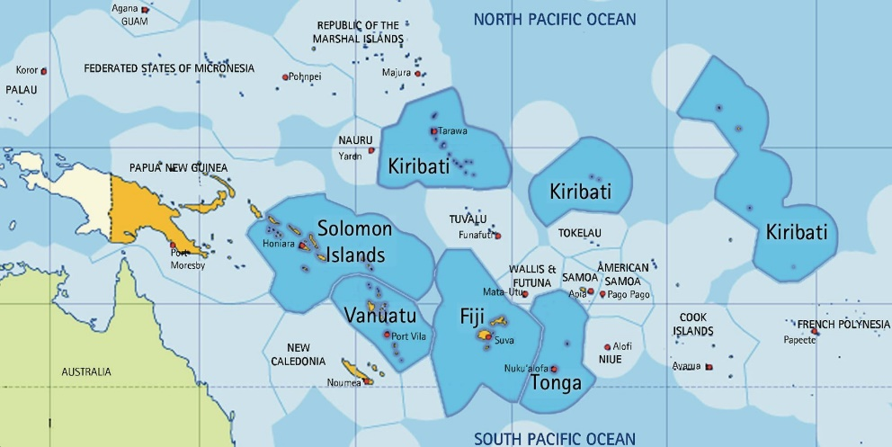
Metallic minerals in the Pacific region have been explored by the “deep sea mining” (DSM) industry, interested in bringing harvested premium minerals to markets with competitive capital investments through a rapid delivery route. Seafloor massive sulphides (SMS) can be found in the EEZ of Fiji, Solomon Islands, Tonga and Vanuatu. Polymetallic manganese nodules (PMN) are in the EEZ of the Cook Islands, Kiribati, Niue and Tuvalu. Cobalt-rich ferromanganese crusts (CFC) are found in the EEZ of Kiribati, the Marshall Islands, the Federated States of Micronesia, Niue, Palau, Samoa and Tuvalu. Licenses have been granted for exploration, while concerns have been raised about transparency and consultation, value assessment and cost-sharing, associated with difficulties in regulatory monitoring and understanding of environmental risks. DSM is by definition a long-term, non-renewable, extractive enterprise and will have to be followed up on attentively, but the potential is undeniable as a resource of the Pacific region. As incontestable are the risks of mining and the likelihood to have a degrading impact on fisheries. A better-informed approach may be warranted as science is not conclusive, but the risks exist and ought not to be underestimated.

To exploit the resource, cumulative impact assessments beyond individual operations and analyses of the repercussions on marine ecosystems and food chains, on other sectors of the economy and on traditions and habitat, will have to become more accurate. Good tax design would be paramount, as this industry is unlikely to generate significant local employment. Regional cooperation and UN costing, monitoring and technical assistance to Governments might be part of the necessary confidence-building measures to develop the regulatory framework for this economic transformation. Multinational corporations might take advantage of their advanced knowledge of market dynamics and decide on which investments to make or not make, ahead of governments, especially where they may lack the knowledge infrastructure to make informed decisions or engage in large scale contract negotiations. Extractive industries may be motivated to maximize returns and extract these resources, at least temporarily eschewing environmental sustainability concerns. The controversy inevitably surrounding such an extractive industry is compounded by the likely negative consequences for ocean biodiversity and climate impact it is bound to imply. There is serious scientific scepticism that DSM can be undertaken without damage to the oceans and their sustainability. Conversely, Governments in whose jurisdiction the resources sit can´t afford to ignore the existence of DSM, and policy responses need to be provided, grounded in principle, aware of the political economy implications and operationally sound.

Innovative Financing and FDI

Given the small size of the tourism sector in most PICTs (in absolute terms, even though in relation to the size of the economy they may be large), harmonized business regulations that make it easier for tourism operators to operate in multiple countries may increase the attractiveness of the region for international investors. As in many other regions, fiscal and financial incentives seem to be an important tool for PICTs that seek to attract investment. Pacific Trade & Invest (PT&I), the region’s largest trade-promotion organization, notes on its website (2017) that “Great tax incentives and hardworking people make the Pacific Islands perfect for investment.”

Other factors such as political and macroeconomic stability, and quality of infrastructure seem to be the primary drivers of investment decisions. As the geography of the PICTs raises cost of production and limits their international competitiveness for many activities, there is also the risk that investment incentives provided for a limited time to attract new investment may turn into permanent subsidies to retain activities that would not be competitive without such subsidies. In addition, there is also a risk that if PICTs compete against each other using tax incentives, this may lead to a suboptimal situation for the entire region, generating a race to the bottom.

The Pacific countries have progressed in general in the adoption of economic reforms and the creation of business-friendlier enabling environments for FDI and domestic private capital mobilisation. More transparent investment climates are making economic activity less cumbersome in Samoa, Fiji, Tonga and Vanuatu. Less fluid environments are found in Solomon Islands, Palau, RMI, FSM and Kiribati. The difficulties of accessing credit, trading across borders, enforcing contracts, dealing with construction permits or contracting electricity represent obstacles that deter economic operators from investing or developing their business footprint. Transparency International´s Corruption Perception Index (2020) affords better rankings, due to the perceived greater integrity of public officials and institutions within the 180 nations surveyed, to Vanuatu (75) and Solomon Islands (78).

Impact investments are mainly articulated via NGOs, religious organisations, and other entities with a focus on the environment, health and disaster relief. Pacific SIDS may wish to explore how impact investors could be encouraged to support key national sustainable development priorities. The Blue Economy is an obvious starting point to leverage impact investment (and other private sector capital) in initiatives that support sustainable fisheries management and sustainable aquaculture, for instance. SIDS in the Indian Ocean have been awarded international recognitions for promoting investments in the Blue Economy. In Fiji, the UN is providing catalytic concessional financing to Blue Economy investments to crowd-in more commercial sources of capital. The UN’s combined offering of high-touch engagement with businesses to make them investment-ready and concessional financing has the potential to open doors for vertical funds on climate to scale these initial investments. This has been Fiji´s recent experience with the approval Green Climate Fund’s investment in the Global Fund for Coral Reef’s Investment Window.

Development partners have a key role to work with national authorities to identify innovative finance options, facilitate connections with relevant technical experts and impact investment communities, help countries devise project proposals, and also provide blended finance in the form of co-financing and guarantees when there is clear additionally of funding. It should be noted however that innovative finance schemes represent complementary sources of development finance. Development partners have the opportunity to use innovative debt instruments such as thematic bonds which can attract investment capital to green, social and sustainability projects. Blended finance in the form of concessional loans or guarantees are also options often used as catalytic capital to mobilize funding towards projects which are considered to be higher risk.

Debt is showing signs of distress in the Pacific, mostly due to the increased borrowing to front COVID-related expenditures, leading to an increase of public debt ratios and elevation of risk indicators in the region. Notwithstanding this constraint, the determination of the IFIs and key bilateral donors in supporting the Pacific nations through the pandemic has led to a significant increase of the PICTs´ capacity to avoid a fiscal crisis, respond to the heath emergency, vaccinate a segment of their adult population, and create a safety floor for their economies, businesses, and workforce.

The G20 approved the Debt Service Suspension Initiative (DSSI) to help select countries concentrate their resources on fighting the pandemic and safeguarding the lives and livelihoods of millions of the most vulnerable people. Since it took effect on May 1, 2020, the initiative has delivered more than US$5Bn in relief to more than 40 eligible countries, including Fiji, Samoa, Solomon Islands and Vanuatu. In all, 73 countries are eligible for a temporary suspension of debt-service payments owed to their official bilateral creditors, including some PICs who have not availed themselves of this possibility, like Kiribati, RMI, FSM or Tuvalu. The G20 has also called on private creditors to participate in the initiative on comparable terms. The suspension period has been extended through December 2021.

The World Bank and the IMF are supporting implementation of the DSSI—by monitoring spending, enhancing public debt transparency, and ensuring prudent borrowing. DSSI borrowers commit to use freed-up resources to increase social, health, or economic spending in response to the crisis. They commit to disclose all public sector financial commitments (involving debt and debt-like instruments). They also commit to limit their non-concessional borrowing to levels agreed under IMF programs and the World Bank’s non-concessional borrowing policies.

The Federated States of Micronesia, the Republic of the Marshall Islands, and the Republic of Palau are signatories to the Compacts of Free Association (COFA) with the United States of America. These agreements will expire in 2023. Similarly, the Cook Islands and Niue are associated states to New Zealand. Such agreements provide financial assistance from the US and New Zealand to their associate countries, visa-free travel between the US/New Zealand and associate countries, and access by associate countries to many US and New Zealand domestic programs and other benefits. Compact funding is also provided by the US to the Government of Palau through a separate agreement, signed in 2018 with accompanying financial provisions. The financial assistance provisions under the Palau Compact Review will expire in 2024.

Several PICTs have established their own sovereign development funds as innovative FfD structures to increase their public spending capacity. “Nauru, Palau, FSM, RMI, Kiribati, and Tuvalu have sizeable trust funds, which have in some cases also played an important role in financing public expenditures, given a shortfall of revenues from other sources in the 18 months following the outbreak of COVID-19. The trust funds in FSM, RMI, and Palau were established as part of the Compact of Free Association with the USA. Kiribati has a trust fund that was built with phosphate tax revenues, while Tuvalu has a donor-funded trust fund. Nauru also had a large sovereign wealth fund built from the country’s phosphate resources. However, following the exhaustion of primary phosphate reserves, poor investment decisions led to a rapid loss in value of the country’s sovereign wealth fund, which is now being dissolved. With the support of development partners, Nauru established a new Trust Fund in 2016 funded from government as well as development partner resources. More research is recommended to explore how this wealth could be most effectively deployed in support of sustainable development.

The objective is that the investment income from these funds—which are placed in foreign financial assets—will eventually help the PICs to achieve a measure of budgetary self-reliance, in recognition of the reality that the PICs will not be able to generate sufficient revenues on their own to meet long-term development financing needs. Other innovative finance channels include digital finance and FinTech solutions which support domestic and cross boarder payments; fiscal resilience mechanisms to cope with shocks, including new insurance and de-risking instruments; impact investments from the private sector and incentives for the mobilisation of domestic savings; and new digital lending mechanisms to ease access to capital while maintaining financial sector stability and curbing over indebtedness.

One of the new instruments are the so-called nature bonds which make developing countries´ debt more sustainable. The bonds aim to link new debt to targets for biodiversity and carbon emissions, The discussions on greening sovereign debt come as mitigating climate change and spending to recover from the pandemic have climbed to the top of the agenda for governments. To match borrowers with creditors, at a time of surging investor demand for environmental assets, the cost of debt repayments is usually tied to quantified biodiversity and emissions-reductions targets, meaning borrowing PICTs would have to pay less interest if they hit those. The new proposals aim to integrate nature and climate into sovereign debt more systemically, including with credit-rating agencies and investment banks that advise governments on their debt. The incentive creates positive consequences to actually meeting environmental targets.

The Care Economy

The Care Economy comprises all activities, paid and unpaid, that contribute to the care of people. It includes childcare, eldercare, healthcare, family care (cooking, cleaning and feeding) and non-market (subsistence) food production and processing for family consumption.

The greater part of the Care Economy in terms of time spent on it is unpaid work within the household. However, precisely because it is unpaid this work does not appear in national accounts and is therefore often overlooked in analysis and planning. For some analysts it is therefore not regarded as economic activity, although it is critically important to all economies, not least because it is responsible for the daily and generational reproduction of the capacity to work. The paid component of the Care Economy is principally State provision of care services such as health, education and social services, with a small segment of private provision. This aspect is included in national accounts, typically as an underfunded, poorly paid and over-stretched sector. There is a need to recognize, reduce and redistribute unpaid care work, while creating more and decent jobs for paid care workers. COVID-19 has increased the demands on both paid and unpaid care work, including through demands on the health sector and periods of home-schooling (see Section 3.3. on COVID-19 Impact).

Targeted support to the Care Economy across the region would bring a two-fold equality dividend to society, while increasing GDP and national capacity. Extending the reach of State-provided and private sector social service provision would generate more jobs for women in this highly feminized sector, equalising incomes and providing enhanced fiscal benefits and significant contributions to GDP. It would also reduce the burden of those engaged in unpaid care work within the household (overwhelmingly women), especially for those who are also working in the formal economy, thereby promoting greater intra-household equality and balance, A yet further benefit is that greater support would increase the capability of the Care Economy as a whole to produce and support a high-capacity labour force, also increasing its indirect contribution to GDP. Prioritizing the Care Economy pays dividends not only for those in need of care and those that provide care, but also helps to build both stronger economies and more equal societies.

“Care work, both paid and unpaid, is at the heart of humanity and our societies. Economies depend on care work to survive and thrive. Across the world, women and girls are performing more than three-quarters of the total amount of unpaid care work and two-thirds of care workers are women. Demographic, socio-economic and environmental transformations are increasing the demand for care workers, who are often trapped in low quality jobs. If not addressed properly, current deficits in care work and its quality will create a severe and unsustainable global care crisis and further increase gender inequalities in the world of work.”

COVID Impact Analysis

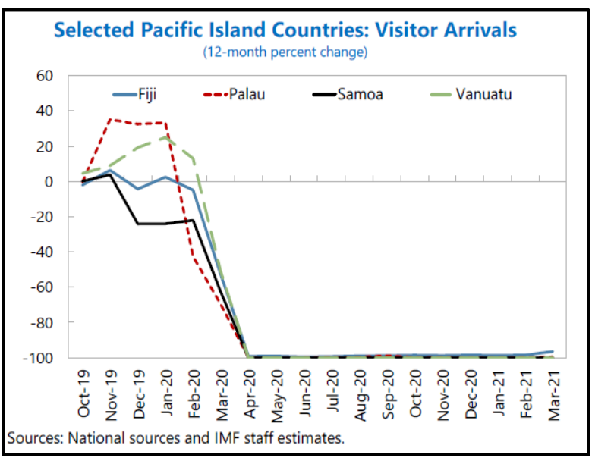
Compared to other parts of the world, and against all odds, the reported COVID-19 incidence in the Pacific has remained relatively low, with the exception of Fiji and parts of the North Pacific. Pacific Island Countries have high vulnerability to outbreaks of communicable disease due to relatively weak health systems, the prevalence of non-communicable diseases, and social norms that are both challenging to effective prevention and conducive to rapid transmission. But the Pacific´s geographic remoteness and prudent public policies preventing international travellers from entering, declaring states of emergency and imposing other internationally recommended measures allowed for a relatively low COVID-19 incidence. Close control of immigration and systematic health checks, in addition to outer islands lockdown due to the possibility of exposure to COVID-19 and the use of emergency provisions by PIC governments to restrict domestic travel have contributed to pandemic control. In the early months of the pandemic, 13 Pacific Island countries declared a state of emergency. Governments are responsible for the protection of rights and faced with the challenges of delivering public health but also protecting other rights, including to freedom of expression, freedom of association, freedom of movement and people’s right to participate in public affairs especially in regards to law and policy-making and in humanitarian contexts. Emergency measures that infringe on fundamental human rights during the pandemic need to be legal, necessary and proportionate to be in compliance with human rights standards. In some countries, new emergency powers were used to limit people’s participation and rights, e.g. through the passing of legislation under emergency provisions that were introduced during 2020, e.g. in Fiji or Samoa.

Pacific leaders acted quickly to limit exposure to the virus with robust and timely public health and border protection measures. The region was however not spared from a devastating economic impact. The sobering impact of COVID-19 and the evaporation of tourism due to the border closings has made the importance of the sector – and its vulnerability – particularly evident. “Tourism, trade and remittances were significantly reduced, and health expenditures rocketed. The COVID-19 crisis has impacted labour mobility and diaspora groups from the Pacific, with consequent reductions in remittances. Many Pacific workers find employment in Australia under the Seasonal Worker Programme (SWP) and Pacific Labour Scheme (PLS), and in New Zealand under the Recognised Seasonal Employer (RSE) Scheme. The countries most exposed, including to temporary suspension of labour mobility programmes – Palau, Fiji, Samoa, Vanuatu, Solomon Islands and Tonga – suffered income reductions between 10 percent and 25% of GDP. On the health front, the shutdown of commercial airlines across the region made it difficult to import necessities quickly (including medical supplies) and send out medical samples for international testing. This was countered through charted WFP humanitarian flights moving medical supplies on behalf of partners including governments along with PICT governments waiving restrictions for health and humanitarian flights.”

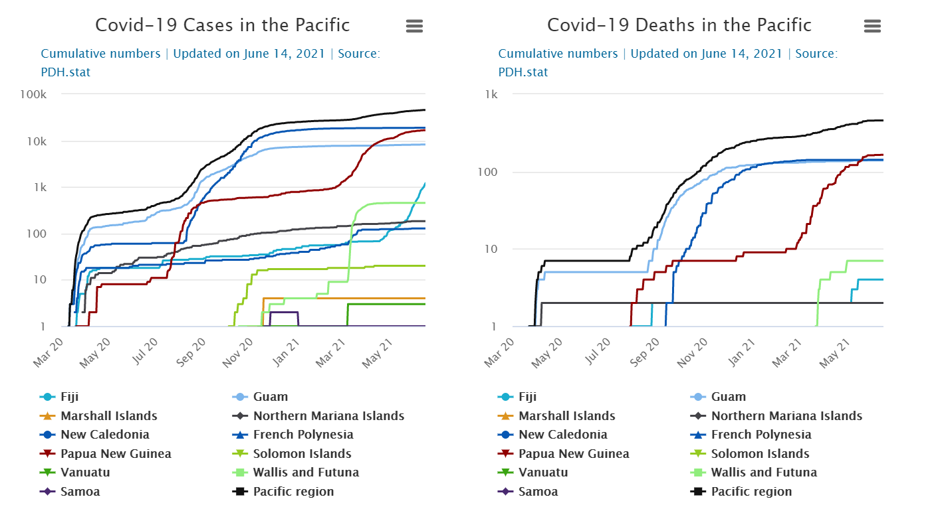

Source SPC. 2021 COVID SEIA. CROP

Nevertheless, COVID-19 lockdowns aimed at flattening the curve have managed to slow or stop the spread of the virus, providing enough time for vital medical facilities and supplies to mobilize and cope with the influx of infected people. Health impacts as a result of COVID-19 have been mitigated against, including in Fiji where imported cases led to localized community transmission. Fiji has cumulatively reported less than 50,000 cases and less than 500 deaths, Solomon Islands 20 cases, RMI, Vanuatu, Samoa and Palau less than five each. Tonga and Tokelau report not having any cases to date.

Pacific Islands Forum Leaders have recognised COVID-19 as a major crisis and have invoked the Biketawa Declaration to collectively respond to COVID-19. According to the IMF, in the Pacific Islands GDP losses due to COVID-19 are estimated to bring GDP about 3 percent below trend in 2023, of which 0.4 percentage point is estimated to be due to the shock in the tourism sector. For two out of three SIDS, tourism accounts for 20% of GDP or more, compared to 4.2% for OECD countries. In 2019, remittances as a share of GDP averaged 8.3% across SIDS, with Tonga receiving remittances worth almost 40% of GDP. The children and youths in the region experienced significant education and socialisation losses.

The impacts on tourism, job losses, and reduced economic activity were reported across household types, sectors, and geographies. The 2020 Biennial Pacific Sustainable Development Report indicates that the COVID-19 pandemic could set the fight against poverty back by a decade, and in some Pacific Island countries by as much as 30 years. Renegotiating building rental, deferment of loan repayments and reduction in working hours, wages and salaries, including through laying off staff, were the key measures undertaken by businesses during COVID-19 to manage business expenditure and ensure survival. Young people are also facing challenges. The return of many young people and workers back to their islands and communities due to unemployment and under-employment is putting pressure on scarce resources and services, placing extra demands on the household labour of women, and giving rise to inter-community tensions, including intergenerational tensions and those between urban vs. rural life.

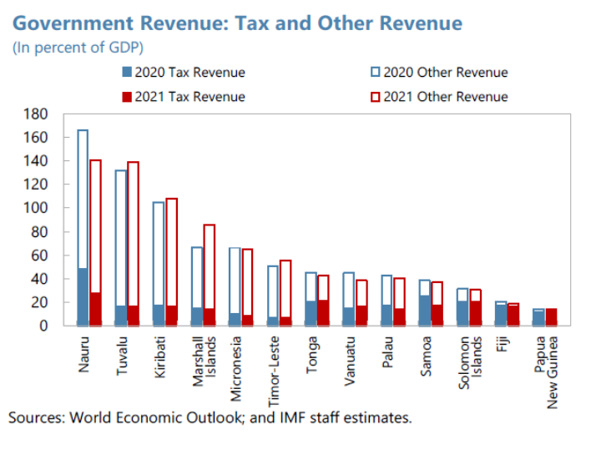
The fiscal responses to the crisis have been large and well-targeted. The Fijian government, for instance, designed and funded two major stimulus packages, amounting to an estimated total of 26% of GDP. Measures included unemployment assistance, tax and tariff cuts, and a holiday program for loan repayment, guarantees to the national airlines and tourism incentives. The Fijian Government also announced measures to boost agriculture production in order to ensure food security, and a period of fee relief for market vendors to ensure the continued operation of agricultural markets. Other Pacific Island States announced fiscal stimulus packages and social protection measures: Kiribati and Palau expanded unemployment benefits; Tonga, Vanuatu, and Samoa, announced moratorium on loan payments, to help MSMEs avert bankruptcies. Palau, Solomon Islands and Tonga provided temporary relief on payment of rental or utilities. Like in other countries, health and economic protection public expenditures have increased sharply while revenues have plummeted. Debt has risen and its sustainability shrank.

IFIs have provided financial emergency assistance to several of the PICTs, to sustain their countercyclical policies. The absence of tourism related revenues has also been partially offset by the direct budget support that traditional donors such as Australia, New Zealand, the EU and the World Bank have provided across the Pacific. The immediate bilateral support has acted as a safety cushion. Growing remittances have also had a powerful countercyclical effect during this time of economic downturn. Without the direct budget support and the incoming remittances, the situation would have been much worse. However, as the PICTs recover from the pandemic, there will be need to understand how far the remedial measures benefitted those in formal employment and with access to financial services (mainly those in urban areas and men), and how far they benefitted those engaged in agriculture and other sectors in which women are clustered, to ensure inclusive growth.

While the closure of borders has held back imports of capital goods and the arrival of foreign experts, delaying infrastructure and reconstruction efforts for many PICs (such as Marshall Islands, Micronesia, Solomon Islands, Tonga, and Vanuatu), the IMF states on a more positive side that “Nevertheless, for most of the islands, the contraction has turned out to be less severe than previously expected, as governments have taken measures to support the populations and sectors most affected by the pandemic. The economic contraction in some of PICs´ main trading partners (such as Australia and New Zealand) also turned out to be less severe than expected; and remittances have held up relatively well.

Nevertheless, all PICTs experienced disruption to social and cultural life due to COVID-19, although several cultural practices and the mutuality of many social institutions, including high value placed on caring for others in the community, provided support and resilience. However, the long-term impacts of COVID-19 may influence PICTs’ ability to advance development outcomes and achieve all the Sustainable Development Goals (SDGs).

Despite the milder-than-expected economic impacts of the pandemic, most households across the Pacific have been affected negatively by it. Pre-existing gender discrimination and barriers to women’s equal participation in economic, cultural and political life, including their exclusion from decision-making processes related to COVID-19 and pandemic related security issues have caused the brunt of these effects to be felt by women, and their specific needs have often been unmet or intensified by COVID response. In particular, their traditional domestic and care-work responsibilities were greatly expanded by the epidemic, with relatively little state support, which instead focused on the formal economy.

Furthermore, during COVID-19, persons with disabilities, who make up approximately 15% of Pacific populations, faced more discrimination, violence, and various barriers to accessing information, education and services, in particular those related to gender-based violence and sexual and reproductive health. COVID-19 has emphasised how women and gender non-conforming persons with disabilities are also impacted by a lack of planning for the continued provision of sexual and reproductive health services for all in times of crisis. Globally, many women and girls with disabilities have reported increases in disability discrimination and exclusion with barriers in meeting basic needs or to accessing employment and education during the COVID-19 pandemic. Pre-existing barriers, combined with the impact of COVID-19 itself is expected to have created new challenges for women and girls with disabilities, particularly around access to sexual and reproductive health and GBV services.

Household strategies employed in response to this stress frequently centred on expansion of women’s workload and included lowering expenditure by reducing food and non-food consumption and the number of children going to school, while finding alternative sources of income by taking on extra debt, selling harvests in advance, and receiving assistance from friends or family. There were disruptions to the food supply as a result of travel and transport restrictions. Villagers with available fishing resources increased their catch for consumption or sale. However, households experiencing loss of income were unable to participate, which reduced potential sales and trade. Family gardens became an important food source in many communities, also increasing the workload of women, who are chiefly responsible for these gardens. The increase in gardening and agricultural activity was supported by local, provincial and national leadership through provision of seeds, seedlings, and equipment. However, this did have a negative flow on effect of reducing the earnings of market vendors, again principally women.

“An interesting phenomenon during the pandemic is the surge in online bartering providing a social net and a modern twist on a traditional practice. In Fiji, a Facebook page created on 21st April 2020 to encourage non-cash trading accumulated nearly 200,000 members in a few weeks, which has been replicated in other PICs. The members, mostly women, barter agricultural produce, books, household items, art and crafts, baked goods, and groceries. Similar schemes followed in Samoa ‘Le Barter’; Tonga ‘Barter for Change’ with 11,000 members, and Vanuatu ‘Barter for Nambawan Life Vanuatu’, all of which helped families facing financial strain due to COVID-19.”

The COVID-19 crisis has also laid bare the precarity of gains to date in women’s labour force participation. The International Labour Organization (ILO), McKinsey, and others have found that women’s jobs have been disproportionately affected by COVID-19 due to occupational segregation in the hardest-hit sectors and the impact of increased care duties on women’s labour force participation. “Across the Pacific, the COVID-19 crisis has underscored the particular vulnerability of women in informal work, as these women have faced barriers to small-scale income generation in the context of mobility restrictions and a drop in demand for goods and services and have been easily dismissed without social protection to fall back on.” It is likely also that the coping capacity of women-led businesses and women workers is severely affected as women often lack access to financial mechanisms (such as credit) and digital technologies, which means that they cannot participate in remote work or learning activities.

Women are more exposed to the virus as they make up the majority of pandemic frontline workers (they represent approximately 70% of the global health-care and social services workforce) and are overrepresented in informal work sectors and other highly exposed sectors like accommodation, domestic work and food services. As health systems undergo strain due to the virus, efforts must be made to account for the unique challenges faced by female health workers. For example, gender inequalities may leave women health workers less able to advocate for protective equipment. They may be less able to attend to their own sexual and reproductive health needs, such as hygiene supplies for menstruating staff or breaks for pregnant staff. In addition, in many countries, funding for sexual and reproductive health services has been redirected to addressing the pandemic.

In many PICTs schools closed and students shifted to learning from home. This was difficult for many as they faced practical barriers such as inability to receive school resources or work online, and many students lost interest. 800,000 Pacific children in schools and early childhood centres faced at least some disruptions to learning due to COVID-19, including 200,000 children in Fiji who were out of school for 3 months in 2020 and 6 months in 2021 at the time of drafting this Assessment. Limited ICT infrastructure and affordable access hampered access to alternative online learning options, leaving countries relying heavily on paper-based options for home schooling, even as many started to work on expanding connectivity and developing online content and platforms in other areas. In Tuvalu, where the vast majority of secondary students attend boarding school, closed dormitories saw these students returning to their home islands.

Even though this typically placed a further burden on women, who were responsible to care for their home-bound children, many parents were reluctant to send their children to school. All PICT education agencies have had to advocate with parents and communities to overcome their reluctance for children to attend school – even in countries where cases are yet to be recorded. There is no concrete regional data yet on the impacts of these set-backs on levels of achievement by pupils, but it is likely that average educational progress has slowed, as elsewhere in the world. The evidence indicates that girls were more disadvantaged by the school closures that boys because in many cases they were expected to undertake some of the increased domestic duties and childcare caused by the pandemic, instead of schoolwork.

Although it is likely that women are at greater risk of experiencing adverse impacts of COVID-19 because, as described above, in general women have more vulnerable employment, fewer resources, are expected to undertake more unpaid care work, and face greater barriers to accessing information, services and support than men, there is a lack of empirical evidence describing the full gendered impacts of COVID-19.

Nevertheless, there are some indications that the pandemic will compound existing gender inequalities and increase risks of gender-based violence. Evidence from prior epidemics shows that existing inequalities for women and girls, and discrimination of other marginalized groups such as persons with disabilities and those in extreme poverty, worsen in these times. Women and girls face higher risk of domestic violence, as well as other forms of gender-based violence including sexual exploitation and abuse.

The impact of the COVID-19 pandemic is deeply gendered, which is to say that women and girls have experienced more negative consequences than men and boys. The pandemic has exacerbated existing gender inequalities, widening the poverty gap between women and men; it is estimated that COVID-19 will push 47 million more women and girls below the poverty line. Female-dominated economic sectors, particularly small or informal businesses, have been hit hardest by the pandemic, leaving millions of women unemployed. The coping capacity of women-led businesses and women workers is severely affected as women often lack access to financial mechanisms (such as credit) and digital technologies, which means that they cannot participate in remote work or learning activities.

Fiji’s Minister for Women, Children and Poverty Alleviation reported on May 4, 2020, that “close to 50 percent of women are reporting a correlation between COVID-19 and increased violence, linked directly to the restrictions of movement and economic strain on families”. This is confirmed by Fiji´s high rates of gender-based violence in the pandemic environment. The national domestic violence helpline recorded a 300% increase in domestic violence-related calls one month after curfews and lockdowns were announced in March 2020 during the first wave of the pandemic. Helpline calls in Samoa jumped 150% from the same time the previous year.

Fiji women´s groups also reported that the frequency and intensity of violence against women had increased since the onset of the pandemic due to the combination of unemployment-related stress and social confinement, compounded by women’s lack of access to the formal justice system. Several women with disabilities in Fiji have reported that financial hardships as a result of the pandemic have exacerbated the situation of GBV. Limited access to services for sexual and reproductive health, including contraception and maternity services, has been reported, particularly with lock-down restrictions. Surveys on adolescent girls have registered additional problems, such as disrupted education; increased anxiety and loneliness; feelings of isolation and insecurity at home and online; increased care burden at home, and disrupted access to menstrual hygiene and sexual health services.

As discussed elsewhere in this CMCA, one of the saddest outcomes of discrimination against women across the Pacific is the very high incidence and tolerance of violence against women and girls. The resulting loss of bodily autonomy directly constrains the full economic and political agency of women. The COVID-19 pandemic has affected those already living with pre-existing disadvantage most severely, including the poor, the elderly, those living in remote areas and those living with disability. In each of these categories women have been particularly badly affected by the disease due to the very factors that create their gender disadvantage: their caring and domestic responsibilities, their clustering in the worst-affected employment sectors and their vulnerability to social pathologies such as gender-based violence, which increases in times of crisis. If these issues are not addressed systemically, recovery from COVID-19 will be partial, and inclusive growth impossible.

Pacific Countries’ Position on the Multi-dimensional Vulnerability Index

The Multidimensional Vulnerability Index (MVI) aims at measuring States´ structural vulnerability, defined as any structural limitation which impedes a country to achieve sustainable development. Three different dimensions of structural vulnerability are considered: economic, structural development (geographic), and environmental. MVI consists of 18 indicators covering these three dimensions. To shed light on how Small Island Development States (SIDS) are placed compared to the rest of the world, each indicator in the MVI, as well as the overall index, is calculated for 195 countries, including developed and developing economies. The MVI can inform national policies, debt restructuring, UN Cooperation Frameworks, as well as the review of eligibility criteria in accessing concessional financing, dedicated funding streams for SIDS, insurance, and compensation schemes.

Pacific countries and territories’ economic and social achievements and challenges should be viewed in the development context faced by SIDS, to which PICTs belong. As highlighted in recent research, “SIDS face a unique set of vulnerabilities which impede their ability to achieve sustainable development. Structural factors, including their size, remoteness, limited resource base, market size, very high exposure to climate risks and natural disasters impact socio- economic outcomes and their ability to achieve the SDGs. The COVID-19 pandemic has amplified those vulnerabilities with many SIDS countries being particularly affected by the drop in international tourism and travels and international remittances.” The SDSN analysis has clearly shown that countries with higher structural vulnerabilities tend to perform worse on the overall SDG Index and other SDG outcomes, including extreme poverty, life expectancy and subjective well-being.

According to the SDSN analysis, 12 Pacific Island countries and territories (PICTs) are among the 30 most vulnerable countries in the MVI economic dimension, among the 195 countries for which the index is computed. The average economic MVI score for these 12 PICTs of 45.4 is almost double that of the global average value of 24.2. Moreover, the top 8 spots on the top 30 most vulnerable countries list are all occupied by PICs, with the Federated States of Micronesia (FSM) having the highest score of 53.6.

Top 8 PICTs on Economic MVI score vs. global average

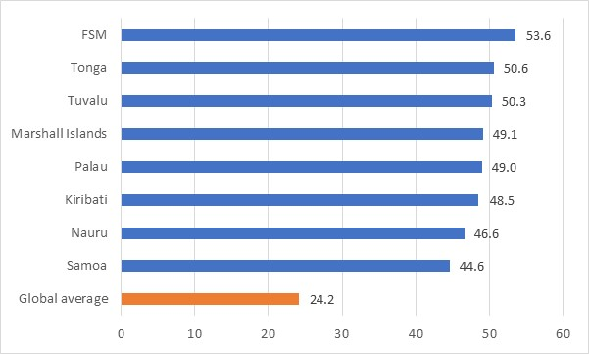
Source: Prepared by the UN RCO based on data from the SDSN

10 PICs can also be found among the 30 most vulnerable countries on the MVI structural dimension. The average score for these 10 countries of 66.5 exceed by 37.4% the global average score of 48.4. The top 5 most structurally vulnerable PICs include Palau, Tuvalu, Nauru, Marshall Islands and FSM, with the scores significantly above global average (see Figure Y).

Top 5 PICTs on Structural MVI score vs. global average

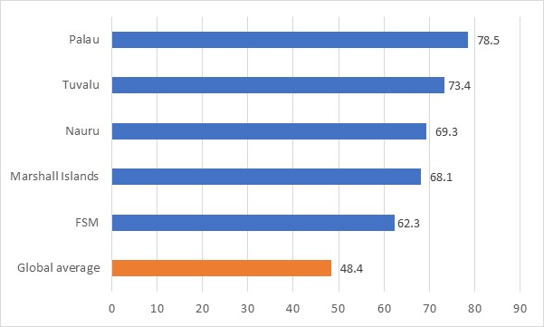
Source: Prepared by the UN RCO based on data from the SDSN

Finally, 11 PICTs are also among the 30 most vulnerable countries globally in the MVI environmental dimension. The average MVI environmental score for the 11 countries is 5 times the global average of 2.9. The top 5 PICTs on this dimension include American Samoa, Tuvalu, Marshall Islands, Tonga and Kiribati.

Top 5 PICTs on Environmental MVI score vs. global average

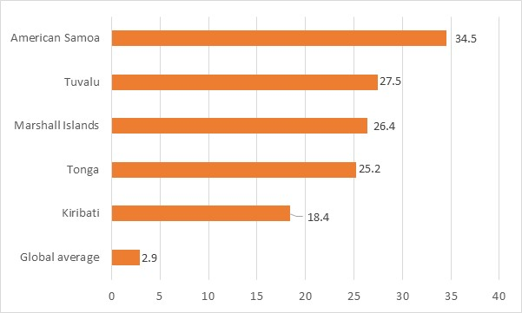
Source: Prepared by the UN RCO based on data from the SDSN

This MVI analysis should not be interpreted as catastrophism or meaning that PICTs are facing doom and gloom. It only puts more emphasis on the fact that these countries and territories face many vulnerabilities inherent to SIDS, and that in this context the right policy choices and prioritization of development objectives are even more important for PICTs to make progress towards the SDGs.

Regional Integration and Political Context

The Pacific Leaders have pursued the goal of regional integration for decades now. Since the establishment of the Pacific Forum in 1971, the last four decades have been a mix of progress in coordination of efforts, investment of political will in regionalism, and the ultimate goal of a deeper integration remaining elusive. Pre-dating the Forum, the South Pacific Commission, now called Pacific Community (SPC) after being enlarged in the mid-1990s to include the northern Pacific Island states, RMI, FSM and Palau, was established in 1947 under the Canberra Agreement signed by Australia, France, New Zealand, the Netherlands, the United Kingdom, and the USA.

In the 1970s, the South Pacific Applied Geo-Science Commission (SOPAC) started as a UN Project for mineral prospecting in offshore areas, and assisted member countries in identifying, assessing, and developing mineral and non-living resource potential of extensive marine resources. The South Pacific Regional Environment Programme (SPREP), the Pacific Forum Line, the Forum Fisheries Agency (FFA) and the South Pacific Trade Commission were founded for regional cooperation in environmental protection, shipping, fisheries, and trade, respectively.

Today there are over 30 regional organisations for Pacific Cooperation and regional integration. The Council of Regional Organisations of the Pacific (CROP) functions as a coordination mechanism between the heads of the regional organizations in the Pacific, and as a high-level advisory body, to provide policy advice and facilitate policy formulation at national, regional and international level. CROP provides a forum to enable CROP heads to collectively review progress with their respective organizations’ contributions on the Framework for Pacific Regionalism. The Secretary General of the Pacific Islands Forum Secretariat (PIFS) is the permanent chair of CROP.

Recognizing the key role the Pacific Islands Forum plays in promoting sustainable development, environmental protection, good governance and peace and security, as well as supporting integrated ocean policy in the Pacific through regional cooperation, the UN General Assembly Resolution A/75/L.98 urges the United Nations system to align its work programmes and operations in the region of the Forum members … taking into account the priorities of the Pacific Islands Forum members, including as reflected in relevant regional agreements. The document further stresses the value of enhanced close cooperation and coordination between the programmes and activities of the United Nations system and Pacific Islands Forum members, the Forum secretariat and associated institutions, including the Office of the Pacific Ocean Commissioner, welcomes recent efforts by United Nations and regional agencies in the Pacific to enhance cooperation through joint activities, working groups and other means, and encourages further practical steps to enhance such cooperation and coordination.

In the new Millennium, the Pacific Island Countries Trade Agreement (PICTA) for free trade among the Pacific Island Countries, and the Pacific Agreement on Closer Economic Relations (PACER) for trading with Australia and New Zealand, were concluded and signed in 2001. The region has negotiated as a bloc in the UN and with the EU and has become more recently an influential force for climate action on the multilateral scene and was always a main actor in the negotiation process over the United Nations Convention on the Law of the Sea (UNCLOS).

The Pacific is a notable global negotiator of universal norms. As early as in 2005, the leadership of the region already defined regional integration as one of four pillars of the Pacific Plan. Trade policy both with major trade partners and within the region has seen successes in the form of non-reciprocal and preferential agreements, and setbacks with delayed economic cooperation in some sectors and with some nations. Trade is highly imbalanced due to limited domestic production, in turn explained through higher production costs that would make import substitution unviable. Eight PIF members ratified and have been Party to the PACER Plus Agreement since its entry into force on 13 December 2020: Australia, Cook Islands, Kiribati, New Zealand, Niue, Samoa, Solomon Islands and Tonga. Nauru, Tuvalu and Vanuatu have signed the agreement and are yet to ratify it. In contrast, American Samoa, French Polynesia, Guam, New Caledonia, and Northern Mariana Islands, do not have any preferential trade agreements. The absence of certified auditors hampers manufacturers´ ability to obtain or renew International Organisation for Standardisation (ISO) certifications to engage in international trade. Lack of diversified ship ownership has become another obstacle to port calls. Ports in smaller countries do not offer the full range of logistics vessels need to dock. Access to credit is also restricted in the 14 PICTs. Finally, low-quality product exports, especially of foodstuffs, have been widespread in the region, generating a non-nutritious unhealthy input to the dietary availabilities on-island.

Political disruptions, concerns about the impact on local manufacturing as well as the impact on government finances due to loss of revenue from tariffs, and the difficulty of coordinating the interests of the region´s two metropolitan powers and those of the less populated nations or Smaller Islands have placed obstacles on the road to integration. As the Leaders stated, “The strength and solidarity of the Forum family is also being tested.” The notion of a political and economic Pacific community or a monetary union – tagged or not to one of the region´s stabler currencies - has not found enough traction. Research has taken the view of regional integration as both a challenge and an opportunity: “Overall, regional integration in the South Pacific is weak because of a multitude of challenges for public governance. On the other hand, though, those challenges might become a motivation for the small island states to improve the level of regional governance.”

The Pacific Islands Development Forum (PIDF) was formally established in 2015. Subregional platforms for the Melanesian and the Polynesian clusters of countries have contributed to the integration efforts. The Melanesian Spearhead Group and the Polynesian Leaders Group gather regularly to launch close cooperation in basic disciplines, like health care, judiciary, police etc.
Achievements along the way of regionalisation efforts include the creation of Air Pacific, the foundation of the University of the South Pacific, its special campuses and extension centres, the negotiations on labour mobility with Australia and New Zealand, and the regional agreements on fisheries, to mention only a few. The global agenda for sustainable development and the specific problematique of SIDS have led to important regional cooperation efforts on economic, social and climate issues.

The region jointly monitors the Pacific´s progress in implementing the 2030 Agenda, the SIDS Accelerated Modalities for Action (S.A.M.O.A) Pathway and the Framework for Pacific Regionalism (FPR), predated by the Pacific Plan. In 2016, Leaders also directed that joint regional reporting efforts include a review of progress under the Pacific Leaders Gender Equality Declaration (PLGED).

In 2017, the Pacific Roadmap for Sustainable Development (PRSD) was endorsed by Pacific Leaders. The quadrennial regional reports and Voluntary National Reviews (VNR) reporting on the 2030 Agenda to the annual HLPF are part of the global accountability process for the 2030 Agenda and SDGs, but also part of the regionalisation efforts. Sectoral regional initiatives, platforms, institutions and mechanisms include the Pacific Urban Forum, the Pacific Aviation Safety Office, the South Pacific Tourism Organisation, the University of the South Pacific, the Pacific Framework for the Rights of Persons with Disabilities, Pacific Platform for Action on Gender Equality and Women’s Human Rights, the Pacific Leaders Gender Equality Declaration, the Framework for Resilient Development in the Pacific (FRDP), the Pacific Resilience Partnership (PRP), the Pacific Islands Literacy and Numeracy Assessment, the Pacific Islands Private Sector Organisation, and the Pacific Power Association.

The FRDP, approved by Pacific leaders in September 2016, is the overarching regional framework for providing an integrated all-stakeholder approach for coping with and managing climate change and disaster risks, in order to make more efficient use of resources, to rationalise multiple sources of funding which address similar needs, and for more effective mainstreaming of risks into development planning and budgets. It is closely aligned to key global agreements, including the Paris Agreement, the Sendai Framework for Disaster Risk Reduction 2015- 2030, and the S.A.M.O.A Pathway, and identifies three interrelated goals to enhance resilience to disasters and climate change in the context of sustainable development and efforts to eradicate poverty: strengthened integrated adaptation and risk reduction to enhance resilience to climate change and disasters; low-carbon development; and strengthened disaster preparedness, response, and recovery.

The governance and operationalisation of the FRDP is supported by the multi-stakeholder Pacific Resilience Partnership (PRP), which consist of government, civil society, private sector, regional agencies, development partners and academia. The PRP is mandated by Pacific leaders to support national implementation and monitoring of the FRDP. The PRP also acts as a key forum for regional policy deliberations on climate change and disaster risk reduction through the biennial Pacific Resilience Meeting, Technical Working Groups, and provision of policy and technical advice. The UN is one of 15 constituencies represented on the PRP and is also represented as chairs and members of the Technical Working Groups. This representation provides a direct link between UN strategic support and programming (at the regional and national level) and the FRDP.

Looking broadly at the regional integration process and institutions, PIF Leaders have signalled the successes of the Forum, which espouse the aspirations to peace, development and human rights of the United Nations: “supporting self-determination and statehood; the assertion of Pacific interests in the shaping of the 1982 UN Convention on the Law of the Sea; the establishment of a Nuclear Free Zone in the Pacific through the 1985 Treaty of Rarotonga; the proactive institution of oceans governance measures at all levels to protect the health and resilience of the oceans and its resources, gaining recognition as leaders in oceans governance; the establishment of dedicated regional agencies for fisheries and the environment; strengthening regional security through the 2000 Biketawa Declaration and the 2018 Boe Declaration; the common advancement of economic and trade interests within the region and further abroad; and global advocacy on climate change culminating in our positioning within the Paris Agreement.”

In recent times, differing views on the strategic direction of the Pacific Community have created a distance in the context of the PIF, leading to a fracture and to the announced withdrawal as of February 2022 by 5 states and territories: FSM, RMI, Nauru, Palau and Kiribati. As the PIF Leaders stated, “The strength and solidarity of the Forum family is also being tested.” The Micronesian Presidents collectively expressed their formal disappointment at the PIFS Secretary-General election process and jointly agreed to initiate the process of withdrawal from the PIF. Several other regional leaders have indicated their support for an immediate review of the structures and functions of the Forum in relation to ‘sub-regional balance’, suggesting thereby an active Pacific diplomacy to avoid the fracture and the pursuit of equitable opportunities to serve the region at the highest level. Suggestions have been made for the Secretary-General’s position to be rotated amongst the three sub-regions for a four-year term non-contestable on expiry, and appeals have been made to the Micronesian Group to remain with the PIF whilst the reforms are enacted.

The patent reasons for the crisis of Pacific Regionalism do not explain fully the latent accumulation of disappointments for some of its members. In spite of the PIF´s stellar role in electoral observation throughout the region, the deposit of trust it possesses with the leadership, its mediation capacity in the spirit of Art. 52 of the UN Charter, delivering effectively “pacific settlement of local disputes through such regional arrangements…”, some in the Forum have felt left behind. Leaders have expressed that the disagreements of note will not affect the common agenda of the Pacific, in particular on climate action. However, Leaders have reaffirmed “the importance of, and committed to, ongoing and focused dialogue at the political level on the issues raised by the Micronesian Presidents’ Summit and other leaders. Leaders emphasised the importance of developing a balanced reform package that respects the equality of all Members and to which all members can agree. Leaders considered this essential for strengthening the Pacific family.”

The United Nations is since its inception a strong supporter of regional integration and has been a constant ally of Pacific Regionalism. The UN General Assembly has recognized “the key role the Pacific Islands Forum continues to play in promoting sustainable development, environmental protection, good governance and peace and security, as well as supporting integrated ocean policy, in the Pacific through regional cooperation”. It has stressed the importance of the “regular meetings between the Secretary-General of the United Nations and Forum leaders” and of the “ Resident Coordinators and United Nations Country Teams in the region (…) strengthening consultations with (…) relevant stakeholders, including the Pacific Islands Forum…” The PIF is therefore an actor of singular relevance for the UN System in general and for the UN Development System based in the region, the Pacific Regionalism platform of choice for the UN´s collaboration. A strong and representative coordination of the PICTs is essential for the UN to work at regional level on the issues that are common to the Pacific Island peoples. The United Nations will lend all its support to the consolidation of regional integration, including regional institutions, arrangements and agencies.

Regional Development Challenges and Pacific Vision

PICTs are Small Island Developing States (SIDS), and as such part of a distinct group of 58 countries characterized by certain common inherent characteristics.

“They are small, undiversified, highly open, in most cases far away from main world markets, and with challenging natural environments (e.g., minimal elevation above sea level, limited access to freshwater resources). Because of these features, they are exposed to vulnerabilities that hinder their development progress. They are highly exposed to international trade shocks, financial volatility, and economic downturns, as well as to natural disasters (e.g., storms, floods, droughts, landslides, etc.) and adverse impacts of climate change (e.g., sea level rise). Despite the above commonalities, SIDS are also a rather heterogeneous group of countries. They differ by income level, population size, and land area.”

The Pacific Islands Leaders were instrumental to the creation of the 2030 Agenda and the SDGs, an agenda that responds neatly to the development challenges of their region. They have adapted the agenda to Pacific realities and developed the regional agenda on sustainable development around the SIDS Accelerated Modalities for Action (SAMOA) Pathway, the Framework for Pacific Regionalism (FPR), the Pacific Leaders Gender Equality Declaration (PLGED) and the Pacific Roadmap for Sustainable Development (PRSD), containing the Pacific Sustainable Development Indicators (PSDI) and mandating a review mechanism implemented through the Pacific Sustainable Development Reports, inter alia.

Important steps in tailoring and accounting for the 2030 Agenda for Sustainable Development and the SDGs in the Pacific context include the first quadrennial and biennial Pacific progress reports on sustainable development in 2018 and 2020, the Voluntary National Review (VNR) reports from Fiji, Kiribati, Federated States of Micronesia, Nauru, Palau, Samoa, Solomon Islands, Tonga and Vanuatu and other national plans and strategies attuned to the global agendas. The national reports of the PICs to Universal Periodic Reviews cut across the SDGs and contribute to a rights-based approach to development.

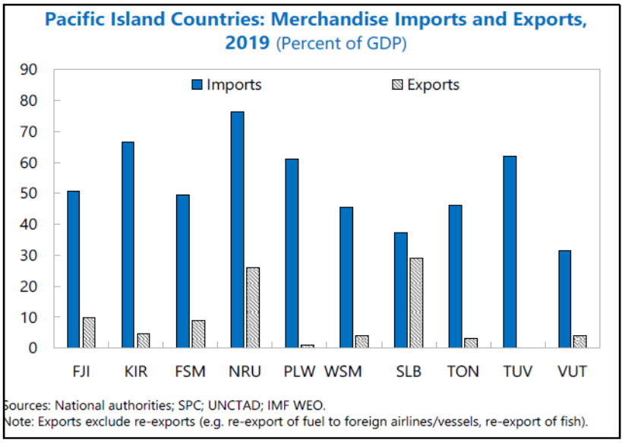
This PCMCA focuses on the 14 small island countries north of Australia and New Zealand, south of Hawaii, east of the Philippines, and west of South America, that together comprise of thousands of islands scattered across a large ocean area, 15% of the globe´s surface, and from a distance may appear highly similar. Their isolation has resulted in their development of distinct cultures, traditions and political systems. There is however one feature they all have in common, and which has influenced and sustained life since the arrival in PICTs of the first migrants and will continue to do so: the ocean - and the resources it provides. The United Nations Convention on the Law of the Sea (UNCLOS) came into force in 1994 and by 1st September 2021 had been ratified by 168 parties. UNCLOS defines the rights and responsibilities of nations with respect to their use of the world’s oceans, establishing guidelines for businesses, the environment, and the management of marine natural resources. It opened the way for PICTs to develop new approaches to the use of fisheries and seabed resources. Some of the more prominent regional development challenges of this unique economic geography are:
(a) Small size and remoteness
(b) Institutional challenges to support adequate provision of public services
(c) High dependence on imports and scarce diversity of foreign earnings
(d) Environmental, climate and economic vulnerability
(e) Widespread poverty levels without extreme poverty; and
(f) Low levels of Human Resource Development

The 2050 Strategy for the Blue Pacific Continent

Before the outbreak of the pandemic, PICTs launched a broad-based consultative process involving all key stakeholders in the region towards defining a visionary 2050 Strategy for the Blue Pacific Continent. The Strategy represents the ongoing commitment of the region to develop long-term approaches to critical challenges such as climate change, sustainable development and security. It sets out the short-, medium- and long-term objectives for dealing with many of the region’s key priority areas, including climate change, oceans, governance, fisheries, education and economic development. At the time of drafting this assessment, the main aspirational statements were grouped under clusters of political affairs, oceans and natural environment, people-centered development, resources and economic development, and technology and connectivity. Under the political pillar, the Pacific countries and territories while fully recognising their national sovereignty, commit to working together to safeguard the Blue Pacific continent and achieve regional priorities through an effective regional architecture, by 2050, that involves the region’s non-state actors and external partners to strengthen the region’s economic, social and environmental outcomes, thereby ensuring the safety, security and well-being of all Pacific people. On oceans and the natural environment, by 2050, Pacific Ocean people would be steadfastly resilient to climate change, disasters and environmental threats that threaten their island homes, way of life and very existence through the enhanced safeguarding as well as productive use of the Blue Pacific Ocean Continent and its life-giving function. Through people-centered development, in 2050, the region would thrive based on its unique and positive cultural values and identities; by its commitment to ensuring full inclusivity, equity and equality for all people, by defending and promoting human rights, gender equality and social inclusion so that no one is left behind; and by providing quality, affordable and accessible education, health, training, financial and other services for all Pacific people. On resources and economic development, by 2050, the region would have achieved a sustainable, resilient and Pacific-relevant model of development that balanced investment, international trade, low carbon commitments, import substitution, equity and value addition, and private sector development while bringing improved socio-economic wellbeing for all Pacific people by ensuring their access to employment, trade and investment in the region. Finally, on technology, by 2050, the region’s connectivity and commitment to regionalism would be sustained through access to more affordable, safe and reliable up-to-date air and sea transport infrastructure, systems and operations, and the adoption of up-to-date, innovative ICT infrastructure and technology, while ensuring adequate user-protection and cyber security.

The United Nations in the Pacific fully embraces the 2050 Strategy for the Blue Pacific Continent and pledges to support its implementation under national ownership and regional leadership of the Pacific´s sustainable development process.

Progress towards the 2030 Agenda in the Pacific

Environmental Analysis

Pacific Leaders consider climate change the greatest threat to the lives, livelihoods, security and wellbeing of the peoples of the Pacific. PICTs are disproportionately vulnerable to disasters triggered by natural hazards. Especially children, women, people with disability and the poor are vulnerable, with the latter having limited income generation opportunities and coping capacities and those working in economic sectors most at risk. Humanitarian emergencies and subsequent displacement of women, children and people with disability renders them more vulnerable to gender-based violence and sexual exploitation and abuse. Each year, countries, communities and families face the risk of serious droughts, flooding, landslides, earthquakes, volcanic eruptions, tsunamis, cyclones/hurricanes, high seas and waves, coastal flooding and inundation. PICTs account for six of the top twenty, and three (Vanuatu, Tonga and Solomon Islands) of the top five disaster-prone countries in the world, according to the World Risk Report 2020. Dangerous climate change is an existential issue for the Pacific.

Asset Loss Value Calculation

Climate losses and damages affect particularly the islands´ infrastructure and its tourism sector. Disaster risk management and planning has targeted in all PICTs the underlying causes of vulnerability by incorporating resilience dimensions into development strategies, while impacts and symptoms are managed, often with support of the Pacific´s development partners.
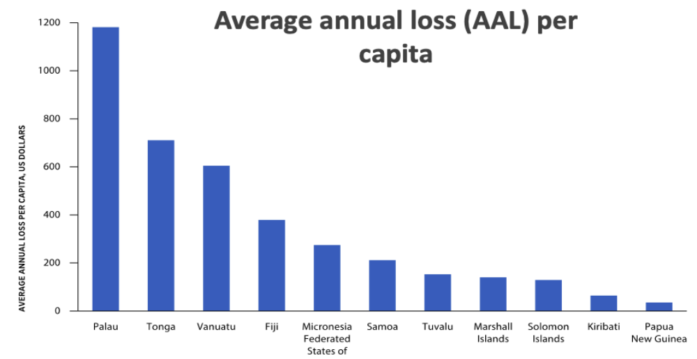
The economic costs of natural hazards are already high for most PICTs. The less at-risk country loses on average half a point of its GDP annually, and climate change is predicted to increase vulnerabilities and damage. Recent estimates (World Bank, SPC and ADB) show that, as percentage of GDP, expected losses due to natural hazards on an annualized basis in the Pacific far exceed those in almost all other countries in the world. The impact of disasters triggered by natural hazards is equivalent to an annualized loss of 6.6% of GDP in Vanuatu (the most at risk from cyclone events, expected to lose on average US$48 million annually), 5% in Fiji, and 4.3% in Tonga. Natural hazards will increase in intensity, if not in frequency, in the Pacific, over the coming decade.

Cyclones, Tsunamis, Earthquakes and Droughts

Between 2000 and 2020, there were fifty-three Category 4 and eleven Category 5 cyclones in the region. The WMO established Tropical Cyclone Committee for the South Pacific and South-East Indian Oceans Operational Plan (TCOP) provides coordinated and cooperative among PICTs and some countries in the Indian Ocean to improve the warning systems for the protection of lives and reduction of human suffering and property damages caused by tropical cyclones and associated storm surges, floods and landslides.

Floods from rainfall (not related to cyclones) have heavily affected Fiji and Solomon Islands. The Severe Weather Forecasting Programme (SWFP) for the South Pacific focuses on building the capacity of PICTs to deliver improved weather forecasts and warning for severe weather events (not including tropical cyclones) including heavy rainfall and associated floods, strong winds, high seas and waves. Flood early warning systems are either established or under development in some PICTs such as the country-wide Flash Flood Guiding System (FFGS) in Fiji'; flood early warning systems for Rewa, Nadi and Ba rivers catchments in Fiji, and flood early warning system for Vaisigano Catchment in Samoa.

Droughts are increasingly frequent (see section on water). In the recent past, the Federated States of Micronesia and the Marshall Islands have declared a state of emergency due to the 2015-16 El Niño-induced drought. Tuvalu had to ration fresh water in the last decade. In 2020, FSM had four months of drought while in 2021 Kiribati had more than two months of drought – in the middle of the pandemic outbreak! – reducing the availability of water in homes and schools. The WMO designated Pacific Regional Climate Center (RCC) network is a virtual centre assisting PICTs’ National Meteorological and Hydrological Services (NMHSs) to deliver climate information and prediction for 3 to 6 months of rainfall, drought and tropical cyclones.

Coastal erosion is a major hazard affecting the PICTs´ 50,000 km of shoreline. Most of the population, urban centres and 60% of infrastructure assets in the PICTs are within 500 meters of the coastline.

Atoll nations are particularly vulnerable to sea level rise and regular coastal flooding and inundation from high seas and waves, king tides. The urbanized islands in the three atoll island nations of Tuvalu, Marshall Islands, and Kiribati - Funafuti, Majuro, and Tarawa - serve as examples where substantial post-independence rural-urban migration has resulted in extreme urban population densities (over 30,000 people per square kilometre in the atoll of Ebeye, Marshall Islands) and intense pressure on scarce resources including land, firewood, sand, and gravel. The modification of shorelines by reclamation, sand and gravel mining for construction and increased runoff has exacerbated issues of flooding and coastal erosion impacting those most vulnerable to sea level rise and king tides on account of the low elevation of their homes and businesses. Approximately 45% of Funafuti households live in coastal or narrow areas affected by coastal erosion, increased king tides and storm surges each year, facing greater hardship, exposure and vulnerability to disasters compared with the rural outer islands. Tarawa is also regularly flooded, with drinking water and soils becoming increasingly saline.

Poor management of urbanization and pressure on available land has led to environmental degradation including the removal of mangroves to make way for private sector coastal development, a key natural barrier against storm surges and cyclones, making settled areas even more vulnerable. Many PICs are situated within the Pacific “Ring of Fire”, an area of vulnerability to earthquakes and tsunamis. Solomon Islands, Tonga, and Vanuatu are the most at risk to earthquakes and tsunamis of all PICTs. Vanuatu, Samoa and Solomon Islands have been affected by violent tsunamis and devastating earthquakes. Better land-use planning will be essential to avoid damages and reduce their impact and represent a more cost-effective option than defensive infrastructures or investments in reconstruction and recovery. Roads, ports and buildings will need to be built to more demanding codes – according to each PICT´s risk level - to protect life and property against cyclonic winds, king tides, seismic waves, rains and floods. Public buildings, energy, water, health and education infrastructure, private housing, tourism infrastructure and agriculture will need adaptation measures fit for the class of asset and the category of risk associated with the geographic area where they are located. Enhancing adaptive capacity and shock-responsive social protection mechanisms will be essential to deal with the socio-economic impact of disaster events such as droughts or pandemics result in major job and income losses from disrupted supply chains and livelihoods strategies.

Water, Sanitation & Hygiene

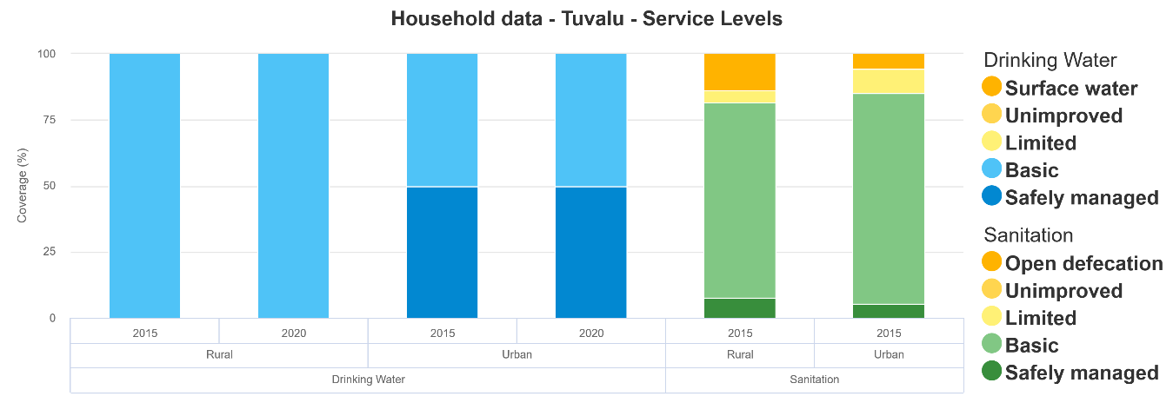
Improved water and sanitation coverage continues to be a pressing need in the Pacific region, with urban-rural inequality particularly visible in some of the PICTs. While most countries have high coverage levels for ‘basic’ water services there is little data available on whether these sources are ‘safely managed’. Notably the Solomon Islands and Kiribati both have more than 20% of their populations currently using unimproved sources or surface water.

Access to sanitation and water in rural schools requires investment programmes, including maintenance and support to staff in terms of supplies and training, especially at times of a pandemic.

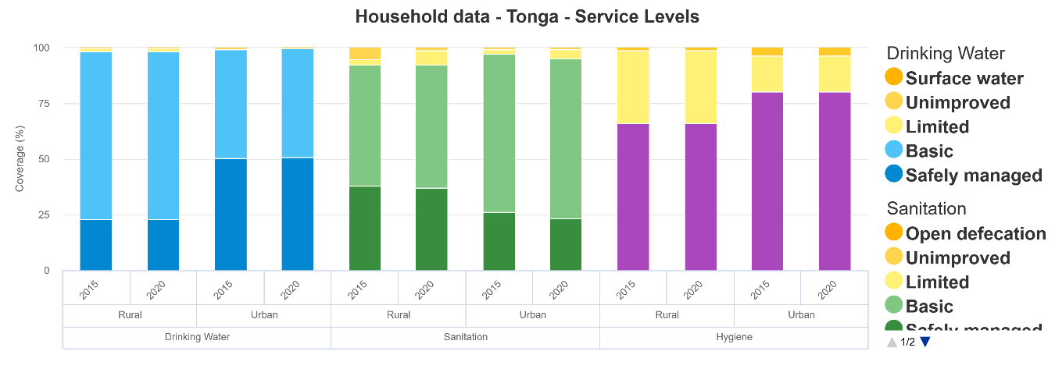

Access to water in informal urban dwellings has been the objective of several programmes supported by development partners, to improve informal settlements’ access to water services. “In Kiribati, metered water connections were provided to households without formally registered tenure. When reviewing progress toward SDG 6.1 data is limited and only available for 7 countries none of which are currently on track to reach universal basic water by 2030.

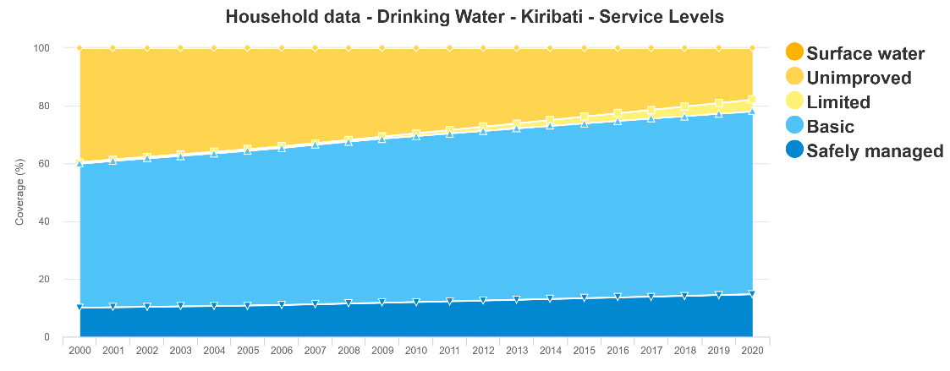

In Vanuatu, engineering analysis and preliminary cost estimation demonstrated that in situ upgrading of existing informal settlements – providing a basic package of services and disaster-risk reduction measures – is both feasible and affordable in places where authorities are ready to acknowledge the settlements as permanent parts of the larger urban economy and fabric.

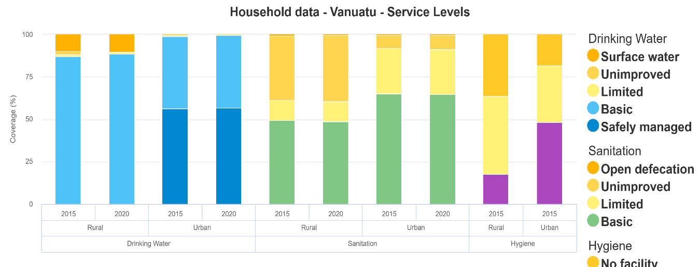

By placing customers’ water meters at the edge of settlements, Fiji provided access to water for households and reduced meter-reading and public infrastructure costs.”

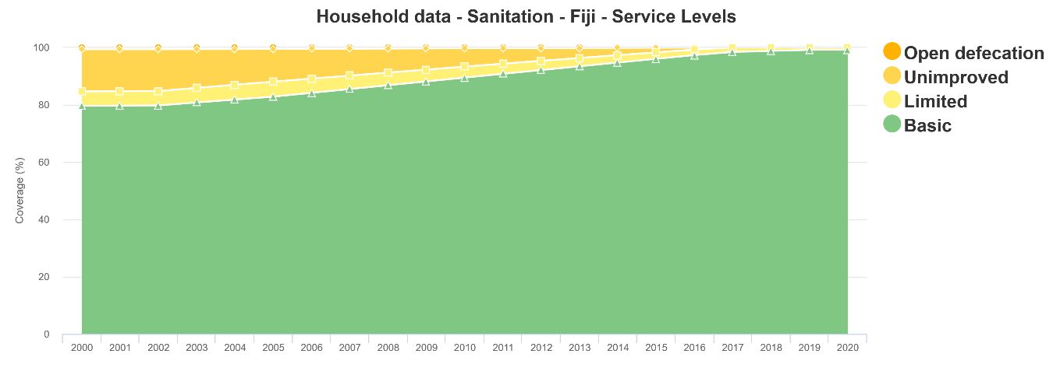
Data also show the need to increase water storage capacity in drought affected PICTs (Solomon Islands and Tuvalu and, to a lesser extent, Fiji, Palau, and the Marshall Islands).

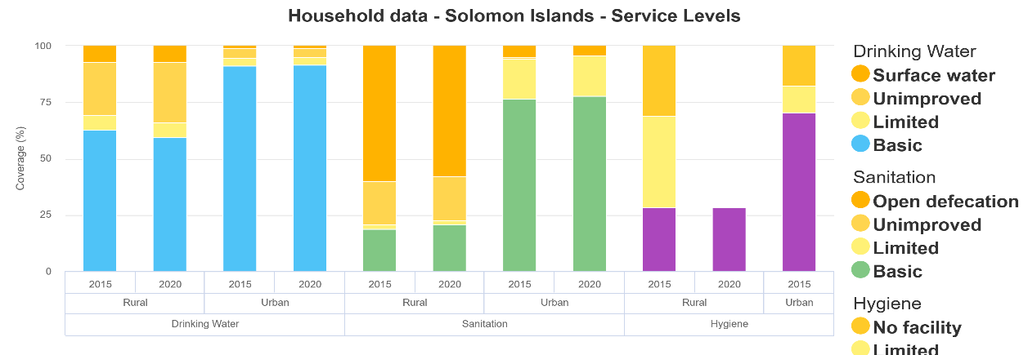

Many atolls and small Pacific Islands such as Tuvalu, Kiribati, Marshall Islands and Nauru with limited water storage and high variability in precipitation levels already face major challenges with water security. This is exacerbated by saline intrusion to freshwater supplies. SDG results are shown here in graphs.

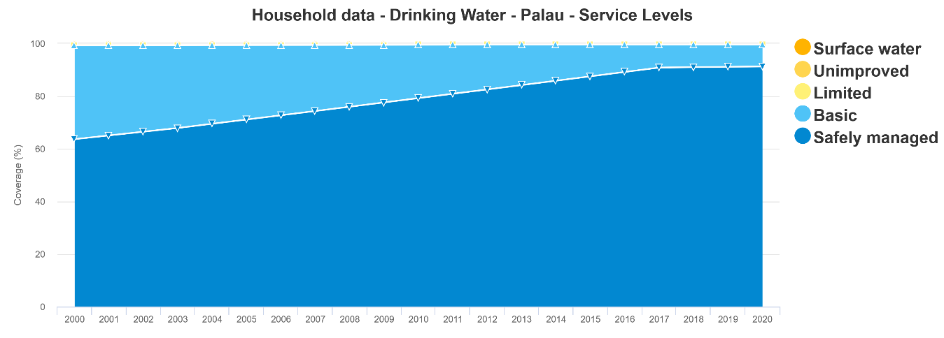

Thousands of people in the Pacific Islands, including children, will be unable to access safely managed household drinking water, sanitation, and hygiene services in 2030 unless the rate of progress increases, according to WHO and UNICEF research. Estimates on changes to household access to safely managed drinking water, sanitation and hygiene services over the past five years, and progress assessment toward achieving the sixth sustainable development goal (SDG) to ‘Ensure availability and sustainable management of water and sanitation for all by 2030’ show that the pace and impact of public investments have not been sufficient.

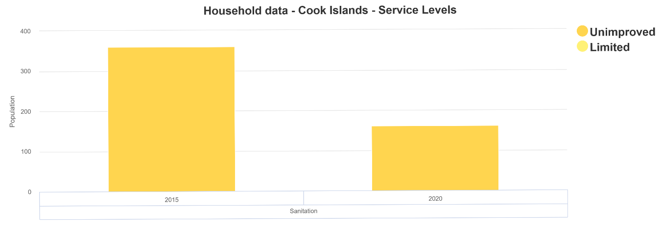

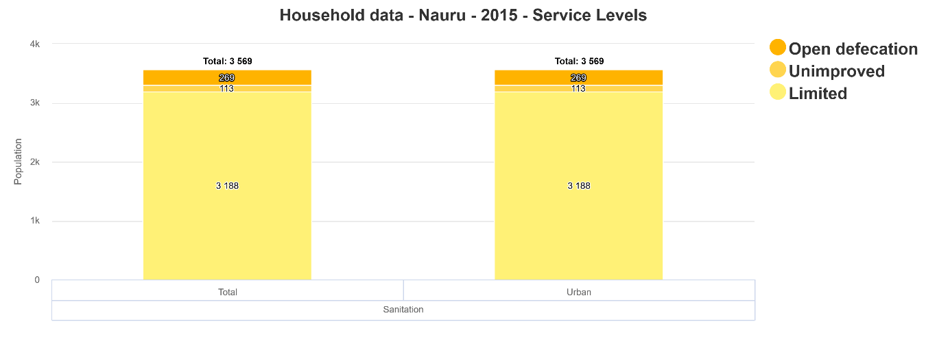

Countries in the Pacific are noted as having limited progress on household handwashing facilities, including Kiribati, Niue and Marshall Islands, an issue of concern when handwashing with soap and water is vital to help prevent illness and to stay healthy in times of COVID-19 good hygiene response.

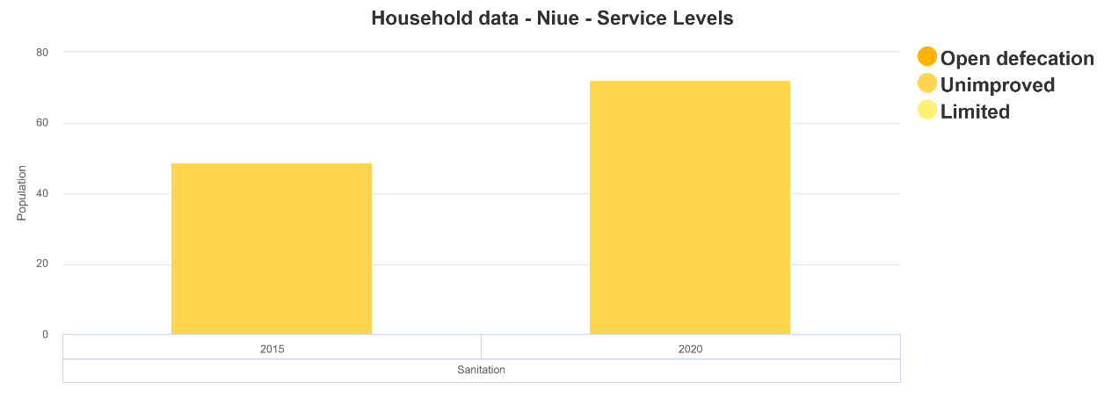

Consistent access to basic services ensuring clean water, hygiene and the adequate treatment and disposal of waste is not a universal reality in the Pacific, exposing underserved populations to deadly yet preventable diseases.

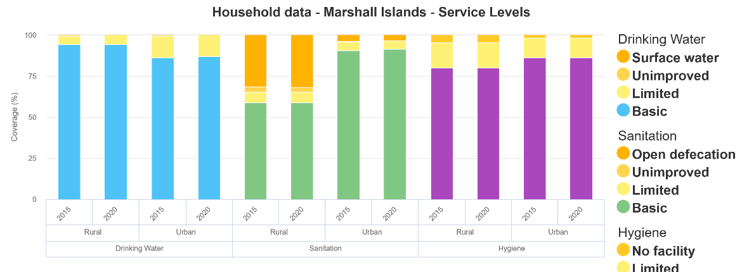

Progress has been reported towards achieving universal access to basic water, sanitation and hygiene (WASH) services in the Pacific Islands.

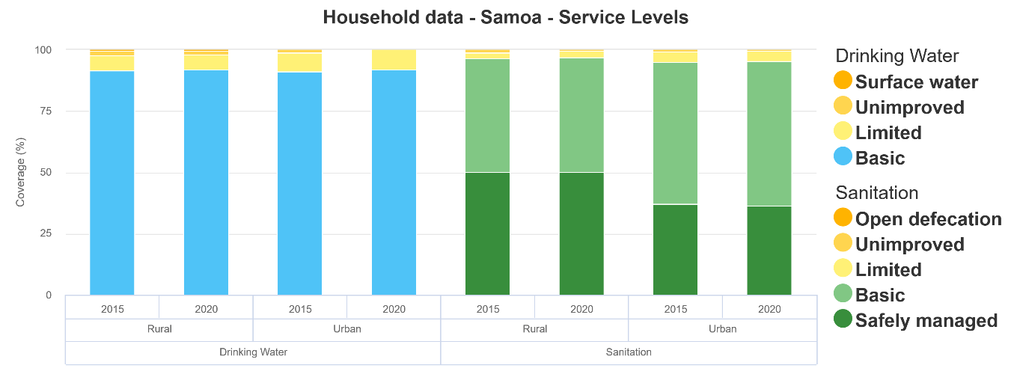

Tokelau is on track to achieve universal basic sanitation services by 2030.

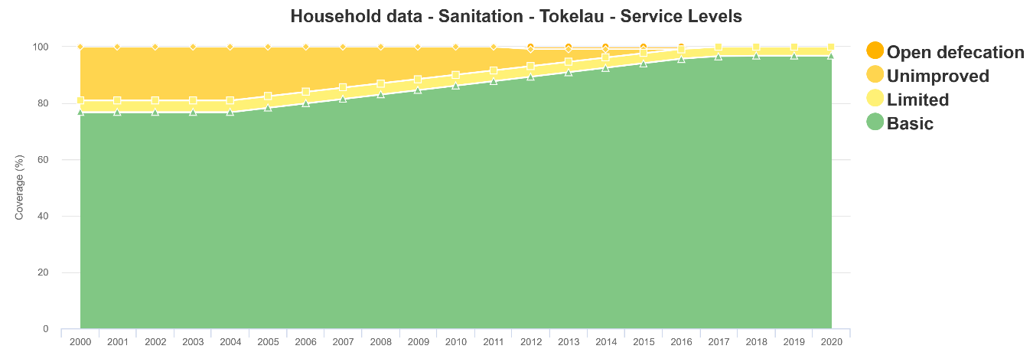

However, progress is moving too slowly in several countries, with many nations off track to reach the target of universal access to basic water services by 2030. Urgent investments could provide families in the Pacific with critical, life-saving WASH services, reducing inequalities with vulnerable families suffering the most. Special attention to service delivery in underserved areas of the countries (outer islands, rural areas, urban squatter settlements) would assist in bringing WASH up to par with the rest of school infrastructure.

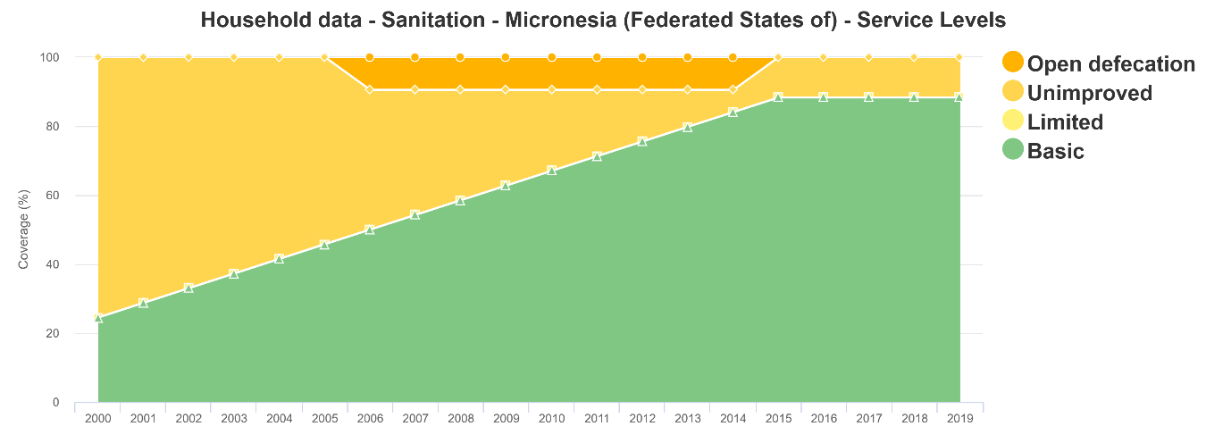

Fragility of Land and Marine Natural Environments

Poor coastal development and land-use planning, unplanned urban growth, overpopulation and water and ecosystem degradation are symptoms and causes of land fragility and represent risks to life on the Pacific earth. Life under the Pacific waters is equally menaced by overexploitation, maritime traffic and uncertainty of the impact of extractive economic activities. To mitigate against the risk of fragility in urban settings, it will be necessary to reduce leaks in water distribution systems, improve the code standards of new buildings, better the waste management systems, increase the frequency of road maintenance and pursue better public transport options. Coastal and river infrastructure investment decisions will depend on touristic value, risk assessment and available public budgets.

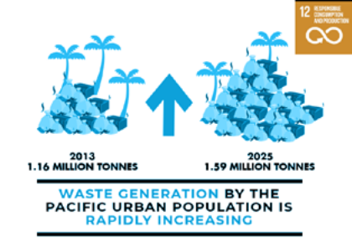
According to the Pacific SDR, “growing economies and population numbers, coupled with poor waste management practices and limited land availability, has resulted in an increased volume of solid and hazardous wastes threatening the sustainable development of PICTs. The indicative waste generation for the region’s urban population is estimated at over 1.16 million tonnes in 2013. It is projected to increase to more than 1.59 million tonnes in 2025. Waste generation by the Pacific urban population is rapidly growing. Over 80% of ocean litter is from land-based sources, which is impacting and killing sea life including coral reefs. The North Pacific Gyre, or the Great Pacific Garbage Patch between the US and Hawaii, occupies an ocean area that is twice the size of Texas. Ocean pollution kills more than 1 million seabirds…” and over 100.000 marine mammals (whales, dolphins, seals, sea lions and porpoises) every year.

Solutions in implementation stage include regular collection, recycling programmes, public awareness, offshoring, deterrent fees and bans for select plastics, already enacted in several countries. The Cleaner Pacific 2025 integrates strategic actions to address municipal solid waste, asbestos, electrical and electronic waste, healthcare waste, chemicals, used oil and lubricants, marine litter, ship-sourced pollution and disaster, sewage and trade waste. Waste disposal on land, via dumps and landfills, is the main method of MSW disposal in PICTs. There are over 333 temporary dumpsites, 96 open dumps, 34 controlled dumps and 15 sanitary landfills. There remains a need for some PICTs to elevate waste management in their development agenda. In particular, in the Pacific, circular economy solutions can have economic, social, and environmental co-benefits through reduced demand for natural resources, reduced emissions, job creation and demand for innovation.

The Pacific contains and supports the most extensive and diverse coral reefs in the world, the largest tuna fishery, the deepest oceanic trenches and some of the healthiest and in some cases, largest remaining populations of many globally threatened species such as whales and dolphins, sea turtles, dugongs, sharks and stingrays. The Pacific’s global leadership on Oceans reflects the importance of the Pacific Ocean to the region. “Demonstrating this global leadership, the Pacific is making good progress towards achieving the SDG14 target of 10 percent marine protection and conservation with 8 percent already conserved through the many marine protected areas (MPA) such as the Micronesian Challenge; the Phoenix Island Protected Area; the Cook Islands Marine Park, the Palau National Marine Sanctuary and the New Caledonia Coral Sea Nature Park.” Palau made a decisive investment by establishing a no-catch area in 80 percent of its waters, this MPA became the sixth largest in the world. This has proved to be effective in terms of revenue from tourism, as well as for ecosystem restoration.

Through the implementation of the 1972 Convention concerning the Protection of the World Cultural and Natural Heritage, the 12 PICTs that have ratified the Convention, acknowledge and conserve the diversity of cultural and natural heritage, ensure fair access to it and the equitable sharing of the benefits deriving from its use. This enhances the sense of place and belonging, mutual respect for others and social cohesion.

The countries covered by this assessment are home to eight World Heritage sites. Three of these are defined as Natural or Mixed Natural and Cultural Heritage the Phoenix Islands Protected Area (Kiribati), the Rock Islands Southern Lagoon (Palau), and East Rennell Island (Solomon Islands). East Rennell Island having been inscribed on the List of World Heritage in Danger in 2013. Governments in the region are mindful of the challenges that existing sites in the region have faced, including strains on institutional capacity to manage and limited capability within local communities to effectively manage sites which occur on customary land.

The implementation of the 2001 Convention on the Protection of the Underwater Cultural Heritage in FSM and Niue contributed to the sustainability of coastal societies, and to the protection of their cultural identity. In 2021 the Solomon Islands and the Republic of the Marshall Islands made efforts to raise awareness around the benefits of the 2001 Convention. Research and safeguarding activities within the framework of this Convention contributes to improved conservation of coastal and marine areas for future generations and provides potential economic benefits through sustainable tourism.

International Agreements on Biodiversity and the Pacific

The Conference of the Parties to the Convention on Biological Diversity (CBD) is expected to adopt the new Post-2020 Global Biodiversity Framework at its next meeting (CBD Conference of the Parties (COP) 15). The Framework will contain new goals and targets for the next 10 years (2021-2030) in order to reach the 2030 Agenda and the 2050 Vision of “Living in Harmony with Nature”. This new framework is particularly relevant for PICTs, as the protection of biodiversity and the sustainable use of natural resources is closely linked to their sustainable development and livelihoods. The CBD reflects SIDS’ ecosystems vulnerabilities.

The Aichi Biodiversity Targets were not met by 2020 and this is strongly connected to some challenges that SIDS are facing in the implementation phase of the Biodiversity Convention, mostly related to funding issues. In fact, as highlighted by the Global Environment Facility, many island states still lack adequate technical support and structures that would allow for effective implementation of the Convention. Furthermore, the COVID-19 pandemic risks to exacerbate these challenges due to related financial instability. A green recovery that includes the mainstreaming of environmental considerations and climate action could support PICTs toward reaching the Agenda 2030 goals. The adoption of the Post-2020 Framework will help catalyse new investments to support the implementation of the Biodiversity Convention. UNESCO Biosphere Reserves have been established by the Federated States of Micronesia (Utwe in 2005 and And Atoll in 2007) and Palau (Ngaremeduu in 2005). This represents a lasting international commitment to biodiversity conservation and local sustainable development.

The Paris Agreement and the Pacific

SIDS have demonstrated strong leadership in raising ambition to help secure a long-term temperature goal of limiting global warming to “well below 1.5 °C” through the Paris Agreement under the United Nations Framework Convention on Climate Change (UNFCCC). Several of the Pacific SIDS, including Fiji and Palau, were among the first to ratify the Paris Agreement in 2016. Many Pacific countries have made important commitments to the Paris Agreement in the context of the UNFCCC through NDCs. Assessments of the implementation of NDCs show that the region is falling short of reaching the targets. NDC implementation is hampered by lack of climate finance plans and sectoral budget allocations. The existing NDCs do represent a first step in the direction to reach Paris Agreements goals, and some already include multi-sectoral commitments. But the current pledges are insufficient to attain the temperature reduction that is targeted in the Paris Agreement for the region. The Marshall Islands got the race to carbon-neutrality by 2050 started among the Pacific, and others are following on those steps, including Niue, Cook Islands, PNG, Samoa, Federal states of Micronesia, Solomon Islands, Tonga, Vanuatu, Tuvalu that are in the stage of consideration of their pledges. After publishing these NDCs, governments have started to translate those commitments into national legislation and develop plans and institutional frameworks to implement the proposed strategies.

The analysis of COVID-19 green recovery plans in the region highlighted the lack of sector-specific policies needed for proper NDC implementation. Many Member States have expressed their lack of financing and governmental capacity to carry out proper implementation plans and requested support from developed countries. Four elements are vital for the successful implementation of these plans: the integration of climate change policies within the existing development policies, the focus on climate finance, the introduction and further development of national and private sector monitoring, reporting and verification (MRV) systems, which will help access climate finance, and the coordination across key stakeholders. PICTs have developed relevant climate change national plans and made significant pledges and commitments in this context, showing international and national leadership, focusing on low-carbon development, and using innovative financing instruments like green bonds to fund its strategies.

Governance and Institutional Analysis

In the Pacific, the balanced blending of traditional and modern systems of governance provides a pathway for sustainable development and community well-being. The Pacific is, despite its distance from major markets, indissolubly connected to the global world and the Asia-Pacific region. Global trends have a strong impact on the PICTs, such as “emerging tendencies towards populism and nationalism, challenges to multilateralism, including willingness to withdraw from regional political groupings and multilateral trade agreements, and increased preferences for bilateral action, an increasing number of political actors and donors, including in the Pacific, challenges to the stability of the global rules-based order and competition between Pacific Rim major powers, and continued degradation of, and disputes over, natural resources”.

Leaders across the Pacific have committed to strengthening governance and improving the rule of law for more than two decades. In 1997, the Forum of Economic Ministers Meeting (FEMM) endorsed the Forum Economic Action Plan Eight Principles of Good Governance. In 2000, this was bolstered by explicit commitments to good governance by Pacific Islands Forum (PIF) Leaders in the Biketawa Declaration. The Biketawa Declaration was updated through the 2018 Boe Declaration on Regional Security and its supporting Action Plan; Priority 6D (iii) commits PICs and the Pacific Islands Forum Secretariat (PIFS) to “strengthening of good governance, rule of law and enhancing anti-corruption and electoral processes under the Biketawa Declaration”. Reinforcing the Pacific’s commitments is the framework provided by Agenda 2030 and the Sustainable Development Goals (SDGs), endorsed by all PIC Governments in September 2015.

Social and political instability and ethnic polarisation and tensions in some countries have been attributed to competition over land and access to resources; the role of chiefly leadership, influence, and authority; and inequalities and structural divisions in legislation and policies. Over the past decades, some countries have witnessed violent conflict (Solomon Islands), political unrest (Tonga, Vanuatu) and military coups d'états (Fiji), violence directed against some ethnic groups, human rights abuses against activists and increased militarization.

Constitutional reform is a need in many Pacific nations. Most of the Pacific Island Countries' post-independence Constitutions are in need of profound updates to address the systemic causes of political instability or simply to respond to modern day institutional life. For example, a number of countries are in discussion on types of elections systems and different types of accountability and transparency institutions that need to be in place. There is need for the Constitutions to guarantee more forcefully the separation of powers between the judiciary, the legislature and the executive, the structure and size of Cabinets, national identity and unity and political party frameworks.

Political institutions and processes remain weak. Pacific countries are democratic regimes where free and fair elections take place allowing voters to show their preference and hold rulers accountable. However, elections are often poorly managed, with many PICs having part-time and/or poorly capacitated Electoral Commissions. Outright electoral corruption in some PICs is exacerbated by voters who have only a limited understanding of the value of voting and even less appreciation of the proper role that elected representatives should play. Political parties have not fully delivered as a mechanism for ensuring more organized cohorts of candidates and elected representatives. Except for Fiji and Samoa, which have relatively stable parties (in spite of major challenges), Vanuatu, Solomon Islands, Tonga and Nauru all have quite unstable political party environments, with vote-buying and floor crossing around the time of Government formation an unhealthy practice. Parliaments have been impacted, with the Legislature often seen as a place to compete for the spoils that come with Government ministries, rather than as a place for deliberative law-making and oversight. Parliamentarians are overwhelmingly men, with little presence of women leaders in the Legislatures.

Government bodies struggle with public transparency and accountability: Political instability and corruption has tended to undermine the PIC public administrations, with Government accountability relatively weak in many PICTs. Even where corruption is not a threat, public servants across the Pacific have very variable capacities, suffer from weak and ad hoc internal processes. Although several Pacific countries have some form of freedom of information (FOI) legislation, the Pacific is yet to see systematic implementation of the right to information. Otherwise, lack of transparency is often a critical problem, which obscures or fosters mismanagement of government resources; without information about procurements, contracts and service delivery it is difficult for the media, NGOs and the public to hold their governments to account.

Despite the explicit region-wide political commitment and many initiatives across PICTs, the record of governance achievements over the last 15 years remains mixed. Amidst signs of progress, examples of poor governance persist with regards to parliaments, executive governments and key institutions such as auditor general and ombudsman offices. Some of these shortcomings can be linked to examples of corruption and political instability. They also have likely contributed to weak economic growth across Pacific Island countries. In line with a positive long-term trend for the East Asia and Pacific region, global measures such as the World Bank Governance Indicators and the Global Corruption Barometer show improvements in many governance dimensions for most PICTs. At the same time, some countries, including Federated States of Micronesia, Palau and Vanuatu show declining performances with regards to political stability, rule of law, and, in part, control of corruption.
Moreover, the majority of governments have implemented states of emergency measures in response to COVID-19 despite the low number or lack of community transmission cases of COVID-19. According to international human rights standards, the imposition of a state of emergency must meet a number of criteria, including: adoption through law which is public available and accessible; justified as being necessary to pursue a legitimate public health goal; respect for the principle of proportionality when imposing penalties for violating emergency measures; specification of the duration and imposed for the shortest period possible to achieve the public health goal; and refraining from the use of emergency powers to regulate day-to-day life.
In the 2018 global fragility assessment of the World Bank which examined nine PICTs, five of them were rated as fragile, due to having governance scores of less than 3.2 (i.e. poor governance). These included Marshall Islands (2.74), Federated States of Micronesia (2.82), Tuvalu (2.96), Kiribati (2.97), and Solomon Islands (3.08). In comparison, only three Asian countries have governance scores of less than 3.2: Timor-Leste, Afghanistan and Myanmar.
While many contributing factors can be found to explain the poor governance ratings of some PICTs and the mixed performance across key domains of good governance in the Pacific, it is important to understand the governance systems of the Pacific Islands in their cultural and historic context. Although each PICT has its own specific governance systems, needs and challenges, for some of them the “modern” state represents a relatively new form of political organization. Overall, the occidental governance systems and structures left behind by colonial powers did not take account or integrate local cultural concepts and leadership, or adjust to customary political systems and structures. Since independence, the Pacific leaders’ call to better integrate and merge traditional cultural values and norms with formal governance has not been sufficiently implemented. Reasons for lack of integration of the so called “Pacific Way” have been traced back to insufficient political will and leadership, the absence of conceptual tools on how to integrate culture in economic and political measures, and a lack of clarity on the tangible benefits of integrating traditional practices, values and norms into formal governance systems and structures to the extent that they promote and protect international human rights principles, including non-discrimination, equality and accountability. In view of limited institutional capacities and a challenging context across PICTs to provide services to all citizens, better use of customary structures and mechanisms which are in line with international human rights principles could be further explored

Political instability. The relatively unstable political systems and Governments have been a major barrier to development in Pacific Island Countries and Territories. In many Pacific countries with a parliamentary system of governance, there role of elected officials and of the Legislature is tilted, resulting in clientelism where votes are exchanged for immediate or short-term delivery of benefits (e.g. – jobs, school fees, utensils, equipment). In turn, MPs who are elected and operate under this system have limited or no loyalty to a political party and are likely to cross the floor to broker deals for themselves and their constituents. This has resulted in weak Governments, often put in crisis and driven out of office. In some countries it is a rare to see Governments lasts a full term, given the frequent use of no-confidence votes in order for MPs to broker new deals for support. These two factors – the instability in the term of a Government and the clientelism surrounding MPs as a dominant political culture - has impacted the ability of the Executives and Legislative branches of government to deliver sustainable development results to their constituents.

As indicated above, political parties in some shape or form exist in the majority of countries. However, in many of them, these organisations are fluid, loose groupings, often lacking robust central or local structures, dormant between election campaigns and slim on clear policy platforms and ideological content. Common features include the small size of the parties, their elite focus, with no mass membership, their instability, leading to frequent ruptures are mergers, the attention to local (vs. national) interests and their connections with local clans or extended families. Traditional structures and values are key to party values and Churches have a significant role in party structures.

Independent oversight institutions have uneven capacities: Over the last decade, more resources have been directed towards strengthening the capacities of independent oversight institutions (e.g., Ombudsmen, Auditors-General, independent commissions against corruption (ICACs)), but they still require considerable support. NHRIs are operational in Fiji, Samoa and Tuvalu, while the Cook Islands, FSM, Nauru, Palau, PNG, Solomon Islands, Tonga and Vanuatu have an Ombudsman Office that may have a degree of human rights mandate. To meet international standards, NHRIs must comply with the
Paris Principles. Australia, New Zealand and Samoa are the only Pacific states with Paris Principles – compliant NHRIs. Their policy and legal frameworks are often insufficient; even if not, they are often under-resourced and lack staff and funds to do their jobs. An annual survey conducted by a UN Agency on public financial management oversight highlights that oversight is often limited in scope (focusing on inputs and activity lines rather than performance or results). It also confirms concerns about lengthy delays in receipt by Supreme Audit Institutions (SAIs) of financial statements from PIC Governments and in receipt by Parliaments of SAI audited financial reports, which presents a serious public management weakness. The 2017 INTOSAI (International Organization of Supreme Audit Institutions) Global Survey data showed 67 percent of the SAIs experience interference from the Executive in setting their budget.

Justice institutions have insufficient resources. PICs have functioning judicial and
administrative justice systems, although the process for the delivery of justice has sometimes been cumbersome and slow. Legal and judicial systems in the region are mostly modelled after the British judicial system, with the exception of the North Pacific countries, which are modelled after the United States (US) judicial system. Each country
has its own unique system that complies with traditional legal customs, which may raise compliance issues with international human rights law. All PIC constitutions guarantee the independence of the judiciary. The effects of social, economic, and environmental change on PICs has given rise to heightened conflict and criminality. For more than 20 years, Australia and New Zealand have supported security and stabilization in the region; in the Northern Pacific, U.S. Compact nations have utilized U.S.-trained lawyers and court administrators who have performed roles directly, and in some cases, served as on-the-job trainers. Public resources for criminal legal aid are minimal or non-existent, and strategies to bolster civil legal aid that would improve social, economic, and environmental well-being for individuals, families, and communities have not yet taken shape. In many PICs, the Courts are respected but perceived as too opaque and too slow, particularly for domestic violence and corruption cases. Justice systems are under-equipped to perform transparently and efficiently and fall short of expectations to uphold the rule of law and protect human rights. Judges lack training in modern systems and standards for transparency and integrity. They lack the tools to manage processes and publish data electronically. Furthermore, judges and prosecutors lack strategies to integrate traditional, restorative justice approaches that would improve outcomes for individuals, families, and communities where the adversarial system falls short. The Justice Systems in the Pacific are male-dominated, with negligible presence of female jurists and legal professionals in their midst.

Access to justice. There are many hurdles to access to justice such as remoteness, poverty, as well as gender and ethnic bias in the justice system.. In all PICs, the right to due process is protected and generally respected, although some challenges remain. There are limited available studies in the Pacific region that outline the situation of access to justice or provide updated information on legal needs and services to the vulnerable. However, a number of national access to justice programmes were operating in 2020 in places such as Fiji, Vanuatu and Tonga, which should result in improved information collection. Lack of funding for the justice sector hampers the effectiveness of legal aid systems and services. Some of the more specific challenges limiting the rule of law and access to justice in PICTs include lack of funding for the justice sector and significant differences in the effectiveness of legal aid systems and services between PICTs, lack of a whole-of-government approach to access and delivery of legal (and social) services in most PICTs.
In view of the above, programming efforts by the UN and other partners in recent years have focused on providing vulnerable groups, women and youth with improved early access to justice, especially in criminal matters, and on innovative approaches to provide legal services to populations in remote/rural areas. Given similarities in the access to justice challenges across many PICTs, it is planned to scale up and adapt successful pilot experiences to the different country contexts and needs across the Pacific region.

Lack of access to legal aid in civil matters, the level of experience of adjudicators, and the reliance on foreign expertise, deficiencies in most PICTs with regard to the police force, prosecution services, prison services and human rights institutions, result in delayed access to justice for plaintiffs, arrested and detained persons. One area of shortfall in most PICTs is the provision of free legal aid to the disadvantaged, services that are under-resourced where they exist. The non-profit Micronesian Legal Service Corporation continues to operate in FSM, Marshall Islands and Palau. In Kiribati and Tuvalu, the Peoples’ Lawyer provides free legal advice for people who are at a financial disadvantage or who are unable to access private legal representation. Countries such as Cook Islands, Marshall Islands, Tonga and Fiji have non-governmental women’s rights organisations that provide legal assistance to survivors of violence against women and children experiencing sexual and gender-based violence.

The Pacific nations face the challenge of balancing customary law and criminal law, civil law and human rights in their legislation and institutional legal framework. Many nation states, including a number in the Pacific, have plural legal systems in which multiple sources of law are drawn upon simultaneously, for example customary or religious law alongside statutory law. These plural systems can in some cases lead to contradiction in the interpretation or enforcement of laws and can undermine constitutional and statutory provisions that seek to address discriminatory or harmful practices in accordance with international human rights law commitments freely entered into by States parties. This is particularly evident in relation to gender justice, SRHR, violence against women and children, land rights and customary titles issues, and participation of women in public affairs.Focused programming aimed at aligning national legislation to international obligations as per human rights treaties, and repeal discriminatory customary policies and laws should continue.

Violence and discrimination against members of the LGBTQI+ community occurs amidst widespread tolerance of this breach of human rights, stigma attached to seeking retribution and limited capacity of Courts, Police Forces and other services to protect those under threat of such violence, allow survivors to see justice served and ensure perpetrators are brought before a Court. Widespread physical and psychological abuse, stigmatization, and reduced access to health care, education and stable employment cause many LGBT+ people not to reach their full potential as fully integrated members of society and contribute to disproportionately high suicide rates amongst LGBT+ youth. The situation of LGBT+ in detention is particularly acute. Many LGBT+ associations find it exceedingly hard to be officially recognized. In Fiji, the only officially registered LGBT+ organization has done so by registering as a company rather than an NGO.
While recommendations addressed to individual Pacific governments arising from the UPR process specifically include those related to gender equality, women’s rights and legislative reform to promote and protect the rights of LGBT+ people, national responses still vary. Whereas a number of PICTs have recently decriminalized same-sex relationships and introduced new laws to counter discrimination against LGBT+ people in employment and education, Cook Islands, Kiribati, Samoa, Solomon Islands, Tonga, and Tuvalu still criminalize consenting relationships between adults of the same sex – a fundamental human rights violation.
Both progress and continuing challenges in fulfilling the human rights of LGBT+ Pacific islanders are placed in a cultural context that is characterized by diverse expressions of gender identity and sexual orientation. Historically, these expressions often fulfilled important cultural or ritual functions in various parts of the Pacific. More recently this diversity is being reclaimed and redefined, responding to both traditional and external influences and expectations. A number of PICs exhibit a high degree of tolerance when it comes to a person’s sexual orientation, with some allowing people assigned male gender at birth to identify as women or with other diverse genders. Many agree that the terms “homosexual” and “transgender” do not always align with concepts of gender and sexuality in the Pacific and are too narrow to embrace the fully lived experiences in Pacific cultures. The fa’afafine of Samoa, the leiti of Tonga, the fakafifine of Niue, the pinapinaaine of Tuvalu and binabinaine of Kiribati, the vakasalewalewa and hijras of Fiji, the palopa of PNG, the akava’ine of the Cook Islands all represent diverse gender identities that have existed for a very long time. Fakaleiti and fa’afafine are gender identities unique to the Pacific Islands. These long-standing traditions of celebrating diverse and fluid gender identities are an important part of the cultures of the Pacific and provide a certain degree of societal security for some LGBTI persons in the region.
In line with Pacific cultural roots and to include traditional third gender communities who do not identify with the global LGBT+ label, activists in a number of PICTs have developed their own terminology by referring to the rights of Pacific Islanders of Diverse Sexual Orientation and Gender Identity and Sex Characteristics (PIDSOGIESC+) to recognize the range of cultures and communities within the region.
The Security Sector in the region fluctuates between a rampant lack of resources, absence of modern training and equipment, an old-style repressive culture, in some countries a better performance and attitude, or simply inexistence where the State cannot afford a Police Force. Numerous incidents and complaints of serious human rights violations, lack of respect for due process, brutality and ill-treatment mar the image of Law Enforcement in the countries where such a force exists. Although human rights trainings have significantly improved professionalism amongst the police officers, a large part of the law enforcement in the Pacific remain heavy handed and the use of excessive force has become a norm amongst the police and military in most Pacific island countries. Pacific governments have been slow to address safety of persons in prisons, pre-trial detention, immigration detention, institutions, and other places of detention who are at heightened risk of infection in the case of an outbreak, in their response plans. More capacity building training, gender sensitization and human rights training is needed across the law enforcement agencies.

Interpersonal violence, particularly against women, is one of the gravest systemic challenges to good governance in the region – an issue which the local Police forces often seek to mediate rather than counter with protection of victims and pursuit of perpetrators. Incidence of violence against women is documented as among the highest in the world, while state-provided protection and remedial services for women and girls are limited, and legal recourse is challenging due to high levels of social stigma attached to it and barriers to accessing the justice sector.

The penitentiary system suffers from prison overcrowding and poor physical infrastructure and conditions for detainees. Samoa has recently improved these conditions with the new Tanumalala prison, which affords separate cellblocks for male and female inmates, and persons in provisional custody, a facility to hold high-risk detainees, a medical clinic, and a chapel. Better physical conditions (ventilation, lighting, and sanitation, food and water) are coupled with greater respect for rights (prisoners and detainees can submit complaints to judicial authorities and request investigation on issues), buttressed by external oversight (monitoring visits by independent human rights observers, including the NHRI, and the Judiciary). These are steps towards meeting the United Nations Standard Minimum Rules for the Treatment of Prisoners. Fiji Police Force and the Samoa Police have shared training resources to enhance access to justice for arrested and detained persons, and to prevent torture in police custody. However, the general situation of carceral institutions is one of neglect and substandard, if not dangerous, conditions of custody.

The integrity agenda in the Pacific focuses on corruption risks arising from forms of bureaucratic, administrative, and political wrongdoing, patronage, natural resource management (especially in the oil, mining, forestry and fisheries sectors), financial loopholes associated with aid, offshore banking activities and some indices of transnational crime (for instance in human trafficking, drug trafficking, illegal fishing and cybercrime). All governments are seen as deploying sound anti-corruption efforts, enrolling public participation, civil society oversight and media scrutiny, and protecting cultural and underwater cultural heritage. Pacific Island countries adopted in February 2020 the Te Ieniwa Vision, the official regional commitment to achieve Pacific unity against Corruption. They all also endorsed a new Political Declaration agreed at the United Nations Special Session of the General Assembly (UNGASS) on anti-corruption on 2 June 2021. The UNGASS political declaration resonates with the Pacific Teieniwa Vision and is an opportunity for the Pacific countries to reinvigorate their anticorruption commitments firmly anchored to the United Nations Convention against Corruption (UNCAC) and Sustainable Development Goal 16 on peace, justice and strong institutions.

In view of continuing constraints on fundamental freedoms of association, assembly, exrpession, information and participation, there are challenges in ensuring an enabling environment for civic space in the Pacific, Civil society is generally weak, with some exceptions: The Pacific women’s movement, in particular in relation to domestic violence, has been an active and vocal force in the region, but in a number of PICs, civil society advocacy and oversight has been unwelcomed. Civil society organisations represent a critical constituency and development partner for advancing human rights and the 2030 Agenda and SDGs. Earlier assessments identified more than 1,000 CSOs covering a wide range of issues aligned with the global development agenda including disabilities, youth, gender, trade, health, environment, governance and culture. As such, CSOs in the Pacific region not only serve as important agents for positive change, but also as essential voices and representatives of the most vulnerable groups who can hold governments accountable for delivering on their promises and plans. This includes the human rights obligations of public institutions to deliver on their role as “duty bearers” with regards to basic services and upholding the rule of law. The reality, however, is that this potential is constrained by the numerous challenges CSOs are facing. Their legitimacy is frequently questioned by governments, with many governments viewing them with skepticism and distrust.
CSOs face numerous challenges: their legitimacy is frequently questioned by governments, many of which view them with skepticism and suspicion – generating a reciprocal distrust. The internal capacities of many PIC CSOs are often limited (both in terms of operational management and technical capacities) and most rely heavily on fluctuating external funding to fund their activities and structures, due to donor-driven project funding, and inability to recruit and retain high quality staff.. Recent 2021 OHCHR research on the Situation of Human Rights Defenders in selected Pacific island countries show that human rights defenders in PICs require access to greater protections mechanisms and strengthened networks and continue to face many challenges and have been threatened with harm, attacked and intimidated by authorities as well as their own communities. In countries where mining is present, environmental activists reportedly face being harassed by the government and mining company officials and are censored when trying to raise environmental issues in the media. Other challenges include financial uncertainties and changes in donor funding and priorities especially for human rights defenders operating in rural and remote areas. The OHCHR supports a regional human rights defenders network that has more than 100 human rights defenders. Youth groups exist, but they need support to help channel the energy of the ample cohort of Pacific young people. They also require training and empowerment to better engage in policy and decision-making processes. At the regional level, there is often a lack of coordination and space available for non-State actors. This disconnect is having a disproportionate impact on the North Pacific and Micronesia, especially as time zones and travel costs constitute additional barriers, though a few CSO partners in Palau and FSM have increased their regional profiles. Dialogue between CSOs and Governments is often ad-hoc, unsupported by legal or institutional frameworks, with the exception of tripartite social dialogue between employers’ organizations, unions and governments. Still, in some PICTs, union leadership continues to be intimidated or restrained.

Media is weak and interference frequent. The Pacific’s media footprint is relatively light, with different skillsets amongst journalists. Many newspapers simply publish Government press releases and public TV is similarly Government-oriented. A number of journalists have been exemplary in their efforts to uncover Government misconduct and publish high quality stories at considerable personal risk. Investigative journalists face difficulties, including menaces, arrest or violence from Governments and other actors who dislike their coverage. Social media penetration via mobile phones allows Pacific Islanders to receive information on global and local issues through other channels, but misinformation is problematic; conversely, government crackdowns on social media has not been unheard of.

Public engagement with (modern) governance institutions and processes is infrequent. Although there are few very active political actors in most PICs, by and large, politics is captured by elites, and the public engage during electoral events, with vote-buying and voter coercion still rife in many countries. Pacific voters are more closely connected with traditional decision-making structures than with issues-based and programmatic democratic processes. Political party memberships are relatively small (where parties exist), and personality-based politics tends to dominate voter choices. Many Pacific people live in non-urban settings, from where it is more difficult to convey needs and exercise representational scrutiny. Services are not necessarily delivered by impartial State institutions but rather are a result of direct political largesse, patronage and benevolence. The connection between voting, representation, and government service delivery is distorted with the public not necessarily seeing their vote as a way of holding governments to account.

For the majority of people in the region, local government remains the most accessible level of public administration. It is the most direct way for people to access basic services and opportunities to improve their lives, to participate in public processes where decisions affecting their lives are made, and to exercise their rights. As such, effective local governance is key to inclusive and sustainable development. It is also essential for improving the quality of life of people both in urban and rural settings and in particular in outer islands, reducing inequality across society, and enhancing relations between people and public institutions.

For a region like the Pacific, relatively small populations dispersed over immense areas in the Pacific Ocean make efficient service delivery a daunting challenge. Environmental, social and economic factors, including limited land access and productive resources, have increased human mobility, including internal migration. Consequently, haphazard urbanization and urban development, and the creation of informal settlements have led to new forms of hardship, impeding even more the access to public services. Further, it is not only the physical access and long distances between islands that makes service delivery difficult. Weak governance structures and limited human resources capacities, both at the national and the provincial levels, exacerbate the situation.

Although Pacific Islands Countries have had relatively low numbers of COVID-19 cases in comparison to other regions of the world, they have however not been spared the devastating social, economic and political impacts of this global pandemic. Highly linked and connected to the economic impact of the pandemic is the curtailment of the ability of both central and local governance structures to deliver the most basic services to citizens and residents. As the economic crunch has significantly affected the ability of Central Government to disburse funds to local authorities and for local authorities to collect revenue using the usual revenue streams (which include charging for services), service delivery has been significantly crippled. Fiscal and policy measures adopted at the central level by Reserve Banks, Ministries of Finance, and budgets passed by Parliaments have inevitably limited downflow of resources to the local level. For the Pacific Islands States, efficient service delivery has historically been a daunting task due to the geography of the countries and remoteness of the outer islands. This has been exacerbated by COVID-19. The pandemic also brought additional challenges to the private sector and civil society at the local level, where they play a key role in promoting economic development and ensuring transparency and accountability of government action. Local authorities remain the coalface for citizens engagement, service delivery and delivery of SDGs.

One of the potential fractures in the Pacific relates to outer islands´ calls for greater independence or autonomy, grounded in grievances over the distribution of resources and real or perceived neglect from their central government. The United Nations will remain attentive to potential Government requests to support with impartiality processes like the intended independence referendum in the State of Chuuk (FSM) scheduled for 2022 or any such developments in Solomon Islands.

Human Rights Commitments under International Norms and Standards

“Human rights are a fundamental pillar of Pacific Island societies. Enshrined in the region’s national laws, policies and other normative frameworks, human rights also find meaningful purchase in the culture and customs embodying the Pacific way of life. Core human rights principles such as dignity, fairness, respect, participation, non-discrimination, and the responsibilities of individuals to the community, resonate widely in the diverse tapestry of Pacific cultures. Yet the challenges before us are also numerous and acute, with multiplying inequalities and a changing environment.”

The 2030 Agenda for Sustainable Development is explicitly grounded in human rights. Full implementation by Member States of the international human rights obligations and commitments would ensure that no-one is left behind. The SDGs reflect key international human rights and labour standards and affirm that they seek to realize the human rights of all. The 2030 Agenda and human rights are thereby mutually reinforcing way. Over 90 percent of the goals and targets of the SDGs correspond to human rights obligations. Advancing the SDGs is furthering human rights for all, especially if the emphasis is placed on leaving no one behind. The Human Rights-based approach to development is normatively based on international human rights standards and operationally directed towards promoting and protecting human rights by developing the capacities of duty bearers to meet their obligations and/or of rights-holders to claim their rights. Good governance requires the protection of human rights, and importantly the principle of equality that they enshrine also underpins the communal values of many traditional governance structures in the Pacific. This may provide a pathway towards reconciliation of global and customary governance practices, and achievement of the 2030 Agenda.

Human Rights machineries and institutions are instrumental in promoting and protecting rights. In contrast to most other regions of the world, there is still no regional Pacific human rights mechanism, but national human rights institutions have begun to occupy a growingly recognised space in some countries, while others still trail behind in the creation of such institutions. NHRIs are operational in Fiji and Samoa. Tuvalu has passed legislation, while other countries have expressed interest in doing so, or made progress towards that goal, including the Cook Islands, FSM, Nauru, Palau, RMI, Solomon Islands, Tonga. Vanuatu. In 2021 the Global Alliance of National Human Rights Institutions (GANHRI) re-affirmed its accreditation of Samoa’s NHRI with ‘A’ status, in terms of its compliance with the Paris Principles, the international standards for national HR institutions.
Increased understanding of the role of NHRIs and overcoming resourcing constraints that stem from de-prioritisation, are two of the challenges to be addressed. In Samoa and Tuvalu, NHRIs were established by granting additional powers to their Ombudsman. Also in 2021, Fiji’s NHRI was re-accredited with ‘B’ status, after losing accreditation in 2010. A coordinated human rights structure within government, to ensure comprehensive, more efficient and sustainable approaches to reporting to the international human rights system and following up on the recommendations emanating from them, known as the National Mechanism for Implementation, Reporting and Follow-up (NMIRFs), has been established in FSM, Kiribati, RMI, Samoa, Tonga and Vanuatu but in some of these countries, the NMIRFs are not fully operational.

While ratification of core human rights treaties is steadily increasing, many countries have yet to ratify the 1966 International Covenant on Civil and Political Rights (ICCPR) and the International Covenant on Economic Social and Cultural Rights (ICESCR). During the third cycle of the Universal Periodic Review (2017-2022 reporting period), both Fiji and the Marshall Islands ratified or acceded to ICESCR and ICCPR, with Fiji becoming the first PIC to ratify all core nine human rights treaties. The Marshall Islands acceded to the International Covenant on the Elimination of All Forms of Racial Discrimination (ICERD). Ratification of human rights treaties in the Pacific tends to favour treaties that protect group rights, especially those of women, children and persons with disabilities. All countries in the region have ratified the Convention on the Rights of the Child (CRC). With the exception of Tonga, and Palau (which has signed but not yet ratified), all have ratified the Convention on the Elimination of all forms of Discrimination against Women (CEDAW).

Despite the Convention on the Rights of Persons with Disabilities (CRPD) being a relatively new treaty, 13 PICs have now ratified it, with Fiji, Federated States of Micronesia (FSM) and Samoa doing so in 2016. Kiribati, Marshall Islands and Samoa ratified the Convention against Torture and Other Cruel Inhuman or Degrading Treatment or Punishment (CAT), bringing the total number of PICs to eight. Samoa and Fiji are the only two countries to have ratified the Convention against Enforced Disappearances (CED), and Fiji is the only PIC to have ratified the Convention on the Protection of the Rights of All Migrant Workers and Members of their Families. Palau has ratified the CRC and CRPD and signed the other seven core human rights treaties. While it is not a core human rights treaty, the United Nations Convention against Corruption has been ratified by all PICs, with Niue and Samoa acceding in 2016 and Tonga in 2020.

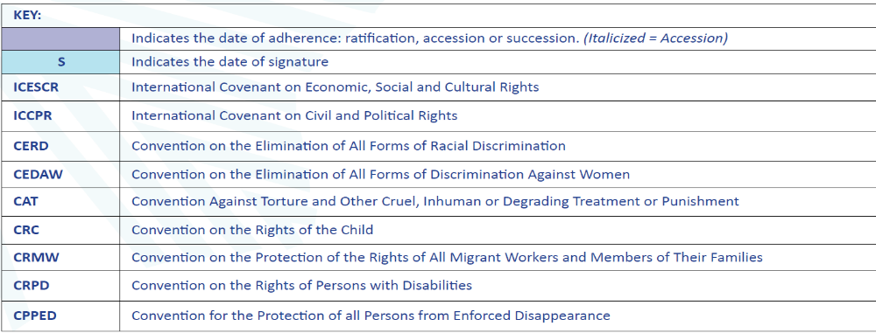

Status of Human Rights Treaties Ratification in the Pacific
(December 2020)



Regional declarations adopted by Pacific Leaders to strengthen human rights include the 2014 Framework for Pacific Regionalism, the 2012 Pacific Leaders Gender Equality Declaration, the Pacific Platform for Action on Gender Equality and Women’s Human Rights 2018-2030, the 2016 Pacific Framework for the Rights of Persons with Disabilities, and the 2019 Boe Declaration on Regional Security. Many PICTs have conducted significant legal reforms, including to improve respect for the rights of persons with disabilities, and to end torture and ill-treatment of people in detention, while some have started trainings for judges in human rights law and court reporting, and for police forces in respecting human rights. Human Rights content is part of several countries´ social studies primary and secondary curricula. Domestic laws on human rights have also been passed by national Parliaments and Governments have approved and implemented human rights policies, action plans and programmes.

The degree of implementation the Convention on the Rights of Persons with Disabilities and CEDAW, as well as the situation of widespread violence against women will be discussed in other sections. Regarding the implementation of the Convention on the Rights of the Child, available data show that progress has been made in a number of areas including amongst others, laws protecting the rights of children such as the RMI Child Rights and Protection Act; Nauru Child Protection and Welfare Act; improvement in birth registration coverage due to the introduction of civil registration database system; positive steps in strengthening minimum standards of care for children; and overall improvement in health and education status in a number of countries. While much progress has been made, gaps remain. Some children face violence, abuse, neglect and exploitation in the home, school and community. Corporal punishment is not explicitly prohibited in laws governing the penal system, home, alternative care settings and day care in many PICTs, leaving many children including those in conflict with the law at risk. The Committee on the Rights of the Child on various occasions highlighted their concern for the reportedly high level of abuse of children including domestic violence and sexual abuse; as well as significant underreporting for a variety of reasons including fear of stigma. Inadequate resources to enforce laws designed to protect children; shortage of specialized personnel as well as inadequate structures and shelters to support child victims; and insufficient counselling, psychological, recover and reintegration services are other areas of support that need to be strengthened.

Child justice systems are not fully compliant with the CRC and other relevant international standards. Areas of improvement include the setting of appropriate minimum age of criminal responsibility - lowest currently at 7 years of age; limited diversion options; and in cases where detention is unavoidable, detention conditions are not compliant with international standards.

Child protection needs to be enforced in the Pacific with more determination and efficacy. “Rates of violent discipline including physical punishment and psychological aggression range from 83% to 92%. Bullying and physical fights in schools, some of which resulting in severe injuries, affect between 30% and up to 83% of children. Child labour ranges between 15% and 25%” despite the criminalisation of child labour employment in some countries. Urban migration, poverty, homelessness and children living away from parents are contributing factors. Anecdotal evidence suggests the existence of sexual abuse of children, mostly by relatives and family friends, online abuse and access to inappropriate contents on the Internet, substance abuse and law-breaking, as emerging issues in particular affecting adolescents. “Overall, across the Pacific, child protection systems to prevent and respond to these concerns are at an early stage of development or non-existent.” The CRC Committee also recognizes the impact of climate change on the rights of the child. While national plans and strategies on climate change and disaster risk management have been introduced, the Committee has recommended to a number of countries the inclusion of children including children with disabilities in planning disaster risk reduction preparedness, response and recovery. Meaningful engagement with children and young people in climate action and other issues, require a sustainable approach.

Since 2016, PICTs have engaged with the UN Special Procedures mandate holders with visits to the region of the Special Rapporteur on contemporary forms of racism (2017), the Special Rapporteur on human rights and the environment (2018), the Special Rapporteur on the right to education (2016), and the Special Rapporteur on the right to health (2019), as well as the Independent Expert on the enjoyment of human rights by persons with albinism (2019) to Fiji; and the Special Rapporteur on Cultural Rights to Tuvalu (2019).

Through the Universal Periodic Reviews (UPR), countries in the region received recommendations to to ratify remaining core international human rights treaties and their optional protocols; ensure the independence of the judiciary; intensify child protection through the adoption of laws and policies in line with the CRC, including laws prohibiting child labour, abuse and exploitation; combat gender-based discrimination and violence, including domestic violence and ensure quality support services for victims and survivors of GBV; increase the representation of women in public life at all levels; raise the mandatory minimum age of criminal responsibility; ensure human-rights based approaches in environmental, climate change and disaster reduction policies, laws and regulations; establish an effective social protection system, in particular for those working in the informal sector and those living in rural areas; combat discrimination on the grounds of sexual orientation and gender identity and decriminalize same-sex relations between consenting adults; strengthen legal and policy frameworks to combat trafficking in persons; decriminalize abortion; adopt a comprehensive sexual and reproductive health policy and comprehensive sexuality education in line with the UN International Technical Guidelines on Sexuality Education; and comply with reporting obligations to the treaty bodies.

The need to ensure the protection of the rights of persons in detention, and to combat allegations of torture and ill-treatment by police and military officials including through investigations, prosecution and punishment, have been noted during the UPRs of several PICTs. The “first hour procedure” in Fiji to protect the rights of persons in police custody and the abolition of the death penalty in its legislation are steps forward in the direction of protecting individuals in conflict with the law.

As the only international agreement binding Parties to the integration of culture in their development policies, the 2005 Convention on the Protection and Promotion of the Diversity of Cultural Expressions actively works toward promoting human rights and fundamental freedoms. Samoa and Niue have ratified this Convention.

Fundamental Freedoms

During the UPRs, other states have noted concerns regarding discrimination against lesbian, gay, bisexual, transgender, intersex, queer or questioning and other sexual identities (LGBTIQ+) persons (right to marriage, a family, blood donation) in PICTs. It is likely that they live at constant risk of gender-based violence. Whereas a number of PICTs have recently decriminalized same-sex relationships among consenting adults and introduced new laws to counter discrimination against LGBTIQ+ people in employment and education, Cook Islands, Kiribati, Samoa, Solomon Islands, Tonga, and Tuvalu still criminalize consenting relationships between adults of the same sex – a fundamental human rights violation.

UPR recommendations addressed to PICTs have including undertaking legislative reforms to fully ensure the rights to freedoms of association, assembly, expression, information and participation, in line with international standards. Concerns have been raised with regard to the reintroduction as criminal offences of activities which would constitute individuals’ exercise of their right to freedom of speech, the limitation to public servants’ right to organize and strike, as well as concerns related to the sparse development, or inexistence, of minimum wage legislation.

Based on a commitment to cultural rights and cultural diversity, and guided by the international human rights framework, the 2003 Convention for the Safeguarding of the Intangible Cultural Heritage￼ has been ratified by 13 PICTs. has been ratified by 13 PICTs.

Public Services

Pacific Islands´ Public Agencies face institutional challenges to support adequate provision of public services. The absolute size of the public sector in the small PICTs and the difficulty of delivering education and health services, law and order, transport and communications, water or the collection of statistical information in small, remote communities are faced with the equation of cost versus population. “Greater population density results in reduced unit cost for such services, many of which are only available on main islands because unit costs on outer islands would be prohibitive. (…) In health, policing and justice, electricity, sanitation, and transport, outer island populations may not be large enough to make even very basic services viable at reasonable cost, leaving governments facing very difficult choices about the minimum level of services that will be offered on outer islands irrespective of the cost.” Shortcomings in these services impact mainly women and children, who make most use of both health and education services, and women who need social services support in their domestic responsibilities. Limited reproductive healthcare services contribute to the high level of adolescent pregnancy across the region, while limited support to survivors of violence against women and girls, and to LGBTQI+ survivors of gender-based violence, exacerbates the trauma they experience. Technical assistance’s role in filling capacity gaps is therefore of the greatest importance and can provide much-needed support to improve online service and e-participation by advancing e-government development.

Right to Health

Progress has been registered in the Pacific on some of the main health indicators such as child, neonatal and maternal mortality. Some PICTs have more than halved the maternal mortality rate within this period, such as Samoa (88 to 43 deaths per 100,000 live births between 2000 and 2017) and Solomon Islands (245 to 104 over the same period), with many others close to achieving this milestone. Both the under-five and infant mortality rates across the Pacific region are also dropping at a good rate since 2000. Skilled birth attendance rates over 80% across most Pacific Island countries has increased the wellbeing of mothers and babies alike.

Reversely, the Pacific region scores the lowest of all world regions on the Universal Health Coverage index with a clear lacuna in primary healthcare, principally used by women and children. Many PICTs are characterized by over-strained and under-resourced health systems, health workforce shortages, high aid dependency, infrastructure limitations (including lack of transport among low-income groups and overcrowded facilities) and challenging geographic conditions.

The economic burden of NCDs in the Pacific is already high compared with other middle-income countries. Countries could lose between 3 and 10 percent of GDP by 2040 (WB). Obesity and diabetes are two serious and negative health outcomes in the region, the leading causes of death in the Pacific. Tobacco use, alcohol abuse, insufficient physical activity, and unhealthy diets, and a combination thereof, are responsible for most deaths due to NCDs. A significant portion of the Pacific population lacks access to safe and nutritious food. Well above the WHO recommendation for a balanced intake, too much of the average dietary energy consumed comes from fats. Vegetables are enormously more expensive than cereals, oils and sugar.

The list of NCDs includes respiratory infections, heart disease, stroke and hypertension. NCDs require overseas medical referrals, an option only available to few of the patients, accentuating individual, social and national cleavages in healthcare. Population growth and the proportional weight of the age groups more at risk, project an increase in vulnerability and a limited enjoyment of the right to health for many Pacific Islanders. The impact will be further felt in the economy, the workforce, government priorities in service provision and cost of healthcare to the States and individuals (out-of-pocket spending). Long-term effects are to be expected if a sea-change doesn´t occur. WB projections for a business-as-usual scenario predict a workforce loss from NCD mortality of over 10% and a GDP reduction between 5-9% by 2040. Changes in lifestyle across the board are the most effective response to produce an urgent reduction of the risk. Drastic fiscal policies may help reduce the risk and partly offset the cost to society of the NCDs.

Sexual and Reproductive Health, including maternal health indicators have improved across almost all countries; however unmet need for contraceptives, adolescent pregnancies and addressing the SRHR needs of women with disabilities remain problematic, as will be seen in the section on Human Rights. Several countries have developed a supportive environment for girls to pursue their education, ending the practice of expelling girls who become pregnant while at school and supporting their re-entry to school following childbirth.

The Pacific region still has the highest level of unmet needs for family planning in the world, especially among adolescents and young people. Between 1990 and 2010, it remained stagnant around 25%, exceeding that of Sub-Saharan Africa at 23% in the same period. The remoteness of many of the outer Islands and atolls in PICTs poses an on-going challenge to provide universal access to sexual and reproductive health services. In Kiribati, only half of women aged 15-49 years currently married or in union have their need for family planning satisfied with modern contraceptive methods. The burden of cervical cancer caused by sexually transmitted Human Papilloma Virus (HPV) is significant in the region, with Melanesia classified as a sub-region with one of the highest incidence rates of cervical cancer in the world (33.3 cases per 100,000 females per year).

Health worker availability and density remains below WHO guidelines in most PICTs, especially in outlying islands. While most countries in the region have good availability of nurses, they are suffering from a pervasive shortage of qualified Reproductive, Maternal, New-born, Child and Adolescent Health (RMNCAH) specialists, including doctors and midwives. Large-scale migration of health workers to Australia and New Zealand contributes significantly to these shortages. The number of healthcare workers from some Pacific Island countries who migrated to Australia exceeds the total number of local healthcare workers in these countries.

The tuberculosis incidence rate remains a critical issue for some countries in the Pacific, with the new cases above 300 per 100,000 population, and there has been no sign of progress since the year 2000. The Pacific subregion is also particularly affected by chronic hepatitis B prevalence. In seven countries in the Asia-Pacific region more than two per cent of children under age 5 are affected, and six of the seven countries are in the Pacific subregion. In terms of communicable diseases, Pneumonia and Leptospirosis account for the greatest number of deaths in several countries. An insufficient proportion of HIV cases are receiving anti-retroviral therapy. Suicides, mental health problems, including depression and serious anxiety have augmented during the pandemic.

In November 2019, Samoa declared its first ever public health State of Emergency (SOE) following a wide scale measles outbreak. The SOE lasted six weeks with significant impact on the population and the health care system. There were 5,700 measles cases and 83 measles-related deaths, the majority of whom were children under the age of 5. The measles epidemic led to the compulsory vaccination for all children and a requirement for all students’ enrolment, a successful two-day mass vaccination campaign resulting in the now 95% coverage achieving herd immunity in Samoa.

Across the region and except for Vanuatu, over 40 percent of adults are obese, and 80% are overweight, leading to a higher occurrence of NCDs such as cardiovascular disease, diabetes, and cancer. The WB estimates that 40%-60% of government health budget is spent on NCDs (notably for the higher cost curative and palliative care services, including expensive overseas medical referrals). NCDs account for 70%-75% of all deaths in the PICTs and up to 84% of deaths in Fiji, Samoa, and Tonga. NCDs are the major leading cause of preventable death in the Pacific, with two thirds of those who die from a NCD, doing so before the age of 60. Approximately 35% of the population of Chuuk in the Federated States of Micronesia (FSM), 28% in Kiribati and 24 percent in the Cook Islands and Samoa have diabetes. Approximately half of the adult populations in Kiribati, Tokelau and Nauru smoke daily and two countries (Kiribati and Tonga) are among the top ten highest rates of tobacco users in the world. Physical activity is extremely low as is vegetable and fruit consumption.

NCD incidence, in particular obesity and diabetes
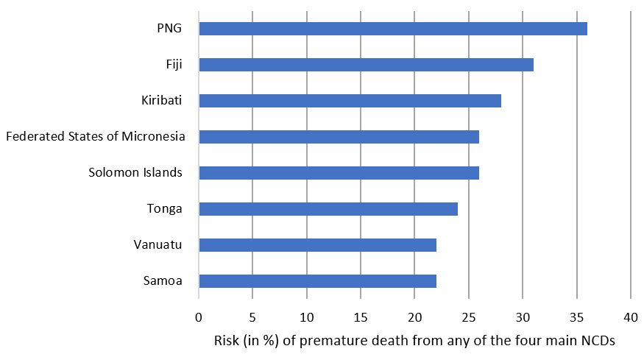
To scale up multi-sectoral responses to the Pacific NCD crisis, the Health Ministers of the region have endorsed the Pacific NCD Roadmap and activated the response along five key areas: strengthening tobacco control by an incremental increase in excise duties to 70% of the retail price of cigarettes; increasing taxation of alcohol products; improving policies on food and drink products directly linked to NCD; enhancing primary and secondary prevention of NCD; and strengthening the evidence base for programme effectiveness.

The progress made in 2019-2021 includes RMI, Solomon Islands and Tokelau´s new tobacco taxation measures, joining 20 PICTs out of 21 PICTs. Increase in taxation of alcohol products has become public policy in RMI. Tonga put in place a policy to reduce salt consumption and Cook Islands, Niue, Samoa, and Tuvalu have some policy measures to restrict trans-fat in the food supply. Palau and Tuvalu have endorsed food based dietary guidelines. Cook Islands, Niue, and Samoa have policies to restrict marketing of foods and non-alcoholic beverages to children. Nauru, Palau, and Tonga encourage provision and promotion of healthy food choices in schools. Palau has joined the other PICTs having adopted national guidelines for the diagnosis and management of at least one of the four main NCDs, and FSM, RMI, and Solomon Islands have essential NCD medicines included in the national list of essential medicines.

Samoa has established restrictions on the marketing of breast milk substitutes. The monitoring of adult NCD risk prevalence data has been completed in RMI, while Niue, and RMI join the PICTs who monitor adolescent prevalence data. Cook Islands, Fiji, Kiribati, Nauru, RMI and Tokelau have established a multi-sectoral NCD taskforce to oversee the implementation of their national NCD plan. Most countries have new legislation to create smoke free public places and for health warnings on tobacco packaging, restricted advertising, sales, and licensing.

The Pacific Health Ministers recognise that a strong challenge lies ahead to promote healthy lifestyles through tough public policy. Tobacco industry interference, pervasive trans-fats in the food supply, generalised marketing of sugary drinks to children, wide presence of breastmilk substitutes, and difficulties to enforce policies and legislation are difficulties exacerbated by the reallocation of resources to the COVID-19 pandemic response.

The COVID-19 pandemic unmasked inequities in access to and quality of health care services. For instance, women’s access to essential sexual and reproductive health services which is already a challenge in the Pacific, such as lifesaving maternal healthcare and contraception, are disrupted due to restricted transportation, closure of health clinics and stock outages of essential commodities. Persons with disabilities are at greater risk of contracting COVID-19, developing more severe health complications or dying from COVID-19 and being denied to essential regular healthcare and rehabilitation due to deteriorating accessibility of relevant facilities and services during the pandemic. Those living in institutions are at even greater risks. These are intensified by contextual and sociocultural realities due to geographic locations and remoteness of the islands. For example, an assessment of intensive care unit capacities (medical equipment and health workforce) conducted in 2020 as part of the COVID-19 preparedness and response activities identified that there are: (1) varied levels of ICU units, medical equipment necessary for respiratory support such as ventilators, (2) different levels of trained health workforce (clinicians and nurses) that can provide intensive care to critically ill COVID-19 cases, and (3) most of the health care systems are not well prepared to provide quality intensive care services to severe COVID-19 cases. Even Fiji indicated that it needs more medical equipment and human resources to further strengthen ICU care systems.

Health Public Spending in the Pacific

Health expenditure in the PICTs varies greatly from country to country. According to 2018 pre-COVID-19 data, RMI, FSM, Palau and Tuvalu Governments spent on average 14.5 percent of GDP on health, while Fiji spends around 3%. In 2018, current health expenditure per capita for Pacific Island Small States was US$207, compared to US$387 for East Asia and Pacific (excluding high income countries). In the decade to 2018, government financial investment in the health sector has overall increased in nominal terms, but in some countries real total expenditure per capita has declined or stagnated because nominal increases in expenditure have been offset by population growth.

The continuous commitment of PICTs Governments to health is illustrated by the relatively high share of Government budgets allocates to health. Indeed, Ministries of Health often receive the 2nd or 3rd largest appropriation in Governments´ budgets after the central Ministry of Finance and the Ministry of Education, around 12% of total Government budget which is higher than the global average. The Solomon Islands Government allocates 13.5% of the total budget, since 2012, to the Ministry of Health and Medical Services. In Kiribati, MHMS has received a consistent share of the domestic budget between 12% and 15% between 2015 and 2019. More than 80% of health expenditures are funded by Governments from a combination of domestic revenues and relatively high levels of external financing from development partners The remaining balance comes from external financing outside of the budget, and from households’ out-of-pocket spending, which average 10% each.

As noted in the November Pacific Heads of Health meeting, the impact of COVID-19 on PICTs´ health financing will depend not only on the extent, duration, and severity of the economic contraction, but also on general domestic revenues, on government borrowing and external financing, as well as on health’s share of public expenditure, and how well that share is managed. Encouragingly, since the start of the pandemic, resources for health in PICTs have been maintained or increased. Most governments provided additional domestic budget allocations to health in 2020, and anecdotal data suggest that the health sector continues to be prioritized in the 2021 and 2022 fiscal year budgets. While many PICTs have provided stimulus packages and COVID assistance, OOP contributions are likely to further decline due to lower use of health services and reduced household incomes. More vulnerable citizens are less likely to seek health care even when needed generating ‘foregone care’.

Significant additional resources have also been made available by DPs since the start of the Pandemic. Current indications signal that external financing will remain unchanged as a share of GDP across most countries. While health budgets appear to have been protected so far, increasing pressure on public resources could lead to a decline in health budget allocations over the coming years. High-cost areas such as payroll, medical referrals and pharmaceutical procurement should remain under considerable scrutiny to continue to identify options for achieving better value for money and ensuring transparency and accountability.

Right to Education
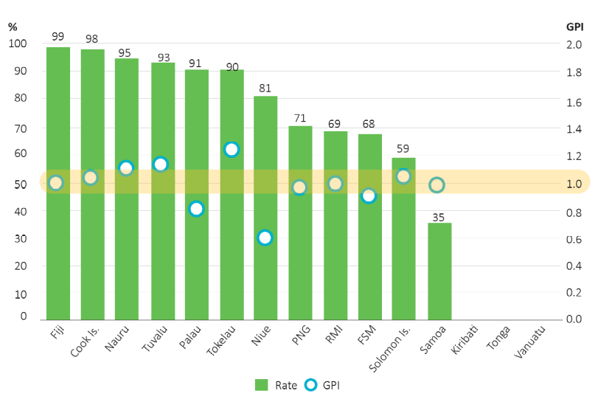
“Investments that promote human capital have the great advantage of broadening peoples’ capacity to take advantage of economic opportunities; at the same time, they serve as an important element of human development itself. These investments are also less vulnerable to risks from natural disasters and climate change.”
Enrolment in Pre-primary Education. Source UIS

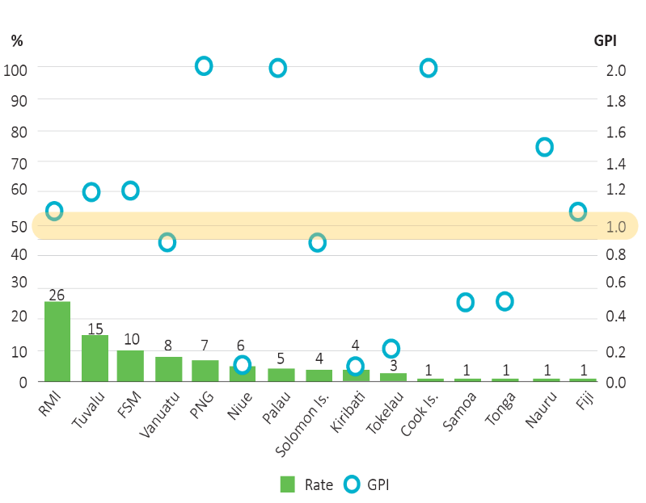
For populations that need skills to be competitive at home and abroad, investment in training is a key development input. The delivery of quality education and training services has a spill-over effect on other development strategies like tourism development or a smarter agriculture. “Unlike other interventions, education is an investment with benefits that remain with individual recipients rather than being tied to physical locations. By seeking more productive jobs elsewhere, beneficiaries can reap education’s rewards even if income-earning opportunities are not available…” where they live. The Pacific Forum Education Ministers, in May 2018, endorsed the “Pacific Regional Education Framework, Moving Towards Education 2030” (PacREF). This twelve-year (2018-2030) Framework emphasises four key principles including Quality and Relevance, Learning Pathways, Student Outcomes and Well-being, and Teacher Professionalism. The Framework, developed by the Pacific Heads of Education Systems (PHES), promotes equitable access to high quality education by all Pacific Islanders. The first “Status of Pacific Education Report” monitors the PacREF. The Pacific Education Ministers, in the subsequent Forum in 2021, discussed the impact of COVID-19 and building resilient education systems. Ministers highlighted the importance of pedagogy, utilization of multiple learning platforms, and maintaining quality of education in this transition. Also highlighted was ensuring learning pathways connecting students from early childhood to technical, vocational education and higher education.
Out of School Rate in primary Education. Source UIS

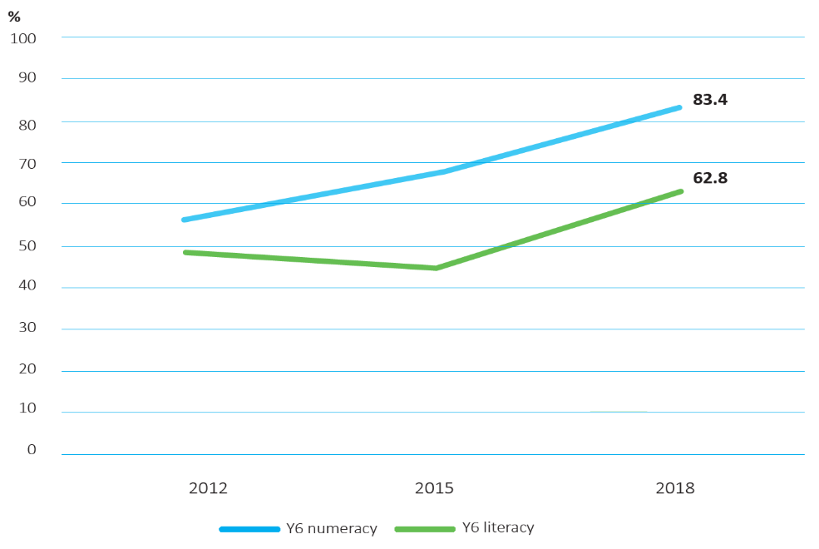

Regional Literacy and Numeracy Proficiency. Source PILNA

Student literacy outcomes are of great concern to Governments in the Pacific region and especially in Kiribati, Solomon Islands and Vanuatu. Primary school student literacy and numeracy learning outcomes in the Pacific have however gradually improved over the last decade. There have been for instance significant improvements in numeracy and literacy for Year 6 students over the last three assessments: most Year 6 students who were assessed are now proficient in numeracy with an average of eight out of 10 students meeting the expected standard and almost two-thirds of students meeting the regional literacy proficiency levels.

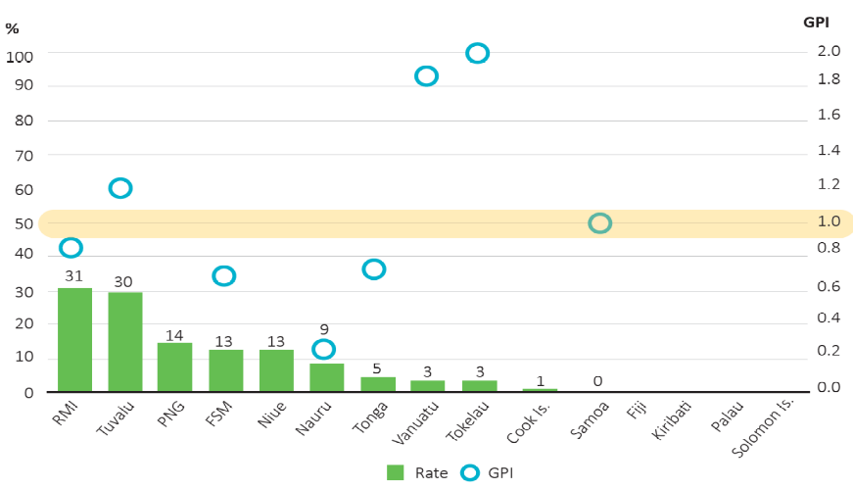

Out of School Rate in Lower Secondary Education. Source UIS

Most countries have low rates of out-of-school children with rates less than 10% not attending primary school and less than 15% not attending secondary school. 94% of the out-of-school children are located in Melanesian countries compared with less than 5 percent in Micronesian countries.

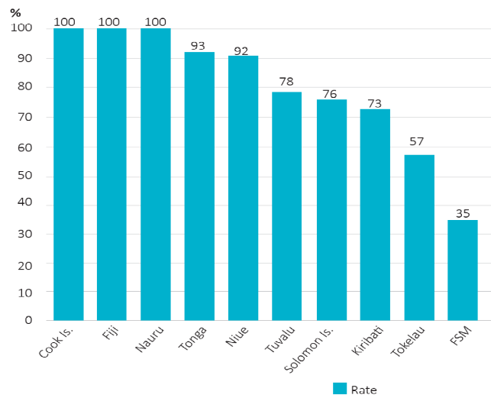
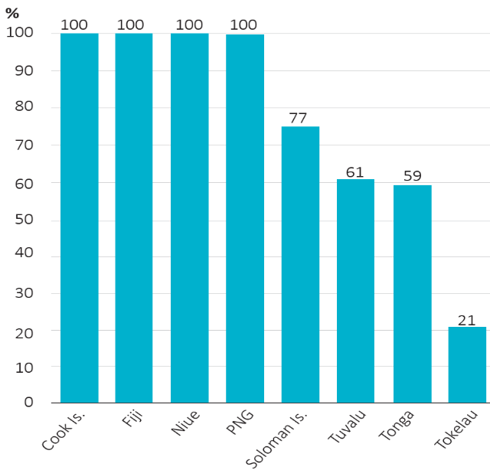
Across the Pacific region, relatively few children are not enrolled in and attending primary school. The rates of out-of-school children has been falling over the last three years. Evidence suggests that this is largely due to the free and compulsory nature of schooling (in all PICTs except Solomon Island) and to the widely shared value placed on schooling that ensures that where there is access there is participation. Unfortunately, some PICTs face serious difficulties in providing schooling in remote and isolated areas and on distant islands. In many of these instances, children are required either to travel far or to relocate to attend school. Another matter that requires attention is linked to the indirect costs, such as for uniforms, books and transport, that partly remain in place, cancelling the free access to schooling and leading to children dropping out of school when their families can´t afford those costs. These costs have been the matter of recent policy measures to make them accessible or free. Over-age progression and significant repetition are associated with lower levels of student learning achievement. The Melanesian sub-region has the largest percentage of over-age children, both at primary and lower-secondary levels: three-quarters of students in primary and lower-secondary education are over the official school age for year level in Solomon Islands. Between 10 and 15 per cent of elementary school students are overage for their grade in Micronesian countries in the northern Pacific sub-region. Statistical evidence shows reasonably good levels of primary and lower secondary education completion, with an overall gender parity in the first segment and more girls than boys completing the second segment. Only two PICTs, Cook Islands and Fiji, have all teachers in their workforce that are trained to teach in both primary and secondary education. All primary teachers in Nauru and more than 90% of primary teachers in Niue and Tonga are trained teachers, and all secondary teachers in Niue are trained to teach at secondary level, though it is uncertain whether all are qualified to do so. Only a third of teachers in the FSM were trained teachers in primary education, and only one in five teachers in Tokelau are trained at the secondary level. The relatively low levels of trained teachers in some PICTs have significant policy implications for the development of education in the Pacific region, especially for the Melanesian sub-region and small island states. Student–teacher ratios are within or below regional norms in primary education, and well below regional norms in secondary education. On average, there are 22 students per primary teacher and 15 students per secondary teacher.
Trained Teachers in Primary Education. Source UIS

Trained Teachers in Secondary Education. Source UIS

Although few PICTS have achieved full participation in early childhood education (ECE), the majority of children in the Pacific region benefit from some form of ECE, and the percentage of children that enrol in the year prior to primary education is increasing annually. The majority of children in the Pacific region attend and complete the last year of primary education and the trend has been slightly increasing. Census data show similar levels of primary and secondary school enrollment for children from outer and main islands. “Access to secondary education appears lower on outer islands than on main islands in FSM and Kiribati but higher in Tuvalu. In RMI, overall school enrollment rates are higher outside the main island; for Tonga, by contrast, there is no systematic difference in the share of children attending school on main and outer islands. Literacy rates are also only moderately lower on outer islands than on main islands. These data point to some of the PIC governments’ successes in making basic education available for all.” It will also result in the migration of many better-educated people from outer to main islands or overseas. The right to education in the region would not be complete if the curricular content and syllabi did not include, from early grades onwards, environmental education with a focus on climate adaptation and resilience as a life skill, given the threats to human wellbeing and life in the Pacific. It is also important to remove gender stereotypes and gender-discriminatory images and themes from school curricula, and to include pro-active attention to the promotion of gender-inclusive cultural norms. The widespread discriminatory and even misogynistic attitudes to women and girls is a root cause of their being the largest group of left behind people: a barrier to achievement of the 2030 Agenda and a great loss of human capital to regional economies.

Right to Food

The Pacific is at risk of not achieving SDG 2, with underlying food security and nutrition vulnerabilities affected by the socio-economic impacts of COVID-19 and high exposure to climate and disaster risk. Lockdowns, mobility restrictions and difficulties with international transport have put food systems under pressure in different countries. PICTs are net food importers, with most countries producing less than 65% of their dietary energy supply domestically. Distance from global markets impacts food prices and the ability of Pacific communities to access and afford healthy diets. The COVID-19-induced economic crisis, with significant impacts on the informal sector and resulting loss of jobs, is is also affecting access to an affordable, diverse and healthy diet.

In 2020 in response to COVID-19 and in recognition of the limited access to timely data on the impact of shocks on household food security, WFP’s mobile vulnerability analysis and mapping (mVAM) has been rolled out across Fiji, Samoa, Tonga, Vanuatu and Kiribati. This high frequency monitoring has confirmed concerns related to dietary diversity and livelihood coping strategies, and while the data varies across countries, households with a person with a disability and in some contexts, female headed households appear to be at higher risk.

Across the PICTs, dietary diversity is typically low, and consumption of fruits and vegetables is well below WHO recommended intakes. Although fish and fish products remain the main source of protein for most Pacific communities, imported, processed foods and beverages are responsible for a significant proportion of daily energy intakes. Most imported products are nutritionally poorer than local foods but are often cheaper and easier to prepare, making the promotion of healthy diets a continuous challenge. Food affordability, especially for the poor, is threatened by rising prices, which have an enormous impact on household diets and dietary outcomes. Price inflation means that households are forced to make their purchasing decisions based mainly on economic factors, particularly threatening the right to adequate food for the most vulnerable groups.

The region has a large and growing triple burden of malnutrition. Overall, the prevalence of undernourishment is increasing in the region, and rates of childhood stunting, and micronutrient deficiencies in women and children remain of serious concern in a number of countries. Access to foods in enough quantity or quality is becoming an increasing challenge across the region and urgent action is needed to ensure access by all people to safe, nutritious, and sufficient food year around, as stated by SDG Target 2.1. The Pacific states which are the most food insecure produce only small volumes of traditional staples and very little fruit and vegetables. In the larger Melanesian countries and the mid-sized Polynesian countries, much bigger per capita volumes of nutritious food are produced and there is far greater income earning capacity to pay for the necessary food imports. However, even within these larger countries with substantial arable land resources, there are sizable segments of the population living in urban and peri urban areas that are food insecure. At the same time, the transition towards dietary patterns high in energy-dense, nutrient-poor, processed foods has been associated with rapid increases in rates of obesity and diet-related NCDs across the region, notably cardiovascular diseases and diabetes.

The multidimensional threats to the right to adequate food, in particular for vulnerable groups, call for a cross sectoral approach to food systems transformation that identifies and considers the most vulnerable and marginalized populations. Looking forward it will be important to support more consistent and timely data on food security across the region that is disaggregated by age, gender and disability to inform and program responses and better understand who is being left behind.

Right to Work

The situation of the right to work in the Pacific has been analysed under different lenses. The access to the labour market for young workers and women, the composition of the workforce and actual levels of employment and unemployment, by country, sector (agriculture, fisheries, tourism, logging, the civil service, ICT) and gender, as well as the existing unemployment protection and benefits, and any active employment policies enacted by governments of the region, have been discussed in other sections. Decent work, low quality of work and under-employment were specifically identified as key issues.

Gender data related to the workforce and conditions of employment for Pacific women, including progress in addressing bias, pay gaps, discrimination, and harassment in the workplace, have been especially highlighted. Other situations of discrimination or difficulty to land a job (i.e., for persons with disability) have been noted. Traditional non-cash-based work and informality of the labour market have also been analysed.

The impact of COVID on the levels of employment and the support provided by Governments to those who have lost their jobs and to businesses who struggled through the pandemic were discussed in some detail. New forms of work and technology, experienced before and accentuated during the outbreak of COVID-19 were also described. Pacific workers´ labour mobility inside the region and abroad, the representation of the workforce and the situation of labour rights, instances of child labour and concerns about conditions of modern slavery have also been addressed.

Social Exclusion Analysis

Poverty Drivers and Outcomes

While extreme poverty is not seen often in the region, an estimated one in every four Pacific Islanders live below their national poverty lines (particularly in FSM and Fiji), a situation made worse by the COVID pandemic. Marginalised population groups, especially suburban informal dwellers and homeless, and people living in remote communities, the outer island atoll poor, rural islanders where subsistence agriculture is scarce, female-headed households, the elderly and the unemployed - particularly women and young people, with youth unemployment averaging 23% in the Pacific region before the pandemic – and the working poor in informal activities with a heavy gender bias against women, are all at risk of falling into, or immersed in, poverty. A significant proportion of Pacific islanders living with some form of disability are poor. Poverty can also be a sudden onset phenomenon, related to catastrophic events, in particular climate shocks, accident, loss of a provider or illness.

The traditional economy of resource allocation, production and distribution where the factors of production (land and labour) are not considered tradable commodities is frequent, especially in the outer islands of the Pacific: a transition to the modern cash economy and monetization of PICT societies has an uneven and paradoxical effect of reducing multi-dimensional poverty for some (the successful migrants, the better-off community members) while increasing inequality (when compared to the marginalised main island suburban settlers and those failing to transition to a cash economy).

Weakening of the social safety nets at the local level is a consequence of inevitable market economy expansion. Needs for cash that erstwhile were covered through other means (community work and common land) cannot always be fully satisfied through cash-remunerated activities. According to WB studies, migrants move away from areas with minimal cash-based employment or income-earning opportunities and toward areas where the cash economy is more developed, to less-remote islands for instance, where these opportunities are more abundant. Social protection gaps frequently leave those who fail unshielded.

“Traditional forms of social protection, such as the Pacific’s clan and extended family structures, have always played an important role in mitigating the impact of economic pressures on households. The kinship system, referred to as veiwekani in Fiji, fa’a-Samoa in Samoa or wantok in PNG and the Solomon Islands, sustains individuals and groups on a daily or occasional basis. Remittances, from migrants to urban areas, overseas and temporary migrants to other countries also play an important role in supporting families… the gradual erosion of informal systems [have left] an increasing proportion of the population without adequate social protection.”
Some of the urban poor have lived a different experience, being forced out of their villages for not conforming to village norms – including for holding alternative views or even simply leaving abusive relationships. “In the PICs, formal social protection programs tend to be small, constituting a particular constraint to helping the vulnerable This has become particularly evident during the COVID-19 pandemic. Most PICs have established contributory pensions for the relatively small proportion of the total workforce in the formal sector. Universal old age pensions are the most common type of non-contributory social protection.” All PICTs maintain national social insurance or social security schemes, such as national provident funds and social security systems, primarily for those in formal employment. Nine countries provide universal non-contributory pension schemes for the elderly; four deliver disability benefits (the Cook Islands, Fiji, Nauru, RMI), but only Fiji, the Cook Islands, Palau, Niue, and Nauru have benefits targeting children. The bottom 40% of the population has as everywhere in the world a lesser chance of sharing in the prosperity of their nation or community. Economic opportunities are scarce and less attractive, access to health care, education and public services is harder for the poor, and the resilience of their communities frailer. In the Pacific, there is a wide gap between household wealth of the poorest 40% and the richest 20%, indicating high rates of inequality. In Samoa for instance, “inequality is significant with the top 10% of the population earning more than the combined earnings of the bottom 30%.”

“As land becomes scarcer, poorer populations and rural-urban migrants are forced to live on low value land, often close to flood prone waterways and in higher-risk coastal areas, making them more likely to be affected by adverse natural events. In addition to lack of savings and insurance, poor people often have no choice but to live in hazard prone areas to satisfy their immediate basic needs. Many live in informal settlements with homes self-built from whatever materials are available including corrugated iron and wood that are generally non-durable and highly sensitive to flooding, storms and cyclones, along with additional health hazards. For example, in Port Vila, Vanuatu, informal settlements account for 70 percent of the improvised, makeshift or traditional housing stock. Most of these were destroyed by Cyclone Pam in 2015, while during Cyclone Harold in 2020, between 80 and 90 percent of homes on Espiritu Santo were destroyed. Even people above the poverty line and vulnerable populations including children, women and the elderly, can be pushed into transient poverty when a disaster hits as their livelihoods and homes are destroyed.” “Given the extreme vulnerability of PICTs to natural disasters and climate change, disaster risk reduction and adaptation measures to reduce exposure and vulnerability lie at the heart of poverty reduction.”

Inequality in the Outer Islands

Most countries include improving the livelihood of people on the outer islands in their NDPs. However, methods differ. Increasing incomes from agriculture, fishing, and industry are goals for most countries. Research lists RMI’s coconut replanting plan; Tuvalu’s support for copra products, traditionally prepared foods, and fishing; FSM’s investment in the coconut oil industry; RMI, Fiji, Solomon Islands and Vanuatu propose providing more business and trade opportunities on outer islands and in rural areas. RMI, FSM, and Solomon Islands plan to offer new employment opportunities on their country’s outer islands. Only Kiribati and Vanuatu have considered tourism as a viable method to improve outer island/rural area income. “The smaller PICs give much attention to improving connections between outer islands, the whole country, and the world. In their NDPs, they each cover all three pillars of connectivity: maritime transportation, air service, and ICT networks. Approaches for improving interisland transportation include building and repairing outer island airstrips and docks, investing in new ships and equipment, continuing subsidies to uneconomical routes, and providing continuous and regular transportation schedules.”

NDPs often include responses to climate change threats to outer islanders. The aforementioned research quotes the following: “RMI will develop an early warning system that targets outer island communities. Tuvalu plans to provide financial and technical support to outer islands that are responding and adapting to climate change threats. Fiji has identified for relocation all vulnerable communities at risk from climate-related events, and it has adopted plans for protective measures, including constructing of sea walls, watershed management, and riverbank protection. FSM has plans for upgrading critical infrastructure for climate change resilience. Solomon Islands will rely on effective disaster risk management, response, and recovery.”

Migration from outer islands/rural areas to capital cities and other economic hubs places burdens on the supply of basic services in areas of in-migration – mentioned in the Kiribati NDP. On the other hand, it draws potential workers away from development of the outer islands/rural areas – mentioned in the Tuvalu NDP. “Many of the PIC development plans include population goals for outer islands. For example, RMI set ‘stable outer island population’ as a national target. Tuvalu’s goal is to ‘retain population in outer islands and create a more balanced age structure.’ FSM designates copra price as social payment to encourage outer islanders to remain on their islands. Kiribati has also adopted a population strategy that intends to stem migration by improving access to economic and social infrastructure on the outer islands.”

Inequality of Opportunity and Intersecting Disadvantages

Inequality exists also in terms of access to opportunities. Inequality of opportunity undermines the realization of human rights and constitutes a barrier for social mobility. Identifying the furthest behind is particularly important, to better direct policies to specific population groups that tend to be disproportionally marginalized.

The groups left furthest behind are not necessarily the same across different development objectives, and do not have a unique identity. Commonly several characteristics intersect to create disadvantage, such as being poor, a woman or from a rural area. Digging into recent available household surveys (MICS) from Kiribati, Tonga and Tuvalu reveals how various circumstances, or disadvantages, intersect to form furthest behind groups.

Among 11 basic opportunities or barriers studied reflecting SDG indicators, inequality of opportunity in Kiribati is highest in access to electricity and clean fuels, followed by ownership of a bank account, and education completion. The furthest behind groups are less educated rural residents in the case of access to energy. Less educated, poorer individuals have the lowest ownership rate of bank accounts, while poorer men have the lowest rates of secondary education completion. In Tonga, inequality of opportunity is highest in secondary and higher education completion, as well as in meeting the demand for family planning with modern methods.

The furthest behind groups are different for each indicator: for education, it is poorer individuals, while the furthest behind group in family planning consists of younger (15-24) married women. Finally, in Tuvalu, recent data suggest that inequality of opportunity is highest in meeting demand for family planning with modern methods, in secondary and higher education and in the prevalence of violence against women. Poorer men are the furthest behind in education completion, while younger (15-34), less educated, urban women have the lowest rate of demand for family planning met with modern methods. Less educated women between 25-34 years of age justify violence against women the most. The variety in the composition of these furthest behind groups suggests that data-driven people-centred analysis requires a dive into hard evidence, to correctly determine the most disadvantaged groups in the Pacific in distinct development areas.

Gender Analysis

“The Pacific region includes a myriad of cultures, languages and ethnic groupings. It is diverse in terms of geography, natural resources, social systems and colonial contact experiences. Each country has also had unique experiences transitioning to and integrating political and economic systems that differ from their historical practices. What is common however is the prevalence of male-dominated systems of decision-making, even in countries with matrilineal systems of lineage and inheritance. This creates a commonality of gender disadvantage across the region although it may be manifested in diverse ways.”

Progress on gender equality has been lagging in the Pacific. Despite ratification or signature, directly or through another Member State, of CEDAW by all PICTs assessed except Tonga, the design by many PICTs of development strategies and plans with a gender lens, and preparation in many cases of specific national gender equality strategies and plans, the commitment to women’s and girl’s human rights have not delivered the kind of progress Agenda 2030 and the PLGED expected to unleash.

These commitments, and the need to do more were recognised by Pacific Governments at the 14th Triennial Conference of Pacific Women and 7th Meeting of Pacific Ministers for Women, held in April and May 2021:

The Conference and Ministerial recognised and reaffirmed all national, regional and international commitments by PICTs to gender equality, including the Pacific Leaders Gender Equality Declaration and the Convention on the Elimination of All Forms of Discrimination against Women, while acknowledging that implementation remains a challenge for many of them. The Conference and Ministerial further recognised and reaffirmed that advancing gender equality requires a holistic and collaborative approach that leverages partnerships between governments, the media, civil society, private sector, academia, traditional and faith leaders, communities and families, and requires genuine political commitment at all levels.

There are multiple reasons for this shortfall. Needed increase in collection and use of sex-disaggregated data across sectors is hindered by the lack of public resources for statistical development. Pacific governments allocate very limited financing to national institutions and initiatives to address gender equality (1%). Gender budgeting in line Ministries remains an exception. “Many of the efforts to alleviate women’s poverty in the Pacific are initiatives funded by multilaterals, donors and non-government organisations. Women’s savings clubs, financial inclusion initiatives, training programs and cash transfer pilots are largely delivered with development funding.” Pacific Countries have thereafter approved the more ambitious Pacific Platform for Action for Gender Equality and Women’s Human Rights 2018–2030 which complements the PLGED by integrating the vision and principles of the 2030 Agenda.

In 2018, Fiji, Republic of Marshall Islands, the Cook Islands and Nauru reported on CEDAW with modest progress in areas of domestic violence, criminal and common laws. Violence against women and girls (VAWG), however, continues to be extremely high in a number of countries in the region. COVID-19 impact has been detrimental to an improvement in the levels and frequency of violence. Women in more than half of the PICTs suffer partner or non-partner violence, at rates that well exceed global averages. The UN in the Pacific has called for an end to “testimonies in courts, regarding the morality or good character of perpetrators of violence, by church leaders and others in position of authority in the community”, as a practice that banalizes and at times condones VAWG through the introduction of references only valid in international legal standards for rehabilitation of convicted felons, not as an element of judgment before sentencing. Pacific Governments, through the Triennial Conference of Pacific Women and Ministerial Meeting “acknowledged GBV as a continuing scourge of the Pacific, and reaffirmed that its root cause is gender inequality, unequal gender power relations, privilege and patriarchy.”

The Committee on the Rights of the Child has also argued that traditional apologies should not be used as a mitigating factor, nor as reparation for sexual abuse and exploitation of children. “Increased information and awareness on domestic violence, in partnership with and in some cases led by CSO partners, has helped break the silence and initiated legislative reforms to increase protection for women and children. Nevertheless, access to justice and essential services for survivors including execution of protection orders remains inadequate and largely insufficiently resourced, particularly outside urban areas.” In fact, few countries in the region possess health facilities that meet international standards to provide GBV care to victims and survivors. While there are moves to improve access to and standards for counselling and shelters in a number of PICTs, significantly more remains to be done.
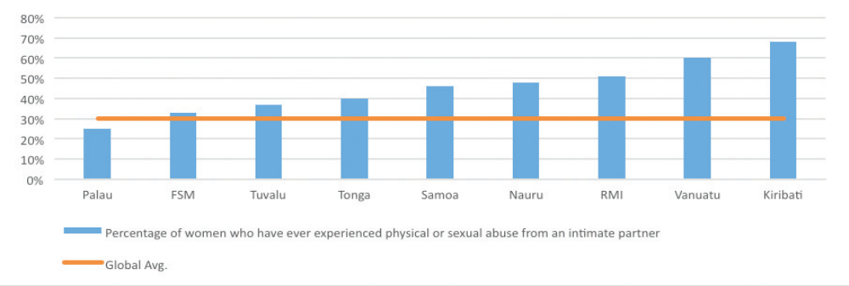

Source: UNFPA Pacific quoted by WB 2016

Women´s representation in Pacific legislatures is low compared to global averages but progressing in several countries: 22% in Niue and Fiji, 16% in the Cook Islands, 10 percent in Nauru, 10% in Samoa, 8% in Solomon Islands, 7% in Tonga (from 0% in 2016), 6% in Kiribati, Tuvalu, the Marshall Islands; 6% also in Palau (from 0% in 2016), 0 percent in FSM and Vanuatu. According to the Pacific Women in Politics database, women have never comprised more than 30% of the membership of national parliaments in the Pacific Islands Countries since Independence (not counting Australia, New Zealand, and the territories of USA and France in the region), and the percentage of women in Pacific parliaments currently hovers at 8.4% (as of February 2021) compared to the world average of 25% elected women MPs. Samoa and Vanuatu have passed Constitutional Amendments to promote women’s political participation, reserving 10% of seats for women in the Samoan Parliament and 30% in municipal councils in Vanuatu. 7% of the Fijian village chiefs are women, as per the Government´s official data.

Solomon Islands´ Political Parties Integrity Act requires parties to reserve 10% of candidatures for women. The Act includes incentive grants for parties that support women but does not sanction parties who fail to attract women applicants. Some local governance legislation remains that hinders the representation of women. “In many Pacific countries, the political environment is not attractive to women. Adversarial norms and standards of electioneering and parliamentary procedure can be intimidating and mask harassment, bullying and abuse. The numbers of women in public service leadership positions seem to indicate that many women find it easier and more secure to follow a career path in government civil service than in politics.” The substantial resources required to run for parliament, and systems of patronage, are significant barriers to women’s election in many Pacific countries. The limited number of women in parliament in the region is just one indicator of the hurdles to women’s voice, agency and decision-making.

Regional Trends

Pacific Women MPs 2013 2014 2015 2016 2017 2018 2019 2020 2021
Numbers 26 32 30 35 40 44 47 49 48
% 4.7 5.7 5.4 6.3 7.2 7.9 8.4 8.8 8.6

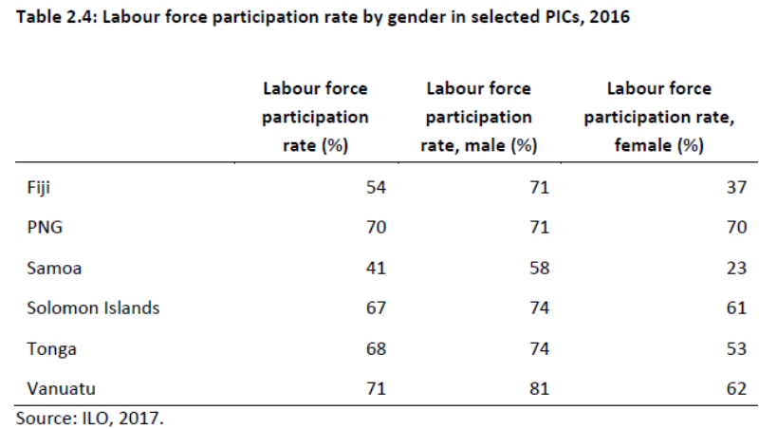
Women´s economic opportunities are known to be inequitable – unequal pay, feminisation of informal labour markets, lack of social protection, over-representation in sectors at risk, lack of effective anti-harassment regulations, and financial exclusion are all symptoms of the same inequality scene. Labour force participation is, according to ILO data, tilted towards male workers in all Pacific countries, except for PNG. FAO also reports a significant gap in rural women’s and men’s farmers income in Fiji, with women farmers earning 25% less than men.

The recent Fiji Agricultural census showed that while many women take part in farming activities, they do not count themselves as farmers. This has a number of consequences, including excluding them from training and support provided to farmers. There are no reasons to believe that the gender pay gap in other Pacific islands´ agriculture deviates from this inequality pattern.

Women’s agricultural and fisheries livelihoods and economic security are disproportionately affected by the COVID-19 pandemic and will likely experience longer-term impacts due to the inequalities they face in economic opportunities. Data and anecdotal evidence indicate that women are worse affected by the pandemic’s negative impacts on tourism and fishing industries and cuts in remittances. They are less likely to benefit from Governments’ economic responses which usually target the formal sector and formal businesses, such as suspension of loan repayments, wage support and access to superannuation, social security and employer support. Economic stimulus measures in many countries increase funding allocations to sectors such as construction, infrastructure and roads which are traditionally male-dominant and therefore, are less likely to increase women’s employment opportunities and income. “Women’s financial inclusion is unequal and low. Many women remain unbanked and access to finance is difficult for many women, making them vulnerable to payday lenders and microfinance schemes charging extraordinary interest rates. There are continuing challenges linked to access to collateral and credit and other financial services, however a number of collaborative development initiatives are improving financial literacy and inclusion.”

Reporting over the past decades, Pacific Governments including Fiji, Marshall Islands, Palau, Samoa, Tonga, and Vanuatu mentioned incidents of people being trafficked into their countries. Facilitators of human trafficking are often not based in the region and the most publicised cases have involved a transnational element. Trafficking has been known to be linked to commercial sex trade. On the upside, small cohesive communities have contributed to improved policing and reporting of the crime. Several PICTs are source, destination and transit countries for men, women and children subjected to sex trafficking and forced labour. Family members, taxi drivers, foreign tourists, businessmen and crew on foreign fishing vessels have allegedly exploited Pacific and foreign children and women in sex trafficking. Penalties are stringent in Pacific criminal law.

Culture and traditions matter when it comes to gender generally discriminatory attitudes and behaviours towards women strongly influence and rationalize the distribution of resources across the region in favour of men, significantly undermining optimal progress under the 2030 Agenda. While not all gender patterns can be generalized in the region, the Pacific by and large shares gender norms, patterns and challenges that confine women primarily to responsibilities of unpaid and under-resourced work such as domestic chores, caring for family members and subsistence activities. Formal employment, leadership positions and decision-making roles are significantly influenced by gender discrimination, which also serves to relegate women to informal and precarious economic activities, constraining women’s overall income. In this way both governance and economic growth are deprived of the full range of talent so badly needed for development. Across the region girls’ education performance is equal to that of boys in primary school, and exceeds boys’ achievement at the secondary level, which signals that they do not lack the capacity to contribute perhaps even more than their brothers to national development, and that their over-representation among the disadvantaged is the outcome of discrimination that is socially and economically irrational. Social and cultural barriers to women’s full contribution to society continue to hamper progress in achieving the great impulse to development that gender equality would bring. National development plans are unlikely to be fully effective without attention to these counter-productive barriers.

Children and Youth Integration Analysis

The Pacific region has a vast young populace, with almost a fifth of its population between 15 and 24 years of age (18.2%) with the youngest country being Kiribati (22%) and with the Cook Islands having the lowest, although still significant percentage of youth (16%). Although the international definition of youth refers to person between the ages of 15 and 24, each Pacific country sets its own criteria and, in some cases, the upper age limit is extended to 29 or 34 years, Kiribati and Fiji being examples of countries using varying definitions. The adolescent population refers to persons aged 10-19 years. Together, the adolescents and youth population in the Pacific comprise almost a third of the population (29.2%). With the present age structure and relatively high birth rates, the number of working age youth is expected to continue to grow over the next two decades. Given the demographic importance of the adolescent and youth population investing in them is indispensable to the sustainable development of the Pacific countries. On the other hand, not acknowledging the opportunities which this age group can provide to a country, if the right investments are made, can result in a range of economic and social challenges.

The Pacific region has the opportunity to benefit from the ongoing population and age structure dynamics which present the possibility of harnessing the demographic dividend from a demographic bonus created by a number of people of working age (youth bulge) that has increased in relation to the number of dependent young and older persons. In order to create such a favourable age structure, mortality has to decrease so that the children and adolescents can grow up and survival rates of the working age group can increase, and fertility must decline so that the upcoming young generations are smaller with a decreased related burden. The demographic bonus can be transformed into a demographic dividend, i.e., into a gain for the national economy (economic dividend), if the many employable people, largely the youth, actually have the opportunity to become employed. A more recent argument also poses that there can be a gain on social well-being (social dividend), given the right conditions, for the youth and other sub populations. For this to happen, investing in adolescents and youth is essential, but the resulting impact can be truly transformative for the Pacific countries and the region as a whole.

The graph below shows the 2021 regional population structure for the Pacific. While it is based on the aggregated population for the region, many of the countries, particularly the eight countries with the largest populations, have a similar structure given that they are experiencing a ‘youth bulge’ where a large portion of the population is integrated by children and young adults. As can be seen from the wide base of the population pyramid, the size of the young dependent population is disproportionately larger than the working age population. If fertility and mortality rates were to decrease further from the current status, the shape will change from today’s pyramid shape to an ideal jar shaped or contracting pyramid type. Some of the smaller countries such as Cook Islands, Niue and Palau have already begun to experience this contraction with the window of opportunity closing.
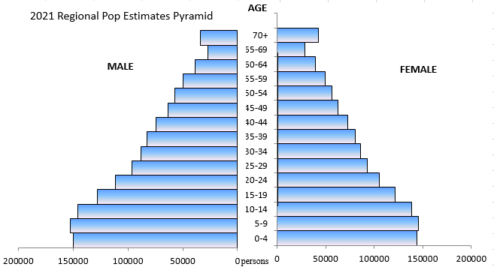

Investing in education, employment, health and well-being for the adolescents and youth of the Pacific Islands countries and territories will provide a unique opportunity to increase the size of the productive labour force and have a larger and more skilled young population to grow the economy, meet the challenges of climate change and advance the Blue Economy. These investments are catalytic and must ensuring human rights, gender equity and equality, expand opportunities for youth to contribute to political and civic rights and leadership, ensure a better-informed and educated community, and a healthier population that is able to reverse harmful trends caused by high or increasing adolescent pregnancy, non-communicable diseases, gender-based violence and mental health stressors.

While strategic and policy planning must work in an organic way to carefully carve out the path for a demographic dividend, there are four main areas that will need attention from the United Nations within the next phase of its cooperation framework with the Pacific. These are:

Health and gender equality: Recent data from Multiple Indicators Cluster Surveys and Ministries of Health in the region show a relatively higher age-specific birth rate for adolescents and young people. The Adolescent Birth Rate measured by the number of births per 1,000 girls aged 15 to 19 has remain unchanged or has been increasing at an alarming rate in some of the Pacific Island countries and territories in the last few years. The rates are the highest in Kiribati (51), Marshall Islands (49) excepting in the neighbouring islands (100), Solomon Islands (78) and Vanuatu (81). Additionally, in almost half of the 14 PICTs, ten to nineteen percent of girls are married in the age group 15-19. Adolescents and young people are often not well informed about the challenges of transitioning through adolescence, making it difficult to overcome the social and culturally harmful practices that limit their access to information and services. Adolescent girls who become pregnant often do not complete school, face social and familial exclusion, and are at increased risk of poverty, and sexual and gender-based violence. Being a mother while still a child impacts their overall health and well-being and compromises their opportunities to achieve their full potential. While policies and programmes aimed at improving education, skills and job opportunities are important, they can be rendered ineffective if young people suffer from sexual AND reproductive ill health and face unintended pregnancies, or do not have information, contraceptives and other SRH services to enable them to make conscious and informed, childbearing and health choices.

Likewise, education can influence a young person’s sexual and reproductive health. Interventions that encourage school attendance have been shown to reduce overall adolescent fertility. Poverty and ongoing economic uncertainty, migration, and the effects of climate change, all pressing issues in the Pacific, can drive harmful practices such as child marriage, violence against women and girls, and poor health in general. These interconnected phenomena provide strong support for a holistic, cross-sectoral approach to investing in young people’s human capital, and for the need to ensure young people’s access to sexual and reproductive health services and information.

Lifetime prevalence rates of physical and/or sexual violence by a partner and/or a non-partner for women including girls in the region are above the global average of one in three women experiencing violence. Indeed, between 36 and 79 percent of women experienced such violence in their lifetime, with eight out of the ten countries having prevalence rates of more than 50%, and seven out of the ten more than 64%, according to GBV surveys conducted between 2007 and 2020. Various factors contribute to the high prevalence of GBV in the region, including cultural and social norms that create power imbalances between young women, girls and their male counterparts, and ultimately impede their sexual reproductive rights.

For instance, the age of consent for marriage is below 18 for women in Nauru, Samoa, Solomon Islands, and Vanuatu. In some other countries that recognize customary marriage, girls can marry even younger. Early marriage puts girls at higher risk of sexual violence by their spouses, as they may have less negotiating power within their relationships and a lower understanding of their rights as compared to older women. A determined focus on demanding and attaining gender equity and gender equality for all women and girls across the Pacific Islands is a vital and necessary undertaking.

Education must be recognized as critical for development. It prepares the way for the demographic bonus because mortality and fertility will decrease with the population’s rising standard of education. In addition, human capital increases through education. Education is fundamental to harnessing the demographic dividend. It is essential for Governments to create equal education opportunities for vulnerable young people such as those with disabilities and those least likely to complete their education; to expand secondary education for everyone raising literacy standards, workforce capabilities, building economic and social capital, and establishing gender equity as a bedrock with girls being retained in school and empowered with the agency to exercise choice over the future, and acting as a protective factor in decreasing adolescent pregnancy.

It is essential, too, to establish and strengthen vocational training as a bridge between school and the labour market; and through gender equality interventions, ensure vulnerable women have access to microcredits for furthering their skills training for entrepreneurship. Countries must invest in preparing young people for emerging job markets where technology plays a crucial role. Access to quality education not only nurtures quality workforce but also delays early marriage and childbirth. Through effective Comprehensive Sexuality Education, women are empowered to decide and control when and how many children to have, gender-based violence (GBV) is reduced and more women enter the formal sector, contributing to economic growth based on decent jobs.

Employment. Human capital, built through education and economic independence is a critical asset for propelling national economies. It is fundamentally entwined with advancing and achieving the Blue Economy in the Pacific. To build human capital, jobs must be created that not only ensure improved human well-being but also guarantee social equity while significantly reducing environmental risks and ecological scarcities for the region. As the number of working-age youth will grow quickly over the next decade, urgent action must be taken now to prevent high unemployment rates among youth sparking a range of social problems which many public institutions in the Pacific will have little experience in addressing.

Youth unemployment is an issue in all Pacific Island countries, with young women particularly affected. The Asia Foundation´s research indicates that “across the Pacific, one in four people are unemployed, and in Kiribati, Nauru, and Marshall Islands, unemployment is over 50%.” Compared to ILO´s global and regional averages, the placement capacity of the Pacific economies ranks low. High rates of youth unemployment are rooted in low economic growth, high population growth, and mismatches between the skills employers require and those attained through educational and training programs. Recent series show a systemic large Pacific youth unemployment compared to other cohorts´ employment rates.

In the Solomon Islands, 10,000 job seekers enter the labour market each year, but only 400 new jobs are created. Given the limited number of opportunities, most of the young people engage in non-monetary activities such as subsistence agriculture or fishing within their home communities, or take on informal employment characterized by insecurity, low wages, and lack of social protection. While informality is not the province of the young workers only, it affects them disproportionately. ADB reports that a significant proportion of Fiji’s economic activity occurs in the informal sector (estimated at 85%) especially in rural areas. Sidewalk vendors, market sellers, domestic household workers, nannies, and other care workers, are at risk and live in a poverty trap.

Moreover, many young people in Pacific Island countries who are not working are also not in training, given the low prospects for quality employment upon graduation. ILO notes some distinct progress in the technical and vocational education and training (TVET) programmes in Kiribati, where the syllabi have been upgraded and aligned with international standards, and successful apprenticeship schemes implemented in Fiji to provide students with the requisite skills to match local employment needs. Industry associations and employers´ involvement in the development of training curricula has been at the origin of these successes. However, migration, with its accompanying “brain drain” remains the clearest pathway to prosperity for many young people. Petty crime, drugs and alcohol abuse are the consequences associated with youth marginalisation.

It is essential, as a first step, to create productive employment opportunities for the youth, and in doing so, to invest mainly in sectors with a high need for low-skilled workers, and as the second step, to create jobs in knowledge-intensive sectors that achieve greater added value, once the population’s level of education has increased.

Governance and Decision-making. Youth agency is a crucial asset in building social security, cohesion and resilience; when the formal employment sector grows, social security systems should be developed or expanded. Young people represent a large proportion of the Pacific population and have to be part of decision making at national and sub national level. Youth involvement in governance and decision making empowers a nation and maximises youth potential to innovate and propel development. In addition, it contributes to mitigating social anxiety caused by uncertainties of social welfare and thus reduce tension that could undermine peace building and social cohesion. Lastly, the ultimate benefit to formidable social security is resilience and adaptation against effects of climate change, disasters and epidemics, and young people in the region are already taking centre stage in shaping the climate action movement in the region. The increasing role of Pacific youth in climate justice is very important in supporting climate-friendly impacts since SIDS continue to bear the brunt of ecological devastation and calamity that are largely not of their making.

In conclusion, for the Pacific Island countries to benefit from the demographic dividend, requires that each country understand the size and distribution of its population, its current and projected age structure, and the pace of population growth. National needs must be matched to a sequence of short- and medium-term investments that assure the rights of all young people to plan their lives, be free of violence and trauma, be assured of essential freedoms and reproductive rights, and have access to quality education and mentoring. An all-rounded approach which includes health, education, employment and training, and participation in decision making is recommended. The policy approaches cannot be completed without active and meaningful participation of the young people themselves in the process. Strengthening the existing youth councils and networks and ensuring representation in the public sphere will bring about a better tailored, needs-based and human rights based approach to the population that can propel economic development in the region.

Rights of Persons with Disability

At least 1.5 million Pacific Islanders have some form of disability. Persons with disabilities, coordinated through the Pacific Disability Forum, play critical roles to support disability-inclusive developments in the countries and the region. Their governments allocate very limited financing to national institutions and initiatives to support them (0.2%). The Pacific Disability Forum SDG-CRPD Monitoring report (2018) showed that the disability expenditure as a share of GDP may even be lower. Persons with disabilities often suffer from marginalisation and fall into poverty, if they weren´t already poor, in a cause-and-effect vicious loop. Access to adapted education, employment and basic social services is rare, discrimination, prejudice, and rejection regrettably frequent.

PICT leaders are reported to have strengthened their commitments to tackle barriers faced by PWD. The 2016-2025 Pacific Regional Framework for the Rights of Persons with Disabilities is viewed by the Pacific Disability Forum (PDF) as an important step forward. PIC governments also prioritised PWD in the 2017 Roadmap for Sustainable Development. PDF reported that commitments have begun to translate into greater efforts and progress in terms of awareness raising, legal harmonisation, data collection, inclusive education, vocational training, and access to assistive devices, social protection, disaster risk reduction and humanitarian response. Engagement with OPDs was said to have significantly increased in many countries.

The reality of basic human rights enjoyment is bleak for persons with disabilities in the Pacific. Children with disabilities do not have the option of fully inclusive schools with physical and curricular accessibility. With few exceptions (Fiji, Cook Islands and Solomon Islands), laws, policies, and systems to prevent discrimination have not been developed yet. Health outcomes of persons living with a disability are poorer than those of their fellow citizens. NCDs are a frequent cause of disability in the region. Women living with disabilities are more likely to suffer physical and sexual abuse than men with disabilities or other women. One area of extreme disadvantage and discrimination is education. Across the region, there are insufficient teachers trained in inclusive education, including sign language and braille.

Accessibility as a pre-condition to inclusion is an important element in ensuring equal opportunities for persons with disability. This is also mentioned SDG 4-10-; CRPD 9-19-21; IS goal 3 and is a key element for inclusive implementation of the SDGs and the Sendai Framework for Disaster Risk Reduction. To date, 13 of the 14 PIF countries have ratified the CRPD. Regional efforts have generated a regional framework, under the conventional umbrella of rights, to bring further attention to this group representing 15% of the Pacific population. With the exception of Solomon Islands and Tonga who are only signatories, all Pacific countries have now ratified the Convention on the Rights of Persons with Disabilities (CRPD). In 2016, Pacific Countries adopted the Pacific Framework for the Rights of Persons with Disabilities (PFRPD 2016-2025). The latter focuses on livelihoods; mainstreaming; leadership and the enabling environment; disaster risk management; and evidence. Implementation and reporting on the PFRPD are coordinated by a regional Reference Group on Disability supported by the PIFS.

Advocacy needs to continue in favour of the ratification of the ILO 1983 Convention C159 on Vocational Rehabilitation and Employment (Persons With Disability), which promotes better opportunities to decent employment.

Other Populations at Risk or Furthest Behind

Children

Children are more at risk of poverty and deprivations. Poverty incidence is consistently higher amongst children than the national average across the Pacific countries, 44% amongst children compared to 29.9% in the population in the case of Fiji according to the latest HIES, for example. The impacts of poverty are more significant for children, and there is growing evidence that children experience poverty more acutely than adults: the negative impacts on their development can have profound and irreversible effects into adulthood.

Children face violence, abuse, neglect and exploitation at home, school and community, and corporal punishment is not explicitly prohibited by law in some PICTs while enforcement may still remain an issue in some other PICTs where it is prohibited by law. For example, approximately 84% of Ni-Vanuatu children experience violent discipline in their homes. Violence in schools is also prevalent with high rates of bullying (66%) and physical fights (52%) leading to severe injuries (68%) in Solomon Islands. Mental health of children is also a growing concern in a number of PICTs.

Children face exclusion in access to key essential services such as health, education, protection and social welfare. Routine immunization rate for young children in some PICTs is still suboptimal despite good processes made over the past decades. Triple burden of malnutrition remains a challenge in many PICTs. In terms of social protection, there are few schemes specifically addressing the vulnerabilities of children, despite an overall progress seen in strengthening the social protection systems in many PICTs, particularly during the COVID-19 pandemic. For example, in 2020 while 22% of the Tongan population were in receipt of at least one social protection benefit, only 3% of children were covered (although 26% of mothers with new-borns were beneficiaries).

Children have no or little voice in the key decision-making processes that affect their wellbeing such as national and sub-national planning and budgeting processes. Policies and mechanisms for safeguarding the rights and interests of children may need to be strengthened and made more explicit to ensure every child can reach his or her full potential.

Indigenous People

Pacific Islanders are the peoples of the Pacific Islands, particularly those who are indigenous to them. As an ethnic or racial term, it is used to describe the original peoples—inhabitants and diaspora—of any of the three major subregions of Oceania (Melanesia, Micronesia, and Polynesia). The Pacific is home to a diversity of indigenous languages, cultures, knowledge, traditions, social structures, politics, socio-economic circumstances and history, as well as a variety of unique biodiversity, habitats, and ocean and landscapes. Simultaneously, there is a degree of shared experience among the Pacific’s indigenous peoples in terms of the enduring impacts of colonization, the consequences of international trade and economic activity, the global concerns on climate crisis and the pandemic, and of course the influence of the great ocean itself.

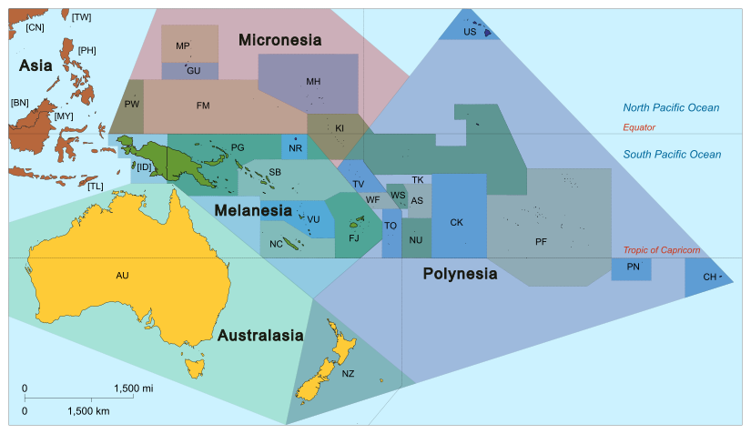
The right to non-discrimination may be violated in the ways that policies are implemented, or services are delivered by States while systemically failing to provide for the specific needs of indigenous individuals or communities, or those who live in more vulnerable or marginalized conditions, as compared with mainstream populations. The right to a healthy environment may be threatened by the climate effects of sea level rise or the devastating force of severe weather events, destructive mining activity, or pollution. The right is often ignored, to participate fully in decision-making affecting their lives and to give their free, prior and informed consent (FPIC) concerning activities proposed affecting their lands, territories and resources.

This fundamental right, which indigenous peoples are often deprived of, would allow them to enjoy a dignified standard of living, and to determine and prioritize for themselves how they wish to subsist and develop – including with respect to ensuring water and food security, education, health, society, culture and economics. Certain human rights issues are more critical for particular indigenous peoples in the Pacific than they are for others - for example, violence and suppression facing Environmental Human Rights Defenders (EHRD) and HRDs in Fiji; gender-based violence in Samoa; or issues of forced migration in Kiribati and low-lying atoll or coastal-dwelling communities.

Cultural rights and identity of the Pacific islanders and indigenous communities are at risk in the Pacific for a variety of reasons, including sea-level rise, displacement, loss of indigenous languages, impacts of open markets, demographic changes, and loss of traditional knowledge. Cultural preservation of sites, objects, knowledge and practices that define identities in the Pacific require constant restoration and/or safeguarding. While defenses such as seawalls and flood gates are being tried but they might not be effective for long. Given the increasing demographic tilt towards youth in the Pacific, social transformation and ecological resilience need to go hand-in-hand. Culture is a major aspect of people’s sense of well-bring in the Pacific that necessitates using a culture and development approach and placing communities, in particular youth and indigenous communities, at the center of the development planning process.

LGBTIQ+

In spite of some progress in attitudes and law and in some instances inclusion culturally and linguistically – decriminalisation of homosexuality in some countries, first pride parade in Fiji – LGBTIQ+ men and women do not enjoy equal rights (e.g., to marriage, family, the right to donate blood...) They also experience high levels of state and societal violence and marginalisation and discrimination, including intimate partner violence, and for the young, widespread homelessness. (see above, p. 93 ff)

Older Persons

The issue of ageing was considered a matter of importance for only a handful of countries. Now, the number of persons aged 60 and over is increasing at an unprecedented pace, anticipated to rise from its current 740 million to reach 1 billion by the end of the decade. Unfortunately the increase in numbers has also shed light on the lack of adequate protection mechanisms, and on the existing gaps in policies and programmes to address the situation of older persons. Today, two-thirds of the world’s older people live in low-and middle-income countries and this proportion will rise to 80 per cent by 2050. Older persons are not a homogenous group, and the challenges they face in the protection or enjoyment of their human rights vary greatly. While some continue to lead active lives as part of their community, many others face homelessness, lack of adequate care or isolation. Multiple discrimination appears as an essential component of any analysis, particularly when considering that age-related discrimination if often compounded by other grounds of discrimination, such as sex, socio-economic status, ethnicity, or health status. The Report of the Secretary-General to the General Assembly focuses on the human rights of older persons. It identifies four main challenges older persons are facing in terms of human rights as discrimination, poverty, violence and abuse as well as the lack of specific measures and services. The report further stresses several key areas for responses to the challenges as strengthening the international protection regime, elimination of financial exploitation and employment discrimination, establishing adequate care facilities and participation in political life [Reference: , https://www.ohchr.org/en/professionalinterest/pages/olderpersons.aspx]. Lack of legislation and resources prevent the State from offering additional and specific protection to citizens in their old age, when they need it. Rather, the obligation for their care typically falls upon female family members as part of their expected domestic responsibilities.

In the Pacific as elsewhere, women have a higher life expectancy than men, combined with lower capacity to save during their economically active years. Among older people persons, defined as people aged 60 years or over, women have a high probability of experiencing greater income insecurity and vulnerability as they age. Stark gender differences from the formal labour market participation rates translate into fewer women having access to pensions who enjoy old age social protection. Pension schemes in the Pacific are dominated by provident funds, with lump sums being paid upon retirement that are often spent on investments in consumption goods and quickly depleted, thus, not providing income security in old age. This has been exacerbated by COVID-19, with individuals able to withdraw portions of their savings. While this has assisted in addressing immediate income needs, it will be at the long-term expense of people’s retirement savings.

Refugees and Asylum Seekers

Incidents of forcible returns to countries where refugees may be at risk of serious human rights violations have been considered seriously problematic. Absence of permission to seek legal advice or appeal their forcible return aggravated the incidents. Fiji, Nauru, Papua New Guinea, Samoa, the Solomon Islands and Tuvalu are Contracting States to the 1951 Convention relating to the Status of Refugees and its 1967 Protocol with Fiji, Papua New Guinea, Nauru and Vanuatu having enacted refugee-specific national legislation and accompanying regulations.
UPRs have recommended special attention to legislative provisions to protect accompanied refugee and asylum-seeking children and support the family reunification of unaccompanied minors.

Incarcerated Persons

One of the most striking SDG indicators in reverse trend is the number of unsentenced detainees in several Pacific countries. Recommendations have been made to meet the United Nations Standard Minimum Rules for the Treatment of Prisoners. This is particularly urgent with respect to physical conditions, premises, rights of visit and complaint, external oversight and monitoring, and especially the prevention of torture and degrading or inhumane treatment while under penitentiary custody. There is need for greater understanding of the needs of incarcerated women, including the risk of gender-based violence, and the impact on their families through loss of their care economy contributions. PICTs have not yet promoted to the fullest extent possible alternative measures to detention, such as diversion, probation, mediation, counselling or community service, to alight the carceral overcrowding, ensure that detention is used as a last resort and for the shortest possible period of time, and that it is reviewed on a regular basis with a view to withdrawing it.

Other Groups

Instances of discrimination of persons with albinism in access to and maintenance of employment, disregard for the needs of pupils with albinism in school settings, leading to early school dropout, discrimination in access to social welfare, and abandonment of children and cases of divorce as a result of the birth of children with albinism have been noted in some of the countries in the region. UPRs have recommended urgent action and awareness-raising on this issue.

Multidimensional SDG Risk Analysis

The Sendai Framework works hand in hand with the 2030 Agenda, the Paris Agreement on Climate Change, the Addis Ababa Action Agenda for financing development post 2015, the New Urban Agenda, and advocates for the substantial reduction of disaster risk and losses in lives, livelihoods, and health and in the economic, physical, social, cultural, and environmental assets of persons, businesses, communities, and countries. It focuses on both natural and man-made hazards and related environmental, technological, and biological hazards and risks. All PICs are signatories to the Sendai Framework as well as to the Framework for Resilient Development in the Pacific, the regional framework closely aligned to Sendai and SAMOA Pathway 2014.

PICTs have made significant progress on Sendai Framework´s global targets by collecting disaster loss information and reporting disaster damage and loss and policies against indicators for Sendai global targets in the online Sendai Framework Monitor tool. All 11 PICs have self-assessed and reported on their national disaster risk reduction policies (target E) as well as recorded progress on other Sendai global targets on reduction of disaster loss and risks, like target A (mortality) and B (people affected). Nonetheless, a recent UNDRR-conducted report on strengthening disaster loss data (DLD) management systems in the Pacific, confirmed persistent institutional challenges. It found that while data, information, and knowledge management challenges are often perceived as technology issues, essential barriers relate to people and behaviours, governance, and frameworks, as well as processes and coordination. Further strengthening capacities to assess, with relevant disaggregation levels, disaster and climate change damages and losses and related socio-economic, ecological, fiscal, security, and political impacts, is essential to ensure differentiated impacts and vulnerabilities to climate and disaster risks are understood and addressed. Improved disaster impact and vulnerability information will enable more anticipatory action approach to mitigate disaster impact, adapt social protection mechanisms, and reduce humanitarian response and recovery needs.

The evolving nature of risk, involving compound and cascading hazards that are interconnected in increasingly interdependent socio-economic systems, requires an all-stakeholder and multi-hazard systemic approach to risk identification, assessment, and management. Examples of such risks include COVID-19 and its impacts on the ability to respond and prepare to cyclones, as witnessed during TC Harold in 2020. It is therefore pivotal that all risk assessments, risk management, responses, and joint programming to support Governments and other stakeholders in PICTs work in greater coordination mode for more inclusive, effective, and comprehensive climate, public health, and disaster risk governance. It will also ensure synergies and avoid the development of parallel structures and process for the same issues.

There are several indices, including INFORM, Think Hazard, and World Risk Index, which aggregate risk data into rankings/levels of hazards, exposure, vulnerability, coping capacity, adaptation capacity etc. These are all underpinned by different methodological approaches (incl. weighting, variables, datasets etc.), which is why results differ. For example, INFORM ranks flood risk at low score for all Pacific SIDS, whereas floods, such as coastal floods, are listed as high or medium level risks for the same countries in the Think Hazard tool. Furthermore, some risks may be considered as low impact when observed in siloes; however, when compounded with other hazards, their impact could increase, with domino (indirect and direct) effects across other sectors. While these different tools and indices are helpful to understand the complexities and interplay between elements of risks, they highlight the need for the UN to collectively manage risks from varying sectoral perspectives, and to integrate systemic risk thinking in all their planned activities going forward.

Source DRMKC-INFORM

Regional SDG Dashboard. SDG Assessment of Key Targets.

Regional progress towards the SDGs has been robustly documented through a concerted effort of the Pacific, articulated via its regional institutions, in particular PIF and its Secretariat, the Council for Regional Organisations in the Pacific (CROP), its Agencies (PASO, PIDP, FFA, PIFS, PPA, SPC, SPREP, SPTO), and USP; and the Pacific´s development partners, especially the United Nations (UN) agencies in the region (notably FAO, ILO, UNESCAP, UNESCO, UNICEF, UNDP, UN Women, WHO), the World Bank and ADB.

Salient regional priorities include the need for increasing the pace of progress towards the achievement of the 2030 Agenda, responding to increasing vulnerabilities and deepening inequalities, limited access to infrastructure and basic services. Regional strategies focus on significant opportunities for accelerating the development of Pacific societies, protecting the rich Pacific biodiversity, and sustainably harvesting oceanic and tropical resources, and increasing access to and use of ICT and connectivity. Regionalities include “the value of shared stewardship of the Pacific Ocean, and (…) the connection of Pacific peoples with each other, and with their natural resources, environment, culture and livelihoods.”

Transboundary issues have been appropriately identified and comprise of climate change (SDG13), disaster risk management (SDG11) and integrated oceans management (SDG14); as well as poverty reduction (SDG1); reducing inequality (SDG10), including gender inequality (SDG5); addressing the needs of persons living with disabilities (SDG11); improving quality of education (SDG4); tackling non-communicable diseases and cervical cancer (SDG3); improving connectivity (SDG9); and ensuring decent work and economic growth (SDG8). Food security (SDG2), water and sanitation (SDG6), transportation (SDG9), culture and sports, sustainable energy (SDG7) and tourism, waste management, sustainable consumption (SDG12), biodiversity (SDG15) and peaceful, safe communities and migration (SDG16) are equally considered areas of potential or actual regional cooperation.”

According to ESCAP, PICTs remain off-track on all 17 SDGs and have only made slow progress on goals related to gender equality, access to basic services including healthcare, water, sanitation and hygiene, sustainable cities and communities, the environment and means of implementation. COVID has surely not increased the pace of achievement of Agenda 2030 in the region.

Risks to Peace and Security

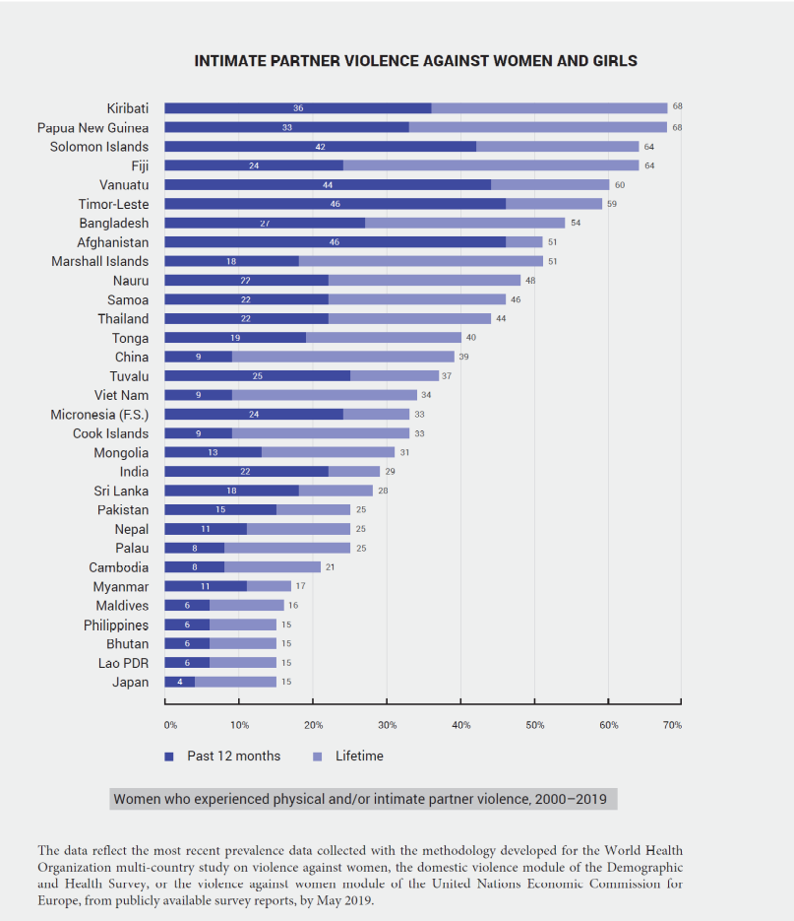
An estimated one in four Pacific Islanders live under their respective national poverty lines. Youth unemployment averages one quarter of the young workforce ready, willing and able to take on a job, but not finding one. Inequality and insecurity are deepening across the region – with several factors linked to the dangers of climate change, the volatility of the economy and undesired population dynamics. Violence against women has become entrenched and stands out negatively in the broader Asia-Pacific region (Graph from ESCAP 2020a). This can give rise to social unrest and political instability.

Polarized politics along ethnic fault lines generate a risk of social confrontation and political violence. According to the 2020 UN Pacific CCA, despite its relative political stability, potential risks to peace, conflict and security in the Pacific region center around democratic space, justice, rule of law and governance. These risks can be exacerbated by the impact of multiple and compounding disasters and events, including the impact of COVID-19, climate change and disasters triggered by natural hazards. To mitigate and respond to these potential drivers of conflict, it is important to create and utilize early warning and response mechanisms, including anticipatory ones and Pacific contextualized peacebuilding opportunities that foster social cohesion and the promotion and protection of human rights. These include actions and avenues to establish and strengthen platforms and mechanisms for diverse stakeholder and community engagement, promoting social cohesion and peace processes, especially with vulnerable, at-risk and discriminated groups, dialogue and citizen participation for accountability, democratic governance, and rights-based and inclusive development.

Risks to the Environment and Climate Resilience

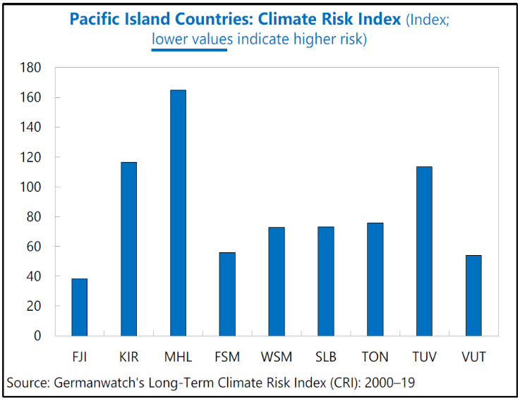
Climate change, climate variability and extreme weather events turn the Pacific into one of the most natural hazard risk prone regions in the world. Kiribati, Tuvalu and the Marshall Islands are only one to three meters above sea level, and thus are threatened by projected sea-level rises of around 60 centimeters or more by 2100. “The extreme events occurring today, such as storms, tropical cyclones, droughts, floods and marine heat waves, provide striking illustrations of the vulnerability of small island systems. Societal dimensions, such as the greater levels of socio-economic disadvantage in the most exposed remote, atoll and coastal communities reducing overall resilience, can combine with climate changes, e.g., sea level rise, to amplify the impact of TCs, storm surge and ocean acidification in small islands contributing to loss and damage.

“Climate change and related disasters impact women, girls, and persons with disabilities disproportionately, while women’s knowledge and resilience are undervalued and overlooked.” Two important risks are the threat to subsistence production and food security, typically the domains of women, and the relative exclusion of women from resilience planning and limited access to the technologies increasingly used to provide warnings and guidance. These two risks combine to reduce overall community resilience and delay recovery

Rapid and unplanned urbanization resulting in underserved informal settlements with drainage, sewerage, housing, and waste management issues; non-risk sensitive land use, exposing critical infrastructures to coastal hazards; unsustainable use of natural resources resulting in accelerated coastal and soil erosion; result in increased vulnerabilities to climate change impacts and disasters, driving up risks and eroding resilience.

For example, Category 5 TC Pam devastated Vanuatu in 2015 with 449.4 million US$ in losses for an economy with a GDP of 758 million US$. Kiribati, Papua New Guinea, Solomon Islands and Tuvalu were all impacted by the TC Pam system. In 2016, TC Winston caused 43 deaths in Fiji and losses of more than one third of the GDP. In 2018, Category 4 TC Gita struck the Pacific islands of Eua and Tongatapu, impacting 80% of the population of Tonga through destruction of buildings, crops and infrastructure, and resulting in 165 million US$ of losses with a national GDP of 461 million US$.” Cyclones Harold and Yasa in April and December 2020, respectively, caused further loss of life and devastation in Solomon Islands, Vanuatu, Fiji and Tonga. In April 2021, Typhoon Surigae hit Palau. King tides have impacted low-lying atoll countries, in particular RMI and Kiribati.

“More than 80% of small island residents live near the coast where flooding and coastal erosion already pose serious problems and since the IPCC 5th Assessment Report and the Special Report on Global Warming of 1.5ºC, there is consensus on the increasing threats to island sustainability in terms of land, soils and freshwater availability. As a result, there is growing concern that some island nations as a whole may become uninhabitable due to rising sea levels and climate change, with implications for relocation, sovereignty and statehood. For example, at the island scale, recent studies (e.g., on Roi-Namur Island, Marshall Islands; Storlazzi et al., 2018) estimate some atoll islands to become uninhabitable before the middle of the 21st century due to the exacerbation of wave-driven flooding by sea level rise, compromising soil fertility and the integrity of freshwater lenses (Cheriton et al., 2016).”

“The literature also discusses the future of atoll island shoreline. In Solomon Islands, where rates of sea level rise exceed the global average at 7–10 mm yr–1 (Becker et al., 2012), a study of 33 reef islands showed five vegetated islands had disappeared and six islands were concerned with severe shoreline erosion (Albert et al., 2016). In Micronesia, a study showed the disappearance of several reef islands, severe erosion in leeward reef edge islands and coastal expansion in mangrove areas (Nunn et al., 2017). In Tuvalu, with sea level rise of ~15 cm between 1971 and 2014, small islands decreased in land area while larger populated islands maintained or increased land area with the exception of the remote island of Nanumea (Kench et al., 2018). Positive shoreline and surface area changes over the recent decades to century have been observed for atoll islands in the Pacific and Indian oceans. Out of 709 islands studied, 73.1% had stable surface area, 15.5% increased and 11.4% decreased in size over the last 40–70 years (Duvat, 2019). Indeed, the projected combination of higher rates of sea level rise, increased wave energy, changes in storm wave direction, as well as the impacts of ocean warming and acidification on the reef system, is expected to shift the balance towards more frequent flooding and increased erosion.”

Risks to Sustainable Economic Growth

Undiversified and open economic structures require massive imports, which expose dependent and small economies to the volatility of global markets and their shocks. Resilience of the private sector is an essential precondition for sustainable development in such economies. The IMF working paper on Tracking Trade from Space summarises the risks to the Pacific region´s sustainable economic growth: “Pacific islands are small open economies vulnerable to climate change and disasters triggered by natural hazards. They consist of remote and dispersed islands served by a few container lines (sea locked), as indicated by their low liner connectivity index and high transportation costs. As such, they have a few large trading partners (Australia, China, Japan, New Zealand, United States) that make them vulnerable to supply shocks in those countries.

As their economies are not diversified, they are highly dependent on imports of manufactured goods for both consumption and investment. Some are also highly reliant on tourism. In general, they have limited statistical capacity that hinders the timely production of essential macroeconomic data. Indeed, timely macro-economic indicators are missing or only reported with significant lags or low frequency.”

Moreover, the 2030 Agenda is very clear that growth cannot be sustainable unless it is socially inclusive, so that no one is left behind. Economic performance, especially in developing countries, is subject to global shocks and fluctuations that often delay, and sometimes derail, the achievement of key development priorities. The UN development system therefore supports its partners in strengthening the resilience of the economy through appropriate macroeconomic policies and individual resilience (of both men and women) through social protections and redistributive policies that reduce vulnerability and preserve gains against poverty and inequality.

This support focuses on fostering patterns of growth that improve the distribution of incomes, increase economic diversification and take full advantage of the appropriate technologies and innovations. This includes valuing properly and fully the many non-monetized activities in the modern economy, such as unpaid care work, informal labour and the provision of essential services, and the people who undertake them. Thus, in moving away from past practices focused on production and consumption, it is critical to focus not only on growth itself, but on sustainable forms of growth that are low-carbon, resource- efficient and redistributive.

Risks to Social Progress and Social Cohesion

Inequalities, lack of opportunity, discrimination, unemployment and obstacles to access services and enjoy rights, all constitute risks to individual wellbeing and fractures to the social fabric. Among the many risks, climate change, economic shocks and the general exclusionary attitudes towards women are likely to be the most damaging, and root causes of many development challenges. Disparities in education, lack of attention to people living with disabilities, employment formality and pay gaps, discriminatory practice on the part of employers against pregnant women in recruitment and during employment, violence against women and girls, discrimination and societal violence against the LGBTIQ+ community, and blatant lack of response from Law-and-Order institutions to both these forms of violence, will require further political emphasis and strong prioritization of remedial measures and reforms, evidenced in budget allocations, specific public service focus and legislative change.

Tenure and property of land is one of the most sensitive and volatile issues anywhere in the world. When combined with inter-ethnic divisions, it represents a serious risk to social cohesion. Entitlement to land outside freeholding areas is still a contentious matter. Similarly, reports have captured with concern the publication in some countries of newspaper advertisements seeking tenants or housemaids of a particular ethnicity or religion, or the overrepresentation of dominant ethnic groups in neuralgic institutions of some countries, such as the Police or the Armed Forces.

Risks to Gender Equality

The region´s leadership is aware that more needs to be done on gender equality. This was the purpose and mandate of the PLGED. Its implementation has shown uneven results.

Discriminatory attitudes. Most Pacific countries are close to achieving gender parity in primary enrolment while secondary enrolment shows girls outnumbering boys. Nevertheless, pervasive discriminatory attitudes tend to exclude women from the most dynamic and productive sections of social and economic life, despite their educational achievement, and comprise a significant threat to progress under the 2030 Agenda. The low investment in inclusive education and disability-friendly schools remains a barrier to education for women and girls with disabilities.

Violence Against Women and Girls. One of the saddest outcomes of the culture of gender discrimination across the region is the very high level of violence against women, and widespread tolerance of it. This is a violation of their human rights, not only devastating for the women concerned, their children and often their families. It also reduces women’s productivity, and places unnecessary burdens on health and social services. The prevalence of violence against women in the Pacific region is up to twice the global average. Prevalence studies have now been completed in eleven PICTs, drawing a compelling and disturbing picture of the nature of VAW across the region, including its causes, consequences, and service-seeking patterns and behaviours. Across the region, incidence of domestic violence is such that approximately one in three women experience it during their lifetime. However, all women are affected by the threat of such violence, and the extent to which this threat constrains the behaviour of all women and inhibits social change is unresearched, but no doubt extensive. The physical and psychological experience of violence is not the only harm: women face significant resistance to the search for redress, laws in many cases favour perpetrators and impose additional harms on the survivors through loss of anonymity and significant social stigma. In many cases the perpetrators have absolute impunity. Furthermore, it is likely that, as elsewhere in the world, VAWG increases during emergencies.

Governance and legislation. The levels of representation of women in the public sphere are discussed above under the gender analysis, registering tepid progress towards women’s empowerment and participation in decision making that deprives countries of the full range of much-needed and available talent. Focused attention to temporary special measures is needed to remedy this problem, as repeatedly recommended by the CEDAW Committee. Discriminatory legislation still survives the wave of equality, establishing prejudiced bias in employment, social protection including maternity and paternity leave, sexual harassment in the workplace, decision-making, land ownership, social, health and family status, education, and in constitutional protection. These not only deprive the women concerned, and their families, of full enjoyment of their rights, they deprive the countries concerned of much needed human capital.

Women’s labour force participation rates remain low across the Pacific, including in labour migration schemes. In a number of countries men’s participation in the formal economy is almost double that of women and women’s participation is more likely to be in the most precarious and poorly paid sectors of the employment market. Domestic work conditions remain unprotected and the International Labour Organization (ILO) Domestic Workers Convention, 2011 (No. 189) has not been widely ratified. Increased services targeted to women’s needs, and especially a reduction in their responsibility for unpaid care work are preconditions for the increases to GDP that would derive from expanded female labour force participations.

Women’s sexual and reproductive health. Fertility rates remain high in the majority of the countries. Limited sexual and reproductive rights and a lack of resources for women and girls, are constraining the attainment of improved levels of basic health in the region. More than half of PICTs have unmet family planning needs above 50%, indicating that a majority of women lack control over their fertility. This is particularly serious in the case of adolescent girls, reducing the potential gain to be made from any demographic shift that countries may be experiencing. On the other hand, maternal mortality has been reduced to almost zero across the region – a considerable achievement. Unnecessary legal hurdles add to the difficulties in accessing reproductive health: in Samoa, while there are no legal barriers for young people and adolescents in accessing family planning supplies and information, HIV and STI testing remain restricted to people aged 18 and over. Parental consent is required for people under 18. In Nauru and Marshall Islands, 27-28% of girls are married or in a union before the age of 18, followed by Vanuatu at 24%, Solomon Islands at 21%, and Kiribati at 18%. Childbearing begins early for these girls; in Vanuatu, 38% of women aged 19 have already given birth or are pregnant. Young motherhood can curtail advanced education and work opportunities and the financial independence those can bring, not to mention the potential loss of their contribution to economic growth.

Climate Change. In a region so heavily influenced by climate outcomes, the inequitable impacts of climate change on men and women, such as loss of educational opportunities due to the need to migrate to find natural resources, result in the myriad ways that gender, climate change and natural hazards interact to create specific development and social challenges in the Pacific. The subordinate position of women in many Pacific communities and households, the decreased access and control over resources making it difficult to bounce back after a disaster, and disproportionate reliance on agricultural activities mean that women are significantly more vulnerable to the impacts of climate change and natural hazards than men. UN Women has documented this SDG inequality gap with case studies of The Republic of Marshall Islands, Samoa, and Vanuatu. Further research suggests that the impacts of climate change across the region are far from gender-neutral: lower representation in decision-making, restricted access to physical and economic resources due to gendered economic opportunities and gendered roles in the family and household mean that women are disproportionately exposed to climate change impacts and have far less opportunities than men to minimise their own vulnerability.

Transboundary, Regional, and Subregional Perspectives

Humanitarian-Development Nexus

The adoption of the 2030 Agenda and the Sustainable Development Goals set out not just to meet needs, but to reduce risk, vulnerability and overall levels of need, provided a reference frame for humanitarian and development actors to contribute to the common vision of supporting the furthest behind first and a future in which no one is left behind. The United Nations’ ongoing reform process envisions UN entities working in humanitarian, development (and peace) realms to work more cohesively together, capitalizing on their respective comparative advantages. Frameworks on CCA/DRR contribute to sustainable development such as the 2018 Boe Declaration on Regional Security, the 2015 Suva Declaration on Climate Change and the 2010 Majuro Declaration for Climate Leadership.

The volume, cost and length of humanitarian assistance over the past few years has increased dramatically. This is very much the case in the Pacific. Funds for humanitarian needs inevitably reduce available funding for development work, including for the reduction of vulnerabilities, the construction of resilience, the prevention of crises and the preparedness for these. Humanitarian and development efforts need to be more effectively connected, working towards achieving collective outcomes that reduce need, risk and vulnerability, over multiple years. This proposed approach is referred to as the Humanitarian-Development Nexus (HDN).

Through a strategic focus on resilience, the UN aims to strengthen and support the preparedness and capacity of Pacific communities and families, to manage risks and to help restore livelihoods in the face of recurrent crises. Addressing people’s vulnerability before, during and after crises challenges the status quo of the aid system, which operates with little coordination between project-based development and humanitarian interventions, resulting in it not effectively meeting the needs of the most vulnerable people. The idea is not new. The nexus is a continuation of long-running efforts in the humanitarian and development fields, such as ‘disaster risk reduction’ (DRR); ‘linking relief rehabilitation and development’ (LRRD); the ‘resilience agenda’; and other similar precursor notions.

The emphasis on a more coherent approach offers many opportunities. Meeting immediate needs at the same time as ensuring longer-term investment addressing the systemic causes of vulnerability has a better chance of reducing the impact of cyclical or recurrent shocks and stresses. The welcome emphasis is on early warning, early action and prevention. The HDN is an integral part of the UN´s assessment of what is needed for future development efforts to be successful in the Pacific. It will be developed into a core programming principle, as it has been under the COVID response, when all pillars of intervention were mutually reinforcing. The coordination structures will have to be streamlined in accordance, to avoid fragmentation and dispersion of efforts. One aspect of this improved coordination could be a surge capacity for any available services for survivors of VAWG. VAWG is likely to increase during humanitarian emergencies, including the internal displacement discussed below, and pandemic related shut-downs, for which these services should be prepared.

Importantly, the pursuit of HDN at the global level has to be transferred to and realized at the local level. Hence, the integrated approach has to be embraced and moulded by all stakeholders at the operational level, facilitated by national governments and flexible, long-term funding schemes that discourages competition for resources. In fact, some donors at the global level have already instigated specific funding programs targeting projects with nexus approaches. Notwithstanding difficulties in operationalizing the nexus approach on the local level, its rationale to detect complementarities and build synergies between various agencies is compelling. Indeed, solely prioritizing humanitarian response may undermine opportunities to strengthen local systems to provide for essential services and thus undercut prospects of enhancing resilience for future disasters. As such, nexus programming represents systemic change in response to systemic risks.

The humanitarian needs assessment, as well as the post disaster need/ damage and loss assessment offer concrete opportunities to identify responses that while addressing immediate needs, prevent new risks and contribute to reduce existing ones. UN support to strengthen application of risk information to humanitarian response planning, capacity development for strengthening disaster damage, loss and impact analysis, as well as enhancing shock-responsiveness of social protection systems are concrete opportunities for addressing crisis related impacts while addressing their drivers.

Population Migration and Displacement

Remittances Share of GDP (Source: 2018 World Development Indicators, World Bank)
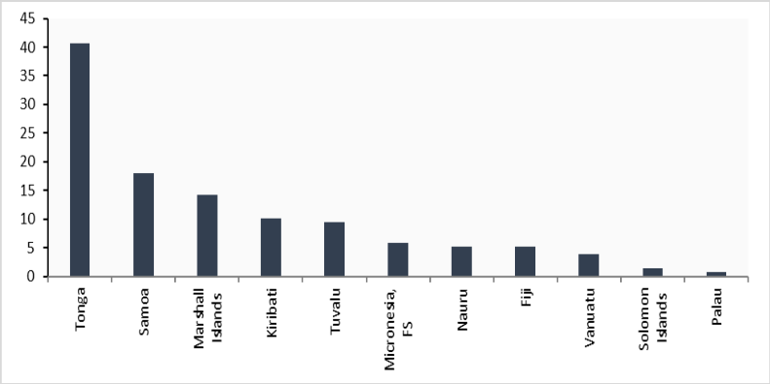
Migration can provide access to enhanced economic and social opportunities, and it is an important element of economic development for most PICTs. Migration, whether short-term, long-term, permanent, circular, internal, or international, sits at the heart of Pacific opportunity and connectivity. Concerns have been voiced about safety and security of Pacific migrants abroad and their working conditions. On the other hand, “Internal migration will on average lead to higher incomes and improved economic well-being for the migrant households. In addition, it will improve access to services necessary for increasing human capital, including health and education. However, migrants may lose access to traditional safety nets such as kinship networks and subsistence agriculture and fishing and thus become more vulnerable to hardships. The policy questions centre on creating the conditions that support successful internal migration, including improved urban management.” If well managed, migration from outer islands to main islands can bring benefits for the migrants, existing residents in urban areas, and communities remaining on the outer islands. For most islands, out-migration does not lead to a significant decline in population but helps to keep it stable and mitigate pressures on fragile outer island ecosystems (see also the section on Population Growth and Flows). While the women left in migrant supply areas may benefit from remittances, there are likely to be stresses from assuming unaccustomed tasks, increased agricultural work for already very time-poor people, and new responsibilities.

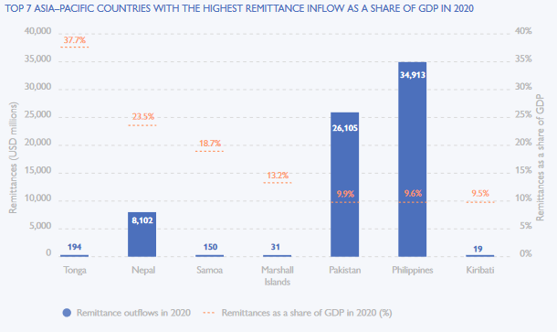

The importance of remittances to the Pacific national and domestic economies cannot be overstated. Fiji is among the region’s top ten recipients by value of remittance inflows, receiving nearly US$290M in 2019. In Tonga, remittances were equivalent to nearly 38% of its GDP in 2019. In Tonga and Samoa, four out of every five households receive remittances from abroad, with a similar share of households across the consumption distribution benefitting. Nationally representative household data in Tonga indicate that remittances are equivalent to approximately 30% of household consumption, while in Samoa they are equivalent to 8% of household consumption.

Transfers of Pacific migrants to their home communities have been discussed above as part of the human mobility process, as a source of foreign earnings, in the context of the pandemic-imposed restrictions and as a mitigating factor against the home community´s poverty. Here they are viewed as part of the resource base of PICTs. Though Pacific countries have very small natural resource bases compared to other smaller countries in the Asia Pacific region or globally, there is still a strong human capital inflow of income via remittances that comes to the Pacific. Remittances remain an important export income for majority of the Pacific SIDS, including Tonga, Samoa, Marshall Islands and Kiribati being the most remittance-dependent economies in the world in 2019, whereby remittance inflows representing between 10% to 40% of GDP. Tonga features among the top five remittance-receiving countries in the world. Countries such as Fiji and Samoa also saw their absolute amount of remittance inflows increase between 2019 and 2020 (Fiji +10.9% and Samoa +10.5%) when most of the countries in the Asia Pacific region had either shown a resilient or negative remittance inflows.

Displacement

Pacific islanders are one of the most vulnerable populations facing displacement risks due to cyclones, sea-level rise and coastal flooding. Climate change and urbanisation are expected to compound the issue. The increasing frequency and severity of extreme weather events in PICTs, due to climate change, is putting at least 50,000 Pacific Islanders at risk of being displaced by natural hazards. Up to 832,000 new displacements were recorded in the region between 2010 and 2020. Pacific countries with the highest level of new displacements per year, covered in this assessment, are Fiji, Vanuatu, and Solomon Islands.

In 2020, storm activity began in the South Pacific in January, when cyclone Tino triggered 3,500 displacements in Fiji and Tuvalu. Cyclone Harold then struck in April, triggering more than 93,000 displacements in Fiji, the Solomon Islands, Tonga and Vanuatu and affecting up to 160,000 and 186,000 people in Vanuatu and Fiji respectively. It became the second strongest storm to hit Vanuatu, displacing around a quarter of the country’s population in two days. It destroyed many homes, left 19,000 people homeless, and increased food insecurities. Nearly 4,500 people are thought to have had prolonged displacement in Fiji. COVID-19 restrictions hampered assessments in rural and isolated areas of both Fiji and Vanuatu, meaning that estimates of damage and displacement are likely to be conservative. Measures to prevent the spread of the virus further hampered humanitarian interventions, and overseas aid workers were not allowed to enter the country.

PICTSs are exposed to a range of natural hazards including floods, cyclones, storms, wildfires, volcanic eruptions and earthquakes amongst others. Human mobility, spanning migration, displacement and planned relocation occurring in the context of climate change and disaster events is taking place in the Pacific, primarily as a result of sudden onset disasters, but also due to slow-onset events such as sea level rise, coastal erosion and saltwater intrusion. These slow-onset events combined with other climate triggers, or a range of socioeconomic factors generate critical thresholds for displacement and pose significant humanitarian and sustainable development challenges in the Pacific. Among these the increased risk of VAWG must be addressed, particularly, but not only, in the chaos and upheaval of sudden onset disasters.

Beyond climate-related displacement or human mobility, there are also documented cases in the Pacific involving permanent displacement internally. These cases reinforce the need for legal protection for displaced populations as part of overall social, economic and cultural welfare, and the importance of integrated land use planning in receiving communities to prevent conflict. In the context of future climate risks, particularly those for low-lying atoll nations, regional collaboration to ensure protection of people displaced across borders is of critical importance.

Disaster displacement is the result of a complex process with multiple drivers. A multitude of demographic, historical, political, social and economic factors determine whether people can withstand the impacts of a hazard or are forced to leave their homes, chief among which are likely to be socio-economic disadvantage and exclusion. The limited availability o displacement data, in the Pacific, including disaggregated data, makes it particularly difficult to monitor the trends in displacement and know exactly who has been displaced, where to, and for how long. Localised and regional responses within the Pacific are vital to respond to the needs of displaced persons due to geographical, cultural, demographic and other factors. Pacific regional bodies, governments and UN agencies have undertaken multiple initiatives to address the vulnerabilities of the region, including the Framework for Resilient Development in the Pacific 2017 – 2030, the Pacific Response to Disaster Displacement Project (a collaboration between the IDMC, IOM and the Platform on Disaster Displacement (PDD) to contribute to better policy responses and disaster planning, as well as new and improved operational tools.

Trafficking in Persons in the Pacific

Human trafficking has been discussed above from the perspectives of governance failures and responses, human rights violations, the connection to commercial sex trade, forced labour and IUU. Several PICTs are source, destination and transit countries for men, women and children subjected to sex trafficking and forced labour. Family members, taxi drivers, foreign tourists, businessmen and crew on foreign fishing vessels have allegedly exploited Pacific and foreign children and women in sex trafficking. Trafficking for the purpose of forced labour typically occurs in the mining, logging, construction and agricultural sectors, as well as in the fishing sector. The vulnerability of migrant fishers, from countries such as Indonesia and the Philippines, is particularly pronounced, with indications of labour exploitation and forced labour occurring on foreign-flagged fishing vessels in the Pacific.

While vulnerabilities have been exacerbated by the COVID-19 pandemic, these could be minimized, in part, through monitoring and enforcement of the Crew Employment Conditions included under the FFA’s ‘Harmonised Minimum Terms and Conditions for Access by Fishing Vessels to the exclusive economic zones of FFA Member States. Penalties against trafficking in persons are stringent in some PICTs. In others, clear legislative gaps remain. Notably, only five PICs have acceded to the Protocol to Prevent, Suppress and Punish Trafficking in Persons, Especially Women and Children. Trafficking in persons cases remain under-identified and under-reported across the region, due to low levels of knowledge and a lack of specialized frontline officials. Moreover, most Pacific Island Countries lack specialized response and support services for victims of trafficking. While in some countries, gender-based violence and domestic violence service providers are able to offer shelter and support services to female victims, shelter options for male victims are usually non-existent.

Migrant Smuggling in the Pacific

PICTs share some transnational challenges and responses with the wider Asia-Pacific region. M (except for FSM, RMI and Tuvalu) are members of the Bali Process on People Smuggling, Trafficking in Persons and Related Transnational Crime, which raises awareness of the consequences of people smuggling, trafficking in persons, and related transnational crime throughout the region. Identified transit countries for smuggling in the Pacific among those covered in this assessment, include Fiji, Samoa, Palau, and FSM. Few PICs are signatories to the Protocol against the Smuggling of Migrants by Land, Sea and Air (2000), supplementing the United Nations Convention against Transnational Organized Crime. In several PICTs, the legal system is not well equipped to deal with the magnitude and new modus operandi or types of crimes taking place within their jurisdictions. Some crime classifications are yet to be included in national legislation. As a result, transnational organized crime-related legislation across several of the PICTs is outdated and inconsistent with international standards and norms, which limits the capacity of national and regional authorities to effectively deal with these challenges.& In the context of the Pacific Islands Development Community (PIDC), a regional framework to combat human trafficking and people smuggling was proposed in 2019.

Available information suggests that the repercussions of COVID-19 on migrant smuggling in the Asia Pacific region are complex and far-reaching. COVID-19 measures have included closures and restrictions at land, sea and air borders, which have influenced the modus operandi of organized crime groups involved in migrant smuggling. Undocumented migrants are particularly vulnerable, as the lack of legal status impedes further mobility which may fuel the demand for smuggling services and exacerbate risks for migrants. Available evidence suggests that law enforcement authorities would greatly benefit from improved transnational coordination to collect and share information about potential cases of falsification of travel and health documents. Moreover, intergovernmental cooperation and information sharing are fundamental to extend the data collection capability on irregular migration and migrant smuggling in the future.

Financial and Partnership Landscape Analysis

The Pacific region has been successful in attracting financial flows from overseas to support the development of its nations. FDI, ODA, in particular Climate Finance, concessional loans from MDBs, and growing government revenues and foreign earnings from key strategic sectors have combined more traditional resources with a growing SSC, innovative financing and other sources of FfD.

The Pacific is not, as are other clusters of nations in the same income group, in the league of the aid orphan regions. Quite the opposite: despite the relatively high costs of doing development and the comparatively short list of development partners, these have remained committed, new arrivals have been registered and aid flows remain significant. “There is an increasingly complex array of programs, stakeholders, and partners involved in the Pacific development space. This underscores the critical need to strengthen member countries leadership to enable them to guide how initiatives and partners respond adequately to their needs.”The Forum Compact on Strengthening Development Coordination in the Pacific, an initiative of the PIFS, strengthens national ownership and mutual accountability over development partnerships. Development assistance plays a critical role in funding public expenditure in most of the Pacific, and on a per capita basis, is among the highest in the world (largely due to their small populations).

Concessional Debt Financing and ODA

The Pacific is also one of the most aid‐dependent regions in the world, where ODA represents the highest proportion of national income. For the biennium 2019 and 2020, a total of 1,796 development partner-funded projects were active in the 14 PICTs, including direct budget support agreements, which represent about 40% of the aid flows. Australia, New Zealand, the World Bank and the Asian Development Bank were the first four donors/lenders by volume, followed by the USA (and USAID), UNDP, the EU, UNICEF, WHO, UNCDF, UN Women, FAO and UN Pooled Funds for the top dozen, in the listed order. The biennium is representative of the last decade, where China has also featured as one of the Pacific´s most prominent development partners. The European Union is one of the region´s most attentive humanitarian actors. The U.K. has been broadening its diplomatic and development footprint since Brexit. The dynamic between development partners is a mix of collaboration and coordination, not exempt of elements of competition. During the pandemic, development partners´ support has been vital, as economic downturn left PICTs with little if any fiscal space to strengthen health and other essential services, acquire vaccines and testing equipment or fund stimulus packages.

In the Pacific, China, the World Bank, ADB, Japan and OPEC Fund for International Development represent the top 4 ODA loan providers in the region. China and the WB represented more than 75% of ODA loans in the region alone. In terms of loan recipients, Vanuatu, Fiji, Palau and Solomon Islands are the top recipient countries, (though PNG, not covered in this assessment, remains the leading Pacific country with highest dependency on concessional financing).

Chart developed by RCO with Data from Pacific Aid Map, Lowy Institute

While Solomon Islands, Fiji, Vanuatu and Samoa were the top recipients of ODA in 2019 in absolute terms but their ODA per capita is the smallest. On average, the Pacific SIDS receive US$424 per capita in ODA - one of the highest ODA recipient countries in the world. Nauru and Tuvalu received US$5,047 and US$3,130 per capita respectively in 2019. The main aid sectors for the two countries are climate change and coastal adaptation; direct budgetary support; infrastructure development; and social & economic development, much of the ODA disbursed as direct budget support.

Net ODA received per capita (2019 US$) - Pacific SIDS

Australia remains the top ODA contributor in the region. In 2019, Australia contributed US$864.60M to the region. The second donor is New Zealand, contributing US$253.92M. Japan´s contributions to the region in 2019 amounted to US$179.29Mmillion. These three partners represent more than 55% of overall ODA grants in the region. ADB and the World Bank have traditionally been the largest loan providers to the region. China has recently positioned itself as a new loan provider along the lines of its “Belt and Road Initiative”.

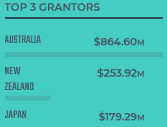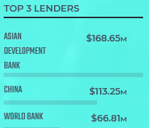

Derived from Pacific Aid Map for Pacific SIDS, Lowy Institute

Overseas Development Assistance (ODA) plays a vital role in the financing for development of Pacific SIDS. Overall, the 10-year trend in ODA offers a positive outlook, peaking in 2018, and slightly reducing in 2019. Solomon Islands, Fiji, Vanuatu and Samoa continue to be the main ODA recipients in the last decade in absolute terms. The aid by sector notes an increase in ICT connectivity and network infrastructure development; road construction or upgrades; urban water supply and waste management; aviation upgrade; economic and social sector development and police development.

Chart developed with Data from Pacific Aid Map, Lowy Institute

Regional Institutions

Mostly organised as Agencies belonging to the CROP, they include the PIFS, the Pacific Islands Forum Fisheries Agency (FFA), the Pacific Aviation Safety Office (PASO), the Pacific Islands Development Programme (PIPD, based at the East-West Center in Honolulu, USA), the Pacific Power Association (PPA), the Pacific Community (SPC), the Pacific Island Association of NGOs (PIANGO), the Pacific Disability Forum (PDF) the South Pacific Tourism Organisation (SPTO), the Secretariat of the Pacific Regional Environment Programme (SPREP), the University of the South Pacific (USP), the Pacific Islands Private Sector Organisation (PIPSO), and the Pacific Island Development Forum (PIPD).

The Chief Justices’ Leadership Forum is part of the Pacific Judicial Strengthening Initiative. In consultation with stakeholders, these organizations have developed a number of frameworks, plans and strategies that define the region´s common challenges and aspirations: the Framework for Pacific Regionalism (FPR), the Framework for Resilient Development to Climate Change and Disaster Risks (FRDP), the Pacific Roadmap for Sustainable Development, the Pacific Leaders Gender Equality Declaration (PLGED), the Platform for Action on Gender Equality and Women’s Human Rights, Pasifika Call to action on Early Childhood Development, the Pacific Youth Development Framework, the Pacific Islands Non-Communicable Diseases Roadmap, the Pacific Regional Education Framework (PacREF) and the Pacific Framework for Rights of Persons with a Disability (FRPD), among others.

The United Nations in the Pacific endeavours to work more closely, in a complementary partnership, with the relevant CROPs in its development programming. In particular, it is of the essence to link global processes under UN auspices and the Pacific positions in their context, with local UN support to the PICTs when they implement the global commitments at national level. This means support to the NDCs and other obligations arising from the Climate framework, in particular the CoP under the UNFCCC. It also means supporting global ocean action adopted by the Ocean Conferences. It further requires localizing in the Pacific the objectives of the Food Systems Summit.

Private Sector, FDI, Public Revenue and Debt

The UN detects a clear opportunity and mutual desire for engagement between the System and the Pacific Private Sector. This opportunity has however not materialized in the past in a coherent approach or in systematic alliances. Mindful of the differences of the private sector across the region, there are distinct possibilities for partnerships that range from more traditional sponsorship and donorship to joint initiatives, collaboratives in emergencies, UN advocacy for policies that would be supportive of Private Sector development, and contribution of corporate Pacific to Agenda 2030. In other latitudes, the sectors of tourism, energy, transportation, IT, construction, fisheries and retail are strong partners to the UN. The UN works with private operators on liberalization strategies, fiscal policy, financial inclusion, affordable housing and the provision of public services through technology applications. For example, The UN has engaged the maritime sector and submarine telecommunications networks on strategies to make use of high accuracy GPS and Global Navigation Satellite Systems (GNSS) data with ships, radar/laser sea surface height (for stationary platforms), and shared telecom + early warning/science submarine cable systems, respectively, to augment tsunami monitoring in a more cost-effective and more maintainable manner. This UN work came about due to the impacts of vandalism, theft, limited budgets, and technical damage that leave a fair fraction of all tsunami buoys not functional and thus greatly compromising early warning on tsunami. Because of this gap, lives and livelihoods of coastal communities continue to be needlessly exposed. The Digital, Blue and Green Economies are growth strategies where the private sector´s initiative is of the essence. The UN is committed to strengthening this partnership across sectors and countries.

Public revenue and domestic resource mobilization had increased steadily until COVID hit the national budgets of all countries. Fishing and tourism revenues have significantly expanded in several PICTs. Climate-resilient infrastructure financing through green or blue bonds is still in its infancy although Fiji has successfully placed its two maiden green bond issues in the domestic and international markets. Financing for climate change adaptation and mitigation has increased over recent years, mostly via the Green Climate Fund and IFI policy-based loans.

FDI and debt. The total value of net inflows from FDIs to Pacific SIDS was noted at US$412million in 2019, a drop of US$186million from 2018 figures. The FDI net inflows to Pacific SIDS vary substantially between countries, with Fiji well above the regional average, attracting around 80% of the FDIs to all Pacific SIDS. Whilst both FDI inflows and outflows started to recover in 2019 globally, the COVID-19 pandemic has caused the global FDI flows to shrink further by 49% as noted in the first two quarters in 2020. The FDI trend is likely to remain low and well below pre-COVID levels throughout 2021. Future outlook is quite uncertain and largely depends on the duration of the COVID-19 crisis and how effective public policy interventions are to stimulate investments and growth in the Pacific SIDS. Whilst FDI analysis is going to take place at each country levels, most of these are consequently expected to be determined by the larger Indo-pacific regions socio-economic recovery, and hence, investment appetite from investors outside the region.

Total FDIs to Pacific SIDS (most recently in 2019)


FDIs to Pacific SIDS by Country in 2019
(some prior to 2019 where latest figures are not readily available)

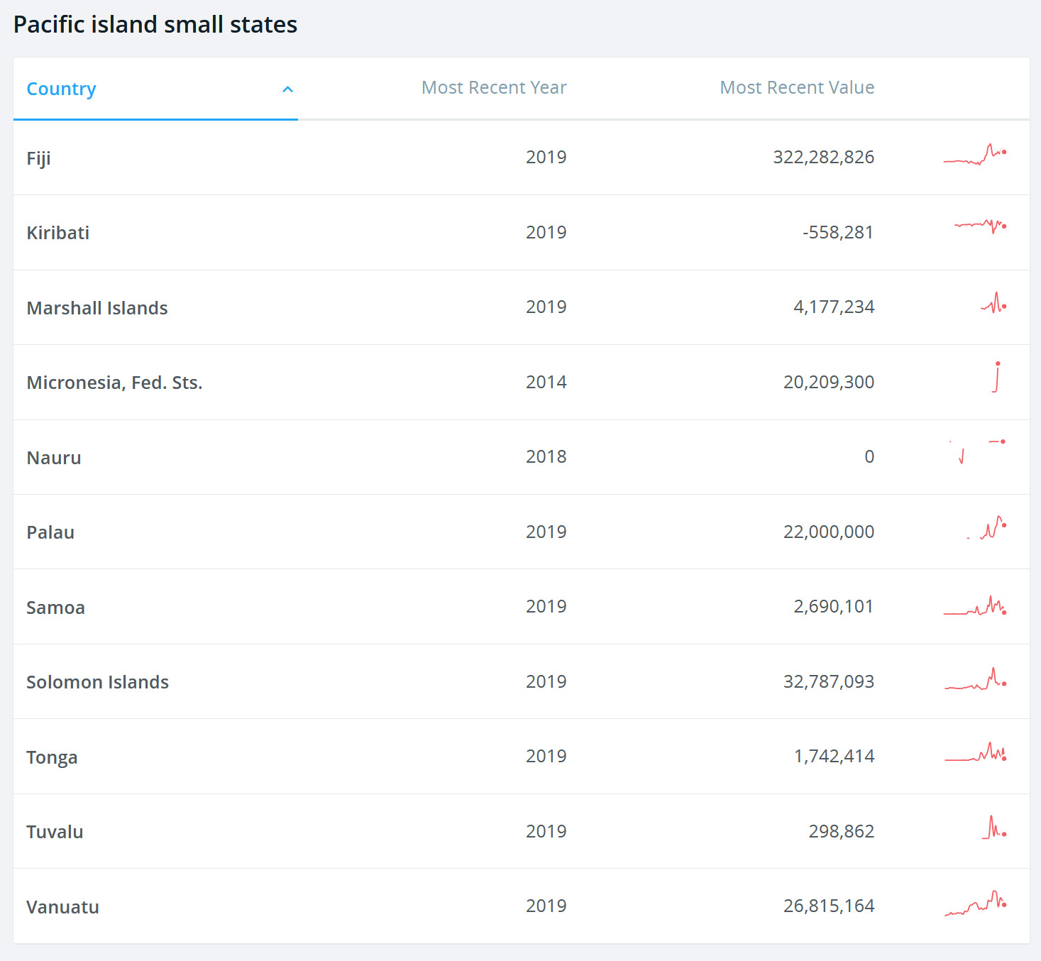

FDI Inflows to the Pacific SIDS in 2019

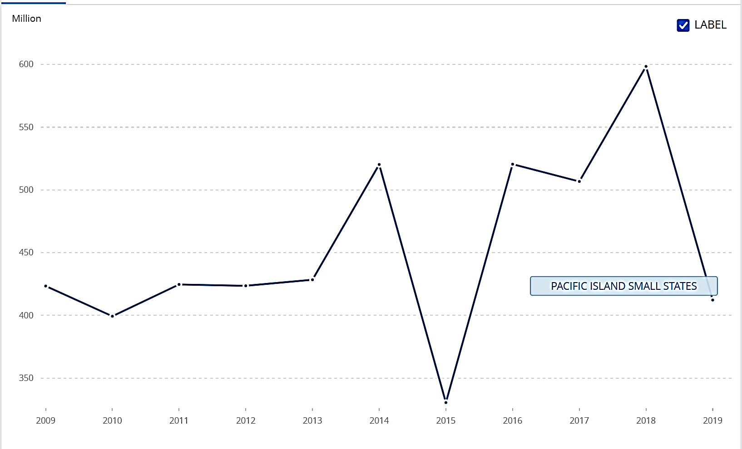

Conclusions: Key Opportunities towards Achieving the SDGs in the Pacific

In 2016, the WB stated that it was “difficult to project developments for the group of Pacific Islands and (...) even more difficult to make projections for individual countries”. The right development policies may lead to a regional scenario where the risks are mitigated against, and the opportunities seized. It is probable that climate-related risks will materialise and intensify. It is also likely that the Asian demand for quality island tourism and forest products will grow, and that tuna markets will remain stable. Vessels will require servicing and catches processing capacities. There will be technology-related employment and education opportunities, just as the ageing population in surrounding developed economies will require workforce in the care industry, which only migrant workers will be able to fill.

Skilled Pacific Islanders, especially women, may be the first on call, so care must be taken to compensate for their absence by greatly increased social service provision. Significant seabed minerals could open a new mining industry, around which regulatory decisions will determine the sustainability and impact of the exploitations, keeping in mind the potential risks of negative impacts on other sectors such as fisheries and on carbon sequestration. De-risking climate-vulnerable sectors by investing in infrastructure and planning with disaster prevention in mind and focusing on behavioural change to foster better health outcomes may also reduce government and international partners´ expenditure in NCD-related care and recovery. Similarly, addressing the risk that these interventions could cause greater inequality will require investment in concrete measures to expand the participation of women in governance and in the economy, develop the capacity of NGOs to represent the interests of the disadvantaged, and a strengthening of national capacity to prevent violence against women and girls, and support its survivors.

Alternative development strategies will need to focus on: (i) the role of the public sector as the main source of formal sector employment and driver of economic activity; (ii) the need for, and appropriate management of, development assistance to sustain public services and standards of living in the PICTs; and (iii) labour mobility opportunities as a key source of employment and income. Among the socio-economic variables that are likely to affect achievement of these strategies, their interaction with existing gender relations is among the most impactful and must be taken into account. “The aging of the population of developed countries in the region, including Australia, New Zealand, Japan, and Korea, technological progress, as well as the shift to a more multi-polar geopolitical environment with growing levels of insecurity, are among the global megatrends that could give rise to greater demand for what the PICTs can offer competitively–an attractive and safe island and marine environment, labour, natural resources, especially fish, and potentially deep sea minerals, and their geostrategic position.”

With a projected additional 1 million in tourist arrivals to the region by 2040, tourism will provide the main opportunity to accelerate growth and generate employment for many countries. “Increasing the Chinese market, increasing the number of luxury resorts, capturing the retiree market, and basing cruise ships in the Pacific could increase the number of tourists visiting the Pacific by about 1 million, generate additional spending of more than US$1.6 billion, and create more than 110,000 additional jobs by 2040. Vanuatu, Samoa, and Palau are well positioned to be the biggest beneficiaries of the projected increase in arrivals to the region. Over the period to 2040, this could yield an additional increase in per capita incomes of 20%-30% for these countries. Fiji and Tonga could garner an additional increase in per capita incomes of about 10%.” This opportunity must be balanced by attention to fair and equal employment practices and benefits, combined with strengthening of protections for informal, exploited and trafficked workers.

Improved Internet access and connectivity could translate into additional GDP of more than US$5 billion and close to 300,000 additional jobs by 2040. In recent years, the PICs have liberalized their telecoms markets and invested heavily in fibre optic cable connections. This creates the basis for significant increases in mobile and Internet penetration over the next 25 years. The combination of a small public sector and vast distances presents a major risk in achieving the goal of “leaving no one behind and reaching the furthest behind first.” In this regard, investing in digital or e-governance that is explicitly designed to reach and include those furthest behind can be especially effective in overcoming these major contextual constraints to sustainable development.

Fisheries could generate more than US$300 million in additional revenue by 2040 and significantly boost incomes in Kiribati, Tuvalu, and the Federated States of Micronesia. Regional processing clusters and vessel support hubs could generate an additional US$80 million in value added and create between 7,500 and 15,000 new jobs. By 2040, fisheries opportunities could translate into an additional increase in per capita income of between 50 and 60% in Kiribati and Tuvalu, and around 20% in Micronesia. The forestry sector's current contribution to Fiji's GDP is meagre (at 0.6%), but this contribution could be increased manyfold – experts target the figure of over US$610M in exports (25% GDP) over the next 10-20 years, with major rural employment and environmental benefits. This would require careful management of the environmental and social impacts.

Expanded labour mobility opportunities could generate an additional net income of about US$13 billion for about 240,000 permanent migrants by 2040. Additional labour-mobility opportunities would generate benefits for the labour-receiving and labour-sending countries as well as for the migrants themselves. The reduction of working age populations has potential to result in socio-economic stress for the more remote and less developed areas that are likely to provide the out-migrants, undermining overall development. Government action to support the care economy will be critical to compensate for this, maximising the “benefits for all” approach.

Significant potential mineral resources include Seafloor Massive Sulphides (SMS) in the waters of Fiji, Papua New Guinea, Solomon Islands, Tonga and Vanuatu, Polymetallic Manganese Nodules (PMN) in the waters of Kiribati, and to a lesser extent in Tuvalu, and Cobalt-rich Ferromanganese Crusts (CFCs) in Kiribati, the Marshall Islands, the Federated States of Micronesia, Palau, Samoa and Tuvalu.

While climate change and natural hazards induced disasters have an overall negative impact on the PICTs, implementation of anticipatory actions and climate adaptation and resilience measures can not only help to protect vulnerable populations and their livelihoods, but also create new jobs. For all the opportunities and threats discussed, there will also be increased demand for highly specialized technical and managerial skills. While, at present, many of these skills are imported, with adequate investments in education and training it will be possible to fill many of these positions locally. A strong focus on sustainable management of the above-listed human activities will address the multiple high vulnerabilities of PICTs to the effects of climate change and natural disasters, the loss of biodiversity, and increasing environmental degradation due to unsustainable exploitation of natural resources and lack of sustainable waste management. Transformative actions to curb marine plastic pollution and manage waste sustainably can no longer be postponed. Further, accurate and high-resolution bathymetric maps are essential for simulations of tsunami wave inundation along beaches. Also, bathymetric maps contain information on the depths of landforms below sea level and can support the conservation of our oceans, seas and marine resources for sustainable development. Effective environmental protection, disaster risk-informed planning, resilience-building and natural resource management will be essential to ensure and sustain people’s long-term food security, health, and general wellbeing.

Four major opportunities emerge from this analysis, summarised by the WB: first, pursuing integration to reduce the economic costs of distance, including through increased labour market integration, better transport and communication links, and the alignment of regulatory frameworks and services; second, pooling the provision of public services across small PICs ; third, ensuring that gains from natural resource industries (including tourism) are maximized, and that these benefits are distributed broadly and equally across the population; and fourth, maximizing the benefits from international assistance, focusing reforms on a small set of growth opportunities; while managing stress on Pacific livelihoods by strengthening PICTs’ resilience to threats from natural hazards induced disasters, climate change, and NCDs. In each of these, existing gender relations are highly likely to impact outcomes, and must be taken into account. Integrated national financing frameworks can help PICTs manage the increasingly complex financing landscape, ensure coherence of different financing policies, as well as help mobilise additional financing to realise these major opportunities. In numerical growth terms, five countries (Palau, Fiji, Samoa, Tonga, and Tuvalu) could have per capita incomes of more than US$8,000 in 2040 and another four countries (the Federated States of Micronesia, Vanuatu, Kiribati, and the Marshall Islands) could have incomes of at least US$4,000.

Thriving economies and societies depend on care in all its forms. After years of unequal growth and the recent shock of the COVID-19 pandemic, it is imperative that Pacific economies and societies rebuild better, with care at the centre of their development plans. Particular attention to the care economy in each of the above four major opportunities will help to ensure that they result in fair reconciliation of conflicting interests, many of which centre on community viability, with the sustainability of the care economy at the heart of the matter. Assessment of the interactions between proposed interventions and the care economy will be particularly necessary in connection with disaster risk reduction and climate-related hazard preparations; coastal developments associated with the Blue Economy, encouragement of migration, and technological development, especially in ICTs. Action to end violence against women and girls would enhance overall productivity in both the paid and unpaid sections of the economy. Investment in care-related social infrastructure has been demonstrated to deliver employment and fiscal benefits as well as to promote gender equality and social inclusion for all. It is also consistent with the need to move to the more carbon-efficient and greener economic models addressed in this CMCA.

Effective international climate finance and development assistance will remain essential to reduce environmental vulnerability, invest in resilient infrastructure, fund the public health and other expensive services, develop the ICT sector and improve governance institutions and recovery efforts. Foresight exercises and modelling have assessed the needs of the Pacific, if it should not live a lost decade for its development, at 5 billion US$ in grants or partly in preferential concessional loans - to avoid creating future debt sustainability problems. Additionally, expanded lending by the multilateral development banks and international debt-for-recovery swaps, particularly in relation to bilateral Chinese loans, could help meet the total scale of Pacific recovery financing required.

Effective governance and strong institutions are an essential and foundational ingredient for the attainment of the SDGs in the Pacific Region. Effective, inclusive and accountable governance is essential for managing the risks and impacts of structural transformations. The recovery process from COVID-19 presents an opportunity for the Pacific to strengthen its governance systems and institutions for effective service delivery and protection of human rights. This entails a strong focus on local governance systems and their linkages to multilevel systems, where there is most potential for change and capacity to prevent and recover from shocks, strengthening core- government functions and the public sector, integrity and oversight mechanisms and institutions, representative institutions and civic space. It includes prudent public expenditure management, enhanced fiscal design, integrity in public office and handling of public monies, well-advised contract and fee negotiation, regional integration and standards, pooled services and procurement schemes, harmonized business and travel regulations and decentralised investments.

Significant potential mineral resources include Seafloor Massive Sulphides (SMS) in the waters of Fiji, Papua New Guinea, Solomon Islands, Tonga and Vanuatu, Polymetallic Manganese Nodules (PMN) in the waters of Kiribati, and to a lesser extent in Tuvalu, and Cobalt-rich Ferromanganese Crusts (CFCs) in Kiribati, the Marshall Islands, the Federated States of Micronesia, Palau, Samoa and Tuvalu.

There is a need to strengthen independent national human rights institutions and create a more enabling environment for civic space through a focus on fundamental freedoms, including the rights to freedom of association, assembly, expression, information and participation. Free, prior and informed consent and public participation in decision-making related to sustainable development policies are required. There needs to be renewed attention to discriminatory laws against people, and to actions that increase inequalities and poverty even further, to honour the Leave No One Behind principle. Managing volatility and shocks, and de-risking promising sectors of development are aspects of economic governance management that contribute to better development outcomes. Easing business environment will require facilitation of permits and licenses, power supply, contract enforcement and overall perceived fairness and honesty in full alignment with the UN’s Guiding Principles on Business and Human Rights. Access to credit and development finance, especially climate finance, will both allow addressing these needs and facilitate obtaining resources from external lenders and donors, who pay attention to sound economic reform policies, sustainable human development orientations and business-friendly stability. This also comprises of equity boosts through public policy that deliberately includes the full diversity of each country (especially in public representation, civil service employment, education, training and health), collaborative international arrangements for out-migration, the reduction of cost of remittances to the Pacific, assessed somewhere between 8% and 12%, fishing licensing, attractive FDI incentives and infrastructure improvement, in agreement with the job-creating private sector.

Finally, the PICTs have an intangible geopolitical opportunity in reach: the PICTs’ votes in regional and international bodies as well as their ability to provide a basis for defense, security, satellite, and space installations, have become coveted by many countries. “The vast Pacific Ocean and sits across important lines of communication. The Second World War underlined the strategic importance of the Pacific. After some years of relatively little attention, external powers are increasingly seeking influence in the region.” Development assistance is and will continue being an important instrument to establish amicable relationships. As the Secretary General of the PIF has said: “The Blue Pacific Continent comprises our sea of islands dotted across our vast ocean. It is again becoming a place of geo-strategic importance and interest.” Significant seabed minerals could open a new mining industry, around which regulatory decisions and scientific evidence will determine the sustainability and impact of eventual exploitations. The likely negative consequences for biodiversity and climate, the non-renewable nature, non-sustainability and potential damage this industry could inflict, give pause to this route as a preferred pathway to growth in the Pacific. The prospect of access to rare earth minerals through seabed mining will however generate strategic as well as commercial interest from established and emerging powers. If global security threats persist in a multi-polar world, the PICs could gain in attractiveness for relatively secure locations that are rarely the focus of terrorist activities or cross-border conflict.

In managing this range of potential development trajectories, PICTs need to give strong consideration to the principle of leaving no-one behind. The Pacific is faced with significant challenges - including more than half the population under the age of 25 and high youth unemployment rates, a quarter of people living below the poverty line, issues in access to services for remote communities, and high rates of gender-based violence and discrimination against women. Addressing these issues is crucial to ensuring inclusive growth. This should entail a focus on strengthening the human rights-based approach to development and strong and transparent governance systems. Improved attention to age, gender and diversity disaggregated data will be key to targeting policies and development efforts, as well as measuring progress. A major role for the UN development system is to ensure consultation with all the stakeholders and communities associated with the various changes, so rights and transparency are protected at all times.

Deciding which suite of reforms and development journey to pursue is a complex matter for Governments and societies. Trade-offs are tough and uncertainty the norm, in a volatile world. The Sustainable Development Goals and Agenda 2030 charts a route of economic growth, climate resilience, biodiversity regeneration, social inclusion, democratic governance and human rights, and gender equality, which the Pacific Region should follow, having rallied a significant number of development partners along the way. The United Nations is probably one of the longest-standing and steadiest among these partners. This Multi-country Assessment represents the foundation upon which the ecosystem of multilateral UN allies wishes to renew its promise to contribute to a bright future for the peoples of the Pacific.



References

Anderson, Ian. April 18, 2018. NCD prevention and control: special challenges in the Pacific. DevPolicy Blog. Development Policy Centre. Crawford School of Public Policy. College of Asia and the Pacific. Australian National University.

Arslanalp, Serkan; Koepke, Robin; Verschuur, Jasper. August 2021. Tracking Trade from Space: An Application to Pacific Island Countries. IMF Working Paper. Asia and Pacific Department and Statistics Department. International Monetary Fund (IMF).

Asian Development Bank (ADB). May 2019. The Pacific Islands: The Push for Renewable Energy.

______________. 2016. The emergence of pacific urban villages: Urbanization trends in the Pacific islands.

______________. 2016. Fiji Country Gender Assessment 2015.

Australian Aid. March 2021 (Update). Thematic Brief. Gender and COVID-19 in the Pacific: Gendered Impacts and Recommendations for Response. Pacific Women Shaping Pacific Development.

Australian Strategic Policy Institute (ASPI). 2020. ICT for Development in the Pacific Islands. An assessment of e-government capabilities in Fiji, Papua New Guinea, Samoa, Solomon Islands, Tonga and Vanuatu. International Cyberpolicy Center. E-Governance Academy.

Balasundharam, Vybhavi and Hunter, Leni. April 2021. Managing Fiscal Risks from National Airlines in PICs. In IMF Pacific Islands Monitor, Issue 14 (see below).

Boccuzzi, Ellen. 2021. The Future of Work for Women in the Pacific Islands. Asia Foundation.

Bündnis Entwicklung Hilft and Ruhr University Bochum – Institute for International Law of Peace and Armed Conflict (IFHV). 2020. WorldRiskReport 2020.

Cook, Susan. Hooper, Carolyn. Shields, Emma. 30 April 2021. Synthesis of COVID-19 impacts on the Pacific. Final report. Allen + Clarke.

Council of Regional Organizations in the Pacific (CROP) Taskforce. June 2021. Socio-Economic Impact Assessment of COVID-19 in the Pacific Region.

Cross-Cultural Center (CSUSM). 2021. Defining Diaspora: Asian, Pacific Islander, and Desi Identities. www.csusm.edu

Elson, Diane. 2018. Push No-one Behind. Committee on Development Policy. UNDESA. CDP Background Paper No. 43.

Everett, Hayden; Simpson, Dain; Wayne, Scott. June 2018. Tourism as a Driver of Growth in the Pacific: A Pathway to Growth and Prosperity for Pacific Island Countries. Issues in Pacific Development. No. 2. The Pacific Private Sector Development Initiative. Australian Aid, New Zealand Foreign Affairs and Trade Aid Programme, Asian Development Bank (ADB).

Federated States of Micronesia. June 2020. Our actions today are our prosperity tomorrow: First Voluntary National Review on the 2030 Agenda for Sustainable Development.

Food and Agriculture Organization of the United Nations (FAO). 2019. Country Gender Assessment of Agriculture and the Rural Sector in Fiji.

______________. 2016. Mainstreaming Ecosystem Services and Biodiversity into agricultural production and management in the Pacific Islands.

Global Witness. October 2018. Paradise Lost. How China can help the Solomon Islands protect its forests.

Government of the Cook Islands. April 2019. Statistical Bulletin. Ministry of Finance and Economic Management

Government of Solomon Islands. June 2020. Solomon Island Voluntary National Review Report on the SDGs.

Greenpeace. November 2020. The State of Climate in the Pacific 2020. Čašule, Nikola and Jiva, Genevieve.

Habtezion, Senay. 2013. Overview of linkages between gender and climate change. United Nations Development Programme (UNDP). Global Gender and Climate Alliance.

Hoegh-Guldberg. O., et al. 2019. The Ocean as a Solution to Climate Change. Five Opportunities for Action. World Resources Institute.

Howes, Stephen. Orton, Beth. Surandiran, Sherman. 6 November 2020. In the Pacific, Migration and Population Growth are Inversely Related. The Devpolicy Blog. Development Policy Centre. Crawford School of Public Policy. The Australian National University’s College of Asia and the Pacific.

Independent State of Samoa. 2021. National Report to the 3rd Universal Periodic Review.

______________. 2020. 2nd Voluntary National Review Report for Implementation of Sustainable Development Goals.

Intergovernmental Panel on Climate Change (IPCC). Special Report on the Ocean and Cryosphere in a Changing Climate. Magnan, A.K., M. Garschagen, J.-P. Gattuso, J.E. Hay, N. Hilmi, E. Holland, F. Isla, G. Kofinas, I.J. Losada, J. Petzold, B. Ratter, T. Schuur, T. Tabe, and R. van de Wal. 2019. Cross-Chapter Box 9: Integrative Cross-Chapter Box on Low-Lying Islands and Coasts. H.-O. Pörtner, D.C. Roberts, V. Masson-Delmotte, P. Zhai, M. Tignor, E. Poloczanska, K. Mintenbeck, A. Alegría, M. Nicolai, A. Okem, J. Petzold, B. Rama, N.M. Weyer (eds.)

Internal Displacement Monitoring Centre. 2021. Pacific Response to Disaster Displacement Project. Norwegian Refugee Council. https://www.internal-displacement.org/pacific-disasters

______________. 2021. Global Report on Internal Displacement. https://www.internal-displacement.org/global-report/grid2021/

International Monetary Fund (IMF) Pacific Islands Monitor. April 2021. Financial Technical Assistance Centre (FTAC).

______________. Climate Change Indicators Dashboard. A statistical tool linking climate considerations and global economic indicators. https://climatedata.imf.org/

International Labour Organisation (ILO). July 2020. Impact of COVID19 on employment and business in the Pacific: Findings of the Rapid Assessment in Fiji and Samoa.

______________. 2020. Asia–Pacific Employment and Social Outlook: Navigating the crisis towards a human-centered future of work.

______________. 2020. Pacific Labour Market Review 2020. Pre-COVID-19 Baseline Labour Market Information for Post-disaster Recovery.

______________. 2018. Asia-Pacific Employment and Social Outlook: Advancing decent work for sustainable development.

______________. 2018. Care Work and Care Jobs for the Future of Decent Work.

______________. 2017. A Study on the Future of Work in the Pacific.

International Organization for Migration (IOM). 2021. Asia Pacific Migration Data Report 2020.

International Telecommunication Union (ITU). 2021. Measuring Digital Development. ICT Price Trends 2020.

______________. 2021. Global Cybersecurity Index 2020. Measuring Commitment to Cybersecurity.

Jayaraman, Tiru K. 2012. Regional Integration in the Pacific

Kingdom of Tonga. 2019. Voluntary National Review on implementation of the Sustainable Development Goals.

Kiribati National Statistics Office. 2019. Kiribati Social Development Indicator Survey 2018-19. Survey Findings Report.

Lindley, Jade; Beacroft, Laura. November 2011. Vulnerabilities to trafficking in persons in the Pacific Islands. Trends & issues in crime and criminal justice No. 428. Australian Government. Australian Institute of Criminology.

Live & Learn Environmental Education. Care. Fiji Disabled Peoples Federation. Rainbow Pride Foundation Fiji. Church Agencies Network Disaster Operations. Save the Children. ADRA. April 2021.Fiji Gender, Disability and Inclusion Analysis COVID-19, TC Yasa and TC Ana.

McAdam, Jane. 2016. Under Two Jurisdictions: Immigration, Citizenship, and Self-Governance in Cross-Border Community Relocations. Vol. 34, Issue 2. Law and History Review 281-333.

McGovern T, Baumont M, Fowler R, Parisi V, Haerizadeh S, Williams E, et al. 2019. Association between plural legal systems and sexual and reproductive health outcomes for women and girls in Nigeria: A state-level ecological study. PLoS ONE.

Morioka, Kate. 2016. Time to Act on Gender, Climate Change and Disaster Risk Reduction. An overview of progress in the Pacific region with evidence from Marshall Islands, Vanuatu and Samoa. UN Women.

New Zealand Law Commission. 2006. Converging Currents – Custom and Human Rights in the Pacific. Study Paper 17.

Office for the Coordination of Humanitarian Affairs (OCHA) and UNDP. August 2021. Guidance Note: Addressing the Gendered Impacts of COVID-19. Connecting Business Initiative.

Office of the United Nations High Commissioner for Human Rights (OHCHR). Annex to the letter of the High Commissioner to the Minister for Foreign Affairs of the Republic of Fiji. 20 May 2020. Documents of UPR Session 34.

______________. 22 August 2019. Compilation Report on Fiji. Universal Periodic Review. Thirty-fourth session.

______________. 10 February 2018. Human Rights in the Pacific: Navigating New Challenges with the Universal Declaration of Human Rights (Lecture by UN High Commissioner for Human Rights Zeid Ra'ad Al Hussein).

_______________. 2015. Frequently Asked Questions: Sexual orientation, gender identity and intersex status in the Pacific.

Pacific Community (SPC). May 2021. 14th Triennial Conference of Pacific Women and 7th Meeting of Pacific Ministers for Women. Outcomes and Recommendations. 2021. The status of Pacific Education.

______________. 2021. Beijing +25: review of progress in implementing the Beijing Platform for Action in Pacific Island countries and territories.
_______________. and United Nations Office of the High Commissioner for Human Rights (UNOHCHR). 2020. Human Rights in the Pacific: a situational analysis 2020.

Organisation for Economic Cooperation and Development (OECD). 2021. DAC Recommendation on the Humanitarian-Development-Peace Nexus, OECD/LEGAL/5019.

Pacific Heads of Health. Leveraging the COVID-19 pandemic to build sustainable systems and advance Universal Health Coverage.

Pacific Islands Forum Secretariat. 2020. Biennial Pacific Sustainable Development Report.

______________. 2018. Quadrennial Pacific Sustainable Development Report.

_______________. 2017. The 2050 Strategy for the Blue Pacific Continent.

_______________. 2014. Framework for Pacific Regionalism.

______________ and World Health Organisation (WHO). 4 June 2021. Information Paper 5: NCD Roadmap.

Passarelli, David. Denton, Fatima; Bay, Adam. 2021. Beyond Opportunism: The UN Development System’s Response to the Triple Planetary Crisis. United Nations University.

Pearsons, Ruth and Nietzert, Eva. September 2021. Learning from COVID-19: How to make care central to economic policy around the world. New York University. Center for International Cooperation. Pathfinders for Peaceful, Just and Inclusive Societies.

Rajah, Roland and Dayant, Alexander. December 2020. Avoiding a Pacific lost decade: Financing the Pacific’s COVID-19 recovery. Lowi Institute. Policy Brief.

Ratuva, Steven. 2006. Primordial Politics? Political Parties and Traditions in Melanesia. Research School of Pacific and Asian Studies. Australia National University.

Resident Coordinator´s Office (RCO) UN Pacific. August 10, 2021. CCA template.

Republic of Fiji. 2021. 2020 Fiji Agriculture Census. Volume III: Gender Analysis Report. Parliamentary Paper No. 59/2021. Ministry of Agriculture.

______________. 7 October 2019. National Report. Universal Periodic Review. Thirty-fourth session.

______________. June 2019. Voluntary National Review. Fiji’s Progress in the Implementation of the Sustainable Development Goals.

______________. 2018. Fiji Low Emission Development Strategy 2018-2050. Ministry of Economy & Global Green Growth Institute.

______________. 2011. The National Housing Policy.

Republic of the Marshall Islands. June 2021. Voluntary National Review.

Republic of Nauru. 2019. Voluntary National Review on the implementation of the 2030 Agenda.

Republic of Palau. June 2019. Pathway to 2030: Progressing with our Past towards a Resilient, Sustainable and Equitable Future. 1st Voluntary National Review of the SDGs.

Republic of Vanuatu. 2019. Voluntary National Review on the Implementation of the 2030 Agenda for Sustainable Development.

______________. 2019. Vanuatu National Security Strategy: Secure & Resilient. Ministry of Internal Affairs.

Sachs, Jeffrey. Massa, Isabella. Marinescu, Simona. Lafortune, Guillaume. July 2021. The Decade of Action and Small Island Developing States: Measuring and addressing SIDS’ vulnerabilities to accelerate SDG progress. SDSN.

______________, Kroll, Christian. Lafortune, Guillaume. Fuller, Grayson. Woelm, Finn. 2021. Sustainable Development Report 2021. The Decade of Action for the Sustainable Development Goals. Sustainable Development Solutions Network. Bertelsmann Stiftung. Cambridge University Press.

Siekiera, Joanna. 2020. Regional integration in the South Pacific: challenges for public governance. Brazilian Journal of International Law. Volume 17, Nº1.

United Nations. 2020. United Nations Common Guidance on Helping Build Resilient Societies. United Nations Sustainable Development Group.

______________. May 2020. Policy Brief: A Disability-Inclusive Response to COVID-19.

UN Caribbean. 2021. Caribbean Common Multi Country Analysis.

UN Malaysia. 2020. Common Country Assessment.

UN Pacific and Samoa CCA Task Force. August 5, 2021. Presentation to the first CCA task force meeting.

UN Pacific. December 2020. Common Country Analysis.

______________. July 2020. Socio-economic Impact assessment of COVID-19 in Fiji, Full Report and Recommendations and Summary of Key Findings and Policy Recommendations.

______________. 2017. UN Strategic Framework for the Pacific (UNSFP) 2018-2022 Common Country Analysis (CCA) – Meta Analysis.

______________. 2017. United Nations Pacific Strategy 2018 – 2022 (UNPS).

United Nations Children´s Fund (UNICEF). 2017. Situation Analysis of Children in the Pacific Island Countries.

______________. Molendijk, Simon J.; Coombs, Steven J; Bhattacharya, Madhumita. December 2017. Bridging the Gap between Education Policy, Planning and Practice: Establishing and Effecting National Minimum Quality Service Standards for Effective Schools in Pacific Island Countries.

United Nations Country Team (UNCT) Samoa. 2021. Joint Submission to the 3rd Universal Periodic Review of Samoa.

United Nations Department of Economic and Social Affairs (UNDESA), Population Division. 2019. World Population Prospects 2019, Online Edition. Rev. 1.

______________. Blue Economy Concept Paper. www.sustainabledevelopment.un.org/content/documents/2978BEconcept.pdf

United Nations Development Programme (UNDP). 2020. Human Development Report. The Next Frontier: Human Development and the Anthropocene.

______________. July 2020. Barbados Blue Economy Scoping Study: Stocktake and Diagnostic Analysis.

______________. 2019. Access to Justice and Rule of Law Mapping in Pacific Island Countries.

______________. October 2019. Justice Needs and Satisfaction in Fiji.

______________. August 2017. Financing the SDGs in the Pacific islands: Opportunities, Challenges and Ways Forward. Discussion Paper.

______________. 2016. Access to Justice Project Fiji.

______________. 2009. A Capacity Assessment of CSOs in the Pacific: Six Country Profiles.

United Nations Economic and Social Commission for Asia and the Pacific (UNESCAP). August 2021. Inequality, Discrimination and Exclusion. Assessing CRPD Compliance in Pacific Island Legislation.

______________, United Nations Environment Programme, United Nations Women and the Greenwerk. 2021. Is 1.5°C within Reach for the Asia-Pacific Region? Ambition and Potential of NDC Commitments of the Asia-Pacific Countries.

______________. 2020a. Asia and the Pacific SDG Progress Report 2020.

______________. 2020b. Asia-Pacific Countries with Special Needs Development Report. Leveraging ocean resources for sustainable development of small island developing States.
______________. 2020c. Asia Pacific Disaster Report 2019. Pathways for Resilience, Inclusion and Empowerment. The Disaster Riskscape across the Pacific Small Island Developing States: Key Takeaways for Stakeholders.

______________. Progress of NDC Implementation in Asia-Pacific: Methodological Framework and Preliminary Findings. Environment and Development Technical Paper.

United Nations Education, Science and Culture Organisation (UNESCO). 2020. Pacific response to COVID-19 and education data issues and challenges.

United Nations Entity for Gender Equality and the Empowerment of Women (UN Women). 2020. https://www.unwomen.org/en/news/stories/2020/6/feature-pacific-crisis-centres-respond-to-covid-19-amid-naturaldisasters

United Nations General Assembly. 10 June 2021. GA Resolution A/75/L.98. Cooperation between the United Nations and regional and other organizations: cooperation between the United Nations and the Pacific Islands Forum.

United Nations Human Settlements Programme (UN-Habitat). 2020. National Urban Policy: Pacific Region Report.

United Nations Office on Drugs and Crime (UNODC). July 2018. Migrant Smuggling in Asia and the Pacific: Current Trends and Challenges. Volume II. Deanna Davy, lead author.

______________. September 2016. Transnational Crime in the Pacific: Threat Assessment.

United Nations Population Fund (UNFPA) and Women Enabled International. 2021. The Impact of COVID-19 on Women and Girls with Disabilities. A Global Assessment and Case Studies on Sexual and Reproductive Health and Rights, Gender-Based Violence, and Related Rights. UNPRPD. UN Women. AECID.

______________. March 2020. COVID-19: A Gender Lens. Protecting Sexual and Reproductive Health and Rights and Promoting Gender Equality.

______________. 2018. A Transformative Agenda for Women, Adolescents and Youth in the Pacific: Towards Zero Unmet Need for Family Planning 2018- 2022.

______________. 2014. Population and Development Profiles: Pacific Island Countries. The United Nations Population Fund Pacific Sub-Regional Office. UNFPA PSRO.

Utz, Robert (ed.). 2021. Archipelagic Economies: Spatial Economic Development in the Pacific – Synthesis Report. Washington, DC: World Bank

Veron, Pauline & Hauck, Volker. 2021. Connecting the pieces of the puzzle: The EU’s implementation of the humanitarian-development-peace nexus. Discussion paper 301. European Centre for Development Policy Management (ECDPM).

Watson, Danielle; Sousa-Santos, Jose Luis; Howes, Loene. 2021. Transnational and organised crime in Pacific Island Countries and Territories: Police capacity to respond to the emerging security threat. Development Bulletin. Pp 151-155. Issue 82. February 2021. Australian Development Studies Network.

World Health Organisation (WHO) Coronavirus (COVID-19) Dashboard. https://covid19.who.int

______________/UNICEF. 2020. Progress on Household Drinking Water, Sanitation and Hygiene. Joint Programme for Water Supply, Sanitation and Hygiene 2000-2020.

World Bank Group. 30 November 2020. Interim Report: Pacific Labor Mobility, Migration and Remittances in Times of COVID-19: Interim Report. Dung Doan, Matthew Dornan, Kenia Parsons, Kirstie Petrou and Soonhwa Yi.

World Bank. 2020. Doing Business 2020. Washington, DC: World Bank.

______________. 2017. Climate and Disaster Resilient Transport in Small Island Developing States: A Call for Action

______________. 2017. Pacific Possible: Long-term Economic Opportunities and Challenges for Pacific Island Countries. Washington, DC.

______________ and United Nations Department of Economic and Social Affairs. 2017. The Potential of the Blue Economy: Increasing Long-term Benefits of the Sustainable Use of Marine Resources for Small Island Developing States and Coastal Least Developed Countries.

______________. 2016. Regional Partnership Framework FY 2017-2021 for Kiribati, Republic of Nauru, Republic of The Marshall Islands, Federated States of Micronesia, Republic of Palau, Independent State of Samoa, Kingdom of Tonga, Tuvalu, and Vanuatu.

______________. March 2014. Hardship and Vulnerability in Pacific Island Countries. Feature Story.

WHO, UNICEF, UNFPA, World Bank Group, and the United Nations Population Division. 2019. Trends in Maternal Mortality: 2000 to 2017.

World Vision Australia. 2020. Pacific Aftershocks: Unmasking the impact of COVID-19 on lives and livelihoods in the Pacific and Timor-Leste.

World Wildlife Fund Australia. July 2021. Plastic in our oceans is killing marine mammals.

Babacan (2014). Good Governance and Development in the Pacific (The Journal of Pacific Studies, Volume 34, 2014)
Ibid.
United Nations. 2020. United Nations Common Guidance on Helping Build Resilient Societies. United Nations Sustainable Development Group.
Passarelli, David. Denton, Fatima; Bay, Adam. 2021. Beyond Opportunism: The UN Development System’s Response to the Triple Planetary Crisis. United Nations University.
The PICTs are scheduled to run approximately 35 core surveys and censuses over a five-year cycle. They acknowledge that national policymakers and development partners work with out-of-date data. This is the case for the baselines used by this PCMCA. The partnerships for Pacific statistics include The World Bank, Pacific Financial Technical Assistance Centre (PFTAC), Statistics NZ, Australian Bureau of Statistics (ABS), the European Union (EU), University of the South Pacific (USP), United Nations Development Program (UNDP), United Nations Population Fund (UNFPA), the United Nations Children’s Fund (UNICEF), the United Nation Economic and Social Commission for Asia and Pacific (UNESCAP), and other UN agencies including International Labour Organisation (ILO) and the Food and Agriculture Organisation (FAO) [cited by Quadrennial Pacific SDR, 50].
All population estimates are based on data from the United Nations Department of Economic and Social Affairs (UNDESA), Population Division. 2019. World Population Prospects 2019, Online Edition. Rev. 1. Estimates are for 2020.
UN Pacific CCA 2020, 8
Howes, Stephen; Orton, Beth; Surandiran, Sherman (6 November 2020): In the Pacific, migration and population growth are inversely related. The Devpolicy Blog, Development Policy Centre, Crawford School of Public Policy, The Australian National University’s College of Asia and the Pacific.
United Nations Department of Economic and Social Affairs (UNDESA). 2015. World Population Prospects: Volume I: Comprehensive Tables 2015 Revision.
WB, Pacific Possible, 19
UNDESA. Population Division. 2015. Migrant stocks in 34 OECD countries taken from the Database on Immigrants in OECD Countries (DIOC) 2010/13. Due to data constraints, the calculation only includes emigrants to OECD countries. Emigrants to the US territories of Guam and Commonwealth of the Northern Mariana Islands are also included. Migrant stocks for Kiribati, PNG, Solomon Islands and Vanuatu have been adjusted to record only migrants in Australia who claim their ancestry is indigenous to their country of birth.
Population projections for Fiji, Samoa, and Tonga were calculated using the cohort component method with zero migration. Data source for base populations in 1990, and fertility and mortality rates from 1990-2019: UNDESA. UN World Population Prospects 2019. The authors use ‘migration’ and ‘out-migration’ interchangeably.
Utz, Executive Summary, x.
Greenpeace. November 2020. The State of Climate in the Pacific 2020. Čašule, Nikola and Jiva, Genevieve.
Samoa reports however a positive increase from 13% in 2015 to 22% in 2019 of women registered as matai title holders.
Pacific Possible, 13
Utz, 37
Balasundharam, Vybhavi and Hunter, Leni. April 2021. Managing Fiscal Risks from National Airlines in PICs. In IMF Pacific Islands Monitor, Issue 14. Graphs are from this essay.
Pacific Possible, 13
World Bank. 2017. Climate and Disaster Resilient Transport in Small Island Developing States: A Call for Action
51st PIF Communiqué. 6 August 2021. Paragraph 11.
https://reliefweb.int/report/fiji/fiji-s-honest-appraisal-cyclone-winston#:~:text=It%20is%20estimated%20that%20Winston%20affected%20540%2C400%20people%2C%20including%20263%2C000%20women.
Asia Pacific Disaster Report 2019. Pathways for Resilience, Inclusion and Empowerment. The Disaster Riskscape across the Pacific Small Island Developing States: Key Takeaways for Stakeholders.
Fiji´s debt levels escalated to the equivalent of 65.6% of GDP at the end of July 2020 driven by fiscal deficit which increased from the equivalent of 3.6% of GDP in FY2019 to 8.2% in FY2020. For FY 2021, the forecasted Debt to GDP ratio is 91%.
Pacific Islands Monitor (April 2021), Financial Technical Assistance Centre & IMF
United Nations Development Programme (2020): Human Development Report: The Next Frontier: Human Development and the Anthropocene.
WB 2016, 32
Data from Asian Development Bank (ADB). 2016. The emergence of pacific urban villages: Urbanization trends in the Pacific islands.
Republic of Fiji. 2011. The National Housing Policy
United Nations Human Settlements Programme (UN-Habitat). 2020. National Urban Policy: Pacific Region Report.
International Labour Organization (ILO). 2020. Pacific Labour Market Review 2020. Pre-COVID-19 Baseline Labour Market Information for Post-disaster Recovery.
World Vision Australia. 2020. Pacific Aftershocks: Unmasking the impact of COVID-19 on lives and livelihoods in the Pacific and Timor-Leste.
Pacific Possible, 107
UNDESA and UNDP. https://inff.org/reports/assessment-and-diagnostics.
Pacific Possible, Op. Cit.
International Telecommunication Union (ITU). 2021. Measuring Digital Development. ICT Price Trends 2020.
SIDS Solutions Forum, August 2021
Graham Hassall (2018). Special Issue on public sector enhancement in Pacific Island states, Asia Pacific Journal of Public Administration (published online: 18 December 2018)
UNODC (2020)
ITU. 2021. Global Cybersecurity Index 2020. Measuring Commitment to Cybersecurity.
Australian Strategic Policy Institute (ASPI). 2020. ICT for Development in the Pacific Islands. An assessment of e-government capabilities in Fiji, Papua New Guinea, Samoa, Solomon Islands, Tonga and Vanuatu. International Cyberpolicy Center. E-Governance Academy. Quoted in UN Pacific CCA 2020.
UNDP. July 2020. Barbados Blue Economy Scoping Study: Stocktake and Diagnostic Analysis.
UNDESA. Blue Economy Concept Paper. www.sustainabledevelopment.un.org/content/documents/2978BEconcept.pdf
World Bank and United Nations Department of Economic and Social Affairs. 2017. The Potential of the Blue Economy: Increasing Long-term Benefits of the Sustainable Use of Marine Resources for Small Island Developing States and Coastal Least Developed Countries.
Everett, Hayden; Simpson, Dain; Wayne, Scott. June 2018. Tourism as a Driver of Growth in the Pacific: A Pathway to Growth and Prosperity for Pacific Island Countries. Issues in Pacific Development. No. 2. The Pacific Private Sector Development Initiative. Australian Aid, New Zealand Foreign Affairs and Trade Aid Programme, ADB.
Fiji is regulating and revising the minimum size limits of fisheries and mesh sizes to restore the populations. of 14 of the most commonly caught and sold species. Some fish groups are even considered to be locally extinct.
https://www.fao.org/port-state-measures/en/
Hoegh-Guldberg. O., et al. 2019. The Ocean as a Solution to Climate Change. Five Opportunities for Action. World Resources Institute.
FAO, 2016
Global Witness. October 2018. Paradise Lost. How China can help the Solomon Islands protect its forests.
Q Pacific SDR, 26
Asian Development Bank (ADB). May 2019. The Pacific Islands: The Push for Renewable Energy
Maxwell, Antony (ADB Pacific Department's Principal Energy Specialist), op. cit. ADB 2019.
Pacific Possible, 70
https://unctad.org/news/unctad-awards-agencies-promoting-investment-health-and-blue-economy
https://globalfundcoralreefs.org/news/gfcr-awarded-gcf-commitment/
UNDP. August 2017. Financing the SDGs in the Pacific islands: Opportunities, Challenges and Ways Forward. Discussion Paper.
WB 2016, 27
For example, in Malaysia it has been calculated that a 30% increase in women’s labour force participation would lead to a 13% increase in GDP. United Nations Malaysia. 2020. Common Country Assessment. P. 19.
Pearsons, Ruth and Nietzert, Eva. September 2021. Learning from COVID-19: How to make care central to economic policy around the world. New York University. Center for International Cooperation. Pathfinders for Peaceful, Just and Inclusive Societies.
ILO 2018. Care Work and Care Jobs for the Future of Decent Work. Preface.
American Samoa, FSM, Guam, Nauru, CNMI, Palau, PNG, RMI, Samoa, Solomon Islands, Tonga, Tuvalu and Vanuatu. In UNESCO. 2020. Pacific response to COVID-19 and education data issues and challenges.
WHO Coronavirus (COVID-19) Dashboard, interrogated on 1st September 2021. https://covid19.who.int
IMF (2021), World Economic Outlook. Managing Divergent Recoveries, IMF: International Monetary Fund, Washington D.C.
Sachs, Massa, Marinescu and Lafortune. 2021. Op. Cit.
UN Pacific CCA 2020, 15
United Nations Population Fund (UNFPA) and Women Enabled International. 2021. The Impact of COVID-19 on Women and Girls with Disabilities. A Global Assessment and Case Studies on Sexual and Reproductive Health and Rights, Gender-Based Violence, and Related Rights. UNPRPD. UN Women. AECID.
Council of Regional Organizations in the Pacific (CROP) Taskforce. June 2021. Socio-Economic Impact Assessment of COVID-19 in the Pacific Region.
Boccuzzi, Ellen. 2021. The Future of Work for Women in the Pacific Islands. Asia Foundation.
Office for the Coordination of Humanitarian Affairs (OCHA) and UNDP. August 2021. Guidance Note: Addressing the Gendered Impacts of COVID-19. Connecting Business Initiative.
UNFPA. March 2020. COVID-19: A Gender Lens. Protecting Sexual and Reproductive Health and Rights and Promoting Gender Equality.
Documented in Fiji Gender, Disability and Inclusion Analysis COVID-19, TC Yasa and TC Ana. April 2021. Live & Learn Environmental Education. Care. Fiji Disabled Peoples Federation. Rainbow Pride Foundation Fiji. Church Agencies Network Disaster Operations. Save the Children. ADRA. And in UN Women 2020. https://www.unwomen.org/en/news/stories/2020/6/feature-pacific-crisis-centres-respond-to-covid-19-amid-naturaldisasters
UNFPA March 2020, Op. Cit.
UNICEF. Gender-based Violence in Emergencies. https://www.unicef.org/protection/gender-based-violence-in-emergencies
Small Island Developing States (SIDS) are a distinct group of 58 States and territories (non-UN Members) characterized by certain common inherent characteristics. The list of SIDS is the one reported by the United Nations Office of the High Representative for the Least Developed Countries, Landlocked Developing Countries and Small Island Developing States (UNOHRLLS) and is available at https://www.un.org/ohrlls/content/list-sids.
Sachs, J; Massa, I; Marinescu, S and Lafortune, G. July 2021. The Decade of Action and Small Island Developing States: Measuring and addressing SIDS’ vulnerabilities to accelerate SDG progress. Sustainable Development Solutions Network.
The category of economic vulnerabilities considers seven indicators measuring a country’s degree of exposure to unforeseen exogenous shocks, arising out of economic openness as well as dependency on a narrow range of exports and strategic imports such as food and fuel. To account for a country’s exposure to drops in economic resources from abroad, the dependency on remittances, tourism receipts and official development assistance (ODA) are included.
In the dimension of structural development limitations, five proxies for geophysical vulnerability are used. The size of population is included as a measure for the physical size of a country. The remoteness of an economy is captured through maritime connectivity, as well as transport costs. In addition to this, a measure of the percentage of arable land and a measure of total internal renewable freshwater resources per capita are included.
The environmental dimension includes six factors related to a country’s vulnerability to natural hazards and climate change. Both the frequency and severity of natural disasters are considered. The index factors distinguish between hydrometeorological and seismic disasters. As a proxy of vulnerability to sea-level rise the percentage of land areas where elevation is below 5 meters is included.
See Section 4.7 on Partnerships Landscape
United Nations General Assembly. 10 June 2021. Cooperation between the United Nations and regional and other organizations: cooperation between the United Nations and the Pacific Islands Forum
PIF Communiqué 2021.
Siekiera, Op. Cit.
51st PIF Communiqué. 6 August 2021.
PIF Communiqué 2021, Op. Cit.
United Nations General Assembly Resolution A/75/L.98. 2021. Cooperation between the United Nations and the Pacific Islands Forum.
Ibid.
Sachs, Massa, Marinescu and Lafortune. 2021. The Decade of Action and Small Island Developing States: Measuring and addressing SIDS’ vulnerabilities to accelerate SDG progress. SDSN.
Graph from Arslanalp et al., IMF Working Paper, 2021.
Bündnis Entwicklung Hilft and Ruhr University Bochum – Institute for International Law of Peace and Armed Conflict (IFHV). 2020. WorldRiskReport 2020.
ESCAP. 2020c.
List of Category 4 Pacific hurricanes, Wikipedia contributors, 15 August 2021, https://en.wikipedia.org/w/index.php?title=List_of_Category_4_Pacific_hurricanes&oldid=1038840873 and List of Category 5 Pacific hurricanes, Wikipedia contributors,9 July 2021 https://en.wikipedia.org/w/index.php?title=List_of_Category_5_Pacific_hurricanes&oldid=1032816875
https://community.wmo.int/tropical-cyclone-operational-plans
https://community.wmo.int/swfp-south-pacific
https://www.pacificmet.net/rcc
UN Pacific CCA 2020, 26 (with information from Connell, John (2015). Vulnerable Islands: Climate Change, Tectonic Change, and Changing Livelihoods in the Western Pacific. The Contemporary Pacific. 27. 1-36. 10.1353/cp.2015.0014 and CESinfo Working Paper No. 6128 (2016). Household Vulnerability on the Frontline of Climate Change: The Pacific Atoll Nation of Tuvalu. https://www.cesifo.org/DocDL/cesifo1_wp6128.pdf
Utz, 66
Q Pacific SDR, 33
All tables generated by the WHO/UNICEF Joint Programme for Water Supply, Sanitation and Hygiene Database https://washdata.org/data
WHO/UNICEF. 2020. Progress on Household Drinking Water, Sanitation and Hygiene. Joint Monitoring Programme for Water Supply, Sanitation and Hygiene 2000-2020.
Q Pacific SDR, 16-17
According to World Wildlife Fund (WWF) Australia. Plastic in our oceans is killing marine mammals. 1 July 2021. www.wwf.org.au www.wwf.org.au
B Pacific SDR, 33
Q Pacific SDR, 36
UN Pacific CCA 2020, 24
The 12 PICTS that are State Parties to the 1972 Convention concerning the Protection of the World Cultural and Natural Heritage are the Cook Islands, FSM, Fiji, Kiribati, Marshall Islands, Niue, Palau, PNG, Samoa, Solomon Islands, Tonga, and Vanuatu.
UNESCO. 2001. Underwater Cultural Heritage Convention. http://www.unesco.org/new/en/culture/themes/underwater-cultural-heritage/2001-convention/official-text/
United Nations, Economic and Social Commission for Asia and the Pacific, United Nations Environment Programme, United Nations Women and the Greenwerk. 2021. Is 1.5°C within Reach for the Asia-Pacific Region? Ambition and Potential of NDC Commitments of the Asia-Pacific Countries.
UNESCAP. Progress of NDC Implementation in Asia-Pacific: Methodological Framework and Preliminary Findings. Environment and Development Technical Paper, p.12.
Q Pacific SDR, 16
Pacific Islands Forum. The 2050 Strategy for the Blue Pacific Continent. https://www.forumsec.org/2050strategy/
Babacan (2014). Good Governance and Development in the Pacific (The Journal of Pacific Studies, Volume 34, 2014)
The Worldwide Governance Indicators (WGI) project reports aggregate and individual governance indicators for over 200 countries and territories over the period 1996–2019, for six dimensions of governance: Voice and Accountability; Political Stability and Absence of Violence; Government Effectiveness; Regulatory Quality; Rule of Law; and Control of Corruption. https://info.worldbank.org/governance/wgi/
The Global Corruption Barometer includes a series of worldwide and regional public opinion surveys - conducted by Transparency International - to capture the direct personal experiences of citizens on corruption in their daily lives. https://www.transparency.org/en/what-we-do
OHCHR Guidance on Emergency Response and COVID-19, https://www.ohchr.org/Documents/Events/EmergencyMeasures_COVID19.pdf.
Stephen Howes (2019). Poor Governance in the Pacific: The forgotten Issue (Development Policy Centre, August 15, 2019) https://devpolicy.org/poor-governance-in-the-pacific-a-forgotten-issue-20190816/
Firth (2018). Instability in the Pacific Islands: A status report
Babacan (2014). Good Governance and Development in the Pacific (The Journal of Pacific Studies, Volume 34, 2014)
World Bank. March 2014. Hardship and Vulnerability in Pacific Island Countries. Feature Story.
Ratuva, Steven. 2006. Primordial Politics? Political Parties and Traditions in Melanesia. Research School of Pacific and Asian Studies. Australia National University.
UNDP (2019). Access to Justice and Rule of Law Mapping in Pacific Island Countries 2019.
UNDP (2016). Access to Justice Project Fiji (ProDoc)
McGovern T, Baumont M, Fowler R, Parisi V, Haerizadeh S, Williams E, et al. 2019. Association between plural legal systems and sexual and reproductive health outcomes for women and girls in Nigeria: A state-level ecological study. PLoS ONE.
OHCHR (2015). INFORMATION SHEET Frequently Asked Questions: Sexual orientation, gender identity and intersex status in the Pacific (UN Free&Equal Campaign, August 2015). https://www.ohchr.org/Documents/Publications/UNFE_PacificCampaignInfoSheet-Aug2015.pdf
OHCHR (accessed 02/11/20). Human Rights in the Pacific: Navigating New Challenges with the Universal Declaration of Human Rights (Lecture by UN High Commissioner for Human Rights Zeid Ra'ad Al Hussein, 10 February 2018 https://www.ohchr.org/EN/NewsEvents/Pages/DisplayNews.aspx?NewsID=22649&LangID=E
OHCHR (2015). INFORMATION SHEET Frequently Asked Questions: Sexual orientation, gender identity and intersex status in the Pacific (UN Free&Equal Campaign, August 2015). https://www.ohchr.org/Documents/Publications/UNFE_PacificCampaignInfoSheet-Aug2015.pdf
The Royal Commonwealth Society (2019). Opportunities for Women and LGBTI Rights in the Pacific (September 2019) https://www.pgaction.org/pdf/Opportunities_for_women_and_LGBTI_rights_Pacific.pdf
OHCHR (accessed 02/11/20). Human Rights in the Pacific: Navigating New Challenges with the Universal Declaration of Human Rights (Lecture by UN High Commissioner for Human Rights Zeid Ra'ad Al Hussein, 10 February 2018 https://www.ohchr.org/EN/NewsEvents/Pages/DisplayNews.aspx?NewsID=22649&LangID=E
University of Hawaii (accessed 04/11/20). Gender Identity and Sexual Identity in the Pacific and Hawai'i: Introduction https://guides.library.manoa.hawaii.edu/Pacificsexualidentity
Joseph-Zane Sikulu, “I am a Gay Tongan Man Trying to Figure out how we all fit In”, Gay Star News, 2 February 2019, available at https://www.gaystarnews.com/article/i-am-a-gay-tongan-man-trying-to-figure-out-how-we-all-fit-in/#gs.0mlaml , (accessed 1.3.19)
The Royal Commonwealth Society (2019). Opportunities for Women and LGBTI Rights in the Pacific (September 2019) https://www.pgaction.org/pdf/Opportunities_for_women_and_LGBTI_rights_Pacific.pdf
Analytics from the United Nations Development Programme (UNDP): Access to Justice and Rule of Law Mapping in Pacific Island Countries. 2019. Justice Needs and Satisfaction in Fiji. October 2019. Access to Justice Project Fiji. 2016. Quoted in UN Pacific CCA, 2020, 64-65
Samoa 2020 UPR Report.
Drug trafficking through Pacific countries, especially cocaine and methamphetamine, is reported to have increased over the past five years. While the destinations for the drugs are known to be Australia and New Zealand, the use of small vessels, such as yachts, places some PICTs as a convenient transit point. Reports mention that traffickers leave behind a few kilos of drugs as payment for assistance received from their Pacific networks and the drugs end up in the local market, contributing to a marked increase in use amongst the population. From SPC and OHCHR 2020, 65.
Samoa for instance has established the Samoa Integrity Organisation Network (SION) co-led by the country´s NHRI and the Samoa Audit Office. SION is mandated to strengthen integrity and prevent and control corruption and related improprieties or irregularities. Cf. Samoa UPR Report 2020.
UNDP (2009). A Capacity Assessment of CSOs in the Pacific: Six Country Profiles http://www.undp.org/content/dam/rbap/docs/Research%20&%20Publications/democratic_governance/UNDP_PC_DG_A_Capacity_Assessment_of_CSOs_in_the_Pacific_Six_Country_Profiles.pdf
Ibid.
Pacific Community (SPC) and United Nations Office of the High Commissioner for Human Rights (UNOHCHR). 2020. Human Rights in the Pacific: a situational analysis 2020. Foreword.
Elson, Diane. 2018. Push No-one Behind. Committee on Development Policy. UNDESA. CDP Background Paper No. 43.
New Zealand Law Commission. 2006. Converging Currents – Custom and Human Rights in the Pacific. Study Paper 17. Quoted in Beijing +25: Review of progress in implementing the Beijing Platform for Action in PICTs. 2021. P 129
Independent State of Samoa. 2021. National Report to the 3rd Universal Periodic Review.
SPC and UNOHCHR. 2020, 8
Niue is covered under Cook Islands ratifications.
UN Pacific CCA 2020, 72.
Ibidem
All PICs have been through three rounds of UPR reporting
UNESCO. 2005. Convention on the Protection and Promotion of the Diversity of Cultural Expressions https://en.unesco.org/creativity/convention/texts
Office of the High Commissioner for Human Rights (OHCHR). 10 February 2018. Human Rights in the Pacific: Navigating New Challenges with the Universal Declaration of Human Rights (Lecture by UN High Commissioner for Human Rights Zeid Ra'ad Al Hussein).
Annex to the letter of the High Commissioner for Human Rights to the Minister for Foreign Affairs of the Republic of Fiji. 20 May 2020. Documents of UPR Session 34.
Utz, 18 and 33
https://knoema.com/atlas/Samoa/Maternal-mortality-ratio and https://www.macrotrends.net/countries/WSM/samoa/maternal-mortality-rate based on World Development Indicators. WB.
WB, WDI; “Maternal mortality at the National Referral Hospital in Honiara, Solomon Islands over a five-year period”, Manarangi De Silva, Leeanne Panisi, Anita Maepioh, Rebecca Mitchell, Anthea Lindquist, Stephen Tong, Roxanne Hastie, 11 September 2019; and World Health Organisation (WHO), UNICEF, UNFPA, World Bank Group, and the United Nations Population Division. 2019. Trends in Maternal Mortality: 2000 to 2017.
From UNICEF. 2007. Situation Analysis of Children in the Pacific Island Countries.
Alkema, Leontine et al. 2013. National, regional and global rates and trends in contraceptive prevalence and unmet need for family planning between 1990 and 2015: a systematic and comprehensive analysis. The Lancet, Volume 381, Issue 9878, 1642-1652. Quoted in UNFPA. 2018. A Transformative Agenda for Women, Adolescents and Youth in the Pacific: Towards Zero Unmet Need for Family Planning 2018- 2022.
Kiribati National Statistics Office. 2019. Kiribati Social Development Indicator Survey 2018-19, Survey Findings Report.
In UN Pacific CCA 2020, 54-55
ESCAP, 2000a, 41
Data and graph from Anderson, Ian. April 18, 2018. NCD prevention and control: special challenges in the Pacific. DevPolicy Blog. Development Policy Centre. Crawford School of Public Policy. College of Asia and the Pacific. Australian National University.
Pacific Islands Forum Secretariat and World Health Organisation (WHO). 4 June 2021. Information Paper 5: NCD Roadmap.
Australian Aid. March 2021 (Update). Thematic Brief. Gender and COVID-19 in the Pacific: Gendered Impacts and Recommendations for Response. Pacific Women Shaping Pacific Development.
United Nations. May 2020. Policy Brief: A Disability-Inclusive Response to COVID-19.
World Health Organization (WHO) Global Health Expenditure Database
WB World Development Indicator Database
Solomon Islands Government budget and expenditure data & WB staff calculations
Kiribati Government budget and expenditure data & WB staff calculations
Pacific Heads of Health. Leveraging the COVID-19 pandemic to build sustainable systems and advance Universal Health Coverage.
Victoria Kwakwa, Regional WB Vice President, East Asia and the Pacific Region, Foreword to Utz
Utz, 56
See Pacific Community (SPC). 2021. The Status of Pacific Education.
The Status of Pacific Education, 31
Utz, 33
FAO. 2020. Food and Nutrition Security Policy Effectiveness Analysis for Fiji. In Food Security Portal [online].
FAO, IFAD, UNICEF, WFP and WHO. 2021. The State of Food Security and Nutrition in the World 2021. Transforming food systems for food security, improved nutrition and affordable healthy diets for all.
B Pacific SDR, 9
Utz, 57
UNICEF, 2017, 34
Independent State of Samoa. 2020. 2nd Voluntary National Review Report for Implementation of Sustainable Development Goals.
Analysis from UN Pacific CCA 2020, 25, based on Reliefweb data.
UN Pacific 2020, 26
Utz, 13
Utz, ibidem
Utz, ibidem
Pacific Community. 2021. Beijing +25: review of progress in implementing the Beijing Platform for Action in Pacific Island countries and territories. P.1
Pacific Community. May 2021. 14th Triennial Conference of Pacific Women and 7th Meeting of Pacific Ministers for Women. Outcomes and Recommendations. Para 6. https://www.spc.int/sites/default/files/documents/14th%20Triennial%20Conference%20of%20Pacific%20Women%20Eng.pdf
Q Pacific SDR, ix
B Pacific SDR, 54
14th Triennial Conference, Op. Cit., para 11
Q Pacific SDR, 56
Pacific Women in Politics
Inter-parliamentary Union (IPU) (June 2021), Monthly ranking of women in National Parliaments.
Pacific Women in Politics, Cook Islands Country Profile (2019 elections data)
Inter-parliamentary Union (IPU) (June 2021), Monthly ranking of women in National Parliaments.
B Pacific SDR, 55. Samoa´s 2019 data signal 57% of CEO positions in the public sector held by women. Fiji reported in 2019 that women hold 29% of leadership positions in the Civil Service.
Pacific Women in Politics, Cook Islands Country Profile (2019 elections data)
See International Labour Organisation (ILO). 2017. A Study on the Future of Work in the Pacific.
Food and Agriculture Organisation (FAO). 2019. Country Gender Assessment of Agriculture and the Rural Sector in Fiji.
Republic of Fiji. 2021. 2020 Fiji Agriculture Census. Volume III: Gender Analysis Report. Parliamentary Paper No. 59/2021. Ministry of Agriculture.
Pacific Women, Op. Cit.
B Pacific SDR, 56
Lindley, Jade; Beacroft, Laura. November 2011. Vulnerabilities to trafficking in persons in the Pacific Islands. Trends & issues in crime and criminal justice No. 428. Australian Government. Australian Institute of Criminology.
SPC 2021 Mid-year Estimates, https://sdd.spc.int/topic/population.
Unpublished graph based on SPC 2021 Mid-year Estimates, https://sdd.spc.int/topic/population
2019-2021 MICS results from Fiji, Kiribati, Samoa, Tonga and Tuvalu, Administrative data from the countries’ Ministries of Health
2019-2021 MICS results from Fiji, Kiribati, Samoa, Tonga and Tuvalu, Administrative data from the countries’ Ministries of Health.
Family Health and Safety Studies conducted between 2007 and 2014 and MICS Results from Kiribati, Samoa, Tonga and Tuvalu conducted between 2019 and 2020
WB 2016, 54
Boccuzzi, Ellen. 2021. The Future of Work for Women in the Pacific Islands. Asia Foundation.
ADB. 2016. Fiji Country Gender Assessment 2015.
ILO 2017, p. 8
Pacific Community (SPC) and United Nations Office of the High Commissioner for Human Rights (UNOHCHR). 2020. Human Rights in the Pacific: a situational analysis 2020.
United Nations Economic and Social Commission for Asia and the Pacific (UNESCAP). August 2021. Inequality, Discrimination and Exclusion. Assessing CRPD Compliance in Pacific Island Legislation.
Pacific Disability Forum. 2018. SDG-CRPD Monitoring Report 2018. Executive Summary. From Recognition to Realisation of Rights: Furthering Effective Partnership for an Inclusive Pacific 2030
Cross-Cultural Center (CSUSM). 2021. Defining Diaspora: Asian, Pacific Islander, and Desi Identities. www.csusm.edu
Map of Oceania based on the United Nations geoscheme M49 coding classification devised by the United Nations Statistics Division with illustrative (not definitive, nor authoritative) Zones for countries and ISO-3166 country codes.
https://help.unhcr.org/pacific/
Q Pacific SDR, i
Q Pacific SDR, vi
Asia and the Pacific SDG Progress Report 2020
Source: Jansen, Henrica. kNOwVAWdata. 2019. Regional Snapshot: Women Who Experience Intimate Partner Violence, 2000–2019. United Nations Population Fund (UNFPA).
14th Triennial Conference, Op. Cit.
Magnan, A.K., M. Garschagen, J.-P. Gattuso, J.E. Hay, N. Hilmi, E. Holland, F. Isla, G. Kofinas, I.J. Losada, J. Petzold, B. Ratter, T.Schuur, T. Tabe, and R. van de Wal, 2019: Cross-Chapter Box 9: Integrative Cross-Chapter Box on Low-Lying Islands and Coasts. In: IPCC Special Report on the Ocean and Cryosphere in a Changing Climate [H.-O. Pörtner, D.C. Roberts, V. Masson-Delmotte, P. Zhai, M. Tignor, E. Poloczanska, K. Mintenbeck, A. Alegría, M. Nicolai, A. Okem, J. Petzold, B. Rama, N.M. Weyer (eds.)], 663
IPCC, ibidem
IPCC, ibidem
Arslanalp, Serkan; Koepke, Robin; Verschuur, Jasper. August 2021. Tracking Trade from Space: An Application to Pacific Island Countries. IMF Working Paper. Asia and Pacific Department and Statistics Department. International Monetary Fund (IMF).
UNSDG 2019 Cooperation Framework Guidance. Page 8.
SPC/UNFPA/WHO studies on VAW in Samoa (2006), Solomon Islands (2009), Kiribati (2010), Vanuatu (2009-10), Tonga (2012) and Fiji (2013). The Australian Aid programme and UNFPA supported similar studies based on the methodology of the World Health Organisation’s Multi-Country Study on Women’s Health and Domestic Violence Against Women (WHO 2005) in Cook Islands (2014), FSM (2014), Nauru (2014), RMI (2014) and Palau (2014).
ILO has produced research, shared evidence, and developed policy on sexual harassment in workplaces in the Pacific Islands. Sexual harassment in the workplace was found to be a problem for several reasons, including not being widely recognised as a problem, some evidence suggesting that it is in fact prevalent but under-reported; very few Pacific Island States having comprehensive sexual harassment in the workplace legislation; employers not being legally required to have policies on sexual harassment in the workplace; and absence of effective and clear complaint mechanisms. The two Pacific SDRs recommend that PICTs ratify the 2019 ILO Convention on Violence and Harassment in the World of Work (Convention 190). Samoa has recently prepared the introduction of a grievance mechanism to address sexual harassment in the workplace in the Labour and Employment Relations Act, and a clear definition of harassment was inserted in the Public Service Act, to provide more legal certainty.
United Nations Country Team (UNCT) Samoa. 2021. Joint Submission to the 3rd Universal Periodic Review of Samoa.
Morioka, Kate. 2016. Time to Act on Gender, Climate Change and Disaster Risk Reduction. An overview of progress in the Pacific region with evidence from Marshall Islands, Vanuatu and Samoa. UN Women.
Habtezion, Senay. 2013. Overview of linkages between gender and climate change. UNDP. Global Gender and Climate Alliance.
OECD. 2021. DAC Recommendation on the Humanitarian-Development-Peace Nexus, OECD/LEGAL/5019.
Veron, Pauline & Hauck, Volker. 2021. Connecting the pieces of the puzzle: The EU’s implementation of the humanitarian-development-peace nexus. Discussion paper 301. European Centre for Development Policy Management (ECDPM).
Utz, xii
IOM, Pacific Displacement Data, 2021
Internal Displacement Monitoring Centre (IDMC). 2021. Pacific Response to Disaster Displacement Project. Norwegian Refugee Council. https://www.internal-displacement.org/pacific-disasters
IOM 2021, Op. Cit.
IDMC. 2021. Global Report on Internal Displacement. https://www.internal-displacement.org/global-report/grid2021/
McAdam, Jane. 2016. Under Two Jurisdictions: Immigration, Citizenship, and Self-Governance in Cross-Border Community Relocations. Vol. 34, Issue 2. Law and History Review 281-333.
Federated States of Micronesia, Fiji, Kiribati, Nauru and Palau.
United Nations Office on Drugs and Crime (UNODC). July 2018. Migrant Smuggling in Asia and the Pacific: Current Trends and Challenges. Volume II. Deanna Davy, lead author.
UNODC. September 2016. Transnational Crime in the Pacific: Threat Assessment.
Ibid.
Watson, Danielle; Sousa-Santos, Jose Luis; Howes, Loene. 2021. Transnational and organised crime in Pacific Island Countries and Territories: Police capacity to respond to the emerging security threat. Development Bulletin. Pp 151-155. Issue 82. February 2021. Australian Development Studies Network.
https://www.pidcsec.org/news/pidc-regional-immigration-human-trafficking-and-people-smuggling-framework/
IOM. 2021. Asia Pacific Migration Data Report 2020.
B Pacific SDR, 29
IATI d-portal.org data accessed on 1 September 2021
World Bank. https://data.worldbank.org/indicator/DT.ODA.ODAT.PC.ZS?locations=S2
https://www.unescap.org/sites/default/d8files/knowledge-products/APTIT%20FDI.pdf
https://data.worldbank.org/indicator/BX.KLT.DINV.CD.WD?locations=S2
Pacific Possible, XV
Pacific Possible, XVI
UN Pacific CCA, 93
Thomson, LAJ; Doran JC; 2019. Review of Silviculture. Research Division, Ministry of Forests, Republic of Fiji.
Pacific Possible, 15
Pacific Possible, 106
Rajah, 3
Q Pacific SDR, V. B Pacific SDR, 37 situates the average cost at 10%. The 7th target of SDG10 is to reduce by 2030 to less than 3% the transaction costs of migrant remittances and eliminate remittance corridors with costs higher than 5%.
Republic of Vanuatu. 2019. Vanuatu National Security Strategy: Secure & Resilient. Ministry of Internal Affairs.
Q Pacific SDR, Foreword
Ibidem

