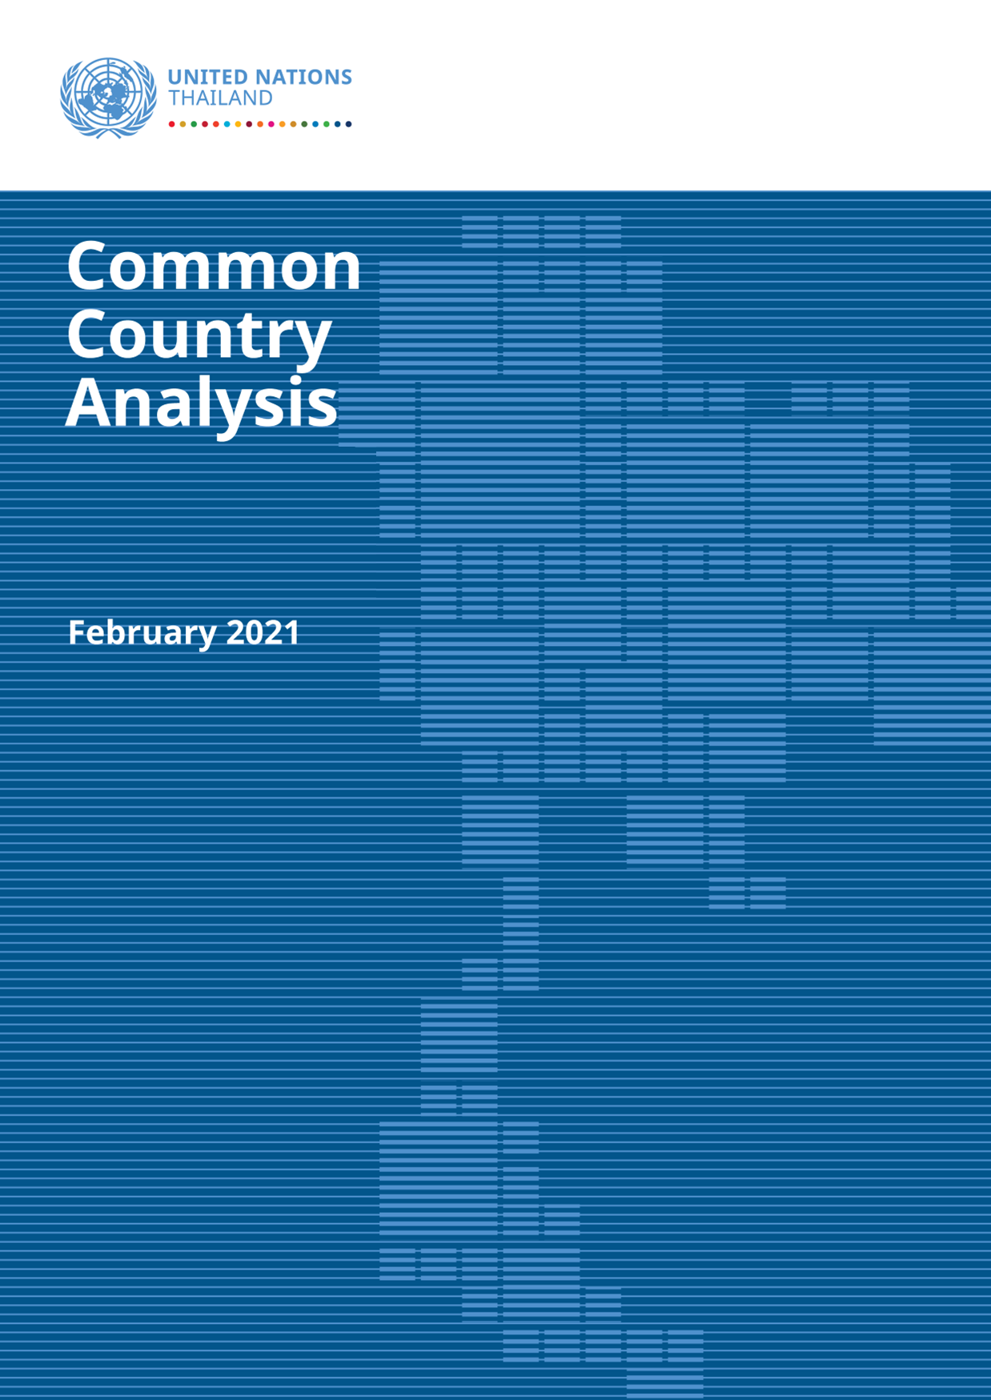

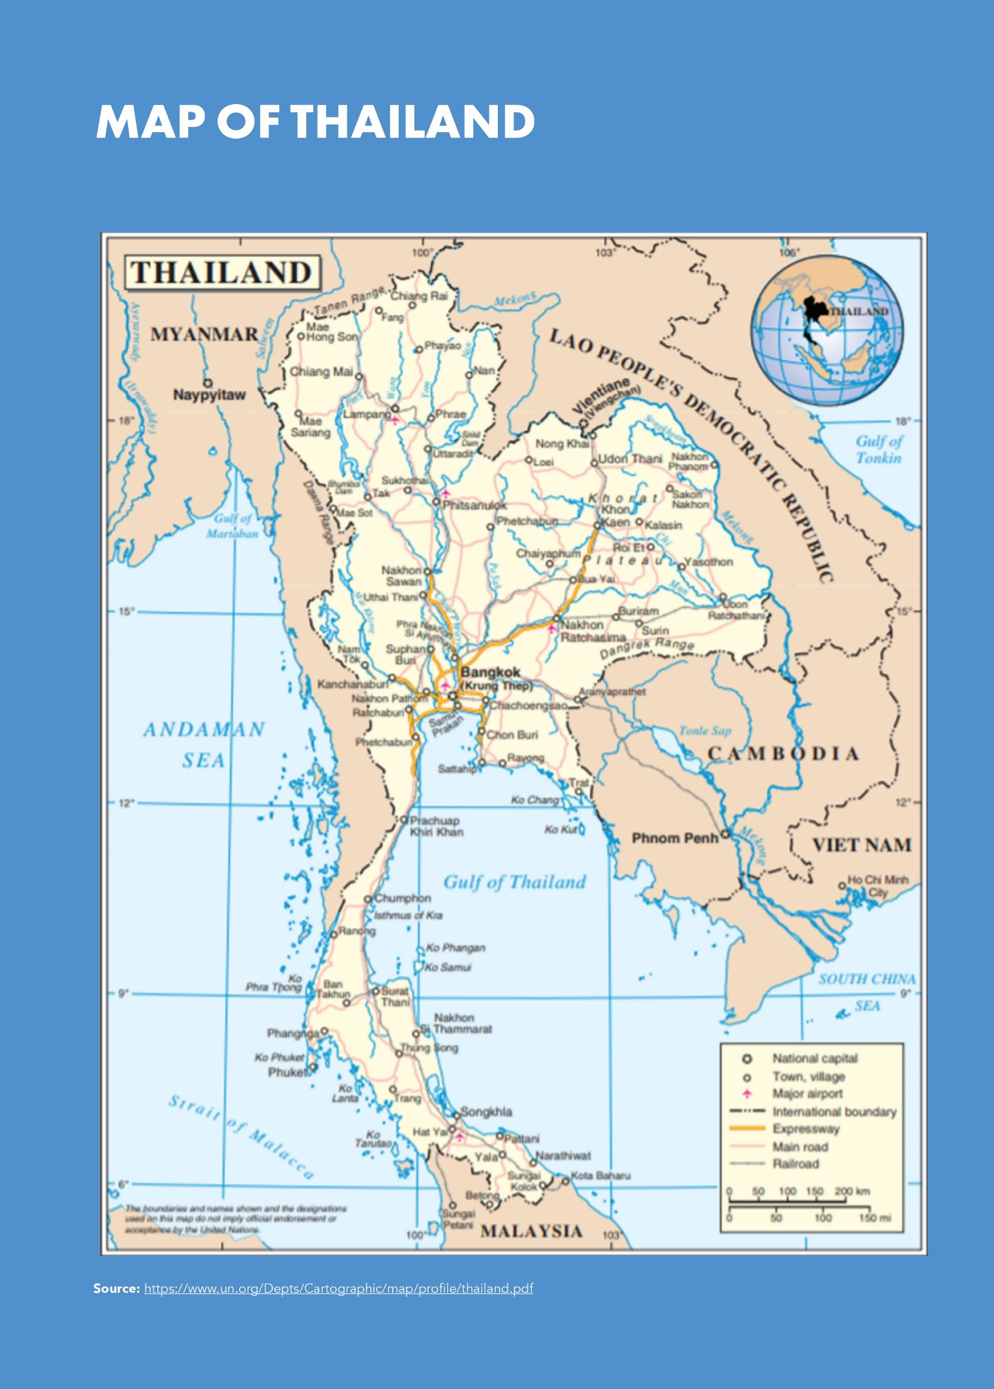

Contents
EXECUTIVE SUMMARY 1
INTRODUCTION 6
CHAPTER 1: ANALYSIS of ECONOMIC, SOCIAL, ENVIRONMENTAL AND GOVERNANCE ISSUES 7
ECONOMIC SECTOR 7
GDP Growth and Macro-economic Stability 7
Structure of the Economy 8
The Labour Market 9
Competitiveness and Innovation 10
Informal Employment 11
Household Debt 12
SOCIAL SECTOR 12
Demographics 12
Human Development and Human Capital 13
Health, Nutrition and Sanitation 14
Education and Training 15
Social Protection 17
Child Protection 17
ENVIRONMENT SECTION 18
Biodiversity and Natural Resources 18
Greenhouse Gas Emissions and Climate Change 20
GOVERNANCE 21
CHAPTER 2: POVERTY AND INEQUALITIES 23
Poverty 23
Income Inequalities 24
Digital Inequalities 24
Inequality of Opportunity 26
Regional Inequalities 27
Gender Inequality 28
CHAPTER 3: ANALYSIS OF IMPACT OF COVID-19 30
Impact on Health 30
Economic Impact 31
Impact on SMEs 31
Impact on Household Welfare, the Informal Sector and the Working Poor 32
Impact on Migrant Workers 32
Impact on Education 33
Social Impact 33
Environmental Impact 34
CHAPTER 4: LEAVING NO ONE BEHIND IN THAILAND 35
LNOB Groups 35
Children and Young People 36
Women and Girls 37
People with Disabilities 37
People Living with HIV 38
Migrants 38
Non-Thai Ethnic, Religious and Linguistic Groups 39
Farmers and Small-holders 40
Refugees and Asylum-Seekers 40
Stateless Persons 40
CHAPTER 5: ANALYSIS OF COUNTRY PROGRESS TOWARDS THE SDGS 42
SDGs in the Thai Context 42
Assessment of SDG Progress 43
Goal by Goal Assessment 43
Investments Needed to Help Reach the SDGs 47
CHAPTER 6: SDG BASED MULTI-DIMENSIONAL RISK FRAMEWORK 48
Economic Risks 48
Political Risks and Democratic Space 49
Social Cohesion, Equality and Non-discrimination Related Risks 49
Climate, Environment and Disaster Risks 50
Gender Risks 52
CHAPTER 7: TRANSBOUNDARY ISSUES 53
Environmental Pollution 53
Transboundary Haze Pollution 53
Transboundary Marine Litter 53
Transboundary Riparian Issues 54
Transnational Organized Crime 54
The Illicit Drug Trade 54
The Illegal Trade of Wildlife 55
Human Trafficking 55
Population Migration and Displacement 55

Table of Boxes
Box 1 Purpose of the CCA and Consultations that Informed its Content 1
Box 2 The SDGs within Thailand’s National Policy Framework 2
Box 3 The UN75 Survey and the 2021 UN Analysis of Key Development Challenges in Thailand. 3
Box 4 The Main Risks to Thailand’s Progress in Achieving the SDGs are Broad and Interrelated. 5
Box 5 The UN75 Survey and the 2021 UN Analysis of Key Development Challenges in Thailand. 6
Box 6 Thailand's Key Economic Indicators 8
Box 7 Efficiencies of the Tech-driven Enterprise* 9
Box 8 Improving access to finance in Thailand. 9
Box 9 Skills Mismatches and Migrant Workers 10
Box 10 Capitalizing on upcoming Economic Agreements 10
Box 11 Migrant Workers in Thailand 13
Box 12 Thailand’s Progress on Human Development and Human Capital 13
Box 13 Progress in Key Health Indicators 14
Box 14 Non-Communicable Diseases in Thailand* 14
Box 15 The Status of HIV in Thailand 15
Box 16 Barriers for improving access of children with disabilities for quality education. 17
Box 17 Environmental risk factors 18
Box 18 Eco Tourism 19
Box 19 Thailand’s multi-level governance framework 21
Box 20 Public Procurement, Transparency and Participation 22
Box 21 Integrating the SDGs into Municipal Planning – A Case Study of Participatory Governance and Problem Solving in the Solid Waste Management (SWM) 22
Box 22 Child Poverty in Thailand 23
Box 23. Internet Disparities in Schools 25
Box 24 Opportunities and Barriers that Drive Inequality in Thailand* 27
Box 25 Inequalities and the Furthest Behind Groups in Thailand* 28
Box 26 Thailand’s Private Sector Leads the Way for Women in the Workforce^{[1]} 29
Box 27 The COVID-19 Pandemic Exacerbates Previously Unresolved Challenges 30
Box 28 The Interconnected Impact of COVID-19 on Economic and Social Conditions* 31
Box 29 Thailand and the Global Compact for Safe, Orderly and Regular Migration 32
Box 30 Leadership for Sustainability in the New Normal 34
Box 31 The SDGs and Human Rights in Thailand 35
Box 32 Child Labour in Thailand 36
Box 33 People with Disabilities 37
Box 34 Marginalization and Discrimination 38
Box 35 Education, Migration and Refugee Status in Thailand. 39
Box 36 Thailand’s Diversity of Ethnic Groups 39
Box 37 The SDGs within Thailand’s National Policy Framework* 42
Box 38 Thailand’s SDG Snapshot of Progress 43
Box 39 Government Leadership in the 2030 Agenda for Sustainable Development 45
Box 40 Context of the Sustainable Financing Framework in Thailand 47
Box 41 A Second Wave of COVID-19 48
Box 42 Thailand’s Universal Periodic Review (UPR) on Human Rights 49
Box 43 The Risks Associated with Inequalities, Discrimination, and Injustices (real or perceived) 50
Box 44 Waste Management in Thailand 50
Box 45 Gender Based Violence in Thailand 52
Box 46 Thailand’s Role in International and Regional Cooperation 53

Table of Figures
Figure 1 National Official Poverty Rates 1988-2018 2
Figure 2 GDP Growth, Selected ASEAN Countries 3
Figure 3 Thailand’s Economic Growth 7
Figure 4 National Official Poverty Rates, 1988-2018 7
Figure 5 GDP Growth, Selected ASEAN Countries 7
Figure 6 Thailand’s Public Debt to GDP 8
Figure 7 Labour Force Participation Rates by Gender (per cent) by ASEAN Member States, 2018* 10
Figure 8 ASEAN – Ease of Doing Business Ranking 11
Figure 9 Gross Expenditure on R&D, Per cent of GDP 11
Figure 10 Informal Employment Rate by Sex (percent) 11
Figure 11 Thailand’s Household Debt Levels & Non-Performing Loan 12
Figure 12 Projected Growth of Thailand’s Population by Age Group, 1995-2050 12
Figure 13 HIV Testing Coverage among Key Populations 15
Figure 14 Education Completion Rates of 24 to 26-Year-Olds 16
Figure 15 Trends In Performance In Reading, Mathematics And Science Among 15-Year-Old Students In Thailand 16
Figure 16 Public Expenditures on Social Protection 17
Figure 17 Share of Final Energy Consumption by Economic Sectors 2018 20
Figure 18 Growth in GHG Emissions and Removals by LULUCH by Sectors 2000 – 2016 20
Figure 19 GHG Emissions in Energy Sector 2016 20
Figure 20 National Determined Contribution Targets for Thailand 21
Figure 21 PM 2.5 Pollution in Bangkok Showing Season Pollution Peaks²¹⁰ 21
Figure 22 Trends in Provincial Poverty Rate 23
Figure 23 Censored Headcount Ratios ‘Lack of Access’ by Urban and Rural Areas, 2017 23
Figure 24 Thailand’s GINI Index 24
Figure 25 Mobile Broadband and Household Internet Penetration (Thailand), 2019 24
Figure 26 Mobile-Data Prices as a Percentage of GNI p.c. and Monthly Data Allowance, Asia and the Pacific, 2019 24
Figure 27 State of Access to Computer and Internet Connectivity in Thai Schools 25
Figure 28 Average D-Index in Asia and the Pacific 26
Figure 29 D-Index in Thailand, by Opportunity or Barrier 26
Figure 30 Official Poverty Rates by Region 27
Figure 31 Impact Pathway Analysis on Overall Economic and Social Impact of COVID-19 31
Figure 32 In the short term, income loss will result in an expansion of the economically insecure and a reduction of the middle class (Q1 2020 pre-COVID-19 scenario, left below / Q2 – 75 per cent income loss scenario, right) 32
Figure 33 Children Aged 6 to 14, by Region and Decile 36
Figure 34 SDGs and the 20-Year National Strategy 42
Figure 35 SDGs Snapshot in Thailand: Progress so far 43
Figure 36 SDGs Awareness of the Thai Population 46
Figure 37 Preliminary Estimates of Additional Annual Investment Need to Achieve SDGs in Thailand 47
Figure 38 Comparison of Accumulative Hotspots in Five Countries (2016-2019) 53

Table of Tables
Table 1 Thailand’s Economy by Value Added (per cent) and Employment (percent) 2005 – 2019 8
Table 2 Thailand’s HDI 1990 - 2019 14
Table 3 Species at Risk of Extinction in Thailand, Cambodia, Lao PDR, Myanmar and Viet Nam 19
Table 4 Thailand’s Multi-dimensional Poverty Index (MPI), Incidence and Intensity, 2017 23
Table 5 Total Number of Cases and Deaths from COVID-19 as of 27 January 2021 30
Table 6 Top Concerns of Marginalized Groups about being Left behind 38
Table 7 People Affected and Cost of Disasters, Top Five Countries Globally 51

EXECUTIVE SUMMARY
For most of the last four decades Thailand has been a social and economic success story with sound macroeconomic fundamentals providing a secure basis for economic stability. In less than a generation, Thailand has transitioned from a low-income to an upper middle-income country through sustained strong growth and impressive poverty reduction. Its economy has become more sophisticated, diversified and regionally integrated, based increasingly on manufacturing and services. Over the past 20 years, Thailand has successfully maintained a high foreign reserve, low inflation, a sound banking system and a stable exchange rate. These features, combined with an openness to trade, financial flows, labour migration and investments in both human and physical capital, have facilitated high levels of GDP growth and significant gains in poverty reduction. Long-term gains in social welfare have been equally impressive, with increasing numbers of children now obtaining many more years of education and virtually everyone covered by health insurance, while other forms of social security have expanded. Access to safe water, basic sanitation and digital connectivity is almost universal. Such widespread social and economic progress provides a solid bedrock for advancing the 2030 Agenda for Sustainable Development in Thailand.
The COVID-19 pandemic, while being relatively well contained in Thailand in 2020, has impacted the economic and social life of the nation and exposed pre-existing imbalances, inequalities, vulnerabilities and risks. Thailand reported the first COVID-19 case in mid-January 2020 and is considered to be among the top ten most prepared countries, ranking first among all upper middle-income countries. The extensive network of healthcare facilities, expertise and an impressive cadre of health volunteers contributed to successful case finding, contact tracing and containment efforts. However, a UN report undertaken to understand the impact of COVID-19 showed ‘a strong causal relationship between the pandemic and the immediate economic, macro-economic, and social impact, which pushed vulnerable groups into poverty, and created social problems’. The economic consequences resulted in a broad decline in consumption, investment and trade, affecting all sectors, such that the economy in 2020 contracted by about 8 per cent, with up to 8.4 million jobs lost on top of 6 million farmers at risk from drought. The ongoing impact on household welfare is likely to be significant, with Thailand’s middle class expected to contract, and the number of economically insecure people is projected to double and working poverty is anticipated to rise. Nearly half of Thailand’s workforce face some risk of impact. Many lack social protection, which will result in a further increase in already high levels of household debt. Two groups especially hard hit are new graduates, and migrant workers.
Box 1 Purpose of the CCA and Consultations that Informed its Content
The United Nations Common Country Analysis, or CCA, is a key part of the United Nations Sustainable Development Cooperation Framework, occurring at the first stage of the preparatory process. Integral to the CCA are the consultations with national stakeholders. From a development perspective the CCA strives to outline ‘what’ is happening and ‘why’, by identifying some of the underlying structural development issues.
In formulating the CCA, the UN crafted six background papers drawing on different parts of the UN system, including ESCAP, the UNCT and the Regional Issue Based Coalitions: i) Analysis of Economic, Social, Environmental and Governance; ii) COVID-19 Impact; iii) SDG Progress; iv) Poverty, Inequalities and Leave No One Behind (LNOB) Analysis; v) Transboundary Issues; and vi) SDG-based Multi-Dimensional Risk Assessment (MDRA).
For the MDRA, the UN consulted various stakeholders and interest groups, including the government, private sector, industry organizations, civil society as well as academia and university students. Specific to LNOB, direct polling and focus group discussions were held across the country with the most marginal and ‘at-risk’ groups. Not least the UN75 survey sought a broader perspective on development challenges and issues (Box 3).
Chief among the many reference documents consulted were the Government’s National 20-Year Strategy (2017 - 2036); the Twelfth National Economic and Social Development Plan for Thailand (2017-2021); The Covid-19 Contingency Plan; the UN Socio-Economic Impact Assessment of COVID-19 in Thailand; as well as detailed analysis of International Financial Institutions and UN agencies.
The CCA sets the scene for preparing the UN Sustainable Development Cooperation Framework, a five-year programme of collaboration between the UN, the Government and development partners, to further advance the aspirations and goals of the 2030 Sustainable Development Agenda in Thailand.

Thailand sets an excellent example on advocacy for the Sustainable Development Goals (SDGs) at the international and national levels and has integrated the Goals into its development plans. There is strong alignment between the 2030 Agenda and Thailand’s own development agenda. The Government has established the National Committee for Sustainable Development to lead on SDG implementation within national policies and strategic development plans. Voluntary Nations Reviews are prepared on an annual basis and national agencies are invested in an integrated online SDG monitoring system (eMENSCR) which aims to provide accurate, up to date information on national progress. In addition, the Government has recently adopted the Bio-Circular Green Economic Model (BCG), making stronger connections between the human development and environmental SDGs and comprises four keys to development; i) Agriculture and Food; ii) Health and Medication; iii) Energy and Bio-Chemical; and iv) Tourism and Creative Economy. These four development keys will be integrated with biodiversity and culture which are the fundamental capital to create well-being for all citizens. Thailand has thereby built a solid foundation for accelerating its progress towards the SDGs but will need to redouble its efforts in respect to human capital development, climate change, biodiversity and the environment, and inequalities, including through its commitment to those populations at greatest risk of being ‘left behind’. Meanwhile, sufficient data is currently available for assessing just over half of the global SDG indicators, suggesting that the UN will need to work with the Government to address the remaining data gaps. To meet the SDGs in Thailand it is estimated that US$ 40.9 billion in additional annual investment from 2020 to 2030 will be required. Box 4 sets out the broad and interrelated risks to Thailand’s progress across the economic, political, social, environmental and gender spheres by 2030.
Box 2 The SDGs within Thailand’s National Policy Framework
Since the launch of the 2030 Agenda for Sustainable Development, Thailand has stressed the importance of and has continued to press ahead with implementation of the SDGs, despite the setback of the COVID-19 pandemic. The country’s homegrown development approach, the Sufficiency Economy Philosophy remains the country’s guiding philosophy and pathway towards the achievement of the SDGs.
The country has integrated the 17 Goals into the 20-Year National Strategy, (2017 - 2036) for realization of the vision of ‘Thailand as a developed country with security, prosperity and sustainability’ covering six areas including stability, competitiveness enhancement, human capacity development, social equality, eco-friendly growth, as well as rebalancing and improving public sector management.
In this context, a good platform is in place for advancing the SDGs in Thailand, for example around health (SDG 3) and the economy (SDG 8). The 12th National Economic and Social Plan (2017 – 2021) places a priority on human capital development, structural transformation and innovation, particularly SDGs 3, 4, 8 and 9, and recognizes that Thailand needs to address its persistent inequalities (SDG 1, 2, 5 and 10). The National Plan also states that the quality of Thailand’s natural environment has been eroded and hence SDGs 7, 11, 12, 13 and 14 all require greater prioritization. Not least, SDG 16 concerning the efficiency of governance institutions needs fundamental reform.
Investment in human capital is key to completing the structural transformation of Thailand’s economy, addressing the productivity gap and the middle-income trap in the process, and getting Thailand on the trajectory to advanced country status on a solid bedrock of SDG progress. Agriculture still accounted for over 30 per cent of all jobs in 2019, contributed about 9 per cent of total value addition, though it ranks 12th among food exporters worldwide. Lack of reform in the sector dampens national productivity and prevents it from effectively completing the economic transformation process. In addition, low levels of productivity combined with a large unskilled informal sector and insufficient investment in human capital, innovation and technology lock Thailand in the middle-income trap. Moreover, in 2018 Thailand was the 25th largest economy in the world in terms of GDP/ but over recent years it has been losing ground.
The Government’s Thailand 4.0 initiative provides a framework to restructure the economy to promote innovation and creativity. Digitalization, automation and the transition to Industry 4.0 involving the internet of things, artificial intelligence and big data analytics are all being utilized to transform Thailand’s economy and enable the country to accede to more advanced levels of development. At the heart of the challenge, however, is that Thailand’s education system has been unable to prepare graduates sufficiently for labour market transformation in line with the demands and requirements of industry 4.0. In brief, there is a shortage of science and technology graduates, with manufacturing firms reporting that the lack of skilled workers is one of the leading constraints to growth.
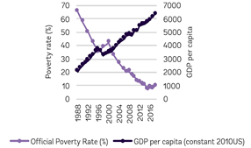
Figure 1 National Official Poverty Rates
1988-2018
Source: World Bank, Taking the Pulse of Poverty and Inequality in Thailand, 2020.
Thailand has a good legacy of human development gains, but now needs to adjust to face a rapid demographic transition and address the deficit in human capital investment relative to its regional peers, which is otherwise bound to constrain economic transformation and SDG accomplishment. Thailand has made good historical progress on most of its health, education, and social assistance policies and indicators. Widespread universal healthcare and vaccination programmes have been rolled out, educational outcomes have risen significantly since the 1990s, and the country now has a relatively well-developed high level of social protection. While key challenges in these human capital sectors remain, critically the Government’s revenue generation is only 21.4 per cent of GDP, which is considerably lower than both the regional average (40.7 per cent) and the average for its income group (30.6 per cent). As a result, Thailand invests much less (6.5 per cent of its GDP) in human capital (education, health and social assistance), compared to the 10.7-per-cent regional average.
Thailand is also experiencing a rapid demographic transition. The steadily declining fertility rate has resulted in a high dependency ratio, effectively shrinking the proportion of working-age people relative to older people. Thailand must find ways to raise productivity, invest in skills development, and further strengthen its healthcare and social protection systems, such as pensions, and leverage this ‘longevity dividend’. These factors will all impact Thailand’s ability to raise productivity, revenues and investments in human capital capable of completing the economic transformation necessary for achieving the SDGs. They also imply that Thailand’s demand for migrant workers will continue based on this demographic transition and in response to increased demand in key sectors including care, infrastructure, agriculture and fishing.
Recent increases in poverty and persistent inequalities also impede SDG progress and Thailand’s leadership in economic growth and poverty reduction. Extreme poverty was reduced to negligible levels between 1986 and 2015, and over a similar period the national poverty rate fell to about 10 per cent in 2014. This equates to more than a third of the population moving out of poverty during this period. However, rates of poverty have increased twice in recent years, returning to 2014 levels. This recent increase in poverty occurred in almost all provinces, with the majority of poor residing in the North and Northeast, as well as in rural as opposed to urban areas. Furthermore, poverty rates in three of the southern border provinces have remained high at around a third of the population. Meanwhile, Thailand experiences higher level of household income inequality compared to other ASEAN countries. Inequalities of opportunities and services also occur, such as access to education, clean fuels, sanitation and financial services, with barriers such as geography, socio-economic status, and the incidences of violence against women, all of which prevent people from fulfilling their potential. These inequalities and barriers, as noted above, have been compounded by the pandemic, and exacerbate vulnerabilities among particular population cohorts.
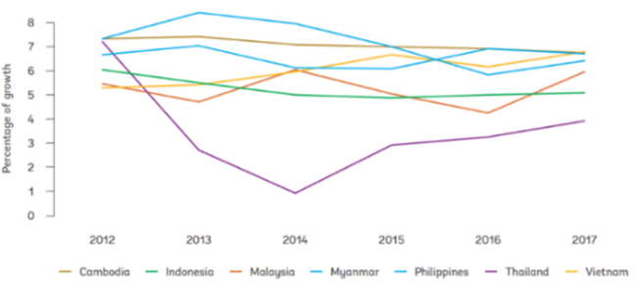
Figure 2 GDP Growth, Selected ASEAN Countries
Source: Thailand – World Bank Group Country Partnership Framework, 2019–2022
Various forms of digital divide are apparent in Thailand, which serves as an impediment to SDG acceleration across all sectors, despite mobile-cellular connectivity in Thailand being near universal and the country ranking third in the ASEAN region for fixed broadband subscription. Although internet connectivity (access to internet and mobile devices) covers 98 per cent of Thailand’s population, a significant digital divide is observed across income groups, urban/rural populations and regions when accounting for internet access and computer use. For example, nearly six out of ten households in the bottom quartile had an internet connection in their home compared to eight in the top quartile. Similarly, the per centage of households with access to computer from the provinces within the top quartile was double than the bottom quartile. This underscores the learning challenges presented to children when schools were closed during the pandemic as education transitioned to online platforms, which might exacerbate existing inequalities. Similar manifestations of the digital divide also exist in schools, in rural areas, the North and Northeast, as well as provinces with lower per capita income being further disadvantaged. In sum, technological poverty compounds disadvantages and inequalities faced by already poor and vulnerable populations. This requires concerted efforts by stakeholders focused on 2030 Agenda and SDG attainment, that can unlock the potential of all of its population for the technology age.
Central to the 2030 Sustainable Development Agenda is the requirement of addressing inequalities and ensuring no one is left behind in Thailand, which requires improved levels of investment and coordination of services in human capital development. Research findings show that the people at risk of being left behind in Thailand are the rural poor, children and young people, women, people with disabilities, ethnic minorities, migrants, LGBTI communities, HIV-affected people, sex workers, farmers/smallholders, refugees, asylum seekers and the stateless. Evidence shows that different groups experience several barriers and multiple deprivations simultaneously, which compounds their impact. For example, the rural poor includes people living with disabilities, including children, and from ethnic/linguistic minorities, who face multiple challenges. Similarly, women and children from lower socio-economic groups, belonging to migrant, refugee and/or asylum-seeking households, face multiple disadvantages. Furthermore, Thailand’s child poverty rate is nearly 13 per cent, with large segments of poor children living in the rural areas of the North and Northeast regions, from the lowest income groups and often from ethnic minority backgrounds. Of concern, stunting and wasting rates among children have also begun to rise. In poorer regions, lower-income people, including minorities, such as those living in hill areas, may also be more likely to be discriminated against by the majority of the mainstream population.
Box 3 The UN75 Survey and the 2021 UN Analysis of Key Development Challenges in Thailand.
In 2020, the UN marked its 75th Anniversary by starting a global conversation through a creative one-minute ‘UN75’ online survey campaign about ‘the future we want’ In Thailand, with over 8,100 people participating - the highest rate in Southeast Asia. About 77 per cent of participants were young people and over half were female.
There is a strong alignment of the UN75 survey findings with the analysis in the CCA. For example, in response to the three UN survey questions relating to: i) recovery from the COVID – 19 pandemic; ii) priorities for the UN in terms of longer term global trends; and iii) the world you would like to see in 25 years, all responses point towards an enhanced focus in Thailand on four key issues:
- Better human capital development through improved health and education.
- Addressing inequalities, with a focus on the most vulnerable.
- Climate change, biodiversity, and environmental protection.
- Prominent attention to human rights.
Good governance and human rights constitute the enabling environment for advancing the 2030 Sustainable Development Agenda and SDGs. Thailand’s recent national and provincial elections in March 2019 and December 2020 respectively were indicative of the intention of the government and the direction of the country in its ongoing democratic process. Thailand was subsequently upgraded by the Freedom House index to ‘partly free’ for civil liberties and political rights. In terms of fundamental rights and effective governance, the country also records mid-range performance, which the Government seeks to improve upon. The Government has also made a strong commitment to prioritize corruption prevention as evidenced by the 20-year National Strategy (2017-2038) and 12th National Socio-economic Development Plant (NSEDP) (2017-2021). Furthermore, within Thailand’s complex multi-level system of governance, further decentralization and digitization are among some of the most promising areas of innovation that would yield tangible gains in strengthening an enabling environment and accelerating SDG attainment.
Thailand’s aspiration of accelerating the SDGs also depends on achieving greater progress on gender equality (SDG 5). While women tend to achieve better educational outcomes than men and do not appear to be disadvantaged by access to digital connectivity, these gains do not easily translate into wider societal gains. Clear challenges persist in Thailand arising from women’s unequal participation in the political, social, economic, environmental, and legal domains, including the incidences of discrimination and violence against women and girls. As a result, the lack of gender equality is an impediment and risk factor to Thailand being able to achieve the SDGs, which cuts across all sectors of the 2030 Agenda. While there have been notable gains within the economic sector and in labour market participation, women are still underrepresented in politics at all levels. Thailand’s gender wage gap has been narrowing over the years, helped partly due to the growing economy and greater improvements in education and skills made by women, but there still remains a factor-weighted pay gap of 10.9 per cent. Concurrently, women remain under-represented in STEM-related degree programmes and are predominantly in jobs requiring low STEM skills, which are clearly at risk of automation. Regarding indicators to monitor progress from a gender perspective, just over 30 per cent of the gender-specific SDGs have data available, with gaps in key areas such as violence against women and skills in information and communication technology. Addressing these data gaps will be a prerequisite for deepening the understanding of the situation of women and girls in Thailand and achieving gender-related SDG commitments.
Reflecting on the immediate and longer-term challenges presents Thailand with an opportunity to shift its development trajectory and environmental credentials to align with the 2030 Agenda for Sustainable Development. Thailand’s economic and social progress has been accompanied by conspicuous levels of environmental degradation, biodiversity loss and air pollution through greenhouse gas (GHG) emissions, as well the contamination of land and water resources. The country ranks high on the global list of GHG emitting nations, in turn contributing to climate change, which increases Thailand’s already high exposure to extreme weather events and their devastating effects. In the same vein, Thailand’s rich biodiversity faces an immediate challenge with nearly 460 species currently threatened with extinction. Forests and marine ecosystems have also been significantly degraded and remain under threat. A financing requirement of close to US$1 billion, among other capacity gaps, is needed to begin to remedy this precarious situation, including critical transboundary issues. For example, haze pollution, which originates from neighbouring countries as well as domestically, exerts a substantial impact on human health, local economies and biodiversity. / Thailand has redoubled its efforts to address marine plastic waste domestically and regionally and as of 2019 its ranking has improved from sixth to tenth biggest contributor of marine plastic waste. However, this still remains one of the critical transboundary issues.// Not least, ongoing international cooperation is needed to more prudently manage the Mekong river basin, one of the world’s most ecologically diverse and productive inland fisheries, to balance competing pressures for hydro-power, biodiversity, livelihoods and sustainability among riverside countries. Thailand has arrived at a pivotal opportunity to transform its economic model based on green principles, for example via eco-tourism, by signalling leadership in the environmental domain.
Thailand is a country of origin, transit and destination for transnational organized crime groups from across Southeast Asia that trade and transport drugs and wildlife products and also engage in human trafficking. These criminal networks, which possess unprecedented influence and control multi-billion dollar ‘industries’, have become more complex with global reach as they traffic unprecedented quantities of methamphetamine, related precursor chemicals and other synthetic drugs. Southeast Asia has experienced a continuous, rapid expansion of the illicit manufacture, trafficking and use of a variety of synthetic drugs, especially methamphetamine, over recent years, with Thailand becoming one of the primary gateways for regional drugs to reach global markets. Similarly, Thailand’s rich biological diversity is a target and major source of origin, transit, and destination for many different types of wildlife and wildlife products. Habitat loss, poaching and trafficking, human-wildlife conflict and domestic use of wildlife has heavily impacted many native plant and animal species. Furthermore, the vast majority of human trafficking victims in East and Southeast Asia are being trafficked from less developed countries, including neighbouring countries, to more developed countries, such as Thailand. Human trafficking for sexual exploitation accounted for almost 80 per cent of all cases in Thailand/ with victims predominantly from the Mekong region.
Box 4 The Main Risks to Thailand’s Progress in Achieving the SDGs are Broad and Interrelated.
In terms of economic risks, Thailand’s economy has slowed in recent years and is increasingly vulnerable to a variety of factors originating from different sources, but which are ultimately interconnected. For example, the key drivers of slowing growth were weaker demand for exports reflecting the impact of trade tensions (geopolitical risk), low levels of revenue as a percentage of GDP and lower levels of investments in human capital and infrastructure (fiscal risk), climate change induced droughts and floods (environment risk), which have disrupted economic output and agricultural production (export/potential food supply risk). There is a risk that the need to quickly reactivate the economy may override the requirement of environmental sustainability.
Political risks affect all countries, and Thailand is no exception. Political stability is largely determined by the relationship between the people and their governments, including the degree of integrity and trust populations invest in public and private institutions. In this regard, Thailand faces issues at the juxtaposition between political, social and economic risks,as there is room for improvement in terms of public confidence in governance institutions .* In addition to human, geographic and digital inequalities, which is a central theme of this CCA, there is a risk that social and economic inequalities, and perceptions of social injustice, become factors of instability. Along similar lines, significant wealth inequality is running parallel to high levels of household debt, exposing additional vulnerabilities and risk factors in the political realm. Furthermore, the impact of COVID-19, notwithstanding a comprehensive public sector support package, has placed additional pressures and altered the economic prospects for both middle classes and the poor, who have been significantly affected. This may signal increased risk of social, economic, and political instability, with possible implications for deepening polarization in the governance sphere.
The challenge to social cohesion, and persistent inequalities yields a risk to the social fabric of the country. This manifests through a marked strain on Thailand’s social contract, with concerns for different forms of inequality, discrimination and marginalization coupled with the growing aspiration for greater appreciation for embracing diversity.** The COVID-19 pandemic may pose the risk of a rise in xenophobia, impacting vulnerable groups.
In addition, there are specific gender risks in Thailand arising from women’s unequal participation in society, underpinned by social norms, for example in politics, leadership and the STEM sectors, with women facing a concerning degree of violence.
Disaster and climate risk pose a considerable and increasing threat to Thailand’s future development trajectory with floods, droughts and storms being the top three hazards. While extreme weather events have inflicted a high cost on Thailand’s economy, a multi-hazard and multi-sector approach to disaster risk reduction must continue, with increased disaster risk reduction (DRR) governance and planning at the local levels. Disaster events stall, and in some instances temporarily reverse, economic growth and gains in poverty reduction. Not least they take time, effort and resources to recover from, impacting the poorest and vulnerable the most.*** Thailand’s ability to collect, manage, share and analyze disaster information remains critical challenges that impede better efforts to understand, reduce and manage disaster risks more comprehensively and achieve the SDGs and the Sendai Framework for DRR.
Source:
* The index, which ranks 180 countries and territories by their perceived levels of public sector corruption according to experts and businesspeople, uses a scale of zero to 100, where zero is highly corrupt and 100 is very clean (https://www.transparency.org/en/countries/thailand).
** Minorities and marginalized groups include children without parental care, youth, women, farmers, migrants, ethnic groups, the urban poor, sex workers, men who have sex with men (MSM), LGBTI communities, people who inject drugs (PWID) and people living with HIV (PLHIV) who are among the most vulnerable and discriminated.
*** ADPC and UNDRR (2020). Disaster Risk Reduction in Thailand: Status Report, 2019.

INTRODUCTION
This Common Country Analysis (CCA) of the United Nations (UN) reviews Thailand’s current development status through the perspective of the 2030 Agenda for Sustainable Development, drawing on a comprehensive review of primary research and publications, including various direct consultations organized by the UN with a wide diversity of stakeholders (Box 5). The sections below review Thailand’s recent and current economic, social and environmental trends and conditions. The analysis then looks at issues of poverty and inequality from various viewpoints that have an impact on Thailand’s development. A section of this CCA is dedicated to assessing the COVID-19 pandemic’s impact on the country. ‘Leave No One Behind’ (LNOB), a central principle of the 2030 Agenda, is integral to the analysis. Thailand’s progress towards the 2030 Agenda is then assessed, working systematically through all 17 Sustainable Development Goals (SDGs), followed by a forward-looking multi-dimensional risk assessment. The final section contains a discussion on some of Thailand’s most pressing transboundary issues.
The United Nations Common Country Assessment is a key part of the United Nations Sustainable Development Cooperation Framework, occurring at the first stage of the preparatory process. The CCA provides the opportunity for the UN to consult with national stakeholders. From a development perspective, the CCA strives to outline ‘what’ is happening and ‘why’, by seeking to identify some of the underlying structural development issues. The CCA sets the scene for preparing the UN Cooperation Framework, a five-year programme of collaboration between the UN, Government and development partners, to further advance the aspirations and goals of the 2030 Sustainable Development Agenda in Thailand.
Box 5 The UN75 Survey and the 2021 UN Analysis of Key Development Challenges in Thailand.
In 2020, the UN marked its 75th Anniversary by starting a global conversation through a creative 1-minute ‘UN75’ online survey campaign about ‘the future we want’ In Thailand, over 8,100 people participated - the highest rate in Southeast Asia. 77 per cent of participants were young people and over half were female.
There is a strong alignment of the UN75 survey findings with the analysis in the CCA. For example, in response to the three UN survey questions relating to: i) recovery from the COVID – 19 pandemic; ii) priorities for the UN in terms of longer term global trends; and iii) the world you would like to see in 25 years, all responses point towards an enhanced focus in Thailand on four key issues:
- Better human capital development through improved health and education.
- Addressing inequalities, with a focus on the most vulnerable.
- Climate change, biodiversity and environmental protection.
- Prominent attention to human rights.
The CCA has also been framed by the universal impact of the COVID-19 pandemic. The pandemic has forced leaders, policy-makers and decision-takers to rethink the way we look at, analyze and understand the world in which we live. It has exposed more profoundly the intricacies, interconnectedness and interdependencies, not only between human beings, but also those inextricable ties that bind humans to nature. For all the human suffering and tragedy that COVID-19 has inflicted, it has also provided a vital opportunity to re-evaluate the world we want to live in and resonated through the creation of this CCA.
In formulating the CCA, the UN crafted six background papers drawing on different parts of the UN system. Engaging ESCAP, the UNCT and Issue-Based Coalitions, the contributory papers included: i) Economic and Social Analysis; ii) Impact of COVID-19; iii) SDG Progress; iv) Inequalities and Leave No One Behind (LNOB) Analysis; v) SDG-based Multi-Dimensional Risk Assessment (MDRA); and vi) Transboundary Issues.
The MDRA and LNOB background papers provided the opportunity for extensive nationwide consultations. The UN consulted various stakeholders and interest groups, including government, private sector, industry organizations, civil society as well as academia and students at universities. Specific to LNOB, direct polling and focus group discussions were held across the country with seven of the most marginalized and ‘at-risk’ groups. Not least, the UN75 survey sought a broader perspective on development challenges and issues (Box 5). Chief among the many reference documents consulted were the Government’s National 20-Year Strategy (2017 - 2036); the Twelfth National Economic and Social Development Plan for Thailand (2017-2021); the Government’s Covid-19 Contingency Plan; the UN Socio-Economic Impact Assessment of COVID-19 in Thailand; as well as detailed analysis of International Financial Institutions and UN agencies.

CHAPTER 1: ANALYSIS of ECONOMIC, SOCIAL, ENVIRONMENTAL AND GOVERNANCE ISSUES

ECONOMIC SECTOR

GDP Growth and Macro-economic Stability
Thailand is a regionally and globally integrated upper middle-income country that for long periods during the past few decades has recorded impressive GDP growth. This has been punctuated by a series of setbacks, with Thailand more recently experiencing an economic slowdown. GDP grew at an average of 9.5 per cent per year between 1987 and 1996 on the back of political stability, a business-friendly regulatory environment, a large domestic market, open access to foreign investment and greater participation in regional value chains. In the years following the Asian financial crisis (1997–1998), growth slowed to an average of 3.9 per cent up to 2014. GNI per capita rose almost fivefold from US$1,160 in 1988 to US$5,690 in 2015./ Slowdowns have been largely due to a series of shocks that hit the economy, the global financial crisis, occasional coups and subsequent political unrest, as well as periodic floods and droughts. Between 2014 and 2017 economic growth continued to average about 3.6 per cent, falling to 2.4 per cent in 2019, with the significant impact of the COVID-19 pandemic in 2020 (Figure 3). The key drivers of slower growth were weaker demand for exports, the impact of trade tensions, slowing public investments and a drought that impacted agricultural production.
Figure 4 National Official Poverty Rates,
1988-2018
Source: World Bank, Taking the Pulse of Poverty and Inequality in Thailand, 2020.
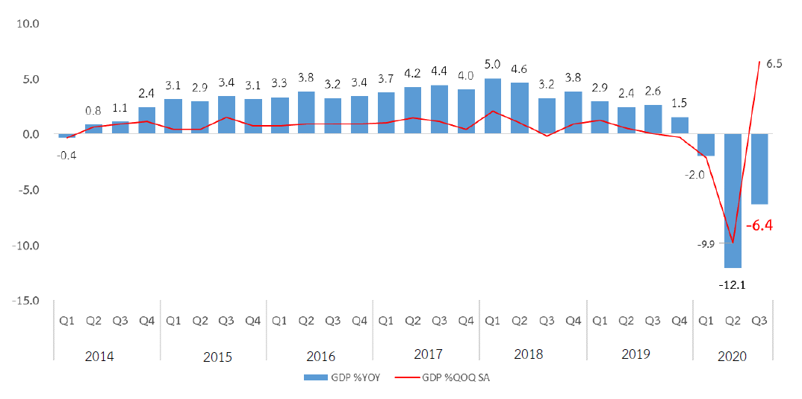
Figure 3 Thailand’s Economic Growth
Source: NESDC, FPO.
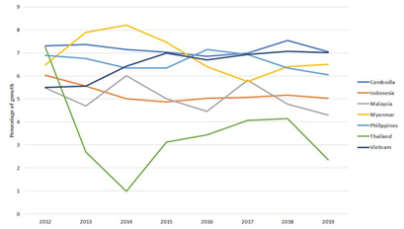
Figure 5 GDP Growth, Selected ASEAN Countries
Source: IMF
Thailand has provided a model for other countries seeking to eradicate poverty fuelled by sound macroeconomic fundamentals. Thailand’s openness to trade, financial flows, labour migration and investments in both human and physical capital, allied to policies that have facilitated the inclusiveness of economic growth, combined with the country’s export-oriented economy, have provided the foundation for high average GDP growth, which made significant gains in poverty reduction possible (Figure 4). Since the Asian financial crisis, Thailand has maintained a high foreign reserve, low inflation, a sound banking system and a stable exchange rate. Thailand has also become an important contributor to Overseas Development Assistance (ODA).
When compared to countries in the region however, Thailand’s recent GDP growth has not done as well. In 2018, Thailand was the 25th economy in the world in terms of GDP. / However, the country has lost some of its competitive edge regionally. This is largely due to the slow pace of reforms as well as insufficient quality of human capital and infrastructure investments mitigating efforts to eliminate poverty and ensure prosperity gains. The Government’s Thailand 4.0 initiative provides a framework with which to restructure the economy to promote innovation. In 2020, its implementation was hindered by COVID-19 and the associated economic downturn.
Box 6 Thailand's Key Economic Indicators
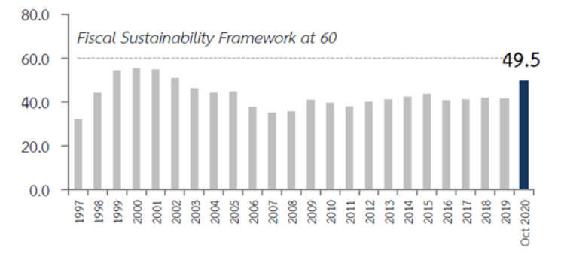
Figure 6 Thailand’s Public Debt to GDP
In 2018, Thailand exported US$262 billion of products and services and imported US$227 billion, resulting in a positive trade balance of US$34.3 billion. In 2019, the current account registered a surplus of 7.0 per cent of GDP, foreign reserves stood at US$224.3 billion, or 3.8 times the country’s short-term foreign debt, and total public debt was 49.5 per cent of GDP.
Capital buffers in the banking system have remained high, with capital adequacy and liquidity coverage ratios above 19 per cent and 180 per cent, respectively. The exchange rate index has also remained fairly stable. FDI inflows averaged approximately 3 per cent of GDP until 2017, but have become more volatile in recent years as a result of faltering investor confidence and declining competitiveness with respect to some of Thailand’s peers.
Source: * Number 22 in terms of total exports, 23 in total imports and 28 most complex economy according to the Economic Complexity Index (ECI).
In terms of revenue generation as a per centage of GDP and public investments in the core human capital sectors, Thailand considerably underperforms its regional peers. In overall terms, general government revenue in Thailand is 21.4 per cent of GDP. This is considerably lower than both the regional average (40.7 per cent) and the average for its income group (30.6 per cent). Thailand spends 6.5 per cent of its GDP on the core social services of education, health and social protection compared to the 10.7 per cent regional average. It spends 2.9 per cent of its GDP in public spending on health compared to the 4.9 per cent regional average. Similarly, the country spends 4.1 per cent of its GDP on public education, versus the regional average of 4.7 per cent, and 0.5 per cent of its GDP on social assistance, compared to an average of 1.1 per cent in the region. This will impact on Thailand’s ability to achieve its SDG Targets by 2030.

Structure of the Economy
Lack of reform in the agricultural sector places a brake on productivity gains transformation of the workforce. Although agriculture provided almost 10 per cent fewer jobs from 2005 to 2019, it still accounted for more than 30 per cent of all jobs in the country in 2019. Agriculture’s share of total value-added has declined, although the movement of workers out of agriculture has slowed in recent years. Over the same period, industry declined in its value addition to the overall economy by more than 2.5 per centage points, despite a 2 per cent gain in employment. Services increased both its share of employment and contribution to value addition by 4 per cent and 9 per cent respectively (Table 1). Millions of workers continue to migrate between agricultural and industrial jobs, keeping one foot in the primary and secondary economies. While these fluctuations have declined over time, 2.3 million workers (equivalent to approximately 6 per cent of total employment) moved from agricultural jobs (where they worked during the planting and harvesting season) to industrial jobs or out of the labour force.
Table 1 Thailand’s Economy by Value Added (per cent) and Employment (per cent) 2005 – 2019
 | 2005 |  | 2010 |  | 2019
 | Value Added  (%) | Employment  (%) | Value Added  (%) | Employment  (%) | Value Added  (%) | Employment  (%)
Agriculture | 9.2 | 42.6 | 10.5 | 38.2 | 8.7 | 31.2
Industry | 38.6 | 20.3 | 40 | 20.6 | 35.1 | 22.5
Services | 52.5 | 37.1 | 49.5 | 41.1 | 56.3 | 46.3
Source: UN, http://data.un.org/en/iso/th.html.
Thailand has the second highest share of agricultural workers among middle-income countries, many of whom are ageing and regard the sector as a safety net. Thailand’s agriculture sector includes both commercial full-time farmers as well as part-time farmers who use land as a safety net rather than as a productive asset. This phenomenon slows down the land consolidation process needed to increase productivity. A large number of people working in agriculture are in their 50s or older, perhaps because the country does not have a pension system able to provide adequate income security for old age. Even as the industrial and service sectors began to grow and provide better-paying jobs, families kept their agricultural land. Doing so meant having an extra (although usually meagre) source of income and, more importantly, a potential retirement income and a livelihood during economic downturns (such as is now being experienced during the pandemic). On average, industrial workers in Thailand are 6.5 times more productive than farmers.
Thailand’s industrial sector suffers from a ‘missing middle’ in enterprise size with a small number of large firms employing less than 20 per cent of the workforce, making superior productivity gains than those found in small and medium-sized enterprises (SMEs). A few large firms dominate output over many small firms. The contribution of SMEs to GDP has decreased continuously, with the productivity gap between SMEs and larger firms widening. For example, more than 99.7 per cent (2.7 million enterprises) are classified as being small or medium-sized, accounting for over 80 per cent (13.0 million) of the jobs in the country, and contributing to about 36 per cent of GDP. These firms are especially important for the Central region and outlying provinces. The slowdown of labour and capital productivity growth in recent years has further widened the productivity gap between small and medium-sized enterprises and larger firms, which is worrisome given the predominance of SMEs in Thailand’s business sector.
Box 7 Efficiencies of the Tech-driven Enterprise*
Innovative digital technologies have drastically reduced the minimum efficient scale of tech-driven businesses so that in start-up and going global, enterprises now have ready and affordable access to a wide choice of digital infrastructures and tools as well as free or inexpensive third-party solutions for business management and marketing, among other software services. At a basic level, an internet-based business requires a digital device, an internet connection, and some digital and digital finance literacy. These prerequisites can help to overcome the tyranny of space and time in open vast economic spaces and opportunities across the globe. They can also help to bridge part of the credit gap in funding from formal financial institutions through fintech crowd funding and lending platforms.
Note: *2013 data
Although Thailand has a relatively open economy, the service sector remains protected and would benefit from increased competition, enabling state-owned enterprises (SOEs) to become more efficient. In 2019, Thailand’s service trade restrictions from import and domestic competition were the highest in the region. These include the domination of state-owned enterprises and regulations prohibiting full competition in vital economic sectors, most notably the high value service sectors, such as finance and capital, as well as telecommunications. Deeper trade integration within the service sector will be critical to foster competition, facilitate innovation and technology spill-overs, and open new growth opportunities, such as through the ASEAN Economic Community (AEC) and the Cambodia-Lao PDR-Myanmar-Viet Nam-Thailand community. At the same time, strengthening the capacity of relevant government institutions will be critical to ensure the government’s efforts are contributing to a conducive business environment. Introducing competitive neutrality in Thailand’s SOEs will also be important for providing a level playing field, avoiding crowding out private firms, and improving the efficiency of the SOE sector. In addition, there is also a need for better efficiency of public expenditure and service delivery, which will further facilitate private sector development. This issue is particularly critical in the context of COVID-19 recovery, where public financial sources play a key role in supporting businesses to survive.

The Labour Market
Not only is the labour force participation rate declining due to an ageing population, but Thailand’s productivity is also low. As the populace ages, the country faces a reduction in the labour force due to a rise in the share of older non-working people and a decrease in the youth population. The labour force participation rate declined from 73.0 per cent to 67 per cent between 2010 and 2019 due to a significant surge in the economically inactive population, which is expected to steadily increase. In addition, the majority of Thailand’s workforce still engages in low-productivity employment. This is especially the case for agriculture, forestry, fishing, wholesale, retail trade as well as motor vehicle and motorcycle repair. Real GDP per employed person is low in these segments of the economy, accounting for about half of all workers in 2017. There is a need to foster greater labour productivity in the agricultural and industrial sectors to generate higher value add, more employment opportunities and maintain competitiveness.
Box 8 Improving access to finance in Thailand.
Improving access to finance in Thailand will also help to increase competition. If firms face fewer obstacles in getting credit and capital, and if there are good mechanisms for resolving financial distress, they are better placed to improve productivity and maintain sustained levels of private investment.
Labour shortages are expected to increase and a mismatch between skills and employer needs acts as a constraint to growth. Migrant workers represent between 7 to 12 per cent of employment in Thailand. Furthermore, there is a shortage of science and technology graduates, with the overall labour shortage predicted to rise to 1.7 million workers by 2025, compared to 0.3 million in 2017. Manufacturing firms report that the lack of skilled workers is one of the leading constraints to growth. Despite this, graduates with bachelor’s degrees have the highest unemployment rate (17 per cent), while those with lower primary education have the lowest unemployment rate (almost 3 per cent). Hence, education mismatch is one of the main causes of graduate unemployment. Slow growth in the number of technical and vocational education and training (TVET) graduates has also impacted the labour market.
Thailand’s low unemployment does not reflect the structural challenges of the labour market. Ongoing challenges in Thailand’s labour market are reflected in informality, vulnerable and precarious employment, low earnings, and weak labour market governance. Male participation in the labour market is around 77 per cent, with women’s participation being considerably less, at 60 per cent (Figure 7), reflecting similar characteristics to other ASEAN nations. Thailand’s unemployment rate over the past few years has varied between 0.9 per cent to 1.2 per cent of the total labour force. In recent years, there has been a slight increase in the total number of unemployed, from around 350,000 in 2013, up to 470,000, but then the number declined again in 2018.
Box 9 Skills Mismatches and Migrant Workers
Mismatches in skills development and recognition frameworks also occur between Thailand and key countries of origin, particularly for the overwhelming majority of migrant workers who are lower-skilled. This in turn places the long-term productivity of their employers at risk* and presents a significant opportunity cost for Thailand in terms of achieving maximum labour market efficiency. Businesses report that there is considerable unmet demand for migrant workers in key segments of the labour market (especially post COVID-19), including food processing, construction, manufacturing, and care and domestic work. A shortage of elderly care and domestic workers has also been reported**.
Source:
*ILO/OECD (2018). How Immigrants Contribute to Thailand’s Economy.
**https://www.bangkokpost.com/business/2011439/closed-borders-worsen-labour-dearth
Figure 7 Labour Force Participation Rates by Gender (per cent) by ASEAN Member States, 2018*
Note: *As measured by the Services Trade Restrictiveness Index.
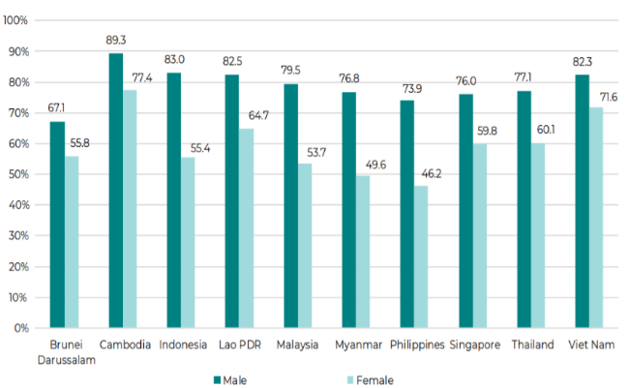
More recently, the number of employed persons declined in the manufacturing sector as a result of the continued contraction of exports and the slowdown in domestic demand. Some workers have given up job-seeking and are therefore excluded while others have taken early retirement and are not counted in the labour force. Other workers confront a skills mismatch given their educational levels or fields of studies. Nearly 15 per cent (about 1.4 million) of people aged 15 to 24 are not in employment, education or training (NEET), two-thirds of whom are women. The youth unemployment rate of 4.9 per cent is five times that of the total population with young women more likely to be unemployed (5.9 per cent) than their male counterparts (3.9 per cent). Nevertheless, when comparing Thailand to other regional countries, it has one of the lowest youth unemployment rates as opposed to Malaysia (11.2 per cent), Indonesia (16.3 per cent) and India (22.5 per cent).
The impact of digitalization and automation, and the transition to Industry 4.0 is expected to be significant. Digitalized machinery and learning robotics, instructed by optimizing software that is constantly updated by the internet of things and artificial intelligence, can cause job losses as well as employment displacement inequitably borne by women. For example, the digitalization and automation of routine, labour-intensive and codifiable work processes and services could displace 11 per cent of the female workforce, and 9 per cent of the male workforce. Over 80 per cent of the jobs in textile and apparel industries in several ASEAN economies, Thailand included, are expected to be lost to robots and digitalized machinery. Young women comprising the large majority of the 9 million workers dependent on those activities.

Competitiveness and Innovation
Thailand has made impressive gains in recent years in the ease of doing business index and performs well in competitiveness but lags somewhat in innovation. In 2018, Thailand ranked 21st among 190 economies in the ease of doing business, up from 48th in previous years (Figure 8). The 2020 rankings showed that Thailand had moved up a further five places. Key reforms that have helped include streamlining requirements to start a business, introduction of an automatic risk-based system to select companies for a tax audit, and a broadening of the scope of assets that can be used as collateral. Even though Thailand performs well in competitiveness, it struggles in key areas. Areas that hold Thailand back include innovation capacity, skills, ICT adoption and institutional arrangements, which are all critical elements of reform needed to keep Thailand’s economy transforming and growing.
Box 10 Capitalizing on upcoming Economic Agreements
It is forecast that the Regional Comprehensive Economic Partnership (RCEP) will increase Thailand’s trade competitiveness and boost GDP by about 0.5 per cent by 2030. In the medium to longer term, following gradual liberalization, the recently signed pact will open up business opportunities for key exports including agriculture products, electronics and other manufacturing goods, as well as strengthen supply chain linkages with the other members.

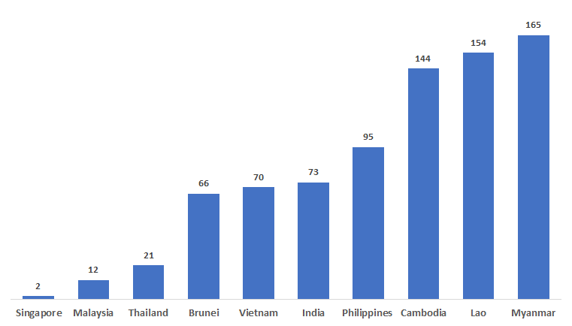 | 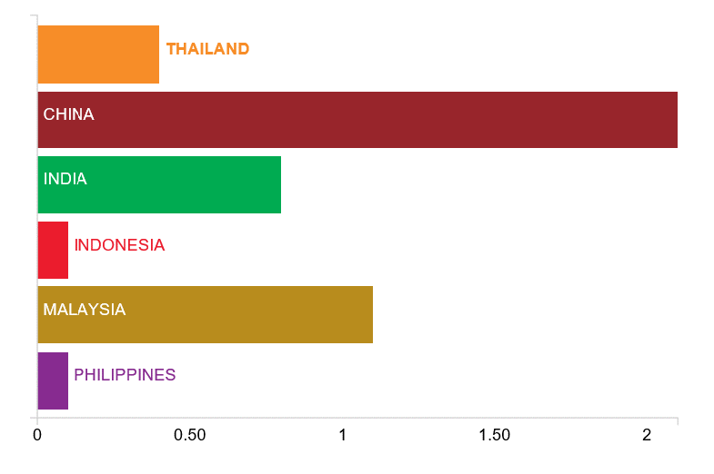
Figure 8 ASEAN – Ease of Doing Business Ranking  Source: https://www.doingbusiness.org/content/dam/doingBusiness/country/t/thailand/THA-LITE.pdf | Figure 9 Gross Expenditure on R&D, (% GDP)  Source: World Bank 2015 data

Informal Employment
Informal employment as a share of total employment accounts for 64.4 per cent of Thailand’s workforce, with 65.2 per cent of workers in this sector being women. This is in line with the Asia-Pacific region as a whole where the informal sector also accounts for a similar portion of the workforce and about 36 per cent of GDP. Women are more likely than men to be self-employed or in unpaid family labour, which is especially the case as the country experiences a demographic transition to an aged society. In addition, female heads of household working in the agricultural sector tend to have lower level of education, lower income, higher debts from the informal sector, and much less land tenure than male heads working in agriculture. The high proportion of informality in the economy raises concerns for workplace safety, job security and other social protection.
Figure 10 Informal Employment Rate by Sex (%)
Source: The Informal Employment Survey 2018, National Statistical Office, cited in ‘A Better Understanding of Thailand’s Informal Sector’, Bank of Thailand.

Thailand is confronted with the middle-income trap in which low-paid workers combined with relatively low levels of productivity, innovation and technological acquisition are insufficient to propel the country to the next level. The country continues to depend on the same model of development that lifted it out of poverty – namely, cheap labour, lower levels of innovation and technological acquisition achieved principally through importation. This model is not sufficient to propel Thailand into higher levels of income. There has been a shortage of both skilled and lower-skilled labour for many years and a reliance on low-paid migrant workers to fill labour market gaps. Thailand’s education system has been unable to prepare graduates adequately for the labour market, which is increasingly facing global competition. For example, Thailand’s labour-intensive exports are increasingly squeezed by competition from lower-cost producers in low-income countries and better-quality exports from higher-income ones. Rising production costs are also eating into Thailand’s competitiveness in garments, food products, auto parts and electronic components, which are being squeezed by products from other countries in the region.

Household Debt
Thailand experiences high levels of household debt, which could expose the country to financial and macroeconomic instability. At 80.1 per cent of GDP, household debt (Figure 11) is among the highest in the region and is well above average for a country in the upper middle-income range. Hence, in absorbing risks, for example, from medical care, the debt burden from deceased family members, liabilities from accidents or damages to property from hazards and disasters all compound peoples’ vulnerability to poverty. If the ability of households to service their debt is in doubt, loan losses could be significant and increase the fragility of the financial system. The high level of indebtedness constrains households’ access to credit and limits their ability to be consumers over time. This reduces the role of domestic demand as a shock absorber and increases economic volatility. Furthermore, the ratio of Thailand’s non-performing loans has been rising over the past five years in line with the deteriorating quality of consumer loans across all loan categories, especially credit cards and personal loans (Figure 11).

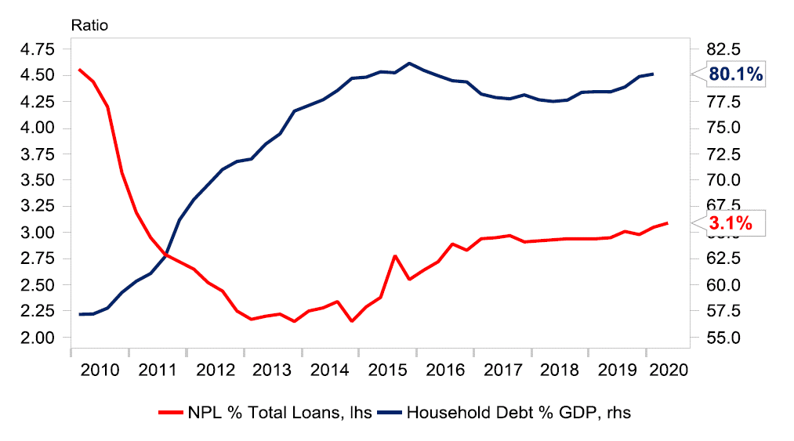
Figure 11 Thailand’s Household Debt Levels & Non-Performing Loan
Note: Bank of Thailand data

SOCIAL SECTOR

Demographics
Thailand is experiencing a demographic transition. With population growth down and fewer working-age people, the country is becoming an ‘aged society’. Over recent decades Thailand achieved continued progress in bringing down the population growth rate, lengthening life expectancy at birth and lowering its infant mortality rate. This has been largely achieved through improvements in rural development, universal health coverage, the better quality of and access to education and reproductive health services, and improved gender equality. This has resulted in changes in the age structure, with a greater share of working-age people and fewer young dependents allowing the country to benefit from the demographic dividend. At the same time, steadily declining fertility has resulted in shrinking the combined proportion of young people and working-age people between the ages of 15 and 60 relative to the overall number of older people. This effectively makes Thailand an ‘aged society’ with more than 10 per cent of people aged 60 and above since 2015. Thailand is predicted to be a ‘completed-aged society’ in 2021 and a ‘super-aged society’ in 2031. Within this transition, 2025 will become the ‘cross-over year’, with the number of older persons exceeding the number of young people. Over the long term, the number of older persons will continue to rise from approximately 10.7 million in 2015 to 18.7 million in 2030 and to about 23 million by 2050. Thailand’s current population of around 69.8 million will reach its peak in 2028 at 70.4 million people before eventually decreasing to about 65 million by 2050 (Figure 12).
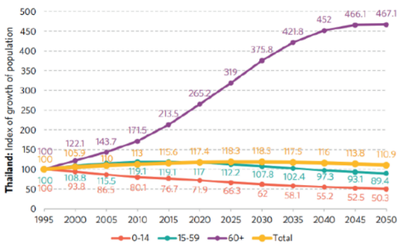
Figure 12 Projected Growth of Thailand’s Population by Age Group, 1995-2050
Source: UNFPA, Population and Development for a Sustainable Future in Thailand, 2020.
The speed of Thailand’s demographic transition is swift when compared to other countries and presents a particular range of challenges. Thailand’s transition to an ageing population appears quite acute, eclipsed only by that of Singapore, and the Republic of Korea. The speed of demographic transition stands in contrast to developments in most advanced ageing countries and Thailand will face issues in social security, healthcare costs and intergenerational equity in a far shorter time than has been the case in other nations. As a consequence, the age dependency ratio of youth and older persons will increase from 56 per cent in 2020 to 81.6 per cent in 2040. Hence, Thailand needs to prepare for a long period of a high dependency ratio, accompanied by the need to raise productivity, strengthen social protection and intergenerational support. The obvious challenges include the strain placed on pension systems, pressures on young adults, in particular women, to support their parents, increasing care needs and rising healthcare costs. There will be fewer working people to support a larger base of older people and fewer students enrolling in schools, colleges, and universities. This can lead to a shortage of qualified workers, making it more difficult for businesses to fill in-demand roles. An economy that cannot fill key occupations can face declining productivity, higher labour costs, delayed business expansion and reduced international competitiveness.
On the other hand, the same demographic conditions that are producing an end to the demographic dividend may yield a longevity dividend. Whether increased longevity is a burden or a dividend depends on the extent to which Thailand prepares for the challenges of ageing populations and plans to leverage the benefits. One of the most tangible benefits of living and working longer is the retention of skills and knowledge. Older workers have formal and technical skills that they have accumulated through long service. Employers in sectors that are facing labour shortages can seek to acquire such skills through programmes such as mid-career apprenticeships. Older workers can guide younger ones towards pathways to secure well-paid work through mentoring and job sharing. Many older people also take on caring roles such as looking after grandchildren and elderly parents. The longevity dividend, like most economic benefits, is attainable but needs to be worked for. Mobilizing older workers’ experience, knowledge and skills will mean that rising life expectancy can be both socially and economically rewarding.
Population migration continues to offer opportunities for Thailand’s economic development. One side-effect of the consistently low rates of unemployment and the above demographic shifts among Thai nationals is a structural reliance on migrant workers, who comprise almost 80 per cent of the total workforce in some sectors, such as fishing, and a high proportion in construction. Thailand’s demand for migrant workers, especially in lower- and mid-skilled jobs, is predicted to continue based on this demographic transition and in response to increased demand particularly related to caregiving and infrastructure projects (also Box 11).
Box 11 Migrant Workers in Thailand
There are an estimated 3.9 million migrant workers in Thailand, equal to 5.6 per cent of the country’s population and 10 per cent of Thailand’s total labour force. Most of these workers are from neighbouring countries. There is an absence of confirmed data on irregular migration in Thailand. Estimates of the proportion of irregular migrant workers among the total migrant workers population in Thailand range from 20 per cent to 50 per cent.

Human Development and Human Capital
Box 12 Thailand’s Progress on Human Development and Human Capital
Thailand compares well with its peers, with girls excelling boys, although Thailand’s Human Development Index (HDI) appears to have been improving at a slower pace in the past few years. Between 1990 and 2019, Thailand’s HDI increased by over 33 per cent and for 2019 had a value of 0.777, which puts the country in the high human development category, positioning it at 79 out of 189 countries and territories.
In the same period, Thailand’s life expectancy at birth increased by seven years, mean years of schooling increased by 3.4 years and expected years of schooling increased by 6.5 years. Thailand’s GNI per capita also increased by over 150 per cent. Thailand is above the average of 0.750 for countries in the high human development group and above the average of 0.741 for countries in East Asia and the Pacific.
However, rates of progress have showed signs of slowing since 2017/. Between 2010 and 2020, Thailand’s Human Capital Index (HCI) also increased, from 0.58 to 0.61, which is also higher than the average for East Asia and the Pacific region and upper-middle-income countries. Thailand’s HCI for girls at 0.63 is higher than that for boys at 0.59. Human capital from health and education perspectives is discussed further in the following section, showing Thailand’s progress in each of the HDI indicators. Further information on the Gender and Inequalities HDI provided at Technical Annex at Tables 3 - 6.
Source: http://hdr.undp.org/en/countries/profiles/THA.

Table 2 Thailand’s HDI 1990 - 2019
 | Life expectancy at birth | Expected years of schooling | Mean years of schooling | GNI per capita (2011 PPP US$) | HDI value
1990 | 70.2 | 8.4 | 4.6 | 6,562 | 0.574
1995 | 70.2 | 9.6 | 5.0 | 9,180 | 0.611
2000 | 70.6 | 11.2 | 6.1 | 9,004 | 0.649
2005 | 72.1 | 12.7 | 7.0 | 11,008 | 0.693
2010 | 74.2 | 13.3 | 7.3 | 12,921 | 0.721
2015 | 76.1 | 13.9 | 7.6 | 14,466 | 0.746
2016 | 76.4 | 14.3 | 7.6 | 14,966 | 0.753
2017 | 76.7 | 14.7 | 7.7 | 15,548 | 0.762
2018 | 76.9 | 14.7 | 7.7 | 16,129 | 0.765
2019 | 77.2 | 15.0 | 7.9 | 17,781 | 0.777
Source: http://hdr.undp.org/en/countries/profiles/THA.

Health, Nutrition and Sanitation
Thailand has been making good progress on most of its health SDG targets with widespread universal healthcare, financial protection, reproductive health and vaccination coverage being achieved alongside reductions in maternal, infant and under-5 mortality rates (Box 13). However, a key concern is the recent increase in stunting and wasting among children under age 5. The extent of universal health coverage (SDG 3.8) and financial protection has increased from 59 per cent of the population in 2010 to 85 per cent in 2019. However, there are still challenges in relation to unwanted pregnancies, abortion and sexually transmitted infections (STIs), the last of which is rising among young adults. In the four main areas, the indicators are good, except for tuberculosis treatment. Since 1980, the national immunization programme has been rolled out successfully nationwide, but with a slight curtailing of rates in the past couple of years. Ninety-five per cent of provinces benefit from over 80 per cent coverage for critical vaccines, although coverage is poorest in the Southern Border Provinces. The nutritional status of children under 5 years of age is a concern with over 13 per cent of children under 5 being stunted, nearly 8 per cent affected by wasting and over 9 per cent overweight, indicators that have deteriorated in the past few years.
Box 13 Progress in Key Health Indicators
The maternal mortality ratio (MMR) is 37 maternal deaths per 100,000 live births, and the Infant Mortality Rate (IMR) and the under-5 mortality rates are at 7.8 and 9.1 per 1,000 live births*, respectively. Hence, maternal and neonatal mortality rates are well below the global targets, due largely to 99.6 per cent of births being attended by skilled health personnel and around 98 per cent of pregnant women have prenatal care for at least one visit, while 71.3 per cent receive prenatal care in the first 12 weeks of pregnancy**.
Note:
* MOPH, 2019 records MMR at 21.8 maternal deaths per 100,000 live births see (WHO SE Asia, Factsheet 2020, Thailand, Expanded Programme on Immunization)
** The coverage of eight out of the nine key maternal neonatal and child health intervention dimensions is high, except for the early initiation of breastfeeding. In addition, contraceptive prevalence continues to be high at over 70 per cent of married women aged 15-49 years since 1987, reaching 78.4 per cent in 2015. See 25 Years after the ICPD: Population and Development for a Sustainable Future in Thailand, UNFPA, 2020:……………………………………………………………………. (https://thailand.unfpa.org/sites/default/files/pub-pdf/icpd25report-download)-compressed-final-2020.pdf.
Box 14 Non-Communicable Diseases in Thailand*
Of the causes of death in Thailand, those from non-communicable diseases (NCDs) account for 71 per cent of the total. As the number of older persons increases, it is likely the burden of NCDs will too. Cardiovascular diseases account for 29 per cent of deaths followed by cancers (17 per cent) and chronic respiratory diseases (9 per cent). Communicable diseases and maternal, perinatal and nutritional conditions account for 18 per cent of deaths. Injuries account for 11 per cent.
Source:
* Social Impact Assessment of COVID-19 in Thailand, United Nations in Thailand, OPM, 2020
Thailand faces persistent challenges in addressing priorities in non-communicable diseases (NCDs) among its increasingly aged population, noting that cardiovascular diseases and cancers account for nearly 56 per cent of deaths, road traffic accidents are among the highest in the world, and the burden of dealing with mental health conditions is rising. In addition to non-communicable diseases (Box 15), persistent challenges include tuberculosis; HIV/AIDs; reproductive, maternal, new born, child and adolescent health challenges (including teenage pregnancy); road traffic accidents; and migrants’ health. Performance on NCDs also lags behind and, because such diseases are growing, so is the increased demand for health services and associated increased healthcare costs. Compared to ASEAN nations, Thailand suffers 25.2 deaths per 100,000 people from road and traffic accidents, ranked second highest in the world. While the rate of access to basic sanitation rates is high at 95 per cent, the remaining 5 per cent prove hard to reach, especially among the non-Thai population. This serves to marginalize them and expose them to greater health-related risks. There are also signs that the burden of mental health conditions and disorders is increasing in Thailand./
Box 15 The Status of HIV in Thailand
HIV reversed from being a generalized to a concentrated epidemic between 1993 and 2006 with a similar decline of HIV prevalence in pregnant women from a peak of 2.3 per cent in 1995 to 0.5 per cent in 2012. By the end of 2015, new paediatric HIV infections had declined and the mother-to-child HIV transmission rate* had fallen significantly from 10.3 per cent in 2000-2003 to 1.68 per cent in 2017**. In 2019, in total, there were 5,400 new infections, 14,000 AIDS-related deaths and around 470,000 people living with HIV (PLHIV)***. HIV prevalence however remains high among key populations**** with about 50 per cent of new infections being among young people aged 15 to 24 years.
Note:
* In 2016, Thailand became the first country in Asia and the second country in the world to eliminate the mother-to child transmission of HIV and syphilis (WHO)
** MOPH, 2019, cited in 25 Years after the ICPD: Population and Development for a Sustainable Future in Thailand, UNFPA, 2020
*** In the year 2019 population rates, per 1000 people, of new HIV infections was 0.14 [ [0.13-0.15]
**** 11.9 per cent men who have sex with men, 11 per cent transgender women, 7.8 per cent people who inject drugs, 3.8 per cent male sex workers and 2.8 female sex workers.
While Thailand has been acknowledged for reducing TB and malaria cases and has made notable progress on HIV and AIDS, it has not met its declaration targets. Both the ratio of tuberculosis (171 tuberculosis cases per 100,000 people) and the ratio of malaria (37.9 cases per 1,000 people) continue to decrease, thanks to prevention, education and the distribution of treated bed nets. However, efforts must be sustained as mobile populations such as migrant workers often lack access to treated bed nets and basic knowledge on symptoms and treatment options. Furthermore, it is estimated that there are many patients with chronic hepatitis B and C. Regarding the response for HIV (Box 15), Thailand provides antiretroviral treatment (ART) for free as part of Universal Health Coverage (80 per cent of PLHIV are currently on ART). Notwithstanding these important gains, Thailand has not yet met the 90-90-90 global targets among marginalized populations and inequality of access in HIV testing and treatment has been observed, which is a critical gap to achieving the life-saving treatment targets.
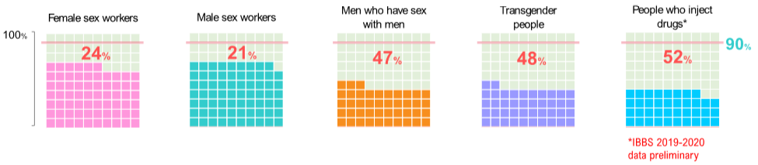
Figure 13 HIV Testing Coverage among Key Populations
Source: UNAIDS, 2020

Education and Training
Educational enrolment and completion rates have risen significantly since the 1990s, although completion rates at higher education level are much higher for girls than boys. Since primary and lower-secondary education is compulsory in Thailand and nationwide education is virtually universal. However, enrolment rates drop off at age 15 when compulsory education ends. Among older children, gender differences emerge, with boys being more likely to cease their education once compulsory schooling had ended. Among young adults (18 to 26 years), 7 per cent of women’s highest level of education is the completion of primary school, while 14.2 per cent of men have completed primary school as their highest level. Older women also have higher education completion, for example, among 24 to 26-year-olds, 43 per cent completed post-secondary education compared with only 26 per cent of men (Figure 14). Girls outperform boys in reading, mathematics and science and are more likely than boys to continue into higher education. In addition, over 86 per cent of children aged 3 to 5 years now attend Early Childhood Centres (ECD) or pre-primary education along with three years of free pre-primary education through kindergartens (attached to primary schools). Nearly 16,000 ECD centres reach over 1 million children with over 98 per cent of children attending first grade of primary school having attended pre-school in the previous year.
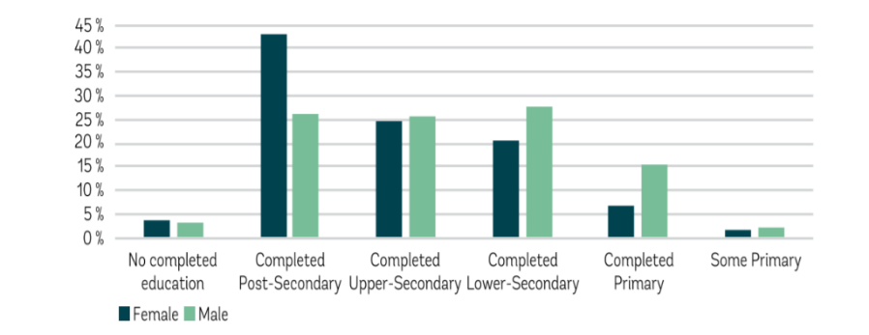
Figure 14 Education Completion Rates of 24 to 26-Year-Olds
Source: Taking the Pulse of Poverty and Inequality in Thailand, World Bank, p.55 (World Bank staff calculations using THA SES 2017).
The quality of Thailand’s education system appears to have worsened relative to its ASEAN neighbours, when assessed against mathematics, science and reading, leading to recommendations for education reform. Thailand’s education system fares less well when compared to other OECD countries (Figure 15), with average scores among 15-year-old students well below their overseas counterparts in reading, mathematics and science. Thailand's Programme for International Student Assessment scores are much lower than high-income countries in the region, though higher than Indonesia and the Philippines. Despite 93 per cent of children being developmentally on track, nearly 85 and 40 per cent of children respectively are off-track in the ‘social-emotional’ and ‘literacy-numeracy' domains. The latter is especially critical as a domain for establishing future educational outcomes and lack of progress often negates the overall investments being made in ECD.
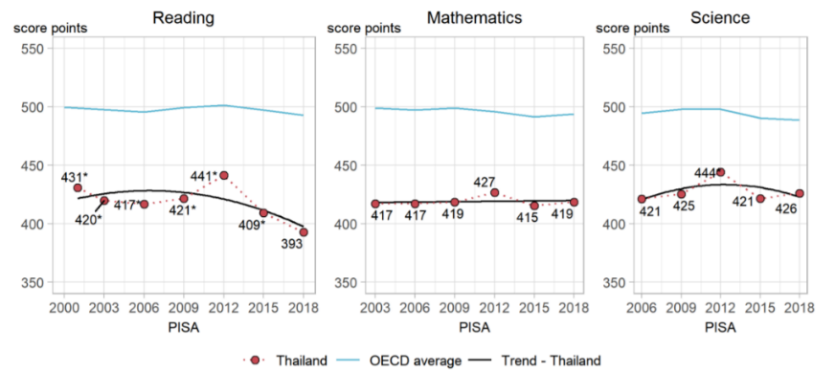
Figure 15 Trends In Performance In Reading, Mathematics And Science Among 15-Year-Old Students In Thailand
Source: Thailand, Country Note, 2018. The Programme For International Student Assessment (PISA): Http://Www.Oecd.Org/Pisa/Publications/PISA2018_CN_THA.Pdf.
Thailand’s reading performance shows an increasingly negative trajectory, while scores in math and science have stagnated. In 2018, around 60 per cent of students scored below the minimum proficiency level in reading. More than half (53 per cent) were unable to attain the minimum proficiency level in mathematics, while 44 per cent failed to reach basic proficiency in science.
Educational inequalities exist and are broadening in Thailand when viewed by outcomes across regions and socioeconomic status, with clear differences in rural and urban settings, as well as by status and ethnicity. Children from poor rural populations and linguistic-ethnic minorities have markedly lower enrolment and graduation rates than the population as a whole. An estimated 200,000 migrant children remain out of school. Forty-seven per cent of 15-year olds attending village schools are ‘functionally illiterate’, whereas that figure reduces to 31 per cent for small towns, and 16 per cent for large cities. Small village schools serving disadvantaged children are also inadequately endowed with educational materials and infrastructure. Disruption in education is disproportionately higher in the Southern Border Provinces, where 5.6 per cent of children are not enrolled in school. Inequities in education outcomes are revealed by disparities in performance across sociodemographic characteristics such as gender (in favour of girls), socioeconomic status (in favour of advantaged students), school ownership types (in favour of students in private independent schools), school community types (in favour of students in urban school communities), and language (in favour of those speaking at home the language of the test).
Nearly 40 per cent of children with disabilities are out of school and face a range of barriers to access quality education. According to the 2017 Disability Survey, of the 17.4 million school-going population, 1.5 per cent had disabilities. Thirty-eight per cent of children with disabilities were out of school at the time of the survey. Within the education sector plans, social, economic, geographical, and other determinants of exclusion are not acknowledged comprehensively and segregation through special schools persist (refer LNOB section).

Social Protection
In relation to other countries in the region, Thailand has a relatively well-developed social protection system, with high levels of coverage but faces increasingly challenges in terms of coordination and the adequacy of benefits. In total, 44 welfare programmes managed by 11 Ministries support people in different age groups. Between them, the Ministry of Social Development and Human Security (MSDHS), the Ministry of Interior, the Ministry of Agriculture and Cooperatives, and the Ministry of Education run 27 cash welfare programmes in addition to 17 non-cash programmes. Non-contributory welfare programmes are complemented by a comprehensive social insurance scheme managed by the Social Security Office (SSO), which provides a number of core benefits. However, key service delivery and access issues include a lack of coordination within the sector and the issue of exclusions in eligibility, including based on migration status and sector of employment, due in part to inadequate targeting. Information silos perpetuate fragmented and inconsistent management information systems as well as the lack of a harmonized social registry. Inadequate coordination is a bottleneck to providing integrated social transfers and services to the neediest. On the positive side, most transactions are via an electronic payment system direct to recipient bank accounts. Similarly, social welfare cash benefits are delivered through an e-voucher for use in registered stores. Other barriers to the system include language, poor enforcement of registration rules for employers and the high degree of mobility. In terms of public expenditures on social protection, Thailand ranks in the middle compared to its ASEAN peers.
Box 16 Barriers for improving access of children with disabilities for quality education.
The barriers for improving access of children with disabilities for quality education include:
- Generating reliable data on children with disabilities,
- Addressing discriminatory attitudes toward children with disabilities and promoting strategies for inclusive education,
- Appropriate infrastructure, learning material and assistive technologies.
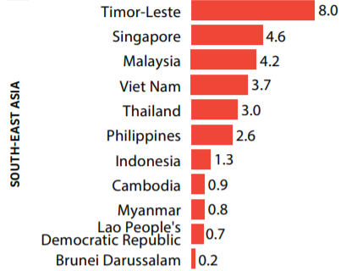
Figure 16 Public Expenditures on Social Protection
Source: The Protection We Want, Social Outlook for Asia and the Pacific, UNESCAP & ILO, 2020.
Thailand’s social protection sector has evolved from a system designed for formal sector workers to one with an increased emphasis on the informal sector. Universal schemes, such as social pensions and social health protection have the highest level of coverage. However, in the case of pensions, the adequacy of benefits is low. Both Thais and those migrants who are eligible to enrol in the social security system are protected through the provision of various benefits. Several schemes include provision for both Thai and migrant employees who have worked 15 years or longer. However, an estimated one-third of regular migrant workers are employed in the informal sector and do not qualify for the Social Security Scheme (SSS) with women migrant workers facing specific gender-based barriers. For example, many migrant women work in domestic work, an occupation that is largely excluded from protection under SSO. As of November 2018, out of nearly 3.9 million non-Thai migrant workers present in Thailand, 863,000 migrants and their dependents had successfully enrolled in the Migrant Health Insurance Scheme (MHIS), which provides health coverage for migrant workers excluded from the SSS. Refugees are not able to access national health insurance on account of their lack of legal status in Thailand. In general, registered stateless persons in Thailand have access to health insurance (under the Healthcare Fund for Persons with Legal Status Problems), but not all stateless persons are automatically entitled to coverage.

Child Protection
The true scale and prevalence of violence, exploitation, abuse, and neglect of children in Thailand is unknown. Administrative data provides some account of cases that reach the government system. Statistics in 2019 revealed 7,670 children, of whom 6,686 were girls, received support from hospital One Stop Crisis Centres. This mean 21 children were abused and reported each day (or almost one case per hour), in the form of sexual abuse (5,182 children), physical abuse (1,806 children), psychological abuse (305 children) and neglect (284 children). According to data form OBEC from 2013 to 2015, at least 1,186 students had been sexually abused and 105 students reported that perpetrators were teachers. Violence continues in schools and other settings on both online and offline platform. These numbers are likely to reflect a minor fraction of actual child protection cases. According to the MICS survey 2019, the percentage of children aged 1 to 14 years who experienced severe physical punishment was 2.2 per cent which represents about 249,624 children. This reflects that children who accessed the One Stop Crisis Centres account for about 3 per cent of children that might have needed help. Violence in childhood can have immediate physical, emotional, and developmental impacts, as well as to problems well in adulthood. It also has a significant macro-economic impact. A UNICEF regional study estimated that violence against children is costing upper-middle-income countries in East Asia and the Pacific more than an estimated 3.45 per cent of GDP.
Thailand has developed a child protection system that has been a model for other countries in the region but needs to extend services to a greater number of children at the community level. Most specialized services are located at the provincial level in the Provincial Shelters for Children and Families and in One Stop Crisis Centres in government hospitals at the district level. While some effort has been made to increase social welfare and child protection at the sub-district level, child protection has not yet been formally taken up in the decentralization agenda. Thailand’s workforce is also limited with 3,008 registered (2,176 licensed) social workers in Thailand as of 2018, providing a ratio of 20.1 social workers per 100,000 children.
Thailand’s child protective services are arranged mainly around a rescue and rehabilitation model, with prevention and family support receiving less emphasis. Thailand depends largely on shelters and One Stop Crisis Centres to address the most serious cases. Some regions are seeking to address this through stronger surveillance measures coupled with parenting programmes for families, which are at risk of child abuse. Many children also end up in residential care for reasons of poverty and access to education when these issues would have better been addressed through family support to allow the child to stay at home instead of being institutionalized.
Justice for children has also continued to develop in Thailand to position a range of actors to protect children from violence, exploitation, abuse, and neglect. The Office of the Attorney General is investing in providing specialized child protection training to public prosecutors while strengthening nine Regional Centres on the Protection of Children, Youth and Family Rights. Thailand is also strengthening its pre-trial alternative measures, increasing the rate of these from 1.47 per cent in 2016 to 46.7per cent of qualified cases in 2019. Likewise, alternatives to detention are increasingly being utilized by Juvenile and Family Courts to find ways to rehabilitate children instead of sentencing them to detention. The efforts include exploration of community-based mechanisms and strengthening employability with the objectives to improve the efficiency of reintegration and reduce recidivism. Thailand is considering raising its minimum age of criminal responsibility from 10 to age 12 years of age.

ENVIRONMENT SECTION

Biodiversity and Natural Resources
Extensive degradation to the natural environment has led to 468 species threatened with extinction. Thailand is located within two major biogeographical regions (the Indochinese and the Sundaic), making it one of the most biodiversity rich countries in the world. The country comprises 15 mountain ranges and 22 watersheds that form the main river basins, connected to the Mekong River, the Gulf of Thailand and to the Andaman Sea. This major junction of land, river and seascapes provides a variety of ecosystems that create the conditions for 15,000 plant species, representing 8 per cent of the world’s total, to flourish. / The species currently at risk of extinction, include 58 mammals, 70 birds, 38 reptiles, eight amphibians, 61 fish, 44 invertebrates and 189 plants. This is comparatively high compared to other countries in the region.
Box 17 Environmental risk factors
Thailand faces further environmental degradation, loss of its biodiversity*, declining wildlife populations, deforestation, creeping desertification, water scarcity, climate change and air and water pollution. Furthermore, these negative impacts of economic growth, when taking into account the COVID-19 pandemic, has made more evident the strong links between ecosystems and human health. Over encroachment on ecosystems results in declines in species diversity, as well as polluting the land, seas and air, all of which increase our exposure to zoonotic diseases. This is evidenced in the 2019 Human Development Index (HDI) where Thailand’s otherwise quite impressive 0.777 measure falls by nearly 8 percentage points to 0.716**.
Source/Note:
* In 2016 Thailand had 58 threatened mammal species, 54 threatened bird species, 106 threatened fish species and 152 threatened plant species on this list, which is comparatively high compared to other countries in the region. Thailand’s landscape also comprises a wide range of habitats that support diverse flora and fauna populations. At least 15,000 plant species have been identified in the country, representing 8 per cent of the world’s total. Thailand is a sanctuary for world rice species with over 10,000 varieties. However, there has been a rapid genetic erosion of rice due to urban rice paddy cultivation and farmers’ preference over prolific species (with less conservation of indigenous crops).
** http://hdr.undp.org/en/countries/profiles/THA.
A recent UN study identified that financing of up to 1 billion dollars was needed for Thailand to achieve its National Biodiversity Strategy and Action Plan (NBSAP). Other important challenges include the general lack of awareness, knowledge and understanding of the value, importance and benefits arising from the conservation and sustainable use of biodiversity resources, including a lack of qualified personnel in the sector. Limited awareness of the environmental role performed by biodiversity and healthy ecosystems, such as watersheds, river basins and coastal areas and their significance for supporting people’s livelihoods with links to agriculture, fisheries, recreation and tourism, among others has also contributed towards the lack of resources available and allocated to support conservation efforts.
Box 18 Eco Tourism
Consensus supports not going back to normal in tourism in Thailand in light of COVID-19. Normal was low-value tourism, pollution, congestion, and a prevalence of unskilled work by an informal labour force without social protection. This model was already increasingly questioned and meant Thailand was losing competitive edge. A new tourism model for Thailand offers the possibility of jobs with higher skills, higher productivity, and higher wages. Linked to this is recognition that Thailand’s old tourism model depleted the natural assets that made Thailand special, with environmental impacts threatening its tourism future. This will need to preserve and build on these natural assets including Biosphere Reserves and world natural and cultural heritage if the country is to remain a special destination that can attract high-spending tourists. This sets a store on environmental protection and biodiversity conservation both on land and under water which will need to be centre stage in COVID-19 recovery.
Thailand’s marine ecosystems of coastal mangroves, coral reefs, and fish stocks, upon which local livelihoods are based, have been severely degraded and remain under continuous threat. Mangrove forests are a crucial component of Thailand’s ecosystems that constitute about one-third of its coastal areas, providing food sources, nursery grounds, and habitat for various animals, as well as natural resources for people, such as fishers, shrimp farmers and charcoal producers who benefit from these productive ecosystems. Yet in less than 20 years, the area of mangrove forests in Thailand has been almost halved and deforestation continues. The primary reason for this is large-scale encroachment of aquaculture ponds for intensive shrimp production into forested areas. Nevertheless, Thailand still remains one of the leading aquaculture producers in the world, and the small areas of remnant mangroves in the country have been more heavily protected to mitigate further negative impacts. About 80 per cent of Thailand’s 24,000 hectares of coral reefs are classified as ‘severely damaged’ due mostly to increase in sea temperatures.
Table 3 Species at Risk of Extinction in Thailand, Cambodia, Lao PDR, Myanmar and Viet Nam
Country | No. of Species at Risk of Extinction
Thailand | 468
Cambodia | 192
Lao PDR | 281
Myanmar | 273
Viet Nam | 608
Source: World Bank 2017. “World Development Indicators: Deforestation and Biodiversity”.
Thailand is home to three dominant types of tropical forest (monsoon, rain and mangrove forests), all of which have experienced substantial deforestation, while reafforestation efforts have progressed at a slower pace. Similar to other developing countries in the region, forests in Thailand have been disappearing due to massive deforestation and lack of care for those that remain. Forest cover declined from 53.5 per cent in 1961 due mainly to population growth, agricultural expansion, illegal logging, and uncontrolled forest fires. Forest areas today cover 32 per cent of the country’s total area, with at least 20 per cent composed of conserved forests./ Reafforestation has been a part of the national agenda for some time. However, for several decades, key drivers of deforestation hinder Thailand from attaining noticeable progress, including illegal land clearing, logging and wood export, encroachment on forests, agro-industrial mono-cropping, resort development projects, mining and the construction of roads and hydropower dams. Underlying causes of such degradation relate to the insufficient value placed on nature and biodiversity alongside inadequate stewardship of the natural environment.
Thailand’s rich natural resource and bio-diversity endowment has underpinned much of the country’s wealth creation. However, unsustainable development in the form of industrialization, urbanization, pollution, tourism, and large-scale infrastructure, combined with inadequate management of nature, has led to environmental challenges. Thailand’s rich natural resources have long supported local livelihoods, helped to drive economic growth and contributed significantly to its wealth and competitiveness, but rapid economic growth has also resulted in environmental degradation. For example, forests, watersheds, marine environments and mineral resources have all been instrumental in supporting the manufacturing, export and tourism industries. However, the value and contribution of these resources are often not fully reflected and integrated in economic planning and decision-making processes. Rapid economic development over the past several decades has often occurred through the unsustainable exploitation of natural resources with short-term economic priorities too often taking precedence over conservation. And while tourism makes a substantial contribution to the national economy, rapid growth has also resulted in adverse environmental impacts and natural resource depletion.

Greenhouse Gas Emissions and Climate Change
While Thailand's share of global GHG emissions is less than 1%, it remains among the top 30 emitting nations, reflecting its substantial impact on the worldwide emissions landscape with its energy, industrial, transport, and agriculture sectors playing a significant role. Being one of the fastest-growing energy-intensive economies in Southeast Asia, Thailand produced a total of 263.223 million tonnes of CO2eq emissions in 2016 including next sequestration of GHG emissions in land use, land-use change and forestry (LULUCF) (Third Biennial Update Report to the UNFCCC, 2020), placing it 22nd on the list of nations with the highest GHG emissions. In 2016, 71.65 per cent emissions were from energy generation and use, 14.72 per cent from the agriculture sector, 8.9 per cent from industrial processes and product use, and 4.73 per cent from the waste sector. The energy related emissions have increased by about 54 per cent between 2000 and 2016. Within energy use and production related emissions, energy industries (electricity production and other energy conversion processes) account for 42.84 per cent, transport sector accounts 27.21 per cent and the manufacturing, industrial and construction sectors’ energy consumption contributes 19.53 per cent.
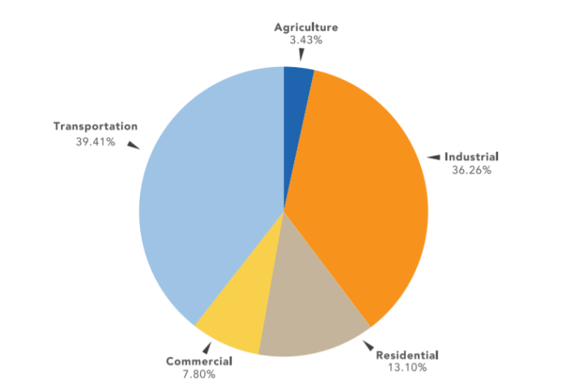
Figure 17 Share of Final Energy Consumption by Economic Sectors 2018
Source: Our World in Data: Thailand: CO2 Country Profile
(https://ourworldindata.org/co2/country/thailand?country=~THA).
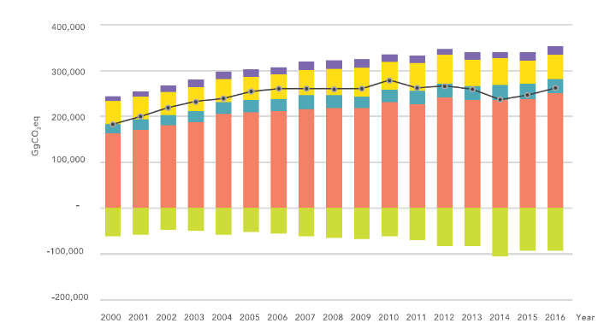 | 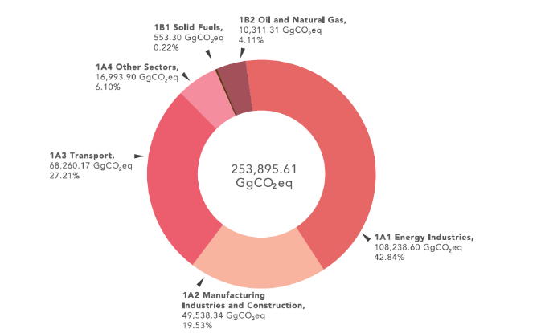
Figure 18 Growth in GHG Emissions and Removals by LULUCH by Sectors 2000 – 2016  Source: Third Biennial Update Report to the UNFCCC, 2020 | Figure 19 GHG Emissions in Energy Sector 2016  Source: Third Biennial Update Report to the UNFCCC, 2020
The Government of Thailand recently started to make inroads into mitigating GHG emissions, while at the same time, the country is extremely vulnerable to the impacts of climate change. In terms of progress, by the time of the COP 25 in 2019, it had successfully secured a 14 per cent GHG reduction in the energy and transport sectors. At the same time, the Government committed that GHG emissions would be reduced by 20 to 25 per cent from BAU level by 2030 (Figure 20) through renewable energy technologies and energy efficiency improvement measures in both the supply and demand sectors. Thailand has not yet developed a long term emission reduction strategy for 2050 or defined a carbon neutral target. One of the key challenges for Thailand’s GHG emissions in the long run would be its use of coal. The data from the Energy Policy and Planning Office (EPPO) indicates that coal-based power accounted for 39.15per cent of power sector GHG emissions in 2019. The Electricity Generating Authority of Thailand (EGAT) energy plan developed in 2018 has focussed on natural gas instead of coal. The country has significant renewable energy potential and with falling prices it will be economically viable to enhance renewable energy targets instead of coal.
As the Government addresses the challenge of reducing GHG emissions, the country remains vulnerable to the impact of climate change. It has led to more extreme weather events, including dry spells, flash floods and tropical storms, which in turn have become more frequent and intense. Sea level rise threatens significant population centres, including Bangkok. Climate change impact constitutes one of Thailand’s greatest risk factors (see MDRA in Box 1). Analysis suggests that weather-related disasters can lower the life expectancy of women more than men leading to higher female disaster mortality rates. In addition, the mortality rate of people with disabilities during disasters is two to four times higher than that of persons without disabilities as emergency-related information and warnings are often not accessible to persons with disabilities./
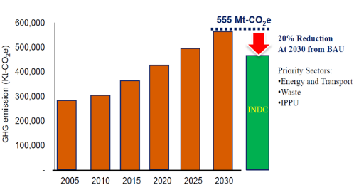
Figure 20 National Determined Contribution Targets for Thailand
Source: Achieving Thailand’s Nationally Determined Contributions: National Perspective (2017) by Dr. Phirun Saiyasitpanich
Thailand experiences periodic smoke and haze pollution, which combines particulate matter from biomass fires with emissions from motor vehicles, industry, and power plants to form toxic air pollution. This affects visibility and makes breathing extremely difficult, especially in the northern provinces and Bangkok, and is a major cause of ill-health. Northern and some Eastern provinces as well as the Greater Bangkok Metropolitan Region (BMR) are particularly affected (Figure 21). An estimated 87 per cent of Thailand’s 68 million people live in areas where the annual average particulate pollution level exceeds the World Health Organization guidelines, while 75 per cent live in areas where it exceeds Thailand’s own air quality standard, with an increasing prevalence in high levels of PM2.5, affecting a large proportion of the country. Thailand’s smoke and haze pollution problem (also transboundary section) follows an annual cycle, during which large amounts of particulate matter from biomass fires combined with emissions from motor vehicles, industry and power plants form a toxic cloud that lessens visibility and makes breathing difficult and unhealthy.
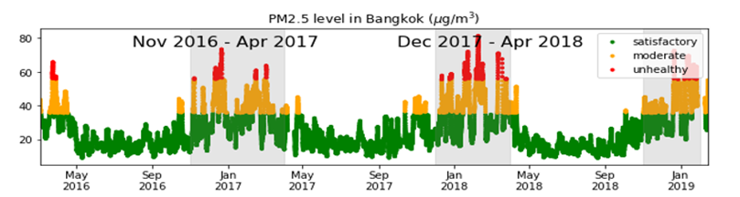
Figure 21 PM 2.5 Pollution in Bangkok Showing Season Pollution Peaks²¹⁰
Source: Berkeley Earth database
GOVERNANCE
Good governance provides the overarching enabling environment for advancing the 2030 Sustainable Development Agenda and SDGs. In this regard, as a constitutional monarchy, Thailand’s framework of governance is invested through its National Assembly and Council of Ministers. The Head of Government is the Prime Minister, elected by the National Assembly, comprised of an elected House of Representatives and an appointed Senate. Thailand held democratic national elections in March 2019, which resulted in Thailand being upgraded by the Freedom House index to ‘partly free’ from ‘not free’ in terms of civil liberties and political rights. Provincial elections also took place in December 2020, with municipal elections planned for early 2021.
Box 19 Thailand’s multi-level governance framework
Thailand’s current system of multi-level governance is based on a dual model. For example, deconcentrated central government units and Local Administration Organizations, (LOAs) both enjoy certain levels of administrative autonomy as established by law. However, local offices of central government often operate in parallel with the local administration sector, which confuses service delivery.
Overall, Thailand’s democracy remains vibrant, but with some fragility. Thailand has a number of long-standing independent institutions, namely the Election Commission, National Anti-Corruption Commission, the Constitutional Court, and the National Human Rights Commission. However, the country has experienced two military coups in recent decades, resulting in disruptions to the continuity of policies and strategies aimed at advancing SDGs./ The country records mid-range performance in the essentials of fundamental rights (access to justice, civil liberties, social rights and equality), and in checks on media integrity, judicial independence and effective parliament. These characteristics affect the country’s ability to create an enabling environment for accelerating the SDGs.
The Government has made a clear strong commitment to prioritizing corruption prevention. The 20-year National Strategy and 12th NSEDP contain important objectives to combat and prevent corruption - a direction reaffirmed by the Prime Minister this year to mark the International Anti-Corruption Day. However, corruption, and perceptions of corruption, represent a significant challenge. In 2020, Thailand ranked 104th among 180 countries in Transparency International’s Corruption Perceptions Index (CPI). According to the CPI Thailand’s state institutions, including the government, courts and the police perform inadequately in terms of citizens' trust. /
Box 20 Public Procurement, Transparency and Participation
The UN supported ‘CoST’ intervention in Thailand is aimed at supporting the Government of Thailand in improving transparency in government contracts in line with international procurement and trade standards, and thereby empowering communities to better monitor projects. The intended impact of CoST is the delivery of better and cost-efficient infrastructure that can bring inclusive economic growth and better lives to people. In 2019, the Government of Thailand embedded the CoST Infrastructure Transparency Data into the revised 2016 public procurement law. Over 400 new infrastructure projects are now disclosing procurement data. To date, 408 stakeholders have been engaged in procurement monitoring of infrastructure projects (80per cent female and 20per cent male).
The 12th NESDP also highlights important steps forward for Thailand’s decentralization agenda, which has so far been incrementally pursued through a succession of reforms. The current National Plan candidly notes that inefficiency of the public management system as a significant obstacle to national development and provides guidelines for better decentralizing power, enhancing public participation, and redistributing responsibilities among national, regional and local actors. The underlying idea is that decentralized policy-making enhances innovation in governance. In this regard the National Plan proposes five main objectives:
- Revision of the dual model of governance.
- Clarification of roles, tasks, and powers of each level of government.
- Step up public sector performance.
- Reform the financing system.
- Strengthening the subnational capacity for strategic planning and territorial development.
In addition, Thailand’s subnational government expenditure as a share of general government spending (12.8 per cent in 2016) and as share of GDP (2.4 per cent in 2016) is one of the lowest among Asia-Pacific countries.
Box 21 Integrating the SDGs into Municipal Planning – A Case Study of Participatory Governance and Problem Solving in the Solid Waste Management (SWM)
Nadee Municipality Key Issues:
- Unsustainable resource management (e.g. waste water and SWM) due to rapid growth rate in urbanisation and industrialisation.
- Economic growth had attracted large numbers of unskilled migrant workers coming from other Thai provinces and neighbouring countries.
- Nadee produces 32,850 tons of household waste produced per annum (excluding industrial waste).
- Currently systematic arrangements for sustainable resource management and monitoring mechanism to identify types of industrial waste are lacking in Nadee.
- Effective planning and implementation of innovative solutions was needed to manage the increasing amount of solid and liquid waste from industrial, commercial and residential sources.
In mid-2019, a strategic planning workshop took place where a multi-stakeholder group was formed of a total of 30 members from the Nadee Sustainable Urban Development Committee including representatives from:
- National government
- Local government
- Civil society
- Academia and research institutions
- Private sector
Using systems approach, partners identified the connection between environmental pollution, solid waste management and health and indicated the need to invest in awareness raising and capacity development to enable the implementation of solutions to improve solid waste management practices and transform into a Healthy and Zero-Waste Nadee in the long-term.
The SDGs cluster analysis generated by the core team identified the SDGs that had direct, indirect and cross-cutting impacts on SWM, enabling participants draw important interlinkages of the SDGs and make an important contribution to evidence-based planning for SDG acceleration.
Source: Nadee Municipality, Thailand (https://www.unescap.org/projects/da11/pilot-cities/nadee).

CHAPTER 2: POVERTY AND INEQUALITIES

Poverty
Thailand’s leadership in economic growth and poverty reduction has recently given way to a 2 per centage point increase in the rate of poverty, which has affected all regions of the country. Thailand had long led the way in poverty reduction. Between 1986 and 2015, the incidence of extreme poverty as measured by the international benchmark of US$1.90 per day fell from 14.3 per cent to negligible levels, and over a similar period using the national rate, poverty fell from 67 per cent in 1986 to 10.5 per cent in 2014. This equates to about 27 million Thais, or more than one third of the population, moved out of poverty during this period. However, rates of poverty have increased twice in a relatively short period, so even those who had recently moved out of poverty are still vulnerable. Official estimates of the poverty rates were 9.9 per cent in 2018 compared to 7.9 per cent in 2017. This increase in poverty occurred in all regions and in 61 out of 77 provinces
Table 4 Thailand’s Multi-dimensional Poverty Index (MPI), Incidence and Intensity, 2017
Poverty Cut-off (k) | Index | Value | Confidence Interval (95per cent)
26 % | MPI | 0.068 | 0.065 | 0.071
26 % | Headcount Ratio (H) | 17.6 % | 16.8 % | 18.4 %
26 % | Average Intensity (A) | 38.7 % | 38.4 % | 39.0 %
Source: Thailand National MPI Short Report, Oxford Poverty and Human Development Initiative (OPHI) Results based on SES 2017, April 2020.
Box 22 Child Poverty in Thailand
When disaggregated by different age groups, the poverty rate among children* is almost twice as high as the national poverty rate**. Results based on data for 2015/16 indicate that the Percentage of children living in multi-dimensional poverty in Thailand was 21.5 per cent. The intensity of poverty or the average number of deprivations faced by children in Thailand was 34.7 per cent, meaning that, on average, each poor child experienced more than one-third of the possible weighted deprivations.
Note: under 17 years old.
Source: NESDC, Poverty and Inequality Report, 2019.
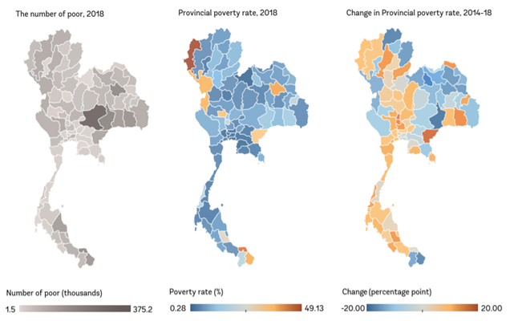
Figure 22 Trends in Provincial Poverty Rate
Source: Taking the Pulse of Poverty and Inequality in Thailand, World Bank, p.7
Poverty is much higher in rural areas than in urban areas, clearly manifested in multi-dimensional poverty comparisons between them, with rural poverty closely linked to the productivity of the agriculture sector. Rural areas face a poverty rate of 10.8 per cent compared to 0.3 per cent in Bangkok and 5.3 per cent in urban areas outside Bangkok. Multi-dimensional poverty is also a largely rural phenomenon. For example, in rural areas, more than one-quarter of the population is multi-dimensionally poor, while in urban areas, the proportion is less than one-tenth. The characteristics of multi-dimensional poverty in rural versus urban areas are also illustrated in Figure 23, which shows that the rural population is disadvantaged across all measures, including years of schooling, access to drinking water, food security, waste management, access to the internet and pensions. Regarding food security, ensuing access to commodity crops for all is a critical issue to consider as surging commodity prices could have devastating impact for the most vulnerable. Rice prices in Thailand plunged in April and May 2020, which posed a higher risk of hunger and malnutrition for people and communities living in vulnerable conditions.
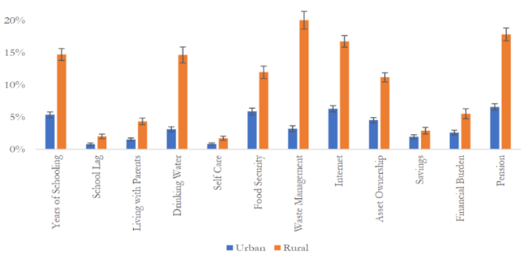
Figure 23 Censored Headcount Ratios ‘Lack of Access’ by Urban and Rural Areas, 2017
Source: Thailand National MPI Short Report, Oxford Poverty and Human Development Initiative (OPHI) Results based on SES 2017, April 2020.
Nearly 20 per cent of Thailand’s population remains multi-dimensionally poor. This means suffering several deprivations at the same time. In addition, the average intensity of poverty is 38.7 per cent, meaning that poor people, on average, experience 38.7 per cent of the weighted sum of deprivations (Table 4). The censored headcount ratio of an indicator represents the proportion of individuals who are multi-dimensionally poor and also deprived in that indicator. Lack of pensions, waste-management, schooling, and the internet contribute most to multi-dimensional poverty.
More than one in five children lives in multi-dimensional poverty, and children experience high levels of poverty intensity. Learning, nutrition and health prevention are key to the child multi-dimensional poverty index in Thailand. Child poverty tended to be higher in rural areas (where 23 per cent of rural children identified as poor) compared to urban areas (19 per cent). Given the large population size in the Northeast, it is estimated that 38 per cent of all multi-dimensionally poor children live in the region. The education of the household head was one of the strongest predictors of child poverty, with higher levels of education associated with much lower levels of poverty. Children who lived in a household in which the head of the household spoke Thai were significantly less likely to be poor than those in households where the head spoke another language (20 per cent to 36 per cent). Larger households were also associated with higher levels of child multi-dimensional poverty.

Income Inequalities
Over the long-term, income distribution in Thailand has become less unequal, although progress in this regard has recently shown signs of reversal. Thailand has the highest level of household income inequality compared to other ASEAN countries. Over a 30-year period, Thailand has exhibited a decline in both the income and consumption-based Gini coefficients, meaning that income distribution has become more equalized, with the bottom 40 per cent accounting for 17 per cent of total household expenditure in 2013, compared with 15.5 per cent in 1986. The downward trend of Thailand’s Gini coefficient is consistent with the higher growth of the bottom 40 per cent than the average of the population. However, more recently growth in the bottom of the distribution has declined and Thailand’s inequality has slightly increased. Based on income, Thailand has higher levels of inequality compared with other ASEAN countries when based on consumption and the highest Gini coefficient when based on household incomes.
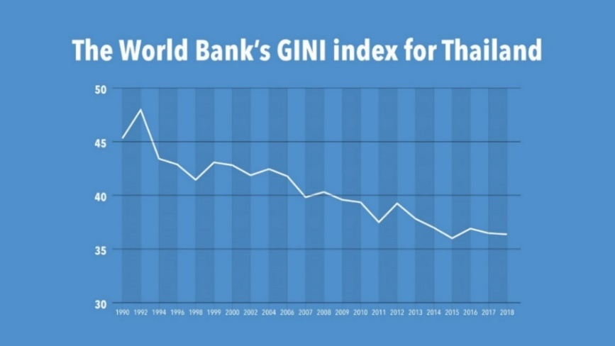
Figure 24 Thailand’s GINI Index
Source: World Bank

Digital Inequalities
Thailand has made significant progress in developing digital connectivity over the years. Mobile broadband covers 98 per cent of Thailand’s population and the country has also launched 5G services. Mobile broadband subscription in Thailand stands at 87 per cent. Universal and inclusive broadband connectivity remains an important focus area given the rising importance of digital connectivity to drive digital services in the country through the pandemic and the ‘new normal’.
Affordability of broadband services is equally important in the digital economy as data consumption rises. In comparison with the affordable entry-level broadband internet target for 2025 set by the Broadband Commission, the fixed data (5GB) basket and mobile broadband (data only) in Thailand were at 3.6 per cent and 1.44 per cent respectively of monthly GNI per capita in 2019 (Figure 25).
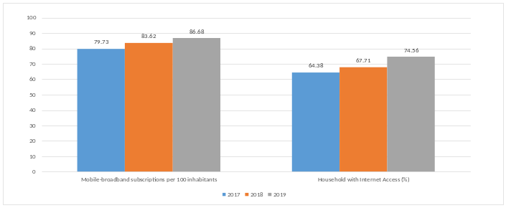  Figure 25 Mobile Broadband and Household Internet Penetration (Thailand), 2019  Source: ITU, 2019. | 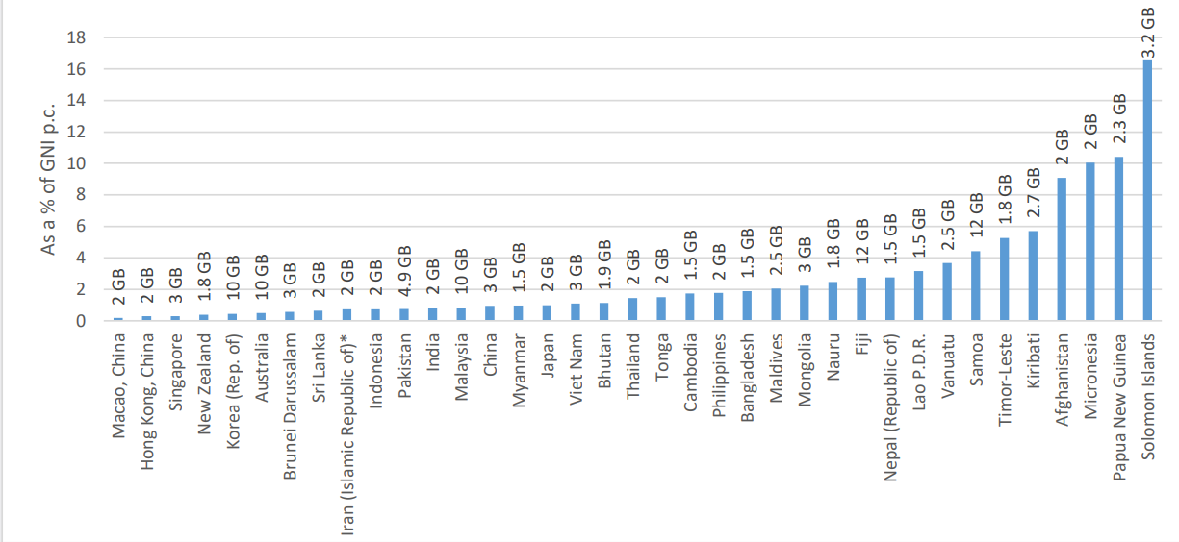  Figure 26 Mobile-Data Prices as a Percentage of GNI p.c. and Monthly Data Allowance, Asia and the Pacific, 2019  Note: Data correspond to the GNI p.c. (Atlas method) in 2017. Source: ITU. GNI p.c. values are World Bank data.  Source: ITU, 2019.
Box 23. Internet Disparities in Schools
Internet access at schools reveals that two-thirds of schools are connected to fibre-optic cables, which provide high quality and stable connections to support e-learning needs. However, the digital divide for schools has a regional dimension with those in the North and Northeast having lower levels of internet connections as compared to other regions (Figure 27).
Despite high levels of internet connectivity, socioeconomic-based digital inequalities exist across the country when comparing internet access at home. Only 65 per cent of households in the lowest level of the economic, social, and cultural status index (ESCS) had an internet connection in their home versus 99 per cent of the households with the highest ESCS. Efforts to address under-connected communities has been a priority for the Ministry of Digital Economy and Society through its Net Pracharat project (village broadband) and the National Broadcasting and Telecommunication Commission (NBTC) through its universal service obligation programme. However, preliminary evidence suggests a decline in the usage of the Net Pracharat project during the pandemic, indicating the need for connectivity initiatives that connect households as well.
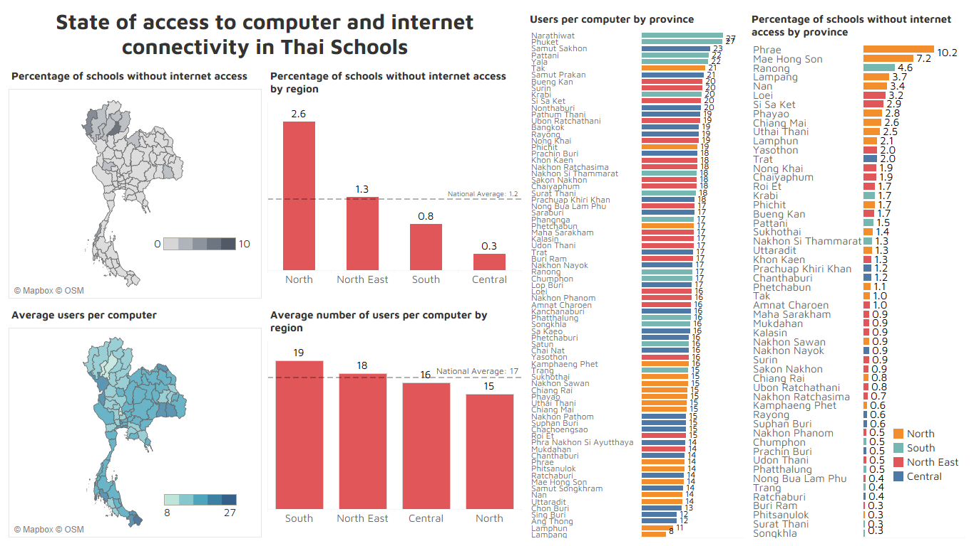
Figure 27 State of Access to Computer and Internet Connectivity in Thai Schools
Note: Mapping the Digital Divide in the School Education of Thailand, Associate Professor Dr. Jomphong Mongkhonvanit, Siam University and Dr. Dipendra K C, School of Global Studies, Thammasat University - Presentation and Report prepared for the UN in Thailand.
Digital inequality has regional, urban/rural and socio-economic dimensions. Despite high levels of access at the school level, on average, 17 students share a computer at school (Figure 27). This increases to 19 students per computer in the South. In this regard, Thailand is par to OECD and non-OECD countries' average. While 70 per cent of students in urban school communities have a computer at home, only 45 per cent of students in rural school communities reported the same. A smaller gap was observed in internet access, with 89 per cent of students in urban school communities, as opposed to 79 per cent of students in rural school communities, reporting having a link to the internet at home. When examined by socioeconomic status, access to these digital learning resources were more limited among disadvantaged students. While close to 90 per cent of advantaged students have a computer at home, only 20 per cent of disadvantaged students have access to the same. Similarly, although internet access is available at home for nearly every advantaged student, a link to the internet at home is available to only 61 per cent of disadvantaged students. Smartphone applications may lead to greater penetration of future learning materials. In general, more girls and women in Thailand have access to devices compared to their male counterparts. They have marginally better access to televisions at home, mobile phones with internet access, education software at home and computers at home for schoolwork.
Barriers to education remain, including access to digital devices, digital computing capacity and lack of ITC skills among teachers. Nationwide, three out of ten school principals stated the number of digital devices connected to the internet and the bandwidth were not sufficient, while four out of ten indicated that both the software and digital computing capacity of the school's digital devices were inadequate. Access to devices and the internet is equally important at home, since five out of ten do not have access to tablets and three out of ten do not have a quiet place to study. Survey results also indicate that 15 per cent of teachers do not have the skills to integrate devices into their instruction.

Inequality of Opportunity
In Thailand, limited opportunities such as access to education, clean fuels, sanitation and financial services, and barriers such as geography, socio-economic status, ethnicity and the prevalence of violence against women, significantly prevent people from fulfilling their potential and serve to exacerbate inequalities. Inequalities in Thailand are worsened by differences in access to higher and secondary education and to clean fuels and providing insights into inequalities that have important implications for LNOB groups. Calculations based on ESCAP’s dissimilarity index (D-Index) measure show how different groups, such as women, poorer households and rural residents, fare in terms of access to certain opportunities or how different groups disproportionately experience particular barriers. The ESCAP inequality of opportunity analysis uses new methodological tools to identify those furthest behind by grouping people with the lowest access to opportunities or the highest barriers to effective participation. These groups are defined by common circumstances over which the individual has little or no direct control, such as their household’s wealth or their place of residence (Figure 28 and Figure 29)
Structural vulnerabilities and exclusions limit possibilities for populations most likely to be left behind, infringe on their human rights and contribute to the perpetuation of poverty and inequality in Thailand. The findings from the ESCAP analysis have significant implications for different LNOB populations affected by discrimination, socio-economic status, geographical location and environmental fragility who may struggle to access opportunities or overcome barriers. These factors often reveal structural vulnerabilities. The analysis explores inequalities from seven aspects affecting a person’s life prospects in Thailand. These barriers impact Thailand’s inequalities (SDG 10). Importantly, inequality of opportunity undermines the realization of human rights and constitutes a significant barrier for social mobility.

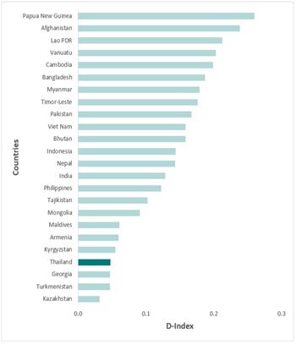  Figure 28 Average D-Index in Asia and the Pacific  Source: ESCAP, Leaving no one behind: A methodology to identify those furthest behind in  accessing opportunities in Asia and the Pacific, 2019. | 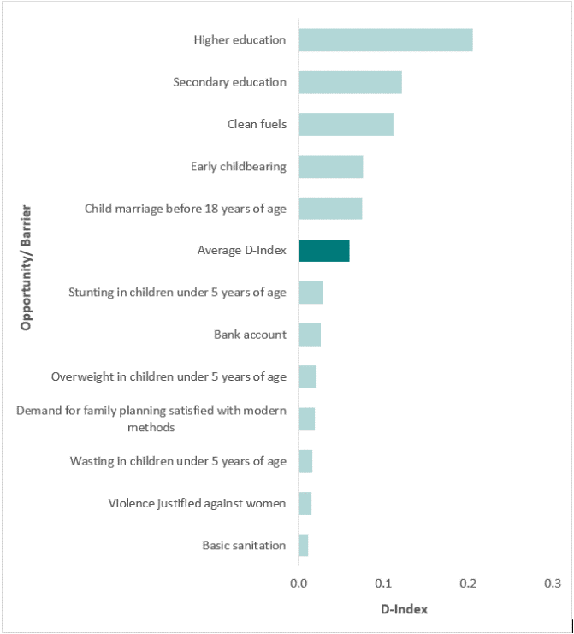  Figure 29 D-Index in Thailand, by Opportunity or Barrier  Source: ESCAP, Policy Paper, 2020. Inequality of Opportunity, Who are those Left Behind? - Thailand (MICS 2019 Update).

Box 24 Opportunities and Barriers that Drive Inequality in Thailand*
The opportunities and barriers referred above are: access to clean fuels, bank account ownership, basic sanitation, prevalence of society’s attitudes towards violence against women, completion of secondary and higher education, women’s access to modern contraception, early childbearing, and the prevalence of stunting, wasting, and overweight in children under 5 years of age.
Access to clean fuels: Reliable and affordable energy services are fundamental to everyday life. Equality in access to clean energy increases productivity, reduces health disparities, and bolsters gender equality.
Bank account ownership: Owning a bank account encourages saving, enables people to obtain loans and provides a secure channel for payments in the form of remittances, government cash transfers and salaries. Inequality in access to formal financial services amplifies existing divisions in communities and societies.
Basic sanitation: The use of improved facilities that are not shared with other households and where excreta is safely disposed helps to maintain health and increase lifespans. Inequality in basic sanitation threatens human dignity and constitutes a major economic and health burden.
Prevalence of society’s attituded towards domestic violence: The social acceptance of the use of violence to uphold gender stereotypical roles in society such as limitations on mobility and decision-making for women and expectations for women to manage children and work can signal a broader acceptance of violence against women in intimate relationships. For example, these gender roles include whether a woman goes out without telling her husband, she neglects the children, she argues with him, she refuses sex with him, or she burns food while cooking.
Completion of secondary and higher education: Inequality in education matters because more education often results in a better job with higher incomes and a chance to break patterns of poverty and vulnerability. Inequality in child nutrition, access to basic sanitation and clean fuels is also associated with inequality in educational attainment.
Women’s access to modern contraception: Use of modern contraceptive methods remains the first step towards positive sexual and reproductive health outcomes for all women. Inequality in the use of modern contraceptives renders some women more likely to experience unintended pregnancies, which can result in disability and death. Tightly spaced births also have significant cognitive and nutritional consequences for children. Early childbearing: Adolescent pregnancy and childbearing are dangerous for mothers and their infants and is especially detrimental for the future potential of women and the health of their babies. Early childbearing often leads to girls to drop out of school, jeopardizing future education and employment opportunities. Babies of adolescent mothers often face higher risks of low birth weight and severe neonatal conditions.
Stunting, wasting and overweight in children under 5 years of age: Inequality among children’s nutrition levels matters because proper nutrition provides the foundation upon which developmental progress is built. As children receive poorer nutrition, they are more likely to be stunted or wasted and face cognitive and developmental consequences of malnutrition in the long term. Similarly, being overweight can lead to serious health consequences such as cardiovascular diseases and diabetes.
Source: * ESCAP, Policy Paper, 2020. Inequality of Opportunity, Who are those Left Behind? - Thailand (MICS 2019 Update).

Regional Inequalities
Bangkok and its vicinities contribute about 50 per cent of Thailand’s wealth, while around the country regional disparities within socio-economic quintiles appear to have grown. Bangkok’s contribution to national wealth has declined slightly over recent years as regions have increased their own rates of productivity, particularly the Central region (Figure 30). At the same time, the wage differential, comparing average real monthly wages in non-agriculture to agriculture, has grown over time, including across regions. When the changes are compared across the quintiles and regions, regional disparities within each quintile appear to have grown in the period 2011 to 2017. The Northeast region tends to do less well than other regions, while the South region was above the nationwide average in 2011, but fell below it by 2017 across all quintiles. The South has been overtaken by the Central region, which from a position largely below the nationwide average in 2011 now enjoys average per capita household income above the nationwide average. The bottom two quintiles for all regions remain almost unchanged over the same period.
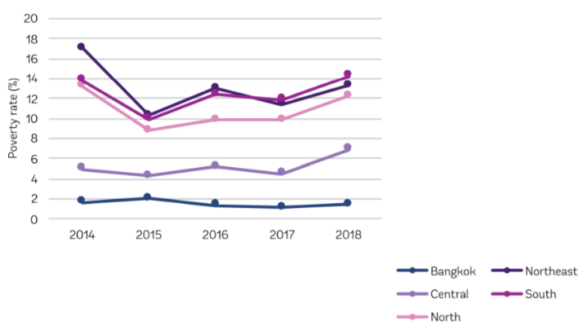
Figure 30 Official Poverty Rates by Region
Source: World, Bank, ‘Taking the Pulse of Poverty and Inequality in Thailand, 5th March 2020 (p.4).
The highest rates of poverty are in the North, Northeast and three Southern Border Provinces. Approximately 4.7 million poor, or two-thirds of the country’s poor, live in the North and Northeast. Poverty rates in the three most Southern Border Provinces have remained stubbornly high at 33 per cent of the population. Poverty intensity is similar across all regions although multi-dimensional poverty varies. In Bangkok, only 3.1 per cent of people are multi-dimensionally poor, while more than one-quarter of those in the Northeast are poor. In the South, a slightly lower per centage of people are poor than in the Northeast (24.0 per cent versus 26.1 per cent), but they experience a slightly higher average share of deprivations (39.3 per cent versus 39 per cent). Even though the Central region has the second lowest incidence of poverty of any region, because of its larger population it is still home to almost one-fifth of Thailand’s poor.

Box 25 Inequalities and the Furthest Behind Groups in Thailand*
The furthest behind group for access to clean fuels are the rural poor. Average access to clean fuels is 78 per cent nationwide. The furthest behind group in this regard are households in rural areas belonging to the bottom 40 of the wealth distribution and in which the highest level of education is lower (primary or none), among which 55 per cent have access to clean fuels (compared to 94 per cent in the best-off group). Only 47 per cent of this same furthest behind group used clean fuels four years earlier.
The furthest behind group in regards to stunting and wasting are children from poorer households. The average stunting rate for children under 5 years of age is 13.3 per cent (MICS 2019), up from 10.5 per cent (MICS 2015-6). The furthest behind group consists of boys from poorer households, among whom 18 per cent are stunted (compared to 8 per cent in the best-off group). The average wasting rate for children under 5 years of age is 8 per cent, which is higher than 5 per cent four years ago. The furthest behind group consist of children in poorer households with one or more siblings under 5 years of age, among whom 10 per cent are wasted (compared to 4 per cent in the best-off group).
When considering wasting in children under 5 years of age, the furthest behind group are poorer children whose household head speaks a minority language. After including language and religion as additional variables, poorer children speaking a minority language are worse off when compared to their counterparts using Thai as their main language. In this furthest behind group, 12 per cent of children are wasted compares to 9 per cent of their counterparts speaking Thai.
The furthest behind group for having completed secondary and higher education is among poorer boys. The average secondary education completion rate is 63 per cent, and for higher education 43 per cent. Among poorer boys, only 35 per cent have completed secondary education, and only 11 per cent have completed higher education (compared to 82 per cent and 67 per cent in the respective best-off groups).
The furthest behind group among those married before the age of 18 were rural women with a lower or secondary education. Across the nation, 20.2 per cent of 20 to 24-year-olds were married before the age of 18 (MICS 2019), whereas this rises to 43 per cent among rural women with lower or secondary education, but who belong to the top 60 of the wealth distribution. This compares to 4 per cent of 20 to 24-year-olds who were married before the age of 18 in the best-off group.
The furthest behind population in terms of those women most likely to have had a baby when they were 19 years old or younger are rural women with lower or secondary education. The national prevalence of early childbearing for women aged 20 to 24-years-old is 9.1 per cent (MICS 2019), but which rises to 29 per cent for rural women with lower or secondary education, (compared to 2 per cent in the best-off group, which is women with a higher education)
The furthest behind in regard to violence against women are poorer, rural women. On average 7 per cent of women tolerate or condone violence against women. The characteristics of those women most likely to justify this practice are poorer, rural women with either lower or secondary education and at least one child under 5 years of age, among which 14 per cent justify their partner in abusing them (compared to 5 per cent in the best-off group).
The furthest behind group in both child marriage (under 18 years of age) and early childbearing are women with lower or secondary education and who live in rural areas. After including language and religion as additional variables, women living in rural areas with lower or secondary education only are worse off when compared to their counterparts from other religions. For example, in regard to early childbearing, 30 per cent of those have had a child before the age of 19 are worse off in contrast to only 19 per cent of women from other religions but similar educational backgrounds and residence.
The furthest behind in relation to access to basic sanitation are also the urban poor. On average, 97 per cent of Thailand’s households have access to basic sanitation. However, in urban-area households belonging to the bottom 40 per cent of the wealth distribution this reduces to 92 per cent (compared to 99 per cent in the best-off group and 90 per cent of this same furthest behind group in 2015).
The furthest behind group in terms of owning a bank account are the urban poor in which the highest level of education is primary or ‘none’. In Thailand, 94 per cent of households own a bank account, up from 90 per cent four years ago. Yet only 85 per cent of households in urban areas belong to the bottom 40 per cent of the wealth distribution in which the highest level of education is primary or none held a bank account, compared to 99 per cent in the best-off group. Noteworthy is the increased rate of bank account ownership, up from 70 to 85 per cent in the furthest behind group between 2015 and 2019.
The furthest behind group after including language and religion as additional variables are households speaking a minor language when compared to Thai speaking households. This pattern is seen only among households belonging to the bottom 40 of the wealth distribution. The furthest behind group consists of poorer households speaking a minority language, among whom 75 per cent owns a bank account (compared to 99 per cent in the best-off group).
Source: * ESCAP analysis.

Gender Inequality
Thailand’s human capital gender gap is small, although women are significantly under-represented in leadership positions in the public sector, it boasts a relatively high per centage of women in leadership positions in the private sector compared to other countries (Box 25). Thailand’s male and female Human Capital Index (HCI) scores are 0.59 (men) and 0.61 (women) respectively – one of the narrowest gaps among ASEAN countries, which is also mirrored in the female HDI and gender development index. Thailand has a greater per centage of women in senior leadership positions in the private sector than both in the Asia-Pacific region overall and the global average.
While Thailand has transitioned to an upper-middle-income country, structural challenges to gender equality and women’s empowerment remain, such as poverty, unpaid care burdens, discrimination, exploitation and violence. Particular challenges are faced by women across Thailand’s geographical regions, including ethnic minorities, migrant women and women in the southern border provinces. Despite some success in private-sector leadership, women tend to be concentrated in insecure jobs in the informal sector, including agriculture, often contributing as ‘family workers’ for which they are undervalued in terms of their social and economic contribution.
Thailand’s gender wage gap has been narrowing gradually over the years helped partly due to the growing economy and greater improvements in education and skills made by women to build their human capital. What is not clear, however, is if the wage gap has narrowed for all women in the workforce or for only for some. In general, public policy in Thailand has been supportive of gender equality. Notwithstanding this progress, Thailand does have a factor weighted gender pay gap of 10.9 per cent.
In rural areas, women remain affected by poverty. Equal educational opportunities between the genders do not always translate into equal outcomes as girls tend to outperform boys but as still under-represented in STEM-related degree programmes. The number of girls not in education, employment, and training (NEET) is considerably higher than boys. Violence against women and girls (VAWG) persists as a challenge in Thailand hindering progress towards empowerment.
Thailand is the single biggest destination country for intra-ASEAN women migrant workers. However, the majority are employed informally without adequate or appropriate levels of opportunity or protection. These women represent slightly more than half of all migrant workers in the country. Only 43 per cent of women migrant workers migrate to Thailand under official MOU arrangements, which limits their job opportunities in the formal sector as well as their access to protections afforded to regular migrant workers. Women migrant workers are also more likely to be in informal employment. This also manifests itself in wage inequalities. A 2017 survey of migrant workers in Thailand found that, on average, men migrant workers earned US$36 more per month than women migrant workers. Women migrants remain especially vulnerable and face different forms of labour exploitation, including the risk of human trafficking, due to limited gender-sensitivity in addressing language barriers, legal status, gaps in knowledge and awareness of rights and access to social protection.

CHAPTER 3: ANALYSIS OF IMPACT OF COVID-19

Impact on Health
Thailand’s relatively strong healthcare delivery system and the near-universal health insurance coverage have contributed to effectively containing the spread of the virus, with a relatively low number of confirmed cases and deaths. / Thailand reported the first COVID-19 case outside China in mid-January 2020 and is considered to be among the top ten most prepared countries to deal with the coronavirus and ranks first among all upper-middle-income countries. After a peak of transmission in March 2020, infections were contained after strong community-based contact tracing and quarantine. By the end of January 2021, there had been a total of 14,646 confirmed cases of COVID-19 and 75 deaths, which although tragic, is yet miniscule compared to some countries and significantly fewer than most neighbouring countries (Table 5). The quality and reach of the healthcare system has helped to keep the death toll low. The Government’s rapid and comprehensive delivery of public health measures, case finding, contact tracing and containment efforts, allied to the extensive system of healthcare volunteers, also contributed significantly to Thailand’s exemplary response. The Government’s extensive COVID-19 socio-economic response and stimulus package is summarized in Table 14 of the Technical Annex.)
Box 27 The COVID-19 Pandemic Exacerbates Previously Unresolved Challenges
This section briefly charts the devastating implications of the pandemic for the economic sectors as well as its primary repercussions for health, poverty, social protection, education and nutrition, including issues of discrimination and exploitation.
In sum, the COVID-19 pandemic has exacerbated underlying issues of inequalities and sounded a clarion call for a more balanced relationship between economic growth, biodiversity, the environment and nature.
Source: Social Impact Assessment of COVID-19 in Thailand, United Nations in Thailand, OPM, 2020
Near universal levels of health financing coverage enabled the Government to quickly offer free COVID-19 tests and medical care via the three major public health insurance schemes in the country. In principle, the Government guaranteed free treatment for COVID-19 patients, regardless of migration status, although current practice suggests that this is not being applied consistently with regards to refugees and undocumented migrants. The Government also launched a COVID-19 hotline for migrants in Khmer, Lao and Myanmar languages, increasing the access of at-risk migrants to information and advice on prevention, testing and treatment. However, the over-reaction in some quarters to non-Thai people associated with the fear of contagion coming from foreigners threatens to further marginalize migrant workers, who may experience difficulty accessing testing and treatments as a result.
Table 5 Total Number of Cases and Deaths from COVID-19 as of 27 January 2021
Country | Confirmed cases | Deaths
Thailand | 14,646 | 75
Indonesia | 999,256 | 28,132
Singapore | 59,352 | 29
Philippines | 514,996 | 10,292
Malaysia | 186,849 | 689
Source: WHO, COVID-19 Dashboard, https://worldhealthorg.shinyapps.io/covid/.
COVID-19 has a disproportionate impact on vulnerable populations, especially the elderly, with problems gaining access to critical out-patient services and treatments. Globally, an estimated 66 per cent of people aged 70 and over have at least one underlying condition that places them at increased risk of the severe impact of COVID-19 on top of already high demand for health services and medicines. The lockdown has also reduced access to necessary out-patient services. The elderly also face risks due to a worsening economic well-being, including issues of mental health, neglect and abuse.
Other vulnerable groups affected by the COVID-19 pandemic includes the poor, mothers, youth and children, as well as migrants, refugees, asylum-seekers and stateless people. Those able to migrate across countries or provinces might not find it easy to obtain adequate care and also have more difficulty understanding public health messages related to COVID-19 responses. The number of new HIV diagnoses and new antiretroviral (ARV) treatments have dropped, and some HIV patients cannot travel to obtain HIV medicines from their usual providers. There are also reported difficulties accessing family planning and contraception, sexually transmitted infection (STI) screening and obtaining treatment among sex workers. People with COVID-19 may be subject to stigma and discrimination. Not least, as the mental health impacts of COVID-19 are better understood, this will require considerable investment in prevention and mitigation going forward. As a result of social distancing measures, more LBGTI persons have had to spend more time at home, increasing their risk of facing GBV from family members.

Economic Impact
COVID-19 left Southeast Asia experiencing a broad decline in consumption, investment and trade affecting all sectors of the economy and leading to about an 8 per cent contraction. All economies in the region have suffered losses due to restrictions on movement imposed by governments to contain the pandemic and the slump in global trade and demand. In Thailand, the manufacturing industry has been particularly hit hard by the international supply chain disruptions. Thai businesses manufacturing electronic equipment are projected to have lost 3 per cent, or $1.5 billion, of their exports to China, the European Union and the United States in 2020 in comparison with 2019. Tourist arrivals plunged in Thailand, impacting the aviation, hospitality and retail industries. No return to normalcy is expected before 2022
As many as to 8.4 million jobs could be lost in the country. The number of hours worked in Thailand declined equivalent to the loss of 2.2 million full-time jobs with commensurate or worse reductions in wages and higher declines in both working hours and employment for women compared to men in the second quarter of 2020 compared to the previous year. More than 170,000 people in the formal sector filed for unemployment benefits in the first quarter of 2020 alone. Farm household income has been negatively impacted by both COVID-19 and drought. Demand fell due to a lack of tourism and to lower domestic incomes. In addition, price rises for some commodities increased due to higher transport costs, particularly for exporters using airfreight. Exports were also impacted due to closure of airports and border crossings. Additionally, 6 million farmers have been placed at risk from drought.
Box 28 The Interconnected Impact of COVID-19 on Economic and Social Conditions*
In 2020 the UN commissioned the in-depth Socio-Economic Impact Assessment of COVID-19 in Thailand. The report exposed ‘a strong causal relationship (Figure 31) between the pandemic and the immediate economic, macro-economic, and social impact, which pushed vulnerable groups into poverty, and created social problems.’
Source: * Social Impact Assessment of COVID-19 in Thailand, United Nations in Thailand, OPM, 2020.

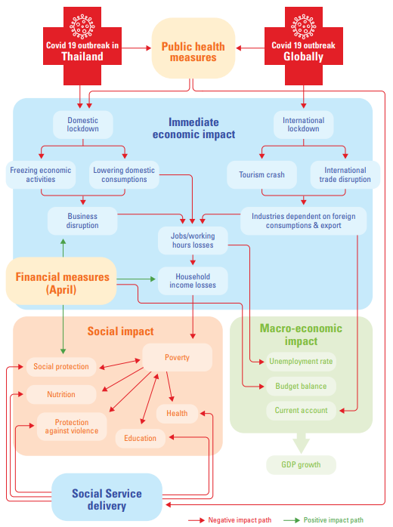
Figure 31 Impact Pathway Analysis on Overall Economic and Social Impact of COVID-19

Impact on SMEs
Small-size and low-tech firms report low levels of demand, high levels of revenue loss, lack of access to finance and disruptions in supply chains as a direct result of the pandemic. Demand reduction has posed the biggest impact to firms in Thailand, reducing revenue flows with small-sized firms having had the least access to government stimulus schemes. Consequently, extreme revenue loss is expected by 90 per cent or more for firms regardless of their location (whether inside or outside provinces with high infection rates), with more than 50 per cent of revenue expected to be lost in 2020. Difficulties in obtaining loans to compensate for the cash flow shortage has exacerbated the situation. Cutting operational costs is another option that firms have undertaken. They are also concerned about payments to employees and social security as well as repayment of loans to commercial banks. The shortage of inputs, including raw materials, is reported to be the second biggest problem for firms due to disruptions of the supply chain from international border closures and domestic movement restrictions. See also page 23 of the Technical Annex.

Impact on Household Welfare, the Informal Sector and the Working Poor
The impact of COVID-19 on household welfare is likely to be severe, with the share of middle-class households falling while the number of working poor will increase, and the loss of income among informal workers will push many over the poverty threshold. As a direct result of the economic consequences of the pandemic, Thailand’s middle class is expected to contract by 12 per centage points from 50.6 per cent to 38.4 per cent, while the number of economically insecure, those living below US$5.5 per day in purchasing power parity (PPP) terms, is projected to have doubled from 4.7 million in the first quarter of 2020 to an estimated 9.7 million in the second quarter. Working poverty is forecast to rise by the end of 2020 from 4.7 per cent to 14.5 per cent, with nearly 21 of 37 million workers at risk of significant impact (Figure 32).
Informal workers, women and youth have been severely affected with the loss or reduction in income transitioning many into poverty. This is particularly concerning given that women account for a larger share of employment in sectors that are most at risk because of the pandemic. Many of these lack social protection and have moved into survival mode as government social transfers expire. This will result in a further increase in household debt as people run out of money. Youth are disproportionately impacted, experiencing job disruptions from reduced working hours and layoffs, disruptions in education and training as they try to complete their studies, and difficulties transitioning from school to work and moving between jobs. About 500,000 graduates this year will join the 300,000 jobless graduates yet to find work.
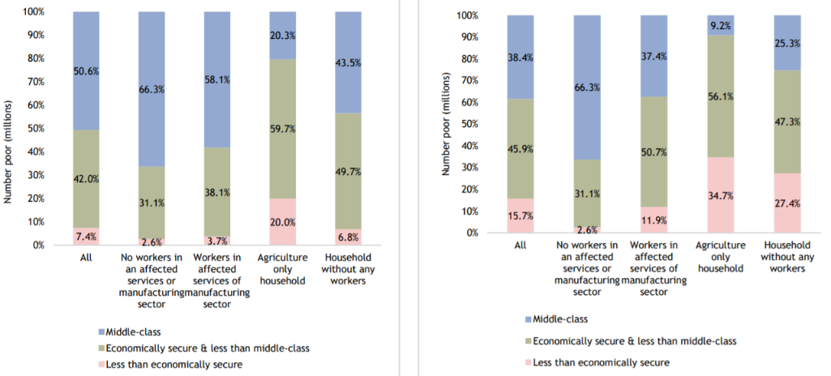
Figure 32 In the short term, income loss will result in an expansion of the economically insecure and a reduction of the middle class (Q1 2020 pre-COVID-19 scenario, left below / Q2 – 75 per cent income loss scenario, right)
Source: Social Impact Assessment of COVID-19 in Thailand, United Nations in Thailand, OPM, 2020.

Impact on Migrant Workers
Migrant workers are key to Thailand’s economy but are among the most at-risk. They not only face loss of livelihoods as a result of COVID-19 but are also exposed to higher risks of exploitation, lack of social assistance, and stigma and discrimination. Remittances from employment in Thailand are an important source of household income and GDP for neighbouring countries. Thailand is also a country of origin for migrant workers, with remittances comprising 1.3 per cent of Thailand’s GDP in 2019. Safe and orderly migration to and from Thailand will be critical to economic recovery for both the country and the region. However, the Thai Development Research Institute estimates that as many as 500,000 migrant workers have lost their jobs since the lockdown./ Loss of livelihoods in the form of job losses, loss of income and reduced working hours are the single biggest challenge facing non-Thai people in Thailand. COVID-19 may also have heightened the risk of exploitation and labour rights violations,/ which remain long-term challenges as businesses recover from the pandemic and labour migration resumes. In principle, migrant workers enrolled in the Social Security Fund have the same eligibility criteria as Thai nationals for compensation schemes, yet many are excluded due to their sector of employment, their migration and or employment status, or they do not access benefits due to a lack of targeted information, support and administrative complexity. Border closures, combined with a lack of social protection, mean that they have limited access to basic needs, including food and housing, and are less likely to be able to repay their debts./
Box 29 Thailand and the Global Compact for Safe, Orderly and Regular Migration
In December 2018, Thailand adopted the Global Compact for Safe, Orderly and Regular Migration, the first inter-governmentally negotiated agreement covering all dimensions of international migration. In August 2020, the country committed to becoming a Champion Country for its implementation, with an interest in sharing lessons learned and positive practices in access to healthcare for migrant communities as well as alternatives to detention for migrant children.
Significant progress has been made with over 200 children and their mothers released from detention since the 2019 signature of Thailand’s Memorandum of Understanding on “The Determination of Measures and Approaches Alternative to Detention of Children in Immigration Detention Centres”, with considerable efforts made to extend health coverage to all migrant populations, including during the COVID-19 pandemic. However, many vulnerable migrants continue to face multiple barriers in accessing healthcare and alternatives to immigration detention.

Impact on Education
COVID-19 not only appeared as a global public health and economic crisis, but also as an education crisis, which laid bare the digital divide and inequalities that exist in the school system in Thailand. The pandemic negatively impacted about 15 million Thai students enrolled from pre-primary school to the tertiary education level. /// Nationwide school closures required students to adapt to the new norms of distance education and have highlighted the importance of schools in providing essential services, such as school meals and student welfare. Distance Learning Television (DLTV) was pursued for primary school students and online learning for secondary students. When schools reopened in July 2020, there were four different scenarios for the post-pandemic classes: i) onsite (physical classes at schools); ii) on-air (television); iii) online, and; iv) on-demand. However, three out of four scenarios presume the students have access to devices, connectivity and the skills required to pursue distance learning. Those with access to digital tools could continue their learning remotely despite school closures. In contrast, those without access were left out. There is also a link between the closure of schools and migrant learning centres, and increased rates of child labour, particularly among migrants. As a result, the pandemic laid bare the inherent inequalities and digital divide that exist in the school education system. Based on the three key dimensions of the digital divide - access, use and ICT skills - a significant minority of the school-age population will be affected.
Keeping children at home during lockdown incurs a range of other risks such as domestic violence, neglect, mental health issues, sexual exploitation, teenage pregnancy, early marriage and cyberbullying. It also impacts mothers, who are often obligated to manage a disproportionate share of unpaid care work within the household. Children and young people have also expressed that COVID-19 has affected their mental health, with a majority of children reporting stress, worry and anxiety about family income and the ability to continue their education. The increased exposure of younger students to internet technology can also put them at a greater risk of cyber bullying and online exploitation.
The immediate economic impact of COVID-19 is predicted to increase student dropout. This takes place via two channels: i) directly by reducing household income, thereby affecting the ability of households to bear the auxiliary costs of education; and ii) indirectly via the opportunity cost of education versus work, because some students might need to start working to supplement their household’s income. Students from poorer urban households are likely to experience the largest increase in dropouts due to these compounding effects of the increased opportunity cost of education, learning losses from school closures and reduced learning overall due to the adoption of blended learning approaches. The economic recession may also result in a reduction in the demand for private education and could reduce government spending on education./

Social Impact
The economic shocks of COVID-19 have increased social stress and manifested in the risks of violence (including gender-based violence), exploitation and abuse, especially among vulnerable populations, while placing crisis support services under heightened pressure. Violence appears to be more prevalent as individuals, households and communities struggle to sustain livelihoods and cope with future economic uncertainty within the short-term constraints imposed by measures to mitigate the spread of the virus. At particular risk are those groups set out in the LNOB section, among whom women and children are generally at highest risk. Specialist multidisciplinary services under the Ministry of Social Development and Human Security and the Ministry of Public Health to support survivors of violence, exploitation and abuse have been placed under enormous pressure. Lockdowns in homes with limited access to traditional reporting lines to provincial shelters, hospitals and schools mean that women, children and young people may have suffered abuse undetected. In addition, access to public health services by stateless ethnic persons, present a particular challenge, because they are often far from clinics or hospitals and lack citizenship, which restricts their freedom of movement. COVID-19 has aggravated the situation for many, due to language barriers (including psychosocial support and medical services) as well as lack of access to digital education.

Environmental Impact
COVID-19 has had a mixed environmental impact that includes improved air quality and reduced pollution, but an increase in plastic and electronic waste and concern that recovery policies may tend towards less sustainable practices. On one hand, during the global lockdown, many countries, including Thailand, experienced improved air quality and reduced pollution. Major tourist hotspots reported a reduction in waste and GHG emissions from the transport sector. For example, Pattaya showed a 55 per cent reduction in waste. On the other hand, food delivery and online shopping have caused an increased amount of plastic and electronic waste.

Economic pressures may prioritize consumption within the recovery, limit environmental safeguards and further degrade land and water resources. Short-term economic recovery policies appear biased towards higher polluting technologies and approaches. Rural communities risk falling back on unsustainable extractive practices to revive their livelihoods from disastrous COVID-related impacts, which may slow progress towards a just transition to environmentally sustainable jobs and decent work. The increase in e-waste coupled with dilapidated waste management systems and inadequate recycling further risks heavy metal and chemical pollution leakages into soil and water sources. In addition, the pandemic exacerbates the Government’s capacities on waste management in particular due the increasing amounts of wastes and potentially reduced recycling rate because of hygienic safety. The amount of daily healthcare waste in Bangkok has increased almost six-fold in comparison to before the pandemic.
Box 30 Leadership for Sustainability in the New Normal*
‘National development after this [COVID-19] crisis will depend on a strong foundation of the country and the ability to build upon, develop and improve from it. We have to switch from heavy use of resources and environmental destruction to optimal utilization and conservation with a focus on integrated management, coordination of all sectors, and knowledge-based and technology-based investment and development to create our own innovation with the local wisdom of the Thai people.’
Source: * Excerpt from Prime Minster of Thailand’s Keynote Speech “Leadership in Crisis Management: Experiences from COVID-19” at the Global Compact Network Thailand’s Seminar: “Leadership for Sustainability in the New Normal”, 31 August 31, 2020

CHAPTER 4: LEAVING NO ONE BEHIND IN THAILAND
Leaving no one behind (LNOB) is central to the 2030 Agenda for Sustainable Development and requires progress for all population groups. LNOB requires moving beyond average and aggregate progress towards ensuring progress for all people everywhere, and Thailand is no exception. It entails the qualitative and quantitative analysis of data to identify who is being excluded or discriminated against, where, how and why. Since the risk factors and vulnerabilities to being ‘left behind’ can be caused by a variety of conditions or impediments, the analytical framework for assessing LNOB populations set out below is based on the five structural factors: i) discrimination; ii) geography; iii) vulnerability to shocks; iv) governance frameworks; and v) socio-economic status. The analysis also draws upon existing data and brings in new methods introduced by ESCAP to support the better targeting of policies. It includes an analysis of data to augment the national measures of income and multi-dimensional poverty and inequalities. To complement the research, the United Nations County Team (UNCT) in Thailand undertook a range of surveys, polling and focus group discussions across the regions of the country with vulnerable groups to deepen an issue-based understanding, the findings of which are set out below.
Box 31 The SDGs and Human Rights in Thailand
The SDGs stem from, build on and take forward the principles of the Universal Declaration of Human Rights, which Thailand endorsed in 1948 as one of the first Asian countries, as well as other core human rights treaties. Thailand is now party to seven of the nine core international human rights instruments and five optional protocols. The country also has ratified 17 international labour conventions. The country reports to treaty bodies, and its Human Rights Action Plan includes action to follow up on treaty body reviews and Universal Periodic Review (UPR). The Technical Annex (Table 16) contains the complete list of human rights instruments to which Thailand is party.

LNOB Groups
People at risk of being left behind in Thailand include children, youth, women, people with disabilities, ethnic minorities, migrants, LGBTI communities, HIV-affected people, sex workers, and farmers/small-holders, refugees, the stateless and asylum seekers, with the ESCAP analysis showing that different groups can experience several barriers and deprivations simultaneously. Important for the purposes of this CCA is to strive towards obtaining a better understanding of the immediate, underlying and structural root causes that contribute to or reinforce inequality and discrimination as well as recognizing some of the barriers and challenges that face those cohorts of the population most likely to be left behind. The findings point to certain populations drawn from among the most at-risk groups experience multiple barriers and deprivations simultaneously. For example, the rural poor include disabled children from ethnic and linguistic minorities, who face multiple challenges, as do children from lower socio-economic backgrounds belonging to migrant, refugee and/or asylum-seeking households. LGBTI groups are more likely to face discrimination and be subject to gender-based violence. Multiple deprivations also exist among urban poor men, with low levels of education and the least access to bank accounts and sanitation. Although the characteristics of the furthest behind differ in each case, poverty is a constant, though not a prerequisite.
Between 2015 and 2019, gaps between the furthest behind groups and the rest of society have generally fallen, marking a positive trend of furthest behind groups catching up slightly. Despite a slight overall improvement in conditions between the furthest behind groups and the rest of society, gaps have also widened in some critical areas, including the completion of secondary and higher education, in perceptions of the justification of violence against women, and in wasting in children under 5 years of age. The furthest behind groups in 2019 are not the same as in 2015. For example, in completing higher education, the furthest behind group in 2015 were poorer men (16 per cent of the population), while in 2019, they were poorer men living in rural areas (11 per cent of the population).
Geography and aspects of regional inequality appear to play an important role in the marginalization of the most at-risk population groups. This is particularly the case in relation to the poorer and more disadvantaged areas of Thailand, such as the Northeast and the Northern regions as well as the Southern Border Provinces districts. Within these areas, population groups with different socio-economic, circumstantial, and cultural characteristics face prejudice. In these areas, poor people, which can include stateless ethnic minorities, are more likely to be discriminated against by the majority of the mainstream population. Geographical identity is thereby an additional intersectional factor in the marginalization of certain populations, for example, people living with HIV. While urban centres have their own distinct risk environment for key ‘at-risk’ populations, they also provide support services specifically for them that are not available in rural settings. Urban centres such as Bangkok and Pattaya and the southern region of Thailand have specific features that increase the vulnerability of people who inject drugs, sex workers, transgendered people and people living with HIV to stigma, discrimination, abuse and violence. Due to local cultural contexts and security concerns, people who inject drugs in the Southern regions reported that they need more protection than elsewhere. Big cities also enable marginalized populations to hide or be hidden.

Children and Young People
Thailand’s child poverty rate is nearly 13 per cent, with large segments of poor children living in the rural areas of the North and Northeast regions, coming from the bottom socio-economic deciles and ethnic minority backgrounds. The largest number of poor children reside in the Northeast region and make up almost half of all poor children in Thailand. Across the country’s socio-economic deciles, more children live in the bottom of the distribution than at the top. As a result, household income is obviously very important and is related to a child’s access to goods and services. Figure 33 illustrates the distribution of children by region. Of considerable concern, the average stunting and wasting rates for children are increasing. For children under 5 years of age, stunting is 13.3 per cent, up from 10.5 per cent in 2015, and the average wasting rate for children under 5 years of age is 8 per cent, up from 5 per cent four years ago. Poorer households witness stunting rates of 18 per cent, and 12 per cent of children from households speaking a minority language are stunted. Poverty and ethnicity thereby conspire against children from poor and ethnic minority backgrounds.
Box 32 Child Labour in Thailand
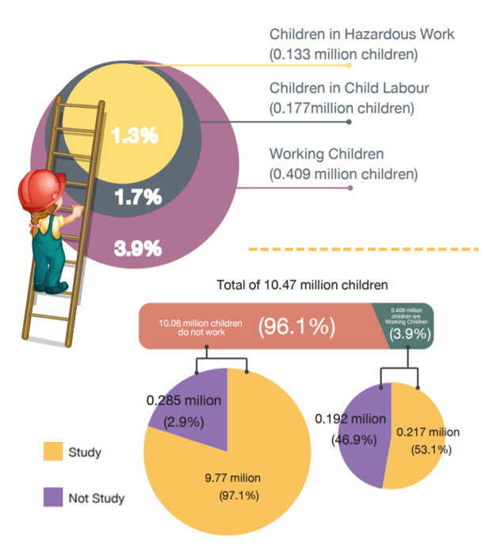
Source: ILO, Thailand’s Working Children Survey 2018
(https://www.ilo.org/asia/media-centre/articles/WCMS_769690/lang--en/index.htm.)
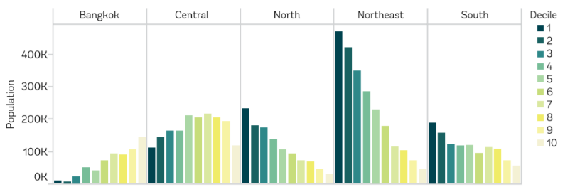
Figure 33 Children Aged 6 to 14, by Region and Decile
Source: World Bank staff tabulations using THA SES 2017. Notes: Deciles are based on household consumption per capita, cited in Taking the Pulse of Poverty & Inequality in Thailand, World Bank.
Poorer children, non-Thai native speaking and migrant children, children with disabilities, and refugee, asylum-seeker and stateless children face significant educational barriers. In the lowest income group, only one in two attend upper secondary school compared to nearly 90 per cent from the highest income group. A third of all upper secondary school-age children from households headed by a non-Thai native speaker are not in school. Approximately half of all migrant children are out of school and about 70 per cent of children with disabilities do not make it beyond primary education. Migrant and stateless adolescents are among the most marginalized, suffering from a lack of access to free education beyond the elementary level, limiting their ability to develop the necessary skills to access the job market.
Drug use and new HIV infections among young people are on the rise, and discrimination is a major concern for those with disabilities from ethnic backgrounds, as well as people from slum and LGBTI communities. A recent study showed that intravenous drug use is an emerging behaviour of young people and that half of all intravenous drug users are aged 15 to 24. Many young people in urban slum areas and the Northeast region report habitually engaging in drug use and dealing, despite repeated police fines. The lack of youth-friendly health services are seen as the root cause of youth lacking skills in managing their comprehensive sexual and reproductive health. The situation has been aggravated by the lack of rehabilitative opportunities, including healthcare services and skills building. Almost 50 per cent of new HIV infections are found in young people aged 15 to 24. Although the overall HIV infection rate in Thailand is dropping, about 3,000 cases per year are recorded in young people. And, as noted above, young PWDs have limited opportunities to receive equal standards of education and most study in non-science fields. Discrimination in employment opportunities was also reported among certain groups of young people, such as those from slum communities, ethnic backgrounds, LGBTI and PWDs.

Women and Girls
Despite progress in the political, educational, and economic spheres, women in Thailand face considerable social pressures, cultural challenges and discrimination. Thai women were among the first in Asia granted the right to vote in 1932. However, today they are still underrepresented in politics at all levels. Adolescent pregnancy continue to affect significant numbers of adolescent girls. Pregnant adolescents and adolescent mothers commonly drop out or are forced out of school and face social stigmatization from their peers, teachers, and parents. Despite Thailand’s female population constituting 47 per cent of the country’s workforce, the highest per centage of working women in the Asia-Pacific region, women are also confronted by hiring discrimination and gender inequality in wages, with some notable exceptions, and concentrated in lower-paying jobs. In addition, although in general the adolescent birth rate decreased in the past years to 23 per 1,000 among 15-to 9 year old girls and women, the rate among poorer households is 49 per 1,000 people and 47 for non-Thai native speakers, which is still very high.
Violence against women and girls remains prevalent in Thailand, is a barrier to women’s empowerment, and warrants further addressing. Approximately 15 per cent of women have experienced psychological, physical, and/or sexual violence in their lifetimes. The per centage of women who faced various forms of controlling behaviours varied from 4.6 per cent to 29.3 per cent. Yet as revealed in the ESCAP study, 9 per cent of adult women believe their partners are justified in beating them, which is doubled among women in the bottom 40 per cent of the wealth distribution. Despite under-reporting, about 30,000 cases are brought to One Stop Crisis Centres per year. However, only one-sixth of these result in any police record and far fewer proceed to arrest and court. Data to demonstrate patterns of abuse for evidence-planning is not well coordinated among agencies responsible for dealing with GBV. As noted earlier, it is expected that domestic violence during the COVID-19 pandemic will have increased.
The top three concerns of women include discrimination, livelihoods and the environment. The majority of women have witnessed, or experienced different types of discrimination based on religion, economic and/or social status. One of the most common human rights violations based on racial discrimination in the Southern Border Provinces is that people have been forced to undergo a compulsory DNA testing for national security purposes. In the Southern Border Provinces, DNA testing is required for some criminal investigations, and is applicable to all citizens without discrimination. However, some people oppose the use of this method. Among other significant concerns cited by women are unemployment, insufficient income, increasing daily and household expenditures, rising household debt, and the high cost of living. Based on these observations, most women are unsatisfied with their current economic and social situation due to pre-existent political and economic instability. In addition, during COVID-19, many male partners who have returned from abroad, remain unemployed, placing an additional burden on households. Regarding the environment, toxic smoke from forest burning (also transboundary section) is a cause of health problems, alongside unmanageable waste issues. Women also cited their and local men’s lack of participation in participatory governance as well as, social and natural resource-related development projects.

People with Disabilities
People with disabilities (PWD) face particularly challenging barriers to mainstream opportunities and services and are more likely to experience poverty as well as direct discrimination (Box 33). Of concern, PWDs are often refused services solely because of their disability status. For example, it is common for banks to deny serving PWDs unless they bring a witness, and hearing-impaired persons are often denied services unless they bring a guardian. Discriminatory practices often infringe on the privacy and integrity of PWDs, especially pertaining to mental disabilities. Additionally, disabled LGBTI people face double discrimination. In some cases, extra costs related to disabilities can also be applied by service providers.
Box 33 People with Disabilities
About 5.5 per cent of the population identified themselves as living with disability* with the highest percentages being in the North (7 per cent) and Northeast (6.5 per cent). When disaggregated by sex, the prevalence was at 5.7 per cent for women, higher than that of men at 5.2 per cent. Furthermore, 20.6 per cent of the general population aged 60 and above reported a disability. People living with disability or chronic illness were the group with the highest poverty rate in Thailand in 2017 at 14.1 per cent. Those with a disability often experience stigma and/or discrimination and often lack visibility at community and national level**. This is particularly the case for disabled women.
Source:
* Disability Survey 2017, National Statistical Office.
** Sample Surveys with LNOB groups commissioned by the United Nations in Thailand, October 2020 revealed there is considerable dissatisfaction among PWDs across a range of issues. PWDs expressed an overall lack of satisfaction with the current economic and social situation, as well as the direction of national development toward equal opportunities for PWDs. Major concerns included the lack of a strong social protection system, lack of social equality, insufficient income, and access to employment. The main challenges to access the social services came from discrimination, limited access, and limited information about service providers.
Disability significantly impacts lifetime prospects, evidenced through education, training and employment outcomes, as well as levels of household poverty. One in every three children with a disability is out of school and only four out of every 10 disabled adults of working age are in employment. The education system is not equipped to meet the needs of students with disabilities and neither do teachers have the overall capacity, both in terms of understanding and skills to provide adequate learning opportunities. Accessible formats in the form of assisting technology, sign language interpretation and text available in Braille are rarely provided. These challenges flow into the world of work where regulations on the employment rely on a quota system, which only guarantees jobs for a limited number of people with disabilities. They face additional challenges regarding access to information, participation, transportation, justice and services. The proportion of PWDs living on less than US$1.25 a day was 16.1 per cent, while the proportion living under the national poverty line was 16.4 per cent. Less than half of all PWDs access the disability grant./ In addition, households with members with disabilities often become poorer leading to a vicious cycle, with 10.8 per cent of caregivers resigning from jobs to devote themselves to caring for household members with disabilities.

People Living with HIV
While Thailand has made notable progress with HIV prevention, the momentum needs to be maintained, especially among key populations, given that the country now has one of the highest HIV prevalence rates in Asia and the Pacific, with 9 per cent of the region’s population of people living with HIV (PLHIV). The rate of decline in numbers of new HIV infections was estimated to be 65 per cent in the period from 2010 to 2019, with 5,400 new infections reported in 2019, contributing to a total of almost half a million PLHIV in Thailand. However, access to prevention services has not been sufficiently widespread to significantly reduce the rate of new infections among key populations. For example, a substantial number of people are still dying each year from AIDS (14,000 in 2019, down from 25,000 in 2010 – a 44 per cent decline). This means that many are not accessing life-saving treatment in time or receiving quality treatment and care services. HIV prevalence remains high among key populations such as men who have sex with men (MSM) and their partners, people who inject drugs (PWID), sex workers (SW), transgender people (TG) and young people (15 to 24 years). From these populations, about 50 per cent of new infections occur, 40 per cent of which are among MSM. SW and their clients, TG and PWID each account for about 10 per cent of new infections. Migrants and prisoners are also vulnerable to HIV. Unprotected sex is estimated to account for 90 per cent of all new infections.
Box 34 Marginalization and Discrimination
Approximately 20 per cent of all groups reported being denied access to services, including health, education, employment, protection and justice. PWID, SW and TG all reported degrading treatment by police. The internalization of stigmatizing attitudes has led many of the marginalized groups to suffer self-stigma and shame. This adversely affects mental health and well-being, deterring people from seeking health services and starting HIV treatment. It can also lead to treatment disruption and treatment failure. Survey data shows that discrimination against key populations has increased from 2015 to 2017 (Table 6).
All marginalized groups reported various forms of stigma and discrimination, which is their greatest concern, and affects their ability to access a range of core services (Table 6). Meanwhile, discrimination against key groups appears to be increasing. PWID who are HIV-positive and/or LGBTI experience multiple layers of stigma and discrimination that leave them among the furthest left behind. Female PWID in a couple relationship reported that they are at higher risk of arrest, domestic violence and financial hardship than their male counterparts. Social expectations force female PWID to hide their dependency on drugs or use of methadone from partners and family members. More than 50 per cent of targeted groups have been told that LGBTI people are not normal (the highest for all groups). Many hide their LGBTI identity due to social pressures or family expectations. High rates of bullying in schools are also reported across all groups. In addition, access to decent work is also severely constrained by stigma, with discrimination in the workplace reported by about 40 per cent of groups. Pre-employment HIV screening makes PLHIV feel that their rights are being violated and threatens their ability to be hired. Worries about workplace discrimination cause a low rate of retention.
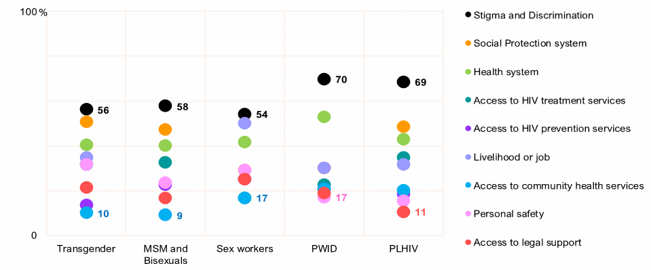
Table 6 Top Concerns of Marginalized Groups about being Left behind
Source: Sample surveys with LNOB groups commissioned by the United Nations in Thailand, October 2020.

Migrants
Migrant workers account for about 10 per cent of Thailand’s total labour force with an estimated one-third of regular migrant workers employed in the informal sector, who do not qualify for the Social Security Scheme (SSS). The number of non-Thai residents in the country increased to 4.9 million in 2018 with migrant workers representing up to 50 to 60 per cent of workers in certain labour-intensive industries (such as agriculture and food processing)./ Many migrants are often involved in ‘3D’ jobs (dirty, dangerous and difficult), where the risk of injury and illness is high. The majority of migrants are from neighbouring countries./ Official data shows that 45 per cent of migrant workers in Thailand are women./ Migrant workers in the informal sector are mostly involved in agriculture, fishing, domestic work, livestock and forestry. Women migrant workers are generally more likely to be employed in lower-skilled, lower-wage jobs than men migrant workers. Despite legislative progress, migrants remain vulnerable and face exploitation including labour exploitation and human trafficking due to language barriers, legal status, and limited knowledge and awareness on rights.
A number of migrant workers to Thailand continue to be paid below the minimum wage but recognize their prospects are better than in their home countries, albeit with enduring concerns related to employment security, access to health services and discrimination (Box 35). Even longstanding and well-informed migrants who have overcome often complex registration processes continue to be paid below the minimum wage, with identity documents commonly withheld, and have reservations about making formal complaints for fear of retaliation. Some migrants expressed their top three concerns as employment security, access to health services and discrimination. With respect to employment security, migrants are not preoccupied just by finding a job but also by finding a secure job with a fair employer who treats workers well, stressing that employment security was key to their being able to cover their families’ expenses. Challenges exist regarding health services in relation to language barriers, documentation requirements, financial cost and discrimination as well as the health insurance scheme in terms of affordability and coverage. Positive factors include the ability to pay hospital fees in instalments and ensuring all migrant children received required vaccinations. However, migrants also reported facing discrimination at the workplace, especially from law enforcement officials, and harboured concerns for the safety of their children when they went to work. Despite a favourable education policy, about 200,000 migrant children are out-of-school./
Box 35 Education, Migration and Refugee Status in Thailand.
Landmark education laws exist in Thailand relating to unregistered persons, specifying that every child is entitled to 15 years of free education regardless of their legal status or nationality. This has significantly increased migrant children’s enrolment in public schools. However, migrant children, as reported in the children and youth section above, are the largest group of children out of school.
Despite the Education For All (EFA) policy, refugee children in urban areas face language barriers and generally do not have access to scholarships and educational grants available to nationals which are in practice required to attend upper secondary and tertiary education. Additionally, the risk of arrest and detention for refugees and asylum-seekers can prevent their children from being taken to school. Moreover, it is noted that the EFA does not extend to the refugees in the temporary shelters, where the responsibility and administration of education is still assigned to a consortium of NGOs through the Committee for Coordination of Services to Displaced Persons in Thailand (CCSDPT) and remains informal in nature.
Barriers for migrant workers in bringing their dependents to Thailand through regular channels mean that the dependents of migrants are often undocumented. This increases their vulnerability, affects their well-being and usually means that the dependents are not included in official data, and are therefore inadequately included in policies, planning and access to services. Due to the long periods of time that many migrants remain in Thailand, a large number of migrant children are born within the country. Incomplete birth registration and birth certification further increases the number of migrant children in Thailand without legal documentation, which can be a source of vulnerability and limit access to higher education and employment in the future.

Non-Thai Ethnic, Religious and Linguistic Groups
Notwithstanding the recognition of non-Thai ethnic groups, which constitute almost 10 per cent of the population of Thailand, they face challenges relating to discrimination, access to core services, benefits, opportunities and rights (Box 36). In 2015, the Government recognized 6.1 million people in 56 ‘ethnic groups’ in Thailand. Yet the unavailability of data often renders invisible the deprivation and vulnerabilities experienced by ethnic minorities. This is despite policy consensus on integrating the needs of ethnic-minority groups into development. Notwithstanding progress in this regard, ethnic minorities in Thailand face persistent challenges relating to access to social protection, health, education, equal employment opportunities, housing security, and lack of rights to use and accessing natural resources. For example, education is seldom provided to ethnic children in their native languages and frequently offered in a context that overlooks their diverse cultures. These issues are all reflected in Thailand’s education system in which the Thai language and culture are central. Despite efforts to address this, in remote areas a shortage of facilities, teachers, teaching materials and resources is a barrier to accommodating multicultural and bilingual classes. About 480,000 stateless people in Thailand are also subject to restrictions on their freedom of movement.
Box 36 Thailand’s Diversity of Ethnic Groups*
There are 56 ethnic minority groups in 67 provinces of Thailand, with over 6 million people identified as belonging to an ethnic minority. Ten groups in the north have been officially recognized by the Ministry of Interior as ‘hill tribes’ and consist of Karen, Hmong, Mien, Akha, Lahu, Lisu, Lua, H’tin, Khamu and Mlabri. There are also several ethnic groups living along the coast and in the south, including Moken, Moklen and Urak Lawoi, also called Sea gypsies or ‘Chao Lay’. They live in 46 communities made up by approximately 13,444 people spread across five provinces: Phuket, Phang Nga, Satun, Ranong and Krabi. They have been living around the islands and the coast of the Andaman Sea for a long time. Before they settled in the coastal areas, they used to travel by boat between the seashores of Malaysia, Thailand and Myanmar. Moreover, another ethnic group called Mani, also known to Thai people as Orang Asli or Zakai, lives in the forests in the highlands in the Southern Border Provinces.
Note: * This is defined as ‘a group of people with distinct history, language, culture, tradition or with common way of living, and most importantly, with a shared sense of belonging to the same group or race. See Baird, I. G. ‘From Hill Tribes to Ethnic Peoples: The localisation of a global movement in Thailand’, Journal of Southeast Asian Studies, March 2019.
Ethnic women in Thailand are particularly likely to face being left behind, having to deal with vulnerabilities and barriers across a range of issues, including with language and illiteracy, when it comes to accessing key services. The Asia Ethnic Peoples’ Pact (AIPP) has highlighted a number of issues that lead to ethnic women in Asia, including Thailand, being vulnerable: i) human trafficking: ii) erosion of land rights and traditional livelihoods and environmental degradation; iii) the lack of appropriate educational opportunities for girls from ethnic minority backgrounds and societal expectations around child labour; iv) customary practices that impede women’s empowerment; v) poor government communication, lack of prevention and perceptions of complicity; and vi) an inaccurate understanding of human trafficking.
The right of some ethnic people to use the forest and natural resources for their survival has not been recognized by the Government, meanwhile climate change may have acute effects due to their livelihoods and reliance on their lands. The Special Rapporteur on the Rights of Indigenous Peoples notes in general that ‘the failure to ensure land rights constitutes the core underlying cause of violations of ethnic peoples’ rights’. About 1.3 million ethnic people in Thailand are now living in illegal areas because of laws and regulations tied especially to national parks. This is problematic as they lack rights to use land and sea for their livelihoods. It is this ‘disregard of ethnic rights of traditional lands ownership that breeds tensions, subsequent violence and criminalization, as ethnic peoples become trespassers or illegal occupants of their own lands’. These groups are unable to collect forest products, and their seafarer contemporaries are forced to search for fish in deeper water than previously. Environmental hazards such as wildfires, floods, and droughts, exacerbated by climate change, tend to occur in the North where many ethnic minority groups live. The Community Forest Act, B.E. 2562 was enacted to address this issue by promoting the participation of the community in resource management.

Farmers and Small-holders
Small-scale farmers face an array of economic challenges. Forty per cent of farming households earned an annual income below Thailand’s poverty line, with many in debt and/or ageing as well as suffering very low levels of productivity. Poverty is a major problem in the sector accompanied by issues of debt, ageing, land ownership and access to water resources. The debt burden is key to the challenge, with 30 per cent of farming households having debt above the average annual farming income per person. The ageing farm population presents another hurdle since agricultural labourers aged 40 to 60 increased significantly while the number of younger farmers declined. Four in ten farm households do not have land ownership and access to water resources. Progress seen in improved education for farmers, especially the young. The share of agricultural workers who graduated at least upper secondary school is increasing, providing an opportunity to introduce modern technology to improve the productivity of farming.

Refugees and Asylum-Seekers
Thailand hosts about 92,000 refugees from Myanmar residing in nine Government-run temporary shelters on the Thai-Myanmar border and approximately 5,000 urban refugees and asylum-seekers of about 40 nationalities residing in Bangkok and surrounding urban areas. Refugees residing in the nine camps on the Thai-Myanmar border are of mainly Karen, Karenni and Burmese ethnicity, some of whom have lived in Thailand since the mid-1980s after fleeing conflict. There is no legal framework for camp-based refugees, and they are only permitted to stay by virtue of an exemption clause in the 1979 Immigration Act. They are not officially permitted to access national institutions, including health and education, nor to move outside the camps including for the purpose of accessing livelihood opportunities. They rely on non-governmental humanitarian services for their basic needs. Camp-based refugees expressed their top three concerns as food and nutrition, access to income and access to health services. The majority are clearly dissatisfied with their economic situation citing unemployment, lack of regular income and restrictions on freedom of movement for livelihood opportunities outside the camps.
In the urban context, refugees and asylum-seekers without valid visas are subject to the 1979 Immigration Act imposing penalties for illegal entry/stay and detention without periodic judicial review. Fear of arrest is a common concern among the group. In December 2019 the Government adopted a regulation that will establish a regulatory framework to differentiate individuals in need of protection from economic migrants through a National Screening Mechanism. This procedure, which is still under development, and has the potential to provide those seeking international protection with legal status and improved access to rights and services in Thailand. However, currently refugee status determination facilitates durable solutions for the most vulnerable refugees. Refugees and asylum-seekers are considered to be illegal migrants and unable to exercise their basic rights. This has been exacerbated by the socio-economic impact of the pandemic, which has reduced informal opportunities to improve self-reliance. The majority of urban refugees and asylum-seekers interviewed during the pandemic have reported being unable to meet even half of their basic needs. Access to livelihoods, income and health services are frequently raised as concerns.

Stateless Persons
As of June 2020, there are 480,549 stateless persons registered with the Government, although some unofficial estimates are higher. Eighty-five per cent of the registered stateless population resides in five provinces located near border areas. They are mostly members of ethnic minorities living in mountainous regions, including ethnic groups who have not been entered in the civil registration system and do not hold identity documents. Following important reforms to nationality and civil registration laws, and the adoption of a progressive nationality strategy to address statelessness, over 100,000 registered stateless persons have acquired Thai nationality since 2008. While some progress has been made, there remain significant gaps in civil registration and nationality procedures and the process of applying for nationality is slow and cumbersome. Furthermore, stateless people in Thailand continue to face challenges accessing their basic rights, including freedom of movement, healthcare and education. Stateless persons have only limited access to state social protection mechanisms because of their status and faced challenges in meeting basic needs, particularly in the context of COVID-19. They are not entitled to cash subsidies to alleviate hardship caused by the pandemic, which has impacted all segments of society. Many stateless persons expressed concern with their current economic and social situation, particularly with regard to employment security, livelihood or jobs, and access to income. Statelessness in Thailand is known to impact job opportunities – they suffer restricted movement, challenges accessing education, and lack property rights – increasing vulnerability to poverty, including in hill areas.

CHAPTER 5: ANALYSIS OF COUNTRY PROGRESS TOWARDS THE SDGS

SDGs in the Thai Context
Thailand sets an excellent example on advocacy for the SDGs at the international and national levels and has integrated the SDGs into national development plans as well as regular national reviews. The Government has established the National Committee for Sustainable Development to lead SDG implementation and integration into national policies and strategic development plans. The Sufficiency Economy Philosophy has been adopted for the SDGs as a key guiding principle. In 2017, the first Voluntary National Review (VNR) was presented at the High-Level Political Forum on Sustainable Development (HLPF), and an annual VNR has been produced since.
Box 37 The SDGs within Thailand’s National Policy Framework*
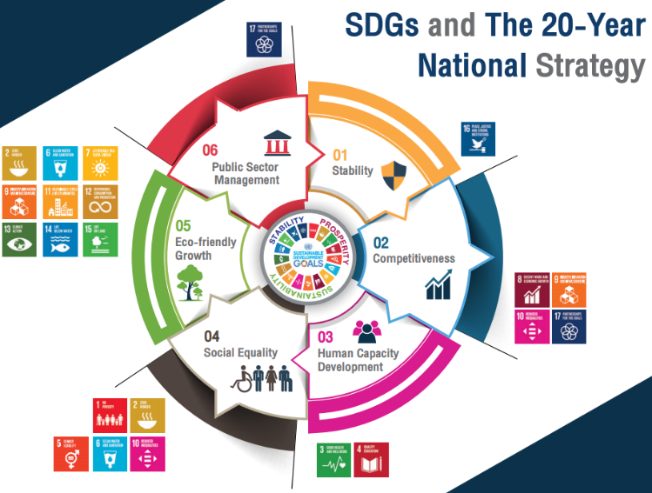
Since the launch of the 2030 Agenda for Sustainable Development, Thailand has stressed the importance of and has continued to press ahead with implementation of the SDGs, despite the setback of the COVID-19 pandemic. The country’s homegrown development approach, the Sufficiency Economy Philosophy remains the country’s guiding philosophy and pathway towards the achievement of the SDGs.

Thailand’s SDG Roadmap developed by NESDC with support from UNDP, and endorsed by the National Committee for Sustainable Development provides a clear path towards SDG achievement in several dimensions, taking into account coordinated efforts at awareness raising, monitoring and evaluation, project implementation, and partnerships.

The country has integrated the 17 Goals into the 20-Year National Strategy, (2017 - 2036) for realization of the vision of ‘Thailand as a developed country with security, prosperity and sustainability’ covering six areas including stability, competitiveness enhancement, human capacity development, social equality, eco-friendly growth, as well as rebalancing and improving public sector management.

In this context, a good platform is in place for advancing the SDGs in Thailand, for example around health (SDG 3) and the economy (SDG 8). The 12th National Economic and Social Plan (2017 – 2021) places a priority on human capital development, structural transformation and innovation, particularly SDGs 3, 4, 8 and 9, and recognizes that Thailand needs to address persistent inequalities (SDG 1, 2, 5 and 10). The National Plan also states that the quality of Thailand’s natural environment has been eroded and SDGs 7, 11, 12, 13 and 14 all require greater prioritization. Not least, SDG 16 concerning the efficiency of governance institutions needs fundamental reform.
Source: * NESDC
Figure 34 SDGs and the 20-Year National Strategy

To strengthen the SDG monitoring system, a number of national agencies have collaborated to develop an online integrated monitoring system (eMENSCR) which aims to provide accurate, up to date information on national progress. However, data gaps exist for about 50 per cent of SDG indicators. The Thailand National Statistical Office (NSO) has developed a lead position to ensure coordinated, robust and reliable SDG monitoring. There are a number of data issues, for example, according to ESCAP there are sufficient data for assessing just over half of the global SDG indicators in Thailand and of the remaining indicators, 13 per cent have insufficient data and 36 per cent have no data at all. There is also a strong link between policy prioritization and the availability of statistics with the least progress made in Thailand towards Goals for which there is limited data.

Assessment of SDG Progress
The SDG progress assessment utilizes the global indicator framework. The SDG snapshot (Box 38) shows where Thailand stands in 2020 in regard to each of the 17 SDGs. The assessment utilized national data for Thailand drawn from the global database across the 17 SDGs. When sufficient data on a particular SDG indicator are not available, the analysis uses additional indicators from internationally recognized sources. To facilitate progress assessment, the methodology sets target values for the SDG indicators, and in this report regional-level target values have been used. As discussed, the pandemic and its repercussions are most likely to further complicate the trajectory towards meeting the Goals of the 2030 Agenda.
Box 38 Thailand’s SDG Snapshot of Progress
Thailand is making the most overall SDG progress in eradicating poverty (Goal 1), industry, innovation, and infrastructure (Goal 9) and partnerships for the goals (Goal 17). A good platform has been built for accelerating progress in good health and wellbeing (Goal 3), quality education (Goal 4), gender equality (Goal 5), clean water and sanitation (Goal 6), affordable and clean energy (Goal 7), decent work and economic growth (Goal 8), life on land (Goal 15) and in peace, justice and strong institutions (Goal 16). Inequality and sustainability goals in relation to zero hunger (Goal 2), reducing inequalities (Goal 10), sustainable cities and communities (Goal 11), responsible consumption and production (Goal 12), climate action (Goal 13) and life below water (Goal 14) need more attention and greater prioritization.
An assessment has also been made for Thailand’s progress against each of the 17 Goals and it predicts, if continuing current practices, whether Thailand can achieve 2030 Agenda Targets by 2030 based on its trajectory. In this analysis, the ‘current status’ index is presented at the Goal level in a snapshot (Figure 35) and the ‘anticipated progress index’ is presented at the SDG Target level in a dashboard.

Goal by Goal Assessment
Goal 1. Despite good progress on eradicating poverty and basic services, the 2030 predictions show a mixed trajectory. Good progress is noted in reducing income poverty (SDG Target 1.1 and 1.2) and extending access to basic services for all (SDG Target 1.4). However, the country needs to invest further on resilience to disasters (SDG Target 1.5) as well as allocating sufficient resources to the poverty programme (SDG Target 1.a). To achieve the SDG Targets on Goal 1, Thailand needs to accelerate progress or reverse trends on several targets and improve data availability for (SDG Target 1.b).
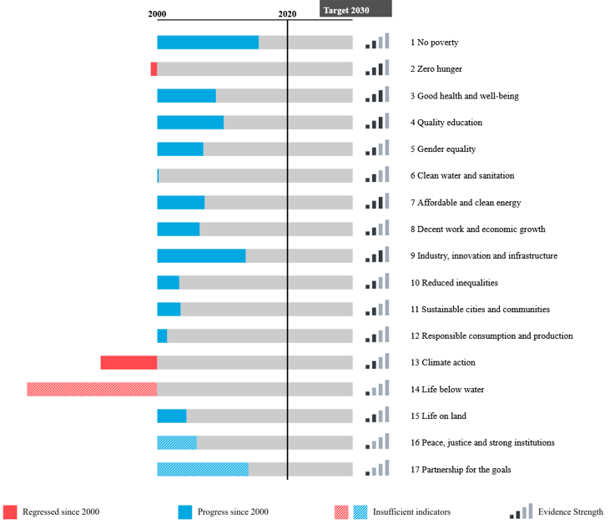
Figure 35 SDGs Snapshot in Thailand: Progress so far
Note: This assessment is conducted based on the availability of data for Thailand in the global SDG database. In circumstances when there are more updated data available at national level and not yet reflected on the global database, or when countries adopt a subset of global SDG indicators, the results may differ from nationally conducted assessments.
Goal 2. Thailand needs to accelerate its efforts on zero hunger. The biggest challenge is the prevalence of the double burden of malnutrition, in particular for wasting and stunting, where prevalence is rising (SDG 2.2), and investment/reform in agriculture (SDG Target 2.a) where Thailand will falter if current trends continue. Thailand needs to accelerate progress on SDG Targets related to small-scale food production (SDG Target 2.3) and sustainable agriculture (SDG Target 2.4). The country also needs to improve data availability (SDG Targets 2.b and 2.c).
Goal 3. Thailand has made good progress on three out of 13 SDG Targets in health and well-being. Substance abuse (SDG Target 3.6) and sexual and reproductive health (SDG Target 3.7) are challenging issues and current trends need to reverse. Acceleration or trend reversal is needed on more than half of the SDG targets to achieve the ambitions of the 2030 Agenda in this area.
Goal 4. Progress on quality education is key to the country’s long-term prosperity. The SDG dashboard shows Thailand has made good progress regarding qualified teachers (SDG Target 4.c) if current trends can be maintained. The most challenging SDG Target in education is in early childhood development (SDG Target 4.2) for which current trends need reversal. All other measurable SDG Targets in education need acceleration. Improvements to data availability are needed for (SDG Targets 4.7 and 4.b)
Goal 5. Further progress on gender equality is required. Only four out of nine SDG Targets could be measured. In particular, progress is needed to end violence and discrimination against women and girls, increasing labour force participation, access to education and earnings (SDG Target 5.1), ending early marriage (SDG Target 5.3), putting women in leadership positions (SDG Target 5.5) and using technology for empowering women (SDG Target 5.b). None of these are currently at sufficient levels to meet the ambitions of the 2030 Agenda. Sex, age, and disability disaggregated statistics are essential to produce a realistic progress narrative on gender equality in Thailand.
Goal 6. From a solid foundation, Thailand needs to accelerate progress on access to water, sanitation and hygiene (SDG Target 6.2). This includes in local communities’ engagement in water and sanitation planning and management (SDG Target 6.b), water use efficiency (SDG Target 6.4) and reverse the current trend on protecting and restoring water-related ecosystems (SDG Target 6.6) as well as on international cooperation on water and sanitation (SDG Target 6.a).
Goal 7. Good progress is possible on affordable and clean energy. Extra efforts are needed to improve access to energy services (SDG Target 7.1), the country’s energy mix (SDG Target 7.2), energy efficiency (SDG Target 7.3) and investment in energy infrastructure (SDG Target 7.b) if Thailand is to meet its Targets by 2030.
Goal 8. Thailand is making steady progress in decent work and economic growth. More progress is needed for the country to reach the SDG Targets related to economic productivity and innovation (SDG Target 8.2). Thailand also needs to speed up on per capita economic growth (SDG Target 8.1), formalizing and supporting micro, small and medium-sized enterprises (SDG Target 8.3), achieving full employment and decent work (SDG Target 8.5) and ensuring labour rights and safe working conditions (SDG Target 8.8). One of Thailand’s main challenges is to reverse the deteriorating trend on material resource efficiency in consumption and production (SDG Target 8.4) and the proportion of youth (including migrant children) not in employment, education or training (SDG Target 8.6). More investment is also needed to populate the relevant data for access to financial services (SDG Target 8.10), child and forced labour (SDG Target 8.7), sustainable tourism (SDG Target 8.9), aid for trade (SDG Target 8.a), and the strategy for youth employment (SDG Target 8.b) for a more complete picture of progress on decent work and economic growth.
Goal 9. Industrial, innovation and infrastructure present a mixed picture, but good overall progress has so far been recorded. Evidence is strong on industrial innovation infrastructure in six (out of eight) SDG Targets where data is available. Thailand has performed well on two of them and can achieve the remainder by maintaining current trends. For example, Thailand is on track in promoting resilient infrastructure (SDG Target 9.a), and significantly increasing access to information and communications technology as well as the internet (SDG Target 9.c). Nevertheless, the country still lags behind and needs to accelerate the development of infrastructure (SDG Target 9.1), investment in sustainable and inclusive industrialization (SDG Target 9.2), enhanced access to finance for small-scale industries (SDG Target 9.3), adopting sustainable and clean industries (SDG Target 9.4) and enhancing research and development capabilities (SDG Target 9.5). The country also needs to maintain a focus on domestic technology development.
Goal 10. There is a need to ensure progress in Goal 10 and continue to reduce inequalities. Only half of the ten targets are measurable. Thailand’s current progress for reduced inequalities suggests that while fewer people are living under poverty (Goal 1), the income gaps are not adequately narrowing. This is because the proportion of households earning less than 50 per cent of the national median income has not improved significantly (SDG Target 10.2). While fewer households are living below the national poverty line (using the baseline), their income remains below the average, which deprives them of the opportunities to enjoy the same living standards other than basic needs. Many also live without adequate social protection (SDG Target 10.4). At the same time, current progress on reducing transaction costs of migrant remittances by 3 per cent needs attention (SDG Target 10.c) even though Thailand is making progress to achieve safe migration and mobility (SDG Target 10.7). By maintaining the current trend, the country is also making progress towards achieving special and different treatment for developing countries (SDG Target 10.a). Significant data gaps remain regarding income growth of the bottom 40 per cent (SDG Target 10.1), elimination of discrimination (SDG Target 10.3), regulation of financial markets (SDG Target 10.5), inclusive social governance (SDG Target 10.6) and resource flows for development (SDG Target 10.b).
Goal 11. More progress is needed to make cities more inclusive, safe, resilient and sustainable in Thailand. With its current pace of progress, Thailand needs increased sustained attention to SDG Targets on providing adequate housing and basic services to all (SDG Target 11.1), providing access to a safe and sustainable transport system (SDG Target 11.2), tackling air pollution and improving waste management (SDG target 11.6). Thailand has made good progress on implementing policies to manage disaster risks (SDG Target 11.b) with a new national DRR strategy being endorsed in 2021 and an increase in the number of local authorities with a local DRR strategy increasing from 32 per cent (2016) to 52 per cent (2020), but more work will be needed to increase at the local level to ensure more resilient cities and communities. Of great importance is ensuring enhanced resilience, but Thailand is challenged in terms of reducing the lives lost to, and economic loss from, climate-induced disasters (SDG Target 11.5). Improvements are also needed in SDG data investment as only 50 per cent of the SDG Targets for sustainable cities and communities (Goal 11) can be measured.
Box 39 Government Leadership in the 2030 Agenda for Sustainable Development
The Government has shown clear leadership in some key areas of the 2030 Agenda. These include; The National Committee for Sustainable Development (CSD), chaired by the Prime Minister, is Thailand’s main and highest mechanism responsible for the country’s sustainable development. The CSD has 37 members from public, private academia and civil society, with the Secretary-General of National Economic and Social Development Board (NESDB) as the secretariat.
Production of an Annual VNR outlining the Government’s progress in seeking to advance the global goals. The successive themes of the VNRs demonstrate the Government’s commitment to broadening ownership and partnership for the SDGs:
2018 VNR focused on two main themes – ‘localizing the SDGs’ and ‘stakeholder engagement’.
2019 VNR emphasized ‘the empowerment of people and communities’ as the main theme.
2020 VNR emphasizes “Volunteerism for the SDG”.
Under the auspices of the UN Global Compact and committed to conducting business in accordance with its 10 principles in the areas of human rights, labour, environmental protection, and anti-corruption, the Global Compact Network in Thailand has so far welcomed more than fifty company members.
As evidenced by the relative containment of the COVID-19 pandemic, Thailand exemplifies the importance of a strong health system. Allied to this, sound macro-economic fundamentals reinforce the country’s overall resilience to shocks.
Thailand became the first country in Asia to adopt the National Action Plan on Business and Human Rights (NAP) in 2019. The action plan is underpinned by three pillars – protection, respect, and remedy and as developed in partnership with the Global Compact Network for Thailand.
The Thai government is implementing a new economic model called “Bio-Circular-Green Economy” or “BCG”, which consists of bio-economy, circular economy, and green economy. Recent adoption of the Bio-Circular Green Economic Model (BCG) (2021 – 2026) begins to address the inter-connected nature of the SDGs and comprises four keys to development;
- Agriculture and Food;
- Health and Medication;
- Energy and Bio-Chemical;
- Tourism and Creative Economy.
These four development keys will be integrated with biodiversity and culture which are the fundamental capital to create well-being for all citizens. It also includes:
- The National Biobank to conserve and efficiently utilize biodiversity resources.
- The Genomics Thailand Project is a study of the genetic information of Thai people to advance how to prepare medication, preventive measures, and treatments
- Regional Science Parks to conduct research at the local level and to help local people use research results to improve the grassroots economy and innovation.
- The Biorefinery Pilot Plant to expand the production scale of biomass industry from the laboratory to the industrial level.
- Thailand’s Big Data or a large database of Thailand, which is of great importance in helping the government solve problems on the spot and quickly.
Not least, Thailand is also a proponent of championing volunteerism and the role that volunteers can play in advancing the SDGs. Thailand’s volunteer networks are strong and include groups such as the ‘Marine and Forrest Rangers’, ‘Healthcare Volunteers’, ‘Social Development and Human Security’ and the ‘Friends from Thailand.
Goal 12. More progress is also needed when it comes to responsible consumption and production and for which progress cannot be measured adequately due to the limited data. Only six SDG Targets out of eleven are measurable. The good news is that Thailand is making good progress to achieve the SDG Target for phasing out fossil fuel subsidies by 2030 (SDG Target 12.c) and has taken steps to mainstream sustainable consumption and production in its policy framework (SDG Target 12.1). Nevertheless, extra efforts are needed to reduce the use of material resources (SDG Target 12.2) and improve chemicals and waste management (SDG Target 12.4). The use of material resources (SDG Target 12.2) suggests that the environment is bearing increasing pressure due to the extraction of raw materials to fuel the economy. Mounting pressure is coupled with the need for further progress in treating chemical and other types of hazardous waste released to air, water and soil (SDG Target 12.4). Thailand needs to reduce waste generation (SDG Target 12.5), increase support for research and development capacity for sustainable development (SDG Target 12.a) and improve the monitoring of sustainable tourism (SDG Target 12.b).
Goal 13. Thailand needs to redouble its efforts to achieve the 2030 Targets to tackle climate action. Improvement is required for both resilience and adaptive capacity (SDG target 13.1) and climate change policies (SDG target 13.2). An acceleration is needed for resilience and adaptive capacity (SDG target 13.1) otherwise Thailand and its population will remain increasingly vulnerable to the impacts of climate change, which also underlines the need to invest in building resilience to climate-induced disasters under SDG targets 1.5 and 11.5. At the same time, climate actions have yet to take root in national policy planning and implementation, evidenced by the limited progress into date SDG target 13.2. There is widespread recognition that sustained progress is required to reducing greenhouse gas emissions under SDG target 13.2, which further highlights the need for tackling air pollution (SDG target 11.6) and reducing the extraction and use of natural resources (SDG target 12.2). The 2019-20 drought and 2020 floods emphasize that disaster damage and loss may be increasing because of climate changes.
Goal 14. The Life below water also needs prioritization. This is Thailand’s most data-poor goal with only 30 per cent of SDG targets being measurable. The limited evidence suggests however that, at the current pace, Thailand needs to pay greater attention to this target to attain the ambitions of the 2030 Agenda. Progress on conservation of coastal areas (SDG target 11.5) needs to be accelerated as well as respect for the oceans’ health (SDG target 14.1) and marine resources for small island developing states SIDS and the least developed countries (LDCs) (SDG target 14.7). Efforts must be redoubled to produce more reliable data on life below water for a better understanding on the progress and priority areas for sustainable development.
Goal 15. Overall progress on life on land needs accelerated efforts. Continuing current trends, Thailand will be able to meet only one SDG target on mobilizing financial resources from all sources to conserve and sustainably use biodiversity and ecosystems (SDG target 15.a). While the country has taken some positive steps in mainstreaming biodiversity in national planning (SDG target 15.9), the country needs to accelerate its efforts in protecting territorial and freshwater ecosystems (SDG target 15.1), conserving mountain ecosystems (SDG target 15.4), and ensuring fair and equitable sharing of the benefits arising from the utilization of genetic resources (SDG target 15.6). Thailand also needs to address the loss of biodiversity (SDG target 15.5) and unsustainable use of forest resources (SDG target 15.2) to achieve its commitments to the 2030 Agenda. Investments in SDG data are also needed as only 50 per cent of the SDG targets for life on land (Goal 15) can be measured.
Goal 16. Peace, justice and strong institutions are making incremental progress and in need of accelerated progress towards the targets, and is another SDG with poor data availability. Only five out of 12 SDG targets can be measured. The significant reduction in the number of intentional homicides as well as an increased number of births registered in Thailand is promising. Based on the current trajectory, targets on violence and related deaths (SDG target 16.1) and providing legal identity to all (SDG target 16.9) are within reach for Thailand. The ongoing situation in the Southern Border Provinces, however, continues to be a concern. However, the number of detected victims of human trafficking (SDG target 6.2) and the incidence of unequal access to justice for all (SDG target 16.3) are increasing in Thailand. The country needs to accelerate on substantially reduce corruption and bribery in all their forms (SDG target 16.5). Improvements in SDG data are needed as 60 per cent of targets are not measurable.
Goal 17. Partnership for the goals is making good progress and extremely important for achievement of the 2030 Agenda. However, it is the second most data-poor SDG as nearly 70 per cent of targets are not measurable. Of seven (out of 19) SDG targets that could be measured for Thailand, two are making good progress and potentially achievable by 2030 if current progress is maintained: debt sustainability (SDG target 17.4) and capacity building for SDGs (SDG target 17.9). Thailand needs to accelerate its efforts strengthening statistical capacity (SDG target 17.19), increasing science and technical international cooperation (SDG target 17.6) and developing capacity for information and communication technology (SDG target 17.8). In particular, raising the public funds needed to invest in the SDGs targets on domestic resource mobilization (SDG target 17.1) need further prioritization. Building statistical capacity to produce reliable data and monitor the SDGs is one of the means of implementation under Goal 17 (SDG target 17.19). Improvements to data availability are needed for 13 of the SDG targets under partnership for the goals.
In overall terms, Thailand is making good progress in a number of the SDG targets, but will need to redouble its efforts in order to attain its SDGs. Using the overall assessment, the SDG dashboard set out at Figure 34 of the Technical Annex predicts Thailand’s likelihood to achieve the SDG targets based on its rate of progress to date. It shows that 106 of the 169 global SDG targets have sufficient data to be measured. Of these, Thailand is making sufficient progress towards achieving 17 targets and will need to leverage all possible means to change current trends for the remainder of the measurable targets.
More broadly, there is a general lack of awareness around sustainability in Thailand. Despite frequent mention of the word ‘sustainability’ by the media, a recent poll conducted by the National Institute of Development Administration (NIDA) in June 2020 showed that only a quarter of the population was aware of the Sustainable Development Goals. While there was no difference in awareness across gender, lower awareness was evident among the younger generation (at 20 per cent).
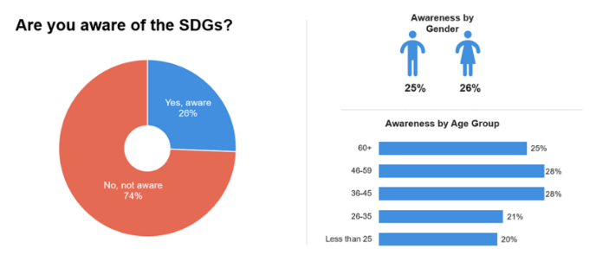
Figure 36 SDGs Awareness of the Thai Population
Source: UN in Thailand, 2020.

Investments Needed to Help Reach the SDGs
Attainment of the SDGs will require a reorientation of investment and efforts across all stakeholders, including Government, NGOs, companies and investors. Never before has the global community set out such an ambitious agenda – and the need to meet the challenges is urgent. It is projected that meeting the SDGs will require about THB 1.27 trillion (or US$40.9 billion) in additional annual investment from 2020 to 2030, equivalent to 50 baht per person per day. The estimate, which was undertaken before the pandemic, consists of investments in people (THB 513.5 billion), prosperity (THB 426.1 billion) and planet (THB 327.8 billion) (Figure 37). Leveraging all partnerships, including national and sub-national Governments, the private sector, civil society and communities will be vital to the success of the collective endeavour. Besides monetary investments, improving governance structures, including policy making through tripartite social dialogue, ensuring freedom of association and collective bargaining rights for workers is also necessary. These are also measures that can be utilized as instruments of state policy to achieve objectives of inclusive sustainable growth.
Box 40 Context of the Sustainable Financing Framework in Thailand
Thailand is a leading innovator in many key areas of SDGs financing. The Government’s Sustainable Finance Framework[^{1]} will facilitate the development of an Integrated National Financing Framework (INFF) for the country. The INFF, premised on a Development Finance Assessment^{[2]} will lay out the full range of financing sources – domestic public resources, aid and development cooperation, and domestic and international private finance –to develop a strategy to increase investment, and achieve SDG priorities, as identified in a country’s national sustainable development strategy. To meet the SDG goals including climate change the government has done the following:
- It is one of the first countries to implement the biodiversity finance (BioFin),^{[3]}
- Issued inaugural sovereign sustainability bond USD 944.9 million,^{[4]}
- Institutionalized the UN Principles for Responsible Banking which represents 22per cent of the Thai banking sector with a combined asset base of approximately $200 billion and servicing more than 38 million customers,
- Thai Securities and Exchange Commission and the Stock Exchange of Thailand are promoting sustainable capital markets,
- The Government Pension Fund of Thailand is a member of the Principles for Responsible Investment to support sustainable business,
- The private sector has issued green bonds raising over USD 1 billion to enhance green investments.^{[5]}
Source/Note:
^{[1]} Public Debt Management Office, Ministry of Finance, Thailand ( https://www.pdmo.go.th/pdmomedia/documents/2020/Jul/KOTper cent20Sustainableper cent20Financingper cent20Framework.pdf.
^{[2]} UNDP, Development Finance Assessment Guidebook, ( https://v2.sdgfin.org/wp-content/uploads/2019/04/development-finance-assessment-guidebook.pdf).
^{[3]} UNDP, Biodiversity Finance Plan, 2020 (https://www.th.undp.org/content/thailand/en/home/library/environment_energy/the-biodiversity-finance-plan.html).
^{[4]} August 2020
^{[5]} Four private firms (e.g., BTS Group, Energy Absolute, PTT Public Company and B. Grimm Power) raised from corporate green bonds sold.
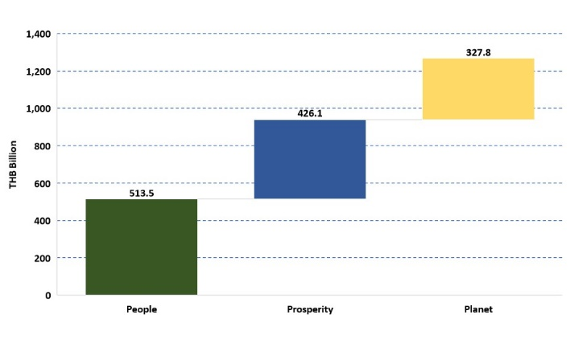
Figure 37 Preliminary Estimates of Additional Annual Investment Need to Achieve SDGs in Thailand
Source: ESCAP projection.

CHAPTER 6: SDG BASED MULTI-DIMENSIONAL RISK FRAMEWORK
The risks to Thailand’s progress in achieving the SDGs are broad and inter-related across the economic, political, social, environmental and gender spheres. In September 2020, a multi-dimensional risk assessment was undertaken by the UN Country Team, with national partners consulted as part of the process. The impact of the pandemic is inherent throughout and forms an integral part of the CCA. The analysis concludes five priority risks in no order of priority:
Box 41 A Second Wave of COVID-19
The second wave of COVID-19 in December 2020 placed further strain on economic, social and political systems. An increasing reliance on social protection programmes has already stressed the Government’s budget and this is likely to continue. It is evident that even the immediate impacts of COVID-19 are far from over and further unemployment, and under-employment are forecast. Those who lose work may find other opportunities with worse conditions, and more businesses will become bankrupt – particularly SMEs. There is concern over an anticipated increase in non-performing loans, which will also affect the finance and banking sector. For this reason, observers reflect that 2021 will be critical to manage and gradually lead to the beginnings of Thailand’s recovery. The second wave is prolonging the crisis and resulting in greater economic impact with further risks to social cohesion as well as access to health and potentially other basic services. Any additional disaster or crisis will only serve to further stretch the Government’s resilience.
- Economic risks
- Political risks and democratic space
- Social cohesion, equality, and non-discrimination related risks
- Climate, environment, and disaster risks
- Gender equality risks
Understanding the complex interrelated nature of these major risk areas in Thailand is a key part of this analysis, which is vital for advancing the 2030 Agenda and for progressing the SDGs in Thailand.

Economic Risks
Thailand has been struggling to overcome the middle-income trap with key development challenges posing the greatest risk to future growth and SDG attainment including the implementation of industry 4.0 reforms, addressing poor quality educational outcomes alongside considerable wealth, digital and regional inequalities. As reported, Thailand has been struggling to secure the human capital transformation needed to overcome the middle-income trap. If the country wants to accelerate its rate of SDG delivery, implement industry 4.0 and arrive at high-income status by 2037, key weaknesses in educational outcomes and skills matching, which risk the future productivity of the younger generation, will need to be addressed. In addition, digital and spatial inequality, a central theme of this CCA, with outlying areas at risk of falling further behind in economic and welfare indicators, will also require careful attention. Significant wealth inequality is coupled with high levels of household debt, the second highest in Asia. These changing fortunes in which both middleclass and the poor are being affected may signal increased risks to social and economic stability and human rights.
Although Thailand successfully managed the health dimensions of the pandemic in 2020, the economic impact has been significant and deepened pre-existing difficulties (Box 41). While Thailand has been successful in stemming the tide of COVID-19 infections, the economic impact has already led to widespread job losses, particularly in tourism, affecting middle-class households, migrants’ livelihoods, young peoples’ prospects and the poor. As noted above, this is beginning to erode hard-won gains in poverty reduction with working poverty set to rise by the end of 2020. Prolonged economic distress is undermining the viability of SMEs that lack the resilience to weather the crisis. Nearly 21 million of 37 million workers are at risk of experiencing a significant impact. Many without social protection are in the over-sized informal sector, which accounts for about 54 per cent of the workforce, and who have to move into survival mode. The full impact of COVID-19 is forecast to magnify pre-existing fault lines and vulnerabilities, further concentrate power and wealth, and as a result deepen the political divide, risking further social and political turbulence. The Government has forecast a contraction in the economy of 8.1 per cent this year, with no return to normalcy before 2022. As many as 8.4 million jobs are expected to be lost on top of 6 million farmers directly impacted from environmental risks arising from by drought.
Growing inequality and worsening poverty could magnify existing fault lines around uneven development and across generations. Economic problems entrenched in Thailand’s development model are being exacerbated by COVID-19. The twin risks of a prolonged economic slowdown and stronger popular defiance towards the economic and governance model will continue to exacerbate each other.

Political Risks and Democratic Space
Political stability, democratic space and sustainable development are inextricably linked and essential for Thailand to progress the 2030 Agenda for Sustainable Development and the SDGs. Several 2020 indices, which indicate weaker fundamental freedoms and shrinking civic space./.
Box 42 Thailand’s Universal Periodic Review (UPR) on Human Rights
Thailand will undergo its third cycle of the Universal Periodic Review (UPR) during the 39th Session in November 2021, for which the Ministry of Foreign Affairs is drafting the State Report. During the second cycle of the UPR in May 2016, Thailand received 249 recommendations of which 187 were accepted and became the basis for Thailand’s UPR action plan. In addition, 62 recommendations were noted, and 7 voluntary pledges were made. The 249 recommendations were grouped into 47 themes with highest recommendations received in the theme of Acceptance of International Norms.^{[1]}
Thailand noted rather the recommendations related to reformation of and amendments to various domestic laws, trial of civilians in military courts, issues of arbitrary detention and some recommendations related to death penalty. Recommendations related to ratification of the Second Optional Protocol to the International Covenant on Civil and Political Rights, the 1951 Convention Relating to the Status of Refugees, the Rome Statute of the International Criminal Court, the ILO Indigenous and Tribal Peoples Convention, 1989 (No.169) and the International Convention on the Protection of the Rights of All Migrant Workers and Members of their Families were also noted. On the other hand, all the recommendations related to women rights under the themes of advancement, discrimination and violence against women, and their participation in political and public life were supported. Similarly, all the recommendations to children rights under the themes of general protection, family environment and alternative care, protection against exploitation and juvenile justice were supported.
In March 2019, Thailand submitted a mid-term report (2016-18) to provide an update on the implementation of recommendations received for its second cycle UPR.^{[2]} The mid-term report informed about Thailand’ accession to the Marrakesh Treaty^{[3]} and being the first country in Asia to ratify the ILO ‘Work in Fishing Convention. In addition, Thailand also withdrew its reservation to article 4 of the International Convention on the Elimination of All Forms of Racial Discrimination (CERD) in October 2016.
Source:
^{[1]} http://lib.ohchr.org/HRBodies/UPR/Documents/Session25/TH/UPR25_Thailand_recommendations.docx.
^{[2]} https://www.ohchr.org/EN/HRBodies/UPR/Pages/UPRImplementation.aspx.
^{[3]} https://www.wipo.int/treaties/en/notifications/marrakesh/treaty_marrakesh_51.html.
The street protests and social media campaigns led largely by young people are an indicator of intergenerational polarization in society. The latest developments in the constitutional reform process are an outcome of the ongoing transition. In addition, the government is also seeking to take forward the dialogue of reconciliation through parliamentary processes including the establishment of the reconciliation committee under the leadership of the speaker. So far opposition has not agreed to be part of this dialogue, which is one reflection of the political polarisation. Within the above context, there is a potential risk that the situation could deteriorate into acts of violence.
A number of UN human rights mechanisms, including the UN Human Rights Committee, which oversees implementation of the International Covenant on Civil and Political Rights (ICCPR), in its concluding observations on the second periodic report of Thailand in 2017 recommended that sections of the Criminal Code should be reviewed, to ensure their consistency with article 19 of the Covenant. More recently, the Spokesperson for the High Commissioner for Human Rights has raised concerns over the application of these sections of the Criminal Code given that more than 56 individuals have been charged since November 2020, including three minors. /
Furthermore, the situation in the Southern Border Provinces is likely to continue. The government has addressed the cultural, religious, and historical dynamics through various mechanisms, including development projects and dialogues. However, at least 277 people were affected by the situation although violent incidents have been in decline. The complex situation has also taken a toll on social cohesion as Muslim and Buddhist communities remain fractured.

Social Cohesion, Equality and Non-discrimination Related Risks
Thailand faces a number of distinctive demographic risks across various segments of its population, in particular for older and younger people, as well as migrants, among which include fiscal, health and social care, as well as educational and economic risks. While there are some acknowledged virtues (as noted in the demographic section above), a rapidly ageing population and skewed demographic structure are likely to add additional stress to Thailand’s economic complexion. From 2025, the population will be in decline, the proportion of those of working age will reduce relative to the whole, and an increasingly older population will result in an accumulated burden on government. spending for social protection from a potentially reduced the tax base. Meanwhile, young people continue to face educational and health risks through a learning system that is not fully preparing them for the challenges they face in the workforce, while half of new HIV infections occur in the 15 to 24 age range/ with young people also witnessing an alarming rise in the rates of sexual transmitted diseases. COVID-19 poses an increased risk of stigmatization, xenophobia and politicization of issues targeting specific populations, with potential knock-on effects of increasing risks of abuse and exploitation of migrants, smuggling and trafficking in persons.
Box 43 The Risks Associated with Inequalities, Discrimination, and Injustices (real or perceived)
These factors have influence on social, economic and political risks. Concerns about inequality underlies recent social unrest on almost every continent with social upheaval being sparked in various locations by different tipping points – such as corruption, constitutional breaches, or the rise in prices for basic goods and services. And although global inequality has declined over the past three decades, domestic income inequality has risen in many countries, particularly in advanced economies, and reached historical highs in some. The OECD reports that ‘income inequality in OECD countries is at its highest level for the past half century.’* What is also known is that inequality hinders growth, damages macroeconomic fundamentals, slows economic activities and casts doubt on a country’s stability. This damages investor confidence and undermines political capital – both fundamental conditions for prosperity, especially in times of economic volatility. The profound political consequences of inequality can also undermine economic growth by making a country harder to govern – in ways ranging from legislative impasses to complete government paralysis. Such risks are accentuated by the decentralized and spontaneous ‘pop-up’ nature of recent demonstrations as have occurred recently in Thailand.
Source: * http://www.oecd.org/social/inequality.htm
Thailand’s weak public participation and engagement in planning processes alongside corruption and perception of corruption is a challenge. The government is seeking to accelerate the transition to a working style to fit the ‘new normal’ model while prioritizing a joint approach in which all sectors at all levels of society are involved and play a greater role in determining the future of the country. In addition, the Government is seeking to enhance accountability and transparency by encouraging the public to play a role in evaluating and providing feedback on government projects directly to the senior executives in the Government. The Human Rights National Action Plan (2019-2022) also calls for promoting people’s political and administrative participation whereby their rights of expression are protected through the creation of community-level mechanisms for monitoring and addressing human rights issues.
The Government has made a clear strong commitment to prioritizing corruption prevention. The 20-year National Strategy and 12th NESDP contain important objectives to combat and prevent corruption - a direction reaffirmed by the Prime Minister this year to mark the International Anti-Corruption Day. However, corruption, and perceptions of corruption, represent a significant challenge. In 2020, Thailand was positioned 104th among 180 countries in Transparency International’s Corruption Perceptions Index (CPI). According to the CPI Thailand’s state institutions, including the government, courts and the police fare poorly in terms of citizens' trust. /

Climate, Environment and Disaster Risks
Thailand is noticeably affected by environmental degradation, biodiversity loss, the pollution of its air, land and water resources, and more particularly, its exposure to climate-related hazards such as flooding and drought. At the global level, climate change is striking harder and more rapidly than many expected, with the last five years being on track to be the warmest on record. Climate-related hazards and subsequent disasters are becoming more intense and more frequent, and unprecedented extreme weather is being experienced throughout the world. Global temperatures are on track to increase by at least 3 Degree Celsius towards the end of the century – twice what climate experts have warned is the limit to avoid the most severe economic, social, and environmental consequences. Biodiversity, which underpins the world’s food system, is declining faster than it has at any other time in human history. Thailand is being noticeably affected by this interrelated environmental crisis and has its part to play in both the degradational aspects as well as in helping todrive forward solutions that improve environmental health, ecosystem vitality and resilience to weather disasters, all of which have the potential to provide green job creation and green economic growth.
Box 44 Waste Management in Thailand
In respect to water management, only about 50 per cent of wastewater is treated in Thailand with water pollution remaining a concern to many communities.^{[1]} Thailand generates more than 27.8 million tons of solid waste per year out of which plastics accounted for 12-13 per cent, and as noted in the transboundary section above, Thailand is the tenth largest source of marine pollution in the world. Even before the COVID-19 crisis, effective waste management has been an ongoing challenge for municipalities and authorities. About 60 per cent of waste is not managed and disposed of properly.^{[2]} To effectively manage waste and to achieve the circular economy as per the Government’s goals, the whole waste management sector should be restructured and re-priced. In overall terms, overlapping mandates and legal frameworks conspire with insufficient law enforcement to inadequately mitigate risks posed to the environment.
Source/Note:
[1] Communities along Thailand’s river systems are especially vulnerable to the risk using unsafe water for consumption and food-production. Wetlands located in peri-urban areas in Thailand have also become increasingly degraded through conversion to urban and industrial development, as well as pollution from industrial run off and pesticides. Coastal communities face erosion, ocean waste, and illegal, destructive fishing. The coasts are also increasingly vulnerable to storm surges and sea level rise, due in part to the destruction of mangroves and coral reefs. See Birdlife 2003. “Thailand Wetlands” in Saving Asia’s Threatened Birds: A Guide for Government and Civil Society. Access December 2017. See also World Bank. 2016. “Getting Back on Track: Reviving Growth and Securing Prosperity for All.” http://documents1.worldbank.org/curated/en/855161479736248522/pdf/110396-REVISED-v1-4-26-WB-TH-SCD-REPORT-BOOKLET-159PAGE-RevisedApr26.pdf.
[2] Report of Thailand’s Pollution Control Department, in 2016. According to UNIDO’s internal study on Mercury Management in household products and waste in Thailand, 2018 (unpublished), mercury-containing waste such as dry-cell batteries and used fluorescent lamps and other hazardous waste (household small electronic items) discharged from households has been mixed with municipal solid waste and has not been disposed properly. A total amount of about 0.2 million tons of household hazardous waste, including batteries, used fluorescent lamps, containers of chemicals and spray cans, but excluding waste from electrical and electronics equipment) was generated in Thailand.
Thailand is among the top ten most vulnerable countries to climate change and ranks fifth in terms of both the number of people affected and economic cost of disasters, and may improve its capabilities to deal with environmental hazards, and including a lack of green jobs. Based on an assessed level vulnerability and susceptibility to hazards (floods, sea-level rise, cyclones, droughts, earthquakes, etc.), Thailand has a high level of exposure to hazards but low levels of overall coping and adaptive capacities to deal with them/. Additionally, disasters disproportionately impact poor and marginalized people, meaning that disasters also risk widening social gaps and increasing levels of vulnerability. On average, disasters killed more than 70,000 people and affected more than 200 million people per year during the last decade in the Asia-Pacific region. Along these same lines, the World Disaster Report 2018 found that in the period 2008 to 2018, Thailand ranked fifth highest globally in terms of the number of people affected by disasters (60 million people over the ten year period), and fifth in terms of the economic cost, amounting to about US$46 billion (Table 7).
Disaster and climate risk pose a considerable threat to Thailand’s development trajectory with floods, droughts and storms being the top three hazards with the highest cost in terms of damage. Among a range of other environmental challenges, weak data and analysis functions prevents better disaster management. In the past two decades, Thailand has undergone observed changes in precipitation and seasonal weather patterns. Shorter winters, the delayed onset of rainfall, periodic droughts, flash floods and landslides are regular occurrences affecting the more disaster-prone areas of the country the most. Major incidents have stalled and in some instances temporarily reversed economic growth and gains in poverty reduction, and take time, effort and financial resources to recover from. The Bangkok flood of 2011 alone caused extreme economic loss at about US$42 billion (representing over 11 per cent of GDP), while major flooding in the South occurred in December 2016 and January 2017 and again in the Northeast from August to October 2019.
Urban inundation risks are predicted to escalate human and economic costs, particularly in Bangkok, due to rising sea levels. Recent research indicates that Thailand may, by the end of the century, face high tide lines that will cover land now home to an estimated 17 per cent of the population. This does not include people affected by disasters associated with higher sea levels, including more severe storm surges, salinization of water supplies and coastal flooding. Extreme weather events pose considerable risks to the population, and not least to agriculture, foods systems and to small-scale farmers’ livelihoods. Increased pressure on land use and the use of flood plains are also important factors that increase exposure and vulnerability to the risk of flooding. In addition, parts of the North and West lie on several active faults considered as highly exposed to earthquake risk with between six to eight mild to medium strength quakes being felt each year.
Table 7 People Affected and Cost of Disasters, Top Five Countries Globally
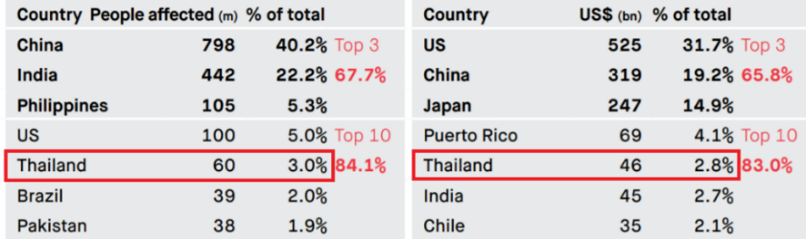
Source: IFRC, Leaving No One Behind, World Disaster Report, 2018.
Collecting, managing, sharing, analyzing and using disaster information remains a critical challenge in Thailand. This is due not because of lack of information, but more related to issues around consistency in data format, scale, capacity to utilize data and creating a publicly accessible central hub for data sharing with both Government and private sector partners. These factors impede Thailand’s ability to analyze, understand and take steps to reduce disaster risk. Making such data accessible is critical to ensure risk-informed development in the country across all sectors. It would also be prudent to reduce new risks to future infrastructure and development projects and create communities that are more resilient to disaster and climate shocks, including the protection of livelihoods.
Thailand is a strong advocate of the Sendai Framework for Disaster Risk Reduction (DRR). Notwithstanding the challenges outlined above, the country has made efforts to strengthen DRR systems. Further investments are needed to ensure development gains are protected to achieve both the SDGs and ensure full utilization of the Sendai Framework. A new multi-sectoral national DRR strategy is being finalized, which is expected to be endorsed by the Government in 2021. In addition, the number of local authorities in Thailand with a local DRR plan has gradually increased from 2,500 (2016) to 4,102 (2020). Over 50 per cent of local authorities now have a DRR plan in place.
Degradation of Thailand’s pristine environment has occurred steadily and waste management systems have proven inadequate to cope with the levels of waste generation (Box 44). Despite protection of the environment being prioritized in government strategies, the pace of policy change and support for green jobs has been slow and inter-ministerial cooperation weak. The incremental degradation of Thailand’s natural environment is due largely to unsustainable industrialization and an extractive economic model, compounded by ineffective law enforcement, limited coordination between responsible agencies, and limited resources devoted to environmental protection and green jobs. As Thailand continues to urbanize and industrialize, natural resources such as forests, farmland, wetlands and greenspace have been transformed to serve urban, economic and industrial purposes. Furthermore, freshwater resources have been reduced, related principally to the growth in population, presenting an increased risk of water scarcity arising from prolonged dry seasons. / This is a risk to the foundation of the country’s development, which has depended on Thailand’s abundant natural resources and rich ecosystems for food production, tourism and economic growth.

Gender Risks
There are clear and specific gender risks in Thailand. These arise principally from women’s unequal participation in the political, social, economic, environmental, legal, budgeting and data domains, which represent extensive in public policy response, with societal repercussions, not least reflected in the persistence of gender-related prejudice and violence targeting women and girls (Box 45). Inherent gender disparities intersect with and affect all other domains of risk. Although Thailand does not have one overarching law addressing all forms of degrading discrimination and violence against women, several laws have been put in place or amended, thereby providing an overall better legal framework to promote and protect human rights of women in Thailand. National policies and mechanisms have also been put in place to better protect women, such as the National Women’s Development Strategic Plan (2017-2021). However, effective enforcement of these laws and policies remains a challenge.
Box 45 Gender Based Violence in Thailand
Gender-based violence and intimate partner violence (GBV/IPV) responses require improvement and better coordination between Line Ministries. Legislation on GBV focuses on domestic violence and the family, while the definition of GBV is contested among governmental and non-governmental organisations.
According to MICS 2019, a high proportion of women aged 20 to 24 years old (20.2 per cent) reported being first married or in union before 18 years old contributing to a high adolescent birth rate, and although the adolescent birth rate has been decreasing, it remains high and may be a vulnerability factor leading to sex work. The same child marriage rate is even higher among some groups, including women in the Northeast (28 per cent), those who only completed lower secondary education (46 per cent) and those from the poorest families (30 per cent).
As in many countries, there is also a scarcity of data on violence and harassment in the world of work, including sexual harassment, which disproportionately affects women and thwarts their career progression and employment outcomes.
Women’s political participation in Thailand is limited (as noted above). This impacts the role of women in decision-making and is reflected in the low proportion of seats held by them in national and local governments. There is limited gender-sensitive support and services as well as fewer opportunities for women in specific professional occupations and sectors, STEM in particular. Gender gaps are also prevalent in the area of entrepreneurship and corporate management. At the global level, a survey found about 64 per cent of women-led firms declared their business operations were strongly affected by the COVID-19 crisis, compared with 52 per cent of companies led by men.
The Government enacted the Gender Equality Act (BE 2558) in 2015, yet the issue of pay equality in itself has not been explicitly dealt with and scope for improvement remains, including for gender budgeting and sex-disaggregated data. There are as yet no measures for promoting pay transparency under condition in which women face a pay gap of 10.9 per cent. Primary responsibility for unpaid domestic and care work falls largely upon women, which with Thailand’s ageing population outlined above is only likely to increase. These challenges are reinforced by data that show ‘strong expectations’ that women should stay at home to care for family needs. There is no meaningful gender-responsive budgeting or tracking of allocations to monitor or address these concerns. As noted under SDG 5 and 10 above (gender and inequalities, respectively), there is a paucity of sex, age and disability-disaggregated data on vulnerable groups through which to arrive at detailed gender analysis for decision making or policy setting and targeting.

CHAPTER 7: TRANSBOUNDARY ISSUES
By virtue of Thailand’s extensive borders and geopolitical position, bounded by nations predominantly with varied governance structures, the country is relatively exposed to a range of transboundary issues. Thailand has a long territorial border running almost its entire western flank with Myanmar and to its north and east with Lao PDR and Cambodia. To the south lies Malaysia. Thailand’s northern and lateral neighbours have economies, governance structures and social systems at various stages of development. As a result, Thailand is often the centre of gravity in mainland Southeast Asia.
Box 46 Thailand’s Role in International and Regional Cooperation
In order to address these and other transboundary concerns Thailand plays an important role in regional cooperation bodies such as ASEAN APEC, APFSD, ESCAP, as well as other bodies, such as the Mekong River Commission (MRC) and Lancang-Mekong Cooperation Mechanism.

Environmental Pollution

Transboundary Haze Pollution
Transboundary haze pollution is one of Thailand’s most significant regional challenges, generating a substantial impact on human health, local economies and biodiversity. Domestic and neighbouring countries’ open burning of agricultural materials and forest fires emit a range of particulate matter, toxic gases, volatile organic compounds and trace gas emissions, which correlate to an increase in respiratory illnesses and cases of mortality or morbidity. Data suggest 87 per cent of Thailand’s 68 million people lived in areas where the annual average particulate pollution level exceeded the WHO guideline. Seventy-five per cent lived in areas where it exceeded Thailand’s own air quality standard. Air pollution shortens the average person’s life expectancy in the country by more than two years, relative to what it would have been if the WHO guideline for long-term fine particulate matter (PM2.5) pollution was met. Some areas of Thailand fare much worse than average, with air pollution shortening lives by more than four years on average in the most polluted regions (Figure 38). Air pollution is even more severe in Northern Thailand, where agricultural biomass burning, and forest fires are common. From an environmental perspective, forest fires and biomass burning also contribute to global climate change and have devastating effects on biodiversity and habitats.
Haze pollution originates principally from neighbouring countries, as well as domestically, and requires renewed regional cooperation and commitment to action. From all emissions, about three-quarters (73 per cent) are linked to the open burning of agricultural residues and forests originating in neighbouring countries and one quarter (27 per cent) from within Thailand./ Satellite data also reveal that the number of fire hotspots were significantly higher in the neighbouring countries, with a lesser number in Thailand (Figure 38). Ozone, which is released through agricultural and forest burning, constitutes the greatest risk when compared to CO emissions from coal-fired energy generating plants and SO² vehicle emissions. Despite an agreement signed by all ASEAN Member States in June 2002, progress on transboundary haze pollution has been slow. More recently, Environment Ministers of ASEAN countries endorsed the Roadmap on ASEAN Cooperation towards Transboundary Haze Pollution Control that seeks to serve as a strategic, action-oriented and time-bound framework.
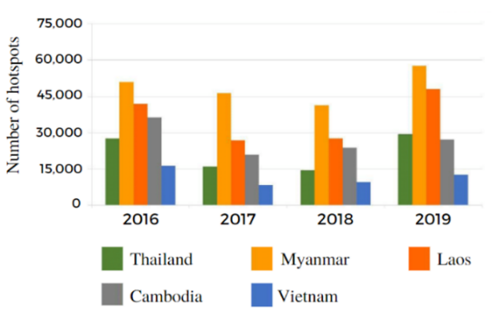
Figure 38 Comparison of Accumulative Hotspots in Five Countries (2016-2019)
Source: For the period of 2017-2018, the GISTDA (Geo-Informatics and Space Technology Development Agency).

Transboundary Marine Litter
Thailand is contributing significant plastic waste to the oceans, which has become one of the most critical global transboundary issues due to the multiple threats it poses to marine biodiversity, human health and local economies. Thailand’s average per capita plastic waste generation is more than twice the world average with about 336 thousand tonnes of plastic ending up in the ocean from Thailand every year. This is equivalent to a plastic leakage of 48 kg/capita/year. About 41 per cent of the collected plastic waste in Thailand is improperly managed while another 30 per cent of plastic waste in the country is uncollected. Out of the country’s 2,490 waste management sites, just 19 per cent are properly managed. The other 81 per cent are essentially open dump sites, often located on the banks of rivers and streams, or adjacent to the coast where waste washes into the ocean before being transported further by ocean currents.
The increasing significance of transboundary marine pollution necessitates Thailand to work with its regional neighbours and partners for acceptable and enduring solutions. The littoral countries around the Gulf of Thailand and South China Sea are listed as some of the biggest sources of plastic pollution. Transboundary movements of waste that ends up at the coast could also be coming through the Mekong River. These sources are significant and require Thailand to work with neighbours within the South China Sea, Gulf of Thailand and Mekong countries, as well as globally. Regional and wider international frameworks and mechanisms are required to tackle transboundary marine waste. Intergovernmental mechanisms are critical for knowledge sharing, coordination, and harmonizing monitoring approaches, standards and regulations to address transboundary flows of marine litter. Achieving international targets requires political commitment, effective legislative and regulatory frameworks, and significant civic and private sector participation.

Transboundary Riparian Issues
The Mekong is one of the world’s most abundantly biodiverse and fisheries-productive rivers in the world, which supports the livelihoods and food security of millions of people. The construction of large dams on the upper reaches of the Mekong for hydropower has resulted in a widely fluctuating river flow. Changes in river flow play an important role in the ecology and economy of the Mekong Region. Fishing is particularly important to people as the Mekong River is one of the world’s most productive inland fisheries, with an annual catch of 2.6 million tonnes. The annual value of the river’s fisheries is estimated to be US$4 billion to $7 billion. Over 1,000 fish species have been found in the Mekong.
International cooperation is key to balance demands for hydropower with biodiversity, livelihoods, and river sustainability. In addition to China, the lower Mekong countries are also heavily involved in hydropower development. As their economies continue to grow, so does their demand for energy. These countries have built over 40 large dams in the Mekong River Basin and plan to construct another 80. The extensive hydropower development in the Mekong River requires effective cooperation mechanisms between the riparian countries to ensure sustainability. In 2016, a new Lancang-Mekong Cooperation Mechanism was launched and signed by all six Mekong countries. This initiative is still in its early stages and it remains to be seen whether it will provide an effective forum for tackling the complex issues faced by its members.

Transnational Organized Crime
Thailand is used as a transit and destination country by transnational organized crime groups from across Southeast Asia, trading and transporting drugs, wildlife products and trafficking of people. These criminal networks, which possess unprecedented influence and control multi-billion dollar ‘industries’, have become more complex and attain global reach as they traffic unprecedented quantities of methamphetamine, related precursor chemicals and other synthetic drugs. They are also responsible for the trafficking of massive consignments of illicit wildlife, forest products and species essential to biodiversity. At the same time criminal groups continue in the smuggling of migrants and trafficking in persons for the purposes of sexual and labour exploitation, and in this regard Thailand is a country of destination, transit, and origin. Observations suggest that the impact of the pandemic may have caused an increase in illicit activity as global supply chains have broken down, monitoring and identification efforts have been impeded by mobility restrictions, and increased poverty has resulted in people resorting to acts of greater desperation. The transnational crime is a challenge to the peace, security and well-being of the region, which is best tackled through cross-border and regional cooperation.
To combat these transboundary challenges, Thailand continues to play a prominent role in numerous regional drug and transnational organized crime-related cooperation frameworks. These include the ASEAN Ministerial Meetings on Transnational Crime, the Mekong Memorandum of Understanding and the ASEAN Working Group on CITES and Wildlife Enforcement. However, weaknesses remain in coping with the complex issue of the transboundary drug trade and organized crime.

The Illicit Drug Trade
Ever larger quantities and values of methamphetamine are being generated by well-resourced and organized syndicates that have perpetuated the rapid expansion of production and trafficking throughout the Greater Mekong Subregion. Southeast Asia has experienced a continuous, rapid expansion of the illicit manufacture, trafficking and use of a variety of synthetic drugs, especially methamphetamine, over recent years, more than any other part of the world. In 2019, seizures of methamphetamine amounted to 140 tons, with a large majority of the drug being manufactured in neighbouring countries. It is estimated that regional drug production and trafficking generates an annual profit of at least US$71 billion, with methamphetamine accounting for US$61 billion, over four times more than six years ago. Organized crime has been able to respond quickly to changes in the environment, where weak governance, porous borders and law enforcement gaps are readily exploited. Thailand has become one of the primary gateways to transit drugs manufactured in the region to global markets.

The Illegal Trade of Wildlife
Thailand is used as a transit hub to reach other countries for wildlife products, due to the strength of its transportation infrastructure. Thailand is a country rich in biological diversity, and home to unique and rare species of flora and fauna. It is thereby a major source, transit, and destination country for many different types of wildlife and wildlife products. Habitat loss, poaching and trafficking, human-wildlife conflict, and domestic use of wildlife has heavily impacted on many of Thailand’s native plant and animal species, including those afforded protection under the Convention on International Trade in Endangered Species of Wild Fauna and Flora (CITES). Government and law enforcement agencies are working closely together to fight this trade and have made numerous seizures of CITES protected wildlife species coming illegally into Thailand or en-route to other countries in Asia.

Human Trafficking
The majority of human trafficking victims in the Greater Mekong Subregion are being trafficked from less developed countries to more developed countries, including Thailand. In Thailand, victims of trafficking (VOT) are predominantly from the neighbouring countries, with smaller numbers originating from other parts of the world. Thai nationals accounted for 34 per cent of the victims identified in Thailand over the period 2016 to 2019, and for 14 per cent of the victims identified in 2019. A slight majority of the victims identified from 2016 to 2019 were male (52 per cent). In 2019, 288 cases were initiated, of which 76 per cent related to forms of sexual exploitation.
Human trafficking for sexual exploitation (including prostitution, pornography and other forms of sexual exploitation) accounted for 64 in 2019 and for 77 per cent of all cases for the period of 2016 to 2019. Thailand is a country of origin for trafficking to other countries both within Asia and beyond. Trafficking for labour exploitation, though insufficiently identified, is known to be a serious problem, with victims forced into work in fisheries, construction, agriculture, manufacturing, hospitality, and domestic work help. The smuggling of migrants continues as a lucrative criminal activity for organized crime groups in Southeast Asia, generating annual illicit revenues of between US$132 million to $196 million in Thailand alone. Recognition of extortion as a form of exploitation in Thailand’s trafficking legislation means that trafficking and smuggling are sometimes confused by frontline officials, leading to some smuggled migrants being misidentified as VOT and vice versa. In 2019, while trafficking for the purpose of extortion only accounted for 12 per cent of Thailand’s trafficking cases, in terms of numbers of victims, over half of the 1,818 VOT identified were trafficked for the purpose of extortion, predominantly from a neighbouring country. The numbers of victims identified has fluctuated over the past three years, with the number of VOT identified in 2019 a significant increase from the 631 VOT identified in 2018. However, due to the COVID-19 pandemic, 2020 saw only 214 VOT identified.

Population Migration and Displacement
Uneven economic development across the region and demand for low wage labour have been a large part of the driving force behind population migration, although other factors, such as flight from conflict and persecution, are also important drivers of population movements. As noted in the body of the CCA, economic migrants enter Thailand seeking better prospects, principally from neighbouring countries, and often through risky and irregular channels. In addition, due to the prevailing situation in Myanmar’s Rakhine State, numbers of displaced people in need of international protection are driving population movements to neighbouring countries. As mentioned above, Thailand has one of the world’s largest stateless populations (about 480,000), although there are stateless populations in countries in the region. Very few countries in the region are signatory to the key statelessness instruments.

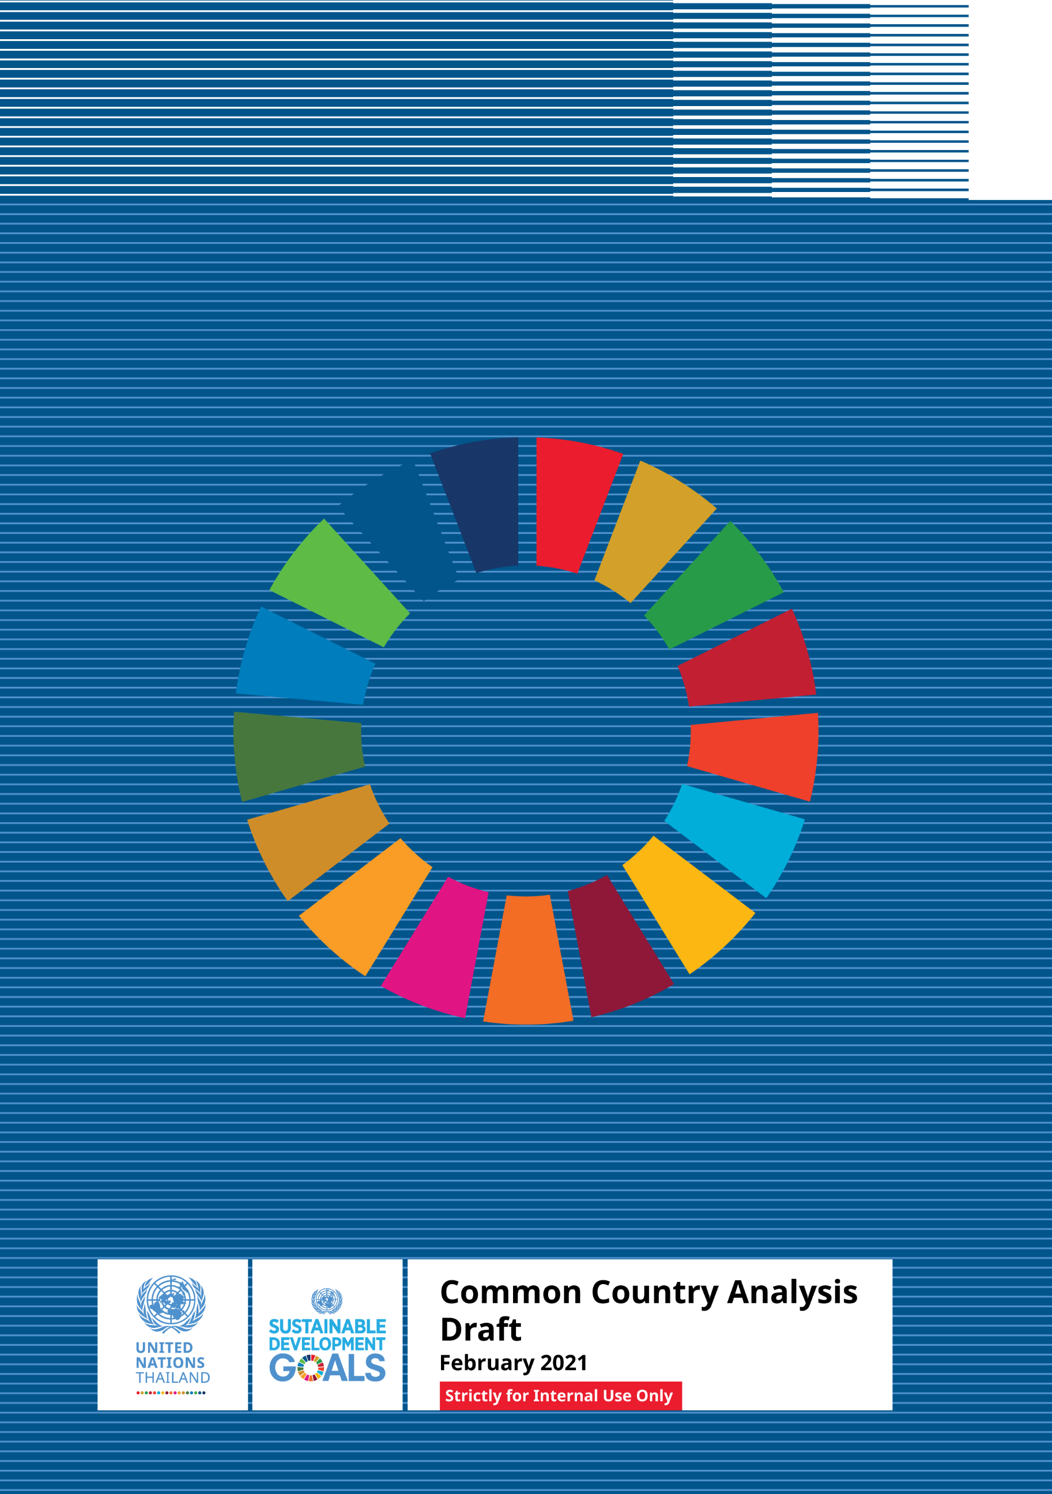

https://www.worldbank.org/en/country/thailand/overview.
In 2020, the country recorded less than one death per million population.
Based on the 2019 Global Health Security Index.
Socio-Economic Impact Assessment of COVID-19 in Thailand, October 2020, United Nations, page 6.
Economist Intelligence Unit. 2020. “Covid-19 Economic impact assessment for Thailand,” Thailand, Research Paper for UNDP. Bangkok and Office of the National Economic and Social Development Council (NESDC). 2020. Gross Domestic Product: Q2/2020. Bangkok: NESDC.
Thailand’s middle-class expected to contract from 50.6 per cent to 38.4 percent, whilst the number of economically insecure is projected to double from 4.7 million to an estimated 9.7 million.
Thailand in the Time of COVID-19, Thailand Economic Monitor, World Bank July 2020.
Working poverty is anticipated to rise by the end of 2020 from 4.7 per cent to 14.5 percent, with nearly 21 million of Thailand’s 37 million workers at risk of impact.
The ten occupations with the highest shares of daily and hourly workers saw a reduction of 435,000 persons employed between the first quarter 2019 and first quarter 2020. Those most affected was agriculture (partly also due to seasonal effect), but also low-skilled undertaking clerical work including customer service, refuse workers and other elementary occupations, assemblers, handicraft workers and persons in the electrical and electronic trades.
In 2017, 2018, 2019.
Recent adoption of the Bio-Circular Green Economic Model (2021 – 2026) by the Government of Thailand indicates the intent to regard human development and environmental concerns in a more holistic manner in line with the integrated nature of the sustainable development agenda.
ESCAP projection.
THB 1.27 trillion.
Ministry of Agriculture and Cooperatives 2020.
Based on current US$.
The number 22 in terms of total exports, the number 23 in total imports, and the number 28 most complex economy according to the Economic Complexity Index (ECI).
A middle-income trap is commonly defined as a situation in which a country that is successful in lifting its economy from the status of being a least developed or low-income country to a middle-income one but remains at that level without much prospect of becoming an advanced, rich country.
Thailand – World Bank Group Country Partnership Framework, 2019–2022
2018.
https://databank.worldbank.org/data/download/hci/HCI_2pager_THA.pdf.
Thailand spends 2.9 per cent of its GDP in public spending on health, compared to 4.9 per cent of the regional average. It spends 4.1 per cent of its GDP on public education, versus 4.7 per cent of the regional average. And it spends 0.5 per cent of its GDP on social assistance, compared to an average of 1.1 per cent in the region.
Thailand – World Bank Group Country Partnership Framework, 2019–2022.
See Figures 7, 8, 18, 19 and 20 as well as Table 6 in the Technical Annex.
ILO, Thailand Decent Work Country Programme, 2019 – 21, p.19.
The longevity dividend is characterized by an accumulation of wealth and savings as older individuals save for consumption at old age and invest in their human capital, especially in health and education.
From 2013, at approximately US$6.20 per day based on 2011 PPP.
Thailand – World Bank Group Country Partnership Framework, 2019–2022.
Official figures showed that poverty rates increased both in 2016 and in 2018; Thailand’s Poverty on the Rise Amid Slowing Economic Growth (worldbank.org); Taking the Pulse of Poverty and Inequality in Thailand, World Bank, p.7.
See Technical Annex Figure 10.
The findings of recent research carried out by ESCAP shows that populations drawn from among the most at risk groups experience multiple barriers and deprivations simultaneously.
Sample Surveys with LNOB groups commissioned by the United Nations in Thailand, October 2020.
ESCAP: Inequality of opportunity – Who are those left behind in Thailand.
UNICEF – Multi-dimensional poverty.
https://freedomhouse.org/country/thailand/freedom-world/2020.
Thailand also records mid-range performance in the essentials of fundamental rights (access to justice, civil liberties, social rights and equality), and in checks on Government (media integrity, judicial independence and effective parliament). Similarly, in the World Justice Project Rule of Law Index for 2020, Thailand performs in the lower range in fundamental rights, coming 90th out of 128 countries measured.
Women account for only 23.9 per cent of high-ranking civil servants, and gender equality in senior leadership positions has risen by just 3 per cent in the last fifteen years. The results of the General Election in 2019 show a three-fold increase in women’s representation as female Members of Parliament increased from 5.4 per cent in January 2019 to 16.2 percent. The National Percentage remains lower than the average of women MPs in Asia (20.5 percent), Pacific (16.6 percent), and the Middle East and North Africa (17.5 percent), as well as far below the global average of 24.9 percent.
ILO, Global Wage Report, 2018/2019 (https://www.ilo.org/global/about-the-ilo/multimedia/maps-and-charts/enhanced/WCMS_650829/lang--en/index.htm).
ILO, Women in STEM workforce readiness and development programme in Thailand, 2020 (https://www.ilo.org/wcmsp5/groups/public/---asia/---ro-bangkok/documents/publication/wcms_673419.pdf.
https://data.unwomen.org/country/thailand).
For the period 2019-2021.
Cheong, K., Ngiam,N., Morgan, G., Pek, P.,Tan, B., Lai, J., Koh, J., Ong, M., Ho, A. Acute Health Impacts of the Southeast Asian Transboundary Haze Problem—A Review. Published online 2019 Sep 6. DOI: 10.3390/ijerph16183286.
IQAir (2012). 2019 World Air Quality Report, V8.
Plastics are the largest by volume of waste found in the oceans, making up approximately 60 to 80 per cent of the total marine debris.
Marks, D., Miller, M. and Vassanadumrongdee, S., The geopolitical economy of Thailand’s marine plastic pollution crisis. Asia Pacific Viewpoint, 2020.
Between Thailand, China, Cambodia, Lao PDR and Viet Nam.
UNODC, Transnational Organized Crime Threat Assessment, 2019.
Ibid.
From 2016 through 2019.
Asian Development Bank, Thailand – Industrialization and Economic Catch-Up - Country Diagnostic Study, 2015, https://www.adb.org/sites/default/files/publication/178077/tha-industrialization-econ-catch.pdf
Thailand – World Bank Group Country Partnership Framework, 2019–2022.
See also Technical annex, Figure 3 for GDP per capita (US$) by ASEAN Member States, 2000-2018.
Extensive flooding and droughts affecting large parts of the country.
Thailand in the Time of COVID-19, Thailand Economic Monitor, World Bank July 2020.
Based on current US$.
The number 22 in terms of total exports, the number 23 in total imports, and the number 28 most complex economy according to the Economic Complexity Index (ECI).
World Bank, Taking the Pulse of Poverty and Inequality in Thailand, 2020.
2018.
https://databank.worldbank.org/data/download/hci/HCI_2pager_THA.pdf.
Thailand – World Bank Group Country Partnership Framework, 2019–2022.
2013 data.
Based on 2017 data - http://data.un.org/en/iso/th.html.
World Bank Consultations, Systematic Country Diagnostic, 2017.
Getting Back on Track: Reviving Growth and Securing Prosperity for All, World Bank, p.33.
World Bank Consultations, Systematic Country Diagnostic, 2017.
As measured by the Services Trade Restrictiveness Index.
National Statistical Office of Thailand.
ILO, Thailand Decent Work Country Programme, 2019 – 21, p.19.
IOM, Thailand Migration Report, 2019.
A study of the Office of Education Council, Ministry of Education (2016).
Thailand – World Bank Group Country Partnership Framework, 2019–2022.
They are not in the social security system and many of them have unstable jobs. In addition, there is considerable under-employment, since average working hours of the agricultural sector is 36 hours per week, which is lower than the average of the non-agricultural sector at 46 hours per week.
This can be observed in the rising number of ‘house-workers’ out of the labour force aged between 51 and 60.
For instance, one out of every ten non-agricultural workers in Thailand is underpaid given his or her educational level, as their job does not match his or her level of skills.
TDRI, 2019.
Source: Mariya Brussevich, Era Dabla-Norris, Christine Kamunge, Pooja Karnane, Salma Khalid, and Kalpana Kochhar, 2018, Gender, Technology, and the Future of Work, International Monetary Fund Staff Discussion Note 18/07, October, Washington, D. C., IMF.
Source: Jae-Hee Chang and Phu Huynh, 2016, ASEAN in Transformation: The Future of Jobs at Risk of Automation, ILO Bureau for Employers’ Activities, Working Paper No. 9, July, Geneva, ILO; and Jae-Hee Chang, Gary Rynhart and Phu Huynh, 2016, ASEAN in Transformation: How Technology Is Changing Jobs and Enterprises, ILO Bureau for Employers’ Activities, Working Paper No. 10, July, Geneva, ILO.
Thailand – World Bank Group Country Partnership Framework, 2019–2022.
See also Figures 5 and 6 in the Technical Annex.
The country scored 80.1, slightly below Malaysia (ranked 12th with a score of 81.50) and Singapore, (ranked 2nd, with a score of 86.2).
Thailand also saw a significant improvement in both score and ranking in two indicators: dealing with construction permits and protecting minority investors.
In the Global Competitiveness Report (2019).
The ‘informal economy’ refers to all economic activities by workers that are – in law or in practice – not covered (or insufficiently covered) by formal employment arrangements. Although it is hard to generalize about the quality and nature of informal employment, the characteristics include a lack of protection for non-payment of wages, retrenchment without notice or compensation, unsatisfactory occupational health and safety conditions and an absence of social benefits such as pensions, sick pay and health insurance.
ILO, ILOSTAT Database, referencing Thailand Informal Employment Survey.
Although there is no unique definition of the informal economy, it typically refers to economic transactions that are not explicitly observed or recognized. Measuring the size of the informal sector is even more challenging with a change in legality status.
Population and Development for a Sustainable Future in Thailand, UNFPA. https://thailand.unfpa.org/sites/default/files/pub-pdf/icpd25report-download-compressed-final-2020.pdf.
TDRI Quarterly Review, 2012, Somchai Jitsuchon, https://tdri.or.th/wp-content/uploads/2012/12/t5j2012-somchai.pdf.
OECD, 2013, Innovation Report for South East Asia.
See Figures 7 and 20 in the Technical Annex.
Thailand’s older population has been growing faster than the rest of the population since 1995, and will continue to do so. By 2021 and 2031 around 20 per cent and 28 per cent of the population, respectively, will be elderly.
Population and Development for a Sustainable Future in Thailand, UNFPA 2020
The United Nation’s World Population Prospect 2019 states the numbers slightly differently, though the same principle applies: ‘the number of people with age greater than 65 will increase from 9.0 million or 13.0 per cent of the total population in 2020 to 19.5 million or 29.6 per cent of the total population in 2050.’
ILO, Thailand Decent Work Country Programme, 2019 – 21, p.19.
The longevity dividend is characterized by an accumulation of wealth and savings as older individuals save for consumption at old age and invest in their human capital, especially in health and education.
World Bank, 2016. Aging Society and Economy. Thailand Economic Monitor, June. World Bank, Bangkok.
According to the World Health Organization (WHO) Southeast Asia Regional Office (SEARO) report entitled ‘2019 Health SDG Profile: Thailand’.
25 Years after the ICPD: Population and Development for a Sustainable Future in Thailand, UNFPA, 2020 (https://thailand.unfpa.org/sites/default/files/pub-pdf/icpd25report-download-compressed-final-2020.pdf).
Thailand provides many vaccines to its children – effectively protecting them against polio, measles, diphtheria, pertussis, tetanus, mumps, rubella, Japanese encephalitis, human papilloma virus, hepatitis B, and Hemophilus influenzae type B (common cause of meningitis in children). Note that vaccines against human papilloma virus and hepatitis B protect against adult cervical cancer and liver cancer respectively. These are two cancers are caused almost entirely by infectious diseases that can be prevented with vaccines.
See also LNOB section.
‘Social Impact Assessment of COVID-19 in Thailand’, United Nations in Thailand, OPM, 2020.
Social Impact Assessment of COVID-19 in Thailand, United Nations in Thailand, OPM, 2020.
Thailand VNR 2017, https://sustainabledevelopment.un.org/memberstates/thailand.
See also LNOB section.
Increasing rates of suicide in adolescents and youth has become a major concern among mental health professionals in the last two to three years. Additional mental health threats from COVID-19 and the related economic downturn, lower household income and impending job losses, as well as educational disruption can cause anxiety, leading to mental health conditions and the risk of increased suicide. The stress is not only among people who are infected or suspected of infection and the healthcare workers and carers, it also affects the general public and vulnerable populations at risk of the disease.
The overall suicide death rate in 2020 could reach a level like the 1997 economic crisis of up to 8–8.8 per 100,000 population, or around 30,000 extra cases of suicide attempts and 2,000 extra suicide deaths. In the first four months of 2020, there were 1,416 suicide deaths, a 14.3 per cent increase on the same period last year. The Department of Mental Health estimated that by the end of 2020, the suicide death rate will be higher as the economic impact will be more prominent in the later months.
World Health Organization (WHO).
WHO.
Thailand VNR 2017, https://sustainabledevelopment.un.org/memberstates/thailand.
2019 figures.
Based on Global Competitiveness Indicators.
http://documents1.worldbank.org/curated/en/683311593415205230/pdf/Thailand-Programme-for-International-Student-Assessment-PISA-2018-Country-Report.pdf.
Thailand, Country Note, 2018. The Programme for International Student Assessment (PISA): http://www.oecd.org/pisa/publications/PISA2018_CN_THA.pdf
http://documents1.worldbank.org/curated/en/683311593415205230/pdf/Thailand-Programme-for-International-Student-Assessment-PISA-2018-Country-Report.pdf
The Program for International Student Assessment (PISA) reflects student learning and achievements.
2019 UN Thailand Migration Report - https://thailand.un.org/en/50831-thailand-migration-report-2019
Taking the Pulse of Poverty and Inequality in Thailand, World Bank, p.55.
http://documents1.worldbank.org/curated/en/683311593415205230/pdf/Thailand-Programme-for-International-Student-Assessment-PISA-2018-Country-Report.pdf;
Impact of COVID-19, OPM study, commissioned by the United Nations, 2020.
Further details of Thailand’s contributory and non-contributory social protection system can be found at Figure 23 and Table 10 in the Technical Annex.
Includes subsidies for utilities cost, support for land use rights, a moratorium on loan repayments, the provision of loans and trainings etc.
Such as pensions, child allowances, unemployment benefit, sickness compensation and disability compensation.
These include child allowance, retirement pension (both lump sum and monthly allowance), sickness compensation, including AIDS, and disability compensation.
Other vulnerable groups of the Thai population receive welfare support that can provide at least 26 per cent of consumption with respect to the poverty line, or 8 per cent with respect to Thailand’s average consumption.
Particularly those working in agriculture, fishing, domestic work, livestock, forestry and other sectors are excluded.
2019 UN Thailand Migration Report - https://thailand.un.org/en/50831-thailand-migration-report-2019.
2019 UN Thailand Migration Report - https://thailand.un.org/en/50831-thailand-migration-report-2019.
Being hit or slapped on the face, head, or ears; or being beaten up over and over as hard as one could.
UNICEF, Estimating the Economic Burden of Violence against Children in EAP, 2015.
UNICEF, The Social Service Workforce in the East Asia and Pacific Region: Multi-Country Review, 2019.
The 6th National Report to the UN Convention for Biological Diversity, 2019.
Agriculture and forest ecosystems are dominant, taking up to 56 and 32 per cent of country’s territory respectively. The country is also a sanctuary for world rice species with over 10,000 varieties.
Species assessed as globally threatened on the IUCN Red List or being ‘Vulnerable’, ‘Endangered’ or ‘Critically Endangered’.
World Bank 2017. “World Development Indicators: Deforestation and Biodiversity”.
A study by UNDP’s Biodiversity Finance Initiative, covering the period identified a financing gap of THB 31,978 million ($942 million) for 2019 – 2021. for Thailand to achieve its National Biodiversity Strategy and Action Plan (NBSAP).
THB 31,978 million.
Other challenges include insufficient finance for taxonomic work in Thailand which underpins research and development on biodiversity, and access to genetic resources, biological resources, and traditional knowledge and the sharing of benefits arising from their utilization.
IUCN 2006. “Ecological and socio-economic values of Mangrove ecosystems in tsunami affected areas: Rapid ecological-economic-livelihood assessment of Ban Naca and Ban Bangman in Ranong Province, Thailand” Accessed December 2017.
Between 1975 and 1993.
Havanond, S. 1997. “Meeting Report: Mangrove Forest Conservation in Thailand”. Biol. Bull. NTNU. 32(2) pp 97-102. Accessed May 2017.
Richards D. & Friess, D. 2015. “Rates and drivers of mangrove deforestation in Southeast Asia, 2000–2012” Accessed December 2017.
Thailand’s coral reefs are situation in the Andaman Sea and the rest in the Gulf of Thailand.
The remaining 15 per cent are in ‘fair condition’ and 5 per cent are in ‘good’ to ‘very good’ condition.
Thailand’s live coral cover rate is 23 per cent which is still better than many areas in the world.
Forest cover in 2018-2019 is 31.68 Per cent (Source: Office of Forest Land Management, Royal Forest Department).
FAO report.
World Bank 2017. “World Development Indicators: Deforestation and Biodiversity”. Accessed December 2017.
USAID LEAF 2015. “Drivers of Forest Change in the Greater Mekong Subregion Thailand Country Report”. Accessed December 2017.
Open Development Thailand, https://thailand.opendevelopmentmekong.net/topics/environment-and-natural-resources/.
ICEM 2003. “Thailand National Report on Protected Areas and Development”. Accessed December 2017.
Announced by Mr. Varawut Silpa-archa, Thailand’s MONRE Minister.
GIZ. Where do we stand in the battle to tackle climate crisis?, January 14, 2020.
111 MtCO2e.
With international support.
This is largely due to the energy required in the production, transportation and use of goods and services, which has been accompanied by a significant population migration from rural to urban areas, placing increasing demands on urban infrastructure.
http://www.eppo.go.th/epposite/index.php/en/en-energystatistics/co2-statistic.
Naruchaikusol, S. 2016. “Climate Change and its impact on Thailand: A short overview of actual and potential impacts of the changing climate in South East Asia”. Accessed December 2017.
Kulp, S. & Strauss, B. 2019 "New elevation data triple estimates of global vulnerability to sea-level rise and coastal flooding: https://www.nature.com/articles/s41467-019-12808-z
E Neumayer and T Plümper. The Gendered Nature of Natural Disasters: The Impact of Catastrophic Events on the Gender gap in Life Expectancy, 1981–2002. Annals of the Association of American Geographers, 97(3). pp. 551-566.
F. Katsunori. The Great East Japan Earthquake and Disabled Persons. Japanese Society for Rehabilitation of Persons with Disabilities.
Analytical Study on the Promotion and Protection of the Rights of Persons with Disabilities in the Context of Climate Change. UNOHCHR, 2020.
According to the Second Biennial Update Report of Thailand, as a signatory Party under the United Nations Framework Convention on Climate Change (UNFCCC), the country pledged its first Nationally Appropriate Mitigation Actions (NAMA) to the UNFCCC in 2014.
The Southern provinces (Phuket, Krabi, Surat Thani, etc.) mostly enjoy clean air throughout the year, although there are also some years that coincide with strong El Nino events in which the region is subject to smoke haze pollution emanating from peatland fires set in Kalimantan and Sumatra, Indonesia.
PM 2.5 refers to particles that have diameter less than 2.5 micrometres (more than 100 times thinner than a human hair) and remain suspended in the air for long time periods. These particles are formed as a result of burning fuel and chemical reactions that take place in the atmosphere.
AQLI, 2017.
Smoke haze that plagues Thailand the most, consisting of Particulate Matter (PM10 and PM2.5), carbon monoxide, carbon dioxide, sulfur dioxide (SO2) and nitrogen oxides (NOx), volatile organic compounds, and carcinogenic hydrocarbons 2013.
Phoothiwut, S. and Junyapoon, S., Size distribution of atmospheric particulates and particulate-bound polycyclic aromatic hydrocarbons and characteristics of PAHs during haze period in Lampang Province, Northern Thailand, Air Quality, Atmosphere & Health, vol. 6, no. 2, pp. 397–405, 2013.
The House of Representatives is the lower house of the National Assembly consisting of 500 members sitting for four years, 350 members are elected from a constituency basis and 150 members are elected from a party-list proportional representation.
The Senate consists of 250 senators each holding a five-year term. This means the appointed senate will be instrumental in selecting a PM for a further 4-year term.
https://freedomhouse.org/country/thailand/freedom-world/2020.
In the World Press Freedom index, Thailand is ranked 140 out of 180.
https://rsf.org/en/thailand.
https://thailand.prd.go.th/mobile_detail.php?cid=4&nid=10489.
https://www.transparency.org/en/countries/thailand The index, which ranks 180 countries and territories by their perceived levels of public sector corruption according to experts and businesspeople, uses a scale of zero to 100, where zero is highly corrupt and 100 is very clean.
https://www.transparency.org/en/countries/thailand The index, which ranks 180 countries and territories by their perceived levels of public sector corruption according to experts and businesspeople, uses a scale of zero to 100, where zero is highly corrupt and 100 is very clean.
With as many as 71 per cent of respondents indicated they had little or no trust in government, 59per cent said they had little or no trust in the police, and 40per cent had little or no trust in the courts.
mandated by Thailand’s Constitution in 1997 and implemented through decentralisation reforms in 1999, 2000, 2002, 2006 and 2008.
OECD Multi-Dimensional Review of Thailand, April 2018.
OECD Multi-Dimensional Review of Thailand, April 2018.
At 2011 PPP.
From 2013, at approximately US$6.20 per day based on 2011 PPP.
Thailand – World Bank Group Country Partnership Framework, 2019–2022.
Official figures showed that poverty rates increased both in 2016 and in 2018.
20 per cent of the population in rural areas is poor and lacks adequate waste management, compared to 3 per cent of the population in urban areas. Furthermore, 15 per cent of the rural population is poor and lacks access to clean drinking water, compared to 3 per cent of the urban population. See Figure 11 in the technical annex for more information.
ITC, SME Competitiveness Outlook 2020, pp. 13-14 (https://www.intracen.org/uploadedFiles/intracenorg/Content/Publications/ITCSMECO2020.pdf).
Thailand’s Multi-dimensional Poverty Index (MPI) for 2017 is 0.068, which is the product of the incidence and intensity of poverty. This means that multi-dimensionally poor people in Thailand experience 6.8 per cent of the total deprivations that would be experienced if everyone was deprived in all indicators.
https://www.unicef.org/thailand/media/3171/file/Childpercent20percent20Multi-dimensionalpercent20percent20Povertypercent20percent20inpercent20percent20Thailand.pdf.
To understand what deprivations, create child poverty in Thailand and how they can be reduced, the child MPI can be broken down by indicator in order to examine its composition.
https://www.unicef.org/thailand/media/3171/file/Childpercent20percent20Multi-dimensionalpercent20percent20Povertypercent20percent20inpercent20percent20Thailand.pdf.
https://www.unicef.org/thailand/media/3171/file/Child Percent20Multi-dimensional Percent20Poverty Percent20in Percent20Thailand.pdf.
See also LNOB section of the CCA.
The consumption-based Gini coefficient fell from 0.45 in 1988 to 0.36 in 2017.
Thailand – World Bank Group Country Partnership Framework, 2019–2022.
See also Figures 12, 13 and 14 in the Technical Annex.
At least an LTE/WiMax network.
ITU, 2019.
Set by ITU/UNESCO.
Mapping the Digital Divide in the School Education of Thailand, Associate Professor Dr. Jomphong Mongkhonvanit, Siam University and Dr. Dipendra K C, School of Global Studies, Thammasat University - Presentation and Report prepared for the UN in Thailand.
State of Digital Divide in School Education in Thailand, ITU, 2020.
http://documents1.worldbank.org/curated/en/683311593415205230/pdf/Thailand-Programme-for-International-Student-Assessment-PISA-2018-Country-Report.pdf.
Mapping the Digital Divide in the School Education of Thailand, Report prepared for the United Nations in Thailand, December 2020.
OECD, 2019.
OECD, 2019.
Similarly, a little more than a quarter of respondents indicated they do not have sufficient time to prepare lessons integrating digital tools. Data suggests one in four teachers do not have access to adequate professional resources to learn how to use digital devices. It is crucial to address the gaps mentioned above to facilitate Thai students’ education online. Critical actions must be taken to enhance access to digital devices and the internet. Also, it is essential to make the internet affordable both at school and at home. Schools need sufficient digital devices and affordable connection, and quality human resources, including trained teachers to manage the transition to a more ICT enabled teaching-learning process.
Based on ESCAP Inequalities and LNOB Analysis using 2019 MICS data.
See LNOB section of the CCA.
Like the Gini coefficient (another measure of inequalities), the D-Index ranges from 0 to 1, where 0 indicates no inequality, and 1 indicates that the entire access to a service is reserved to a specific group of people with shared circumstances (e.g. men from urban areas).
Through two new methodological tools, it is possible to identify the furthest behind in a range of development areas.
ESCAP: Inequality of Opportunity - Who Are Those Left Behind, Thailand. ESCAP elaboration using data from the latest MICS 2015 survey as well as the updated version based on 2020 MICS data.
Taking the Pulse of Poverty and Inequality in Thailand, World Bank, p.38.
See also for interest in the Technical Annex Figures 16, 17, 22 and Table 8, including ‘the Economist’ 2012 map of Thailand’s regional share of GDP, public expenditure and population and Thailand’s GRP per capita and Growth rates for 2017-2018.
For further information see also Tables 3, 4, 5 and 6 for the HDI, IHDI, GDI and GII in the Technical Annex.
The 2018 female HDI value for Thailand is 0.763 in contrast with 0.766 for males, resulting in a Gender Development Index (GDI) value of 0.995. In comparison, GDI values for Philippines and Viet Nam are 1.004 and 1.003 respectively. The Gender Inequality Index (GII) reflects the three dimensions of gender inequality: reproductive health, empowerment, and economic activity. College graduation rates among women are also significantly higher than those among men.
Women in Business Report 2020: Thailand, Grant Thornton Services Ltd, 2020.
Low level unrest in the south have hindered human development more generally, perpetuating human insecurity, inequality, deprivation, and socioeconomic disparities.
OECD Development Pathways Multi-Dimensional Review of Thailand, 2018.
https://www.ilo.org/global/about-the-ilo/multimedia/maps-and-charts/enhanced/WCMS_650829/lang--en/index.htm.
ILO, Women in STEM workforce readiness and development programme in Thailand, 2020, (https://www.ilo.org/wcmsp5/groups/public/---asia/---ro-bangkok/documents/publication/wcms_673419.pdf)
The share of males in the ‘Not in Education, Employment, and Training (NEET)’ category was lower at 33 per cent compared to 67 per cent females. The main reason is that young women tend not to enter the labour force after dropping out from school and instead become household workers.
Thailand Migration Report, 2019: https://thailand.iom.int/sites/default/files/document/publications/Thailand Percent20Report Percent202019_22012019_LowRes.pdf
2017 Risks and Rewards: Outcomes of Labour Migration in South-East Asia. ILO and IOM, Bangkok.
See also transboundary section of this CCA report.
Data in this paragraph sourced from: Social Impact Assessment of COVID-19 in Thailand, United Nations in Thailand, OPM, 2020.
The country has recorded less than one death per million population.
Based on the 2019 Global Health Security Index.
For details of Thailand’s COVID-19 cases, see Figure 27 in the Technical Annex.
https://www.who.int/docs/default-source/searo/thailand/iar-covid19-en.pdf.
This raises the issue of imported new clusters across Thailand’s porous borders that may go unnoticed if a whole-of-society approach is not developed to reach out and involve non-Thai communities in the COVID-19 prevention and response.
Forth coming. Survey of COVID-19 impact on sexual and reproductive health of youth by UNFPA, UNICEF and UN Sub-group in young people.
Economist Intelligence Unit. 2020. “Covid-19 Economic impact assessment for Thailand,” Thailand, Research Paper for UNDP. Bangkok and Office of the National Economic and Social Development Council (NESDC). 2020. Gross Domestic Product: Q2/2020. Bangkok: NESDC.
ITC, SME Competitiveness Outlook 2020, p. 132 (https://www.intracen.org/uploadedFiles/intracenorg/Content/Publications/ITCSMECO2020.pdf).
ADB. 2020. “Asian Development Outlook 2020 Supplement: Lockdown, Loosening, and Asia’s Growth Prospects.” https://www.adb.org/sites/default/files/publication/612261/ado-supplement-june-2020.pdf.
Economist Intelligence Unit. 2020. “Covid-19 Economic impact assessment for Thailand,” Thailand, Research Paper for UNDP. Bangkok and Office of the National Economic and Social Development Council (NESDC). 2020. Gross Domestic Product: Q2/2020. Bangkok: NESDC.
ITC. 2020. SME Competitiveness Outlook 2020: COVID-19: The Great Lockdown and its Impact on Small Business. https://www.intracen.org/smeco2020/.
UNIDO. 2020. “Impact Assessment of COVID-19 on Thai Industrial Sector.” http://www.un.or.th/wp-content/uploads/2020/06/Impact-Assessment-of-COVID-19-on-Thai-Industrial-Sector.pdf.
Thailand in the Time of COVID-19, Thailand Economic Monitor, World Bank, July 2020.
The ten occupations with the highest shares of daily and hourly workers saw a reduction of 435,000 persons employed between the first quarter 2019 and first quarter 2020. Those most affected was agriculture (partly also due to seasonal effect), but also low-skilled undertaking clerical work including customer service, refuse workers and other elementary occupations, assemblers, handicraft workers and persons in the electrical and electronic trades.
For nationals (those already in low-income families) 41 per cent of parents reported a reduced income, 15 per cent reported temporarily stopping work, and 14 per cent had lost their jobs.
https://www.ilo.org/wcmsp5/groups/public/---asia/---ro-bangkok/---sro-bangkok/documents/publication/wcms_764084.pdf.
ILO report: Covid-19 labour market impact assessment in Thailand, 7 May 2020.
See ILO-ADB report for Asia-Pacific, and data for Thailand, https://www.ilo.org/asia/publications/WCMS_753369/lang--en/index.htm.
Cambodia, Lao People’s Democratic Republic and Myanmar etc.
https://data.worldbank.org/indicator/BX.TRF.PWKR.DT.GD.ZS?locations=TH.
ILO (2020). COVID-19: Impact on migrant workers and country response in Thailand.
IOM, Thailand Migration Report 2019 - https://thailand.un.org/en/50831-thailand-migration-report-2019.
The results of Rapid assessments conducted in April and May 2020.
Rapid assessment on migrant workers in ASEAN countries, including Thailand, during April-May 2020 finding that 32 per cent report work-related problems or abuses such as inability to refuse work during the lockdown, being forced or coerced to take unpaid leave, retention of personal documents by employers, threats of contract termination, and other forms of harassment and violence.
ILO (2020). Experiences of ASEAN migrant workers during COVID-19: Rights at work, migration and quarantine during the pandemic, and re-migration plans.
Inability to make repayments can lead to losing their houses, agricultural land, businesses and equipment or other valuables, undermining their ability to generate future income.
IOM (2019). Debt and the Migration Experience: Insights from South-East Asia.
UNESCO, 2020.
This included pre-primary, primary, lower-secondary, upper-secondary and tertiary education levels.
Thamtanajit, 2020.
Azevedo, Hasan, Goldemberg, Iqbal, & Geven, 2020.
Optimistic estimates suggest that during COVID-19, the average three-month school closure would lead to a loss of 0.3 years of schooling and an estimated 1 per cent decline on the learning levels measured by PISA scores. The average student in the school today is expected to face a reduction of US$355 in annual earnings and an estimated US$6,500 across their lifetimes due to the school closure.
UNESCO, 2020.
Based on Ministry of Education guidance.
Bangkok Post, 2020.
https://www.reuters.com/article/us-thailand-workers-education-idUSKBN26S03M
Following on from regional digital inequalities sub-section.
Social Impact Assessment of COVID-19 in Thailand, United Nations in Thailand, OPM, 2020.
A chart summarising a framework of these impacts to the education sector can be found in the Technical Annex at Figure 29.
Impact of COVID-19, OPM study, commissioned by the United Nations, 2020.
Progress in registering those with legitimate claims has also slowed over recent years. It is also complicated and costly for stateless people to obtain citizenship, and who face discrimination and stigma when trying.
The waste statistic from https://www.statista.com/statistics/1167512/healthcare-waste-generation-before-during-covid-19-asia-by-city/.
In unanimously adopting the 2030 Agenda for Sustainable and 17 SDGs in September 2015, UN Member States put the imperative to ‘leave no one behind’ and ‘reach the furthest behind first’ at the centre of development planning. Nations thereby: i) Resolved to end poverty and hunger everywhere; to combat inequalities within and among countries; to build peaceful, just and inclusive societies; to protect human rights and promote gender equality and the empowerment of women and girls; and to ensure the lasting protection of the planet and its natural resources; ii) Pledged that no one will be left behind. Recognizing that the dignity of the human person is fundamental, we wish to see the Goals and targets met for all nations and peoples and for all segments of society. And we will endeavour to reach the furthest behind first.
https://unsdg.un.org/resources/leaving-no-one-behind-unsdg-operational-guide-un-country-teams-interim-draft.
The main groups were: i) Ethnic minorities – (lead UNDP); ii) Disability groups (lead UNDP); iii) Women’s organizations (lead UNWOMEN/UNDP); iv) Children and young people (lead UNICEF, UNESCO); v) Migrants, refugees, and asylum seekers (lead UNHCR, IOM); vi) LGBTI communities, HIV-affected people and sex workers (lead UNDP/UNAIDS).
Conflict, climate, environmental.
See also Technical Annex: Table 15 for a broader description of the UN HRBA framework for LNOB; Figure 21 for censored Headcount Ratios 2015 - / 15 and; Table 1 and Table 2 for Multi-Dimensional Poverty by urban / rural areas and by region respectively.
Inequality of Opportunity analysis for Thailand (2020), ESCAP.
This Leave No One Behind (LNOB) assessment is primarily based upon information and data in the ESCAP July 2020 Policy Paper (updated in a power point presented to UNCT in August 2020), the (draft) Oxford Policy Management Social Impact Assessment of COVID-19 in Thailand, the MICS and position papers prepared for the CCA by the UNRCO. Neither does the CCA LNOB attempt to rank vulnerability or groups other than to report the ranking provided within the abovementioned ESCAP report.
In terms of the mean average.
Taking the Pulse of Poverty and Inequality in Thailand, World Bank, 2020.
Based on the UMIC poverty line of US$5.5/day 2011PPP.
In addition, the furthest behind group consist of children in poorer households with one or more siblings under 5 years of age, among which 10 per cent are wasted (compared to 4 per cent in the best-off group).
IOM, Thailand Migration Report 2019.
Study based on Bangkok, by Chiang Mai and Songkla (2019-2020).
Joint United Nations Programme on HIV/AIDS (UNAIDS) (2017), Asia Pacific Data.
Findings from a Sample Survey commissioned by the United Nations in Thailand, October 2020.
Women account for only 23.9 per cent of high-ranking civil servants, and gender equality in senior leadership positions has risen by just 3 per cent in the last fifteen years. The results of the General Election in 2019 show a three-fold increase in women’s representation as female Members of Parliament increased from 5.4 per cent in January 2019 to 16.2 percent. The National Percentage remains lower than the average of women MPs in Asia (20.5 percent), Pacific (16.6 percent), and the Middle East and North Africa (17.5 percent), as well as far below the global average of 24.9 percent.
UN Women.
MICS 6.
A study conducted in 2018 using the same WHO 2000 questionnaire.
Chuemchit M (2018). Prevalence of Intimate Partner Violence in Thailand. J. of Family Violence, 33(5): 315-323.
Forth coming. Inequity of Opportunity: Who are those left behind in Thailand? An analytical report by ESCAP.
Sample Surveys with LNOB groups commissioned by the United Nations in Thailand, October 2020.
Out of the 25 impairment categories used in the survey, the groups with the five largest populations were: 1) low vision (16.8 percent); 2) spasticity, tremor (15.1 percent); 3) hard of hearing (13.3 percent); 4) paresis (11.7 percent); and 5) one-eyed blindness and one-eyed low vision (7.5 percent), taken from the Disability Survey 2017, conducted by the National Statistical Office (NSO).
As an example, airlines often charge extra fees for wheelchairs.
Sample Surveys with LNOB groups commissioned by the United Nations in Thailand, October 2020.
Almost all PWDs are eligible to access government health insurance (98.5 percent). Around 40 per cent of PWDs need assistive devices in their daily lives, and 11.8 per cent receive devices from the government. With regard to disability registration, less than half of PWDs had applied for such registration, resulting in only 44 per cent of PWDs accessing the disability grant. The possible reasons for under-registration identified were: i) many did not recognize themselves as having a disability; ii) people did not recognize the need for registration; iii) information on the registration did not reach those in need; iv) PWDs were not able to find accompanying persons to go to the registration office; v) and transportation was not available to go to registration offices.
This is reflected in Thailand not having met the 90-90-90 targets (figure x in the heath sub-section above) relating to testing and treatment set for 2020 with the goal of ending AIDS by 2030 in particular among key populations.
This includes migrant workers as well as other non-Thai nationals, migrants on temporary stay permits, spouses and dependents, migrants on retirement visas, migrants in tertiary education, refugees and asylum seekers, and stateless individuals.
These sectors are at present estimated to be short of 200,000 to 300,000 workers.
It is estimated that that around 310,000 migrants from Cambodia, Lao PDR and Myanmar returned to their countries of origin in March to June 2020, preceding the closure of international borders.
IOM (2020). COVID-19 Response Situation Report 3.
Official statistics form DOE, Nov 2020, documented women migrant workers equalled 45 Per cent of the total.
IOM, Thailand Migration Report, 2019 - https://thailand.un.org/en/50831-thailand-migration-report-2019.
IOM, Thailand Migration Report 2019.
Sample Surveys with LNOB groups commissioned by the United Nations in Thailand, October 2020.
IOM, Thailand Migration Report, 2019.
Figure 30 in the Technical Annex shows the top concerns of migrants.
Sample Surveys with LNOB groups commissioned by the United Nations in Thailand, October 2020.
IOM, Thailand Migration Report, 2019.
This is defined as ‘a group of people with distinct history, language, culture, tradition or with common way of living, and most importantly, with a shared sense of belonging to the same group or race.’
Baird, I. G. ‘From Hill Tribes to Ethnic Peoples: The localisation of a global movement in Thailand’, Journal of Southeast Asian Studies, March 2019.
As highlighted in Thailand’s submission to the International Committee on the Elimination of all forms of Racial Discrimination (CERD), 2011.
SOWIP, 2009, pp.8.
Ibid. ILO, 2017, pp.51.
Asia Ethnic Peoples Pact: Ethnic Women and Human Trafficking in the Mekong Region, 2015.
Paragraph 17. Report of the Special Rapporteur on the rights of indigenous peoples to the 39th session of Human Rights Council, 10-28 September 2018. https://undocs.org/en/A/HRC/39/17
Ibid. Paragraph 32.
Recognition of the importance of ethnic peoples with regards to climate change has been made under the UN Framework Convention on Climate Change.
Thailand’s Education for All policy does not extend to the Myanmar refugees in the temporary shelters, where the responsibility and administration of education is still assigned to a consortium of NGOs and remains informal in nature and is subject to funding, which continues to decline.
Sample Surveys with LNOB groups commissioned by the United Nations in Thailand, October 2020.
Sample Surveys with LNOB groups commissioned by the United Nations in Thailand, October 2020.
Sample Surveys with LNOB groups commissioned by the United Nations in Thailand, October 2020 and see https://reliefweb.int/sites/reliefweb.int/files/resources/UNHCR Percent20Thailand Percent20Urban Percent20COVID-19 Percent20Impact Percent20Assessment_July Percent202020.pdf.
See https://www.unhcr.org/th/en/16791-unhcr-welcomes-thai-cabinet-approval-of-national-screening-mechanism.html.
Carried out by UNHCR.
See https://reliefweb.int/sites/reliefweb.int/files/resources/UNHCR Percent20Thailand Percent20Urban Percent20COVID-19 Percent20Impact Percent20Assessment_July Percent202020.pdf.
Sample Surveys with LNOB groups commissioned by the United Nations in Thailand, October 2020.
Stateless persons face restrictions leaving their provincial area and require permission from the District Chief to do so: MOI Proclamation on the Designation of Control Area and Permission for Some Groups of Non-Thai Population with Temporary Residency to Travel Outside the Control Area B.E. 2559 and MOI Regulation on the Permission for Non-Thai Population to Travel Outside the Control Area Temporarily to Enroll in Educational Institutes B.E. 2553.
Not all stateless persons are entitled to healthcare support via the Healthcare Fund for Persons with Legal Status Problems. Despite progress gaps remain for undocumented registered stateless persons, including approximately 60,000 so-called “G-students” see: https://www.unhcr.org/th/en/21829-unhcr-welcomes-move-to-strengthen-healthcare-for-stateless-students.html.
See https://www.mof.go.th/th/detail/2020-04-03-10-20-57/2020-04-09-16-09-53.
Sample Surveys with LNOB groups commissioned by the United Nations in Thailand, October 2020.
See for example https://files.institutesi.org/Stateless-Trafficking_Thailand.pdf and https://www.reuters.com/article/us-thailand-stateless/thailand-grants-nationality-to-18770-stateless-people-over-three-years-idUSKBN0TK57B20151201.
The National Economic and Social Development Council (NESDC) has teamed up with the National Electronics and Computer Technology Center (NECTEC) of the Ministry of Higher Education, Science, Research and Innovation.
TNSO, Data Availability Status of Thailand’s SDG Indicators, 2019. NSO of Thailand conducted SDG data assessment of Thailand in 2019 and found a data gap of 56.1per cent with data for 43.9 per cent of. SDG indicators.
Thailand - Are we on track?, Who is left behind? SDG Gateway, ESCAP, November 2020, https://data.unescap.org/.
Thailand has low data availability on Goals 5, 6, 11 to 14, 16 and 17, for which less than half of the SDG indicators have sufficient data.
This assessment is conducted based on the availability of data for Thailand in the global SDG database. In circumstances when there are more updated data available at national level and not yet reflected on the global database, or when countries adopt a subset of global SDG indicators, the results may differ from nationally conducted assessments.
The number of indicators without any data – 83 out of 231 – indicates the challenges for the government of Thailand to overcome to adequately measure progress towards the 2030 Agenda and priorities for investment in statistical development.
More information on the progress assessment methodology, national SDG data and definitions of indicators are available on Asia-Pacific SDG Gateway (https://data.unescap.org/).
UNDRR (2020), Sendai Framework Monitor: Thailand National Disaster Data, retrieved on 21 January 2021 from https://sendaimonitor.undrr.org/
More investment is also needed to populate the relevant data for implementation of the ten-year sustainable consumption and production framework (SDG target 12.1), food waste and losses (SDG target 12.3), corporate sustainable practices (SDG target 12.6), public procurement practices (SDG target 12.7), and sustainable development awareness (SDG 12.8).
SDG data improvements are needed for climate change awareness (SDG target 13.3), implementation of the UN Framework Convention on Climate Change (UNFCCC) commitment (SDG target 13.a), and climate change planning and management (SDG target 13.b).
These include marine and coastal ecosystems (SDG target 14.2), ocean acidification (SDG target 14.3), sustainable fishing (SDG target 14.4), fisheries subsidies (SDG target 14.6), research capacity and marine technology (SDG target 14.a), small-scale artisanal fishing (SDG target 14.b), and implementing United Nations Convention on the Law of the Sea (UNCLOS) (SDG target 14.c).
The non-measurable targets are desertification and land degradation (SDG target 15.3), protected species trafficking (SDG target 15.7), invasive alien species (SDG target 15.8), biodiversity in national and local planning (SDG target 15.9), resources for forest management (SDG target 15.b), and efforts to combat poaching and trafficking of protected species and enhance sustainable livelihood opportunities for local communities (SDG target 15.c).
Efforts are needed to address SDG data gaps on public access to information (SDG target 16.10), illicit financial and arm flows (SDG target 16.4), effective institutions (SDG target 16.6), inclusive decision making (SDG target 16.7), inclusive global governance (SDG target 16.8), capacity to prevent violence (SDG target 16.a), and non-discriminatory laws (SDG target 16.b).
These include multilateral trading system under the World Trade Organization (SDG target 17.10), exports of developing countries (SDG target 17.11), duty-free market access for LDCs (SDG target 17.12), global macroeconomic stability (SDG target 17.13), policy coherence for sustainable development (SDG target 17.14), respect country policy’s space (SDG target 17.15), global partnership for sustainable development (SDG target 17.16), domestic partnerships for the SDGs (SDG target 17.17), national statistics availability (SDG target 17.18), official development assistance commitment (SDG target 17.2), mobilization of additional financial resources for developing countries (SDG target 17.3), investment promotion for LDCs (SDG target 17.5), and transfer of technologies (SDG target 17.7).
See further Technical Annex Figure 34. SDG indicators for which the country is ‘on track’ and expected to achieve the target value by 2030 are listed. The bar chart shows the magnitude of the gap between the predicted and target values of indicators that are not expected to hit the target by 2030. Red bars refer to indicators for which the trend needs to be reversed, and yellow bars to indicators for which progress needs to be accelerated. For more details, please refer to ESCAP's Progress Assessment Methodology: https://data.unescap.org/.
Udomkerdmongkol, M. 2020c. “Thailand Economic Focus: Additional THB 50 investment per person per day to help reach SDGs.” https://thailand.un.org/en/88956-thailand-economic-focus-additional-thb-50-investment-person-day-help-reach-sdgs.
ESCAP projection.
World Bank, September 2020: Overview: https://www.worldbank.org/en/country/thailand/overview.
From the onset of the pandemic in March through to June 2020, 310,000 migrant workers left the country. With migrant workers accounting for an estimated 10 per cent of Thailand’s total pre-pandemic labour force, significant labour shortages have been reported in key sectors of the economy. Their delayed return will have an impact on the economic recovery. As a result, economic growth in Thailand in 2020 will be among the sharpest projected declines in the East Asia and Pacific region, due to a decline in external demand affecting trade and tourism, supply chain disruptions and weakening domestic consumption.
World Bank, September 2020: Overview: https://www.worldbank.org/en/country/thailand/overview
ITC. 2020. “Promoting SME competitiveness in the Philippines: Compete, connect and change to build resilience to crises.” https://www.intracen.org/publication/SME-competitiveness-Philippines; ITC. 2020. “Promoting SME competitiveness in Benin: COVID-19: An inclusive path towards resilience. https://www.intracen.org/publication/SME-Competitiveness-Benin/.
ILO report: Covid-19 labour market impact assessment in Thailand, 7 May 2020.
https://asia.nikkei.com/Economy/Thai-central-bank-cuts-2020-GDP-outlook-to-negative-8.1.
https://www.bangkokpost.com/business/1925808/nesdc-14-4m-workers-at-risk.
WJP Rule of Law Index, https://worldjusticeproject.org/rule-of-law-index/factors/2020/Thailand/Fundamentalpercent20Rights/.
The Economist, Democracy Index, https://www.eiu.com/n/campaigns/democracy-index-2020/#mktoForm_anchor.
A number of phenomena present in the global risk landscape are also apparent in Thailand. For example, ‘citizens discontent’ has hardened with systems that have failed to promote advancement. Disapproval of how governments are addressing economic and social issues, including the contraction of democratic space, impinging on basic human rights, has sparked protests throughout the world. Thailand is no exception to these pressures and forces, which are currently playing out.
Human Rights Committee in its concluding observations on the second periodic report of Thailand in 2017 recommended, ‘The State party should review article 112 of the Criminal Code, on publicly offending the royal family, to bring it into line with article 19 of the Covenant. Pursuant to its general comment No. 34, the Committee reiterates that the imprisonment of persons for exercising their freedom of expression violates article 19.
https://www.ohchr.org/SP/NewsEvents/Pages/DisplayNews.aspx?NewsID=26621&LangID=E.
Article 112. Insulting or Defaming Royal Family: Whoever, defames, insults or threatens the King, the Queen, the Heir-apparent or the Regent, shall be punished with imprisonment of three to fifteen years. https://library.siam-legal.com/thai-law/criminal-code-royal-family-sections-107-112/.
For example, in January 2021, two individuals who had been arrested during the military regime for lese majesté violations in 2014 and 2015 were sentenced by the criminal court. One of the defendants, a woman, was sentence to 87 years imprisonment on 29 counts, which was converted to 43.5 years as she had entered a guilty plea.
Source: https://dswdatabase.info.
Peace Survey https://deepsouthwatch.org/th/search/node/peace Percent20survey.
A number of opportunities also exist as a result of the demographic transition, which are discussed in the demographic section of the CCA above.
The majority of whom being among MSM, TGP and Male SW.
The AIDS Global Report, UNAIDS 2020.
Prime Minister Speech, Global Compact Network Thailand’s Seminar on 31 August 2020.
https://thailand.un.org/en/89815-thai-pms-keynote-speech-leadership-crisis-management-experiences-covid-19-seminar-leadership.
The Summary of Thailand’s 4th National Human Rights Action Plan 2019-2022.
https://thailand.prd.go.th/mobile_detail.php?cid=4&nid=10489.
https://www.transparency.org/en/countries/thailand The index, which ranks 180 countries and territories by their perceived levels of public sector corruption according to experts and businesspeople, uses a scale of zero to 100, where zero is highly corrupt and 100 is very clean.
https://www.transparency.org/en/countries/thailand The index, which ranks 180 countries and territories by their perceived levels of public sector corruption according to experts and businesspeople, uses a scale of zero to 100, where zero is highly corrupt and 100 is very clean.
With as many as 71per cent of respondents indicated they had little or no trust in government, 59per cent said they had little or no trust in the police, and 40per cent had little or no trust in the courts.
World Economic Forum; ‘The Global Risks Report, 2020, p.7.
FAO (Food and Agriculture Organization of the United Nations). The Biodiversity That Is Crucial for our Food and Agriculture Is Disappearing by the Day. Press Release, 22 February 2019. http://www.fao.org/news/story/en/item/1180463/icode/.
See Technical Annex Figure 35.
Disaster Risk Classification Table: https://reliefweb.int/sites/reliefweb.int/files/resources/WorldRiskReport-2019_Online_english.pdf.
ESCAP. (2011). Statistical Yearbook for Asia and the Pacific, Thailand, 2011.
IFRC, Leaving No One Behind, World Disaster Report, 2018.
ADPC and UNDRR (2020). Disaster Risk Reduction in Thailand: Status Report 2019.
World Bank (2011). Thai Flood 2011: Overview: Rapid Assessment for Resilient Recovery and Reconstruction Planning.
Kulp, S. & Strauss, B. 2019 "New elevation data triple estimates of global vulnerability to sea-level rise and coastal flooding: https://www.nature.com/articles/s41467-019-12808-z
This is resulting in increasingly severe and frequent floods and droughts, impacting the large agricultural sector and rural population in particular, but ultimately the entire country. For example, although floods in the Northeast part of the country in 2017 had a modest impact on the national economy they impacted many small-scale farmers with damages to the rice crop in the region of around US$300 million. Due to the poor harvest and low income earned, households were unable to pay back loans and invest to in crops for the following season. Longer-term, increases in average growing season temperatures above key thresholds will yield a decline in a range of crops capable of being grown.
Thailand Meteorological Department.
UNDRR (2021). Sendai Framework Monitor: Thailand National Disaster Data, retrieved on 21 January 2021 from https://sendaimonitor.undrr.org/
See Figure 11 in the Technical Annex.
FAO 2016. “AQUASTAT – Thailand” Accessed February 2018.
ILO, Women in STEM workforce readiness and development programme in Thailand, 2020, (https://www.ilo.org/wcmsp5/groups/public/---asia/---ro-bangkok/documents/publication/wcms_673419.pdf).
ITC, ITC Executive Director opening remarks at the W20 Virtual Summit (https://www.intracen.org/news/ITC-Executive-Director-opening-remarks-at-the-W20-Virtual-Summit/).
https://www.ilo.org/global/about-the-ilo/multimedia/maps-and-charts/enhanced/WCMS_650829/lang--en/index.htm.
ILO report – Care Work and care jobs for the future of decent work: Thailand – women and men do, on average, 173 minutes and 56 minutes per day respectively on unpaid care work (https://www.ilo.org/wcmsp5/groups/public/---dgreports/---dcomm/---publ/documents/publication/wcms_633135.pdf).
The burden of caring for the elderly in a rapidly ageing society will likely fall on women. In 2021, 20 per cent of the population will be more than 60 years old, with likely more women than men as women tend to live longer.
Thailand data on attitudes towards women’s work in ILO-Gallup report showed strong expectations that women stay home to care for family needs (https://www.ilo.org/global/about-the-ilo/multimedia/maps-and-charts/enhanced/WCMS_546424/lang--en/index.htm).
Over 8000km of borders.
Cheong, K., Ngiam,N., Morgan, G., Pek, P.,Tan, B., Lai, J., Koh, J., Ong, M., Ho, A. Acute Health Impacts of the Southeast Asian Transboundary Haze Problem—A Review. Published online 2019 Sep 6. DOI: 10.3390/ijerph16183286.
Cheong, K., Ngiam,N., Morgan, G., Pek, P.,Tan, B., Lai, J., Koh, J., Ong, M., Ho, A. Acute Health Impacts of the Southeast Asian Transboundary Haze Problem—A Review. Published online 2019 Sep 6. DOI: 10.3390/ijerph16183286.
This can include CO2, CO, CH4, NOx, NH3, N2O and SO2, carbon monoxide etc.
Ultra-fine particles from smoke haze pollution can settle deep in the lungs and lead to cancer, heart attack and stroke, can irritate the nose and throat, damage the lungs, aggravate bronchitis, asthma and shorten life.
It is estimated that burning of agricultural wastes and forest fire contribute 23 per cent and 18 per cent of aggregate worldwide emissions respectively
IQAir (2012). 2019 World Air Quality Report, V8.
N Sirimongkonlertkun, N., 2018. Assessment of Long-range Transport Contribution on Haze Episode in Northern Thailand, Laos and Myanmar. IOP Conf. Ser.: Earth Environ. Sci. 151 012017.
Yasanga N., Traisathit P. and Prasitwattanaseree S., 2010. Identification of backward trajectory air transport patterns to Chiang Mai and Bangkok using cluster analysis, 11th Stat. and Applied Stat. Conf. Chiang Mai Thailand.
For the period of 2017-2018, the GISTDA (Geo-Informatics and Space Technology Development Agency).
Ozone (O3), Carbon Dioxide (CO) and Sulphur Dioxide (SO2).
This action has been guided by the Regional Haze Action Plan - 1997 (RHAP) and the ASEAN Agreement on Transboundary Haze Pollution (AATHP).
Plastics are the largest by volume of waste found in the oceans, making up approximately 60 to 80 per cent of the total marine debris.
P.41 https://plastichotspotting.lifecycleinitiative.org/wp-content/uploads/2020/11/Thailand_Final-report_2020_11_03_SMALL.pdf.
Marks, D., Miller, M. and Vassanadumrongdee, S., The geopolitical economy of Thailand’s marine plastic pollution crisis. Asia Pacific Viewpoint, 2020.
Wongruang, P, Special Report: Alarm raised as Thailand drowns in plastic trash. The Nation Thailand, 5 May 2018.
These include the Coordinating Body on the Seas of East Asia (COBSEA) and its Regional Action Plan on Marine Litter, the Global Partnership on Marine Litter (GPML), ASEAN and the Framework of Action on Marine Litter, the APEC Roadmap on Marine Litter, and global discussion of response options through the ad hoc open-ended expert group on marine litter and microplastics (AHEG) and the United Nations Environment Assembly (UNEA).
Timo A. Räsänen et al. Observed river discharge changes due to hydropower operations in the Upper Mekong Basin, Journal of Hydrology (2017).
See Figure 38 in the Technical Annex.
The lower Mekong countries signed the Mekong agreement in 1995, which resulted in the establishment of the Mekong River Commission. However, China and Myanmar did not take part in the agreement. The international framework of the UN Watercourses Convention has also so far been sidelined, and only Viet Nam has ratified it.
Timo A. Räsänen et al. Observed river discharge changes due to hydropower operations in the Upper Mekong Basin, Journal of Hydrology (2017).
UNODC, Transnational Organized Crime Threat Assessment, 2019.
UNODC, Transnational Organized Crime Threat Assessment, 2019.
Including the Thai Customs Department, Department of National Parks, Wildlife and Plant conservation (DNP) and the Royal Thai police etc.
For example, between 2014 and 2017 Customs authorities seized about 7 tonnes of ivory, approximately 10,000 turtles and tortoises, and nearly 6 tonnes of pangolin. At least 111 rhino horns (presumably from Southern Africa) were seized between 2012-2017, more than 4,500 Kgs of pangolin scales were seized between 2017-2019 and at least 351 tigers were seized in 2000-2018, with at least 172 of them coming from captive facilities. The illegal trade of wildlife in or through Thailand includes also helmeted hornbills, live otters, live orangutan, tortoises, geckos and much more.
Data from Royal Thai Government’s Country Report on Anti-Human Trafficking Efforts 2019 – available here: RTG-Country-Report-2019-Full-Report.pdf (thaianti-humantraffickingaction.org). Disaggregated data for 2020 not yet available but # of VOT for 2020 available on MSDHS website: electronic Database System for Anti-Human Trafficking of Thailand (e-aht.com).
UNODC, Transnational Organized Crime Threat Assessment, 2019.
Royal Thai Government’s Progress Reports on Anti-Human Trafficking Efforts 2018; 2019 and 1 January - 31 March 2020.
Ibid.
UNODC, Transnational Organized Crime Threat Assessment, 2019.
See also the contribution of migrants to social and economic development, as well as the impact of COVID-19 and LNOB sections of the CCA.

