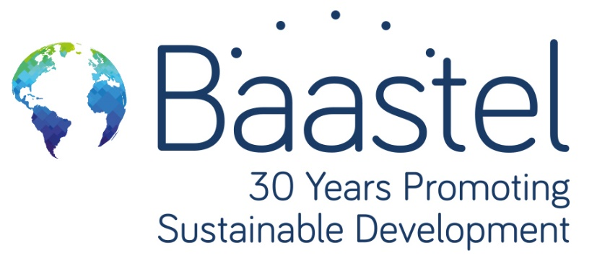

Evaluation of the united nations sustainable development cooperation framework (UNSDCF) 2020-2024 End of cycle, sierra leone
Draft Inception Report


Prepared for
United Nations Sustainable Development Cooperation Framework (UNSDCF)

27 July 2023

LE GROUPE
CONSEIL BAASTEL



Le Groupe-conseil baastel ltée
92, rue Montcalm, Gatineau QC, Canada
Rue de la Loi 28, Brussels, Belgium
P: +1 (819) 595-1421
E: alexandre.daoust@baastel.com // jade.pichard@baastel.com
W: www.baastel.com

TABLE
OF CONTENTS
1. Introduction 6
1.1. Background 6
1.2. Country Context 9
2. Objectives and scope of the evaluation 17
2.1. Objectives of the evaluation 17
2.2. Scope of the evaluation 20
3. Evaluation criteria, Questions and Methodology 21
3.1. Evaluation Criteria and Questions 21
3.2. Methodology 24
4. Theory of change 60
5. Evaluation work plan and management arrangements 64
5.1. Evaluation Work Plan 64
5.2. Evaluation steps 66
5.3. Management arrangements 68
6. potential Risks and Mitigation measures 71

Annex I – preliminary key documents identified 74
Annex ii – evaluation matrix 76
ANNEX III – The cooperation framework results matrix 106
Annex iV – Theory of change 114
Annex V – data collection protocols 129
Key Informant Interviews 129
Online survey 165
Annex VI – Terms of reference 197

ACRONYMS

CCA | Common Country Analysis
CBOs | Community Based Organisations
COP | Conference of Parties
CF | Cooperation Framework
CRP | Constitutional Review Process
CSOs | Civil Society Organisations
DDCC | District Development Coordination Committee
ECOWAS | Economic Community of West African States
EITI | Extractive Industry Transparency Initiative
ET | Evaluation Team
FAO | Food and Agriculture Organisation
FGM | Female Genital Mutilation
GEWE | Gender Equality and Women’s Empowerment
GDP | Gross Domestic Product
GOSL | Government of Sierra Leone
IAEA | International Atomic Energy Agency
IFAD | International Fund for Agricultural Development
IFIs | International Financial Institutions
ILO | International Labour Organisations
IOM | International Organisation for Migration
ITC | International Trade Centre
NALC | National Association of Local Councils
MCC | Millennium Challenge Cooperation
MPI | Multidimensional Poverty Index
MRU | Mano River Union
MTNDP | Medium-Term National Development Plan
NRAs | Non-resident Agencies
PC | Policy Cluster
PEA | Public Election Act
PR | Proportional Representation
RC | Resident Coordinator
SDGs | Sustainable Development Goals
SLCS | Sierra Leone Correctional Services
ToC | Theory of Change
UNAIDS | Joint United Nations Programme on HIV/AIDS
UNCDF | United Nations Capital Development Fund
UNCT | United Nations Country Team
UNDP | United Nations Development Programme
UNDSS | United Nations Department of Safety and Security
UNEG | United Nations Evaluation Group
UNESCO | United Nations Educational, Scientific and Cultural Organisation
UNFPA | United Nations Population Fund
UNICEF | United Nations Children's Fund
UNIDO | United Nations Industrial Development Organisation
UNODC | United Nations Office on Drugs and Crime
UNOPS | United Nations Office for Project Services
UNSDCF | United Nations Sustainable Development Cooperation Framework
UPR | Universal Periodic Report
USAID | United States Agency for International Development
WFP | World Food Programme
WHO | World Health Organisation

Introduction

Background
Sierra Leone was on track to recover economically from the effects of the COVID-19 pandemic, when the global implications of the war in Ukraine wiped out almost all the economic gains made during the first quarter of 2022. The medium-term outlook remains challenging, as the increase in fuel price and recent global supply chain disruptions are compromising favorable growth prospects and causing negative impacts on households’ purchasing power and business operations. The Russia/Ukraine conflict and other supply side factors have resulted in higher inflation and put pressure on the Leone (local currency), which has depreciated by over 68 percent since December 2021, further fueling import-related inflation. The budget deficit increased to 5.9 percent of GDP in 2021, from 5.8 percent in 2020 and 3.1 percent in 2019, due to expected revenue shortfalls as the economy weakened and expenditures increased.

The country’s political and governance space has witnessed unprecedented political turmoil, shifts, and changes, over the past years. One such incident is the August 2022 demonstrations against rising prices, as long-simmering economic grievances, compounded by the global food crisis impact in the country, erupted into street clashes which cost the lives of civilians as well as law enforcement agents.

However, Sierra Leone has made several positive efforts in enacting various legislation and reforms aimed at improving the country’s governance, development, and human rights landscape. Some of these reforms/legislation are still ongoing, including the constitutional review process and the electoral reform process. The Gender Equality and Women Empowerments Act was recently passed and received the Presidential accent. With the representation of women in governance still weak in Sierra Leone, this Act sets a 30% representation quota of women in all appointive positions as well as in the civil service.

Sierra Leone continues to show vulnerability to the effects of climate change which has resulted in increased severity of droughts, floods, and storms and hence impacted on sectors such as agriculture, fisheries, and infrastructure. The country’s strategy to combat climate change is contained in its Nationally Determined Contribution document, which was presented at the COP 26 and COP 27 in Glasgow, Scotland and Sharm El Sheikh, Egypt, respectively.

Food insecurity and malnutrition remain a challenge in Sierra Leone. The situation has been exacerbated by climate vulnerabilities, market distortions, the COVID-19 pandemic, and lately the Russian-Ukrainian crisis, all contributing to the persistence of a food crisis in the country. Food inflation increased by 3.08% from 43.62 percent in November 2022 to 46.70 percent in December 2022; and the inflation rate increased by 3.08 percentage points year-on-year. While the country has made considerable progress in terms of school enrollment, retention rate remains equally low for both girls (40 per cent) and boys (40 per cent) in primary schools. The Government’s Free Quality Education Programme supports the provision of teaching and learning materials, examination fees, and a school feeding programme. Sierra Leone’s resident donor community remains relatively small to support the country’s huge development challenges.

In addressing these challenges the United Nations Sustainable Development Cooperation Framework (UNSDCF) 2020-2024 was developed as a strategic plan by the United Nations Country Team (UNCT) in Sierra Leone. It is designed to align with the national development priorities and strategies of the Government of Sierra Leone as outlined in the Medium-Term National Development Plan (MTNDP) 2019-2023. The plan is also intended to contribute to the global 2030 Agenda for Sustainable Development and is focused on four high-level outcome areas: Sustainable Agriculture, Food and Nutrition Security, and Climate Resilience; Transformational Governance; Access to Basic Services; and Protection and Empowerment of the Most Vulnerable.

The first area refers to the key government policy on promoting sustainable agriculture, food and nutrition, and strengthening resilience and capacities to prevent the adverse effects of climate change. The second area addresses the government agenda on transformative governance and institution building as well as the promotion of an enabling environment to sustain peace and stability in the country. The third area supports the flagship government programmes on free quality school education and human capital development as well as the government efforts on promoting access of the population to basic services, including healthcare and energy. The fourth area sustains the government agenda on empowerment and social protection of women and other vulnerable members of society and promotes conditions for the vulnerable groups to be able to seize social and economic opportunities and play a role as agents of change in the society.

The Government’s vision for national transformation and development has been articulated in the country’s Medium-Term National Development Plan (MTNDP) (2019-2023) entitled ‘Education for Development’, launched in February 2019. The plan is aligned with the United Nations Agenda 2030, the Sustainable Development Goals (SDGs), the Africa Union Agenda 2063, and the New Deal Peacebuilding and State-building Goals. The MTNDP has marked the start of a new vision embedded in the Government’s New Direction Agenda, which translates Sierra Leone’s aspirations of becoming a middle-income country by 2039 into tangible achievements. Human capital development is at the centre of the Government’s vision in the MTNDP and forms the basis of the Government’s goal of providing free quality school education for all in the context of promotion of inclusive growth and leaving no one behind. The Government has articulated its development strategy in these four key goals: (Goal 1: A diversified resilient and green economy, Goal 2: A nation with educated, empowered, and healthy citizens capable of realizing their fullest potential, Goal 3: A society that is peaceful, cohesive, secure and just and Goal 4: A competitive economy with a well-developed infrastructure)

The UNSDCF is implemented at both national and district levels, under the Joint Steering Committee's leadership, which is co-chaired by the Minister of Planning and Economic Development and the United Nations Resident Coordinator. This committee ensures that the response to national challenges and transformation is "Delivered as One" (i.e., through one UN approach and not by each individual UN agency separately). The plan is also guided by the principles of gender equality, human rights, and conflict sensitivity to ensure that "no one is left behind".
The CF is developed to support the full implementation of the Medium Term National Development Plan with a results matrix as well as a monitoring and evaluation framework established. The MTNDP is based on an ambitious macro fiscal framework that aims at achieving key macroeconomic objectives including: attaining and maintaining single-digit inflation, reducing the budget deficit and maintaining the public debt at the sustainable threshold of not more than 70 per cent of GDP, increasing domestic revenue collection and maintaining government expenditures within budgetary limits of around 24 per cent of GDP. The new MTNDP (2019–2023) is organised around eight policy clusters and several sub clusters including;
PC1: Human Capital
PC2: Diversifying the economy and promoting growth
PC3: Infrastructure and economic competitiveness
PC4: Governance and accountability for results

PC5: Empowering women, children, adolescents and persons with disability
PC6: Youth employment, sports and migration
PC7: Addressing vulnerability and building resilience
PC8: Means of implementation

Therefore, an independent end-of-cycle evaluation of the UNSDCF will be undertaken during the penultimate year of the plan's implementation. The evaluation will assess whether planned UNSDCF results were achieved, and whether they made a durable contribution to national development processes, and delivered on the commitment to leave no one behind. This evaluation is mandatory, independent, and system-wide, following the United Nations Evaluation Group (UNEG) Norms and Standards for Evaluation. The evaluation will assess whether the planned outcomes were achieved, if they contributed sustainably to national development processes, and if they delivered on the initial theory of change developed.

Country Context
In 2022, Sierra Leone’s political and governance space witnessed unprecedented political turmoil and changes, with one notable incident being the 10 August 2022 demonstrations against rising prices, where long-simmering economic grievances, compounded by the global food crisis, prompted the demonstrations that erupted into street clashes in multiple locations throughout the country, including the capital of Freetown. In a bid to stem riots in the following days, a nationwide curfew was imposed, but this also had associated socio-economic costs.

The 2023 elections heightening Sierra Leone’s history of commitment to regional and cross-border economic and security issues which have enhanced its development, peace, and security. For example, it has benefited in peace dividends from the treaty which was signed on 3rd October 1973 in Sierra Leone by the Heads of the States of Liberia and Sierra Leone to establish the Mano River Union (MRU). Freetown houses the MRU secretariat headed by a Secretary-General. Though Guinea and Cote d’Ivoire later joined the union, the limited number of the MRU states has necessitated that it collaborates with the Economic Community of West African States (ECOWAS) which was founded two years after the MRU.

This collaboration has helped to inculcate the country’s flair for a regional approach to problem-solving in issues related to cross-border governance, and the various threats to regional peace and security as seen, for example, in the country’s participation in the Accra Initiative which seeks to ward off jihadist activities from West Africa’s coastal states. Sierra Leone has adopted a peaceful approach to its conflict with the Republic of Guinea over the status of Yenga, a Sierra Leonean border village partially occupied by Guinean troops since the 1990s and has become a subject of varying bilateral tensions between the two countries.

Specific observations about the civil society climate in Sierra Leone were made in the 2021 Civil Society Organisation Sustainability Index for Sub-Saharan Africa, published by the US Agency for International Development (USAID). It found the country’s overall CSO sustainability environment unchanged from 2019 to 2021 and included it among the middle group of the country ranking, considered as ‘sustainability evolving.’ It noted that the laws governing CSO registration remain unfavorable and contradictory. CSOs are required to register with all government agencies with which they will work and local councils in each of their geographic areas of operation. Unregistered organisations operate freely, but without legal status they may not interact formally with other entities.

The Development Cooperation Framework (DCF) requires CSOs to align their work with government priorities and limits CSOs to working in no more than two sectors, which many CSO leaders believe is meant to hinder their operations. The Civil Society Forum is newly created, composed of national and district-level CSOs, that primarily represents CSO interests as concerns the DCF.
Most national and community-based organisations (CBOs) engage in advocacy, and their cooperation with the government, policy advocacy initiatives, and lobbying efforts reached an all-time high in recent years. Even so, specific instances of civic freedoms and right to expression being under stress, met with intimidation and harassment by state entities, were noted. CSOs engage with the media to promote their activities, showcase their work, and build a positive public image. The USAID report found that media coverage of CSOs was mostly positive in 2021 and focused on their activities and achievements. CSOs’ frequent presence in media such as African Young Voices Television, Radio Democracy, and Epic Radio 99.3 assure them a role in setting the national agenda. Public perceptions of CSOs are considered positive and communities appreciate CSO contributions. Government and business perceptions are mixed.

Looking at Sierra Leone compared to other countries on international rankings, Sierra Leone has varied in its ranking in the last 5 years on the Global Peace Index, dropping from a score of 35 in 2018 to a score of 50 in the most recent 2022 ranking. Sierra Leone has, for the last three years, progressed upwards in Transparency International’s Global Corruption Perception Index rankings, showing progress in combatting corruption. Sierra Leone is the 110th least corrupt nation out of 180 countries, according to the 2021 Corruption Perceptions Index by Transparency International. During the period 2003 to 2021, the Corruption Index score for Sierra Leone averaged 27 points (out of 100 which is very clean) but is at an all-time high of 34 in 2022. According to the Mo Ibrahim's African governance index, Sierra Leone ranked 22nd and improved in all 4 categories of the Ibrahim Index of African Governance (IIAG) - Security and Rule of Law; Participation, Rights and Inclusion, Foundations for Economic Opportunities and Human Development.

In October 2022, Sierra Leone achieved a high overall score in implementing the 2019 Extractive Industry Transparency Initiative (EITI) Standard (87.5 points). It is based on extensive stakeholder consultations and a review of three templates that reflect the components of EITI Validation, namely “Outcomes and Impact”, “Stakeholder Engagement” and “Transparency”. The Validation is the EITI’s quality assurance mechanism to assess implementing countries on their ability to meet the provisions of the EITI Standard. Sierra Leone has, for the third time in three years, progressed upwards in Transparency.

Sierra Leone has passed 11 out of the 20 indicators on the US Government’s Millennium Challenge Corporation (MCC) 2023 scorecard used to evaluate countries, making it the country’s fourth consecutive ‘pass’, and positioning it to develop a multi-year MCC programme funded by the US Government for up to $300-450 million. This year’s performance was the highest since Sierra Leone started engaging with the MCC 16 years ago. (Previously, MCC and the Government of Sierra Leone partnered to improve access to clean water and reliable electricity under a $44.4 MCC Threshold Programme that included support for reforms to limit opportunities for corruption). For the first time, Sierra Leone passed the MCC Land Rights and Access indicator. In the category of Ruling Justly, Sierra Leone passed 5 out of the 6 indicators including Control of Corruption at 83%.7 Other positive scores include Political Rights 92%; Civil Liberties 92%; Freedom of Information 90%; and Rule of Law 63%. The country did poorly on Government Effectiveness at 40%. Sierra Leone’s Parliament has passed two groundbreaking bills that transform communities’ ability to protect their land rights and the environment. The Customary Land Rights Act and the Land Commission Act, both enacted, empower local landowners to negotiate the value of their land with investors and prevent it being leased out without their express consent.

The Constitutional Review Process (CRP) and electoral reforms have been the dominant themes within the country’s socio-political milieu in 2022. The Government of Sierra Leone (GoSL) launched its White Paper on the review of the 1991 Constitution of Sierra Leone on 13th January 2022 following repeated calls from civil society organisations and development partners for the resumption of the CRP. Most importantly, the launch was viewed as the fulfilment of one of the pledges made by Sierra Leone during the Universal Periodic Review (UPR) on Human Rights in May 2021 - to finalize the CRP. Though the White Paper proposed significant changes, it is yet to be presented to Parliament for discussion.

The representation of women and girls in the governance architecture is still weak. Only 19% of women are represented at local councils in Sierra Leone. Of the total Parliamentarians in the fifth republic of the Sierra Leone parliament, only 12.9% are women. There is a huge gap in the representation of women in parliament, cabinets, the judiciary, and local government. The Gender Equality and Women’s Empowerment (GEWE) Act 2022 was passed in November 2022 and signed by the President in January 2023. With the new law, all appointed positions, including in the cabinet and ministries, with agencies, as ambassadors, and in elected positions, including parliament and local councils and wards, must have at least thirty percent women.

The law also criminalizes discrimination based on gender and sets equal pay, facilitates access to finance for women, provides for equal access to training and 14-week maternity leave, and requires all private employers with more than 25 employees to meet the thirty percent quota. In addition, the Act has provisions for increasing financial inclusion of women and gender-responsive national budgeting. A Multi-Sectoral Steering Committee will be established to implement the law. As referenced above, the new Gender Equality and Women ‘s Empowerment Act 2022 (GEWE Act 2022) could double the number of women in Sierra Leone’s next parliament, following the 2023 election. GEWE sets a minimum of 30 percent quota for women in leadership positions. Currently, of the 146 members of parliament elected in 2018, only 12% are women.

Sierra Leonean youth complain about the continuous marginalization and infantilization of their communities particularly by political elites. This they believe is contributing to the failure in enhancing the agency of the youth, hindering their representation at both the central government and local authority levels. It is important to note that the female youth are particularly affected by this challenge, as the patriarchal systems, structures, traditions and cultures have continuously denied them their place and voice in society. Similar to this, there is the continued marginalization of youth with disability and the lack of enforcement of laws and policies that protect and promote their rights.

On 6th September 2022, the Public Elections Act, 2022 (Act 17 of 2022) was assented to and thereby repealed and replaced the Public Elections Act, 2012 (Act No.4 of 2012), to provide for supplementary provisions to Sections 32 and 33 of the Constitution of Sierra Leone (Act No. 6 of 1991), and strengthen the electoral laws of the State. However, there was a strong contention between the two dominant political parties vis-à-vis the suitability and legality of the District Block and Local Councils Proportional Representation (PR) Systems for presidential and national elections enacted by these changes. Whilst proponents of the PR system rationalize its relevance for national unity, the opposition views introduction of the new electoral system as unconstitutional and an attempt to deprive citizens the opportunity to choose their parliamentary representatives directly. This state of affairs has the potential to worsen the already polarized ethno-political and regional tensions within the country and can create impediments for both the election management bodies and contestants to timely adapt to these fundamental changes in elections.

Access to justice remains a challenge especially for the poor, women and persons living in remote villages because of the distance to court facilities, difficulties to get a lawyer, etc., and some legislation needs to be better aligned with the international standards on the rights to access justice. Key legislation such as revisions to the aging Criminal Procedure Act, Human Rights Commission Act 2004 and the Sierra Leone Correctional Services Act, are yet to be tabled before Parliament for scrutiny, update, and subsequent enactment. The Sexual Offences Model Court (SOMC) has proved very effective in punishing offenders of sexual violence, thereby enhancing access to justice for survivors, many of whom are vulnerable women and girls. The SOMC convictions and discharges from January to October 2022 stand at 51 and 39, respectively. However, there remain inherent challenges affecting justice and human rights institutions. For example, access to justice at the district level for people in remote communities remains a challenge, with limited court infrastructure and irregular court sessions.

In addition to legal reforms for the advancement of human rights, actions have been taken by the government to address issues of prolonged detention and overcrowding at correctional centers nationwide. During the first quarter of 2022, the Judiciary held “Access to Justice through Judicial Week”, to increase access to justice and to decongest correctional centers across the country. Near the capital of Freetown, a total of 17 courts were constituted in the Western Area and one court at Waterloo. In the provinces, judges sat in all the 14 districts headquarters towns for this event. A total of 870 cases were processed and 1,175 detainees had their incarceration reviewed. In all, 374 detainees were granted bail to secure their release; 259 were from the provinces and 115 from the Western Area. A total of 93 cases of prolonged adjournments, 101 of summary review cases, and 78 with habeas corpus applications were completed.

The government of Sierra Leone continued to make significant efforts to fulfill its regional and international obligations and ensure tangible actions to promote, protect and fulfil human rights in the country. As a UN Member State, Sierra Leone is legally bound by the UN Charter which affirms the inherent dignity and the equal and inalienable rights of all members of the human family, upholding these human rights principles as the foundation of freedom, justice, and peace in the world. Also, Sierra Leone has ratified key human rights conventions including the International Covenant on Civil and Political Rights, the International Covenant on Economic, Social and Cultural Rights, the Convention on the Rights of the Child, and the Convention on the Elimination of All Forms of Discrimination against Women. In addition to its global commitments, Sierra Leone is a party to several regional and sub-regional treaties including the African Charter on Human and People’s Rights and the Maputo Protocol, which guarantees women social and political rights and equality with men. The country is also party to human rights instruments of the Economic Community of West African States. On 26 April 2022, the Parliament adopted the Anti-Human Trafficking and Smuggling Act. The establishment and operationalization in 2022 of the National Reporting Mechanism to Treaty Bodies (NRM) was adopted by the cabinet in October 2021. The Ministry of Foreign Affairs and International Cooperation (MFAIC) has been working with the UN to strengthen the capacity of this mechanism for better coordination among government stakeholders and to ensure regular reporting to Treaty Bodies and the Universal Periodic Review.

In April 2022, the UN supported the government in developing and launching the National Implementation Plan and Reporting Matrix for the Recommendations of the 3rd cycle of the Universal Periodic Review. Sierra Leone committed to fully implement 216 accepted recommendations out of the 274 it received from various countries. The plan will continue to serve as a roadmap to implement the recommendations it accepted following the third UPR cycle and the preparation for the 4th review of the country. Despite these positive developments recorded in 2022, much remains to be done to ensure effective promotion and protection of human rights in the country.

The ongoing war between Russia and Ukraine has concrete impacts on the enjoyment of human rights of the population of Sierra Leone. For instance, the 10 August events described above were triggered inter alia by the dire socio-economic situation in the country, due to disruption of the supply chains for key commodities, economic spillover effects and price transmissions which have led to domestic price surges. This eroded households’ purchasing power in towns and remote villages as well, where many people already live below the poverty line. This situation, combined with the steady depreciation of the national currency despite the launch of a new redenominated currency (New Leones) in 2022, has a potentially explosive effect on social stability.

According to the authorities, 27 civilians and 6 police officers were killed, and many others injured during demonstrations in Freetown and in at least four other towns. According to the police, 506 civilians were arrested and detained and among them, 133 were released by the end of August, including 24 minors who were handed over to the Ministry of Gender and Children’s Affairs following engagement of the authorities by UNICEF. Many other civilians arrested have been sentenced, and others were awaiting trial at the end of 2022. A Special Investigation Committee (SIC) was set up by the President on 24 August to “examine both the immediate and underlying causes, sources of financing, execution, and consequences of the insurrection of 10 August, as well as the response of the security forces.” The outcomes of the work of the SIC were not available as of the writing of this report.

Following the 10 August incidents, the UN Special Rapporteur on Freedom of Peaceful Assembly and Association issued a press release and several tweets calling for the respect of the rights to freedom of assembly and association. These actions were positively received by the general population in Sierra Leone, as observed in various media coverage. The UN continued to work with the national authorities to ensure humane and dignified detention conditions in correctional centers. Pursuant to a collaboration between the United Nations and management of the Sierra Leone Correctional Service (SLCS), 35 senior staff of the Sierra Leone Correctional Service, including 12 women, received a three-day capacity building training on detention conditions and human rights in Freetown in June 2022. A report was issued following the training and discussions took place for the implementation of key action-points including cascading the training to regional correction centers.
Government commitment to Public Sector Reform has been promising, and measures bringing together diaspora experts, recruiting mid-level technical experts, and implementing performance management and performance contracting systems, have been introduced. In addition, improved local governance and local economic development practices have led to increased revenues at the Local Council level, and the Ministry of Local Government and Rural Development has enhanced its function through the establishment of the National Association of Local Councils. Despite these reforms there are still some local councils lagging in performance, and unless a performance monitoring system and a rigorous cadastral for mapping local income generation for the councils is fixed, challenges will remain to transfer them from reliance on the central government to independently functioning bodies.
Sierra Leone’s real GDP contracted by -2.16 percent in 2020 due to the COVDI-19 pandemic, after growing by 5.6 percent in 2019. More recently, the surge in the prices of food and petroleum products, exacerbated by the Russia-Ukraine conflict, intensified energy shortages in Sierra Leone, creating more hardship for local businesses and consumers, particularly the poorest and the most vulnerable. The decline in the economy during the pandemic was attributable to slow growth in agriculture and weak external demand for major exports during turbulent times, such as minerals, (something the country had disproportionately depended on for foreign exchange since independence), and decline in the general mining activities, transport, trade, and tourism sectors. Growth in 2022 has been revised downwards to an estimated 2.8 percent from an earlier forecast of 5.9 percent. The sharp rise in global food and fuel prices and the pass-through effects on domestic prices, combined with the depreciation of the local currency, resulted in high inflation during the year.
The country was on track to fully recover economically from the effect of the pandemic, but the medium-term outlook now is challenging as the increase in fuel prices and the recent global supply chain disruptions are constraining favorable growth prospects and causing negative impacts on households’ purchasing power and business operations. These circumstances, in a country where two-thirds of the population are identified as multi-dimensionally poor, triggered the social unrest and anti-government protests of 10 August.
The government-mandated cost per liter of fuel increased by 50 percent on 17 March 2022 from an initial price of Leone 10 000 to 15 000. Prices were further adjusted to Leone 18 000 and all-time high at Leone 22 000 in June 2022, as a result of the continuous global price hike. The high fuel price and electricity tariff, as well as more frequent electricity blackouts, are influenced by several internal and external factors including cost of fuel importation, perceived risk of market disruptions, shipping cost, premium fees and other transactions costs. The increase in fuel prices has a pass-through effect on prices of other commodities via mainly transportation costs. Higher inflation has put pressure on the Leone, which has depreciated by over 40 percent since December 2021, further fueling inflation on imported goods. Inflation will likely remain in double digits in the near future, given the current trend of global prices for key imported commodities. The latest official annual national Consumer Price inflation figure for December 2022 stood at 37.09%, (year on year). This is one of the highest inflation figures among African countries.
Sierra Leone has effectively integrated the SDGs into its national, sectoral, and local development plans to promote inclusive growth and achieve tangible progress. The country's MTNDP (2019-2023) focuses on human capital development, with the goal of providing free quality school education for all. The UNSCDF supports the implementation of the MTNDP in achieving the aspirations of the Government of Sierra Leone related to the Sustainable Development Goals (SDGs). The UNSDCF and is organised into eight policy clusters, with four key goals focusing on building a diversified, resilient, green economy; educating, empowering, and maintaining healthy citizens; promoting peace, cohesion, security, and justice; and building a competitive economy with a well-developed infrastructure. The District Development Coordination Committee (DDCC), initiative chaired by the local councils with a membership of government agencies, community based and international organisations has also been implemented to ensure effective development accountability and reporting at the local level.
Sierra Leone faces significant challenges across a range of socio-economic and political indicators. These challenges are numerous and multifaceted, ranging from high rates of poverty and food insecurity to gender inequality and discrimination, high rates of child labor, and low levels of education and literacy among people with disabilities. As a result, in 2017, the UNDP, in partnership with its national and international partners, revealed that the rate of multidimensional poverty in the country was 64.8 % meaning that almost two-thirds of the population in the country was considered as “multidimensionally poor” which is as “being deprived in at least 40% of the 14 indicators”.
The country has made some progress in recent years, including positive GDP growth since 2016 and an easing of COVID-19 restrictions, but structural challenges remain, and there is a risk that ongoing socioeconomic difficulties could hinder long-term recovery..
One of the most pressing challenges facing Sierra Leone is climate change, which poses a significant threat to the country's food security, with the majority of the population depending on subsistence agriculture. This is compounded by the impact of natural disasters such as flooding and the ongoing, long-lasting effects of the COVID-19 pandemic, which has exacerbated food insecurity and malnutrition. It is estimated that 3.8 million people is food insecure (roughly 54% of the population) and that 29.5% of children under 5 are stunted.
The country has a Gender Inequality Index-GII value of 0.633, ranking it 162 out of 170 countries in the 2021 Index. Gender inequality is also a major issue in Sierra Leone, with high rates of maternal mortality, female genital mutilation (FGM, i.e., 83% of women aged 15-49 years are circumcised. The most common type of FGM in Sierra Leone is type II (some flesh removed), with 84% of women undergoing this procedure. One percent of women underwent type I procedure (clitoris nicked, no flesh removed), and 12% underwent a type III procedure (sewn closed) ,and violence against women and girls. This is worsened by high rates of child marriage and adolescent pregnancy, which can have long-lasting negative effects on women's health and well-being. More men than women are in governance of public and private sector, have access to skilled and professional labor, earn 3 times more wages in professional and skilled employment and participate more in the public finance sector. Contributing to this is the high levels of illiteracy and gender socialisation that has contributed to low levels of skills, access to information and technology. This has shaped the way women and men actualise their goals and rights and the economic growth of the country.
Finally, the large youth population in Sierra Leone faces significant challenges, including high rates of unemployment and poverty, as well as widespread child labour. Children with disabilities are also at a disadvantage, facing higher rates of multidimensional poverty, including illiteracy, and limited access to essential health services.
Addressing these challenges requires significant investment and effort from the government and international community, including UN agencies and the UNCT, as well as a focus on building resilience to climate change, improving gender equality, and ensuring that all people in Sierra Leone have access to education, healthcare, and economic opportunities.

Objectives and scope of the evaluation
The Cooperation Framework (CF) evaluation will be disseminated to the Government of Sierra Leone, UN Agencies, Funds and Programmes, development partners, civil society, academia, private sector, implementing partners.. Overall, the results of the evaluation will aim to provide strategic and programmatic lessons that can help promote accountability and visibility regarding the work and achievements of UN Sierra Leone in supporting the government’s efforts to achieve its National Development Goals and the SDGs over the past five years (2020- 2024. The evaluation results are expected to be used as a tool for learning and improvement to enhance the effectiveness of UN Sierra Leone’s work towards achieving the expected outcomes.

Objectives of the evaluation
The evaluation of the Common Framework (CF) during Sierra Leone's presidential elections on the 24th of June 2023 holds significant importance and relevance. The timing of the evaluation, coinciding with the elections, adds an extra layer of importance and relevance to the process.
The evaluation serves multiple purposes outlined in the Terms of Reference (ToR) for the evaluation of the United Nations Sustainable Development Cooperation Framework (UNSDCF) 2020-2024. Firstly, it aims to promote greater learning and operational movement by providing valuable information to strengthen programming and achieve better results at the country level. The evaluation will inform the planning and decision-making process for the next cycle of the UNSDCF programme and help improve UN coordination at the country level. The documentation of good practices and lessons learned will also be shared with the UN Development Coordination Office (DCO) and other countries, enhancing the effectiveness of UN programming and coordination efforts in similar contexts.
Secondly, the evaluation supports greater accountability of the United Nations Country Team (UNCT) to CF stakeholders. By objectively assessing the effectiveness of strategies and interventions used and providing evidence of the results achieved, the evaluation enables stakeholders to hold the UNCT and other parties accountable for fulfilling their roles and commitments. It is crucial for promoting accountability, identifying areas for improvement, and informing future efforts to support development and achieve the Sustainable Development Goals (SDGs). The evaluation should be impartial and consider the perspectives of various stakeholders to ensure comprehensive and diverse input.
Thirdly, the evaluation aims to deliver clear recommendations to support the next CF cycle and ensure accelerated progress towards the SDGs. By identifying the strengths, weaknesses, and areas for improvement in the current CF, the evaluation can guide the formulation of a more effective and responsive framework that aligns with Sierra Leone's developmental priorities. The recommendations generated through the evaluation will serve as valuable input for the new, upcoming framework. Moreover, incorporating the evaluation's recommendations into the national plan will enhance the government's policies, programmes, and projects, ensuring their alignment with the CF's objectives and maximizing their impact on the country's development.
Furthermore, the evaluation of the CF will contribute to the Common Country Analysis (CCA). The CCA is an essential analytical process that informs the United Nations' strategic response to a country's development challenges. By considering the evaluation's results, the CCA can identify the areas where the UN's support and interventions should be focused, ensuring a coherent and coordinated approach to address Sierra Leone's developmental challenges and needs.
In conclusion, the evaluation of the CF during the crucial period of Sierra Leone's presidential elections holds important significance. Its recommendations will shape the new UNSDCF, influence the National Development Plan, and contribute to the CCA. This comprehensive approach will foster effective collaboration and enable targeted interventions to support Sierra Leone's sustainable development in the years to come.

The specific objectives, as per the ToR, are:
- To assess the contribution of the CF to national development results through evidence-based judgements using evaluation criteria (accountability)
- To assess the contribution and accountability of the Government of Sierra Leone as the primary partner to the UNSDCF, alongside the UNCT
- To assess the effectiveness of the Joint Steering Committee as the key coordination mechanism between the Government and the UNCT
- Identify factors that have affected the CF’s contribution; answering the question of why the performance is as it is; and explaining the enabling factors and bottlenecks (learning)
- Reach conclusions concerning the UN’s contribution across the scope being examined
- Provide clear, forward-looking, actionable recommendations for improving UN Sierra Leone contribution through the UNSDCF, especially for incorporation into the new UNSDCF programming cycle. These recommendations will be linked to conclusions and findings of the evaluation and will draw upon lessons learned identified through the evaluation process
- To gauge what kind of joint programmes and joint operations provided evidence of efficiency gains by reducing the cost of doing business through reducing multiple and extensive transaction costs incurred by a number of agencies carrying out their own programmes independently by combining their initiatives with other agencies.
- To assess the contribution to the SDGs.

Scope of the evaluation
As per the ToR, the evaluators understand that the evaluation will consider all the following elements:
- Implementation period covered by the evaluation: January 2020 to December 2022
- Geographical coverage: nation wide
- Results will be assessed against the four strategic outcomes identified above as well as the outputs and sub-outputs
- Incorporation of the cross-cutting issues (i.e., gender equality and empowerment of women, human rights, disability inclusion, and environmental sustainability) and normative work of the UNCT
- All UN Agencies, Funds and Programmes that implement UNSDCF will be covered as well as implementing partners, donors, and relevant stakeholders including target populations
- Consideration of changes in context and emerging challenges (e.g., COVID-19, Russia/Ukraine conflict) will be included to assess their impact on UNSDCF programming and its operations
- UNCT coordination structured including Results Groups, M&E Group, and thematic and operation groups will be covered.

Evaluation criteria, Questions and Methodology

Evaluation Criteria and Questions
The evaluation uses the OECD/DAC criteria namely Relevance, Effectiveness, Efficiency, Impact and Sustainability. Additionally, based on the UNEG Guidelines, the evaluation will also assess the following criteria: Adaptability and Coordination. The detailed evaluation matrix is available in Annex II.
Relevance
R1. To what extent has the CF integrated key issues and development challenges identified by the UN Common Country Analysis (CCA) in its design and implementation?
R2. To what extent has the CF integrated the following: a) the promotion of gender equality and women’s empowerment, b) the promotion of human rights, including disability inclusion, c) the promotion of environmental sustainability objectives in its design and implementation?
R3. To what extent are the CF objectives aligned with the needs, priorities, and policies of the government (including alignment to national development goals and targets, national plans, strategies, and framework)?
R4. To what extent are the CF objectives aligned with the needs and priorities of the rights holders, especially the most vulnerable group?
Adaptability
A1. To what extent did the implementation of the CF adjust to emerging issues faced by the country during the implementation? (e.g. COVID-19)
A2. To what extent did the monitoring and evaluation strategies of the CF adjust to emerging issues faced by the country during the implementation?
Coherence
C1. To what extent have the CF partnerships with civil society/private sector/ local government/ international development partners contributed to the achievement of the results?
Effectiveness
E1. To what extent has the CF achieved and is likely to achieve its intended results and ensure that the rights holders, especially the most vulnerable have access access to and benefit from services?
E1.1. To what extent has outcome 1 : “By 2023, Sierra Leone benefits from more productive, commercialized and sustainable agriculture, improved food and nutrition security, and increased resilience to climate change and other shocks” been achieved?
E.1.2. To what extent has outcome 2 “By 2023, people in Sierra Leone benefit from more gender and youth responsive institutions that are innovative, accountable, and transparent at all levels and can better advance respect for human rights and the rule of law, equity, peaceful coexistence, and the protection of boys and girls, women and men including those with disabilities.” been achieved?
E.1.3. To what extent has outcome 3 “By 2023, the population of Sierra Leone, particularly the most disadvantaged and vulnerable, will benefit from increased and more equitable access to and utilization of quality education, health care, energy and WASH services, including during emergencies.” been achieved?
E.1.4. To what extent has outcome 4 “By 2023, the most vulnerable, particularly women, youth, adolescents and children (especially girls), and persons with disabilities, are empowered and benefit from increased social and economic opportunities.” been achieved?
E2. What internal and external factors contributed to or hindered the attainment of the intended results?
E3. What expected and unexpected, positive and negative outcomes has the CF yielded as a result of its intended goals and objectives?
Efficiency
Effi1. To what extent the programme resources (human and financial) have been utilized efficiently?
Effi1.1. How efficient was the programme in utilizing financial resources?
Effi1.2. How efficient was the programme in utilizing its human resources?
Effi1.3. To what extent has the CF been implemented and achieved its intended results as planned and in a timely way?
Effi1.4. To what extent has the CF's monitoring and evaluation (M&E) system ensured results-based management and efficient, effective implementation?
Coordination
Co1. To what extent has the CF promoted complementarity, harmonization and coordination with other key partners to maximize the achievement of results?
Co1.1. To what extent has the CF fostered internal coordination, through the promotion of synergies and interlinkages between its interventions to maximize efficiency, coverage, reaching the most vulnerable while reducing and avoiding overlaps?
Co1.2. To what extent does the CF align with the strategic priorities of the UN Agencies?
Co2. To what extent has the different UN agencies contributed to the functioning and consolidation of UNCT coordination mechanisms?
Co3. To what extent has the Joint Steering Committee ensured efficient coordination between the Government and the UNCT?
Orientation towards Impact
I1. To what extent has the CF in each of its strategic areas contributed to the following : a) promotion of gender equality and women’s empowerment, b) promotion of human rights, including disability inclusion, c) promotion of environmental sustainability objectives?
I1.1. To what extent has Strategic Area 1 Sustainable Agriculture and Food Security contributed to a) promotion of gender equality and women’s empowerment, b) promotion of human rights, including disability inclusion, c) promotion of environmental sustainability objectives?
I1.2. To what extent has Strategic Area 2 Transformational Governance contributed to a) promotion of gender equality and women’s empowerment, b) promotion of human rights, including disability inclusion, c) promotion of environmental sustainability objectives?
I1.3. To what extent has Strategic Area 3 Access to Basic Services contributed to a) promotion of gender equality and women’s empowerment, b) promotion of human rights, including disability inclusion, c) promotion of environmental sustainability objectives?
I1.4. To what extent has Strategic Area 4: Protection and Empowerment of the most vulnerable contributed to a) promotion of gender equality and women’s empowerment, b) promotion of human rights, including disability inclusion, c) promotion of environmental sustainability objectives?
Sustainability
S1. To what extent has Strategic Area 1: Sustainable Agriculture and Food Security contributed to building national and local capacities and ensuring long-term gains?
S1.1. What are the risks under the Strategic Area 1 that may impact the sustainability of its results? What are the possible mitigation measures and recommendations?
S2. To what extent has Strategic Area 2: Transformational Governance contributed to building national and local capacities and ensuring long-term gains?
S2.1. What are the risks under the Strategic Area 2 that may impact the sustainability of its results? What are the possible mitigation measures?
S3. To what extent has Strategic Area 3: Access to Basic Services contributed to building national and local capacities and ensuring long-term gains?
S3.1. What are the risks under the Strategic Area 3 that may impact the sustainability of its results? What are the possible mitigation measures?
S4. To what extent has Strategic Area 4: Protection and Empowerment of the most vulnerable contributed to building national and local capacities and ensuring long-term gains?
S4.1. What are the risks under the Strategic Area 4 that may impact the sustainability of its results? What are the possible mitigation measures?

Methodology

Approach
The evaluation will be guided by i) the Organisation for Economic Co-operation and Development – Development Assistance Committee (OECD-DAC) Evaluation Quality Standards for Development Evaluation, ii) the United Nations Evaluation Group (UNEG) Norms and Standards for Evaluation in the UN System, and iii) the UNEG Ethical Guidelines and Code of Conduct for Evaluation in the UN System.
The evaluation of the UN CF in Sierra Leone will adopt a theory-based approach, leveraging the concept of the theory of change as its fundamental framework. The theory of change serves as a comprehensive model that outlines the causal relationships between programme activities, intermediate outcomes, and long-term impacts. It provides a roadmap for understanding how and why interventions lead to desired changes.
To begin the evaluation process, the initial step involves constructing a theory of change that represents the UN CF’s underlying assumptions, logic, and expected outcomes. This involves a thorough analysis of the framework's goals, objectives, strategies, and interventions as stated in the initial documents of the UN CF. The theory of change serves as a visual representation or narrative that maps out the theory behind the framework's approach to achieving its intended impact.
Once the theory of change is established, the evaluation team can move on to developing evaluation questions and identifying relevant indicators to assess progress and outcomes. These indicators should align with the different elements of the theory of change, allowing for a comprehensive and systematic evaluation of the framework. At the end of the evaluation process, the ET will be able to re-construct the ToC based on the findings.
Additionally, the overall approach of the evaluation will be based on the following:
- Focus on utility: The research process should always aim to ensure that the data collection, stakeholder consultation, analysis, report, and recommendations are relevant to the evaluation objectives. In particular, the evaluation team will ensure that the process and deliverables meet the expectations and needs of the relevant stakeholders. In the present case, to the extent possible, the evaluation needs to make sure that government and all UN agencies’ utility needs are considered. Thus, the need to a participatory approach.

- Participatory and inclusive approach: Engaging as many stakeholders as possible as sources of information and creating space for their voices and views to be heard. This may sometimes be best supported by consulting with different categories of stakeholders separately – for example via focus groups discussions with different stakeholders depending on the power dynamics in the partnership. To ensure the inclusivity of all stakeholders and in line with the “leaving no one behind approach” the following criteria will be taken into account:
  - Diverse representation: Aim to have a diverse range of stakeholders participating in the focus groups, ensuring the representation from different backgrounds, perspectives, and experiences. This includes considering gender, age, ethnicity, socioeconomic status, disability, and other relevant characteristics.
  - Safe and inclusive environment: Create a safe and inclusive space for discussion, where all participants feel comfortable expressing their views. Establish ground rules that encourage respectful and inclusive dialogue, ensuring that no individual or group dominates the conversation.
  - Accessibility: Ensure that the focus group sessions are accessible to all participants, including individuals with disabilities.
  - Gender and women empowerment: Pay attention to gender dynamics and strive for equal participation and engagement of both men and women. Create an environment where women feel comfortable expressing their opinions and ensure that their perspectives are valued and integrated into decision-making processes.
  - Active listening and empathy: Encourage active listening among participants and emphasize the importance of empathy. Encourage individuals to consider the perspectives and experiences of others, fostering an environment where everyone's input is respected and acknowledged.
  - Feedback mechanisms: Establish mechanisms for participants to provide feedback and raise concerns if they feel their voices are not being adequately heard or if they encounter any barriers to participation. Actively address these concerns and make adjustments as necessary to ensure inclusivity.

- Gender and Human Rights Based Approach: This evaluation will also use a human rights-based approach in conjunction with the integration of the above-mentioned participatory approach. More specifically, it will ensure that key gender equality (GE) and human rights (HR) principles identified by UNEG are taken into account in the evaluation process:
  - Non-discrimination and equity: All individuals are equal as human beings by virtue of the inherent dignity of each person. The evaluation process recognizes and addresses existing disparities and inequalities. It will pay attention to intersecting identifies such as gender, age, disability, ethnicity, socioeconomic status, and others, to ensure that the evaluation accounts for the specific needs and challenges faced by vulnerable populations. As such, all participants in the evaluation will be treated without discrimination as outlined in multiple human rights treaties.
  - Participation and inclusion of vulnerable populations: Every person and all people are entitled to active, free, and meaningful participation in, contribution to, and enjoyment of, civil, economic, social, cultural and political development in which human rights and fundamental freedoms can be realized.. As such measures will be taken during the evaluation process to include the voices and perspectives of vulnerable populations such as persons with disabilities, marginalized communities, and those facing social exclusion. This may involve providing accessible formats, accommodating different communication needs, and creating a safe and inclusive space for their meaningful participation.
  - Disability inclusion: The team will use a disability inclusion lens and will be mainstreamed throughout the evaluation process based on the Guidance from UNEG. Using a disability inclusion lens means actively considering and addressing the needs, perspectives, and rights of persons with disabilities throughout the evaluation process. It involves recognizing disability as a cross-cutting issue that intersects with other dimensions of diversity, such as gender, age, and socioeconomic status.
  - Accountability and the rule of law: Duty bearers (primary and secondary) are answerable for the observance of human rights while rights holders (children supported by advocates) are entitled to claim and/or institute proceedings for appropriate redress before a competent court.
  - Gender mainstreaming: it involves:
    - 1) integrating female and male right holders’ needs and interests into all development policies and programmes: is not just about focusing on women's rights but also understanding and addressing the specific needs, concerns, and rights of men. It involves conducting gender analysis to identify the distinct challenges and opportunities faced by women, men, girls, and boys in a particular context.
    - 2) developing interventions oriented at empowering women and girls: Gender mainstreaming also emphasizes the importance of developing targeted interventions to empower women and girls, as they often face specific and systemic disadvantages and discrimination. This involves addressing gender-based inequalities, promoting women's leadership and decision-making, enhancing their access to education, healthcare, economic opportunities, and addressing issues such as gender-based violence and discrimination.
- Adopt an environmental lens to assess actual or potential climate-related and other environmental dimensions in the programme’s design and implementation.

Ethical considerations
The evaluation process adhere to and will be guided by the UNEG Norms and Standards and the UNEG Ethical Guidelines, more specifically the ET will ensure that the following ethical principles are taken into account at every stages of the evaluation process:
- Integrity:
  - Honesty and trustfulness in communication and actions
  - Professionalism based on competence, commitment, ongoing reflective practice and credible and trustworthy behavior
  - Independence, impartiality and incorruptibility to mitigate or prevent conflicts of interests, bias or undue influence of others, which may otherwise compromise responsible and professional evaluation practice
- Accountability
  - Transparency of the evaluation, thereby increasing accountability for performance to the public
  - Responsiveness as questions or events arise. Where corruption, fraud, sexual exploitation or abuse or other misconduct or waste of resources is identified, it must be referred to appropriate channels
  - Taking responsibility for meeting the evaluation purpose and for actions taken
  - Fairly and accurately reporting to stakeholders’ decisions, actions, and intentions
- Respect
  - Access to the evaluation process and products by all relevant stakeholders – with due attention to factors that can impede access such as sex, gender, race, language, country of origin, LGBTQ status, age, background, religion, ethnicity and ability
  - Meaningful engagement and fair treatment of all relevant stakeholders in the evaluation processes, so they can actively inform the evaluation approach and products rather than being solely a subject of data collection
  - Fair representation of different voices and perspectives in evaluation products
- Beneficience
  - Explicit and ongoing consideration of risks and benefits from evaluation processes, products and longer-term consequences
  - Maximizing benefits at systemic (including environmental), organisational and programmatic levels
  - Doing no harm and not proceeding with an evaluation when harms cannot be mitigated
  - Ensuring evaluation makes an overall positive contribution to human and natural systems and to the mission of the United Nations

Stakeholders map
The UNCT leads the implementation of the UNSDCF 2020-2024, with its steering committee co-chaired by the UN resident coordinator (RC) and the Minister of Planning and Economic Development, as well as the government ministries who serve as members of the committee: agriculture, forestry and food security, basic and senior secondary education, gender and children's affairs, health and sanitation, and social welfare.
The UNCT is composed of a wide range of UN agencies, funds, and programmes, including non-resident agencies (NRAs) as well as international finance institutions, who are all working together with the Government of Sierra Leone and local partners to deliver sustainable development interventions across different areas. More precisely, as shown in the picture below, the UNCT is composed of 21 UN Agencies, with 17 residents and 4 non-residents.
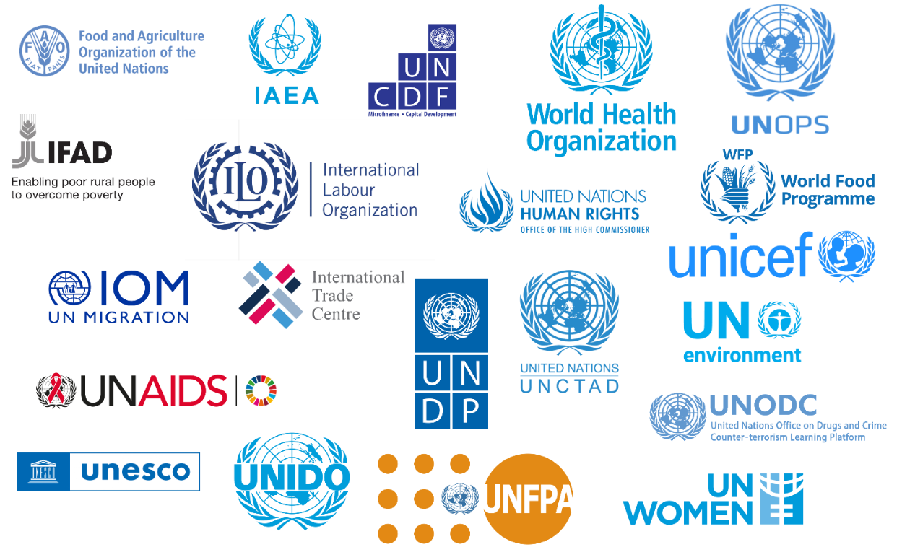

The table below shows which UN Agencies are contributing to which UNSDCF Outcomes.
Table 1 - UNSDCF Outcomes and UN Agencies
UNSDCF Outcomes | UN Agencies contributing
Outcome 1: By 2023, Sierra Leone benefits from a more productive, commercialised and sustainable agriculture, improved food and nutrition security, and increased resilience to climate change and other shocks | FAO  IAEA  IFAD  ILO  IOM  ITC  UNCDF  UNCTAD | UNICEF  UNIDO  UNDP  UNOPS  UNWOMEN  WFP  WHO
Outcome 2 : By 2023, people in Sierra Leone benefit from more gender and youth responsive institutions that are innovative, accountable and transparent at all levels and can better advance respect for human rights and the rule of law, equity, peaceful coexistence, and protection of boys and girls (children, girls), women and men including those with disabilities | FAO  ILO  IOM  UNAIDS  UNDP  UNOPS | UN Women  UNCDF  UNICEF  UNIDO  IOM
Outcome 3 : By 2023, the population of Sierra Leone, particularly the most vulnerable, will benefit from increased and more equitable access to and utilisation of quality education, healthcare, energy and water, sanitation and hygiene services, including during emergencies | IAEA  IOM  UNAIDS  UNDP  UNICEF (lead 3b, 3c, 3d)  UNFPA (lead 3°) | UNESCO  UNIDO  UNOPS  WHO  WFP
Outcome 4 : By 2023, the most vulnerable, particularly women, youth, adolescents and children (especially girls), and persons living with disabilities are empowered and benefit from increased social protection services, economic and social opportunities | ILO  IOM  UNAIDS  UNCDF  UNDP  UNFPA (lead 4c) | UNICEF (lead 4d, 4e)  UN Women  (lead 4a, 4b)  WFP  WHO
Table 2 below presents, by UN Agency, each of the stakeholders involved in the UNSDCF activities (national implementing partners, Beneficiaries and target groups, donor/strategic partners).
Additionally, the following government entities at National level have been identified, some of them are also implementing partners :
    - Republic of Sierra Leone Armed Forces
    - Sierra Leone police
    - Ministry of Gender and Children’s Affairs
    - Electoral Commission
    - Statistics Sierra Leone
    - Ministry of Agriculture and Food Security
    - Ministry of Agriculture and Forestry
    - Ministry of Local Government Community Affairs
    - Ministry of Fisheries and Marine Resources
    - Ministry of Youth Affairs
    - Ministry of Energy
    - Parliament of Sierra Leone
    - Economic Community of West African States
    - Ministry of Environment and Climate Change
    - Sierra Leone Electricity & Water Regulatory Commission
    - Human Rights Commission of Sierra Leone
    - Ministry of Information and Civic Education
    - Ministry of Planning and Economic Development
    - Ministry of Health and Sanitation
    - Ministry of Political and Public Affairs
    - Ministry of Social Welfare
    - National Secretariat for the Reduction of Teenage Pregnancy
    - Judiciary of Sierra Leone
    - Ministry of Justice
    - Ministry of Water Resources
    - Ministry of Finance
    - National Commission for Social Action
    - National Commission for Persons with Disability
    - Ministry of Basic and Senior Secondary Education
    - Sierra Leone National Commission for UNESCO
    - Ministry of Technical and Higher Education
    - Ministry of Tourism and Culture
    - Ministry of Internal Affairs
    - Sierra Leone Immigration Department
    - National AIDS Secretariat
    - Ministry of Trade and Industry

Table 2 - Stakeholders Mapping
UN Agency | National Implementing partners | Beneficiaries, target groups | Donor/strategic partners
UN Women | - Ministry of Gender and Children’s Affairs  - Republic of Sierra Leone Armed Forces  - Sierra Leone Police  - Electoral Commission Sierra Leone  - Political Parties Regulation Commission  - Sierra Leone Association of Female Journalist  - 50/50 Group  - Women’s Forum  - Campaign for Good Governance  - MAWOPNET  - Sierra Leone Female Parliamentary Caucus  - SEND  - Action Aid  - Statistics Sierra Leone  - Sierra Leone Market Women’s Association  - World Vision  - Mabunduka Agro Farms  - Ngoila Women in Agriculture Cooperative Society  - Commit and Act  - Women in Agriculture Network  - Agro Fish Farms  - Salone Youth Empowerment and Advocacy Network | - Women, youths,  - women farmers,  - agri-businesses,  - Women Community Stakeholders,  - Gender Focal Points in targeted MDA’s | - Irish Aid  - UNFPA  - Elsie Initiative Fund  - UNDP  - UN Women  - UN Peacebuilding Fund  - UBRAF  - NATCOM Netherlands
UNDP | - Ministry of Planning & Economic Deployment  - National Investment Board  - Statistics Sierra Leone  - Ministry of Trade & Industry  - Ministry of Social Welfare  - National Youth Commission  - Fourah Bay College -FBC)  - Catholic Agency for Overseas Development (CAFOD)  - Global Youth Network for Empowerment and Development, Sierra Leone  - Volunteers Involving Organisation’s Network (VIONet)  - Institute for Development and Humanitarian Assistance (IDHA)  - SEND, Sierra Leone  - National Youth Service  - Restless Development  - Limkokwing University of Creative Technology  - Institute of Public Administration and Management  - Kailahun District Council  - Environment Protection Agency (EPA)  - Ministry of Environment (MoEnv.)  - National Disaster Management Agency (NDMA)  - National Water Resource  - Management Agency  - National Protected Area Authority (NPAA)  - Karene District Council  - Trocaire  - Legal Aid Board  - Ministry of Fisheries  - National Tourist Board  - ENFORAC  - Sierra Leone Meteorological Agency  - Judiciary of Sierra Leone  - Sierra Leone Correctional Services  - Legal Aid Board  - Human Right Commission SL  - Humanist Watch Sierra Leone  - Centre for Accountability and Rule of Law  - Justice Sector Coordination Office  - National Council for Civic Education and Development  - Network Movement for Justice and Development  - Fambul Tok  - Political Party Regulations Commissions  - National AIDS Secretariat  - National Election Commission  - BBC Media Action  - Sierra Leone Association of Journalists  - Office of National Security | - Government entities  - People with disabilities  - Youth & women  - Men  - Kailahun District Council and communities  - Rural, urban communities, cities & MDAs  - Karene District Council and communities  - Youth and Bike riders  - Coastal communities  - Women, Youths & Parliamentarians  - Political Parties  - Key Affected population  - Security forces | - UNDP TRACT  - UN PBF  - GEF  - Irish Aid  - Human Security Fund  - EU,  - Government of Iceland,  - Government of Ireland,  - Government of Canada
UNICEF | - MoHS - Child Health/EPI program  - Concern Worldwide  - MoHS – Directorate of Food and Nutrition (DFN) and Directorate of Planning Policy and Implementation (DPPI) and Ministry of Agriculture (MAF)  - FOCUS1000  - Defense for Children International (DCI)  - Restless Development  - Development Initiative Programme  - Legal Aid Board  - SLP- Family Support Unit  - National Civil Registration Authority  - Justice Sector Coordination Office  - Ministry of Social Welfare  - Ministry of Gender and Children’s Affairs  - Community Action for the Welfare of Children (CAWeC)  - Community Organisation for Development and Empowerment (CODE)  - Family Homes Movement (FHM)  - Movement Towards Peace and Development Agency (MOPADA)  - Living Water International  - Sierra Leone Social Aid Volunteers (SLSAV)  - Action for Development Programme, Sierra Leone (ADP SL)  - Community Empowerment and Development Agency (CEDA)  - Directorate of Environmental Health and Sanitation, Ministry of Health of Health and Sanitation  - National Commission for Social Action (NACSA)  - Ministry of Planning and Economic Development  - National Monitoring and Evaluation Directorate (NaMED)  - Anti-Corruption Commission (ACC)  - Ministry of Labour and Social Security  - Ministry of Finance  - Ministry of Social Welfare  - National Commission for Persons with Disability (NCPD)  - Directorate of Science, Technology, and Innovation (DSTI)  - Ministry of Basic and Senior Secondary Education (MBSSE)  - Ministry of Technical and Higher Education (MTHE)  - Teaching Service Commission  - Canadian Organisation for development through Education (CODE)  - Education Development Trust  - Girl-Child Network  - Development Initiative Programme (DIP)  - Teacher Training Institutions: Njala University, EBK University, Eastern Technical University, Freetown Technical University, Milton Margai Technical University  - Christian Aid for Under assisted Societies Everywhere (CAUSE)  - World Hope International (WHI) | - All target age groups for both routine and COVID-19 vaccination  - People 12yrs and above. High-risk groups for COVID-19 vaccination  - For children under five, Adolescents, and women of Reproductive age (including Pregnant and Lactating women)  - Adolescents, young people, parents / caregivers, religious and traditional leaders  - Provision of Legal Aid services for children in conflict with the law  - Investigation for violence against women and children  - Community members including children and women. Targeted with Community WASH, WASH in Schools, and WASH in Healthcare facilities  - MOHS staff at National and Subnational levels. Targeted with training, Policies and strategies development.  - Teachers  - Parents | - JICA  - USAID  - Government of France  - UNICEF  - Government of Japan  - Latter Day Scent Church  - Global Affairs Canada  - PBF/UNDP  - DCI  - FOCUS1000  - UNFPA  - NSRTP  - DGIS/ASWA  - Government of Iceland  - Bill & Melinda Gates Foundation  - FCDO  - AFDB  - IsDB  - Soccer Aid  - UNPRPD  - Norway  - GPE  - International Development Research Centre (IDRC)  - Irish Aid  - World Bank  - NATCOM (Swedish)
UNOPS | - WINCH Energy  - PowerGEN  - Power Leone  - Sustainable Energy for All (SE4ALL)  - UNOPS | - Households beneficiaries  - Health Patients  - Education/School pupils  - Commercials / productive use  - Other public institutions  - Indigenes of Conakry-Dee (including Disabled people, Women and girls etc)  - Pregnant and lactating women // Children under five | - FCDO  - Government of Japan  - World Bank  - European Union
UNFPA | - Statistics Sierra Leone  - Office of the First Lady  - Directorate of Reproductive Health, Ministry of Health  - Ministry of Basic and Senior Secondary Education  - Ministry of Gender and Children’s Affairs  - Ministry of Youth Affairs  - Ministry of Planning and Economic Development  - Directorate of Drugs and Medical Supplies  - Directorate of Nursing and Midwifery Services  - National Medical Supplies Agency  - Ministry of Social Welfare  - National Secretariat for the Reduction of Teenage Pregnancy  - Women in Crisis Movement  - Planned Parenthood Association  - Haikal Foundation  - Restless Development  - Aberdeen Women Centre  - Fambul Initiative Network – Sierra Leone  - Capacare  - Doctors with Africa (CUAAM)  - Rainbo Initiative – Sierra Leone | - Women and adolescent girls, youths  - Men | - UNFPA  - FCDO  - Government of Iceland  - Government of China  - Government of Ireland  - MPTF-PBF  - UNPRPD  - Government of Italy  - Government of Japan
FAO | - Ministry of Local Government and community Affairs  - Ministry of Agriculture and Food Security Kono district office  - Sierra Leone Seed Certification Agency(SLeSCA)  - Forestry Department of Njala University  - Mabunduka Agro Farms  - Cotton Tree Foundation | - Youth, vulnerable farmers  - Women, Community farmers and stakeholders in the seed value chain across the 5 regions  - All including people living with disability, children, youths, women, men, chiefs, landowners, forest resources users etc.)  - Commercial vegetable farmers ( women and youth) | - Human Security Secretariat  - FAO  - Swedish Agency for International Development (SIDA)  - KOICA  - SFERA Early Action in Belgium
ILO | - Sierra Leone Roads Authority  - Public Private Partnership Unit  - Bo District Council  - Bombali District Council  - Port Loko District Council  - Kenema District Council  - Bokatala Investment and General Services  - SEDMO Construction and General Services  - Adamaris Industries Limited  - Imam Moiwa Plantation  - Green Energy Charcoal Brequette Enterprise  - Nongowa Green Farmers Enterprise  - Apex Bank Sierra Leone Limited  - The Sierra Leone Chamber for Agribusiness Development (SLeCAD)  - Sierra Leone Local Content Agency (SLLCA)  - Sierra Leone Small and Medium Enterprises Development Agency  - West Africa Network for Peacebuilding, Sierra Leone (WANEP-SL)  - Sierra Leone Labour Congress  - Sierra Leone Employers' Federation | - Youth, Women, People with disabilities  - Women, Community members and stakeholders in 5 project communities  - Workers ( Formal and Informal)  - Employer Organisations and Representatives | - European Union
UNESCO | - Teaching Service Commission  - Njala University  - Sierra Leone National Commission for UNESCO  - Teaching Service Commission  - Right to Access Information Commission  - Initiative for Media Development (IMdev)  - National Youth Commission  - Ministry of Technical and Higher Education (MTHE)  - Ministry of Basic and Secondary Schools  - Ministry of Environment  - Ministry of Tourism and Cultural Affairs  - Ministry of Tourism and Culture | - Teachers  - Lecturers and experts in E-Learning and Mobile Learning for four universities in Sierra Leone  - Policy makers, teachers & school administrators  - Policy makers & teacher trainers  - Adolescent girls and boys  - Female Journalists in Community Radio  - Youth including PWD and policy makers  - Scientists  - Research  - Academia  - Industry  - Innovators  - Science Technology and Innovation (STI) Policy Makers  - STEM teachers  - private Sector  - Young women and girls in STEM  - Female Film Makers and Cultural and Creative Entrepreneurs  - Ministry of Culture and Tourism  - Local communities around the Tiwa/Gola site  - Environmental Foundation for Africa (EFA) | - GPE  - UNAIDS  - Shanghai Municipal - Government of the People’s Republic of China  - IPDC  - Swedish International Development Cooperation Agency (SIDA)  - UNESCO  - World Heritage Centre
WHO | - Ministry of Health | - General population | - Islamic Development bank  - Ministry for Europe and Foreign Affairs (MEAE), France  - Germany  - Gavi  - USAID  - United Kingdom of Great Britain and Northern Ireland  - Korea International Cooperation Agency ( KOICA)  - Susan Thompson Buffet Foundation  - Department of Health and Social Care, United Kingdom  - Irish Aid  - GIZ  - Bill & Melinda Gates Foundation  - FCDO  - CDC  - Directorate-General for International Partnerships (INTPA), European Commission
WFP | - Directorate of Food and Nutrition  - Kambia District Health Management Team  - Moyamba District Health Management Team  - Pujehun District Health Management Team  - Institute of Development and Humanitarian Assistance (IDHA)  - Falaba Ministry of Agriculture and Food Security  - Talking Drums Studio  - Kambia Ministry of Agriculture and Food Security  - Kenema Ministry of Agriculture and Food Security  - Koinadugu Ministry of Agriculture and Food Security  - Moyamba Ministry of Agriculture and Food Security  - Pujehun Ministry of Agriculture and Food Security  - Tonkolili Ministry of Agriculture and Food Security  - Bonthe Ministry of Basic and Senior Secondary Education  - Kambia Ministry of Basic and Senior Secondary Education  - Karene Ministry of Basic and Senior Secondary Education  - Kenema Ministry of Basic and Senior Secondary Education  - Pujehun Ministry of Basic and Senior Secondary Education  - MADAM  - Pure Heart Foundation  - National Disaster Management Agency  - Sierra Leone Red Cross Society | - Children aged 6 - 24 months and - Pregnant and Lactating Women  - Smallholder farmers  - Primary school children  - Crisis affected households  - Severely food insecure | - Government of France  - Irish Aid  - Peace Building Fund  - Government of Japan  - Government of Sierra Leone  - USAID
IFAD | - Sierra Leone Agricultural Research Institute (SLARI)  - Environmental Protection Agency (EPA)  - Meteorological Agency | - Smallholder farmers  - Petty traders  - Private sector entities along the value chain  - People with disabilities  - Youths  - Women headed households | - Ministry of Agriculture  - Ministry of Finance  - Adaptation Fund  - OFID
ITC | - Sierra Leone Chamber of Agribusiness Development  - Jula Consultancy  - Balmed Holdings  - Melo Africa  - Produce Monitoring Board (PMB)  - Sierra Leone Investment and Export Promotion Agency (SMEDA) | - Key actors across the cashew value chain in the beneficiary districts,  - Women, women Associations, women cashew Farmers, Women cashew processors, lead farmers/role model Agribusinesses, Business Support Organisations  - Key actors in the Cocoa, Palm Oil and Cassava Value Chains, represented by Agribusinesses, Trade Support Institutions/Business Support Organisations, Cooperatives, Farmers, Farmers Associations, Micro Finance  - Institutions, Policy Makers | - Korea International Cooperation Agency (KOICA)  - EU (11th EDF)
UNAIDS | - National AIDS Secretariat (NAS)  - National AIDS Control Programme (NACP)  - Ministry of Basic and Senior Secondary Education (MBSSE)  - Network of HIV Positives In Sierra Leone (NETHIPS)  - Girls Advocacy and Development Network (GaDNET)  - Alliance for Women’s Development Sierra Leone (AWOD-SL)  - WELL WOMAN CLINIC | - People Living with HIV (PLHIV)  - Key Populations (KPs)  - Young People and adolescent  - People affected by HIV  - Women Living with HIV (PWHIV)  - Female Sex Workers (FSWs)  - Vulnerable | - UNAIDS  - Luxembourg Fund  - CDC
UNCDF | - Federation of Urban and Rural Poor (FEDURP)  - Institute for Legal Research and Advocacy for Justice  - Trocaire  - Mosabi  - A Call To Business Microfinance (ACTB)  - LAPO Microfinance  - Institute for Development & Humanitarian Assistance (IDHA)  - Orange MFSL  - Empire Solutions  - Apex Bank (Community Banks) | - Community Members in Informal Settlements  - SGBV survivors  - Youth Commercial Bike Riders  - Women and Youth | - UN S-G’s Peacebuilding Fund  - Joint SDG Fund
IOM | - United Nations Office on Drugs and Crime (UNODC)  - Ministry of Health and Sanitation (MoHS)  - National COVID-19 Emergency Response Centre (NaCOVERC)  - Ministry of Agriculture and Forestry (MAF)  - UN Resident Coordinator's Office  - Community Road Empowerment (CORE)  - Ministry of Social Welfare  - Makona River Organisation  - WFP SL and Guinea  - Talking drum Studies SL and Guinea  - Ministry of Internal Affairs  - Office of National Security  - Environment Protection Agency Sierra Leone (EPASL) of the Government of Sierra Leone  - local authorities from the Plantain and Yelibuya Islands  - Platform on Disaster Displacement (PDD)  - Economic Community of West African States (ECOWAS)  - United Nations Economic Community for Africa (UN-ECA)  - United Nations High Commissioner for Refugees (UNHCR)  - World Bank  - Office of National Security  - Mano River Union  - Ministry of Local Government.  - Ministry of Social Welfare Gender and Children Affairs; - Sierra Leone Immigration Department  - Statistics Sierra Leone  - regional institutions and economic communities  - Civil Society Organisations: Child Protection Societies, Community-based Organisations, NGOs, National Anti-trafficking in persons secretariats. | - Youth, vulnerable farmers, and Public Health officials  - Cross border community members, Point of Entry Personnel at the Parrots beak area  - Crop farmers, cattle herders, border officials and border communities members  - Vulnerable communities in coastal areas of Yelibuya and Plaintain Island  - Governments in West Africa  - Data actors in West Africa  - Media and communication representatives in West Africa  - Border management officials, border management and security agencies, travellers, cross border communities  - Ministries of Foreign Affairs, Gender and Children, Health, Labor, Local Government, Social Welfare; Immigration; vulnerable migrants including stranded and smuggled migrants, migrant workers, victims of trafficking, and migrant children; local authorities and traditional leaders; faith-based and civil-society organisations; and communities living in border areas. | - UN Trust Fund for Human Security  - Migration Multi Partner Trust Fund  - MPTF - UN peacebuilding fund  - IOM Development Funds  - Ministry of Foreign Affairs  - USA - Bureau of population refugee and migration
UNIDO | - Ministry of Technical and Higher Education  - Ministry of Trade and Industry  - Sierra Leone Standard Bureau (SLSB)  - Produce Monitoring Board (PMB)  - University of Sierra Leone  - Private SMEs  - Cooperatives | - Youth and Government Technical Institute (GTI) Trainers  - Government Staff  - USL faculty  - SMEs and its staff  - Cocoa and Cassava Farmers | - Government of Japan  - European Union

Sampling
The process of selecting an appropriate sampling method is a critical component of any rigorous evaluation. In this section, we present our sampling approach, which utilises purposive sampling. This section outlines the rationale behind our choice and emphasizes how this method enhances the quality and depth of insights to ensure adequate outcome representation both programmatically and in terms of partners.
Purposive sampling, often referred to as judgmental or selective sampling, is a non-probability sampling technique that allows for intentional and systematic selection of specific individuals or groups from the target population. Unlike random sampling methods, which offer an equal chance for all members of the population to be included, purposive sampling allows us to focus on participants who possess unique attributes, experiences, or expertise that align closely with the evaluation's objectives.
The primary reason for adopting the purposive sampling approach is its ability to yield detailed and context-specific data. As our evaluation revolves around a specific program with distinct objectives and outcomes, it is crucial to gain insights from individuals with specialized expertise and firsthand experiences in the program's domain. By carefully selecting participants based on predetermined criteria, we can capture rich and comprehensive insights that might not be as readily available through other sampling methods.
Moreover, purposive sampling allows us to ensure adequate outcome representation both programmatically and in terms of partners. By intentionally targeting participants who have been directly involved in the program or have deep knowledge of its implementation, we aim to obtain a holistic understanding of its impacts and outcomes. Additionally, by engaging with key stakeholders and partners through this approach, we can obtain valuable perspectives on the program's effectiveness and relevance, enhancing the evaluation's credibility and applicability. The evaluation team will also consider in its purposive sampling approach the principles of i) gender equality, ii) human rights, and iii) inclusivity for people with disabilities as shown in the table below. When employing the purposive sampling approach, these considerations play a pivotal role in ensuring a comprehensive and equitable representation of diverse perspectives within the target population.

Gender Considerations | To account for gender in purposive sampling, the evaluation team will strive to achieve balanced and representative participation of individuals of all genders. This involves deliberately selecting participants from different gender groups to avoid gender biases in the findings.
Human Rights Perspectives | Incorporating human rights perspectives in purposive sampling means being attentive to the rights and dignity of participants throughout the research process. It is essential to obtain informed consent from all participants, ensuring they fully understand the objectives, potential risks, and benefits of their involvement. Respecting participants' autonomy and privacy while safeguarding their confidentiality are equally vital aspects of upholding human rights principles.
Inclusivity for People with Disabilities | The evaluation team will actively include individuals with disabilities, to the extent possible.
It is important to highlight that transparency and methodological rigor are central to the implementation of the purposive sampling approach. The criteria used for participant selection are clearly defined below, ensuring that our choices are justified and align closely with the evaluation's objectives.
The following stakeholders group have been identified from the previous section:
- UNCT members
- Joint Steering Committee
- Donor/strategic partners
- National implementing partners such as the government of Sierra Leone, CSOs, NGOs, private sector, academia, mass media
- Beneficiaries, community members (including women, people with disabilities) and local decision-makers

UNCT MEMBERS
The evaluation team proposes a sampling approach for UNCT members, organising grouped interviews for each outcome. Each grouped interview will include one representative (ensuring as much as possible a gender balanced representation, as well as people with disability) from each UN agency, ensuring a diverse mix of agencies with expertise and direct involvement in the specific areas related to each outcome (cf Table 1). This selection ensures that each UN agency's expertise is represented in the grouped interviews for the evaluation of the outcomes, allowing for a comprehensive and well-informed assessment of the UNSDCF in Sierra Leone. The suggested selection of UN agencies for each outcome is as follows:
Table 3 - Grouped Interviews - UN Agencies
Outcome | UN Agencies selected for grouped interviews
Outcome 1 | Group 1.1:  - FAO: they have expertise in agriculture, food security, and climate resilience.  - IAEA: Their involvement can bring knowledge and support for sustainable agriculture practices and climate change adaptation.  - IFAD: Given their focus on rural development and smallholder farmers, they can provide valuable insights into improving productivity in the agricultural sector.
Outcome 1 | Group 1.2:  - UNCTAD: With expertise in trade and development, they can provide insights into commercializing agricultural products and enhancing trade opportunities.  - ITC: Their focus on trade-related technical assistance and capacity-building can be relevant for Outcome 1 evaluation.  - WFP: they have expertise in food assistance and nutrition to complement FAO's efforts in improving food security and nutrition, especially for vulnerable populations.
Outcome 2 | Group 2.1:  - UNDP: They can contribute to evaluating governance, human rights, and accountability aspects.  - UN Women: With a primary focus on gender equality, their insights are crucial for assessing the gender-responsive nature of institutions.  - ILO: Their experience in labor and employment issues can be relevant for evaluating institutional innovation and accountability.
Outcome 2 | Group 2.2:  - IOM: Their involvement can contribute to assessing institutions' responsiveness to migration and related challenges.  - UNCDF: Expertise in financial inclusion and local development, which aligns with Outcome 2's focus on transformational governance.
Outcome 3 | Group 3.1:  - UNICEF (lead): Expertise in child rights and well-being, leading some components of Outcome 3, including access to quality education and healthcare.  - WHO: Expertise in healthcare and public health, relevant for evaluating equitable access to quality healthcare services.  - UNOPS: Expertise in project management and infrastructure development, which aligns with Outcome 3's focus on education
Outcome 3 | Group 3.2:  - UNESCO: Expertise in education, critical for assessing educational access, quality, and inclusive education efforts.  - UNFPA (lead): Focus on reproductive health and population issues, leading some components of Outcome 3, including access to healthcare services.  - UNIDO: UNIDO’s work on youth employment aligns with Outcome 3's focus on increasing equitable access to energy and water services, contributing to sustainable development.
Outcome 4 | Group 4.1:  - UNFPA (lead): Leading Outcome 4, with a focus on reproductive health and empowering vulnerable populations.  - UNICEF (lead): Leading Outcome 4, with a focus on child protection and empowerment.
Outcome 4 | Group 4.2:  - UN Women (lead): Leading Outcome 4, with a focus on women's empowerment and gender-responsive social protection.  - UNAIDS: Bringing a perspective on health and HIV/AIDS, they can contribute to the protection of vulnerable populations, including those living with disabilities.

Additionally, other representatives of the UNCT involved in the UNSDCF will receive the link to the online survey.
JOINT STEERING COMMITTEE MEMBERS
The evaluation team will interview either individually or in group one representative (ensuring as much as possible a gender balanced representation, as well as people with disability) for each members of the Joint Steering Committee.
Table 4 - Joint Steering Committee Members - participants
Joint Steering Committee Members | # of participants
UN Resident Coordinator | 1
Ministry of Planning and Economic Development | 1
Ministry of Agriculture, Forestry and Food Security | 1
Ministry of Basic and Senior Secondary Education | 1
Ministry of Gender and Children’s Affairs | 1
Ministry of Health and Sanitation | 1
Ministry of Social Welfare | 1
Additionally, other representatives of the Joint Steering Committee involved in the UNSDCF will receive the link to the online survey.

DONOR/STRATEGIC PARTNERS
The evaluation team will conduct key informant interviews with key donor/strategic partners that are based in Sierra Leone. Discussions with the Evaluation Steering Committee will help to identify the most relevant and involved donor/strategic partners based on Table 2, which contains the list of identified donor/strategic partners.
Table 5 - Donor/Strategic partners - participants
Outcome | # of participants
Outcome 1 | 2
Outcome 2 | 2
Outcome 3 | 2
Outcome 4 | 2

NATIONAL IMPLEMENTING PARTNERS (Government of Sierra Leone, Csos, Ngos, Private Sector, Academia, Mass Media)
The national consultant will conduct preliminary discussions with the Evaluation Steering Committee to identify key national implementing partners that are involved under each outcomes. The evaluation team will organise focus group discussions with national implementing partners. The table below provides a sampling strategy to ensure that all types of partners are represented in the discussions. Additionally, other national implementing partners involved in the UNSDCF will receive the link to the online survey.

Table 6 - National implementing partners - participants
Outcome | # of participants
Outcome 1 | 1 or 2 mixed focus group discussion including targeting 10 participants (5 male, 5 female) and if feasible including youth and persons with disabilities  - Government of Sierra Leone: 2  - CSOs: 2  - NGOs: 2  - Private Sector: 2  - Academia: 1  - Mass Media: 1
Outcome 2 | 1 or 2 mixed focus group discussion including targeting 10 participants (5 male, 5 female) and if feasible including youth and persons with disabilities  - Government of Sierra Leone: 2  - CSOs: 2  - NGOs: 2  - Private Sector: 2  - Academia: 1  - Mass Media: 1
Outcome 3 | 1 or 2 mixed focus group discussion including targeting 10 participants (5 male, 5 female) and if feasible including youth and persons with disabilities  - Government of Sierra Leone: 2  - CSOs: 2  - NGOs: 2  - Private Sector: 2  - Academia: 1  - Mass Media: 1
Outcome 4 | 1 or 2 mixed focus group discussion including targeting 10 participants (5 male, 5 female) and if feasible including youth and persons with disabilities  - Government of Sierra Leone: 2  - CSOs: 2  - NGOs: 2  - Private Sector: 2  - Academia: 1  - Mass Media: 1

BENEFICIARIES, COMMUNITY MEMBERS AND LOCAL DECISION-MAKERS (including women, people with disabilities)
The national consultant will conduct preliminary discussions prior to the field mission with the Evaluation Steering Committee to identify up to maximum 2 key projects/activities per outcome that will be visited/assessed during the field mission in August. The projects/activities selected should have a national outlook. This will also enable us to know which districts have the greatest impact, so that we can respond to the call to leave no one behind. During the field visit, the evaluation team will organise focus group discussions with beneficiaries, community members, as well as local decision-makers (if applicable). The table below provides examples of projects/interventions/activities that could be potentially assessed during the evaluation but discussions with the Evaluation Steering Committee will help to make a final call on the ones that will be selected for the evaluation process.
Outcome | Projects/Interventions/Activities | # of participants
Outcome 1 | Example 1: Production and dissemination of foundation and breeder seeds of new varieties of targeted crops that are high yielding, economically viable and disease resistant | 1 or 2 mixed focus group discussion in one community targeting 10 participants (5 male, 5 female) including beneficiaries, community members, and local-decision makers and if feasible including youth and persons with disabilities
Outcome 1 | Example 2: Opportunity Salone Programme | 1 or 2 mixed focus group discussion in one community targeting 10 participants (5 male, 5 female) including beneficiaries, community members, and local-decision makers and if feasible including youth and persons with disabilities
Outcome 2 | Example 1: Effectively influence political parties, service delivery organisations, media institutions and local/traditional governance institutions to promote increased women leadership and participation through advocacy and technical support | 1 or 2 mixed focus group discussion in one community targeting 10 participants (5 male, 5 female) including beneficiaries, community members, and local-decision makers and if feasible including youth and persons with disabilities
Outcome 2 | Example 2: Strengthen the capacity of public institutions and duty bearers (District Civil registrars, health workers, etc.) to enhance service delivery (birth notification, registration) | 1 or 2 mixed focus group discussion in one community targeting 10 participants (5 male, 5 female) including beneficiaries, community members, and local-decision makers and if feasible including youth and persons with disabilities
Outcome 3 | Example 1: Implementation of Home Grown School Feeding programme | 1 or 2 mixed focus group discussion in one community targeting 10 participants (5 male, 5 female) including beneficiaries, community members, and local-decision makers and if feasible including youth and persons with disabilities
Outcome 3 | Example 2: Improve the coverage and quality of water services for rural and poor urban households, and institutions (schools and PHUs) in development and humanitarian situations | 1 or 2 mixed focus group discussion in one community targeting 10 participants (5 male, 5 female) including beneficiaries, community members, and local-decision makers and if feasible including youth and persons with disabilities
Outcome 4 | Example 1: Develop and implement male involvement strategy (including HeForShe campaign) for SRHR, gender equality and prevention of HIV and SGBV | 1 or 2 mixed focus group discussion in one community targeting 10 participants (5 male, 5 female) including beneficiaries, community members, and local-decision makers and if feasible including youth and persons with disabilities
Outcome 4 | Example 2: Strengthen the production and use of gender statistics to enable the monitoring of national policies and development plan, international standards and commitments including SDGs, CEDAW and the Beijing Platform for Action | 1 or 2 mixed focus group discussion in one community targeting 10 participants (5 male, 5 female) including beneficiaries, community members, and local-decision makers and if feasible including youth and persons with disabilities

Data collection methods and triangulation

Data collection methods
The ET will use a mixed-method approach, i.e. a combination of data sources, collection methods, and analyses techniques, both quantitative and qualitative, to support its findings. This array of data integrating and reflecting various sources of information and perspectives will provide the basis for data triangulation. The proposed methods are: 1) desk and document review, 2) semi-structured qualitative individual (or group) interviews, 3) focus groups discussion, 4) online survey, 5) direct observations. The protocols can be found in Annex V.
Category | Type | Tool | Relevance | Stakeholders consulted
Primary | Qualitative | Key Informant Interview (individual or grouped): Semi-structured interviews will be guided by key evaluation questions and sub-questions (probes) based on the OECD-DAC criteria (relevance (adaptability), coherence, efficiency, effectiveness, impact and sustainability) plus the cross-cutting issues. The interview protocols were designed following the document review. Interview questions will be tailored to different stakeholders, but consistent key questions will be included across all interviews to provide a basis for the triangulation of data. To ensure data collected in all sessions is comparable, and there is no bias, tools will be the same. | Key Informant Interviews allow evaluators to gather in-depth insights, perspectives, and opinions from key stakeholders. By engaging with individuals who have direct knowledge or involvement in the evaluated programme or project, evaluators can obtain detailed information, clarifications, and nuanced perspectives related to the evaluation criteria. The interviews can be tailored to different stakeholder groups while ensuring consistency in key questions across all interviews, facilitating data triangulation. | - UNCT members  - Joint Steering Committee  - Donor/strategic Partners
Primary | Qualitative | Focus groups discussion (FGD): Focus groups provide an opportunity to discuss a pre-determined topic and engage in reflection. Focus groups will be organised (possibly with groups and sub-groups of beneficiaries including community members including women , decision-makers, and other key stakeholders and development partners), depending on availability and timing, with several stakeholder groups, at selected sites. | FGDs are valuable for capturing collective opinions, exploring diverse perspectives, and analyzing issues where there may be divergent views. By organising FGDs with various stakeholder groups, including beneficiaries, community members (including women), decision-makers, evaluators can gain a comprehensive understanding of different stakeholder experiences, perceptions, and feedback. FGDs facilitate the exploration of group dynamics, shared experiences, and consensus-building, enhancing the evaluation process. | - Beneficiaries, community members (including women, people with disabilities), decision-makers (local),  - National implementing partners such as CSOs, NGOs, private sector, academia, mass media
Primary | Quantitative/ Qualitative | Online survey: The ET will develop an online survey and submit it for approval to the evaluation committee. The evaluation team anticipates a survey instrument, requiring between 15 and 20 minutes to complete would be sent to all available emails considered relevant (i.e., a census approach). | The online survey is an effective tool for reaching a wide range of stakeholders, including institutional partners involved in the UNSCDF, both in government and UN agencies and, as well as key development partners. By using an online survey, the evaluation team aims to gather input and perspectives from a larger sample size. It provides a quantitative snapshot while incorporating qualitative aspects, thereby enriching the overall evaluation process.  Quantitative Aspect: The online survey allows for the collection of quantitative data by including closed-ended questions with pre-determined response options. These questions can be used to gather numerical data, such as ratings, rankings, or frequency counts, which can be analyzed statistically to derive insights and measure patterns or trends.  Qualitative Aspect: The online survey will also incorporate open-ended questions that enable respondents to provide descriptive and narrative responses. These qualitative inputs offer valuable insights into stakeholders' perceptions, experiences, suggestions, and specific details related to the evaluation criteria and objectives. | - UNCT members  - Joint Steering Committee members  - National implementing partners such as Government of Sierra Leone, CSOs, NGOs, private sector, academia, mass media
Primary | Qualitative | Direct observations: Direct observations involve the systematic and firsthand observation of the evaluated activities, projects. The evaluators will directly observe the activities, behaviors, interactions, and outcomes in real-time, without intervention or manipulation. | Direct observations are valuable for capturing real-time information and contextual details that cannot be obtained through interviews, surveys, or document reviews alone. They provide an opportunity to witness and document the actual implementation, processes, and dynamics of the evaluated programme, allowing for a deeper understanding of how it operates and its impact on the target population or environment. | None
Secondary | Qualitative | Desk and document review such as CCA, CF and Joint Work Plans; mid-term progress reviews (where undertaken); annual reports and existing evaluation reports (notably those conducted by individual UN agencies, and those issued by national counterparts); strategy papers; national plans and policies; and related programme and project documents but not limited to the above mentioned documents | Qualitative secondary data collection through desk and document review provides a rich source of contextual information, programme details, policies, and reports. It helps evaluators gain insights into the historical background, implementation strategies, achievements, challenges, and lessons learned from previous evaluations or programme-related documents. | None
Secondary | Quantitative | Desk and document review such as big data surveys (e.g. DHS, MICS, and admin data) as well as available data from monitoring of programmes, surveys, research and evaluation | Quantitative secondary data collection through desk and document review allows evaluators to access numerical data that can provide statistical evidence, trends, patterns, and indicators. It helps in measuring programme outcomes, assessing impact, and comparing data across different sources or time periods. | None

Triangulation and data analysis
Once all necessary data will be collected through 1) desk and document review, 2) semi-structured qualitative individual (or group) interviews, 3) focus groups discussion, 4) online survey, 5) direct observations, content analysis of data from multiple sources to the same evaluation questions will be conducted. This will allow a thorough triangulation and will inform the drafting of evidence-based findings, conclusions, lessons learned, and recommendations. Triangulation will be used to validate and enrich findings with details or additional perspectives from different sources including women, girls, and people with disabilities, countering any potential bias, and gaining greater understanding of identified facts. Evidence supplied by the different lines of enquiry will be placed in an internal evidence matrix in which facts and opinions from various sources will identified and triangulated per evaluation questions. This evidence matrix will not be shared with the Evaluation Committee for anonymity purposes.
Figure 1 - Evidence Matrix
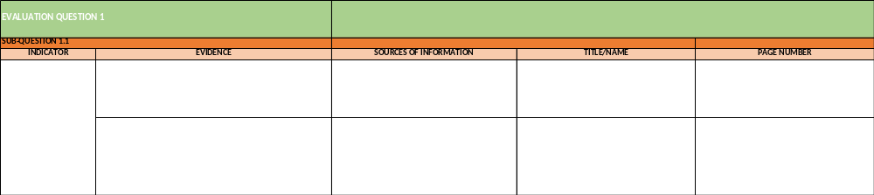
Once all the necessary data have been collected through the following methods: 1) review of documents and desk research, 2) semi-structured qualitative interviews conducted individually or in groups, 3) discussions held in focus groups, 4) online surveys, and 5) direct observations, a content analysis of the gathered data from multiple sources will be carried out in relation to the evaluation questions. This comprehensive approach, known as triangulation, will inform the creation of evidence-based findings, conclusions, lessons learned, and recommendations.
Triangulation is employed to validate and enhance the findings by incorporating additional details and perspectives from various sources, including women, girls, and individuals with disabilities. By doing so, any potential biases are countered, and a deeper understanding of the identified facts is gained. The evidence obtained through different lines of inquiry will be organised in an internal evidence matrix, as shown below. This matrix will identify and triangulate facts and opinions from diverse sources for each evaluation question. To ensure anonymity of the respondents, this evidence matrix will not be shared with the Evaluation Committee.

Potential Methodological limitations
Data Collection Methods | Methodological Limitations | Mitigation Measures
Purposive sampling | As purposive sampling involves the intentional selection of participants, our findings may not be fully generalizable to the entire program population. | Despite this limitation, we will approach the interpretation and conclusions of our evaluation with a nuanced perspective, recognizing the specific context in which our research was conducted and the valuable insights obtained from our purposively selected participants.
KIIs | Bias and subjectivity can arise if the selection of key informants is not representative or if interviewers have preconceived notions. | Mitigate bias by using a purposive sampling strategy to ensure diverse perspectives and by developing interview protocols that adhere to standardized guidelines. Evaluators will maintain consistency, neutrality, and professionalism during interviews.
FGDs | Dominance of certain participants or group dynamics may limit the expression of diverse viewpoints, leading to biased outcomes. | Mitigate dominance by facilitating a safe and inclusive environment where all participants can freely express their opinions. Evaluators will manage group dynamics, ensure equal participation, and encourage the exploration of diverse perspectives. The ET will consider organising separate FGDs for different stakeholder groups to avoid power imbalances.
Online survey | Low response rates or non-response bias can occur if participants choose not to complete the survey or if the sample is not representative. | Increase response rates by using clear and concise survey questions, providing a user-friendly online platform, and ensuring the survey's relevance and importance are conveyed to participants by the Evaluation Committee or other relevant actor. The ET will Implement strategies such as reminders and personalized communication to encourage participation if needed. The final dataset will be thoroughly cleaned to ensure that the responses recorded have at minima a response rate of 85%. The ET will also be transparent regarding the composition of the respondents in terms of gender, organisations etc.
Direct observations | The presence of the observer may influence participant behavior or lead to the observer's interpretation bias. | The ET will adopt a non-participatory observation approach to reduce the influence on participants. At all times the ET will be composed of two members on the ground to have multiple observers to compare observations and validate findings.

Theory of change
The evaluation team has reconstructed the initial Theory of Change (ToC) of the UNSDCF 2020 -2023 based on the documents available. Figure 2 is a reconstruction of this ToC with its assumptions, outcomes, long term outcomes and expected impact. The four outcomes in the ToC have been identified by the UNCT as four strategic areas that are mutually reinforcing and underpinned each by a ToC. As a result, the ET reconstructed all of the four initial outcomes’ ToC (available in Annex IV).

Figure 2 - ToC UNSDCF 2019-2024
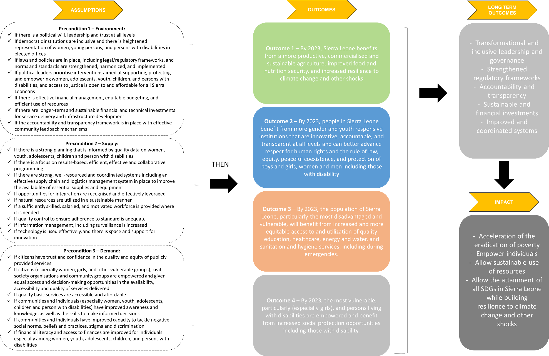

Given that the ToC has been reconstructed solely based on project documentation, the evaluation team will organise a ToC workshop. This workshop will aim to discuss programmatic changes that may have occurred in the programme’s result chain during implementation in response to emerging challenges and needs, such as the impact of COVID-19 and the Russia/Ukraine conflict. The reconstructed ToC will serve as the basis for these discussions. If deemed relevant, the outcomes of these meetings will be utilized to reconstruct the initial ToC, which originally supported the development of the current programme being evaluated. This will ensure better alignment between the ToC and the programme’s implementation, taking into account the emerging development changes in the country.
The workshop will take place the first week of August 2023, the entities and number of participants identified to take part in the workshop is available in the table below.
Table 7 - List of participants
# | Name of Ministry/Agency | # of participants
 | Ministry of Planning and Economic Development (MOPED) | 2
 | Ministry of Health and Sanitation (MOHS) | 2
 | Ministry of Basic and Secondary School Education (MBSSE) | 2
 | Ministry of Youth Affairs (MOYA) | 2
 | Ministry of Agriculture and Food Security (MAFS) | 2
 | Ministry of Gender and Children’s Affairs (MoGCA) | 2
 | Ministry of Social Welfare (MoSW) | 2
 | Ministry of Finance (MoF) | 2
 | Human Rights Commission Sierra Leone (HRCSL) | 2
 | Stats Sierra Leone | 2
Total |  | 20
The preliminary agenda of the ToC workshop can be found below:
Table 8 - Preliminary agenda
8:30 – 9:00 | Arrival and Registration of Participants
9:00 – 9:30 | Opening Ceremony:  - Opening Prayers  - Welcome statement – Rep, UNCT  - Statement and Official Opening – Ministry of Planning and Economic Development
9:30 -10:15 | Setting of the Scene  - Introduction of participants and facilitators – Evaluation Team  - Workshop Objectives – Evaluation Team  - UNSDCF Presentation(s) – Dr. Isaac, Evaluation Manager
10:15 – 10:45 | Introduction on ToC
10:45 – 11:00 | Tea break
11 :00-11 :30 | Reflection on the Theory of Change (ToC)  - Presentation on the UNSDCF ToC – Evaluation Team
11:30 -1:00 | Review of outcomes and planned interventions of the ToC (Group Works)  - Group 1 – Outcome 1  - Group 2 – Outcome 2  - Group 3 – Outcome 3  - Group 4 – Outcome 4
1:00 – 1:30 | Closing and next steps

Evaluation work plan and management arrangements

Evaluation Work Plan
 | May | June | July |  |  |  | August |  |  |  | September |  |  |  | October |  |  |  | November
 |  |  | W1 | W2 | W3 | W4 | W1 | W2 | W3 | W4 | W1 | W2 | W3 | W4 | W1 | W2 | W3 | W4
Phase 1: Design/Inception Phase
Virtual kick-off meeting | 25/05
Preliminary doc review
Draft Inception Report |  | 26/06
Comments Inception Report |  |  |  | 10/07
Inception Report version 2 |  |  |  |  |  | 26/07
Phase 2: Data collection phase
In-depth documentation review
Theory of Change Workshop |  |  |  |  |  |  | 1
First wave of on-site data collection by Dominic Boima (National Consultant) – if needed
Online Survey
Field mission in Sierra Leone – Alexandre Daoust |  |  |  |  |  |  |  |  | 14/08 – 22/08
Field mission in Sierra Leone – Jade Pichard |  |  |  |  |  |  |  |  | 19/08 – 25/08
Phase 3: Analysis and report writing
Analysis and triangulation of data
Preliminary findings
Comments Preliminary findings + virtual feedback meeting
Draft Final Report
Comments Draft Final Report
Final Report
Virtual presentation of the final report

Evaluation steps
The proposed approach will follow five major steps described below. The main meetings and deliverables are highlighted in blue.
    - Phase 1: Design/Inception Phase
A first virtual meeting took place on the 25th of May 2023 with the Evaluation Technical Team. Discussions focused on the understanding of the deliverables in the ToR, expectations, quality assessment and how and who will be part of the evaluation team and evaluation management. On 19th June 2023, the Evaluation Steering Committee met and . during this meeting, responsibilities and expectations as to what will be done were discussed, including the development of the roadmap the evaluation team.
Due to the need to quickly proceed with the coordination of the meeting, Monday June 19th was the scheduled date for the meeting, as was announced by the evaluation manager.
Upon completion of the desk and document review, a draft inception report is hereby submitted to the Evaluation Manager on the 26th of June 2023. This inception report is a crucial step of the evaluation process as it will set the conceptual framework and main operational plan for the CF evaluation. The draft inception report here presents a reconstruction of the main ToC as well as the outcomes’ ToCs. Following the inception report phase, meetings will be organised with the Evaluation Steering Committee to discuss the reconstructed ToC and to agree on the final ones to be used for the evaluation.
A final version of the inception report based on the comments received by the Evaluation Manager will then be submitted and sent to the Evaluation Technical Team and Evaluation Joint Steering Committee for validation. The evaluation team understands that the inception report will be subject to a satisfactory rating using quality assurance checklists from UNEG.
The evaluation approach will be grounded in ethical principles defined in the UNEG Guidelines that fall under three broad categories: obligations of evaluators, safeguards of participants, and the evaluation process and product. The evaluation team will comply with all the related obligations.
First, the obligations of the evaluation team include independence, impartiality, credibility, honesty and integrity, conflicts of interest and accountability. These will all be met by the team throughout the evaluation without bias or conflict of interest. Secondly, the principles of safeguards for participants of confidentiality, do no harm, respect for dignity and diversity and rights, will also be met through using the approved instruments, ethics protocol and consent forms. Participants will be informed that the final report will be a public document to which they will have access. Finally, the evaluation team will also comply with the third area of Evaluation Process and Products, which covers transparency, accuracy, reporting, and omissions and wrongdoing.
In terms of data security, the team is security cleared for multiple clients and will seek to meet all methods requested and will also comply with all ethical standards in terms of questions, etc.
    - Phase 2: Data collection phase
The evaluation team will continue the document review (in-depth review), organise an online survey (if deemed necessary, which at this point, the ET considers it will be) and conduct individual interviews in Sierra Leone with various stakeholders as mentioned previously in the methodology section. On the week of the 7th of August, a Theory of Change workshop will be organised with representants from the relevant ministries.
Field mission in Sierra Leone
Data collection in Sierra Leone will be conducted by the evaluation team :
- Beginning of August by the national consultant
- Between the 14th of August and 25th of August by the international consultant and the national consultant
. During the field mission, the evaluators will meet with UN representatives, Government representatives and key development partners. Additionally, the evaluators will visit some selected sites with activities implemented under the CF. A proposed sites selection is available in the sampling section.
    - Phase 3: Analysis, reporting, and Management Response Phase
Data will be collected and analysed using standardised collection and recording templates. Careful review and triangulation will ensure that conclusions are based on valid and reliable evidence, and any gaps identified will be filled by follow-up data collection. The approach to analysis will be qualitative and quantitative. The evaluation team will ensure that the cross-cutting dimensions of gender equality, human rights, disability inclusion and environmental concern are also reflected throughout the evaluation.
Following the analysis, the evaluation team will submit a report of the preliminary findings for Evaluation Quality Assessment (EQA) in September 2023 (e.g., September 8th). A virtual feedback meeting will be organised with the UNCT and Evaluation Steering Committee, which will provide an opportunity for oral and written comments. If the evaluation team does not agree with some of the observations made by the steering committee, these will be annexed to the final report and commented on by the evaluation team using an audit trail template. Following the first review, the team will submit the draft evaluation report incorporating, if deemed relevant, the feedbacks received. An additional round of feedback will be received from the Evaluation Steering Committee. The team will then submit the final evaluation report and will organise virtually a presentation of the findings and recommendations.
Baastel's quality control procedures will support all aspects of the evaluation. Deliverables will be rigorously reviewed to ensure the robustness of the findings and conclusions and the usefulness of the lessons and recommendations.

Management arrangements
Figure 3 - Evaluation Team Composition
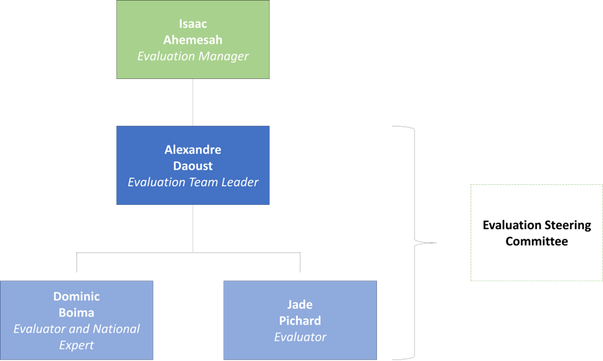

Table 9 - Roles and Responsibilities
Role | Responsibilities
Evaluation Manager | - Oversees the entire process of the evaluation, from its preparation to the dissemination and use of the final evaluation report.  - Technically oversees the evaluation and reports regularly to the evaluation steering committee by organising regular evaluation steering committee meetings. The Evaluation Manager works in close collaboration with DCO for quality assurance purposes and technical support.  - In consultation with and support from the RCO and UNCT, establishes an Evaluation Steering Committee as a technical subset of the joint national and UN Steering Committee.  - Ensures consultations with all UN entities in the country (based on the evaluation plan), to align their potential evaluations calendar and identify possible synergies in process and content.  - Prepares the Terms of Reference (TOR) of the evaluation in a consultative manner.  - With support from the RC’s office, compiles a preliminary list of background information and documentation on both the country context and the CF and list these in an Annex of the TOR.  - In collaboration with DCO, identifies potential independent candidates to conduct the evaluation, guaranteeing the absence of any kind of conflict of interest and ensuring a gender-balanced Evaluation Team.  - Requests a first stakeholders mapping of the main partners relevant for the CF evaluation from the relevant bodies, including the Programme Management Team and RCO.  - Manages interactions and serves as interlocutor between the Evaluation Team and the Evaluation Steering Committee;  - Sets up meetings during the fieldwork phase, and organises briefing and debriefing sessions between the Evaluation Team and evaluation users.  - Organises theory-of-change analyses meetings as necessary.  - Coordinates comments on and ensures the quality control of deliverables submitted by the Evaluation Team throughout the evaluation process ensuring that the UNEG Norms and Standards, Code of Conduct and Ethical Guidelines for Evaluations, as well as guidance on integrating human rights and gender equality in evaluation are followed/adhered to.  - Sends all evaluation products to DCO for approval.  - Ensures the Evaluation Report is sent for publication and dissemination, and supports the dissemination activities of the Evaluation Steering Committee.  - Ensures the management response is provided by concerned units/agencies/bodies.  - Clears payment of the Evaluation Team once outstanding issues have been addressed satisfactorily.
Evaluation Team Leader (TL) | - Project planning: planning the evaluation project, including defining the scope, objectives, and evaluation questions.  - Team coordination: Coordinating the activities of the ET members, ensuring that everyone understands their roles and responsibilities.  - Methodological expertise: Guiding the ET in selecting appropriate evaluation methods and design data collection instruments.  - Stakeholder engagement: Engaging with stakeholders involved in the evaluation process, including UNCT and Evaluation Steering Committee.  - Data collection and analysis: Overseeing the data collection process, ensuring that data is collected in a rigorous and systematic manner. Overseeing the data analysis and interpretation, ensuring that the team follows appropriate analytical approaches and techniques.  - Quality assurance: Maintaining the quality and integrity of the evaluation. Establishing quality assurance processes, review team member’s work, and provide feedback. Ensuring that evaluation findings and conclusions are based on valid and reliable evidence.  - Reporting and communication: Preparing evaluation reports and presenting findings to stakeholders. Ensuring that the evaluation results are effectively communicated in a clear and concise manner.  - Ethical considerations: Ensuring that ethical considerations are taken into account throughout the evaluation process (confidentiality of data, informed consent when necessary, adhere to ethical guidelines and standards).  - Evaluation management: Managing the overall evaluation process to ensure that it aligns with organisational goals and objectives.
Evaluators | - Designing the evaluation: Under the supervision of the TL, the evaluators are responsible for designing the evaluation process i.e. evaluation objectives, evaluation questions, evaluation methods, and data collection tools.  - Data collection: Evaluators are responsible for collecting data using the methods mentioned above (KIIs, survey, document review). They ensure that data collection is conducted in a systematic and rigorous manner, adhering to ethical considerations and maintaining data quality.  - Data analysis: Evaluators are responsible for analyzing the collected data using appropriate analytical techniques i.e. mixed methods approach to ensure that the data is carefully triangulated.  - Contextual knowledge (national expert): The national evaluator, on top of all the other responsibilities, is also responsible for providing in-depth knowledge and understanding of the country context. Additionally, the national evaluator is responsible for providing expert advice and guidance on the recommendations drawn from the data analysis.  - Reporting: Evaluators prepare the evaluation report that summarizes the findings, conclusions and recommendations of the data analysis.
Evaluation Steering Committee | - Supports the evaluation process, guide the ET and facilitate access to stakeholders and information.  - Responsible to report and work with EM  - Provides input to the evaluation TOR, and selection of evaluation issues and questions.  - Facilitates stakeholder identification and consultations, and provide access to information sources (documents and interviewees) to support data collection.  - Provides overall comments on the main deliverables of the evaluation, including the inception report and draft evaluation report.  - Prepares management response to the evaluation, in consultation with the UNCT members, within two months of receiving the final evaluation report  - Ensures the evaluation report and its results are disseminated and shared with key stakeholders, promoting the use of evaluation and lessons.

potential Risks and Mitigation measures
Possible risks identified | Mitigation measures
Limited time to conduct the evaluation | Due to some delays in the evaluation process (prior to hiring Baastel) and the pressing changes in the country, the evaluation will be conducted over a reduced period of time, at least until the delivery of the preliminary impressions by early September 2023. As a result, the following measures will be put in place as much as feasible to ensure the relevance and quality of the evaluation:  - Prioritization of the evaluation objectives  - Development and approval of a detailed evaluation plan (including the methodology, protocols etc.)  - Allocation of resources efficiently by prioritizing data collection efforts based on the critical information needed for the evaluation, and review existing data sources  - Set realistic deadlines and milestones  - Seek stakeholders (Evaluation Steering Committee) inputs early on and whenever required  - Communicate and manage expectations
Lack of access to all relevant documents and information does not allow to formulate a solid methodology at the inception phase | ; an evaluability assessment will be conducted at inception to identify data gaps; client to ensure the team has access to all information required to formulate methodology, identify stakeholders to meet and develop the evaluation matrix
Low stakeholders’ cooperation | A high level of participation is foreseen in the ET ‘s methodology, and it will highly depend on the willingness to participate and the availability of all stakeholders. Support from the Evaluation Managers will be important to inform stakeholders of the activities and to start scheduling interviews as early as possible in the process.
Low response rate to surveys | To increase response rates among stakeholders the ET has found that survey responses are increased by the following factors:  - Surveys are endorsed and issued from a credible source within the organisation and not from an unknown third party.  - The survey can be easily accessed, and easily navigated.  - Periodic reminders from the same credible source are sent to boost participation rates.
Security | The current security situation in Sierra Leone appears to be relatively stable, but situations can change rapidly. Given the possibility of unpredictable developments, all team members are familiar with security procedures (e.g. UN BSAFE training and procedures);  Nevertheless, the ET will put in place appropriate mitigation mechanisms to ensure that the evaluation proceeds effectively and the results are not compromised. These mechanisms may include:  - Continuous Monitoring: The ET and Evaluation Managers will maintain vigilant monitoring of the security situation throughout the evaluation process. This will involve regularly assessing and analyzing security updates, and information from reliable sources to stay informed about any changes or emerging risks.  - Security Protocols and Procedures: The ET will strictly adhere to established security protocols and procedures. This includes following UN guidelines, such as the UN BSAFE training, and implementing necessary measures to safeguard the team’s safety. The team will also receive regular briefings on security protocols and be equipped with the necessary resources and contacts for emergencies.  - Flexibility and Adaptability: The ET will remain flexible and adaptable in response to changing security conditions. This may involve adjusting the evaluation schedule, modifying travel plans, or implementing alternative data collection methods to mitigate potential risks (such as remote KIIs or national consultant to conduct field mission). The team will stay prepared to modify their approach as required while ensuring the quality and validity of the evaluation.  - Local Expertise and Partnerships: One team member of the ET is a national consultant that possesses in-depth knowledge of the local context and security dynamics. Collaborating with with him will provide valuable insights and guidance for navigating potential security challenges effectively.

Annex I – preliminary key documents identified
FAO (2019), Country programme document for Sierra Leone (2020-2023)
Government of Sierra Leone – Ministry of Basic and Senior Secondary Education (2021), 2020 Annual School Census Report.
Government of Sierra Leone – Ministry of Planning and Economic Development (2021), 2021 VNR Report on SDGs in Sierra Leone.
Government of Sierra Leone (2019), Sierra Leone’s Medium-Term National Development Plan 2019-2023
Government of Sierra Leone (n.d.), Republic of Sierra Leone – National Statement: Transforming Education Summit.
Government of Sierra Leone/United Nations Country Team in Sierra Leone (2019), Report on the Joint Assessment mission on youth at risk in Sierra Leone.
UNEG (2021), Guidelines for the Evaluation of the United Nations Sustainable Development Cooperation Framework. United Nations: United Nations.
United Nations Country Team in Sierra Leone (2019), United Nations Sustainable Development Cooperation Framework 2020-2023. United Nations: United Nations.
United Nations Country Team in Sierra Leone (2020), Common Country Analysis, 2020 Update. United Nations: United Nations.
United Nations Country Team in Sierra Leone (2020), Joint Financing and Resource Mobilization Strategy. United Nations: United Nations.
United Nations Country Team in Sierra Leone (2020), UNDAF Evaluation 2015-2018 Sierra Leone. United Nations: United Nations.
United Nations Country Team in Sierra Leone (2021), 2020 UN Annual Results Report Sierra Leone. United Nations: United Nations.
United Nations Country Team in Sierra Leone (2021), Common Country Analysis, 2021 Update. United Nations: United Nations.
United Nations Country Team in Sierra Leone (2021), Communications Strategy 2020-2023. United Nations: United Nations.
United Nations Country Team in Sierra Leone (2021), Newsletter Issue 1.
United Nations Country Team in Sierra Leone (2021), Newsletter Issue 2.
United Nations Country Team in Sierra Leone (2022), 2021 UN Annual Results Report Sierra Leone. United Nations: United Nations.
United Nations Country Team in Sierra Leone (2022), Common Country Analysis, 2022 Update. United Nations: United Nations.
United Nations Country Team in Sierra Leone (2022), Newsletter Issue 3.
United Nations Country Team in Sierra Leone (2023), 2022 UN Annual Results Report Sierra Leone. United Nations: United Nations.
United Nations Country Team in Sierra Leone (n.d.) Climate Action for Sierra Leone – Partnerships Resource Brief. United Nations: United Nations
Additional documents: reports provided by the UN Agencies

Annex ii – evaluation matrix

Relevance
R1. To what extent has the CF integrated key issues and development challenges identified by the UN Common Country Analysis (CCA) in its design and implementation?
Sub-questions | Assumptions to be assessed | Indicators | Data Collection Tools | Source of Information
 | The CF has integrated key issues and development challenges identified by the UN CCA in its design and implementation | Degree of alignment between the CF and the key issues and development challenges identified in the UN CCA | Desk and Documents review  KIIs | CF documentation  CCA (2020,2021)  UNCT  Steering Committee
R2. To what extent has the CF integrated the following: a) the promotion of gender equality and women’s empowerment, b) the promotion of human rights, including disability inclusion, c) the promotion of environmental sustainability objectives in its design and implementation?
Sub-questions | Assumptions to be assessed | Indicators | Data Collection Tools | Source of Information
 | The CF has integrated the promotion of gender equality and women’s empowerment in its design and implementation | Integration of gender perspectives, needs and priorities across all aspects of the CF (goals, objectives, strategies, activities, indicators, gender-specific goals and targets) | Desk and Documents review  KIIs  Survey  FGD  Observations | CF documentation  Progress reports  Evaluations  UNCT  Steering Committee  Donor/strategic partners  Beneficiaries and community members  National implementing partners such as Government of Sierra Leone, CSOs, NGOs, private sector, academia, mass media
 | The CF has integrated the promotion of human rights, including disability inclusion in its design and implementation | Integration of a human-rights based approach in its design and implementation (e.g. indicators that measure explicit recognition of human rights principles: non-discrimination, equality, participation; disability-inclusive goals and targets) | Desk and Documents review  KIIs  Survey  FGD  Observations | CF documentation  Progress reports  Evaluations  UNCT  Steering Committee  Donor/strategic partners  Beneficiaries and community members  National implementing partners such as Government of Sierra Leone, CSOs, NGOs, private sector, academia, mass media
 | The CF has integrated the promotion of environmental sustainability objectives in its design and implementation | Integration of environmental goals and targets (e.g. related to climate change mitigation, biodiversity conservation, natural resource management, environmental pollution reduction etc.), monitoring and reporting on environmental indicators | Desk and Documents review  KIIs  Survey  FGD  Observations | CF documentation  Progress reports  Evaluations  UNCT  Steering Committee  Donor/strategic partners  Beneficiaries and community members  National implementing partners such as Government of Sierra Leone, CSOs, NGOs, private sector, academia, mass media
R3. To what extent are the CF objectives aligned with the needs, priorities, and policies of the government (including alignment to national development goals and targets, national plans, strategies, and framework)?
Sub-questions | Assumptions to be assessed | Indicators | Data Collection Tools | Source of Information
 | The CF objectives are aligned with the needs, priorities, and policies of the government. | Policy integration such as:  - The extent to which the objectives of the CF align with existing national policies, strategies, and development plans  - Demonstrated coherence between the CF objectives and government’s priorities as stated in official policy documents | Desk and Documents review  KIIs  Survey | Documentation Government of Sierra Leone (e.g. Medium-Term National Plan 20219-2023)  CF documentation  UNCT  Steering Committee  National implementing partners such as Government of Sierra Leone, CSOs, NGOs, private sector, academia, mass media
 |  | Stakeholder involvement such as:  - The level of involvement of government officials, policymakers and relevant ministries in the development and review of the CF objectives  - Existence of mechanisms for ongoing engagement between the government and stakeholders throughout the implementation of the framework to ensure government perspectives and priorities | Desk and Documents review  KIIs  Survey | Documentation Government of Sierra Leone (e.g. Medium-Term National Plan 20219-2023)  CF documentation  UNCT  Steering Committee  National implementing partners such as Government of Sierra Leone, CSOs, NGOs, private sector, academia, mass media
 |  | Resource Allocation such as:  - Extent to which the government provides financial and non-financial resources to support the implementation of the UNCF objectives  - Allocation of national budget resources to activities that are aligned with the priorities outlined in the CF | Desk and Documents review  KIIs  Survey | Documentation Government of Sierra Leone (e.g. Medium-Term National Plan 20219-2023)  CF documentation  UNCT  Steering Committee
R4. To what extent are the CF objectives aligned with the needs and priorities of the rights holders, especially the most vulnerable group?
Sub-questions | Assumptions to be assessed | Indicators | Data Collection Tools | Source of Information
 | The CF objectives are aligned with the needs and priorities of the rights holders, especially the most vulnerable group | Stakeholder Engagement such as:  - Percentage of rights holders and representatives of vulnerable groups involved in the development and review of the CF objectives  - Number and diversity of stakeholder consultations conducted to gather input and feedback on the objectives  - Existence of mechanisms and continuous engagement with rights holders and vulnerable groups throughout the implementation of the framework | Desk and Documents review  KIIs  Survey  FGD  Observations | CF documentation  Progress reports  Evaluations  UNCT  Steering Committee  Donor/strategic partners  Beneficiaries and community members  National implementing partners such as Government of Sierra Leone, CSOs, NGOs, private sector, academia, mass media
 |  | Inclusiveness and Representation such as:  - Proportion of objectives that explicitly address the needs and concerns of vulnerable groups  - Representation of vulnerable groups in decision-making bodies or committees responsible for defining the objectives.  - Availability of disaggregated data on the participation and representation of vulnerable groups in the development of the framework. | Desk and Documents review  KIIs  Survey  FGD  Observations | CF documentation  Progress reports  Evaluations  UNCT  Steering Committee  Donor/strategic partners  Beneficiaries and community members  National implementing partners such as Government of Sierra Leone, CSOs, NGOs, private sector, academia, mass media
 |  | Needs and priorities assessment such as:  - Documentation of a comprehensive needs assessment conducted to identify the specific needs and priorities of vulnerable groups.  - Evidence of the integration of findings from needs assessments into the objectives of the Country Framework.  - Adequate consideration of intersectional vulnerabilities and specific challenges faced by different subgroups within the vulnerable population. | Desk and Documents review  KIIs  Survey  FGD | CF documentation  Progress reports  Evaluations  UNCT  Steering Committee  Donor/strategic partners
 |  | Policy alignment such as:  - Demonstrated coherence between the objectives and internationally recognized human rights standards and principles.  - Clear references to relevant international conventions, agreements, or guidelines that address the concerns of the most vulnerable groups. | Desk and Documents review  KIIs  Survey | CF documentation  Progress reports  Evaluations  UNCT  Steering Committee  Donor/strategic partners
 |  | Monitoring data on the progress made in addressing the needs and priorities of vulnerable groups as outlined in the objectives. | Desk and Documents review  KIIs  Survey | Monitoring and Evaluation documents  UNCT  Steering Committee
 |  | Rights holders opinion on the alignment and relevance of the activities to answer their needs and priorities and recommendations | FGD | Beneficiaries and community members
Adaptability
A1. To what extent did the implementation of the CF adjust to emerging issues faced by the country during the implementation? (e.g. COVID-19)
Sub-questions | Assumptions to be assessed | Indicators | Data Collection Tools | Source of Information
 | The CF was able to adjust its initial design and implementation strategy to emerging issues faced by the country during its implementation. | Examples of emerging issues faced by the country during the CF implementation period. | Desk and Documents review  KIIs  Observations | CF documentation  Progress reports  Evaluations  COVID-19 reports  Government Reports  UNCT  Steering Committee  Donor/strategic partners  Beneficiaries and community members  National implementing partners such as Government of Sierra Leone, CSOs, NGOs, private sector, academia, mass media
 |  | Number of adjustments made to the CF in response to emerging issues (e.g. activities/programmes modified or expanded to address emerging issues) | Desk and Documents review  KIIs | CF documentation  Progress reports  Evaluations  UNCT  Steering Committee  National implementing partners such as Government of Sierra Leone, CSOs, NGOs, private sector, academia, mass media
 |  | Extent to which the adjustments facilitated achievement of results | Desk and Documents review  KIIs | CF documentation  Progress reports  Evaluations  UNCT  Steering Committee
 |  | Evidence of reallocation of resources (financial and human) from less critical areas to address emerging issues (budget adjustments, resource allocation) | Desk and Documents review  KIIs | CF documentation  Progress reports  Evaluations  UNCT  Steering Committee
 |  | Evidence of methods for managing stakeholder participation and inclusiveness in times of crisis (e.g. COVID 19) and evidence of collaborative efforts and partnerships to tackle emerging issues (stakeholder engagement) | Desk and Documents review  KIIs  Survey | CF documentation  Progress reports  Evaluations  UNCT  Steering Committee  Donor/strategic partners  Beneficiaries and community members  National implementing partners such as Government of Sierra Leone, CSOs, NGOs, private sector, academia, mass media
A2. To what extent did the monitoring and evaluation strategies of the CF adjust to emerging issues faced by the country during the implementation?
Sub-questions | Assumptions to be assessed | Indicators | Data Collection Tools | Source of Information
 | The M&E strategies of the CF were able to adjust to emerging issues faced by the country during its implementation. | Evidence of proactive monitoring and early detection of emerging issues (timeliness of response) (relies on the availability of real-time data) | Desk and Documents review  KIIs  Survey | Monitoring and Evaluation documents  UNCT
 |  | Evidence and example of a flexible M&E framework that allows for adjustments and revisions to indicators, targets, and methodologies in response to emerging issues. | Desk and Documents review  KIIs  Survey | Monitoring and Evaluation documents  UNCT
 |  | Inclusion of specific sections or reports within the M&E framework dedicated to monitoring and reporting on emerging issues faced by the country. | Desk and Documents review  KIIs  Survey | Monitoring and Evaluation documents  UNCT
Coherence
C1. To what extent have the CF partnerships with civil society/private sector/ local government/ international development partners contributed to the achievement of the results?
Sub-questions | Assumptions to be assessed | Indicators | Data Collection Tools | Source of Information
 | The CF partnerships with civil society contributed to the achievement of the results | Evidence of i) effective collaboration and coordination, ii) capacity building and knowledge sharing, iii) stakeholder engagement and participation, iv) impact of the partnership on policy and change and advocacy efforts (at all levels), v) results achieved through the partnership | Desk and Documents review  KIIs  Survey  FGD | CF documentation  Progress reports  Evaluations  UNCT  Steering Committee  Donor/strategic partners  National implementing partners such as Government of Sierra Leone, CSOs, NGOs, private sector, academia, mass media
 | The CF partnerships with the private sector contributed to the achievement of the results | Evidence of i) effective collaboration and coordination, ii) capacity building and knowledge sharing, iii) stakeholder engagement and participation, iv) impact of the partnership on policy and change and advocacy efforts (at all levels), v) results achieved through the partnership | Desk and Documents review  KIIs  Survey  FGD | CF documentation  Progress reports  Evaluations  UNCT  Steering Committee  National implementing partners such as Government of Sierra Leone, CSOs, NGOs, private sector, academia, mass media
 | The CF partnerships with the local government contributed to the achievement of the results | Evidence of i) effective collaboration and coordination, ii) capacity building and knowledge sharing, iii) stakeholder engagement and participation, iv) impact of the partnership on policy and change and advocacy efforts (at all levels), v) results achieved through the partnership | Desk and Documents review  KIIs  Survey  FGD | CF documentation  Progress reports  Evaluations  UNCT  Steering Committee  Donor/strategic partners  Beneficiaries and community members
 | The CF partnerships with international development partners contributed to the achievement of the results | Evidence of i) effective collaboration and coordination, ii) capacity building and knowledge sharing, iii) stakeholder engagement and participation, iv) impact of the partnership on policy and change and advocacy efforts (at all levels), v) results achieved through the partnership | Desk and Documents review  KIIs  Survey  FGD | CF documentation  Progress reports  Evaluations  UNCT  Steering Committee  Donor/strategic partners
 |  | UNCT, Steering Committee, civil society, private sector, local government, international development partners opinions and recommendations | KIIs  FGD  Survey | UNCT  Steering Committee  Donor/strategic partners
Effectiveness
E1. To what extent has the CF achieved and is likely to achieve its intended results and ensure that the rights holders, especially the most vulnerable have access access to and benefit from services?
Sub-questions | Assumptions to be assessed | Indicators | Data Collection Tools | Source of Information
E1.1. To what extent has outcome 1 : “By 2023, Sierra Leone benefits from more productive, commercialized and sustainable agriculture, improved food and nutrition security, and increased resilience to climate change and other shocks” been achieved? | Outcome 1 has been achieved at a satisfactory level = 75% of the targets have been reached (16 out of 21 targets) | Level of achievement of indicators of the Cooperation Framework results matrix under Outcome 1 (i.e. indicators: 1a, 1b, 1c, 1d, 1e, 1f, 1g) | Desk and Documents review | - Big data surveys: DHS, MICS, admin data  - Monitoring and evaluation reports of Programmes  - Survey  - Research  - UN Websites  - World Bank  - HCSS  - UNFO
 |  | Level of achievement of indicators of the Cooperation Framework results matrix under Results:  - 1.1  - 1.2  - 1.3  - 1.4  - 1.5  - 1.6 | Desk and Documents review | - Big data surveys: DHS, MICS, admin data  - Monitoring and evaluation reports of Programmes  - Survey  - Research  - UN Websites  - World Bank  - HCSS  - UNFO
 |  | UNCT, Steering Committee, Government, Development partners opinions on the level of achievement of Outcome 1 and recommendations | KIIs  Survey  Observations | UNCT  Steering Committee  Donor/strategic partners
 |  | Most significant changes achieved according to beneficiaries and their communities as well as key local development partners and attributed to the activities of the CF | FGD  Observations | Beneficiaries and community members  National implementing partners such as Government of Sierra Leone, CSOs, NGOs, private sector, academia, mass media
E.1.2. To what extent has outcome 2 “By 2023, people in Sierra Leone benefit from more gender and youth responsive institutions that are innovative, accountable, and transparent at all levels and can better advance respect for human rights and the rule of law, equity, peaceful coexistence, and the protection of boys and girls, women and men including those with disabilities.” been achieved? | Outcome 2 has been achieved at a satisfactory level = 75% of the targets have been reached (19 out of 25 targets) | Level of achievement of indicators of the Cooperation Framework results matrix under Outcome 2 (i.e. indicators: 2a, 2b, 2c, 2d) | Desk and Documents review | - Transparency international  - Institute for Economics and Peace  - Mo Ibrahim  - World Bank  - Big data surveys: DHS, MICS, admin data  - Monitoring and evaluation reports of Programmes  - Survey  - Research  - UN Websites  - UNFO
 |  | Level of achievement of indicators of the Cooperation Framework results matrix under Results:  - 2.1  - 2.2  - 2.3  - 2.4  - 2.5  - 2.6  - 2.7 | Desk and Documents review | - Big data surveys: DHS, MICS, admin data  - Monitoring and evaluation reports of Programmes  - Survey  - Research  - UN Websites  - World Bank  - HCSS  - UNFO
 |  | UNCT, Steering Committee, Government, Development Partners opinions on the level of achievement of Outcome 2 and recommendations | KIIs  Survey  Observations | UNCT  Steering Committee  Donor/strategic partners
 |  | Most significant changes achieved according to beneficiaries and their communities as well as key local development partners and attributed to the activities of the CF | FGD  Observations | Beneficiaries and community members  National implementing partners such as Government of Sierra Leone, CSOs, NGOs, private sector, academia, mass media
E.1.3. To what extent has outcome 3 “By 2023, the population of Sierra Leone, particularly the most disadvantaged and vulnerable, will benefit from increased and more equitable access to and utilization of quality education, health care, energy and WASH services, including during emergencies.” been achieved? | Outcome 3 has been achieved at a satisfactory level = 75% of the targets have been reached (16 out of 22 targets) | Level of achievement of indicators of the Cooperation Framework results matrix under Outcome 3 (i.e. indicators: 3a, 3b, 3c, 3d) | Desk and Documents review | - Big data surveys: DHS, MICS, admin data  - Monitoring and evaluation reports of Programmes  - Survey  - Research  - UN Websites  - UNFO
 |  | Level of achievement of indicators of the Cooperation Framework results matrix under Results:  - 3.1  - 3.2  - 3.3  - 3.4 | Desk and Documents review | - Big data surveys: DHS, MICS, admin data  - Monitoring and evaluation reports of Programmes  - Survey  - Research  - UN Websites  - World Bank  - HCSS  - UNFO
 |  | UNCT, Steering Committee, Government, Development Partners opinions on the level of achievement of Outcome 3 and recommendations | KIIs  Survey  Observations | UNCT  Government  Steering Committee  Donor/strategic partners
 |  | Most significant changes achieved according to beneficiaries and their communities as well as key local development partners and attributed to the activities of the CF | FGD  Observations | Beneficiaries and community members  National implementing partners such as Government of Sierra Leone, CSOs, NGOs, private sector, academia, mass media
E.1.4. To what extent has outcome 4 “By 2023, the most vulnerable, particularly women, youth, adolescents and children (especially girls), and persons with disabilities, are empowered and benefit from increased social and economic opportunities.” been achieved? | Outcome 4 has been achieved at a satisfactory level = 75% of the targets have been reached (13 out of 18 targets) | Level of achievement of indicators of the Cooperation Framework results matrix under Outcome 4 (i.e. indicators: 4a, 4b, 4c, 4d, 4e) | Desk and Documents review | - Big data surveys: DHS, MICS, admin data  - Monitoring and evaluation reports of Programmes  - Survey  - Research  - UN Websites  - World Bank  - HCSS  - UNFO
 |  | Level of achievement of indicators of the Cooperation Framework results matrix under Results:  - 4.1  - 4.2  - 4.3  - 4.4  - 4.5  - 4.6  - 4.7 | Desk and Documents review | - Big data surveys: DHS, MICS, admin data  - Monitoring and evaluation reports of Programmes  - Survey  - Research  - UN Websites  - World Bank  - HCSS  - UNFO
 |  | UNCT, Steering Committee, Government, Development partners opinions on the level of achievement of Outcome 4 and recommendations | KIIs  Survey  Observations | UNCT  Steering Committee  Donor/strategic partners
 |  | Most significant changes achieved according to beneficiaries and their communities as well as key local development partners and attributed to the activities of the CF | FGD  Observations | Beneficiaries and community members  National implementing partners such as Government of Sierra Leone, CSOs, NGOs, private sector, academia, mass media
E2. What internal and external factors contributed to or hindered the attainment of the intended results?
Sub-questions | Assumptions to be assessed | Indicators | Data Collection Tools | Source of Information
 | Key internal factors have contributed to the attainment of the intended results | Identification of key internal factors that have contributed to the attainment of the intended results such as i) leadership and governance, ii) coordination and collaboration, iii) internal capacity, iv) financial management etc. | Desk and Documents review  FGD  KIIs  Survey  Field Observations | CF documentation  Progress reports  Evaluations  UNCT  Steering Committee
 | Key external factors have contributed to the attainment of the intended results | Identification of key external factors that have contributed to the attainment of the intended results such as i) Government commitment and support, ii) stakeholder engagement, iii) socioeconomic and political context, iv) legislative and policy environment | Desk and Documents review  FGD  KIIs  Survey  Field Observations | CF documentation  Progress reports  Evaluations  UNCT  Steering Committee  Donor/strategic partners  Beneficiaries and community members  National implementing partners such as Government of Sierra Leone, CSOs, NGOs, private sector, academia, mass media
 | Internal factors might have hindered the attainment of the intended results | Identification of key internal factors that might have hindered the attainment of the intended results such as i) leadership and governance, ii) institutional capacity, iii) coordination and collaboration, iv) resource management, , v) M&E, vi) knowledge management | Desk and Documents review  FGD  KIIs  Survey  Field Observations | CF documentation  Progress reports  Evaluations  UNCT  Steering Committee
 | External factors might have hindered the attainment of the intended results | Identification of key external factors that might have hindered the attainment of the intended results such as i) Political instability, ii) economic factors, iii) environmental factors, iv) external conflict or security issues, v) global or regional economic issues, vi) legal and regulatory environment, vii) stakeholder engagement | Desk and Documents review  FGD  KIIs  Survey  Field Observations | CF documentation  Progress reports  Evaluations  UNCT  Steering Committee  Donor/strategic partners  Beneficiaries and community members  National implementing partners such as Government of Sierra Leone, CSOs, NGOs, private sector, academia, mass media
E3. What expected and unexpected, positive and negative outcomes has the CF yielded as a result of its intended goals and objectives?
Sub-questions | Assumptions to be assessed | Indicators | Data Collection Tools | Source of Information
 | Expected outcomes as stated in the CF have been yielded by the CF as a result of its intended goals and objectives | Identification of expected positive or negative outcomes yielded by the CF | Desk and Documents review  FGD  KIIs  Field Observations | CF documentation  Progress reports  Evaluations  UNCT  Steering Committee  Donor/strategic partners
 | Some unexpected impacts have been yielded by the CF as a result of its intended goals and objectives | Identification of unexpected positive or negative outcomes such as i) unforeseen social or cultural changes, ii) environmental impacts, iii) economic disparities, iv) unintended consequences for vulnerable populations | Desk and Documents review  FGD  KIIs  Survey  Field Observations | CF documentation  Progress reports  Evaluations  UNCT  Steering Committee  Donor/strategic partners  Beneficiaries and community members  National implementing partners such as Government of Sierra Leone, CSOs, NGOs, private sector, academia, mass media
E3.1. To what extent has the rights holders and institutions including the most vulnerable, disadvantaged and marginalized population benefitted from the CF’s results? | The rights holders and institutions including the most vulnerable, disadvantaged and marginalized population have benefitted from the CF’s results | Identification of benefits that result from the CF such as access to basic services, social inclusion, poverty reduction, human rights protection, participation and representation, reduction of vulnerabilities | Desk and Documents review  FGD  KIIs  Survey  Field Observations | CF documentation  Progress reports  Evaluations  Rights holders  UNCT  Steering Committee  Donor/strategic partners  Beneficiaries and community members  National implementing partners such as Government of Sierra Leone, CSOs, NGOs, private sector, academia, mass media
Efficiency
Effi1. To what extent the programme resources (human and financial) have been utilized efficiently?
Sub-questions | Assumptions to be assessed | Indicators | Data Collection Tools | Source of Information
Effi1.1. How efficient was the programme in utilizing financial resources? | The programme was efficient in utilizing financial resources | Planned VS actual expenditures (+ Mobilized) | Desk and Documents review  KIIs  Survey | Joint Financing and Resource Mobilization Strategy  UNCT  Joint Steering Committee
 | The programme was efficient in utilizing financial resources | Capacity to prioritize activities based on the needs (demand side) rather than on the availability of resources (supply side) | Desk and Documents review  KIIs  Survey | CF Documentation  UNCT  Joint Steering Committee
 | The programme was efficient in utilizing financial resources | Value for money | Desk and Documents review  Survey  KIIs | CF Documentation  UNCT  Joint Steering Committee
 | The programme was efficient in utilizing financial resources | UNCT and Joint Steering Committee opinion | KIIs  Survey | UNCT  Joint Steering Committee
Effi1.2. How efficient was the programme in utilizing its human resources? | The programme was efficient in utilizing its human resources | Staff utilization rate | Desk and Documents review  KIIs  Survey | CF Documentation  UNCT  Joint Steering Committee
 | The programme was efficient in utilizing its human resources | Cost-effectiveness of the human resources vs outputs/outcomes achieved | Desk and Documents review  Survey  KIIs | UNCT  Joint Steering Committee
 | The programme was efficient in utilizing its human resources | UNCT and Joint Steering Committee opinion | KIIs  Survey | UNCT  Joint Steering Committee
Effi1.3. To what extent has the CF been implemented and achieved its intended results as planned and in a timely way? | The CF has been implemented and achieved its intended results as planned and in a timely way | Implementation progress in terms of planned outputs and activities | Desk and Documents review  KIIs | CF Documentation  UNCT  Joint Steering Committee
 |  | Evidence and reasons of delays (if any) in activities’ implementation | Desk and Documents review  KIIs | CF Documentation  UNCT  Joint Steering Committee
 |  | UNCT and Joint Steering Committee opinion | KIIs  Survey | UNCT  Joint Steering Committee
Effi1.4. To what extent has the CF's monitoring and evaluation (M&E) system ensured results-based management and efficient, effective implementation? | The M&E system ensured results-based management and efficient, effective implementation | Extent to which the M&E system facilitated efficiency through i) data accessibility, ii) timeliness of data availability, iii) Tools and technology utilization, iv) communication mechanisms, v) reporting quality, vi) feedback processes | Desk and Documents review  KIIs  Survey | CF Documentation  Monitoring and evaluation documents  UNCT  Joint Steering Committee
 |  | Level of relevance of objectively verifiable indicators including cross-cutting themes | Desk and Documents review  KIIs  Survey | CF Documentation  Monitoring and evaluation documents  UNCT  Joint Steering Committee
 |  | UNCT and Joint Steering Committee satisfaction with the M&E system and recommendations | KIIs  Survey | UNCT  Joint Steering Committee
Coordination
Co1. To what extent has the CF promoted complementarity, harmonization and coordination with other key partners to maximize the achievement of results?
Sub-questions | Assumptions to be assessed | Indicators | Data Collection Tools | Source of Information
Co1.1. To what extent has the CF fostered internal coordination, through the promotion of synergies and interlinkages between its interventions to maximize efficiency, coverage, reaching the most vulnerable while reducing and avoiding overlaps? | The CF fostered internal coordination through the promotion of synergies, interlinkages between its interventions to maximize efficiency, coverage, reaching the most vulnerable while reducing and avoiding overlaps | Evidence of interlinkages and complementary approaches between various interventions | Desk and Documents review  KIIs  Survey | CF documentation  Progress reports  Evaluations  UNCT  Joint Steering Committee  Donor/strategic partners  National implementing partners such as Government of Sierra Leone, CSOs, NGOs, private sector, academia, mass media
 |  | Evidence of resources optimization and efficiency through coordination between interventions (e.g. transaction costs) | Desk and Documents review  KIIs  Survey | CF documentation  Progress reports  Evaluations  UNCT  Joint Steering Committee
 |  | Evidence of mechanisms or platforms for information and knowledge sharing between key partners | Desk and Documents review  KIIs  Survey | CF documentation  Progress reports  Evaluations  UNCT  Joint Steering Committee
 |  | Evidence of strategy to reduce overlaps between interventions | Desk and Documents review  KIIs  Survey | CF documentation  Progress reports  Evaluations  UNCT  Joint Steering Committee  Government  Donor/strategic partners  National implementing partners such as Government of Sierra Leone, CSOs, NGOs, private sector, academia, mass media
 |  | Perception of relevant stakeholders including target populations on the synergies vs overlap between interventions | KIIs  Survey  FGD | UNCT  Joint Steering Committee  Government  Donor/strategic partners  National implementing partners such as Government of Sierra Leone, CSOs, NGOs, private sector, academia, mass media
Co1.2. To what extent does the CF align with the strategic priorities of the UN Agencies? | The CF aligns with the strategic priorities of the UN Agencies | Evidence of strategic plan alignment : alignment between the goals and objectives of the CF and the goals and objectives of the UN Agencies operating in the country | Desk and Documents review  KIIs | Strategic plans CF  Strategic plans UN Agencies  CF documentation  UNCT
 |  | Evidence of programmatic alignment: alignment between the programmes and initiatives implemented by the CF and the thematic areas and focus of the UN Agencies | Desk and Documents review  KIIs | Programmatic activities, projects and interventions from the UN Agencies  CF documentation  UNCT
Co2. To what extent has the different UN agencies contributed to the functioning and consolidation of UNCT coordination mechanisms?
Sub-questions | Assumptions to be assessed | Indicators | Data Collection Tools | Source of Information
 | The different UN Agencies contributed to the functioning and consolidation of UNCT coordination mechanisms | Functionality and effectiveness of coordination mechanisms such as Results Groups, Joint Programmes, Project Management Teams (PMT), Operations Management Teams (OMT) and other mechanisms in ensuring collaboration and coordination to ensure Delivering as One principles i.e. in terms of participation rate, collaboration and information sharing, adherence to coordination mechanism decisions, support for joint programming, synergies etc. | Desk and Documents review  KIIs  Survey | CF documentation  UNCT  Joint Steering Committee
 |  | UN Agencies and Steering Committee opinion on the coordination mechanisms and recommendations | KIIs  Survey | UNCT  Joint Steering Committee
Co3. To what extent has the Joint Steering Committee ensured efficient coordination between the Government and the UNCT?
Sub-questions | Assumptions to be assessed | Indicators | Data Collection Tools | Source of Information
 | The Joint Steering Committee ensured efficient coordination between the Government and the UNCT | Evidence in terms of 1) meeting frequency and timeliness, 2) participation (engagement), 3) decision-making and coordination, 4) communication and information sharing, 5) satisfaction | KIIs  Survey | UNCT  Joint Steering Committee
Orientation towards Impact
I1. To what extent has the CF in each of its strategic areas contributed to the following : a) promotion of gender equality and women’s empowerment, b) promotion of human rights, including disability inclusion, c) promotion of environmental sustainability objectives?
Sub-questions | Assumptions to be assessed | Indicators | Data Collection Tools | Source of Information
I1.1. To what extent has Strategic Area 1 Sustainable Agriculture and Food Security contributed to a) promotion of gender equality and women’s empowerment, b) promotion of human rights, including disability inclusion, c) promotion of environmental sustainability objectives? | Strategic Area 1 has contributed to the promotion of gender equality and women’s empowerment | Evidence of impact of the CF in terms of i) women’s access to land, ii) women’s participation in agricultural decision-making, iii) gender-responsive agricultural policies and programmes, iv) women’s access to agricultural resources and information, v) income generation and economic empowerment, vi) improving women’s and children’s nutrition and food security, vii) women’s resilience to climate change | Desk and Documents review  FGD  KIIs  Survey  Field Observations | Monitoring and Evaluation reports  UNCT  Joint Steering Committee
 | Strategic Area 1 has contributed to the promotion of human rights, including disability inclusion | Evidence of impact of the CF in terms of i) disability-inclusive policies and strategies in agriculture, ii) changes in the accessibility of agricultural resources for persons with disabilities, iii) promotion and adoption of inclusive agricultural practices, iv) raising awareness and advocating for the rights and inclusion of persons with disabilities in the agriculture and food security sector | Desk and Documents review  FGD  KIIs  Survey  Field Observations | Monitoring and Evaluation reports  UNCT  Joint Steering Committee
 | Strategic Area 1 has contributed to the promotion of environmental sustainability objectives | Evidence of impact of the CF in terms of i) sustainable land management practices, ii) water resource management practices, iii) climate change mitigation and adaptation practices, iv) biodiversity conservation, v) reduction of agrochemical use, vi) energy efficiency practices and/or use of renewable energy | Desk and Documents review  FGD  KIIs  Survey  Field Observations | Monitoring and Evaluation reports  UNCT  Joint Steering Committee
 |  | Opinion of the UNCT, Joint Steering Committee, beneficiaries and development partners on the contribution of Strategic Area 1 on the above mentioned and recommendations | KIIs  FGD | UNCT  Joint Steering Committee  Government  Donor/strategic partners  National implementing partners such as Government of Sierra Leone, CSOs, NGOs, private sector, academia, mass media
I1.2. To what extent has Strategic Area 2 Transformational Governance contributed to a) promotion of gender equality and women’s empowerment, b) promotion of human rights, including disability inclusion, c) promotion of environmental sustainability objectives? | Strategic Area 2 has contributed to the promotion of gender equality and women’s empowerment | Evidence of impact of the CF in terms of i) gender-responsive laws and policies, ii) women’s political participation, iii) gender-responsive institutions, iv) gender mainstreaming in public administration, v) access to justice, vi) women's economic empowerment in Governance | Desk and Documents review  FGD  KIIs  Survey  Field Observations | Monitoring and Evaluation reports  UNCT  Joint Steering Committee
 | Strategic Area 2 has contributed to the promotion of human rights, including disability inclusion | Evidence of impact of the CF in terms of i) disability-inclusive laws and policies, ii) access to justice, iii) disability-inclusive institutions, iv) participation and representation of persons with disabilities in decision-making processes, v) accessibility of public services, vi) raising awareness and promoting sensitization about disability rights and inclusion | Desk and Documents review  FGD  KIIs  Survey  Field Observations | Monitoring and Evaluation reports  UNCT  Joint Steering Committee
 | Strategic Area 2 has contributed to the promotion of environmental sustainability objectives | Evidence of impact of the CF in terms of i) environmental policy framework, ii) institutional capacity for environmental governance, iii) environmental justice and social inclusion etc. | Desk and Documents review  FGD  KIIs  Survey  Field Observations | Monitoring and Evaluation reports  UNCT  Joint Steering Committee
 |  | Opinion of the the UNCT, Joint Steering Committee, beneficiaries and development partners on the contribution of Strategic Area 2 on the above mentioned and recommendations | KIIs  FGD | UNCT  Joint Steering Committee  Donor/strategic partners  National implementing partners such as Government of Sierra Leone, CSOs, NGOs, private sector, academia, mass media
I1.3. To what extent has Strategic Area 3 Access to Basic Services contributed to a) promotion of gender equality and women’s empowerment, b) promotion of human rights, including disability inclusion, c) promotion of environmental sustainability objectives? | Strategic Area 3 has contributed to the promotion of gender equality and women’s empowerment | Evidence of impact of the CF in terms of i) gender-responsive service delivery in basic services, ii) changes in gender disparities accessing basic services, iii) women’s participation in service planning and decision-making, iv) gender-sensitive infrastructure, v) quality and gender-responsive education, vi) women’s access to healthcare services, vii) capacity building | Desk and Documents review  FGD  KIIs  Survey  Field Observations | Monitoring and Evaluation reports  UNCT  Joint Steering Committee
 | Strategic Area 3 has contributed to the promotion of human rights, including disability inclusion | Evidence of impact of the CF in terms of i) improving the accessibility of basic services for persons with disabilities, ii) participation of persons with disabilities in the planning, implementation and evaluation of basic service delivery, iii) access to inclusive education, iv) access to disability-inclusive healthcare services | Desk and Documents review  FGD  KIIs  Survey  Field Observations | Monitoring and Evaluation reports  UNCT  Joint Steering Committee
 | Strategic Area 3 has contributed to the promotion of environmental sustainability objectives | Evidence of impact of the CF in terms of i) access to sustainable energy, ii) improvements in water conservation and management within basic service provision, iii) waste management and recycling, iv) environmental education and awareness | Desk and Documents review  FGD  KIIs  Survey  Field Observations | Monitoring and Evaluation reports  UNCT  Joint Steering Committee
 |  | Opinion of the UNCT, Joint Steering Committee, beneficiaries and development partners on the contribution of Strategic Area 3 on the above mentioned and recommendations | KIIs  FGD | UNCT  Joint Steering Committee  Donor/strategic partners  National implementing partners such as Government of Sierra Leone, CSOs, NGOs, private sector, academia, mass media
I1.4. To what extent has Strategic Area 4: Protection and Empowerment of the most vulnerable contributed to a) promotion of gender equality and women’s empowerment, b) promotion of human rights, including disability inclusion, c) promotion of environmental sustainability objectives? | Strategic Area 4 has contributed to the promotion of gender equality and women’s empowerment | Evidence of impact of the CF in terms of i) access to social protection programmes for vulnerable groups, including women and girls, ii) gender-responsive legal protection, iii) capacity building and empowerment, iv) awareness raising and behaviour change towards women and girls’ rights, v) access to protection services | Desk and Documents review  FGD  KIIs  Survey  Field Observations | Monitoring and Evaluation reports  UNCT  Joint Steering Committee
 | Strategic Area 4 has contributed to the promotion of human rights, including disability inclusion | Evidence of impact of the CF in terms of i) access to social protection programmes for vulnerable groups, including persons with disability, ii) legal protection for people living with disabilities, iii) capacity building and empowerment, iv) access to protection services | Desk and Documents review  FGD  KIIs  Survey  Field Observations | Monitoring and Evaluation reports  UNCT  Joint Steering Committee
 |  | Opinion of the UNCT, Joint Steering Committee, beneficiaries and development partners on the contribution of Strategic Area 4 on the above mentioned and recommendations | KIIs  FGD | UNCT  Joint Steering Committee  Donor/strategic partners  National implementing partners such as Government of Sierra Leone, CSOs, NGOs, private sector, academia, mass media
Sustainability
S1. To what extent has Strategic Area 1: Sustainable Agriculture and Food Security contributed to building national and local capacities and ensuring long-term gains?
Sub-questions | Assumptions to be assessed | Indicators | Data Collection Tools | Source of Information
 | Strategic Area 1 contributed to building national and local capacities and ensuring long-term gains | Evidence in terms of i) institutional capacity of national and local agricultural and food security agencies, ii) knowledge and skills development of farmers and other stakeholders, iii) adoption of sustainable farming practices, iv) access to resources and technologies, v) building resilience to climate change within the agricultural sector, vi) income and livelihood improvement, vii) sustainable land management, viii) changes in food production, availability, accessibility and utilization, ix) strengthening of farmer organisations and cooperatives, x) M&E systems at national and local level | Desk and Documents review  FGD  KIIs  Survey  Field Observations | Monitoring and Evaluation reports  UNCT  Joint Steering Committee
S1.1. What are the risks under the Strategic Area 1 that may impact the sustainability of its results? What are the possible mitigation measures and recommendations? | Some risks may impact the sustainability of the results under Strategic Area 1 | Examples of risks | Desk and Documents review  FGD  KIIs  Survey  Field Observations | Monitoring and Evaluation reports  UNCT  Joint Steering Committee
 |  | Examples of mitigation measures | Desk and Documents review  FGD  KIIs  Survey | Monitoring and Evaluation reports  UNCT  Joint Steering Committee
 |  | UNCT, Joint Steering Committee, Government, Development Partners, Beneficiaries opinion and recommendations | KIIs  FGD | UNCT  Joint Steering Committee  Beneficiaries and communities  National implementing partners such as Government of Sierra Leone, CSOs, NGOs, private sector, academia, mass media
S2. To what extent has Strategic Area 2: Transformational Governance contributed to building national and local capacities and ensuring long-term gains?
Sub-questions | Assumptions to be assessed | Indicators | Data Collection Tools | Source of Information
 | Strategic Area 2 contributed to building national and local capacities and ensuring long-term gains | Evidence in terms of i) institutional capacity of national and local governance institutions as a result of Strategic Area 2, ii) impact of the CF on policy and legal reforms at the national and local levels, iii) contributed to enhancing citizen participation and engagement in decision-making processes, iv) anti-corruption measures, v) improvements in data and information systems, vi) service delivery and public administration etc., vii) M&E systems at national and local level | Desk and Documents review  FGD  KIIs  Survey  Field Observations | Monitoring and Evaluation reports  UNCT  Joint Steering Committee
S2.1. What are the risks under the Strategic Area 2 that may impact the sustainability of its results? What are the possible mitigation measures? | Some risks may impact the sustainability of the results under Strategic Area 2 | Examples of risks | Desk and Documents review  FGD  KIIs  Survey  Field Observations | Monitoring and Evaluation reports  UNCT  Joint Steering Committee
 |  | Examples of mitigation measures | Desk and Documents review  FGD  KIIs  Survey | Monitoring and Evaluation reports  UNCT  Joint Steering Committee
 |  | UNCT, Joint Steering Committee, Government, Development Partners, Beneficiaries opinion and recommendations | KIIs  FGD | UNCT  Joint Steering Committee  Beneficiaries and communities  Donor/strategic partners  National implementing partners such as Government of Sierra Leone, CSOs, NGOs, private sector, academia, mass media
S3. To what extent has Strategic Area 3: Access to Basic Services contributed to building national and local capacities and ensuring long-term gains?
Sub-questions | Assumptions to be assessed | Indicators | Data Collection Tools | Source of Information
 | Strategic Area 3 contributed to building national and local capacities and ensuring long-term gains | Evidence in terms of i) institutional capacity of national and local service delivery agencies, ii) policy and regulatory reforms that promote access to and quality of basic services, iii) human resource development to enhance the skills and knowledge of service providers, iv) improvement in infrastructure development, v) service delivery performance, vi) inclusive service delivery, vii) M&E systems at national and local level | Desk and Documents review  FGD  KIIs  Survey  Field Observations | Monitoring and Evaluation reports  UNCT  Joint Steering Committee  Government  Donor/strategic partners
S3.1. What are the risks under the Strategic Area 3 that may impact the sustainability of its results? What are the possible mitigation measures? | Some risks may impact the sustainability of the results under Strategic Area 3 | Examples of risks | Desk and Documents review  FGD  KIIs  Survey  Field Observations | Monitoring and Evaluation reports  UNCT  Joint Steering Committee
 |  | Examples of mitigation measures | Desk and Documents review  FGD  KIIs  Survey | Monitoring and Evaluation reports  UNCT  Joint Steering Committee
 |  | UNCT, Joint Steering Committee, Government, Development Partners, Beneficiaries opinion and recommendations | KIIs  FGD | UNCT  Joint Steering Committee  Beneficiaries  Donor/strategic partners  National implementing partners such as Government of Sierra Leone, CSOs, NGOs, private sector, academia, mass media
S4. To what extent has Strategic Area 4: Protection and Empowerment of the most vulnerable contributed to building national and local capacities and ensuring long-term gains?
Sub-questions | Assumptions to be assessed | Indicators | Data Collection Tools | Source of Information
 | Strategic Area 4 contributed to building national and local capacities and ensuring long-term gains | Evidence in terms of i) changes in the institutional capacity of national and local agencies responsible for the protection and empowerment of the most vulnerable, ii) policy and legal reforms at the national and local levels, iii) provision of capacity development and training programmes, iv) Access to Services and Resources, v) Human Rights Promotion, vi) changes in social inclusion and empowerment of the most vulnerable | Desk and Documents review  FGD  KIIs  Survey  Field Observations | Monitoring and Evaluation reports  UNCT  Joint Steering Committee  Donor/strategic partners
S4.1. What are the risks under the Strategic Area 4 that may impact the sustainability of its results? What are the possible mitigation measures? | Some risks may impact the sustainability of the results under Strategic Area 4 | Examples of risks | Desk and Documents review  FGD  KIIs  Survey  Field Observations | Monitoring and Evaluation reports  UNCT  Joint Steering Committee
 |  | Examples of mitigation measures | Desk and Documents review  FGD  KIIs  Survey | Monitoring and Evaluation reports  UNCT  Joint Steering Committee
 |  | UNCT, Joint Steering Committee, Government, Development Partners, Beneficiaries opinion and recommendations | KIIs  FGD | UNCT  Joint Steering Committee  Beneficiaries  Donor/strategic partners  National implementing partners such as Government of Sierra Leone, CSOs, NGOs, private sector, academia, mass media

ANNEX III – The cooperation framework results matrix
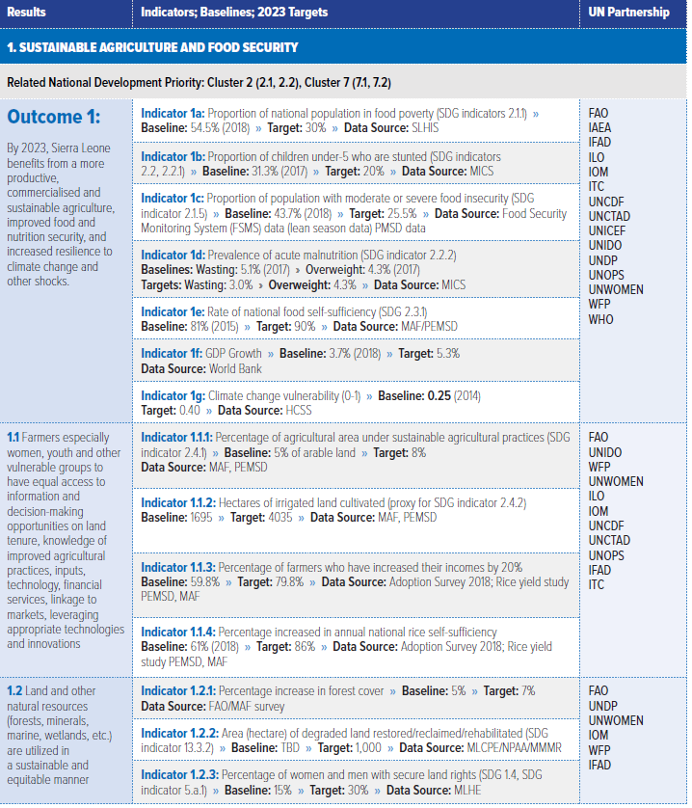

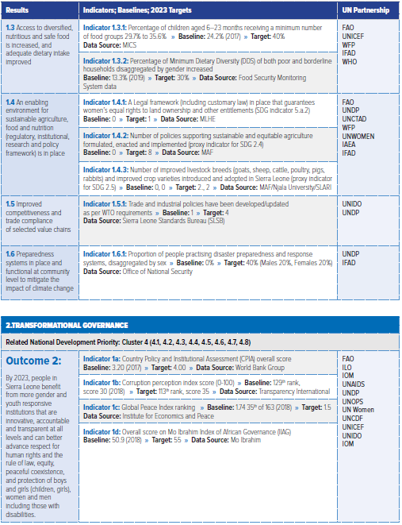
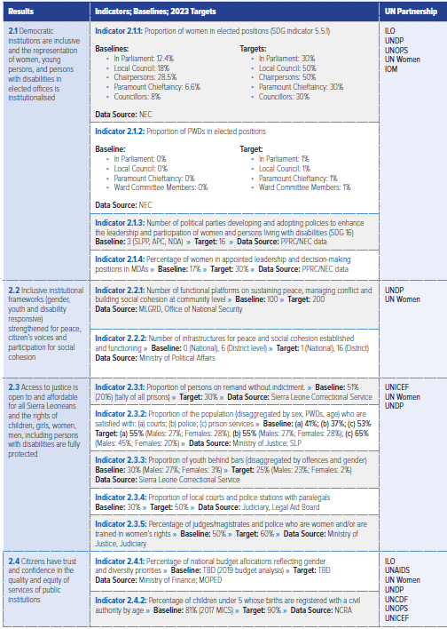
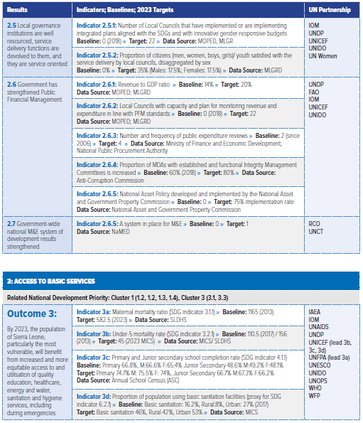

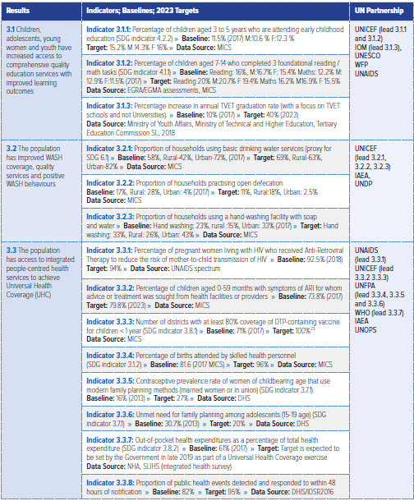

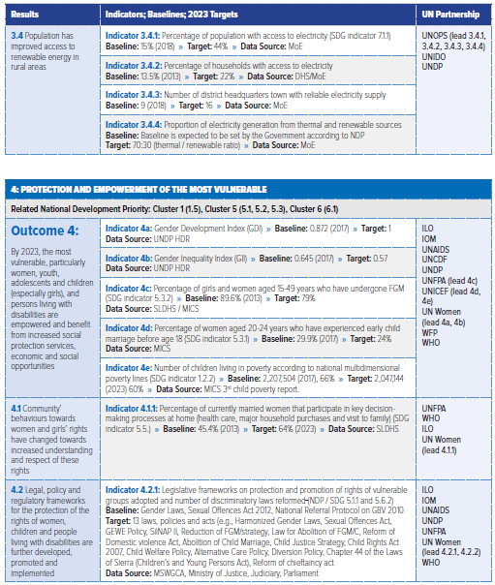

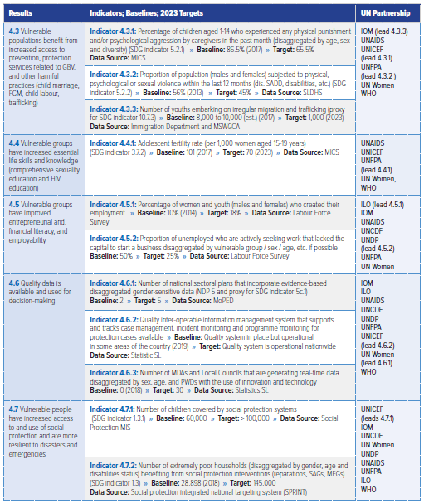

Annex iV – Theory of change
Figure 4 - ToC Outcome 1
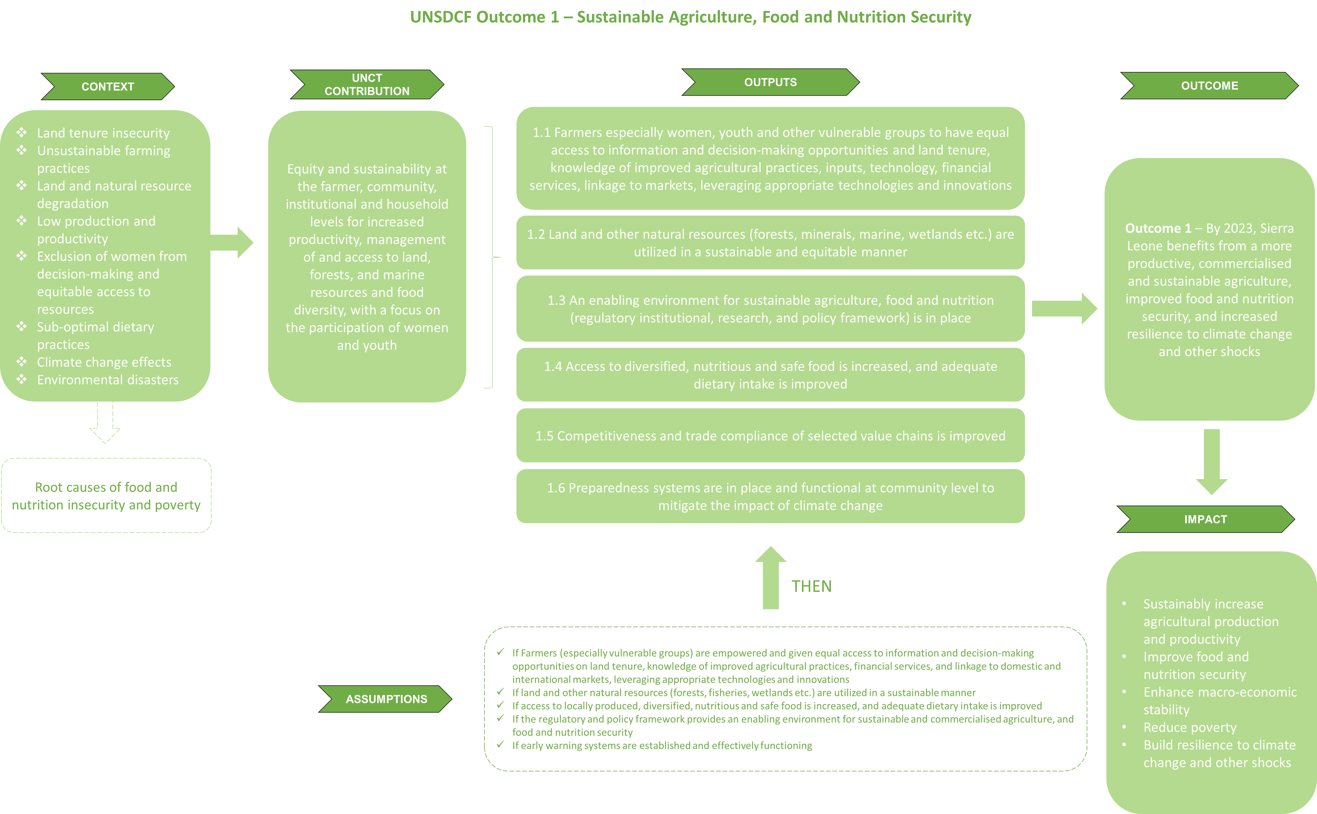

Figure 4Error! Reference source not found. above is a reconstruction of the ToC to achieve Outcome 1 – Sustainable Agriculture, Food and Nutrition Security, and Climate Resilience. The ToC has been reconstructed based on the documentation, and presents only the general theory as initially established. In addition to the ToC, the evaluation team has identified some of the activities implemented by FAO, IAEA, IFAD, ILO, IOM, ITC, UNDP, UNICEF, UNIDO, WFP, and WHO to achieve the expected results:
Table 10 - Examples of activities implemented under Outcome 1
Outputs | Activities implemented (examples)
1.1 | - Trainings on: technical package for rice production, effective use of farming machines for rice and cassava post-harvest production and post-harvest management of rice  - Provided supplies, tools and technical assistance  - Supported valley swam cultivation, Gender Action Learning System with nutrition education, and Good Agricultural Practices certification  - Certified farmers accessed information on best agriculture practices globally to improve the efficiency of farm processes and management  - Youths supported with information, inputs, and technology on sustainable and climate-smart agriculture, fishery, and agribusiness.  - Financial services and support from financial institutions  - Training on financial management, group cohesion and business principles  - Seed fund  - Road rehabilitation  - strengthened governance, sustainable management of fisheries, farmer group mobilization and management, and electrification efforts towards increased livelihood and income through access to technology, finance and markets.
1.2 | - Training on geospatial technology with landowner, land users, local authorities, CSOs, the Ministry of Lands and other Ministries, Departments and Agencies (MDAs)  - Supported post-harvest management of fish  - Supported Government to develop policy and regulatory frameworks affecting enabling environment  - Supported NWRMA to delineate and map out water catchments and sub-catchments areas  - Rehabilitated of degraded land.  - Rested of wetlands.  - Established climate information and early warning systems at community/district level  - Supported government for conservation and protection of protected areas/forest  - Supported to develop the National Blue Economy Framework  - Enhanced capacities of District Council for integration of the Nationally Determined Contributions (NDCs)
1.3 | - School feeding programmes  - Home grown school feeding programme  - Investment in food system strengthened  - Capacity of key food system actors strengthened  - National Nutrition Policy 2022-2031 of the MoHS finalized  - Research completed to support development of an adolescent nutrition strategy  - Health staff capacitated on the management of severe acute malnutrition  - Implementation of Baby Friendly Hospital Initiative
1.4 | - Strengthened research and policy development capacity of domestic financing, agriculture, food and nutrition institutions  - Completion of the National Multi-Sectoral Nutrition Information Strategy and Nutrition Surveillance Guidelines  - Supported the Ministry of Fisheries and Marine Resources in constructing fish landing infrastructure, hygiene facilities, and liquid waste treatment  - Ensured quality Food Security Monitoring System  - Supported international standardization processes, provision of equipment and qualification of internationally certified auditors
1.5 | - Use of new varieties of cocoa  - Establishment of field schools  - Mapping value chain actors  - ISO certification of SMEs  - Developed sector and market studies in cassava, cocoa, and palm oil value chains to affect policy development and business creation
1.6 | - Established district and chiefdom-level disaster preparedness mechanism and enhanced the capacity of the members  - Pilot of a Disaster Risk Reduction and Climate Change Adaptation and Integrated Human Mobility Assessment Tool  - Training of district council's staff  - Launched of the Climate Information Disaster Management and Early Warning System (CIDMEWS)  - Disaster risk reduction management guidelines piloted  - Implementation of disaster mitigation measures  - Integrated coastal zone management plan  - Rehabilitation of degraded mangrove forest  - Radio discussions on disaster preparedness, mitigation, response etc.

Figure 5 - ToC Outcome 2
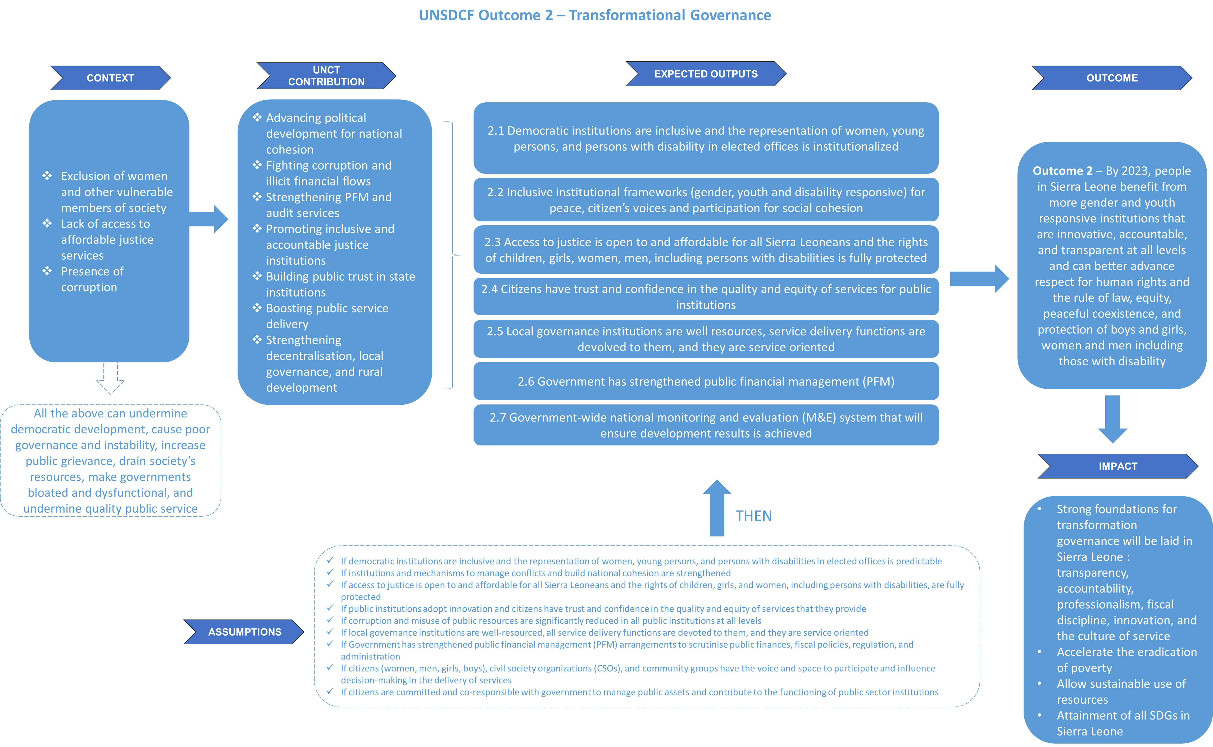
Figure 5 above is a reconstruction of the ToC to achieve Outcome 2 - Transformational Governance. The table below presents some of the activities implemented by ILO, IOM, UNAIDS, UNCDF, UNDP, UNICEF, UNIDO, UNODC, UNOPPS, and UN Women under Outcome 2 between 2020 and 2022.
Table 11 - Examples of activities implemented under Outcome 2
Outputs | Activities implemented (examples)
2.1 | - Strengthened the capacity of the Electoral Commission  - Supported the review of laws that hindered gender equality and women’s empowerment  - Supported the revision Criminal Procedure Act to give way to proper procedural involving youths in contact with the law  - Revision of the Parliamentary Standing Order  - Supported the instalment of new ICT infrastructural system, retrofitting electrical system, health and safety equipment  - Set-up a mentorship programmes in schools to prepare young women and girls for leadership  - Provided equipment to Chiefdom Youth Councils and the District Youth Councils to enhance their participation in the local development agenda as well as capacity building effort on leadership and ability to make meaningful contribution in decision making processes  - UN Women scaled up its communication and advocacy
2.2 | - Trainings, and awareness raising activities for youths and women on civic rights and responsibility  - Supported the revision of the Child Rights Act  - Supported the mid-term review of the MTNDP  - Supported the development of the 'Patient's Charter'  - Increased access to social protection assistance to PLHIV and KPs through establishing a partnership agreement  - Developed and operationalized the Multi-year Plan to Remove Human Rights-Related Barriers to HIV and TB Services (2021-2024)  - Provided technical, advisory, and financial support to Sierra Leone to reactivate the implementation of SILNAP II
2.3 | - Provided services to victims of violence and supporting the Judiciary, lawyers and law enforcement agencies  - Contributed to improve legal representation resulting to increase convictions for sexual offences  - Supported the training of officers on the revised SGBV protocol  - Supported the incorporation of child protection and child justice components in Sierra Leone Police Academy Recruitment and In-Service training curricula  - Supported the review of Criminal Procedure Act and SLCS Act  - Supported with capacity building of the correction service staff on the application of the Mandela rule and international Human Rights standard and best practice in the auditing of inmates
2.4 | - Supported the quality of public services for the registration of migrants, births, and deaths and delivery of health and justice services  - Completed the Global Aid Monitoring Report  - Provided capacity and technical support to the NCRA  - Supported the instalment of a central IT Infrastructural system for the National Civil Registration Authority  - Provided technical advisory and financial support to institutional and legal reforms of the justice sector  - Supported the development and validation of a Data Protection and Privacy Policy, Bill and Regulations  - Contributed to the enactment of 8 Acts (Gender Equality & Women’s Empowerment (GEWE), Data Protection, National Civil Registration Authority (NCRA), Political Parties Registration & Regulation Commission (PPRC), Public Elections (PEA) National Land Commission, Customary Land Rights, Anti-Human Trafficking and Migrant Smuggling)  - Contributed to 9 policies, frameworks, Standard Operating Procedure and Guidelines (Migration Governance profile, Registration and Conferral of Legal identity to Refugees & Return Migrants SOP; GBV & Case Management SOP, National Community Health Workers Policy, Global Compact on Migration (GCM) guideline, Parliamentary standing Order, Medium-Term Revenue Strategy and the National tax policy),  - Contributed to Sierra Leone achieving a number of global standards and improved rankings like the Corruption Perception Index, Global Peace index Mo Ibrahim index of African Governance and an overall high score in implementing the 2019 EITI Standard (87.5 points) in 2022  - Facilitated strategic engagements with global and national stakeholders to contribute to effective resource mobilization for MoHS
2.5 | - Contributed to local service delivery and institutional strengthening of local councils  - Supported MoPED to review and update district councils' development plans  - Supported MoPED to pilot and roll-out functioning of District Development Coordination Committees  - Supported the development of a framework on comprehensiveness of city migration governance structures and priorities for the way forward  - Supported the Ministry of Trade and Industry with technical trainings
2.6 | - Supported the development of Medium-Term Revenue Strategy and a National Tax Policy  - Supported MOPED to maintain and sustain the development assistance database  - Capacitated fiduciary staff for revenues and expenditure forecasting, collection strategies, and reporting  - Produced a brief on Multidimensional Vulnerability Index for informal businesses  - Supported the design and implementation of the Sierra Leone Integrated Financing Framework (INFF)  - Strengthened the capacity of Bank of Sierra Leone through online training courses
2.7 | - Contributed to supporting government institutions with key monitoring and evaluation frameworks  - Contributed to establish a M&E unit at the Ministry of Planning and Economic Development  - Supported the development of a digital national SDGs Monitoring Platform hosted by Statistics Sierra Leone  - Contributed to capacity strengthening of the newly established National Monitoring and Evaluation Directorate (NaMED)  - Supported the submission of the third inclusive and participatory Voluntary National Review (VNR)

Figure 6 - ToC Outcome 3
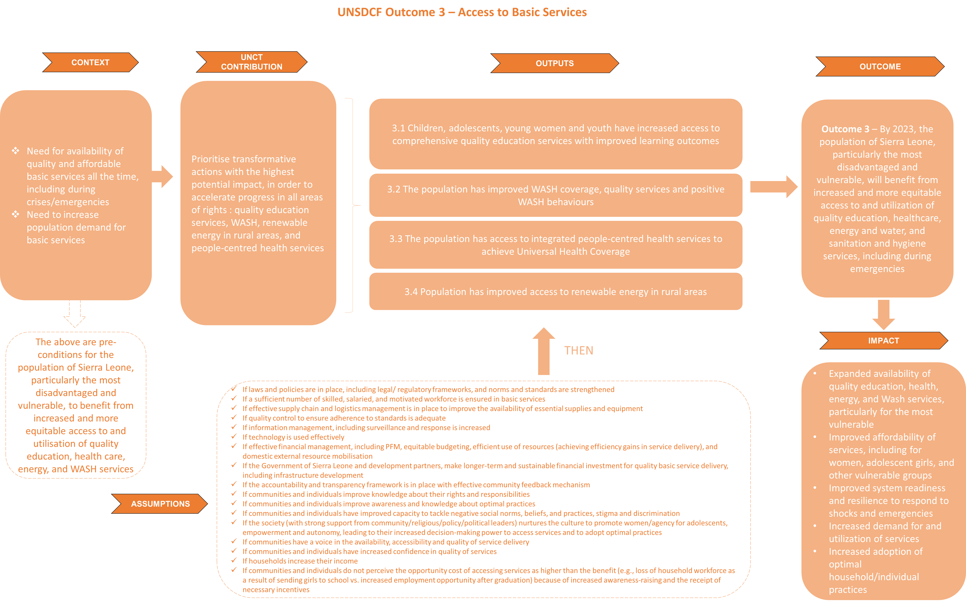
Figure 6 above is a reconstruction of the ToC to achieve Outcome 3 - Access to Basic Services. The table below presents some of the activities implemented by IAEA, IOM, UNAIDS, UNESCO, UNDP, UNICEF, UNFPA, UNIDO, UNOPS, and WHO under Outcome 3 between 2020 and 2022.
Table 12 - Examples of activities implemented under Outcome 3
Outputs | Activities implemented (examples)
3.1 | - Supported the government in terms of policies, strategies, and initiatives (e.g. Education Sector Plan 2022-2026, National Out-of-School (OOS) Children Strategy, 'Reimagine Education Agenda')  - Establishment of a regional center of excellence for automotive training in Freetown  - Institutional support to three vocational centers  - Set up a learning assessment unit at the Ministry of Basic and Senior Secondary Education  - Training of faculty members of the Government Technical Institute  - Provided teacher trainings  - Initiated in collaboration with the WB an Education Public Expenditure Review (PER)  - Launched the UPSHIFT programme  - Supported resilience of schools to respond to COVID-19  - Provided vocational skills enhancement to vulnerable youth
3.2 | - Development of policy and institutional frameworks, capacity building of partners, and evidence generation using real-time data for planning, monitoring, and resource mobilization  - Improved coverage and quality of WASH services for rural and poor urban households and institutions  - Improved learning and quality of care services within schools and health facilities through strengthening intersectoral collaboration between WASH and Education to deliver higher impact for children  - Supported the Government to roll out the implementation of the National Strategy on Sanitation and Hygiene Promotion  - Constructed solar-powered motorized water supply facilities in communities, schools and Healthcare facilities (HCF)
3.3 | - Supported the review, update, and development of health sector laws and policies that contributed to improved access to quality and patient safety health services.  - The Public Health Bill, and the Tobacco and Nicotine Bill, have been enacted into law with the support and advocacy of UN agencies.  - National guiding documents including policies, strategic plans, guidelines, and tools have been developed and contributed to the Government’s vision for achieving Universal Health Coverage  - Organised of the First National Health Summit  - Strengthened the capacity to deliver quality comprehensive reproductive, maternal, new-born child and adolescent health plus nutrition  - Quality of RMNCAH service delivery was strengthened and scaled up through development of Family Planning Policy, Guidelines, and Integrated Basic Emergency Obstetric and Newborn Care Guidelines, that provide policy and strategic framework for provision of RMNCAH services  - Supported policy dialogue  - Improved skills of family planning providers in health facilities p.34  - Supported conduct of National SRHR Summit  - Supported improvement of Quality of Care (QoC) of health services by strengthening leadership and management for QoC at national and hospital levels, organisation of a national QoC summit, capacity building of health workers on quality improvement (QI) methodologies, conduct of child death audit including mortality conference, and development and rolling out of MNH Implementation Package  - Completed the construction of one Basic Emergency Obstetric Neonatal Care Facility at Jojoima Health Centre (Kailahun District) and formally handed it over to the MoHS in December 2022.  - UN supported improvement in human resources for health by facilitating the development and roll out of the Post-Graduate Paediatrics Course, Post-Basic Neonatal Nursing Programme, and MNH package of care.  - Strengthened the capacity for health supply chain management, last mile assurance, and monitoring of the utilization of health care commodities and equipment, vaccines, RHFP and HIV commodities, and nutrition therapeutics  - Strengthened government capacity through surveillance systems, laboratory capacity, antimicrobial stewardship, and infection prevention and control  - Supported the government and partners in updating and implementing the national comprehensive multi-year plan for immunization (CMYP) and annual implementation plans  - Supported the government and partners in achieving and sustaining vaccine preventable disease (VPD) surveillance performance indicators.  - Supported the efforts to increase access to quality and safe health care technologies, including medical devices, mHealth, laboratories, medicines, vaccines, procedures, and systems  - Supported the integration of COVID-19 vaccination and HPV vaccine introduction during the immunization campaign
3.4 | - Supported the people of Sierra Leone to access increased clean and renewable energy in rural areas following the ratification of mini-grid regulations in 2020.  - Used and developed PPP initiative to invest in and maintain mini grid-based electricity generation and distribution  - Strengthened the institutional capacity of Ministry of Energy personnel to facilitate and sustain mini-grid development in Sierra Leone  - Strengthened the reporting system of the Electricity and Water Regulation Commission and provided technical assistance to the Sustainable Energy for All Programme.  - Increased demand for electricity through the stimulation of market development of productive use of energy by providing matching grants

Figure 7 - ToC Outcome 4
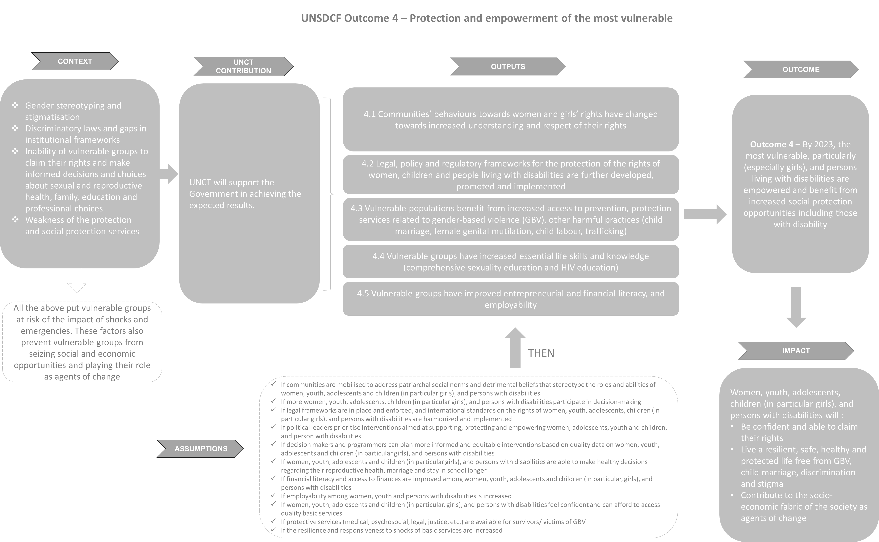
Figure 7 above is a reconstruction of the ToC to achieve Outcome 4 - Protection and empowerment of the most vulnerable. The table below presents some of the activities implemented by ILO, IOM, ITC, UNAIDS, UNCDF, UNDP, UNESCO, UNFPA, UNICEF, UNODC, UNWOMEN, WFP and WHO under Outcome 4 between 2020 and 2022.
Table 13 - Examples of activities implemented under Outcome 4
Outputs | Activities implemented (examples)
4.1 | - Awareness and community advocacy drives in communities  - Establishment of "husband" schools to enhance the capacity of men to lead community sensitizations and advocacy on GBV  - Training of men advocates and peer educators  - Development and roll out of a national curriculum on positive parenting  - Strengthened the capacity of the National Secretariat for the Reduction of Teenage Pregnancy and Child Marriage
4.2 | - Contributed to national progress with the enactment of the GEWE Act, 2022 and the review of the National Strategy for Reduction of Adolescent Pregnancy and Child Marriage  - Enhanced the capacity of stakeholders on the 2022 GEWE Act operational strategy  - Establishment of a multi-stakeholder coordination mechanism to support consultations, mobilized Members of Parliament and built their capacity on the Convention on the Rights of Persons with Disability  - Support the Ministry of Labour and Social Security to review the National HIV/AIDS in the Workplace Policy  - Supported the development of a Social Work Bill (2022)  - Supported the development of the Child Rights Coalition  - Supported the inclusion of implementation of international labour standards  - Supported MOYA to finalise and launch the National Youth Policy  - Supported NAYCOM to produce the Status of Youth Report 2020-2021  - Supported MoSW to develop and sign MoUs with Colleges and Universities to ensure social work students are assigned to placement agencies  - Supported the revision and adoption of the National Action Plan for the Elimination of Child Labour
4.3 | - Provided technical and financial support to the government to increase access to quality services related to protection, GBV and other harmful practices  - Strengthened the capacity of institutions to promote gender equality, prevent and respond to SGBV, and eliminate harmful practices  - Strengthened the capacity of government and community-based organisations service providers to improve case management and demand generation for SRHR, family planning services, and response services for victims of GBV respectively.  - Supported provision of legal aid services and representation to enhance access of SBGV survivors to justice  - Supported psycho-education on the bio-psychosocial effects of drug abuse  - Supported MoSW to train social workers to use case management tools and provide MHPSS and Psychological First Aid services integration of the Nationally Determined Contributions (NDCs)  - Provided psycho-social counselling to youth and women
4.4 | - Supported the MBSSE roll out of comprehensive sexuality education in schools  - Strengthened engagement with women farmers including women living with AIDS resulting to increased knowledge on SGBV, HIV, and SRH  - Supported Action Plans for increased awareness raising and sensitization  - Supported Sierra Leone to become the first country to officially announce government leadership and support for the Education Plus Initiative (EPI)  - Improved knowledge on key life skills of girls
4.5 | - Supported efforts on rural SMEs, improved skills, employability and incomes of women and young people through knowledge transfer in various technologies and innovation areas  - Training rural dwellers  - Training, transfer of technology, and economic empowerment for job creation of youth and women from engaged project road contractors  - Establishment of fish farms  - Supported entrepreneurs to enhance business development skills and financial literacy  - Supported Mobile Money Operators  - Supported the development of Consumer Protection Guidelines  - Supported the government in establishing the National Youth Empowerment Fund  - supported career development, for vulnerable youths to promote youth and young women empowerment and entrepreneurship  - Supported the establishment of Village Loan and Saving Associations and provided seed money.  - Provided COVID-19 Stimulus packages in the form of grants and technical assistance  - Establishment of skill training centers  - Established partnerships with 5 government universities to create space at the university for supporting innovative, scalable, and impactful entrepreneurship to solve the country’s development challenges
4.6 | - Supported the report no enablers and drivers of women’s participation in revenue mobilization  - Supported the finalization and dissemination of the 2021 integrated Bio-behavioural Surveillance Survey  - Supported the government in updating the multidimensional child poverty estimates  - supported the generation of rich data including HIV epidemiological estimates, Spectrum, Global AIDS Monitoring (GAM), Integrated Bio-behavioural Surveillance Survey (IBBSS), impacts of diseases, social dynamics and drivers of violence and harmful practices, HIV profiling and vulnerability assessment, survey on social and behavioural drivers of child marriage, the Situational Analysis for people with disability, system management of the Child Protection IMS (CPIMS), school-related gender-based violence action research, and SPRINT for social protection
4.7 | - Supported the development of strong policy framework to strengthen vulnerable populations’ social protection  - Supported the Government in finalizing the National Social Protection Strategy and validating the National Social Protection Bill  - Continue supporting the Social Safety Net Grievance Response Mechanism (GRM)  - Strengthened capacities of women as well as coastal communities  - Supported awareness raising for CSOs  - Increased the capacity of individual, communities, and authorities to deal with the adverse effects of a disaster (cash transfer)  - Procured and installed a small-scale waste treatment system  - Provided energy-efficient cooking stoves to school

Annex V – data collection protocols

Key Informant Interviews
Evaluation Of The United Nations Sustainable Development Cooperation Framework (Unsdcf) 2020-2024 End Of Cycle, Sierra Leone
Interview notes by:
Organisation interviewed:
Name and function:
Location:
Date:

Interview instructions:
- Focus groups and interviews will normally last between 90 and 120 minutes. It should not exceed 120 minutes.
- Semi-structured interviews with UNCT member may last around a little longer, as the questions are more numerous.
- Prior to each interview or focus group, the evaluator must obtain the informed consent of the participants as follows:
Greetings, introduction of the evaluator and thank you for your availability.
As agreed, we are here to solicit your contribution to the evaluation of the UNSDCF supported by the UN. This is a confidential and independent exercise, i.e. as an evaluator I am not attached to the UN or any other organisations involved in the implementation of the UNSDCF. I have been commissioned by an external consultancy firm.
The partners who work with you are constantly seeking to improve the quality and relevance of their actions. This is why the time has come to take stock and assess the extent to which the programme has been able to support and equip the beneficiaries towards greater autonomy and enhanced well-being.
For beneficiaries and community members: We'd like to talk to you about the activities you've been involved in, why they were or weren't relevant, what major challenges you're facing, what the next step should be to consolidate your development efforts, and so on. It's an open discussion.
Your participation is voluntary, and you can end the discussion at any time. The duration of the discussion can vary from 1 to 2 hours. The information shared is confidential, and notes are taken for the purpose of faithfully transcribing the ideas and information retained, without citing their sources.
Do you understand the purpose of the evaluation process?
Do you agree to participate on a voluntary basis?

- The evaluator should ask all the questions in each protocol, and ask the questions as they are written.
- It's very important to tell respondents that the changes they've observed can be positive or negative, and that we want to know about all the types of changes they've observed. There are no "right" or "wrong" answers - all answers are correct, we just want to know what they think and what's important to them.
- When (and if) you ask probing questions following a response, the evaluator needs to make sure to ask only neutral questions, not leading questions, as this may prompt the interviewee to answer what you suggest.
- The evaluator needs to take into account that some stakeholders like beneficiaries might not be aware of the term UNSDCF or what it entails.

Interview Notes:
Background: Interviewee’s general background; Nature and dates of interviewee’s involvement with the project.
Topics: Record responses by topic with clear headings – using the Eqs where possible, not necessarily in chronological sequence of discussion. Make clear when a direct quote is recorded. Add headings and sub-headings as needed and/or record against evaluation criteria.
Data/documents provided/recommended: Seek full references for documents not already in evaluation team library.
Other proposed follow-up: e.g. other interviewees recommended (obtain full contact details) / proposals on consultation and dissemination etc.

Interviews : UNCT Members
For all questions related to Strategic Areas or Outcomes, ask the person representing the UN Agency if she/he is knowledgeable about all of them or only the ones its agency have been involved in, and then adapt the questions.
Identification
Could you please briefly describe your role/responsibilities at xx? What was your involvement in the UNSDCF and tell us a bit more about the programme in general?
Relevance
R1. | Regarding the design and implementation of the CF, to what extent would you say that it has integrated the key issues and development challenges identified by the UN CCA?  Can you maybe provide one or two examples of how these identified issues and challenges have influenced the decision-making processes, strategies, and activities within the CF?
R2. | In your opinion, to what extent would you say that the CF has integrated the three cross-cutting dimensions (i.e promotion of gender equality and women’s empowerment, promotion of human rights, including disability inclusion, promotion of environmental sustainability objectives) in its design and implementation?  Can you provide specific examples of how each of these elements has been incorporated into the CF?  Do you have any recommendations on how to improve the integration of these dimensions in the next UNSDCF?  Prompts: for example in terms of goals, objectives, strategies, activities, indicators, gender-specific goals and targets, indicators that measure explicit recognition of human rights principles, disability-inclusive goals and targets, any indicators related to climate change mitigation, natural resource management etc.
R3. | In your opinion, would you say that the CF objectives are aligned with the needs, priorities, and policies of the government?  Can you provide examples to support your answer?  Do you have any recommendations on how to align better with the needs, priorities, and policies of the government?  Prompts: alignments in terms of :  - policy integration i.e. the extent to which the objectives of the CF align with existing national policies, strategies, and development plans or Demonstrated coherence between the CF objectives and government’s priorities as stated in official policy documents  - Stakeholder involvement: level of involvement of government officials etc. in the development and review of the CF objectives, existence of mechanisms for ongoing engagement  - Resource allocation: extent to which the government provides financial or non-financial resources to support implementation of the CF
R4. | In your opinion, would you say that the CF objectives are aligned with the needs and priorities of the rights holders, especially the most vulnerable?  Can you provide examples to support your answer?  Do you have any recommendations on how to align better with the needs and priorities of the rights holders, especially the most vulnerable ?  Prompts:  - Stakeholder engagement: rights holders and representatives of vulnerable groups involved in the development and review of the CF objectives, Number and diversity of stakeholder consultations conducted to gather input and feedback on the objectives, Existence of mechanisms and continuous engagements  - Inclusiveness and representation: objectives that explicitly address the needs and concerns of vulnerable groups, Representation of vulnerable groups in decision-making bodies or committees responsible for defining the objectives, availability of disaggregated data on the participation and representation of vulnerable groups in the development of the framework  - Needs and priorities assessment: Evidence of the integration of findings from needs assessments into the objectives of the Country Framework, adequate consideration of intersectional vulnerabilities and specific challenges  - Policy alignment: Demonstrated coherence between the objectives and internationally recognized human rights standards and principles, Clear references to relevant international conventions, agreements, or guidelines that address the concerns of the most vulnerable groups
Adaptability
A1. | In your opinion, to what extent did the implementation of the CF adjust to emerging issues faced by the country during the implementation? Can you list the main emerging issues?  Can you provide examples of how the CF adapted its strategies, activities, and partnerships to address these emerging issues and ensure continued progress towards its objectives in light of the challenges posed by the pandemic?  Do you have any recommendations?  Prompts:  - Budget adjustments, resource allocation: Evidence of reallocation of resources (financial and human) from less critical areas to address emerging issues  - Stakeholder engagement: Evidence of methods for managing stakeholder participation and inclusiveness in times of crisis and evidence of collaborative efforts and partnerships to tackle emerging issues
A2. | Building on the previous question, to what extent do you think that the M&E strategies of the CF adjust to emerging issues?  Can you provide examples?  Do you have any recommendations?  Prompts:  - Evidence of proactive monitoring and early detection of emerging issues (timeliness of response) (relies on the availability of real-time data)  - Evidence and example of a flexible M&E framework that allows for adjustments and revisions to indicators, targets, and methodologies in response to emerging issues.  - Inclusion of specific sections or reports within the M&E framework dedicated to monitoring and reporting on emerging issues faced by the country.
Coherence
C1. | In your opinion, to what extent have the partnerships with civil society organisations, private sector entities, local government, and international development partners contributed to the overall results achieved by the CF?  Can you provide some insights into the collaborative efforts and contributions made by these partners in terms of resource mobilization, expertise sharing, innovative solutions, and coordinated actions that have played a role in achieving the desired outcomes of the CF?  Do you have any recommendations? (specific stakeholders with whom the partnerships need to be strengthened?)
Effectiveness
E1.1. | In your opinion, has outcome 1 been achieved at a satisfactory level?  Can you elaborate and provide examples?  Do you have any recommendations?  Outcome 1 = By 2023, Sierra Leone benefits from more productive, commercialized and sustainable agriculture, improved food and nutrition security, and increased resilience to climate change and other shocks
E1.2. | In your opinion, has outcome 2 been achieved at a satisfactory level?  Can you elaborate and provide examples?  Do you have any recommendations?  Outcome 2 = By 2023, people in Sierra Leone benefit from more gender and youth responsive institutions that are innovative, accountable, and transparent at all levels and can better advance respect for human rights and the rule of law, equity, peaceful coexistence, and the protection of boys and girls, women and men including those with disabilities
E1.3. | In your opinion, has outcome 3 been achieved at a satisfactory level?  Can you elaborate and provide examples?  Do you have any recommendations?  Outcome 3 = By 2023, the population of Sierra Leone, particularly the most disadvantaged and vulnerable, will benefit from increased and more equitable access to and utilization of quality education, health care, energy and WASH services, including during emergencies
E1.4. | In your opinion, has outcome 4 been achieved at a satisfactory level?  Can you elaborate and provide examples?  Do you have any recommendations?  Outcome 4 = By 2023, the most vulnerable, particularly women, youth, adolescents and children (especially girls), and persons with disabilities, are empowered and benefit from increased social and economic opportunities
E2. | What are, in your opinion key internal and external factors that have contributed to the attainment of the intended results?  Prompts:  - Internal factors: leadership and governance, coordination and collaboration, internal capacity, financial management etc.  - External factors: government commitment and support, stakeholder engagement, socioeconomic and political context, legislative and policy environment
E2. | What are, in your opinion key internal and external factors that have hindered the attainment of the intended results?  Prompts:  - Internal factors: leadership and governance, institutional capacity, coordination and collaboration, resource management, M&E, knowledge management  - External factors: political instability, economic factors, environmental factors, external conflict or security issues, global or regional economic issues, legal and regulatory environment, stakeholder engagement
E3. | What would you say are expected outcomes (positive or negative) as stated in the CF that have been yielded as a result of its intended goals and objectives?  Can you provide evidence and examples of how the CF's actions, strategies, and partnerships have directly contributed to the realization of the expected outcomes outlined in the CF document?
E3. | What are unexpected impacts (positive or negative) that have been a result of the CF?  Prompts:  - Unforeseen social or cultural changes  - Environmental impacts  - Economic disparities  - Unintended consequences for vulnerable populations
E4. | Would you say that the rights holders and institutions, including the most vulnerable, disadvantaged and marginalized population benefitted from the CF’s results?  Can you provide examples?  Prompts:  - In terms of : access to basic services, social inclusion, poverty reduction, human rights protection, participation and representation, reduction of vulnerabilities
Efficiency
E1.1. | In your opinion how efficient was the programme in utilizing its financial resources?  Any recommendations?  Prompts:  - Planned vs actual expenditures  - Capacity to prioritize activities based on the needs (demand side) rather than on the availability of resources (supply side)  - Value for money
E1.2. | In your opinion how efficient was the programme in utilizing its human resources?  Any recommendations?  Prompts:  - Staff utilization rate  - Cost-effectiveness of the human resources vs outputs/outcomes achieved
E1.3. | In your opinion, would you say that the CF has been implemented and achieved in a timely way i.e. as planned?  Why or why not?  Any recommendations?  Prompts:  - Implementation progress in terms of planned outputs and activities  - Evidence and reasons of delays in activities’ implementation
E1.4. | In your opinion, would you say that the M&E system ensured results-based management and efficient, effective implementation?  Do you have any recommendations?  Prompts:  - Data accessibility, timeliness of data availability, tools and technology utilization, communication mechanisms, reporting quality, relevance of objectively verifiable indicators including cross-cutting themes, feedback processes
Coordination
Co1.1. | In your opinion, would you say that the CF fostered internal coordination through the promotion of synergies and interlinkages between its interventions (to maximized efficiency, coverage and avoid overlaps)? Can you elaborate on the synergies vs overlap?  Can you provide examples?  Do you have any recommendations?  Prompts:  - Resource optimization and efficiency through coordination  - Mechanisms or platforms for information and knowledge sharing between key partners  - Strategy to reduce overlaps => The World Bank also has a Country Partnership Framework in Sierra Leone, how do you ensure that there are no overlaps in your (UNCT and WB) interventions?
Co1.2. | Would you say that the CF aligns with the strategic priorities of the UN Agencies in general? Of your Agency?  Prompts:  - Alignment between the goals and objectives  - Alignment between the programmes and initiatives implemented by the CF and the thematic areas and focus of the UN Agencies
Co2. | In your opinion, did the different UN Agencies contributed to the functioning and consolidation of UNCT coordination mechanisms?  What could worked? What could be improved?  Prompts:  - Functionality and effectiveness of coordination mechanisms such as Results Groups, Joint Programmes, Project Management Teams (PMT), Operations Management Teams (OMT) and other mechanisms in ensuring collaboration and coordination to ensure Delivering as One principles  - Participation rate, collaboration and information sharing, adherence to coordination mechanism decisions, support for joint programming etc.
Co3. | In your opinion, did the Joint Steering Committee ensured efficient coordination between the Government and the UNCT?  What could worked? What could be improved?  Prompts:  - In terms of meeting frequency and timeliness, participation (engagement), decision-making and coordination, communication and information sharing, satisfaction
Orientation towards Impact
I1.1. | Would you say that Strategic Area 1 “sustainable agriculture and food security” has contributed to a) promotion of gender equality and women’s empowerment, b) promotion of human rights, including disability inclusion, c) promotion of environmental sustainability objectives? Any examples?  What would be your recommendations?
I1.2. | Would you say that Strategic Area 2 “transformational governance” has contributed to a) promotion of gender equality and women’s empowerment, b) promotion of human rights, including disability inclusion, c) promotion of environmental sustainability objectives? Any examples?  What would be your recommendations?
I1.3. | Would you say that Strategic Area 2 “Access to basic services” has contributed to a) promotion of gender equality and women’s empowerment, b) promotion of human rights, including disability inclusion, c) promotion of environmental sustainability objectives? Any examples?  What would be your recommendations?
I1.4. | Would you say that Strategic Area 4 “Protection and empowerment of the most vulnerable” has contributed to a) promotion of gender equality and women’s empowerment, b) promotion of human rights, including disability inclusion, c) promotion of environmental sustainability objectives? Any examples?  What would be your recommendations?
Sustainability
S1. | In your opinion, to what extent has Strategic Area 1 “sustainable agriculture and food security” contributed to building national and local capacities and ensuring long-terms gains?  Do you have any examples?  Any recommendations?  Prompts:  - i) institutional capacity of national and local agricultural and food security agencies, ii) knowledge and skills development of farmers and other stakeholders, iii) adoption of sustainable farming practices, iv) access to resources and technologies, v) building resilience to climate change within the agricultural sector, vi) income and livelihood improvement, vii) sustainable land management, viii) changes in food production, availability, accessibility and utilization, ix) strengthening of farmer organisations and cooperatives, x) M&E systems at national and local level
S1. | What are the main risks that might impact the sustainability? How would you mitigate them?
S2. | In your opinion, to what extent has Strategic Area 2 “transformational governance” contributed to building national and local capacities and ensuring long-terms gains?  Do you have any examples?  Any recommendations?  Prompts:  - i) institutional capacity of national and local governance institutions as a result of Strategic Area 2, ii) impact of the CF on policy and legal reforms at the national and local levels, iii) contributed to enhancing citizen participation and engagement in decision-making processes, iv) anti-corruption measures, v) improvements in data and information systems, vi) service delivery and public administration etc., vii) M&E systems at national and local level
S2. | What are the main risks that might impact the sustainability? How would you mitigate them?
S3. | In your opinion, to what extent has Strategic Area 3 “access to basic services” contributed to building national and local capacities and ensuring long-terms gains?  Do you have any examples?  Any recommendations?  Prompts:  - i) institutional capacity of national and local service delivery agencies, ii) policy and regulatory reforms that promote access to and quality of basic services, iii) human resource development to enhance the skills and knowledge of service providers, iv) improvement in infrastructure development, v) service delivery performance, vi) inclusive service delivery, vii) M&E systems at national and local level
S3. | What are the main risks that might impact the sustainability? How would you mitigate them?
S4. | In your opinion, to what extent has Strategic Area 4 “Protection and Empowerment of the most vulnerable” contributed to building national and local capacities and ensuring long-terms gains?  Do you have any examples?  Any recommendations?  Prompts:  - i) changes in the institutional capacity of national and local agencies responsible for the protection and empowerment of the most vulnerable, ii) policy and legal reforms at the national and local levels, iii) provision of capacity development and training programmes, iv) Access to Services and Resources, v) Human Rights Promotion, vi) changes in social inclusion and empowerment of the most vulnerable
S4. | What are the main risks that might impact the sustainability? How would you mitigate them?
Is there anything else you'd like to add that wasn't covered during the interview?

Interviews: Joint Steering Committee Members
For all questions related to Strategic Areas or Outcomes, ask the person representing the Joint Steering Committee if she/he is knowledgeable about all of them or the overall objective(s) of the CF, and then adapt the questions.
Identification
Could you please briefly describe your role/responsibilities at xx? What was your involvement in the UNSDCF and tell us a bit more about the programme in general?
Relevance
R1. | Regarding the design and implementation of the CF, to what extent would you say that it has integrated the key issues and development challenges identified by the UN CCA?  Can you maybe provide one or two examples of how these identified issues and challenges have influenced the decision-making processes, strategies, and activities within the CF?
R2. | In your opinion, to what extent would you say that the CF has integrated the three cross-cutting dimensions (i.e promotion of gender equality and women’s empowerment, promotion of human rights, including disability inclusion, promotion of environmental sustainability objectives) in its design and implementation?  Can you provide specific examples of how each of these elements has been incorporated into the CF?  Do you have any recommendations on how to improve the integration of these dimensions in the next UNSDCF?  Prompts: for example in terms of goals, objectives, strategies, activities, indicators, gender-specific goals and targets, indicators that measure explicit recognition of human rights principles, disability-inclusive goals and targets, any indicators related to climate change mitigation, natural resource management etc.
R3. | In your opinion, would you say that the CF objectives are aligned with the needs, priorities, and policies of the government?  Can you provide examples to support your answer?  Do you have any recommendations on how to align better with the needs, priorities, and policies of the government?  Prompts: alignments in terms of :  - policy integration i.e. the extent to which the objectives of the CF align with existing national policies, strategies, and development plans or Demonstrated coherence between the CF objectives and government’s priorities as stated in official policy documents  - Stakeholder involvement: level of involvement of government officials etc. in the development and review of the CF objectives, existence of mechanisms for ongoing engagement  - Resource allocation: extent to which the government provides financial or non-financial resources to support implementation of the CF
R4. | In your opinion, would you say that the CF objectives are aligned with the needs and priorities of the rights holders, especially the most vulnerable?  Can you provide examples to support your answer?  Do you have any recommendations on how to align better with the needs and priorities of the rights holders, especially the most vulnerable ?  Prompts:  - Stakeholder engagement: rights holders and representatives of vulnerable groups involved in the development and review of the CF objectives, Number and diversity of stakeholder consultations conducted to gather input and feedback on the objectives, Existence of mechanisms and continuous engagements  - Inclusiveness and representation: objectives that explicitly address the needs and concerns of vulnerable groups, Representation of vulnerable groups in decision-making bodies or committees responsible for defining the objectives, availability of disaggregated data on the participation and representation of vulnerable groups in the development of the framework  - Needs and priorities assessment: Evidence of the integration of findings from needs assessments into the objectives of the Country Framework, adequate consideration of intersectional vulnerabilities and specific challenges  - Policy alignment: Demonstrated coherence between the objectives and internationally recognized human rights standards and principles, Clear references to relevant international conventions, agreements, or guidelines that address the concerns of the most vulnerable groups
Adaptability
A1. | In your opinion, to what extent did the implementation of the CF adjust to emerging issues faced by the country during the implementation? Can you list the main emerging issues?  Can you provide examples of how the CF adapted its strategies, activities, and partnerships to address these emerging issues and ensure continued progress towards its objectives in light of the challenges posed by the pandemic?  Do you have any recommendations?  Prompts:  - Budget adjustments, resource allocation: Evidence of reallocation of resources (financial and human) from less critical areas to address emerging issues  - Stakeholder engagement: Evidence of methods for managing stakeholder participation and inclusiveness in times of crisis and evidence of collaborative efforts and partnerships to tackle emerging issues
Coherence
C1. | In your opinion, to what extent have the partnerships with civil society organisations, private sector entities, local government, and international development partners contributed to the overall results achieved by the CF?  Can you provide some insights into the collaborative efforts and contributions made by these partners in terms of resource mobilization, expertise sharing, innovative solutions, and coordinated actions that have played a role in achieving the desired outcomes of the CF?  Do you have any recommendations? (specific stakeholders with whom the partnerships need to be strengthened?)
Effectiveness
E1. | In your opinion, have the outcomes/the CF been achieved at a satisfactory level?  Can you elaborate?  Do you have any recommendations?  Outcome 1 = By 2023, Sierra Leone benefits from more productive, commercialized and sustainable agriculture, improved food and nutrition security, and increased resilience to climate change and other shocks  Outcome 2 = By 2023, people in Sierra Leone benefit from more gender and youth responsive institutions that are innovative, accountable, and transparent at all levels and can better advance respect for human rights and the rule of law, equity, peaceful coexistence, and the protection of boys and girls, women and men including those with disabilities  Outcome 3 = By 2023, the population of Sierra Leone, particularly the most disadvantaged and vulnerable, will benefit from increased and more equitable access to and utilization of quality education, health care, energy and WASH services, including during emergencies  Outcome 4 = By 2023, the most vulnerable, particularly women, youth, adolescents and children (especially girls), and persons with disabilities, are empowered and benefit from increased social and economic opportunities
E2. | What are, in your opinion key internal and external factors that have contributed to the attainment of the intended results?  Prompts:  - Internal factors: leadership and governance, coordination and collaboration, internal capacity, financial management etc.  - External factors: government commitment and support, stakeholder engagement, socioeconomic and political context, legislative and policy environment
E2. | What are, in your opinion key internal and external factors that have hindered the attainment of the intended results?  Prompts:  - Internal factors: leadership and governance, institutional capacity, coordination and collaboration, resource management, M&E, knowledge management  - External factors: political instability, economic factors, environmental factors, external conflict or security issues, global or regional economic issues, legal and regulatory environment, stakeholder engagement
E3. | What would you say are expected outcomes (positive or negative) as stated in the CF that have been yielded as a result of its intended goals and objectives?  Can you provide evidence and examples of how the CF's actions, strategies, and partnerships have directly contributed to the realization of the expected outcomes outlined in the CF document?
E3. | What are unexpected impacts (positive or negative) that have been a result of the CF?  Prompts:  - Unforeseen social or cultural changes  - Environmental impacts  - Economic disparities  - Unintended consequences for vulnerable populations
E4. | Would you say that the rights holders and institutions, including the most vulnerable, disadvantaged and marginalized population benefitted from the CF’s results?  Can you provide examples?  Prompts:  - In terms of : access to basic services, social inclusion, poverty reduction, human rights protection, participation and representation, reduction of vulnerabilities
Efficiency
E1.1. | In your opinion how efficient was the programme in utilizing its financial resources?  Any recommendations?  Prompts:  - Planned vs actual expenditures  - Capacity to prioritize activities based on the needs (demand side) rather than on the availability of resources (supply side)  - Value for money
E1.2. | In your opinion how efficient was the programme in utilizing its human resources?  Any recommendations?  Prompts:  - Staff utilization rate  - Cost-effectiveness of the human resources vs outputs/outcomes achieved
E1.3. | In your opinion, would you say that the CF has been implemented and achieved in a timely way i.e. as planned?  Why or why not?  Any recommendations?  Prompts:  - Implementation progress in terms of planned outputs and activities  - Evidence and reasons of delays in activities’ implementation
E1.4. | In your opinion, would you say that the M&E system ensured results-based management and efficient, effective implementation?  Do you have any recommendations?  Prompts:  - Data accessibility, timeliness of data availability, tools and technology utilization, communication mechanisms, reporting quality, relevance of objectively verifiable indicators including cross-cutting themes, feedback processes
Coordination
Co1.1. | In your opinion, would you say that the CF fostered internal coordination through the promotion of synergies and interlinkages between its interventions (to maximized efficiency, coverage and avoid overlaps)? Can you elaborate on the synergies vs overlap?  Can you provide examples?  Do you have any recommendations?  Prompts:  - Resource optimization and efficiency through coordination  - Mechanisms or platforms for information and knowledge sharing between key partners  - Strategy to reduce overlaps => The World Bank also has a Country Partnership Framework in Sierra Leone, how do you ensure that there are no overlaps in your (UNCT and WB) interventions?
Co2. | In your opinion, did the different UN Agencies contributed to the functioning and consolidation of UNCT coordination mechanisms?  What could worked? What could be improved?  Prompts:  - Functionality and effectiveness of coordination mechanisms such as Results Groups, Joint Programmes, Project Management Teams (PMT), Operations Management Teams (OMT) and other mechanisms in ensuring collaboration and coordination to ensure Delivering as One principles  - Participation rate, collaboration and information sharing, adherence to coordination mechanism decisions, support for joint programming etc.
Co3. | In your opinion, did the Joint Steering Committee ensured efficient coordination between the Government and the UNCT?  What could worked? What could be improved?  Prompts:  - In terms of meeting frequency and timeliness, participation (engagement), decision-making and coordination, communication and information sharing, satisfaction
Orientation towards Impact
I1.1. | Would you say that Strategic Area 1 “sustainable agriculture and food security” has contributed to a) promotion of gender equality and women’s empowerment, b) promotion of human rights, including disability inclusion, c) promotion of environmental sustainability objectives? Any examples?  What would be your recommendations?
I1.2. | Would you say that Strategic Area 2 “transformational governance” has contributed to a) promotion of gender equality and women’s empowerment, b) promotion of human rights, including disability inclusion, c) promotion of environmental sustainability objectives? Any examples?  What would be your recommendations?
I1.3. | Would you say that Strategic Area 2 “Access to basic services” has contributed to a) promotion of gender equality and women’s empowerment, b) promotion of human rights, including disability inclusion, c) promotion of environmental sustainability objectives? Any examples?  What would be your recommendations?
I1.4. | Would you say that Strategic Area 4 “Protection and empowerment of the most vulnerable” has contributed to a) promotion of gender equality and women’s empowerment, b) promotion of human rights, including disability inclusion, c) promotion of environmental sustainability objectives? Any examples?  What would be your recommendations?
Sustainability
S1. | In your opinion, to what extent has Strategic Area 1 “sustainable agriculture and food security” contributed to building national and local capacities and ensuring long-terms gains?  Do you have any examples?  Any recommendations?  Prompts:  - i) institutional capacity of national and local agricultural and food security agencies, ii) knowledge and skills development of farmers and other stakeholders, iii) adoption of sustainable farming practices, iv) access to resources and technologies, v) building resilience to climate change within the agricultural sector, vi) income and livelihood improvement, vii) sustainable land management, viii) changes in food production, availability, accessibility and utilization, ix) strengthening of farmer organisations and cooperatives, x) M&E systems at national and local level
S1. | What are the main risks that might impact the sustainability? How would you mitigate them?
S2. | In your opinion, to what extent has Strategic Area 2 “transformational governance” contributed to building national and local capacities and ensuring long-terms gains?  Do you have any examples?  Any recommendations?  Prompts:  - i) institutional capacity of national and local governance institutions as a result of Strategic Area 2, ii) impact of the CF on policy and legal reforms at the national and local levels, iii) contributed to enhancing citizen participation and engagement in decision-making processes, iv) anti-corruption measures, v) improvements in data and information systems, vi) service delivery and public administration etc., vii) M&E systems at national and local level
S2. | What are the main risks that might impact the sustainability? How would you mitigate them?
S3. | In your opinion, to what extent has Strategic Area 3 “access to basic services” contributed to building national and local capacities and ensuring long-terms gains?  Do you have any examples?  Any recommendations?  Prompts:  - i) institutional capacity of national and local service delivery agencies, ii) policy and regulatory reforms that promote access to and quality of basic services, iii) human resource development to enhance the skills and knowledge of service providers, iv) improvement in infrastructure development, v) service delivery performance, vi) inclusive service delivery, vii) M&E systems at national and local level
S3. | What are the main risks that might impact the sustainability? How would you mitigate them?
S4. | In your opinion, to what extent has Strategic Area 4 “Protection and Empowerment of the most vulnerable” contributed to building national and local capacities and ensuring long-terms gains?  Do you have any examples?  Any recommendations?  Prompts:  - i) changes in the institutional capacity of national and local agencies responsible for the protection and empowerment of the most vulnerable, ii) policy and legal reforms at the national and local levels, iii) provision of capacity development and training programmes, iv) Access to Services and Resources, v) Human Rights Promotion, vi) changes in social inclusion and empowerment of the most vulnerable
S4. | What are the main risks that might impact the sustainability? How would you mitigate them?
Is there anything else you'd like to add that wasn't covered during the interview?

Interviews: Donor/strategic Partners
Ask the person representing the development partners how she/he is knowledgeable about the CF, and then adapt the questions.
Identification
Could you please briefly describe your role/responsibilities at xx? What was your involvement in the UNSDCF and tell us a bit more about the programme in general?
Relevance
R2. | In your opinion and to the extent of your knowledge, to what extent would you say that the CF has integrated the three cross-cutting dimensions (i.e promotion of gender equality and women’s empowerment, promotion of human rights, including disability inclusion, promotion of environmental sustainability objectives) in its design and implementation?  Can you provide specific examples of how each of these elements has been incorporated into the CF?  Do you have any recommendations on how to improve the integration of these dimensions in the next UNSDCF?  Prompts: for example in terms of goals, objectives, strategies, activities, indicators, gender-specific goals and targets, indicators that measure explicit recognition of human rights principles, disability-inclusive goals and targets, any indicators related to climate change mitigation, natural resource management etc.
R4. | In your opinion, would you say that the CF objectives are aligned with the needs and priorities of the rights holders, especially the most vulnerable?  Can you provide examples to support your answer?  Do you have any recommendations on how to align better with the needs and priorities of the rights holders, especially the most vulnerable ?  Prompts:  - Stakeholder engagement: rights holders and representatives of vulnerable groups involved in the development and review of the CF objectives, Number and diversity of stakeholder consultations conducted to gather input and feedback on the objectives, Existence of mechanisms and continuous engagements  - Inclusiveness and representation: objectives that explicitly address the needs and concerns of vulnerable groups, Representation of vulnerable groups in decision-making bodies or committees responsible for defining the objectives, availability of disaggregated data on the participation and representation of vulnerable groups in the development of the framework  - Needs and priorities assessment: Evidence of the integration of findings from needs assessments into the objectives of the Country Framework, adequate consideration of intersectional vulnerabilities and specific challenges  - Policy alignment: Demonstrated coherence between the objectives and internationally recognized human rights standards and principles, Clear references to relevant international conventions, agreements, or guidelines that address the concerns of the most vulnerable groups
Adaptability
A1. | In your opinion and according to your knowledge, to what extent did the implementation of the CF adjust to emerging issues faced by the country during the implementation?  Can you list the main emerging issues faced by Sierra Leone since the beginning of the implementation of the UNSDCF?  Are you content with the way the UNCT managed stakeholder participation and inclusiveness and cooperation in times of crisis?  Do you have any recommendations?  Prompts:  - Budget adjustments, resource allocation: Evidence of reallocation of resources (financial and human) from less critical areas to address emerging issues  - Stakeholder engagement: Evidence of methods for managing stakeholder participation and inclusiveness in times of crisis and evidence of collaborative efforts and partnerships to tackle emerging issues
Coherence
C1. | In your opinion and according to your knowledge, to what extent have the partnerships with international development partners, civil society, private sector, local government contributed to the overall results achieved by the CF?  Can you provide some insights into the collaborative efforts and contributions made by this partnership in terms of resource mobilization, expertise sharing, innovative solutions, and coordinated actions that have played a role in achieving the desired outcomes of the CF?  Do you have any recommendations?
Effectiveness
E1. | In your opinion, have the outcomes/the CF been achieved at a satisfactory level?  Can you elaborate?  Do you have any recommendations?  Outcome 1 = By 2023, Sierra Leone benefits from more productive, commercialized and sustainable agriculture, improved food and nutrition security, and increased resilience to climate change and other shocks  Outcome 2 = By 2023, people in Sierra Leone benefit from more gender and youth responsive institutions that are innovative, accountable, and transparent at all levels and can better advance respect for human rights and the rule of law, equity, peaceful coexistence, and the protection of boys and girls, women and men including those with disabilities  Outcome 3 = By 2023, the population of Sierra Leone, particularly the most disadvantaged and vulnerable, will benefit from increased and more equitable access to and utilization of quality education, health care, energy and WASH services, including during emergencies  Outcome 4 = By 2023, the most vulnerable, particularly women, youth, adolescents and children (especially girls), and persons with disabilities, are empowered and benefit from increased social and economic opportunities
E2. | What are, in your opinion key external factors that have contributed to the attainment of the intended results?  Prompts:  - External factors: government commitment and support, stakeholder engagement, socioeconomic and political context, legislative and policy environment
E2. | What are, in your opinion key external factors that have hindered the attainment of the intended results?  Prompts:  - External factors: political instability, economic factors, environmental factors, external conflict or security issues, global or regional economic issues, legal and regulatory environment, stakeholder engagement
E3. | What would you say are expected outcomes (positive or negative) as stated in the CF that have been yielded as a result of its intended goals and objectives?  Can you provide evidence and examples of how the CF's actions, strategies, and partnerships have directly contributed to the realization of the expected outcomes outlined in the CF document?
E3. | What are unexpected impacts (positive or negative) that have been a result of the CF?  Prompts:  - Unforeseen social or cultural changes  - Environmental impacts  - Economic disparities  - Unintended consequences for vulnerable populations
E4. | Would you say that the rights holders and institutions, including the most vulnerable, disadvantaged and marginalized population benefitted from the CF’s results?  Can you provide examples?  Prompts:  - In terms of : access to basic services, social inclusion, poverty reduction, human rights protection, participation and representation, reduction of vulnerabilities
Coordination
Co1.1. | In your opinion, would you say that the CF fostered internal coordination through the promotion of synergies and interlinkages between its interventions (to maximized efficiency, coverage and avoid overlaps)? Can you elaborate on the synergies vs overlap?  Can you provide examples?  Do you have any recommendations?  Prompts:  - Resource optimization and efficiency through coordination  - Mechanisms or platforms for information and knowledge sharing between key partners  - Strategy to reduce overlaps => The World Bank also has a Country Partnership Framework in Sierra Leone, how do you ensure that there are no overlaps in your (UNCT and WB) interventions?
Orientation towards Impact
I1.1., I1.2., I1.3., I1.4. | Would you say that the CF has contributed to a) promotion of gender equality and women’s empowerment, b) promotion of human rights, including disability inclusion, c) promotion of environmental sustainability objectives? Any examples?  What would be your recommendations?  Strategic Area 1 = Sustainable Agriculture and Food Security  Strategic Area 2 = Transformational Governance  Strategic Area 3 = Access to Basic Services  Strategic Area 4 = Protection and Empowerment of the most vulnerable
Sustainability
S1., S2., S3., S4. | In your opinion, to what extent has the CF contributed to building national and local capacities and ensuring long-terms gains?  Do you have any examples?  Any recommendations?  Strategic Area 1 = Sustainable Agriculture and Food Security  Strategic Area 2 = Transformational Governance  Strategic Area 3 = Access to Basic Services  Strategic Area 4 = Protection and Empowerment of the most vulnerable
S1., S2., S3., S4. | What are the main risks that might impact the sustainability? How would you mitigate them?
Is there anything else you'd like to add that wasn't covered during the interview?

Focus Groups Discussion: Beneficiaries and community members including decision-makers
Identification
To which activities/interventions did you take part in?
Relevance
R2. | The CF must take into account three cross-cutting dimensions when implementing its activities : i) promotion of gender equality and women’s empowerment, ii) promotion of human rights, including disability inclusion, iii) promotion of environmental objectives.  From your perspective as beneficiaries and community members, do you feel that the activities have incorporated these dimensions? If so, can you share instances where the activities have ensured the respect of these dimensions (examples)?  Based on your experiences and observations, what recommendations do you have for improving the integration of gender equality, human rights (including disability inclusion), and environmental sustainability in the next iteration of the CF? How can the activities/interventions better address the specific needs and priorities of beneficiaries in these areas?
R4. | In your opinion, do you feel that the activities/interventions are aligned with your needs and priorities? Can you provide specific examples?  Have you been involved in the decision process when it comes to identifying the relevant activities for you and your community?  From your standpoint, what recommendations do you have to better align the activities/interventions with the needs and priorities of your communities, especially the most vulnerable? How can the activities/intervention improve their understanding of your unique circumstances and ensure that their objectives and better reflect and respond to your specific needs?
Adaptability
A1. | Can you tell us what emerging issues you and your communities have been facing in the past years? Do you feel that these issues have been taken into account in the implementation of the activities/interventions? Have you been involved in some of the discussions to adapt the activities/interventions to the emerging needs?  Do you have any recommendations?
Coherence
C1. | In your opinion and according to your knowledge, to what extent have the partnerships with your communities have been beneficiary?  From your perspective as beneficiaries, how have the partnerships with your communities enriched the activities? Can you share any instances where the involvement of the community has led to the identification of innovative approaches or solutions, improved the utilization of resources, or enhanced the overall outcomes of the activities/interventions?  Do you have any recommendations to improve these partnerships?
Effectiveness
E1. | What are the most significant changes that you have witnessed around you and in your communities that are due to the activities/interventions?  Do you have any recommendations on how to have more significant changes?  Side note: since beneficiaries will be split by activities that are linked to strategic areas we will be able to identify the most significant changes by strategic areas during the data triangulation phase
E2. | What are, in your opinion key external factors that have contributed to the attainment of the intended results?
E2. | What are, in your opinion key external factors that have hindered the attainment of the intended results?
E3. | What are unexpected impacts (positive or negative) that have been a result of the activities and interventions?  Prompts:  - Unforeseen social or cultural changes  - Environmental impacts  - Economic disparities  - Unintended consequences for vulnerable populations
E4. | From your perspective as beneficiaries, can you give examples where the activities/interventions have directly improved the conditions and opportunities of the most vulnerable, disadvantaged, and marginalized populations?  What recommendations do you have?  Prompts:  - In terms of : access to basic services, social inclusion, poverty reduction, human rights protection, participation and representation, reduction of vulnerabilities
Orientation towards Impact
I1.1., I1.2., I1.3., I1.4. | Do you feel that the activities that you took part in had an impact on the promotion of gender equality and women’s empowerment ? Can you provide concrete examples?  Prompts: For example: women’s access to land, women’s participation in agricultural decision-making, income generation and economic empowerment, improving women’s and children’s nutrition and food security, women’s resilience to climate change, quality and gender-responsive education, women’s access to healthcare services, awareness raising and behaviour change towards women and girls’ rights, access to protection services etc.
I1.1., I1.2., I1.3., I1.4 | Do you feel that the activities that you took part in had an impact on the promotion of human rights, including disability inclusion ? Can you provide concrete examples?  Prompts: for example: improving the accessibility of basic services for persons with disabilities, participation of persons with disabilities in the planning, implementation and evaluation of basic service delivery, access to inclusive education, access to disability-inclusive healthcare services etc.
I1.1., I1.2., I1.3., I1.4 | Do you feel that the activities that you took part in had an impact on the promotion of environmental sustainability ? Can you provide concrete examples?  Prompts: for example: sustainable land management practices, water resource management practices, climate change mitigation and adaptation practices, biodiversity conservation, reduction of agrochemical use, energy efficiency practices and/or use of renewable energy, access to sustainable energy, improvements in water conservation and management within basic service provision, waste management and recycling, environmental education and awareness etc.
Sustainability
S1., S2., S3., S4. | To what extent do you feel that you have been directly involved in implementing the activities proposed by the implementing partner “x” in order to appropriate the capacities and tools so that you can be autonomous? How confident are you with the knowledge that you gained while partaking in the activities/interventions.
S1., S2., S3., S4. | What would be the main risks that could hinder what you have learned? How can it be avoided?
Is there anything else you'd like to add that wasn't covered during the interview?

Focus Groups Discussion: National implementing partners such as CSOs, NGOs, private sector, academia, mass media

Identification
What was your involvement in the UNSDCF interventions?
Relevance
R2. | The CF must take into account three cross-cutting dimensions when implementing its activities : i) promotion of gender equality and women’s empowerment, ii) promotion of human rights, including disability inclusion, iii) promotion of environmental objectives.  From your perspective as a key development partner, do you feel that the activities have incorporated these dimensions? If so, can you share instances where the activities have ensured the respect of these dimensions (examples)?  Based on your experiences and observations, what recommendations do you have for improving the integration of gender equality, human rights (including disability inclusion), and environmental sustainability in the next iteration of the CF? How can the activities/interventions better address the specific needs and priorities of beneficiaries in these areas?
R3. | In your opinion, would you say that the CF objectives are aligned with the needs, priorities, and policies of the government?  Can you provide examples to support your answer?  Do you have any recommendations on how to align better with the needs, priorities, and policies of the government?  Prompts: alignments in terms of :  - policy integration i.e. the extent to which the objectives of the CF align with existing national policies, strategies, and development plans or Demonstrated coherence between the CF objectives and government’s priorities as stated in official policy documents  - Stakeholder involvement: level of involvement of government officials etc. in the development and review of the CF objectives, existence of mechanisms for ongoing engagement  Resource allocation: extent to which the government provides financial or non-financial resources to support implementation of the CF
R4. | In your opinion, do you feel that the activities/interventions are aligned with needs and priorities of the beneficiaries? Can you provide specific examples?  Would you say that the beneficiaries have been sufficiently involved the decision process when it comes to identifying the relevant activities for them and their communities?  From your standpoint, what recommendations do you have to better align the activities/interventions with the needs and priorities of the beneficiaries and their communities, especially the most vulnerable?
Adaptability
A1. | Can you tell us what emerging issues the country has been facing in the past years? Do you feel that these issues have been taken into account in the implementation of the activities/interventions? Have you been involved in some of the discussions to adapt the activities/interventions to the emerging needs?  Do you have any recommendations?
Coherence
C1. | In your opinion and according to your knowledge, to what extent have the partnerships initiated with your organisation as part of the UNSDCF have been beneficiary?  Do you have any recommendations to improve these partnerships?
Effectiveness
E1. | What are the most significant changes that you have witnessed for the beneficiaries and their communities that are due to the activities/interventions?  Do you have any recommendations on how to have more significant changes?
E1. | In your opinion, have the outcomes/the CF been achieved at a satisfactory level?  Can you elaborate?  Do you have any recommendations?  Outcome 1 = By 2023, Sierra Leone benefits from more productive, commercialized and sustainable agriculture, improved food and nutrition security, and increased resilience to climate change and other shocks  Outcome 2 = By 2023, people in Sierra Leone benefit from more gender and youth responsive institutions that are innovative, accountable, and transparent at all levels and can better advance respect for human rights and the rule of law, equity, peaceful coexistence, and the protection of boys and girls, women and men including those with disabilities  Outcome 3 = By 2023, the population of Sierra Leone, particularly the most disadvantaged and vulnerable, will benefit from increased and more equitable access to and utilization of quality education, health care, energy and WASH services, including during emergencies  Outcome 4 = By 2023, the most vulnerable, particularly women, youth, adolescents and children (especially girls), and persons with disabilities, are empowered and benefit from increased social and economic opportunities
E2. | What are, in your opinion key external factors that have contributed to the attainment of the intended results?
E2. | What are, in your opinion key external factors that have hindered the attainment of the intended results?
E3. | What are unexpected impacts (positive or negative) that have been a result of the activities and interventions?  Prompts:  - Unforeseen social or cultural changes  - Environmental impacts  - Economic disparities  - Unintended consequences for vulnerable populations
E4. | From your perspective as a development partner, can you give examples where the activities/interventions have directly improved the conditions and opportunities of the most vulnerable, disadvantaged, and marginalized populations?  What recommendations do you have?  Prompts:  - In terms of : access to basic services, social inclusion, poverty reduction, human rights protection, participation and representation, reduction of vulnerabilities
Coordination
Co1.1. | In your opinion, would you say that the CF fostered internal coordination through the promotion of synergies and interlinkages between its interventions (to maximized efficiency, coverage and avoid overlaps)? Can you elaborate on the synergies vs overlap?  Can you provide examples?  Do you have any recommendations?  Prompts:  - Resource optimization and efficiency through coordination  - Mechanisms or platforms for information and knowledge sharing between key partners  - Strategy to reduce overlaps => The World Bank also has a Country Partnership Framework in Sierra Leone, how do you ensure that there are no overlaps in your (UNCT and WB) interventions?

Orientation towards Impact
I1.1., I1.2., I1.3., I1.4. | Do you feel that the activities that you have been implemented had an impact on the promotion of gender equality and women’s empowerment ? Can you provide concrete examples?  Prompts: For example: women’s access to land, women’s participation in agricultural decision-making, income generation and economic empowerment, improving women’s and children’s nutrition and food security, women’s resilience to climate change, quality and gender-responsive education, women’s access to healthcare services, awareness raising and behaviour change towards women and girls’ rights, access to protection services etc.
I1.1., I1.2., I1.3., I1.4 | Do you feel that the activities the activities that you have been implemented had an impact on the promotion of human rights, including disability inclusion ? Can you provide concrete examples?  Prompts: for example: improving the accessibility of basic services for persons with disabilities, participation of persons with disabilities in the planning, implementation and evaluation of basic service delivery, access to inclusive education, access to disability-inclusive healthcare services etc.
I1.1., I1.2., I1.3., I1.4 | Do you feel that the activities that the activities that you have been implemented had an impact on the promotion of environmental sustainability ? Can you provide concrete examples?  Prompts: for example: sustainable land management practices, water resource management practices, climate change mitigation and adaptation practices, biodiversity conservation, reduction of agrochemical use, energy efficiency practices and/or use of renewable energy, access to sustainable energy, improvements in water conservation and management within basic service provision, waste management and recycling, environmental education and awareness etc.
Sustainability
S1., S2., S3., S4. | In your opinion, to what extent has the CF contributed to building national and local capacities and ensuring long-terms gains?  Do you have any examples?  Any recommendations?  Strategic Area 1 = Sustainable Agriculture and Food Security  Strategic Area 2 = Transformational Governance  Strategic Area 3 = Access to Basic Services  Strategic Area 4 = Protection and Empowerment of the most vulnerable
S1., S2., S3., S4. | What are the main risks that might impact the sustainability? How would you mitigate them?
Is there anything else you'd like to add that wasn't covered during the interview?

Online survey
Introduction:
Welcome to the online survey for the Evaluation Of The United Nations Sustainable Development Cooperation Framework (UNSDCF) 2020-2024 End Of Cycle, Sierra Leone.
The e-survey is designed to provide useful information that will inform the planning and decision-making process for the next cycle of the UNSDCF programme, and also help to improve UN coordination at the country level.
Your participation in this e-survey is important. The e-survey should take no more than 10 to 15 minutes to complete. We also invite you to provide additional qualitative information to explain or detail your responses when you believe it to be relevant.
We kindly request you to respond to this survey by xx. Your insights and responses are greatly appreciated and are valuable to the success of the Project. Your individual feedback will be kept confidential to the evaluator.
This survey has been designed and is managed by the independent external evaluator Mr. Alexandre Daoust. You may contact Mr. Daoust via alexandre.daoust@baastel.com if you have any questions on the survey.
We thank you in advance for your valuable contribution to this important evaluation exercise.
Consent
Do you agree to take part in this survey:
Yes
No (if no then survey ends here)

A. Identification
A.1. What type of organisation do you work in? Please select from the list
UN Agency (UNCT)
Government of Sierra Leone
International Finance Institutions
Development agencies and/or Donor Governments
Civil Society Organisations (CSOs)
NGOs
Private sector
Academia
Mass media
Other public sector institutions
If non of the above, please specify here

A.1.1 {if selected Government of Sierra Leone or UN Agency the following question will appear} Are you a member of the Joint Steering Committee?
Yes
No

A.2. What is your current position? [open ended question]
A.3. Please identify your gender
Male
Female
Other
Prefer not to say
A.4. Do you identify yourself with disabilities?
Yes
No
Prefer not to say

B. Relevance
B.1. To what extent did the Country Framework integrated the following in its design:
 | Not at all integrated | Somewhat integrated | Moderately integrated | Mostly integrated | Fully integrated | Don’t know
Promotion of of gender equality and women’s empowerment
Promotion of human rights, including disability inclusion
Promotion of environmental sustainability objectives
B.2. To what extent did the Country Framework integrated the following in its implementation:
 | Not at all integrated | Somewhat integrated | Moderately integrated | Mostly integrated | Fully integrated | Don’t know
Promotion of of gender equality and women’s empowerment
Promotion of human rights, including disability inclusion
Promotion of environmental sustainability objectives

B.3. To what extent, in your opinion, does the Country Framework align with the objectives, needs, priorities and policies of the government of Sierra Leone?
Strongly aligned
Aligned
Neutral
Not very much aligned
Not at all aligned
Don’t know
B.4. To what extent have you been involved/consulted during the development of the Country Framework to ensure that it is aligned with the needs and priorities of Sierra Leone?
Strongly involved/consulted
Involved/consulted
Neutral
Not very much involved/consulted
Not at all involved/consulted
Don’t know
B.5. To what extent, in your opinion, does the Country Framework align with the needs and priorities of the rights holders, especially the most vulnerable groups?
Strongly aligned
Aligned
Neutral
Not very much aligned
Not at all aligned
Don’t know

B.6. More specifically to what extent do the following exist to ensure that the needs and priorities of rights holders, including the most vulnerable are factored in the Country Framework. [multiple choices]
The Country Framework demonstrates inclusiveness and representation of the most vulnerable group in decision-making bodies or committees responsible for defining the objectives.
Stakeholder consultations, including representatives of rights holders and vulnerable groups, were conducted to gather input and feedback on the Country Framework objectives.
Mechanisms for continuous engagement with rights holders and vulnerable groups were in place throughout the implementation of the Country Framework.
Disaggregated data on the participation and representation of vulnerable groups in the development of the Country Framework objectives are available.
None of the above
Don’t know

C. Adaptability
C.1. To what extent do you feel that stakeholder participation and inclusiveness in times of crisis (e.g. COVID 19) have been well managed? [on a scale from 1 to 5 – 5 being very well managed]
Don’t know
C.2. [question only for UNCT members] To what extent do you think that the monitoring and evaluation strategies of the Country Framework adjust to emerging issues faced by the country during the implementation? [on a scale from 1 to 5 – 5 being adjusted well]
Don’t know
C.3. [question only for UNCT members] More precisely, to what extent have the following been implemented ? [multiple choices possible]
Proactive monitoring and early detection of emerging issues
Flexible monitoring and evaluation framework that allows for adjustments and revisions to indicators, targets, and methodologies in response to emerging issues.
Inclusion of specific sections or reports within the M&E framework dedicated to monitoring and reporting on emerging issues faced by the country..
None of the above
Don’t know

D. Coherence
D.1. To what extent do you feel that the Country Framework sought partnerships with civil society to enhance achievement of the results?
Strongly sought partnerships
Sought partnerships
Neutral
Did not very much sought partnerships
Not at all
Don’t know
D.2. To what extent do you feel that the Country Framework sought partnerships with private sector to enhance achievement of the results?
Strongly sought partnerships
Sought partnerships
Neutral
Did not very much sought partnerships
Not at all
Don’t know

D.3. To what extent do you feel that the Country Framework sought partnerships with local government to enhance achievement of the results?
Strongly sought partnerships
Sought partnerships
Neutral
Did not very much sought partnerships
Not at all
Don’t know

D.4. To what extent do you feel that the Country Framework sought partnerships with international development partners to enhance achievement of the results?
Strongly sought partnerships
Sought partnerships
Neutral
Did not very much sought partnerships
Not at all
Don’t know

D.5. What needs to be improved? (e.g. sought more partnerships with the civil society etc.) [open ended question]

E. Effectiveness
E.0. The next questions will be assessing the level of effectiveness of each of the Strategic Areas of the UNSDCF. Please select the strategic area of the UNSDCF that you are knowledgeable about: [Based on the response some of the questions after might be hidden]
Strategic Area 1 - Sustainable Agriculture, Food and Nutrition Security
Strategic Area 2 – Transformational Governance
Strategic Area 3 – Access to Basic Services
Strategic Area 4 - Protection and empowerment of the most vulnerable
None of the above
Don’t know

Below is a picture of Strategic Area 1 Sustainable Agriculture, Food and Nutrition Security of UNSDCF 2020-2024

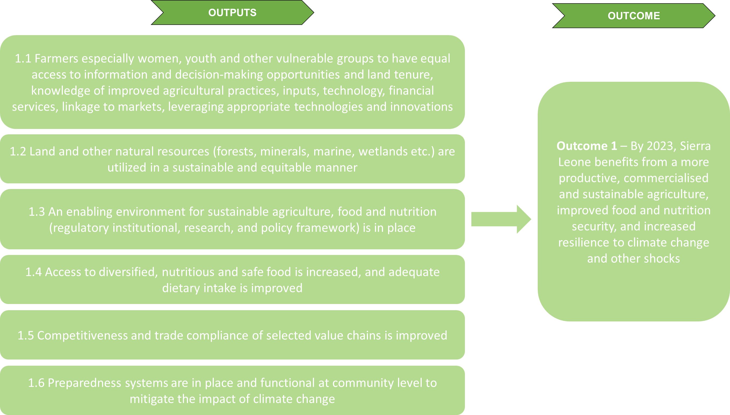

E.1. What is, in your opinion, the level of achievement of Outcome 1 – By 2023, Sierra Leone benefits from a more productive, commercialised and sustainable agriculture, improved food and nutrition security, and increased resilience to climate change and other shocks?
Fully achieved
Mostly achieved
Moderately achieved
Partially achieved
Not achieved at all
Don’t know

E.1.1. In your opinion, what is the level of achievement of Ouptut 1.1. Farmers especially women, youth and other vulnerable groups to have equal access to information and decision-making opportunities and land tenure, knowledge of improved agricultural practices, inputs, technology, financial services, linkage to markets, leveraging appropriate technologies and innovations?
Fully achieved
Mostly achieved
Moderately achieved
Partially achieved
Not achieved at all
Don’t know
E.1.2. In your opinion, what is the level of achievement of Ouptut 1.2. Land and other natural resources (forests, minerals, marine, wetlands etc.) are utilized in a sustainable and equitable manner.
Fully achieved
Mostly achieved
Moderately achieved
Partially achieved
Not achieved at all
Don’t know

E.1.3. In your opinion, what is the level of achievement of Ouptut 1.3. An enabling environment for sustainable agriculture, food and nutrition (regulatory institutional, research, and policy framework) is in place
Fully achieved
Mostly achieved
Moderately achieved
Partially achieved
Not achieved at all
Don’t know

E.1.4. In your opinion, what is the level of achievement of Ouptut 1.4. Access to diversified, nutritious and safe food is increased, and adequate dietary intake is improved
Fully achieved
Mostly achieved
Moderately achieved
Partially achieved
Not achieved at all
Don’t know

E.1.5. In your opinion, what is the level of achievement of Ouptut 1.5. Competitiveness and trade compliance of selected value chains is improved
Fully achieved
Mostly achieved
Moderately achieved
Partially achieved
Not achieved at all
Don’t know
E.1.6. In your opinion, what is the level of achievement of Ouptut 1.6. Preparedness systems are in place and functional at community level to mitigate the impact of climate change
Fully achieved
Mostly achieved
Moderately achieved
Partially achieved
Not achieved at all
Don’t know

Below is a picture of Strategic Area 2 Transformational Governance of UNSDCF 2020-2024
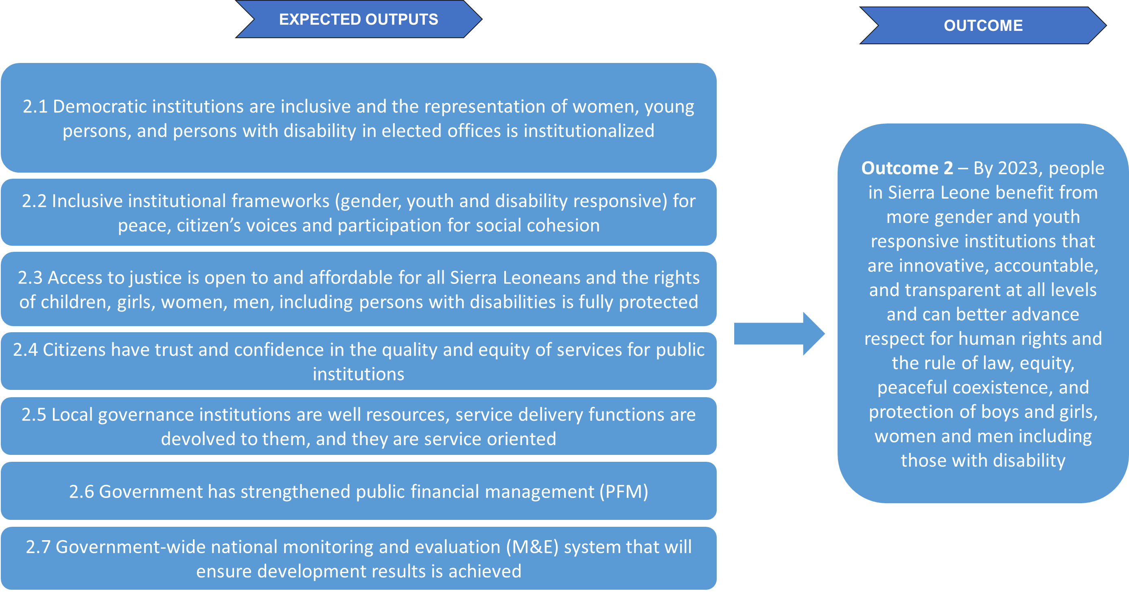
E.2. What is, in your opinion, the level of achievement of Outcome 2 – By 2023, people in Sierra Leone benefit from more gender and youth responsive institutions that are innovative, accountable, and transparent at all levels and can better advance respect for human rights and the rule of law, equity, peaceful coexistence, and protection of boys and girls, women and men including those with disability.
Fully achieved
Mostly achieved
Moderately achieved
Partially achieved
Not achieved at all
Don’t know

E.2.1. In your opinion, what is the level of achievement of Ouptut 2.1. Democratic institutions are inclusive and the representation of women, young persons, and persons with disability in elected offices is institutionalized
Fully achieved
Mostly achieved
Moderately achieved
Partially achieved
Not achieved at all
Don’t know
E.2.2. In your opinion, what is the level of achievement of Ouptut 2.2. Inclusive institutional frameworks (gender, youth and disability responsive) for peace, citizen’s voices and participation for social cohesion
Fully achieved
Mostly achieved
Moderately achieved
Partially achieved
Not achieved at all
Don’t know

E.2.3. In your opinion, what is the level of achievement of Ouptut 2.3 Access to justice is open to and affordable for all Sierra Leoneans and the rights of children, girls, women, men, including persons with disabilities is fully protected
Fully achieved
Mostly achieved
Moderately achieved
Partially achieved
Not achieved at all
Don’t know

E.2.4. In your opinion, what is the level of achievement of Ouptut 2.4 Citizens have trust and confidence in the quality and equity of services for public institutions
Fully achieved
Mostly achieved
Moderately achieved
Partially achieved
Not achieved at all
Don’t know

E.2.5. In your opinion, what is the level of achievement of Ouptut 2.5 Local governance institutions are well resources, service delivery functions are devolved to them, and they are service oriented
Fully achieved
Mostly achieved
Moderately achieved
Partially achieved
Not achieved at all
Don’t know
E.2.6. In your opinion, what is the level of achievement of Ouptut 2.6 Government has strengthened public financial management (PFM)
Fully achieved
Mostly achieved
Moderately achieved
Partially achieved
Not achieved at all
Don’t know

E.2.7. In your opinion, what is the level of achievement of Ouptut 2.7 Government-wide national monitoring and evaluation (M&E) system that will ensure development results is achieved
Fully achieved
Mostly achieved
Moderately achieved
Partially achieved
Not achieved at all
Don’t know

Below is a picture of Strategic Area 3 Access to Basic Services of UNSDCF 2020-2024
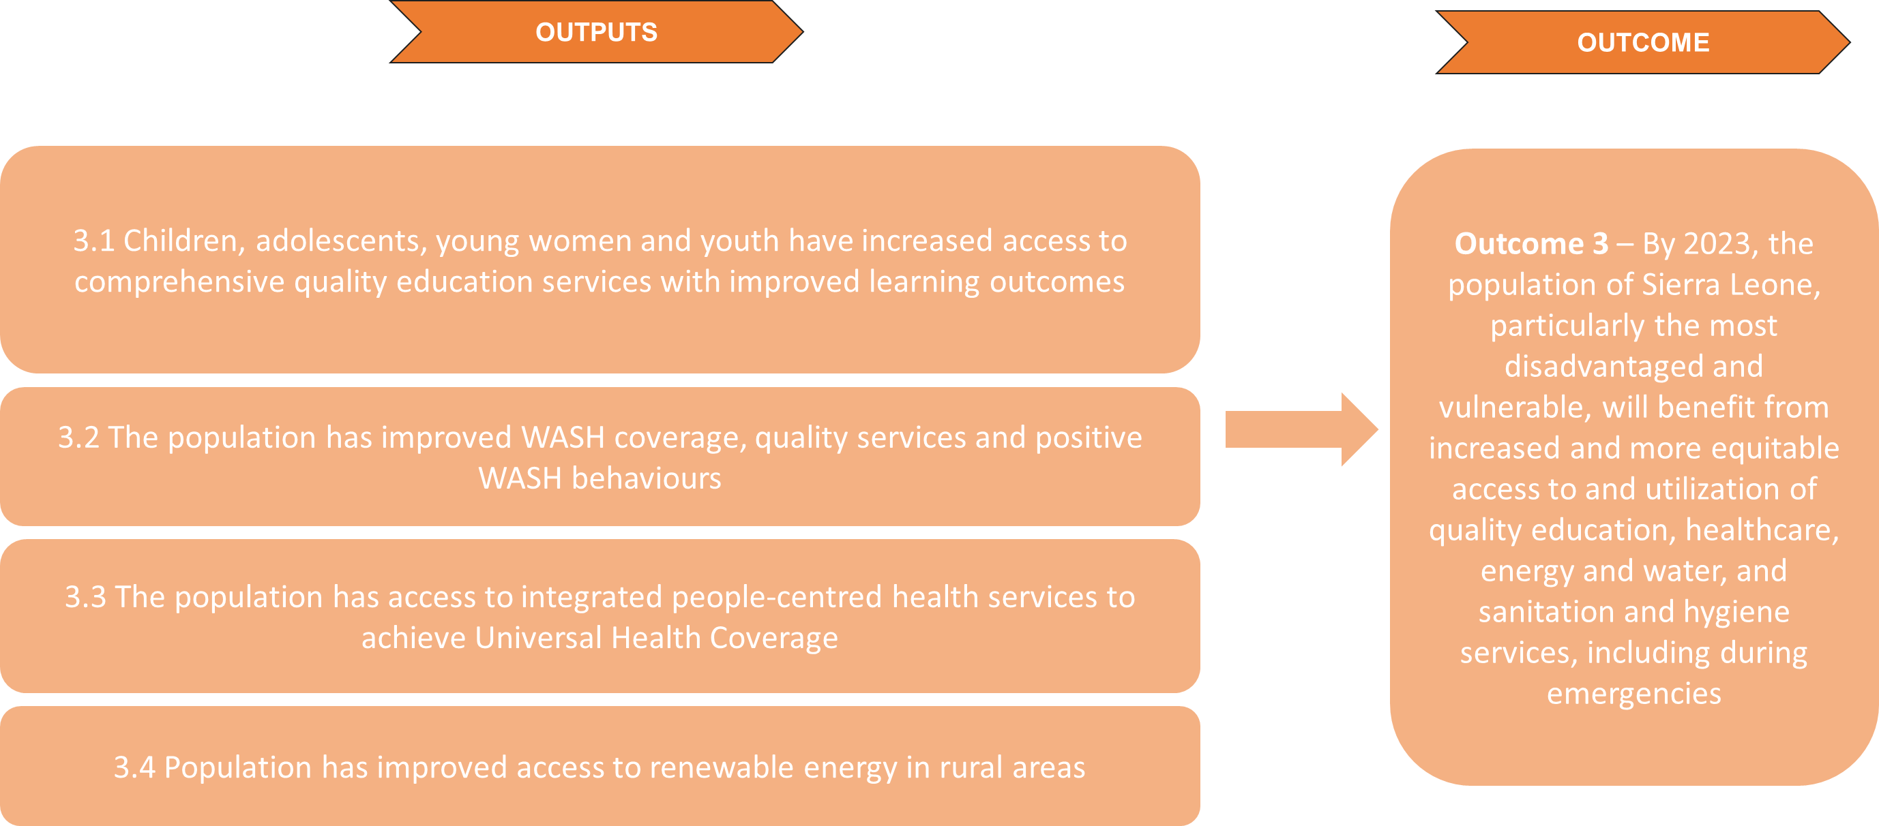

E.3. What is, in your opinion, the level of achievement of Outcome 3 - By 2023, the population of Sierra Leone, particularly the most disadvantaged and vulnerable, will benefit from increased and more equitable access to and utilization of quality education, healthcare, energy and water, and sanitation and hygiene services, including during emergencies
Fully achieved
Mostly achieved
Moderately achieved
Partially achieved
Not achieved at all
Don’t know

E.3.1. In your opinion, what is the level of achievement of Ouptut 3.1 Children, adolescents, young women and youth have increased access to comprehensive quality education services with improved learning outcomes
Fully achieved
Mostly achieved
Moderately achieved
Partially achieved
Not achieved at all
Don’t know
E.3.2. In your opinion, what is the level of achievement of Ouptut 3.2 The population has improved WASH coverage, quality services and positive WASH behaviours
Fully achieved
Mostly achieved
Moderately achieved
Partially achieved
Not achieved at all
Don’t know

E.3.3. In your opinion, what is the level of achievement of Ouptut 3.3 The population has access to integrated people-centred health services to achieve Universal Health Coverage

Fully achieved
Mostly achieved
Moderately achieved
Partially achieved
Not achieved at all
Don’t know

E.3.4. In your opinion, what is the level of achievement of Ouptut 3.4 Population has improved access to renewable energy in rural areas
Fully achieved
Mostly achieved
Moderately achieved
Partially achieved
Not achieved at all
Don’t know

Below is a picture of Strategic Area 4 Protection and empowerment of the most vulnerable of UNSDCF 2020-2024
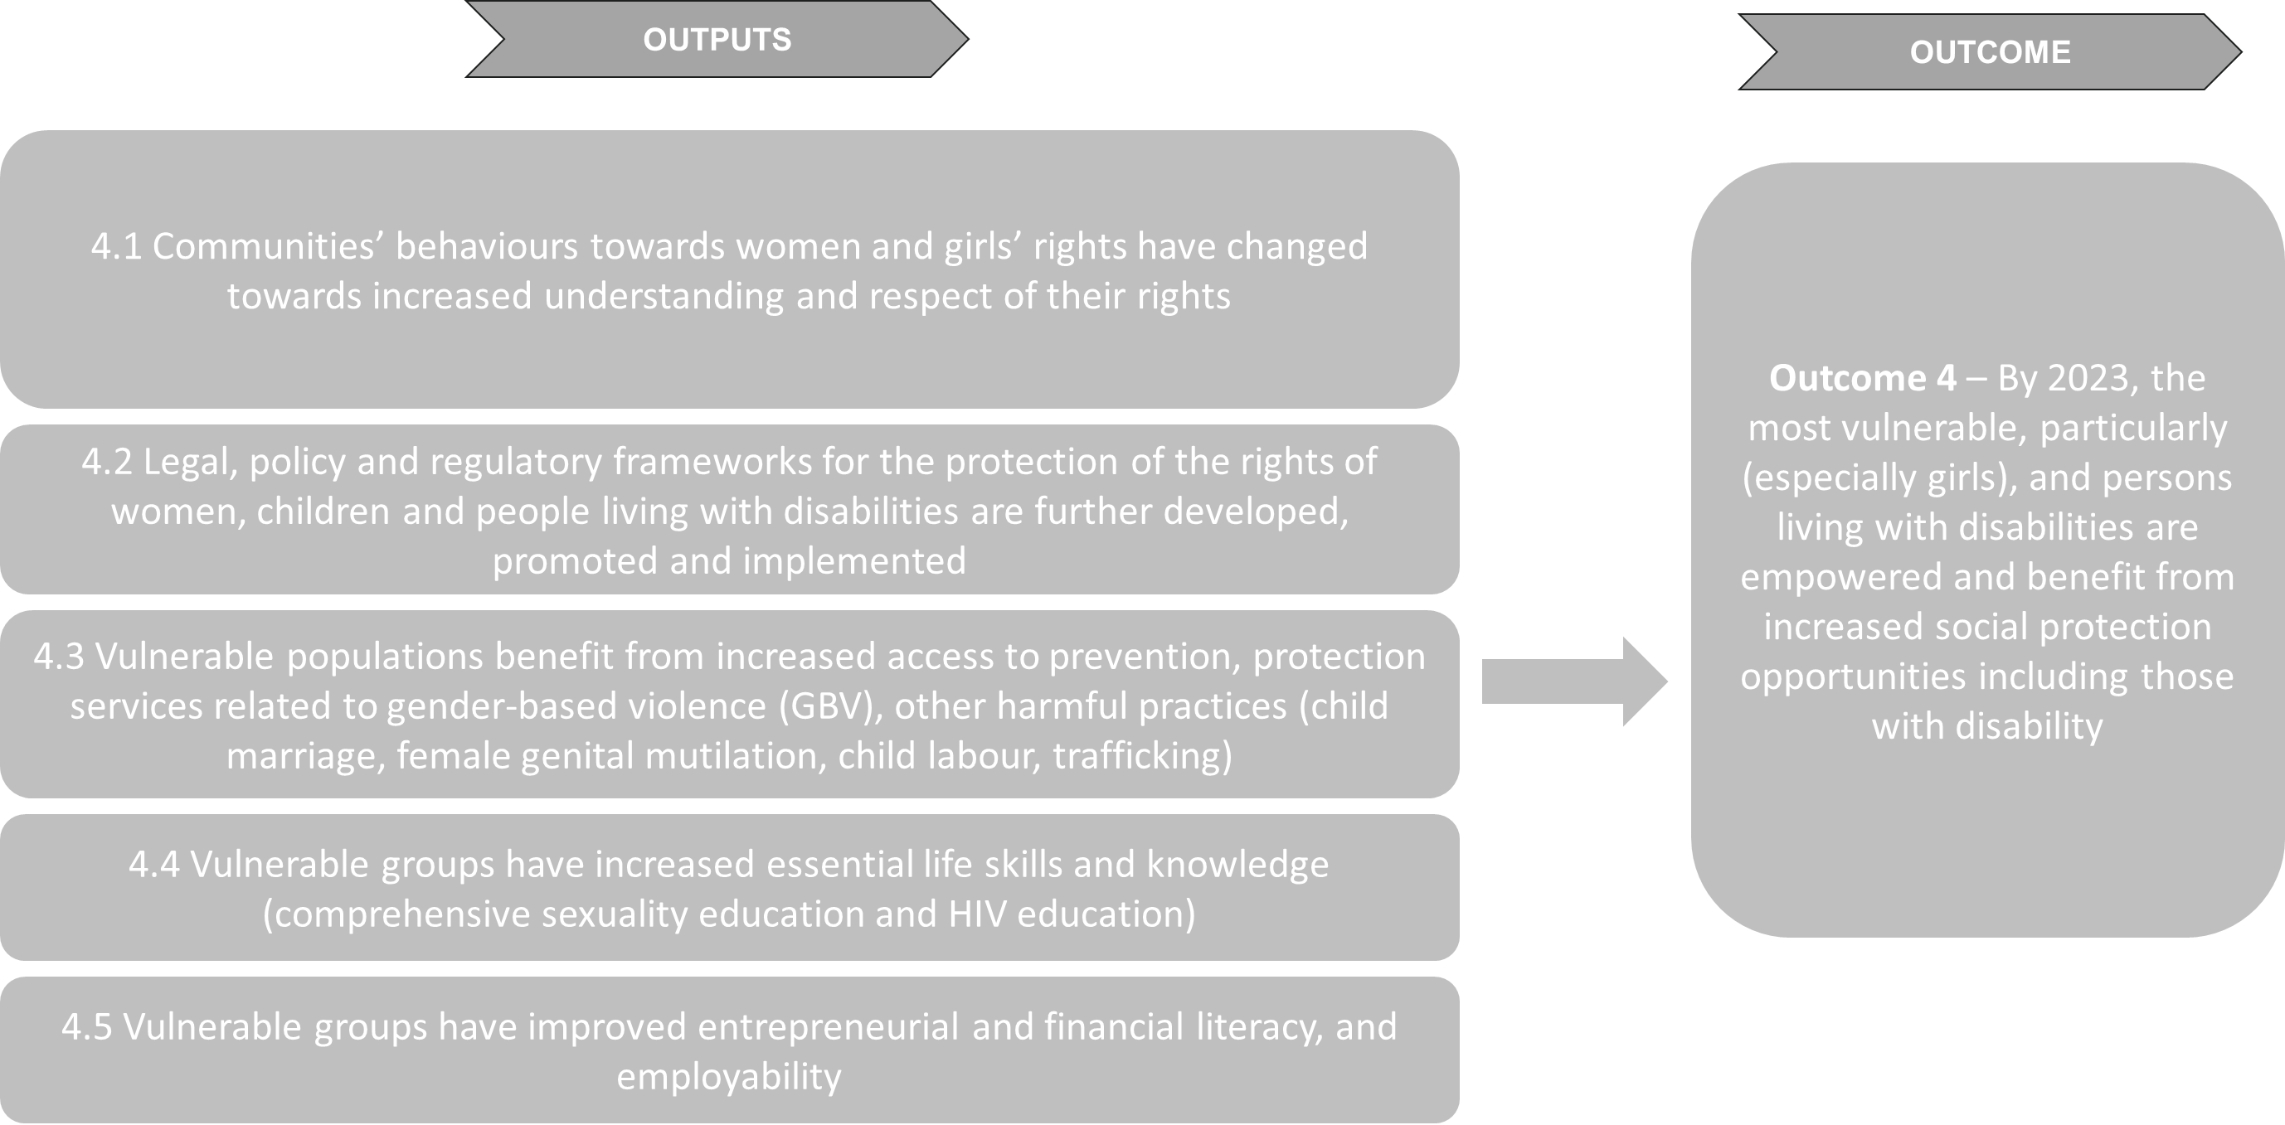

E.4. What is, in your opinion, the level of achievement of Outcome 4 – By 2023, the most vulnerable, particularly (especially girls), and persons living with disabilities are empowered and benefit from increased social protection opportunities including those with disability
Fully achieved
Mostly achieved
Moderately achieved
Partially achieved
Not achieved at all
Don’t know

E.4.1. In your opinion, what is the level of achievement of Ouptut 4.1 Communities’ behaviours towards women and girls’ rights have changed towards increased understanding and respect of their rights
Fully achieved
Mostly achieved
Moderately achieved
Partially achieved
Not achieved at all
Don’t know
E.4.2. In your opinion, what is the level of achievement of Ouptut 4.2 Legal, policy and regulatory frameworks for the protection of the rights of women, children and people living with disabilities are further developed, promoted and implemented
Fully achieved
Mostly achieved
Moderately achieved
Partially achieved
Not achieved at all
Don’t know

E.4.3. In your opinion, what is the level of achievement of Ouptut 4.3 Vulnerable populations benefit from increased access to prevention, protection services related to gender-based violence (GBV), other harmful practices (child marriage, female genital mutilation, child labour, trafficking)
Fully achieved
Mostly achieved
Moderately achieved
Partially achieved
Not achieved at all
Don’t know

E.4.4. In your opinion, what is the level of achievement of Ouptut 4.4 Vulnerable groups have increased essential life skills and knowledge (comprehensive sexuality education and HIV education)
Fully achieved
Mostly achieved
Moderately achieved
Partially achieved
Not achieved at all
Don’t know
E.4.5. In your opinion, what is the level of achievement of 4.5 Vulnerable groups have improved entrepreneurial and financial literacy, and employability
Fully achieved
Mostly achieved
Moderately achieved
Partially achieved
Not achieved at all
Don’t know
E.5. What do you think are key areas of development that have not been covered in the 4 strategic areas/outcomes/outputs above and should be covered in the next Country Framework? Please write below each of the relevant outcomes
Strategic areas 1:
Strategic areas 2:
Strategic areas 3:
Strategic areas 4:
Other:
Don’t know
E.6. Can you list and explain up to three key external factors that have enabled the achievement of the outcomes and outputs (e.g. political, stakeholder engagement, contextual factors etc.)
Enabling Factor 1:
Enabling Factor 2:
Enabling Factor 3:
Don’t know

E.7. Can you list and explain up to three key external factors that have hindered the achievement of the outcomes and outputs (e.g. political, stakeholder engagement, contextual factors etc.)
Hindering Factor 1:
Hindering Factor 2:
Hindering Factor 3:
Don’t know
E.8. [For UNCT and Steering Committee respondents only]
Can you list and explain up to three key internal factors that have enabled the achievement of the outcomes and outputs (e.g. political, stakeholder engagement, contextual factors etc.)
Enabling Factor 1:
Enabling Factor 2:
Enabling Factor 3:
Don’t know

E.9. [For UNCT and Steering Committee respondents only]
Can you list and explain up to three key internal factors that have hindered the achievement of the outcomes and outputs (e.g. political, stakeholder engagement, contextual factors etc.)
Hindering Factor 1:
Hindering Factor 2:
Hindering Factor 3:
Don’t know

E.10. Can you list and explain up to three key unexpected outcomes (positive or negative) that have been yielded by the Country Framework as a result of its intended goals and objectives.
Unexpected Outcome 1:
Unexpected Outcome 2:
Unexpected Outcome 3:
Don’t know
E.11. To what extent do you agree with the following: Rights holders and institutions including the most vulnerable, disadvantaged and marginalized population have benefitted from the CF’s results
Fully agree
Mostly agree
Moderately agree
Partially agree
Do not agree at all
Don’t know

F. Efficiency [only for respondents from UNCT and Joint Steering Committee]
F.1. In your opinion, how efficient was the programme in utilizing its financial resources?
Very efficient
Efficient
Neither efficient nor inefficient
Inefficient
Very inefficient
Don’t know
F.1.1. More precisely, please rate the following aspects between 1(= strongly disagree) and 5 (=strongly agree):
 | 1 | 2 | 3 | 4 | 5 | Don’t know
The programme effectively managed its financial resources by aligning planned expenditures with actual expenditures and effectively mobilizing additional resources when needed
The programme demonstrated the ability to prioritize activities based on the needs and demands of the beneficiaries, rather than solely considering the availability of resources
The programme provided value for money by efficiently utilizing its financial resources to achieve the desired outcomes and impacts

F.2. In your opinion, how efficient was the programme in utilizing its human resources?
Very efficient
Efficient
Neither efficient nor inefficient
Inefficient
Very inefficient
Don’t know
F.2.1. More precisely, please rate the following aspects between 1(= strongly disagree) and 5 (=strongly agree):
 | 1 | 2 | 3 | 4 | 5 | Don’t know
The programme effectively utilized its staff members by allocating them to appropriate tasks and maximizing their skills and expertise
The programme demonstrated cost-effectiveness by achieving desired outputs and outcomes through efficient utilization of human resources

F.3. To what extent do you agree with the following: the CF has been implemented in a timely manner?
Strongly agree
Agree
Neutral
Disagree
Strongly disagree
Don’t know
F.3.1 {for the respondents that selected “neutral” “disagree” “strongly disagree” the following question will appear} Could you explain why you don’t agree with the above statement? [open ended question]
F.4. To what extent do you think that the monitoring and evaluation (M&E) system is adequate?
Very adequate
Adequate
Neutral
Not very much adequate
Not at all adequate
Don’t know
F.4.1 {for the respondents that selected “neutral” “not very much adequate” “not at all adequate” the following question will appear} Could you explain why you don’t find the M&E system adequate? [open ended question]
G. Coordination
G.1. To what extent do you feel that the CF …
 | Strongly disagree | Disagree | Neither agree or disagree | Agree | Strongly Agree | Don’t know
Promoted interlinkages and complementary approaches between various interventions
Promoted resources optimization and efficiency through coordination between interventions
Developed mechanisms or platforms for information and knowledge sharing between key partners
Promoted synergies and reduced overlaps between similar interventions

G.2. {this question will only be displayed for respondents from the Government and UNCT } How efficient, in your opinion, was the Joint Steering Committee as a key coordination mechanism between the Government and the UNCT?
Very efficient
efficient
Neutral
Not very much efficient
Not at all efficient
Don’t know
G.2.1. {for the respondents that selected “neutral” “not very much efficient” “not at all efficient” the following question will appear} Could you explain why you don’t find the Joint Steering Committee efficient? [open ended question]
G.3.. {this question will only be displayed for respondents that selected ‘yes’ to question A1.1 } Could you rate the following regarding the Joint Steering Committee (1 being the lowest and 5 the highest)
 | 1 | 2 | 3 | 4 | 5 | Don’t know
Meetings frequency and timeliness
Participation (engagement of the members)
Decision-making and coordination
Communication and information sharing
Level of satisfaction

G.4. {this question will only be displayed for respondents from the Joint Steering Committee and UNCT } To what extent do you agree with the following: The different UN Agencies contributed to the functioning and consolidation of UNCT coordination mechanisms?
Strongly agree
Agree
Neutral
Disagree
Strongly disagree
Don’t know
G.4.1. {for the respondents that selected “neutral” “disagree” “strongly disagree” the following question will appear} Could you explain why you don’t agree with the above statement? [open ended question]
G.5. Do you have any recommendations when it comes to the topic of coordination? Be as precise as possible. [open-ended question]
H. Orientation towards impact
The below questions will be accessing the impact of each strategic area of the Country Framework, do you consider yourself knowledgeable enough to answer the questions:
Yes
No => skip all questions and goes to H.5. [will be skipped automatically by the software]

H.1. To what extent do you agree with the following: Strategic Area 1 – Sustainable Agriculture and Food Security has contributed to the following:
 | Strongly disagree | Disagree | Neutral | Agree | Strongly agree | Don’t know
Promotion of gender equality and women’s empowerment
Promotion of human rights, including disability inclusion
Promotion of environmental sustainability objectives
H.1.1. Could you elaborate on your previous answer? [open-ended question]
H.2. To what extent do you agree with the following: Strategic Area 2 – Transformational Governance has contributed to the following:
 | Strongly disagree | Disagree | Neutral | Agree | Strongly agree | Don’t know
Promotion of gender equality and women’s empowerment
Promotion of human rights, including disability inclusion
Promotion of environmental sustainability objectives
H.2.1. Could you elaborate on your previous answer? [open-ended question]
H.3. To what extent do you agree with the following: Strategic Area 3 – Access to basic services has contributed to the following:
 | Strongly disagree | Disagree | Neutral | Agree | Strongly agree | Don’t know
Promotion of gender equality and women’s empowerment
Promotion of human rights, including disability inclusion
Promotion of environmental sustainability objectives
H.3.1. Could you elaborate on your previous answer? [open-ended question]
H.4. To what extent do you agree with the following: Strategic Area 4 – Protection and Empowerment of the most vulnerable has contributed to the following:
 | Strongly disagree | Disagree | Neutral | Agree | Strongly agree | Don’t know
Promotion of gender equality and women’s empowerment
Promotion of human rights, including disability inclusion
Promotion of environmental sustainability objectives
H.4.1. Could you elaborate on your previous answer? [open-ended question]
H.5. [question for the respondents that were not knowledgeable enough about each strategic area] Overall, in your opinion, to what extent did the country framework contributed to the following:
 | Strongly disagree | Disagree | Neutral | Agree | Strongly agree | Don’t know
Promotion of gender equality and women’s empowerment
Promotion of human rights, including disability inclusion
Promotion of environmental sustainability objectives
H.5.1. Could you elaborate on your previous answer? [open-ended question]

- Sustainability
I.1. On a scale from 1 to 5 (1 being the lowest), to what extent do you think that Strategic Area 1: Sustainable Agriculture and Food Security contributed to building national and local capacities and ensuring long-term gains?
1 | 2 | 3 | 4 | 5 | Don’t know
I.1.1. Could you elaborate on your previous answer? [open-ended question]
I.2. What would you say are the main risks (up to 4) that may impact the sustainability Strategic Area 1? [open ended question] Be as precise as possible and if possible link the risks to specific outputs of Strategic Area 1.
Risk 1
Risk 2
Risk 3
Risk 4
Don’t know

I.3. On a scale from 1 to 5 (1 being the lowest), to what extent do you think that Strategic Area 2: Transformational Governance contributed to building national and local capacities and ensuring long-term gains?
1 | 2 | 3 | 4 | 5 | Don’t know
I.3.1. Could you elaborate on your previous answer? [open-ended question]
I.4.What would you say are the main risks (up to 4) that may impact the sustainability Strategic Area 2? [open ended question] Be as precise as possible and if possible link the risks to specific outputs of Strategic Area 2
Risk 1
Risk 2
Risk 3
Risk 4
Don’t know

I.5. On a scale from 1 to 5 (1 being the lowest), to what extent do you think that Strategic Area 3: Access to basic services contributed to building national and local capacities and ensuring long-term gains?
1 | 2 | 3 | 4 | 5 | Don’t know
I.5.1. Could you elaborate on your previous answer? [open-ended question]
I.6. What would you say are the main risks (up to 4) that may impact the sustainability Strategic Area 3? [open ended question] Be as precise as possible and if possible link the risks to specific outputs of Strategic Area 3
Risk 1
Risk 2
Risk 3
Risk 4
Don’t know

I.7. On a scale from 1 to 5 (1 being the lowest), to what extent do you think that Strategic Area 4: Protection and Empowerment of the most vulnerable contributed to building national and local capacities and ensuring long-term gains?
1 | 2 | 3 | 4 | 5 | Don’t know
I.7.1. Could you elaborate on your previous answer? [open-ended question]
I.7. What would you say are the main risks (up to 4) that may impact the sustainability Strategic Area 4? [open ended question] Be as precise as possible and if possible link the risks to specific outputs of Strategic Area 4
Risk 1
Risk 2
Risk 3
Risk 4
Don’t know

Final remark
I.1. Is there anything else that you would like to add? (e.g. recommendations for the next CF, remarks on the 2020-2024 CF that you could not mention in the survey etc.) [open ended question]

Thank you very much for your time.

Annex VI – Terms of reference
Consultancy Services for the Evaluation of the United Nations Sustainable Development Cooperation Framework (UNSDCF) 2020-2024 End of Cycle, Sierra Leone.
1. INTRODUCTION
The United Nations Sustainable Development Cooperation Framework (UNSDCF) 2020-2024 is the strategic plan of the United Nations Country Team (UNCT) contributing to the national development priorities and strategies of the Government of Sierra Leone as established in the Medium-Term National Development Plan (MTNDP) 2019-2023. Harmonized with the MTNDP, the UNSDCF incorporates the goals and principles that underpin the global 2030 Agenda for Sustainable Development. It focuses on four high-level outcome areas: Sustainable Agriculture, Food and Nutrition Security, and Climate Resilience; Transformational Governance; Access to Basic Services; and Protection and Empowerment of the Most Vulnerable. In each case, the outcomes are mapped to the MTNDP policy clusters they directly support, as well as to the 17 Sustainable Development Goals (SDGs) they are intended to accelerate toward the 2030 Agenda.
The UNSDCF is implemented at central and district levels under the leadership of the Joint Steering Committee, co-chaired by the Minister of Planning and Economic Development and the United Nations Resident Coordinator, which ensures that response to national challenges and transformation are “Delivered as One”. It is one of the first full, new model of cooperation frameworks to be developed and implemented after the UN Reform. The UNSDCF upholds the principles of gender equality, human rights, and conflict sensitivity, ensuring that “no one is left behind”, which guide all UN system programmes and projects. It also intends to advance the United Nations Secretary-General’s agenda on repositioning the United Nations development system and responds to the Secretary-General’s call for optimizing resources and improving effectiveness of the UN’s support to countries.
As outlined on the UNSDCF 2020-2024 Evaluation Plan1, an end of the cycle evaluation will be conducted during the penultimate year of the UNSDCF implementation. Guided by the United Nations Evaluation Group (UNEG) Norms and Standards2 for Evaluation, the UNSDCF Evaluation is a mandatory, independent, and system-wide country assessment that seeks to ensure accountability, support learning, and inform decisions regarding the design of the subsequent UNSDCF cycle as well as UN entity country programme documents and strategic plans.3 The evaluation will also assess whether planned UNSDCF results were achieved, and whether they made a sustainable contribution to national development processes; and delivered on the commitment to leave no one behind.
The results of the UNSDCF evaluation will be disseminated to the Government of Sierra Leone, UN Agencies, Funds and Programmes, development partners, civil society, academia, private sector, implementing partners and other secondary users including the public through several platforms. The evaluation results will further provide strategic and programmatic lessons to promote accountability and visibility around the work and achievements and work of UN Sierra Leone in support of the Government to achieve its National Development Goals and the SDGs.
2. COUNTRY CONTEXT AND UNDAF/UNSDCF HIGHLIGHTS
Sierra Leone
The UNSDCF Evaluation will take place amidst on-going socio-economic and political developments in Sierra Leone as detailed below.
Sierra Leone is categorized as a least developed country, with a total population of 7,092,113, of which, nearly two thirds of the population are still identified as multi-dimensionally poor. It ranks 182 out of 189 countries and territories in 2020 Human Development Index. Sierra Leone’s macroeconomic situation remains challenging despite the implementation of bold policy measures since 2018. Following the twin shocks of 2014 and 2015—the Ebola epidemic and fall of iron ore prices, the economy registered modest socio-economic gains, including positive GDP growth since 2016, before contracting to -2 per cent in 2020 due to the COVID- 19 pandemic. Economic growth rebounded by 2.9 per cent in 2021 with GDP per capita of US $516, reflecting the easing of COVID-19 restrictions and government fiscal response to the pandemic. Although growth is expected to rebound at 5 per cent in 2022, structural challenges could continue to impact long-term socio- economic recovery if remain unaddressed.
Sierra Leone is ranked as the third most vulnerable country after Bangladesh and Guinea Bissau to the adverse effects of climate change. Ranking 157 out of 181 in the Notre Dame Global Adaptation Index, it is also one of the least able countries to adapt to climate change characterized by high vulnerability and low readiness. Since most of the population is dependent on agriculture, this significantly affects food insecurity (food shortages, hunger, and malnutrition). Due to adverse weather events (flooding), fall armyworm attacks on maize in some localized areas, high inflation rate, weakening local currency and the impacts of the COVID-19 pandemic on the value chain, food insecurity has worsened with 3.9 million people food insecure in 2021, 2 million people chronically hungry, and 1.4 million people acutely hungry (IPC Phase 3+). The number is estimated to increase during the lean season of 2022 to 1.5 million. Moreover, Food Security Monitoring System (FSMS) in August 2021 showed a continued and steady deteriorating trend in the Food Consumption Score (FCS), with the proportion of households categorised as having “poor” FCS doubling between September 2018 and August 2021 (37 per cent). Consistent deterioration in FCS most likely reflects the impact of continuously increasing food and fuel prices given that Sierra Leone is a net importer of food.
Gender inequality and discrimination against women and girls in Sierra Leone is prevalent, with Gender Inequality Index value of 0.644, ranking it 153 out of 162 countries in the 2018. Female mortality in Sierra Leone is one of the highest in the world, with maternal mortality showing 1 in 139 pregnant women dying due to complications from pregnancy of childbirth. Female Genital Mutilation (FGM) rate is high with 83 per cent of women 15-49 years in the country having experienced it. Violence against women and girls remains rampant—62 per cent of women aged 15-49 years had experienced some form of violence (i.e., sexual and/or physical) in their lifetime, and 42.8 per cent had experienced physical violence in the last 12 months. Although the prevalence of child marriage has seen a slight decrease over the years, the practice remains widespread with 29.6 and 8.6 per cent of women aged 20 to 24 years first married or in union before age 18 and 15 years, respectively. The rates of adolescent pregnancy are also high with 21 per cent of girls aged 15-19 years having begun childbearing.
Sierra Leone’s youth (under 34 years old) is estimated to make up 80 per cent of the population, with those age 24 years and below making up 62.3 per cent, and 42 per cent of the population under the age of 15. In 2019, the unemployment rate is higher among youth than older people (defined as people aged 36–64) at 5.9 per cent versus 2.2 per cent, respectively. Apart from the high rate of unemployment, poverty also presents a barrier not only to the youth population, but to children as well. As many as 66 per cent of children were affected by multidimensional poverty in 2017, with more children at risk of falling into poverty as a result of COVID-19 affecting families’ livelihood. The latest National Child Labour Survey indicated that 45.9 per cent of children in Sierra Leone are engaged in child labour while 22 per cent are engaged in hazardous jobs. In 2019, child mortality rate for Sierra Leone was 109.2 deaths per 1,000 live births, with 1 in 39 infants dying during their first month of life.
According to the 2018 Integrated Household Survey, persons with disabilities makeup 4.3 per cent of the population. The Sierra Leone Multidimensional Poverty Index 2019 indicated that multidimensional poverty based on disability stood at 68.1 per cent persons with functional disabilities being poorer than those without functional disabilities. The proportion of illiterate adults is also higher among people with disabilities-46.5 per cent of people with disabilities have never been to school and 63.9 per cent were illiterate, compared to 34.3 per cent and 50.7 per cent for people without disabilities, respectively. The COVID-19 pandemic brought adverse impact to persons with disabilities, including their access to livelihood, employment and physical barriers that inhibit their access to public health information and health facilities. Similarly, the disruption of essential health services as a result of the pandemic has affected people living with communicable diseases such as HIV/AIDS as there has been delays in accessing medical assistance which has in turn increased deaths in most communities. Prevalence rates for people living with HIV/AIDS is estimated at 1.7 per cent among adults ages 15-49 with 2.2 and 1.1 percent in women and men, respectively. HIV prevalence in urban areas is almost twice as high compared to rural areas, at 2.3 per cent in urban areas compared with 1.2 percent in rural areas.
Sierra Leone has demonstrated resilience by achieving significant progress in building state institutions and maintaining stability as part of its post-conflict peacebuilding and reconstruction agenda. The progress has not only taken place at national level but also through decentralization and strengthening of local governance as well. It has consolidated state authority, extended public services, and undertaken significant reforms in the governance and security sectors. Sierra Leone scored 51 out of 100 in overall governance, ranking 24 out of 54 countries in Africa in the 2020 Mo Ibrahim Index. The country has also conducted four elections with peaceful transfer of power in 2002, 2007, and 2018 (in 2012 there was no change of power). However, significant systemic and structural challenges remain. Public service delivery institutions are challenged by weak accountability mechanisms, while effective administration of justice is hampered by limited institutional capacity and the limited application of the rule of law. Pervasive corruption and allegations of mismanagement of public funds continue to permeate, with Sierra Leone ranking 115 out of 180 countries in the 2021 Corruption Perceptions Index 2021. Despite the acclamation of the elections being peaceful, they are still characterised by heightened political tension and violence, resulting to perceptions of diminishing social cohesion. Sierra Leone ranked 50 out of 163 countries in the 2022 Global Peace Index. The political landscape remains fragile, with the potential for heightened tension between the two main political parties (largely along ethno-regional lines) to spill over to the larger society in the lead-up to the next general elections in mid-2023.
The two main political parties, the Sierra Leone People’s Party (SLPP) and the All-People’s Congress (APC) have dominated the country’s political scene for almost 70 years. Attempts by other parties to diversify the arena has remained challenging. Currently, Sierra Leone operates on a hung 4 Parliament with a total membership of 146 Members. The ruling SLPP has 58 MPs; the main opposition, APC has 59; Coalition 4 Change (C4C) 8; the National Grand Coalition (NGC) 4; Independent MPs 3, and 14 Paramount Chiefs. Only 18 of these MPs are women, including 2 Paramount Chiefs.
Sierra Leone is one of the Mano River countries, bordering Guinea and Liberia. Sharing similar economic and social typologies, the borders between countries are porous. Movement of people and goods has increased in border areas in the last two decades, subsequently augmenting economic activities, albeit most of these activities are informal. However, concerns over security, development and humanitarian issues have been much more salient, including the spill-over of communicable diseases such as Ebola. Other challenges include trafficking, forced labour, transhumance, and irregular migration. Within the regional context affected by growing insecurity and banditism, it is also important to consider security risks, including the risk of radicalization of the youth and disenfranchised. Tensions linked to transhumance are of particular concern in the Parrot Beak area of Sierra Leone and have generally increased in the West Africa region.
3. NATIONAL DEVELOPMENT PRIORITIES AND THE SDGS
Sierra Leone continues to uphold the alignment between the Sustainable Development Goals (SDGs) and the country’s national development frameworks at different delivery levels, as described in its previous Voluntary National Review (VNR) reports of 2016, 2019 and 2021. The first major step undertaken by the country to domestically adapt the SDGs was the effective integration of the goals into the national, sectoral, and local development plans.
Sierra Leone has ensured the integration of the SDGs at all levels of national, sectoral, and sub-national policy synthesis, as well as in the implementation of programmes where monitoring of the interaction between the three dimensions in service delivery is constantly needed. The country’s regular participation in the Voluntary National Review (VNRs) has been instrumental particularly as consultations organically evolve into public sensitization on the SDGs and their key principles including balancing the three dimensions.
The Government of Sierra Leone’s vision for national transformation and development is articulated in the country’s Medium-Term National Development Plan (MTNDP) (2019-2023) entitled “Education for Development”, launched in February 2019. The plan is aligned with the 2030 Agenda for Sustainable Development, the Sustainable Development Goals (SDGs), the Africa Union Agenda 2063, and the New Deal Peace-building and State-building Goals. The MTNDP marked the start of a new vision embedded in the Government’s New Direction Agenda, which translates Sierra Leone’s aspirations of becoming a middle- income country by 2039 into tangible achievements.
Human capital development is at the centre of the MTNDP and forms the basis of the Government’s goal of providing free quality school education for all in the context of promotion of inclusive growth and leaving no one behind. Organised along eight policy clusters, the development strategy is articulated in these four key goals:
• Goal 1: A diversified, resilient, green economy
• Goal 2: A nation with educated, empowered, and healthy citizens capable of realizing their fullest potential
• Goal 3: A society that is peaceful, cohesive, secure, and just
• Goal 4: A competitive economy with a well-developed infrastructure
The United Nations Sustainable Development Cooperation Framework (UNSDCF) for the 2020-2023 period is aligned with the structure of the MTNDP and builds on its strategic vision and development goals, with a particular focus on the implementation of programmes at both national and district levels. In addition to prioritizing Human Capital Development as the first policy cluster in the new plan, the MTNDP identifies specific and critical results like economic diversification, governance and accountability for results, infrastructure, and economic competitiveness.
To ensure effective development accountability and reporting at local level, the District Development Coordination Committee (DDCC) initiative has been created to address the problems of duplication, service delivery overlap and uncoordinated development interventions in the districts. DDCCs also provide an inclusive platform for consultations, integrating voices of women, youth and persons with disabilities.
4. UNSDCF DEVELOPMENT AND HIGHLIGHTS
The United Nations Country Team (UNCT) is composed of the heads of all the UN agencies, funds and programmes active in Sierra Leone. The UNCT leads the implementation of the United Nations Sustainable Development Cooperation Framework (UNSDCF) 2020-2024, with its steering committee co-chaired by the UN Resident Coordinator and the Minister of Planning and Economic Development.
21 UN Agencies, Funds and Programmes signed the UNSDCF 2020-2024, 18 of which are implementing the UNSDCF Joint Workplan. The UNCT is composed of 15 resident agencies and 3 non-resident agencies. Four international finance institutions also closely interact with the UNCT and participate in UNCT meetings. The UN family works as one with the Government and partners to deliver sustainable development interventions across People, Prosperity, Planet, Partnership, and Peace.
The UNCT and its partners jointly identified four strategic and mutually reinforcing priority areas for the UNSDCF. Each of these were underpinned by a theory of change 5 that articulates the key development challenges and the transformative agenda that the UNCT supports to meet the targets established in the MTNDP. Following the identification of the strategic priorities, the UNCT identified key outcomes under each 5 United Nations Sustainable Development Cooperation Framework Sierra Leone 2020-2023, pp 20-21.
Outcome 1: Sustainable Agriculture, Food and Nutrition Security
Implementing Agencies: FAO, IAEA, IFAD, ILO, IOM, ITC, UNDP, UNICEF, UNIDO, WFP, WHO
By 2023, Sierra Leone benefits from a more productive, commercialized and sustainable agriculture, improved food and nutrition security, and increased resilience to climate change and other shocks.
  - Farmers especially women, youth and other vulnerable groups to have equal access to information and decision-making opportunities on land tenure, knowledge of improved agricultural practices, inputs, technology, financial services, linkage to markets, leveraging appropriate technologies and innovations.
  - Land and other natural resources (forests, minerals, marine, wetlands, etc.) are utilized in a sustainable and equitable manner
  - An enabling environment for sustainable agriculture, food and nutrition (regulatory, institutional, research and policy framework) is in place.
  - Access to diversified, nutritious and safe food is increased, and adequate dietary intake is improved.
  - Competitiveness and trade compliance of selected value chains is improved.
  - Preparedness systems are in place and functional at community level to mitigate the impact of climate change

Outcome 2: Transformational Governance
Implementing Agencies: ILO, IOM, UNAIDS, UNCDF, UNDP, UNICEF, UNIDO, UNODC, UNOPPS, UNWOMEN
By 2023, people in Sierra Leone benefit from more gender and youth responsive institutions that are innovative, accountable, and transparent at all levels and can better advance respect for human rights and the rule of law, equity, peaceful coexistence, and protection of boys and girls, women and men including those with disability.
  - Democratic institutions are inclusive and the representation of women, young persons, and persons with disability in elected offices is institutionalized.
  - Inclusive institutional frameworks (gender, youth and disability responsive) for peace, citizen’s voices and participation for social cohesion.
  - Access to justice is open to and affordable for all Sierra Leoneans and the rights of children, girls, women, men, including persons with disabilities are fully protected.
  - Citizens have trust and confidence in the quality and equity of services of public institutions.

Outcome 3: Access to Basic Services
Implementing Agencies: IAEA, IOM, UNAIDS, UNESCO, UNDP, UNICEF, UNFPA, UNIDO, UNOPS, WHO
By 2023, the population of Sierra Leone, particularly the most disadvantaged and vulnerable, will benefit from increased and more equitable access to and utilization of quality education, healthcare, energy and water, and sanitation and hygiene services, including during emergencies.
  - Children, adolescents, young women and youth have increased access to comprehensive quality education services with improved learning outcomes.
  - The population has improved WASH coverage, quality services and positive WASH behaviours.
  - The population has access to integrated people-centred health services to achieve Universal Health Coverage.
  - Population has improved access to renewable energy in rural areas.

Outcome 4: Protection and Empowerment of the Most Vulnerable
Implementing Agencies: ILO, IOM, ITC, UNAIDS, UNCDF, UNDP, UNESCO, UNFPA, UNICEF, UNODC, UNWOMEN, WFP, WHO
By 2023, the most vulnerable, particularly women, youth, adolescents and children (especially girls), and persons living with disabilities are empowered and benefit from increased social protection services, economic and social opportunities.
  - Communities’ behaviours towards women and girls’ rights have changed towards increased understanding and respect of their rights.
  - Legal, policy and regulatory frameworks for the protection of the rights of women, children and people living with disabilities are further developed, promoted and implemented.
  - Vulnerable populations benefit from increased access to prevention, protection services related to gender-based violence (GBV), other harmful practices (child marriage, female genital mutilation, child labour, trafficking).
  - Vulnerable groups have increased essential life skills and knowledge (comprehensive sexuality education and HIV education)
  - Vulnerable groups have improved entrepreneurial and, financial literacy, and employability

The Joint Financing and Resource Mobilization Strategy accompanies the UNSDCF to support the joint funding and financing framework below. The Strategy provides insight into global sustainable development finance, overviews of the national financial landscape, profiles resource opportunities, and presents strategies under each outcome area.
5. OBJECTIVES AND SCOPE OF THE EVALUATION
Purpose and Objectives
The UNSDCF evaluation has three primary purposes:
Promote greater learning and operational improvement. The evaluation will provide important information for strengthening programming and results at the country level, specifically informing the planning and decision-making for the next CF programme cycle and for improving UN coordination at the country level. The UNCT, host government and other CF stakeholders can learn from the process of documenting good practices and lessons learned, which can then be shared with DCO and used for the benefit of other countries.
1. Support greater accountability of the UNCT to CF stakeholders. By objectively providing evidence of results achieved within the framework of the CF and assessing the effectiveness of the strategies and interventions used, the evaluation will enable the various stakeholders in the CF process, including national counterparts and donors, to hold the UNCT and other parties accountable for fulfilling their roles and commitments.
2. Deliver clear recommendations to support the next CF cycle and ensure accelerated progress towards the SDGs. The evaluation will provide important information for strengthening programming and results at the country level, specifically informing the planning and decision-making of the next UNSDCF programme cycle and improving UN coordination at the country level.
The specific objectives of the evaluation are to:
1. To assess the contribution of the CF to national development results through evidence-based judgements using evaluation criteria (accountability).
2. Identify factors that have affected the CF’s contribution; answering the question of why the performance is as it is; and explaining the enabling factors and bottlenecks (learning).
3. Reach conclusions concerning the UN’s contribution across the scope being examined.
4. Provide clear, forward-looking, actionable recommendations for improving UN Sierra Leone contribution through the UNSDCF, especially for incorporation into the new UNSDCF programming cycle. These recommendations should be logically linked to the conclusions and findings of the evaluation and should draw upon lessons learned identified through the evaluation.
5. To gauge what kind of joint programmes and joint operations provided evidence of efficiency gains by reducing the cost of doing business through reducing multiple and extensive transaction costs incurred by a number of agencies carrying out their own programmes independently by combining their initiatives with other agencies.

Scope
The Evaluation will cover the UNSDCF 2020-2024 implementation from January 2020 to June 2022. It will be conducted nation-wide. The results will be assessed against the identified four strategic outcomes and multiple outputs of the UNSDCF Results Framework and the indicative sub-outputs of UNSDCF Joint Workplan 2020-2023. Cross-cutting issues and normative work of the UNCT under the leaving no one behind principle (i.e. gender equality and empowerment of women, human rights 7 , disability inclusion 8 , and environmental sustainability) will be included in the scope of the evaluation. All UN Agencies, Funds and Programmes, that implement the UNSDCF Joint Workplan will be covered, regardless of their physical presence in Sierra Leone.
The UNSDCF Evaluation will also consider any changes in context and emerging challenges including the COVID-19 pandemic, and their impact on UNSDCF programming (i.e., UNCT’s responsiveness, adaptation and reprioritization) and its operations (i.e., methods for managing stakeholder participation and inclusiveness in the COVID-19 context). The Evaluation will also build on existing global evaluations conducted against the response to the pandemic (i.e. Global Humanitarian Response Plan to COVID-19 and UN COVID-19 Socioeconomic Response Plan).
The scope of the Evaluation will also assess the contribution and accountability of the Government of Sierra Leone as the primary partner to the UNSDCF, alongside the UNCT. The effectiveness of the Joint Steering Committee as the key coordination mechanism between the Government and the UNCT will be assessed. Findings and results will be useful to strengthen relevant coordination and implementation modalities for the next cycle of the UNSDCF. Moreover, implementing partners, donors, and relevant stakeholders, including target populations will also be included in the Evaluation.
The scope of the Evaluation will not extend to individual programme of activities of UN Agencies, Funds and Programmes (AFPs), but will consider the available programme and project evaluations conducted by these AFPs. Joint projects developed outside of the multiyear Joint Workplan but aligned to the UNSDCF will be considered. UNCT coordination structures that support the UNSDCF implementation, particularly on the cross-cutting issues stated above will be taken into account, including Results Groups, M&E Group, and thematic and operation groups.
The appointments and visits to all relevant stakeholders will be facilitated by the Evaluation manager as part of the inception phase, in consideration of data availability and areas for in-depth analysis and upon UN approval.
6. EVALUATION PROCESSES
The Evaluation process will take 10 months end to end, with an additional month to allow integration of the Evaluation recommendations to the UNSDCF design9. The Evaluation will be defined by five distinct phases, set activities under each phase and corresponding timeline, which are summarized below.
1. Preparatory Phase. The preparatory phase includes the development of the Evaluation roadmap; nomination of the Evaluation Manager; Constitution of the Evaluation Technical Steering Committee; Development of the Evaluation Terms of Reference (ToR); and, Recruitment and onboarding of the Evaluation Team.
2. Design /inception Phase. The design phase includes compilation of the related documents for desk review; development of the methodology; and assessment of the theory of change and reconstitution (as necessary) to better adhere to the CF as implemented. The design phase is particularly crucial to the Evaluation process as the main deliverable, the inception report, will provide the conceptual framework and main operational plan for the CF evaluation, including indicative timelines.
3. Field Phase. Includes data collection in the field and validation of information. The activities under this phase will be determined by the Evaluation Team, following the Inception Report.
4. Analysis, Reporting, and Management Response Phase. This phase includes data management, analysis and report writing; report validation; submission of draft report for evaluation quality assessment (EQA); approval of the final report; presentation of findings to stakeholders; management response development; and submission of the management response.
5. Dissemination Phase. This phase includes internal dissemination, report distribution to stakeholders and uploading of the final evaluation report to the DCO database.
7. EXPECTED DELIVERABLES
The following are key deliverables that the UNSDCF Evaluation Team is expected to produce. The format and structure of these deliverables must adhere to the Guidelines for the Evaluation of the United Nations Sustainable Development Cooperation Framework, 2021.
1. Inception Report11, containing a preliminary analysis of the soundness of the UNSDCF ToC; a reconstruction of the ToC corresponding to the implementation and taking into account how emerging issues have been addressed in the course of implementation of the Excom-agencies and joint work- plans; an elaboration of the evaluation approach and methods, including the evaluation design matrix12; a comprehensive stakeholders’ map; a purposive representative (programmatic; UN Agencies; stakeholders and coverage) sample of stakeholders to be interviewed, locations and implementation sites to be visited during the data collection phase; as well as a detailed evaluation plan and timeline13. An elaboration of the evaluation approach and methods in line with the UN Evaluation Group14 guidance will also be provided. The inception report will be submitted to Evaluation Managers and validated by the Evaluation Technical Team and the Evaluation Joint Steering Committee.
2. Preliminary findings report and presentation and draft Evaluation Report15 and its annexes, The Evaluation Team will submit a report of the preliminary findings and present it to the UNCT and Evaluation Technical Steering Committee (ETSC). Feedback provided during the meeting will be incorporated to the final evaluation report and presentation.
3. Final Evaluation Presentation and Final UNSDCF Evaluation Report, including the annexes
4. Additional products for dissemination, as agreed during the inception phase. These may include an evaluation brief, executive summary, and summary of recommendations.
The submission of all reports should be in electronic copy, with the drafts on Microsoft Word format. All reports and presentations should be produced in English. Reports are also required at each payment schedule. The inception report and draft final report will be subject to a satisfactory rating using quality assurance checklists16.
All deliverables must be submitted in a timely manner by the Evaluation Team Leader and are accepted as complete once approved by the Evaluation Manager using the UNEG checklists and guidance for quality assurance.
All the deliverables must be produced in English language.

8. MANAGEMENT OF EVALUATION
The following are key deliverables that the UNSDCF Evaluation Team is expected to produce. The format and structure of these deliverables have to adhere to the Guidelines for the Evaluation of the United Nations Sustainable Development Cooperation Framework, 2021.
1. Inception Report17, containing a preliminary analysis of the soundness of the UNSDCF ToC; a reconstruction of the ToC corresponding to the implementation and taking into account how emerging issues have been addressed in the course of implementation of the Excom-agencies and joint work- plans; an elaboration of the evaluation approach and methods, including the evaluation design matrix18; a comprehensive stakeholders’ map; a purposive representative (programmatic; UN Agencies; stakeholders and coverage) sample of stakeholders to be interviewed, locations and implementation sites to be visited during the data collection phase; as well as a detailed evaluation plan and timeline19. An elaboration of the evaluation approach and methods in line with the UN Evaluation Group20 guidance will also be provided. The inception report will be submitted to Evaluation Managers and validated by the Evaluation Technical Team and the Evaluation Joint Steering Committee.
2. Preliminary findings report and presentation and draft Evaluation Report21 and its annexes, The Evaluation Team will submit a report of the preliminary findings and present it to the UNCT and Evaluation Technical Steering Committee (ETSC). Feedback provided during the meeting will be incorporated to the final evaluation report and presentation.
3. Final Evaluation Presentation and Final UNSDCF Evaluation Report, including the annexes.
4. Additional products for dissemination, as agreed during the inception phase. These may include an evaluation brief, executive summary, and summary of recommendations.
The submission of all reports should be in electronic copy, with the drafts on Microsoft Word format. All reports and presentations should be produced in English. Reports are also required at each payment schedule. The inception report and draft final report will be subject to a satisfactory rating using quality assurance checklists22.
9. MINIMUM QUALIFICATIONS OF THE PROPOSED PERSONNEL:
1. A relevant advanced degree, such as a master's degree or PhD in international development, economics, public policy, or a related field.
2. Minimum of 10 years’ experience in conducting evaluations, preferably in the field of international development, and a demonstrated ability to design and implement evaluations that use rigorous methods.
3. Experience working with national and/or international organisations.

4. In-depth knowledge of the Sustainable Development Goals and the UN Sustainable Development Cooperation Framework.
5. Excellent analytical and report writing skills, with the ability to communicate complex ideas clearly and succinctly.
6. Strong project management skills, including the ability to manage timelines, budgets, and multiple stakeholders.
7. Excellent written and spoken English language skills.


North American Office

Le Groupe-conseil Baastel ltée
92, rue Montcalm
Gatineau (Québec)
Canada, J8X2L7

P: +1 819 595 1421
F: +1 819 595 8586
European Office

Le Groupe-conseil Baastel srl
Rue de la Loi 28
B-1000 Brussels
Belgium

P: +32 (0)2 355 4111
Representation France
Olivier Beucher & Gaetan Quesne
T: +33 7 82 92 44 98
E: olivier.beucher@baastel.com
gaetan.quesne@baastel.com
Representation Jamaica
Curline Beckford
P: +1 876 298 6545
E: curline.beckford@baastel.com

https://ophi.org.uk/wp-content/uploads/Sierra_Leone_MPI_2019_final.pdf
United Nations Country Team in Sierra Leone (2022), 2021 UN Annual Results Report Sierra Leone. United Nations: United Nations.
Sierra Leone Demographic and Health Survey (2019)
UNEG (2021), Guidelines for the Evaluation of the United Nations Sustainable Development Cooperation Framework. United Nations: United Nations.
"Integrating human rights and gender equality in evaluations" by UNEG, UNEG Guidance Document (2014): http://www.unevaluation.org/document/detail/1616. The UNEG Handbook on "Integrating human rights and gender equality in evaluations: Towards UNEG Guidance" by UNEG, UNEG Guidance Document (2011): http://www.uneval.org/document/detail/980.
The UNEG Handbook on “Integrating disability inclusion in evaluations and reporting on the UNDIS Entity Accountability Framework Evaluation Indicator”. http://unevaluation.org/document/detail/3050
If needed, depending on the percentage of donor/strategic partners available in Sierra Leone, the evaluation team could also conduct online interviews with donor/strategic partners that are based somewhere else
The number of projects to be visited will depend on the availability of the stakeholders and the availability of the evaluation team in Sierra Leone. The projects should be either in Freetown or in a reasonable driving distance of Freetown, keeping in mind the rain season.
Baastel uses the online software Qualtrics (https://www.qualtrics.com/) to develop and send online surveys.
List of documents available in Annex I
Source: UNEG (2021), Guidelines for the Evaluation of the United Nations Sustainable Development Cooperation Framework. United Nations: United Nations.
Source: UNEG (2021), Guidelines for the Evaluation of the United Nations Sustainable Development Cooperation Framework. United Nations: United Nations.
Basic services = healthcare, education, water and sanitation
Activities have been retrieved from : United Nations Country Team in Sierra Leone (2021), 2020 UN Annual Results Report Sierra Leone. United Nations: United Nations. // United Nations Country Team in Sierra Leone (2022), 2021 UN Annual Results Report Sierra Leone. United Nations: United Nations. // United Nations Country Team in Sierra Leone (2023), 2022 UN Annual Results Report Sierra Leone. United Nations: United Nations.
Activities have been retrieved from : United Nations Country Team in Sierra Leone (2021), 2020 UN Annual Results Report Sierra Leone. United Nations: United Nations. // United Nations Country Team in Sierra Leone (2022), 2021 UN Annual Results Report Sierra Leone. United Nations: United Nations. // United Nations Country Team in Sierra Leone (2023), 2022 UN Annual Results Report Sierra Leone. United Nations: United Nations.
Activities have been retrieved from : United Nations Country Team in Sierra Leone (2021), 2020 UN Annual Results Report Sierra Leone. United Nations: United Nations. // United Nations Country Team in Sierra Leone (2022), 2021 UN Annual Results Report Sierra Leone. United Nations: United Nations. // United Nations Country Team in Sierra Leone (2023), 2022 UN Annual Results Report Sierra Leone. United Nations: United Nations.
Activities have been retrieved from : United Nations Country Team in Sierra Leone (2021), 2020 UN Annual Results Report Sierra Leone. United Nations: United Nations. // United Nations Country Team in Sierra Leone (2022), 2021 UN Annual Results Report Sierra Leone. United Nations: United Nations. // United Nations Country Team in Sierra Leone (2023), 2022 UN Annual Results Report Sierra Leone. United Nations: United Nations.

