UNCT-SWAP GENDER EQUALITY SCORECARD

COMPREHENSIVE ASSESSMENT REPORT AND ACTION PLAN

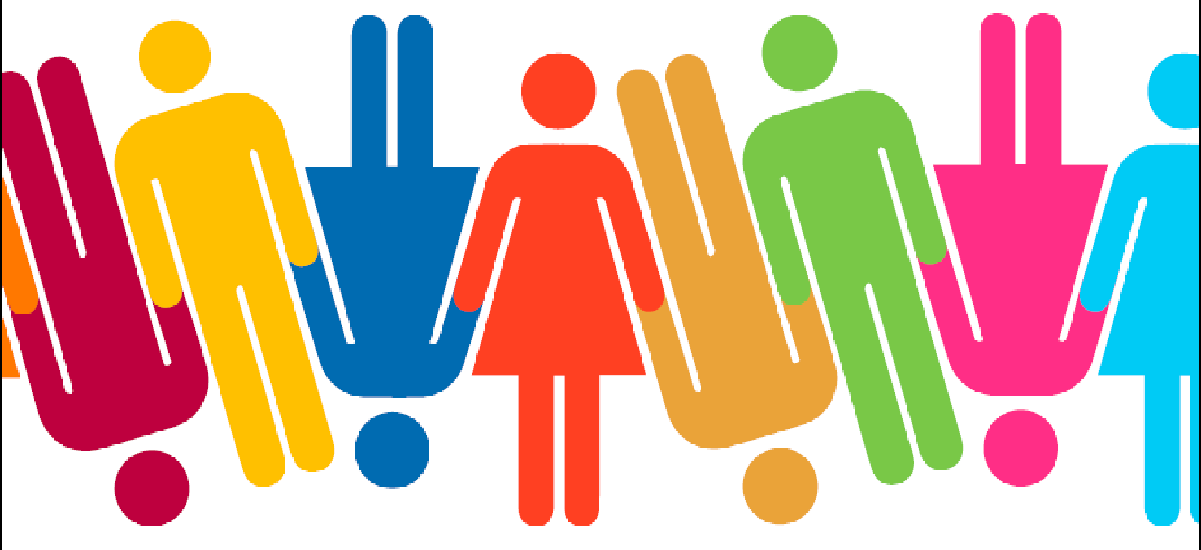
UNITED NATIONS COUNTRY TEAM IN MOZAMBIQUE
2023|

Índice
1. THE CONTEXT AND PROCESS OF THE 2023 UNCT-SWAP GENDER EQUALITY SCORECARD IN MOZAMBIQUE | 3
The context 3
The process and methodology of the Mozambique 2023 UNCT-SWAP Scorecard 4
Composition of the IAT 5
2. OVERVIEW OF 2023 UNCT RESULTS BY PERFORMANCE INDICATOR | 7
3. PROGRESS AGAINST BASELINE (CUMULATIVE RESULTS, 2022) | 9
4. THE 2023 UNCT-SWAP SCORECARD DETAILED FINDINGS BY PERFORMANCE INDICATOR UNDER THE SEVEN DIMENSIONS | 10
Dimension Area 1| Planning 10
Dimension Area 2|Programming and M&E 16
Dimension Area 3| Partnerships 22
Dimension Area 4| Leadership and Organizational Culture 27
Dimension Area 5| Gender Architecture and Capacities 32
Dimension Area 6| Resources 35
Dimension Area 7| Results 37
5. ACTION POINTS RECOMMENDATIONS AGAINST FINDINGS | 40
6. FOLLOW-UP ON THE FINDINGS OF THE COMPREHENSIVE REPORT AND MONITORING OF THE ACTION PLAN | 44

The context and process of the 2023 UNCT-SWAP Gender Equality Scorecard in Mozambique |

The context
The United Nations Country Team in Mozambique is dedicated to advancing gender equality and women's empowerment aligned with the SDG Agenda and national priorities. With 84% of its 25 specialized agencies, funds, and programs based in the country, the UN has consistently supported the government and civil society in creating a better environment for women, men, boys, and girls.
The agencies have collaborated to tackle issues such as gender-based violence, sexual and reproductive health rights, harmful practices affecting women and girls, women's leadership and participation, access to education, Water, Sanitation, and Hygiene (WASH), and women's poverty, among others. Recently, the UN in Mozambique has focused on integrating gender concerns in humanitarian settings due to the country's climatic crises and extremist violence in the north. These crises have required a concerted effort from the UN to comprehend and respond to women and girls’ specific needs and priorities in crisis contexts.
The newly implemented United Nations Sustainable Development Framework (UNSDCF) for 2022-2026, jointly developed with the Mozambique government, provides an opportunity for the UN to improve its contributions towards achieving impactful results for both men and women. The UNSDCF 2022-2026 has a vision of promoting Gender Equality and Women's Empowerment (GEWE) by ensuring that all citizens have equitable access to and benefit from sustainable development in a peaceful and resilient Mozambican society built on the foundation of gender equality. The framework further articulates gender priorities throughout its results frameworks, including across the four outcomes and corresponding indicators. Priorities are set under social, economic, environmental, and governance development pillars, aligning with SDG gender-specific priorities.
The UNCT in Mozambique is dedicated to upholding gender responsiveness and accountability in both the implementation of UNSDCF and its operations, structures and processes. Since 2019, the Country Team has been continuously monitoring its performance to ensure that the minimum standards set by the UNCT-SWAP Gender Equality Scorecard are met. This monitoring includes extensive reviews conducted in 2019, followed by annual reviews in 2021 and 2022 to track progress against the baselines set in 2019. With the new UNSDCF 2022-2026, the UNCT is conducting its second comprehensive review to establish new baselines, covering the new programming cycle. Based on the findings and baselines of this review, improvement actions will be taken for the next three years until 2026, which marks the last year of the CF implementation.
Contrary to the previous UNCT-SWAP Gender Equality Scorecards in Mozambique, which was conducted with in-house capacities only, the 2023 exercice counted on the technical support of an external consultant to guide and facilitate the exercise. Evidence shows that the UNCT-SWAP Scorecard has helped ensure the gender-responsive implementation of the 2030 Agenda and COVID-19 response and recovery plans. It has also been an opportunity to bring the UNCT together around the issues of organizational culture and leadership and how to commit resources towards substantial investment in enhanced gender competencies and coordination capacities of inter-agency working groups (Gender Theme Groups, Operational Management Teams, UN Inter-Agency Communication Groups, CF Strategic Pillar Groups, Monitoring, Evaluation and Reporting Group, and others).
The main goal of this exercise is to:
- Identify areas in which the UNCT meets or does not meet minimum standards in terms of gender mainstreaming.
- Set new baselines for the current UNSDCF 2022-2026 cycle.
- Stimulate a constructive dialogue within the UNCT about the existing support for gender equality and women’s empowerment and how it can be improved.
- Identify where technical assistance can support the achievement of minimum standards.
- Propose the minimum actions needed to support gender equality in Mozambique’s UNCT, focusing on the current UNSDCF cycle and the 2030 Agenda for Sustainable Development.

The process and methodology of the Mozambique 2023 UNCT-SWAP Scorecard

The exercise was driven by an external consultant, under the coordination of the RCO and UN Women and in close dialogue and consultation with the Inter-agency Assessment Team (IAT), composed of members of GTG and representatives of different inter-agency groups and agencies.

The consultant was hired to guide the group and facilitated the entire exercise, including desk review and data analysis, systematizing inputs, and drafting the assessment report with consolidated inputs from the IAT. She worked mainly home-based, with a short mission to Maputo/ Mozambique. The assessment process took about two and a half weeks, starting on October 23rd and ending on November 14th, with the finalization and submission of the assessment report and action plan to the global reporting platform by the UNCT scorecard focal points.
As the exercise coordinators, the RCO and UN Women provided most of the requested documentation for desk review, called and organized the necessary meetings, including the feedback and planning workshop with IAT, and articulated with the RC and the UNCT for briefings. At the same time, the IAT operated as the convening platform for quality assurance by reviewing the scoring of the indicators, the narrative of findings and explanations, providing additional evidence, and suggesting recommendations for action to address gaps and improve scores.
The leadership and joint coordination of the RCO and UN Women were critical to ensure timely feedback and engagement of different agencies and inter-agency groups for the timely completion of the exercise.

The methodology for the Mozambique UNCT-SWAP GE Scorecard has followed the guidance provided by the UNSDG in the Technical Guidance and adjusted as necessary to the beneficiary's requirements and the calendar. The work plan was structured into four main phases:

- Preparations, which included inception meetings with RCO, UN Women, and GTG to discuss the roadmap and timelines, roles and responsibilities, composition of the IAT, a methodology adapted to the deadline calendar, list of documentation for desk-review and information management and tools – the establishment of the shared-folder). Furthermore, the preparations included the development of tools for data analysis and systematization of information.

- (Self-)assessment: desk review and data analysis; documentation tracking for data review; draft and submission of first draft report of preliminary findings. During this phase, communication was kept open with the coordination team to ensure further sharing and updates on progress.
- Mission to Maputo/ Mozambique and Feedback and Action Planning Workshop with IAT (validation of results): The five-day mission to Mozambique helped finalize the assessment: collect complementary documentation for the desk review, conduct a feedback, planning, and consolidation workshop with the IAT and provide a briefing to the Resident Coordinator, on key findings and action point recommendations. The IAT provided inputs to the preliminary review and assessment and actively participated in the feedback and planning workshop held on 8 November. A briefing to the RC was also conducted at the end of the mission to share findings and recommendations for action, along with a briefing paper on the assessment’s findings and recommendations to be circulated within the UNCT.
- Finalization of the consolidated report: the final report, including Action Points Recommendations, was finalized and submitted for uploading in the UNCT-SWAP GE Scorecard global reporting platform (by the UNCT Moz Scorecard focal points).

Composition of the IAT
According to guidelines, the IAT included members of different UNCT inter-agency groups, such as the Gender Thematic Group (GTG), the Communication Group (UNCG), the Monitoring & Evaluation Group (MERG) and the Operations and Management Team (OMT) and Strategic Pillar Groups (SPG). The 16 IAT members (all females) are staff with different gender expertise and management knowledge, skills and experiences, coming from the following UN Entities: UN Women, UNPFA, UNAIDS, UNICEF, UN Habitat, ILO, UNODC, UNESCO, FAO, WFP and RCO.

 | Name | Sex | Inter-Agency Group | UN Entity
1. | Ondina da Barca Vieira | F | GTG, PMT & GCG | UN Women
2. | Amelia Tunzine | F | GTG | RCO
3. | Marta Bazima | F | GTG, UNJT, PMT, HCT | UNAIDS
4. | Teemar Kidane | F | GTG & SP4 | UNFPA
5. | Delfina Rangel | F | GTG | UNFPA
6. | Sheila Matavele | F |  | UNESCO
7. | Emelina Murrure | F | HGCG | ILO
9. | Eliana Cossa | F |  | UN Habitat
10. | Rossella Albertini | F | GTG, HGCG, COW gender | UNICEF
12. | Teresa Dybeck | F | GTG, SP4, HRN | UNODC
13 | Clelia Guareschi | F | MERG, SP1 | UNFPA
14. | Isabel Sitoe | F | MERG | FAO
15 | Lissungo Mazula | F | GTG | WFP
16 | Sarah TALON SAMPIERI | F | UNCG, UNJT | UNAIDS

Overview of 2023 UNCT Results by Performance Indicator |

Indicator |  | Misses  Minimum Requirements | Approaches Minimum Requirements | Meets  Minimum Requirements | Exceeds Minimum Requirements
1. Planning | 1.1 CCA
1. Planning | 1.2 UNSDCF Outcomes
1. Planning | 1.3 UNSDCF Indicators
2. Programming and M&E | 2.1 Joint Programmes
2. Programming and M&E | Communication and Advocacy
2. Programming and M&E | 2.3 UNDAF M&E
3. Partnership | 3.1 Engagement with Government
3. Partnership | 3.2 Engagement with CSOs
4. Leadership and Organizational Culture | 4.1 Leadership
4. Leadership and Organizational Culture | 4.2 Organizational Culture
4. Leadership and Organizational Culture | 4.3 Gender Parity
5. Gender Architectures and Capacities | 5.1 Gender Coordination Mechanism
5. Gender Architectures and Capacities | 5.2 Gender Capacities
6. Resources | 6.1 Resources
7. Results | 7.1 Gender Results
Missing requirements > Approaches minimum requirements > Meets minimum requirements > Exceeds minimum requirements

The assessment findings reveal that the UN in Mozambique is progressing well in continued efforts to mainstream gender equality and women’s empowerment in its inter-agency processes, mechanisms, and tools. The Country Team scored well in over half of the indicators (10 out of 15) and exceeded minimum requirements in 5. Positive ratings were reached on the Planning dimension (PI 1.2 – UNSDCF Outcomes and PI 1.3 – UNSDCF Indicators), Programming and M&E (PI 2.2 – Communication and Advocacy) Partnerships (PI 3.1 and PI 3.2, both with Government and Civil Society), Leadership and Organizational Culture (PI 4.1 - UNCT Leadership and PI 4.3 Gender Parity), Gender Architecture and Organizational Culture (PI 5.1 – Gender Coordination Mechanism) and Results (PI 7.1 Gender Results).

The combined positive scores represent 67 percent (14 percent higher than in 2022), which meets the QCPR Monitoring Framework Indicator 1.4.15: Fraction of UNCTs that conducted the Comprehensive UNCT-SWAP Gender Equality Scorecard in the past year and met or exceeded at least 60% of the UNCT-SWAP standards.

However, more needs to be done. The results indicate some shortcomings and areas for improvement. For instance, under the planning dimension, one indicator (PI 1.1 gender mainstreamed in the CCA) performed ‘approaching minimum requirements, which means that the UNCT needs to work towards meeting the minimum requirements. The CCA (2021) scored below the minimum required because not every sector in the CCA provides visible gender analysis and sex-disaggregated data. This means the current exercise of CCA updating is a timely opportunity to reverse the scoring. The inter-agency Gender Thematic Group can continue to play a decisive quality control role.

Another 3 indicators score ‘approaches minimum requirements’: PI 2.1 Gender Mainstreaming in Joint Programmes; PI 2.3 UNSDCF M&E PI 6.1 Resources. Quickly implementable actions are suggested in the indicator’s analysis section and action point recommendations to ensure the UNCT improves performance in these areas. For instance, on Joint Programmes (JPs), a screening system or quality control of JPs proposals could be adopted to ensure that all JPs have gender visibly mainstreamed, combined with a gender mapping of the current JPs. For the UNSDCF M&E, training on gender-sensitive M&E should be carried out, while the use of UN INFO to track progress on gender indicators at output and outcome levels must be scaled up. Regarding the allocation to gender equality, the review of the gender marker codes must be completed for all sub-outputs of the JWPs. The Quadrennial Comprehensive Policy Review (QCPR 2021-2024) target 1.4.18 (70% budget allocation in JWPs contributing to GEWE: GEM 3 and GEM 2) should be used as the target to be met.

The UNCT must ensure that all staff members are provided with capacity building on gender equality (PI 5.2). To achieve this, a comprehensive capacity assessment should be carried out. Moreover, an induction package for all onboarding staff members should be developed and made available. It is also recommended that a mapping of gender equality expertise within the UNCT be conducted. It is important to note that this is the only indicator that fails to meet the minimum requirement, which means none of the set criteria were met.

While some of these actions may require additional funds allocation and technical support, others can be implemented using in-house capacities.

Progress against baseline (cumulative results, 2022) |

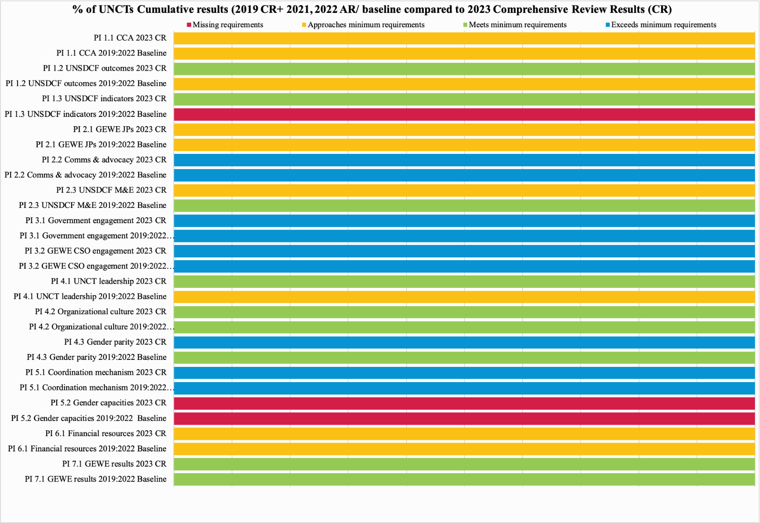

- The 2023 Mozambique UNCT-SWAP Scorecard findings show some progress against the previous assessment. It registered an increase of 14 percent of positive ratings (from 53 percent in 2022, to 67 percent in 2023).
- Positive developments against 2022 baselines on indicators PI 1.2, 1.3, 4.1 and 4.3; no progress registered on Performance Indicators 1.1 and 5.2 and regression on PI 2.3, from meeting to approaching.

The 2023 UNCT-SWAP Scorecard detailed findings by Performance Indicator under the Seven Dimensions |

Dimension Area 1| Planning
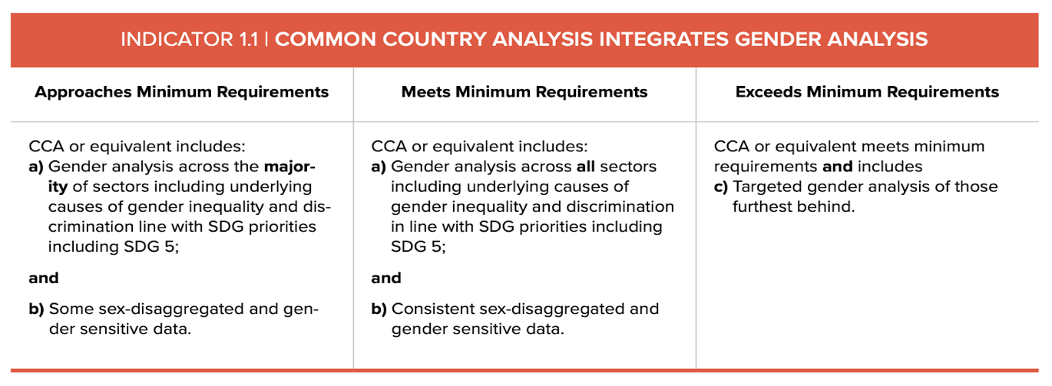
Approaches minimum requirements

Findings and Explanation:

CCA or equivalent includes:
a) Gender analysis across the majority of sectors, including underlying causes of gender inequality and discrimination in line with SDG priorities, including SDG 5: Met
b) some sex-disaggregated and gender-sensitive data: Met

The Common Country Analysis (CCA) was developed in 2021 and served as the basis for the current UNSDCF 2022-2023 development. The UNCT has initiated the process for an updated CCA to be available in 2024.
The assessment shows that the UNCT has made significant efforts to incorporate gender mainstreaming in CCA 2021, in line with the new United Nations Sustainable Development Cooperation Framework guidelines. However, despite these efforts, the gender analysis, including underlying causes analysis and the use of sex-disaggregated and gender data, is inconsistent across all sectors and insufficient to meet the minimum criteria. Thus, the UNCT only approaches the minimum requirements.

In presenting its analysis of gender equality and women empowerment, the UNCT adopted the dual gender mainstreaming approach. Firstly, a gender-targeted analysis is presented under Chapter 1, which covers Progress towards the 2030 Agenda and the SDG in Mozambique. Secondly, gender analysis is mainstreamed across most chapters and sectors covered by the CCA, albeit not all:

- Gender analysis is more substantial, including the use of sex-disaggregated and gender data in the: (i) Executive Summary, which includes a Leave No One Behind (LNOB analysis and findings of a forward-looking assessment of critical challenges to be tackled to advance sustainable development and peace in the country. Gender Equality and Empowerment of Women (GEEW) is one of the eight identified challenges to be addressed and is also a cross-cutting dimension in other identified challenges. (ii) LNOB, GEEW, and The Situation in Cabo Delgado under working at the Humanitarian - Development- Peace Nexus

- Some key gender analysis along with some gender-sensitive statistics and data, on (i) Demographic Trends, (ii) Social Dimension (in particular on poverty, demographic dividend, health, education, but not on social protection, chronic malnutrition, or WASH), (iii) Economic dimension (some gender analysis on women in the informal sector and linkages to the time use and care work and limited discussions on the agricultural sector, tourism, industries - including cultural and creative industries, business environment); (iv) Governance and Rule of Law and Human Rights and finally on (v) National Vision for Sustainable Development.

- Limited gender analysis and use of sex-disaggregated data on (i) Strengthening the financing for development architecture (ii) Environmental dimension (iii) Financial Landscape and Opportunities and (iv) Disaster risks in Mozambique and the humanitarian-development nexus

- Gender neutral: gender equality was not discussed in relation to the regional challenges and opportunities. However, several issues could have been explored, such as the AfCFTA Protocol on Gender, trafficking and the gender agenda in the context of the Migration Dialogue for Southern Africa and the Global Compact, the SADC Gender Protocol, the Protocolo de Maputo, and the Women, Peace and Security Agenda.

The CCA Annexes contain evidence of GEEW issues, emphasizing Annex 1, which summarizes root causes by priority areas such as patriarchal culture and negative gender power relations. Additionally, Annex 3 highlights data gaps per SDG.

As mentioned in the 'Data Gaps' section of the National Vision for Sustainable Development chapter, the UNCT should continue to focus on supporting the production and collection of sex-disaggregated data. It is also recommended that sectorial analysis be conducted, especially on economic sectors and environmental dimensions, to inform future CCAs, program design, and M&E. Additionally, it is suggested that the UNCT make greater use of normative frameworks such as CEDAW (conclusions and recommendations), UNSCR 1325, Beijing Platform of Action Reports, and others. This will help move beyond the situational analysis of vulnerabilities and expand on gender implications, along with intersectional analysis of opportunities in different sectors.

c) Targeted gender analysis of those furthest behind – Met
The Leaving No One Behind (LNOB) assessment of the CCA identifies 20 groups. There are overlaps between the groups, but they are analyzed separately for specific vulnerabilities and exclusion factors. There is a significant gender lens in the analysis of LNOB groups. It also includes an in-depth targeted analysis of marginalized groups based on gender. About nine of the twenty identified groups at risk of being left behind are marginalized gender-specific groups, such as:
- Women exposed to GBV (aged 15-49)
- Young girls (aged 10-19)
- Rural women (aged 20+ years)
- Male youth in northern provinces (aged 15-24)
- Food insecure households headed by women
- LGBTI+
- Transgender people
- Sex workers

Evidence or MoV:
- CCA, 2021

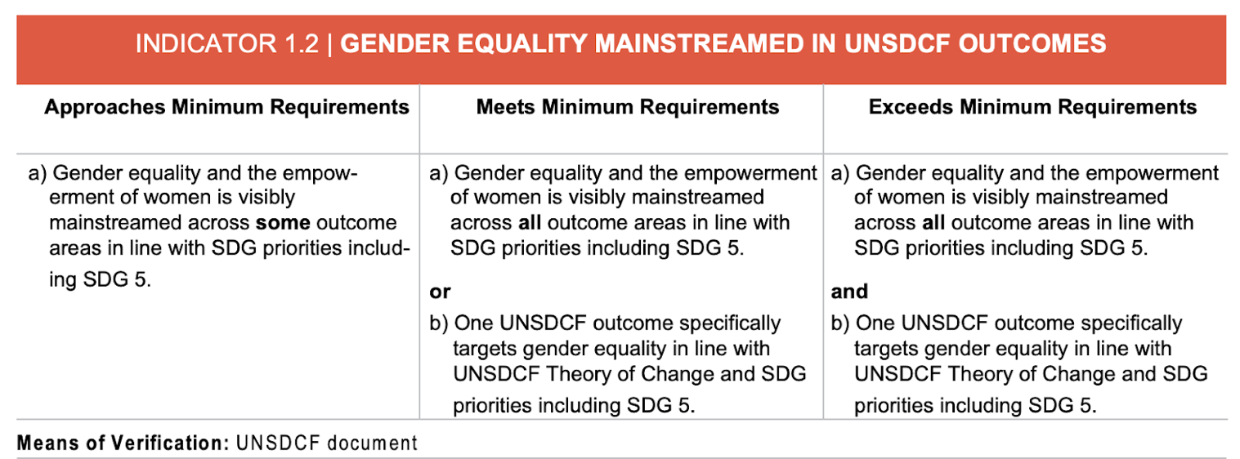
Meets minimum requirements
Findings and Explanation:
The United Nations Sustainable Development Cooperation Framework (UNSDCF) in Mozambique has identified four strategic priority areas and corresponding outcomes for 2022-2026. Since there is no gender standalone outcome in the CF 2022-2026 (criteria b – not met), the assessment was conducted to determine whether gender equality and women's empowerment have been visibly mainstreamed in all four outcomes. To achieve this, the assessment looked into several aspects such as the outcome statement, focus, results chain, linkages with gender-related SDG targets (including SDG5), alignment with national policies and strategies, outcome narrative (including ToC), partnerships, conditions for success, and areas of interventions. The conclusion was that even though gender equality is not the primary focus, it has been visibly and consistently mainstreamed in all four outcomes in line with SDG priorities, including SDG 5, covering priorities such as women’s and girls’ body autonomy and freedom from GBV, women’s economic empowerment, women’s political participation, women peace and security, women in climate change and resilience, among others (criteria a) across all CF outcomes – met). Specifically, gender is integrated as follows:
Outcome 1, under Human Development - Strategic Priority 1, aims to provide more equitable access to and utilization of quality, inclusive, resilient, gender and shock-responsive social protection and essential social services by 2026, focusing on vulnerable and marginalized people. Gender equality and women's and girls' empowerment are critical to this outcome. The outcome's achievement depends on ensuring gender-responsive laws, policies, regulations, norms, and standards in key social sectors and services, including health, education, WASH, and social protection. In addition, interventions for fighting GBV and combating stigma and discrimination are also emphasized. The outcome is aligned with the National Gender Policy and its implementation strategy, as well as SDG 5. Providing equitable and inclusive access to essential social services is the primary goal, with women and girls as one of the priority groups. The outcome has three indicators that measure changes in GEWE: gender-specific and sex-disaggregated. Additionally, Output 1.1 under this outcome focuses on strengthening the mechanisms and capacities of community actors and institutions to address discriminatory gender and social-cultural norms and to prevent and respond to violence and harmful practices.
Outcome 2 under the Strategic Priority 2 of Economic Diversification and Sustainable Livelihoods states that by 2026, there will be more people, specifically women and youths, who will participate in and benefit from a more diversified, inclusive, and sustainable economic growth based on increased production, productivity, and greater value-added chains. Regarding GEWE results, the outcome aims to address the existing gender and age barriers, gaps, and disparities by identifying women and youth as the primary beneficiaries. The outcome rationale, Theory of Change (ToC), and results chain reflect gender equality and women empowerment (GEWE) considerations. Three of the five outcome indicators aim to measure different impacts on women and men, while all three outputs are formulated in a gender-responsive manner. The outcome is expected to increase women's access to technical and vocational education and training, employability, decent jobs, financial and non-financial services, and income-generation opportunities.
Outcome 3, under SP3 on Climate resilience and sustainable use of natural resources: By 2026, more people, especially the most vulnerable, are resilient to climate change and disasters and benefit from more sustainable management of environment and natural resources and resilient infrastructures and human settlements, with positive effects on national GDP.
Under this outcome, the UN will provide technical assistance and policy support to the government to formulate, review, and reform policies, strategies, plans, and budgets that ensure the adequate integration of gender mainstreaming, women's empowerment, and sexual and reproductive health. To ensure that vulnerability is reduced effectively, it is essential to address the root causes of gender disparities and discrimination against women and girls. The UN will contribute to this achievement by implementing interventions that strengthen their resilience, such as promoting women's leadership in the sustainable management of natural resources and risk reduction. At least one of the outcome indicators is sex-disaggregated, and three of the four outputs under this outcome are gender-responsive.
Outcome 4, under SP4 on Peacebuilding, Human Rights, and Inclusive Governance: By 2026, more people, especially the most vulnerable and marginalized, are protected, enjoy their rights, and benefit from a secure, peaceful environment enabled by inclusive governance systems, and independent and accountable institutions abiding by the rule of law. Interventions to achieve this outcome will be closely coordinated and complementary to Outcome 1’s focus on governance, access to justice, and protection of women, youth, and marginalized communities. The United Nations will provide support to the country in addressing a range of issues, including domestic and sexual violence against children and adolescents, prevention and response to gender-based violence, child marriage, trafficking and exploitation, people affected by conflicts (especially women and girls), and women's representation in political and decision-making spheres. Four out of seven indicators will measure progress on gender equality and women's empowerment, while all three outputs are gender-responsive.
Evidence or MoV:
- UNSDCF 2022-2026, Mozambique
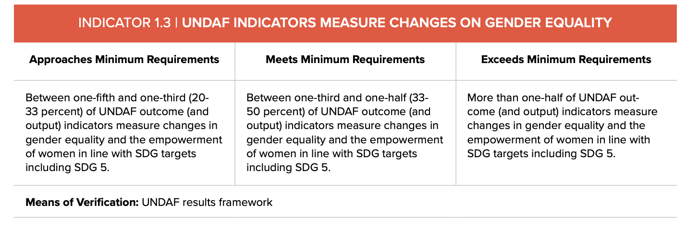
Meets minimum requirements
Findings and Explanation:
Between one-third and one-half (33-50 percent) of CF outcome (and output) indicators measure changes in gender equality and women’s empowerment in line with SDG targets, including SDG 5. Met
The Mozambique United Nations Sustainable Development Cooperation Framework (UNSDCF) has identified four strategic priority areas for 2022-2026. Each area has an associated outcome and corresponding indicators to measure progress toward addressing key challenges identified in the Common Country Assessment (CCA). These indicators align with the government's priorities as reflected in national strategic planning documents and SDGs gender-related targets.
The UNSDCF has 29 outcome indicators, of which 11 are relevant to gender equality and empowerment of women and girls, following the SDG framework, including SDG 5. These gender indicators comprise 37.9% of the total indicators in the UNSDCF (11 of 29), meeting the established minimum criteria.
Out of the eleven gender indicators, five are gender-specific, measuring progress towards SDG targets related to Women’s Sexual and Reproductive Health and Rights, Gender-Based Violence (GBV), Harmful Practices affecting young girls, Women's Political Participation, and the Women, Peace, and Security agenda. The following is the list of gender-specific outcome indicators in the Cooperation Framework linked to gender priorities under SDG 3 (on Good Health and well-being) and 5 (Gender Equality and Empowerment of Women):
- 1.4 Maternal mortality ratio
- 1.8 Proportion of ever-partnered women and girls aged 15 years and older subjected to physical, sexual, or psychological violence by a current or former intimate partner in the previous 12 months, by a form of violence and by age;
- 4.1 Proportion of women and girls aged 15 years and older subjected to sexual violence by persons other than an intimate partner in the previous 12 months, by age and place of occurrence;
- 4.2 Proportion of women aged 20-24 years who were married or in a union before age 15 and before age 18;
- 4.3 Proportion of seats held by women in (a) national parliaments and (b) local governments

Six other indicators focus on numerical changes and are more at the sex disaggregation level (1.7, 2.1, 2.2, 2.5, 3.7 and 4.5).
Outcome 3 has only one indicator that measures changes on GEEW, while outcomes 1, 2, and 4 have three, three, and four gender indicators, respectively. The number of gender-neutral indicators is still high (18 out of 29, corresponding to 61%), which will require more concerted efforts on disaggregation and ensuring gender dimensions in measuring the progress of UN investments. Particular attention should be paid to Outcome 1 and Outcome 3, concentrating on the higher number of gender-neutral indicators (13).
It should be noted that although the CF results framework goes up to the outcome level, data from the UN INFO reveals that the proportion of gender-responsive indicators is similar at the output level. Out of 60 indicators, 22 track changes against GEEW results, which accounts for 36.7%. These indicators can be categorized as gender-sensitive, sex-disaggregated, and gender-specific and are concentrated primarily under outputs 1.1, 1.2, 1.4, 4.1, 4.2, and 4.3.
However, it is essential to highlight that all indicators listed under outputs 1.3, 2.1, 2.2, 2.3, 3.1, and 3.4 are gender-neutral. This means there is a pressing need for concerted efforts to disaggregate data and ensure that gender dimensions are taken into account in measuring the progress of UN investments. These outputs are meant to contribute to gender equality and promote the empowerment of women and girls. To achieve this goal, exploring and reflecting upon dimensions such as women's decent work, unpaid work, informal sector work, primary sector work, and so on is crucial. Gender dimensions should be strengthened during future reviews of the indicator’s framework, discussed in the 2022 UN Country Results Report ‘lessons learned’.

Evidence or MoV:
- UNSDCF 2022-2026 – Results Framework, Mozambique
- Output Indicators Report (UN INFO, 27.10.2023)
- 2022 UN Country Results Report

Dimension Area 2|Programming and M&E
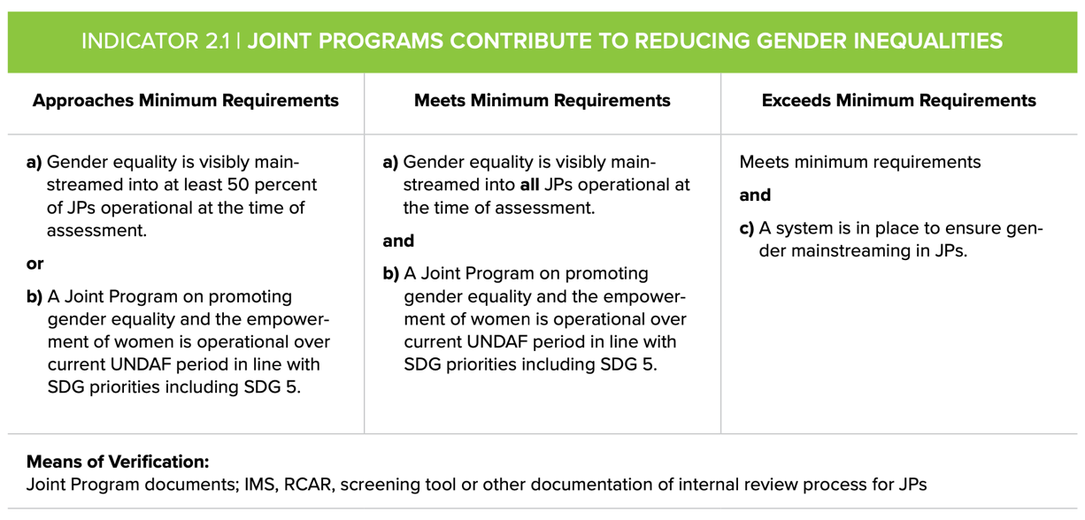
Approaches Minimum Requirements
Findings and Explanation:
It is important to note that we did not conduct an in-depth analysis of each of the 16 Joint Programs currently operating during the assessment. Instead, we collaborated with the JP coordinators to create an analysis matrix. This matrix allowed us to collect and review critical information about JPs for the assessment. JPs were examined under various variables, including the program's primary goal, thematic issues, participating UN Agencies/Programmes/Funds, program results framework (at outcome and output levels), alignment with SDG targets and indicators, and Implementing Partners. We also examined the programs' gender markers, whether applied or not. Our methodology involved a descriptive analysis of updated data/ list provided by the RCO on existing JPs, which we cross-checked with the information gathered in the UN INFO, after which we created our matrix, with complementary data to be collected and relevant for the gender assessment. Despite requests, there were very few contributions to the matrix, limiting the comprehensiveness of the analysis.
However, based on our review and available data, it was found that:
(Met a) approaching) Of a total of 16 JPs, 9 JPs contribute directly or in a significant way to gender equality, therefore meeting the minimum criteria for approaching (gender equality is visibly mainstreamed into at least 50 percent of JPs operational at the time of the assessment) being:
- (Met b) Four dedicated to promoting gender equality and empowerment of women and girls (GEM 3) and aligned with SDG Gender-Specific Indicators, including of SDG 5:
- Spotlight Initiative to end violence against children and women (UNFPA, UN Women, UNICEF, UNDP)
- Action for Girls and Young Women’s Sexual and Reproductive Health and Rights (Rapariga Biz), (UNFPA, UN Women, UNICEF, UNESCO)
- Enhancing the Quality of the Midwifery Workforce (UNFPA, WHO)
- Global Programme to Accelerate Action to End Child Marriage (UNICEF, UNFPA)
- Five significantly contribute to GEEW (GEM 2). These programs cover different thematic areas, such as Social Protection, HIV-AIDS, Child Protection, Climate Resilience Security, Humanitarian-Development-Peace Urban Durable Solutions involving Internally Displaced Men and Women (IDPs), and income security.
- It must be clarified if and how the remaining seven JPs contribute to GEEW. The information provided was insufficient to ascertain the level of gender mainstreaming.

Evidence or MoV:
- Mapping of UN Joint Programmes operational at the time of the assessment, RCO
- UN INFO database

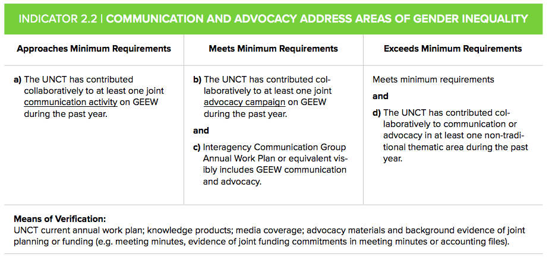
Exceeds minimum requirements
Findings and Explanation:
- The UNCT has contributed to at least one joint advocacy campaign on GEEW during the past year. Met
Gender Equality and Empowerment of Women (GEEW) is a common area for joint advocacy initiatives among UNCT in Mozambique, and it enjoys support at the highest level of leadership. The UN in Mozambique has conducted several joint GEEW communication events and advocacy campaigns published on various social media channels, particularly during Women's Month and the 16 Days of Activism. Similarly, several communication and advocacy were conducted in the context of implementing the Spotlight Initiative (SLI), jointly implemented by UNFPA, UNICEF, UN Women, and UNDP. Examples included active communication on social media of partners’ channels (RCO, UN agencies, EU Delegation, Government, and civil society partners) to disseminate SLI publications and link all content to the global Spotlight Initiative accounts. A social media pack was compiled in August 2023, which is annexed to this report.
One of the most widely participated campaigns is the 16 Days of Activism Campaign on Ending Violence Against Women, supported by the country’s highest leadership, the UN. In 2022, the Spotlight Initiative campaign also included a photo exhibition. Planning is currently underway for the 2023 campaign as part of the GTG work plan.
Every year, the UN collaborates with the government and stakeholders to support the celebration and advocacy of Women's Month, beginning with International Women's Day on March 8th and ending with Mozambican Women’s Day on April 7th. 2022 and 2023 were no exception, and various activities were organized and carried out.
In September 2023, UNAIDS and UNFPA collaborated on a communication campaign called "A NOSSA CENA" to increase condom usage among adolescents and young adults in Mozambique. Approximately 20 schools and their surrounding neighborhoods participated in the campaign, which included a variety of activities such as dialogues, lectures, health fairs (which provided counseling, voluntary testing for STIs and HIV, and blood donation), surveys, mapping of condom availability, content production (magazines and programs), podcasts, road shows, and activations. The main objective of these activities was to encourage and create demand for condom usage while also measuring some indicators of demand creation and understanding the level of information about condoms among female and male teenagers and young adults in the Matola district. The campaign is part of the Condom Strategic Initiative (SI) programme, implemented by UNAIDS and UNFPA in coordination with CNCS, and funded by the Global Fund.
In 2023, the UN Women and UNDP collaborated to support a Women’s Political Participation advocacy event. The focus was on violence against women during the elections in light of the upcoming municipal elections in the same year.
- Interagency Communication Group AWP visibly includes GEEW communication and advocacy. Met
The UNCG Mozambique AWP 2023 has three priority areas. Priority #2 is to leverage the International and National Days to enhance advocacy and maximize the visibility of the UN's work in Mozambique, with a visible emphasis on GEEW communication and advocacy. At least five entries are gender-related for UNCG's focus in collaboration with other agencies and inter-agency groups. These entries include CSW68, International Women's Day, International Day of Girls Child, ICPD 30th Anniversary, and 25 Nov-10 Dec (16 Days of Activism Campaign). Regarding advocacy on GEEW, the UN Communications Group works closely with the GTG.
- The UNCT has contributed collaboratively to communication or advocacy in at least one non-traditional thematic area during the past year. - Met
UN Women and UNESCO organized a one-day hybrid event called 'Share Fair', with the support of UNIDO, to raise awareness about Gender Digital Gaps and innovation and technology for gender equality. The event brought together organizations and companies at the forefront of digitalization and innovation to provide a synergistic portfolio of offerings to support the country's digital transformation further. The event's primary objective was to bridge the gender gap in innovation, technology, and education in development, peace, and humanitarian action, ultimately contributing to achieving the SDGs, women's empowerment, and gender equality. Participants were from different backgrounds with relevant roles vis-a-vis and experiences of the theme, including key Government Institutions, CSOs, professionals in ICT, Innovation Centers, and the Private sector.

Evidence or MoV
- UNCG ToR
- UNCG 2023 Annual Work Plan
- GTG Biannual Work Plan (2022-2023)
- Notes/ Minutes of GTG Meeting held on 31 May 2023
- Women’s Month 2023 Planning Matrix
- MasterLink – Plano de Campanha
- The Condom Strategic Initiative, UNAIDS, UNFPA, CNCS
- SLI HIS, Social Media Pack, August 2023
- Concept Note Share Fair, 2023
- 2022 IMS Annual Survey – Programme and Coordination Areas, Mozambique
- UN Mozambique social media channels:
Website www.mozambique.un.org
Facebook https://facebook.com/ONUMocambique/
Twitter https://twitter.com/onumocambique
Youtube https://www.youtube.com/channel/UC_wjpOPxCkNnuscbXx315Eg/featured
Instagram URL https://www.instagram.com/onu_moz/?hl=en
- Speeches RC (24.10.22 and 30.11.22)

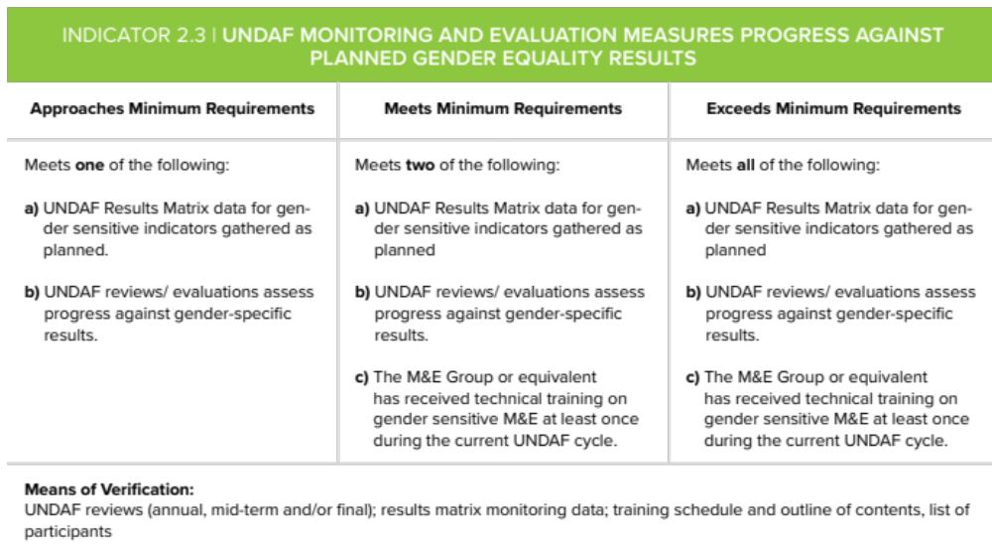

Approaches minimum requirements
Findings and Explanation:
- The CF Results Framework data for gender-sensitive indicators is gathered as planned. Not met
The CF Monitoring and Evaluation Plan states, “Data collected throughout the implementation of the UNSDCF will be systematically integrated into UN INFO to improve coordination, transparency, and accountability for results by tracking the UNSDG’s contributions to Agenda 2030 and the Sustainable Development Goals.” In addition, the Monitoring, Evaluation, and Learning Plan (MEL) reiterates that the collection and analysis of monitoring data against CF outcome and output indicators by results groups/ strategic priority groups should happen every quarter.
Despite the UN’s solid intentions, there seem to be inconsistencies in gathering appropriate data and quantitative reports in the UN INFO system (the primary tracking tool), at least for the first year of the CF 2022-2026 implementation. There is no tracking evidence in the UN INFO's Outcome Indicators Report 2022. Some gender-specific outcome indicators also miss baselines and targets (three out of five). At both outcome and output levels, data presented in the platform lacks sex disaggregation. When available, data from indicators' baselines and targets that promise sex disaggregation are aggregated.
Although this is a work in progress, the data must be collected and tracked disaggregated, as promised. The RCO has frequently reminded and requested MEL focal points of all UN Agencies, Programmes, and Funds in the JWP through emails or meeting calls to the Monitoring, Evaluation, and Learning Group (MERG) to establish a system for timely and effective monitoring and reporting progress on CF’s implementation including on Gender Equality and Women's Empowerment (GEWE), at both output and outcome levels. The requested action aims to make full use of UN INFO as the primary platform for CF M&E and to use available data and information systems at the national level to help strengthen data collection and annual reporting, as planned.
It is worth noting that efforts are underway to review the indicators framework at the output level, based on the new guidelines for adopting new global output indicators for UNSDCF. Furthermore, the Programme Management Team (PMT) has recommended a review of the existing indicators framework based on the lessons learned from the development process of the 2022 UN Country Results Report.
- CF reviews to assess progress against gender-focused results – Met
Gender results are consistently captured throughout the UN Country Results Report, 2022 Mozambique, using qualitative and quantitative data. GEWE is covered by the different chapters and components of the report, from the RC's foreword to the country development context, and in a comprehensive manner under each strategic priority and programmatic result of the CF. The report, which is the first of the current cycle of the CF in Mozambique (2022-2026), provides innovative and comprehensive qualitative information reflecting gender results, showcasing the voices of LNOB groups, including rural women, women exposed to GBV, women heads of households impacted by food insecurity, young girls, and others.
Chapter two of the report assesses progress against each SP and corresponding outputs by tracking the progress of outputs and sub-output indicators.
Despite the positives, there is still room for improvement, particularly at the output level. For instance, the report can ensure that output indicators promising disaggregation are collected and reported accordingly, such as 1.2.3 and 1.2.4. Other indicators, particularly under outputs 2.2 and 2.3, can be sex-disaggregated, which will improve the gender-responsiveness of the CF results framework.
It is also recommended that the report presents sex-disaggregated figures in the visual/graphic representation of the annual results report, including Chapter 2 and the front pages of each SP.
Several challenges in reporting and ways to address them were discussed during the MERG meeting held on April 27, 2023. These issues included implementation timelines, data accessibility, alignment between narrative and indicators, and methodological limitations. Addressing these issues by the roles and responsibilities of MERG, as stated in the ToRs, will make Mozambique's UN Country Results Report an excellent example of effective gender mainstreaming in monitoring and reporting processes and tools.
- The MEL Group has received technical training on gender-sensitive M&E at least once during the current CF cycle – Not met
No gender-sensitive monitoring and evaluation (M&E) training has been conducted during the current CF cycle. However, a follow-up action on this topic will likely happen soon. Preparations for the GTG’s 2023 Annual Retreat are currently underway, and the Concept Note for the event states that after the retreat, the GTG will undergo two days of training on the UNCT SWAP Gender Scorecard, as well as training for the GTG and MERG on the Gender Equality Marker. The MERG's April 27th meeting also discussed the 2023 MERG roadmap, which provides an opportunity to assess the need for capacity-building initiatives, including gender-sensitive M&E training, and to establish a training schedule immediately. Additionally, nine colleagues, including M&E specialists from the UN Mozambique, participated in the 2023 Regional training on the UNCT-SWAP GE Scorecard and UNCT-GEM. As a result, the organization has developed in-house capacity and acquired training materials that can be used to customize internal training. This information is detailed in Performance Indicator 6.1.

Evidence or MoV:
- UNSDCF Results Framework, 2022-2026
- Outcome and Output Indicators Report (UN INFO, 27.10.2023)
- 2022 UN Country Results Report
- RCO’s email to Agencies’ MEL focal points and members of the MERG
- Minutes of the MERG Meeting on 27th April 2023
- MERG ToRs
- Concept note and agenda for the 2023 GTG Annual Retreat

Dimension Area 3| Partnerships
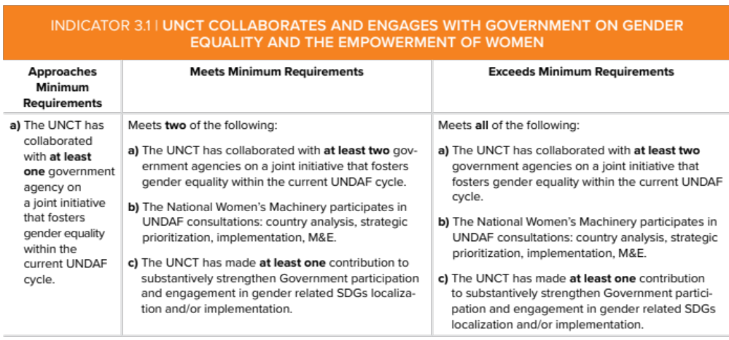
Exceeds minimum Requirements
Findings and Explanation:
Criteria a) The UNCT has collaborate with at least two government agencies on a joint initiative that fosters gender equality within the current UNSDCF cycle: Met:
The partnership between the United Nations Country Team (UNCT) and the Mozambican Government has been solid and well-coordinated during the entire United Nations Sustainable Development Cooperation Framework (UNSDCF 2022-2026). The UN, through its various agencies, programmes, and funds, has supported Mozambique in implementing its key gender priorities, which align with global normative and development frameworks such as the Convention on the Elimination of All Forms of Discrimination Against Women (CEDAW), the Beijing Platform for Action, and the Sustainable Development Goals (SDGs) gender priorities. The UN has provided policy support, technical and financial assistance to build capacity, humanitarian aid, advocacy and normative support, coordination, convening, and knowledge sharing.
The GTG BWP for the years 2022-2023 outlines the UN's collaboration with the Mozambican Government, specifically with the Ministry of Gender, Children and Social Action (MGCAS), in matters related to norms and standards to support various global normative frameworks such as CSW, Beijing+25, UPR, COP27, and others. Additionally, the XX anniversary of ICPD was commemorated during this time. The collaboration also extended to the technical and financial support provided to national partners for participation in global events, including CSW67. Moreover, technical support was provided for Mozambique's 6th report preparation to CEDAW until June 2023, when the Secretary of the CEDAW Committee informed that a new calendar for the LOIPR for Mozambique will be communicated in due time, but most likely to be adopted in 2025.
The UN is an active member of the Gender Coordination Group, established by the Ministry of Gender, Children and Social Action. This Government-led group is a coordination mechanism for policy dialogue, consultation, information sharing, policy and programme analysis, technical support, and advocacy on national gender priorities. The group comprises government institutions, civil society organizations, and development partners. According to the updated membership list, at least 5 UN Agencies participate in this coordination mechanism: UNODC, UN-Habitat, UN Women, UNFPA, and UNESCO. The UN's contribution to the group has provided policy advice, technical support on the global normative framework, sharing good practices, and international agenda and opportunities. These contributions are reflected in the minutes of meetings held in 2023 (February 26th, May 3rd, July 18th), which were reviewed during the assessment.
At the programmatic level, the UN actively addresses various crucial thematic areas impacting women and girls across Mozambique. These areas include Gender-Based Violence (GBV) and harmful practices, Sexual and Reproductive Health and Rights (SRHR), access to justice, women's leadership and political participation, women's economic empowerment, climate change and climate resilience, the Women, Peace and Security Agenda, social protection, gender-responsive planning and budgeting, local development, and peace consolidation.
The UN collaborates with ministries, public institutions, and universities at the central and local levels to address these issues.
First and foremost, the UN has jointly collaborated with the Ministry of Gender, Children, and Social Action (MGCAS), the leading government body on Gender policies and regulations. Also, in the framework of a cross-sectoral approach and gender mainstreaming across all sectors, the UN has been working collaboratively with several other ministries, including the Ministry of Health and Ministry of Education and Human Development, to address SRHR and the Ministry of Justice to improve access to justice. Some examples are the following:
- Under the Spotlight Initiative to End Violence Against Children and Women, the UN (UN Women, UNFPA, UNICEF and UNDP) cooperates with a wide range of Ministries and public Institutes. Among them are the Ministry of Gender, Children and Social Action, Ministry of Health, Ministry of Justice, Constitutional and Religious Affairs, Ministry of Interior, Ministry of Economy and Finance, Ministry of Education and Human Development, Ministry of Science, Technology and Higher Education, Ministry of Culture, Ministry of Youth, Ministry of Communication and Transport.
- On the Global Programme to Accelerate Action to End Child Marriage (UNICEF and UNFPA) the UN work together with the Secretariat of State of Youth and Employment; Ministry of Education and Human Development, Ministry of Health, Ministry of Justice, Constitutional and Religious Affairs, Ministry of Gender, Children and Social Action) and their provincial branches.
- In the context of the implementation of the UN Women’s Programme on Women, Peace and Security Promotion of Adequate, Accessible, Safe, and Resilient Housing for Displaced Women and Girls, UN Women and UN-Habitat have cooperated with the Ministry of Gender, Children and Social Action, State Secretariat and Government of Cabo Delgado Province, including key Provincial Directorates and Local Authorities (District, Municipal and selected Community).
- In September 2023, UNODC, UNDP and OHCHR supported the Mozambique Ombudsperson in conducting a two-day 'Seminar on Protecting Fundamental Rights and Freedoms and Preventing GBV and HIV-AIDS in Inhambane'. Over 70 representatives from various justice administration institutions, public servants, community leaders, academics, and civil society participated in the two-day seminar.
Criteria b) Met: The UNSDCF was developed with a fully consultative approach. The MGCSA has been involved in developing the new CF (for 2023-2027) and participated in the different steps: in CCA, in the prioritization, and the national consultation workshop. The Ministry of Gender, Children and Social Action continues to be an active member of UNSDCF JWPs development and implementation processes and mechanisms. Furthermore, the Ministry is a member of the Joint Steering Committee for the UNSDCF, the highest governing body chaired by the Minister of Foreign Affairs and Cooperation and the UN Resident Coordinator, to ensure strategic direction and oversight of the UNSDCF, alignment with national, regional, and international development processes, mechanisms and goals.
Criteria c) Met: The UN provided: (i) technical assistance to the formulation of the National Development Strategy with a submission to the Ministry of Economy and Finance (as the Government-wide champion of the Agenda 2030), outlining five recommendations aligned to the findings of the CCA and the strategic priorities in the CF, being one of them focused on gender: Empowering women and realizing the demographic dividend to transform the country. (ii) Furthermore, supported gender mainstreaming in the SDG Voluntary National Report (VNR) process of the government by helping with data collection, analysis and dissemination, consultations with different government institutions, engaging stakeholders and raising awareness for SDGs, including SDG 5 and (iii) In 2022 and 2023, various UN Entities, including UN Women, UNFPA, UNESCO, FAO and UNICEF supported the MGCAS in organizing the National Gender and Women’s Conference. This annual conference tracks progress in implementing national gender commitments, including policies and strategies. The 2023 edition of the forum focused on several key themes, including Financing for Women’s Economic Empowerment, Violence Against Women, Sexual and Reproductive Health and Rights, Environment and Climate Change – and issues about other themes such as Women, Peace and Security in a Humanitarian context.

Evidence or MoV:
- List of JPs Mapping, RCO
- 2022 UN Country Results Report
- Notes/Minutes of GCG Meeting held on 31 May 2023
- Notes of the GCG Meeting of July 2023
- 2022 IMS Annual Survey – Programme and Coordination Area
- National Gender and Women’s Conference
- Minutes of CF’s Consultation Meeting and List of participants

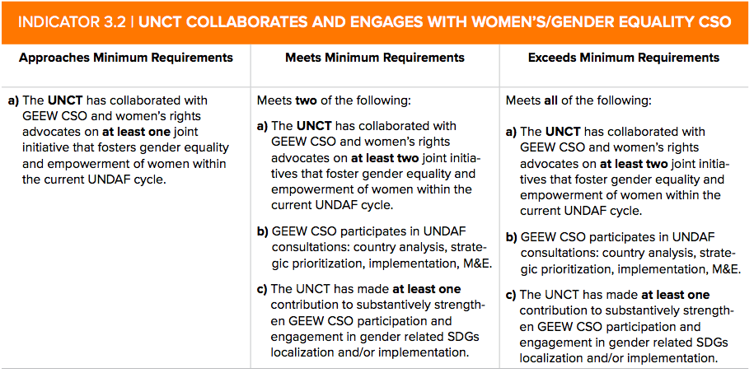
Exceeds minimum Requirements
Findings and Explanation:
- The UNCT has collaborated with GEEW CSOs and women’s rights advocates on at least two joint initiatives that foster gender equality and empowerment of women within the current UNSDCF cycle - Met
Civil society organizations have been vital partners in advancing gender equality and women's and girls' empowerment in Mozambique and essential stakeholders across the UN Cooperation Framework cycle, from planning to implementation, monitoring, and evaluation. The UNCT in Mozambique has developed strong partnerships with national and international NGOs, community-based organizations working on women’s rights, women’s associations, and female and male activists. The UN supports normative and development frameworks, including SDGs, technical and financial support for programme implementation, and advocacy.
In May 2023, the High-Level Meeting of the National Reference Group of Civil Society (GNR-SC) was held as part of the Spotlight Initiative. This event brought together various stakeholders to discuss three key topics related to the initiative: integrating its strategic pillars into the National Development Strategy, addressing gender and sexual diversity, and working with men and boys to combat Gender-Based Violence. The GNR-SC was formed to facilitate collaboration between UN, EU, and Government agencies and serve as a platform for consultation, assessment of progress implementation, and strategic planning. The group aims to build on shared experiences and successful practices.
UN Women and OHCHR collaborated with Observatorio das Mulheres e Justa Paz to organize training sessions for CSOs on CEDAW shadow and independent reports to prepare for Mozambique's VI Report to CEDAW. Training concept note and agenda were developed closely with the two NGOs. However, due to the global rescheduling of the CEDAW Committee calendar for 2023 reviews, Mozambique's review was postponed to a later date that has yet to be communicated. As a result, the training sessions have also been delayed, aligning with the new calendar.

- GEEW CSO participates in UNSDCF consultations: country analysis, strategic prioritization, implementation and M&E - Met
In August 2021, the UN organized a consultation meeting with CSOs to discuss the UNSDCF 2022-2026 development. The meeting was coordinated by the RCO and aimed to identify priority areas for the advancement and achievement of Sustainable Development Goals (SDGs) along with the strategic areas and expected results. Representatives from 24 CSOs, including GEEW CSOs such as Forum Mulher, Gender and Sustainable Development Association (formerly Gender Links), AREPACHO, ADEL SOFALA, Grupo de Desenvolvimento da Mulher e Rapariga, among others attended the meeting. The agenda included a briefing on the CF's roadmap and results from the prioritization retreat. The discussions were structured around three main topics: LNOB (Leave No One Behind) in Mozambique, partnerships with CSOs, and addressing inequalities and discrimination. The participants shared their inputs and good practices related to these topics. The inputs from the participants were integrated across the CF document, including the results framework.
- The UNCT has made at least one contribution to substantively strengthen GEEW CSO participation and engagement in gender-related SDGs localization and/ or implementation – Met
CSOs of GEEW have played a crucial role in supporting the implementation of UN Joint Programs on Gender-Based Violence, harmful practices, Sexual and Reproductive Health and Rights, and Women's Economic Empowerment, all connected to Sustainable Development Goals, especially SDG 5. (please refer to section 2.1). Alongside government entities, CSOs at national and local levels are chosen as Implementing Partners of gender-focused UN programs.
Although it is not an assessment criterion, the UN has increasingly partnered with the Donor's Community on Gender Equality and Empowerment of Women (GEEW). In December 2020, the Coalition of the Willing for GEWE (GE CoTW) was established to promote high-level political dialogue and action on gender equality and women's empowerment issues between the Donors Community Platform (DCP) members and the Government of Mozambique (GoM). Canada and UN Women co-chair the GE CoTW, which convenes quarterly with technical and/or Head of Cooperation level representatives. As of June 2023, the group comprised 21 Countries/ Organizations, including UNDP, UNFPA, UNICEF and UN Women. The group aims to inform and influence high-level strategic dialogue and advocacy on targeted gender equality and women's empowerment issues with the GoM and other key stakeholders. The GE CoTW carries out various activities such as developing policy dialogue messages, providing strategic advice, coordinating social media campaigns, communication and advocacy events, identifying key stakeholders for further engagement, and producing and using data. This work is cross-cutting and multi-sectoral, engaging other ministries beyond the Ministry of Gender, Children and Social Action (MGCAS).
Given the above, Mozambique may consider introducing a new indicator to measure partnership with the Donor Community/ Development Partners and partnership with the Government (3.1) and GEEW CSOs (3.2).

Evidence or MoV:
- 2022 UN Country Results Report
- ToRs and agenda of the High-Level event of the Civil Society National Reference Group (GRN-SC)
- List of Participants in the High-Level Event of the GRN-SC
- Notes/ Minutes of GTG Meeting held on 31 May 2023
- Concept Note and Agenda of Civil Society Capacity building for CEDAW shadow Reports, 2023
- Minutes of the Consultation Meeting with CSOs in the context of the development of the UNSDCF 2022-2026
- GE CoTW Overview
- GE CoTW membership list

Dimension Area 4| Leadership and Organizational Culture
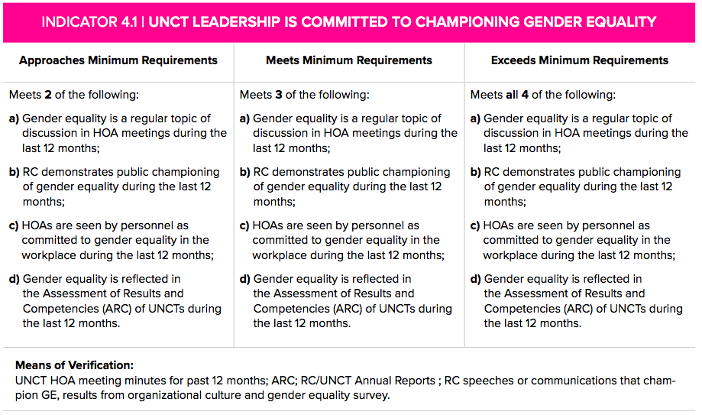
Meets Minimum Requirements
Findings and Explanation:
- Gender Equality is a topic of discussion in at least 60 percent of UNCT meetings during the last 12 months – not met
The minutes of UNCT meetings held in 2023 were reviewed during the assessment. The evidence gathered revealed that Gender Equality and Empowerment of Women and Girls was not a meaningful discussion topic at these meetings. Instead, it was more often a topic under AOB and at the general information-sharing level only. Out of the seven meetings that year (meetings with minutes), only two reported some meaningful discussion, engagement, and follow-up action points on GEEW, as required. These meetings were (i) on September 19th, where the UNCT received a briefing on the coordinated efforts on PSEA, including feedback on the PSEA Risks Assessment and its action planning, and (ii) an ad hoc meeting on September 26th, held at the request of UNFPA during the visit of the UNFPA East and Southern Regional Director, Ms. Lydia Zigomo, to Mozambique. During the latter meeting, discussions and reflections were focused on the ICPD achievements and commitments in Mozambique and on achieving three zeros by 2030: zero unmet need for family planning, zero preventable maternal deaths, and zero GBCV and harmful practices. Members of the UNCT agreed on follow-up discussions at the PMT level. They highlighted the importance of working together to accelerate progress in critical areas, including demographic dynamics and gender equality. They suggested having more of these presentations and discussions in UNCT meetings.
It is important to note that in three meetings held on May 16th, July 18th, and August 15th, information was shared regarding past, ongoing, or planned activities related to GEEW. This included sharing information about the Regional Training on the UNCT-SWAP GE Scorecard in Mozambique and inviting agencies to nominate participants, discussing gender as a normative area in the IMS report and the role of GTG, sharing information about the National Conference on Women 'Empowering Women for the achievement of Gender Equality' and gender-sensitive information related to project implementation for elections. However, per the guidelines, these discussions did not meet the criteria as they were at the information level only and were often under AOB in the agenda, resulting in limited time allocated, with no evidence of decision-making or follow-up. Furthermore, in the first two meetings held on January 17th and March 21st, no evidence was found of any discussions or information sharing on GEEW. Therefore, the UNCT needs to meet the criteria of at least 60 percent of UNCT meetings addressing issues on GEEW.
- RC has demonstrated a championship of gender equality during the past 12 months – met
The United Nations Resident Coordinator and Humanitarian Coordinator (UN RC/HC) played a vital role in promoting gender equality and women's empowerment, aligning with SDG 5. Her effective communication and advocacy for gender priorities in internal and external contexts were confirmed by reviewing fifteen speeches delivered between October 2022 and October 2023. These speeches were available on the UN Mozambique website and included fourteen public events and one UN Staff Townhall meeting. It is worth noting that during this period, the UN leadership in Mozambique transitioned, with a new RC/HC taking office in July 2023.
The review found that the RC included messaging on gender equality in 80 percent of the speeches. Of the total analyzed, five speeches were gender-specific, covering topics such as Gender-Based Violence (GBV), women's rights and empowerment, UNCT-SWAP Gender Equality Scorecard, and UNCT-GEM. Seven speeches were gender-sensitive, on human rights and GEEW, sustainable development and centrality of GEEW, and gender centrality in the African Continental Free Trade Area (AfCFTA). Three speeches were neutral, with minor gender-sensitive language included on topics such as Migration, COP28, and Peace and Reconciliation. Additionally, the RC actively participated in key events linked to the Spotlight Initiative on Eliminating Violence Against Women and Girls (EVAWG), the Women's National Conference, and East and Southern Africa Regional Training on the UNCT-SWAP GE Scorecard and UNCT-GEM, organized by the UN Women Regional Office with the support of the UN Women Mozambique Country Office.
During the GTG’s annual retreat in 2022, the Resident Coordinator (RC) participated in an open discussion and Q&A session with the GTG leadership and its members. This discussion aimed to seek guidance and recommendations from the RC on improving the UNCT's performance regarding gender equality and women's empowerment by enhancing inter-agency coordination. The RC's participation emphasizes the importance of UN leadership involvement in the GTG's work.
c) HOAs are seen by personnnel as committed to gender equality in the workplace during the last 12 months - Met
According to the survey, 70.8% of the respondents positively perceive the leadership and commitment of HoAs towards GEEW. Among them, 23% strongly agree and 48% agree. It was found that male staff have a slightly higher positive perception than female staff, with 78% and 74%, respectively.
d) Gender Equality is reflected in the Assessment of Results and Competencies (ARC) of UNCT during the last 12 months – Met
In her 2022 self-appraisal, the Resident Coordinator (RC) emphasized the importance of gender equality and women's empowerment in her performance. She highlighted this as one of the priority themes of her leadership of UN development activities, which she discussed with the donor community as co-chair of the Donor Coordination Platform (DCP). The RC also promoted UN accountability and transparency by regularly reporting progress towards achieving the Common Framework (CF) outcomes and the Sustainable Development Goals (SDGs), including SDG 5. The RC also highlighted her leadership in strengthening UNCT capacities in PSEA.

Evidence or MoV:
- UNCT Minutes of Meetings (2023)
- UN RC/ HC Speeches (October 2022 – October 2023)
- UN Gender Joint Team 2022 Retreat Report
- Results of the Organizational Culture Survey (Q2)
- 2022 RC Performance Appraisal

INDICATOR 4.2 | ORGANIZATIONAL CULTURE FULLY SUPPORTS PROMOTION OF GENDER EQUALITY AND THE EMPOWERMENT OF WOMEN
Approaches Minimum Requirements | Meets Minimum Requirements | Exceeds Minimum Requirements
Survey results of personnel perception of organizational environment for promo- tion of gender equality scored a positive rating of 50-64 percent. | Survey results of personnel perception of organizational environment for promo- tion of gender equality scored a positive rating of 65-80 percent. | Survey results of personnel perception of organizational environment for promo- tion of gender equality scored a positive rating of over 80 percent.
Meets Minimum Requirements
Findings and Explanation:
The Head of the RCO sent the Organizational Survey link to all UN staff on October 30th, 2023, on behalf of the RC. The survey was open for participation until November 7th, 2023, and received a positive response rate, with 246 staff members (128 female, 119 male, and 1 other) responding. This number exceeded the target sample of 168 responses, ensuring a minimum interval of 7.5. Most respondents were national staff, accounting for 69 percent of the total, and an equal proportion of staff with and without supervisory roles (51 and 49 percent, respectively) participated in the survey.
The survey consisted of 10 questions, which aimed to determine the staff's perception of the leadership on gender-related issues, the prevalence of workplace discrimination, the promotion of gender equality in the workplace, and the measures, policies, and practices related to work-life balance.
The minimum requirement (65-80 percent) is met: The organizational survey results scored an overall positive rating of 69.66 percent (21.8 percent strongly agree and 47.84 percent agree). 20.93 percent are neutral, and 9.4 percent negatively perceive the UN organizational culture supporting gender equality. Generally, the male staff has a more positive perception than females, 77.01 and 62.60 respectively.

The highest positive rating was verified on the perception of Leadership championing and commitment to GEWE in the workplace, adequately facilitating the equal participation of both women and men at all levels of the organization and adequate procedures in place to prevent and address sexual harassment, exploitation and abuse of authority (75 percent and above), while lower favorable rates are regarding flexible work arrangements: work-life balance; HoA support of the adequate relationship between work life and home life; a package of entitlements for work-life balance (maternity/ paternity leave, breastfeeding). However, the overall rating does indicate an optimistic view of the organizational culture in all aspects covered by the staff survey.

Evidence or MoV:
- Organizational Survey Results (responded by 246 UN personnel).

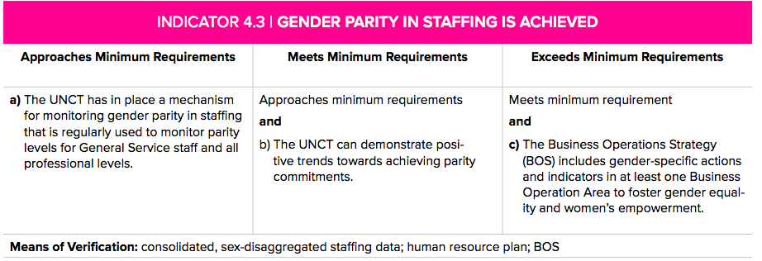

Exceeds minimum requirements
- The UNCT has in place a mechanism for monitoring gender parity in staffing that is regularly used to monitor parity levels for General Service staff and al professional levels (Met)
- The UNCT can demonstrate positive trends towards achieving gender parity commitments (Met)
The UNCT regularly utilizes the UN Global Database to monitor the levels of gender equality in staff. According to the data accessed during the assessment period, the UNCT in Mozambique has made remarkable progress towards achieving gender parity. Female staff constitute 42.18 percent of the total UN staff in Mozambique. The sex-disaggregated data also reveals that the number of female staff has increased by 2 percent compared to the data reported in 2022 (UNCT-SWAP Gender Equality Scorecard Annual Review), which indicates a positive trend. The General Service (SC) and National Professionals (NO) categories have already achieved parity with 50 percent male and 49 percent female, and 50 percent male and 47 percent female, respectively. However, the proportion of male and female international staff differs slightly, with men outnumbering women (50 percent male and 41 percent female).
- The Business Operations Strategy (BOS) includes gender-specific actions and indicators in at least one Business Operation Area to foster gender equality and women’s empowerment - Met
The UNCT BOS was developed in 2021 and has been updated annually. The 2022 Annual Review allowed twelve new common services, including gender equality and disability inclusion.
Gender-related common services are mainstreamed under Common Human Resources, concerning two main issues: Gender Parity and Prevention of Sexual Exploitation and Abuse (PSEA), page 20. Opportunities are identified as follows:
- Gender Parity: monitoring the compliance of gender parity (each agency to share the quarterly report for the composition of the gender in each agency) – with UN Women as the lead entity;
- PSEA: Awareness sessions on PSEA with the dissemination of English and Portuguese brochures – with WFP and lead entity.

Evidence or MoV:
- UN System-Wide Dashboard on Gender Parity:
https://app.powerbi.com/view?r=eyJrIjoiOGY5YjU4ZGEtYmE0ZS00ZDQ4LWJhNjgtNzNhMzJhNmFhMjZmIiwidCI6ImIzZTVkYjVlLTI5NDQtNDgzNy05OWY1LTc0ODhhY2U1NDMxOSIsImMiOjh9
- Business Operation Strategy, Mozambique, Review #2, 2022

Dimension Area 5| Gender Architecture and Capacities
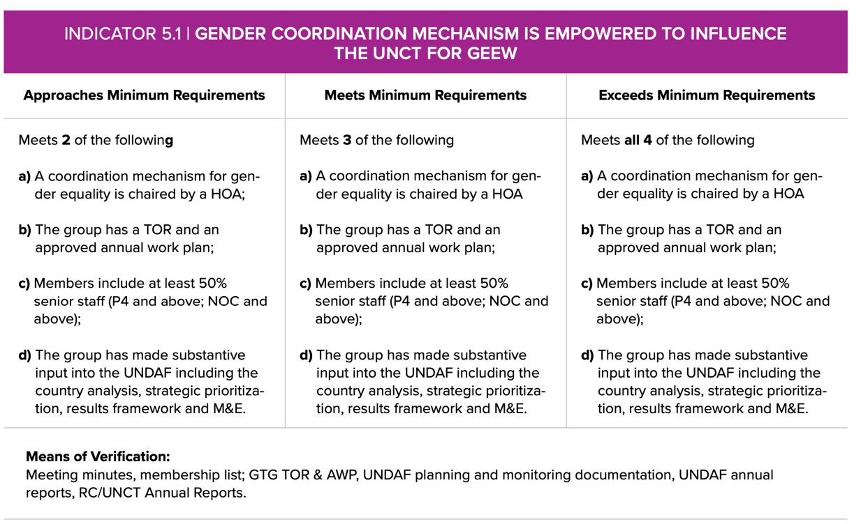
Exceeds minimum requirements
Findings and Explanation:
Met all four requirements: a coordination mechanism for gender equality is chaired by an HOA; the group has a TOR and an approved annual work plan; Members include at least 50% senior staff (NOC and above; P4 and above); the group has made substantive input into the Cooperation Framework, including the Country Analysis, strategic prioritization, results framework and M&E.
The Gender Thematic Group (GTG) is one of the five thematic groups in the UNCT Mozambique. It is a collaborative effort among several UN entities in Mozambique, chaired by the UN Women Resident Representative and co-chaired by the UNFPA Resident Representative.
As per the last updated list, the group is comprised of 24 members (21 female and 2 male) from 16 UN Entities: FAO, ILO, IOM, UN Habitat, UN Women, UNAIDS, UNCDF, UNDP, UNESCO, UNFPA, UNICEF, UNIDO, UNODC, WFP, WHO and RCO. To verify this criterion, 13 group members provided their post-level information, and 10 confirmed that they are senior staff (NOC/P4 and above).
The GTG follows a Biannual Work Plan (BWP 2022-2023) that is endorsed by the UNCT. The group meets quarterly to monitor progress and implementation and discuss joint initiatives. They also organize annual retreats to reflect on the overall functioning of the GTG, for capacity-building purposes, and to prepare mid and annual reports and planning. The last retreat was held in April 2022, and the preparations for the 2023 retreat are ongoing. The GTG has drafted a concept note and detailed agenda for the 2023 Annual Retreat and is currently making arrangements to organize it by the end of the year.
It is worth noting that despite having a significant number of members, their meeting attendance could be more consistent. According to the available information, there have been regular attendees, but some appointed members have yet to attend GTG meetings, while others are not regular attendees. The average number of GTG meeting attendees is between 11 and 14. For instance, in May 2023, there were 14 attendees, in August 2023, 11, and in September 2023, 14. During the 2022 Annual Retreat, only 14 members participated.
Based on the available information, the Group played a crucial role in achieving the gender-related results reflected in the UNSDCF (refer to PI 1.1, 1.2 and 1.3). At the outset of the development process, members were trained on gender mainstreaming in the UNSDCF. GTG continuously collects and shares sex-disaggregated data and relevant gender-related data to support evidence-based analysis and programming. Members systematically share guidelines and tools on gender mainstreaming at the program level. GTG reviewed drafts and coordinated using the UNCT-SWAP Gender Equality Scorecard findings and Action Plan for technical guidance and advocacy purposes. Moreover, GTG facilitated the engagement and participation of gender stakeholders, such as government agencies and civil society organizations, in consultation and prioritization exercises.
Evidence or MoV:
- GTG ToRs
- GTG Biannual Work Plan (2022-2023)
- GTG Membership List
- UN Gender Joint Team 2022 Retreat Report
- Concept note and agenda for the 2023 GTG Annual Retreat
- 2022 UNCT-SWAP Gender Equality Scorecard Annual Review

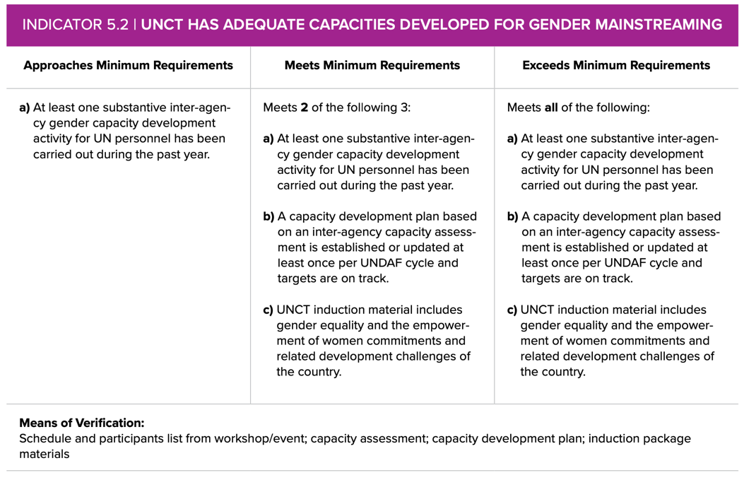
Missing Minimum Requirements
Findings and Explanation
Criteria a) not met – apart from the participation in the Regional Training on UNCT-SWAP Gender Equality Scorecard and UNCT-Gender Marker held in Maputo in June 2023, there is no evidence of a substantive inter-agency capacity development activity for UN personnel that was carried out during the past year.
Criteria b) and c) not met – A capacity assessment will be conducted on Gender Equality and Empowerment of Women (GEEW), and the results will inform the capacity development plan. Preparatory activities are ongoing. Additionally, there are plans to conduct face-to-face training on PSEA and Gender as part of the induction of all newly recruited staff. create an induction material at the UNCT level that addresses PSEA and GEEW and related countries' challenges and priorities. Both the capacity plan based on an inter-agency capacity assessment and a UNCT induction material that includes GEEW-related issues of the country are planned in the context of GTG’s Biannual Work Plan (2022-2023), under Goal 4: Capacity Development on Gender Equality and Output 4.1 Strengthened capacity to mainstream Gender Equality in UN (programmatic and operations) Activities 4.1.1 and 4.1.2. Also, GTG’s plan ensures alignment with the UNCT Gender Equality Strategy developed in 2019 and updated in November 2022. Capacity development is one of the core pillars of the Strategy, with the overall goal of improving UNCT’s performance on GEEW (Result 1).
According to recent information, the PSEA specialist in the RCO has begun offering PSEA training to various agencies and identifying focal points as part of the induction process for all newly recruited staff. GTG recommends leveraging the in-person training to include a Gender Equality module, as outlined in GTG's work plan (4.1.2). Furthermore, it is recommended that the group articulate with the Operations Management Team (OMT) to ensure alignment with the identified opportunity considered under ‘Knowledge sharing’ common service: ‘Opportunity to harmonize the onboarding induction package for all new UN staff members’ (by 2023).

Evidence or MoV:
- GTG Biannual Work Plan, 2022-2023
- UNCT Gender Equality Strategy, 2019-2023
- Notes/ Minutes of GTG meetings from 28 September 2022 – August 2023
- Concept note and agenda for the 2023 GTG Annual Retreat
- 2022 IMS Annual Survey – Programme and Coordination Areas
- Business Operation Strategy, Mozambique, Review #2, 2022

Dimension Area 6| Resources
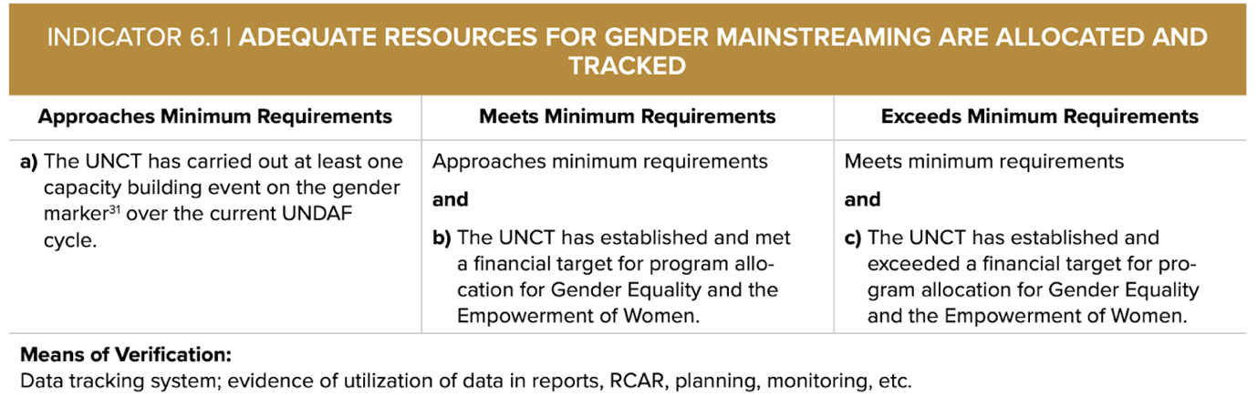
Approaches minimum requirement
Findings and Explanation:
- The UNCT has carried out at least one capacity-building event on the UNCT Gender Equality Marker over the current CF cycle – met
The UN Women East and Southern Africa Regional Office organized the annual regional training on the UNCT-SWAP Gender Equality Scorecard and UNCT-Gender Equality Marker in Maputo, Mozambique, from June 20th to 23rd, 2023. As part of its Biannual Work Plan for 2022-2023 (Output 6.1/ Activity 6.1.1 ‘Training of GTG members on UNSDCF process, UN Guidance on Gender programming, UNCT-SWAP Gender Equality Scorecard and Gender Marker), the UN Women CO was crucial in advocating for Mozambique to host the 2023 edition of the regional training, which it successfully did.
Nine members of the GTG from different UN agencies and the RCO in Mozambique attended the training. They greatly benefited from the experience sharing of 20 participating UNCTs in the region. After completing the training, colleagues were better equipped to lead or support their UNCT in implementing the UNCT-SWAP Gender Equality Scorecard and the UNCT Gender Equality Marker in their Joint Work Plan. As emphasized by the UNFPA RR in her opening remarks, a follow-up plan would be to use the installed capacities to further cascade the training to other colleagues, particularly program colleagues, members of the Strategic Priority Groups, and M&E colleagues who are the primary focal points for the UN INFO.
The four-day training aimed to enhance the capabilities of UNCTs in the region to implement the UN's accountability tools for gender mainstreaming, with the UN Sustainable Development Cooperation Framework (UNSDCF) as the foundation. The UNCT-SWAP Scorecard component consisted of nine sessions organized into three modules, while the UNCT-GEM component consisted of 5 sessions, organized into five modules: the first module was on introducing the UNCT-GEM and reflections on the Global and Regional Outlook on UNCT-GEM, the second on the UNCT GEM in the context of UNCDCF, JWP, and UN INFO, the third on the UNCT-GEM code application, followed by a module on quality assurance of the code application, and finally a module on Monitoring, Evaluation, and Reporting on UNCT-GEM.

- The UNCT has established and met a financial target for program allocation aimed at promoting gender equality and empowering women. Despite positive trends, the target at the global level is yet to be met.
The UNCT has efficiently used the UNCT Gender Equality Marker in the UN INFO. This marker includes targets covering the entire CF cycle and annual breakdowns. The JWP in the UN INFO database provides figures on GEM, such as available resources, expenditure, and the total required for GEM levels 3, 2, 1, and 0. As of 2021, the UN system has established a common global financial target for UNCT allocation to Gender Equality and Empowerment of Women (GEEW). The target sets a financial threshold of 70 percent of UNCT Annual Funding Framework available resources to be allocated to sub-outputs with gender equality as a principal objective (GEM 3) or significant objective (GEM 2).
As of now, UNCT Mozambique is making good progress towards achieving the global target. According to the UNCT-GEM data from the current JWP in UN INFO, the available resources for programs with GEM 3 and 2 in 2023 is at 68 percent, which is a 10 percent increase from 2022 (58 percent) and only 2 percent away from the global target. However, it is important to note that 22 percent of sub-outputs in the JWP still need a code. Therefore, UNCT must take the necessary steps to ensure all sub-outputs have a code applied, even if the code is zero.
It is also important to note that the UNCT GEM has been fully integrated into the UNCT Monitoring and Reporting tools. The UN Country Annual Results Report and the UNSDCF JWPs Quarterly updates include graphic representations of the UNCT GEM. The 2022 UN Country Results Report visually represents the percentage of available resources for each level of gender marker (GEM 3, 2, 1, and 0) and for each Strategic Priority Area of the CF. This practice is commendable, and other countries could adopt it. Furthermore, the data in the same report indicates that SP 3 on Climate Resilience and Sustainable Use of Natural Resources and SP 4 on Peacebuilding, Human Rights, and Inclusive Governance have more sub-outputs with gender as a principal or significant objective (GEM 3 and GEM 2), at 75 percent and 72 percent, respectively. This is followed by SP 1 (Human Development) and SP 2 (Economic Diversification and Sustainable Livelihoods) with 60 percent and 46 percent, respectively.

Evidence or MoV:
- Report of the 2023 Regional Training on the UNCT-SWAP Gender Equality Scorecard and UNCT Gender Equality Marker, UN Women ESARO
- Annex 3 (List of participants) of the Report of the 2023 Regional Training on the UNCT-SWAP Gender Equality Scorecard and UNCT Gender Equality Marker, UN Women ESARO
- UN RC Opening remarks in the Regional Training on the UNCT-SWAP Gender Equality Scorecard and UNCT Gender Equality Marker, UN Women ESARO
- UN INFO Database (Funding Per Standard Marker in a Plan_2023-09-25)
- 2022 UN Country Results Report (GEM data visualization per SP)
- UNSDCF 2022-2026 JWP Quarterly update, Q2, 2023

Dimension Area 7| Results
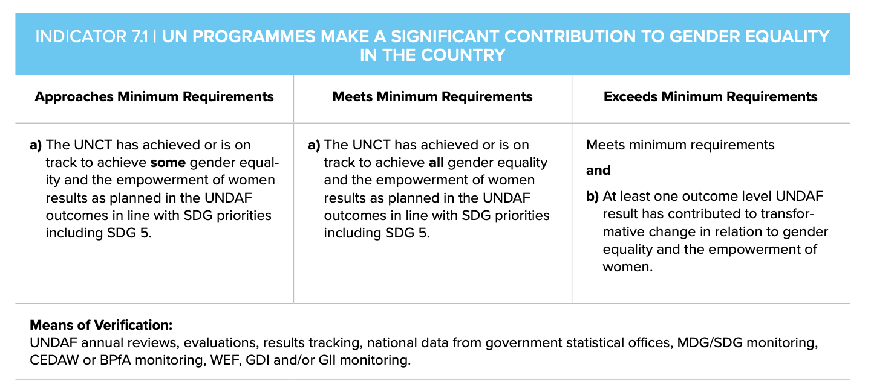
Meets minimum requirements
Findings and Explanation:
- The UNCT has achieved or is on track to achieve all GEEW results as planned in the CF outcomes in line with SDG priorities, including SDG 5 – Met
The year 2022 marked the beginning of implementation of the new United Nations Sustainable Development Cooperation Framework (UNSDCF 2022-2026) in Mozambique which articulates the strategic engagement of the UNCT in Mozambique to support the country to achieve the Sustainable Development Goals (SDGs) and the national priorities. After the first-year implementation, it has been found that the UNCT is progressing well toward achieving all gender-related results across the four focus areas. However, as the implementation is still in its early stages, the results captured in the UN Country Results Report 2022 are at the output level, including qualitative and quantitative data. Notable progress has been observed in policy-making and capacity-building of government, civil society organizations, and community-based organizations across all four outcomes, at their associated outputs and corresponding indicators and targets. Progress is aligned with different SDG gender-related targets, including SDG 5. Furthermore, significant progress has also been made at the private sector level through female and male cooperatives, business associations, and individual entrepreneurs, focusing on the most vulnerable and marginalized groups. Overall, the UNCT in Mozambique is on track to achieve all eleven gender outcome indicators, including the five gender-specific ones (please refer to PI 2.3) across all four outcomes at its associated outputs. Progress is aligned with different SDG gender-related targets, including SDG 5.
Outcome 1: By 2026, more people, particularly the most vulnerable and marginalized, have more equitable access to and utilization of quality, inclusive, resilient, gender- and shock-responsive social protection and essential social services. The UN has provided policy and technical support to promote the mechanisms and institutional capacities of community actors and public institutions such as schools and social services. These mechanisms aim to address social and gender discrimination, prevent harmful practices that affect both genders and respond to GBV. Through community interventions like comprehensive awareness campaigns, capacity-building initiatives, training, and community dialogues, male and female local and religious leaders, local authorities, young men and boys, and young women and girls have been empowered with capacities, skills, knowledge, and tools to promote gender equitable norms, challenge toxic masculinities, address discrimination, and promote referral mechanisms. Government officers have improved capacities to deliver quality and essential services, including GBV case management. To promote gender equitable norms, SRHR, and transformative masculinities, significant capacity-building investments were made in school settings by equipping male and female teachers, directors, and students with knowledge and skills. The UN intervention has also contributed to improving data availability on gender-based violence (GBV) in the country. This was achieved by setting up and piloting a digital platform called 'InfoViolencia', which produced immediate results regarding timely data for evidence-based policies and programs. In 2022, the UN supported the development of the new National Plan to Prevent and Combat GBV, initiated by the Ministry of Gender, Children, and Social Action. The plan builds upon lessons and good practices identified in evaluating the 2017-2021 Plan, supported by the UN. Vulnerable and marginalized women, men, girls, and boys have also benefited from gender-responsive interventions in the WASH sector, social protection, and cash transfer programs in the context of emergency response, health, and education through food transfers and commodities, free school meals, improved infrastructures, vaccination campaigns.
Outcome 2: Outcome 2 By 2026, more people, particularly women and youths, participate in and benefit from a more diversified, inclusive, and sustainable economic growth based on increased production, productivity, and greater value-added chains
The UN’s progress under this outcome is well documented in the Country Results Report 2022. The report highlights that more women, especially those from vulnerable and marginalized groups such as women and adolescent girls affected by conflict, survivors of child marriage and GBV, women facing food insecurity, women from displaced communities, smallholder female farmers, women’s business associations, and women’s entrepreneurs have benefited from training, business development assistance, market information systems, and access to market knowledge, skills, digital technologies, infrastructure, access to capital investments, and business start-up kits. These initiatives have increased women’s and young women’s access to decent jobs, income-generation opportunities, and business development. Additionally, young women and men have increased their employability through participation in Technical and Vocational Education and Training (TVET), which the UN supported.
Outcome 3: Outcome 3 By 2026, more people, especially the most vulnerable, are resilient to climate change and disasters, and benefit from more sustainable management of the environment and natural resources and resilient infrastructures and human settlements, with positive effects on national GDP
Thanks to the support of the United Nations, a significant increase has been observed in the number of women and men who have benefited from implementing Adaptation and Resilience Plans. Through capacity-building processes and technical assistance, different policies, contingency plans, and regulatory frameworks were gender mainstreamed. Additionally, some gender-targeted initiatives were introduced that benefitted women affected by climate change crises: women benefited from targeted training, gender-sensitive emergency supplies, gender-responsive climate-resilient infrastructures and services for enhancing productivity, enabling their voice and participation in community-based governance systems and decision-making forums on disaster risk management and response, and on the management of natural resources. Through training provision, women’s capacities were enhanced in sustainable management of the environment, natural resources, and biodiversity conservation.

Outcome 4: By 2026, more people, especially the most vulnerable and marginalized, are protected, enjoy their rights, and benefit from a secure, peaceful environment, enabled by inclusive governance systems, and independent and accountable institutions abiding by the rule of law
Gender-related results achieved under this outcome can be broken down into three main areas: Firstly, the UN has empowered communities, including local leaders and influential people, to fight against gender-based violence, change gender social norms, and promote human rights. This has been achieved through campaigns to raise awareness and by providing training and resources to public officers, including those from the justice sector. Women and girls affected by conflicts have also been provided with the necessary information, skills, knowledge, and agency to participate in and lead conflict prevention, peacebuilding, and recovery initiatives. This includes access to training, psychological support, early recovery interventions, and participation in gender-sensitive and inclusive planning processes. Secondly, the UN has equipped public sectors and institutions with gender-responsive planning and budgeting knowledge. Some have even received technical assistance to improve their policies and strategies, aligning them with global standards and best practices on gender responsiveness. Finally, it is worth noting that capacity-building events on the Women, Peace, and Security Agenda have also successfully equipped civil society organizations, women, and girls affected by conflicts with the necessary skills to monitor and report on implementing the Women, Peace and Security Agenda. They are now better positioned to advocate and promote the agenda in the context of prevention, peacebuilding, conflict resolution, and recovery processes in the country. These efforts will lead to reviewing the current NAP on WPS and developing the future one.
- At least one outcome level CF result has contributed to transformative change in relation to gender equality and empowerment of women: not met
Despite the positive trend and results achieved during the first year, transformative results cannot be demonstrated at this stage. However, the preliminary results show that the CF will likely contribute to transformative changes in GEEW. This is due to the holistic and multi-stakeholder approach, a combination of interventions at different levels (policy and legal framework, institutional capacity building, and promotion of social, cultural, and behavioral changes), and the appropriate allocation and tracking of financial resources for GEEW. The UN's combined capacities and entities' mandates create a favorable environment for this to happen.

Evidence or MoV:
- UNSDCF 2022-2026 (Results Framework), Mozambique
- 2022 UN Country Results Report

ACTION POINTS RECOMMENDATIONS against findings |

Action Points | Key findings on Gaps and insufficiencies (dimension area)
Planning
- Appoint a task group of the GTG to participate in the CCA update while looking at specific data and analysis for the sectors identified as having insufficient levels of gender analysis (linked to PI 1.1). For the ongoing review of the CCA, update with findings (refer to PI 1.2) and use the recent national gender profile to elaborate on challenges and priorities.  - Knowledge and data management: create a repository of relevant and updated analysis, studies, reports, assessments, statistics and data on the national gender context, including sectorial analysis and data. The resource should be widely disseminated and accessible to all staff.  - Draft and share fact-sheet papers/briefs on the following thematics: gender and climate change; gender and humanitarian context; women in agriculture, gender in WASH sector.  - For regional challenges and opportunities explore issues such as the AfCFTA Protocol on Gender, trafficking and the gender agenda in the context of the Migration Dialogue for Southern Africa and the Global Compact, the SADC Gender Protocol, the Maputo Protocol, and the Women, Peace and Security Agenda. | Gender analysis, including underlying causes analysis and the use of sex-disaggregated and gender data, is inconsistent across sectors and insufficient to meet the minimum criteria. It is present across most chapters and sectors the CCA covers, albeit not all. It is limited or blind on (i) Strengthening the financing for development architecture, (ii) Environmental dimension, (iii) Financial Landscape and Opportunities, (iv) Disaster risks in Mozambique, and (v) humanitarian-development nexus, regional challenges and opportunities.
Programming and M&E
- In addition to sharing the guidance, organize a briefing to all SPGs on the (i) UNSDG Guidance Note on a New Generation of Joint Programmes and (ii) on the interface of RBM with GEEW.  - Consolidate data in the mapping matrix development in the context of this exercise (JPs contribution to GEWE) and update it twice a year.  - Capitalize on existing practices (example from Human Rights Network) to establish a system to ensure gender mainstreaming at the programmatic level, in particular in all UN Joint Programmes (other examples can be a check list, screening process, GTG’s quality assurance…) | - The absence of accurate compiled data on current UN Joint Programmes and, therefore, the inability to ascertain the extent of the contribution of current JPs to Gender Equality and Women’s Empowerment. There is also a lack of a system to ensure gender mainstreaming in all UN Joint Programmes.
- Integrate the gender dimension into the Outcome 3 Statement to align with gender-responsiveness (reflected in the narrative, ToC, outcome indicators, and outputs).  - Review, at the earliest opportunity, the outcome 2 indicators to at least, increase the number of sex-disaggregated indicators.  - Organize a series of thematic webinars for GTG and SPGs (in particular SPG 2 and SPG 3) on gender and trade; gender, climate change and natural resources management; gender and mining; social protection that works for women, gender in crisis and humanitarian context, among others.  - Encourage platforms for regular exchanges between different Inter-agency groups on gender-related issues featured in the UNCT-SWAP Gender Scorecard and shared goals (for example, on gender parity, communication, advocacy, joint programming, M&EL, among others). | Overall, the gender mainstreaming at the CF Outcome level is good and meets requirements. However, there is room for improvement, in particular under Outcome 2 and Outcome 3
- MERG to seek for GTG’s advise on opportunities to strengthen gender in indicators framework at the output level in the context of the ongoing review exercise. | - Despite the UN’s solid intentions and ongoing efforts, there are evidences of inconsistencies in gathering appropriate data in the UN INFO system (the primary tracking tool). There is no tracking evidence in the UN INFO's Outcome Indicators Report 2022. Some gender-specific outcome indicators also miss baselines and targets (three out of five). At both outcome and output levels, data presented in the platform lacks sex disaggregation. When available, data from indicators' baselines and targets that promise sex disaggregation are aggregated.
- MERG to mainstream gender in their work plan and to ensure capacity-building activities related to gender-sensitive M&E in their work plan.  - Encourage colleagues to take advantage of existing free courses offered on the UN Women Training Centre website, namely the Gender Responsive RBM (programme and M&E colleagues).  - Organize a capacity training event targeting M&E staff on gender responsive M&E and SDGs gender-related indicators (if possible, extend it to relevant external partners). | - MERG misses a capacity training on Gender-Responsive M&E; at least one must be conducted during the current CF cycle.
Leadership and Organizational Culture
- Advocate for a gender-standing topic in the UNCT agenda of meetings for tracking the implementation of the UNCT Scorecard Action Plan, engaging beyond GTG to involve OMT, MERG, UNCG, in line with assigned responsibilities in the plan. | - UNCT meetings are not sufficiently addressing GEWE (the requirement is that Gender Equality is a topic of discussion in at least 60 percent of UNCT meetings during the last 12 months)
- UNCT to organize a meeting with GTG and OMT to discuss results of the Organizational Survey and brainstorming ideas of measures to improve on enabling environment in line with the UN System Field-Specific enabling environment guidelines, followed by a Town-All meeting. | - Results of the Organizational culture shows lower favorable rates on the staff perception of flexible work arrangements: work-life balance; HoA support of the adequate relationship between work life and home life; a package of entitlements for work-life balance (maternity/ paternity leave, breastfeeding).
- Conduct a comparative analysis of gender parity in UN staff in humanitarian and development teams in Mozambique | - Female staff constitute 42.18 percent of the total UN staff in Mozambique. The sex-disaggregated data also reveals that the number of female staff has increased by 2 percent compared to the data reported in 2022, which indicates a positive trend.
Gender Architecture and UNCT Capacities
- Regularly update the UNCT on the level of participation at the GTG meetings – hold members and agencies accountable for their participation and contribution commitment to the group.  - Ensure timely and updated info on GTG membership to avoid disruptions and adequate capacity.  - Agencies to invest in strengthening capacities of the gender focal points: those who are not necessarily gender experts, for more effective participation in the group. Financial resources allocated to GTG in line with its BWP and mechanism for funds disbursement discussed and agreed upon. | - GTG meets all the minimum requirements of the Scorecard. However, it is worth noting that there are different levels of engagement in the GTG work, irregular attendance, and high rotativity of appointed members, negatively impacting the more substantive results of the group.
- Conduct a mapping of gender capacities in the UNCT;  - Conduct the staff capacity assessment on gender and use the findings to inform a UNCT capacity development plan that covers the CF cycle.  - GTG, in close collaboration with OMT to work on an All UN onboarding induction package that includes GEWE context.  - Conduct a final evaluation the UNCT Strategy on GEWE (2019-2023) and develop an updated one for the new CF cycle, merging both humanitarian and development gender priorities, structures, resources and capacities  - Strengthen gender coordination capacity at UN Women, in line with its coordination mandate.  - UNCT members to allocate budget to the implementation of the GTG Work Plan | - UNCT does not comply with any requirements for capacities on gender: a staff capacity assessment must be conducted; this should inform a UNCT capacity development plan on GEEW and an induction package for all newly arriving staff that includes gender must be developed; there are intentions and plans but no results.
Adequate Resources
- UNCT will discuss with the SPGs’ chairs and co-chairs a reasonable deadline to complete the UNCT- Gender Marker in ALL sub-outputs of JWPs in the UN Info.  - The organization has developed in-house capacity and acquired training materials that should be used to customize and deliver an internal training on the UNCT-GEM targeting all UN INFO focal Points and Programme staff (refer to PI 6.1) | - Despite positive trends, the target at the global level is yet to be met (target 70% of GEM 3 and GEM 2 and UNCT Mozambique has reached 68%, with a 10% increasing from 2022). However, it is important to note that 22% of sub-outputs in the JWP still need a code. Therefore, UNCT must take the necessary steps to ensure all sub-outputs have a code applied, even if the code is zero.
Results
- Ensure UNCT Annual Results Report features changes at outcome level, by tracking progress on Outcome Indicators, including on gender-related ones (5 gender-specific and 6 sex-disaggregated, refer to PI 1.3). This should be informed by the systematic tracking of CF indicators in UN INFO. | - Outcome and output indicators, including gender-related ones, are not yet adequately tracked and reported upon, to allow measuring of UN contributions towards gender transformative results.
PS: both indicators under the partnership (with Govt and with CSOs) dimension have exceeded minimum requirements, and efforts must be sustained.

Follow-up on the findings of the comprehensive report and monitoring of the Action Plan |
- Circulate the Report and Action Plan to all UN staff and organize a Town-All to present and discuss findings, including Organizational Survey Results.
- To benefit institutional memory and data management, transfer the content from Google’s shared drive to a UNCT shared drive for tracking and updating documentation for annual reviews.
- Conduct an exercise to revisit and cost the Action Plan of the 2023 UNCT-SWAP Gender Equality Scorecard - to take place in the first quarter of 2024. Agencies’ financial commitment should follow immediately after.
- Institutionalize a UNCT calendar for IAT quarterly reporting on the progress of the implementation of the scorecard action plan. Start the process of Annual Reviews, at the latest in September each year (2024, 2025, and 2026), to allow sufficient time for in-depth and comprehensive desk review, substantive participation, ownership, and learning.

