FOREWORD

Despite the unprecedented challenges of recent years — the COVID-19 pandemic, global economic turbulence, and the intensifying impacts of climate change — Uzbekistan’s unwavering partnership with the United Nations and other international allies has remained a cornerstone of our progress.

Together, we have strengthened our resilience, advanced our economic transformation, and safeguarded the well-being of our citizens. Such joint efforts resulted in real change. Our economy has doubled in size. Through targeted social policies and international cooperation, 7.5 million people have been lifted out of poverty, and 2.7 million citizens are now covered by modern social protection systems. In partnership with the UN and our development partners, we have made remarkable progress in promoting gender equality and social inclusion — today, women represent 38 percent of the members of Parliament.

Maternal and child mortality rates have declined, and our ongoing reforms continue to empower families, strengthen education and healthcare, and expand opportunities for every citizen. Uzbekistan’s achievements have been recognized globally.

In the Sustainable Development Goals Index, our nation has climbed 19 places to rank 62nd, entering the group of the top five fastest-advancing countries in the world. As we now look ahead, we open a new and promising chapter in our cooperation with the United Nations — the United Nations Sustainable Development Cooperation Framework (UNSDCF) 2026–2030.

This Framework represents a renewed and strengthened partnership, built on mutual trust, shared responsibility, and a common vision for a sustainable and inclusive future. It fully aligns with Uzbekistan’s national development strategies, encompassing our key priorities: effective and just governance, improved living standards and social protection, quality healthcare and education, environmental protection and climate resilience, and the revitalization of the Aral Sea region.

The UNSDCF 2026–2030 is more than a roadmap — it is a shared commitment to unlock the full potential of our people and to transform Uzbekistan’s demographic and economic strengths into lasting prosperity. It embodies our collective determination to ensure that no one is left behind, that every community benefits from progress, and that development is people-centered, equitable, and sustainable.

As we look toward 2030, we do so with confidence and optimism. Together with our international partners, including UN we will continue to build a just, prosperous, and sustainable Uzbekistan — a country where opportunity, dignity, and hope are the inheritance of every citizen.

Jamshid Kuchkarov
Deputy Prime Minister, Minister of Economy and Finance of the Republic of Uzbekistan

FOREWORD

Dear people of Uzbekistan,
This new United Nations Sustainable Development Cooperation Framework 2026–2030 opens a new chapter in our shared journey towards a more inclusive, sustainable, and prosperous Uzbekistan. At its heart is a simple promise: to turn the country’s demographic momentum into an opportunity — so that every child, young woman and man, and every family can thrive. The main strategic priority is to ensure that all people in Uzbekistan can develop their potential and benefit from enhanced well-being, capabilities, and opportunities in a healthy, sustainable environment in line with the national Sustainable Development Goals.
The spirit of this Framework is practical and people-centered. It is about quality schools and clinics that are closer to communities; decent jobs and fair social protection that cushion shocks; clean air and water, resilient services and green growth; safe spaces and justice that protect rights and dignity; and targeted support for the Aral Sea region, to help its communities rebuild livelihoods and hope. The UN will continue to be a trusted partner in translating reforms into real improvements in everyday life leaving no one behind. Let’s keep moving forward — together, with optimism and determination — to turn Uzbekistan’s human potential, young energy, talent and creativity into lasting progress for all.
Sabine Machl
United Nations Resident Coordinator in Uzbekistan

DECLARATION OF COMMITMENT

The Government of Uzbekistan and the United Nations (UN) are committed to working together to achieve the country’s national vision for sustainable development.

The United Nations Sustainable Development Cooperation Framework (Cooperation Framework) will guide the work of the UN system in Uzbekistan until 2030. This framework builds on the successes of our past cooperation and represents a joint commitment by the Government of Uzbekistan and the UN system to work in close partnership for the achievement of the national priorities framed by the Sustainable Development Goals (SDGs) and international human and labour rights commitments. The collective results expected from this Cooperation Framework will help the people of Uzbekistan to live longer, healthier, and more prosperous and secure lives.

In signing hereafter, the participating partners endorse this Cooperation Framework and underscore their joint commitment towards the achievement of its results.

 | For the Government of Uzbekistan |  | For the United Nations Country Team
 |  |  | 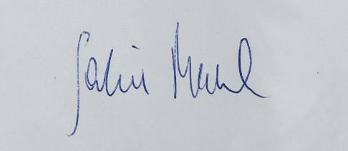
 | Jamshid Kuchkarov  Deputy Prime Minister,  Minister of Economy and Finance  of the Republic of Uzbekistan |  | Sabine Machl  United Nations Resident Coordinator in Uzbekistan

SIGNATURES

In witness thereof, the undersigned, being duly authorized, have signed this Government of Uzbekistan and United Nations Sustainable Development Cooperation Framework for the period of 2026-2030 on 24th of October 2025 in Tashkent, underscoring their joint commitment to its priorities and cooperation results.


Food and Agriculture  Organization (FAO)  Viorel Gutu  Assistant Director-General,  Regional Representative for Europe and Central Asia,  FAO Representative for Uzbekistan a. i.  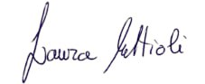 |  | International Trade Centre (ITC)  Elena Boutrimova  Chief of the Office for Eastern Europe and Central Asia  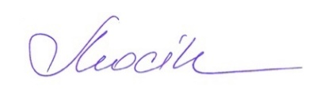 |  | United Nations Conference on Trade and Development (UNCTAD)  Pedro Manuel Moreno    Deputy Secretary-General
International Fund for  Agricultural Development (IFAD)  Laura Mattioli  Country Director, Near East,  North Africa and Europe Division  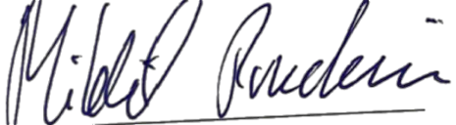 |  | International Telecommunication Union (ITU)  Natalia Mochu  Regional director for  Regional office for CIS  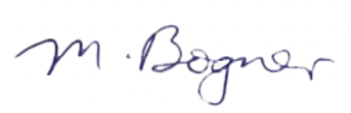 |  | UN Development Programme (UNDP)  Akiko Fujii  UNDP Resident Representative Uzbekistan  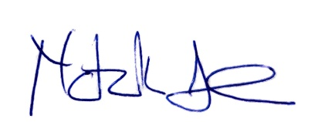
International Labour  Organisation (ILO)  Mikhail Pouchkin  Director, ILO Country Office for  Eastern Europe and Central Asia   |  | Office of the UN  High Commissioner  for Human Rights (OHCHR)  Matilda Bogner  OHCHR Regional Representative  for Central Asia   |  | UN Office for Disaster  Risk Reduction (UNDRR)  Natalia Alonso Cano  UNDRR Chief Regional Office  for Europe  
International Organization  for Migration (IOM)  Andrew Gray  Chief of Mission for Uzbekistan |  | Joint UN Programme on  HIV/AIDS (UNAIDS)  Eamonn Murphy  UNAIDS Regional Director, Asia- Pacific, Eastern Europe and Central Asia |  | UN Economic Commission  for Europe (UNECE)  Dmitry Mariyasin  Deputy Executive Secretary

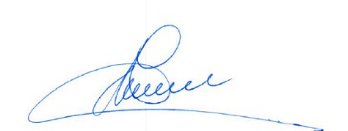
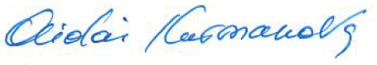

UN Environment Programme (UNEP)  Aidai Kurmanova  Head of UNEP Sub-regional office for Central Asia   |  | UN Refugee Agency (UNHCR)  Dumitru Lipcanu  UNHCR Regional Representative for Central Asia   |  |  |  | UN Office on Drugs and Crime (UNODC)  Oliver Stolpe  UNODC Regional Representative, Regional Office for Afghanistan, Central Asia, Iran and Pakistan  
UN Economic and  Social Commission for Asia  and the Pacific (ESCAP)  Hirohito Toda  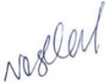  Deputy Executive Secretary for Partnerships and Coordination |  | UN Children’s Fund (UNICEF)  Regina M. Castillo  UNICEF Representative in Uzbekistan  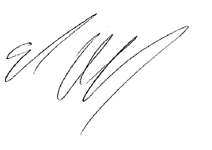 |  |  |  | UN Office for Project Services (UNOPS)  Tim Lardner  Regional Director Europe and Central Asia Region  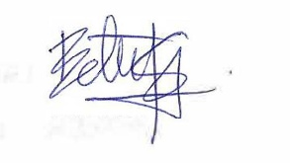
UN Educational, Scientific and Cultural Organization (UNESCO)  Sara Noshadi  UNESCO Representative to Uzbekistan  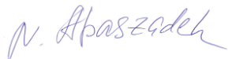 |  | UN Interregional Crime and Justice Research Institute (UNICRI)  Leif Villadsen,  UNICRI Director a.i.  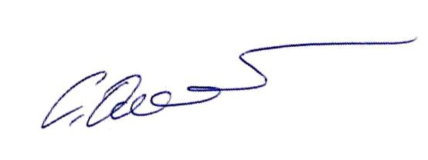 |  |  |  | UN Women  Belén Sanz Luque  UN Women Regional Director for Europe and Central Asia  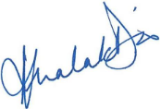
UN Population Fund (UNFPA)  Nigina Abaszade  UNFPA Representative in Uzbekistan |  | UN Industrial Development Organization (UNIDO)  Solomiya Omelyan  Chief, Regional Bureau for Europe and Central Asia   |  |  |  | World Health Organisation (WHO)  Asheena Khalakdina  WHO Representative in Uzbekistan
United Nations Human Settlements Programme (UN-Habitat)
Erfan Ali
Director a.i., Regional Programme Division

Table of Contents
ACRONYMS & ABBREVIATION v
EXECUTIVE SUMMARY vi
CHAPTER 1: COUNTRY PROGRESS TOWARDS THE 2030 AGENDA 1
CHAPTER 2: UN DEVELOPMENT SYSTEM SUPPORT TO THE 2030 AGENDA 6
2.1. STRATEGIC PRIORITIZATION 6
2.2. THEORY OF CHANGE 6
2.3. GUIDING PRINCIPLES 10
2.4. INTENDED DEVELOPMENT RESULTS 11
2.5. SYNERGIES BETWEEN OUTCOMES 33
2.6. SUSTAINABILITY 33
2.7. UN COMPARATIVE ADVANTAGE 33
2.8. UNCT CONFIGURATION 34
2.9. PROTECTION FROM SEXUAL EXPLOITATION AND ABUSE 34
CHAPTER 3: COOPERATION FRAMEWORK IMPLEMENTATION PLAN 36
3.1. IMPLEMENTATION STRATEGY AND STRATEGIC PARTNERSHIPS 36
3.2. GOVERNANCE 38
3.3. JOINT WORK PLANS 40
3.4 OPERATIONAL FRAMEWORK 40
3.4 RESOURCES 40
CHAPTER 4: MONITORING AND EVALUATION PLAN 44
4.1. MONITORING PLAN 44
4.2. EVALUATION PLAN 45
4.3. LEARNING 45
4.4. MEL REQUIREMENTS FOR IMPLEMENTING PARTNERS 45
4.3. RESULTS FRAMEWORK 46
LEGAL ANNEX 55

ACRONYMS & ABBREVIATION

CF | United Nations Sustainable Development Cooperation Framework
CSO | Civil Society Organization
FAO | Food and Agriculture Organization
GBV | Gender-Based Violence
HACT | Harmonized Approach to Cash Transfer
HRBA | Human Rights-Based Approach
IFAD | International Fund for Agricultural Development
IFI | International Financial Institution
ILO | International Labour Organization
IOM | International Organization for Migration
ITC | International Trade Centre
ITU | International Telecommunication Union
LNOB | Leave No One Behind
MEL | Monitoring, Evaluation and Learning
MICS | Multiple Indicator Cluster Surveys
n-MPI | National Multidimensional Poverty Index
NDC | Nationally Determined Contributions
NGO | Non-Governmental Organization
OHCHR | Office of the UN High Commissioner for Human Rights
OSH | Occupational Safety and Health
PHC | Primary Health Care
PSEA | Prevention of Sexual Exploitation and Abuse
SDG | Sustainable Development Goal
SOE | State-Owned Enterprise
SPECA | United Nations Special Programme for the Economies of Central Asia
SWAP | System-Wide Action Plan
TB | Tuberculosis
UHC | Universal Health Coverage
UN | United Nations
UN Women | United Nations Entity for Gender Equality and the Empowerment of Women
UNAIDS | Joint UN Programme on HIV/AIDS
UNCT | UN Country Team
UNCTAD | UN Conference on Trade and Development
UNDG | United Nations Development Group
UNDP | United Nations Development Programme
UNDRR | United Nations Office for Disaster Risk Reduction
UNDSS | United Nations Department of Safety and Security
UNECE | United Nations Economic Commission for Europe
ESCAP | United Nations Economic and Social Commission for Asia and the Pacific
UNESCO | United Nations Educational, Scientific and Cultural Organization
UNFPA | United Nations Population Fund
UN-Habitat | United Nations Human Settlements Programme
UNHCR | United Nations Refugee Agency
UNICEF | United Nations Children’s Fund
UNICRI | UN Interregional Crime and Justice Research Institute
UNIDO | United Nations Industrial Development Organization
UNODC | United Nations Office on Drugs and Crime
UNOPS | UN Office for Project Services
UNRCCA | UN Regional Centre for Preventive Diplomacy for Central Asia
UNV | United Nations Volunteers
VAW | Violence Against Women
WASH | Water, Sanitation and Hygiene
WHO | World Health Organization

EXECUTIVE SUMMARY

Uzbekistan stands at a critical juncture in its pursuit of sustainable development. For nearly a decade, the country has been transforming through widespread structural reforms. Yet, the structural transformation remains incomplete, with inequalities, governance bottlenecks, and environmental vulnerabilities posing significant risks to the country’s path to sustainable and inclusive development.
Uzbekistan’s youthful, rapidly growing population presents opportunities for economic growth, but demographic trends are also straining public services and exacerbating regional disparities. Achieving the nation’s goal of reaching upper-middle-income status by 2030 will require a deepening of reforms to promote inclusive economic growth, enhancing governance and accountability, and investing in human capital and environmental sustainability, ensuring that no one is left behind.
This transformation unfolds within a dynamic regional context, where Uzbekistan’s role as a central node for connectivity and cooperation across Central Asia is pivotal. The UN recognizes Uzbekistan’s contribution to regional stability and economic integration and supports its efforts to embed these national reforms within the wider framework of regional peace, security, and sustainable development.
The Government of Uzbekistan remains committed to the Sustainable Development Goals (SDGs). Its ambitious development plan – the Uzbekistan 2030 Strategy – includes 100 targets across five priority areas that are largely aligned with the SDGs: (i) creation of education, healthcare and social protection systems that fully meet the needs of the population and international standards; (ii) joining the ranks of upper-middle-income countries through a stable economic growth and decent work; (iii) ensuring favourable environmental conditions for the population; (iv) creation of a just and modern state serving the people; and (v) ensuring the sovereignty and security of the country.
To support this ambitious agenda, the UN has developed a Cooperation Framework (CF) that is firmly anchored in the Uzbekistan 2030 Strategy. Adopting a streamlined approach, the vision for this 2026-2030 CF is that “By 2030, Uzbekistan leverages its demographic dividend and implements ambitious reforms, ensuring that all people in Uzbekistan can develop their potential and benefit from enhanced wellbeing, capabilities, and opportunities in a healthy, sustainable environment.” To achieve this single, overarching priority, the CF is built around six, interlinked outcomes: governance and justice, livelihoods and social protection, health, education, climate and environment, and the Aral Sea Region.
This CF carries forward the guiding principles from the previous framework, which will continue to be applied for all interventions undertaken by the UN development system: 1) leave no one behind, 2) human rights-based approach, 3) gender equality and women’s empowerment, 4) accountability, 5) sustainability and 6) resilience. Integrated and multidimensional programming approach—in line with the “five P’s” of the 2030 Agenda (people, prosperity, planet, peace and partnerships), will guide the process and the content of the UN intervention in Uzbekistan.
The CF will be nationally executed under the overall coordination of the Ministry of Economy and Finance of the Republic of Uzbekistan. It will be operationalized through joint work plans developed by the UN in collaboration with government ministries, state institutions, civil society, and non-governmental organizations (NGOs). The CF will remain responsive to emerging and unforeseen needs, and will adapt to significant changes in the country context if needed. The UN will establish synergies with International Financial Institutions (IFIs) and development partners. It will also engage with a wide range of national stakeholders including media and the private sector. Existing governance structures will be revised to align with the new CF, ensuring coordinated delivery by the UN system. A monitoring, reporting and evaluation plan will be implemented in line with UN development system standards. The CF will be reviewed and reported against annually. It will be evaluated prior to subsequent planning cycle.

CHAPTER 1: COUNTRY PROGRESS TOWARDS THE 2030 AGENDA

Uzbekistan's Development Trajectory: Since gaining independence in 1991, Uzbekistan has transitioned from a centrally planned economy to a market-oriented system, with significant structural reforms accelerating under President Shavkat Mirziyoyev’s leadership since 2016. These reforms aim to elevate the country to the upper-middle-income status by 2030, building on significant GDP growth, greater openness, liberalization, elevated international commitments, and increasing international financial flows. Despite these achievements, the structural transformation remains incomplete, with inequalities, governance bottlenecks, and environmental vulnerabilities posing significant risks to the country’s path to sustainable and inclusive development. Additionally, as a landlocked country surrounded only by other landlocked countries, Uzbekistan faces connectivity challenges that must be overcome to benefit from the international trade, and integration into the global economy.
The Government of Uzbekistan remains committed to the Sustainable Development Goals (SDGs). Its ambitious development plan –the Uzbekistan 2030 Strategy – includes 100 targets across five priority areas that are largely aligned with the SDGs: (i) creation of education, healthcare and social protection systems that fully meet the needs of the population and international standards; (ii) joining the ranks of upper-middle-income countries through a stable economic growth; (iii) ensuring favourable environmental conditions for the population; (iv) creation of a just and modern state serving the people; and (v) ensuring the sovereignty and security of the country.
Globally, Uzbekistan has been amongst the fastest progressing countries on the SDG Index (SDGi) since 2015. In 2025, Uzbekistan ranks 62nd out of the 193 UN member states covered by the index, (Figures 1-4).
Box 1. Harnessing the Demographic Dividend
Uzbekistan’s youthful and rapidly growing population offers significant potential for bolstering economic growth, social resilience and stability. But demographic dividends can only be realized if public services, infrastructure and employment opportunities keep up with demand. The working-age population (15–64 years) is expected to grow from 23.9 million in 2024 to over 33 million by 2050. signalling a continuation of the "demographic window of opportunities" during which a high proportion of the working-age population may drive economic growth.
These demographic trends are already placing immense pressure on public services, particularly education, healthcare, and the labour market. Urbanization and migration trends are also reshaping the demographic landscape, highlighting the need for infrastructure development in urban areas while preventing rural economic stagnation.
Harnessing the demographic dividend will require substantial investments to empower the people of Uzbekistan, particularly its young population and underserved rural populations where disparities are most pronounced. Critical needs include improved access to quality and inclusive education, vocational training, gender-responsive healthcare and decent jobs. Family-friendly policies advancing gender equality are needed to encourage greater participation of women in the workforce. The government must also ensure policies and systems can deliver services throughout a life course, recognizing the emerging trend of population aging.

Figure 1. Uzbekistan’s Average Performance by SDG  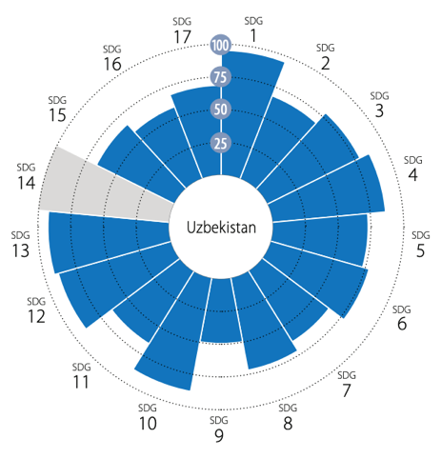  Source: Sustainable Development Report 2025, available at: https://dashboards.sdgindex.org/ | Figure 2. Uzbekistan amongst top 5 fastest countries on SDG progress  Based on progress on the SDG Index between 2015-2024  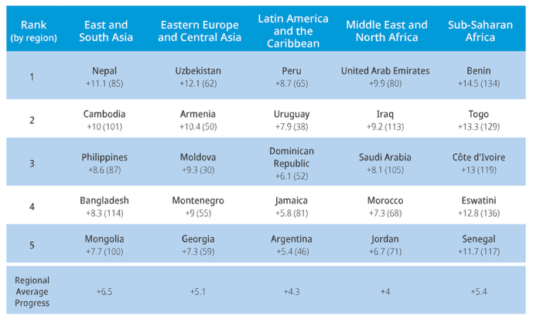  Source: https://dashboards.sdgindex.org/chapters/part-2-the-sdg-index-and-dashboards

Figure 3. Uzbekistan’s SDG Dashboard and Trends
While Uzbekistan is making rapid progress, challenges across all areas must be overcome to ensure SDG achievement.
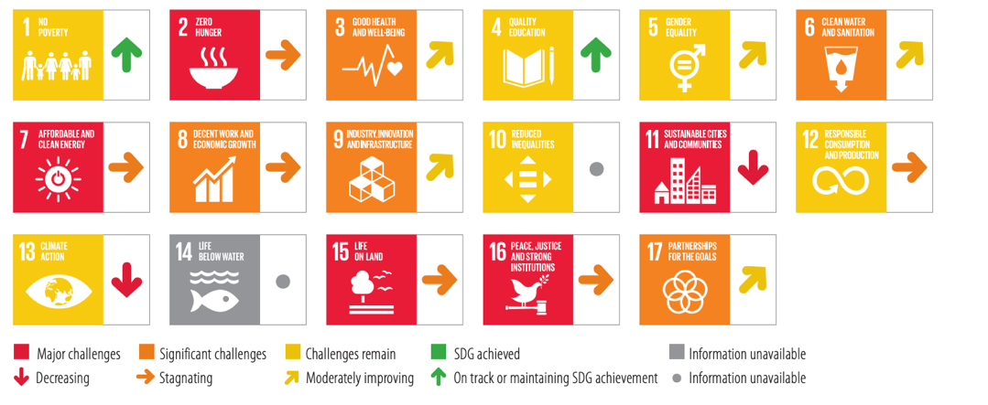
Source: https://dashboards.sdgindex.org/profiles/uzbekistan

Figure 4. Uzbekistan’s progress on SDGs with cross-cutting relevance to the CF

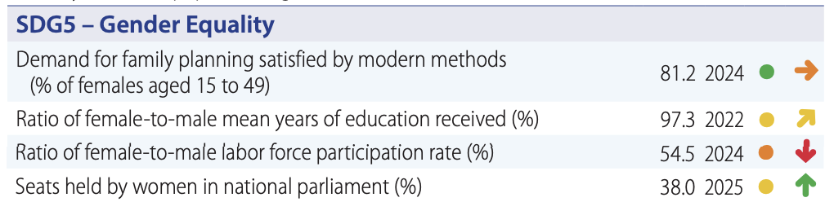

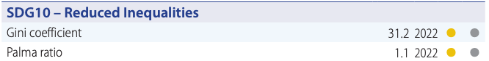

Source: Sustainable Development Report 2025, available at: https://dashboards.sdgindex.org/

Vulnerable Populations and Social Exclusion: Uzbekistan’s 2nd Voluntary National Review (VNR) highlights significant achievements regarding the situation of vulnerable groups. The country has made notable progress on gender equality through implementation of a National Strategy for Gender Equality, improved access to higher education, and adoption of laws to combat violence against women. For children, strides have been made in enhancing access to early childhood education and improving nutrition programs. Reforms for people with disabilities, such as inclusive education initiatives, and rural development programs targeting infrastructure and poverty reduction are underway.
Nevertheless, various population groups in Uzbekistan are still at risk of being left behind due to a combination of complex factors summarized in Box 2 and elaborated further in the Common Country Analysis. These include women, children and youth in vulnerable situations, people with disabilities, people living with HIV, migrants and their children, forcibly displaced people, stateless persons, and other vulnerable groups. The roots of exclusion are multidimensional, driven by discriminatory social norms, gender stereotypes, regional inequalities, lack of relevant legal frameworks and governance deficits.
Multi-dimensional poverty: According to the 2024 pilot of the National Multi-dimensional Poverty Index (n-MPI), around 18.4 percent of the adult population (4.2 million) are multidimensionally poor in Uzbekistan as they experience deprivations in at least 34 percent of the weighted indicators. The main contributors to the multi-dimensional poverty in the country have been found to be Educational attainment (13.7%), Food security (11.7%) and Informal employment (11.5%). By capturing overlapping deprivations in health, education, and living standards, the n-MPI serves as a useful complement to income poverty measurements for understanding poverty.
The n-MPI revealed stark regional disparities and an urban-rural divide in multidimensional poverty. The Republic of Karakalpakstan (29.9%), Namangan region (27.5%), and Tashkent region (26.5%) having the largest proportion of the multidimensionally poor. The incidence of multidimensional poverty in rural areas is significantly larger (23.2 percent) than in urban areas (13.9 percent). This highlights the importance of targeted interventions and policies that address disparities and cater to the specific needs of different areas and vulnerable populations.
Box 2. Main drivers of exclusion
Various population groups in Uzbekistan are still at risk of being left behind due to a combination of factors related to decent work deficits, discrimination, stereotypes, governance, legislation, socio-economic status, geography and vulnerability to shocks. These groups experience multiple forms of exclusion that intersect, compounding their disadvantages and making it difficult for them to fully engage in or benefit from the country’s development efforts. These patterns of exclusion are not only a hindrance to individual well-being, but also pose significant challenges to achieving the national SDGs.

Social Development – Education, Health, Social Protection and Social Services: In recent years, Uzbekistan has expanded access to education and health services, with significant investments in preschool education and Universal Health Coverage (UHC). However, the quality of education and health services, particularly in rural regions, continues to lag behind national goals as well as the international benchmarks. For example, Uzbekistan scored are amongst the lowest across all subjects in the OECD’s Programme for International Student Assessment (PISA) in 2022. Strengthening social protection systems, reducing fragmentation and empowering the National Agency for Social Protection, will be critical to reducing poverty and ensuring that vulnerable groups can benefit from ongoing structural reforms.
Economic Transformation and Inequality: Uzbekistan’s economic transformation has resulted in robust growth and impressive poverty reduction, despite setbacks such as the COVID-19 pandemic and regional conflicts. However, reforms have also been accompanied by rising income inequality, driven by high food and energy inflation, highly regressive energy subsidies, excessive monopolization, fiscal preferences for state-owned enterprises (SOEs), and non-transparent privatization processes. Structural reforms, including energy tariff liberalization and the privatization of SOEs, need to be more transparent and inclusive to avoid exacerbating existing inequalities. Addressing informalities in the labour market and growing decent employment opportunities, especially for women and youth, will be key to ensuring broad-based inclusive economic growth. Promoting decent jobs requires aligning labour market policies with international labour standards. This approach advances SDG 8 while safeguarding fundamental rights at work and ensures that employment gains translate into sustainable poverty reduction and shared prosperity.
These dynamics are further influenced by broader regional and global factors – including ongoing regional conflicts and sanctions regime, shifting trade patterns, climate impacts, and global political and economic volatility – which underscore the importance of aligning Uzbekistan’s economic reforms with regional cooperation and international best practices to build resilience and foster more equitable growth.
Environmental Sustainability and Climate Change: Uzbekistan faces severe environmental challenges on its path to sustainable development. These are driven by climate change and the Aral Sea disaster, as well as the growing population and evolving consumption patterns. Water scarcity, land degradation, and biodiversity loss threaten food security and rural livelihoods, and the well-being of vulnerable communities. The crisis in the Aral Sea region (Box 3), including its profound impacts in Karakalpakstan, has compounded environmental, economic, and social vulnerabilities, underscoring the critical linkages between climate resilience and social cohesion as well as the importance of regional cooperation.
Air pollution is an increasing cause of concern, particularly in large urban settlements such as Tashkent and some regional hubs, where it poses serious health risk for people, especially children. The government's commitment to renewable energy and climate resilience, as part of its Paris Agreement commitments, is a critical step toward a more sustainable future. However, significant investments are required to fully address these environmental risks and ensure a green, participatory and inclusive transition.
Box 3. The Aral Sea Disaster
Drying of the Aral Sea has led to the creation of a vast salt desert - Aralkum, the world’s newest desert with the size of more than 5.5 million hectares. The salty, toxic dust of the Aralkum travels throughout the Aral Sea region and beyond, causing substantial economic, food, health and environmental insecurities of the local population. In recent years, measures have been taken to help mitigate this crisis including the massive planting of saxauls (shrubs/trees) in the dried seabed as well as protective forest belts in order to prevent the shifting sand from advancing and the spread of dust storms and dry, hot winds.

Governance, Rule of Law, and Human Rights: Reforms in governance have led to improvements in civic space, human rights, women’s political participation, and public service delivery (such as e-governance), alongside a reduction of corruption, as evidenced by the country’s remarkable progress in relevant global indexes and rankings. However, significant gaps remain, especially in enforcing laws and accountability, and civic space remains restricted. Ensuring transparent governance and further reduction of corruption, particularly in areas such as restructuring of SOEs and social service delivery – notably in health and education sectors – will be essential for achieving the national SDGs at all levels (including provincial and mahalla levels).
Uzbekistan’s development financing is characterized by a blend of public and private financing mechanisms, innovative financial instruments such as SDG and Green bonds, and increased engagement with the private sector, IFIs and donors. The integrated national financing framework (INFF) and Integrated National SDG Financing Strategy reflect the country’s commitment to aligning financial flows with its development priorities. In this regard, Uzbekistan’s approach is consistent with the principles of the Sevilla Outcome Document on Financing for Development (2025), which calls for strengthening integrated national financing frameworks, mobilizing long-term sustainable financing, and enhancing the coherence and effectiveness of development cooperation to achieve the SDGs. In line with these commitments, Uzbekistan seeks to leverage its reform momentum to mobilize resources – both public and private, domestic and external – more effectively for inclusive, green and resilient growth. However, closing the annual financing gap remains a challenge, necessitating continued efforts to attract private investment, optimize public spending, and secure external support from donors and IFIs.
Cross-border Cooperation: There has been significant progress in cross-border collaboration, For this landlocked country, cross-border cooperation in areas such as trade and investment, transport connectivity, energy connectivity, transboundary water management, and border crossings and demarcation is especially essential for Uzbekistan’s development. Regional cooperation, particularly in transboundary water management with upstream countries like Kyrgyzstan and Tajikistan, and with Afghanistan on the Qosh Tepa canal, will be critical to addressing water scarcity and ensuring regional stability. Improving trade and transport infrastructure will also enhance Uzbekistan’s position as a regional economic hub. Implementation of the Awaza Programme of Action (APoA) for Landlocked Developing Countries 2024-2034 will also be critical, as it seeks to align national-level actions, regional integration efforts and global policy frameworks to place landlocked developing countries on a more dynamic, inclusive path to sustainable development, while safeguarding them against future shocks and disasters.

CHAPTER 2: UN DEVELOPMENT SYSTEM SUPPORT TO THE 2030 AGENDA

2.1. STRATEGIC PRIORITIZATION
The strategic priorities for the United Nations Sustainable Development Cooperation Framework (CF) were identified through participatory, inclusive consultations convened over five months with UN entities, national stakeholders, donors, international financial institutions (IFIs) and other development partners.
- There was an initial Strategic Prioritization retreat for the UN to agree on an initial set of priorities and a draft theory of change. Internal consultations focused on the challenges and drivers of transformative development changes that are needed to accelerate SDG progress.
- The prioritization was further refined through consultations on a draft Results Framework with outcomes and outputs were organized with national stakeholders including government entities, members of Parliament, civil society organizations (CSOs), academia, and the private sector.
- Regional consultations on the new CF’s priorities were conducted in the Kashkadarya, Surkhandarya, and Samarkand regions. More than 200 participants attended, including women, healthcare professionals, farmers, students, representatives from civil society, and local government officials.
- Consultations were conducted with development partners and donors.
Extensive consultations with the Government and other key stakeholders at the national and regional level not only shaped CF priorities and Results Framework, but also the cross-cutting issues and interlinkages between outcomes.
Core elements of the CF (including the Results Framework) were validated by the UNCT and submitted to Government for endorsement before the full draft was elaborated. Additional consultations were held to review and refine the document based on comments received and to conduct a UNCT configuration exercise.
The consultative process built on strong, regular dialogue between the UNCT and Government about national priorities for achieving the SDGs as well as where the Government sees the UN providing the most value added. The timely launch of the Uzbekistan 2030 Strategy in January 2025 further enabled the UN to ensure close alignment of CF priorities with national priorities and the SDGs.
The strategic prioritization process was selective, in recognition of resource constraints, demand from Government, and the comparative advantage of the UN in Uzbekistan vis-à-vis other actors. For example, the CF’s treatment of economic transformation is limited by design. While the CF supports economic transformation in its support of the green transition (outcome 5) as well as employment and entrepreneurship (outcomes 2, 5 and 6), it does not have a heavy focus on economic reforms, industrial development, private sector transformation or integration with global markets. While activities in this CF still touch on these issues, these are areas where other development partners, including IFIs, have been taking a leading role in supporting Government.

2.2. THEORY OF CHANGE
STRATEGIC PRIORITY
The CF’s theory of change summarized in Figures 1 and 2 is firmly anchored in the Government’s vision to become an upper-middle-income country and achieve the national Sustainable Development Goals (SDGs), as articulated in the Uzbekistan 2030 Strategy. It adopts a streamlined approach by focusing on six outcomes contributing to a single overarching priority. This vision for this CF is that “By 2030, Uzbekistan leverages its demographic dividend and implements ambitious reforms, ensuring that all people in Uzbekistan can develop their potential and benefit from enhanced wellbeing, capabilities, and opportunities in a healthy, sustainable environment.”

OVERARCHING ASSUMPTIONS
Achievement of the strategic priority of the CF is premised on the following overarching assumptions:
- The Government of Uzbekistan maintains the pace of its ambitious reform agenda, delivering on the commitments in the Uzbekistan 2030 Strategy.
- Strong political commitment to fight corruption and implement a “service state” system brings services closer to people.
- Adequate resources are mobilized to achieve the national SDGs, with public and private financing, both domestic and international, aligned to achieve the 2030 Agenda.
- Strong political commitment to prioritize gender equality, women’s empowerment, the needs of the most vulnerable, and the elimination of violence against women and children.
- Political and macroeconomic stability is maintained.

OVERARCHING RISKS
Several key risks and bottlenecks have been identified that could impact the development trajectory of the country, including:
- Demographic trends outpace the expansion of services and opportunities, exacerbating inequalities and undermining social cohesion.
- Environmental hazards, pollution, and the impact of climate change undermine development gains.
- Corruption undermines the quality and efficiency of public service delivery and it slows the pace of reforms.
- Insufficient legal responses and social/cultural barriers hinder efforts to ensure the rights and legitimate interests of women and children.
- Geopolitical shocks including spillover of regional security risks impede Uzbekistan’s development.
- Limited space for political pluralism and civic engagement hinder the inclusiveness and resilience of reforms and their ability to sustain progress towards the SDGs.
- Regional social-economic disparities within the country undermine social cohesion.

FIGURE 5. THEORY OF CHANGE FOR THE UN SUSTAINBLE DEVELOPMENT COOPERATION FRAMEWORK (2026-2030)
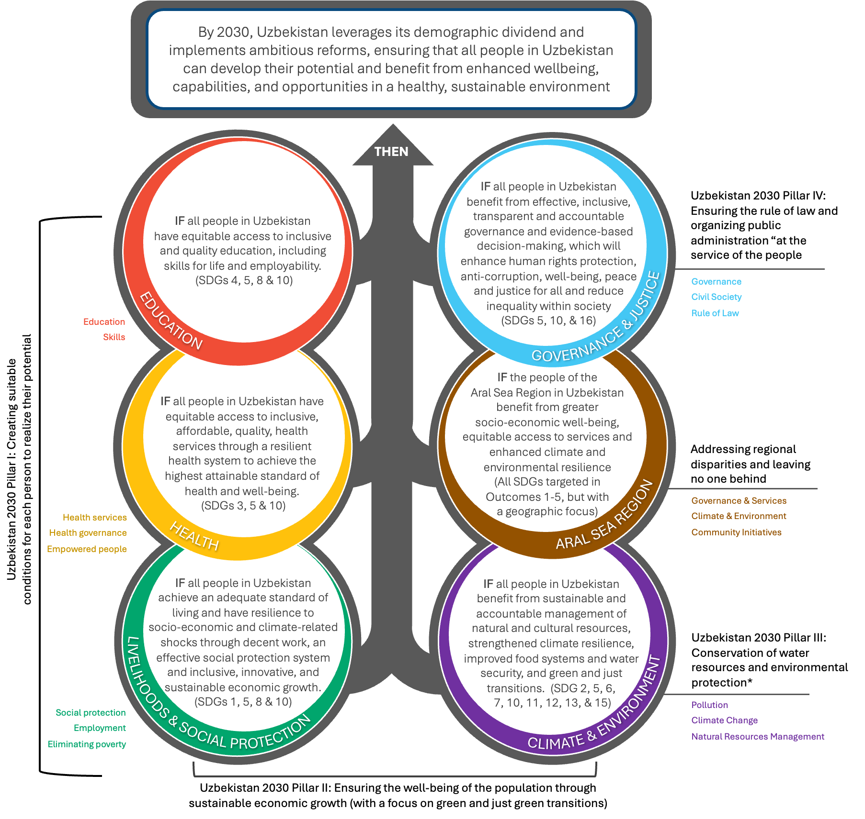

FOR THE BENEFIT OF ALL PEOPLE IN UZBEKISTAN | This CF is designed to benefit all people in Uzbekistan, especially women and the most vulnerable. In targeting support for those at most risk of being left behind, the CF considers sex, age, disability, HIV status, inequalities related to GBV, geographic location, and other vulnerabilities.

FIGURE 6. ALIGNMENT WITH THE UZBEKISTAN 2030 STRATEGY
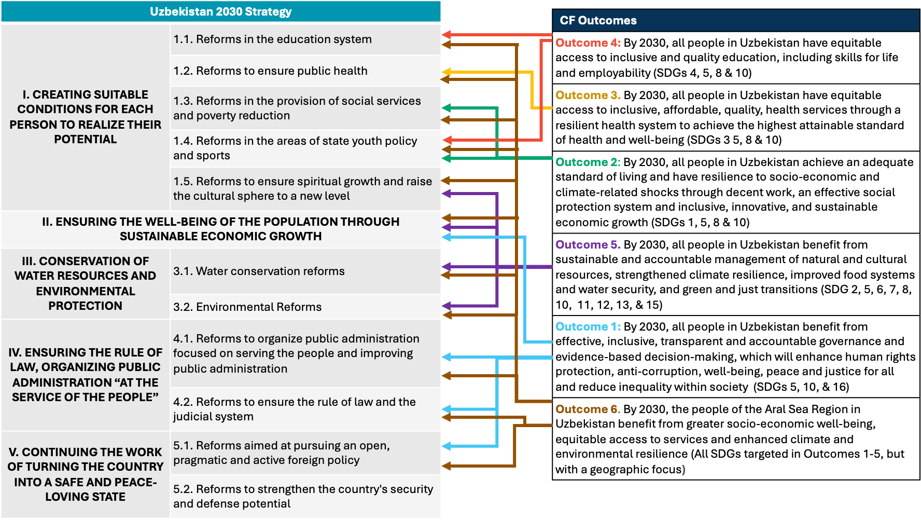

2.3. GUIDING PRINCIPLES
This CF carries forward the guiding principles from the previous framework, which will continue to be applied for all interventions undertaken by the UN development system.
1 | LEAVE NO ONE BEHIND
Leaving no one behind is the central transformative promise of the 2030 Agenda and represents the unequivocal commitment to eradicate poverty in all its forms, end discrimination and exclusion, and reduce inequalities and vulnerabilities. The CF will foster inclusive and equitable social and digital participation and digital participation by addressing multiple drivers of exclusion and promoting universal, affordable and safe connectivity, access to inclusive devices, and the development of digital, media and information, STEM and other 21st-century skills to assess equitable learning opportunities and empowered participation for all, especially those most at risk of being left behind.
In its focus on regional disparities, the UN will pay particular attention to the 16 lagging districts identified by Government.
2 | HUMAN RIGHTS-BASED APPROACH
The CF will adopt a human rights-based approach (HRBA) to support sustainable development outcomes and continuously analyse and address inequalities and discriminatory practices. An HRBA requires human rights principles (equality and non-discrimination, participation and accountability) to guide all development cooperation, and a focus on capacity development of both ‘duty-bearers’ to meet their obligations and ‘rights-holders’ to claim their rights.
3 | GENDER EQUALITY AND WOMEN’S EMPOWERMENT
Gender equality and women’s empowerment are integral to realizing the 2030 Agenda. Development entities will put gender equality at the heart of programming, driving active and meaningful participation of both women and men and consistently empowering all women and girls. This is in line with the minimum requirements agreed upon by the United Nations Sustainable Development Group (UNSDG) in the UNCT System-wide Action Plan (SWAP) Gender Equality Scorecard.
4 | ACCOUNTABILITY
The CF will ensure accountability of the UN Development System to the people of Uzbekistan through: (a) alignment with national priorities and national accountability mechanisms, supporting their further development where warranted; (b) enhanced transparency and improved measurement and reporting of results delivered under the CF, and (c) active and inclusive local community engagement and participation throughout all phases of programme implementation.
5 | SUSTAINABILITY
The 2030 Agenda calls for sustainability by ensuring lasting protection of the planet and its natural and cultural resources, supporting inclusive and sustained economic growth, ending poverty in all its dimensions and enhancing human well-being. Strengthening the capacities of national and subnational institutions and communities is essential and therefore the CF will help to strengthen these institutions so that they are appropriately configured, capacitated and resourced.
6 | RESILIENCE
A focus on resilience will guide the design of integrated, cost-effective approaches to reduce risks and help prevent disasters and crises. The CF will focus on a wide range of risks including those associated with natural and human-induced hazards, violent conflict, epidemics and pandemics, financial systems and food price fluctuations.

2.4. INTENDED DEVELOPMENT RESULTS
OUTCOME 1. GOVERNANCE AND JUSTICE

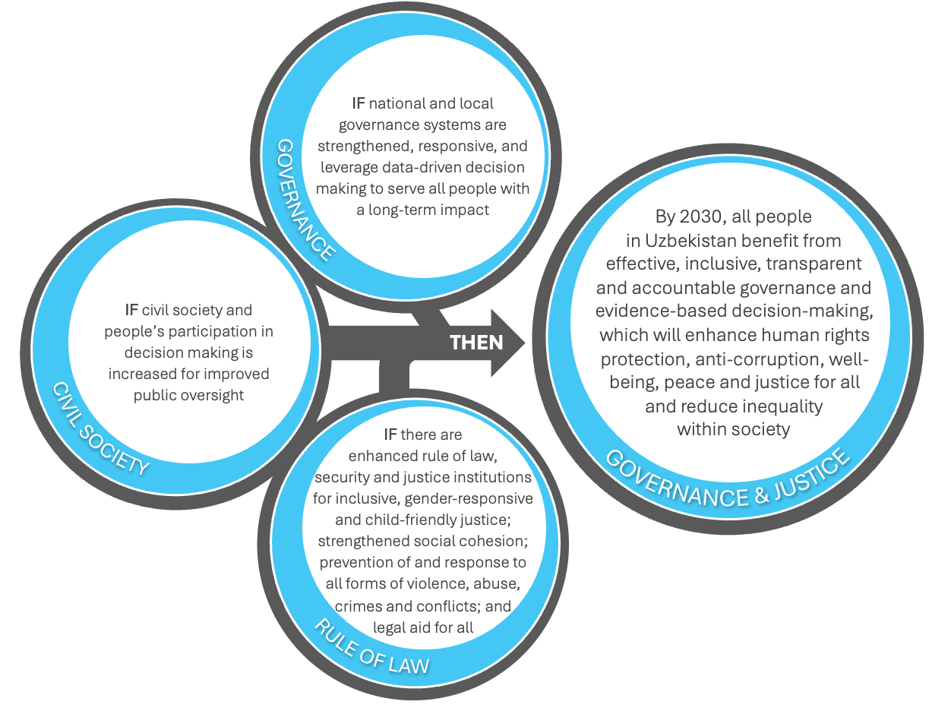

SDG Alignment  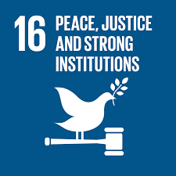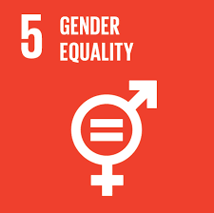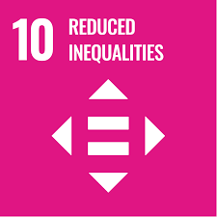 | Snapshot of progress on select indicators  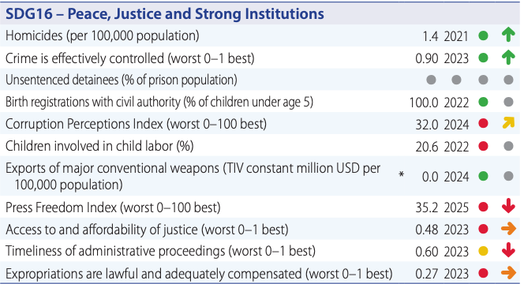  Source: Sustainable Development Report 2025
Uzbekistan 2030 Strategy Alignment
4.1. Reforms to organize public administration focused on serving the people and improving public administration
4.2. Reforms to ensure the rule of law and the judicial system
II. Ensuring the Well-Being of the Population Through Sustainable Economic Growth
5.1. Reforms aimed at pursuing an open, pragmatic and active foreign policy
Examples of mainstreamed efforts to support GEWE under outcome 1 include support for:
- Gender responsive governance and budgeting as well as enhanced data disaggregation
- Opportunities for genuine engagement in decision-making by all, including women and girls
- Expanded access to gender-responsive, survivor-centred and child friendly justice
Examples of interlinkages with other CF outcomes include the following:
- Enhanced data governance and data-driven decision making are needed to enhance service delivery access and quality, including for social protection (outcome 2), health (outcome 3) and education (outcomes 4)
- Increased civil society and people’s participation in decision making for improved public oversight (output 1.2) is critical for achievement of all CF outcomes
- Efforts to enhance the rule of law, security and justice institutions (output 1.3) are linked with work to enhance environmental justice and governance under outcome 5.

Outcome 1: By 2030, all people in Uzbekistan benefit from effective, inclusive, transparent and accountable governance and evidence-based decision-making, which will enhance human rights protection, anti-corruption, well-being, peace and justice for all and reduce inequality within society
The Uzbekistan 2030 Strategy outlines ambitious plans to enhance human rights and rule of law safeguards, prevent corruption, and reform public administration to better serve all people of Uzbekistan. The strategy promotes gender equality and calls for a culture of non-violence against women in society to ensure the rights and legitimate interests of women. Many of the specific public administration commitments relate to the implementation of a “service state” system that brings accessible services closer to people, reduces bureaucratic hurdles, and provides greater space for the voice of people.
LNOB: The UN’s support for the Government commitments described above will focus in particular on population groups at risk of being left behind, namely: women, children and youth, people with disabilities, rural populations (especially in ecologically fragile areas such as the Aral Sea region), the poor (both rural and urban), people living with HIV, and displaced people and stateless people.
To support the achievement of this outcome, the UN development system will contribute to:
- Output 1.1. Strengthened, responsive national and local governance systems that leverage data-driven decision making to serve all people with a long-term impact
The UN will continue to support the government’s efforts to digitalize public services with the aim of improving the accessibility, quality, and transparency of government services. Digitalization will reduce opportunities for corruption and enhance efficiency through the reduction of bureaucratic red tape. Assistance will also be provided to enable the government to take stock of the magnitude, scope and impact of corruption in the public sector’s interaction with the private sector and society, with an aim to develop effective measures to prevent and counter corruption in line with the UN Convention Against Corruption.
The UN will support upgrading of the government’s data governance systems to strengthen evidence-based decision making and response, and to enhance the availability of data disaggregation (by sex, age, disability, HIV status, geographic location, and other vulnerabilities, including forcibly displaced and stateless people, population affected by migration and human trafficking).
The UN will support the population census, migration policy development, and other studies/surveys (e.g. MICS 7, LNOB study, National Survey on Violence Against Women (VAW)). It will provide training to enable analysis to be transparently shared and inform decision making through data-driven planning, resource allocations and service delivery targeting those most at risk of being left behind. The UN will make a concerted effort to strengthen the use of demographic data and population forecasts to inform policy planning, ensuring that development strategies are responsive to current and future demographic trends. Results-oriented management and budgeting, along with efficient monitoring and evaluation (M&E), will also be supported.
The UN will support national efforts to create an enabling environment for gender‑responsive governance, including institutional reforms that foster women’s equal access to public and political life, and meaningful participation in shaping policies, resource allocations, and peacebuilding processes. With the introduction and expansion of Gender Responsive Budgeting (GRB) programme starting from national budget and trickle down into local budgets, will enable identifying and reflecting needed interventions to address gender gaps in sector and local government policies, plans and budgets.
The UN will also promote the development of ethical and rights-based approaches to the use of emerging technologies, including artificial intelligence. This includes supporting the establishment of policy and institutional frameworks that prevent potential discrimination and ensure the protection of personal data, as well as strengthening the capacities of public institutions and civil society actors to understand and address the ethical and legal implications of AI-driven systems.

- Output 1.2. Increased civil society and people’s participation in decision making for improved public oversight
The UN will support the government’s efforts to create a conducive environment for a vibrant civil society and independent media. This includes: i) fostering opportunities for genuine engagement in decision-making by all, including women and girls, such as public participation in the activities of local kengashes; ii) supporting the authorities to address undue restrictions on civic space, including by removing burdensome NGO registration requirements; and iii) supporting efforts to protect media space. The UN will strengthen the capacity of civil society and media to foster civic engagement, hold institutions accountable, defend human rights, and represent the views of the people, especially those in vulnerable situations that exacerbate their risk of being left behind. Outreach activities will be designed to increase: i) demand for social accountability against corruption, including transparency on corruption-related data; ii) awareness of human and other legal rights, especially amongst vulnerable populations, including forcibly displaced and stateless populations and victims of human trafficking; and iii) understanding of gender equality, stereotypes, and cultural norms as a foundation for gender-sensitive content creation and handling GBV and GBV-related cases. This will facilitate the diversity and inclusiveness necessary to make evidence-based decisions and foster accountability in meeting the outcome. The UN will use its comparative advantage to convene and support evidence-based advocacy and decision making.
Box 4. LNOB – Spotlight on statelessness
Thanks to the 2020 law on citizenship, 90,000 stateless people have acquired citizenship in Uzbekistan in recent years. However, statelessness remains a significant issue with 20,000 stateless officially registered as of January 2025. Uzbekistan has not acceded to the Statelessness Conventions, resulting in economic and social exclusion for those without legal identity, diminishing their contribution to the economy.

- Output 1.3. Enhanced rule of law, security and justice institutions for inclusive, gender-responsive and child-friendly justice; strengthened social cohesion; prevention of and response to all forms of violence, abuse, crimes and conflicts, and legal aid for all
The UN will support efforts to: i) enhance the independence, professionalism, and digitalization of lead justice actors (administrative, judiciary, law enforcement); ii) increase the efficiency, accountability, and integrity of criminal justice institutions; iii) support Uzbekistan’s accession to conventions and protocols related to refugees and stateless people and a complaint procedure for children, through phased implementation of the Universal Periodic Review (UPR) recommendations action plan; iv) enhance criminal legislation and implementation of protocols, rules and procedures, including on whistleblowers protection to counter corruption; v) align national legislation with international human rights standards, particularly by addressing the overly broad use of criminal law, advancing human rights protections, ensuring non-discrimination and eliminating all forms of violence and harassment, securing protection from forced return, torture and reducing exposure risks of ill-treatment; vi) strengthen legal frameworks, law enforcement capacities, and cross-border and international cooperation to counter illicit drug trafficking, transnational organized crime (including trafficking in persons), cybercrime, money laundering, terrorism and violent extremism; and vii) expand access to legal aid in criminal justice systems, to those detained, arrested or imprisoned, suspected or accused of, or charged with a criminal offence and for victims and witnesses of crimes. These efforts will be complemented by activities targeting prevention of and response to all forms of violence, abuse, crimes and conflicts.
Box 5. LNOB – Spotlight on violence against women and girls
Discriminatory laws and policies exacerbate deep-rooted discrimination of women and girls in Uzbekistan, which often stems from patriarchal attitudes and societal stereotypes regarding gender roles. In April 2023, a landmark law was enacted to criminalise domestic violence, including economic and psychological abuse, and to establish accountability for sexual violence and harassment against women and girls. Reported cases of violence against women have risen by 30% since its adoption, reflecting increased trust in the legal system and women’s readiness to seek help. However, much remains to be done to ensure all women and girls are aware of their rights and pursue justice.
To expand access to gender-responsive, survivor-centred and child friendly justice, the UN will support efforts to: i) ensure fair, inclusive and accessible legal procedures for women and children; ii) embed gender-sensitive and child—friendly approaches in legal and judicial frameworks; iii) criminalize various forms of technology-facilitated gender-based violence (TFGBV) and violence against children; iv) strengthen multi-sectoral coordination and response to prevent and respond to GBV and violence against children effectively; and v) establishment of child justice system in line with international justice for children standards. This includes working with the health, social, justice and others sectors to improve the identification and support to survivors, and to ensure that health providers, school workforce, social workers and other frontline workers are trained to deliver gender-sensitive services as part of a coordinated response system as well as build capacities of justice professionals to prevent the secondary victimization of violence survivors.
To strengthen social cohesion, the UN will empower young people, particularly young women and vulnerable at-risk groups, to promote their civic participation and socio-economic inclusion. The UN will also address harmful gender stereotypes and empower women and girls and to prevent violence against women and children.

OUTCOME 2. LIVELIHOODS AND SOCIAL PROTECTION

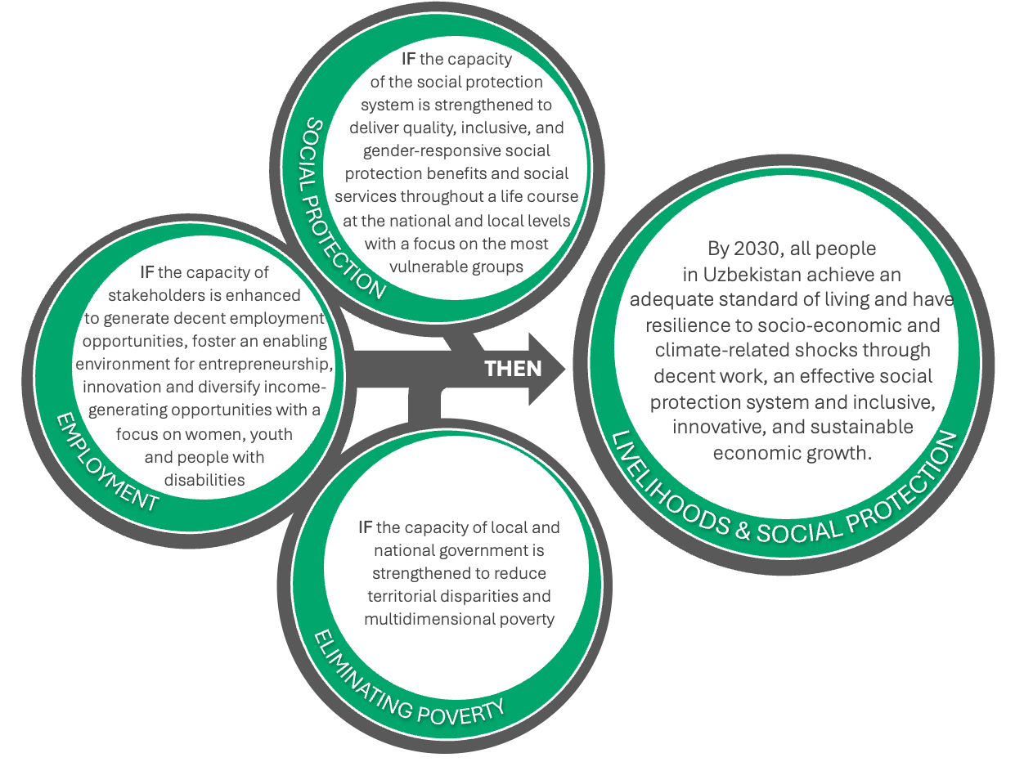

SDG Alignment  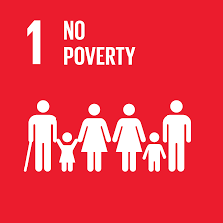  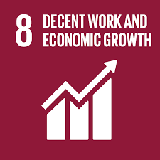 | Snapshot of progress on select indicators  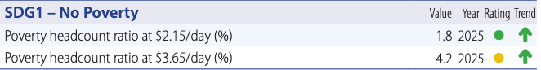  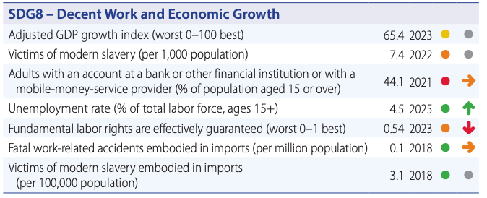  Source: Sustainable Development Report 2025
Uzbekistan 2030 Strategy Alignment
1.3. Reforms in the provision of social services and poverty reduction
1.4. Reforms in the areas of state youth policy and sports
Examples of mainstreamed efforts to support GEWE under outcome 2 include support for:
- Reduced barriers for rural women managing agricultural livelihoods and promotion of women and youth participation in high-value sectors such as horticulture and dairy processing
- Promotion of investment in the care economy and family friendly policies in workplaces
- Integration of social services for GBV and violence against children into the broader social protection system, ensuring a holistic approach
- Innovative entrepreneurship, with a focus on women-led and youth-owned enterprises, and cooperatives
Examples of interlinkages with other CF outcomes include the following:
- The CF prioritizes complementary investments in Uzbekistan’s care economy including in social protection, health, and education (outcomes 2, 3 and 4) in order to harness the country’s demographic and gender dividend to achieve the aims of the Uzbekistan 2030 Strategy and the SDGs.
- UN support for social protection will link with health financing reforms under outcome 3, including initiatives that expand financial protection and reduce catastrophic health spending
- Support for a holistic approach to social protection will help combine immediate response mechanisms with reintegration programs, including vocational training under outcome 4
- To provide comprehensive support for survivors of GBV and violence against children, the UN will support adapting case management services and referral pathways between law enforcement (outcome 1), health services (outcome 3), and social protection programs.

Outcome 2: By 2030, all people in Uzbekistan achieve an adequate standard of living and have resilience to socio-economic and climate-related shocks through decent work, an effective social protection system and inclusive, innovative, and sustainable economic growth
The Uzbekistan Strategy 2030 aims to achieve a radical reduction in poverty and ensure full social protection coverage of the population in Uzbekistan. The strategy includes specific measures fostering opportunities for women, youth, and people with disabilities to obtain decent work, professional development, and leadership positions.
Uzbekistan’s youthful and rapidly growing population offers opportunities for economic growth. The working-age population (15–64 years) is expected to grow to 28.3 million by 2050, an increase of more than 7.8 million people, signalling a continuation of the "demographic window of opportunities" where a high proportion of the working-age population may serve as a driver for economic growth. This trend also presents challenges as rapid population growth, ageing, urbanization, and migration are straining public services and exacerbating regional disparities. To take advantage of this opportunity and harness the demographic dividend, it is necessary to stimulate inclusive economic growth and increased productivity with a focus on women, youth, and people with disabilities. Leveraging the demographic and gender dividend will also require investments in the care economy including health, education and social services (outcomes 3 and 4, respectively).
LNOB: The UN’s support for these Government commitments to achieve a radical reduction in poverty and ensure full social protection coverage of the population in Uzbekistan, with a focus on groups at risk of being left behind, namely: women, children and youth, people with disabilities, elderly, rural populations (especially in ecologically fragile areas such as the Aral Sea region), the poor (both rural and urban), people living with HIV, and displaced people and stateless people.
Box 6. LNOB – Spotlight on child labour
Systematic child labour in the cotton harvest has been successfully eliminated but the 2021 MICS study showed that 21% of 5–17-year-olds were still engaged in labour, particularly in informal sectors outside of the cotton industry. Male children are more prone to engage in child labour (34.3%) compared to female children (25.0%). Hazardous work (with 15.4% children engaged in) threatens the physical and cognitive development of these children, limiting their educational opportunities and long-term potential. This issue disproportionately affects children from the poorest households and rural communities. Children with disabilities, ethnic minority children, and those from Afghan families stranded in Uzbekistan face additional barriers, including limited access to education, healthcare, and social services.

To support the achievement of this outcome, the UN development system will contribute to:
- Output 2.1. Increased capacity of the social protection system to deliver quality, inclusive, and gender-responsive social protection benefits and social services throughout a life course at the national and local levels with a focus on the most vulnerable groups
The UN will support the government’s efforts to strengthen the efficiency, inclusivity, accountability, fiscal space and financial sustainability of social protection by advancing both social benefits and services through an integrated system that meets the needs of the poorest and most vulnerable, including forcibly displaced and stateless populations, victims of violence, adults and children with disabilities, migration-affected persons and families, victims of human trafficking, and other vulnerable groups. This includes integrating climate-responsive benefits (e.g., crop insurance, disaster relief) for smallholder farmers and digitalizing services to reduce barriers for rural women managing agricultural livelihoods. Tailored programmes will address inequalities in caregiving responsibilities, support investments in the health and care economy (e.g., subsidized childcare,) and promote family friendly policies at workplace to enable women’s economic participation. This includes efforts to strengthen the paid care workforce—including health and social care workers—by improving working conditions, supporting career development, and addressing gender disparities in employment and pay. Recognizing that high out-of-pocket (OOP) health expenditures remain a major driver of poverty and vulnerability, particularly for low-income households and persons with chronic conditions or disabilities, the UN will support stronger linkages between social protection and health financing reforms. This includes supporting initiatives that expand financial protection and reduce catastrophic health spending.
Support will target social services system reform, transitioning toward a more universal, preventive and outcome-driven approach, with increased investment in community engagement and support particularly for persons with disabilities, children and women survivors of violence.
The UN will support the integration of social services for GBV and violence against children survivors into the broader social protection system, ensuring a holistic approach that combines preventive efforts (addressing harmful social norms, parenting education, etc.) and immediate response mechanisms (such as emergency shelters and helplines) with reintegration programs and long-term economic empowerment initiatives, vocational training (outcome 4), and access to financial support for survivors. It will work towards strengthening comprehensive support for women and children at risk and women and girl survivors of GBV and child survivors of all forms of violence, including the availability, accessibility, and quality of essential support services, adapting case management services and referral pathways between law enforcement (outcome 1), health services (outcome 3), education (when children, outcome 4) and social protection. Utilizing evidence from the National Survey on Violence Against Women (VAW) to tailor GBV services and enhance responses to violence against women based on its findings will also be critical for achieving this outcome.
Digitalization and integration of social benefits and services (linked with outcome 1) will be supported through IT infrastructure modernization and platform integration, which will also reduce corruption opportunities. Assistive technologies and infrastructure will be deployed to enable access for people with disabilities. There is an urgent need to support the government in transitioning from a medical to a human rights model of disability assessment, to enhance early identification and interventions for children with disabilities, improve access to inclusive education (outcome 4), establish community-based care and support services, and assistive technology.
- Output 2.2. Enhanced capacity of stakeholders to generate decent employment opportunities, foster an enabling environment for entrepreneurship, innovation and diversify income-generating opportunities with a focus on women, youth and people with disabilities
The UN will support the government’s efforts to foster an enabling ecosystem for start-ups and business acceleration, improve working conditions in accordance with international labour standards and labour protection of informal workers, and implement market and labour policies that promote the transition from informal to formal employment. In rural areas, labour formalization efforts will integrate informal agricultural workers into formal employment structures, while entrepreneurship programs will encourage women and youth participation in high-value sectors such as horticulture and dairy processing. To foster innovative entrepreneurship, with a focus on women-led and youth-owned enterprises, and cooperatives, as part of a social and solidarity economy, the UN will facilitate access to financing, mentorship, co-working spaces, accelerators, and capacity-building programmes; promoting family-friendly policies in the workplaces and decent work with the goal of strengthening women's agency and male involvement. Public-private initiatives and social dialogue at all levels will be explored and developed.
Along with this, the UN will support the Government and social partners to translate international labour standards into practice by: addressing decent work deficits and gender inequalities including gender pay gaps in the labour market; promoting equal treatment and opportunities; strengthening enforcement mechanisms including labour inspection and OSH systems in line with international standards; supporting capacity development of workers’ and employers’ organisations; and expanding monitoring and statistical systems to track both quantity and quality of employment (formalization, wages, working conditions, OSH compliance, etc.).
- Output 2.3. Strengthened capacity of local and national government to reduce territorial disparities and multidimensional poverty
The UN will support local and national government to design and implement pro-poor, area-based policy measures that reduce territorial disparities, including across provinces and the urban rural divide, informed by multidimensional poverty measurement tools and instruments. To address disparities, the UN will also help unlock financing for inclusive and sustainable infrastructure investment including for sustainable transport corridors, trade facilitation, digital connectivity, promote market access for regional trade, while ensuring cybersecurity measures to protect digital ecosystems and foster trust in services and innovations. Local governments will be encouraged to prioritize renewable energy and energy efficiency projects (e.g., solar-powered processing units) to reduce costs and create green jobs for youth. Initiatives to address affordable, adequate, climate-neutral housing and sustainable urban development will be implemented (linkage with outcome 5).
Box 7. LNOB – People with Disabilities
People with disabilities are one of the most marginalized groups in Uzbekistan, facing significant barriers to mobility, education, employment, and political participation. Social stigma and a medical approach to disability reinforce their exclusion, limiting their opportunities for decent living. Infrastructure remains inaccessible, and social protection mechanisms fail to adequately address their needs. Women and children with disabilities are particularly vulnerable to violence and neglect. The continued focus on a residential approach to care and education, rather than community-based support and mainstreaming, further isolates people with disabilities from mainstream society.

OUTCOME 3. HEALTH

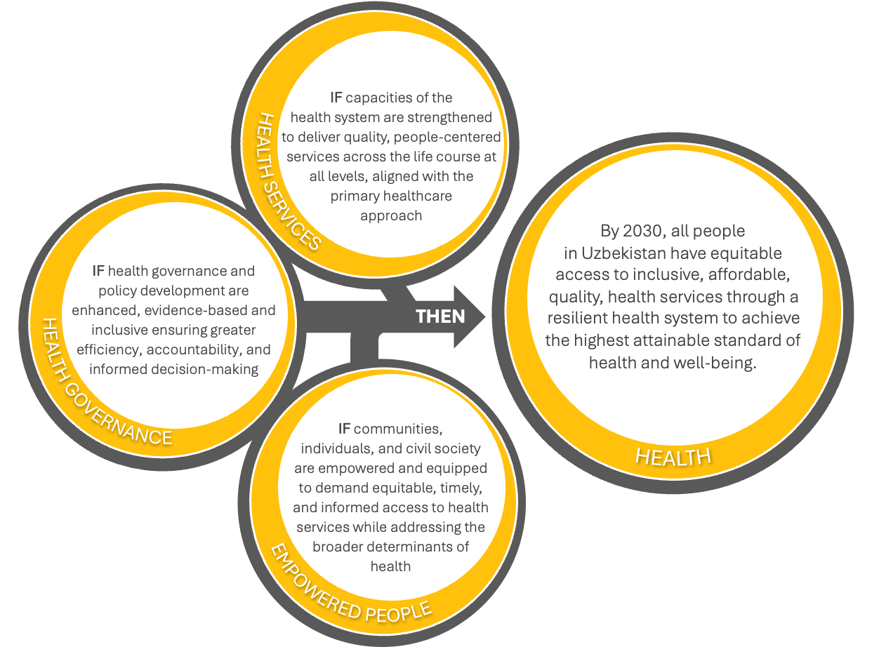
SDG Alignment  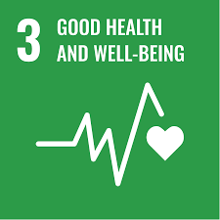 | Snapshot of progress on select indicators  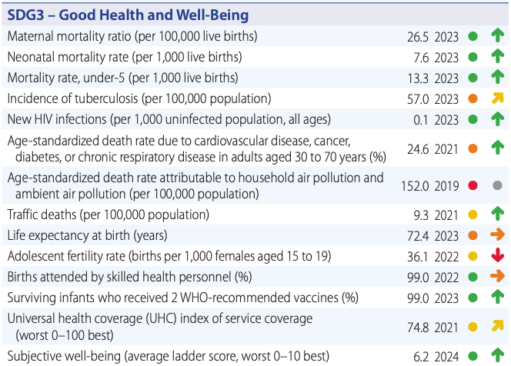  Source: Sustainable Development Report 2025
Uzbekistan 2030 Strategy Alignment
1.2. Reforms to ensure public health

Examples of mainstreamed efforts to support GEWE under outcome 3 include support for:
- A sustainable state budget allocation for the health sector including procurement of high-quality products and contraception to serve the needs of all, including women and the most vulnerable
- Re-orientation of the health system towards a primary health care-based health system to ensure access to people-centred integrated health services across the life course
- Expansion of the home visiting model providing holistic, gender-responsive support
- Quality maternal and reproductive, neonatal, child, and adolescent health services
- Addressing social cultural norms and practices that prevent women, children, and adolescents from accessing health services and health information
Examples of interlinkages with other CF outcomes include the following:
- The CF prioritizes complementary investments in Uzbekistan’s care economy including in social protection, health, and education (outcomes 2, 3 and 4) in order to harness the country’s demographic and gender dividend to achieve the aims of the Uzbekistan 2030 Strategy and the SDGs.
- The support for evidence-based health governance and digital health systems this outcome links with broader, cross-cutting work on evidence-based decision-making and digitalization under outcome 1.
- Similarly, this outcome’s focus on empowering communities, individuals and civil society to demand equitable, timely and informed access to health services is linked with outcome 1’s broader focus on civil society and people’s participation in decision making for improved public oversight.

Outcome 3. By 2030, all people in Uzbekistan have equitable access to inclusive, affordable, quality, health services through a resilient health system to achieve the highest attainable standard of health and well-being
The Uzbekistan 2030 Strategy outlines ambitious reforms to increase average life expectancy and ensure healthy ageing, improve maternal and child health, strengthen health literacy among the population, and enhance health services for all across the life course addressing the main drivers of mortality and morbidity. Reforms aim to strengthen the primary health care (PHC) approach, enhance the quality and management of health services, encourage a healthy lifestyle, and achieve digitalization of the health system.
LNOB: The UN’s support for these Government commitments to ensure public health will focus in particular on population groups at risk of being left behind, namely: women, children and youth, people with disabilities, rural populations (especially in ecologically fragile areas such as the Aral Sea region), the poor (both rural and urban), people living with HIV, and displaced people and stateless people.
To support the achievement of this outcome, the UN development system will contribute to:
- Output 3.1. Enhanced, evidence-based and inclusive health governance and policy development ensuring greater efficiency, accountability, and informed decision-making
The UN will support government efforts to: i) institutionalize evidence-based health policies including multi-sectoral policies, while strengthening regulations and capacities to enhance governance, accountability, and long-term resilience and to address wider determinants of health through multi-sectoral approaches (linkage to outcome 1); ii) support integrated digital health systems to enhance data-driven decision-making, accountability, and health system performance, including data systems for informed decision making leveraging validated HIV response tools (e.g. SPECTRUM and the Global AIDS Report) – which are linked with the digitalization of public services captured under outcome 1; iii) align human and financial resources, expertise, and efforts, leading to more integrated, efficient, and sustainable health services delivery; iv) develop and implement a comprehensive national plan to prevent and combat production, trafficking, distribution, and use of substandard and falsified medical products including non-medical use of prescribed medicines; v) streamline administrative procedures to ensure the accessibility and availability of guaranteed cancer diagnostics and treatment; and vi) provide a sustainable state budget allocation for the health sector including procurement of high-quality products and contraception to serve the needs of all, including women and the most vulnerable.
Box 8. LNOB – People living with HIV
People living with HIV in Uzbekistan face stigmatisation, extreme marginalisation and discrimination. Migrants make up 13% of people living with HIV, which has prompted the Government to prioritize migrant workers in its HIV prevention programmes. This group is particularly vulnerable to violence, arbitrary detention, and harassment by law enforcement, with little recourse to justice.
Although the HIV epidemic affects more men than women in Uzbekistan, women face additional hurdles in accessing essential HIV information, prevention, and care services, making them disproportionately vulnerable.

- Output 3.2. Strengthened capacities of the health system to deliver quality, people-centred services across the life course at all levels, aligned with the Primary Health Care (PHC) approach
The UN will support government efforts to bring quality, primary health services closer to the population and enhance health and well-being across the life course. This will be delivered through activities that: i) support the re-orientation of the health system towards a PHC-based health system to ensure access to comprehensive, continuous, coordinated and people-centred integrated health services across the life course; ii) strengthen the prevention, treatment, and management of major communicable and non-communicable diseases; iii) improve health financing mechanisms for better resource efficiency and financial protection; iv) support evidence-based, sustainable health workforce policies for planning, education and training, recruitment, retention, and equitable distribution ; (vi) expand the home visiting model providing holistic, gender-responsive support to communities and families on topics including maternal and reproductive health, childcare, nutrition and child development, tuberculosis (TB), HIV, cancers, diabetes, and other communicable and non-communicable diseases prevention; vii) strengthen health emergency preparedness and response capacities in line with the International Health Regulations (IHR) and the National Action Plan for Health Security (NAPHS); vii) support a climate-resilient health system which is equipped to address environmental health risks and the health impacts of climate change; viii) expand preventive public health interventions for all hazards, through a multisectoral One Health approach including anti-microbial resistance (AMR), food safety and zoonoses; ix) enhance national capacity to ensure accessible, high-quality, and affordable services for vulnerable populations especially women and adolescent girls, and people living with HIV; x) strengthen the health workforce and referral pathways at primary and secondary levels by enhancing the skills of PHC workers on high-quality maternal and reproductive, neonatal, child, and adolescent health services, as well as communicable diseases including hepatitis, HIV and TB; and xi) support the introduction of innovative solutions—such as telemedicine and other digital tools— that can improve access to quality health services, particularly in underserved areas, accompanied by efforts to improve system readiness for sustainability and scalability of these solutions.
- Output 3.3. Empowered communities, individuals, and civil society are equipped to demand equitable, timely, and informed access to health services while addressing the broader determinants of health
The UN will empower communities and individuals, especially women and children, through health literacy, community engagement and health promotion. More specifically, the UN will: i) scale up, evidence-informed health promotion and prevention programs, improving access to information on key risk factors for ill health and injury, including road safety measures, to promote health and well-being across the life course; ii) strengthen mental health services coverage at the primary level through engagement of Mahalla and community medical workers; iii) provide capacity building of health-focused NGOs for effective and sustainable collaboration with the government institutions, including for data collection and implementation of health related programmes, including TB, HIV, cancers, diabetes and other communicable and non-communicable diseases prevention and treatment; iv) engage and empower individuals, families, and communities for increased social participation and enhanced self-care and self-reliance in enhancing and maintaining health and well-being; vi) advocate for government-CSO-private sector and South-South cooperation, vii) promote informed choices for women and adolescent girls on family planning as fulfilment of their rights and potential for education and professional growth; viii) engage parents, caregivers, and children/adolescents to increase demand for quality maternal and reproductive, neonatal, child, and adolescent health services; ix) address social cultural norms and practices that prevent women, children, and adolescents from accessing health services and health information, x) encourage the HIV response community-led model, bring service closer to the people, improve early detection and enhance treatment adherence; and xi) strengthen community systems and platforms, including schools, to provide quality and integrated health services for learners.

OUTCOME 4. EDUCATION

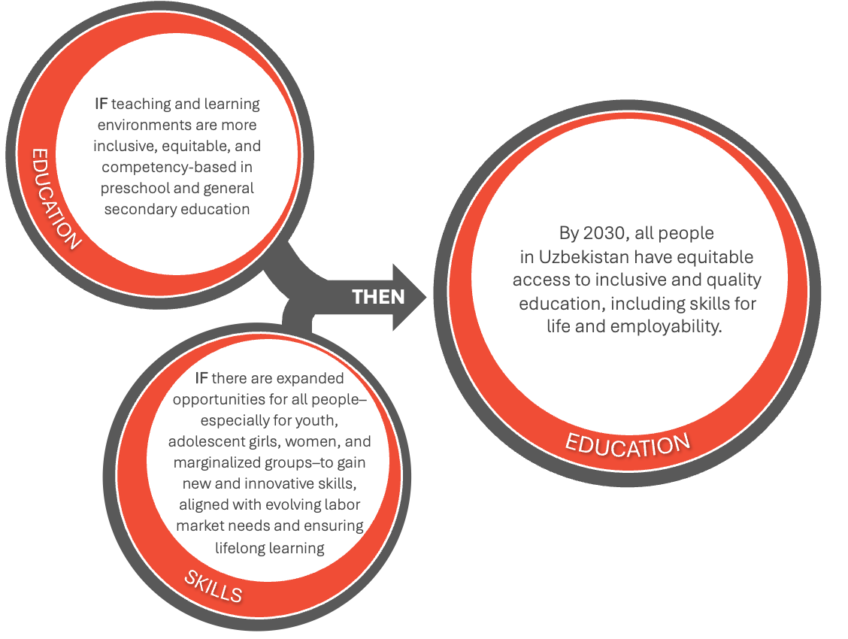
SDG Alignment  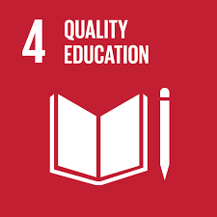 | Snapshot of progress on select indicators  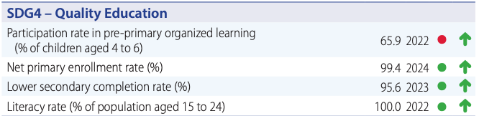  Source: Sustainable Development Report 2025
Uzbekistan 2030 Strategy Alignment
  - Reforms in the education system
1.4. Reforms in the areas of state youth policy and sports
Examples of mainstreamed efforts to support GEWE under outcome 4 include support for:
- Equitable access to quality and inclusive education at the pre-school and school levels for all
- Vocational education and lifelong learning opportunities, including upskilling and re-skilling programmes, prioritizing women of all ages, vulnerable youth and marginalized groups, including persons with disabilities and people living with HIV/AIDS
Examples of interlinkages with other CF outcomes include the following:
- The CF prioritizes complementary investments in Uzbekistan’s care economy including in social protection, health, and education (outcomes 2, 3 and 4) in order to harness the country’s demographic and gender dividend to achieve the aims of the Uzbekistan 2030 Strategy and the SDGs.
- Upskilling and re-skilling programmes are linked with social protection and livelihoods activities (outcome 2) and will include health literacy and life skills training (outcome 3). Additional linkages with outcome 3 include innovative higher education initiatives in the health sector
- Education systems strengthening linked with governance and digitalization (outcome ) and efforts to ensure all school environments meet climate resilience (outcome 5).

Outcome 4: By 2030, all people in Uzbekistan have equitable access to inclusive and quality education, including skills for life and employability
The Uzbekistan 2030 Strategy aims to improve preschool education, ensure universal coverage of children, enhance general secondary education, improve teaching staffs’ knowledge and qualifications, involve the private sector in secondary education, improve the vocational education system, expand higher education coverage, and improve working conditions and quality of training.
The Partnership Compact for Education Reform 2023-2026 serves as Uzbekistan’s roadmap for transforming its preschool and general secondary education system and ensuring equitable access to quality education for all children and youth. It is structured around five pillars addressing: i) infrastructure, construction and equipment; ii) curriculum, teaching and learning resources; iii) teachers’ professional development; iv) learning assessment systems; and v) governance, school improvement, and monitoring and evaluation.
The Compact also recognizes the lifelong learning cycle that is needed for the acquisition of complex competencies. Uzbekistan has developed strategies to enhance vocational education and training, which includes the establishment and modernization of technikums, centres of vocational excellence, vocational training centres and collaboration with the private sector to provide vocational training programs matched with labour market needs.
LNOB: The UN’s support for these Government commitments under the Compact will focus in particular on population groups at risk of being left behind, namely: women, children and youth, people with disabilities, rural populations (especially in ecologically fragile areas such as the Aral Sea region), the poor (both rural and urban), people living with HIV, and displaced people and stateless people.
Box 9. LNOB – Spotlight on NEET
The proportion of women aged 15-25 in Uzbekistan not in education, employment or training (NEET) is much higher than that of men of the same age, 42% and 8.8% respectively. The exclusion of youth stems from a combination of inadequate legal frameworks, lack of civic space, and negative societal perceptions of young people. Additionally, a scarcity of employment and educational opportunities, coupled with low skill levels, deepens this marginalization, leaving many young people without viable pathways to economic and social participation. This marginalization increases their risk of radicalization, mental health issues, and involvement in illicit activities, thereby hindering their ability to contribute to Uzbekistan's development.

To support the achievement of this outcome, the UN development system will contribute to:
- Output 4.1. More inclusive, equitable, and competency-based teaching and learning environments in preschool and general secondary education
In line with the Partnership Compact for Education Reform 2023-2026, UN interventions will focus on increasing equitable access to quality and inclusive education at the pre-school and school levels for all. Efforts will also prioritize technical assistance to the government and national education stakeholders towards ensuring school readiness and a full transition to quality and inclusive competency-based education. Specifically, interventions will: i) support education systems strengthening with improved school-based planning, assessment, monitoring and evaluation, with emphasis on result-based financing (linked with governance and digitalization support under outcome 1); ii) enhance quality and inclusive teaching and learning through competency-based and technology enabled curriculum, with a focus on early childhood and general secondary levels; iii) expand professional development opportunities for teachers, including through the revision of an enhanced system for pre-service and in-service teacher professional development; and iv) ensure all school environments including in rural areas meet climate resilience (linked with the focus on climate change under outcome 5), safety and WASH standards (including for menstrual health management), v) support introduction of healthy lifestyle education, prevention of HIV, and reproductive health topics into school curricula in appropriate age (linked with health under outcome 3).

- Output 4.2. Expanded opportunities for all people – especially for youth, adolescent girls, women, and marginalized groups – to gain new and innovative skills, aligned with evolving labour market needs and ensuring lifelong learning
The UN will improve access to vocational education and lifelong learning opportunities, including upskilling and re-skilling programmes (linked with outcome 2), prioritizing women of all ages, vulnerable youth and marginalized groups, including persons with disabilities and people living with HIV/AIDS. Training and mentorship will be designed to prepare beneficiaries for the future of work, which will require continuous skills attainment and digital leapfrogging. Specifically, interventions will: i) support the strengthening of National Qualifications System by enhancing quality assurance mechanisms and the recognition of prior learning; ii) mitigate skill mismatches by introducing novel methodologies for skill forecasting and the development of national occupational standards; iii) strengthen the continuous professional development of leading and pedagogical personnel of VET organizations, including digital competencies; and iv) enhance the capacity of key stakeholders to effectively plan and deliver career guidance, skills development and lifelong learning programmes for all. As an integral part of live long learning, health literacy and life skills training – addressed further under outcome 3 – will also be provided, with a focus on at risk populations, including people living with HIV/AIDS.
Support will also be extended to the development of innovative higher education initiatives in the health sector, aimed at strengthening academic medical training, fostering research and innovation, and building the national health workforce. These efforts will contribute to modernizing healthcare systems and ensuring equitable access to quality health services, particularly for underserved populations.

OUTCOME 5. CLIMATE AND ENVIRONMENT

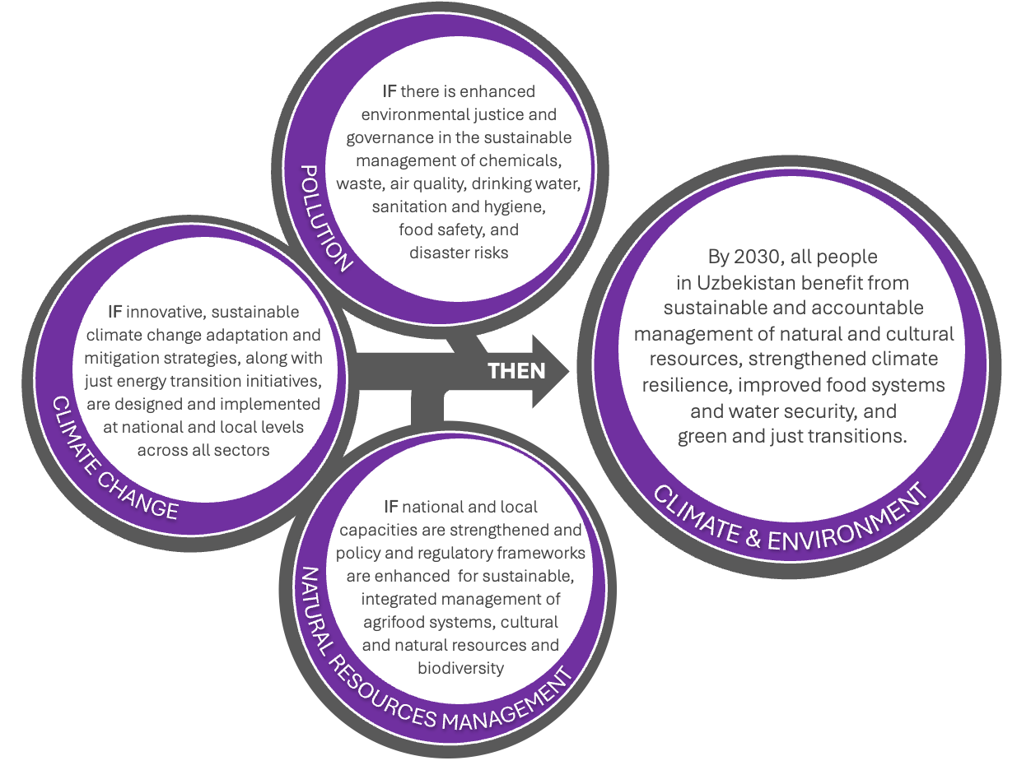
SDG Alignment  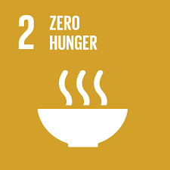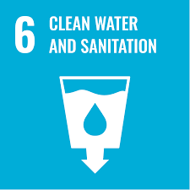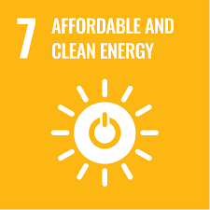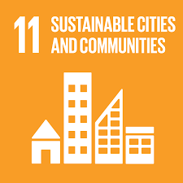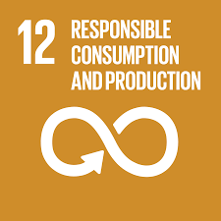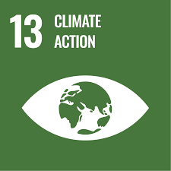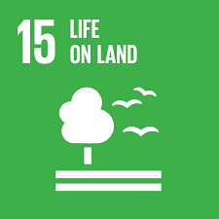 | Snapshot of progress on select indicators  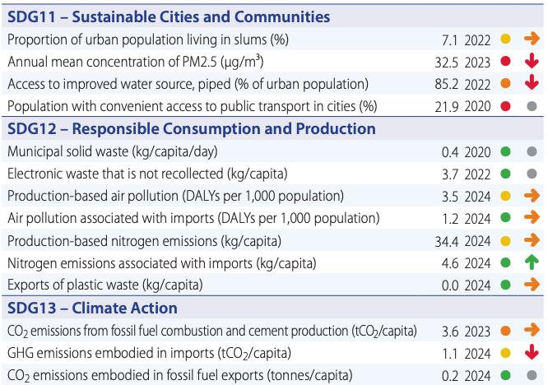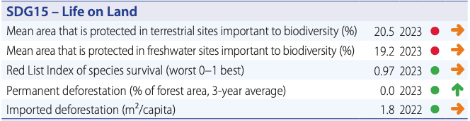  Source: Sustainable Development Report 2025
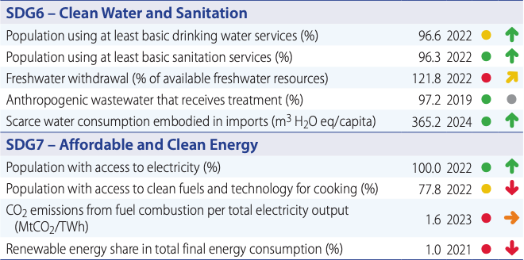
Uzbekistan 2030 Strategy Alignment
II. Ensuring the well-being of the population through sustainable economic growth (focus on green transition)
3.1. Water conservation reforms
3.2. Environmental Reforms
1.5. Reforms to ensure spiritual growth and raise the cultural sphere to a new level
Examples of mainstreamed efforts to support GEWE under outcome 5 include support for:
- Deeper integration of environmental initiatives with local systems to ensure sustained impact and alignment with the needs of communities, including the specific needs of women and vulnerable groups
- Policies, mechanisms and tools to ensure equitable access and sustainable, efficient management of natural resources, which include land, water, forest, mineral and other resources
Examples of interlinkages with other CF outcomes include the following:
- Support for environmental crime forensics capacities for law enforcement, anti-corruption, and public oversight is linked with the work to enhance the rule of law under outcome 1
- Efforts to strengthen the resilience of health systems to climate change and improve capacity to address climate-sensitive health risks links with outcome 3
- Enrichment of the national knowledge base on air and water pollution assessments links with data governance work under outcome 1.

Outcome 5. By 2030, all people in Uzbekistan benefit from sustainable and accountable management of natural and cultural resources, strengthened climate resilience, improved food systems and water security, and green and just transitions
This outcome responds to the triple planetary crisis of climate change, biodiversity loss, pollution and waste. Uzbekistan has made ambitious commitments to pivot towards a green economy, preserve its natural and cultural resources, prevent water and air pollution, and invest in climate change mitigation and adaptation. Through sustainable water hygiene and sanitation (WASH), climate-smart agriculture and improved resource management, Uzbekistan is aiming for a future where its food systems, water security, and cultural heritage are protected and thrive despite climate change and other pressures, such as the needs of a rapidly growing population. The government has increased its focus on the reduction of land degradation and improving the soil productivity to sustain food security in the country.
Article 49 of Uzbekistan's new Constitution grants citizens the right to a healthy environment as well as reliable information about its condition. This signifies a crucial link between human rights and environmental protection, paving the way for increased alignment of policies and programmes with international standards and public participation in sustainable development and decision making. With these initiatives, Uzbekistan is positioning itself to face climate change through responsible land use, integrated agricultural practices, nature-based solutions and the transition to sustainable energy sources.
LNOB: The UN’s support for these Government commitments on climate and the environment will focus in particular on population groups at risk of being left behind, namely: women, children and youth, people with disabilities, rural populations (especially in ecologically fragile areas such as the Aral Sea region), the poor (both rural and urban), people living with HIV, and displaced people and stateless people.
To support the achievement of this outcome, the UN development system will contribute to:
- Output 5.1. Strengthened national and local capacities and enhanced policy and regulatory frameworks for sustainable, integrated management of agrifood systems, cultural and natural resources and biodiversity
The UN will support the government to ensure that Uzbekistan's rich biodiversity and cultural heritage are preserved for future generations and that agriculture is conducted in a sustainable, climate-resilient manner. The integration of sustainable agriculture practices with environmental protection is essential for reducing land degradation and fostering an ecosystem that supports diverse flora and fauna while meeting the food security needs of the population. Specific actions will support: i) policies, mechanisms and tools to ensure equitable access and sustainable, efficient management of natural resources, which include land, water, forest, mineral and other resources; ii) biodiversity conservation, including through strengthened controls over the illegal use of flora and fauna; iii) nature-based solutions; iv) implementation of commitments under relevant global multilateral environmental agreements; v) increased environmental awareness amongst the public, and vi) policies and regulatory frameworks promoting sustainable agrifood systems, WASH, and the preservation, study and promotion of the country's rich cultural heritage.
Box 10. LNOB – Spotlight on rural populations
The rural population in Uzbekistan, especially in ecologically fragile areas such as the Aral Sea region, face compounded risks due to geographic isolation and environmental degradation. These communities suffer from a lack of access to decent jobs, healthcare, education, and social services, exacerbated by poor infrastructure and outdated agricultural practices. Rural areas are particularly vulnerable to the effects of climate change, which threatens livelihoods, exacerbates poverty, and increases the risk of food insecurity. The remoteness of these regions limits economic opportunities and essential services, contributing to the ongoing exclusion of rural populations from Uzbekistan’s development progress.

- Output 5.2. Innovative, sustainable climate change adaptation and mitigation strategies, along with just energy transition initiatives, are designed and implemented at national and local levels across all sectors
The UN will support the government in implementing NDC 3.0 commitments. It will support vulnerable communities to adopt climate-resilient WASH and agricultural techniques to enhance their capacity to cope with environmental challenges and ensure broader community engagement. It will focus on consistent follow-up and deeper integration of environmental initiatives with local systems to ensure sustained impact and alignment with the needs of communities, including the specific needs of women and vulnerable groups. The UN will support efforts to strengthen the resilience of health systems to climate change and improve capacity to address climate-sensitive health risks. The UN supports Uzbekistan’s role as a regional advocate for climate resilience and transboundary water cooperation, aligning national efforts with global climate security priorities.
The UN will facilitate reforestation, afforestation and restoration in urban and rural areas, especially in regions suffering from severe land degradation. Interventions will focus on provinces with the greatest extent of land degradation, including Karakalpakstan (including the Aral Sea region – covered explicitly under outcome 6), Navoiy, Bukhara and Surkhandarya provinces, thereby supporting the government’s ongoing Yashil Makon initiative.
The UN will assist the government to identify and address key barriers to just energy transition and strengthen related regulatory and institutional capabilities. In this context, support will be provided to the implementation of full-scale reforms in energy production and consumption. This will include guidance on mainstreaming Just Transition principles into a low-carbon energy strategy and energy tariff reform. Moreover, an action plan on Just Energy Transition will be developed for endorsement by stakeholders. This process will also be aligned with broader goals of achieving green economic growth by transitioning to low-carbon, renewable energy sources.
- Output 5.3. Enhanced environmental justice and governance in the sustainable management of chemicals, waste, air quality, drinking water, sanitation and hygiene, food safety, and disaster risks
The UN will strengthen institutional capacity to: i) assess and prevent polluting industrial practices at the source; ii) implement emissions reduction efforts from different sources at national and city-level; iii) deploy modernized systems for monitoring and managing the quality of air, water and food; iv) support Uzbekistan’s accession to and implementation of conventions and protocols that address pollution; and v) build environmental crime forensics capacities for law enforcement, anti-corruption, and public oversight (linked with the work to enhance the rule of law - outcome 1).
Working to empower communities, the UN will: i) raise public awareness of pollution, including environmental and health impacts of open burning agriculture and other wastes (linked with outcome 3 on health); ii) promote circularity principles to increase national waste recycling rates, prevent inappropriate practices, and foster action on specific waste streams; and iii) enrich the national knowledge base by disseminating the findings of air and water pollution assessments and related health impacts. (linked with data governance work - outcome 1). These actions will contribute to a holistic approach to environmental management that incorporates both ecological sustainability and social justice, ensuring that all citizens benefit from cleaner air, water, and safer food systems.

OUTCOME 6. ARAL SEA REGION

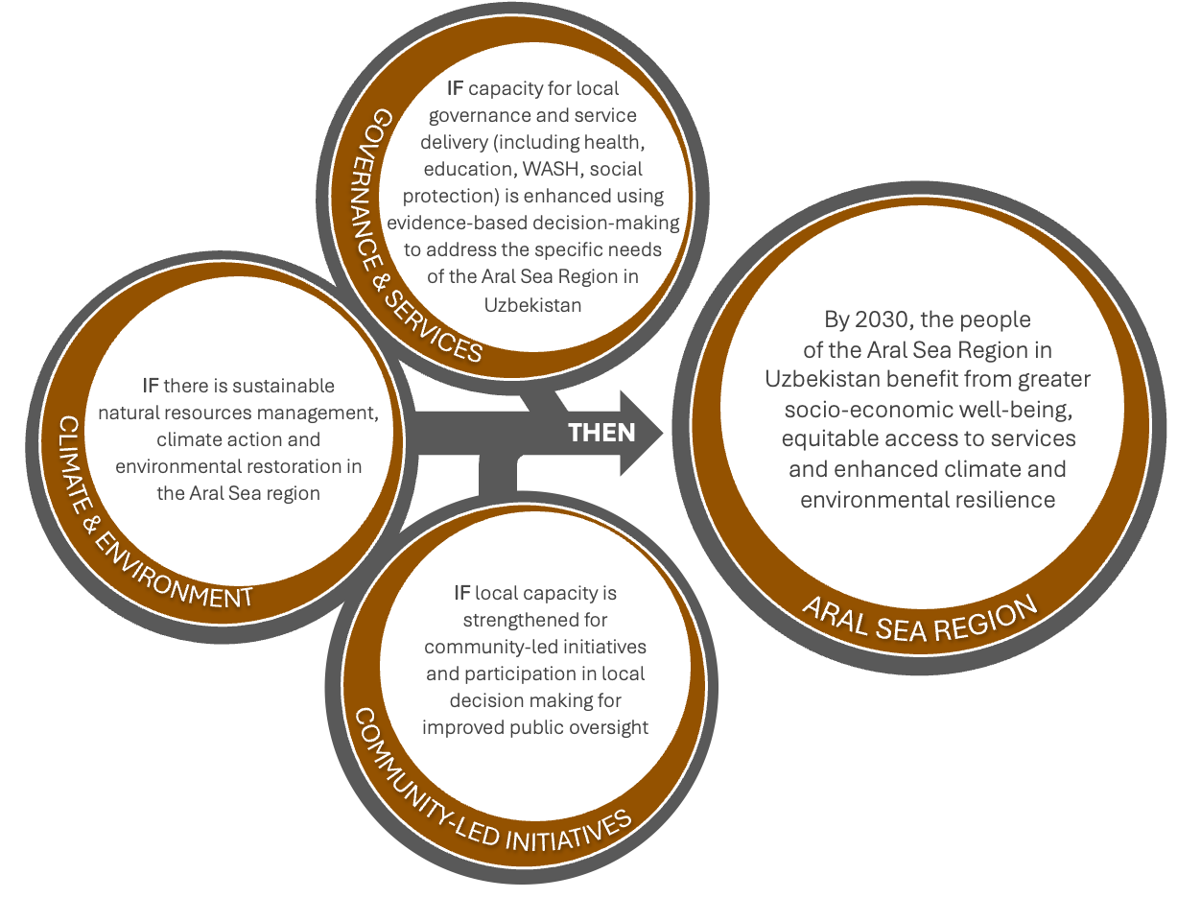

Alignment – SDGs and the Uzbekistan 2030 Strategy
Outcome 6 contributes towards all SDGs listed in outcomes above, albeit with a geographic focus. It also aligns with all of the strategic priorities highlighted under outcomes 1-5. While this region will also benefit from the activities described under the outcomes above, the inclusion of a dedicated outcome in the CF ensures special emphasis on the needs of vulnerable populations in the Aral Sea Region in Uzbekistan.
Examples of mainstreamed efforts to support GEWE under outcome 6 include support for:
- gender-responsive, quality services in the Aral Sea Region
- capacity strengthening of civil society to design, implement, and monitor community-led initiatives and to empower women and adolescent girls
Examples of interlinkages with other CF outcomes include the following:
This outcome links directly with all of the other outcomes. Its inclusion as a dedicated outcome is designed to help prioritize the needs of vulnerable populations in the Aral Sea Region and highlight some of their specific needs.

Outcome 6. By 2030, the people of the Aral Sea Region in Uzbekistan benefit from greater socio-economic well-being, equitable access to services and enhanced climate and environmental resilience
The Aral Sea region remains the most vulnerable and deprived region of Uzbekistan. Once the fourth largest inland lake in the world, the Aral Sea is now down to 10% of its original size. The drying of the Aral Sea set off large-scale human, environmental, socio-economic and demographic insecurities for the population of Karakalpakstan. The state of the Aral Sea region is not a result of a single problem - numerous interconnected issues created the current situation. Based on Uzbekistan’s initiative, the UN General Assembly approved a resolution in May 2021 declaring the Aral Sea region a zone of ecological innovations and technologies. A separate resolution initiated by Uzbekistan was passed in December 2023 acknowledging climate change as a critical challenge affecting global sustainable development; emphasizing the need for regional cooperation, particularly in addressing the environmental issues of the Aral Sea region; and promoting the “Green Agenda for Central Asia” program for sustainable development.
LNOB: Outcome 6 is unique in that it applies a geographic focus on a specific population at risk of being left behind – i.e. rural populations in the ecologically fragile area of the Aral Sea Region. Within this specific geographic targeting, the UN will focus further on people facing layered vulnerabilities, notably women, children and youth, people with disabilities, the poor, people living with HIV, and displaced people and stateless people.
To support the achievement of this outcome, the UN development system will contribute to:
- Output 6.1. Enhanced capacity for local governance and service delivery (including health, education, WASH, social protection) using evidence-based decision-making to address the specific needs of the Aral Sea Region in Uzbekistan
Through dedicated efforts tailored to the needs and unique challenges of the Aral Sea region, the UN will support strengthening local governance and equitable access to inclusive, affordable, gender-responsive, quality services, as captured under other outcomes (governance and justice under outcome 1; health, especially maternal and child health, noncommunicable and communicable diseases under outcome 3; education under outcome 4, social protection under outcome 2; and WASH which is also cross-cutting, etc.). Strengthened service delivery is essential for investments in human capital in the Aral Sea region. Evidence-based decision making will be critical to ensure service delivery accounts for the particular challenges that people – especially vulnerable women, children, and adolescents – are facing as a result of desertification and biodiversity loss. These challenges are leading to worse health outcomes, increasing their vulnerability to gender-based violence, limiting their access to essential services, and exacerbating inequalities in economic and decision-making opportunities. This will also include efforts to implement pro-poor policy through multidimensional poverty measurement tools and instruments. The UN will further work on factoring demographic data into planning and budgeting of Karakalpakstan based on the Regional Demographic Profile, that will assist in defining targeted programmes based on regional disparities and population dynamics.
- Output 6.2. Sustainable natural resources management, climate action and environmental restoration in the Aral Sea region
The UN will work to strengthen natural resources management, enable equitable access to unpolluted water, and strengthen the environmental resilience of the local population in the Aral Sea region. Specific interventions will aim to: i) strengthen the intergovernmental platform for equitable consumption of Amu Darya resources among Central Asian countries (Tajikistan, Turkmenistan, Uzbekistan) and Afghanistan; ii) build knowledge and skills to implement innovative air, land and water management solutions; iii) facilitate reforestation, afforestation and restoration efforts; iv) promote water-saving technologies and enhance the monitoring system for water distribution; v) promote the adoption of climate resilient agriculture; and vi) address migration caused by possible water scarcity through comprehensive regional programs.
- Output 6.3. Strengthened local capacity for community-led initiatives and participation in local decision making for improved public oversight
The UN will strengthen the capacity of civil society to design, implement, and monitor community-led initiatives and to empower women and adolescent girls, enabling more development efforts to be locally owned, efficient, and sustainable. Interventions will build the resilience of local communities against health, environmental and economic insecurities in the Aral Sea Region. Outreach programs will seek to unleash the creativity and innovation of youth, women and vulnerable citizens to address economic, health and food insecurities. The UN will also ensure there are dedicated efforts in the Aral Sea region to strengthen the capacity of civil society and media to hold institutions accountable, defend human rights, and represent the views of the people (linked with outcome 1).

2.5. SYNERGIES BETWEEN OUTCOMES
The CF takes into account the strong interlinkages between sustainability, resilience and peace as well as interconnections among the social, economic and environmental dimensions of sustainable development. The UN system will ensure an integrated and multi-dimensional programming approach by mainstreaming core programming principles in a holistic manner across all outcomes to create synergies. The six outcomes of the CF aim to address the cross-cutting and intersecting areas of the three sustainable development pillars.
The strong interlinkages across the CF are highlighted in the descriptions of each outcome, as are a number of cross-cutting issues. Inclusive digital transformation and gender equality and women’s empowerment are key national priorities that have been mainstreamed across the CF. These cross-cutting issues were specifically highlighted in consultations with the Government and civil society as key areas where there is strong demand for support from the UN.
The UNCT will regularly review its support in advancing gender equality across all outcome areas of the CF in line with the normative and intergovernmental commitments of the Government and UN-wide standards, including through use of tools such as the UNCT SWAP Gender Equality Scorecard and the Gender Equality Marker, and ensuring effective internal coordination on gender equality. Systematic dialogue and consultation with external stakeholders including government bodies, women-led organisations and women’s rights defenders, including through the Extended Gender Theme Group, will strengthen the accountability and responsiveness of the UNCT to the needs and rights of women and girls throughout the period of the CF.

2.6. SUSTAINABILITY
Sustainability is at the heart of all the UNCT’s planned results, and all activities will be implemented in a way that increases the resilience of communities, strengthens governance and institutional capacities, and reduces risks and vulnerabilities. This will require regular assessment of capacity gaps with government partners and corresponding programmes of action to support capacity development. The UN will also enhance engagement with the private sector and diverse civil society including representatives of vulnerable groups, as key agents of social and economic change, to strengthen capacities and ensure that these groups become drivers of sustainable development in their own right. Finally, the UN will support the Government to ensure that internationally agreed conventions and United Nations General Assembly resolutions, for which sustainability is a central component, inform policy at all level.

2.7. UN COMPARATIVE ADVANTAGE
Since 1992 the UN system in Uzbekistan has brought a wealth of technical and coordination capacity to support the Government’s development agenda. Extensive consultations re-affirmed the UN system’s strong comparative advantage to support Uzbekistan’s development priorities in line with the 6 outcomes defined in the CF.
Partners consider the UN to be well positioned to support Uzbekistan to report on and achieve national SDGs, convene national and international partners to address critical development challenges, enable strategic dialogue on mutual priorities and opportunities on the reform agenda, support monitoring and implementation of international norms and standards, and provide impartial policy advice, technical expertise, and good practices.
Partners look to the UN to play the role as a convener and facilitator of a coordinated approach among partners and an honest broker. The key components of the UN’s comparative advantage in Uzbekistan include its people-centred approach to development, ability to convene dialogue around sensitive human rights issues, access to global/ regional knowledge and best practices, and its normative mandate and custody of values.

2.8. UNCT CONFIGURATION
As of May 2025, twelve UN agencies, funds and programmes with mandates in sustainable development and/or human rights had a physical presence in Uzbekistan (FAO, IFAD, IOM, UNAIDS, UNDP, UNESCO, UNFPA, UNICEF, UNODC, UNOPS, UN Women, WHO). The following UN Secretariat entities also maintain country presence: UN RCO, UNRCCA, and UN DSS. Overall, there are around 500 UN personnel in Uzbekistan. Some UN agencies deliver projects and/or provide support to Uzbekistan (ILO, ITU, UNDRR, UNECE, UNEP, ESCAP, UNHCR, UNIDO, UN-Habitat) as non-resident/non-resident regional entities. Together, these UN entities constitute the UN Country Team (UNCT).
There are no major changes to the configuration of the UN Country Team currently foreseen under this CF. Under the previous CF, three UN agencies (IFAD, UNOPS and UN Women) established physical presence in Uzbekistan, having previously operated as non-resident agencies providing support remotely. The new CF has been developed in recognition of recent changes in global funding and donor commitments. As such, it does not put forward substantially different areas of focus requiring additional capacities and expertise for UN system and performance. Rather, the new CF strives to guide the UN’s next phase of work within existing areas of engagement, with greater focus on the demographic dividend, regional disparities, and the urban-rural divide. This focus on regional disparities will enable greater geographic targeting of interventions in order to maximize impact for those most at risk of being left behind. This streamlined approach is also designed to clarify and strengthen the linkages across outcomes, which are explicitly identified in the CF, as well as enable cross-cutting themes (notably digitalization and gender equality and women’s empowerment) to be more clearly mainstreamed.
The configuration of UNCT capacities has been determined and informed by the CF outcomes and outputs. It has been defined in consultation with the Government, facilitated by the RC, and subject to the mandates and budgetary appropriations by individual agencies, and in accordance with the principles of the Charter of the UN and United Nations norms and standards (A/Res/72/279 OP2 and OP3).

2.9. PROTECTION FROM SEXUAL EXPLOITATION AND ABUSE
Protection from Sexual Exploitation and Abuse (PSEA) is a key priority for the UNCT entities, with a special focus on prioritizing victims' rights and creating an environment in which sexual exploitation and abuse (SEA) do not occur. SEA is unacceptable behaviour and is prohibited for UN personnel and UN implementing partners. The UNCT entities will therefore pursue all appropriate means to protect against, prevent and respond to SEA, and will require a similar commitment from its partners.
In delivering on the obligations articulated in the present Cooperation Framework, the UNCT and the Government of Uzbekistan affirm their commitment to preventing and responding to reports of SEA in connection with their personnel involved in common/joint projects. It is understood that this would entail the need to: (i) adhere to common values on PSEA, (ii) take preventative measures against SEA, (iii) investigate allegations, and (iv) take appropriate corrective action when incidents occur, including providing support to victims in accordance with a victim-centred approach.

Figure 7. UNCT CONFIGURATION

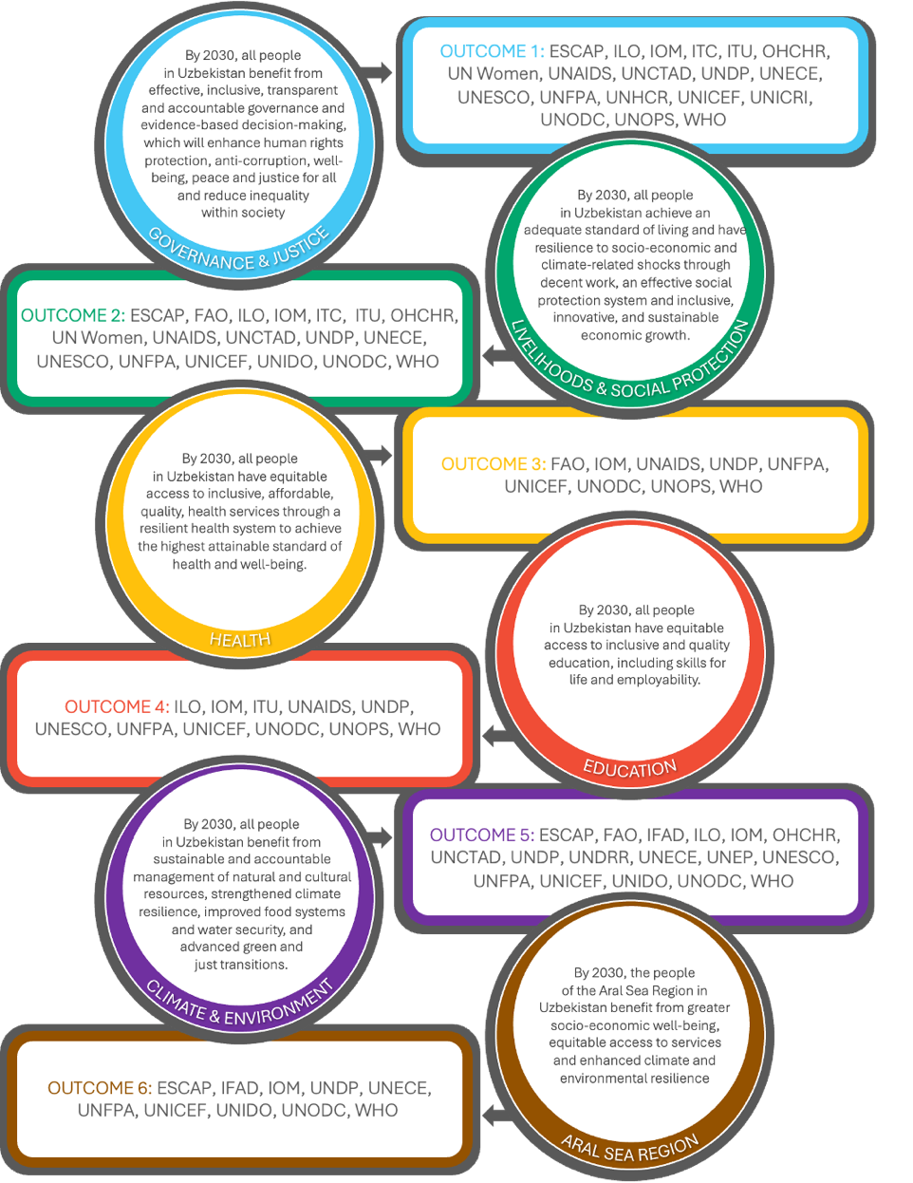

CHAPTER 3: COOPERATION FRAMEWORK IMPLEMENTATION PLAN

3.1. IMPLEMENTATION STRATEGY AND STRATEGIC PARTNERSHIPS
The Cooperation Framework (CF) will be nationally executed under the overall coordination of the Ministry of Economic Development and Poverty Reduction. Government coordinating authorities for specific UN system agency programmes are noted in the Legal Annex. Government Ministries, NGOs, INGOs and UN system agencies will implement programme activities. The Cooperation Framework will be made operational through the development of joint work plan(s) (JWPs) and/or agency-specific work plans and project documents as necessary which describe the specific results to be achieved and will form an agreement between the UN system agencies and each implementing partner as necessary on the use of resources. To the extent possible the UN system agencies and partners will use the minimum documents necessary, namely the signed Cooperation Framework and signed joint or agency-specific work plans and project documents to implement programmatic initiatives. However, as necessary and appropriate, project documents can be prepared using, inter alia, the relevant text from the Cooperation Framework and joint or agency-specific work plans and / or project documents.
The UN will facilitate strategic engagement within and between a wide range of partners from the Government and non-government actors at national and sub-national levels to ensure effective implementation of the CF. Partnerships are required: (a) within the UN family to maximize synergies from multiple UN agencies working with the same sectors, government entities and partners; (b) among development partners to avoid duplication, minimize gaps and provide a coordinated development response to government; and (c) between all development partners and the Government, sharing clear and unified development priorities aligned to national SDGs.
GOVERNMENT: The UN will work with closely with national, regional and local government in Uzbekistan. The UN will support the national SDG Coordination Council, a government-led mechanisms responsible for the coordination, implementation and monitoring of the national SDGs and the national Parliamentary Commission on SDGs.
At the sectoral level, the UN will work with relevant line ministries in areas such as health, social protection, labour market reforms, environment, human rights, gender equality, advancing modernization of governance and public administration and digital transformation, as well as facilitating government engagement in related results groups and “issue-based coalitions.”
CIVIL SOCIETY, MEDIA AND ACADEMIA: The UN County Team will promote and support genuine civic space, including for media and academia, at both national and sub-national levels. Considering the vital role they play in ensuring SDG progress and leaving no one behind, the UN will work to build the capacities of individuals and civil society, particularly women and vulnerable groups, for evidence-based dialogue and advocacy; foster participation and social accountability, especially with youth; and protect civic space through UN advocacy with government as well as support for safe digital activism, in line with the country’s digitalization ambitions.
PRIVATE SECTOR: The UN is well positioned to present a strong business case for the domestic private sector to align their activities to Agenda 2030 and hence, accelerate achievement of the national SDGs. With ongoing reforms and policy measures to create enabling conditions for the private sector there are significant opportunities to engage with private sector organizations, especially in the areas of sustainability, civic space, human rights, gender equality, labour rights, and human capital development. In addition to partnering with a coalition of business champions for the SDGs and promoting UN business principles, the UN will also explore community investment initiatives with local and international private sector actors. All partnerships with private sector actors will be subject to UN due diligence and vetting procedures.
DEVELOPMENT PARTNERS: The UN will work to further scale and deepen partnerships with development partners, including international financial institutions (IFIs), in support to the 2030 Agenda. In addition to the UN’s ongoing development partner mapping and sectoral coordination efforts, the UNCT will systematically engage with and support national coordination mechanisms (e.g. the proposed Country Platform) to enable a deeper understanding of possible gaps, duplication, and opportunities for greater synergies. The UN will also continue its practice of sharing key messages, assessments, lesson learned with interested development partners on topics and themes of mutual interest, to reinforce advocacy impact and coherence.
REGIONAL PARTNERSHIPS
Uzbekistan is a participating State of the United Nations Special Programme for the Economies of Central Asia (SPECA) on such issues as water, energy, environment, sustainable transport, transit and connectivity, trade, statistics, knowledge-based development and gender, drawing as required on the UN Regional Economic Commissions (UNECE and ESCAP) for sub-regional policy analysis, data and advisory services.
Implementation of the CF will benefit from the regional UN Sustainable Development Group including the issue-based coalitions, and the technical expertise of sub-regional UN offices in Central Asia (IOM, UNHCR, UNODC, UNFPA, OHCHR). The CF will also benefit from the co-location of the UN regional development coordination office in Turkey with the regional offices for Europe and Central Asia of FAO, UNDP, UNFPA, UNV, and UN Women.
The UN Regional Centre for Preventive Diplomacy for Central Asia (UNRCCA), as a special political mission, will support the UN development system in generating political will and trust among different interlocutors to support a coherent and coordinated approach on promoting peace and prosperity in the region.
Box 11. Delivering tangible results for the people of Uzbekistan with the return of stolen assets
The Ishonch Fund, also known as the Uzbekistan Vision 2030 Fund, was established in 2022 under an agreement between the Swiss Confederation and the Government of Uzbekistan on the return of illegally acquired assets forfeited in Switzerland. It supports principled, transparent, and effective asset restitution through programmes aligned with the national reform agenda and the SDGs. The Fund is not an Official Development Assistance (ODA) instrument as it is financed by repatriated assets of the people of Uzbekistan. Those assets are dedicated to transparent and transformative use for the benefit of the people of Uzbekistan.
The Fund invests these assets strategically to accelerate national SDG achievement, with current priorities focused on sustainable improvements in health and education, implemented by the UN or the World Bank in partnership with the Government of Uzbekistan.

3.2. GOVERNANCE

To support national ownership, the following governance and coordination structures () are established to operationalize the CF and ensure that coherent delivery by the UN System, in line with the UN Management and Accountability Framework (MAF).
JOINT STEERING COMMITTEE
The Joint Steering Committee provides the strategic direction and oversight of the CF, including: ensuring alignment with national, regional and international development processes, mechanisms and goals including Voluntary National Reviews; monitoring implementation progress, challenges and opportunities; and supporting resource mobilization and development finance opportunities.
The Joint Steering Committee is co-chaired by the Deputy Prime Minister - Minister of Economy and Finance of the Republic of Uzbekistan on behalf of the Government of Uzbekistan and the UN Resident Coordinator (RC) on behalf of the UN. Its membership includes the UNCT and key national partners, including representatives of civil society, as agreed between the UN and Government. The Joint Steering Committee conducts a review at least once a year to review the UN Country Results Report and updated Common Country Analysis (CCA), assess implementation of the Joint Work Plans, and agree on any amendments.
UN COUNTRY TEAM (UNCT)
The UNCT consists of all UN entities delivering results under the CF. It is the main interagency mechanism in country for inter-agency coordination and decision-making. UNCT members actively support the RC within the context of the CF results framework, including in policy and technical support, and normative standards and human rights (including advocacy), as appropriate and within available means to achieve agreed UNCT results, and in analysis, planning, tracking and reporting processes, information management, communication and advocacy in the context of CF implementation and in support of the 2030 Agenda. UNCT members have two interrelated sets of accountabilities: firstly, to their respective entities on individual mandates and secondly, to the RC for results as defined in the CF and other inter-agency agreements of the UNCT.
FIGURE 8. CF GOVERNANCE AND COORDINATION MECHANISM (2026-2030)
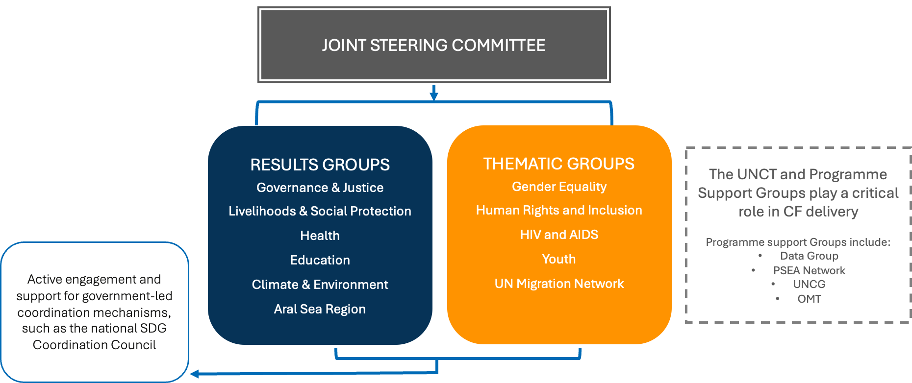

The results, thematic and programme support groups described below are accountable to the RC/UNCT to deliver on responsibilities as set out in their Terms of Reference, and to report on progress in executing their annual plans. These groups will actively engage regionally based United Nations entities to ensure they can participate in and contribute actively to the coordination and delivery of the CF results.
UN RESULTS GROUPS
Results Groups will provisionally be established for each of the six outcomes of the CF and comprise all UN entities, and in line with the UNSDG Common Minimum Standards for Multi-Stakeholder Partnerships will incorporate stakeholders from government, civil society, youth, academia, and other international development partners. Results Groups are co-chaired at Heads of Agency level and by a relevant national counterpart from government.
Their prime responsibilities are to develop UN joint work plans to operationalize the CF, identify opportunities for closer inter-agency collaboration (e.g. through joint programmes), collectively monitor and report on progress towards joint outputs, and provide periodic inputs to update the UN CCA. In addition, results groups will ensure a coordinated approach to capacity assessments of relevant stakeholders. Results Groups may be complemented by UN-led sectoral working groups and task forces, as well as issue-based coalitions.
THEMATIC GROUPS
Five thematic groups will be charged with mainstreaming the CF’s Guiding Principles across the work of the Results Groups and integrating them into all stages of implementation: Gender Theme Group (GTG); Human Rights and Inclusion Theme Group; Joint Task Force on HIV/AIDS; Youth Task Force; and the UN Migration Network, that allows to facilitate effective, timely and coordinated UN system-wide actions addressing migration. A group focused on displacement will convene on an ad hoc basis to address mixed migration situations. Ad-hoc thematic groups, issue-based coalitions, or task forces may be established during the implementation of the CF.
PROGRAMME SUPPORT GROUPS
The Data Group, made up of agency data and statistics experts, focuses on enhancing the coherence of data and statistics across the UN to support the monitoring and reporting of progress against the SDGs. A dedicated group for Monitoring, Evaluation and Learning (MEL) experts will meet on an ad hoc basis, chaired by the data management and results report officer of the RCO.
The Prevention of Sexual Exploitation and Abuse (PSEA) Network is the primary body for coordination and oversight of PSEA activities in line with the PSEA Action Plan and high-level Strategy in Uzbekistan. The network is responsible for implementing coordinated activities between members to minimize the risk of sexual exploitation and abuse by aid workers, ensure effective response when incidents do arise, and raise awareness of PSEA in Uzbekistan. The PSEA Network activities follow a victim-centred approach and will respect the principles of safety, confidentiality, respect and non-discrimination.
The United Nations Joint Communications Group (UNCG) will lead the design of joint UN campaigns on UNCT-agreed advocacy priorities, including Agenda 2030, the Decade of Action, Climate Action and Gender Equality. The UNCG also ensures coherence of messaging on the national SDGs, develops youth engagement campaigns (including through Model United Nations) and supports campaigns on joint UN observances.
The Operations Management Team (OMT) is charged with developing, implementing and reporting on the Business Operations Strategy to ensure and improve efficacy of the UN system’s operations and related priorities. This includes monitoring gender parity across the UNCT Entities as well as monitoring disability inclusion from a human resources perspective.

3.3. JOINT WORK PLANS
The signed CF is implemented through the country programme instruments of the UNCT, which are derived from the CF. UN Results Groups will prepare multi-year Joint Work Plans (JWPs) to reflect CF outputs and key UN contributions delivered jointly or by individual entities, for which UN entities will be accountable to deliver. Beyond accountability, the JWPs should also be used to maximize synergies, reduce fragmentation, prevent duplication, and enhance coherence across the UN system. The JWPs will clearly state available and required resources, indicating any funding gaps. They should reflect the resource contributions of each UN entity. Where Results Groups are aligned with national mechanisms, relevant government ministries may sign on to the joint work plan. The JWPs will be aligned with national SDG development programmes, strategies and plans, while upholding international norms, including through the application of standards outlined in the UN System Wide Action Plan on Gender Equality, the UN Disability Strategy, the UN Youth 2030 Strategy, and other social and environmental standards. The application of the gender equality marker and human rights marker in the JWPs will enhance accountability, coherence and impact in advancing gender equality and human rights across the work of the UNCT. Finally, JWPs will serve as an important joint resource mobilization framework for the CF.
Results Groups will conduct annual reviews of JWPs to inform the UNCT on progress and proposed amendments to outputs and activities required to remain relevant and responsive to emerging needs while maintaining accountability. While CF outcomes are expected to remain stable for the duration of the cycle, outputs and activities are indicative and may need adjustment to remain relevant. The annual review will therefore also enable the UN System to reflect on its capacity to deliver the CF outputs and review the UNCT configuration accordingly. Finally, JWPs will be recorded and digitalized in the global UN INFO online platform for online planning, monitoring and reporting. UN INFO will ensure enhanced transparency and financial and programmatic accountability for results to the government, development partners (including donors), civil society, and most notably, the people of Uzbekistan.

3.4 OPERATIONAL FRAMEWORK
The UN system will support cooperating partners, including non-governmental organizations and civil society groups, through technical knowledge transfers, financial assistance, supplies, commodities and equipment, procurement services, transport, funds for advocacy, research and studies, consultancies, programme development, monitoring and evaluation, training activities, access to information systems, and staff support. Subject to annual reviews, the UN system agencies’ funds will be distributed by calendar year, and by mutual consent between the Government and the UN development system entities funds not earmarked by donors to UN development system agencies for specific activities may be re-allocated to other programmes.
Cash assistance for travel, stipends, honoraria and other costs shall be set at rates commensurate with those applied in the country, but not higher than those applicable to the United Nations system (as stated in the ICSC circulars).

3.4 RESOURCES
The UN system agencies will provide support to the development and implementation of activities within the Cooperation Framework, which may include technical support, cash assistance, supplies, commodities and equipment, procurement services, transport, funds for advocacy, research and studies, consultancies, programme development, monitoring and evaluation, training activities and staff support. Part of the UN system entities’ support may be provided to non-governmental [and civil society] organizations as agreed within the framework of the individual workplans and project documents.
Additional support may include access to UN organization-managed global information systems, the network of the UN system agencies’ country offices and specialized information systems, including rosters of consultants and providers of development services, and access to the support provided by the network of UN specialized agencies, funds and programmes. The UN system agencies shall appoint staff and consultants for programme development, programme support, technical assistance, as well as monitoring and evaluation activities.
Subject to annual reviews and progress in the implementation of the programme, the UN system agencies’ funds are distributed by calendar year and in accordance with the Cooperation Framework. These budgets will be reviewed and further detailed in the workplans and project documents. By mutual consent between the Government and the UN development system entities, funds not earmarked by donors to UN development system agencies for specific activities may be re-allocated to other programmatically equally worthwhile activities.
The Government will support the UN system agencies’ efforts to raise funds required to meet the needs of this Cooperation Framework and will cooperate with the UN system agencies including: encouraging potential donor Governments to make available to the UN system agencies the funds needed to implement unfunded components of the programme; endorsing the UN system agencies’ efforts to raise funds for the programme from other sources, including the private sector both internationally and in Uzbekistan; and by permitting contributions from individuals, corporations and foundations in Uzbekistan to support this programme which will be tax exempt for the Donor, to the maximum extent permissible under applicable law.

Box 12. Harmonized Approach to Cash Transfer (HACT)
The HACT framework represents a common operational (harmonized) framework for transferring cash to government and non-governmental Implementation Partners (IPs), irrespective of whether these partners work with one or multiple United Nation agencies. The objective of the HACT framework is to support a closer alignment of development aid with national priorities and to strengthen national capacities for management and accountability, with the ultimate objective of gradually shifting to national systems. It is understood that ‘harmonized’ in the context of the HACT framework refers to agencies implementing a common operational framework using the same, consistent, standardized approach and tools to manage financial risks in a coordinated fashion.
The Harmonized Cash Transfer (HACT)-specific mechanisms apply only to those UN system agencies that follow HACT procedures.
All cash transfers to an Implementing Partner are based on the Work Plans (WPs) agreed between the Implementing Partner and the UN system agencies.
Cash transfers for activities detailed in work plans (WPs) can be made by the UN system agencies using the following modalities:
1. Cash transferred directly to the Implementing Partner:
a. Prior to the start of activities (direct cash transfer), or
b. After activities have been completed (reimbursement);
2. Direct payment to vendors or third parties for obligations incurred by the Implementing Partners on the basis of requests signed by the designated official of the Implementing Partner;
3. Direct payments to vendors or third parties for obligations incurred by UN system agencies in support of activities agreed with Implementing Partners.
Where cash transfers are made to the State Treasury, the State Treasury shall transfer such cash promptly to the Implementing Partner.
Direct cash transfers shall be requested and released for programme implementation periods not exceeding three months. Reimbursements of previously authorized expenditures shall be requested and released quarterly or after the completion of activities. The UN system agencies shall not be obligated to reimburse expenditure made by the Implementing Partner over and above the authorized amounts.
Following the completion of any activity, any balance of funds shall be refunded or programmed by mutual agreement between the Implementing Partner and the UN system agencies.
Cash transfer modalities, the size of disbursements, and the scope and frequency of assurance activities may depend on the findings of a review of the public financial management capacity in the case of a Government Implementing Partner, and of an assessment of the financial management capacity of the non-UN Implementing Partner. A qualified consultant, such as a public accounting firm, selected by the UN system agencies may conduct such an assessment, in which the Implementing Partner shall participate. The Implementing Partner may participate in the selection of the consultant.
Cash transfer modalities, the size of disbursements, and the scope and frequency of assurance activities may be revised in the course of programme implementation based on the findings of programme monitoring, expenditure monitoring and reporting, and audits.
In case of direct cash transfer or reimbursement, the UN system agencies shall notify the Implementing Partner of the amount approved by the UN system agencies and shall disburse funds to the Implementing Partner in 30 days.
In case of direct payment to vendors or third parties for obligations incurred by the Implementing Partners on the basis of requests signed by the designated official of the Implementing Partner; or to vendors or third parties for obligations incurred by the UN system agencies in support of activities agreed with Implementing Partners, the UN system agencies shall proceed with the payment within 30 days.
The UN system agencies shall not have any direct liability under the contractual arrangements concluded between the Implementing Partner and a third party vendor.
Where the UN system agencies and other UN system agency provide cash to the same Implementing Partner, programme monitoring, financial monitoring and auditing will be undertaken jointly or coordinated with those UN system agencies.
A standard Fund Authorization and Certificate of Expenditures (FACE) report, reflecting the activity lines of the work plan (WP), will be used by Implementing Partners to request the release of funds, or to secure the agreement that the UN system Agency (UNDP, UNICEF or UNFPA) will reimburse or directly pay for planned expenditure. The Implementing Partners will use the FACE to report on the utilization of cash received. The Implementing Partner shall identify the designated official(s) authorized to provide the account details, request and certify the use of cash. The FACE will be certified by the designated official(s) of the Implementing Partner.
Cash transferred to Implementing Partners should be spent for the purpose of activities and within the timeframe as agreed in the work plans (WPs) only.
Cash received by the Government and national NGO Implementing Partners shall be used in accordance with established national regulations, policies and procedures consistent with international standards, in particular ensuring that cash is expended for activities as agreed in the work plans (WPs), and ensuring that reports on the utilization of all received cash are submitted to [UN organization] within six months after receipt of the funds. Where any of the national regulations, policies and procedures are not consistent with international standards, the UN system agency financial and other related rules and system agency regulations, policies and procedures will apply.
In the case of international NGO/CSO and IGO Implementing Partners cash received shall be used in accordance with international standards in particular ensuring that cash is expended for activities as agreed in the work plans (WPs), and ensuring that reports on the full utilization of all received cash are submitted to the UN system Agency (UNDP, UNICEF or UNFPA) within six months after receipt of the funds.
To facilitate scheduled and special audits, each Implementing Partner receiving cash from a UN system Agency (UNDP, UNICEF or UNFPA) will provide UN system agency or its representative with timely access to:
- all financial records which establish the transactional record of the cash transfers provided by the UN system Agency (UNDP, UNICEF or UNFPA) together with relevant documentation;
- all relevant documentation and personnel associated with the functioning of the Implementing Partner’s internal control structure through which the cash transfers have passed.
The findings of each audit will be reported to the Implementing Partner and [UN organization]. Each Implementing Partner will furthermore:
- Receive and review the audit report issued by the auditors.
- Provide a timely statement of the acceptance or rejection of any audit recommendation to the UN system Agency (UNDP, UNICEF or UNFPA) that provided cash and to the SAI, so that the auditors include these statements in their final audit report before submitting it to the UN System Agency (UNDP, UNICEF, or UNFPA).
- Undertake timely actions to address the accepted audit recommendations.
Report on the actions taken to implement accepted recommendations to the UN system agencies (and where the SAI has been identified to conduct the audits, and to the SAI), on a quarterly basis (or as locally agreed).
The audits will be commissioned by the UN system agencies and undertaken by private audit services.

CHAPTER 4: MONITORING AND EVALUATION PLAN

4.1. MONITORING PLAN
The national SDG indicator framework, aligned with the global SDG indicators, is the basis for establishing the Cooperation Framework (CF) outcome indicators. The indicators at Tier I for which metadata and data are available and at Tier II for which metadata are available but not collected will be used to establish key performance indicators, baselines, and targets. Given that the outcome indicators are drawn from the national SDG indicator framework, the outcome performance monitoring will be conducted in close coordination with the inter-agency working group on national SDG indicators set up by government under the Roadmap for national SDG implementation. To measure UN contribution to the implementation of outcomes, agencies report on output indicators aligned with the UN’s global output indicator framework.
Data collection instruments and sources expected to be used for measuring progress at outcome level will include UN Common Country Analysis, government-commissioned data generation activities (including census, surveys, the SDG Voluntary National Reviews), national reports to Human Rights mechanisms (Treaty Bodies, UPR, updates on follow up to the recommendations of the Special Rapporteurs that visited the country), recommendations and concluding observations of the UN Treaty Bodies, UPR Working Group reports and reports of the UN Special Rapporteurs, and other assessments done by UN agencies and partners.
Monitoring of the CF will take place throughout the entire implementation phase and serve as an action-learning process to ensure continuous testing, learning, and adaption. To this end, the MEL experts, in coordination with the Results Groups, will actively track progress towards planned results, monitor changes, and identify emerging opportunities and risks. Refinements and adjustments will be made iteratively based on learning gained through analysis, evaluations and other sources of evidence and data collection.
Key mechanisms for CF monitoring will include:
- CF Annual Review and reporting, including through the UNINFO data portal.
- UN entity monitoring and evaluation activities.
- UN entities’ joint monitoring of joint programmes and projects.
- Quarterly meetings of the Results Groups, with engagement of MEL experts.
A yearly UN Country Results Report will be submitted to the Joint Steering Committee. The report will focus on the progress in achieving the CF’s priorities, outcomes, and outputs, through collection and analysis of data by the agency MEL experts using UNINFO and Results Groups. Furthermore, it will examine new opportunities or changes in the external context that might require expansion or contraction of the UN’s priorities/programmes. It will also assess the overall implementation quality, operational delivery, resource mobilization performance, and partnerships that are critical for CF delivery.
The Joint Steering Committee will convene an annual review meeting at which the UN Resident Coordinator, on behalf of the UNCT, will present the Country Results Report to government and stakeholders. The annual review meeting can be extended to invite representatives of development partners, civil society, and youth to ensure the widest possible engagement the joint UN and government cooperation for development. During the review, the Joint Steering Committee co-chairs will determine if formal revisions of the CF are required and recommend changes to be made.
The Common Country Analysis (CCA) will be updated yearly to feed into the annual review. To this end, the UN Data and Analysis Repository established will provide data and source material for more frequent analytical products. It will combine various UN and open-source analytical resources that will be regularly updated and made available online. The UNCT Data and Analysis Repository will also include SDG data.

4.2. EVALUATION PLAN
An independent evaluation, which contributes to system-wide oversight, transparency, accountability, and collective learning, should be completed in the penultimate year of the CF. The evaluation will adhere to the United Nations Evaluation Group (UNEG) Norms and Standards and aim to reflect the evaluation indicators in the Funding Compact, the UN-SWAP and the United Nation Disability Inclusion Strategy. Linkages should be made with individual and joint UN agency-level evaluations as well as National Voluntary Reviews of SDGs to maximize complementarities. Moreover, using the UN CCA as a benchmark, the evaluation should also assess whether expected results were achieved, if other unintended results are observed, and whether the CF made a worthwhile, coherent, durable, and cost-efficient contribution to national development priorities.
The evaluation will be conducted in an inclusive manner and promote national ownership through meaningful engagement of national partners (including the Government, civil society, youth) and other development partners (including IFIs). Based on the findings and recommendations, an evaluation management response and action plan will be prepared by the UNCT. The final evaluation will be publicly disclosed and inform the visioning exercise, theories of change, and the strategic prioritization of subsequent CFs.

4.3. LEARNING
Learning is the process of generating evidence and making available information from monitoring, evaluation and knowledge generation for its further use to continuously improve the ability of the UN and national partners to achieve results. Together Monitoring, Evaluation and Learning (MEL) provides critical information for the UN’s work with the target populations, partners, and stakeholders. Studies, data collection, content and communication activities and evaluations documenting impact and outcome-level change provide the foundation for the CF’s MEL strategy. Lessons learned, findings and recommendations that come from the MEL activities will be captured by MEL experts across the agencies, funds and programmes, under the guidance of the data management and results report officer of the RCO. These lessons and recommendations will be shared with the Results Groups to inform their work integrated into the UN’s advocacy, communication and visibility work under the CF.

4.4. MEL REQUIREMENTS FOR IMPLEMENTING PARTNERS
Implementing Partners agree to cooperate with the UN system agencies for monitoring all activities supported by cash transfers and will facilitate access to relevant financial records and personnel responsible for the administration of cash provided by the UN system agencies. To that effect,
Implementing Partners agree to the following:
1. Periodic on-site reviews and spot checks of their financial records by the UN system agencies or their representatives, as appropriate, and as described in specific clauses of their engagement documents/ contracts with the UN system agencies’
2. Programmatic monitoring of activities following the UN system agencies’ standards and guidance for site visits and field monitoring,
3. Special or scheduled audits. Each UN organization, in collaboration with other UN system agencies (where so desired and in consultation with the respective coordinating Ministry) will establish an annual audit plan, giving priority to audits of Implementing Partners with large amounts of cash assistance provided by the UN system agencies, and those whose financial management capacity needs strengthening.

4.3. RESULTS FRAMEWORK
Main Overarching Priority: By 2030, Uzbekistan leverages its demographic dividend and implements ambitious reforms, ensuring that all people* in Uzbekistan can develop their potential and benefit from enhanced wellbeing, capabilities, and opportunities in a healthy, sustainable environment.
* As elaborated in chapter 2 (figure 5), the CF is designed to benefit all people in Uzbekistan, especially women and the most vulnerable. In targeting support for those at most risk of being left behind, the CF considers sex, age, disability, HIV status, inequalities related to GBV, geographic location, and other vulnerabilities. To avoid repetition, the use of “all people in Uzbekistan” is understood throughout the CF to be inclusive of women and these vulnerable groups.
NB – Certain indicators lack baseline data disaggregated by sex. The UN will be supporting the Government on statistics under the CF, which will help address many of these data gaps. Several targets are also missing, as they have yet to be set by Government.
GOVERNANCE AND RULE OF LAW
Impact
National development priorities:
Areas 4 and 5 of the Uzbekistan 2030 Strategy on “Ensuring Rule of Law, organization of public administration oriented to serve people” and “Consistent reforms continuity based on principle of “secure and peaceful state,” respectively.
SDGs and SDG targets:
SDG 16: Peace, justice and strong institutions (16.1; 16.2; 16.3; 16.4; 16.5; 16.6; 16.7; 16.8; 16.10; 16.a; 16.b)
SDG 5: Gender Equality
SDG 10: Reduced inequalities
Results | National SDG indicators/Performance Indicators (disaggregated) | Baseline (year) | Target (duration of CF) | Source/ Means of Verification | Assumption Statement | Partners
Outcome 1.  By 2030, all people in Uzbekistan benefit from effective, inclusive, transparent and accountable governance and evidence-based decision-making, which will enhance human rights protection, anti-corruption, well-being, peace and justice for all and reduce inequality within society | A proportion of the population feel safe walking alone around the area they live in after dark (NSDG 16.1.4.) | 90% (2022) | 92% (2030) | MICS survey  National Statistics Committee | The government remains committed to preventing violence by strengthening legal protections, addressing harmful norms, and ensuring access to justice and support services through reliable data and multi-sectoral collaboration.  Recent legislation enhances the Ombudsperson’s mandate, functions, and resources, strengthening human rights oversight.  The country ensures regular population and housing censuses to support data-driven policymaking.  High-quality, timely, and disaggregated data remains a priority, enhancing transparency, accountability, and evidence-based governance. | Parliament  Children’s Ombudsperson  Presidential Administration  Cabinet of Ministers  Ministry of Internal Affairs  Ministry of Justice,  General Prosecutor’s Office  Supreme Court  Agency for Strategic Reforms  Agency of Information and Mass Communication  Anti-corruption Agency  National Human Rights Center  National Agency for Social Protection  Judiciary  Khokimiyats  Mahallas, local communities and associations  Civil society organisations  Think tanks and academia  Media  Private sector  International Financial Institutions
 | Proportion of population subjected to (a) physical violence, (b) psychological violence and (c) sexual violence in the previous 12 months (NSDG 16.1.3) | a) Physical violence: 29% of children 1-14  b) psychological violence: 60% of children 1-14 (2021)  c) 0.60 per 100,000 persons (2021) sexual violence: rape and 0.53 per 100,000 persons (2021) sexual violence: sexual assault | a) Physical violence: 20% of children 1-14  b) psychological violence: 50% of children 1-14 (2030)  c) TBD | MICS survey  UNODC data portal
 | Availability of national human rights institutions, duly accredited in international mechanisms in accordance with the Paris Principles (NSDG 16.а.1.) | Yes (2024-B status) | Yes (2030-A status) | GANHRI accreditation  status of Ombudsperson
 | Have conducted at least one population and housing census in the last 10 years (NSDG 17.19.2.) | No (2025) | Yes (2030) | National Statistics Committee
 | E-Government Development Index | 63 (2024) | 30 (2030) | UNDESA
 | World Governance Indicators (Voice and Accountability, Government Effectiveness, Rule of Law Indices) | 12.25; 40.09; 23.11 (2023) | 20; 54; 38 (2030) | The Worldwide Governance Indicators by the World Bank
 | Statistical capacity indicator (statistical capacity index) for Sustainable Development Goal monitoring / rank among countries (NSDG 17.18.1) | 72.8/78 (2023) | 90-95/TBD (2030) | World Bank
Output 1.1: Strengthened, responsive national and local governance systems that leverage data-driven decision making to serve all people with a long-term impact.
Output 1.2: Increased civil society and people’s participation in decision making for improved public oversight.
Output 1.3: Enhanced rule of law, security and justice institutions for inclusive, gender-responsive and child-friendly justice; strengthened social cohesion; prevention of and response to all forms of violence, abuse crimes and conflicts, and legal aid for all.
LIVELIHOODS AND SOCIAL PROTECTION
Impact
National development priorities: The Uzbekistan 2030 Strategy sets ambitious goals of reducing poverty by 2026 by 2 times compared to 2022, substantial reduction of poverty by 2030, as well as achieving full coverage of all persons in need by the social protection system.
SDGs and SDG targets:
SDG1: No poverty (1.1; 1.2; 1.3; 1.4; 1.5; 1.a; 1.b)
SDG 5: Gender Equality
SDG8: Decent work and economic growth (8.1; 8.2; 8.3; 8.4; 8.5; 8.6; 8.7; 8.8; 8.9; 8.10; 8.b)
SDG10: Reduced inequalities (10.1; 10.2; 10.3; 10.4; 10.7)
Results | National SDG indicators/ Performance Indicators (disaggregated) | Baseline (year) | Target (duration of CF) | Source/ MoV | Assumption Statement | Partners
Outcome 2.  By 2030, all people in Uzbekistan achieve an adequate standard of living and have resilience to socio-economic and climate-related shocks through decent work, an effective social protection system and inclusive, innovative, and sustainable economic growth | Proportion of population living below the national poverty line, by sex and age (NSDG 1.2.1.) | 8.9% (2024) | 5% | National Statistics Committee nsdg.stat.uz | The Government continues economic transformation and structural reforms aimed at elevating the country to the upper middle-income status, substantially reducing poverty and improving the system of social protection.  Creating decent and productive jobs, especially for young people, women, and people with disabilities, formalizing jobs and fostering private sector development will remain priority in the economic reform agenda.  The government will continue to focus in equitable and sustainable development of the territories of Uzbekistan, improving livelihood and income opportunities in the regions, urban and rural areas of the country. | Ministry of Economy and Finance  Ministry of Poverty Reduction and Employment  Ministry of Digital Technologies  Ministry of Agriculture  Ministry of investment, Industry and Trade  National Agency for Social Protection  Migration Agency  Agency for Cultural Heritage  Youth Affairs Agency  Ombudspersons office  Tourism Committee  Committee for Family and Women  Committee for Religious Affairs  Respective Senate Committees  Rehabilitation and  Adaptation Center for Women  National Human rights Centre  Central bank and commercial banks  Federation of Trade Unions  Confederation of Employers  Chamber of Commerce and Industry  Association of Mahallas  Khokimiyats  Religious leaders  Mono Centres Women’s business associations  Hunarmand Craft associations  Academia and universities  Civil society organisations  Association for NGOs  Association for Persons with Disabilities  World Bank, IFC, IMF, ADB, EBRD, IsDB, EU
 | Proportion of men, women and children of all ages living in poverty in all its dimensions according to national definitions (NSDG 1.2.2.) | 18% (national Multidimensional poverty) I, 44.7% MODA (child multidimensional poverty) (2023) | 5% | National Statistics Committee nsdg.stat.uz
 | Spending on social protection as a share of GDP | 7% (2023) | TBD | ILO, https://www.social-protection.org/gimi/ShowCountryProfile.action?iso=UZ
 | Proportion of population covered by social protection floors/systems, by sex, distinguishing children, unemployed persons, older persons, persons with disabilities, pregnant women, newborns, work-injury victims and the poor and the vulnerable (global SDG indicator 1.3.1) | 56% (2022) | TBD | ILO World Social Protection Report
 | Proportion of informal employment in total employment, by sector and sex (NSDG 8.3.1.) | Total: 39% (2023)  Men: 33.1% (2023)  Women: 47.1% (2023)  Agriculture: 60.8% (2023)  Non-agriculture: 31.5% (2023) | TBD | National Statistics Committee nsdg.stat.uz
 | Percentage of the difference between the average monthly wage of male and female employees to the average monthly wage of male (NSDG 8.5.1) | 29.6% (2023) | TBD | National Statistics Committee nsdg.stat.uz
 | Proportion of youth (aged 16 to 24 years) not in education, employment or training (NSDG 8.6.1) | 23.8% (2023) | TBD | National Statistics Committee nsdg.stat.uz
 | Uneven distribution of incomes of the population (Gini coefficient) | 0.288 (2023) | TBD | National Statistics Committee
Output 2.1: Increased capacity of the social protection system to deliver quality, inclusive, and gender-responsive social protection benefits and social services throughout a life course at the national and local levels with a focus on the most vulnerable groups
Output 2.2: Enhanced capacity of stakeholders to generate decent employment opportunities, foster an enabling environment for entrepreneurship, innovation and diversify income-generating opportunities with a focus on women, youth and people with disabilities
Output 2.3: Strengthened capacity of local and national government to reduce territorial disparities and multidimensional poverty.

HEALTH
Impact
National development priorities: Areas 1.2 ”Reforms to Ensure Population Health” of Uzbekistan 2030 Strategy
SDGs and SDG targets:
SDG 3: Good health and well-being (3.1; 3.2; 3.3; 3.4; 3.5; 3.6; 3.7; 3.8; 3.9; 3.a; 3.b; 3.c; 3.d)
SDG 5: Gender Equality
SDG 10: Reduced inequalities
Results | National SDG indicators/Performance Indicators (disaggregated) | Baseline (year) | Target (duration of CF) | Source/ MoV | Assumption Statement | Partners
Outcome 3  (key institutional change)  By 2030, all people in Uzbekistan have equitable access to inclusive, affordable, quality, health services through a resilient health system to achieve the highest attainable standard of health and well-being | Maternal mortality ratio per 100,000 live births (NSDG 3.1.1) | 15.9 (2023) | 8 (2030) | National Statistics Committee | Sustained government commitment to health sector reforms, strong stakeholder collaboration, and adequate resources to expand equitable, high-quality healthcare.  Effective implementation of health interventions and social protection measures to reduce out-of-pocket costs, with no major disruptions hindering progress toward universal health coverage and improved outcomes for all, including vulnerable groups. | Ministry of Health  Ministry of Economy and Finance  Ministry of Ecology, Environmental Protection and Climate Change  Ministry of Pre-school and School Education Ministry of Higher Education, Science and Innovation  Ministry of Agriculture  Ministry of Water Resources  Ministry of Internal Affairs  Ministry of Emergency Situations  Migration Agency  Committee of Sanitary and Epidemiological Wellbeing and Public Health  Center for Pharmaceutical Products Safety  National Information-Analytical Center on Drug Control  Republican Specialized Scientific and Practical Medical Center for Mental Health  Republican Center to Fight AIDS  Research Institute of Virology of the Republican specialized scientific practical medical centre of epidemiology, microbiology, infections and parasitic diseases  Association of Mahallas  Civil society organizations Academia  CDC, GIZ, KfW, ADB, WB, ISDB, AIIB.
 | Under‑5 mortality rate per 1,000 live births (NSDG 3.2.1) | 12.3 (2023) | TBD | National Statistics Committee
 | Proportion of women of reproductive age (aged 15–49 years) who have their need for family planning satisfied with modern methods.  - Urban  - Rural (NSDG 3.7.1) | Total: 80.8% (2022)  a) 79.5% (2022)  b) 81.8% (2022) | 90 (2030)  TBD | National Statistics Committee
 | The proportion of population with large household expenditures on health as a share of total household expenditure  a) more than 10% of expenses;  b) more than 25% of expenses (NSDG 3.8.2) | a) 9.8 (2023)  b) 2.1 (2023) | TBD | National Statistics Committee
 | Mortality rate attributed to cardiovascular disease, cancer, diabetes or chronic respiratory disease (NSDG 3.4.1) | 364.2 (2023) | TBD | National Statistics Committee
 | Percentage of preventable maternal deaths | 74.6% (CEMD 2021-2022) | 40% (2030) | National Statistics Committee UNFPA CEMD report
Output 3.1: Enhanced, evidence-based and inclusive health governance and policy development ensuring greater efficiency, accountability, and informed decision-making.
Output 3.2: Strengthened capacities of the health system to deliver quality, people-centred services across the life course at all levels, aligned with the primary healthcare approach.
Output 3.3: Empowered communities, individuals, and civil society are equipped to demand equitable, timely, and informed access to health services while addressing the broader determinants of health.
EDUCATION
Impact
National development priorities:
The “Uzbekistan – 2030” Strategy : Raising the preschool education system to a new level and ensuring full coverage of children; raising the general secondary education system to a new level; raising the status of teaching staff, developing their knowledge and qualifications in accordance with international standards; broad involvement of the private sector in the development of general secondary education; teaching students modern knowledge and skills through the development of a vocational education system; expanding coverage of higher education, improving the quality of training specialists
SDGs and SDG targets:
SDG 4: Quality education (4.1; 4.3; 4.5; 4.7; 4.c)
SDG 5: Gender equality
SDG 8: Decent work and economic growth
SDG 10: Reduced inequalities
Results | National SDG indicators/Performance Indicators (disaggregated) | Baseline (year) | Target (duration of CF) | Source/ MoV | Assumption Statement | Partners
Outcome 4  (key institutional change)  By 2030, all people in Uzbekistan have equitable access to inclusive, quality education, including skills for life and employability. | Completion rate (primary education, lower secondary education, upper secondary education) (NSDG 4.1.2.) | TBD | TBD | Education Management information system (EMIS)  National Statistics Committee | The government ensures its commitment to education reform and sustained funding for universal educational access and quality learning. | Ministry of Pre-school and School Education  Ministry of Higher Education, Science and Innovation  Ministry of Employment and Poverty Reduction  Ministry of Support of the Mahalla and the Older Generation  Ministry of Digital Technologies  National Agency of Social Protection Center for Educational Projects  Republican Scientific and Methodological Center for the Development of Education  Chamber of Commerce and Industry  Federation of Trade Unions  Sector Skills Councils  Private sector  Academia  International Development Partners, including IFC, EBRD, ADB, ISDB, and the World Bank
 | Percentage improvement in students’ attainment to at least Level 2 proficiency in mathematics, reading and science (PISA) | 19% Mathematics  14% Reading  19% Science | +5% from baseline | International Standardized Tests (EGRA, PISA, etc.)
 | Net early childhood education enrolment ratio in (a) pre-primary education and (b) early childhood educational development (adapted from NSDG 4.1.2.1) | Total: 71.1%  Boys: 78.8%  Girls: 62.6% | Total: 80%  Boys: 80.8% (+2pp.)  Girls: 69.6% (+7pp) | Education Management information system (EMIS)  National Statistics Committee
 | Proportion of youth (aged 16 to 24 years) not in education, employment or training (NSDG 8.6.1) | 23.8% (2023) | TBD | National Statistics Committee nsdg.stat.uz
Output 4.1: More inclusive, equitable, and competency-based teaching and learning environments in preschool and general secondary education.
Output 4.2: Expanded opportunities for all people–especially for youth, adolescent girls, women, and marginalized groups–to gain new and innovative skills, aligned with evolving labour market needs and ensuring lifelong learning

CLIMATE CHANGE AND ENVIRONMENT
Impact
National development priorities:
Uzbekistan 2030 Strategy Area 3: Conservation of water resources and environmental protection
Water conservation reforms (rational and efficient water use, improved irrigation systems and water saving-technologies, introduction of green energy technologies);
Environmental reforms (Yashil Makon project, expansion of forest area, climate change mitigation and adaptation, biodiversity conservation, waste management, abatement of air pollution)
SDGs and SDG targets:
SDG 2: Zero hunger (2.3; 2.4; 2.a; 2.c)
SDG 5: Gender Equality
SDG 6: Clean water and sanitation (6.1; 6.5)
SDG 7: Affordable and clean energy (7.2)
SDG 10: Reduced inequalities
SDG 11: Sustainable cities and communities (Enhancing living standards supports resilient and inclusive communities)
SDG 12: Responsible consumption and production (12.4; 12.5; 12.7; 12.8; 12.b; 12.c)
SDG 13: Climate action (13.2; 13.3)
SDG 15: Life on land (15.1; 15.9)
Results | National SDG indicators/Performance Indicators (disaggregated) | Baseline (year) | Target (duration of CF) | Source/ MoV | Assumption Statement | Partners
Outcome 5  By 2030, all people in Uzbekistan benefit from sustainable and accountable management of natural and cultural resources, strengthened climate resilience, improved food systems and water security, and green and just transitions. | Proportion of electricity generated from renewable energy sources in total electricity production (NSDG 7.2.1) | 16% (2024) | 30% (2030) | National SDG Report  Green Economy Portal  Agencies’ reports | The government remains committed to water conservation, environmental protection, and green energy under the Uzbekistan 2030 Strategy, advancing irrigation efficiency and climate resilience.  Environmental reforms, including Yashil Makon, forest expansion, and pollution control, support biodiversity, waste management, and climate adaptation.  The transition to clean, affordable energy aligns with national demand and strengthens climate resilience.  National agencies sustain efforts to implement international environmental agreements, integrating biodiversity conservation into policies.  The government continues fostering agricultural innovation, promoting advanced crop varieties and technologies for higher productivity.  Commitment to Integrated Water Resources Management (IWRM) ensures progress in policy, institutions, management tools, and financing.  The government and communities remain engaged in afforestation and forest development initiatives, reinforcing climate and environmental goals. | Parliament  Ministry of Agriculture  Ministry of Water Resources  Ministry of Health  Ministry of Ecology, Environmental Protection and Climate Change  Ministry of Culture Agency for Cultural Heritage  Forestry Agency  Uzhydromet  Ministry of Economy and Finance  Federation of Trade Unions  Confederation of Employers  Civil society organisations  Academia  Private Sector  Media  Young people  International Development Partners
 | Number of national, sectoral and regional strategies and programs that take into account the value and conservation of biodiversity and ecosystems (NSDG 15.9.1.1) | 19 (2024) | TBD (2030) | Agencies report
 | Productivity of major agricultural crops by farm category (NSDG 2.3.1.1) | Average total yield by farm category, ton/ha:  - Wheat - 4.1  - Maize - 4.9,  - Rice - 2.8,  - Potatoes -22.5,  - Vegetables - 23.7,  - Fruits - 12.2  - Grape – 15.7  - Melons and watermelons – 18.9 | Average total yield by farm category, ton/ha:  - Wheat - 10.0  - Maize - TBD,  - Rice - 5.5,  - Potatoes -22.2,  - Vegetables - 29.5,  - Fruits - 15.0,  - Grape – 18.0  - Melons and watermelons – 19.0 | Strategy for Ensuring Food Security and Healthy Nutrition in the Republic of Uzbekistan until 2030 (#PF-36 dated 16.02.2024),  Ministry of Agriculture  Statistics Agency under the President of the Republic of Uzbekistan  FAOSTAT
 | Degree of integrated water resources management (NSDG 6.5.1) | 66 (2024) | TBD | National report on tracking progress in implementation of IWRM and SDG indicator 6.5.1.
 | Forest area as a percentage of total land area (NSDG 15.1.1) | 10.6% of the total land area or 3.6 million ha (2023) | 13.78% of total land or 4.68 million ha (a 30 percent increase in the total forest area; 2030) | Agriculture Development Strategy of Uzbekistan 2020-2030  National Statistics Committee (nsdg.stat.uz)  Ministry of Agriculture  Forestry Agency  Uzbek Space Agency  FAO
Output 5.1: Strengthened national and local capacities and enhanced policy and regulatory frameworks for sustainable, integrated management of agrifood systems, cultural and natural resources and biodiversity.
Output 5.2: Innovative, sustainable climate change adaptation and mitigation strategies, along with just energy transition initiatives, are designed and implemented at national and local levels across all sectors.
Output 5.3: Enhanced environmental justice and governance in the sustainable management of chemicals, waste, air quality, drinking water, sanitation and hygiene, food safety, and disaster risks

ARAL SEA
Impact
National development priorities: Uzbekistan is accelerating Karakalpakstan's development with targeted investments, job creation, and improved living standards by 2025. The President has reaffirmed the commitment to transforming the Aral Sea region through strategic implementation. The efforts are focused on unlocking economic and human potential, attracting investments, and enhancing professional skills to boost employment, health, and social resilience.
SDGs and SDG targets:
SDG 1: No poverty (Targeted investments and job creation contribute to poverty reduction)
SDG 3: Good health and well-being (Investments in health and social resilience improve public well-being)
SDG 4: Quality education
SDG 5: Gender Equality
SDG 6: Clean water and sanitation (Addressing environmental challenges in the Aral Sea region supports water security)
SDG 8: Decent work and economic growth (Job creation fosters sustainable economic development)
SDG 10: Reduced inequalities (Efforts to uplift Karakalpakstan help bridge regional disparities)
SDG 11: Sustainable cities and communities (Enhancing living standards supports resilient and inclusive communities)
SDG 13: Climate action (Addressing environmental issues in the Aral Sea region contributes to climate resilience)
SDG 15: Life on land (15.1; 15.9)
SDG 16: Peace, justice and strong institutions
Results | National SDG indicators/ Performance Indicators (disaggregated) | Baseline (year) | Target (duration of CF) | Source/ MoV | Assumption Statement | Partners
Outcome 6  By 2030, the people of the Aral Sea Region in Uzbekistan benefit from greater socio-economic well-being, equitable access to services and enhanced climate and environmental resilience | Proportion of population living below the national poverty line in the Republic of Karakalpakstan (NSDG 1.2.1.) | 13.6% (2023) | TBD | National Statistics Committee | The Aral Sea disaster and Karakalpakstan remain a priority for the government and development partners, ensuring sustained attention and support.  The government remains committed to accelerating Karakalpakstan’s development through targeted investments, job creation, and improved living standards.  The President reaffirms dedication to transforming the Aral Sea region by unlocking economic and human potential, enhancing skills for employment, health, and social resilience. | Ministry of investments, industry and trade of the Republic of Uzbekistan  Ministry of health of the Republic of Uzbekistan  Ministry of health of the Republic of Karakalpakstan  Ministry of economy of the Republic of Uzbekistan  Council of ministers of the Republic of Karakalpakstan  Jogorgi Kenes of the Republic of Karakalpakstan  Ministry of Ecology, climate and environmental protection of the Republic of Uzbekistan  Civil society: Karakalpakstan regional department of association of support to children and families, local NGO
 | Life expectancy at birth in the Republic of Karakalpakstan (years) | 72.7 years (2023) | TBD | National Statistics Committee
 | Maternal mortality ratio per 100,000 live births in the Republic of Karakalpakstan (NSDG 3.1.1) | 27.3 (2023) | TBD | National Statistics Committee
 | Proportion of population using safely managed drinking water services (NSDG 6.1.1) | 99.8% (2023) | TBD | National Statistics Committee
 | Proportion of population using a) sanitation services organized in compliance with safety requirements, b) hand washing facilities with soap and water (NSDG 6.2.1) | a) 96.5% (2023)  b) 99.6% (2023) | TBD | National Statistics Committee
Output 6.1: Enhanced capacity for local governance and service delivery (including health, education, WASH, social protection using evidence-based decision-making to address the specific needs of the Aral Sea Region in Uzbekistan
Output 6.2: Sustainable natural resources management, climate action and environmental restoration in the Aral Sea region
Output 6.3: Strengthened local capacity for community-led initiatives and participation in local decision making for improved public oversight.

LEGAL ANNEX

- Whereas the Government of Uzbekistan (the “Government”) has entered into the agreements listed below with the United Nations, including its Funds, Programmes and other subsidiary organs, and other organizations of the United Nations system (“UN System Organizations”), which are applicable to their programme activities in Uzbekistan (the “UN Agreements”) under the United Nations Sustainable Development Cooperation Framework (the “Cooperation Framework”);
- Whereas the UN Agreements, together with the Convention on the Privileges and Immunities of the United Nations of 13 February 1946 (the “General Convention”) and/or the Convention on the Privileges and Immunities of the Specialized Agencies of 21 November 1947 (the “Specialized Agencies Convention”) as applicable, form the primary existing legal basis for the relationship between the Government and each UN System Organization for supporting the country to deliver on the Cooperation Framework, and are non-exhaustive and without prejudice to any other legal instruments the Government may enter into, including additional agreements with UN System Organizations for the purpose of their activities in the country:
  - With the United Nations Development Programme (UNDP), a basic agreement to govern UNDP’s assistance to the country, which was signed by the Government and UNDP (the “Standard Basic Assistance Agreement” or “SBAA”) on 10 June 1993. This Cooperation Framework, together with a joint results group work plan specifying UNDP programme activities further to this Cooperation Framework (which shall form part of this Cooperation Framework and is incorporated herein by reference), constitute together a “project document” as referred to in the SBAA. The implementing partner and UNDP will sign a project agreement containing the specific arrangements for each project further to the relevant project document.
  - With the United Nations Children’s Fund (UNICEF), a Basic Cooperation Agreement (BCA) concluded between the Government and UNICEF on 19 December 1994. This agreement is grounded in UNICEF’s legal status as a subsidiary organ of the United Nations, enjoying the same privileges and immunities as the UN itself. These include immunity from legal processes and the obligation of member states to facilitate UNICEF’s operations. The BCA defines the scope of UNICEF’s activities in alignment with the host country’s laws and the United Nations Charter, ensuring that UNICEF can operate without hindrance from national legal systems. UNICEF’s governance is overseen by an Executive Board composed of member states, under the broader policy guidance of the UN General Assembly and ECOSOC.
  - With the United Nations Population Fund (UNFPA), the Basic Agreement concluded between the Government and the United Nations Development Programme on 10 June 1993 (the “Basic Agreement”) mutatis mutandis applies to the activities and personnel of UNFPA, in accordance with the agreement [concluded by an exchange of letters] between UNFPA and the Government which entered into force on 7 April 2005. This UNSDCF together with any work plan concluded hereunder, which shall form part of this UNSDCF and is incorporated herein by reference, constitutes the Project Document as referred to in the Basic Agreement.”
  - With the International Labour Organization (ILO), the Convention on the Privileges and Immunities of the Specialized Agencies and its Annex I concerning the ILO concluded between the Government and ILO on 18 February 1997.
  - With the United Nations Industrial Development Organization (UNIDO), the provisions of the Standard Basic Assistance Agreement between the United Nations Development Programme (UNDP) and the Government, signed and entered into force on 10 June 1993, shall be applied, mutatis mutandis, to UNIDO projects and programmes in Uzbekistan.
  - With the Food and Agriculture Organization of the United Nations (FAO), an Agreement for the establishment of the FAO Representation in the Republic of Uzbekistan concluded between the Government of the Republic of Uzbekistan and FAO on 5 June 2014.
  - With the World Health Organization (WHO), a Basic Agreement for the Provision of Technical Advisory Assistance signed by the Government and WHO on 1 December 1994.
  - With the International Organization for Migration (IOM), the Cooperation Agreement between the Government of the Republic of Uzbekistan and the International Organization for Migration on 05.11.2020.
  - With the International Fund for Agricultural Development, during its thirty-fourth session (19-20 February 2011) the Governing Council approved Uzbekistan as a new member of IFAD (List C). IFAD approved the first Result Based Country Strategic Opportunities 2016-2021 for Uzbekistan during the 2017 April session of the Executive Board.
  - The SBAA concluded between the Government and UNDP on 10 June 1993 mutatis mutandis applies to the activities and personnel of UN WOMEN. As of 15 May 2025, the SBAA process has been concluded between the Government of Uzbekistan and UN Women. The provisions of the SBAA signed by UNDP and the government of Uzbekistan on 10 June 1993 (the “Basic Agreement”) mutatis mutandis applies to the activities and personnel of the Joint United Nations Programme on HIV/AIDS (UNAIDS).
  - The United Nations Interregional Crime and Justice Research Institute (UNICRI) and the Government of Uzbekistan signed a Memorandum of Understanding (MoU) on 18 May 2015 for the establishment and functioning of the Chemical, Biological, Radiological and Nuclear (CBRN) Centres of Excellence (CoE) Regional Secretariat for Central Asia in Tashkent, the Republic of Uzbekistan. The MoU was signed within the framework of the EU CBRN CoE initiative.
  - With the United Nations Office on Drugs and Crime (UNODC) operates in Uzbekistan based on the SBAA between the Government of the Republic of Uzbekistan and UNDP, that applies mutatis mutandis, to UNODC. Whereas, UNODC has several agreements at regional level, where Uzbekistan is also signatory, i.e. Memorandum of Understanding (MOU) on Sub-regional Drug Control Cooperation of 1996, there are also several bilateral MOUs signed between UNODC the Government Agencies, i.e. General Prosecutor’s Office.
  - With the United Nations Office for Project Services (UNOPS), the Agreement between the Government of the Republic of Uzbekistan and the United Nations, represented by the United Nations Office for Project Services (UNOPS) concerning the establishment of the UNOPS Office in Tashkent, concluded on 21 September 2023.
  - With the United Nations High Commissioner for Refugees (UNHCR), the SBAA between the Government of the Republic of Uzbekistan and UNDP on 10 June 1993 applies mutatis mutandis to UNHCR.
  - With the United Nations Resident Coordinator’s Office (UN RCO), and other UN System Organizations as applicable, the Agreement between the United Nations and the Government of the Republic of Uzbekistan relating to the establishment of a United Nations Interim Office in Uzbekistan, concluded 4 December 1992, and the SBAA between the Government of the Republic of Uzbekistan and UNDP concluded on 10 June 1993, applies mutatis mutandis.
- With respect to all UN System Organizations: Assistance to the Government shall be made available and shall be furnished and received in accordance with the relevant and applicable resolutions, decisions, rules and procedures of each UN System Organization.
- Without prejudice to the above, the Government shall:
  - apply to each UN System Organization and its property, funds, assets, officials and experts on mission the provisions of the General Convention and/or the Specialized Agencies Convention; and
  - accord to each UN System Organization, its officials and other persons performing services on behalf of that UN System Organization, the privileges, immunities and facilities set out in the UN Agreement applicable to such UN System Organization.
- United Nations Volunteers performing services on behalf of a UN System Organization shall be entitled to the privileges and immunities accorded to officials of such UN System Organization.
- Any privileges, immunities and facilities granted to a UN System Organization under the Cooperation Framework shall be no less favourable than those granted by the Government to any other UN System Organization signatory of the Cooperation Framework.
- Without prejudice to the UN Agreements, the Government shall be responsible for dealing with any claims which may be brought by third parties against any of the UN System Organizations and their officials, experts on mission or other persons performing services on their behalf, and shall hold them harmless in respect of any claims and liabilities resulting from operations under the Cooperation Framework, except where it is mutually agreed by the Government and the relevant UN System Organization(s) that such claims and liabilities arise from gross negligence or misconduct of that UN System Organization, or its officials, or persons performing services.
- Nothing in or relating to this Cooperation Framework shall be deemed:
  - a waiver, express or implied, of the privileges and immunities of any UN System Organization; or
  - the acceptance by any UN System Organization of the jurisdiction of the courts of any country over disputes arising from this Cooperation Framework, whether under the General Convention or the Specialized Agencies Convention, the UN Agreements, or otherwise, and no provisions of this Cooperation Framework shall be interpreted or applied in a manner, or to an extent, that is inconsistent with such privileges and immunities.

United Nations Sustainable Development
Cooperation Framework 2021-2025
Uzbekistan
www.un.uz
Signed: <date>

UNFPA calculations based on detailed single-year age data from the Statistics Committee.
https://nsdg.stat.uz/en/publications/26
https://uzbekistan.un.org/en/288273-common-country-analysis
www.undp.org/sites/g/files/zskgke326/files/2024-03/en_Pilot%20MPI%20report%202023.pdf
This measures the relative importance of these contributors in the overall MPI calculation. For example, a household’s food security status contributes 11.7% to its overall poverty score; it does not mean that 11.7% of people are experiencing food insecurity.
https://doi.org/10.1787/53f23881-en
https://financing.desa.un.org/ffd4/outcome
The UN General Assembly adopted the APoA on 24 December 2024 under resolution A/RES/79/233. For more information, see www.un.org/en/landlocked/awaza-programme-action-lldcs.
To avoid repetition in the outcome statements and enhance readability, the use of “all people in Uzbekistan” is understood throughout the CF to be inclusive of women and all vulnerable groups.
Presidential Decree No. PP-132 identifies the following 16 districts: Kungrad, Chimboy, Asaka, Gijduvan, Gallaorol, Yakkabag, Khatirchi, Chartak, Bulungur, Syrdarya, Denov, Margilan, Shavat, Khazorasp districts. For the full decree, see: https://lex.uz/docs/7463047.
Including through the development and use of quality, accessible, timely and reliable disaggregated data.
Inclusive growth is economic growth that is distributed fairly across society and creates opportunities for all (source: https://www.oecd.org/inclusive-growth/#introduction)
https://www.unhcr.org/centralasia/wp-content/uploads/sites/75/2025/04/Factsheet-Uzbekistan-EN-2025.pdf
TFGBV is a rapidly growing form of abuse that includes cyberstalking, non-consensual image sharing, online harassment, and digital coercion. Addressing TFGBV requires coordinated, multifaceted policy work across legal, social, and technological domains, including enhanced investigative capacities for law enforcement, and improved support mechanisms for survivors.
https://mics.unicef.org/surveys?display=card&f[0]= region:4301&keys=uzbekistan#
This approach focuses on environmental and societal barriers, as well as individuals’ interests, talents and abilities, to facilitate timely identification and needs assessments linked to the provision of effective services and support and improved long-term outcomes for children with disabilities.
The primary health care (PHC) approach refers to “a whole-of-society approach to health that aims at ensuring the highest possible level of health and well-being and their equitable distribution by focusing on people’s needs and as early as possible along the continuum from health promotion and disease prevention to treatment, rehabilitation and palliative care, and as close as feasible to people’s everyday environment.” PHC addresses the broader determinants of health and focuses on the comprehensive and interrelated aspects of physical, mental and social health and wellbeing. For more information, refer to: www.who.int/news-room/fact-sheets/detail/primary-health-care
This approach “aims to sustainably balance and optimize the health of people, animals and ecosystems.” For more information, see: www.who.int/health-topics/one-health.
2024 World Bank Country Gender Assessment Report: Uzbekistan. available at: www.worldbank.org/en/country/uzbekistan/ publication/country-gender-assessment-2024
Safe drinking-water, sanitation and hygiene – referred to as WASH – are “crucial to human health and well-being. Safe WASH is not only a prerequisite to health, but contributes to livelihoods, school attendance and dignity and helps to create resilient communities living in healthy environments.” For more information, refer to: www.who.int/health-topics/water-sanitation-and-hygiene-wash#tab=tab_1.
The resolution "Central Asia in the face of environmental problems: strengthening regional solidarity for sustainable development and prosperity" was unanimously passed by the UN General Assembly on December 19, 2023.
e.g. CEDAW, CSW, Beijing Declaration and Platform for Action.
These include including the Paris Agreement, Addis Ababa Action Agenda, the United Nations Framework Convention on Climate Change, the Sendai Framework for Disaster Risk Reduction, the Quito Declaration on Sustainable Cities and Human Settlements for All, and the General Assembly resolution on Addressing Large Scale Movements of Refugees and Migrants.
As per the UNDG Standard Operating Procedures (SOPs) for countries adopting the “Delivering as One” approach.
In the case of UNDP, the Government Coordinating Authority will nominate the Government Co-operating Agency directly responsible for the Government’s participation in each UNDP-assisted workplan. The reference to “Implementing Partner(s)” shall mean “Executing Agency(s)” as used in the SBAA. Where there are multiple implementing partners identified in a workplan, a Principal Implementing Partner will be identified who will have responsibility for convening, coordinating and overall monitoring (programme and financial) of all the Implementing Partners identified in the workplan to ensure that inputs are provided and activities undertaken in a coherent manner to produce the results of the workplan.
Additional results groups may be added depending on the workload of the provisional six results groups and at the discretion of the RC and UNCT.
Refers to results Groups’ or agency specific annual, bi-annual or multiyear work plans.
For the purposes of these clauses, “the UN” includes the IFIs.

