Executive Summary

Common Country Analysis Report 2021

Viet Nam

Foreword

Over the last five years Viet Nam has continued to achieve strong progress across several key development indicators. Most notable are the achievements in poverty reduction which has, for the first time, propelled the country into the high human development category as recorded in the recent UNDP Human Development Report 2020.
Globally, Viet Nam is viewed as dynamic and industrious, bearing all the hallmarks of an emerging economy with huge potential of igniting a fourth industrial revolution which is green, inclusive and equitable. Nonetheless, there remain a number of communities that have been left out of this rapid ascent into a modern, connected economy. Viet Nam met several of the Millennium Development Goals including MDG 1 on the eradication of extreme hunger and poverty, but the Sustainable Development Goals adopted in 2015 presents a much more challenging set of development objectives, spanning a wider and more integrated set of targets.
As a result, Viet Nam will struggle to meet many SDGs by 2030, and thus this report marks a pivotal opportunity to better define the direction and emphasis for the new United Nations Sustainable Development Cooperation Framework for 2022 – 2026.
The context in which this CCA Report was prepared was truly unprecedented. In January 2020 the world was largely ignorant of the pandemic that would unfold, unravelling all sense of normalcy known in recent modern times. By the first quarter of 2020 the Novel coronavirus (“COVID-19”), a term previously familiar mainly to epidemiologists, became a household name, shutting down countries, restricting movement, causing deaths in the millions and wreaking havoc on the lives of all, especially the most vulnerable in health and economic security. As of March 2021, COVID-19 has infected over 120 million people globally and caused 2.6 million deaths. World growth has declined by -3.5 percent and is not expected to fully recover to pre-COVID-19 levels soon. Equally worrying, the pandemic is expected to plunge up to 150 million people into poverty as a result of the worst recession seen since World War 2.
Close to home, the pandemic has devastated the lives of many in Viet Nam, pushing the millions of poor and near-poor further into poverty, mainly due to the disruptions in the informal sector which rely on the service industries such as tourism. Unfortunately, although Viet Nam has achieved the remarkable feat of lifting 6.5 million Vietnamese out of multidimensional poverty, there remains much work to do.
The CCA found that the poverty in Viet Nam still disproportionately affects the rural Vietnamese – particularly those in the Delta region. Urban poverty also persists despite the rapid modernization and employment opportunities that exist in most cities. Our findings indicate that although being wage poor is the main driver of deprivation among these groups, lack of access to basic services across multiple dimensions from social protection to connectivity also serve to keep these communities entrenched in poverty.
Diving deeper, we found that even among the poor there are inequalities. Women, children, poor youth, People with Disabilities, elderly women, and ethnic minorities, those affected by HIV, LGBTQI Vietnamese, religious minorities and those that have multiple intersecting identities among these groups are grossly underserved and deprived of economic opportunities.
Migrants, informal workers, those living in disaster-prone areas can also find themselves facing multiple vulnerabilities due to a lack of access to health, education, social protection, housing and digital services, which during times of crises or even a temporary economic shock can leave them essentially incapacitated, with sometimes a permanent negative impact on their future well-being and economic prospects.
The risks for these vulnerable groups are now increasingly emphasized by the climate-related disaster and environmental degradation driven by Viet Nam’s burgeoning industries. The health impacts from poor air quality and plastic waste are growing and have the potential to cause a public health crisis if not addressed quickly. The rate at which environment indicators improved during the short period of COVID-19 restrictions in April 2020 shows that with the right policy and regulatory action as well as investments and political will, reversing the trend of environmental decline is very much possible. Nonetheless, the country will need to get better prepared for the growing triple planetary threats – nature, climate and pollution.
Ensuring that no one is left behind requires broad, whole of government and whole of society approaches which recognize that conventional policies and strategies have both winners and losers. Therefore, it is an imperative that Viet Nam capitalize on their adaptative, industrious and growing population to spur a different approach to economic transformation and inclusive development - which puts the redistribution of wealth and opportunities at its center. It is only when this structural shift has occurred that those left behind will have a chance of breaking through the intergenerational cycle of multi-dimensional poverty and be equipped with the tools they need to fully participate in and benefit from the 2030 Agenda for Sustainable Development.
As the Government of Viet Nam and the United Nations prepare to enter the new CF 2022-2026, a landscape of challenges loom ahead – punctuated first by the uphill task of recovery from the pandemic in a green, inclusive manner. Following closely behind is the perennial question of what action could make a real difference to address the widening inequalities as Viet Nam advances towards its development goals.
Although the pandemic has exacerbated some of the issues reported in the CCA, it also presents an unparalleled opportunity for introspection on the development agenda towards 2030, and the ambitious vision of becoming a 'high-income developed country by 2045’, as adopted at the 13th Congress of the Communist Party of Viet Nam in early 2021. Most notably, how can Viet Nam transform whilst ensuring no one is left behind; how can the resilience of Viet Nam economy be strengthen in an increasingly globalized, interconnected and competitive world; and how can the role of governance and human rights be revived to better support Viet Nam’s achievement of the 2030 Agenda.
The CCA attempts to shed light on these issues, culminating with an overview of the critical gaps and opportunities to assist with the formulation of priorities and outcomes for the CF 2022-2026 by identifying which areas and actions will best accelerate the achievement of multiple SDGs whilst ensuring the most vulnerable and marginalized are targeted and supported. The CCA will also signal, for the purpose of formulating the CF 2022 -2026, where the UN will be best placed to support the country towards this endeavor whilst respecting the national ownership of its development pathway.

Kamal Malhotra,
UN Resident Coordinator

  - Institutional Context
The UN Common Country Analysis (CCA) is the UN system’s independent, impartial, forward-looking analysis of the development situation in Viet Nam which provides an important contribution to the development of the new United Nations Sustainable Development Cooperation Framework (UNSDCF, or CF for short).
The process of the CCA began in April 2020 to coincide with the development of the national planning frameworks by the Government of Viet Nam, namely the Socio-Economic Development Strategy (SEDS) 2021 to 2030 and the Socio-Economic Development Plan (SEDP) 2021 to 2025. The SEDS and SEDP were adopted during the 13th Congress of the Communist Party of Viet Nam (CPV) held from 25 January to 2 February 2021.
As part of the CCA process, in November 2020 the UN Country Team (UNCT) and the Resident Coordinator’s Office organized a multi-stakeholder consultation on the main findings. A total of 41 external stakeholders participated including government officials, development partners, non-governmental organizations, international non-governmental organizations and local representative groups. The UN in Viet Nam also consulted with 14 groups/organizations working specifically on Human Rights’ issues.
This Executive Summary aims to provide an overview of the key findings in the CCA report, focusing on the main critical and strategic issues, particularly those that the UN believes could have an accelerant and transformative effect on meeting the SDGs by 2030. This Summary closely follows the main report with Section 1 providing a country context, and Section 2 an overview of key national planning tools and institutional arrangements for mainstreaming the SDGs into national systems. Section 3 presents the main findings on SDG progress with a Leaving No One Behind (LNOB) focus and Section 4 summarizes the status of compliance with international, norms, and standards. Section 5 outlines the most concerning issues on the cross-boundary, regional and sub-regional dimensions impacting development in Vietnam and an overview of the financing landscape is provided in Section 6. In Section 7, the SDG based multi-dimensional risk analysis is provided whilst the final section provides an analysis of the key challenges, gaps, and opportunities for making progress against the SDGs.

Section 1: Country Context

On the political front Viet Nam started the year 2020 with high ambitions at global, regional and national levels, as it took on rare twin-responsibilities of being both a rotating non-permanent member of the UN Security Council (for 2020-2021) and Chair of the Association of Southeast Asian Nations (ASEAN) for 2020. The strong, central, coordinated leadership which characterizes the government’s approach to governance was instrumental in Viet Nam taking fast and decisive measures in the face of COVID-19.
At its 13th Congress from 25 January to 1 February 2021, the CPV elected its new political leadership for the next five years, and adopted its resolution, which included an ambitious vision of becoming a ‘high income developed country by 2045’, and identified major socio-economic development targets for 2021-2025, as well as the orientation for national development for 2021-2030. The National Assembly has convened from 24 March – 8 April, and a new Government is expected to take office in early April 2021.
Political participation is an important area where gender differences emerge. Even though representation of women in the National Assembly is high by regional standards and there are three female members of the Politburo, indicators show that the trend has stagnated at best for women’s voices in the public sphere or representation in decision making. Viet Nam also failed to achieve the target to have 35 percent of female elected officials.
Viet Nam’s early, proactive and effective response to COVID-19 has been a noteworthy testament to preparedness, planning and execution of disease prevention and control, with a low number of cases (currently 2475, as of 3 March 2021 and only 35 deaths). The Government has already begun the implementation of its national vaccination program which is expected to kick-start the economic recovery which has largely been put on hold until COVID-19 was under control.
A key development for governance in Viet Nam is the ongoing public administration reforms which aims to downsize the public service staffing of some 5 million by 10 percent by the end of 2020; tackle the low productivity in the civil service; harmonize the planning and budgeting process, enhance the management of information; improve accountability, reduce corruption and strengthen public financial management.
In terms of the economy, Viet Nam’s economic growth has been relatively inclusive over the past three decades with widely distributed benefits, shared opportunities, and a sharp decline in poverty. This has been accompanied by remarkable social improvements. Viet Nam’s macroeconomic environment has remained relatively stable over the last two decades which provided favorable conditions for business, foreign trade, and investment as well as the accumulation of healthy foreign reserves. In 2017, the Government undertook a successful fiscal consolidation exercise to reduce public spending and improve the oversight of debt management.
Despite this success however, socio-economic development has not occurred equally with increasing inequalities developing between provinces more recently. Poverty remains prevalent and stubborn in the mountainous and ethnic minority areas, and the rural and urban poor remain vulnerable to economic shocks and crises. The onset of COVID-19 and the physical distancing measures put in place from March to April 2020 as well as the largely closed international borders has had a devastating effect on the economy. According to the General Statistical Office (GSO), Gross Domestic Product (GDP) for 2020 grew by only 2.91 per cent compared to 7.02 percent in the same period last year (although this was amongst the highest in the region). By the second quarter of 2020, it was reported that trade had fallen by 50 per cent (although quickly making a strong recovery) and about 2 million workers had left the labour market, the highest figure in the last ten years. Of this group, female workers were the most severely affected as were workers in the service, construction, industry and agriculture sectors.
In addition to making significant strides in economic development, Viet Nam has also observed remarkable social improvements, accompanied by a demographic transformation. The provision of basic services and accessibility have improved significantly as have household accommodation and living conditions. Health and education services have improved and become more widely accessible, poverty rates have declined signiﬁcantly and the quality of life has increased overall. However, the country faces some major socio-economic challenges and increasing inequalities arising from growing income gaps between social groups and regions, as well as unequal access to inclusive social services, notably in health, nutrition, Water, Sanitation and Hygiene (WASH), social protection, child protection, elderly care and education services.
Evidence suggests that Viet Nam’s debt burden combined with a lack of prioritization has hindered the government from increasing budget allocation for human development sectors including those that have a direct impact on the well-being of children; in fact, social sector spending has actually reduced. The current social protection system is also weak in terms of public investment and financial sustainability, leaving out millions of vulnerable families and children. Social insurance coverage is low especially among workers in informal employment, the poor, elderly, and women. The low coverage of social benefits for children and many other vulnerable groups, such as persons with disabilities (PWDs) and persons living with affected by HIV, informal workers and the elderly poor, is partly a result of the social assistance system’s narrowly defined and selected target beneficiaries.
Recognized as one of the world's largest biodiversity centers, Viet Nam comprises various ecosystems, including terrestrial forest, inland freshwater, and marine and coastal ecosystems. Unfortunately, Viet Nam is one of the most vulnerable countries in the world to the effects of climate change and is ranked as the 6th most affected country according to the Global Climate Risk Index 2020. Large population centers and key agricultural sectors are located on Viet Nam’s more than 3,000 km of coastline, which is vulnerable to climate related risks, including increasing temperatures, sea level rise, saltwater intrusion and more frequent and extreme weather events, leading to material loss and loss of life.
Over the past two decades, climate related disasters in Viet Nam have caused an average estimated annual loss of USD 1.8 billion, or 1.2 per cent of GDP, and an average of 660 deaths. The most frequent and damaging natural hazards in Viet Nam are recurrent storms and typhoons, floods, landslides, sea surges, drought, forest fires, heatwaves and cold spells. About 71 per cent of the population and 59 per cent of the land area are vulnerable to natural hazards, with floods and storms causing the highest number of fatalities and economic damage. The poor, ethnic minority groups, people whose livelihoods depend on the climate, the elderly, women, children, and people with chronic illnesses have the highest level of vulnerability. Women, especially ethnic minority women, are highly vulnerable due to a limited access to education and fewer opportunities to participate in non-farm employment.
Viet Nam’s Climate Change policies and strategies have led to some progress at national and local level, leading to some reductions in Greenhouse Gas (GHG) emissions, enhanced adaptation, and environmental protection. However, Viet Nam’s current energy intensity, measured as energy use per unit of GDP, is the highest among major South East Asian economies and without changes to its carbon-intensive growth trajectory, Viet Nam will continue to be a major regional GHG emitter. Globally, Viet Nam ranks 25th in terms of GHG Emissions based on the most recent 2018 data.
As concerns around environment are growing every day, Viet Nam’s ability to prepare for a potential triple planetary crisis around nature, climate and pollution deserves further scrutiny.

Section 2: National Vision and Planning for Achieving the SDGs

The Government’s Ten-Year Socio-Economic Development Strategy (SEDS) for 2011-2021 prioritizes structural reforms, environmental sustainability, social equity and emerging macroeconomic issues. It defines three "breakthrough areas": (i) to develop human resources, science, technology and innovation, particularly for modern industry; (ii) to improve and raise the quality of the socialist-oriented market economy institutions; and (iii) further infrastructure development. The Socio-Economic Development Plan (SEDP) for 2016-2020, emphasized the need to accelerate these reforms. There is, therefore, a continuity in the areas prioritized while Government policies remain growth oriented as Viet Nam seeks to achieve upper middle- income status by 2035, for which a strategy was developed in 2018.
The key tenets of the new SEDS centres on improving socialist-oriented market economy institutions; developing science, technology, and innovation to improve the productivity and competitiveness of the economy; and developing the human resource base to enable IR 4.0. The importance of developing the digital economy and maintaining macro-economic stability have also been highlighted as well as developing infrastructure, and the regional and marine economies. A renewed focus on rural development and maintaining the promotion of cultural development along with improving people’s material and spiritual life with a focus on equity have been newly introduced.
The effective management and use of natural resources, environment protection, climate change action and the prevention and mitigation of natural disasters has been emphasized in the new SEDS. On the governance side, national security, foreign affairs, and international integration, strengthening the rule of law and administrative reform have been identified as priorities.

Section 3: Analysis of SDG Progress and Leaving No One Behind

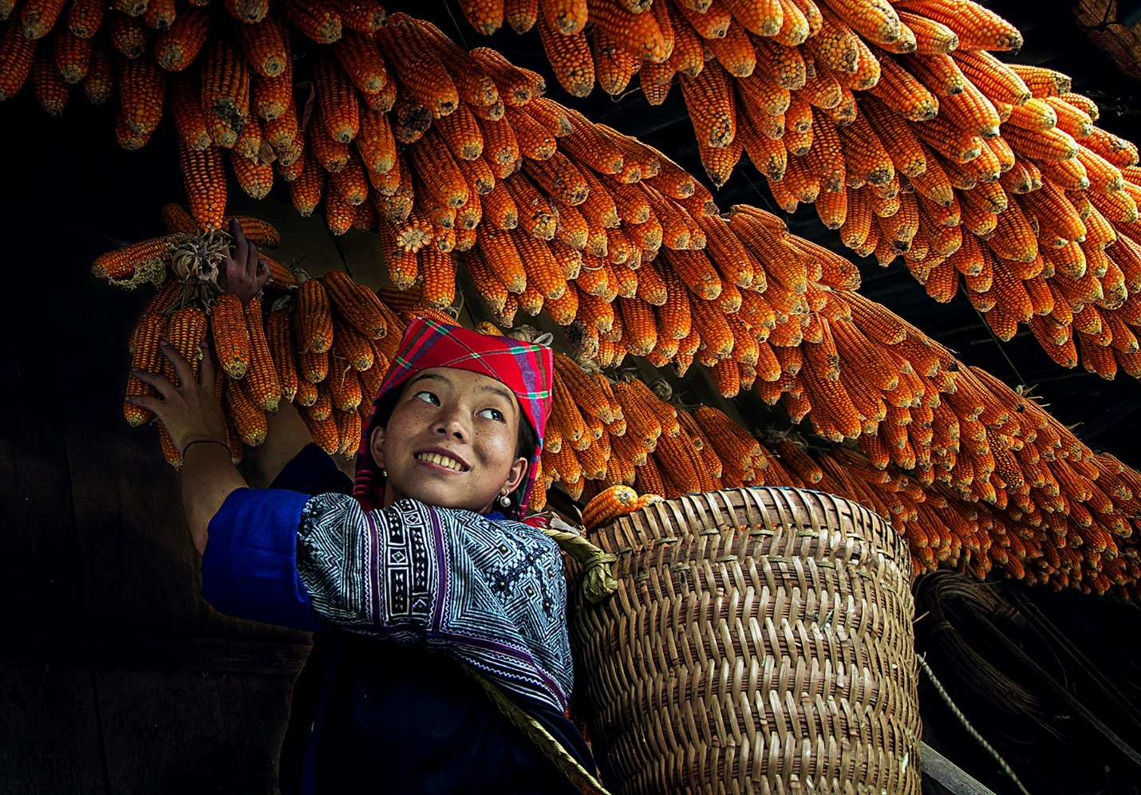

After the adoption of the 2030 Agenda, Viet Nam developed a National Action Plan to implement this in Viet Nam in 2017. A first Voluntary National Review was submitted in June 2018. A review of progress over the past five years is currently being finalized. According to the Sustainable Development Report 2020 Viet Nam’s SDG index score is 73.8 out of 100, higher than the regional average for East and South Asia (67.2). Globally, Viet Nam ranks 49 out of 164 countries climbing from 57th place in 2018. The SDG index scores show 5 out of 17 SDGs on track or maintaining SDG achievement for 2030 (SDGs 1, 4, 6, 11 and 13); seven are moderately improving (SDGs 2, 3, 5, 7, 8, 9 and 16). The SDGs 15 (life on land) and 17 (partnerships for the goals) are decreasing while there was not enough trend information for SDG 10 (reduced inequalities) and 12 (responsible consumption and production).
The five-year National SDG review report is being finalized and highlights several constraints with respect to implementation of the 2030 Agenda, including a lack of budget for mainstreaming; the need for monitoring and improving staff capacities; limited coordination mechanism among ministries and related agencies; and mobilization of stakeholder participation due to both staffing constraints and a lack of awareness.
As it stands, Viet Nam will struggle to meet many SDGs by 2030, and thus the CCA report marks a pivotal opportunity to better define the direction and emphasis for the upcoming UNSDCF to ensure no one is left behind and the furthest behind are supported first. Ensuring that no one is left behind requires broad, whole of government and whole of society approaches which recognize that conventional policies and strategies have both winners and losers. Therefore, it is an imperative that Viet Nam capitalize on their adaptative, industrious and growing population to spur a different approach to economic transformation and inclusive development which puts the redistribution of wealth and opportunities at its centre. It is only when this structural shift has occurred that those left behind will have a chance of breaking through the intergenerational cycle of multi-dimensional poverty and be equipped with the tools they need to fully participate in and benefit from the 2030 Agenda for Sustainable Development.

Focus area 1: People-Centred Social Development
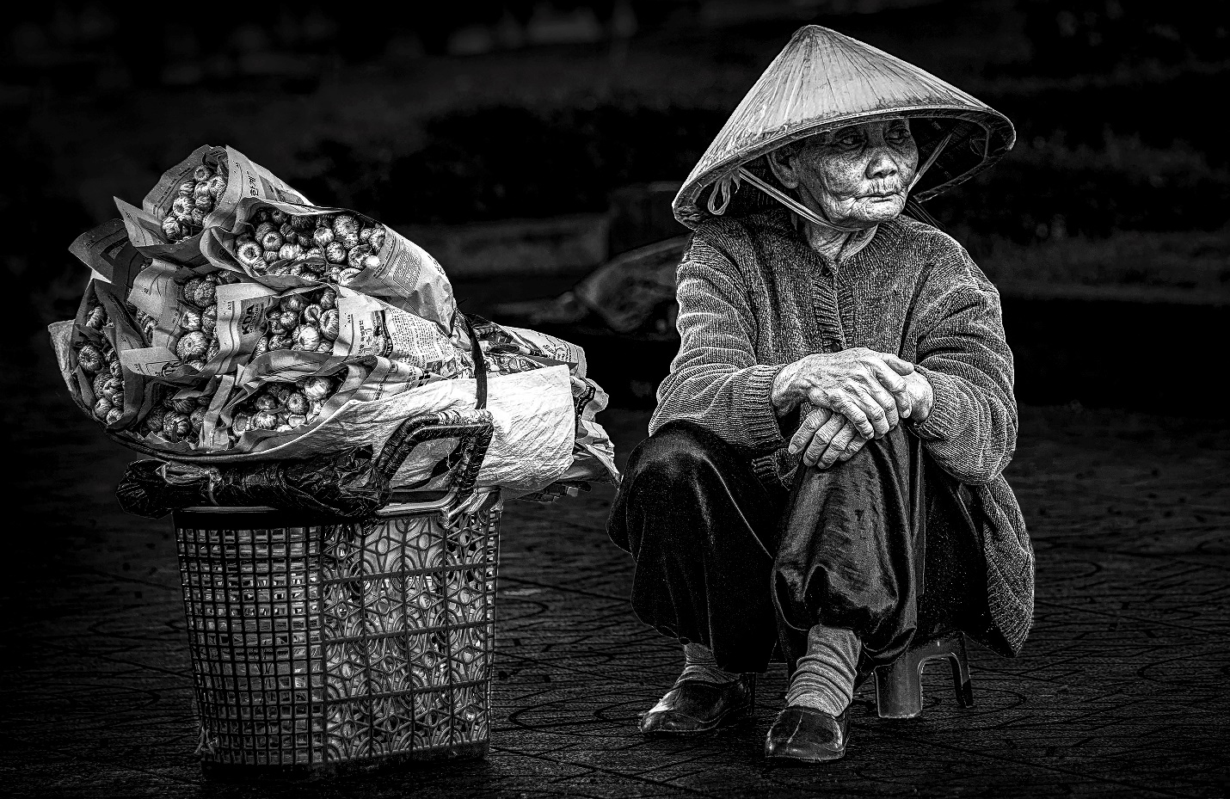
  - Multi-dimensional poverty and Human Development
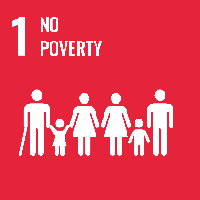
Progress made in the reduction of Multi-Dimensional Poverty (MDP) in Viet Nam since 2015 should be applauded. The Multidimensional Poverty Report 2019 shows that the MDP rate (defined by Viet Nam’s national MDP measurements) reduced remarkably from 8.23 per cent in 2016 to 3.72 per cent in 2019, lifting around 6.5 million people out of multi-dimensional deprivation in just 6 years. Furthermore, extreme poverty has continued to fall, although more slowly in recent years, resulting in an overall reduction of almost 50 percentage points since 1992.
Unfortunately, this steep decline in poverty and rapid headway in human development indicators has not been matched to the same degree by reducing inequalities. The biggest concern is that ethnic minority people experience MDP at a rate approximately 2 to 3 times higher than the national average of 6.8 per cent as do other vulnerable groups such as children, women, older persons, migrants, and People With Disabilities (PWDs).
  - Social protection and Insurance
The Master Plan on Social Insurance Reform and Social Assistance Reform and Development (MPSARD) 2017-2025 has had limited impact on sufficiently broadening the coverage of social protection and insurance in Viet Nam. According to the Ministry of Labour, Invalids and Social Affairs (MOLISA), by 2019 more than 3 million people received monthly social allowance, with cash support and health insurance - accounting for just 3.1 per cent of the population. More specifically, although state investment in social protection has increased, only 31 per cent of the working-age population was covered in social insurance schemes in 2019, less than the 2021 target of 35 percent.
Weak public resource mobilization and low resource allocation has contributed to Viet Nam’s overall low expenditure on social assistance transfers and social insurance coverage in a heavily fragmented system. Social insurance coverage is also constrained by the system’s narrowly defined and selected beneficiaries which inadvertently excludes informal workers, the poor, elderly, women and many other vulnerable groups, such as PWDs, persons affected by HIV, key populations, and informal workers.
  - Food insecurity, safety and agricultural production
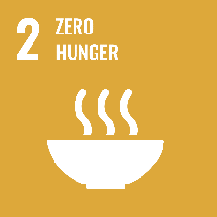
In general, hunger has decreased over the years for most of the provinces. Nevertheless, hunger is growing in the Northwest Mountains and the Central Highlands where high concentrations of ethnic minority communities live. There are some provinces (such as Ha Giang, Bac Kan, Tuyen Quang, Ha Tinh and Dak Lak) where hunger has increased, while some provinces who have eradicated hunger are not able to sustain it. The cause of increasing hunger has been linked to the growing marginalization of smallholder farmers in agricultural production systems which are now dominated by large scale production with high competitiveness.
While steps have been taken to address these challenges, access to nutritious, healthy food and diets remains a critical concern for the poor and ethnic minorities, especially children. The issue of food insecurity and hunger has been further exacerbated by climate change, disasters and COVID-19. Similarly, concerns over food safety have been growing mainly due to the overuse of chemicals, weak regulatory capacity for food safety control, and limited awareness of the impact of unsafe food on public health and the economy.
  - Land Rights
Another driver of food insecurity is the tensions between agricultural food production and land acquisition for ‘development purposes’, which has become a looming source of frustration and discontent among conventional land users. Fast urbanization and industrialization across the country, has led to widespread acquisition of farmland for industrial zones, export processing zones and real-estate development, especially after the 2013 Land Law. Farmers and ethnic/religious minority groups tend to experience the most severe barriers to land due to a lack of inclusion during decision-making processes and minimal protection of interests for “land-losing” communities.
Without adequate safeguards, women, ethnic and religious minorities, and other vulnerable groups who lack secure access to land, capital, and technology, face adverse effects including instability resulting from violent land disputes. Likewise, restricted civic space in policy design often limits a fair acknowledgement of customary tenure rights, which can reduce access to land especially during land consolidation processes or industrialization projects.
  - Health
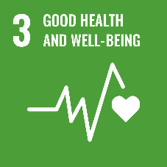
Viet Nam has achieved major progress on key health indicators over the last three decades. Rates on maternal, infant and Under-fives mortality rates have halved from 20 years ago, and morbidity and mortality of communicable diseases (namely HIV, TB and malaria) has fallen. The Government has worked determinedly to strengthen primary healthcare (PHC) to deliver pro-poor distribution of benefits at the primary care level, but the main challenge now is addressing the health inequalities (barriers to affordable and quality health services) which continues to be a real issue for vulnerable groups of the population. Ethnic minorities, people in remote and disaster-prone areas, migrants, elderly, women, youth, adolescents and children from poor households, PWDs as well as those living with HIV, key populations and LGBTQI people all face significant gaps in access to comprehensive healthcare – mainly due to affordability or supply.
Rural and remote populations, the poorest wealth bracket (urban and rural), and ethnic minorities suffer from the highest maternal and child mortality rates and yet have the lowest access to health services. Adolescent fertility and abortion rates are rising among girls– increasing the risk of child poverty, and there is also a rise in non-communicable diseases, and tobacco, narcotics and alcohol use among adult male communities.
The health impacts of climate change are also disproportionately experience by the poor and vulnerable, especially women, children, and the elderly. These are wide and varied including injuries and deaths, water contamination, infectious diseases, food shortages, and mental health problems that arise from climate-induced natural disasters. Further, droughts and heavy rainfall can cause significant reductions in crop yields and productivity of subsistence agriculture, which may lead to malnutrition, and micronutrient deficiencies.
While there are ongoing efforts being made to improve access and the equitable distribution of benefits, the PHC system remains limited in quality, access, and affordability of services. This is mainly due to the lack of incentives for service delivery at the grassroots level, and weak governance and regulations, which overload tertiary and secondary hospitals.
  - Unexploded Ordnance Survivors and Victims of Agent Orange
The land and people of Viet Nam are still severely affected by landmines and other unexploded ordnances from wars which ended many decades ago. Agent Orange is also a remnant from the war which has caused and continues to cause devastation and suffering in the present day. The Vietnamese Red Cross estimates that up to three million Vietnamese have suffered health effects from dioxin exposure (dioxin was a key ingredient of Agent Orange used during the Vietnam War), of whom at least 150,000 are children with birth defects. Like the many Vietnamese PWDs, survivors of unexploded ordnances and Agent Orange suffer hardship due to a lack of access to basic services and economic opportunities. Women survivors or family members are especially hard hit, especially if living in the rural areas where specialized services are hard to access, or if the primary caregiver for a survivor that requires round the clock care. The Government and charity organizations have made great efforts to support these survivors, however, without a comprehensive and nationwide data collection system, it is difficult to assess the resource required, quality and accessibility of required services.
  - Education
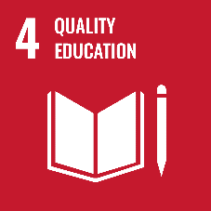
Viet Nam has achieved extraordinary success on many education indicators overall, most notably achieving almost universal net primary and lower secondary enrolment rates in 2020. Likewise, the average years of schooling among the working population have doubled from four in 1990 to eight today. Considering this progress, the inequalities in access to education is disappointing. Gender, geographic location, ethnicity, poverty, disability, and migrant status have all been found to act as barriers to education and learning at all levels. Ethnic minority children fare the worst in this regard, with some groups registering out-of-school rates for 11 to 14-year-olds four to five times higher than for the ethnic majority Kinh.
Among these barriers, however, poverty remains the most determining factor that prevents children from attending school. Children with disabilities tend to suffer the most and even more so if they are disabled, poor and live in geographically remote provinces. The immediate and residual impacts of natural disasters and climate change can also work to limit access to education as can low socio-cultural awareness, which places a lower priority on the long-term value of education in some communities; and cultural norms which prioritizes boys for educational opportunities. On the supply side, unfriendly, inaccessible and unsafe school environments (especially for disabled students), long distances to school with inadequate transportation, a lack of clean water and sanitation facilities, and language barriers for some ethnic minority children.
Over time these issues work to keep the majority of the labour force in Viet Nam locked in unskilled or low-skilled jobs with low productive capacities. Further, although the share of middle and high-skilled jobs is growing fast, the slow expansion of equitable access to vocational and higher education is creating a ‘skills-deficit’, which is further increased by the gender gap in accessing opportunities for skills development. As education is a key pillar of the inclusive economic transformation agenda in Viet Nam, there is an urgent need for targeted policies to address educational bottlenecks for Viet Nam to reach its development targets.
  - Housing
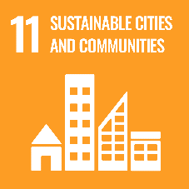
Over the last decade Viet Nam has registered tremendous achievements in urban housing development. Today there is a diversified urban housing stock that is relatively new, offering a good basis for improved housing accessibility but, similar to many fast-growing economies, affordability is an issue. Price-to-income ratios are very high for the lower household income brackets for most types of housing meaning that many urban households find it extremely difficult to afford even modest modern housing units produced by the formal housing sector. Migrant families, the poor, elderly and PWDs all face disadvantages in accessing affordable, safe housing not only because of their low incomes but also due to physical accessibility. Controversial policies regarding land acquisitions, and compensation practices have been cited as the main driver of the limited supply of land, rising land prices and consequently, a lack of affordable housing.
  - Infrastructure & Transport
By facilitating the movement of goods, services and people, connectivity is a critical driver of inclusive economic growth and can also reduce the spatial disparity and associated poverty across the country. Currently, higher poverty rates are concentrated in remote areas, and mountainous regions where most residents are ethnic minorities. This physical remoteness also means low access to infrastructure, services, and market opportunities – which inevitably negatively impacts economic outcomes. Ultimately, better connectivity will improve access to more productive off-farm opportunities for jobs. This also applies to digital connectivity.
Domestic connectivity has improved significantly over the last 20 years, however, there is a mismatch between connectivity demand and supply, leading to increasing congestion and reliance on private vehicles which fuels pollution and lowers productivity. Mass public transportation options are increasing but infrastructure design remains limited both for PWDs, seniors with limited mobility and mothers leaving them at a disadvantage to access economic opportunities - especially when considering the lack of affordable housing options in urban centres. Road and transportation infrastructure across the country are also highly exposed to hazards and climate change events, loss of which could contribute to significant economic losses and heightened reconstruction costs in the aftermaths of catastrophic events.
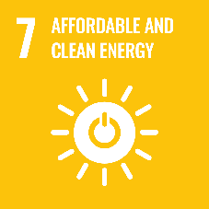
Although Viet Nam is on track to reach SDG 7 (Ensure access to affordable, reliable, sustainable and modern energy for all) target by 2025, almost a third of Viet Nam’s population (30 million people mainly in the poorest 40 percent of the population), rely on solid biomass (fuelwood and agricultural residues) for cooking fuel. Household air pollution from burning solid fuels for cooking is a significant cause of premature deaths and respiratory illness, especially among women and children and the use of fuelwoods also adds a work burden on women and children who are usually responsible for finding and transporting firewood or coal. This responsibility (like water collection, see below) ultimately impacts both productivity and learning opportunities for both women and children.
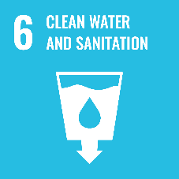
Water, Sanitation and Hygiene (WASH)
Overall, access to basic drinking water and sanitation has increased evidenced by the twofold increase in the number of houses using a private tap between 2008 to 2018. The water pipeline is now considered to be the cleanest and most secure source for people to use, even in rural areas, and almost 90 percent of households in the whole country using hygienic toilets.
Despite this significant progress, there remains a significant proportion of ethnic minority communities without access to clean water and rely on water sources that are very vulnerable to shocks, disasters, pollution, drought and saltwater intrusion. Women are mostly responsible for collecting water, which adds to their workload and takes up time that could be used for more productive activities. Open defecation is still prevalent in some rural areas, despite the widespread use of toilets, and where toilets do exist it is estimated that 94 per cent of rural households use toilets that do not meet hygienic standards.
The causes of the inequitable access to WASH are numerous. Financing on basic WASH activities has declined sharpy over the years, with expenditure primarily on large network systems and supply infrastructure rather than basic drinking water and sanitation, handwashing, and hygiene promotion. Additionally, there are issues of ineffective investment in rural water supply, unsustainable schemes, and inefficient financing mechanisms for urban water supply.
  - Social Cohesion
Existing inequalities, as well as gaps in employment, social, education and fiscal policies, may negatively impact social cohesion. Challenges have been identified in social mobility; access and equity in education (impacting on employment prospects); legal and policy gaps in social protection and in promoting income equality; the weakening of traditional support networks; social norms impacting adversely on gender equity; risks to fiscal legitimacy and the social contract (e.g. through under-reporting of wages by enterprises, or the limited effect of the Personal income Tax); and the limits on the right to public participation. The situation requires efforts across different areas to fill the policy gaps that put social cohesion at risk.

Focus area 2: Nature, Energy and Climate Change
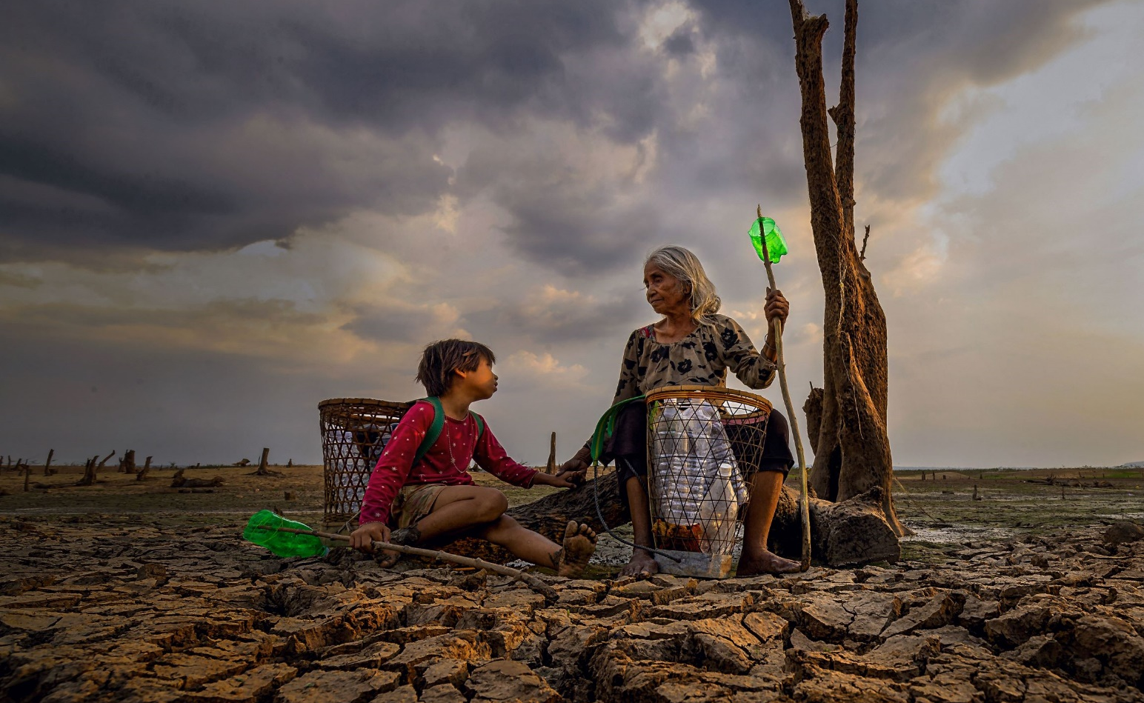

  - Climate Action (Climate Change Adaptation and Disaster Resilience)
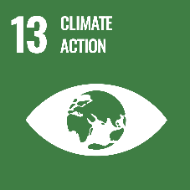
Viet Nam is highly vulnerable to climate change, including increasing extreme weather events, increasing temperatures, sea-level rise, and saltwater intrusion in low-lying areas of the country. Climate change threatens the livelihoods as well as physical and social health of communities and risks unravelling Viet Nam’s fragile development progress with the most vulnerable taking on the highest burden.
Viet Nam’s energy structure not only exacerbates climate change but has been cited as the main cause of environmental pollution which harms citizen health and livelihood. The economy is heavily dependent on fossil fuels, which increase the amount of brown energy that is imported from other countries and reduces the independence and security of the country’s energy sources. By 2025, fossil fuels will likely account for nearly 93 per cent of total commercial primary energy consumption, of which coal will have a 47 per cent share. With rapidly increasing energy demand and limited domestic supply, Viet Nam is expected to become a net energy importer within the next decade, and by 2025 the country will need to import 49 per cent of its total commercial primary energy.
Chronic impacts from climate change, such as saltwater intrusion in low-lying areas of the Mekong Delta, are increasingly affecting cultivation and groundwater in areas where livelihoods and well-being are already precarious. In addition, higher temperatures tend to reduce soil fertility, increase forest fire frequency, and generate more energy demand for air-conditioning – increasing overall energy demand. more than 50 million people are at risk of saltwater intrusion in the Mekong Delta provinces and along the coastal areas due to rising sea levels. Ethnic minorities, who are often subsistence farmers, are particularly vulnerable to crop damage from extreme weather events with minimal alternatives to supplement lost incomes. These communities are also already at a considerable disadvantage due to the lack of access to education, infrastructure, transportation, health care and other key services.
As they move around, Environmental migrants usually experience a loss of social networks, sources of information and safety nets against financial shocks. Elderly people and PWDs are also acutely affected by climate change especially due to the physical risk posed in sudden-onset extreme weather events. They are also the most often unemployed and not able to easily relocate or switch economic activities if their livelihoods are disrupted, entrenching them further in the cycle of poverty.
Climate-sensitive diseases, including dengue fever, malaria, influenza and diarrheal diseases among others are increasingly impacting people’s health and the pressure on the health sector. Extreme weather can lead to chronic and non-communicable diseases for the elderly, such as cardiovascular diseases, cancers, diabetes and, mental disorders which have been increasingly prevalent in recent years. Air quality has been fast-declining due to energy intensive economic activities, outdated technology, poor urban planning and infrastructure, and the increasing numbers of cars and motorbikes. Vietnam’s two biggest cities, Hanoi and Ho Chi Minh City, are now among the top 15 polluted cities in Southeast Asia, which has no doubt led to the number of deaths associated with air pollution to be six times higher than those caused by traffic accidents (60,000 deaths compared to 9,000).
Women, children, the urban poor and informal workers are most at risk of air pollution due to their exposure to outside air and lack of access to premises with air filtration. In addition, women often work in informal food preparation businesses with little to no protection from poisonous fumes. Critical policy, regulatory and enforcement failures to monitor and reduce air pollution, working conditions and accommodation standards have left these groups extremely susceptible to the health ravages of air pollution. This also applies to waste management, and marine and plastic pollution impacts on these groups as discussed below.
Viet Nam’s climate change policies and strategies have led to some progress and achievements, such as a modest reduction in GHG emissions, enhanced adaptation, and environmental protection. However, progress is slow and does not appear to be keeping up with the more frequent and severe effects of climate change. Institutional and operational capacity as well as planning capabilities acts as significant impediments to progressing climate action as does the low levels of climate finance – which is insufficient to tackle the risks.
  - Energy transition
Weaning Viet Nam off its fossil fuel dependency also requires much work as the country’s key economic sectors are heavily dependent on fossil fuels, which increase the amount of brown energy that is imported from other countries and reduces the independence and security of the country’s energy. By 2025, fossil fuels will likely account for nearly 93 per cent of total commercial primary energy consumption, of which coal will have a 47 per cent share. With rapidly increasing energy demand and limited domestic supply, Viet Nam is expected to become a net energy importer within the next decade, and by 2025 the country will need to import 49 per cent of its total commercial primary energy. In terms of investment, the current Power Development Plan (PDP) would require an estimated investment of almost USD$130 billion for the entire energy system, of which US$95.4 billion would be needed for power generation, by 2030.
Although progress in solar power and offshore wind is promising, there is a lack of coherence and coordination in the national energy policy which can address burden and unnecessary demands on electricity generation and investments. Aggressive energy efficiency measures could also significantly reduce the total capacity required to meet electricity demand. However, the current prices of electricity and fuels used by industry however do not reflect their environmental and health costs and are generally too low to justify investments in energy efficiency measures. Further work is needed formulate a long-term energy price roadmap, as well as to strengthen the Law on Energy Efficiency and Conservation.
  - Environmental quality: life below water and on land
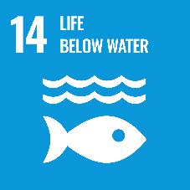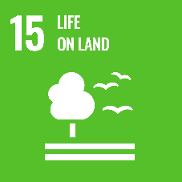
Environmental quality in Viet Nam is under increasing pressure from a high population growth rate, rapid urbanization, and accelerating industrialization. Moreover, environmental issues especially air pollution, and solid waste and water pollution have become extremely serious and a preoccupation for communities living on the coastlines, in urban areas and close to industrial estates. The ineffective use of energy, especially non-renewable energy, and natural resources for production and consumption by citizens has become a critical issue.
Forest conversion to other land use purposes such as agricultural and industrial production, and urban expansion has caused a serious decline in forest quality. Together with the abuse of chemicals in agricultural production and climate change, land conversion threatens extinction of plant and animal species, with a projected decline in ecosystem-related services. Insecure land tenure, unclear and potentially conflicting or ill-adapted legal frameworks, poor law enforcement and unclear management and enforcement responsibilities can drive or exacerbate illegality in the forestry sector, such as the illegal logging and timber trade.
Likewise, inland freshwater ecosystems have been narrowed and degraded by infrastructure development and other human activities. Mangroves, coral reefs, seagrass, and other coastal wetland habitats have also undergone serious degradation due to aquaculture development. The ongoing unsustainable exploitation and over-extraction of assets such as sand, fisheries and timber could negatively affect the potential for future and long-term growth, as will the ongoing degradation of inland freshwater ecosystems by infrastructure development and aquaculture development. An increasing number of species in Viet Nam are at risk of extinction and have been added to the Red List of the International Union for Conservation of Nature (IUCN), while the level of marine and terrestrial protected areas remains low at 2.93 per cent of total territorial areas in 2016 and 2017.
  - Waste Management
Viet Nam generates more than 23 million tons of domestic waste, over 7 million tons of industrial solid waste, and more than 630,000 tons of hazardous waste with limited disposal capacity. E-waste is becoming a growing issue due to domestic production, illegal shipping and dumping from other countries.
A large proportion of the waste generated is plastic and due to poor waste management and limited recycling there is extensive leakage of plastic waste in water and wastewater which has led to widespread marine litter and plastic pollution. This is visually evident in cities, at sea, rivers, or rice fields and explains Viet Nam’s ranking as the fourth largest contributor to marine plastic pollution globally.
The rural poor, ethnic minorities, women, children and the elderly are most at risk from pollution and exploitation of natural resources due to their reliance on subsistence farming, low access to healthcare and lack of opportunities to advocate for their rights. Coastal communities in particular face sexual reproductive health risks from the impact of plastic pollution, compounding their existing vulnerabilities from climate change.

Focus Area 3: Economic Transformation Analysis
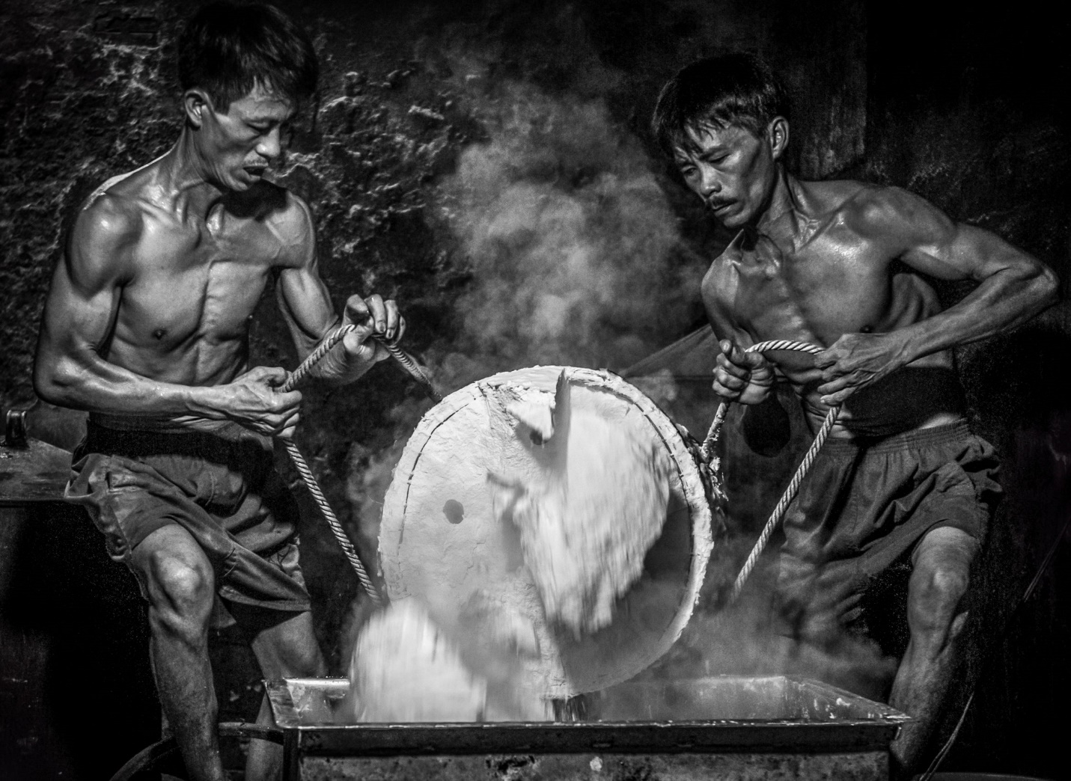

The orientation of the new SEDS (2021-2030) and SEDP (2021-2025) is geared towards addressing the risk of the low middle-income trap and achieving economic transformation through a Fourth Industrial Revolution (IR 4.0). This strategy is aimed at increasing growth through enhanced productivity, value addition, competitiveness, and environmental sustainability rather than exploiting natural resources and cheap/low-skilled labour. There are two main barriers to achieving this goal. The first relates to the COVID-19 pandemic. In 2020 Viet Nam’s economy grew by about 3 percent compared with 7 percent in 2019 as a result of COVID-19. Despite this contraction a strong trade surplus was recorded, driven primarily by export of electronic goods (such as computers and phones) and their parts. Although the economy has managed to stay afloat in the short term, Viet Nam’s recovery is dependent largely on the recovery of external demand, and the long-term fiscal impact of COVID-19 on public finances. The setback (years required to reach pre-COVID-19 growth levels) will have an impact on generating sufficient resources to invest in growth-enhancing economic sectors as well as human capital. The second area is the lack of an enabling policy and regulatory environment to bring about IR 4.0. This includes the need to design and implement effective strategic frameworks to govern labour, environment and energy use, as well as the use of spatial economics to tackle the redistributive gaps driving inequalities experienced by ethnic minorities, women, and the rural poor.
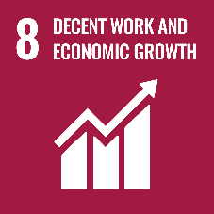
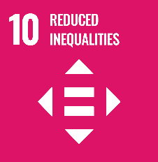
  - Employment and Productivity

Viet Nam’s low unemployment rate of 2.26 per cent mask several inequalities in the labour market, most notably the predominance of informality. It is estimated that 71.4 percent of the labour market are informally employed equivalent to approximately 39 million workers. These workers experience lower job quality, longer and sporadic working hours, low access to labour protection legislation, including social protection which leaves them in conditions of extreme vulnerability during economic shocks. Women are disadvantaged by the gender wage gap which, although closing, is currently at 12 percent for formal workers. Women are also disproportionately found in lower paid segments of the labour market, part-time and informal work and still expected to work full-time whilst undertaking the bulk of unpaid domestic work such as household chores, caring for the elderly and childcare responsibilities. These expectations often begin from childhood and work to lower opportunities for education, upskilling and career progression.
Rural employment, while high, offers low returns on the whole with minimal opportunities to materially improve standards of living and reduce chronic poverty, which is almost three times the urban rate. The drivers of this are numerous and multi-faceted. However, the placement of industry, manufacturing and services in urban centres (due to agglomeration forces) means urban areas attract the most economic opportunities and the multi-dimensional poverty (such as poor education, and digital illiteracy) that is prevalent in rural areas also leave rural dwellers ill-equipped to compete for the better paid jobs even if they migrate. This disparity in wages has widened income inequality between urban and rural Vietnamese and will take targeted, strategic economic policies to remedy. The onset of COVID-19 has only heightened this dynamic had a significant impact on the Vietnamese labour market, affecting already vulnerable households of ethnic minorities, PWDs, informal and migrant worker households as well as female.
Considering the high informality in the labour force and low-wage employment that dominates rural areas, it is of no surprise that productivity across the economy varies so widely. Increasing the productivity of domestic private enterprises in Viet Nam has been a high priority over the last decade, of which improvements have been seen since 2018. Despite this, and particularly in the context of IR4.0, there remains: an insufficient increase in domestic productive capabilities and innovation (to precipitate a bulk shift of labour into manufacturing and eventually services); a sluggish reduction in the amount of time required to achieve competitiveness in higher value-added activities; and poor quality FDI that does not generate significant linkages with the rest of the economy or encourage technology diffusion. Of equal concern is the decline in agricultural productivity which is acting as a drag on attempts to accelerate economic transformation.
Productivity levels have largely been hindered by regulatory and structural issues; and low access to finance, particularly for MSMEs, for innovation and investment. Equally as important is the disconnect between FDI firms (which are the most productive) and MSMEs. It should also be mentioned that poor working conditions, which permeates both the formal and informal labour market, also has an impact on productivity levels. To achieve the level of growth required to become a high-income country, Viet Nam’s strategy will require a shift from quantity to quality underpinned by an improved efficiency of all capital utilized: private, public, human, and natural resources.
Industrialization and the green economy
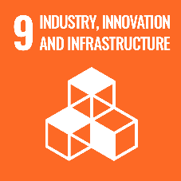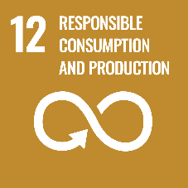
As discussed in Focus Area 2, Viet Nam’s reliance on high energy intensity industries to drive economic growth is becoming increasingly unsustainable on many fronts. Though Viet Nam is currently one of the lowest per capita emitters of carbon emissions, CO2 emissions per unit of GDP are very high - about two times the world average and increasing. Low levels of investment, poor tax incentives, lack of awareness, low and unenforced environmental standards and the lack of mandatory energy efficiency practices need to be addressed quickly. While the government has initiated a number of policy actions and innovative efforts to address these constraints to green growth, much more needs to be done including with the business community to have an impact, and address meaningfully the quality of economic growth as one of the core development challenges.
The Government of Viet Nam has already formulated and adopted a number of legislative frameworks that include the core principles of the circular economy such as the Revised Law on Environmental Protection, the adoption of more stringent Extended Producer Responsibility, or the NDCs recently submitted to the UNFCCC. However, the more detailed lower legislation (Decisions, Circulars) is missing or could be streamlined and strengthened to give more guidance to actors in the economy on environmental and mechanical/technical standards. Currently, industrialization has outpaced the development of the green economy necessitating the prompt centering of green energy production and the circular economy in future industrial policy design.
  - Innovation and digital transformation
Innovation is critical to increasing productivity, value-addition and competitiveness towards economic transformation, especially one which is environmentally sustainable. Multiple support mechanisms have been enacted in Viet Nam to accelerate MSMEs’ innovation including a range of programs and Science, Technology and Innovation-support institutions, funding and tax incentives to advance local innovation. As a result, Viet Nam has made great strides in harnessing the returns from innovation investment, outperforming that of high-income, oil rich countries (such as Kuwait, Saudi Arabia and Oman).
Despite these efforts, the type of innovation required for IR4.0 is not widespread yet and is certainly not the main driver of competition in most of the domestic private sector. Further, the limited knowledge and technology transfer from large FDI enterprises to domestic MSMEs contributes to the persistence of the so-called ‘Two-Speed Economy’ which can only be overcome through further collaboration between the MSMEs, knowledge-generating institutions, large firms, and the public sector. A note of caution however that supporting technical/innovative advancements alone will be insufficient and needs to be combined with upgrading MSMEs’ management, and research and development skills so that they are better equipped for embarking on and managing innovation activities. More inclusive investment policies, especially in vocational and STEM-oriented education, are needed to close this gap as the lack of education reduces employability and access to stable wage jobs with good benefits. Women are already at a disadvantage in this regard as social norms deter their pursuit of education in certain fields required for careers in engineering, construction, chemistry, medicine and information technology, for example, where innovation is most prevalent. Viet Nam will need to pursue a marked shift from accumulation to efficiency and innovation if it is to achieve higher levels of income as seen in China, and the Republic of Korea.
The digital economy, a key result of innovation in modern times, has almost tripled in three years, driven by e-Commerce and online media. The sector is rapidly growing reaching 4 percent of GDP in 2018 and expected to constitute 25 percent of GDP by 2025. Unfortunately not everybody is benefiting from this growing resource and although the internet is being increasingly recognized as a ‘basic necessity’ (especially since the onset of COVID-19), there still exist significant gaps between different population groups in terms of ICT readiness (infrastructure, access) and ICT capability (skills).
In 2018, the internet penetration rate and the percentage of Vietnamese households having access to the internet reached 70 per cent
(although predominantly among young people) and 47 per cent respectively. Ethnic minority people customarily inhabit rural and mountainous areas where infrastructure for internet services remains limited. Hence, the proportion of households having access to the internet among some ethnic minority groups is remarkably lower than the national average, e.g. 10 per cent and 15 per cent for La Hu and Brau households, respectively. Meanwhile, the figure for people with disabilities from the lowest wealth bracket is disturbingly low at only 0.1 per cent.
Digital literacy remains low, indicating the lack of education and readiness to use the Internet. This is well illustrated by the lack of ICT training among lower skilled workers (who make up the majority of the workforce) which when combined with the low levels of innovation will work to suppress new, competitive forms of production that are digital, distributed, smart and circular. This pre-existing digital divide in education and training is more pronounced than ever, and starts from childhood. Interrupted schooling and the emergence of online learning solutions in crisis contexts excessively impact those who do not have access to ICTs and puts them at risk of falling further behind, for example, through learning loss and even drop-out.
On the supply side, Viet Nam still faces challenges such as improving access to 4G technology and expanding broadband fiber optic networks, particularly for businesses, schools, and large institutions; limited cashless payments; scant regulations on consumer protection; incompatibility of digital payment systems; and ensuring secure digital payments for government services.
  - Financial Inclusion
Although financial inclusion has improved over the last decade, there are several gaps in access to financial services among the poor, low income, social protection beneficiaries, rural residents, and agricultural enterprises and MSMEs. Vietnamese people living in rural and isolated areas possess low financial literacy and have limited to no access to financial institutions due to high operating costs and a low consumer base. Women, particularly rural women, are routinely excluded from formal financial services not intentionally but due to lack of knowledge and familiarity with digital payments (options and usage), low accessibility and limited information on related costs. This drives a preference for cash payments and informal financial services.
In early 2020, a national financial inclusion strategy until 2025 with a Vision to 2030 was approved by the Government to tackle these issues. The Strategy targets at least 80 per cent of adults in the country to have bank accounts by 2025. In addition, access to financial services, income, education, financial literacy, gender, age, trust in intermediaries and access to informal credit/savings all affect financial inclusion. Therefore, financial inclusion alone will not suffice to ensure that services are utilized in a manner leading to greater economic empowerment.
  - International Labour Migration
Due to limited access to education, economic and employment opportunities, young individuals facing unemployment and a lack of decent work at home choose to migrate. The government has actively worked to ensure a safe migration environment and protect external migrants’ rights and interests. However, current institutional arrangements, agencies and policies on international migration have displayed distinct limitations in tracking, monitoring, and managing international migration processes.
Lack of transparent, accurate and timely information, deception, long recruitment processes and limited or no access to remedy are additional challenges migrant workers face which effectively prevent migrant workers from knowing when they are being overcharged or exploited. This prevents migrants from making informed decisions, avoiding abusive situations, or exercising recourse further exacerbating the vulnerabilities of migrant workers to exploitation. Advice and support are particularly needed for marginalized groups of women, in particular for women from poor, ethnic minority households or those living in mountainous and remote areas who may have differing service needs and less access to services.

Focus Area 4: Inclusive Participation, Access to Justice and the Rule of Law

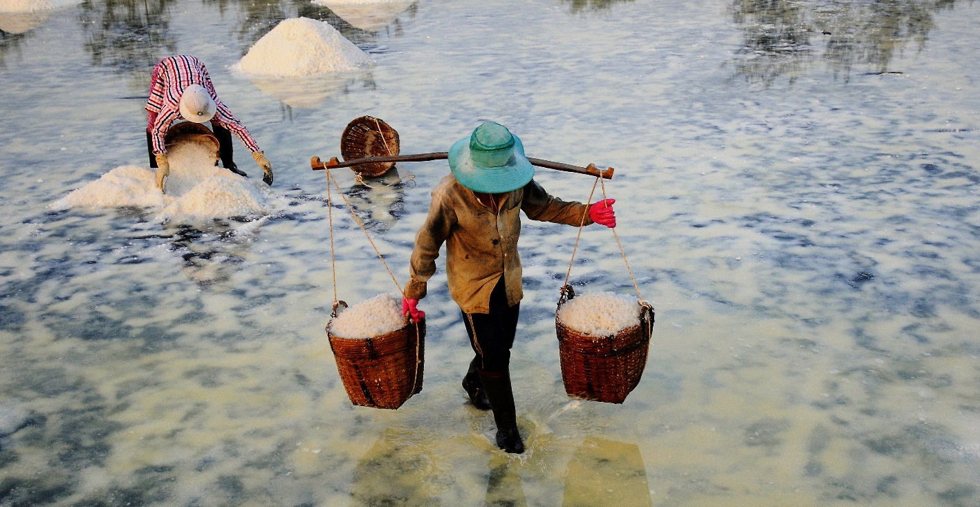

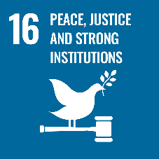
  - Rule of Law
While several institutional and organizational reforms have taken place since the late 1980s, CPV has maintained its one-party power structure, and tightly regulates many of the areas covered in this chapter, seemingly to ensure continuity of the current governance structure. This is reflected in two key areas of concern. Firstly, the independence of the judiciary has been viewed as in need of strengthening. For example, while the independence of judges is guaranteed in law, some judicial positions, including in Viet Nam’s highest court, are given to members of the Communist Party’s Central Committee. Also, the Chief Justice of the Supreme People’s Court can be relieved from duty or dismissed by the National Assembly at the proposal of the President. The Constitution and the Criminal Procedure Code (CPC) recognizes many basic fair trial rights. However, the CPC contains severe limitations on due process, leading to trials falling short of international standards in some cases.
  - Civic Participation
The second area of concern pertains to civic participation. Lack of transparency and limited ability to engage in decision and policy-making are often cited as major constraints in many areas, including justice and the budget. The Law on Access to Information of April 2016 stipulates the citizen's right to access information, in addition to the principles, order and procedures for exercising the right, responsibilities and obligations of state agencies. Many citizens are not yet familiar with it, nor are they taking full advantage of the new opportunities.
The Special Procedures of the UN Human Rights Council have regularly issued communications regarding the situation of human rights defenders in Viet Nam. These individuals are often arrested whilst peacefully advocating for and raising awareness on a range of issues, including democracy, corruption, protection of land, the environment or freedom of religion. Observers raised concerns that the Vietnamese government was also stepping up its crackdown on dissidents, journalists, and activists ahead of the CPV Congress, but these developments are largely consistent with concerns reported regarding the enjoyment of fundamental freedoms in Viet Nam.
While constitutionally protected, freedom of expression remains restricted. The revised 2015 Penal Code includes broad and vague regulations imposing long prison sentences for speech-related offenses. The press is under State management, and the 2016 Press Law expanded the list of prohibited acts. These include several vague and broad provisions such as “distorting history; negating revolutionary achievements; offending the nation and national heroes’’ and gives responsibility to journalists to protect the State against unlicensed expressions. Broadcasting news “contrary to Vietnamese customs and etiquette” or “propagating unsound customs and superstitious beliefs” can result in fines.
The draft Law on Demonstrations has not been finalized, but demonstrations are very tightly controlled, and permission must be sought for any gathering of more than five persons. Restrictions are in place on the time, place, and manner allowed for persons to assemble peacefully, allowing the arbitrary prevention of demonstrations. Demonstrations are also sanctioned for “disruption of security”. Meetings, too, are closely regulated. Any workshop or conference, including online, involving foreign participants or funding requires permission several weeks in advance, which, if concerning human rights, must come from the Prime Minister.
Freedom of association is improving for workers in Viet Nam, however, the Draft Law on Associations, after more than 20 years of drafting, has not been finalized. The conditions and procedures for establishing associations and non-state actors not affiliated with State mass organizations are complex, especially with regards to receiving foreign funding. Associations are limited by vague and broad obligations and have to submit to being managed by state agencies. In addition, the revised 2015 Penal Code includes broad and vague regulations providing for severe sentences, including the death penalty, for anyone “who establishes or joins an organization that acts against the people's government”. In the last two years, many non-government organizations (NGOs) have faced tighter monitoring and increased restrictions on their activities, and the wide-ranging regulations limit the independence of registered NGOs.
The Constitution of Viet Nam states that all individuals have the right to freedom of religion and belief. However, the law provides for considerable governmental control over and restrictions of religious practices based on national security and social unity concerns, which impacts in particular on ethnic minority groups. In particular, the 2018 Law on Belief and Religion requires religious groups to register with authorities and to obtain official approval of their activities, limiting free practice of religion.
  - Corruption
An anti-corruption drive launched in 2016 (known as ‘blazing furnace’–đốt lò) reached the highest-level of the party-state apparatus and state-owned enterprises. The Penal code was updated, and a new Law on Anti-Corruption was introduced which criminalizes public sector corruption. The anti-corruption campaign appears to have been effective, at least from the perception of the public.
Viet Nam has made great strides over the last decade to tackle money-laundering through establishing the legal and regulatory framework to remedy the strategic deficiencies that the Financial Action Task Force (FATF) had identified in October 2010.

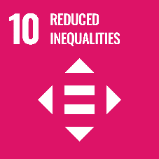
  - Protection of Vulnerable Groups
The adoption of good laws on the legal protection of vulnerable groups represents an achievement, but implementation and monitoring mechanisms are not always strong, and there is a need for close coordination between Government agencies as many issues are cross-sectoral. PWDs (including mental disabilities), persons with intersectional identities, such as girl children, women living with HIV, and ethnic minority persons with disabilities suffer from multiple discrimination. There are many challenges faced by PWDs specifically, with the most acute being accessibility to basic services, economic opportunities and active participation in society in Viet Nam. Although stigma and discrimination against PWDs have been defined in the Law on Persons with Disabilities and Convention on the Rights of Persons with Disabilities (CRPD), anti-discrimination mechanisms have not been established to protect persons with disabilities in Viet Nam.
Currently there are gaps regarding the protection of people living HIV among key population groups, and the legal framework related to HIV, sex work and drug use should be revised in line with international standards and recommendations. Same sex marriage is now permitted by law and changes to gender markers in official documents permitted. However, there is no procedure for the legal recognition of same sex partnerships and legal gaps prevent the changing of gender markers in practice. The 2019 Labour Code, despite representing the most comprehensive set of legal grounds for protection, do not offer specific protection for LGBTQI persons against employment discrimination.
Child abuse and violence, especially child sexual abuse, is increasingly recognized by the Government as a major challenge. Violence against children (VAC) is still a widespread phenomenon, with approximately 68.4 percent of children aged 1 to 14 reporting experience of some form of violence at home by their parents or caregivers. Boys are more likely to experience physical violence and psychological aggression than girls.
Two critical emerging issues for child protection in Viet Nam are children’s mental health and online abuse and exploitation. Very few specialized services are available to address these unique mental health problems amongst children. Formal outpatient mental health services for children are nascent, and families who have children with mental disorders experience extreme difficulty in accessing information and help such as social care and psychosocial support.
Viet Nam has adopted several laws and measures on trafficking in persons (TIP), but TIP, especially of women and children, continues to be of serious concern. According to the report from the Government, between 2011 and 2014, 3,717 Vietnamese people were trafficked across the borders to other countries (primarily China at 70 per cent), with many more thousands of people missing from their communities without explanation. Child trafficking and exploitation in Viet Nam is a grave concern, but data in this area is limited. The major barriers to adequately addressing trafficking include the absence of monitoring mechanisms, lack of a clear definition of TIP when compared with international standards, challenges in victim identification, referral, and inter-sectoral cooperation, lack of capacity and quality disaggregated data on TIP, under-resourced social protection centres for vulnerable groups, including victims of trafficking, and lack of shelters exclusively for male or child victims.
Despite the tremendous efforts undertaken by the Government of Viet Nam in law reform, there are still critical legislative gaps to be addressed to ensure full compliance with the Convention on the Rights of the Child (CRC). While there has been a considerable increase in state budget allocation to child protection, this area remains largely under-funded. There is a lack of human capital investment in professional social workers and dedicated child protection personnel at all levels including community-level service providers (collaborators, and child protection officers).
As of the end of 2019, the Government reported having identified just over 30,500 persons under UNHCR’s statelessness mandate: (1) ethnic minority Vietnamese who returned from Cambodia and are residing permanently in Viet Nam (71%); (2) persons of undetermined nationality who reside in border areas between Laos and Viet Nam including their children (5%); (3) children who were born to a Vietnamese citizen and a foreigner and their nationality is undetermined (due to a single nationality principle) (4%); and (4) other undocumented stateless persons who are not eligible for naturalization according to current nationality law (20%).
On 20 March 2020, the Government approved a document which outlines specific activities relating to statelessness in Viet Nam based on Decision (No. 402/QD-TTg) for Promulgating the plan on implementation of the United Nations’ Global Compact for Safe, Orderly and Regular Migration. Despite these developments, stateless persons are particularly vulnerable to being left behind due to, for example, lack of access to basic services especially social protection and housing; as well as decent, formal jobs due to lack of documentation on status as well as recognized qualifications.
  - Drug Trafficking
As of December 2019, there has been a sharp upward trend in synthetic drug use, with the biggest surge reported in Central and Southern provinces and cities where the proportions of synthetic drug users range from 80 to 90 per cent of all drug users. On the contrary, uses of heroin and other opioid substances are mainly found in the northern mountainous provinces. While Viet Nam has achieved considerable progress in strengthening its laws and policies related to drug treatment and care, the current legislative and institutional frameworks do not fully support the abolition of compulsory drug treatment and a shift to voluntary evidence-based, comprehensive community-based treatment and care. In 2012, the National Assembly approved the Renovation Plan for Drug Treatment and Rehabilitation for the period 2013-2020 which provided legal platforms for the reduction of compulsory drug treatment and rehabilitation. Due to unclear financial and human resource commitments, implementation has been limited thus far.
B. Cross-cutting themes
The CCA examined the three cross-cutting issues of gender equality, youth and partnerships due to: i) the relative slow-progress being made in related progress indicators, especially for gender equality; ii) the impact these issues have on economic opportunities and social welfare, which could have a deleterious effect on developmental gains across all sectors; and iii) the accelerant effect addressing these issues could have on achieving the SDGs.
  - a) Gender
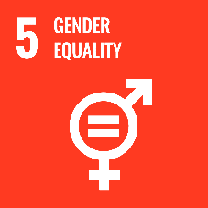
Over the last three decades, Viet Nam has made significant progress in improving its population’s well-being and reducing gender disparities, including those related to the achievement of SDG 5. Despite these achievements, gender inequality and discrimination persist, exacerbating other forms of disadvantage and disparity, and hindering chances for overall attainment of the sustainable development goals. Currently, Viet Nam faces several challenges to achieve the SDG 5 on gender equality. Out of 8 specific targets under this goal, Viet Nam can only reach the target 5.3. Progress on Target 5.5: Ensure women’s full, effective participation in and equal opportunities for leadership at all levels of decision-making in political, economic and public life has seen the weakest progress overall indicating there is significant work to be done.
Awareness of gender issues is still limited in society and the largely continuing belief that women’s roles are linked to families and men’s roles are linked to the society outside has been a huge barrier for women’s participation and leadership in management positions, and serves to maintain the gender wage gap. On the flip side, gender differences in poverty rates are small, but among women the most disadvantaged are migrant women, widows, older women, female ethnic minorities, and women with disabilities. These women are also the first to bear the brunt of economic shocks, for example the impact of COVID-19, and find it difficult to recover especially when responsible for domestic chores.
Although Viet Nam has passed important laws and policies improving gender equality, implementation is far from satisfactory, due to a lack of knowledge, implementing capacity, and the limited presence of women in public decision-making forums and in politics more generally. A lack of data, and roadmaps for the implementation of specific have been cited as barriers to reaching the outstanding targets, whilst specific concerns have been raised about child abuse and violence against women and girls as they are becoming current social issues (target 5.2).
Gender-based violence (GBV), especially violence against women and girls, and the high sex-ratio imbalance are still pervasive issues in Viet Nam. According to the National Study on Violence against Women in Viet Nam 2019, nearly 2 out of 3 women (63 per cent) in Viet Nam experienced one or more forms of physical, sexual, emotional, and economic violence, and controlling behaviors by their husband in their lifetime. One in three women (32.0 per cent) experienced physical and/or sexual violence in their lifetime. Nearly half (47 per cent) of women reported experiencing psychological violence which includes emotional violence and controlling behaviors while 20.6 per cent reported experiencing economic abuse by a husband/partner during their lifetime. All forms of husband/partner violence were higher among women with a disability, and higher in rural areas. Access to quality first line support (care, responses to emotional/psychological needs and safety), sexual assault examination and care, mental health assessment and treatment is very low. Further, many health facilities do not provide for any safety and confidentiality assurance avenues for GBV survivors.
  - b) Youth
Given the country’s socio-economic progress over the last decade, inequalities and disparities for youth persist in relation to access to education, health care including sexual and reproductive health care, decent employment, social protection and youth participation in policy development.
The Vietnamese Youth Development Strategy for 2011-2020 provides the groundwork for relevant ministries and sectors to provide a holistic response to young people’s needs and rights. The recently approved revised Youth Law (commencing January 2021) provides the opportunity for youth to prioritize their needs in an integrated and cross-cutting manner, including aspects of education and TVET, participation and empowerment in for example climate change. It legalizes youth participation, has designated March as ‘Youth Month’, and supports youth dialogues with national/local leaders as well as specific mentioning of state budget for youth.
Consistent with other areas of development, young people in the communities of ethnic minorities, the urban and rural poor, migrants (international and domestic), PWDs, those living with HIV, LGBTQI, and sex workers face similar access to their adult counterparts. This covers all basic services, human rights and future prospects.
It should also be noted that the challenges facing the full development and participation of the youth is not only limited to individual and communal well-being. Youth in Viet Nam will be critical to achieving economic transformation and the Upper middle-income country ambitions of the country. Filling the gaps in tertiary education and its mismatch to the labour market, and addressing the unintended exclusion of female students from STEM-related fields, will therefore be crucial to fostering innovation and enhanced productive capacities in high-value added sectors over the next two decades – when these youth are in the labour market and have fewer options to acquire key skills.
c) Partnerships
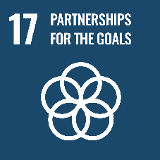
Given the challenges identified so far it will be impossible for Viet Nam to meet the SDGs without strengthening partnerships across government agencies and whole-of-society as well as with external actors at the regional and global levels. Viet Nam’s effective containment of COVID-19 is an excellent example of the whole-of-government approach, supported by various sectors of society and in close partnership with external supporters.
In the current financing landscape with declining ODA (see Section E below), Viet Nam will need to ramp up resource mobilization across many fronts. Partnerships with the private sector need to be strengthened to increase the flow of finance towards lagging SDGs in a timely manner, and there also scope to explore innovative finance mechanisms to capture both domestic and foreign private resources. Nurturing a labour force which is responsive to the labour market and emerging economic integration opportunities also requires closer collaboration between the public and private sector, especially for identifying specific skillsets for growth-enhancing sectors, technology and knowledge transfers, and effective innovation policy frameworks. There is also a role for International Financial Institutions to provide financing for large-scale high value infrastructure projects. Most climate-related infrastructure requires high-levels of financing which only generates returns in the long-term. Leveraging concessional finance for these types of projects may be a more efficient mechanism for financing infrastructure projects which would compete for funds also required for social spending in the short to medium-term.
With Viet Nam playing a prominent role in the region (e.g. ASEAN Chair in 2020) and the world (e.g. a non-permanent member of the UN Security Council for 2020-2021), as well as by generating private sector incentives, there will be much scope to leverage on regional and international expertise and resources going forward. This will be of critical value, especially on key issues such as climate change, clean energy, STEM policy, innovation, and the strengthening of health systems against future pandemics.
South-south cooperation and strategic engagements with development partners (beyond ODA) has already become commonplace for Viet Nam, but more work is needed to better focus these partnerships on addressing urgent and growing threats. These include cross-boundary issues, particularly those related to the preservation of global public goods such as climate change action, pollution, IFFs and cross-border trafficking. The close partnership between the UN, the Government and the people of Viet Nam is evolving due the complexity of development issues (especially planetary threats) and the growing interconnectedness between countries, which although has brought great benefits, comes with increasing risks as seen with the recent pandemic, climate-related crises and rising cross-border pollution. All these partnerships will be of critical importance if Viet Nam were to respond to and contain future shocks and crises.
In terms of the whole-of-society approach, mechanisms to strengthen civic exchange between the Government, the people of Viet Nam, and various organizations and groups that are legally established and operate in line with Government’s rules and regulations need to be significantly improved if Viet Nam is to achieve the SDGs and high-middle-income status by 2045. Civic participation, both physical and virtual, is a critical pillar for inclusive, resilient development ensuring (over time) engagement with those voices least heard voices, fostering innovative policy discourse to adopt the most effective policies, and reducing the cost of public and private political engagement.
C. Commitments Under International Norms and Standards
Viet Nam has taken steps to implement its international obligations and the recommendations of international human rights bodies at the national level. The Government has engaged and continues to engage actively in multilateral fora, including as a Non-Permanent Member of the Security Council (2020-2021) and a Member of the Human Rights Council (2014-2016) and has ratified 7 out of 9 core international human rights treaties. Viet Nam has engaged actively with UN treaty and charter-based human rights mechanisms and with recent reviews in 2018 (Convention Against Torture) and 2019 (ICCPR), and the third cycle of the Universal Periodic Review (UPR), also in 2019. In the UPR, Viet Nam accepted 220 out of 291 recommendations in addition to noting, or partially accepting 71.
Despite this progress, some important gaps remain. Viet Nam does not have an independent national human rights institution as required by SDG 16, and consequently lacks an independent institution responsible for protecting, monitoring, and promoting human rights in the country. Viet Nam has not ratified the International Convention for the Protection of All Persons from Enforced Disappearance or the International Convention on the Protection of the Rights of All Migrant Workers, each of which contain provisions that are highly relevant to Viet Nam, but says it is considering them.
It is necessary for the Government to develop detailed indicators, benchmarks, and timelines with clear responsibilities to ensure coordinated implementation of these recommendations. Viet Nam will have the opportunity to present its progress in implementing the UPR and ICCPR recommendations in 2021. Viet Nam has not extended a standing invitation to the UN Human Rights Council Special Procedures mandate holders. The most recent visit took place in 2017, and several requests by Special Rapporteurs remain outstanding. This situation limits Viet Nam’s ability to receive technical assistance and guidance from these experts.


D. Cross-Boundary, Regional and Sub-Regional Perspectives
Sharing a border with China, Laos and Cambodia presents both opportunities and challenges for Viet Nam, the most prominent being that of the East Sea (also known as the South China Sea). Although historical, the friction on this issue in recent years has presented a catalyst for Viet Nam’s first National Defense White Paper in a decade. This will allow Viet Nam the flexibility to expand its strategic and military relations, with implications for disputes in the East Sea. However, defense issues aside, an immediate constraint for Viet Nam is China’s policy that any resource exploration in the East Sea must be done with Chinese partners – which the White Paper does not impact materially. This position invariably limits Viet Nam’s ability to tap into the energy resources within its Exclusive Economic Zone, posing significant risks to its energy security especially given the increasing demand for electricity and forecasted power shortages.
Cross-border pollution has become increasingly common in the region as the world’s factories and agro-forestry projects grow and cluster in manufacturing and resource-intensive regions in China, India, Indonesia, and ASEAN countries. Two main sources of cross-border pollution in Asia are: a) carbon emissions from fuel combustion in energy production and heavy industry; and b) transboundary haze from the burning of forests for agricultural needs. Plastics in the marine environment have become a major transboundary environmental concern. It is estimated that half of global marine plastic waste comes from five Asian countries, namely China, Indonesia, Philippines, Viet Nam, and Thailand. The underlying causes of this issue are rooted in unsustainable production and consumption patterns, poor solid waste management and lack of infrastructure, lack of adequate legal and policy frameworks and poor enforcement, including on interregional cross-border trade of plastic waste, and a lack of financial resources.
Droughts, lower water level in rivers, salinity intrusion, reduced sediments, flora and fauna, and increased land subsidence, are all related to the nexus between climate change and unsustainable development activities along the entire Mekong River. The construction of dams (mainly for hydropower purpose) along the Mekong and subsidiary rivers upstream have been reducing the natural flow of water, negatively impacting downstream ecosystems and communities. With areas of the coastal belt losing 100 metres per year, and hundreds of thousands of households affected by declining productivity, natural disasters, saltwater intrusion, and increased drought, many are unable to adapt their livelihoods to remain in the region. This could increase the number of environmental migrants and expose these communities to reduced access to basic services such as safe housing, education and social protection, as well as economic opportunities as discussed above.
Improving trade among the members of ASEAN remains a priority for Viet Nam’s trade agenda which is expected to become increasingly important as other traditional global trading routes become more uncertain and riskier – a shift further exacerbated by the COVID-19 pandemic. Among several factors impeding intra-ASEAN trade, connectivity has been highlighted as a major factor over the last three decades. Infrastructure upgrades, whilst lowering the cost of trade between Viet Nam and the ASEAN group, also serve to reduce spatial disparities which currently limit economic opportunities for ethnic minorities and other groups in remote areas.
In recent years, there have been reports of possible refoulement of individuals entering Viet Nam, highlighting the challenge posed by the fact that Viet Nam’s domestic legal framework does not include laws or policies on refugees or asylum-seekers and that there is no procedure for refugee status determination. In addition, there have been reports of rendition of human rights defenders and political dissidents within Southeast Asia. Whether it be individuals in Viet Nam being forcibly repatriated to another country, or individuals in another State being deported covertly to Viet Nam, such acts risk violating international law and standards, including the ICCPR and CAT. The pattern could result in human rights defenders and dissidents moving out of the region, limiting their ability to participate in human rights activities in Viet Nam and creating a detrimental impact on public participation and free expression in the country. Cross-border migration and trafficking of persons, and Illegal cross border trade in goods remain critical issues.
E. Financing Landscape and Opportunities
Due to strong export performance, high FDI flows, significant remittances from the Vietnamese diaspora, and prudent macroeconomic management, Viet Nam’s financial resources has grown. Despite this improvement, domestic resource mobilization (DRM) capabilities, declining Official Development Assistance (ODA) as well as low domestic private investment will pose significant challenges for financing sustainable, inclusive development and the SDGs in the years ahead.
There are three key areas that impede the effective use of resources for achieving the SDGs: i) The weak alignment of development finance flows with the SDGs and wider national development priorities; ii) Inefficient use of public resources driven by limited integration across government (vertical and horizontal) resulting in a fragmented and silo-approach to development planning and public financial management; and iii) The domestic private sector lacks access to finance and its linkages with Foreign Direct Investment (FDI) remain weak. These findings remain as valid in 2020 as they were in 2018.
In order to mobilize the financial requirements which would enable an accelerated achievement of the SDGs, Viet Nam will need to undertake significant reforms to improve DRM, provide incentives to increase domestic private investment and encourage better alignment of FDI with national development goals. There is also a need to improve the efficiency and allocation of both domestic and international public resources.
As expected, the COVID-19 crisis has placed considerable pressure on government revenues and shifted public investment away from a long-term growth strategy to an expansionary policy mechanism to accelerate economic recovery. Prior to the crisis, there was already a tightening of financing conditions due to declines in ODA, fiscal consolidation and more stringent public investment management undertaken to maintain sustainable debt levels.
The links between PFM, accountability and civic engagement are important and yet not fully enabled in Viet Nam due to the lack of citizen engagement in public decision-making (see Focus Area 4); low capacity in PFM coupled with complex mechanisms for ensuring accountability. This has an impact on public spending efficiency and outcomes, especially in the social sectors. It is important that local stakeholders can inform the budgets of the national and provincial governments, as well as increase transparency and accountability on the utilization of these funds. The linking mechanism between these areas will need to be quickly strengthened to improve the efficiency of public investments and development outcomes by 2030.
Currently, public investments in Viet Nam account for 8 per cent of GDP compared with 20 per cent for private investments- significantly lower than comparator countries such as Malaysia, Thailand, Cambodia, and Myanmar. Such low levels of private investment despite high levels of FDI suggest a number of bottlenecks exist, such as challenging regulatory requirements, complex and time-consuming tax and customs procedures, and opaque guidance on land ownership rights, usage, and transfers. Furthermore, inefficiencies in public investment management are believed to greatly undermine the implementation and utility of public investments in driving productivity, innovation, and economic diversification – all key components of successful and accelerated economic transformation. Several bottlenecks in the financial and banking systems have been identified including the undercapitalization of banks; outdated, costly, and cumbersome market infrastructure; and low access to financial services.
For Viet Nam to successfully decouple economic growth from environmental degradation and move towards achievement of SDGs, a shift of public and private sector financial flows towards low carbon investments is needed. Existing public and private financial resource allocations do not significantly focus on ecological efficiency, and climate and green growth aspects of investments are not being prioritized. Such a reallocation should be a top priority for any post-COVID-19 economic and ecological strategy.

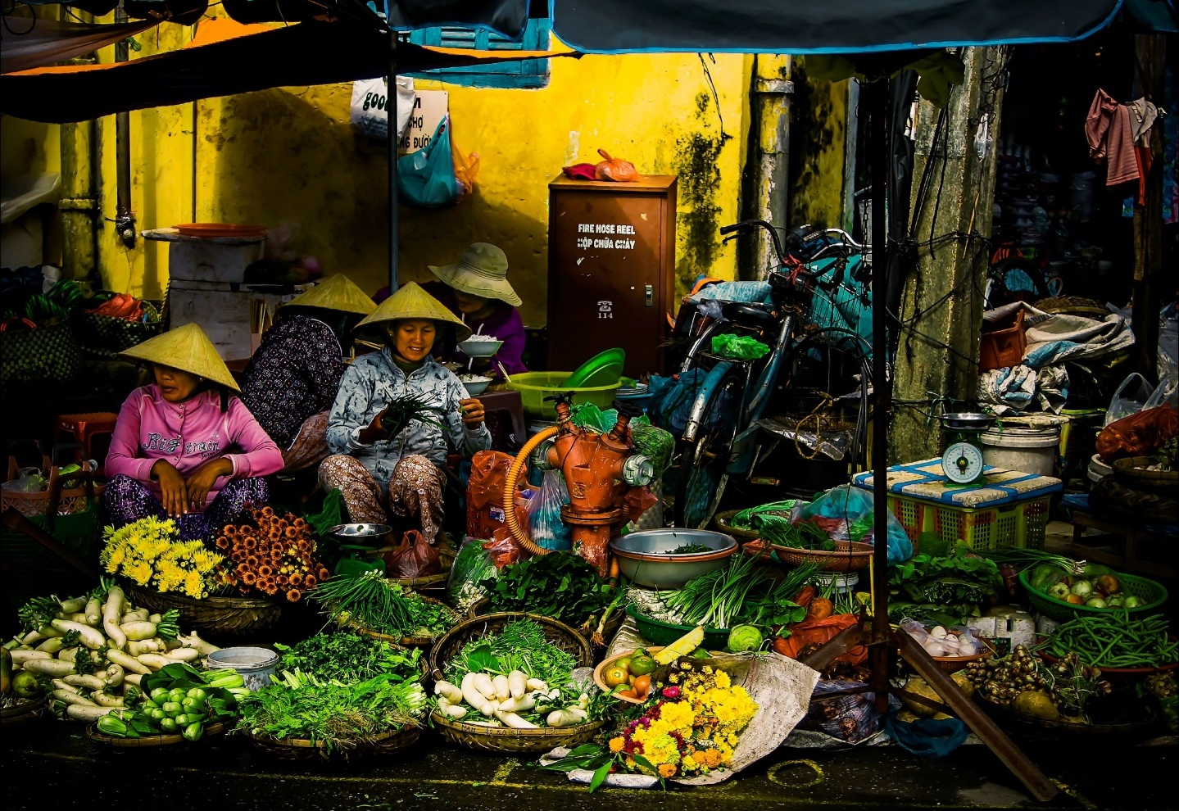
F. Analysis of Risks That May Affect the Ability to Achieve the SDGs
The most critical area of risk in Viet Nam is in relation to the environment and climate change, with the country particularly exposed to natural disasters which impact the marginalized and vulnerable groups in society most severely. There is a lack of progress in addressing pollution, climate change, and the depletion of natural resources all of which have negative impacts on industrialization, on promoting a green and circular economy and on rapidly increasingly clean and affordable energy. There is an urgent need for reform, upgrading and harmonization of national standards, regulations, and procedures which in turn will require stronger, transparent governance and higher environmental and labour standards.
The COVID-19 pandemic has exacerbated risks in the domains of health, poverty, economic stability, social cohesion, and gender equality and has introduced new and unpredictable variables to the risk landscape. The social and economic impact of COVID-19 will exacerbate tensions on issues of food security, land rights disputes, potentially increasing the number of vulnerable workers in the informal economy as well as increasing the levels of internal migration. Health systems capacity is at risk of being stretched in its ability to cope with all health needs and possible future epidemics.
Viet Nam is still exposed to the risk of a more severe global downturn if the forthcoming vaccinations campaigns in 2021 and beyond prove to be limited in slowing the spread of the virus. The impacts of both natural disasters and COVID-19 have already widened the inequalities for those with existing vulnerabilities, and it is unclear how the slow recovery will impact their access to basic services and economic opportunities in the coming years. Restrictions on democratic space, civic dialogue and media constitute a significant area of risk which will impact SDG attainment and the development trajectory if not addressed.
Important cross-border risks also exist and include the increasing geo-political tensions over control and exploitation of the East Sea, which may affect peace, stability, and trade, both in the region (in the context of ASEAN) and globally. There is also a risk around the management of any further reduction in the flow of the Mekong River, which would increase the incidence of drought, erosion, and saltwater intrusion in the lower Mekong delta region of Viet Nam, severely affecting livelihoods, and exports.
Increases in cross boundary criminal activities involving drugs, illegal wildlife trade (which is increasing in importance due to alleged COVID-19 links), illegal natural resources trade especially of timber, money laundering, irregular migration, migrant smuggling and human trafficking all of which have an impact on vulnerable and marginalized groups and run the risk of negatively affecting Vietnam’s international credibility and distorting trade and poverty reduction efforts.


G. The Way Forward to 2030: Gaps, Challenges and Opportunities
PEOPLE: Addressing inequalities and multidimensional poverty
The analysis reveals that drivers of inequality, multidimensional poverty and vulnerability are ineffective policies and state capacity to tackle discrimination, marginalization and ensure equitable access to basic services and economic opportunities. These are further reinforced by physical geographical isolation; ethnicity, economic isolation; cultural and linguistic barriers; and a lack of investments to mitigate these drivers. Those groups that suffer from multidimensional poverty are also most vulnerable to climate change, natural disasters and pollution which is generated by an industrial revolution that has not benefitted them. Current social protection mechanisms are limited in scope and coverage, neglecting to support those who need it most. Lack of basic services such as education, health and WASH facilities further perpetuate multidimensional poverty creating an intergenerational cycle that is difficult to escape from.
Tackling these issues requires political-will and a targeted development strategy that mobilizes ethnic minority groups, geographic hotspots, women, children, youth, and marginalized populations including people living with and affected by HIV, and people with disabilities, to benefit more from government investment and local resources. The strategy should be designed and implemented in a participatory and integrated manner building on local knowledge and assets, increasing productivity in agriculture, natural resource use, building a green, industrial base that can stimulate sub-industries, cultural industries, and ecologically sound tourism. Coordinated support for social protection, nutrition, basic and reproductive health services, education and training, and WASH services where disparities are high should also be re-positioned as critical economic and social investments for this largely neglected segment of society which, if properly nurtured, will inevitable bring substantial value for the country by 2030.
PLANET: Protecting the environment
The environment is degrading at an alarming rate with little impact from policies, regulations and enforcement. There is a lack of investment in climate change action and disaster risk management, and the biggest cost saving exercise, prevention, seems to be evading efforts even with huge potential from hydropower, solar, wind and waste energy generation. Climate change and disasters disproportionately impact the poor and vulnerable, especially women and children and communities living in exposed areas. Rural farmers are also disproportionately impacted by extreme weather events with minimal assistance for recovery such as insurance. Increased pollution and deforestation are threatening biodiversity as well as the livelihoods and health of local communities yet the continued over-reliance on coal to fuel industrial growth and GHG emissions are projected to increase if Viet Nam continues on its current trajectory.
Tackling environment issues whilst preparing the foundations for green, inclusive growth requires a two-pronged approach which: i) accelerates the mobilization of resources for climate change action and disaster risk management by adopting fiscal disincentives for emitters (the polluter pay principle), and tapping into private capital, green and innovative finance mechanisms as well as ODA opportunities; and ii) prioritizes sustainable consumption and production as well as sustainable, clean and green cities and rural areas, which should be the anchor from which all policies/laws are revised. This includes urban planning, investments in energy efficiency initiatives and shifts from fossil fuel subsidies to green subsidies to support mandatory environmental codes; in addition to phasing out of Viet Nam’s coal dependency. Human rights impact assessments of climate actions should be employed to ensure that they respect human rights. Government should develop and monitor relevant human rights indicators in the context of climate change, keeping disaggregated data to track the varied impacts of climate change across demographic groups and enabling effective, targeted and human rights compliant climate action. Vulnerable individuals such as women, children, PWDs, the elderly as well as ethnic minorities deserve separate protection given the disproportionate impact of pollution and environmental migration on these groups.
PROSPERITY: Readiness for the Industrial Revolution 4.0
Since the Doi Moi reforms the developmental state in Viet Nam has created an economy explicitly designed to support SOEs, attract FDI and maximize exports. This fragmented economic structure has aided the slow progress in the formalization of jobs and enterprises, leaving many workers with low access to labour protection legislation, unstable jobs, and little or no access to social insurance. Although this structure is gradually been dismantled, institutional cultures in the banking industry and regulation remains firmly wedded to those norms, especially as markets become increasingly liberalized. The bulk of MSMEs (including household businesses) have therefore found themselves at the fringe of growth opportunities and remain numerous, undiversified and of declining productivity.
The upcoming SEDS 2021 -2030 is geared towards addressing the low middle-income trap risk and accelerating IR 4.0, however, there are gaps in the government’s readiness and capacity to implement this approach, most notably in ensuring that: i) the current and future workforce is well-equipped to meet the shift from low-skilled to middle and high-skilled capacity; ii) that MSMEs are supported to increase their productivity in what has become a fragmented economy; and iii) the regular social dialogue between and among tripartite constituents (Govt, Employees, and Employer) could be reinforced toward the achievement of decent work agenda. The science, technology and innovation sectors are uncoordinated with limited public investment and cross-sectoral policy guidance while the development of the digital economy is yet to take off. Further, the current digital divide could further widen existing inequalities if the structural issues affecting ethnic minorities, women, PWDs and the rural poor are not addressed.
Viet Nam has both a strong industrial and competitiveness policy which could be leveraged to accelerate IR 4.0. Due to COVID-19, there is now a wealth of statistics that can be used to support green growth of MSMEs in an integrated spatial, sectoral (including agriculture) and value chain approach that benefits from access to sustainable technology, with a focus on women, youth, ethnic minorities, PWDs and the youth. Increased investments in tertiary skills, and vocational and management training for these groups which are tailored to sectoral needs will be imperative to ensuring inclusive growth as the economy shifts towards IR 4.0. Regulatory reforms for FDI firms could work to improve linkages with domestic private enterprises as well as to improve Economic, Social and Governance outcomes; and the digital economy can be quickly expanded by improving institutional capacity, the participation of the private sector and e-governance capabilities.
PEACE: Inclusive participation, justice and effective institutions
The ongoing judicial reform could benefit from acceleration with some easing of the existing barriers to access. The high incidence of serious violence against women (especially disabled women) and children including child abuse is compounded by weak capacities in law enforcement and support services, as well as cultural norms. Land rights and protection from discrimination is also lacking for certain groups, impacting livelihoods and stability in certain provinces and freedoms (expression, association, and belief) and access to information remain restricted– impacting human rights defenders particularly. Inclusive participation could be improved, especially in the design/adoption of policies; and decision-making by youth, women, poor and remote dwellers, and ethnic minorities are limited or non-existent.
Accelerating judicial reforms and ensuring legal protection for vulnerable groups would have a significant impact on strengthening institutional capacity for effective governance which would help to achieve the SDGs and ensure that no one is left behind. This includes clarifying provisions for legal aid, establishing alternative justice mechanisms, and improving procedures and access to information. Initiating campaigns to address social norms that promote gender and youth stereotypes, tackling GBV and discrimination against LGBTQI, sex workers and PWD groups could be powerful in creating a cultural shift on how these issues are viewed by society. Increasing space for civic dialogue would enable community empowerment but creating this space has faced significant challenges.
Finally, innovative approaches will need to be used across society and government and at the local level to address deeply entrenched issues, especially with respect to increasing freedom of expression, the participation of women in elected bodies, recognition of land tenure and governance systems for ethnic minorities, and encouraging civic space for groups and individuals who wish to organize and actively contribute to decision-making processes. The full implementation of e-governance systems as part of public administration reforms that are more responsive to the needs of vulnerable groups will better facilitate these changes.
Despite these challenges there are many opportunities for Viet Nam to overcome these issues and achieve their development ambitions. Doing so will require innovative and transparent policy approaches as well as political will. Resource mobilization will also need to improve both in terms of public and private capital, and partnerships with the private sector, development partnerships and south-south peers will need to be better utilized to quickly execute structural shifts that can bring about green, inclusive growth over the next decade, leaving no one behind. Many of the policy instruments required to take full advantage of opportunities already exist and the main bottleneck appears to be the upgrading of institutional capacity to efficiently and effectively address stubborn inequalities, protect the environment, accelerate IR 4.0 and ensure justice, social cohesion and peace.

World Health Organization: https://covid19.who.int/
International Monetary Fund estimate. See: https://www.imf.org/en/Publications/WEO/Issues/2021/01/26/2021-world-economic-outlook-update
World Bank, 2020. COVID-19 to Add as Many as 150 Million Extreme Poor by 2021. Press Release, October 7, 2020. At: https://www.worldbank.org/en/news/press-release/2020/10/07/covid-19-to-add-as-many-as-150-million-extreme-poor-by-2021#:~:text=The%20COVID%2D19%20pandemic%20is,severity%20of%20the%20economic%20contraction
OECD, 2020. Multidimensional Country Review, Viet Nam. OECD: Paris
During the 3rd UPR, Viet Nam received and accepted 19 recommendations on ethnic minorities and persons in rural areas, see OHCHR Matrix of recommendations, and noted 1, pgs 8, 12, 17, 20, 21, 23, 25-27, 32, 33 (https://lib.ohchr.org/HRBodies/UPR/Documents/Session32/VN/Recommendations.docx). CESCR has also made recommendations in these areas (E/C.12/VNM/CO/2-4 (2014), para 28 (https://undocs.org/E/C.12/VNM/CO/2-4))
General Statistics Office, Viet Nam. https://www.gso.gov.vn/en/data-and-statistics/2021/01/viet-nam-economy-in-2020-the-growth-of-a-year-with-full-of-bravery/
International Monetary Fund, June 2020. Presentation at Macroeconomic Dialogue for EU Ambassadors on COVID-19. Hanoi: Viet Nam.
United Nations in Viet Nam, 2020. UN Assessment of Social and Economic Impact of COVID-19 in Viet Nam, p.28. United Nations: Hanoi
Ibid
German Watch, 2020. See: https://germanwatch.org/sites/germanwatch.org/files/20-2-01e per cent20Global per cent20Climate per cent20Risk per cent20Index per cent202020_10.pdf. During the 3rd UPR, Viet Nam received and accepted 5 recommendations on climate change and the environment, see OHCHR Matrix of recommendations, pgs 12, 20, 31, 32 (https://lib.ohchr.org/HRBodies/UPR/Documents/Session32/VN/Recommendations.docx).
German Watch’s report “Global Climate Risk Index 2020”
General Statistics Office of Viet Nam. See: https://www.gso.gov.vn/default.aspx?tabid=723
Elaboration of Em-dat (https://public.emdat.be/) database
Viet Nam Disaster Management Reference Handbook, December 2018
Updated Nationally Determined Contribution, Government of Viet Nam, July 2020
Government Decision 622/QĐ-TTg, 10 May 2017, available at: https://vietnam.un.org/en/download/47488/4123.
See: https://sustainabledevelopment.un.org/memberstates/vietnam
United Nations. Sustainable Development Report 2020, June 2020, Cambridge University Press. https://dashboards.sdgindex.org/profiles/vnm
ibid.
Government of Viet Nam, Ministry of Planning and Investment, Viet Nam. 2020. Draft National Report on the Implementation of the Sustainable Development Goals.
Government of Viet Nam, Ministry of Labour, Invalids and Social Affairs and UNDP (2018), Multidimensional poverty in Viet Nam: Reducing poverty in all its dimensions to ensure a good life for all. http://www.vn.undp.org/content/vietnam/en/home/library/poverty/MDPR.html.
UN in Viet Nam, September 2020. Workshop “Development of high quality human resources for agriculture, new rural development and sustainable poverty reduction in Ethnic Minority and Mountainous Areas” Opening remarks delivered by Kamal Malhotra, UN Resident Coordinator. Found at: https://vietnam.un.org/en/91510-workshop-development-high-quality-human-resources-agriculture-new-rural-development-and
During the 3rd UPR, Viet Nam accepted 19 recommendations relating to the rights to an adequate standard of living, including eliminating inequalities, see OHCHR Matrix of recommendations, pgs 21-23 (https://lib.ohchr.org/HRBodies/UPR/Documents/Session32/VN/Recommendations.docx).
United Nations in Viet Nam, 2020. One UN Results Report 2019. pg 9. At: https://vietnam.un.org/en/52299-one-un-results-report-2019.
Ibid.
CESCR has raised concerns about health and unemployment insurance (E/C.12/VNM/CO/2-4 (2014), para 22-23 (https://undocs.org/E/C.12/VNM/CO/2-4)
ILO, 2020. A focus on families: A short-term benefit package for the extension of multi-tiered social security coverage in Viet Nam. ILO: Hanoi.
Key populations are gay, bisexual and other men who have sex with men, people who inject drugs, sex workers, transgender people and people in prisons and other closed settings.
During the 3rd UPR, Viet Nam received and accepted 2 recommendations on the right to food, see OHCHR Matrix of recommendations, pg 23-24 (https://lib.ohchr.org/HRBodies/UPR/Documents/Session32/VN/Recommendations.docx)
Asian Development Bank, 2013. Viet Nam: Environment and Climate Change Assessment. Asian Development Bank: Mandaluyong City, Philippines. At: Viet Nam: Environment and Climate Change Assessment (adb.org)
Fawthrop, Tom, “Vietnam’s War against Agent Orange”. BBC News story, June 14, 2004: http://news.bbc.co.uk/2/hi/health/3798581.stm. Cited at: https://www.aspeninstitute.org/programs/agent-orange-in-vietnam-program/health-effects/
OECD, 2020. Multi-dimensional Review of Viet Nam: Suggestions for an integrated, transparent and sustainable economy. OECD: Paris.
Government of Viet Nam, Ministry of Labour, Invalids and Social Affairs and UNDP, 2018. Multidimensional poverty in Viet Nam: Reducing poverty in all its dimensions to ensure a good life for all. At: http://www.vn.undp.org/content/vietnam/en/home/library/poverty/MDPR.html.
Government of Viet Nam, Ministry of Education and Training, UNESCO Institute for Statistics and UNICEF, 2018. Report on Out-of-School Children: Viet Nam Country Study 2018.
Ibid.
According to the OOSC report 2018, the OOSC rate from migrant families was higher than that from non-migrant families, more than 1.5 times higher for those of primary and lower secondary school age.
World Bank, 2015. Viet Nam Affordable Housing – A way forward. World Bank: Hanoi.
World Bank, 2016. Transforming Vietnamese Agriculture: Gaining More from Less. Working Paper, World Bank Group, Washington, DC.
Scott, A. (July 2020). Access to Affordable, Reliable, Sustainable, and Modern Energy for All in Vietnam. Centre for Strategic and International Studies. Found at: https://csis-website-prod.s3.amazonaws.com/s3fs-public/200321_Scott_Energy_Vietnam_Background_V1.pdf
World Bank, Sustainable Energy for All (SE4ALL) database from WHO Global Household Energy database. Accessed 26/02/2021.
UNICEF and WHO, Joint Monitoring Programme – Progress on household drinking water, sanitation, and hygiene 2000-2017, 2019, p 104
General Statistics Office, Viet Nam. Result of Viet Nam Household living standards survey 2018. Housing, electricity, water and sanitation facilities, page 519
ibid
General Statistics Office of Viet Nam. Population and Housing Survey, 2019, 319
UNICEF and WHO, Joint Monitoring Programme – Progress on household drinking water, sanitation and hygiene 2000-2017, 2019, 124
UNICEF, Policy Brief on WASH Financing, 2020:6-8.
UNICEF EAPRO, Equity in Public Financing of Water, Sanitation and Hygiene, 2016:1-2
OECD, 2014. Social Cohesion Policy Review of Viet Nam. Development Centre Studies, OECD Publishing. At: http://dx.doi.org/10.1787/9789264196155-en
Thang Nguyen et al., 2018. Environmental disputes, social changes, and distributive justice in Viet Nam: Case studies, comparative analysis, and policy implications. UNDP Viet Nam. Retrieved from https://www.vn.undp.org/content/vietnam/en/home/library/democratic_governance/environmental-disputes--social-changes--and-distributive-justice/
EREA and DEA: Viet Nam Energy Outlook Report 2019 Found at: https://ens.dk/sites/ens.dk/files/Globalcooperation/vietnam_energy_outlook_report_2019.pdf
Ibid.
Ibid.
Updated Nationally Determined Contribution, Government of Viet Nam, July 2020.
Tran Thi Tuyet Hanh, et al., 2020. Vietnam Climate Change and Health Vulnerability and Adaptation Assessment, 2018. Environmental Health Insights 14(1). July 1, 2020.
UNESCAP, UNECE, UNECLAC and Ministry of Transport, Viet Nam, 2018. Road Safety Performance Review, Viet Nam: Project on Strengthening the National Road Safety Management Capacities of Selected Developing Countries, and Countries with Economies in Transition. United Nations: New and Bangkok. At: Road Safety Performance Review Viet Nam
EREA and DEA: Viet Nam Energy Outlook Report 2019 (2019). https://ens.dk/sites/ens.dk/files/Globalcooperation/vietnam_energy_outlook_report_2019.pdf
Ibid.
Ministry of Industry and Trade, Viet Nam. February 2021. Draft national electricity development planning project for the period 2021-2030 with a vision to 2045 (Power Development Plan VIII). Vietnamese version only available at: https://www.moit.gov.vn/web/guest/tin-chi-tiet/-/chi-tiet/bo-cong-thuong-xin-y-kien-gop-y-du-thao-%C4%91e-an-quy-hoach-phat-trien-%C4%91ien-luc-quoc-gia-thoi-ky-2021-2030-tam-nhin-toi-nam-2045-21618-15.html?fbclid=IwAR3YsQ34xZZE2-F1iZ5Lr3klQgtIryWOGBT3cJadhQ1AeEsWWfXcWmDOWV4
Government of Viet Nam, Ministry of Natural Resources and Environment, 2019. The Sixth National Report to the United Nations Convention on Biological Diversity. Found at: CBD Sixth National Report - Vietnam (English version)
Danh, N and Ht, Hoi., 2019. Effects of plastic waste to sea environment in Vietnam. IOP Conference Series: Earth and Environmental Science. 351.
See Nguyen, DQ., Yamasue, E., Okumura, H. et al., 2009. Use and disposal of large home electronic appliances in Vietnam. J Mater Cycles Waste Management, 11, 358–366 (2009). https://doi.org/10.1007/s10163-009-0264-2; and Loan, L., 2017. Electronic waste in Vietnam: There is not really any recycling. Science and Development Magazine, at: https://khoahocphattrien.vn/cong-nghe/rac-thai-dien-tu-o-viet-nam-chua-thuc-su-co-hoat-dong-tai-che/20171101084943577p1c859.htm
February 2019, "Plastic & Health: The Hidden Costs of a Plastic"
Sea-circular (2019), Vietnam Country Profile, COBSEA
A. Ragusa, et al., 2021. Plasticenta: First evidence of microplastics in human placenta. Environment International, Volume 146, 2021, 106274, ISSN 0160-4120.
General Statistics Office of Viet Nam, 2020. Socio-economic Situation in the fourth quarter and the whole year 2020. https://www.gso.gov.vn/en/data-and-statistics/2021/01/socio-economic-situation-in-the-fourth-quarter-and-the-whole-year-2020/
ILO, 2019. Decent Work and the Sustainable Development Goals in Viet Nam: Country Profile ILO:Hanoi. At: https://www.ilo.org/hanoi/Whatwedo/Publications/WCMS_730825/lang--en/index.htm
For international comparability purposes, the ILO established a harmonized deﬁnition of informal employment and the informal sector, based on a number of criteria, including coverage by social protection, access to paid annual leave and paid sick leave, status in employment, destination of production and bookkeeping. The deﬁnition of informal employment used at the national level in Viet Nam refers to employment without social insurance (especially without compulsory social insurance) and the absence of a labour contract of at least three months.
Including agriculture workers
United Nations (UN). 2016. Viet Nam Gender Briefing Kit. UN: Hanoi.
UN Economic Working Group on COVID-19 Impact, August 2020.
World Bank, 2020. Vibrant Viet Nam: Forging the Foundation of a High-Income Economy. World Bank Group: Hanoi.
UNDP, 2020. Inclusive Innovation Policy for the Next Development Stage in Viet Nam. Available at: https://www.vn.undp.org/content/vietnam/en/home/library/InclusiveInnovation.html
OECD, 2020. Multi-dimensional Review of Viet Nam: Suggestions for an integrated, transparent and sustainable economy. OECD: Paris.
Ibid.
Google and Temasek (2018), e-Conomy SEA 2018
Government of Viet Nam, Ministry of Information and Communication, 2020. Viet Nam White Book on Information and Communication Technology 2019. https://mic.gov.vn/Upload_Moi/FileBaoCao/Sach-Trang2019-Final.pdf. Accessed on 9 September 2020.
General Statistics Office of Viet Nam, 2020. Results of the 2019 survey on the Socio-economic Situation of 53 Ethnic Minority Groups in Viet Nam. https://www.gso.gov.vn/default.aspx?tabid=512&idmid=5&ItemID=19670. Accessed on 9 September 2020.
General Statistics Office of Viet Nam, 2017. National survey on people with disabilities 2016. https://www.gso.gov.vn/default.aspx?tabid=460&idmid=5&ItemID=19054. Accessed on 9 September 2020.
https://theinclusiveinternet.eiu.com/explore/countries/VN/performance/indicators/readiness/literacy
UNDP, 2019. Inclusive fourth industrial revolution for achieving the Sustainable Development Goals in Viet Nam. UNDP: Hanoi.
According to the World Bank’s Financial Inclusion survey in 2018, only 22 percent of Vietnamese made or received digital payments in the previous year. And in 2019, only 41 percent of adults had a bank account.
World Bank, 2018. The Global Findex Database 2017: Measuring Financial Inclusion and the Fintech Revolution. World Bank: Washington DC.
Viet Nam Microfinance Working Group, 2020. Decision No.149/QĐ-TTG on Decision on Ratification of National Financial Inclusion Strategy to 2025 with orientation to 2030. https://microfinance.vn/decision-no-149-qd-ttg-on-decision-on-ratification-of-national-financial-inclusion-strategy-to-2025-with-orientation-to-2030/?lang=en
See for example regulation No. 105-QD/TW of the Central Committee of the Viet Nam Communist Party dated December 19, 2017 on devolving of personnel management, personnel appointment and personnel recommendation for election, which regulates that some positions in the judiciary are decided to nominate for election by the Communist party. See https://thuvienphapluat.vn/van-ban/bo-may-hanh-chinh/Quy-dinh-105-QD-TW-2017-phan-cap-quan-ly-can-bo-va-bo-nhiem-gioi-thieu-can-bo-ung-cu-370328.aspx. During the 3rd UPR, Viet Nam accepted a recommendation to continue its efforts to ensure the independence of the courts of adjudication (No. 38.64), Report of the Working Group on the UPR, A/HRC/41/7. https://undocs.org/A/HRC/41/7.
Law on Organization of the People’s Courts, Law No. 62/2014/QH13, art. 26(1). The Human Rights Committee has raised concerns regarding independence of the procuracy and judiciary (CCPR/C/VNM/CO/3 (2019), paras 33-34 (https://undocs.org/CCPR/C/VNM/CO/3))
Came into force in early 2018: Criminal Procedure Code (2015), Law No. 101/2015/QH13, Art. 13, available at: https://thuvienphapluat.vn/van-ban/EN/Trach-nhiem-hinh-su/Law-No-101-2015-QH13-criminal-procedure-code/307841/tieng-anh.aspx.
Viet Nam accepted several recommendations during the 3nd UPR to ensure equality before the law, the presumption of innocence, fair and public trials, provide legal aid, and more generally to improve the legal and judicial systems and the rule of law, see OHCHR Matrix of recommendations, pgs 8, 14, 19 and 20 (https://lib.ohchr.org/HRBodies/UPR/Documents/Session32/VN/Recommendations.docx). The Human Rights Committee has also raised the issue (CCPR/C/VNM/CO/3 (2019), paras 34-36 (https://undocs.org/CCPR/C/VNM/CO/3))
See Criminal Procedure Code (2015), Law No. 101/2015/QH13, arts. 74, 119, 172 and 173, available t: https://thuvienphapluat.vn/van-ban/EN/Trach-nhiem-hinh-su/Law-No-101-2015-QH13-criminal-procedure-code/307841/tieng-anh.aspx. See also,: http://www.ohchr.org/en/NewsEvents/Pages/DisplayNews.aspx?NewsID=21815&LangID=E, http://www.ohchr.org/en/NewsEvents/Pages/DisplayNews.aspx?NewsID=22937&LangID=E, http://www.ohchr.org/en/NewsEvents/Pages/DisplayNews.aspx?NewsID=21921&LangID=E
See for example, the approximately 54 cases sent by the Special Rapporteur on the situation of human rights defenders between December 2010 and December 2020.
For example, Human Rights Watch (see https://www.hrw.org/news/2020/01/14/vietnam-crackdown-rights), Amnesty International (see https://www.amnesty.org/en/documents/asa41/2717/2020/en/, and the Committee to Protect Journalists (see https://cpj.org/asia/vietnam/).
Article 117 provides up to 20 years in jail for producing and disseminating distorted information, aimed to oppose the State. Article 116 provides up to 15 years in jail for sabotaging implementation of solidarity policies, sowing division, causing hostility, etc. Penal Code (2015), Law No. 100/2015/QH13, available at: (http://www.wipo.int/wipolex/en/text.jsp?file_id=446020. During the 3rd UPR, Viet Nam received 23 recommendations related to freedom of opinion and expression. 10 were supported and 12 were noted, see OHCHR Matrix of recommendations, pgs 7, 17, 18, 35, 36, 41, 42, 45 and 46 (https://lib.ohchr.org/HRBodies/UPR/Documents/Session32/VN/Recommendations.docx).
According to Article 7 of the Law on the Press, No. 103/2016/QH13, available at: (http://www.wipo.int/wipolex/en/text.jsp?file_id=447193.
Article 9(4). Other examples include “propagandizing depraved lifestyles […] providing information unsuitable to the fine traditions and customs of Vietnam” (art. 9(7)), or “distorting, defaming or negating the people’s administration” (art. 9(1)a). Law No. 103/2016/QH13 of April 5, 2016, on the Press, available at: (http://www.wipo.int/wipolex/en/text.jsp?file_id=447193.
That is, to protect the viewpoints, line and policies of the Party and policies and laws of the State; to discover, propagandize and protect positive factors; to prevent and fight against wrongful ideas and acts. Law No. 103/2016/QH13 on the Press, Art. 25(3)b, available at: http://www.wipo.int/wipolex/en/text.jsp?file_id=447193.
Decree No. 159/2013/ND-CP, Art. 8(3) c-d. Allegations of human rights violations against journalists have been raised regularly by UN human rights mechanisms. For example, High Commissioner for Human Rights Press Briefing Notes, 8 January 2021 (https://www.ohchr.org/EN/NewsEvents/Pages/DisplayNews.aspx?NewsID=26644&LangID=E), Viet Nam: Arrests send chilling message before key Party meeting – UN experts, 14 January 2021 (https://www.ohchr.org/en/NewsEvents/Pages/DisplayNews.aspx?NewsID=26661&LangID=E)
During the 3rd UPR, Viet Nam received 7 recommendations related to freedom of peaceful assembly. 6 were supported and 1 was noted, see OHCHR Matrix of recommendations, pgs 7, 18, 36 and 42 (https://lib.ohchr.org/HRBodies/UPR/Documents/Session32/VN/Recommendations.docx). The Human Rights Committee and CESCR also raised concerns on this issue (CCPR/C/VNM/CO/3 (2019), paras 47-48 (https://undocs.org/CCPR/C/VNM/CO/3) and E/C.12/VNM/CO/2-4 (2014), paras 20-21 (https://undocs.org/E/C.12/VNM/CO/2-4))
Government of Viet Nam, Ministry of Public Security Circular no. 09/2005 TT-BCA of 5 September 2005.
See Decree 38/2005/ND-CP on some measures to ensure public order, in place since 2005. (https://thuvienphapluat.vn/van-ban/Van-hoa-Xa-hoi/Nghi-dinh-38-2005-ND-CP-bien-phap-bao-dam-trat-tu-cong-cong-52936.aspx).
Penal Code, 2015, Law No. 100/2015/QH/13, Article 118.
Decision No. 6/2020/QD-TTg of 21 February 2020, on organization and management of international conferences and seminars in Vietnam (http://moj.gov.vn/vbpq/en/lists/vn per cent20bn per cent20php per cent20lut/view_detail.aspx?itemid=10713.
For instance, in May 2018 several Embassies organised a workshop on the presumption of innocence with the Supreme People’s Procuracy, hosted by the UN. That meeting required approval from the Prime Minister.
The procedures are regulated by Decree 33/2012/ND-CP (https://thuvienphapluat.vn/phap-luat/tim-van-ban.aspx?keyword=Ngh per centE1 per centBB per cent8B per cent20 per centC4 per cent91 per centE1 per centBB per cent8Bnh per cent2033 per cent2F2012&area=0&type=0&status=0&lan=1&org=0&signer=0&match=True&sort=1&bdate=24/05/1938&edate=24/05/2018) and Decree 45/2010/ND-CP (https://thuvienphapluat.vn/van-ban/Quyen-dan-su/Nghi-dinh-45-2010-ND-CP-to-chuc-hoat-dong-quan-ly-hoi-104561.aspx) that provide for the organization, operation and management of associations. Decree 33/2012/ND-CP revised some articles of Decree 45/2010/ND-CP. The administrative procedures relating to NGOs are provided for in the Decision 579/QD-BNV dated 15 July 2015 of the Ministry of Home Affairs (https://thuvienphapluat.vn/van-ban/Bo-may-hanh-chinh/Quyet-dinh-579-QD-BNV-thu-tuc-hanh-chinh-quan-ly-Bo-Noi-vu-linh-vuc-to-chuc-phi-chinh-phu-288746.aspx). The Decision provided for procedures of establishing associations, approving the association's charter, division, and merger of associations. See also Decree 12/2012/ND-CP on registration and management of activities of foreign NGOs in Viet Nam (https://thuvienphapluat.vn/phap-luat/tim-van-ban.aspx?keyword=Ngh per centE1 per centBB per cent8B per cent20 per centC4 per cent91 per centE1 per centBB per cent8Bnh per cent2012 per cent2F2012&match=True&area=0).
Art. 24, Decree No. 45/2010/ND-CP on the Organization, Operation and Management of Associations.
Penal Code (2015), Law no. 100/2015/QH13, art. 109.
During the 3rd UPR, Viet Nam received 9 recommendations related to the freedom of association, including of workers. 7 were supported and 2 were noted, see OHCHR Matrix of recommendations, pgs 7, 18, 34, 36, 38 and 42 (https://lib.ohchr.org/HRBodies/UPR/Documents/Session32/VN/Recommendations.docx). The Human Rights Committee also raised concerns on this issue (CCPR/C/VNM/CO/3 (2019), paras 49-50 (https://undocs.org/CCPR/C/VNM/CO/3)).
National Assembly, Constitution of the Socialist Republic of Vietnam, 28 November 2013, unofficial translation, Article 24 (http://www.ilo.org/dyn/natlex/docs/ELECTRONIC/94490/114946/F114201808/VNM94490 per cent20Eng.pdf).
US Department of State, 2020. Country Reports on Human Rights Practices for 2019 – Viet Nam. Pg 23. (https://www.state.gov/reports/2019-country-reports-on-human-rights-practices/vietnam/).
The Financial Action Task Force (FATF) is the global money laundering and terrorist financing watchdog. The inter-governmental body sets international standards that aim to prevent these illegal activities and the harm they cause to society. As a policy-making body, the FATF works to generate the necessary political will to bring about national legislative and regulatory reforms in these areas.
During the 3rd UPR, Viet Nam received and accepted 5 recommendations on persons with disabilities, see OHCHR Matrix of recommendations, pgs 29, 31-32 (https://lib.ohchr.org/HRBodies/UPR/Documents/Session32/VN/Recommendations.docx). CESCR also made recommendations on this area (E/C.12/VNM/CO/2-4 (2014), para 15 (https://undocs.org/E/C.12/VNM/CO/2-4)).
General Statistics Office of Viet Nam, UNICEF and UNFPA, 2014. Viet Nam Multiple Indicator Cluster Survey 2014.
Online abuse is any type of abuse that happens on the web, whether through social networks, playing online games or using mobile phones. Children and young people may experience cyberbullying, grooming, sexual abuse, sexual exploitation or emotional abuse. See NSPCC, http://www.nspcc.org.uk/preventing-abuse/child-abuse-and-neglect/online-abuse/.
Government of Viet Nam, Ministry of Public Security, 2015. Annual report on the implementation of the National Plan of Action on Anti-Human Trafficking, 2012-2015
UNHCR, 2020. Resolving Statelessness in Viet Nam: Frequently Asked Questions. UNHCR, January 2020. During the 3rd UPR, Viet Nam received and accepted 1 recommendation on statelessness, see OHCHR Matrix of recommendations, pg 20 (https://lib.ohchr.org/HRBodies/UPR/Documents/Session32/VN/Recommendations.docx). CESCR and the CEDAW also raised this concern (E/C.12/VNM/CO/2-4 (2014), para 26 (https://undocs.org/E/C.12/VNM/CO/2-4) and CEDAW/C/VNM/CO/7-8 (2015), paras 38-39 (https://undocs.org/CEDAW/C/VNM/CO/7-8))
Government of Viet Nam, Ministry of Labour, Invalids and Social Affairs, 2019. Report to the National Committee for HIV/AIDS, Drugs and Prostitution Prevention and Control.
The use of the death penalty for drug related offences does not fall into the category of most serious crimes, as defined by international human rights law (Human Rights Committee, General Comment No. 36, Article 6 (Right to Life), para 35 (https://undocs.org/CCPR/C/GC/36))
The CEDAW made recommendations regarding stereotypes and discriminatory practices (CEDAW/C/VNM/CO/7-8 (2015), paras 16-17 (https://undocs.org/CEDAW/C/VNM/CO/7-8).
Government of Viet Nam, 2020. National Report on the Implementation of the Sustainable Development Goals 2020.
ibid
ibid
During the 3rd UPR, Viet Nam received and accepted 9 recommendations on violence against women, see OHCHR Matrix of recommendations, pgs 6, 10, 13, 16, 29, 30 (https://lib.ohchr.org/HRBodies/UPR/Documents/Session32/VN/Recommendations.docx)
GSO, MOLISA and UNFPA (2020) A National Study on Violence against Women in Viet Nam 2019. Found at: https://vietnam.unfpa.org/en/publications/national-study-violence-against-women-viet-nam-2019
UN WOMEN and Ministry of Labour, Invalids and Social Affairs, 2019. End-Line assessment 2019 – The Joint Program on essential services package (ESP) for women and girls subject to violence in Viet Nam.
During the 3rd UPR, Viet Nam received and accepted 2 recommendations on partnerships, see OHCHR Matrix of recommendations, pg 33 (https://lib.ohchr.org/HRBodies/UPR/Documents/Session32/VN/Recommendations.docx)
In February 2021, Viet Nam announced its candidacy for Human Rights Council membership in 2023-2025.
The International Covenant on Civil and Political Rights (1982), the International Covenant on Economic, Social and Cultural Rights (1982), the Convention on the Rights of the Child (1990), Convention against Torture and Other Cruel, Inhuman or Degrading Treatment or Punishment (2015), Convention on the Elimination of All Forms of Discrimination against Women (1982), International Convention on the Elimination of All Forms of Racial Discrimination (1982) and the Convention on the Rights of Persons with Disabilities (2015).
Committee against Torture, CAT/C/VNM/CO/1 (2018) (https://undocs.org/CAT/C/VNM/CO/1).
Human Rights Committee, CCPR/C/VNM/CO/3 (2019) (https://undocs.org/CCPR/C/VNM/CO/3).
Report of the Working Group on the UPR, A/HRC/41/7 (https://undocs.org/A/HRC/41/7).
Report of the Working Group on the UPR, A/HRC/41/7/Add.1 (https://undocs.org/A/HRC/41/7/Add.1).
During the 3rd UPR, Viet Nam generally accepted recommendations to establish/strengthen an NHRI (Nos. 66, 75, 79), including one specifying “in compliance with international standards” (No. 85), but noted recommendations referring to the Paris Principles (Nos. 68, 71, 80), Report of the Working Group on the UPR, A/HRC/41/7 (https://undocs.org/A/HRC/41/7). The Human Rights Committee and CESCR noted this issue (CCPR/C/VNM/CO/3 (2019) paras 7-8 (https://undocs.org/CCPR/C/VNM/CO/3) and E/C.12/VNM/CO/2-4 (2014), para 10 (https://undocs.org/E/C.12/VNM/CO/2-4)). Viet Nam established a national Human Rights Steering Committee, which includes representatives from key ministries and agencies and is mainly responsible for coordinating human rights activities and submitting strategies, plans, projects, and programs on human rights to the Government, Prime Minister Decision 63/2004/QD-TTg, 16 April 2004, available at http://khpl.moj.gov.vn/qt/tintuc/Lists/CacAnPham/Attachments/22/Thong%20tin%20so%20082016.pdf
Despite accepting during the 3rd UPR, inter alia, recommendation “38.16 Consider adhering to the International Convention for the Protection of All Persons from Enforced Disappearance and the International Convention on the Rights of All Migrant Workers and Members of Their Families (Mexico);” Report of the Working Group on the UPR, A/HRC/41/7 (https://undocs.org/A/HRC/41/7).
The Government was due to submit its periodic report to the CERD in 2015, and to the CESCR and the CEDAW in 2019. It is understood that the Government is currently preparing these reports.
Visit by the Special Rapporteur on the right to food, report available here: https://undocs.org/A/HRC/40/56/Add.1.
See https://spinternet.ohchr.org/ViewCountryVisits.aspx?visitType=all&lang=en. During the 3rd UPR, Viet Nam received many and accepted several recommendations to invite special procedures to visit the country (Nos. 38.8, 38.11-38.13, 38.17, 38.27, 38.34, 38.37), Report of the Working Group on the UPR, A/HRC/41/7, (https://undocs.org/A/HRC/41/7).
Ocean Conservancy 2017
Science Shows Chinese Dams Are Devastating the Mekong, Brian Eyler, 22 April 2020, Foreign Policy
See Human Rights Committee, CCPR/C/VNM/CO/3 (2019), paras 41-42 on the right to leave and enter one’s country. Concerns also raised by Special Procedures (Communications VNM 4/2020 (https://spcommreports.ohchr.org/TMResultsBase/DownLoadPublicCommunicationFile?gId=25649) and VNM 1/2019 (https://spcommreports.ohchr.org/TMResultsBase/DownLoadPublicCommunicationFile?gId=24537), and by the Committee against Torture (CAT/C/VNM/CO/1 (2018), paras 38-39 (https://undocs.org/CAT/C/VNM/CO/1).
Also see: https://www.ohchr.org/EN/HRBodies/UPR/Pages/UPRVNUNContributionsS32.aspx
UNDP, 2018. Financing Sustainable Development in Viet Nam: A Development Finance Assessment. UNDP: Hanoi.
ibid.
OECD, 2020. A Multidimensional Country Review of Viet Nam. OECD: Paris.
Ibid.
Development Partners Group Working Group in Viet Nam, 2019. Position Paper on Restructuring Vietnam’s Financial and Banking Sector 2021 – 2030.
During the 3rd UPR, Viet Nam received and accepted 5 recommendations on climate change and the environment, see OHCHR Matrix of recommendations, pgs 12, 20, 31, 32 (https://lib.ohchr.org/HRBodies/UPR/Documents/Session32/VN/Recommendations.docx).
Viet Nam had received recommendations from UN human rights bodies in all of these areas prior to the COVID-19 pandemic.

