UN Georgia Annual Report 2025 (FINAL DRAFT, 31 March)
With edits based on the final review by the SDG Advisory Team as of 25 March.
Photos included for illustration; to be further revised in the published version.
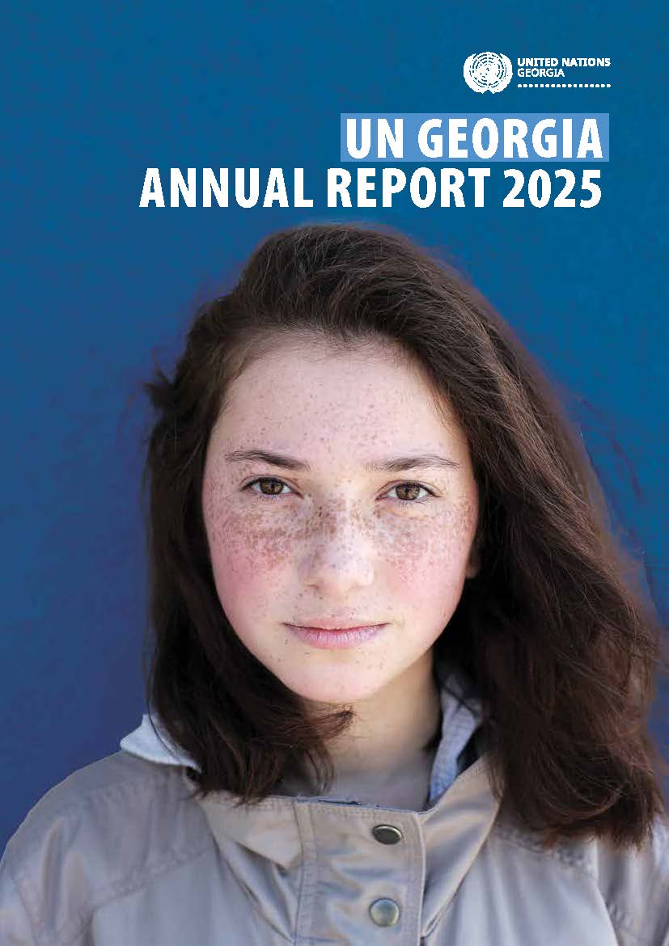

UN Country Team in Georgia
The UN Country Team consisted of 18 UN entities in 2025 with staff based both in and outside of Georgia, working together as One United Nations to support the country in the achievement of its national development priorities and the implementation of the 2030 Agenda for Sustainable Development. The UN Country Team is led by the United Nations Resident Coordinator, who reports to, and is the designated representative of, the United Nations Secretary-General for development operations in the country.

Development partners of the UN development system in Georgia
Action Against Hunger (ACH)
Agence Française de Développement (AFD)
Asian Development Bank (ADB)
Austrian Development Agency (ADA)
Council of Europe (COE)
Czech Development Agency (CzechAid)
Danish Refugee Council (DRC)
Deutsche Gesellschaft für Internationale Zusammenarbeit (GIZ)
Dutch Development Cooperation
European Bank for Reconstruction and Development (EBRD)
European Investment Bank (EIB)
European Union (EU)
Georgian Red Cross
German Development Cooperation
Global Environment Facility (GEF)
Government of Denmark
Government of Estonia
Government of Japan
Green Climate Fund (GCF)
International Committee of Red Cross (ICRC)
International Federation of Red Cross and Red Crescent Societies (IFRC)
Kreditanstalt für Wiederaufbau (KfW)
Japanese International Cooperation Agency (JICA)
Norwegian Development Cooperation
Swedish International Development Cooperation Agency (SIDA)
Swiss Agency for Development and Cooperation (SDC)
Turkish International Development Agency (TIKA)
United States Agency for International Development (USAID)
United States Department of State
United Kingdom Foreign, Commonwealth and Development Office (FCDO)
World Vision (WV)

Foreword
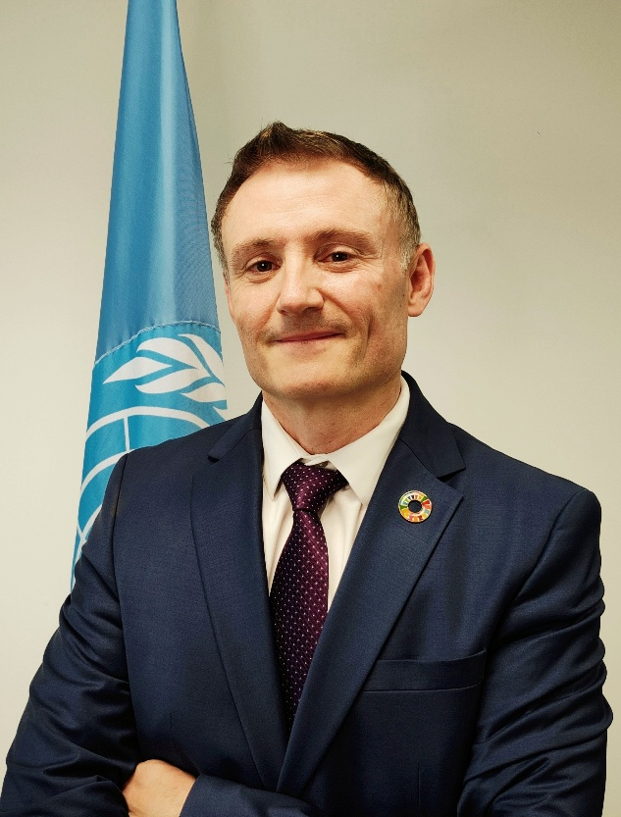
2025 was a pivotal year for the partnership between Georgia and the United Nations. We concluded a full cycle of cooperation with Georgia in line with the 2021–2025 UN Sustainable Development Cooperation Framework and defined the foundations for our support to the country in the years ahead. As Georgia continued its trajectory as a fast‑growing upper‑middle‑income country, the UN strengthened its role as a trusted provider of integrated policy advice, and a convener of diverse actors to find pathways for dialogue and joint action.
Throughout the year, we worked closely with the Government of Georgia, municipalities, civil society, social partners, academia, the private sector and development partners to advance the country’s long‑term development aspirations. Our collaboration remained firmly anchored in the principles of the 2030 Agenda—human rights, gender equality, sustainability, and leaving no one behind. The concluding evaluation of the 2021–2025 Cooperation Framework underscored the value of this partnership, highlighted areas of strong progress, and called for deeper strategic focus, more innovative financing, stronger private sector engagement, and enhanced inclusivity of our support.
These partnerships and insights guided an important milestone: the signing of the new UN Sustainable Development Cooperation Framework 2026–2030 on 9 December 2025, by the Prime Minister of Georgia and me on behalf of the UN Country Team. This Framework represents an ambitious and inclusive strategic aspiration — reflecting national priorities, the voices of more than 300 stakeholders consulted across the country, and the global commitments Georgia upholds. It introduces a renewed UN configuration of 21 UN entities, resident and non‑resident, and a strengthened emphasis on integrated policy support, catalytic financing, digital transformation, and deeper engagement with the private sector.
As we look to 2026, the UN in Georgia steps forward with an important commitment to support the country in translating economic growth into inclusive human development, to protect human rights and strengthen civic space, to expand opportunities for all, and to uphold the dignity and resilience of people affected by conflict. The new Cooperation Framework calls for a whole‑of‑society approach, and we will continue to work alongside all partners, including civil society organizations, youth groups, academia, and the private sector, to mobilize ideas, evidence, and financing for transformative outcomes.
I am grateful for the Government’s leadership and partnership, for the trust and collaboration of local authorities and civil society, for the commitment of Georgia’s development partners, and for the dedication of every UN entity and their teams working in Georgia. Together, we will translate our shared vision into measurable benefit for all people — urban and rural, youth and older persons, women and men — ensuring that the next chapter of Georgia’s development is greener, more inclusive, more resilient, and leaves no one behind.
Didier Trebucq
UN Resident Coordinator in Georgia

Development context in Georgia
In 2025, Georgia experienced continued transformation, marked by both progress and new challenges in its pursuit of sustainable development. The country navigated ongoing and shifting geopolitical tensions and the consequences of conflicts in the wider region, while the aftermath of the October 2024 parliamentary elections fostered ongoing political debate and public demonstrations. Subsequent changes in the legislative framework of Georgia, including on gender equality, triggered reactions from several country partners and European institutions. The expansion of transport and energy connectivity in the South Caucasus continued to drive structural economic change, allowing Georgia to leverage its strategic geographic location along the Middle Corridor between Europe and Asia. The opening of – so far limited – bilateral and transit trade between Armenia and Azerbaijan via Georgia in the second half of 2025 symbolized the shifting geoeconomic landscape in the region. These changes create opportunities for sustainable development but will require proactive policies and strategies to ensure that socio-economic benefits are inclusive and address urban-rural disparities.
Georgia’s economy remained resilient in 2025. Real GDP growth maintained strong momentum, building on the nearly ten percent expansion achieved in the previous year. Economic gains were matched by improvements in social indicators. Gross national income (GNI) per capita surpassed 2,600 USD in the third quarter of 2025, a 15% annual increase, while unemployment stayed close to record lows at around 14%, although the decreasing trend observed since 2021 did not continue. The Labour force participation rate remained largely unchanged, as did the gender gap (44% for participation rate for women and 67% for men). Meanwhile, in 2025 Georgia developed and finalized – but did not yet formally approve and submit – its revised Nationally Determined Contributions (NDCs) under the UN Framework Convention on Climate Change (UNFCCC).
Georgia’s enduring economic vitality presents an opportunity to accelerate SDG investments in social inclusion, human rights protection, poverty alleviation, and green growth, to ensure that prosperity is shared widely and that development remains environmentally and socially sustainable for all Georgians.

[Editorial note: Table to be populated by RCO for the published version.]
Area, km2
Population, 2025
GDP per capita, 2024
Government budget expenditure | On social protection; On health; On education
Unemployment rate | Overall; Women; Men; by age groups; urban vs. rural
Life expectancy | Overall; Women; Men
National poverty rate | Overall; Women; Men
Maternal mortality rate (per 100,000 live births)
Infant mortality rate (per 1,000 live births)
Enrolment rate | Pre-primary; primary and secondary; tertiary
Proportion of women in managerial positions
Economic Freedom Index
SDG Index
Global Gender Gap Index
Environmental Performance Index

2. UN development system’s support to Georgia’s development priorities
[Editorial note: Layout will include an Outcome indicator chart (in an annex) showing baseline, progress and target based on data already submitted by the Results Groups.]
In its fifth and final year of implementing the UN Sustainable Development Cooperation Framework Georgia 2021–2025, the UN Country Team continued to work together with the Government and many other partners towards enhanced human wellbeing, capabilities, and social equality.
The UN supports Georgia in navigating complex development challenges and maintaining focus on protection of human rights, poverty reduction, gender equality, decent work, climate action, improving education and health, strengthening institutions and other key reforms. Through this work, the UN supports the efforts to protect and empower vulnerable people who have so far been often left behind on Georgia’s development pathway: children and youth, informal sector workers, older persons, migrants and refugees, people affected by conflicts, family farmers, rural women, and women survivors of violence, national and religious minorities, persons of non-dominant sexual orientation or gender identity, and persons with disabilities.
This section describes joint UN results achieved in 2025 towards each of the five Outcomes.

Outcome 1: Governance, institutions, rule of law, access to justice, human rights, and women’s representation in decision-making
By 2025, all people in Georgia enjoy improved good governance, more open, resilient and accountable institutions, rule of law, equal access to justice, human rights, and increased representation and participation of women in decision-making
Output | SDGs | 2025 Expenditure
Output 1.1  1.1. Inclusive national and local governance systems have greater resilience and capacities to mainstream gender, migration and ensure evidence-based and participatory policy-making, map and address inequalities and deliver quality services to all. | 1 No Poverty  4 Quality Education  5 Gender Equality  8 Decent Jobs and Economic Growth  10 Reduced Inequalities  11 Sustainable Cities and Communities  13 Climate Action  16 Peace and Justice - Strong Institutions  17 Partnerships for the Goals | $3.2mn
Output 1.2  National legislation and policies to eliminate discrimination, enhance human rights and equal access to justice in Georgia. | 5 Gender Equality  8 Decent Jobs and Economic Growth  10 Reduced Inequalities  16 Peace and Justice - Strong Institutions | $3.9mn
Output 1.3  Legislative frameworks, policies and governance systems deliver gender-equal results, combat GBV, violence against children and other harmful practices towards women and girls. | 3 Good Health and Well-being  5 Gender Equality  8 Decent Jobs and Economic Growth  16 Peace and Justice - Strong Institutions | $1.1mn
Outcome 1, total |  | $8.2mn
Contributing UN Entities: ILO, IOM, OHCHR, UN Women, UNDP, UNECE, UNFPA, UNHCR, UNICEF, UNOPS.

In 2025, the UN worked with national and local authorities, oversight bodies, municipalities, civil society, social partners, academia and communities to protect rights, strengthen civic space and support accountable institutions. The approach combined normative advocacy, institutional capacity building, and community level inclusion, so that policies translate into services and protections for people most at risk of exclusion. Targeted efforts were made to strengthen the capacities of rights-holders, including children, young people, women, and persons with disabilities, on human rights issues and on accessing remedies when their rights are violated. Evidence-based analyses and alternative reports supported alignment with human rights standards.
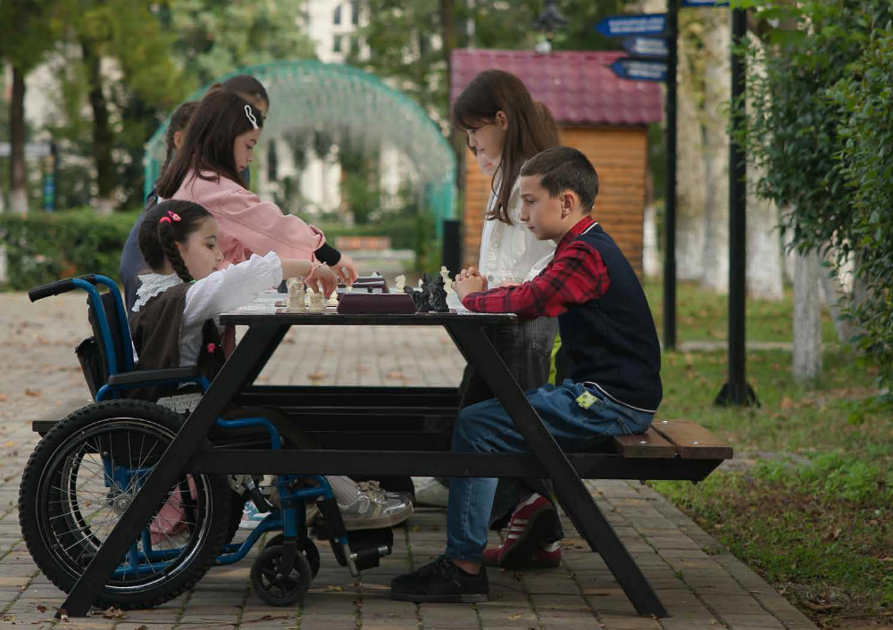
The UN supported the implementation of the biopsychosocial model of disability, which aims to transform the system of disability assessment and status determination, while enabling more targeted, needs-based support for persons with disabilities. A comprehensive curriculum on mainstreaming disability rights in public decision-making was developed, followed by a Training of Trainers programme with organizations of persons with disabilities—embedding accessibility, international standards and structured guidance for national and local policies. These steps strengthened institutional accountability and rights holder participation across sectors. Monitoring by the Public Defender of inpatient mental health facilities reinforced CRPD compliant oversight and remedies.
To make public finance management more gender responsive, officials from eight ministries enhanced gender responsive budgeting capacities, and gender tagging was applied to 19 state programmes and 21 sub programmes—a practical step toward institutionalizing equality in resource allocation. At the local level, 103 municipal officials strengthened gender mainstreaming skills, and four more municipalities signed the European Charter for Equality of Women and Men, bringing the total to 30 of 64 municipalities. The UN also facilitated the development of a country‑specific methodology for child‑rights‑based municipal budgeting and trained around 20 municipalities in its practical application. This support enables local governments to analyse existing spending on children and improve the efficiency and effectiveness of future investments. The State Audit Office advanced a methodology to integrate gender into performance audits and drafted an internal mechanism on sexual harassment prevention, reinforcing independent oversight and workplace safeguards. Across the public sector, 150 officials improved knowledge on sexual harassment prevention and response, while partnerships with the Public Defender’s Office and academic institutions expanded sustainable learning platforms for equality and non-discrimination.
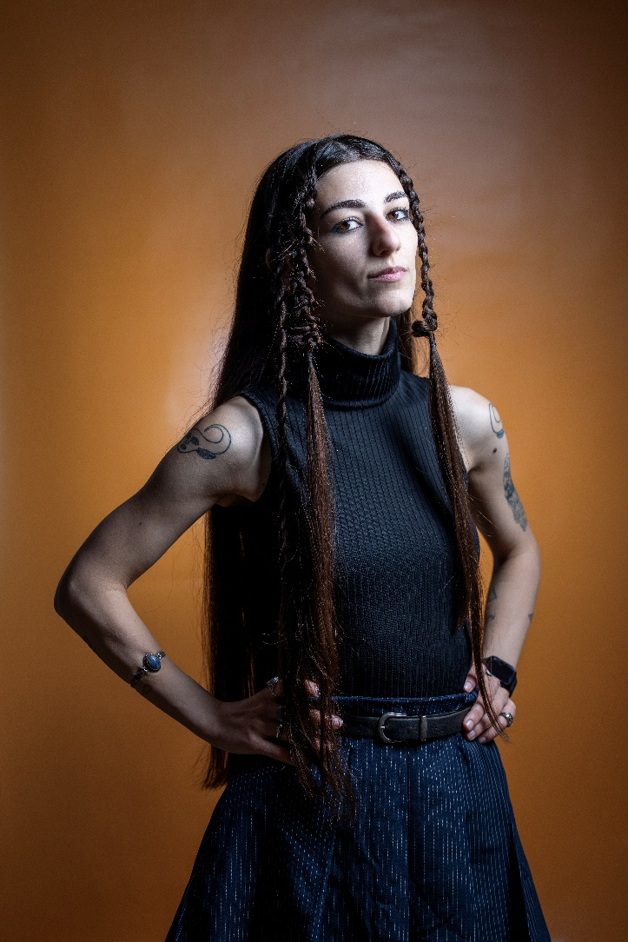
The UN supported policy reforms and multisectoral coordination to prevent and respond to violence against women and girls, including work on technology facilitated gender-based violence, early marriage prevention, and parental leave reform to reduce unequal care burdens. Recent analysis of SDG indicators showed child marriage declining from 14% (2018) to 7% (2024) and early childbirth from 6% to 3%. Health-sector responses to gender-based violence improved through multi-sectoral coordination and legal reform efforts.
Following an international review, social partners launched tripartite dialogue to advance compliance with freedom of association standards and strengthen the Tripartite Social Partnership Commission. A functional review of collective labour dispute mediation informed improvements in accessibility and effectiveness. To underpin decent work and formalization policies, national statistical capacity was upgraded: modern methods (ICSE 18) were introduced in the Labour Force Survey, national definitions were aligned with international standards, and options to capture informal enterprise activity were designed—supporting a national roadmap for formalization and evidence-based policymaking.
A national reintegration framework was advanced to coordinate whole-of-government support for returnees and to strengthen the role of local governments. Migration Service Hubs at the local level improved responsiveness and user experience, connecting residents—including returnees and migrant households—to municipal and national services and employment pathways, while targeted coaching upgraded frontline professional skills. For people with international protection, access to social protection, education and healthcare continued in partnership with the Government. Support to drafting refugee integration policy advanced with a whole-of-government approach, emphasizing community engagement and a stronger municipal role.
In partnership with the civil society, the UN helped to expand access to justice for people in remote and underserved areas: 1,511 vulnerable individuals received assistance (including women affected by gender-based violence, refugees and persons with disabilities), mobile legal clinics reached 23 towns, and targeted training increased state Legal Aid Service expertise in international litigation by up to 83%. Mediation, environmental justice and inclusive legal services were strengthened through training for lawyers, mediators and minority representatives, while thousands accessed combined psychological, social, legal and protection services.
The UN supported child‑sensitive justice reforms by supporting specialized child-friendly legal aid, creating child‑friendly consultation environments, and leading national discussions on establishing a child‑specialized judge. More than 300 children engaged in rights‑based learning activities. To promote meaningful participation in juvenile justice proceedings, the UN supported specialization training for 25 State Care Agency professionals serving as procedural representatives.
The UN also initiated groundwork for introducing child rights impact assessments as a strategic tool for child rights‑based law and policymaking, setting the stage for systematic application in the coming years.
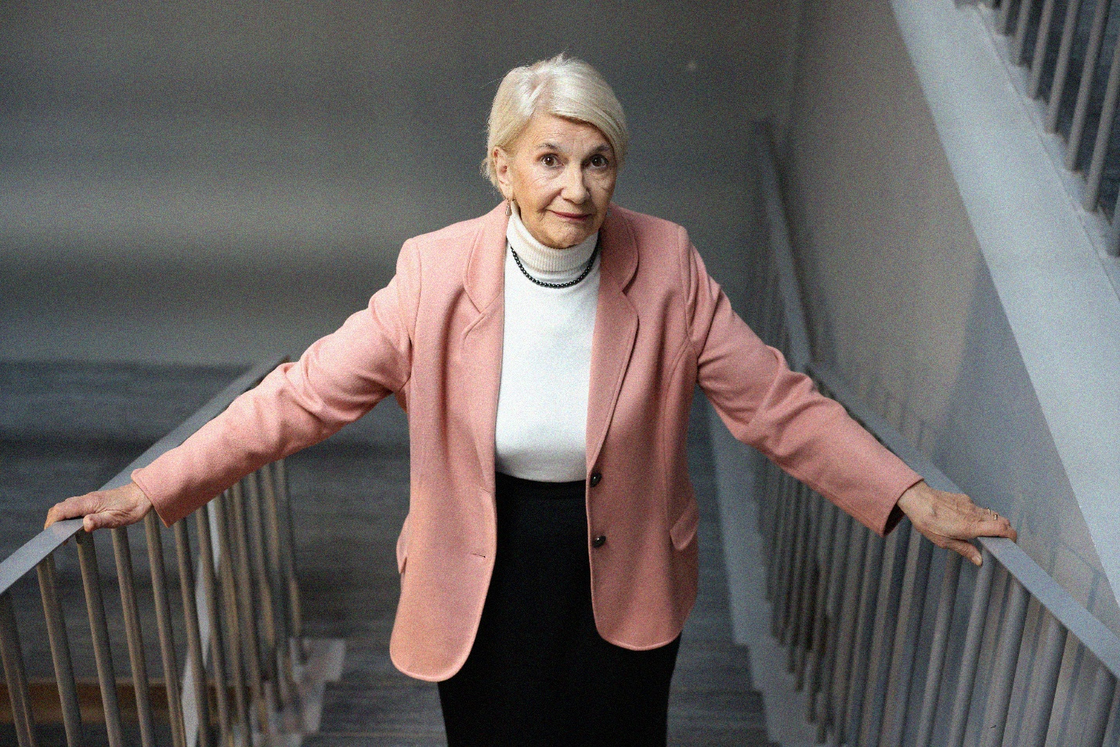
The UN scaled the “60+ Club for Healthy and Active Living” into a sustainable municipal service model. The Clubs enhanced social inclusion, digital literacy and access to age-sensitive health information for older persons.
The UN also advanced youth policies through engagement with the Youth Agency, contributing to the national Youth Action Plan and integrating a Youth, Peace and Security chapter to promote meaningful participation of young women and men in civic and peacebuilding processes.
With the UN support, Georgia expanded its capacity to produce disaggregated demographic and ageing‑related statistics, strengthening the ability of ministries and GEOSTAT to design policies grounded in evidence. The UN also supported the transition toward a register‑based census, improving timeliness and precision in mapping inequalities.
The UN strengthened resilience of civil society organizations as part of its efforts to strengthen civic space and promote local dialogue. Grassroots leadership pipelines for women were expanded through national and local platforms, engaging over 350 civil society representative and 614 rural women. Community mobilization and campaigns reached ~1 million users and 6+ million views, challenging norms around unpaid care work and amplifying diverse voices—especially from rural and minority communities. Innovative partnerships with municipalities, civil society and the private sector scaled public campaigns, expanding civic participation and promoting digital and bodily autonomy as human rights.

Outcome 2: Access to services
By 2025, all people in Georgia have equitable and inclusive access to quality, resilient and gender-sensitive services delivered in accordance with international human rights standards
Output | SDGs | 2025 Expenditure
Output 2.1  Improved national capacities for the implementation of policies and programmes that ensure equitable access to and coverage of quality integrated health and nutrition services and the exercise of reproductive rights for all people, particularly, those left behind. | 2 Zero Hunger  3 Good Health and Well-being  5 Gender Equality  6 Clean Water and Sanitation  10 Reduced Inequalities | $1.2mn
Output 2.2  Improved national capacities for the implementation of policies and programmes that ensure inclusive and equitable access to quality educational programmes that meet international standards. | 4 Quality Education  5 Gender Equality | $2.5mn
Output 2.3  Improved national legislation, policy, programs and capacities protect all people in Georgia, especially the most vulnerable and marginalized, against discrimination and ensure equitable access to and coverage of quality social services. | 1 No Poverty  5 Gender Equality  10 Reduced Inequalities  16 Peace and Justice - Strong Institutions  8 Decent Jobs and Economic Growth | $1.9mn
Outcome 2, total |  | $5.6mn
Contributing UN Entities: IOM, UNDP, UNFPA, UNHCHR, UNICEF, UNOPS, WHO.

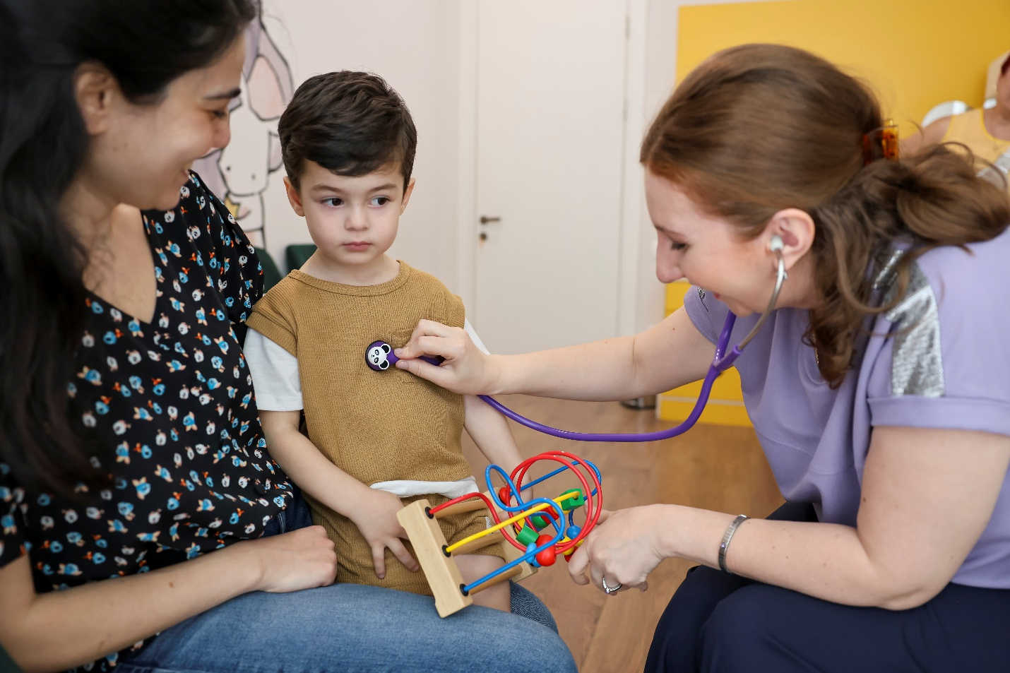

In 2025, the UN worked system wide with national authorities and local partners to strengthen health, education, and social protection systems, aiming to close persistent urban–rural gaps and ensure that children, persons with disabilities, migrants and displaced people, ethnic and linguistic minorities, and older persons were not left behind. The focus was on policy alignment with international standards, institutional capacity, and digital enablers that improve quality, reach and accountability.
The UN supported national efforts to prevent mother to child transmission of HIV, syphilis and hepatitis B by updating surveillance, strengthening provider training and enhancing the Birth Registry. A national agreement to introduce benzathine penicillin G for antenatal syphilis prevention was advanced.
Primary health care (PHC) capacity was expanded through child development monitoring integrated into 50 rural clinics, backed by two national protocols for standardized visits, teleconsultations and cross-sectoral referral pathways. A national queue‑management system enabled nearly 79,000 consultations, reaching 10% of the eligible population. The Cancer Screening E‑Registry reached full provider compliance and drove a 143% increase in screening bookings.
The UN helped improve maternal and reproductive health by expanding Beyond the Numbers approach to all Level III maternity facilities in Georgia, improving emergency obstetric management by 20%.
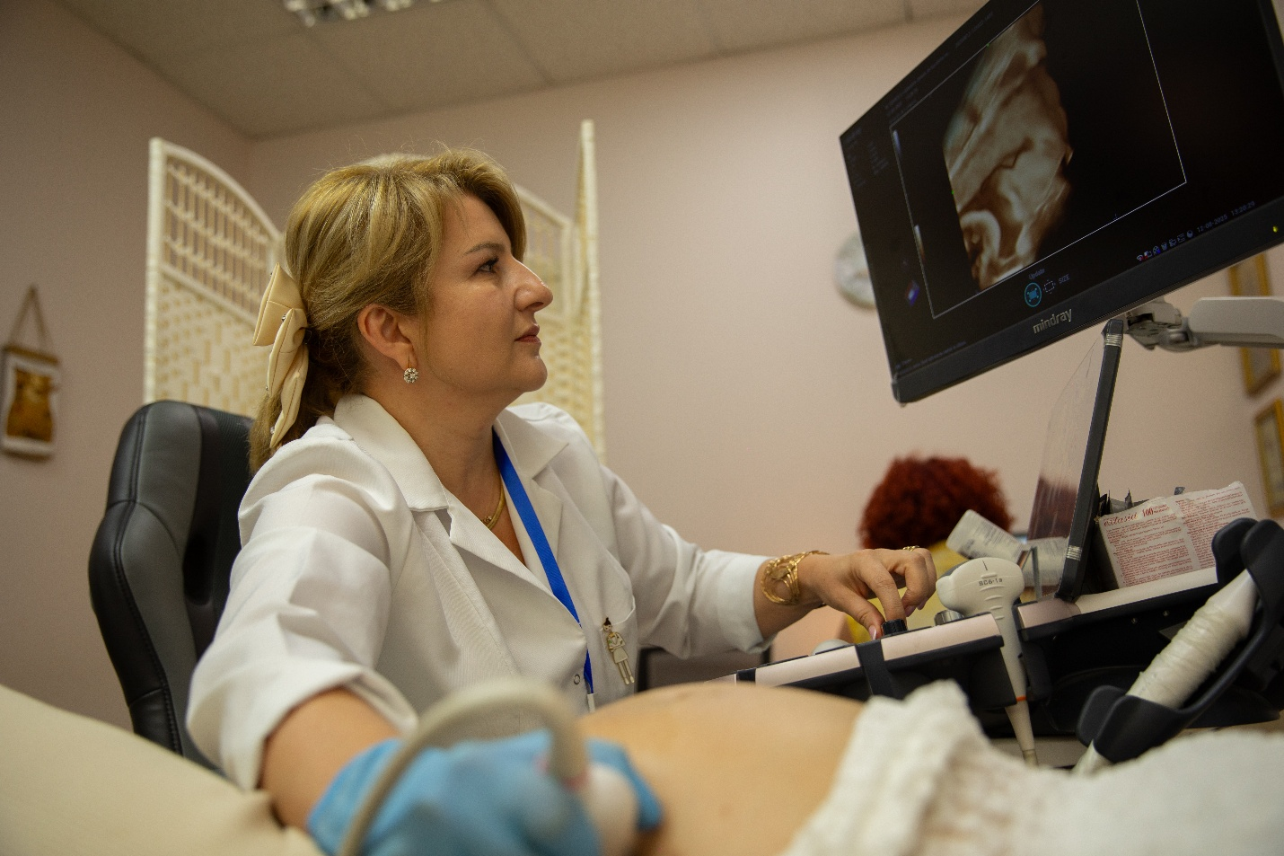
With UN support through policy dialogues and research, Georgia prioritized eliminating industrial trans fats (iTFAs) and adopted best-practice legislation in October 2025 to help protect heart health. Additionally, with UN support, Georgia developed a National Salt Reduction Strategy and Action Plan and drafted the 2026-2027 National Rehabilitation Action Plan to strengthen overall public health and chronic disease prevention.
A UN joint programme, supported by the European Union, equipped 60 rural ambulatories for telemedicine and helped operationalize a Telemedicine Monitoring Framework and the first accredited telemedicine course, complementing broader support to the ongoing PHC reform and work on assistive technologies, rehabilitation, and reduction of risks of non-communicable diseases. The UN also provided analysis to inform breast cancer medicine reimbursement options.
To improve equity and quality in education, the UN in partnership with the Ministry of Education, Science and Youth promoted early bilingual education for ethnic and linguistic minority learners through practical guidelines and teacher capacity building in municipalities with large ethnic minority communities. To strengthen inclusive general education, two national protocols (psychoeducational assessment; consultation for children with disabilities) were developed to improve consistency and quality of support services nationwide.

As a result of a partnership between the UN, Ministry of Education, Science and Youth, and the Communications Commission, the number of schools teaching media literacy reached 230 with around 2,500 teachers trained, enhancing students’ critical thinking and resilience to misinformation. The country’s first multidisciplinary MA in Child Rights progressed toward accreditation, alongside the establishment of Child Rights Centres at universities and capacity building of the Child Rights Academic Network of Georgia.
The UN facilitated high level commitments to expand Barnahus services and initiated a national review of child–family separation AND reintegration processes, as well as a social service workforce mapping to inform standards and coverage. Georgia’s first trauma-focused therapy cohort (19 specialists) was trained to improve trauma recovery for children.
The UN also advanced disability-inclusive health and social care, including a national informed consent guide, service readiness for accessible sexual and reproductive health services, and multi stakeholder dialogue to align governance with CRPD obligations.
System level prevention and response to violence against women and girls were reinforced through legislative and institutional analysis, including a study on the economic costs of inaction on violence and work to align national practice with the Istanbul Convention. Prevention and detection capacities improved nationwide—1,243 school personnel were trained to recognize and respond to violence against women and girls/domestic violence; gender equality modules were integrated into teacher training; and community awareness initiatives reached thousands. Tailored legal and psychosocial support reached survivors and at-risk groups, with specialized services expanded and practical access tools introduced, such as child-friendly legal aid.
At the municipal level, Migration Service Hubs provided counselling, referrals and socioeconomic linkages to 3,073 returnees, IDPs and other local residents (in-person and remote), while 122 municipal social workers were trained to improve early identification and referral of trafficking victims and other vulnerable groups.
The UN also strengthened the capacity of professionals working with Ukrainian children by engaging 51 specialists from government and non-governmental organizations to deliver quality mental health and psychosocial support services, ensuring continuity of care for displaced children and families.

Outcome 3: Inclusive and resilient economy
By 2025, all people without discrimination benefit from a sustainable, inclusive and resilient economy in Georgia
Output | SDGs | 2025 Expenditure
Output 3.1  Improved competitiveness and social responsibility of private sector. | 1 No Poverty  5 Gender Equality  8 Decent Jobs and Economic Growth  9 Industry, Innovation and Infrastructure  16 Peace and Justice - Strong Institutions  17 Partnerships for the Goals | $2.9mn
Output 3.2  Sustainable and inclusive agricultural and rural development, strengthened food systems and improved livelihoods. | 1 No Poverty  2 Zero Hunger  3 Good Health and Well-being  4 Quality Education  5 Gender Equality  7 Affordable and Clean Energy  8 Decent Jobs and Economic Growth  9 Industry, Innovation and Infrastructure  11 Sustainable Cities and Communities  12 Responsible Consumption and Production | $7.1mn
Output 3.3  Increased productive employment, decent work, skills development and effective national social protection for all | 1 No Poverty  2 Zero Hunger  4 Quality Education  5 Gender Equality  8 Decent Jobs and Economic Growth  10 Reduced Inequalities | $2.8mn
Outcome 3, total |  | $12.9mn
Contributing UN Entities: FAO, IFAD, ILO, UN Women, UNDP, UNECE, UNICEF, UNIDO.

In 2025, the UN worked with national and local authorities, social partners, academia, private sector actors and civil society to translate economic growth into more and better jobs, higher productivity and broader inclusion, while aligning policies and institutions with international standards. The approach combined skills and labour market reforms, greener value chains and rural transformation, SDG localization, and child sensitive social protection—so that gains are shared more evenly across regions and people.
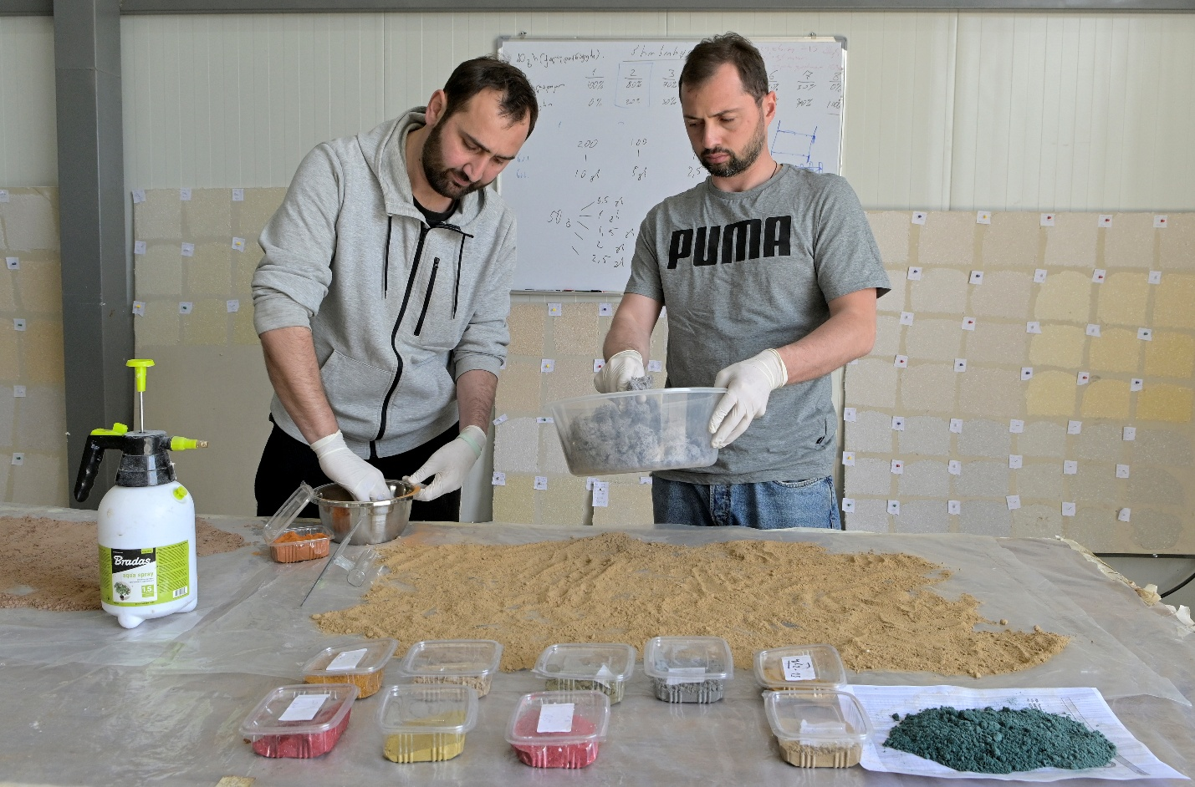
The UN supported a nationwide effort to modernize skills ecosystems, aligning qualifications and work-based learning with real market demand through structured public–private mechanisms. Vocational colleges and municipal extension centres were upgraded for blended and digital learning; institutional development plans were rolled out for six agricultural VET colleges and 25 municipal extension centres, and inclusion measures opened pathways for youth and women. As a result, over 16,000 people (youth, women and farmers) accessed market relevant training; 400+ graduates moved into employment; and 9,000+ farmers adopted improved practices, raising productivity and incomes. The UN also initiated the social entrepreneurship programme UPSHIFT for adolescents to develop their key competencies to address diverse social needs.
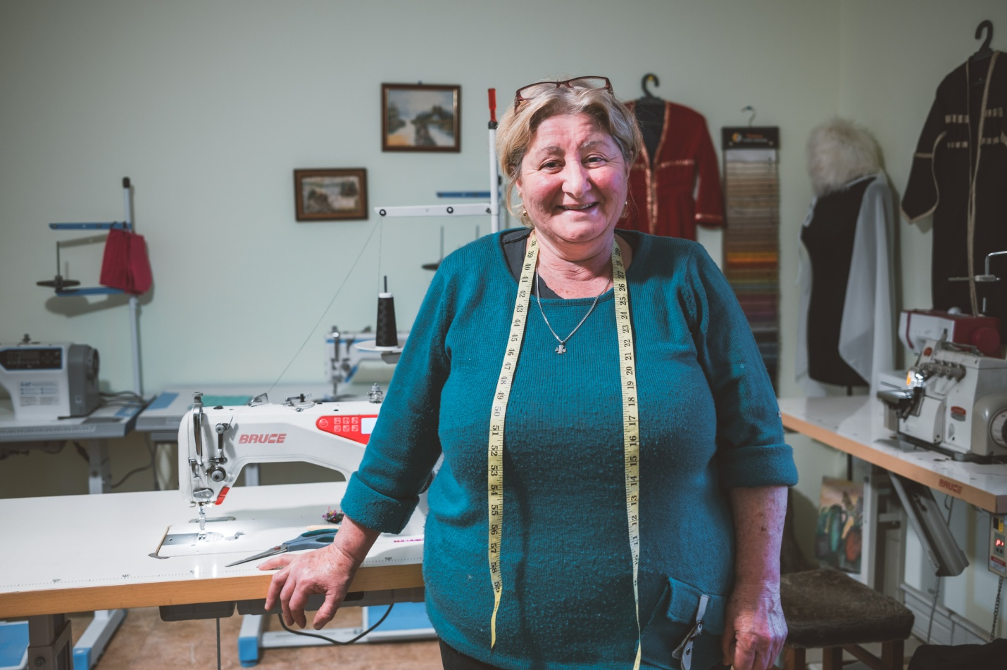
To link climate action with economic prosperity, the UN supported sustainable forest management across 60,000 hectares in Racha, retrained and hired a new cadre of forest engineers, and piloted renewable energy communities that eased pressure on forests and reduced household energy costs. Locally led transitions were anchored by Georgia’s first action-oriented Voluntary Local Reviews (VLRs) in Poti and Khashuri, a digital needs portal to prioritize investments, municipal waste plans, and a child-centred budget lens to ensure that public spending decisions reflect the needs of families and future generations.
With the UN support, Georgia adopted a Law on Food Loss and Waste Reduction and Food Donation, approved a Food Safety Strategy (2025–2028) and a Food Waste Management Concept, and completed a food control system assessment to steer targeted investments. These measures improved resource efficiency, food security, compliance and market access for producers and consumers.
The UN helped enterprises become more export-ready and compliant with international standards. The pesticide management and testing system was strengthened to raise compliance and market access for MSMEs. The UN also helped mainstream gender in national quality infrastructure. Livestock and farm management systems were advanced to improve coverage and accuracy, and aquaculture governance was upgraded.
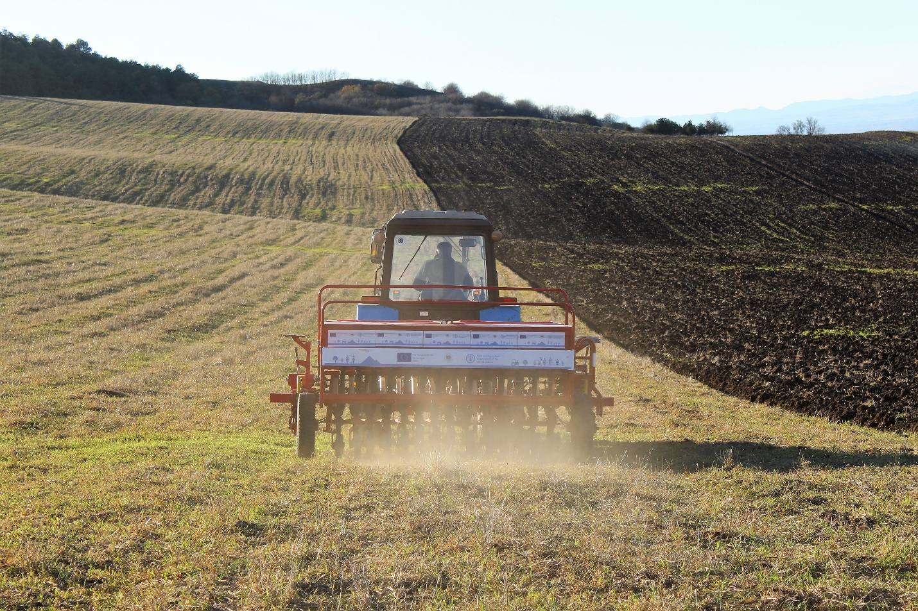
At the same time, work on regional transport corridors progressed by advancing options for modal shift to rail, electrified multimodal infrastructure and greener logistics, while harmonized, digitalized transport documentation and technical workshops addressed bottlenecks and improved container packing safety.
The UN provided policy advice on minimum wage design, unemployment insurance groundwork, quality apprenticeships, and formalization analytics to guide evidence-based improvements to labour and social protection policies. Georgia registered its first Labour Union of Domestic and Care Workers with 92 members.
A national care‑economy investment study quantified service gaps and returns; equal pay efforts progressed via the Structure of Earnings Survey and a campaign reaching 276,000 people. State Employment Support Agency (SESA) institutionalized the Gender‑Aware Employment Consulting Guideline.
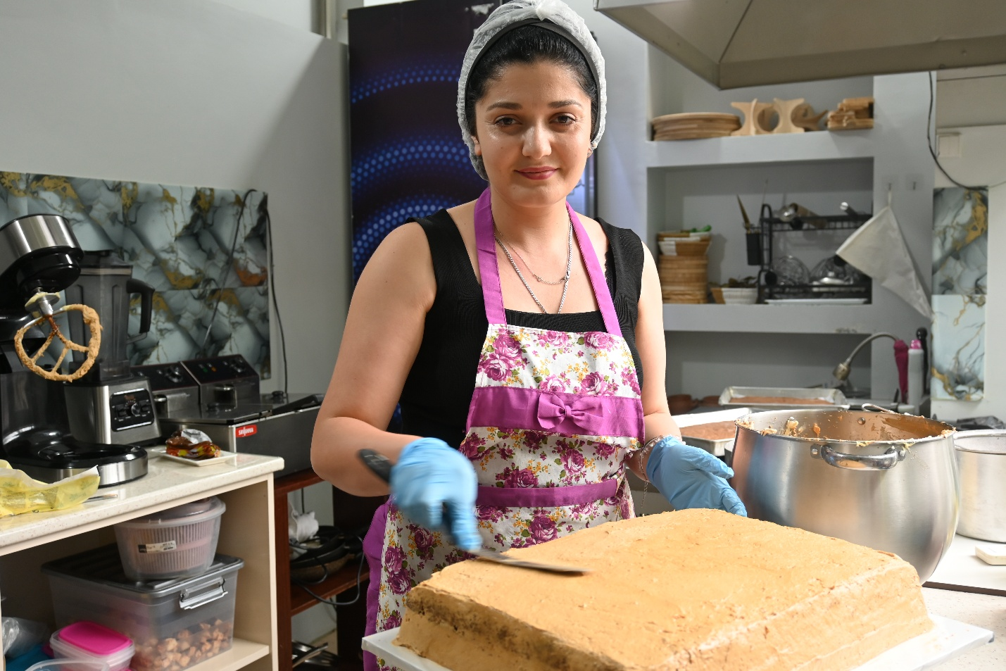
Through integrated municipal support, migrants and returnees received targeted counselling, job placement, skills, and self-employment pathways across 10 municipalities. 698 individuals accessed employment, training, or enterprise support. Financial literacy sessions for labour migrants helped families use remittances to improve household welfare and local development. These measures contributed to sustainable reintegration of Georgian returnees.
The UN also supported the development of Georgia’s first Social Protection Strategic Note for Children and a child-rights based budgeting approach, embedding children’s priorities in national planning and resource allocation. Municipalities piloted workforce capacity assessments (20 municipalities), emergency preparedness and budgeting tools, and service mapping with a minimum social service package, improving equity and coverage. A child-centred framework for individualized packages for children with disabilities linked biopsychosocial assessment to tailored support with clear referral and case management pathways. These steps improved local service quality, helping families manage risks and invest in children’s development.
A stronger push on women’s economic participation saw more companies commit to workplace equality and nurture women leadership pipelines, reinforcing the business case for inclusion. 36 additional companies joined the Women’s Empowerment Principles, bringing the total number of signatories to 323, representing 150,000+ employees. 378 corporate representatives completed training on sexual harassment prevention, equal pay, diversity and inclusion, gender‑responsive procurement and gender gap analysis, while 28 banking sector leaders advanced through an executive programme on women’s leadership.
In partnership with the Rural Development Agency, the UN advanced women farmers’ climate resilience, productivity and access to finance in Kakheti, Shida Kartli and Kvemo Kartli. Over 1,000 rural women-built entrepreneurship skills; 1,194 gained digital skills, 126 accessed small grants, and 65 obtained state‑recognized care certificates enabling employment in state‑funded care programmes.

Outcome 4: Conflict affected communities
By 2025, conflict-affected communities enjoy human rights, enhanced human security and resilience
Output | SDGs | 2025 Expenditure
Output 4.1  Conflict affected  communities have improved  access to essential services,  including education,  healthcare, GBV response and  legal assistance | 3 Good Health and Well-being  4 Quality Education  5 Gender Equality  6 Clean Water and Sanitation  16 Peace and Justice - Strong Institutions | $3.8mn
Output 4.2  Socio-economic  conditions, community  resilience and self-reliance  improved with programmes  benefiting conflict affected  communities particularly those  left behind | 1 No Poverty  2 Zero Hunger  3 Good Health and Well-being  4 Quality Education  5 Gender Equality  16 Peace and Justice - Strong Institutions | $0.1mn
Output 4.3  Space widened for dialogue and participation that strengthens civil society, community resilience, social cohesion and implementation of the Women, Peace and Security agenda | 3 Good Health and Well-being  5 Gender Equality  13 Climate Action  16 Peace and Justice - Strong Institutions | $3.0mn
Outcome 4, total |  | $6.9mn
Contributing UN Entities: FAO, UN Women, UNICEF, UNDP, UNHCR, UNFPA, WHO.

In 2025, the UN worked with national and local authorities, civil society and communities across the country, including in Abkhazia, Georgia, to deliver basic services, to protect rights of conflict-affected people, and to promote an enabling environment for peace.
The UN supported healthcare and psychosocial assistance that reached conflict-affected people in Abkhazia and along the Administrative Boundary Line (ABL): mobile and facility based teams provided consultations to 435 patients, diagnostics (including first time neurological services in Abkhazia for 50 patients), rehabilitation for 112 persons with disabilities, psychiatric support for 61 children, and targeted medical assistance for vulnerable individuals. The UN also strengthened primary care facilities in Abkhazia through updates to clinical guidelines, outbreak surveillance for vaccine‑preventable diseases, and infection prevention and control assessments across 9 facilities, improving preparedness for community outbreaks and ensuring safer care environments.
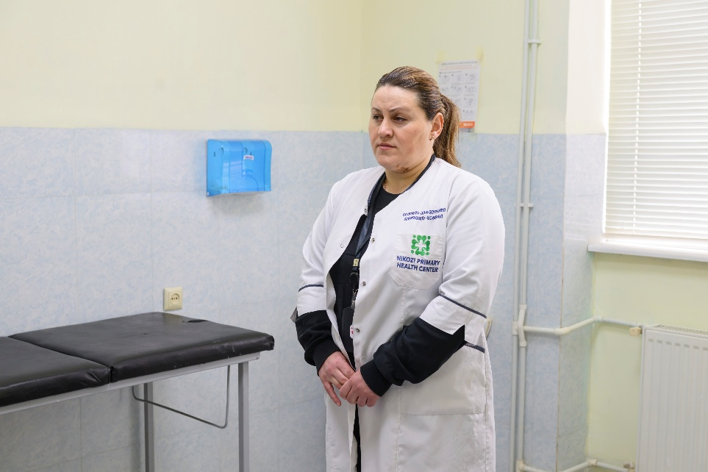
The UN ensured uninterrupted sexual and reproductive health for over 2,500 conflict‑affected women, including cervical cancer screening and family planning. Support included mobile outreach, capacity‑building for 35 specialists and 15 health professionals, and professional exchanges between maternal health specialists across the dividing line, leading to 126 complex case consultations and 43 life‑saving maternal referrals.
The UN facilitated transportation of humanitarian and other essential goods to Abkhazia, including quarterly shipments of vaccines against hepatitis B, rabies, measles, mumps, and rubella, as well as medical consumables and agricultural insecticides. In total, 20 tons of insecticide were delivered for agricultural purposes. The total value of shipments in 2025 exceeded USD 400,000.
Legal aid was expanded for 944 conflict affected people (67% women), with a focus on documentation, social allowances and property rights. The UN also facilitated provision of 428 legal consultations to minors and low-income families. UN supported crisis centres for survivors of gender-based/domestic violence, and mobile outreach in Abkhazia delivered survivor centred legal and psychosocial services and improved case detection for women and girls, while community-based prevention activities addressed barriers to reporting and access. Services were organized to reduce travel burdens and stigma, including helpline support and local referrals. Crisis centres in Gali and Sukhumi provided 136 legal/psychosocial consultations, responded to 36 helpline cases and supported 226 women; mobile teams reached additional survivors and minors facing access barriers.
To safeguard child well-being and learning continuity, the UN improved water, sanitation and hygiene infrastructure and operations in schools and supported psychological services for children in difficult situations in Abkhazia. 16 schools (1,872 children) benefited from WASH upgrades in 2025. Community based child protection mechanisms were further strengthened through district social work support and village level networks, resulting in assistance to 215 children.
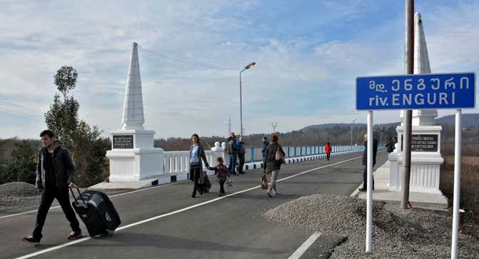
Through five demonstration plots and 24 Farmer Field Schools in Abkhazia (14) and Samegrelo (10), the UN strengthened access to extension services—especially for conflict-affected women smallholders—introducing improved horticulture varieties, dairy practices, and viticulture techniques. Agricultural inputs were distributed to 243 women farmers, and training on pest monitoring and safe practices supported food security and income generation.
While the UN has no access to Tskhinvali region/South Ossetia, it continued to support local environmental advocates, mostly women and young people, in their work on environmental protection and climate action.The UN widened platforms for dialogue and cooperation across Georgia — from regional study visits for civil society organizations to professional exchanges in healthcare and psychosocial care. The UN also strengthened peace education among 278 teachers, and supported community youth initiatives that fostered environmental stewardship and trust among 135 young people.
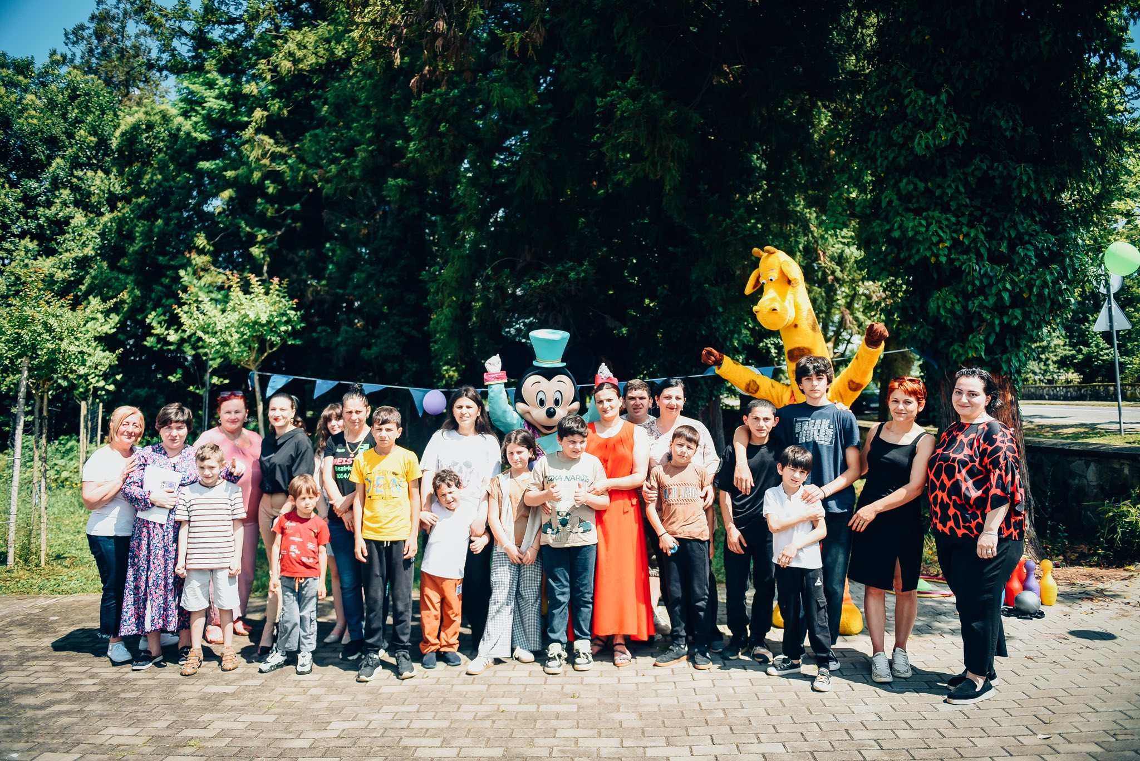
82 stakeholders convened at the annual Open Day on Women, Peace and Security (WPS). The Network of Women and Youth Peace Ambassadors brought together 264 members across 17 municipalities, linking local concerns with national and regional WPS, and Youth, Peace and Security (YPS) agendas. 70+ youth leaders engaged in global platforms, culminating in a youth-led Call for Action advancing both the WPS and YPS agendas.
Women from the Shida Kartli region, representing ethnically mixed Georgian-Ossetian communities, came together for a creative workshop to share their life stories and reimagine peace. Through storytelling circles and art-based practices, they explored conflict and resilience, transforming pain into strength and empathy into connection.
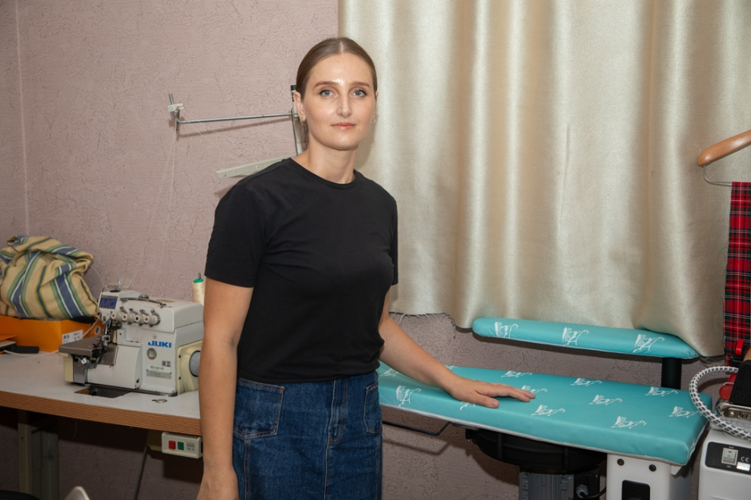
Social mobilization across 15 municipalities helped communities identify priorities and implement initiatives to improve lives of internally displaced residents, with 16 self-help groups, needs assessments and women led actions that improved local services and cohesion engaging 1,843 people. In Abkhazia, the UN supported 18 civil society organizations in implementing community initiatives benefitting more than 1,100 people.
In IDP settlements and ABL adjacent communities, the UN supported community driven infrastructure upgrades (benefiting 680+ residents), smart agriculture training (leading to 14 micro agro enterprises), tailored livelihood support, and entrepreneurship services that enabled new women and youth led businesses. 32 women along the ABL launched micro‑enterprises with the UN support.
The UN supported the integration of peace, equality, and inclusivity into Georgia’s National Goals of General Education, embedding conflict‑transformation principles at the heart of the country’s long‑term education framework. The Government’s adoption of the IDP Women’s Economic Empowerment Programme marks a major institutional step. The UN submitted a dedicated YPS chapter to the State Youth Strategy for possible integration in 2026. The UN also supported reforms across the defence sector, embedding gender mainstreaming in defence structures through leadership programmes.

Outcome 5: Resilience, environmental governance, climate action, and use of natural resources
By 2025, all people, without discrimination, enjoy enhanced resilience through improved environmental governance, climate action and sustainable management and use of natural resources in Georgia
Output | SDGs | 2025 Expenditure
Output 5.1  Environmental governance and institutional capacity enhanced to enable rational, equitable and sustainable use of natural/land resources, to ensure conservation of ecosystems and make communities more resilient to environmental shocks | 1 No Poverty  2 Zero Hunger  3 Good Health and Well-being  5 Gender Equality  6 Clean Water and Sanitation  7 Affordable and Clean Energy  9 Industry, Innovation and Infrastructure  10 Reduced Inequalities  11 Sustainable Cities and Communities  12 Responsible Consumption and Production  13 Climate Action 15 Life on Land  17 Partnerships for the Goals | $2.7mn
Output 5.2  Climate-sensitive, resilient and risk-informed development ensured, without discrimination, in AFOLU, health, water safety, construction, energy and food production sectors to increase adaptive capacities and mitigate impact of climate change pursuing LDN (Land Degradation Neutrality) | 3 Good Health and Well-being  12 Responsible Consumption and Production  13 Climate Action  15 Life on Land | $2.2mn
Output 5.3  Innovative and climate-friendly technologies used for inclusive green economy, energy efficiency and clean energy production to enhance NDCs (Nationally Determined Contributions) and support long-term decarbonization strategies | 7 Affordable and Clean Energy  9 Industry, Innovation and Infrastructure  12 Responsible Consumption and Production  13 Climate Action | $1.5mn
Outcome 5, total |  | $6.4mn
Contributing UN Entities: FAO, IFAD, IOM, UNICEF, UNDP, UNECE, UNIDO, WHO.

In 2025, the UN scaled up support for climate governance, emergency preparedness, clean energy, sustainable land use and biodiversity protection. This work strengthened Georgia’s ability to pursue a low‑emission, climate‑resilient future that leaves no one behind, particularly the communities most exposed to climate-related shocks.
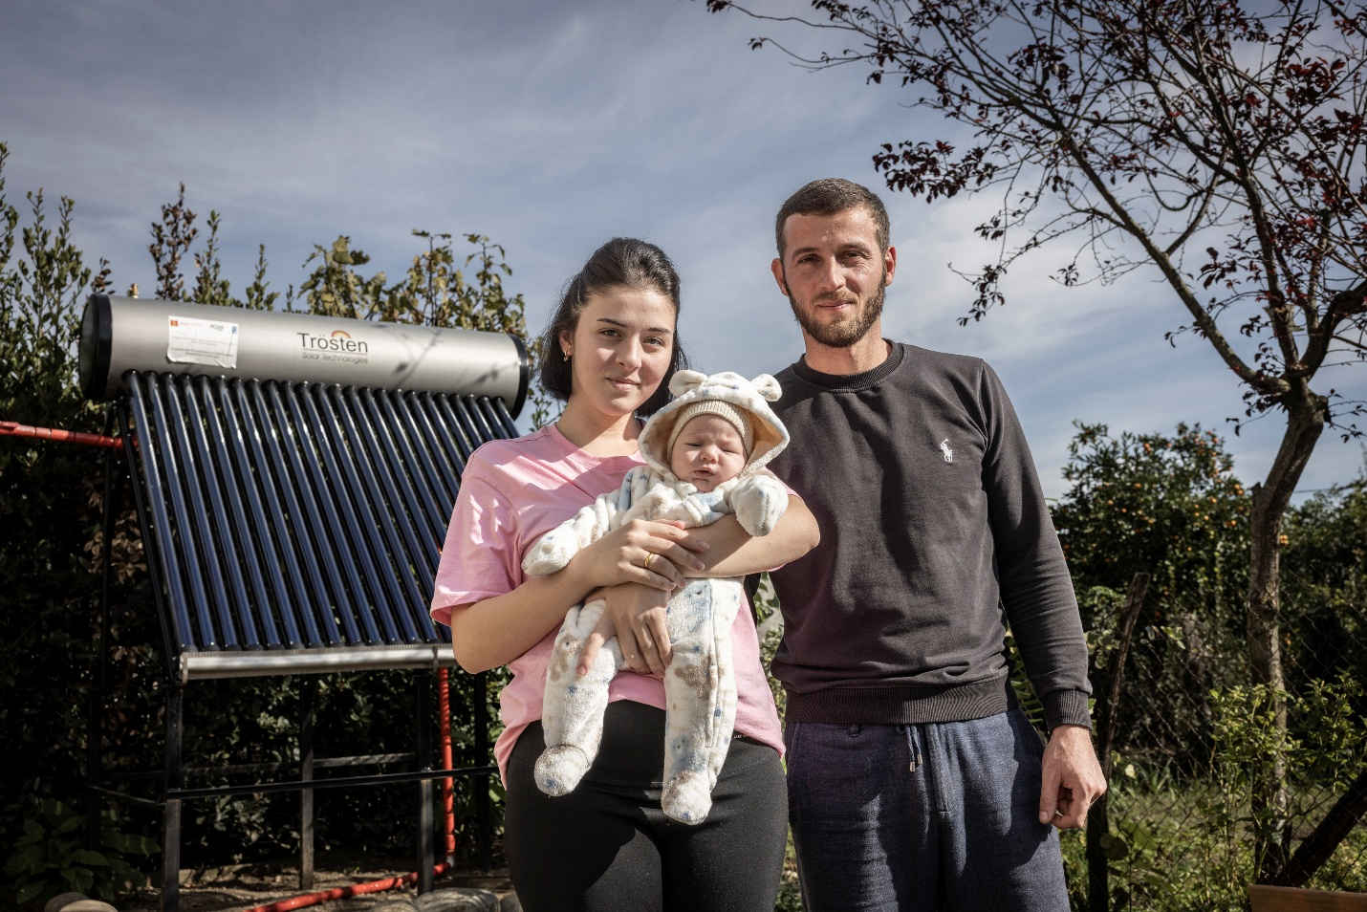

Working across government institutions and civil society, UN agencies supported the development of Georgia’s Nationally Determined Contributions (NDC 3.0), the country’s most ambitious climate commitment to date. The process was grounded in principles of gender equality, environmental justice and responsiveness to the needs of vulnerable communities.
The UN supported the preparation of Georgia’s first Biennial Transparency Report (BTR) and Fifth National Communication to the UNFCCC. A UN system-wide mapping of climate action and a gap analysis were conducted, providing the foundation for the Climate Promise 2025 rollout and the preparation of a joint UN offer.

A national study on Climate Change and Human Mobility in Georgia provided a mapping of climate-related risks at the municipal level, including floods, landslides, drought and heat stress. It also identified vulnerable population groups, generating a strong evidence base to inform future adaptation policies and planning.
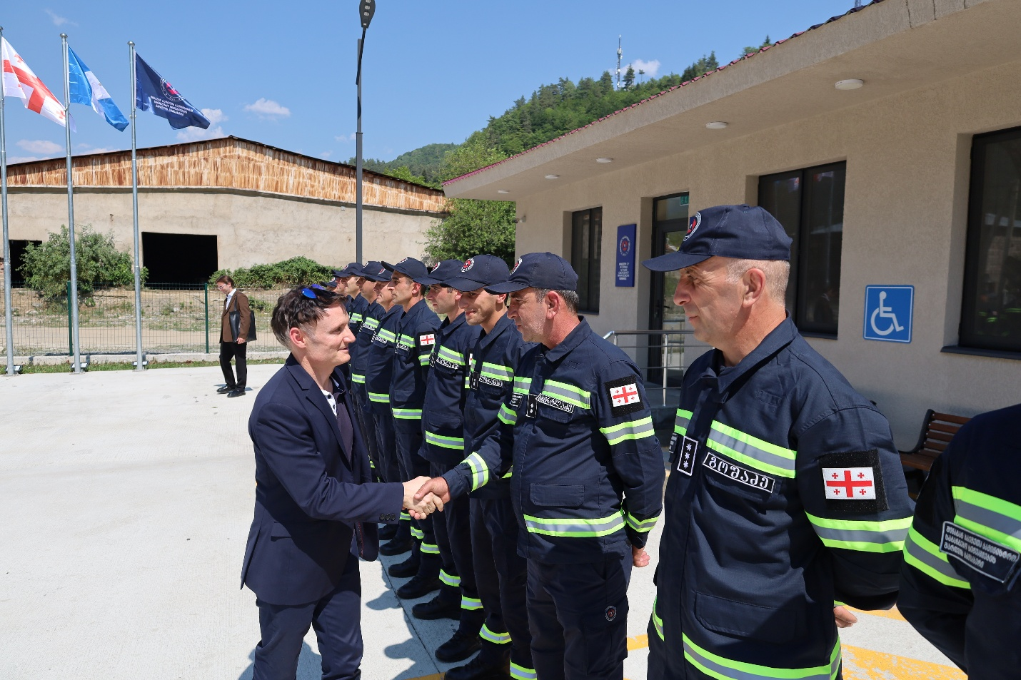
The UN helped to enhance Georgia’s capability to anticipate, respond to and reduce disaster risks:
- Six municipal Emergency Management Plans (Lagodekhi, Gori, Kobuleti, Senaki, Khobi, Samtredia) adopted
- 144 hydro‑meteorological monitoring stations operationalized
- A Multi‑Hazard Disaster Risk Information System deployed
- Forecasting platforms established for all 11 river basins
- 32 climate‑adaptation measures were implemented across 16 high‑risk communities, benefiting 55,188 people.
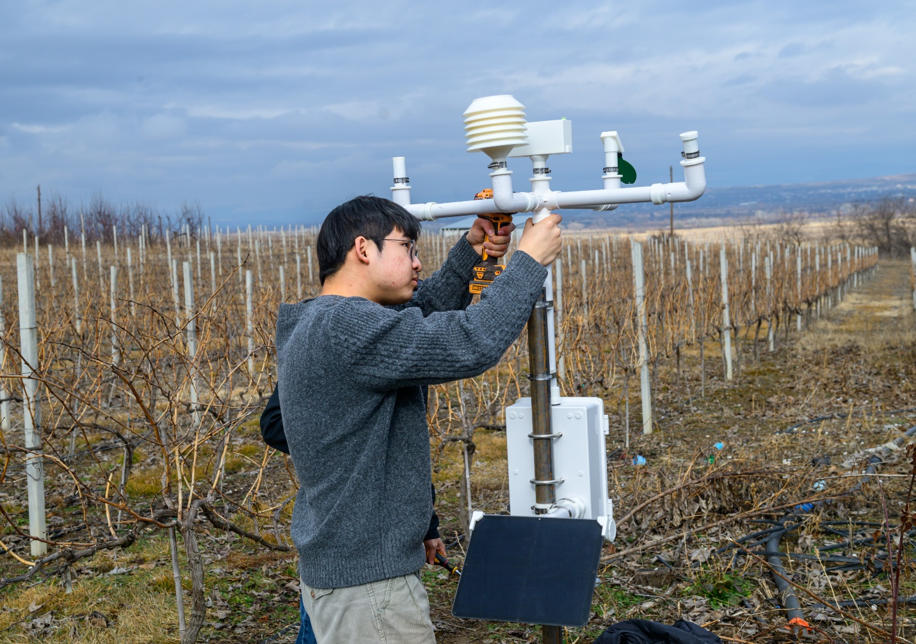
The UN strengthened the technical capacities of national, regional, and municipal agencies. A total of 100 specialists were trained in geological and hydrological hazards, as well as agro-economic modelling, while 138 ministry and municipal officials received training in disaster risk reduction in the context of climate change. Support to the development of the Climate-Resilient Agriculture Sector Roadmap led to the establishment of a clear framework for action and investment. The UN supported the launch of the Climate Services for Agriculture (GECSA) platform that helps farmers and extension specialists make climate-informed decisions, offering weather forecasts, warnings, pest alerts, irrigation tips, and crop advice. As of 2025, the platform has 1,000 active users, primarily in Kakheti and Shida Kartli, and is geared toward nationwide expansion. This helped farmers adopt climate‑resilient planning for five main crops and reduce losses from extreme weather.
A draft Law on Pasture Management was finalized with the regulatory impact assessment and stakeholder consultations. 15,400 hectares of pasturelands in Dmanisi were mapped and submitted for classification.
The UN strengthened Georgia’s ability to collect and use environmental data, making regional forest information more accessible through the INForest and CACAS Forest Information Platform, while supporting improved reporting on circular economy and on gender in the context of environment.
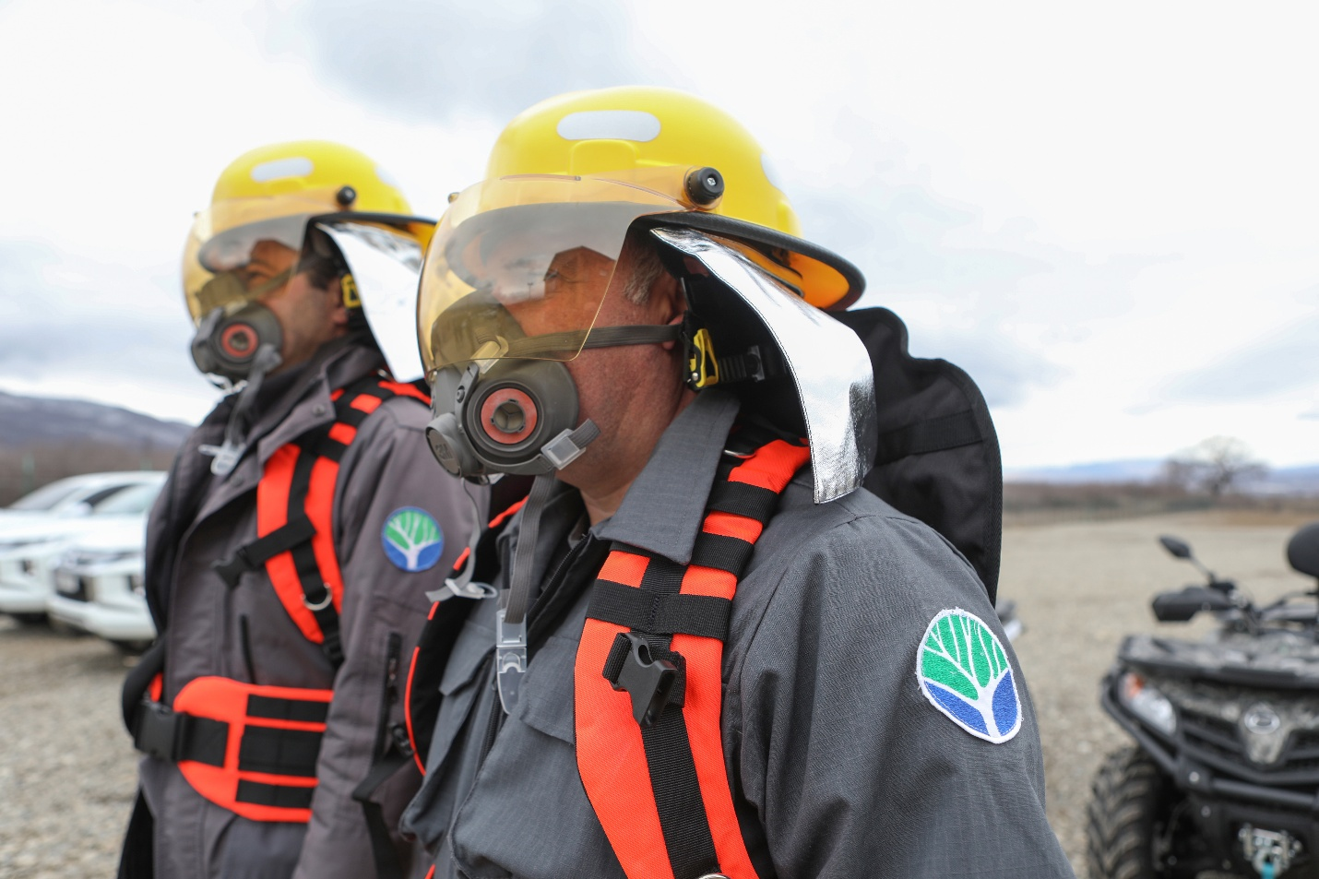
The UN also helped Georgia strengthen environmental health monitoring, with the focus on air quality. A review of national environmental health impact assessment system was conducted and its recommendations informed trainings delivered to national institutions. The UN also advanced climate-sensitive and risk-informed development by integrating public health and behavioural insights into air quality management. A nationwide behavioural study is now informing awareness campaigns and the design of gender-responsive policies. Efforts to reduce industrial emissions and air pollution included a Best Available Techniques feasibility study at the Kaspi Cement Plant and an alignment analysis with the EU Industrial Emissions Directive.
Climate‑resilient water, sanitation and hygiene assessments were expanded across healthcare facilities and kindergartens. An assessment of indoor air pollution and its impact on children’s health allowed to develop recommendations for future interventions. A high‑performance microwave digestion system was delivered to enhance lead‑exposure analysis, and Georgia’s Environmental Health (Lead) Surveillance System expanded to six regions. Public awareness campaigns and youth education initiatives empowered young people to understand environmental risks and advocate for climate resilience.
The UN advanced efforts on decarbonization, clean energy and green technologies in Georgia. A national mapping of just energy transition needs strengthened institutional capacities to develop energy accounts, plan sustainable and interconnected energy systems, and apply international methodologies for long-term decarbonization pathways.
With UN support, Georgia initiated its first reforestation-based carbon offset project. The restoration of 1,255 hectares in the Alazani floodplain established the country’s first pathway toward participation in global carbon markets.
Solar-powered transport hubs in Poti and Dedoplistskaro contributed to emission reductions. A 7,000 m² solar‑powered electric fencing system now supports pasture management in Tetritskaro.
Additional achievements included the distribution of 83 energy-efficient biomass stoves to vulnerable households; the planting of 4,000 saplings in Rustavi; and the installation of electric fencing across 11 farms in Borjomi-Kharagauli to protect livestock and support climate-resilient agricultural practices.
The UN supported regulatory reforms on the governance of hazardous chemicals. An updated regulation on Extended Producer Responsibility included guidelines for management of persistent organic pollutants. New regulations were developed for management of pharmaceutical, cosmetic and textile waste.
Capacity building for five major industrial companies enhanced their ability to safely manage equipment and hazardous waste containing polychlorinated biphenyl (PCB). Over 62,000 kg of PCB oils were removed from equipment, significantly reducing environmental risks.
Sustainable refrigerant management was promoted by building capacity of over 100 inspectors and technicians in good refrigeration practices and alternative refrigerants. More than 1,000 technicians and enterprises were certified in safe low-GWP technologies.

3. Support to Partnerships and Financing the 2030 Agenda
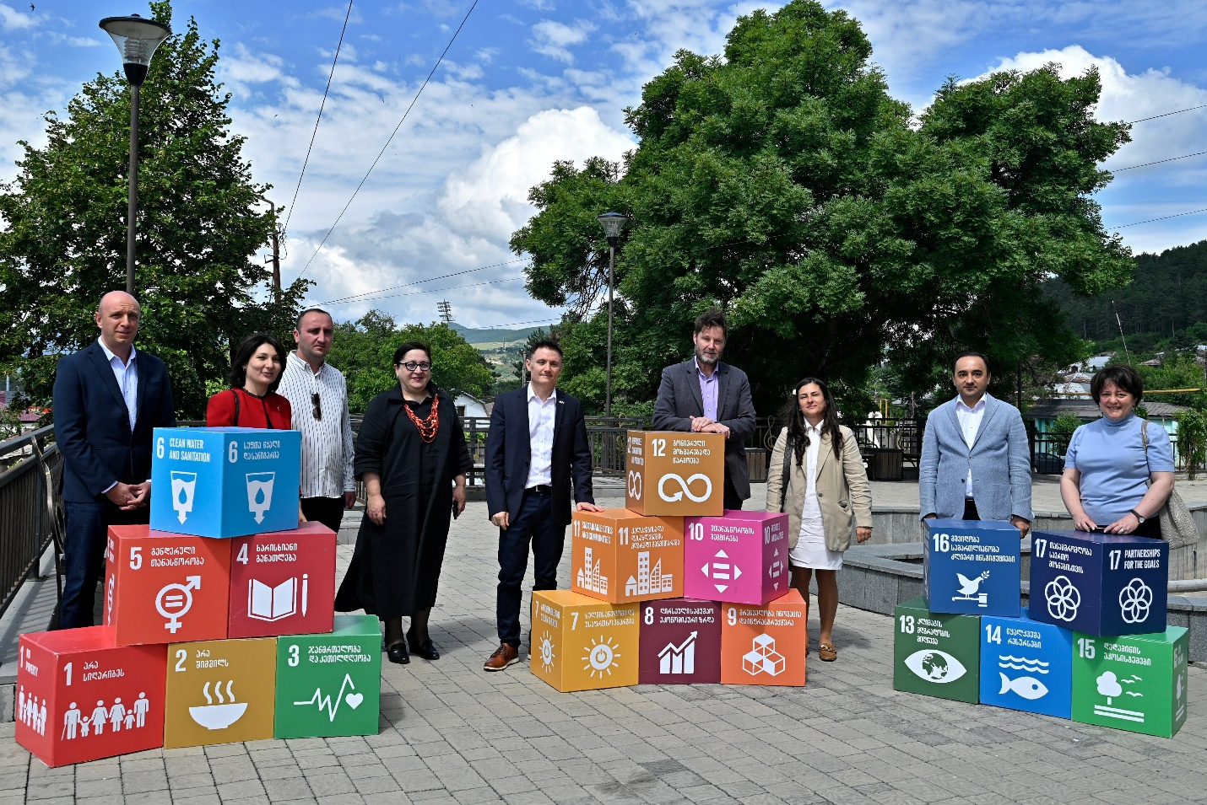
Partnerships with key stakeholders played a pivotal role in the UN's efforts to support Georgia's national development priorities in 2025. The UN strengthened collaboration with a diverse array of partners, including the Government at both national and local levels, social partners, civil society organizations, academia, media, the private sector, and the international development partners in Georgia. Participatory consultations with all stakeholders in Georgia contributed key insights for the development of the new Georgia-UN Cooperation Framework 2026-2030.
The UN Resident Coordinator in Georgia continued chairing the Development Partner Coordination Group and the Ambassadorial Working Group, which play a critical role in coordinating the activities of bilateral and multilateral donors, as well as international financial institutions supporting Georgia.
In addition, the UN Resident Coordinator continued to chair the Abkhazia Strategic Partnership, comprising UN agencies and international non-governmental organizations operating in Abkhazia, Georgia. This collaboration serves as a vital platform for information-sharing, joint reporting, and enhanced resource mobilization.
Engagement with civil society remains fundamental to the UN’s commitment to delivering meaningful and effective support for Georgia’s sustainable development. In 2025, the UN established the first country-level pooled fund in Georgia dedicated to strengthening civic space, especially at the local level across the country (UN Georgia Thematic Pooled Fund –Civic Space). Additionally, the UN Country Team consulted regularly with civil society organizations, facilitating discussions on pressing challenges affecting Georgia’s development.
The private sector is another key partner in driving progress toward the 2030 Agenda. A notable example of successful private sector engagement is the UN’s work in promoting the Women’s Empowerment Principles in partnership with employers. Since 2016, 323 companies representing over 150,000 employees have joined the initiative, championing women’s rights in workplaces and services while advocating for gender equality policies across Georgia.
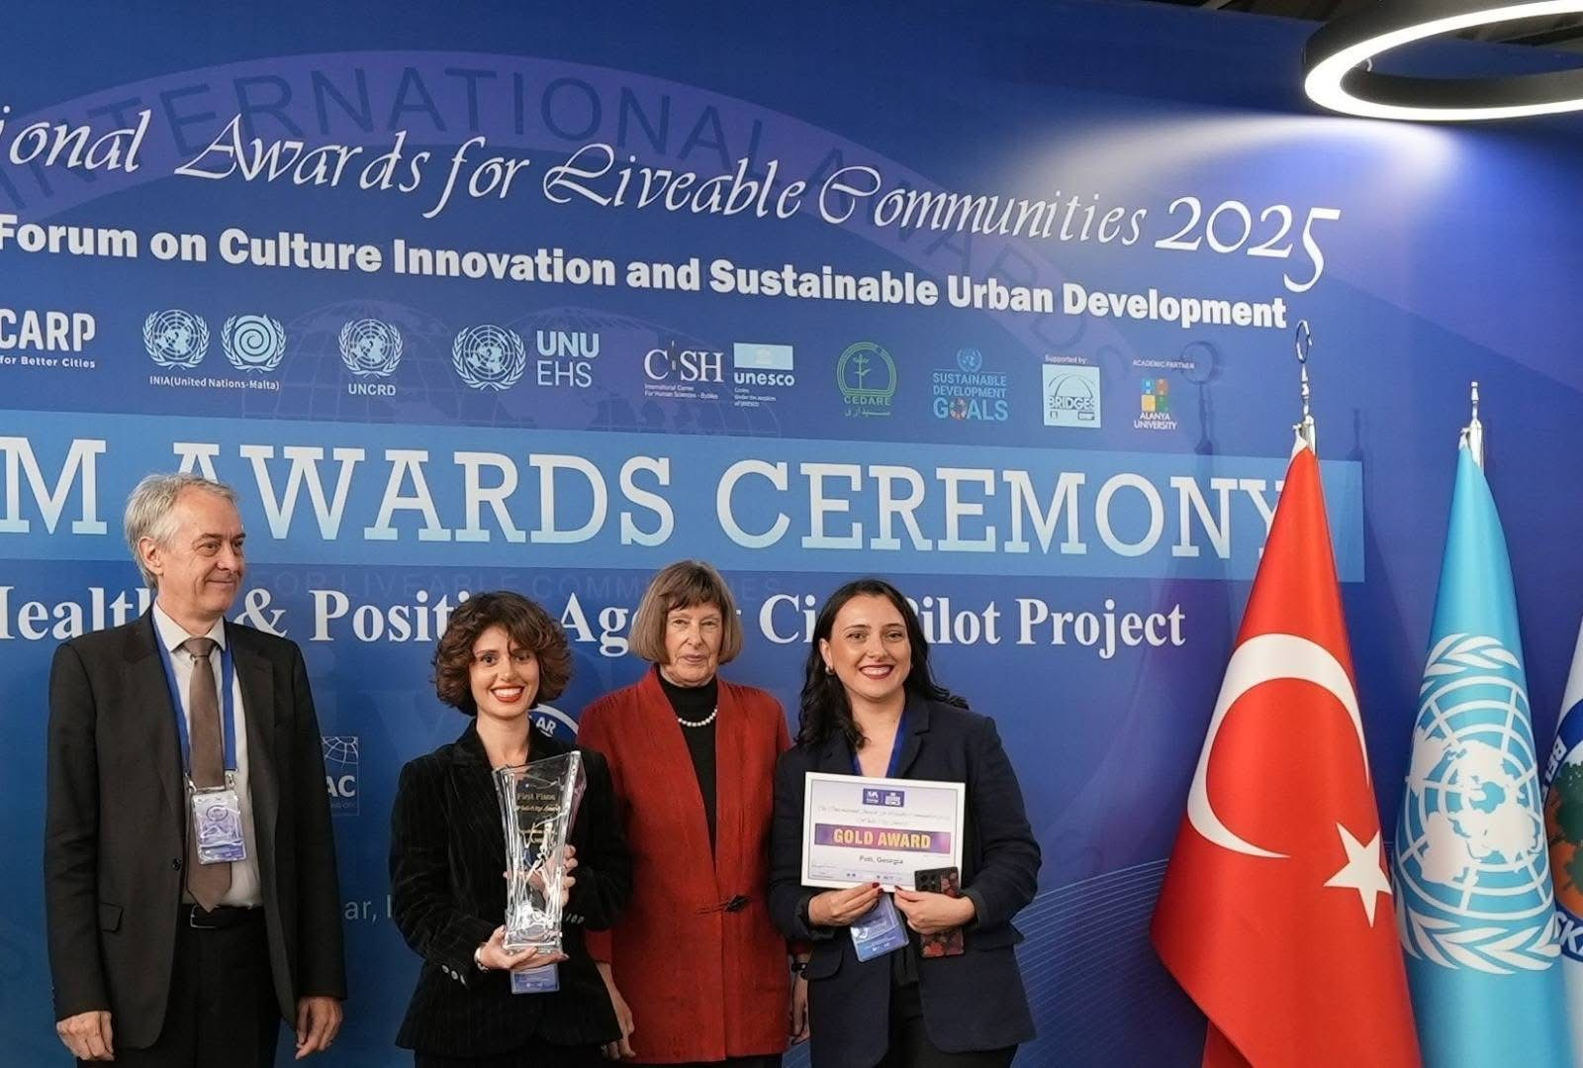
Efforts to promote SDG localization resulted in empowering the municipalities of Poti and Khashuri to enhance innovative public services, advance digital inclusion, and foster participatory, evidence-based policymaking to drive local development. The city of Poti was awarded gold at the International Awards for Liveable Communities for its Voluntary Local Review, developed with the support of the UN Joint SDG Fund.
Reinforced focus on youth engagement resulted in the creation of a UN Youth Advisory Group, which will provide advice on the implementation and monitoring of the UN support to Georgia.
In conclusion, both traditional and innovative partnerships remain at the heart of the UN’s efforts in Georgia. They serve as catalysts for sustainable development and inclusive growth, enabling the UN to maximize its impact through broad-based collaborations and strategic rights-based approaches to address multifaceted challenges.

4. Working more and better together: UN coherence, effectiveness and efficiency
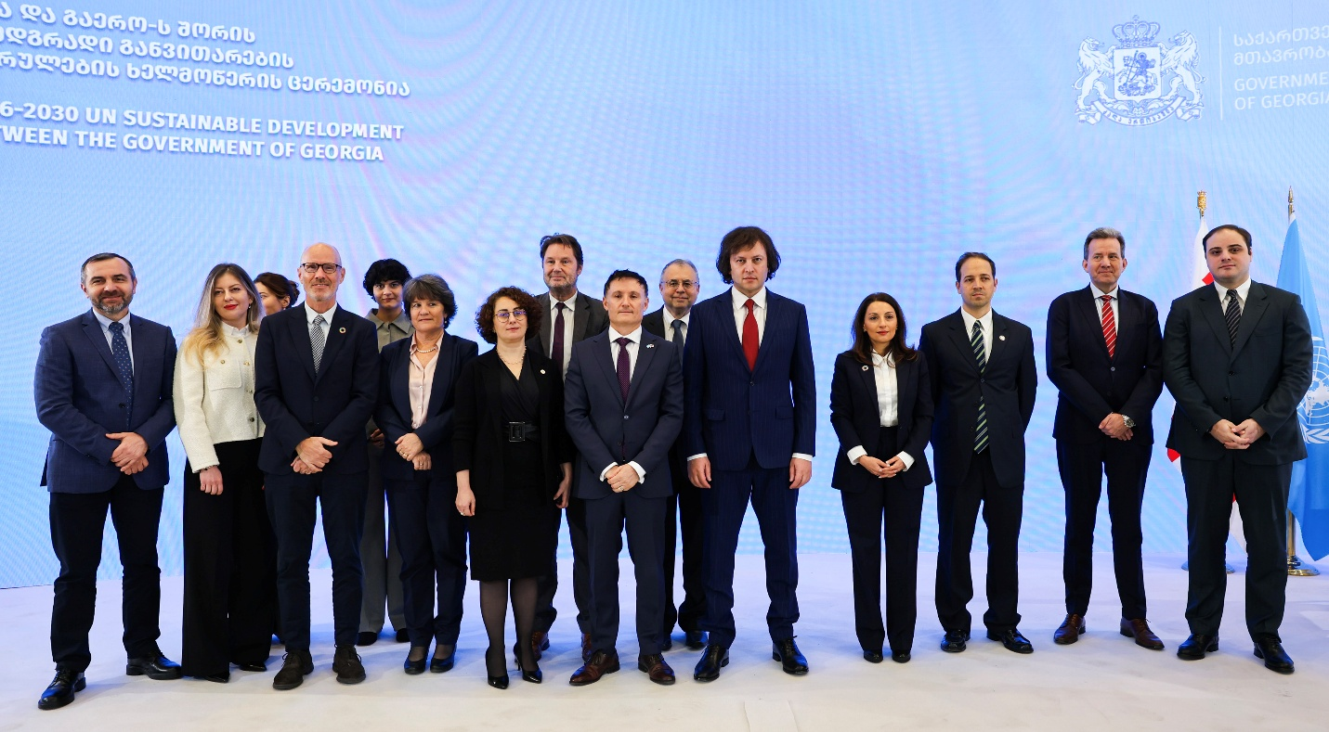
In 2025, the UN Country Team in Georgia continued to deliver as one, fostering synergies through joint programming, advocacy, communications, and enhanced business efficiencies.
In close collaboration with the Administration of the Government of Georgia, the UN completed the development of the UN Sustainable Development Cooperation Framework for Georgia (2026-2030), which was co-signed by the Government and the UN in December 2025.
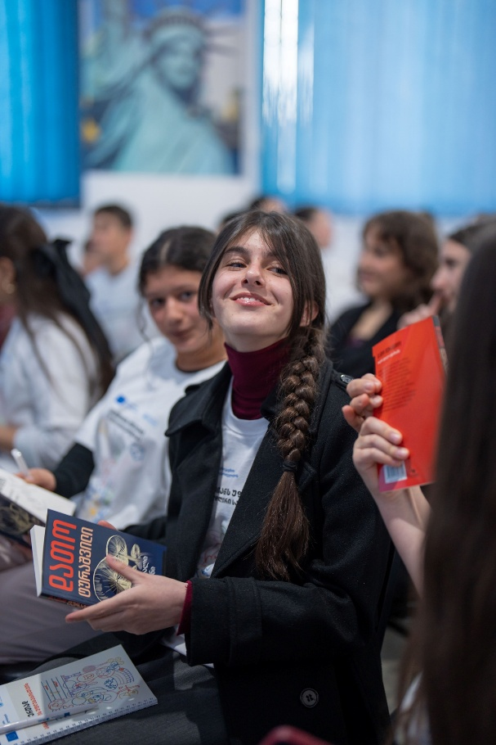
Promoting inter-agency synergies, ten UN joint programmes and initiatives were ongoing in Georgia, including four launched in 2025, addressing a range of priorities—from human rights protection and civic participation to social protection system reforms, gender equality, telemedicine, support for conflict-affected communities, rural development, and SDG localization. The new country-level UN pooled fund on civic space enabled resource mobilization and coordinated efforts by the UN Country Team in support of this priority.
The UN Country Team benefited from the contributions of 23 internationally and locally recruited UN Volunteers throughout 2025 (majority female, average age 30 years), bringing a variety of skill sets that supported UN operations in Georgia across communication, administration, and program and community development.
In 2025, the UN Country Team intensified engagement beyond the capital city of Tbilisi. Official visits by the UN Resident Coordinator to Shida Kartli, Kvemo Kartli, Racha-Lechkhumi, and Samegrelo regions strengthened relationships with local authorities, communities, and beneficiaries. These missions enabled direct assessment of evolving needs and informed forward-looking planning under the new Cooperation Framework.
2025 marked the 10th anniversary of the Sustainable Development Goals (SDGs), offering a timely opportunity for in-depth discussions, youth engagement initiatives and targeted social media campaigns aimed at accelerating progress and inspiring positive action. A panel discussion co-hosted by the International School of Economics and Tbilisi State University brought together young leaders, academia, and development partners to reaffirm the central role of quality education and equality in Georgia’s development agenda.
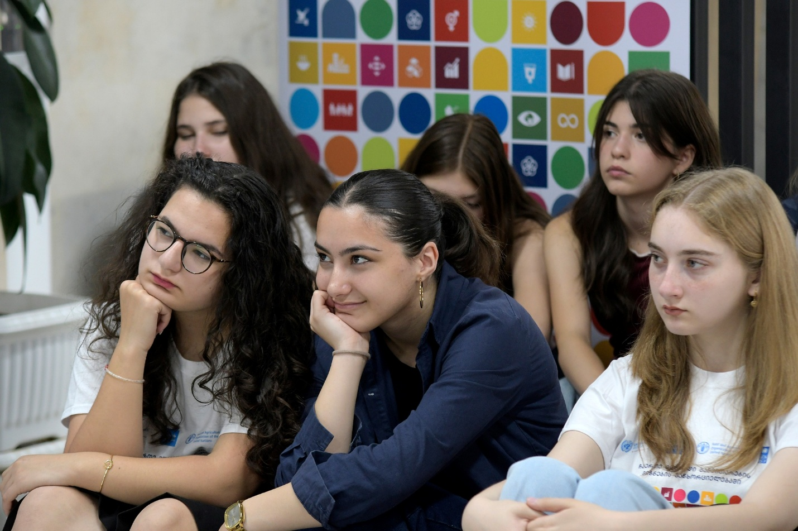
Communications on the 80th anniversary of the UN Charter and the UN Day helped strengthen awareness of the UN founding principles and their continued relevance in today’s world. Key initiatives included a Youth Talk: Building Our Future Together Towards 2030, which brought together UN agencies, international NGOs, donor governments, the private sector, youth representatives, media, and civil society organizations.
Engagement with youth and educational institutions remained central to outreach efforts. Students from Tbilisi-based universities and regions participated in a series of discussions with the UN Resident Coordinator on the SDGs and various dimensions of Georgia’s development. A live-streamed fireside chat by the UN Resident Coordinator with a youth panel on climate action in Georgia gathered thousands of views.
Awareness campaigns focused on promoting gender equality and combating violence against women. In 2025, the 16 Days of Activism campaign, including Bodyright initiative “Own Your Body Online” mobilized institutions, media, youth, and civil society to promote zero tolerance for gender-based violence and amplify survivor-centred narratives.
The UN Resident Coordinator and other senior UN officials participated in prominent national events, including the Silk Road Forum, the Tbilisi Finance Summit, the UN Global Compact Corporate Sustainability Awards in Georgia, and the 8th UN Global Road Safety Week high-level event, further strengthening partnerships with government, business, and development actors.

5. Resource Mobilization and Financial Overview

UNCT expenditure in Georgia in 2025
UNCT expenditure in Georgia in 2025, by Outcome
Outcome | 2025 Expenditure | Share of total
Outcome 1: Governance, institutions, rule of law, access to justice, human rights, and women’s representation in decision-making | $8.2mn | 20.5%
Outcome 2: Access to services | $5.6mn | 14.0%
Outcome 3: Inclusive and resilient economy | $12.9mn | 32.3%
Outcome 4: Conflict affected communities | $6.9mn | 17.3%
Outcome 5: Resilience, environmental governance, climate action, and use of natural resources | $6.4mn | 16.0%
TOTAL | $40mn | 100.0%
See chapter 2 for a breakdown by Output under each Outcome.
UNCT Expenditures in Georgia in 2025, by UN Entity
UNCT Entity | 2025 Expenditure | Share of total
FAO | $5.5mn | 13.8%
IFAD | $0.3mn | 0.8%
ILO | $0.6mn | 1.5%
IOM | $0.8mn | 0.3%
OHCHR | $0.5mn | 1.3%
UN Women | $3.7mn | 9.3%
UNDP | $17.7mn | 44.3%
UNECE | $0.1mn | 0.3%
UNFPA | $1.4mn | 3.5%
UNHCR | $0.4mn | 1.0%
UNICEF | $4.8mn | 12.0%
UNIDO | $1.3mn | 3.3%
UNOPS | $2.4mn | 6.0%
WHO | $0.5mn | 1.3%
TOTAL | $40mn | 100.0%

Main sources of funding to UN Georgia in 2025
Rank | Donor | 2025 funding | Share of total
1 | European Union | $13.7mn | 34.2%
2 | Switzerland | $4.7mn | 11.7%
3 | Sweden | $4.1mn | 10.2%
4 | Green Climate Fund | $2.5mn | 6.3%
5 | Denmark | $2.4mn | 5.9%
6 | Norway | $1.7mn | 4.2%
7 | Global Environmental Facility | $1.5mn | 3.7%
8 | United Kingdom | $1.1mn | 2.8%
9 | Austria | $1.0mn | 2.5%
10 | Germany | $0.9mn | 2.3%
11 | Others* | $6.5mn | 16.1%
 | TOTAL | $40mn | 100.0%
* The category ‘others’ includes Estonia, France, Republic of Korea, and The United States. It also includes a little over $4mn in in the form of core funding of UN Country Team entities as well as from various thematic UN funds.

Expenditures in full 2021-2025 CF cycle
UNCT expenditure in Georgia in 2021-2025, by Outcome
Outcome | 2021-2025 Expenditure | Share of total
Outcome 1: Governance, institutions, rule of law, access to justice, human rights, and women’s representation in decision making | $54.0mn | 21%
Outcome 2: Access to services | $43.1mn | 17%
Outcome 3: Inclusive and resilient economy | $65.5mn | 25%
Outcome 4: Conflict affected communities | $57.8mn | 22%
Outcome 5: Resilience, environmental governance, climate action, and use of natural resources | $40.7mn | 16%
TOTAL | $261.1mn | 100%

Main donors to UN Georgia in 2021-2025 CF cycle, by Outcome
[To be added in the design version for publication]
- Total financial contribution for 2021-2025 by funding source, in USD (bilateral donor funding, multilateral and regional institutions, vertical and joint funds, HQ funding, government, private sector)
- Contribution to SDGs in 2021-2025: per share of budget: total expenditure in USD per SDG and its % in total CF expenditure.
- Expenditure over the 2021-2025 CF cycle by gender equality and HR markers

6. Evaluation: Key Findings and Recommendations
The evaluation of the 2021-2025 Cooperation Framework (CF) assessed implementation from January 2021 to April 2024, covering contributions from all UN agencies working in Georgia, both resident and non-resident, and consulting a wide range of stakeholders.
Key findings:
- Relevance: The CF was well aligned with Georgia’s national development plans and the SDGs, contributing to reforms in governance, human rights, service delivery, progress on climate commitment, and resilience of conflict-affected communities. The evaluation noted the importance of aligning UN support more closely with Georgia’s economic trajectory as an upper-middle-income country, and engaging more strongly in promoting competitiveness, private sector development and regional connectivity.
- Coherence: The CF was internally coherent across its five outcome areas, with clear linkages to cross-cutting priorities such as leaving no one behind, gender, human rights, disability inclusion, and climate resilience. External coherence with national strategies and SDG frameworks was also strong.
- Effectiveness: By April 2024, 91% of outcomes were fully or partially achieved, with particularly strong results in health, education, social protection, gender equality, rural development, disaster risk reduction, and climate governance.
- Efficiency: The UN demonstrated high adaptability, especially during COVID‑19 pandemic, by reallocating resources, shifting to digital delivery, and maintaining service continuity in health and education. Joint programmes created efficiencies through shared expertise and streamlined implementation.
- Coordination: The evaluation noted strong coordination with the Government, donors, and highlighted the importance of the Resident Coordinator’s leadership in fostering UN strategic focus and coherence in external engagement.
- Impact: Through CF implementation, the UN contributed to system-level reforms across governance, health, education, social protection, climate policy, and disaster risk reduction. In conflict‑affected areas, UN programmes strengthened community resilience and access to basic services.
- Sustainability: This aspect was strongest where the UN achieved policy integration and government ownership, for example in areas of maternal health audits, disaster early warning systems, climate action commitments, or promoting child rights.
Recommendations
- Sharpen the strategic focus of the next CF by prioritizing fewer, more catalytic areas with high impact potential.
- Reposition the UN support within Georgia’s upper‑middle‑income, private‑sector‑driven development model.
- Continue advocacy for leaving no one behind agenda, gender equality, and human rights
- Prioritize initiatives with long-term institutional anchoring, especially in agriculture, environment, and social protection.
- Improve modalities for developing and implementing UN joint programmes.
- Broaden partnerships with multilateral development banks, private sector, and local governments.
- Expand climate finance, innovation financing, and blended funding models.

7. UN key focus in 2026
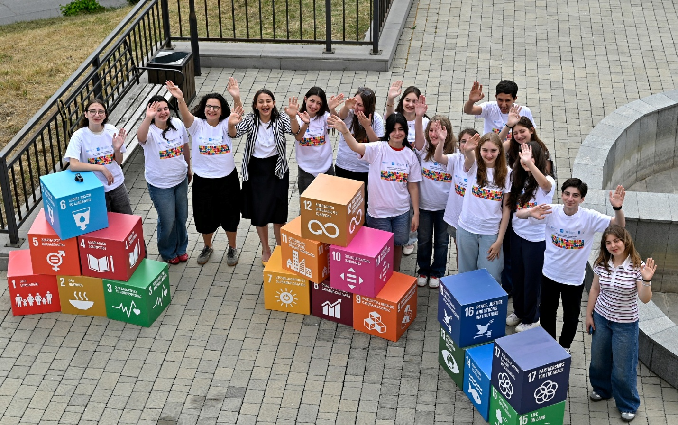
As the UN in Georgia enters a new cooperation cycle in 2026, our focus will be on transforming the way we work — deepening our contributions to key reforms, strengthening partnerships across society, and sharpening our internal efforts to deliver as one, with greater coherence and efficiency. This new phase marks a shift towards integrated, anticipatory and solutions‑driven engagement, fully aligned with Georgia’s ambitions, capabilities and needs as an upper‑middle‑income country that continues to navigate geopolitical tensions and domestic complexities.
A central focus in 2026 will be expanding the UN’s role as a trusted provider of integrated policy advice, drawing on global normative standards and the collective expertise of resident and non-resident entities.
This aligns with the new composition of the UN Country Team in Georgia, which brings new UN entities, such as ITU, UNCTAD, ESCAP, UNESCO and UN‑Habitat, to broaden technical capabilities in areas ranging from digital transformation and connectivity to environmental governance, culture, and sustainable urban development.
Leveraging this expanded UNCT, the UN will prioritize high‑value advisory support on accelerating SDGs progress through economic and social transformation to reduce inequalities and to foster green transition, inclusive national and local governance, human capital systems, and climate adaptation and resilience. The UN will also place stronger emphasis on developing catalytic development financing and partnership models, strategic use of pooled fund mechanisms, stronger partnerships with international financial institutions (IFIs), as well as innovative financing and joint resource mobilization. The UN Thematic Pooled Fund for Civic Space has demonstrated its effectiveness and will be further operationalized and leveraged as a model for integrated funding approaches under the 2026-2030 CF cycle.
To ensure development gains reach all people, especially outside the major urban centres, the UN will invest in whole‑of‑society partnerships. The UN will work with municipalities, civil society, youth and the private sector in an integrated manner to create structured platforms for integrated local development, participation, transparency, and co‑creation. The UN will leverage its convening role to enable open and constructive stakeholder dialogue and action on development priorities, protection of human rights, gender equality, and strengthening civic space and social cohesion.
The UN is committed to continue working with and for the people of Georgia — helping the country advance inclusive, green and peaceful development that leaves no one behind.

Human stories
Outcome 1

Women in AI: Breaking Barriers in Technology

Artificial intelligence (AI) is shaping the future, yet women and girls remain underrepresented in technology and AI due to persistent gender stereotypes and systemic barriers. Initiatives like Women in AI are helping to change this and close the gender gap in the tech sector.
33-year-old Maka Saparashvili is a graduate of the Women in AI training programme, implemented by Business and Technology University (BTU) at the initiative of UN Women.
An economist by profession, Maka has spent nearly a decade as a financial data analyst. Despite her extensive experience with data, she had never coded before. When a friend told her about the programme, she seized the opportunity and successfully passed the selection process.
“Each lecture was a chance to gain new knowledge and practical skills,” Maka reflects. “The programme gave me a solid technical foundation. My next goal is to apply this knowledge in practice and grow in the field of artificial intelligence. Initiatives like this are crucial, especially for women who face financial barriers. They provide equal opportunities and access to valuable knowledge, creating real pathways into tech careers.”
A total of 200 women completed the intensive AI and web development course, gaining in-depth knowledge and hands-on experience that open doors to career opportunities.
The nine-month Women in AI training initiative was supported by UN Women with funding from the European Union and the Government of Norway.
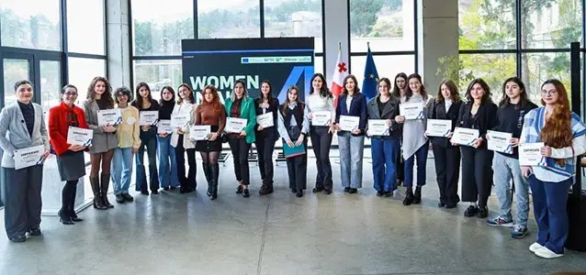
Group photo of the “Women in AI” training programme participants. Photo: UN Women/BTU
Outcome 2

Promoting HPV Vaccination in Georgia
Elene Janukashvili, 24, a sixth-year medical student in Georgia, recalls the moment she received her final dose of the 9-valent human papillomavirus (HPV) vaccine. "Georgia faces a major challenge, as over 200 women die annually from cervical cancer, primarily caused by the human papillomavirus (HPV)," says Elene. “We have the privilege in Georgia, which many other countries lack, to get such an expensive vaccine [for free], protecting not only ourselves but also our partners from the infection."
The vaccine, part of Georgia’s national immunization programme, is free for girls and women aged 10–46 and boys and men aged 10–26. It shields against multiple oncogenic HPV strains, reducing the risk of cervical, genital, and other cancers.
In Georgia, where HPV is the primary cause of cervical cancer, this disease ranks fifth among the most frequently diagnosed oncological conditions among women. Thanks to UNFPA and other UN agencies, and with support from the European Union, HPV vaccination and cervical cancer screening are available free of charge at primary healthcare facilities and national screening centres across the country, including those in rural areas.
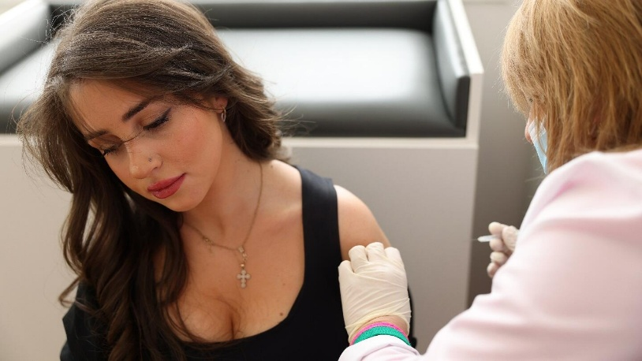
Photo: Dina Oganova/UNFPA
Outcome 3

Digital Transformation through the Farm Management System (FMS) in Georgia
The Farm Management System (FMS) is the only Georgian-language digital platform built on modern technologies and aligned with international best practices. Developed specifically for the needs of Georgia’s livestock sector, the system enables farmers to manage their operations efficiently, increase productivity, and reduce costs through data-driven decision-making.
One of the first farms to successfully adopt FMS is owned by Darejan Kanteladze. Today, her farm manages approximately 300 high-yield dairy cows and produces an average of 120 tons of cheese annually from raw milk. The “Alpia” products are distributed across Georgia through major supermarket chains, supplying high-quality dairy products to the local market.
The introduction of FMS has transformed the farm’s daily management. Its integrated modules provide a comprehensive digital solution for tracking milk production, feed rations, animal health, and reproduction. At the same time, the system remains intuitive and user-friendly, even for staff with limited digital experience. Fully tailored to the realities of the local livestock sector, FMS effectively bridges the gap between traditional farming practices and modern farm management.
Looking ahead, Darejan envisions continued growth: “Our long-term goal is to expand the farm, diversify our products, and further automate processes. The FMS will serve as the central platform around which the farm will continue to develop. We also want to share our experience and encourage other farmers to embrace digital management systems,” she says.
The introduction of this system is one of many initiatives implemented by the Food and Agriculture Organization of the United Nations (FAO) and its partners, including Farmer Field Schools conducted together with UN Women. These initiatives support smallholder dairy farmers in Georgia by strengthening their skills in modern cheese-making, food safety, entrepreneurship, leadership, and women’s rights.
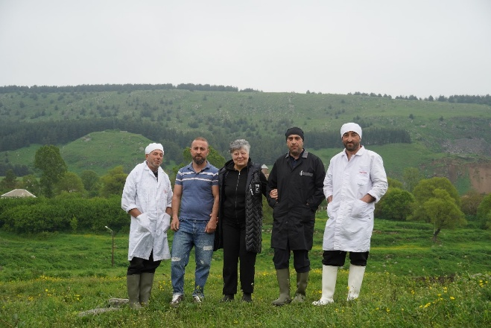
Photos: FAO
Outcome 4

Empowering Women Affected by Conflict through Rural Entrepreneurship
Conflict-affected women in Georgia, particularly those living along the Administrative Boundary Lines (ABLs) near Abkhazia and the Tskhinvali region/South Ossetia, are receiving targeted support to build businesses and achieve economic independence. Through initiatives supported by the European Union and UNDP, these entrepreneurs are running small enterprises in sectors such as agriculture, handicrafts, and increasingly, e-commerce.
Lida Enukidze, 70, represents the resilience and determination of women who overcome adversity and defy expectations. Living in the conflict-affected village of Perevi in Georgia’s Shida Kartli region, near the Administrative Boundary Line with the Tskhinvali region/South Ossetia, Lida turned years of experience in a sewing workshop into an opportunity for entrepreneurship. Together with her fellow villager, Mzia Beridze, she established a small sewing business that has served both individual and commercial clients for over a decade.
“Rural women encounter many challenges that encourage us to find solutions and grow. What we need is inspiration and positive examples. We must take care of ourselves because no one else will. This project showed me that I can be an inspiration for other women in my village,” Lida says.
With support from the EU4Dialogue programme, Lida’s sewing workshop has been upgraded with new equipment, including a multipurpose sewing machine, electric scissors, and a professional iron. This investment has enabled the small village enterprise to expand its production capacity and take on larger orders, such as producing essential bed linen for regional hospitals.

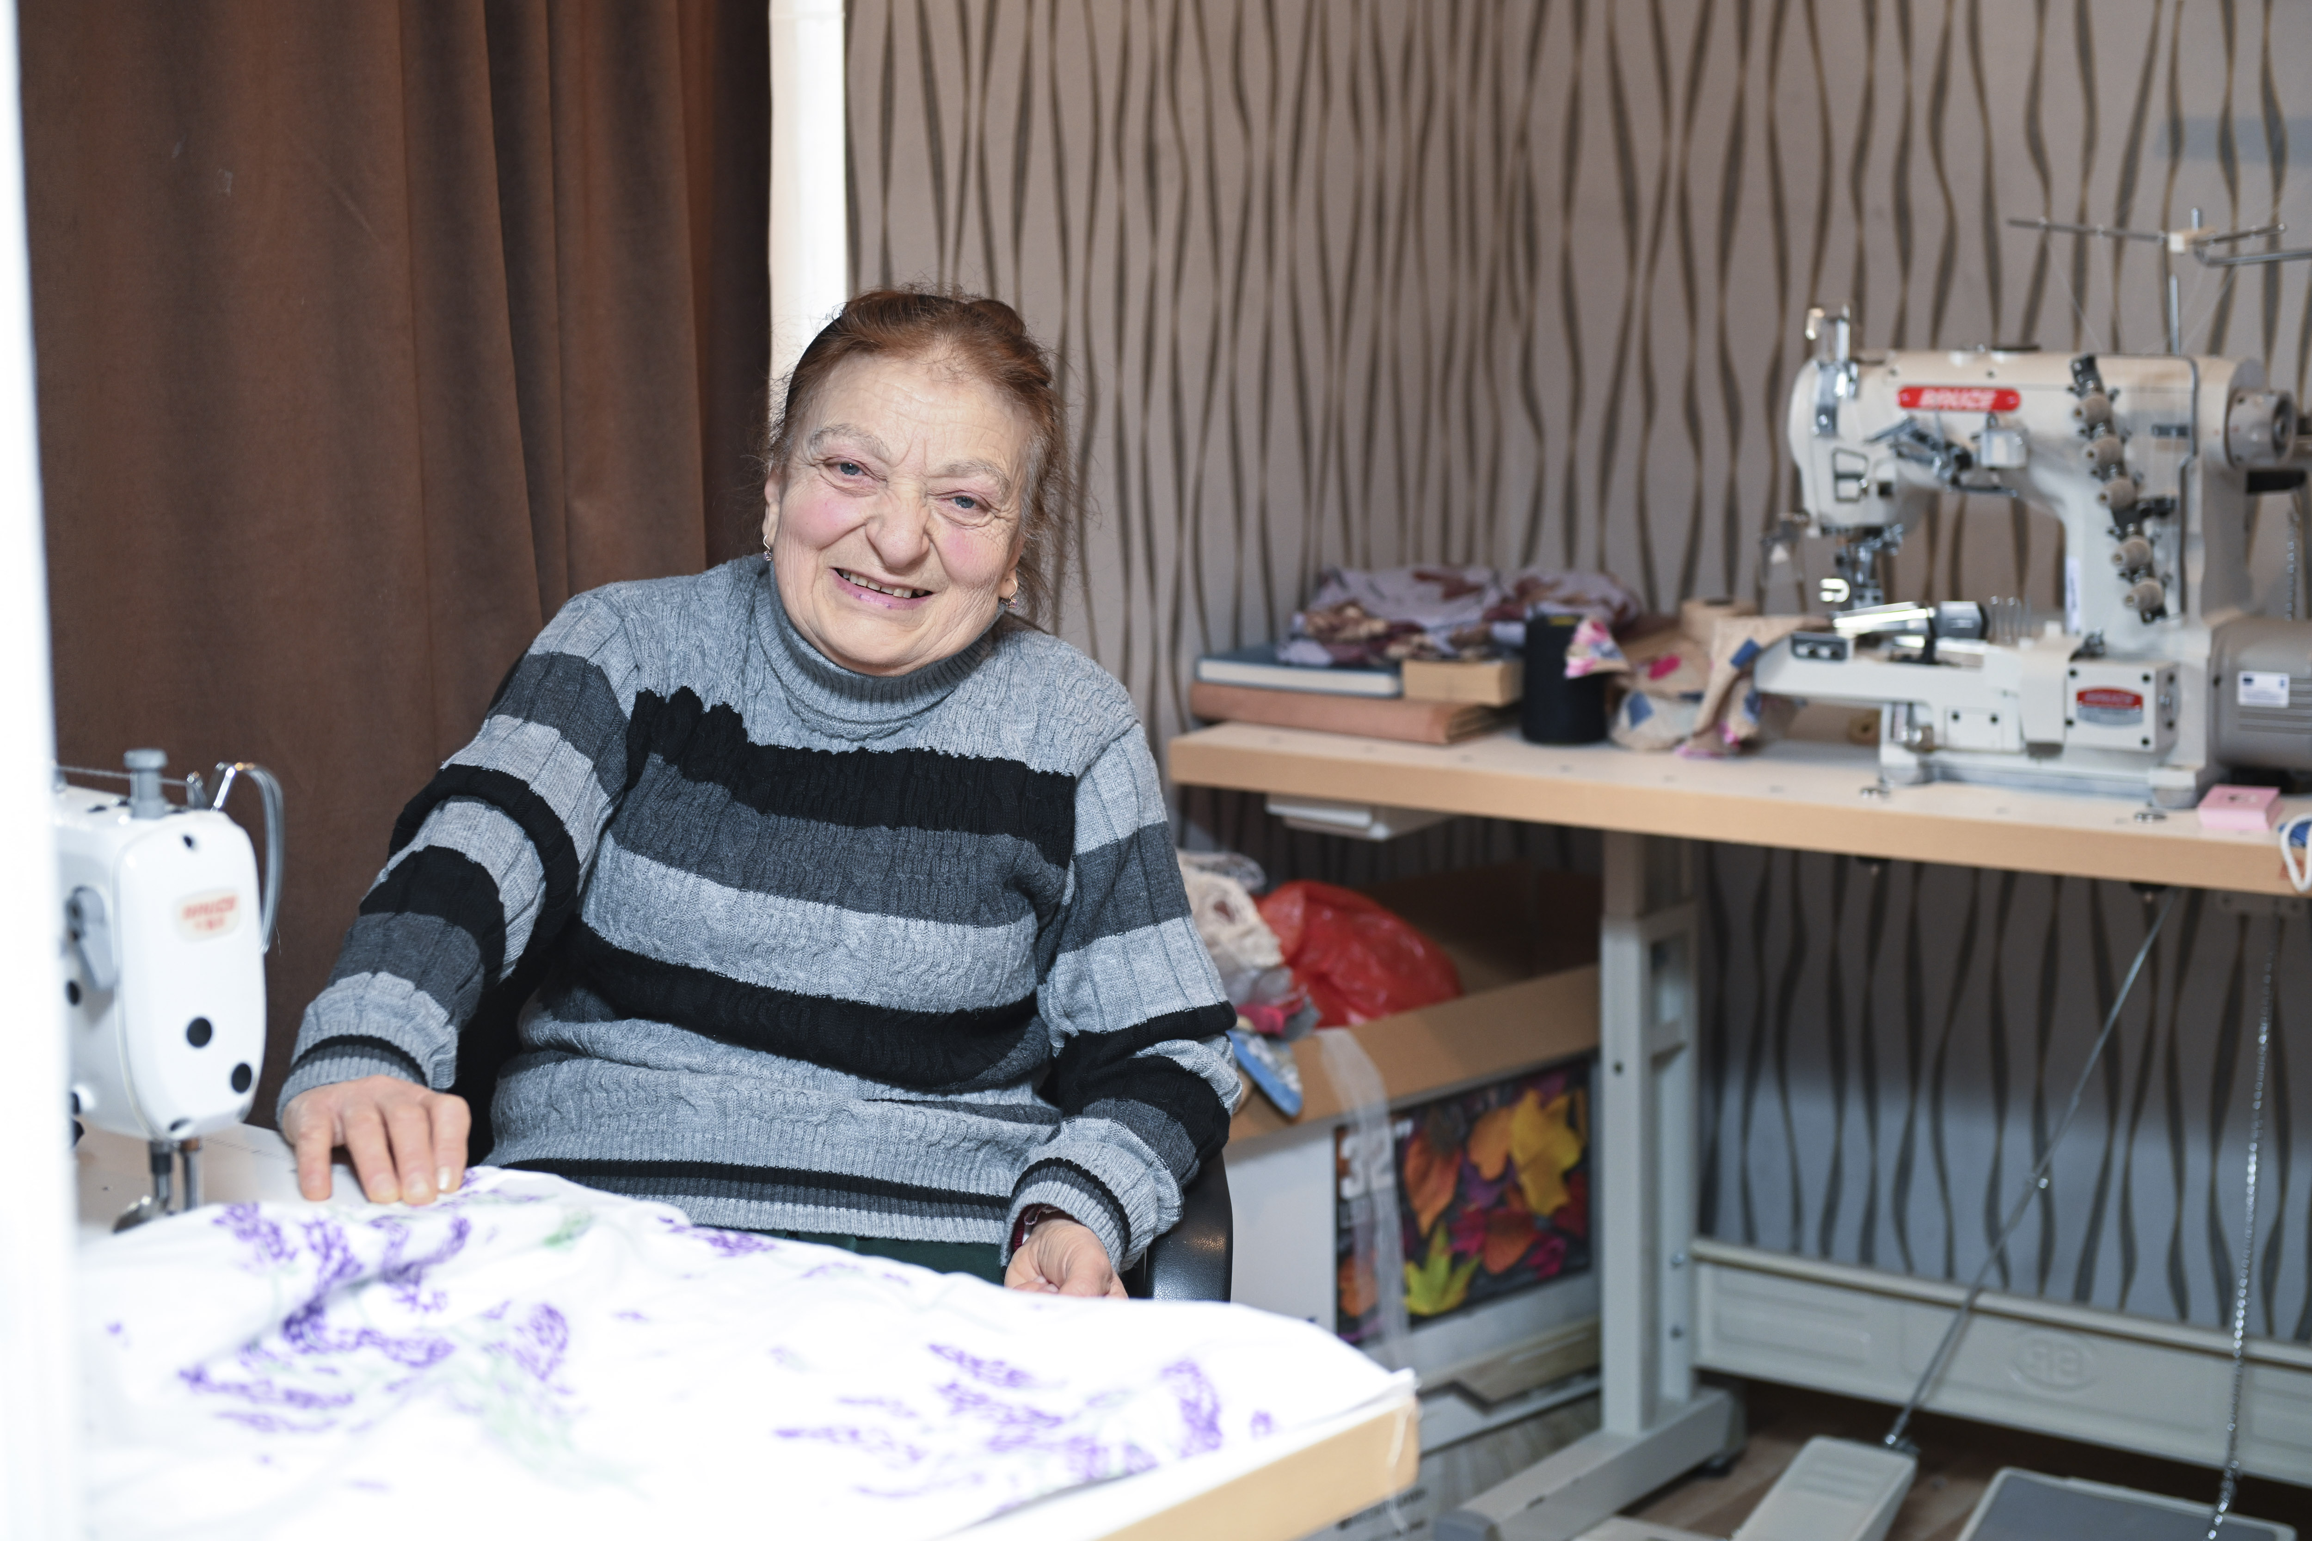
Photo: UNDP/Gela Bedianashvili

Outcome 5

Building Climate Resilience in Georgia
Georgia’s mountains and rivers are stunning, but they bring serious risks. With over 20,000 rivers cutting through steep terrain, floods, landslides, droughts, and avalanches threaten nearly 40% of the population, risks that are rising with climate change.
In the village of Vazisubani, local resident Davit Jaoshvili has seen life transformed by a 580-metre riprap berm and a 200-metre rehabilitated flood-protection dam. “If these structures hadn’t been built, the river would have washed away the banks and poured into our homes. Now, the village is safe,” he says.
These works are part of UNDP’s seven-year climate resilience programme, supported by US$74 million from the Green Climate Fund and the governments of Georgia, Sweden, and Switzerland. Since 2019, 15 high-risk sites across nine river basins have been protected, turning disaster risk reduction from policy ambition into practical, life-saving change.
Across Georgia, flood protective works are being paired with improved climate data, hazard and risk mapping, forecasting and early warning systems, green technologies in rural areas, and community-based climate risk management and disaster preparedness, helping people adapt to a changing climate by anticipating risks and taking early, preventive action.

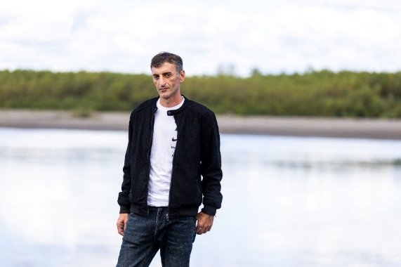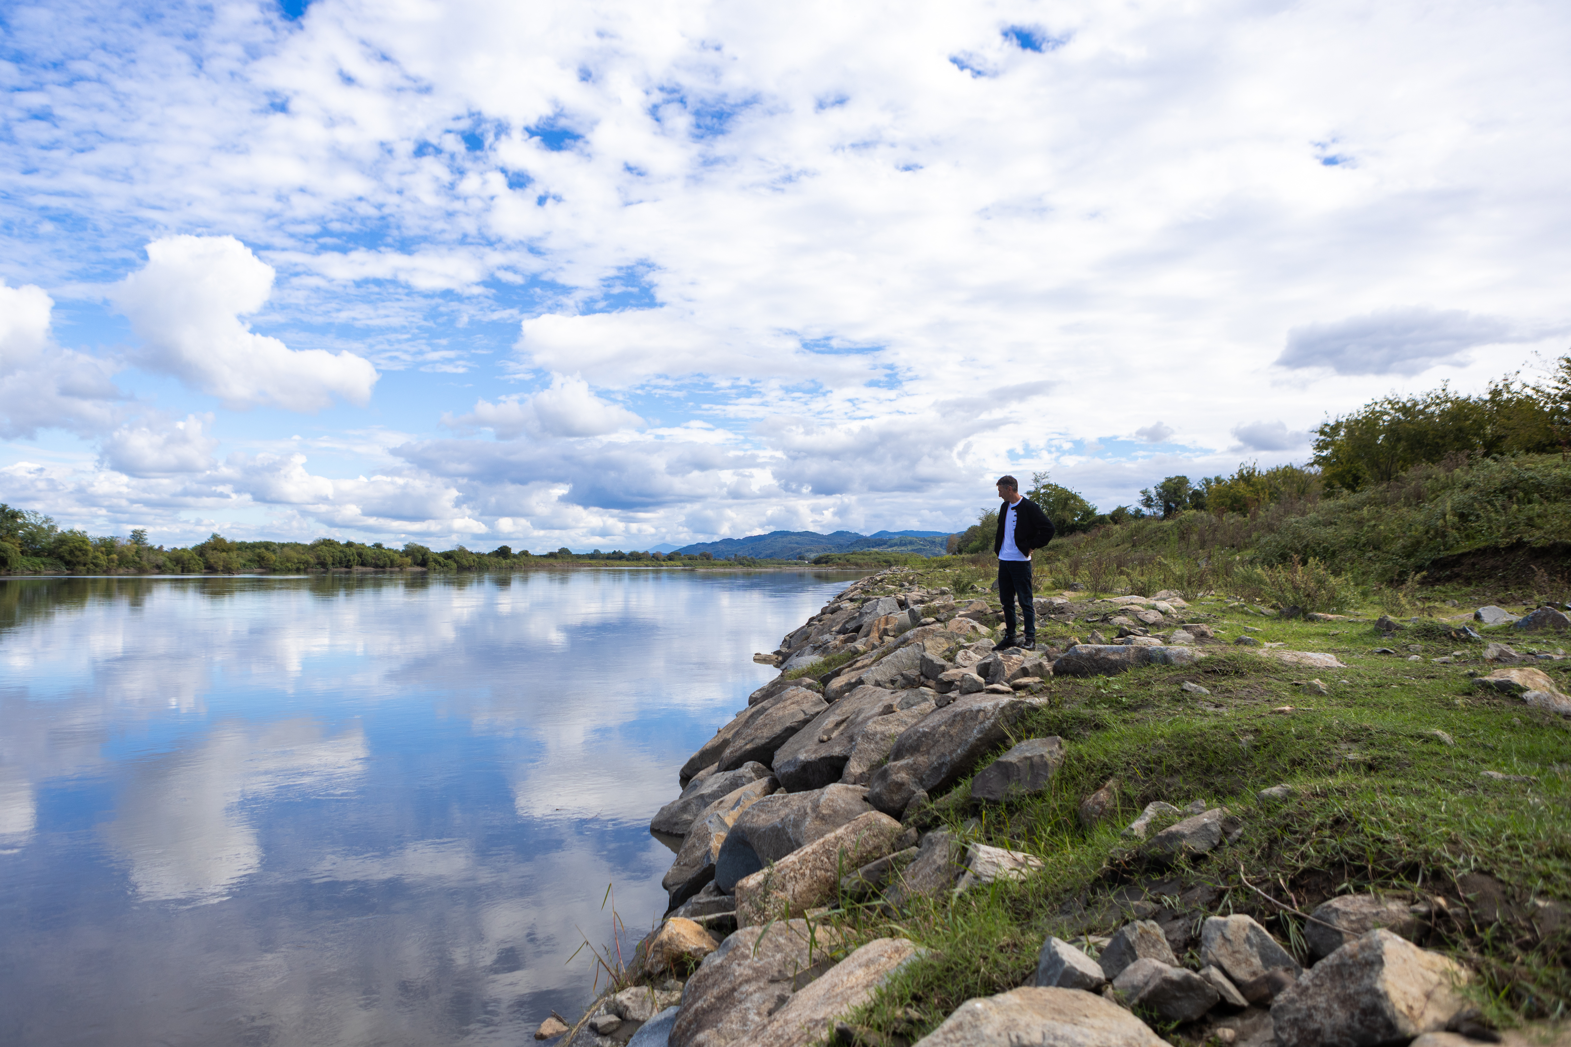
Davit Jaoshvili, Vazisubani Village
Photo: UNDP/Tamuna Amirgulashvili

