

Online UNSDCF Stakeholder Consultation

Partners and Stakeholders Consultations with Organisations of Persons with Disabilities, Academia, Media and Cultural and Creative Organisations

20 and 23 April 2021

Summary Report

Background
The Zimbabwe United Nations Development Assistance Framework (ZUNDAF) 2016-2020 (extended to 2021) will come to an end in December 2021. In 2020 the Government of Zimbabwe (GOZ) finalized and adopted its National Development Strategy (NDS1), which covers the period 2021 – 2025. The UN Country Team in Zimbabwe has commenced the process of formulating the new United Nations Sustainable Development Cooperation Framework (UNSDCF) 2022 - 2026 in alignment with the national planning cycle to ensure that it is anchored in national development priorities.
Partnerships and inclusivity are at the heart of the Cooperation Framework design process. This calls for extensive consultations, in particular with populations that are typically left behind, and engagement of a wide cross section of stakeholders and partners, with full government ownership throughout the process. The Cooperation Framework design process is jointly led by the GOZ through the Office of the President and Cabinet (OPC) and the UN Country Team (UNCT) under the leadership of the Resident Coordinator.
The design process has involved the participation of all UN entities that provide support to the GOZ either through regional or country representation or programmatic presence. Furthermore, to ensure shared vision and broad-based support, key partners and stakeholders have been actively engaged throughout the process.
On the 20th, 2-4 pm, and 23rd 10-12 am, of April 2021, UNESCO supported the UN Country Team in hosting a National Consultation Workshop with Organizations of Persons with Disabilities (OPDs), the Academia, the Media, and Organizations involved in the Cultural and Creative Industries.

Agenda and Participation
55 persons participated in the meeting (Annex 1 shows the list of participants and their organisations).
The CCA and the UNSDCF outcomes were presented to all participants in a plenary session, and each target group were able then to break into specific Working Group on ZOOM to deliberate from their specific perspectives (Programme in Annex 2).
A quick survey was done to assess the level of involvement of the participants with the UN system, as well as the nature of their expectations from the UN.

Survey Findings
The majority (84%) of participants and their organisations reported having collaborated with the UN in Zimbabwe.
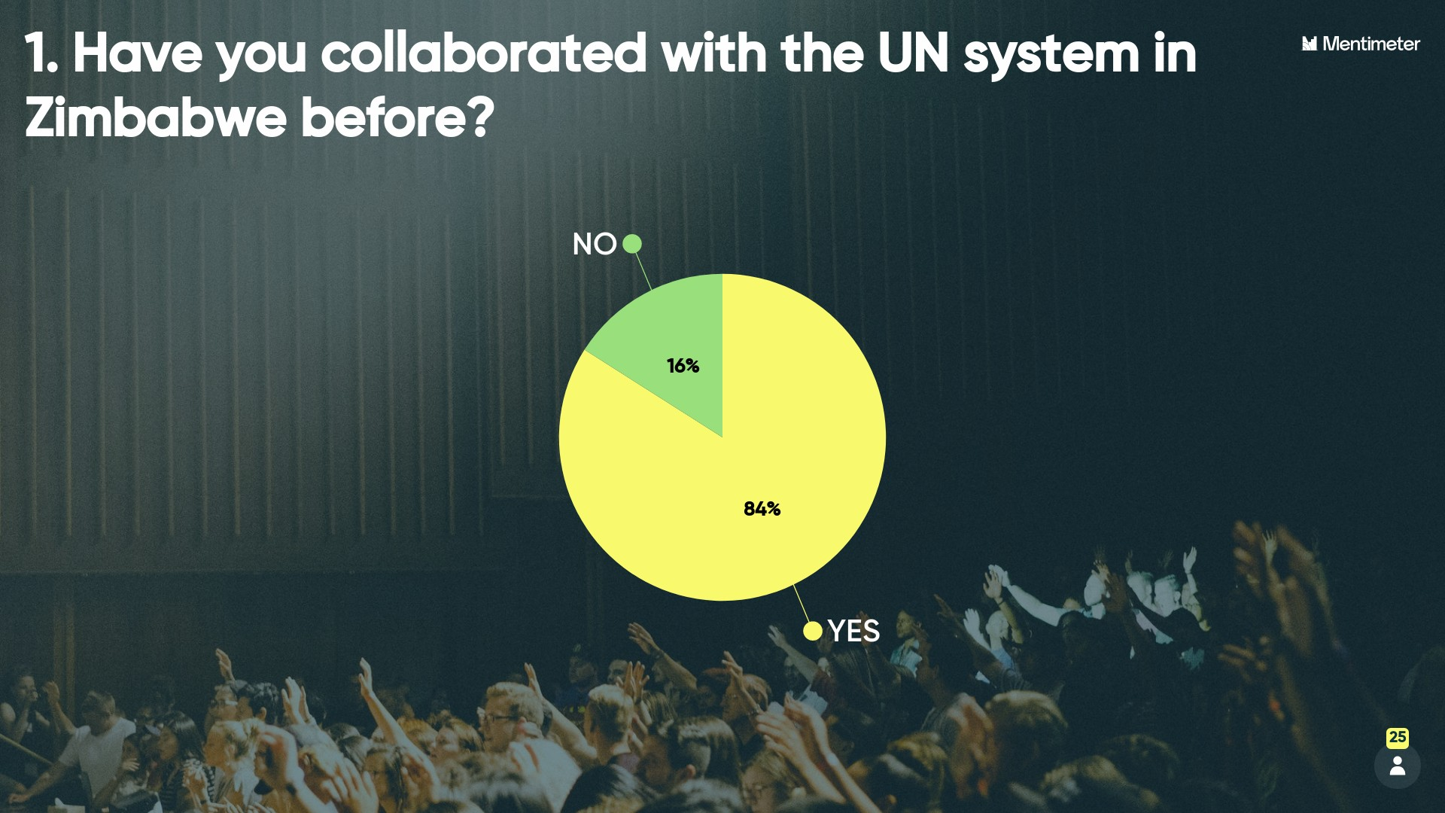

In terms of expectations of the UN, the highest response was for “Capacity building and technical support”, followed by “Networking and exchanges of practices and ideas” and “International exposure and cooperation”, as well as “Funding”, nearly equally. The role of the UN as mediator was not seen as highly relevant.
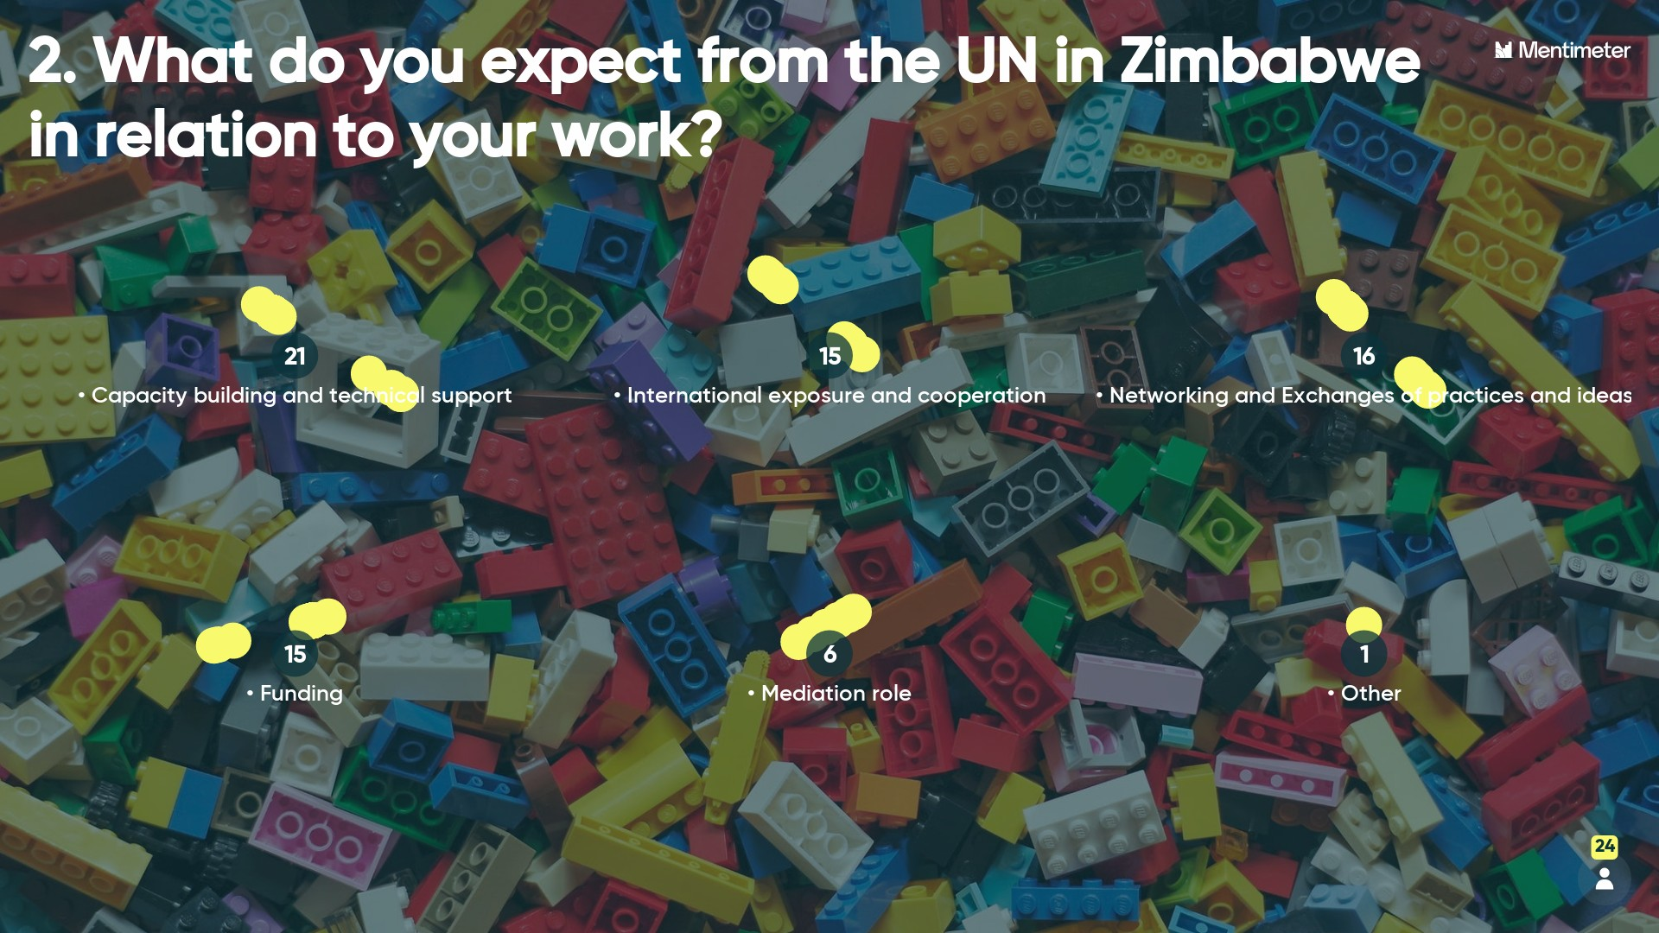

Suggestions and Recommendations from the Participants
Organizations of Persons with Disabilities (OPDs)
Facilitated by Phinith Chanthalangsy, UNESCO; Rapporteur: Memory Zulu, UNESCO
The Group stressed on the importance for the UNSDCF to send a clear and strong message to the national stakeholders on the right-based and no-discriminatory approach to development, when dealing with disabilities, thus aligning with the Convention on the Rights of Persons with Disabilities (CRPD) of which the UN System is the guardian. “Persons with disabilities have to be seen as human beings first, and not through their impairments”, was a sentence that was repeated several times.
Persons with disabilities also need to be part of the decision making processes for the UNSDCF development priorities and not to be just considered as a “target group” during implementation, e.g. in service delivery interventions. The UN must do more to consult and systematically engage with OPDs at their various levels, and the UN is requested to share with disability sector the final Country Framework outcomes and how they can further engage in the implementation processes.
The following recommendations were provided by Organisations of Persons with Disabilities to strengthen disability inclusion and integrate the meaningful participation of persons with disabilities in the design and implementation of the UNSDCF.
People Pillar
- Meaningful Engagement and Participation of Persons with Disabilities across the UNSDF Pillars
Government and Development Partners were encouraged to meaningfully engage with persons with disabilities and their representative Organizations (OPDs) in the Zimbabwe UNSDCF processes. While there was appreciation from persons with disabilities to have been invited in the first dialogue meeting, the UN was requested to use a more inclusive approach that would integrate them not in one targeted group, but include them across all the UNSDCF Pillars (e.g. Planet, Prosperity etc.). This would enable the UNSDCF to become more disability-inclusive across the Pillars.
The following were pointed out by OPDs:
- Making information available in accessible formats: UN encouraged to adopt more disability-inclusive approaches in People Pillar. Information produced and disseminated during UNSDCF implementation processes should be in accessible formats, recognizing that persons with disabilities are not a homogenous group, thus taking reasonable accommodation for the different types of disabilities.
- Reaching the most marginalized disability population groups: Persons with disabilities are still a margined and an “invisible” population group in development. OPDs stressed that the UN should also take cognizance of the commonly “left-behind” and underrepresented disability population groups such as women and girls with disabilities and persons with intellectual/psychosocial disabilities.
- Reasonable Accommodation: OPDS stressed that Reasonable Accommodation should become more evident in the UNSDCF People Pillar. Its prioritization and reflection in the People Pillar outcome areas will strengthen disability-inclusion. The CRPD should guide the UNSDCF on disability inclusion and more trainings for UN and development partners on key concepts on Reasonable Accommodation, disability inclusive budgeting, M & E and service delivery should be prioritized.
- Strengthening disability data processes: Disability data remains a challenge in Zimbabwe (collection & utilization), and the UN is encouraged to do more in this area (Article 31 of the CRPD stresses on the need for Member States to prioritize disability information collected through statistical and research data for disability-inclusive policies and programmes).
- Setting up an official instance of consultation: The OPDs suggested that the UN should set up a platform/instance of consultation and dialogue with the OPDs, that would help the UN better understand and regularly assess progress made in the UNSDCF delivery to respond to the specific needs of persons with disabilities.
Planet Pillar
Organizations of persons with disabilities strongly pointed out that this is one of the areas were they have been less involved, particularly on climate change related issues. UN is requested to engage more with OPDs as agents of change, to identify the specific challenges they face, as well as priority interventions that can be developed.
Prosperity Pillar
UN should engage persons with disabilities more in the Prosperity Pillar as this Pillar is deemed very important for them. Their inclusion in financial empowerment is key to supporting this population group in strengthening their autonomy. Livelihoods skills development for persons with disabilities will promote self-employment.
Specifically, under the Pillar outcome 2, the term “inclusive” needs to be used, e.g. “People, especially the most marginalized are empowered to contribute to and benefit from productive and disability-inclusive decent work opportunities”.
Peace Pillar
  - Gender Equality needs to be strengthened and intersecting forms of discrimination against women and other population groups should be prioritized. Youth should also be prioritized in new development interventions.
  - Systematic Disability-inclusion in the Peace should be prioritized in order not to “leave-behind” persons with disabilities.
  - OPDs stressed that Peace Pillar should also have interventions that address the needs of all types of disabilities, as they are not a homogenous group.
The Academia
Facilitated by Martiale Zebaze Kana, UNESCO; Rapporteur: Broucke Guy, UNESCO
The group gave mainly general feedback across the 4 pillars rather than single out one pillar.
- Focus was on the role of the UNSDCF to enable Academic institutions to play their key role in society in Zimbabwe. As such, various constraints (needs) were mentioned, such as infrastructure including laboratories, hostels; capacity building of lecturers; strengthening exchange programmes for students and staff.
- The suggestion to also discuss the role of the Academia in implementing the 4 pillars, including the relevance of higher education, research, and support for evidence-based policy, etc. was not taken further by the participants.
- A group member also commented that specific focus on some disadvantaged groups (women and girls) could give the impression that other marginalized groups are less relevant, but there was no consensus on this in the group.
The Media
Facilitated by Al Amin Yusuph, UNESCO; Rapporteur: Ingrid Tagwireyi, UNESCO
Feedback from media partners under each pillar was given as follows:
People Pillar
The role of the private sector and business sector was identified as a gap. Inclusive dialogue with telecoms to enable access to information of platforms in Zimbabwe is needed; those is rural areas continue to be marginalised because there is no means of sharing information in those areas. Media can only play their role when the necessary infrastructure that enables the media to reach all communities is in place. Media needs to develop a mechanism to communicate with groups that have a visual or hearing impairment; for example there is limited use of braille.
Community radios should feature as they reach most communities. Zimbabwe economic situation is restricting media to be in urban settings thus there is a need to support community media as they reach marginalised communities.
Planet Pillar
The outputs should focus on the communities as active players not as end beneficiaries. Cross sharing of information in terms of dialogues between experts and communities needs to be prioritised; platforms that are inclusive should be created in the media. Better understanding of impacts of climate change remains a necessity.
Media capacity needs to be strengthened on certain issues, i.e. reporting on climate change and how to share this information in language and formats that they can connect with and understand. Media should have in-house policies targeting sustainability such as business continuity plans in cases of disaster.
Prosperity Pillar
For the media, prosperity goes beyond employment, and should be defined holistically; should be defined in all its aspects. For the media prosperity includes freedom to speak and for citizens to share their concerns and desires. The UN should support research by the media on various factors affecting the media; there is a lack of data to address media work. Media data is needed to ensure the media remains resilient. Community radios sector should focus on building a knowledge base as a currently growing sector in Zimbabwe.
Peace Pillar
Dialogues between different players need to be done, i.e. National Peace and Reconciliation Commission and other human rights monitoring bodies. The UN and media should establish partnerships using a learning approach to learn from each other to work more effectively; media should be viewed as a partner rather than a conduit for disseminating information. Peace needs to be broken down into which elements are being referred to by the pillar as peace is a complex issue. Media need to create platforms where the public can easily access information and claim their rights.

Organizations involved in the Cultural and Creative Industry
Facilitated by Mellisa Muchena, UNESCO; Rapporteur: Rodney Bunhiko
Majority of the respondents lobbied for culture statistics to be part of UNSDCF strategy to ensure monitoring and evaluation of progress. Especially statistics on piracy within the creative industry, there is need for baseline studies on this content. There were also discussions on inclusive dialogues with telecom industries, to discuss matters on access to information. One participant also indicated that the culture and creatives should fall under a well-defined ministry in the country, as this would improve overall coordination of the sector.
The People Pillar
Under this pillar, participants highlighted the need for the inclusion of young people, traditional leaders as levers of development and the need to foster meaningful participation and involvement from outlying communities. The group also pointed out the need to strengthen and advocate for freedom of artistic expression and to introduce initiatives and ways to help creatives access social protection mechanisms and improve their status.
Prosperity Pillar
One of the key responses on this pillar was on the need to support capacity building for the creative sector, as it has issues that effectively cut across all the pillars. There is also need for technical and financial support to help the sector grow and potentially impact on sustainable development. Some of the challenges indicated under prosperity was the lack of representation from creatives, in developmental dialogue. One of the participants also recommended the need to educate and empower creatives on their fundamental and human rights in general.
Furthermore, the digital economy is a sector within the creative economy that requires further exploration, especially in term of employment creation. There are plethora of products and services that the national economy could benefit from such as animation, podcasts, and monetization of social media and websites.
The Planet Pillar
Participants highlighted how the creative sector can raise awareness in local communities on subjects pertaining to climate change and preservation of the planet, for example.
The Peace Pillar
One of the participants indicated that Culture is both an enabler and impediment to peace and that there should be support for programs that ensure inclusive social development and encourage cultural dialogue. It was also suggested that there should be capacity building and awareness among law enforcement agencies for them to appreciate and support the works of art in its different forms. Stakeholders also emphasized the need celebrate and include local languages, especially for easy comprehension by local stakeholders and it was then recommended that once adopted the UNSDCF framework needs to be translated to ensure inclusivity.

Annex 1

Participant List

 | NAME | ORGANISATION | E-MAIL
OPDs
MEDIA
 | Adileth Munyoro | Zimbabwe Albino Association (ZIMAS) | zimalbino.assos@gmail.com
 | Emma Shamuyarira | ZImbabwe Media Commission. | emmashamu7@gmail.com
 | Faith Ndlovhu | International Media Support (IMS) | fnd@mediasupport.org
 | Forget Tsododo | Broadcasting Authority of Zimbabwe | forget@baz.co.zw
 | Helen Mutizamhepo | Zimbabwe Online Content Creators | hmutizamhepo@gmail.com
 | Ishumael Zhou | Umbrella Body National Association of Societies for the Care of the Handicapped (NASCOH)- | ishumaelzhou@gmail.com
 | Itayi Mariko | Midlands State University | marikoi@staff.msu.ac.zw
 | Kuda Machiha | Zimbabwe Albino Association (ZIMAS | kudakmachiha@gmail.com
 | Leonard Marange | Federation of Organisations of Disabled People in Zimbabwe (FODPZ) | lmarange@fodpz.org.zw
 | Lovemore Mwale | National Association of Societies for the Care of the Handicapped (NASCOH)- | lovemoremwale3@gmail.com
 | Mercy Maunganidze | Zimbabwe Albino Association (ZIMAS) | mercy2016@iiseconnect.org
 | Nqaba Matshazi | Media Institute of Southern Africa  MISA Zimbabwe | nqaba@misazim.co.zw
 | Onai Hara | Deaf Women Included | onie.hara@gmail.com
 | Peter Bare | Sightsavers | pbare@sightsavers.org
 | Rashweat Mukundu | International Media Support (IMS) | rm@mediasupport.org
 | Soneni Gwizi | Disability Activist, Action in Disability and Development (ADD) International Ambassador for Africa | sonenigwizi@yahoo.com
 | Susan Makombera | Broadcasting Authority of Zimbabwe | susan@baz.co.zw
 | Tsitsi Mumbure | Deaf Women Included | tsitsimumbure@gmail.com
 | Vimbai Takawira | Broadcasting Authority of Zimbabwe | vimbai@baz.co.zw
 | Vivienne Marara | ZACRAS | viviennem@zacraszim.org
ACADEMIA
 | Chipo Chikwature |  | chikwaturec@hotmail.com
 | Chriswell Chamisa | Kwekwe Polytechnic | chriswellchamisa@gmail.com
 | Edmore Masendeke | Endless Possibilities. | mrmasendeke@gmail.com
 | Edson Munsaka | National University of Science & Technology (NUST) | edson.munsaka@nust.ac.zw
 | Elijah Chikomo | Midlands State University | chikomoe@staff.msu.ac.zw
 | Emmanuel | Muzanenhamo | emuzah2012@gmail.com
 | Kudzai Shava | Centre for Disability & Development | kshava2@uic.edu
 | Makomborero Manenge | Kwekwe Polytechnic | manengemakomborero@gmail.com
 | MpikeMaseko | Lecturer | mpikemaseko@gmail.com
 | Primrose Chiyembekezo | Midlands State University | primrosengondo@gmail.com
 | Prof Ruby Magosvongwe | Media Commission | ruby.magosvongwe@yahoo.com
 | Rudo Mukurazhizha | Midlands State University | mukurazhizharudo@gmail.com
 | Tyanai Charamba | Midlands State University | charambat@staff.msu.ac.zw
 | Vanessa | Kwekwe Polytechnic | vrbutao.qs@kwekwepoly.ac.zw
 | Washington Chandiwana | Gweru Polytechinc | principal@gwerupoly.ac.zw
CULTURE
 | Beaula Chipoyera | UNESCO National Commission for UNESCO | bchipoyera@gmail.com
 | Butholezwe Kgosi Nyathi | Amagugu Heritage Trust | butholezwekgosin@gmail.com
 | Caroline Magenga | Patsimeredu Edutainment Trust | csmagenga@gmail.com
 | Chris Charamba | Enthuze Afrika | chris@enthuseafrika.com
 | Daniel Maposa | Savanna Trust | wamambod@gmail.com
 | Edith WeUtonga Katiji | Zimbabwe Musicians Union/United Women in Music | edithweutonga@gmail.com
 | Farai Mpfunya | Culture Fund Trust Zimbabwe | faraim@culturefund.co.zw
 | Florence Majachani | Arterial Network Zimbabwe | flosywafarai@gmail.com
 | Innocent Veremu |  | innoveremu@gmail.com
 | Jacob Mapara |  | jakob.mapara@gmail.com
 | Lennox Makurumidze | Afrotopia | lennoxmakurumidzet@gmail.com
 | Loice Kudzanai | Patsimeredu Edutainment Trust | loicekudzanai@gmail.com
 | Margaret Chirapa | Zimbabwe UNESCO National Commission | zimnatcom3@gmail.com
 | Melody Zambuko | Music Crossroads | melody@music-crossroads.net
 | Samuel Makore | Zimbabwe International Book Fair (ZIBFA), Zimbabwean Academic and Nonfiction Authors Association (ZANA) and PEN Zimbabwe. | makoresamuel@yahoo.co.uk
 | Simbarashe Mudhokwani | Culture Consultant | simbarashemudhoks@yahoo.com
 | Stephanie Kapfunde | Ethuse Afrika | steph@enthuseafrika.com
 | Tinashe Gwariro | Nhimbe Trust | tanishe-ap@nhimbe.org
 | Walter Wanyanya | Ngoma neHosho | tanishe-ap@nhimbe.org
UN ORGANIZATIONS
 | Al Amin Yusuph | UNESCO | a.yusuph@unesco.org
 | Amanda Sithole | UNICEFF | asithole@unicef.org
 | Anne Rita | International Telecommunication Union – ITU | anne.rita.ssemboga@itu.int
 | Blessing Nyagumbo | United Nations Population Fund | nyagumbo@unfpa.org
 | Broucke Guy | UNESCO | g.broucke@unesco.org
 | Chali Tumelo | International Telecommunication Union – ITU | chali.tumelo@itu.int
 | Chimbikidzai Mapfumo | UNESCO | c.mapfumo@unesco.org
 | Chipo Chidhuhla | World Food Programme | chipo.chipudhla@wfp.org
 | Cynthia Mapisire | International Telecommunication Union – ITU | cynthia.mapisire@itu.int
 | Fiona Adolu | UN | adolu@un.org
 | Hubert Gijzen | Director-UNESCO ROSA | h.gijzen@unesco.org
 | Ingrid Tagwireyi | UNESCO | i.tagwireyi@unesco.org
 | Jabusile Shumba | UN | jabusile.shumba@un.org
 | James Maiden | UNICEF | jmaiden@unicef.org
 | Loveness Makonese | United Nations Population Fund | makonese@unfpa.org
 | Madelena Manoja | UNDP | madelens.monoja@undp.org
 | Magdeline Madibela | RCO-Gender and Disability Coordination Advisor | magdeline.madibela@one.un.org
 | Marika | World Food Programme | marika.guderian@wfp.org
 | Mellisa Muchena | UNESCO | m.muchena@unesco.org
 | Memory Zulu | UNESCO | m.zulu@unesco.org
 | Mickelle Hughes | UNRCO | mickelle.hughes@un.org
 | Mulekeni Ngulube | UNESCO | md.ngulube@unesco.org
 | Mwongeli Makau | WFP | marika.guderian@wfp.org
 | Phinith Chanthalangsy | UNESCO | p.chanthalangsy@unesco.org
 | Prince Kamupunga | UNESCO | p.kamupunga@unesco.org
 | Rodney Bunhiko | UNESCO | rodneybunhiko@gmail.com
 | Rutendo Kambarami | UNICEF | rkambarami@unicef.org
 | Stanley Midzi | World Health Organisation | midzis@who.int
 | Tafadzwa Mwale | UN | mwalet@un.org
 | Tawanda Matanda | International Organization For Migration(IOM) | tawanda.matanda@gmail.com
 | Tich Mabonga | UNHCR | mabonga@unhcr.org
 | Wadzanai Madombwe | UNDP | wadzanai.madombwe@undp.org

Annex 2
Programme
Plenary Session
2-2.15 pm – Opening remarks, purpose and expected outcomes, by Prof. Hubert Gijzen, UNESCO Regional Director
2.15-2.30 pm – Overview of the Cooperation Framework process, priorities, outcomes, Mickelle Hughes, Mickelle Hughes, UN Resident Coordinator Office
2.30-2.40 pm – Mentimeter Survey on:
- Have you collaborated with the UN system before?
- What do you expect from the UN in Zimbabwe in relation to your work?
- Capacity building and technical support
- International exposure and cooperation
- Networking and Exchanges of practices and ideas
- Funding
- Mediation role
- Other
Breakout Sessions
2.40-3.40 pm – Facilitated discussion responding to:
  - Relevance of the proposed priorities and outcomes to contribute to sustainable development in Zimbabwe
  - Strategies to enhance partnerships to support national priorities
Groups:
- Organizations of Persons with Disabilities (OPDs), facilitated by Phinith Chanthalangsy, UNESCO; Rapporteur : Memory Zulu
- The Academia, facilitated by Martiale Zebaze Kana, UNESCO; Rapporteur: Broucke Guy
- The Media, facilitated by Al Amin Yusuph, UNESCO; Rapporteur: Ingrid Tagwireyi, UNESCO
- Organizations involved in the Cultural and Creative Industry, Mellisa Muchena, UNESCO; Rapporteur: Rodney Bunhiko
Plenary Session
3.40-4 pm – Wrap up, summary of discussions, next steps, the Rapporteurs

